Levels of Expressions of Oppression
Individual | Internalized Oppression lies within individuals. These are our private beliefs and biases about others, influenced by our culture. | Systemic | Institutional Oppression occurs within institutions and systems of power. It is the norms, policies and practices that are structured into political, societal and economic institutions that have the net effect of imposing oppressive conditions and denying rights, opportunity, and equality to identifiable groups.
Individual | Interpersonal Oppression occurs between individuals. Once we bring our private beliefs into our interactions with others, we are now in the interpersonal realm. | Systemic | Structural Oppression is bias across institutions and society. It’s the cumulative and compounded effects of an array of factors that systematically privilege some and disadvantage others.

Key Points to Remember
Key Point 1 - There are not hard and fast lines between the levels - and changing one can affect another.

Key Point 2 - The way to effect change is by addressing institutional and structural oppression- this is where injustice lives.

Expressions of Oppression Exercise
INSTRUCTIONS: Please review the cases below and as a group, have a discussion on your assigned case to come to a decision about which level of oppression each case belongs to. Please ensure there is consensus in your group in your answers. Be prepared to share in three minutes – a summary of your case, the level you chose, and why you made that decision.

Scenario #1: Oppression in Medicine
Quick Summary of the Case
Level of Expression of Oppression and Why you chose this
https://www.thetaskforce.org/new-report-reveals-rampant-discrimination-against-transgender-people-by-health-providers-high-hiv-rates-and-widespread-lack-of-access-to-necessary-care-2/
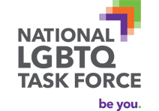
Transgender and gender non-conforming people face rampant discrimination in health care settings, are regularly denied needed care, and experience a range of health risks because they are transgender or gender non-conforming, according to a report of more than 6,450 transgender and gender non-conforming people. The National Transgender Discrimination Survey: Report on Health and Health Care was released nationally today by the National Gay and Lesbian Task Force and the National Center for Transgender Equality.
Key findings include:
- Nearly 1 in 5 (19 percent) reported being refused care outright because they were transgender or gender non-conforming.
- Survey participants reported very high levels of postponing medical care when sick or injured due to discrimination and disrespect (28 percent).
- Harrassment: 28 percent of respondents were subjected to harassment in medical settings.

Scenario #2: LGBTQ+ Youth and the Juvenile Justice System LGBTQ+ youth in the juvenile justice system
Quick Summary of the Case
Level of Expression of Oppression and Why you chose this

For LGBTQ people, criminal justice involvement often starts at a young age. LGBTQ youth are extremely overrepresented in the juvenile justice system. Researchers estimate that 20% of youth in the juvenile justice system are lesbian, gay, bisexual, questioning, gender nonconforming, or transgender compared with 4-6% of youth in the general population. The same research shows that 40% of girls (who were assigned female at birth) in the juvenile justice system identify as LBQ and/or gender nonconforming. This overrepresentation is largely due to the obstacles that LGBTQ youth face after fleeing abuse and lack of acceptance at home because of their sexual orientation or gender identity. In order to survive, LGBTQ youth are pushed towards criminalized behaviors such as drug sales, theft, or survival sex, which increase their risk of arrest and confinement.
Scenario #3: Financial Services
Quick Summary of the Case

Level of Expression of Oppression and Why you chose this

https://www.cnbc.com/2022/06/28/30percent-of-lgbtq-adults-experienced-discrimination-in-financial-services.html
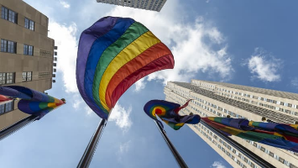
Members of the LGBTQIA+ community are still struggling, in some instances, to access financial services that would help them manage their money.
Some 30% of LGBTQIA+ adults have experienced bias, discrimination or exclusion in the financial services sector, either from individuals or organizations, a survey from the National Endowment for Financial Education found. The online survey of more than 1,000 adults in the LGBTQ+ community took place from May 6 to May 17.
Of those who experienced such barriers to accessing financial services, many noted that age and orientation were the top reasons they felt led to the experience. In addition, transgender respondents face the most discrimination, the survey found.

Scenario #4: Department of Education
Quick Summary of the Case
Level of Expression of Oppression and Why you chose this
https://www.washingtonpost.com/education/2022/03/30/transgender-discrimination-title-ix-rule-students/
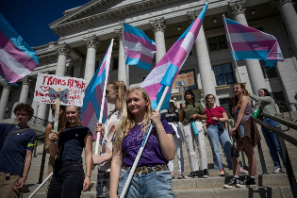
Discrimination against transgender students would be a violation of federal civil rights law under proposed regulations the Education Department is expected to finalize in the coming weeks.

Title IX bars discrimination on the basis of sex in education, and the new rules would make clear this includes discrimination based on sexual orientation and gender identity, among other things, according to two people familiar with a draft of the proposed regulation who spoke on the condition of anonymity because they were not authorized to publicly comment on the subject.

Regulations carry the power of law. The rules, if finalized, would set up a clash with state laws that bar transgender women from competing in women’s sports. Those statutes are already being challenged in the courts.

Scenario #5: Swimming Ban
Quick Summary of the Case
Level of Expression of Oppression and Why you chose this
https://www.nydailynews.com/sports/more-sports/ny-fina-world-swimming-bans-transgender-athletes-elite-women-lia-thomas-20220619-hxjhhrmwaffapibcp3lnogy2hm-story.html


Transgender women have been effectively banned from competing in women’s events, swimming’s international governing body ruled Sunday.
In voting to restrict the participation of transgender athletes, FINA members announced a new “gender inclusion policy” that permits only swimmers who transitioned before age 12 to compete in women’s events.

Transgender rights have been a hotly debated issue in swimming after University of Pennsylvania swimmer Lia Thomas became the first transgender NCAA champion in Division I history. She won the women’s 500-yard freestyle in March, leading to some parents and competitors to complain that she had an unfair advantage. Thomas competed on the men’s team at Penn before transitioning. She competed as a woman for the first time in 2021-22 after meeting NCAA standards for competition after undergoing testosterone suppression therapy for more than two years.

Scenario #6: Personal Story
Quick Summary of the Case
Level of Expression of Oppression and Why you chose this
https://www.glaad.org/amp/lgbtq-youth-share-stories-offer-advice-adults-to-end-bullying


My story: I’m a femme, gay man and since kindergarten I’ve always felt accepted by my friends. But appreciation of my outward expression didn’t reach far past my small friend group. I was bullied for being ‘too femme’ and to avoid being teased I’d deepen my voice around others. In P.E. I’d always be told that I “played like a girl” or that I was not good enough to play with the other boys because I was “too gay.” I was always being labeled as ‘too girly’ for being around so many women and also shunned from masculine groups because no one wanted to be hit on by a ‘gay boy.’ To the other boys, my mannerisms were a sort of oddity that they hoped wouldn’t catch on. Even my father advised me to “act more like a man” rather than more like myself.

Scenario #7: Spray Paint Graffiti
Quick Summary of the Case
Level of Expression of Oppression and Why you chose this
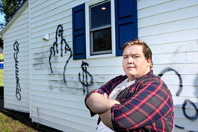
https://www.nvdaily.com/nvdaily/strasburg-residents-home-vandalized-for-second-time-police-investigate-incidents-as-hate-crimes/article_ca7c986f-3770-5de3-91e6-05e8c1d33367.html#:~:text=Statewide%20Notice%20Archive-,Strasburg%20resident's%20home%20vandalized%20for%20second%20time,investigate%20incidents%20as%20hate%20crimes&text=Paul%20Rush%2C%2027%2C%20stands%20outside,in%20the%20last%20two%20months.
For the second time in two months, the home of a transgender Strasburg resident has been vandalized with spray-painted graffiti. Paul Rush, 27, of Branch Street, said that derogatory words and an obscene hand gesture were painted on their house Tuesday night. This comes after a Sept. 26 incident in which anti-LGBTQIA and anti-Black messages were spray painted on Rush’s home. On Sept. 23, Rush had displayed a pride flag to openly express being a non-binary transgender person, which means not identifying as a male or female. “Most of the time people, especially around here, tend to just disagree quietly, even if they put the occasional snarky Facebook post,” said Rush, who uses the pronouns they and their. “But that’s usually as far as it goes.”Rush said they waited until 2017 to come out as transgender to close friends because of the fear of what might happen. “This is the first time I’ve ever seen something like this,” said Rush, a lifelong Strasburg resident. Rush said they were a little worried on Tuesday because there’s generally an uptick of hateful actions against minority groups following a close election, regardless of who wins. Rush added that they stayed up “a little bit late” watching election results and if the vandals “came while we were awake, we certainly didn’t hear anything.” Although Rush said they do not have any proof, they have a gut feeling of the culprit’s identity. “Strasburg is a very small community. There’s not a lot of openly LGBT people here,” Rush said. “I believe it’s just the bigotry of just one person or maybe just a small group of people who live on this street or in this neighborhood.” Rush and their wife, who live with two cats, looked into purchasing a security camera after the first incident. They held off, however, because money was tight, Rush said.
Strasburg Police Chief Wayne Sager said his department is “absolutely” looking into these incidents as hate crimes and is actively working to gather evidence to find the offender and successfully prosecute them.“This is devastating to all of us,” Sager said. “It is not to be tolerated, and we’re going to do our best to bring justice to Mr. Rush and his family and friends as well, the victims of this.” Although officers have contacted 81 residents and businesses in the area, Sager said the department has not identified a person of interest. “With the vulgar language and the hate things that are being targeted there to Mr. Rush’s residence, we want to make sure we do our jobs,” Sager said.

Scenario #8: Workplace Gender Change
Quick Summary of the Case
Level of Expression of Oppression and Why you chose this
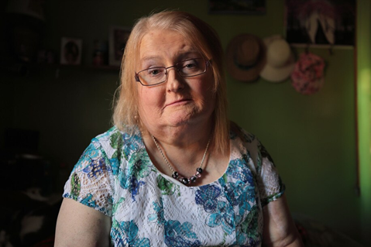
https://www.washingtonpost.com/nation/2019/04/30/transgender-woman-wrote-letter-her-boss-it-led-her-firing-trip-supreme-court/
It took Aimee Stephens several months to write a letter to her boss explaining that she was a transgender woman and planned to start coming to work as her true self.
She had been working as a funeral director and embalmer for RG & GR Harris Funeral Homes in Garden City, Michigan, for almost six years. She loved her job, but didn’t want to hide who she was anymore.
She agonized over what to say in the letter, wrote several drafts and sought input from her therapist. Finally satisfied, she handed the letter to her boss in the summer of 2013.
“He read it, he folded it up and put it in his pocket,” Stephens recalled in an interview with CNN. “And basically stood up and walked away.”
She was fired two weeks later. Stephens filed a complaint with the Equal Employment Opportunity Commission, which then sued the funeral home claiming that firing Stephens for being transgender was unlawful sex discrimination based on her employer’s sex- or gender-based expectations.
“I was proposing to go from being a man in a suit to a woman in a dress and they couldn’t handle that part,” Stephens said.
Her boss stated that he fired Stephens because she “was no longer going to represent himself as a man” and “wanted to dress as a woman,”

Scenario #9: Biracial Boy Pushed Off Table
Quick Summary of the Case
Level of Expression of Oppression and Why you chose this
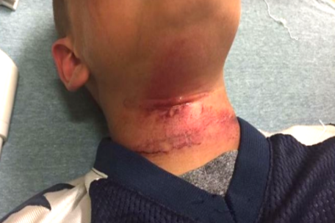
Associated Press September 12, 2017
CLAREMONT, N.H. — Teenagers in New Hampshire taunted an 8-year-old biracial boy with racial slurs and then pushed him off of a picnic table with a rope around his neck, injuring him, the boy’s family said.
The child was treated at a hospital for cuts to his neck following the near-hanging Aug. 28 in Claremont, the boy’s grandmother, Lorrie Slattery, told the Valley News of West Lebanon, N.H. He has since been released and has returned to school in Claremont.

Slattery said the children were in a backyard when some of the teens got on the table and grabbed a rope that held a tire swing. It’s not clear how the rope got around the child’s neck, but Slattery said the teens pushed him off the table. No adults are believed to have witnessed the incident.
An expert on abuse who spoke to the boy at the hospital said he swung from his neck three times before being able to remove the rope, Slattery said. None of the teens came to his aid, she said.

Scenario: #10 The School-To-Prison Pipeline
Quick Summary of the Case
Level of Expression of Oppression and Why you chose this

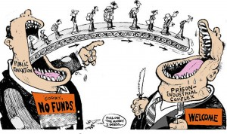
A significant number of Chicago students are pushed into the path of juvenile and adult prisons as a result of harsh disciplinary policies and high stakes testing. By harsh disciplinary policies, we mean excessive security procedures and police involvement as well as the overuse of suspensions and expulsion for minor infractions. These policies feed the “School to Prison Pipeline”, sometimes also called the “Schoolhouse to Jailhouse Track”. Research suggests that students of color, in particular African American students, are disproportionately impacted by these punitive policies.

As Matt Kelley has written: “Whether or not they realize it, the punishments school officials hand out can literally determine — and derail — the path of a student’s life. Which makes it even more critical that when schools make these decisions, they hand out discipline that’s fair.”
The “School to Prison Pipeline” describes a reality in which many young people are being pushed OUT of schools through zero tolerance policies, suspension, expulsion, discouragement and high stakes testing requirements; and INTO the juvenile and adult legal system. These zero tolerance policies involve the police in minor incidents and often lead to arrests, juvenile detention referrals, and even criminal charges and incarceration.

Scenario #11: Doorway To A Better Life?
Quick Summary of the Case
Level of Expression of Oppression and Why you chose this

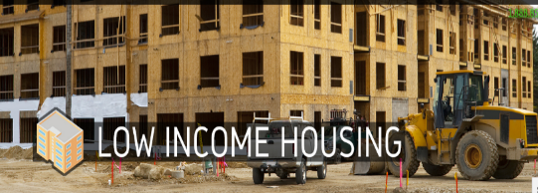
A state government agency decides that low-income housing must be built, which will house low-income Blacks and Latinos. The agency fails to look for locations near jobs and important infrastructures, like schools, decent public transportation, and other services. In fact, it is built in a poor, mostly Black and Latino part of town.

Often times the government locates the housing where it will have the least opposition. White neighborhoods tend to oppose public and affordable housing. Resources, whether public or private, often follow whites who flee urban problems for white suburbs When the housing is built, the school district, already under-funded, has new residents too poor to contribute to its tax base. The local government spends its limited resources on transportation to connect largely white, well-to-do suburban commuters to their downtown jobs.

The public housing residents are left isolated, in under-funded schools, with no transportation to job centers. Whole communities of people of color lose opportunities for a good education, quality housing, living wage jobs, services and support-systems. In this town, no one individual stands in front of the doorway to a better life and says, “No Blacks/Latinos/ Native Americans/Asians allowed.” Race, however, is the unspoken motivator behind a series of actions which lead to decisions about where to place the walls.

Scenario #12: The Doll Case
Quick Summary of the Case
Level of Expression of Oppression and Why you chose this
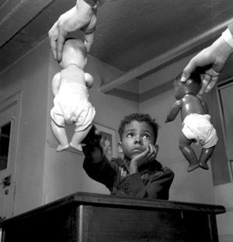
In the 1940s, psychologists Kenneth and Mamie Clark designed and conducted a series of experiments known colloquially as “the doll tests” to study the psychological effects of segregation on African-American children. Drs. Clark used four dolls, identical except for color, to test children’s racial perceptions. Their subjects, children between the ages of three to seven, were asked to identify both the race of the dolls and which color doll they prefer. A majority of the children preferred the white doll and assigned positive characteristics to it. The Clarks concluded that “prejudice, discrimination, and segregation” created a feeling of inferiority among African-American children and damaged their self-esteem.

Scenario #13: The Problem Woman of Color
Quick Summary of the Case
Level of Expression of Oppression and Why you chose this
