NEA ESP YRO Conference Agenda: Day #1 (of 1)
General Materials and Room Set-up:
Round Tables for Participants and one Rectangle for Facilitators
Projector, Screen, Speakers, Microphones – NO PODIUM – only central projection table with laptop connection there
Carousel stations and reporting stations around the perimeter
50 attendees
Material Boxes with participant “toys” on each table
CHARTS NEEDED:
- Identity Stations (premade signs, no chart): Race, gender/presentation, Age, Class, Sexual Orientation, Nation or language of origins, Work category, Ethnic group, Religion, Physical/ mental ability

Overall Outcomes: Participants will learn core definitions of allyship and where they fall in the spectrum of allyship. Participants will also be able to identify level of oppression and the resources needed to address the oppression they or their members face.
Key Outcomes for the Day:
Participants will learn about allyship and their role in being an ally to others.
Participants will develop an understanding of power by also learning about oppression and privilege.
Participants will learn about a framework of understanding oppression so that they can better identify actions to take in seeking justice.

Time and Topic
2:45-2:55, Ellen
2:55-3:30 Monet, Ellen
3:30-3:45 Break
3:45-5:00: Systems of Oppression, Hedy & Katie

2:45-5pm |  |  | Questions and Learning Goals
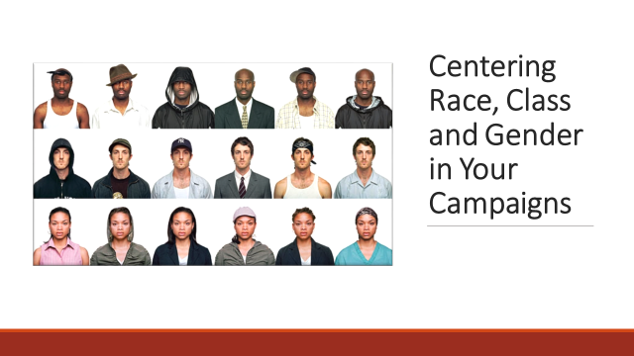  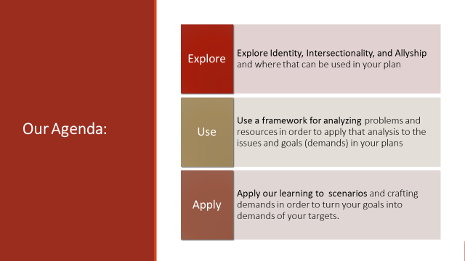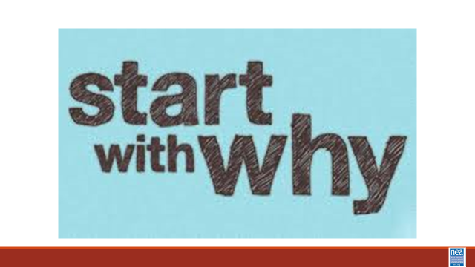  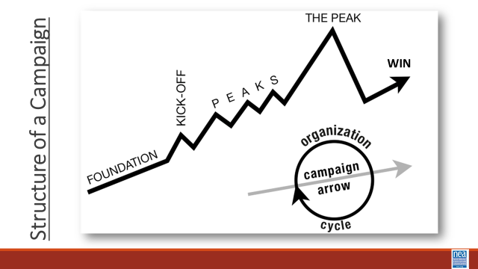  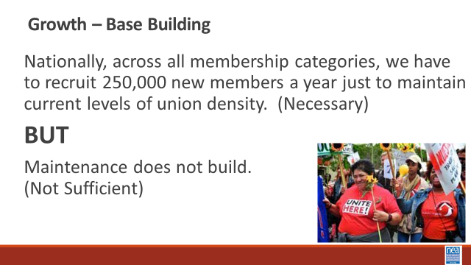  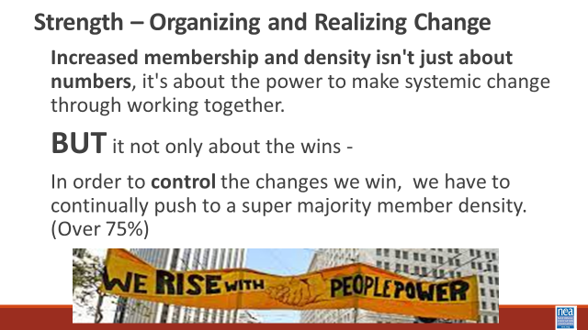  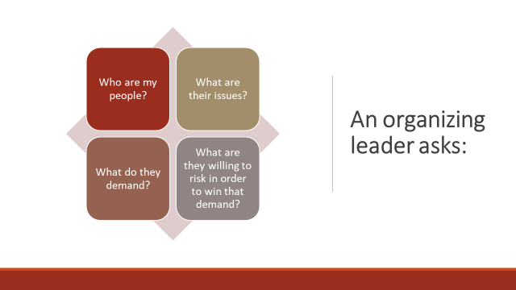  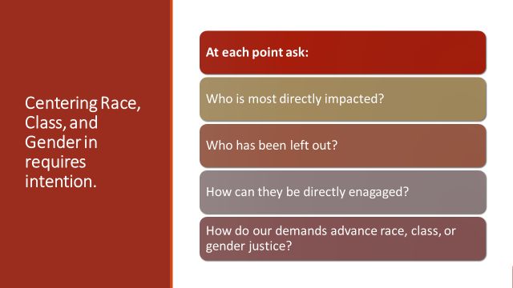  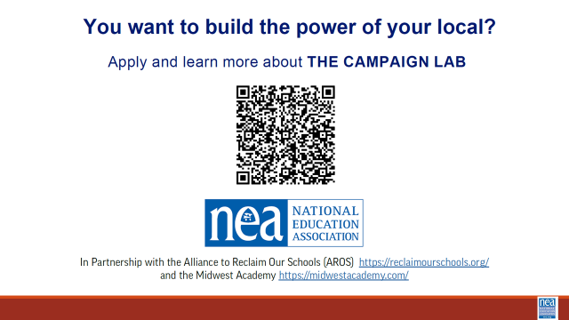  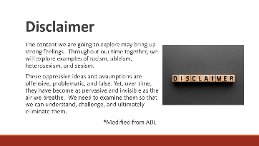 | 2:45-2:55 | Hello – Ellen Holmes She, her, hers.  Review our outcome – Need your ESP BOR Campaign Worksheet in your hand.  So why am I here? I am from a community that grew up in the belief that the people closest to the problem are the experts in that problem and must lead towards the solution to that problem.  Funny thing, that is a core belief of organizers who help implement campaigns. At all points of our best campaigns – members and their community partners lead – affiliate staff coach and enable those folks to achieve the changes that they are willing to demand. In your worksheet you have listed goals- which are critical – I encourage you think about how “Goals, shift when you begin to think of them as DEMANDS of TARGETS . A demand is simply what you want and that demand is made to the person who currently has the power in the system to grant or prevent your demand.  Think about Campaigns in terms of two metrics – Growth and Strength.  Growth, membership recruitment is important. It is necessary but not sufficient.  We also have to think about strength – strength is the ability to win – BUT getting episodic wins are also not enough – you have to continue to grow enough that you control the win you have.  There are 4 questions that all organizers ask  You have to intentionally consider it. (read the questions on the slide that are a Race and Equity Tool )Why do we need to include Race, Class, and Gender –if you want to move from episodic wins and the power to control the wins you get – you need to intentionally increase and diversify your base, your issue messaging, and your leadership teams.  Disclaimer- read the slide. | Participants will understand how growth and strength are connected to campaigns.  Participants will understand how intentionally asking race and equity questions at every point of a campaign helps to center race, class, and gender in campaigns.
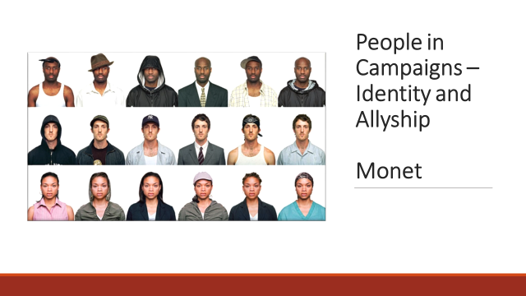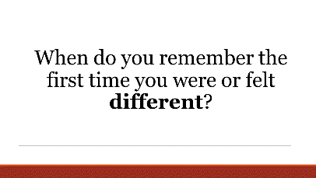  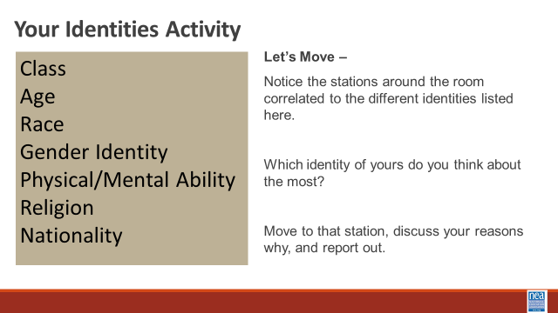  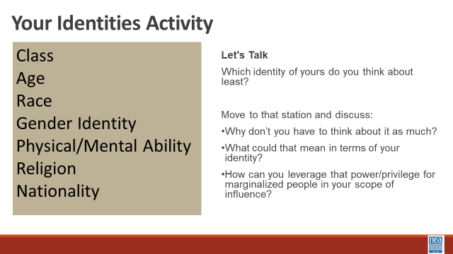  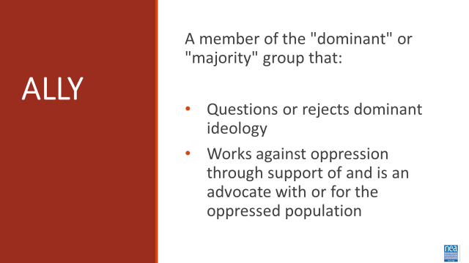  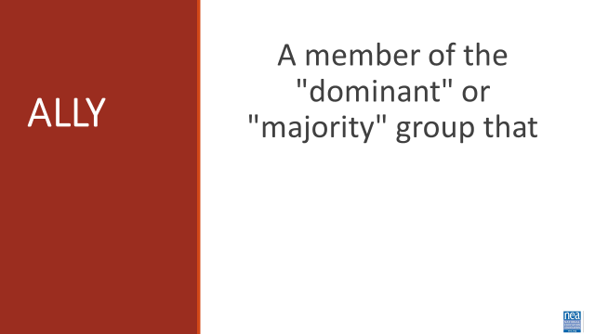  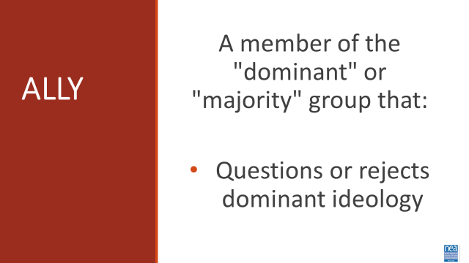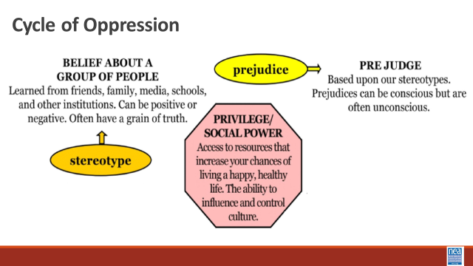  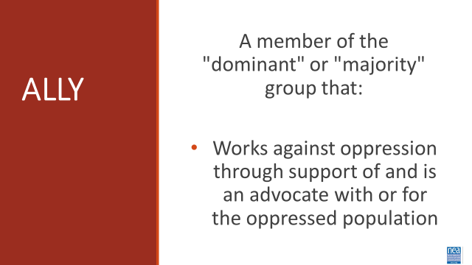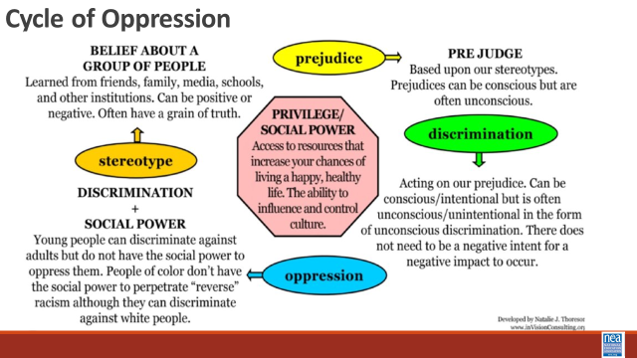  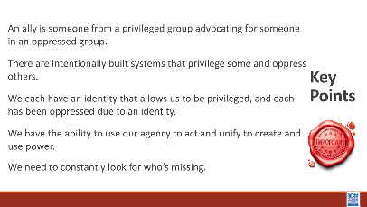 | 2:55-3:00  Stations posted around room include:  - Class  - Age  - Race  - Gender Identity  - Physical/Mental Ability  - Religion  - Nationality  - Mental ability | 7 min- Ice Breaker  We’re going to start off by doing an icebreaker and giving you a chance to hopefully meet some new people. In front of you should be a post it note with a number on it. When I say go please move to the table with the corresponding number.  Okay, now that you’re in your groups, I want you to take 5 minutes to share your answer to this questions. “When do you remember the first time you were or felt different?” Remember you only have 5 min so that gives about 30 seconds per person. And begin.  5 min- debrief  Debrief- Does anyone want to share their story? (Elicit 3 shareouts)  Now when we start to talk about diversity, many peoples minds default to racial diversity. And while we are certainly going to talk about race, there are a variety of ways to be different, and you all just heard first hand from your table talks.  1 Min – Identity Introduction  We are going to take a minute to look intentionally at our identities and help figure out where we are, so we know how to identify who’s missing. This list is not exhaustive but will serve as a foundation for you all as you move forward in creating your Bill of Rights.  9 min- Your Identities Activity  - This list represented 7 groups, each representing one facet or category of our social identity. Short social identity explanation.  - Facilitator note: Explain any confusing identities-  - Gender Identity: For this one, we are referring to whether you are cisgender (identify with the gender you were assigned at birth) and transgender (does not identify with the gender they were assigned at birth)  - Notice the stations around the room correlated to the identities in the shield. Which identity of yours do you think about the most? Move to that station, discuss your reasons why, and report out on common themes. (Everyone chooses. It is a sign of privilege to sit out.)  - Can I get 3 people to share out?  [Facilitator] Define the term: Privilege: A special right, advantage, or immunity granted or available only to a particular person or group.  - Which identity of yours do you think about the least? Move to that station, and discuss why you don’t have to think about it as much, and what that could mean in terms of your identity? How can you leverage that privilege/power for marginalized people in your scope of influence?  - Can I get 3 people to share out?  Optional Question- Which identity gives you power to be able to engage in this work.  13 min- Allyship definition  As you all embark on this work of crafting your ESP Bill of Rights, we want to implore you to be an ally to those who are not in the room and make sure they are reflected in your document, as well as recognizing where you have power in your identity to help advocate for change.  So what is an ally?  You all can see the definition on the screen but the key pieces were going to highlight are: “a member of the dominant or majority group, who questions or rejects the dominant ideology and works against oppression through support of and as an advocate with or for the oppressed population.  Activity- Table Talk 2 min  I want you to turn into your tables and discuss for 2 minutes what you think the dominant and majority group is.  Great job. Many people have crossovers in their identities, which a few may be very privileged and exist soley in the dominant group, many of us cross the spectrum. Having some identities that are in the dominant social structure and some that aren’t.  Next part, An ally is someone who questions or rejects the dominant ideology. Where does this ideology come from?  What you’re looking at is called the cycle of oppression, and where it starts is in believes given to us, typically very young. From our parents, community, tv shows, media etc. These can be both good and bad ideas about particular groups. As we move through the world that negative stereotype that was planted creates prejudices/biases, conscious or unconscious. A great example of this is imagine you booked on Southwest, when you got on the plane there are only middle seats left. How do you decide where to sit? What stereotypes that you have learned do you apply to when choosing that seat? As a woman do you sit between two men? Are any of you sitting between the two moms with lap infants? We prejudge based on these social identities on how we move through the world.  Lastly, an ally is a member of that dominant group that works as an advocate for the oppressed population. How does a group going from having stereotypes to being oppressed?  Let's finish working through the wheel. Next we arrive at discrimination, acting on those biases we have formed. An example of this is the research done with job applications with different names. When looking at employer interest between identical applicants, one with an ethnic name and one European or “white” name, the European name will get twice as many interview requests.  Activity 2 min table talk- Before we finish the wheel, turn into your table and give them your definition of oppression.  Finally we arrive at oppression, oppression is systemic. It’s historical, and it's existed for a long time. Oppression is social power + discrimination. Social norms and attitudes that are threaded through our societal structures. Examples: What kind of hair is considered professional? What color are band aids and ballet shoes? Which some companies have tried to diversify, the effect of the dominant culture is still ever present.  And then as new generations are born, the cycle restarts.  I want you all to hold onto these points as both because you are working on a document that should be representative of all ESP’s, and because now you know you have to ability to advocate for people who can’t always advocate for themselves. There are support staff members who can’t afford to be in this room. Can’t take the time off work, can’t find childcare, can’t miss a shift at a second job. How will you ensure they are reflected in what you create?  Key Points  - An ally is someone from a privileged group advocating for someone in an oppressed group.  - There are intentionally built systems that privilege some and oppress others  - We each have an identity that allow us to be privileged and we each have been oppressed due to an identity  - We need to constantly look for who’s missing.  - We have the ability to use our agency to act and unify to create and use power  You all have 15 minutes, please be back on time. | Definition of Ally, Participants will understand that there is a spectrum of allyship. (introductory)  Participants will understand that intersectionality informs allyship.
Break   | 3:20-3:30
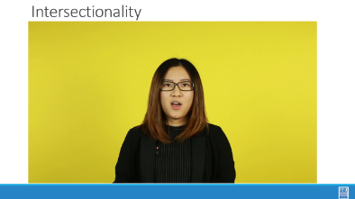  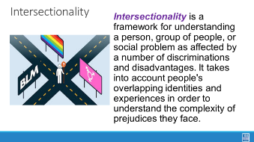  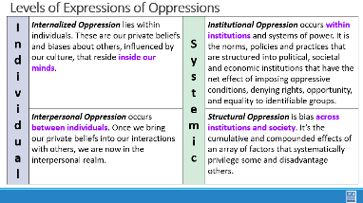  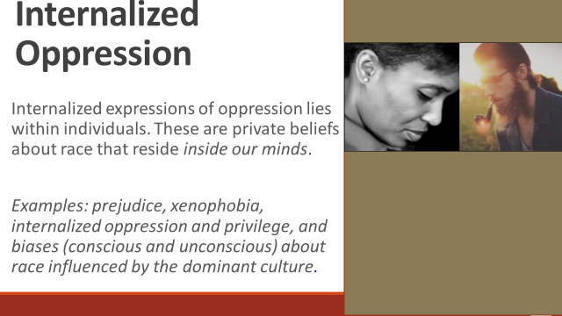  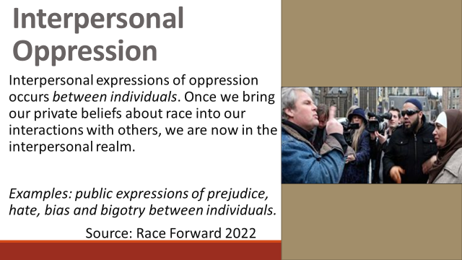  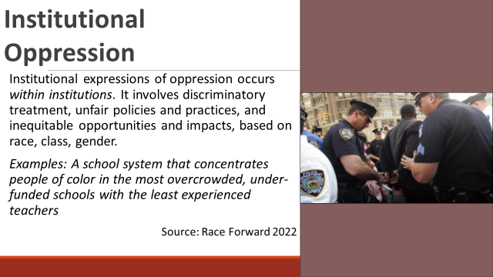  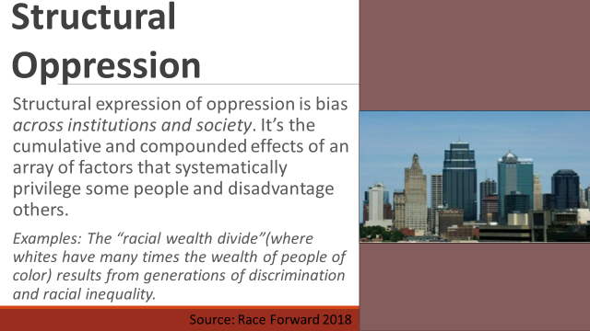  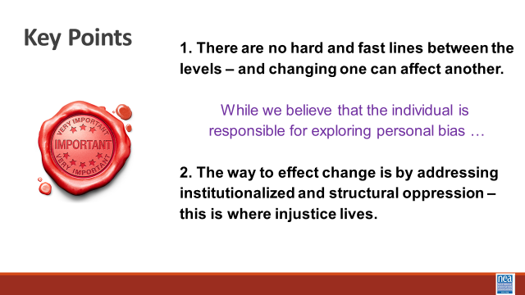  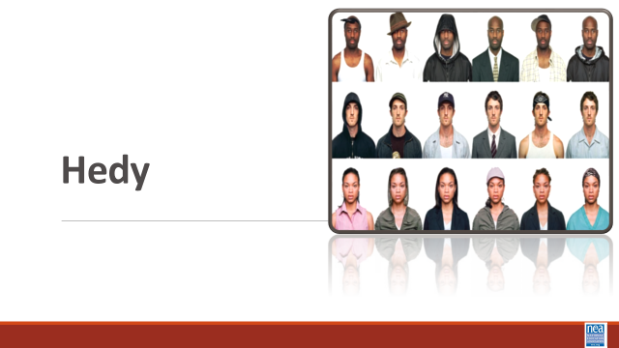  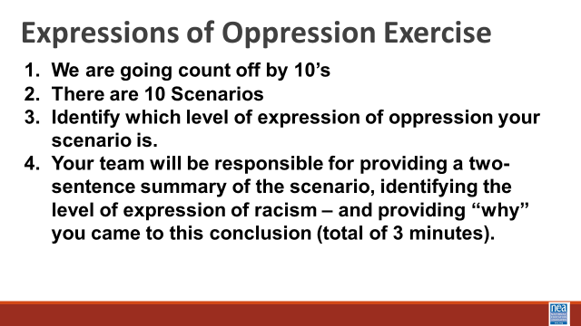  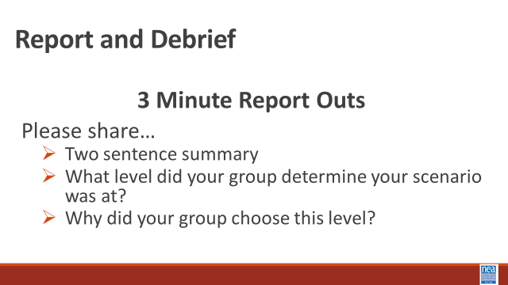  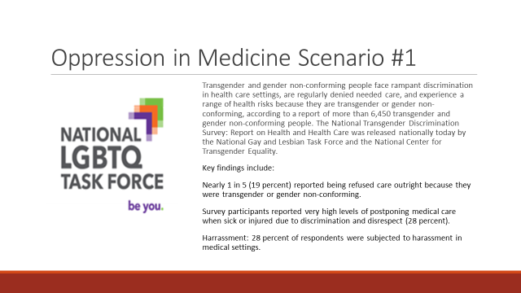  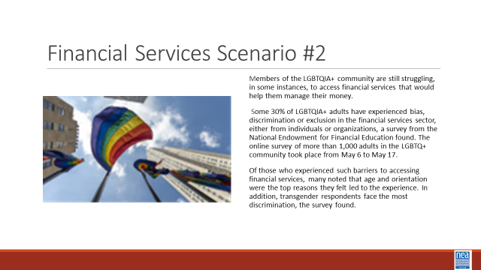  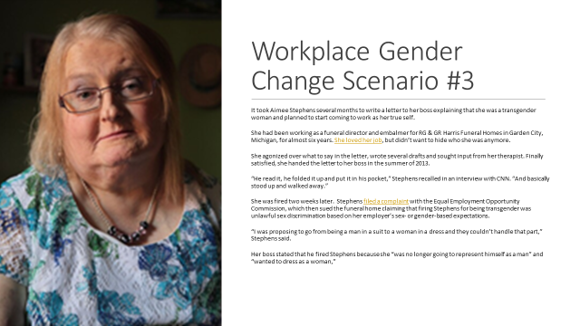  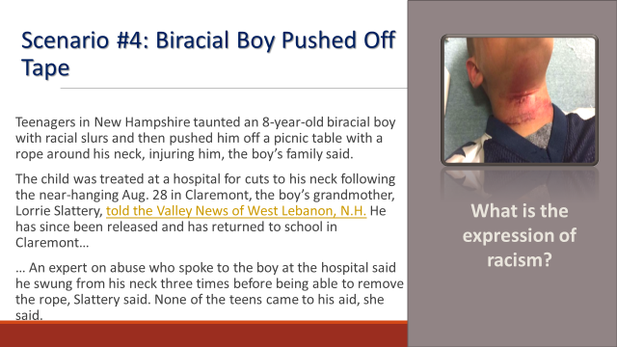  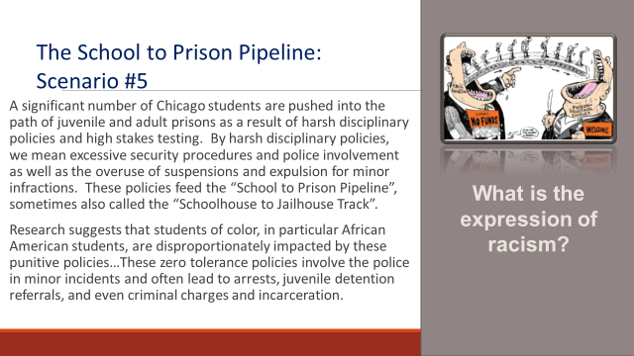  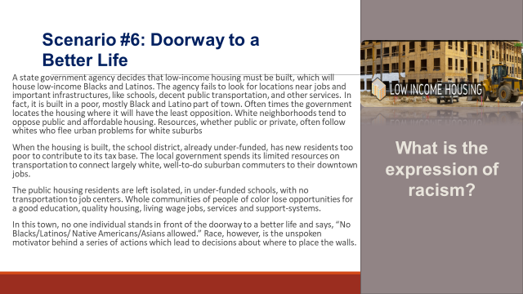  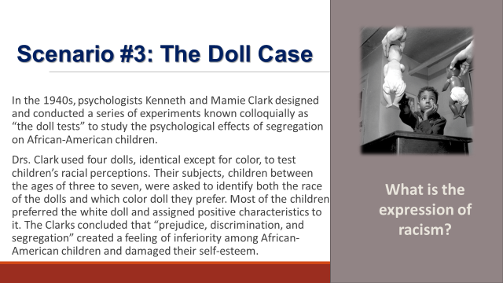  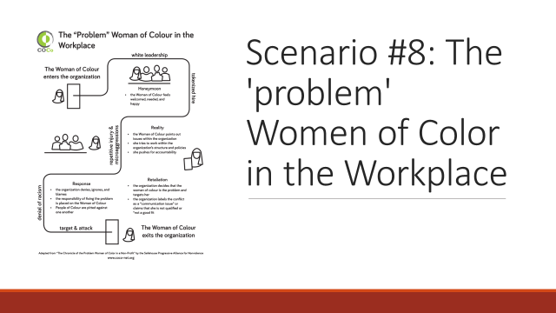  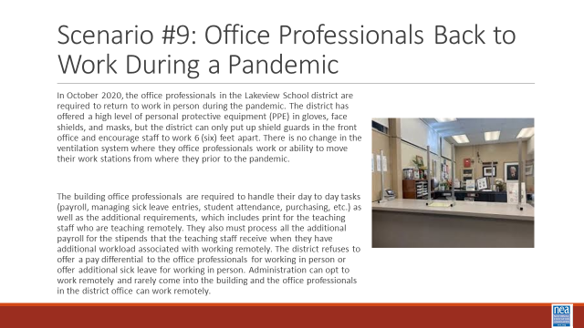  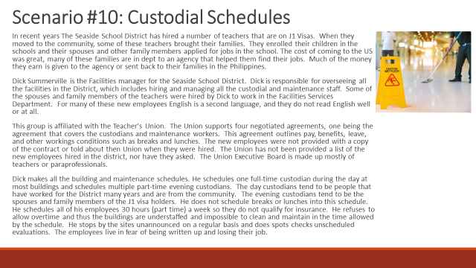  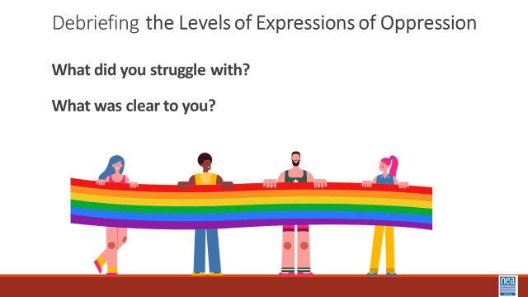  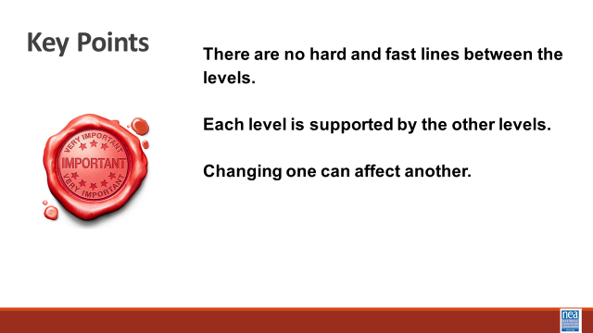  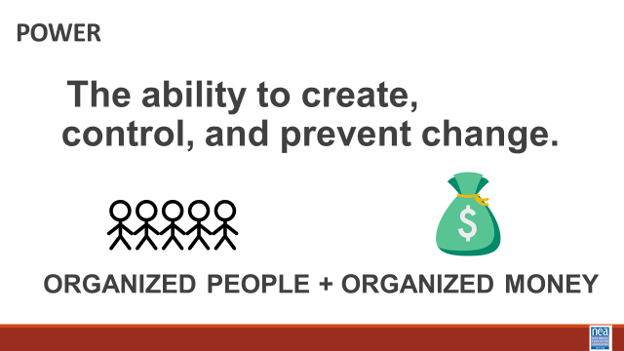  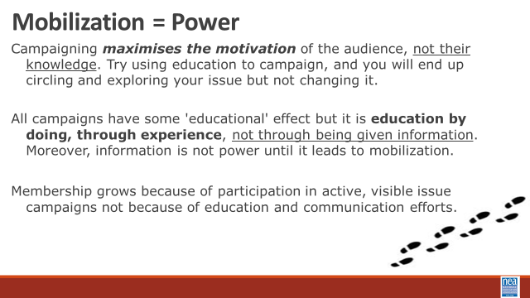  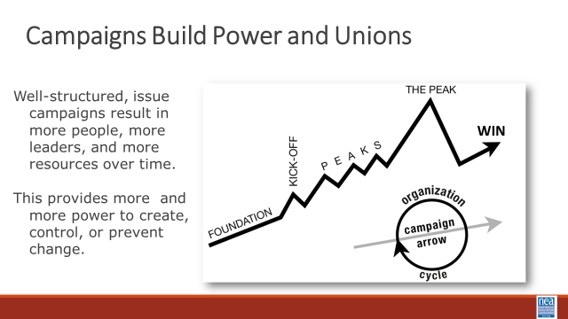  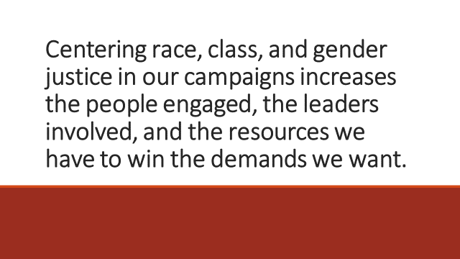  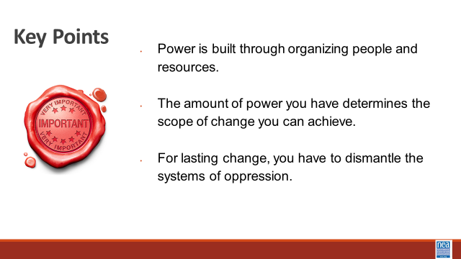  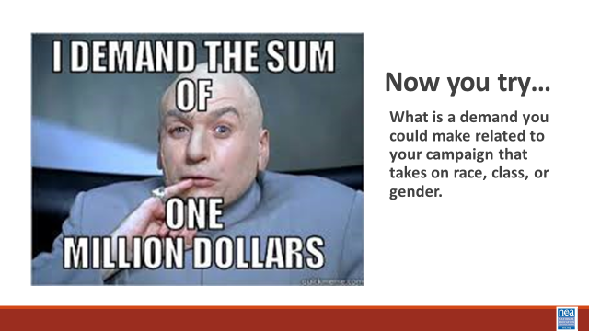   | Systems of Oppression Scenarios  Page. 63  Bill of Rights Scenario | Systems of Oppression – Analyzing, identifying and diagnosing solutions (75 Min)  5 Minutes- Allyship and Cycle of Oppression (Monet/Ellen?)  15 Min – Introduction (Katie):  Framework for planning and think through the amount of resource you have to make change. EX: If you only have enough money to host one training, then you will only make changes at the individual level. If you want to impact systemic change, that endure, you need to organize your people and money to make systemic change.  Going back to our differences and identities: Intersectionality is a framework for understanding a person, group of people, or social problem as affected by a number of discriminations and disadvantages. It takes into account people's overlapping identities and experiences in order to understand the complexity of prejudices they face. This is important to keep in mind as we approach our work in supporting individuals experiencing oppression.  (If time- use Video on intersectionality)  Now, let’s define The Quadrants of Expressions of Oppression. We use this framework because it allows us to think about the scope of the solution to a particular problem.  - Internalized oppression lies within individuals. These are our private beliefs and biases about others, influenced by our culture.  - Interpersonal Oppression occurs between individuals. Once we bring our private beliefs about differences into our interactions with others, we are now in the interpersonal realm.  - Institutional Oppression occurs within institutions and systems of power. It is the norms, policies and practices that are structured into political, societal and economic institutions that have the net effect of imposing oppressive conditions and denying rights, opportunity, and equality to identifiable groups based upon differences.  - Structural Racism is bias across institutions and society. It’s the cumulative and compounded effects of an array of factors that systematically privilege white people and disadvantage people of color.  Remember we work to analyze these levels not simply for identifying the “level of injustice” but to help diagnose what we would do to improve the condition and to assess the amount of resource we would need to pull off the change we want. For instance, a number of you are aware that the right wingers are systematically attacking school districts by passing regulations that restrict the recognition of student gender identity. This is a system level oppression. What would it take (how much people/resource power) to undo or prevent this regulation. Another example, from the individual side, staff in one of your school use gender, race, and class micro-aggressions pretty routinely in their conversations. A number of local leaders want people to be more aware of their biases and language use. A solution to get started might be an unconscious bias awareness training.  Activity:  (Hedy)  Now we are going to practice identifying these levels of oppression in real-life scenarios.  You are going to be assigned to a group that will be given a scenario. Your group is going to discuss possible solutions to the expression of oppression that you find in the scenario.  Move participants into scenario teams (break them up and put into new groups) – count off by 10’s - there are10 scenarios  20 Min - group work  (all walking through the room to check on tables).  Now that you are at your chart, your team will have 30 minutes to develop a chart that identifies the LEVEL OF EXPRESSION OF OPPRESSION that are present in the scenario. YOu will identify the level of oppression of racism  (Hedy and Katie) 30 Min - Share Out – Each group will have 3 minutes to share the expressions they identified, their proposed solutions, and their analysis of how much power would be needed. Some optional debrief questions instead of just a share out  1 minute share summary of situation.  2 minutes to tell us what level it is and why?  Debrief:  - What did you struggle with?  - What was clear to you?  3 Min: Key Points  - There are no hard and fast lines between the levels of expressions of oppression  - Each level is supported by other levels  - Making change at one level can change the others  Let’s talk a bit about power and your campaigns and as it relates to the levels of expressions of oppression  Power is = the ability to create, control, or prevent change. Power is organized people and organized resources.  We need organized people and organized resources to make changes happen. We need to mobilize our power.  Strong campaigns maximize the motivation of our people, not their knowledge. If you try to use education only to campaign, you will end up spinning and circling around your issue and will do nothing to change it.  All campaigns have some component of education; however, it is education by DOING, through experience, not through being given information. Moreover, education is not power unless it leads to mobilization.  Membership grows because of participation in active, visible issue campaigns not because of education and communications efforts.We know that solutions should always begin with members, but we are going to practice the use of the framework for analyzing our solutions and the power needed to achieve them.  Campaigns build power and unions  - Well structure, issue campaigns, result is mor people, more leaders, and more resources over time.  - This provides more and more power to create, control, and prevent change.  Centering race, class, and gender justice in our campaigns increases the people engaged, the leaders involved, and the resources we have to win the demands we want.  Key Points:  - Power is built through organizing- People and Resources  - The amount of power you have determines the amount of change you can achieve | How do power and oppression inform each other?  How much power do you need to address the expression of oppression your people are wanting to change?  Participants will apply the framework of expressions of oppression to scenarios. They will identify a change they want at the individual and systemic levels. They will analyze how much power they would need to achieve the change they want.
Closing |  | Ending it by handing Lisa and Saul

