Levels of Expressions of Oppression
Individual | Internalized Oppression lies within individuals. These are our private beliefs and biases about others, influenced by our culture. | Systemic | Institutional Oppression occurs within institutions and systems of power. It is the norms, policies and practices that are structured into political, societal and economic institutions that have the net effect of imposing oppressive conditions and denying rights, opportunity, and equality to identifiable groups.
Individual | Interpersonal Oppression occurs between individuals. Once we bring our private beliefs into our interactions with others, we are now in the interpersonal realm. | Systemic | Structural Oppression is bias across institutions and society. It’s the cumulative and compounded effects of an array of factors that systematically privilege some and disadvantage others.

Key Points to Remember
Key Point 1 - There are not hard and fast lines between the levels - and changing one can affect another.

Key Point 2 - The way to effect change is by addressing institutional and structural oppression- this is where injustice lives.

Expressions of Oppression Exercise
INSTRUCTIONS: Please review the cases below and as a group, have a discussion on your assigned case to come to a decision about which level of oppression each case belongs to. Please ensure there is consensus in your group in your answers. Be prepared to share in three minutes – a summary of your case, the level you chose, and why you made that decision.

Scenario #1: Oppression in Medicine
Quick Summary of the Case
Level of Expression of Oppression and Why you chose this
https://www.thetaskforce.org/new-report-reveals-rampant-discrimination-against-transgender-people-by-health-providers-high-hiv-rates-and-widespread-lack-of-access-to-necessary-care-2/

Transgender and gender non-conforming people face rampant discrimination in health care settings, are regularly denied needed care, and experience a range of health risks because they are transgender or gender non-conforming, according to a report of more than 6,450 transgender and gender non-conforming people. The National Transgender Discrimination Survey: Report on Health and Health Care was released nationally today by the National Gay and Lesbian Task Force and the National Center for Transgender Equality.
Key findings include:
- Nearly 1 in 5 (19 percent) reported being refused care outright because they were transgender or gender non-conforming.
- Survey participants reported very high levels of postponing medical care when sick or injured due to discrimination and disrespect (28 percent).
- Harrassment: 28 percent of respondents were subjected to harassment in medical settings.

Scenario #2: Financial Services
Quick Summary of the Case

Level of Expression of Oppression and Why you chose this

https://www.cnbc.com/2022/06/28/30percent-of-lgbtq-adults-experienced-discrimination-in-financial-services.html
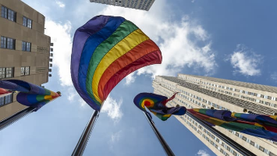
Members of the LGBTQIA+ community are still struggling, in some instances, to access financial services that would help them manage their money.
Some 30% of LGBTQIA+ adults have experienced bias, discrimination or exclusion in the financial services sector, either from individuals or organizations, a survey from the National Endowment for Financial Education found. The online survey of more than 1,000 adults in the LGBTQ+ community took place from May 6 to May 17.
Of those who experienced such barriers to accessing financial services, many noted that age and orientation were the top reasons they felt led to the experience. In addition, transgender respondents face the most discrimination, the survey found.

Scenario #3: Workplace Gender Change
Quick Summary of the Case
Level of Expression of Oppression and Why you chose this
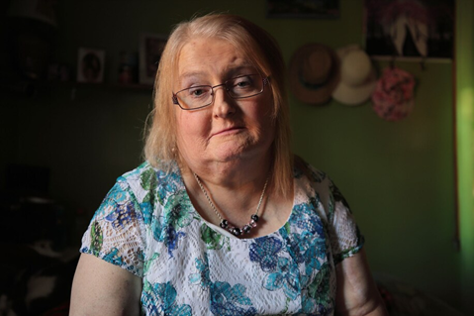
https://www.washingtonpost.com/nation/2019/04/30/transgender-woman-wrote-letter-her-boss-it-led-her-firing-trip-supreme-court/
It took Aimee Stephens several months to write a letter to her boss explaining that she was a transgender woman and planned to start coming to work as her true self.
She had been working as a funeral director and embalmer for RG & GR Harris Funeral Homes in Garden City, Michigan, for almost six years. She loved her job, but didn’t want to hide who she was anymore.
She agonized over what to say in the letter, wrote several drafts and sought input from her therapist. Finally satisfied, she handed the letter to her boss in the summer of 2013.
“He read it, he folded it up and put it in his pocket,” Stephens recalled in an interview with CNN. “And basically stood up and walked away.”
She was fired two weeks later. Stephens filed a complaint with the Equal Employment Opportunity Commission, which then sued the funeral home claiming that firing Stephens for being transgender was unlawful sex discrimination based on her employer’s sex- or gender-based expectations.
“I was proposing to go from being a man in a suit to a woman in a dress and they couldn’t handle that part,” Stephens said.
Her boss stated that he fired Stephens because she “was no longer going to represent himself as a man” and “wanted to dress as a woman,”
Scenario #4: Biracial Boy Pushed Off Table
Quick Summary of the Case
Level of Expression of Oppression and Why you chose this

Associated Press September 12, 2017
CLAREMONT, N.H. — Teenagers in New Hampshire taunted an 8-year-old biracial boy with racial slurs and then pushed him off of a picnic table with a rope around his neck, injuring him, the boy’s family said.
The child was treated at a hospital for cuts to his neck following the near-hanging Aug. 28 in Claremont, the boy’s grandmother, Lorrie Slattery, told the Valley News of West Lebanon, N.H. He has since been released and has returned to school in Claremont.

Slattery said the children were in a backyard when some of the teens got on the table and grabbed a rope that held a tire swing. It’s not clear how the rope got around the child’s neck, but Slattery said the teens pushed him off the table. No adults are believed to have witnessed the incident.
An expert on abuse who spoke to the boy at the hospital said he swung from his neck three times before being able to remove the rope, Slattery said. None of the teens came to his aid, she said.

Scenario: #5 The School-To-Prison Pipeline
Quick Summary of the Case
Level of Expression of Oppression and Why you chose this

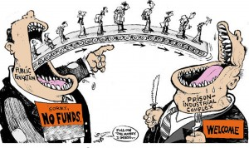
A significant number of Chicago students are pushed into the path of juvenile and adult prisons as a result of harsh disciplinary policies and high stakes testing. By harsh disciplinary policies, we mean excessive security procedures and police involvement as well as the overuse of suspensions and expulsion for minor infractions. These policies feed the “School to Prison Pipeline”, sometimes also called the “Schoolhouse to Jailhouse Track”. Research suggests that students of color, in particular African American students, are disproportionately impacted by these punitive policies.

As Matt Kelley has written: “Whether or not they realize it, the punishments school officials hand out can literally determine — and derail — the path of a student’s life. Which makes it even more critical that when schools make these decisions, they hand out discipline that’s fair.”
The “School to Prison Pipeline” describes a reality in which many young people are being pushed OUT of schools through zero tolerance policies, suspension, expulsion, discouragement and high stakes testing requirements; and INTO the juvenile and adult legal system. These zero tolerance policies involve the police in minor incidents and often lead to arrests, juvenile detention referrals, and even criminal charges and incarceration.

Scenario #6: Doorway To A Better Life?
Quick Summary of the Case
Level of Expression of Oppression and Why you chose this

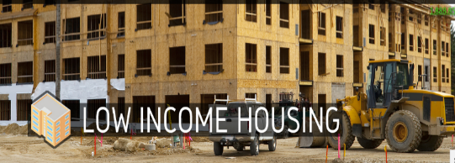
A state government agency decides that low-income housing must be built, which will house low-income Blacks and Latinos. The agency fails to look for locations near jobs and important infrastructures, like schools, decent public transportation, and other services. In fact, it is built in a poor, mostly Black and Latino part of town.

Often times the government locates the housing where it will have the least opposition. White neighborhoods tend to oppose public and affordable housing. Resources, whether public or private, often follow whites who flee urban problems for white suburbs When the housing is built, the school district, already under-funded, has new residents too poor to contribute to its tax base. The local government spends its limited resources on transportation to connect largely white, well-to-do suburban commuters to their downtown jobs.

The public housing residents are left isolated, in under-funded schools, with no transportation to job centers. Whole communities of people of color lose opportunities for a good education, quality housing, living wage jobs, services and support-systems. In this town, no one individual stands in front of the doorway to a better life and says, “No Blacks/Latinos/ Native Americans/Asians allowed.” Race, however, is the unspoken motivator behind a series of actions which lead to decisions about where to place the walls.

Scenario #7: The Doll Case
Quick Summary of the Case
Level of Expression of Oppression and Why you chose this
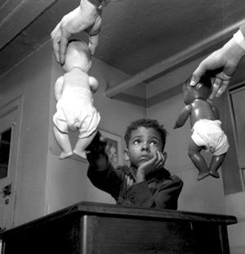
In the 1940s, psychologists Kenneth and Mamie Clark designed and conducted a series of experiments known colloquially as “the doll tests” to study the psychological effects of segregation on African-American children. Drs. Clark used four dolls, identical except for color, to test children’s racial perceptions. Their subjects, children between the ages of three to seven, were asked to identify both the race of the dolls and which color doll they prefer. A majority of the children preferred the white doll and assigned positive characteristics to it. The Clarks concluded that “prejudice, discrimination, and segregation” created a feeling of inferiority among African-American children and damaged their self-esteem.

Scenario #8: The ‘Problem’ Woman of Color In the Workplace
Quick Summary of the Case
Level of Expression of Oppression and Why you chose this
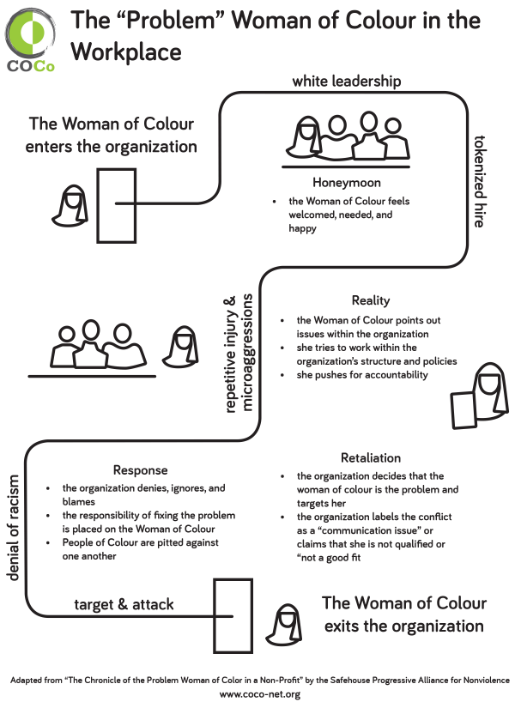

Scenario #9: Office Professionals Back to Work During a Pandemic
Quick Summary of the Case
Level of Expression of Oppression and Why you chose this
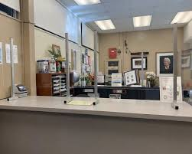
In October 2020, the office professionals in the Lakeview School district are required to return to work in person during the pandemic. The district has offered a high level of personal protective equipment (PPE) in gloves, face shields, and masks, but the district can only put up shield guards in the front office and encourage staff to work 6 (six) feet apart. There is no change in the ventilation system where they office professionals work or ability to move their work stations from where they prior to the pandemic.

The building office professionals are required to handle their day to day tasks (payroll, managing sick leave entries, student attendance, purchasing, etc.) as well as the additional requirements, which includes print for the teaching staff who are teaching remotely. They also must process all the additional payroll for the stipends that the teaching staff receive when they have additional workload associated with working remotely. The district refuses to offer a pay differential to the office professionals for working in person or offer additional sick leave for working in person. Administration can opt to work remotely and rarely come into the building and the office professionals in the district office can work remotely.

Scenario #10: Custodial Schedules
Quick Summary of the Case
Level of Expression of Oppression and Why you chose this


In recent years The Seaside School District has hired a number of teachers that are on J1 Visas. When they moved to the community, some of these teachers brought their families. They enrolled their children in the schools and their spouses and other family members applied for jobs in the school. The cost of coming to the US was great, many of these families are in dept to an agency that helped them find their jobs. Much of the money they earn is given to the agency or sent back to their families in the Philippines.

Dick Summerville is the Facilities manager for the Seaside School District. Dick is responsible for overseeing all the facilities in the District, which includes hiring and managing all the custodial and maintenance staff. Some of the spouses and family members of the teachers were hired by Dick to work in the Facilities Services Department. For many of these new employees English is a second language, and they do not read English well or at all.

This group is affiliated with the Teacher's Union. The Union supports four negotiated agreements, one being the agreement that covers the custodians and maintenance workers. This agreement outlines pay, benefits, leave, and other workings conditions such as breaks and lunches. The new employees were not provided with a copy of the contract or told about then Union when they were hired. The Union has not been provided a list of the new employees hired in the district, nor have they asked. The Union Executive Board is made up mostly of teachers or paraprofessionals.

Dick makes all the building and maintenance schedules. He schedules one full-time custodian during the day at most buildings and schedules multiple part-time evening custodians. The day custodians tend to be people that have worked for the District many years and are from the community. The evening custodians tend to be the spouses and family members of the J1 visa holders. He does not schedule breaks or lunches into this schedule. He schedules all of his employees 30 hours (part time) a week so they do not qualify for insurance. He refuses to allow overtime and thus the buildings are understaffed and impossible to clean and maintain in the time allowed by the schedule. He stops by the sites unannounced on a regular basis and does spots checks unscheduled evaluations. The employees live in fear of being written up and losing their job.

