A resurging union movement must reckon with anti-Blackness

https://prismreports.org/2022/11/30/unions-must-reckon-anti-blackness/
Black workers have always been part of the labor movement, but unions must prioritize anti-racist practices and make room for Black leadership. by Brenton ZolaNovember 30th, 2022

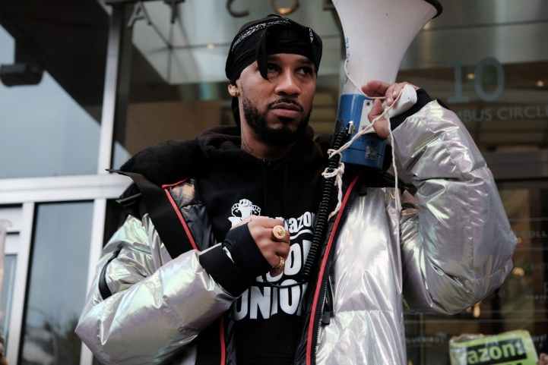
NEW YORK, NEW YORK - NOVEMBER 30: Labor activist Chris Smalls joins members of the Amazon labor union and others for a protest outside of the New York Times DealBook Summit Nov. 30 in New York City. (Photo by Spencer Platt/Getty Images)
This past October, Los Angeles City Council President Nury Martinez resigned over racist remarks she made during an October 2021 meeting with other Latino leaders. Alberto Retana, the president of Community Coalition in southern Los Angeles, called out the councilmembers who “participate[d] in a back door deal to aggrandize the careers of 3 at the expense of Black erasure and Black voter suppression.” As a bulwark of the LA labor movement, Martinez’s remarks dealt an especially painful blow to labor leaders by demonstrating how pervasive anti-Blackness remains within the larger struggle for workers’ rights.
Addressing anti-Blackness in the labor movement is more vital than ever. Unions have seen a fierce resurgence of unions in the U.S. in 2022. In the first half of the year alone, unions have won 641 elections—the most in nearly 20 years, according to data from the National Labor Relations Board (NLRB). But as unions fight for fair pay and better working conditions, advocates say that it’s past time for a critical reckoning with a long history of anti-Black sentiment within unionization efforts and the greater workers’ rights movement.
America itself was built on Black labor. In 1961, Dr. Martin Luther King Jr. spoke before the national AFL-CIO—the largest federation of trade unions in the nation, emphasizing the importance of unions to Black communities. He asserted that even though Black people had the most to gain from a successful labor movement, the labor movements, too, had everything to gain from Black empowerment. He argued that they would be able to organize workers, unseat corrupt politicians, and enact major social reforms. But to do that, union leadership had to confront a well-documented history of excluding Black workers from general membership, apprenticeship programs, and from skilled job training.
King’s perspective was prescient. Since his speech, labor unions have become some of the largest civic organizations in the U.S., representing 14 million workers—a little more than 10% of all U.S. wage and salary workers. Union approval is also at its highest level since 1965. A majority of Americans have recognized the key role unions play for the American worker.
And yet, as the LA City Council scandal neatly illustrates, the current revitalization of unions has yet to fully contend with the extent of racism and anti-Blackness within the movement itself, especially among leadership. As a result, some union members are taking it upon themselves to tackle inequity and injustice in the labor movement.
“Change rooted in anti-racism [and] anti-oppression doesn’t live in the hands of elected officials … True power always lives in the people,” Retana tweeted.

Black workers are vital to union power
Unions have become some of the largest mass membership organizations of people of color writ large. Black workers make up a critical portion of this union membership, a fact that labor leaders can’t afford to ignore. As more Black workers entered the workforce and protested for their rights in the mid-20th century, union leaders needed their support to pass agendas, reach collective bargaining agreements, and even elect preferred political candidates.
Unions also make a critical difference for Black workers. In 2020, Black workers were slightly overrepresented among union workers, making up 13.6% of the union workforce while only being 13% of the overall workforce. And the data shows that unions have become the single greatest force in accelerating economic equity for Black Americans. According to the Center for American Progress and the Center for Economic and Policy Research (CEPR), Black Americans see gains across nearly every category of economic prosperity as part of a union.
Black households with a union member have a median wealth that is more than three times the median wealth of non-union Black households. Wealth benefits hold true even for Black workers with low-wage occupations and fewer years of formal education, taking home 18.9% higher pay than their non-union counterparts.
Furthermore, Black union workers are much more likely to have employer-provided health insurance (71.4% of Black union workers vs. 47.7% of non-union Black workers). Black union workers are also 18.3 percentage points more likely to have an employer-sponsored retirement plan. Unions have also helped to combat the Black-white wage gap by standardizing pay rates among workers in similar positions.
It’s also critical to note that the makeup of the Black union workforce has shifted dramatically over the last several decades. CEPR data finds that today’s Black union workers are more likely to be women, older, immigrant, and have more years of formal education. Cathy Kennedy, a vice president of National Nurses United (NNU), the largest U.S. union and professional association of registered nurses, grounds her experience as a biracial Black and Asian woman and believes that having diverse leadership creates a positive cycle for workers looking to move up the ranks.
“It’s wonderful to see that within our organization, our top leadership consists of women of color,” Kennedy said. “It’s helpful because nurses see someone that looks like them in top leadership, and it’s important to recognize that.”

Anti-racism work requires constant effort
As unions become ever more diverse, confronting anti-Blackness and creating racial equity has become make-or-break to the success of workers’ rights movements. As a son of sharecroppers from the South, the issue is personal for AFL-CIO secretary-treasurer Fred Redmond. After decades of helping to build labor solidarity, Redmond now holds the highest officer position for a Black leader in the history of America’s labor movement and said the AFL-CIO is working to link criminal justice reform to the greater labor movement.
“We have to stand with our Black and brown members no matter what,” Redmond said. “Our priorities include making sure that our federations and central labor councils educate union members and members of the public on racial justice, criminal justice reform, and opening pathways to young people of color to become leadership professionals.”
Redmond noted how Black citizens are locked out of many job opportunities and stripped of their right to fully contribute to society, hurting the labor movement. At the AFL-CIO, leaders have launched a Racial Justice Task Force that has not only facilitated external conversations around police and criminal legal reform but also internal discussions among the rank-and-file, many of whom have never had such a conversation. For advocates like Redmond, it’s vital for workers’ rights organizations to engage in restorative work to support those whom the system has entangled. In their view, the rights to vote and receive government benefits are irrevocably tied to the right to stable and well-paying jobs.
While some unions are exploring external partnerships to address racist inequities within their organizations, others are focused on using internal conversations to create anti-racist and equitable cultures. The NNU has a racial justice curriculum to educate nurses on gender justice and racial justice, as well as how to bring both principles to the bargaining table.
“Nobody wants to talk about a lack of inclusion, so we have to emphasize these issues to support our nurses of color,” Kennedy said. “We have webinars, ongoing classes, and discussions on race, on the history of our Filipino nurses, our African-American nurses … there was a lot of damage done [in the medical field]. So I think the timing is right.”
Further, according to a study published in the American Journal of Political Science by Paul Frymer of Princeton University and Jacob Grumbach of the University of Washington, these efforts work. Union membership has been shown to increase support for issues affecting Black workers, which Frymer and Grumbach connect to unions encouraging political and anti-racist discussions among rank-and-file members.
The study demonstrated that white union members feel less racial resentment than non-union members by between 4.7% and 6.3%. The number is substantial—rivaling or surpassing other demographic variables, such as gender or education, that shape political views in the U.S. White members are also more likely to support policies that benefit Black workers even after union membership has ended.
However, Kennedy admits that there are some who resist this type of education. She’s often heard naysayers claim that they don’t need to know any anti-racist education because they’re not prejudiced and “just want to take care of [their] patients.”
“We all need to confront ourselves,” Kennedy said. “I have my own prejudice, my own bias, but I have to be made aware of it so that I’m open to listening, because it is about listening and recognizing.”

Workers rights don’t exist in a vacuum
According to Redmond, the fight for Black workers requires solidarity on all fronts of injustice and inequity. He said it’s important to the movement’s success to recognize that labor touches everything from mental health and social isolation, to physical wellness, voting access, and, most critically, legal reform.
“One of the biggest threats to our members is legislation that supports union-busting,” Redmond said. “We still have laws tilted toward corporations.”
Redmond and his colleagues have worked to support legislation to empower unions, but progress is slow in a divided Congress. He also highlighted the need for police reform in particular, as there are 13 police unions in the AFL-CIO.
“Along with these unionized officers, we’ve been having some serious discussions about what police reform looks like,” Redmond said. “It’s a challenging issue, but the work is so important.”
There have also been calls and efforts from rank-and-file members within the AFL-CIO and its affiliates to oust police unions entirely, but executive leadership has failed to take meaningful steps in that direction, according to The Real News Network.
Despite the needed work around anti-racism, the biggest threat to Black workers is the decline in the unions’ power. According to CEPR data, in 1983, 31.7% of Black workers were represented by a union. But Black unionization rates have fallen drastically since then, with only 14.2% of Black workers represented by a union in 2015. The data also indicates that the Black-white wage gap would be 13% lower if union membership had not fallen.
Advocates say that the progress of the labor movement for Black and brown workers hinges on leadership. It requires leaders committed to equity and anti-racism—both in public and behind closed doors. It also requires leaders to monitor what individual chapters are doing and to what extent they implement anti-racist practices.
But when the work is done, its potential is powerful. That is why this current resurgence in organized labor is so significant. It presents an opportunity to continue unions’ attempts to tackle both economic and racial justice that began in the 20th century.
“This is about humanity, respect, equality, inclusion, everything,” Kennedy said.

