Facilitator Agenda: Day 1 Coaching Campaign Cycles (WITHOUT LEADS)
General Materials Needed:  Online Course Link https://neapartnera.learnupon.com/content-details/4449849/0 |  |  |  | Room Set-up: 50 people max
1 Set of Handouts per Person  Name Tents with the Norms  Room signs, Stick on Name Tags  Chart Paper (4 to 5 full w Sticky Strip) | Materials Box for each table with:  Markers (Mr. Sketch variety)  Post its – 3x3” and 4X5” sizes  One ream of white photocopy paper |  |  | No podium, table with projector big enough for laptop  Long Rectangle table at back for facilitators  Round Tables for participants  Projector, Screen, mics, and Speakers  Carousel stations and reporting stations
Pre Academy Assignments: 00 Pre Academy Full.pdf
Key Outcomes for the Event:
Participants will understand a high level overview of the purpose of the Campaign Lab
Participants will understand that Leads, Coaches, and Campaign Coaches all have different roles in the Campaign Lab
Coaches and Mentor Coaches will understand each step of a homogeneous campaign cycle
Coaches and Mentor Coaches will be able to identify possible challenges for each stage of the cycle and develop coaching questions
Team Leads will understand how to introduce and lead their organizing teams through each step of a homogenous campaign cycle
Team Leads will dig deeply into how to build an organizing team, identify a theory of change, and cut an issue
Team Leads will learn how to calculate the people needed to achieve the demands of their campaign cycle
Team Leads will be introduced to power analysis, strategy, and design of tactic escalation

Overview of Content, Time, and Facilitator Assignment
5:00-5:30 Entry and Welcome  Community  Chart Doc running list  5:30-6:30 SHIFT Common Analysis of Why  What’s at stake  Why Campaign Lab  Levels, Theory, Vision  6:30- 7:00 Centering Equity |  | Ellen  Carrie  Amanda  Albert/Ellen | 7:00 –7:45 Why coaching -  7:45- 8:00  What is left unclear?  8:00 Adjourn |  | Albert/ Ellen  Ellen
Time Slides Facilitator | Resources | Instructions, Activity and Debrief (Facilitator Script) | Essential Questions and Outcomes
 | Charts, handouts, articles, materials, slide | What are you saying, what are they doing, what questions will you use to guide learning and make clear the important points  Include an estimate for how long each section of the learning will take | What question(s) will this learning answer? What will participants know or be able to do?
Noon-5:00 – Team prep, practice, room set up, sound check, etc.
Entry Activity
5:00-5:30 Ellen |  | 30 Mins TOTAL Getting Started
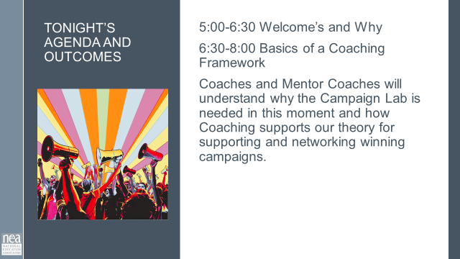  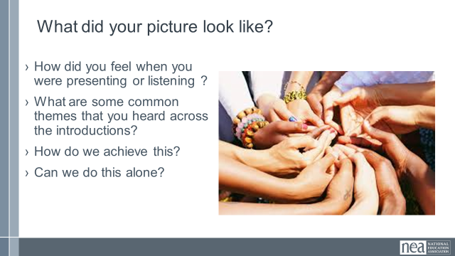 | Norms Online Pre Attendance  Agenda on Slides  Name Tents  Handout Package online  5 Campaign Cycle Planning Workbook.pdf  0 Coaching Campaign Planning.pdf  00 Participant Handouts Full.pdf | 2 Minutes Welcome – basic intro and reading of the confirmation of membership  2 Minutes Land Acknowledgement  We begin by acknowledging that through a history of colonization and brutality, we are currently on the traditional lands stewarded by generations of the Indigenous people(BE SPECIFIC TO AREA). We honor these indigenous people, all elders, past, present, and emerging. We are called to learn and share these learnings about this tribal history, culture, and contributions that have been suppressed in the telling of the story of what we now call the United States of America  .  5 Minutes Outcomes and Agenda Overview  Begin the understanding that the first two nights are about HOW we will achieve the Change that the Campaign Lab represents. We are coaching people into their agency to make decisions about their campaigns – we are not advising or consulting. More about that.  Review Agenda reminder about meals, Karla for Logistics, etc.  5 Minutes – Shout out from your team and around the room -  Very quick and simple name, pronouns, and work location  5 Minutes – Community Agreements  Take 5 minutes and Review the agreements from your pre attendance – at your tables discuss how you answered the final three questions. Return as a whole group and ask what needs to be added, changed, highlighted, etc. Then take a thumbs up, side, or down – looking for near consensus – the goal, all up or sideways thumbs.  Up, Completely agree as is  Sideways, Can commit, not perfect, but I am confident we can revisit if this is not working  Down, I am not yet ready to commit and this is what I need more discussion about….  10 Min - Cell Phone Artifact Mixer  - Participants will need to be able to access the photo on their phone that represents what a loving school or community would look like.  - You will be repeating this at least 3 times with one other person in the room.  - For each round you and your partner will have three minutes TOTAL – 90 seconds each- to share  - Your name  - Where you are from  - WHY you selected this picture as a representation of of what a loving school or community looks like.  - Find a partner and begin – make sure it is someone new to you  - Share and repeat  5 Min - Final Debrief  - How did you feel when you were presenting or listening?  - What are some common themes that you see across the introductions? | Participants will know how we are going to work, the basic schedule, and the logistics relevant to the training.
5:30 – 6:30 Carrie/Amanda |  | 60 Minutes – Common Analysis of Why
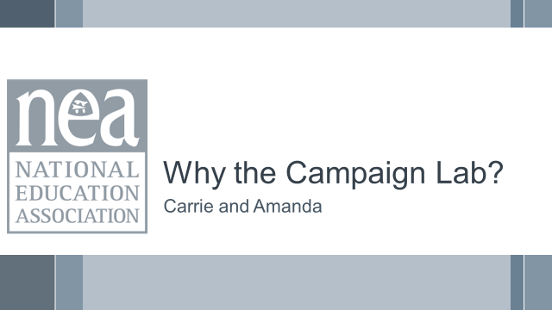  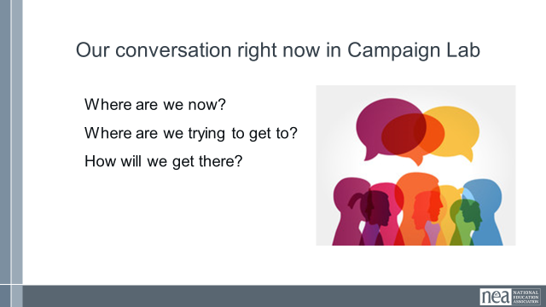  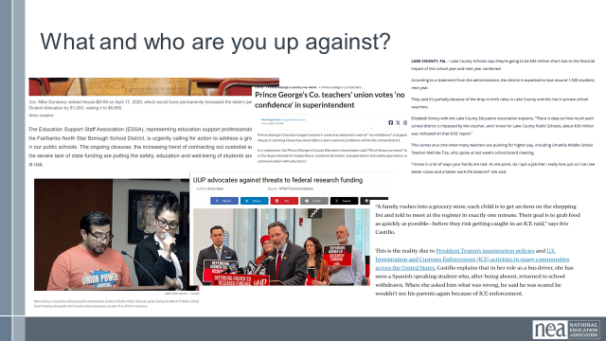  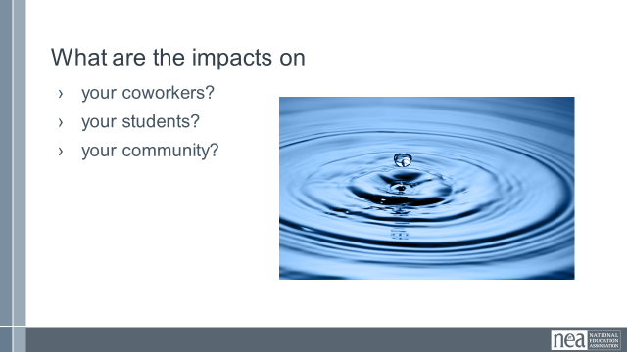  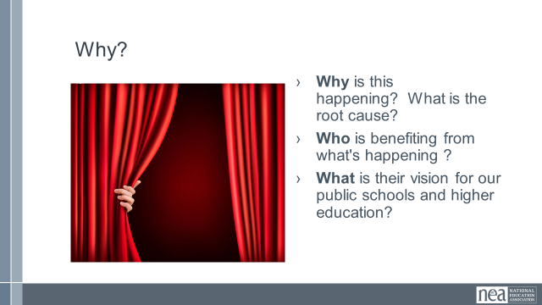  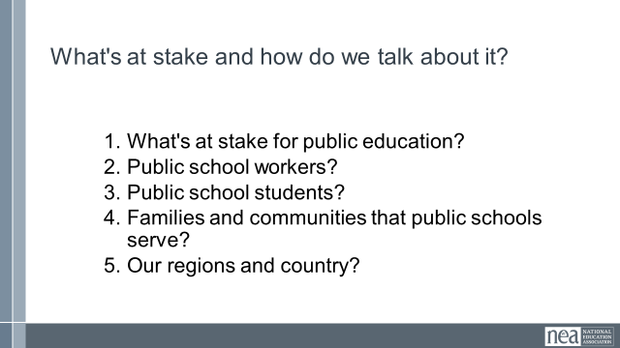  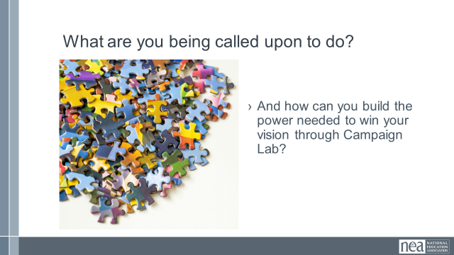 | 1.02 May Day Movement Plan - NEA.docx  2 Draft Descriptions of Levels within Campaign Lab.docx | Amanda: Before we begin this training, it feels important to take some time to talk about what you want Campaign Lab to be, especially given that the program is less than a year old and has already been through many changes.  We have done 1:1s with many of you, and one of the things we hear the participants being most excited about is your ability to connect with and learn from each other, as well as the potential to build and unite strong fighting unions, even in the midst of very difficult times.  On the flip side, many of you said the biggest challenge is a lack of understanding about the bigger purpose of the program.  12 minutes- So let's take a moment to start where we are now and collectively build out an understanding of Campaign Lab so we can be clear on why we are doing this, what we want to do, and how we want to do it. To do that we have to start with the local and zoom out to a bigger picture that connects the local fights.  First, let’s talk about what you and/or the locals you are coaching are up against? And what are the impacts on workers, students, and families in schools? (Ask people to partner and take turns sharing. Switch at 5 minutes)  6 minutes- (Report out) What did you discuss? What are the fights and how are they impacting people? (Facilitators will chart responses adding a “+” for anything that is repeated.) (CG scribe)  5 minutes- Anyone notice any themes emerging? (Popcorn answers to answers with lots of +).  15 minutes- AK: At your table, discuss why you think all of these problems are happening? Who is benefitting from attacking public ed? And what is the vision those people have for our public schools? (10 minutes to discuss, 5 minutes to share out)  20 Minutes- Carrie: So what’s our shared narrative for the moment? We are going to count you off by 5s to answer the question “What’s at stake for...” (Assign every group one topic to discuss). You have ten minutes to discuss and then we will report out.  After 10 minutes, ask each group to report out. Facilitator will chart responses.  3 minutes- So what are we called on to do in this moment? And how can we use Campaign Lab to do that?  We need to meet this moment right now.  Fight back  Build a thriving vision  Organize and become a fighting union  Outcome: greater alignment on our purpose and vision | Participants will cocreate a common understanding of what’s at stake in this moment, and how Campaign Lab can be a powerful tool to strengthen and unite locals across state lines. They will be able to use this analysis to talk about Campaign Lab to interested parties.  Participants will learn how to connect local fights to a larger political analysis, and will understand the purpose of Campaign Lab.  Local fights are a microcosm of bigger political forces. Campaign Lab is an experiment rooted in growing and uniting local campaigns through coaching, and peer-to-peer learning.
6:30 – 7:00 Albert/Ellen |  | 30 Minutes - Centering Equity in your Campaigns
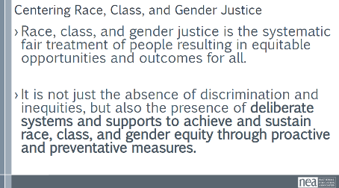 | Charts for problems  Equity Analysis  Equity Assessment  CRSJ BCG Centering Race Guide The links to these handouts are below. The Specific pages are in the Campaign Planning Cycle Guide  2 CRSJ Centering Race.pdf  5 Campaign Cycle Planning Workbook.pdf  0 Coaching Campaign Planning.pdf | 7 minutes – Problems chart and discussion  Whole group: Need someone to chart  Alt question: You shared pictures that embodied a loving school and leaned into why Campaign Lab exists. Who is needed to solve these problems? Name PEOPLE, not organizations  2 minutes – Union Work that Builds Power  For all those things, to make meaningful lasting STRUCTURAL change we need power. Power is defined as that ability to create, control, and prevent change. That typically means organized people and organized money or resources – your work is a resource.  What type of union builds power? Programs, such as professional learning, staff led advocacy, social focused events, even policy advocacy do little to build power. Why is that? Well all of these programs are self-selected with little risk to join or leave them. I want to improve my classroom management, so I come to the Union led training on that. I might even lead one – but I have done little to build power with others. Also in a program, I am choosing to solve a “me” Problem and it does not require any other collective commitment.  Campaigns put people at the center of solving the problems they are experiencing. They name the issue, they decide the solution, they decide who they follow, and they determine what the are willing to risk. When we center people in a campaign – staff move to a coaching role. When people are at the center they use their agency and decide how to act, who they will act with, and what they are willing to risk to win. This is when members and leaders feel powerful in their union.  To begin a campaign you have to ask what the people want to solve, ask what they are willing to risk to solve that, and form demands that they think will provided the solution to their problem.  2 mins - What does it mean to center racial, class and gender justice?  Race, class and gender dynamics, disparities, and divisions permeate our society, communities, schools, and classrooms.  Systemic oppression is so deeply rooted in our history, culture, and institutions that there is no escaping it. Visible or not, the impacts are ever-present. Race, class, and gender justice is the systematic fair treatment of people of all races, resulting in equitable opportunities and outcomes for all.  It is not just the absence of discrimination and inequities, but also the presence of deliberate systems and supports to achieve and sustain race, class, and gender equity through proactive and preventative measures.  To continually and systematically keep equity in your work you have to use a Race, Class, and Gender Equity tool, or lens. This is a person and institutional commitment to  - Proactively seek to both eliminate systemic barriers and advance equity  - Identify clear goals, objectives and measurable equity outcomes  - Develop mechanisms for successful implementation of equity focused programs  - A set of questions used to anticipate, assess, and prevent potential adverse consequences of proposed actions on different race, class, or gender groups.  TOOL IS ON PAGE 30  17 minutes – Review Centering Equity in your Campaigns  -5 minutes – Take a moment to review these tools  -11 minutes – Table discussion: Would the campaign(s) your coaching have answers to these questions or be able to say most components of these tools are a part of their campaign?  What is something you noticed that could support your coaching?  -2 minute – 3 brief things the room needs to hear  As a coach or mentor coach your role will be to continually probe to see if this process has been repeated at various steps and at key decision points throughout the campaign cycle  2 Minutes Key Points-  Intentional campaigns, not programs build power.  Centering race, class, and gender justice in our campaigns increases the people engaged, the number of leaders involved, and the amount of resources we have to win the change we want.  Power is only built through people with a shared vision, making public commitments to act, to risk their collective resources, for the meaningful change they want. | Participants will understand that centering equity in their campaigns at all stages of the planning ensures that they are focused on building power with those most likely to be experiencing the highest levels of oppression in the current systems of power.  Participants will apply a tool that helps them build the habit of practice for centering equity.  Coaches will assess what their possible interventions might be if these practices are not in place with the locals they are coaching.
7:00-7:45 Albert/Ellen |  | 45 Minutes TOTAL –Why Coaching?
 | Coaching 101  Campaign Cycle Plan  Basics of Coaching  5 Campaign Cycle Planning Workbook.pdf  0 Coaching Campaign Planning.pdf | 2 minutes Intro  10 Minutes - Organizing  10 Minutes – Power  10 Minutes – Leadership  8 Minutes – Putting it together  2 Minutes - You were asked to read some articles before you got here. We are going to discuss three of those in relationship to why coaching and why your roles are critical to the Campaign Lab. The Campaign Lab is a different way of doing work. Most programs and support from our state affiliates and from NEA come in the Form of Advocacy – an expert speaking on behalf of others. Another large batch of our work is spent Mobilizing – the episodic engagement and activation of those already committed to our goals. But these don’t get us the sustained power we need for the challenges we are facing and bold dreams you have.  10 Minutes – They Read slide, discuss, and report out  Share the following from three theories in the Pre academy package:  “To organize is to build mass support and strength among ordinary people. Organizing draws its power from working people’s biggest strength: our numbers. Working people may or may not see themselves as activists or politically active or even in political agreement, but through organizing, they come together to act in common cause. The work of organizing is systematic and rigorous: It requires connecting with every single worker in a shop, every educator in a building, every building in a district. At its core, it asks people to understand their own agency and to make choices about how they will exercise it. The work of organizing is difficult; ordinary people are seldom confronted by their own agency nor asked to make choices that recognize their own power.”  Given this – what are your primary roles as coaches in the Campaign Lab?  Discussion from across the room about roles.  Share - Coaching enables others to understand their own agency and make decisions about how to act in the face of their own power.  10 Minutes – Show two slides, then they Read slide, discuss, and report out  Power is the ability to act (use agency collectively)  The Posession of control, authority, or influence over others either preventing or causing action  Campaigners work to move loosely connected communities who shaer common values and interests into constituencies. Constituencies have developed shared commitments to act, to risk their resources to achieve a common goal. This is beyond internal base building – which is necessary, but not sufficient for the kind of power we need to achieve the wins we want.  Read the following slide from our Taking Stock Report  “In order to generate the power needed to rise to the occasion, labor unions and community organizations will need to come together in partnership. The union movement is one of the few forces capable of mobilizing working families en masse to prevent the US from succumbing to MAGA authoritarianism. Education unions are uniquely positioned because they already have a workplace presence in most neighborhoods across the country. Organized communities have ears to the ground on how to build power at the local level and mobilize communities across different neighborhoods. Together they can build power to not only protect, but to strengthen our democracy for future generations.”  Given this – what are your primary roles as coaches in the Campaign Lab?  Discussion from across the room about roles.  Coaching helps campaigners transform communities into constituencies. Coaching transforms actors into leaders.  10 Minutes – They Read two slides, discuss, and report out  “Baker represented a different leadership tradition altogether. She combined the generic concept of leadership— “a process of social influence in which a person can enlist the aid and support of others in the accomplishment of a common task”—and a confidence in the wisdom of ordinary people to define their problems and imagine solutions. Baker helped everyday people channel and congeal their collective power to resist oppression and fight for sustainable, transformative change…  That collective effort required leaders who were accountable to one another and were not singular. There were many organizers in groups such as SNCC who modeled Baker’s brand of what sociologist Charles Payne has called “group-centered leadership.” Rather than someone with a fancy title standing at a podium speaking for or to the people, group-centered leaders are at the center of many concentric circles. They strengthen the group, forge consensus and negotiate a way forward. That kind of leadership is impactful, democratic, and, I would argue, more radical and sustainable, than the alternatives.”  Organizing Leadership is accepting responsibility(self) for enabling others (others) to achieve shared purpose in the face of uncertainty (action). Leadership requires a decision, a choice, to accept responsibility. It is a form of social interaction, of relationship. It is about achieving “shared” purpose. And its domain is the uncertain.  Given this what is the role of coaching in the Campaign Lab?  Discussion across the room  When we coach we build leaders who understand they are interdependent in both responsibility and accountability.  8 Minutes – Let’s put it together  To Coach We Center Their Agency  - Remove barriers to the other’s use of their agency- ability to choose to act. We do this by asking what they think they can do to overcome the barriers (coach)  - When we direct others in action – this is OUR agency.  - When someone defines their goal and uses THEIR agency to move towards it – that builds confidence, power, skills, and trust. We can support the use of agency through good coaching.  Even if we KNOW how WE would do it – THEY have to decide how THEY and THEIR People will do it  To Coach We have to believe that Campaigners can… (Slide)  - Read a political landscape  - Assess their potential allies and opponents  - “Cut an issue” from a big problem to a set a of winnable (local) demands  - Pick fights that will build our base and develop new leaders  - Use a tactic sequence to create a crisis for our targets  Even if we have experts or expertise in this area – we need to rely on their capacity analyze their contexts.  Campaign Coaching: What It Is & Isn’t  - Given what we know about campaigners, here’s how to think of the role of campaign coach  Why is coaching critical to a winning campaign?  - Coaching is a direct intervention in an individual or team’s work process to help them improve effectiveness.  - Coaching enables others to build their own capacity to act.  - Coaching transforms leaders from a relationship where someone else has external control to one where they focus on how to grow.  - Framing for campaigner skills, why coach them.  Key Point – Coaching is the way we walk our talk.  Closing idea – we are going to explore the methods and skills required to coach in a movement focused, organizing context. | Participants will understand why coaching is the way to change culture and enable leaders to use their agency for change.
  What It Is | What It Isn’t
  Helping organizers become strategists and lead powerful local campaigns | Making key strategy decisions for a local group
  Supporting strong containers for collective action and shared power | “Answering questions that come up” as an external consultant
  Balancing the need to learn and develop skills with running a “live” campaign | Having “catch up calls” without preparing questions to support the group through challenges
7:45-8:00 Halimah |  | 15 Minutes - What is left unclear? and Ending it Right
 |  | What is becoming clearer?  What remains murky?  Tomorrow – Problem of Practice  Housekeeping  FOR TOMORROW –  Breakfast time 7:30 to 8:30  Start Time 8:30  Networking time –Leads come | Participants will be able to bring a little closure to their learning and provide feedback on the day.
8:15- ADJOURN

