Struggles for Justice:
Segregation and Housing in the United States
A multi-day lesson created under the direction of the UC Berkeley History-Social Science Project.

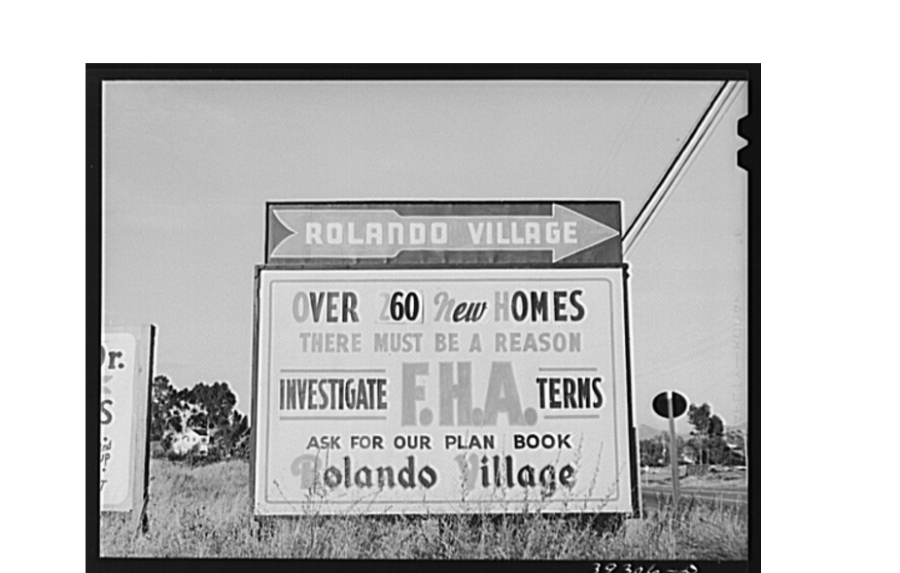

Jenna Rentz  Teacher Leader, UCBHSSP  Mt. Diablo Unified School District | 

Find online: ucbhssp.berkeley.edu/hssp_lessons
2015 © UC Regents

This curricular unit composed of four distinct parts can be taught in its entirety as a case study for the civil rights era, or incorporated into existing units on Jim Crow, civil rights, or contemporary issues. It was created by a high school teacher who wanted to provide students with historical context to understand the underlying conditions that led to the police violence and, consequent, rebellions in Ferguson, Missouri and Baltimore, Maryland.

It was inspired by the argument made by Richard Rothstein, in his article "The Making of Ferguson." Rothstein contends that police actions in African-American neighborhoods must be understood in the context of housing segregation. Contrary to the popular belief that most residential segregation in the United States is de facto, Rothstein traces local, state, and federal policies that deliberately isolated African-Americans into the poorest communities in the major cities of the United States. Although there are certainly other causative factors, including poorly funded schools, lack of municipal services, and oppositional policing tactics, federally-endorsed housing policies provide a clear example for how federal law codified and perpetuated inequities.

This unit traces segregation in the United States across the twentieth century. Students grapple with primary and secondary sources, which illustrate, explain, and outline the government's role in reinforcing housing segregation. While high school textbooks mention African Americans “finding” themselves in segregated neighborhoods, after examining the materials in this unit, students will be able to identify how specific policies led to contemporary conditions.

Focus Question: What led to the segregation of neighborhoods in the United States?

Teaching Thesis: Federal and local housing policies segregated many previously integrated neighborhoods. This residential separation contributed to ongoing racial tension and reinforced income inequality. Beginning in the 1920s, landowners and white-dominated municipal governments placed restrictive covenants on properties, preventing the sale of certain homes to African-Americans and other racial minorities. Local and state governments also “zoned” neighborhoods according to desirability. These zoning laws limited the areas in which African-Americans could by homes. Areas that had high numbers of African American residents were generally given a low rating. This zoning reinforced feelings about the areas in which African Americans lived, exacerbating crowded conditions, because of the inability to move to other areas, and the lack of political will to provide essential city services and maintenance. Consequently, many white homeowners associated African-American neighborhoods with deteriorating conditions, further encouraging and legitimizing “white flight.” In addition to local zoning policies, in the 1930s-1950s, African-Americans were denied access to Federal Housing Administration (FHA) loans. During this period when many white veterans were able to buy homes through the GI Bill, African-Americans, who were denied access to loans lost generations of home equity. In addition to exclusionary local and government policies, white realtors and home owners also took advantage of segregation policies, selling homes to black families on contract and using black families to “blockbust” neighborhoods. The 1968 Fair Housing Act was an attempt by the federal government to correct the wrongs of government-sponsored segregation. However, it remained difficult to enforce.

Lesson Components:

Part 1: Federal and Local Policies Created Segregated Neighborhoods (1917-1935)

Focus Question: What forces contributed to residential segregation?

Goal: In this section, students will learn about official policies that reinforced residential segregation in the United States from 1917-1935.

Lesson Components:
1.1/1.2: Participate in a simulation of the consequences of housing segregation and reflect on the experience.
1.3: Explore the causes and consequences of housing segregation.
1.4: Examine a restrictive covenant from Seattle, Washington.
1.5: Analyze maps to determine how FHA policies perpetuated redlining.

Part 2: Personal Stories of Housing Discrimination (1940s-1960s)

Focus Question: How did housing policies affect individuals?

Goal: In this section, students will explore how policies, reinforced by individual actions, made it difficult for African Americans to purchase homes and build equity at a time when many white Americans were moving into the middle class through home ownership.

Lesson Component:
2.1: Students will analyze five source sets, which relate personal stories regarding housing segregation in the 1940s-1960s.

Part 3: Equality Under the (Housing) Law (1968-1988)

Focus Question: How did the United States government try to correct the inequities in housing opportunities for African Americans?

Goal: In this section, students will determine how the Fair Housing Act attempted to rectify past discrimination.

Lesson Components:
3.1: Categorize the modes of discrimination studied as de facto or de jure.
3.2: Read provisions from the Fair Housing Act (1968) and its 1988 amendment.

Part 4: Long-Term Consequences (1960s-present)

Focus Question: What are the lasting effects of discriminatory housing policy?

Goal: Reflect on the long and short term consequences of discriminatory housing policy and its impact on the contemporary condition of African Americans.

Lesson Components:
4.1: Explore current patterns of residential segregation in local communities and cities in which black residents have recently rebelled in response to police actions.
4.2: Make judgments on the causes of contemporary conditions.

Final Assessment: Based on their study of the history of housing discrimination, students will write an analytical paragraph.

Writing Question: What led to the segregation of neighborhoods in the United States?
- Writing Prompt
- Writing Frame

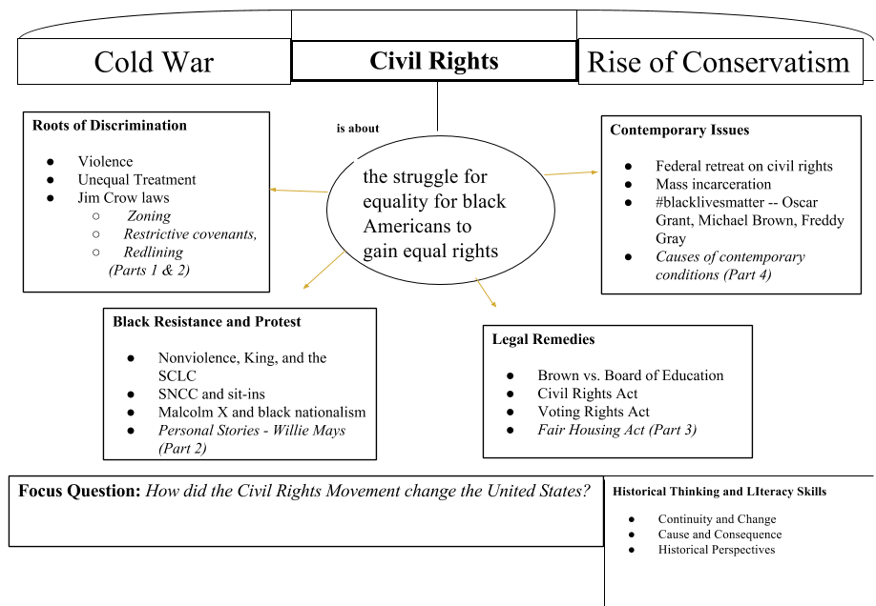

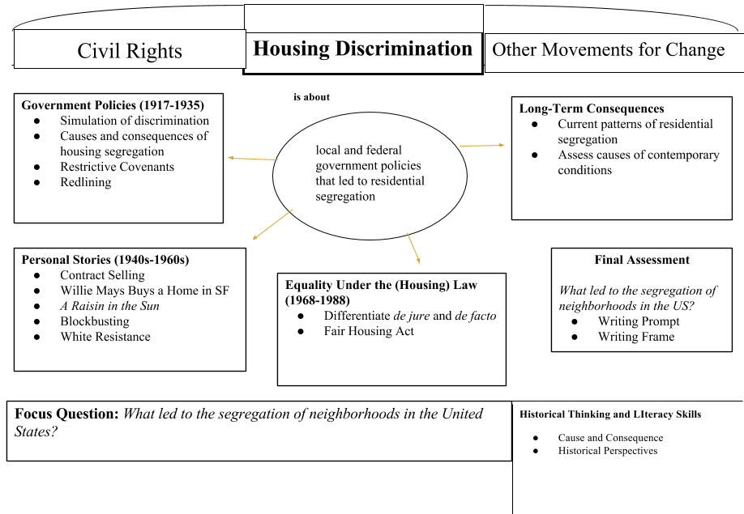

California History-Social Science Content Standards:

11.10 Students analyze the development of federal civil rights and voting rights.

11.11 Students analyze the major social problems and domestic policy issues in contemporary American society.

12.7.5 Explain how public policy is formed, including the setting of the public agenda and implementation of it through regulations and executive orders.

California Historical and Social Sciences Analysis Skills:

Chronological and Spatial Thinking
1. Students compare the present with the past, evaluating the consequences of past events and decisions and determining the lessons that were learned

Historical Interpretation
1. Students show the connections, causal and otherwise, between particular historical events and larger social, economic, and political trends and developments.

2. Students recognize the complexity of historical causes and effects, including the limitations on determining cause and effect.

Common Core Reading Standards for Literacy in History/Social Studies 6-12:

RH.11-12.1 Cite specific textual evidence to support analysis of primary and secondary sources, connecting insights gained from specific details to an understanding of the text as a whole.

RH.11-12.3 Evaluate various explanations for actions or events and determine which explanation best accords with textual evidence, acknowledging where the text leaves matters uncertain.

RH.11-12.7. Integrate and evaluate multiple sources of information presented in different media or formats (e.g., visually, quantitatively) as well as in words in order to address a question or solve a problem.

Common Core Writing Standards for Literacy in History/Social Studies 6-12:

WHST.11-12.1.B Develop claim(s) and counterclaims fairly and thoroughly, supplying the most relevant data and evidence for each while pointing out the strengths and limitations of both claim(s) and counterclaims in a discipline-appropriate form that anticipates the audience's knowledge level, concerns, values, and possible biases.

WHST.11-12.2.B Develop the topic thoroughly by selecting the most significant and relevant facts, extended definitions, concrete details, quotations, or other information and examples appropriate to the audience's knowledge of the topic.

Resources and References:

Primary Sources:

“Chicago Police Car Moving In.” Digital Image. Library of Congress, http://www.loc.gov/item/99400130/

Deeds, Vol. 1450, pages 348, April 1, 1929. King County Recorder’s Office. Courtesy Seattle Civil Rights and Labor History Project. http://www.seattle.gov/cityarchives/exhibits-and-education/digital-document-libraries/the-seattle-open-housing-campaign/restrictive-covenant-from-windermere-neighborhood-

Hansberry, Lorraine. A Raisin in the Sun. New York, NY: Random House Publishing, 1959. (Full text available through books.google.com.)

Lee, Russell. "Sign of Federal Housing Administration Housing. San Diego, California." The Library of Congress. Farm Security Administration - Office of War Information Photograph Collection, 1944. http://www.loc.gov/pictures/item/fsa2000020721/PP/

“Look at These Homes Now!” United Welfare Association Postcard, Missouri History Museum, 1915. http://collections.mohistory.org/resource/166747.html

"The Miami News - Google News Archive Search." The Miami News - Google News Archive Search. The Associated Press, 14 Nov. 1957.

“Racial Dot Map.” Image Copyright, 2013, Weldon Cooper Center for Public Service, Rector and Visitors of the University of Virginia (Dustin A. Cable, creator). http://demographics.coopercenter.org/DotMap/

Siegel, Arthur S. Detroit, Michigan. Riot at the Sojourner Truth Homes. Digital image. Library of Congress, Feb. 1942. Web. 25 June 2015. http://www.loc.gov/pictures/item/owi2001018484/PP/

Title VIII: Fair Housing and Equal Opportunity - HUD." Title VIII: Fair Housing and Equal Opportunity - HUD. U.S. Department of Housing and Urban Development, 1968.

“Underwriting Manual: Underwriting and Valuation Procedure under Title II of the National Housing Act,” Federal Housing Administration, 1935.

Secondary Sources:

Alexander, Michelle. The New Jim Crow: Mass Incarceration in the Age of Colorblindness. New York, NY: The New Press, 2010.

Bouie, Jamelle. “The Crisis in Black Homeownership.” Slate, July 2014. http://www.slate.com/articles/news_and_politics/politics/2014/07/black_homeownership_how_the_recession_turned_owners_into_renters_and_obliterated.html

Coates, Ta-Nehisi."The Case for Reparations." The Atlantic, Atlantic Media Company, 21 May 2014. http://www.theatlantic.com/features/archive/2014/05/the-case-for-reparations/361631/

“Criminal Justice Fact Sheet.” http://www.naacp.org/pages/criminal-justice-fact-sheet

Cutler, Kim-Mai. "East of Palo Alto’s Eden: Race and The Formation of Silicon Valley." TechCrunch, 10 Jan. 2015. http://techcrunch.com/2015/01/10/east-of-palo-altos-eden/

"Historian Says Don't 'Sanitize' How Our Government Created Ghettos." NPR, 14 May 2015.
http://www.npr.org/2015/05/14/406699264/historian-says-dont-sanitize-how-our-government-created-the-ghettos

Rothstein, Richard. "The Making of Ferguson: Public Policies at the Root of Its Troubles." Economic Policy Institute, 15 Oct. 2014. http://www.epi.org/publication/making-ferguson/

Vanhemert, Kyle. "The Best Map Ever Made of America's Racial Segregation | WIRED." Wired.com. Conde Nast Digital.

“Understanding Fair Housing,” US Commission on Civil Rights, Clearinghouse Publication, February 1973. http://www.law.umaryland.edu/marshall/usccr/documents/cr11042.pdf

Student Organizers:

- Unit Organizer: Students can use the included four columned grid to track each phase of the unit (History, Personal Experiences, Corrective Law, and Long-Term Consequences) as a means of understanding causes and consequences, and serve as a useful organizer for the final writing assignment.
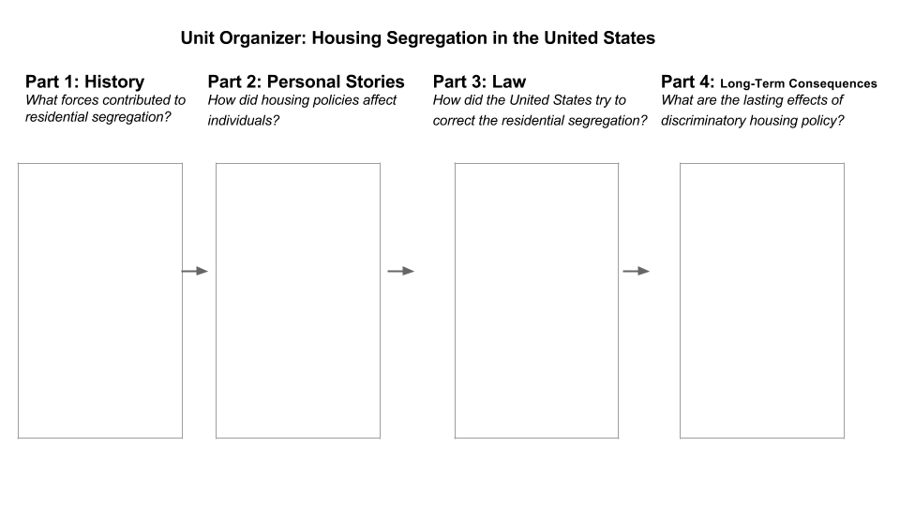

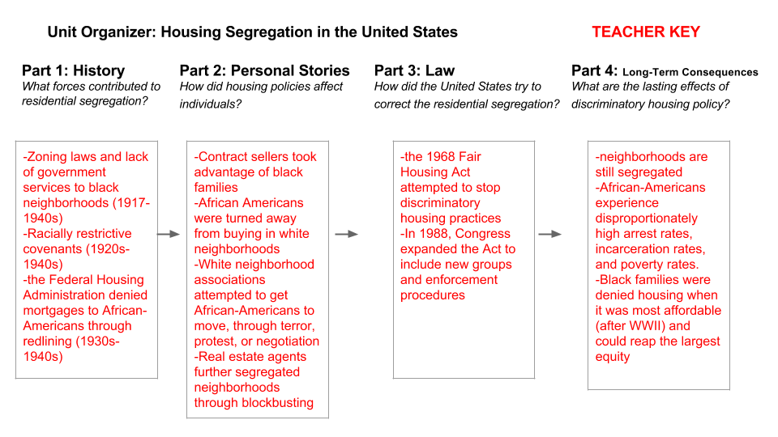

- United States Map: Teachers can provide students with an outline map of the United States in order to locate the communities referenced through the evidence supplied in this unit. This process reveals the national scope of discriminatory practices.

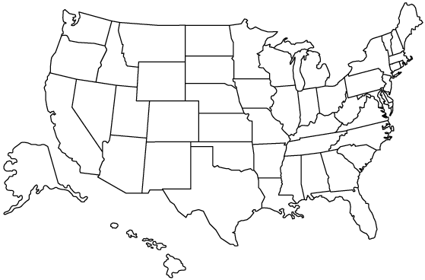

Part 1: Federal and Local Policies Created Segregated Neighborhoods (1917-1935)

Focus Question: What forces contributed to residential segregation?

Goal: In this section, students will learn about official policies that reinforced residential segregation in the United States from 1917-1935.

Lesson Components:
1.1/1.2: Participate in a simulation of the consequences of housing segregation and reflect on the experience.
1.3: Explore the causes and consequences of housing segregation.
1.4: Examine a restrictive covenant from Seattle, Washington.
1.5: Identify how FHA policies fostered redlining.

1.1/1.2 Teacher Instructions Activity: Zoning Simulation

The purpose of this activity is for students to understand the consequences of discriminatory zoning policies.

- Arrange the desks in the front of the classroom. In the back of the classroom, place masking tape in a large rectangle on the floor or make several different “zones” in the back with masking tape. You could also use desks to create a physical rectangle in the back.
- Wear the color green. Tell students that the classroom will be “zoned” today into two different groups: 1) Those who are wearing green, and 2) Those who are not.

- Point out that those wearing green have excellent style, and appear to be more trustworthy. Tell those students who are wearing green that they may sit in the front of the room (and spread out). These students may ask the teacher any questions. Any student not wearing the color green is only permitted to sit or stand in the zones in the back of the room (with no desks). They cannot ask questions.

- Tell the students that they will be taking a quiz today that will count for a significant portion of their grade. Tell the students that you will review all the answers to the quiz in the next few minutes. Review the answers with the students, but speak extremely quietly, so that only the green-wearing students in the front can hear you. If non-green wearing students in the back yell or ask you to repeat yourself, remind them that they are not allowed to ask questions.

- After you have given the quiz, revert the classroom back to the original seating arrangement and have students grade the quizzes (either their own or their neighbor’s). Make a chart on the board with two columns: “Green-Wearing Students” and “Non Green-Wearing Students,” and record the scores.

- After grading the quizzes, give students time to reflect on the exercise (Activity 1.2). Discuss the answers and experiences as a class.

Activity 1.1: Student Quiz Name_________________________

Directions: This quiz is worth 100% of your participation points today. Do your best!

1. During the Constitutional Convention in Philadelphia, what was the name of the compromise that counted every five slaves as three people for representation and tax purposes?

2. Describe the difference between de facto and de jure segregation.

3. What was the purpose of the 13th amendment?

4. What was the purpose of the 14th amendment?

5. What was the purpose of the 15th amendment?

6. What is the informal name for discriminatory laws that were passed on a state and local level after the Reconstruction period of the United States?

7. Which Supreme Court case ruled that “separate but equal” was constitutional?

8. Which Supreme Court case overturned Plessy v. Ferguson in 1954?

9. This law, passed in 1968, protects people from discrimination when buying, renting, or securing financing for housing.

10. Write a phrase that describes white people moving out of a city after other races move in.

Activity 1.1: Student Quiz TEACHER KEY

Directions: This quiz is worth 100% of your participation points today. Do your best!

1. During the Constitutional Convention in Philadelphia, what was the name of the compromise that counted every five slaves as three people for representation and tax purposes?
The 3/5ths Compromise.

2. Describe the difference between de facto and de jure segregation.
De facto = by custom De jure = by law

3. What was the purpose of the 13th amendment?
Abolished slavery.

4. What was the purpose of the 14th amendment?
Gave citizenship to all people born in the United States, including the descendants of slaves.

5. What was the purpose of the 15th amendment?
All men, including African American men, have the right to vote.

6. What is the informal name for discriminatory laws that were passed on a state and local level after the Reconstruction period of the United States?
Jim Crow

7. Which Supreme Court case ruled that “separate but equal” was constitutional?
Plessy v. Ferguson

8. Which Supreme Court case overturned Plessy v. Ferguson in 1954?
Brown v. Board of Education

9. This law, passed in 1968, protects people from discrimination when buying, renting, or securing financing for housing.
Fair Housing Act

10. Write a phrase that describes white people moving out of a city after other races move in.
“white flight”
Activity 1.2: Zoning Simulation -- Reflection

1. Describe your experience. (Were you in Zone 1 or Zone 2? What was it like?)

2. Compare and contrast the scores and behavior of students from Zone 1 and Zone 2.

3. If classrooms were zoned every day, how might this affect student achievement over time?

4. Could students in Zone 2 still achieve success? Why or why not?

5. Describe your understanding of the term “white privilege.” Do you agree with this term? Why or why not? How does privilege relate to this activity?

Activity 1.3: Cause and Consequence Name: _______________________

Directions: Read the paragraph and circle the thesis and underline the causes and consequences. Then, based on the reading, complete the chart on the next page. Use your responses to answer the lesson focus question.

Lesson Question: How did local ordinances contribute to the racial segregation of neighborhoods in the United States?

Prior to the 1900s, many neighborhoods in the United States were racially integrated, however, local cities began passing laws that explicitly forbid African-Americans from buying property in certain areas. In 1917, the United States Supreme Court struck down these laws. Therefore, local governments relied on zoning in order to keep African-Americans out of particular neighborhoods. In St. Louis, for instance, predominantly white neighborhoods were designated as single-family housing zones. Most of the properties in these neighborhoods had restrictive covenants, which legally barred African-Americans from buying a home. Local governments passed laws to prevent any new construction in single-family housing zones in order to preserve white neighborhoods. Therefore, many African-Americans were forced to live in areas that were zoned for multifamily, industrial, or commercial use. These areas were polluted by industry and quickly became overcrowded. These areas also lacked proper city services, such as garbage collection, street lighting, or emergency response. When the Federal Housing Administration was created during the 1930s, the zones where African-Americans lived were determined to be ineligible for mortgage loans, due to the deteriorating conditions of the neighborhood. This meant that many African-Americans were forced to continue renting in substandard neighborhoods.

Source: Adapted from Rothstein, Richard. "The Making of Ferguson: Public Policies at the Root of Its Troubles." Economic Policy Institute, 15 Oct. 2014. http://www.epi.org/publication/making-ferguson/

Activity 1.3: Cause and Consequence Name: _______________________

Thesis:

Cause | Consequence
Because the Supreme Court struck down laws that forbid African-Americans from buying property in certain areas in 1917,
Because white neighborhoods were designated as single-family housing zones with restrictive covenants
Because multi-family, industrial, or commercial zones became polluted and overcrowded
Because many African-Americans couldn’t receive mortgage loans
Because many African-Americans were forced to rent in substandard neighborhoods | [Infer the possible effects.]

Focus question: How did local ordinances contribute to the racial segregation of neighborhoods in the United States?

Activity 1.3: Cause and Consequence TEACHER KEY

Thesis: Prior to the 1900s, many neighborhoods in the United States were racially integrated, however, local cities began passing laws that explicitly forbid African-Americans from buying property in certain areas.
Cause | Consequence
Because the Supreme Court struck down laws that forbid African-Americans from buying property in certain areas | local governments relied on zoning to keep African-Americans out of certain neighborhoods
Because white neighborhoods were designated as single-family housing zones with restrictive covenants | many African-Americans were forced to live in multifamily, industrial, or commercial zones, which became polluted and overcrowded.
Because multifamily, industrial, or commercial zones became polluted and overcrowded | the FHA deemed those zones ineligible for mortgage loans
Because many African-Americans couldn’t receive mortgage loans | African-Americans were forced to rent in substandard neighborhoods
Because many African-Americans were forced to rent | they could not acquire wealth in home equity

Focus question: How did local ordinances contribute to the racial segregation of neighborhoods in the United States?

Local ordinances such as zoning laws and racially restrictive covenants severely limited where African-Americans could live. This led to overcrowded conditions in predominantly black neighborhoods, which later affected African-American’s ability to receive mortgage loans.

Activity 1.4: Restrictive Covenants (1/2) Name: _______________________

Directions: Read the “Warranty Deed” that was included in the 1929 sale of a house in Seattle, Washington, and underline the section that pertains to the sale of the home based on the race of the buyer. Then complete the chart and answer the questions on the following page.

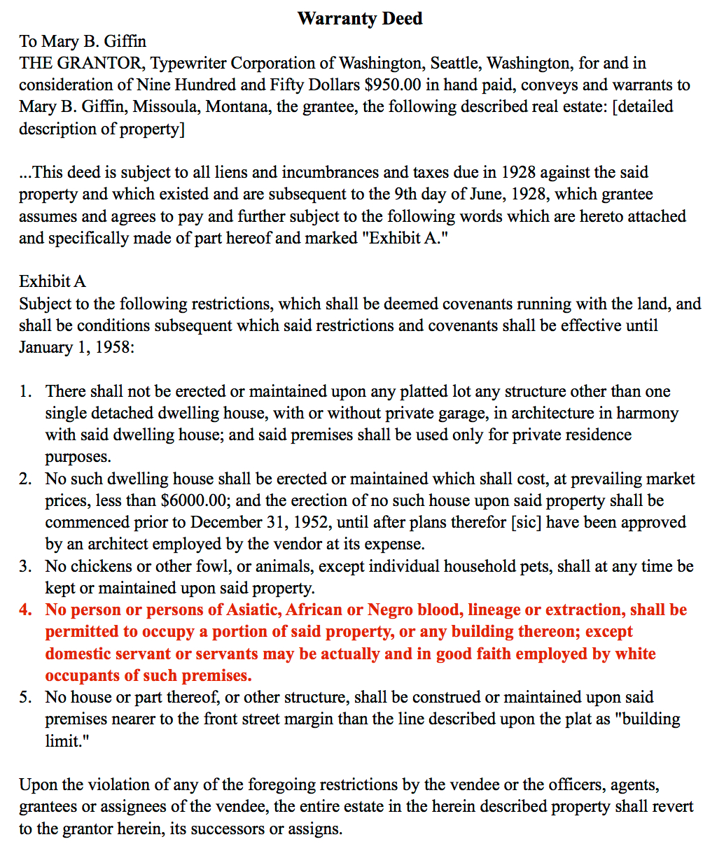
Background: A restrictive covenant is a provision in a property deed that limits or “restricts” what the owner can do with the property. These covenants often contained language that limited the ability to sell property to members of a racial minority group. By 1940, 80 percent of the deeds in Chicago and Los Angeles included restrictive covenants barring black families. In the case of Shelley v. Kraemer (1948), the Supreme Court ruled that restrictive covenants could no longer be enforced. However, they were not explicitly banned or deemed unconstitutional. The result of this decision was that racial covenants were informally used, without official endorsement, until the passage of the Fair Housing Act in 1968.

Source: Deeds, Volume 1450, page 348, April 1, 1929, King County Recorder’s Office, Courtesy Seattle Civil Rights and Labor History Project.

Activity 1.4: Restrictive Covenants (2/2) Name____________________________

Directions: After reading the “Warranty Deed,” complete the following questions.

1. Date of the Deed ______________ 2. City and State of Deed _______________________

3. Complete the chart using Section 4 of the Warranty Deed.

“No person or persons of Asiatic, African or Negro blood, lineage or extraction, shall be permitted to occupy a portion of said property, or any building thereon; except domestic servant or servants may be actually and in good faith employed by white occupants of such premises.”
“Warranty Deed,” King County, Washington, 1929.

Time Marker/  Connector | Actor/Participant (Subject) | Action  (Verb phrase) | Who, what, where (Message) | Observations/Questions/  Vocabulary
No |  | shall be permitted | to occupy a portion of said property or any building thereon
except |  | may be actually and in good faith employed by

4. Who was restricted from residing in this house? What specific group(s) was excluded from the general restriction?

5. How might this racial covenant have influenced where black residents of Seattle lived and worked?

6. How might this racial covenant have benefitted white homebuyers at the expense of homebuyers (or renters) who were African American or of Asian descent?
Activity 1.4: Restrictive Covenants (2/2) TEACHER KEY

Directions: After reading the “Warranty Deed,” complete the chart and questions.

1. Date of the Deed: June 9, 1928 2. City and State of Deed: Seattle, Washington

3. Fill in the following information using Section 4 of the Warranty Deed.

“No person or persons of Asiatic, African or Negro blood, lineage or extraction, shall be permitted to occupy a portion of said property, or any building thereon; except domestic servant or servants may be actually and in good faith employed by white occupants of such premises.” (This is the section students should have underlined on the warranty.)

Time Marker/  Connector | Actor/Participant (Subject) | Action  (Verb phrase) | Who, what, where (Message) | Observations/Questions/  Vocabulary
No | person or persons of Asiatic, African or Negro blood, lineage or extraction | shall be permitted | to occupy a portion of said property or any building thereon | Will vary.
except | domestic servant or servants | may be actually and in good faith employed by | white occupants of such premises. | Will vary.

4. Who was restricted from residing in this house? What specific group(s) was excluded from the general restriction?
African Americans and people of Asian descent were not allowed to live at this address. However, servants were excluded from this provision.

5. How might this racial covenant have influenced where black residents of Seattle lived and worked?
Black residents of Seattle were probably restricted to certain areas of the city, meaning their opportunities for work and play were likely limited.

6.How might this racial covenant have benefitted white homebuyers at the expense of homebuyers (or renters) who were African American or of Asian descent?
White homebuyers had more options available to them. They could shape their own communities without restriction, unlike Asian-Americans or African-Americans.
Activity 1.5: The FHA and Redlining Name_______________________

Directions: Read the text about the Federal Housing Administration, explore the website, and respond to the questions.
Rolando Village was a residential development in San Diego that experienced tremendous growth in the 1930s and 1940s. Following World War II, developers encouraged buyers to use GI benefits and apply for FHA loans.

Source: Lee, Russell. "Sign of Federal Housing Administration Housing. San Diego, California," Farm Security Administration - Office of War Information Photograph Collection, 1944.

In 1934, the Federal Housing Administration was created in response to the housing crisis of the Great Depression. The FHA insured loans made by banks for building and buying homes, and helped many more Americans become homeowners. In the process, it also created and strengthened the racial segregation of neighborhoods.  The FHA would only insure loans to neighborhoods that were considered safe and desirable. The FHA created a rating system, using four different colors: green, blue, yellow, and red, with green areas as the highest rated neighborhoods. According to the 1935 FHA Underwriting Manual, an area could obtain a high rating by “the existence and enforcement of proper zoning regulations and appropriate deed restrictions.” Neighborhoods would receive a lower rating if they had “infiltration of inharmonious racial or nationality groups.”  Source: “Underwriting Manual: Underwriting and Valuation Procedure under Title II of the National Housing Act,” Federal Housing Administration, 1935. | 1. According to the text, what was the purpose of the FHA?  2. Explain what the FHA might have meant by “proper zoning regulations and appropriate deed restrictions.”  3. Describe what the FHA might have meant by “infiltration of inharmonious racial or nationality groups.”

Use these maps to find evidence of redlining: http://ww2.kqed.org/lowdown/2015/07/13/redlining/

Lesson Focus Question: How did the FHS contribute to residential segregation?

Activity 1.5: The FHA and Redlining TEACHER KEY

Directions: Read the text about the Federal Housing Administration and respond to the questions.

Rolando Village was a residential development in San Diego that experienced tremendous growth in the 1930s and 1940s. Following World War II, developers encouraged buyers to use GI benefits and apply for FHA loans.

Source: Lee, Russell. "Sign of Federal Housing Administration Housing. San Diego, California," Farm Security Administration - Office of War Information Photograph Collection, 1944.

In 1934, the Federal Housing Administration was created in response to the housing crisis of the Great Depression. The FHA insured loans made by banks for building and buying homes, and helped many more Americans become homeowners. In the process, it also created and strengthened the racial segregation of neighborhoods.  The FHA would only insure loans to neighborhoods that were considered safe and desirable. The FHA created a rating system, using four different colors: green, blue, yellow, and red, with green areas as the highest rated neighborhoods. According to the 1935 FHA Underwriting Manual, an area could obtain a high rating by “the existence and enforcement of proper zoning regulations and appropriate deed restrictions.” Neighborhoods would receive a lower rating if they had “infiltration of inharmonious racial or nationality groups.”  Source: “Underwriting Manual: Underwriting and Valuation Procedure under Title II of the National Housing Act,” Federal Housing Administration, 1935. | 1. According to the text, what was the purpose of the FHA?  The purpose of the FHA was to make homeownership more affordable and accessible.  - Explain what the FHA might have meant by “proper zoning regulations and appropriate deed restrictions.”  The FHA is referring to racially zoned neighborhoods and restrictive covenants.  3. Describe what the FHA might have meant by “infiltration of inharmonious racial or nationality groups.”  The FHA is referring to neighborhoods that are not exclusively white, or are integrated in some way.

Use the maps to find evidence of redlining: http://ww2.kqed.org/lowdown/

Lesson Focus Question: How did the FHS contribute to residential segregation? The FHA helped many white Americans, but hurt both white and black Americans whose neighborhoods were poorly rated.
Part 2: Personal Stories of Housing Segregation (1940s-1960s)

Focus Question: How did housing policies affect individuals?

Goal: In this section, students will explore how policies, reinforced by individual actions, made it difficult for African Americans to purchase homes and build equity at a time when many white Americans were moving into the middle class through home ownership.

Lesson Components:
2.1: Students will analyze five source sets, which relate personal stories regarding housing segregation in the 1940s-1960s. Teachers are encouraged to jigsaw the sources.
- Contract Selling in Chicago
  - Extension: After reading about Clyde Ross’ experience in Chicago, watch the rest of his story: http://www.theatlantic.com/video/index/371360/the-story-of-clyde-ross-and-the-contract-buyers-league/.
- Willie Mays Buys a Home in San Francisco
- A Raisin in the Sun
- Blockbusting from the 1950s-1960s
- Photographs of White Resistance (1940s-1960s)

Activity 2.1: Multiple Consequences Name________________________

Directions: As you read the sources, individually or in groups, complete the graphic organizer. Then answer the two questions at the bottom of the page.

 | Main Idea  Define key terms, give a general description of the source, and provide specific evidence. | Consequence  How does this source help us understand the individual and group consequences of segregation?
Source 1: Contract Selling
Source 2: Willie Mays
Source 3:
A Raisin in the Sun
Source 4: Blockbusting
Source 5: Photographs

Analysis Question: How were communities (both black and white) affected by racially segregated housing policies?
Activity 2.1: Multiple Consequences TEACHER KEY

Directions: As you read the sources, individually or in groups, complete the graphic organizer. Then answer the two questions at the bottom of the page.
 | Main Idea  Define key terms, give a general description of the source, and provide specific evidence. | Consequence  How does this source help us understand the individual and group consequences of segregation?
Source 1: Contract Selling | Clyde Ross bought his house on contract, which meant that they would not own the house until it was completely paid off. Many contract sellers took advantage of African-Americans since most black families could not receive a legitimate mortgage. | Contract selling ensured that many African-Americans would remain in debt, without the benefits of homeownership. It was a predatory practice that hurt the African-American community.
Source 2: Willie Mays | Willie Mays was denied the right to buy a home in San Francisco because white neighbors were concerned about an African-American family moving in. | The story of Willie Mays shows the housing discrimination even in a “progressive” city like San Francisco. It is also highly unlikely that Willie Mays would have been able to eventually buy the house if he wasn’t a famous baseball player.
Source 3:  A Raisin in the Sun | A white man from the neighborhood association tries to convince the Younger family to leave the neighborhood by offering them money to move. | This scene shows the often racist reactions when black families moved into predominantly white neighborhoods. It also argues that a fear of interracial relationships was one of the main reasons white people opposed integrated neighborhoods.
Source 4: Blockbusting | Real estate agents actively attempted to scare white residents when African-Americans moved into white neighborhoods. White residents then sold their houses at lower prices. | “White flight” occurred due to individual racism and pressure from outside forces, such as exploitive actions by real estate agents.
Source 5: Photographs | The first photograph is from 1941 and reads “We Want White Tenants in our White Community,” and has an American flag in the background. The second photograph, taken in 1963, is of a cross burning on a lawn, and a police car attempting to take it down. | These photographs show the racism and terrorism perpetrated by white people when African-Americans attempted to move into a predominantly white community.
Analysis Question: How were communities (both black and white) affected by racially segregated housing policies? People living in formerly integrated neighborhoods saw a sharp decrease in the values of their homes. African-Americans were often denied access to white communities or were even asked to leave white neighborhoods. African-Americans were also preyed upon by contract sellers, further intensifying the wealth gap between black and white. White homeowners saw their home values drop when African-Americans moved into a neighborhood, further contributing to individually held racist beliefs and white flight.

Source #1: Contract Selling in Chicago

In 1961, [Clyde] Ross and his wife bought a house in North Lawndale, a bustling community on Chicago’s West Side. North Lawndale had long been a predominantly Jewish neighborhood, but a handful of middle-class African Americans had lived there starting in the ’40s . . . .
Three months after Clyde Ross moved into his house, the boiler blew out. This would normally be a homeowner’s responsibility, but in fact, Ross was not really a homeowner. His payments were made to the seller, not the bank. And Ross had not signed a normal mortgage. He’d bought “on contract”: a predatory agreement that combined all the responsibilities of homeownership with all the disadvantages of renting—while offering the benefits of neither. Ross had bought his house for $27,500. The seller, not the previous homeowner but a new kind of middleman, had bought it for only $12,000 six months before selling it to Ross. In a contract sale, the seller kept the deed until the contract was paid in full—and, unlike with a normal mortgage, Ross would acquire no equity in the meantime. If he missed a single payment, he would immediately forfeit his $1,000 down payment, all his monthly payments, and the property itself.
The men who peddled contracts in North Lawndale would sell homes at inflated prices and then evict families who could not pay—taking their down payment and their monthly installments as profit. Then they’d bring in another black family, rinse, and repeat. “He loads them up with payments they can’t meet,” an office secretary told The Chicago Daily News of her boss, the speculator Lou Fushanis, in 1963. “Then he takes the property away from them. He’s sold some of the buildings three or four times.”
Ross had tried to get a legitimate mortgage in another neighborhood, but was told by a loan officer that there was no financing available. The truth was that there was no financing for people like Clyde Ross. From the 1930s through the 1960s, black people across the country were largely cut out of the legitimate home-mortgage market through means both legal and extralegal. Chicago whites employed every measure, from “restrictive covenants” to bombings, to keep their neighborhoods segregated. . . .
In Chicago and across the country, whites looking to achieve the American dream could rely on a legitimate credit system backed by the government. Blacks were herded into the sights of unscrupulous lenders who took them for money and for sport...Contract sellers became rich. North Lawndale became a ghetto.

Source: Ta-Nehisi Coates, "The Case for Reparations," The Atlantic, Atlantic Media Company, 21 May 2014.

Extension: After reading about Clyde Ross’ experience in Chicago, watch the rest of his story: http://www.theatlantic.com/video/index/371360/the-story-of-clyde-ross-and-the-contract-buyers-league/.

Source #2: Willie Mays Buys a Home in San Francisco (1/2)

Background: In 1957, the baseball player Willie Mays was not allowed to purchase a home in a San Francisco neighborhood. After the issue was made public, the owner of the house changed his mind, and Willie Mays and his family moved into the neighborhood.

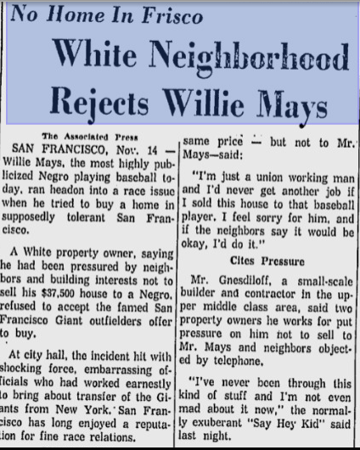
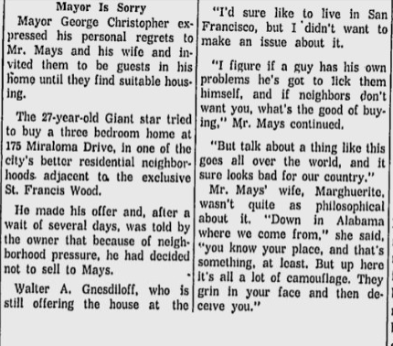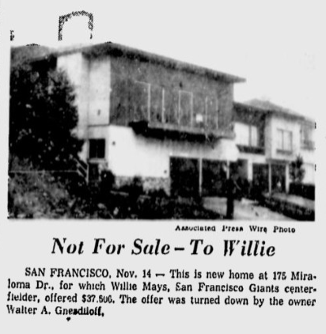

Source: The Miami News, 14 Nov. 1957.

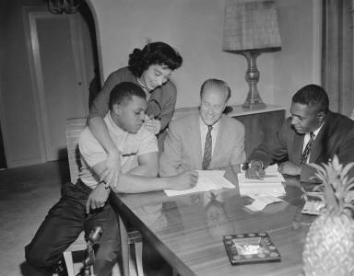

Source: “Willie Mays Beef -- Difficulty Buying House,” November 14, 1957, San Francisco News Archive, UC Berkeley, The Bancroft Library.

Source #3: A Raisin in the Sun

Background: A Raisin in the Sun was written by Lorraine Hansberry in 1959. The play explores the experiences of a black family who had just purchased a home in the predominantly white “Clybourne Park” neighborhood of Chicago, Illinois. In this scene, Mr. Lindner, a white man from the “Clybourne Park Improvement Association,” comes to speak to the Younger family about their house.

LINDNER: Well—you see our community is made up of people who've worked hard as the dickens for years to build up that little community. They're not rich and fancy people; just hard-working, honest people who don't really have much but those little homes and a dream of the kind of community they want to raise their children in. Now, I don't say we are perfect and there is a lot wrong in some of the things they want. But you've got to admit that a man, right or wrong, has the right to want to have the neighborhood he lives in a certain kind of way. And at the moment the overwhelming majority of our people out there feel that people get along better, take more of a common interest in the life of the community, when they share a common background. I want you to believe me when I tell you that race prejudice simply doesn't enter into it. It is a matter of the people of Clybourne Park believing, rightly or wrongly, as I say, that for the happiness of all concerned that our Negro families are happier when they live in their own communities.

BENEATHA (with a grand and bitter gesture): This friends, is the Welcoming Committee!

WALTER (dumbfounded, looking at LINDNER): Is this what you came marching all the way over here to tell us?

LINDNER: Well, now we've been having a fine conversation. I hope you'll hear me all the way through.

WALTER (tightly): Go ahead, man.

LINDNER: You see—-in the face of all the things I have said, we are prepared to make your family a very generous offer . . .

BENEATHA: Thirty pieces and not a coin less!

WALTER: Yeah?

LINDNER (putting on his glasses and drawing a form out of the briefcase): Our association is prepared, through the collective effort of our people, to buy the house from you at a financial gain to your family.

RUTH: Lord have mercy, ain't this the living gall!

WALTER All right, you through?

LINDNER: Well, I want to give you the exact terms of the financial arrangement—

WALTER: We don't want to hear no exact terms of no arrangements. I want to know if you got any more to tell us 'bout getting together?

LINDNER (taking off his glasses): Well—I don't suppose that you feel. . .

WALTER: Never mind how I feel—you got any more to say ‘bout how people ought to sit down and talk to each other? . . . Get out of my house, man. (He turns his back and walks to the door.)

LINDNER (looking around at the hostile faces and reaching and assembling his hat and briefcase): Well—I don't understand why you people are reacting this way. What do you think you are going to gain by moving into a neighborhood where you just aren't wanted and where some elements—well—people can get awful worked up when the feel that their whole life and everything they’ve ever worked for is threatened.

WALTER: Get out.

LINDNER (at the door, holding a small card): Well—I'm sorry it went like this.

WALTER: Get out.

LINDNER (almost sadly regarding WALTER): You just can't force people to change their hearts, son.

[Mama comes in and her children tell her about the visit with Mr. Linder]

MAMA: Father, give us strength, (knowingly—and without fun) Did he threaten us?

BENEATHA: Oh—Mama—they don't do it like that anymore. He talked Brotherhood. He said everybody ought to learn how to sit down and hate each other with good Christian fellowship.

She and WALTER shake hands to ridicule the remark.

MAMA (sadly): Lord, protect us . . .

RUTH: You should hear the money those folks raised to buy the house from us. All we paid and then some.

BENEATHA: What they think we going do—eat ‘em?

RUTH: No, honey, marry 'em.

Source: Lorraine Hansberry, A Raisin in the Sun (New York, NY: Random House Publishing), 1959.

Source #4: Blockbusting from the 1950s-1970s

In the ghettos, government policy — municipal policy, for example — denied adequate services, garbage wasn't collected frequently. African-Americans were crowded into neighborhoods in the ghetto because so much other housing was closed to them and as a result, housing prices in ghettos were much higher than similar housing in white areas. Rents were much higher than similar housing in white areas . . . because you had a smaller supply. It's the basic laws of supply and demand. . . . So this created slum conditions.
So when African-Americans managed to break out of those slums and buy a home in a neighboring area, whites could be persuaded that slum conditions were going to be brought with them. So the real estate agents would go into these neighborhoods and try to panic white families into selling their homes cheap to the real estate agents.
They used techniques: They would recruit blacks from the ghetto to walk around the neighborhood pushing baby carriages. They would phone call families in the white area and ask for names that were stereotypically African-American. . . . All intended to give the impression that this was rapidly turning into another black slum.
The white families who panicked would then sell their homes to the real estate agents or the speculators at prices far below what they were worth. The speculators would then turn around and resell the homes to African-Americans at far more than they were worth because of the restricted supply, and this policy was called "blockbusting" and it was a policy that was condoned by state licensing boards throughout the country.

Source: "Historian Says Don't 'Sanitize' How Our Government Created Ghettos," NPR, 14 May 2015.

Source #5: Photographs of White Resistance

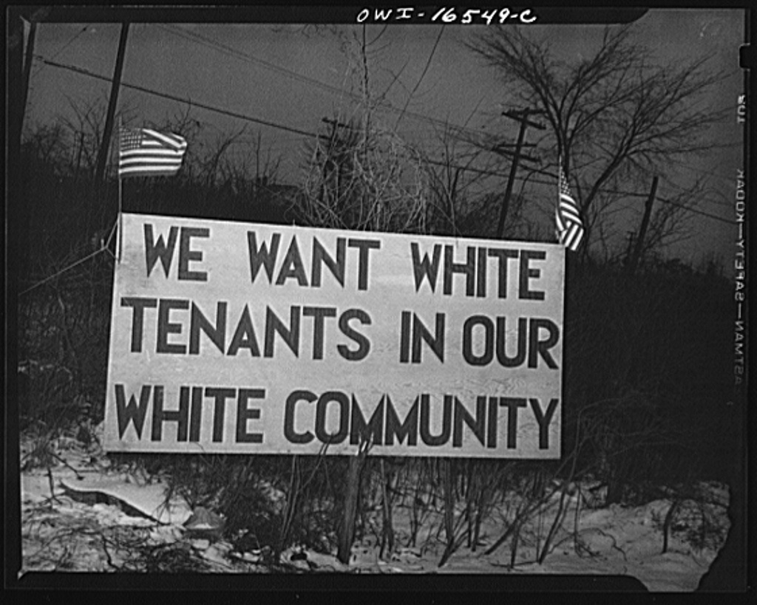 | Context: In 1942, the federal government allowed African-Americans workers to move into a housing development in Detroit, Michigan that had been built for those working for the war effort. The development was in a predominantly white neighborhood. White residents protested this decision, leading to a series of riots in 1943.
Source: Siegel, Arthur S. Detroit, Michigan. Riot at the Sojourner Truth Homes. Digital image. Library of Congress, Feb. 1942.

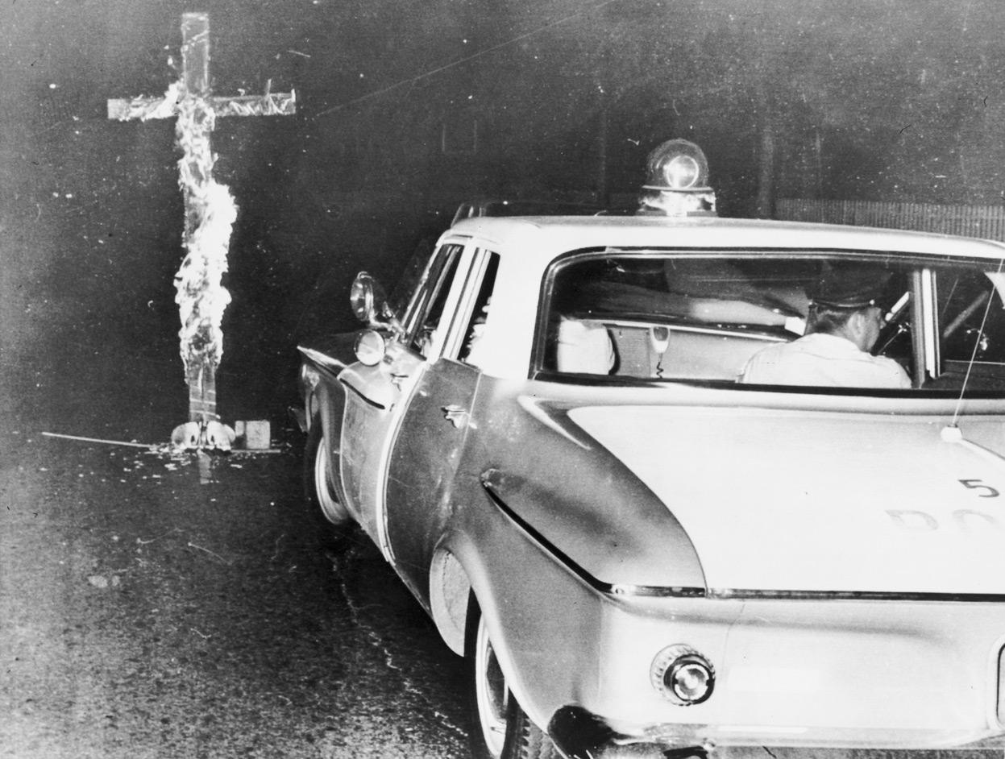 | Context: In Chicago, Illinois, a police car arrives to remove a burning cross. The cross was placed on the lawn of an African-American family who moved into a previously all-white neighborhood.
Source: Chicago Police Car Moving In, Library of Congress, 1963.

Part 3: Equality Under the (Housing) Law (1968-1988)

Focus Question: How did the United States government try to correct the inequities in housing opportunities for African Americans?

Goal: In this section, students will determine how the Fair Housing Act of 1968, and its amendment in 1988, attempted to rectify past discrimination.

Lesson Components:
3.1: Categorize the modes of discrimination studied as de facto or de jure.
3.2: Read provisions from the Fair Housing Act (1968) and its 1988 amendment.

Extension: “House Rules,” This American Life provides contemporary examples on the limitations of the Fair Housing Act. http://www.thisamericanlife.org/radio-archives/episode/512/house-rules

Activity 3.1 de facto or de jure? Name_________________________________

Directions: Define the phrases de facto and de jure, with regard to segregation. Use evidence from the materials you have read to provide examples of each type. Then answer question at the bottom of the chart

de facto Segregation | de jure Segregation
Definition: | Definition:
Examples: | Examples:

Lesson Focus Question: Did residential segregation in the United States primarily result from de facto or de jure actions?

Activity 3.1 de facto or de jure? TEACHER KEY

Directions: Define the phrases de facto and de jure, with regard to segregation. Use evidence from the materials you have read to provide examples of each type. Then answer question at the bottom of the chart

de facto Segregation | de jure Segregation
Definition: De facto segregation means segregation by fact or by circumstance. | Definition: De jure segregation means segregation by law.
Examples:  -“white flight”  -individual preferences when moving to a new neighborhood  -individual racism | Examples:  -local government zoning laws  -restrictive covenants  -FHA policies such as redlining  -legality of contract selling  -“blockbusting”

Lesson Focus Question: Did residential segregation in the United States primarily result from de facto or de jure actions?

Segregation in the United States was primarily a result of government policies, which is de jure segregation.

Activity 3.2: Fair Housing Act Name: _____________________

Fair Housing Act: In 1968, President Johnson signed the Fair Housing Act into law. The act “prohibits discrimination in the sale, rental and financing of dwellings based on race, color, religion, sex or national origin.”

Amendment to the Fair Housing Act: In 1988, an amendment to the Fair Housing Act was passed which:
- Expanded the coverage of the Fair Housing Act to prohibit discrimination based on disability or on familial status (presence of child under age of 18, and pregnant women);
- Established new administrative enforcement mechanisms with HUD attorneys bringing actions before administrative law judges on behalf of victims of housing discrimination; and
- Revised and expanded Justice Department jurisdiction to bring suit on behalf of victims in Federal district courts.

Questions:

- What was the purpose of the Fair Housing Act?

- How might the 1968 and 1988 Fair Housing Acts have benefitted African American home buyers?

- What might be the limitations of these Acts?

Activity 3.2: Fair Housing Act TEACHER KEY

Fair Housing Act: In 1968, President Johnson signed the Fair Housing Act into law. The act “prohibits discrimination in the sale, rental and financing of dwellings based on race, color, religion, sex or national origin.”

Amendment to the Fair Housing Act: In 1988, an amendment to the Fair Housing Act was passed which:
- Expanded the coverage of the Fair Housing Act to prohibit discrimination based on disability or on familial status (presence of child under age of 18, and pregnant women);
- Established new administrative enforcement mechanisms with HUD attorneys bringing actions before administrative law judges on behalf of victims of housing discrimination; and
- Revised and expanded Justice Department jurisdiction to bring suit on behalf of victims in Federal district courts.

Questions:

- What was the purpose of the Fair Housing Act?

The purpose of the Fair Housing Act is to stop discrimination in housing based on race, religion, sex, national origin, disabilities, or family status.

- How might the 1968 and 1988 Fair Housing Acts have benefitted African American home buyers?

The Fair Housing Act makes it illegal to discriminate against those seeking housing, meaning that those that want to keep certain neighborhoods “white” can have legal action brought against them.

- What might be the limitations of these Acts?

It is probably very difficult to prove that someone is denying housing based on race. There are many reasons a landlord or seller could give in order to deny someone housing (credit scores, better offers, etc).

Part 4: Long-Term Consequences (1960s-present)

Focus Question: What are the lasting effects of discriminatory housing policies?

Goal: Reflect on the long and short term consequences of discriminatory housing policy and its impact on the contemporary condition of African Americans.

Lesson Components:
4.1: Explore the current patterns of residential segregation in local communities and cities in which black residents have recently rebelled in response to police actions.
4.2: Make judgments on the cause of contemporary conditions.

Final Assessment: Based on their study of the history of housing discrimination, students will write an analytical paragraph.

Writing Question: What led to the segregation of neighborhoods in the United States?
  - Writing Prompt
  - Writing Frame

Activity 4.1: Residential Segregation Today Name___________________
Directions: Use computers to have students explore the current housing demographics in their area and locations around the country that have experienced racial unrest.
Website: http://www.coopercenter.org/demographics/Racial-Dot-Map

      - What racial and ethnic groups live in your city? Neighborhood?

      - What group is the racial/ethnic majority in your city? Neighborhood?

      - Compare and contrast the racial demographics of at least two neighborhoods in your area.

Neighborhood 1:

Neighborhood 2:

How does your prior knowledge help you understand these housing patterns?

      - Locate at least two of the following cities that have recently experienced significant unrest regarding police actions. Note where different racial/ethnic groups live.
- Ferguson, Missouri (St. Louis County)
- Staten Island, New York
- Oakland, California
- Baltimore, Maryland
- Cleveland, Ohio

How does your prior knowledge help you understand these housing patterns?

Activity 4.2 Long-Term Consequences Name_______________________
Directions: Determine whether the situation results from individual actions, government policies, or the social, political, and cultural conditions. Explain your answer. Place an “X” next to the PRIMARY cause for the situation.

Home Equity: In 1952, white families could use FHA loans to buy a house for around $8,100, which was twice the national median income. Today, those same homes sell for around $400,000, which is currently eight times the national median income.
What is the primary cause of this situation?
___Individual Actions ___Government Policies ___Social, Political or Cultural Conditions
Explain: ___________________________________________________________________________________________
_____________________________________________________________________________________________________

Net Worth: The average net worth of African-Americans in 2014 was $11,000, while the average net worth of white Americans was $141,900.
What is the primary cause of this situation?
___Individual Actions ___Government Policies ___Social, Political or Cultural Conditions
Explain: ___________________________________________________________________________________________
_____________________________________________________________________________________________________

Incarceration: African-Americans are incarcerated at nearly six times the rate of whites.
What is the primary cause of this situation?
___Individual Actions ___Government Policies ___Social, Political or Cultural Conditions
Explain: ___________________________________________________________________________________________
_____________________________________________________________________________________________________

Foreclosures: In the early 2000s, many African-Americans received high-cost and risky loans from banks, who specifically advertised these loans in black churches. Consequently, during the Great Recession of 2008, African-Americans experienced a disproportionate rate of foreclosure on their homes compared to white families.
What is the primary cause of this situation?
___Individual Actions ___Government Policies ___Social, Political or Cultural Conditions
Explain: ___________________________________________________________________________________________
_____________________________________________________________________________________________________

Police Stops: A 1990s era study conducted in New Jersey and Maryland found that black and white motorists violated the same number of traffic laws, but 42 percent of all stops and 73 percent of all arrests were of black drivers.
What is the primary cause of this situation?
___Individual Actions ___Government Policies ___Social, Political or Cultural Conditions
Explain: ___________________________________________________________________________________________
_____________________________________________________________________________________________________

Final Assessment Name ____________________
Focus Question: What led to the segregation of neighborhoods in the United States?
Be sure to include:
-Short and long-term consequences of housing segregation
-Examples of de jure and de facto discrimination
-Evidence from at least three sources from this lesson
-Connections to contemporary issues
Thesis: ________________________________________________________________________________________________________
_________________________________________________________________________________________________________________
Background: __________________________________________________________________________________________________
_________________________________________________________________________________________________________________
Evidence: _____________________________________________________________________________________________________
________________________________________________________________________________________________________________
Analysis: _____________________________________________________________________________________________________
________________________________________________________________________________________________________________
Evidence: _____________________________________________________________________________________________________
________________________________________________________________________________________________________________
Analysis: _____________________________________________________________________________________________________
________________________________________________________________________________________________________________
Evidence: _____________________________________________________________________________________________________
________________________________________________________________________________________________________________
Analysis: _____________________________________________________________________________________________________
________________________________________________________________________________________________________________
Concluding statement: _____________________________________________________________________________________
_______________________________________________________________________________________________________________
Framed Paragraph Name ____________________
Focus Question: What led to the segregation of neighborhoods in the United States?
Be sure to include:
-Short and long-term consequences of housing segregation
-Examples of de jure and de facto discrimination
-Evidence from at least three sources from this lesson
-Connections to contemporary issues

Segregation of neighborhoods in the United States occurred due to ___________________________,
______________________________, and _______________________________________.
Prior to the early 1900s, many neighborhoods in the United States were racially integrated. An early policy that led to the segregation of neighborhoods in the United States was ______________________________ (specific example). This policy meant that___________________________________________________________________.
Further segregation occurred when _____________________________________________________________________. This shows ___________________________________________________________________________________________________. Finally, housing segregation ____________________________________________________________________________________________.
This is significant because _____________________________________________________________________________________.
Residential segregation occurred both by law and by custom. An example of de jure segregation is when ________________________________________________________. An example of de facto segregation is when ________________________________________________. Housing segregation has had a lasting impact on communities in the United States. For example,_____________________________________________________________. In conclusion, (restate thesis) _________________________________________________________________________________.

Title VIII: Fair Housing and Equal Opportunity - HUD." Title VIII: Fair Housing and Equal Opportunity - HUD. U.S. Department of Housing and Urban Development, 1968.
Title VIII: Fair Housing and Equal Opportunity - HUD." Title VIII: Fair Housing and Equal Opportunity - HUD. U.S. Department of Housing and Urban Development, 1968.

