Day 3 email- NOTE: this includes info on the campaign lab… we may need to change language.
Hello all !!
Thank you so much for helping to create this generative and gracious space. You have been a tremendous group to work with. Please take a few minutes as you rush back to your work and families to let us know about our work with you -
Final Feedback for Advancing Racial Justice – Fill out form
If you have any travel issues on the way home, remember that AmTrav is your best friend.

Specific Materials in this course that will help you after you leave us.
Additional Resources Module -
- Paying Attention to White Culture and Privilege: A Missing Link to Advancing Racial Equity – especially helpful for beginning work in which you want to make systemic changes. It includes practical steps for making these plans for change including the use of affinity circles.
- Bargaining for the Common Good Racial Justice Guide – especially good for those of you looking to expand your union’s focus beyond “bread and butter” union work into the space of equity justice.
Advancing Racial Justice Campaign Planning Module:
- This mini-course equips UniServ, Organizers, Leaders, and Members with the skills and knowledge to effectively plan and execute a campaign cycle. Participants will explore critical components, including defining problems, conducting power analyses, and designing escalating tactics. They will learn to apply an equity lens to campaigns, ensuring inclusivity and addressing systemic inequities. The course also focuses on building effective campaign teams, mapping allies, and setting measurable goals to track progress and success. This program provides practical tools and strategies to drive strategic change.
Other Online Courses in PEPs
Now that you are in the PEP learning portal, there are a number of other online courses our program produces. Please consider these two:
Protest Rights & Legal Non-Cooperation Tactics for Educators and Union Members
This course covers essential topics such as First Amendment protections for public school employees, recent anti-protest legislation, and practical safety measures. You’ll also learn about non-cooperation tactics—methods of nonviolent resistance like strikes, boycotts, and civil disobedience—that have historically proven effective in challenging unjust systems. Through real-world examples and strategic planning exercises, participants will gain the skills to map power structures, select impactful tactics, and protect themselves and their communities during collective actions. Participants will be prepared to exercise their protest rights safely, disrupt undemocratic power structures, and build solidarity through informed, strategic action. Whether participants are seasoned organizers or new to advocacy, this training offers practical guidance and legal awareness to strengthen our collective voice.

Campaign Lab: Centering Equity in Your Campaign
This is the first tool in the Campaign Cycle, and it is revisited throughout the cycle. This course is designed for Campaign Lab Team Leads and Coaches. It helps participants integrate race, class, and gender equity into every stage of their campaign planning. Participants will apply a specific Equity Tool to help them identify systemic barriers, set measurable equity-focused goals, and use practical tools to ensure their campaigns build power with those most impacted by oppression. A certificate of 3 Contact Hours is provided upon completion.

Future Support for Your Work From NEA
Want to stay connected and supported around this work and meet new teams from around the country doing this work? The best way is to join the Campaign Lab. You will receive a small seed grant for your work, be assigned a coach to help your team, and receive continued skill support through our in person and online resources.
Campaign Lab Grant Funding
There is seed money available and most comprehensive information about this can be found at https://www.nea.org/resource-library/campaign-lab . The application is quick and easily accessible. Once you are accepted into the Campaign Lab there are four steps you need to complete that are outlined in the following course linked and described here: Campaign Lab: The First Four Steps This course equips Team Leads, Coaches, and Mentor Coaches in the Campaign Lab with the knowledge and skills to successfully navigate getting to the grant application process. Participants will learn how to establish and launch an organizing team, complete a comprehensive assessment of their local, and develop a strategic campaign plan with a concise one-page summary. Additionally, the course will guide learners in identifying a fiscal agent and obtaining a written agreement to meet grant requirements.

Want to extend your leadership skill set? Consider becoming a campaign lab coach. Many of you in this room have the skills and presence to be a Campaign Lab Coach. You may also know other members that have the ability to coach organizing and want to learn more about that. Please apply yourself or share the following link for others to apply to be a coach. Apply to be a Campaign Lab Coach

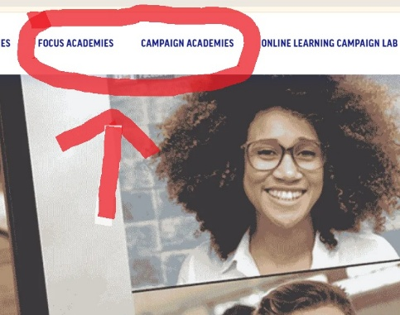
Conference and In-Person Training Opportunities
Our most up-to-date listing of in person training opportunities can be found at https://www.nea.org/UD-Org-Support go to the tabs that say: Focus Academies or Campaign Academies. THIS was a Focus Academy.

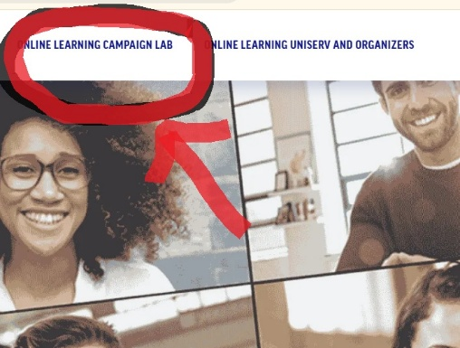
Online Learning Opportunities
Our most up-to-date listing of in person training opportunities can be found at https://www.nea.org/UD-Org-Support go to the tab that say:

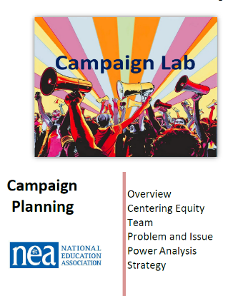
Final Campaign Planning Template
There are two critical resources to use when creating a final campaign plan. One is the comprehensive template that includes all that we covered in this academy. It can be downloaded from your course in the Handouts and Forms Module. The cover looks like:

There is also a course that is built around all steps of Campaign Cycle Planning and is described and linked here Campaign Lab: Campaign Cycle Planning This course equips team leads (coaches if they are unfamiliar with a campaign cycle plan) with the skills and knowledge to effectively plan and execute a campaign cycle. Participants will explore critical components, including defining problems, conducting power analyses, and designing escalating tactics. They will learn to apply an equity lens to campaigns, ensuring inclusivity and addressing systemic inequities. The course also focuses on building effective campaign teams, mapping allies, and setting measurable goals to track progress and success. Designed for leaders and affiliate staff in the Campaign Lab, this program provides practical tools and strategies to drive strategic change. A certificate of 5 Contact Hours is provided upon completion

