Facilitator Agenda: Advancing Racial Justice 2024 Day #2
General Materials Needed: |  |  |  |  |  |  | Room Set-up:
1 Set of Handouts per Person  Name Tags and Name Tents  Sign-in Sheet  Pens and Pencils |  |  | Chart Paper  Markers  Post its  Index Cards |  |  |  | Round Tables  Projector, Screen and Speakers  Carousel stations and reporting stations around the perimeter  50 people
Key Outcomes for the Day
Participants will practice restorative circles
Participants will understand the connection between identity, intersectionality and oppression
Participants will understand systems of racism and explore possible ways to disrupt them
8:30- 8:40 Getting Started  8:40-9:10 Restorative Practices  9:10-9:20 Timeline Bridge  9:20-10:15 White Culture  10:15-10:30 Break  10:30-12:00 Why this Work is Tough  12:00-1:00 Lunch |  |  |  |  | Ellen  Matt  Natasha  Matt and Eric  Ellen and Shelly | 1:00 – 1:45 Identity and Intersectionality  1:45 REAL STOP FOR LEGACY MUSEUM |  |  | Natasha
Time, Slides, Facilitator |  | Resources |  | Instructions, Activity and Debrief (Facilitators) |  |  |  | Outcomes and Essential Questions
 |  | Charts, handouts, articles, materials, slide |  | What are you saying, what are they doing, what questions will you use to guide learning and make clear the important points  Include an estimate for how long each section of the learning will take  P |  |  |  | As a result of this learning, what will participants know or be able to do? What questions will they be able to answer?
8:30 -8:40 Ellen |  | 10 Minutes – Regroup and Ground (IN A CIRCLE OF CHAIRS to Start)
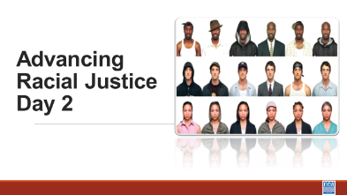  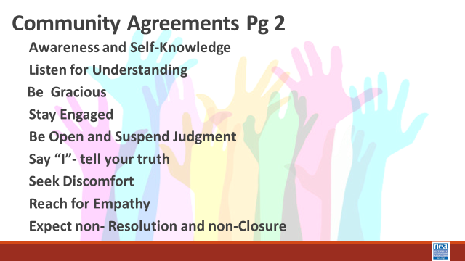   |  | Circle of Chairs for Participants  To be ready for next section |  | 10 Minutes  Review the Community agreements  Feedback on Feedback  Day 2 Agenda  Any logistics  Leaving for the Legacy Sites by 1:45  (I propose cutting White Culture, Nativism and Immigration and Shortening Identity and Intersectionality to make up for the Museum)  *PLAY VIDEO* BEFORE MOVING TO CIRCLES Labels and Identity – As you watch this video remember that we are going to move into affinity groups today. Be listening for the comlexities of identity and how these inform our biases and understandings. |  |  |  | Participants will reflect on Day1 and understand any changes made for Day 2.  How will we work together?
8:40-9:10 Matt |  | 30 Mins – Restorative Practices Introduction
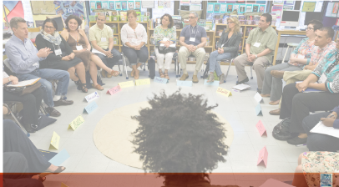  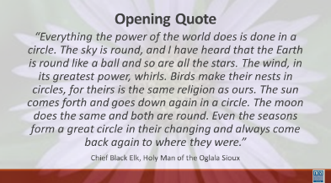 |  | Circle of Chairs for Participants  Restorative Practices Resource p 28-92  Talking piece  Circle norms same as group |  | A note for next year – we really need 90 minutes to do this. In order for each person to share and for the content of how to set up a circle and for the added benefits we always see from this activity – we have to commit to making this 90 minutes.  5 minutes  Ask participants to form a circle.  “I’d like to welcome you to the circle.“  Read quote from Chief Black Elk aloud (slide)  “Everything the power of the world does is done in a circle. The sky is round, and I have heard that the Earth is round like a ball and so are all the stars. The wind, in its greatest power, whirls. Birds make their nests in circles, for theirs is the same religion as ours. The sun comes forth and goes down again in a circle. The moon does the same and both are round. Even the seasons form a great circle in their changing and always come back again to where they were.”  Chief Black Elk, Holy Man of the Oglala Sioux  “Resolving our issues and discussing our experiences is an indigenous practice that is still in use. At one point it was actually outlawed because it was so antithetical to the dominant culture. Think of how most classrooms have been arranged – rows – hierarchy. In a circle there is no hierarchy, and everyone is equal. The process that we are going to engage in is one that you can use to engage colleagues and members in deeper conversations. To engage in deeper conversations about race and social justice, we need to build a community of trust and respect. We will begin to build our community here in this circle. To ensure safety we say that what is said in the circle stays in the circle. Stories stay in the circle, but the lessons are taken out and shared with others.”  Reminder of Agreements  “We will come to the circle throughout our time together, and just as we have norms for the training, we have norms for the circle.” Plus – the use of talking stick, and the ability to pass.  We only did one pass and then a closing and it took 80 minutes  Community Pass One  - The participants in this video mentioned that while avoiding certain labels or ways of identifying people might avoid surface-level conflict, we ignore people’s experiences that are connected to those labels. Are the labels that you hold most closely to your sense of self those that hold more privilege or less privilege? I’ll start, to model this for us. *SHARE*  (*For the facilitator: focus on the more privilege/less privilege, not the specific labels in the modeling.*)  - Internal weather check-in. We want to check in to see how you are all feeling today and rather than asking it directly, we want you to use a weather term or weather terminology to describe how you are feeling. I will model this for you. Today, I am partly sunny. (Pass the talking piece, listening to how everyone is feeling.) When pass is complete, facilitator summarizes the weather terms heard in the circle. This helps us to know the general mood in the room, and if we need to check in with specific people or the entire group.  Community Pass Two  - Share an a-ha moment you had from one of the activities or videos yesterday. (pass the talking the piece)  Community Pass Three (pick one)  - What is your privilege and what role does it play in your life?  - When do you feel powerless and why?  Circle Closing  Facilitator – What are you taking away from this Circle about labels and recognizing our complexities? |  |  |  | Participants will cultivate a reflective mindset.  Participants will begin to build a reflective, trusting community that allows for honest conversations about advancing racial justice.  Participants will be introduced to the Restorative Practices circle process and begin to make the connection about how to use this process as they work  What are Restorative Processes?  How can you use Restorative Processes to build Community?  How can you use Restorative Processes to build collective knowledge?
9:10 – 9:20 Natasha |  | 10 Minute Total - Timeline Bridge
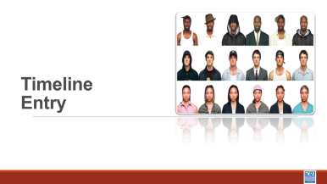  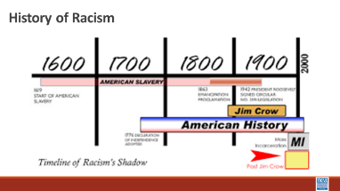  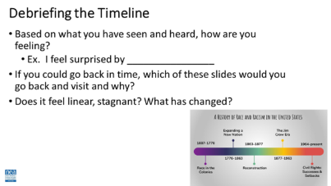  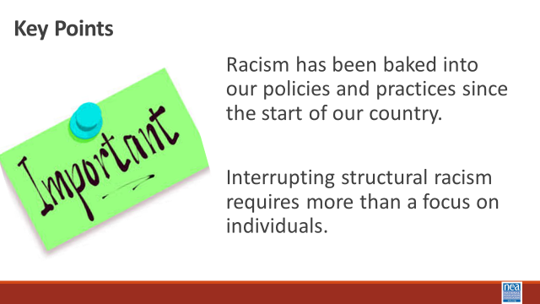 |  |  |  | Official Eurocentric Colonizer’s description of United States history begins with 1612 – and goes through 2022 –  When we hear people say, Slavery ended a long time ago, why are Black people still so upset? Think about this image. Within the context of 417 years, only the last 60 have had any type of progress, and as we saw with the last administration, there is a concerted effort form the alt-right and the republicans to erode that progress and roll back legislation  1 Min – Key points  Racism has been baked into our policies and practices since the start of our country.  Interrupting structural racism requires more than a focus on individuals. |  |  |  | Participants will discuss illustrating the development of structuralized racism in what we now call the United States of America.
9:20-10:15 Eric and Matt |  | 55 Minutes Total – What is White Culture
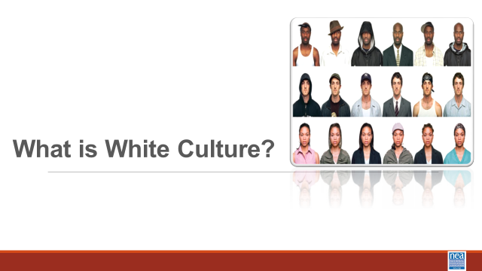  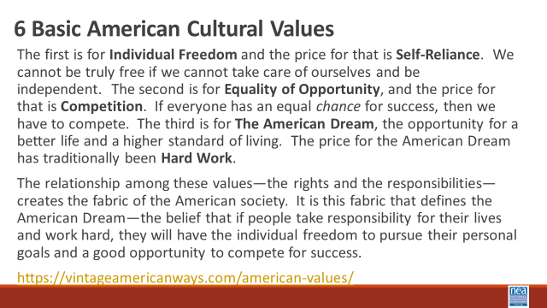  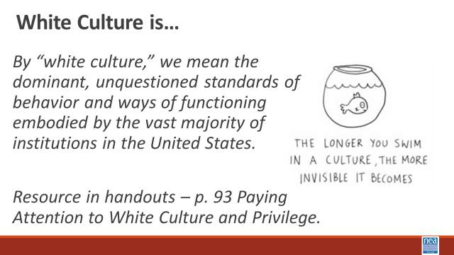  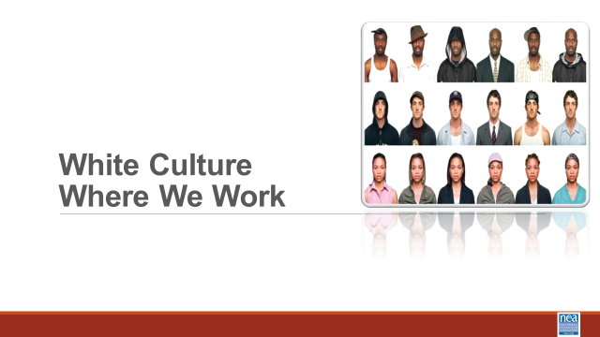  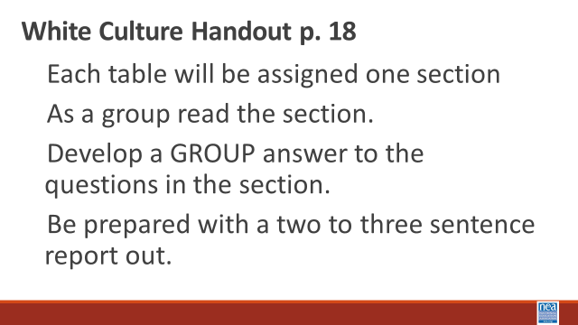  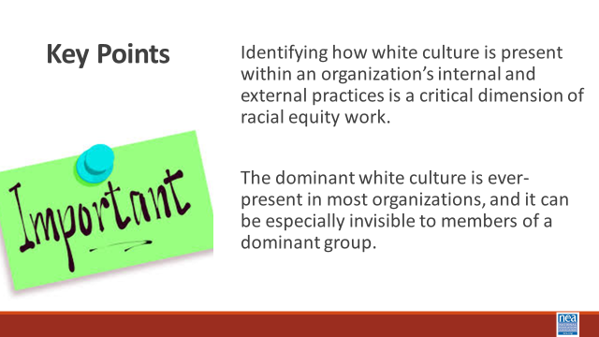  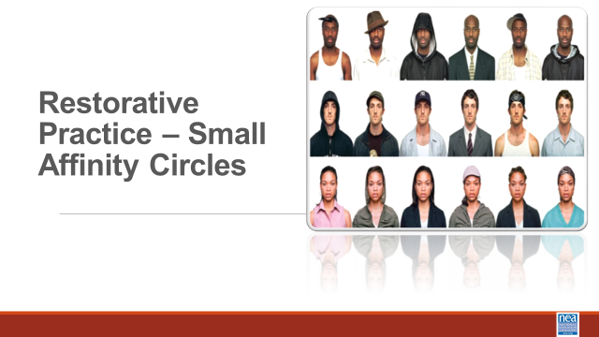  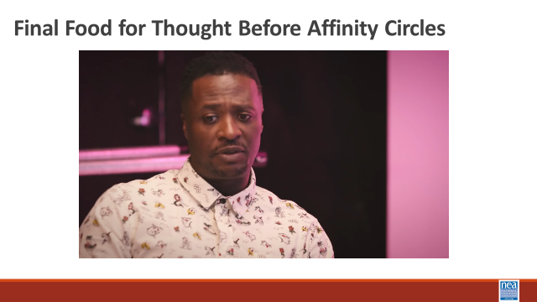 |  | Attention to White Culture and Privilege p. 17-31  Page 17 White Culture Handout  Paying Attention to White Culture and Privilege – P. 18-31 |  | 15 mins- What is White Culture?  2 mins –Intro  We are going to dig into some thinking about what makes discussing race so difficult. To do that we are going to begin by looking through the window of White Culture. At your tables, read the following slide to yourselves – in about one minute – turn to those folks you are sitting with and discuss what stands out as things you agree with and things you don’t agree with – We will take a total of 5 minutes at your tables for this discussion.  (Give them 10 minutes to discuss – then 3 minutes to share out)  “6 Basic American Cultural Values  - The first is for Individual Freedom and the price for that is Self-Reliance. We cannot be truly free if we cannot take care of ourselves and be independent. The second is for Equality of Opportunity, and the price for that is Competition. If everyone has an equal chance for success, then we have to compete. The third is for The American Dream, the opportunity for a better life and a higher standard of living. The price for the American Dream has traditionally been Hard Work.  - The relationship among these values—the rights and the responsibilities—creates the fabric of the American society. It is this fabric that defines the American Dream—the belief that if people take responsibility for their lives and work hard, they will have the individual freedom to pursue their personal goals and a good opportunity to compete for success. Found at https://vintageamericanways.com/american-values/  During the 3-minute report out move to the Slide that defines white culture Report out - Ask for 3 to 4 people to share something that they heard or said at their table. –at this point you are simply getting people to discuss the concept of white culture. At this point, let them know that this comes from Vintage American Ways, a SS curriculum that is easily found and for use in teaching. GTS and be afraid. Pg. 17 as a resource  20 Mins – White Culture Where We Work  1 Min Intro - We are now going to extend our discussion to a set of questions about White Culture. Using the White Culture Handout found on page 18 we are going to get into groups. (no more than 4 or 5) – Once in groups I will give you the directions –  Show the slide with these directions.  - Each group will be assigned one section  - As a group read the section.  - Develop a GROUP answer to the questions in the section.  - Be prepared with a two to three sentence report out.  8 Minutes in your groups  5 Mins - Group Sharing of your answers.  1 Min – Key Points  Identifying how white culture is present within an organization’s internal and external practices is a critical dimension of racial equity work.  The dominant white culture is ever-present in most organizations, and it can be especially invisible to members of a dominant group.  5 Mins – This is a powerful poem to continue our thinking and feeling about this work as we move into our next section.  Play the 5 minute video in the Food for Thought Slide then get folks prepped to be in affinity circles.  Facilitator Notes  Make a set of Possible Racial Affinity Group Names – Signs White, Black, Latin, Multi Race/ Ethnic, Asian After giving the content below ask people to claim a name sign and a space. Facilitation of this should allow for choice. And you should be looking for folks that are confused and help them navigate who to join. Make it clear that the goal is to find a community of learners who will benefit from a safer more respectful examination for their lived experiences. However, inappropriate ways of joining an affinity group would be, “ I am a white women and I have married a black man so I am going to sit with the black men’s table because I know the challenges. People will already have been warned this method is coming and will have been prompted to be thinkning about the racial identity most visible to others and that most enables their relationship with privilege.  10 Mins – Move to Racial Identity Caucuses or Affinity Groups– pg. 28-31  5 Mins - Intro and Content (Facilitator needs to read the following and put it into their own words as they share the bulleted points slide.) - One tool we have found to be very helpful, especially in acknowledging and supporting some of the emotions that naturally occur in racial equity work, is racial identity caucusing. The value of caucusing is so both white people and people of color have intentional space and time to focus on their respective work to dismantle racism and advance racial equity. Caucusing does not happen instead of integrated groups; rather, caucusing can lead to more authentic and powerful integrated groups. Caucusing not only respects the choice of marginalized groups to be together, it also makes the dominant culture visible – an important step in making intentional changes to the culture. Further, working only in integrated groups puts an undue burden on people of color to be the teachers and obscures the responsibility of white people to do their own work. Both people of color and white people are needed to work collectively for racial equity. But they have different work to do, precisely because of their different experiences with and location relative to white culture and privilege. For people of color the caucus can be a space where whiteness is not at the center or a place where one need not accommodate or assimilate to white people’s responses to the emotional and conflictual nature of racial equity work. The caucus provides an opportunity to not only speak about the impact of racism and white culture within an organization, but also about how oppression is internalized on an individual, intergroup, and institutional level. This space can build solidarity among diverse people of color while at the same time allowing that full diversity to emerge and be celebrated. This caucus can be a liberating place for people of color to heal, bring their full selves, and consider how to collectively work for racial equity.  5 Minutes Play the Button Video and ask them to  5 Minutes – Make the move, claim a sign, and remember why we are making this move and discuss your feelings and reactions to the video.  (*For the facilitators: Keep an eye out for the potential for an “affinity group of one,” so none of our participants feel isolated or singled out.*) |  |  |  | Participants will be able to describe the aspects of white culture – and actually recognize that there is a white culture.  Do white people have a culture?  What is the work that we need to do to become anti-racist?  How do we provide spaces where this work can be done?
10:15-10:30   | BREAK
10:30 -12:00 Ellen and Shelly |  | 90 Minutes Total - Why This Work is Tough
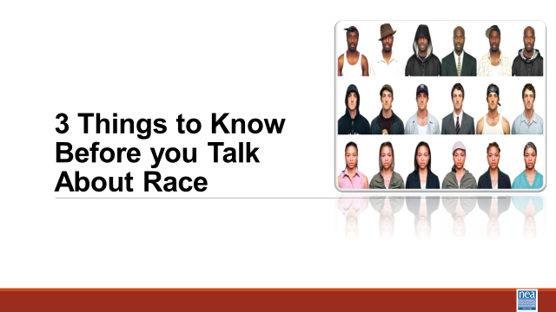  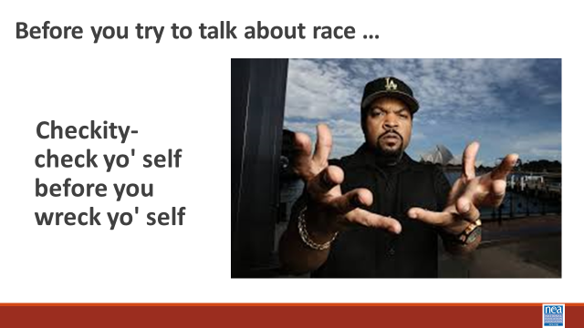  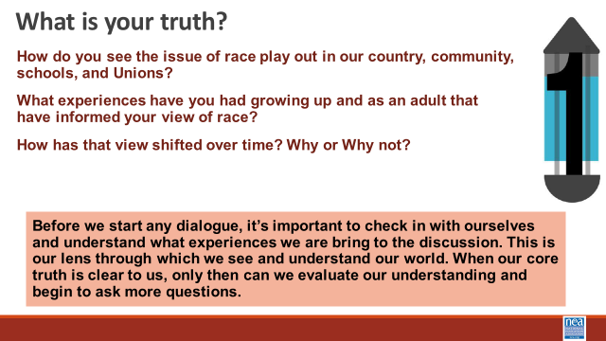  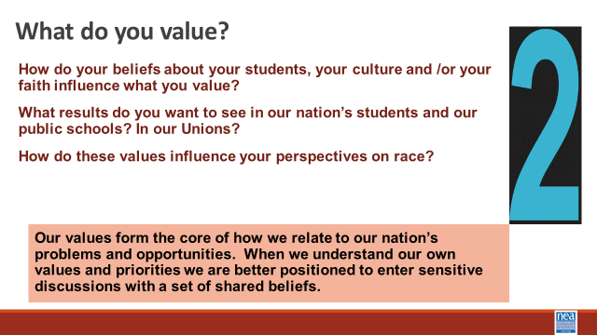  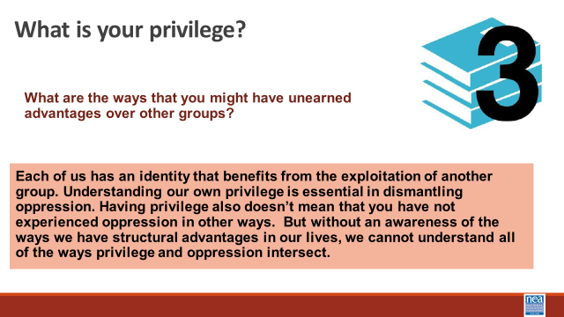  INSERT SLIDE FOR THE MUSEUM  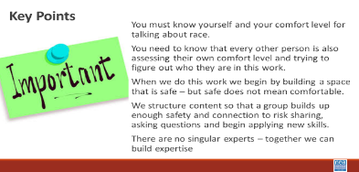  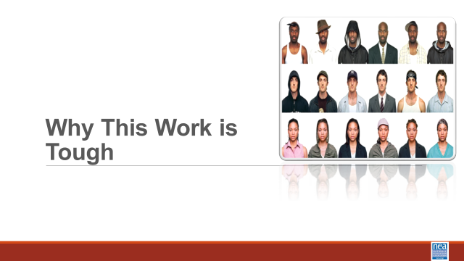  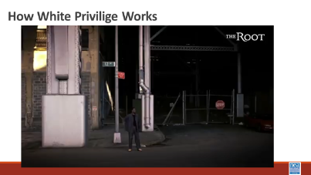  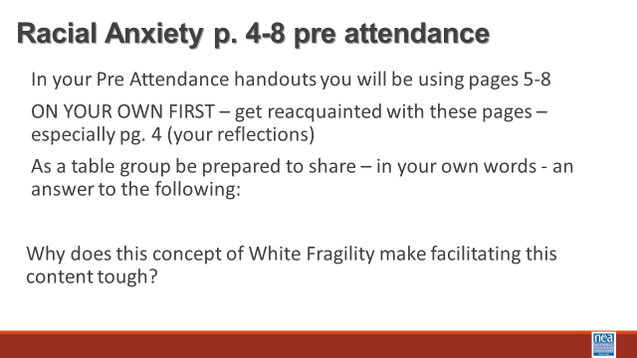  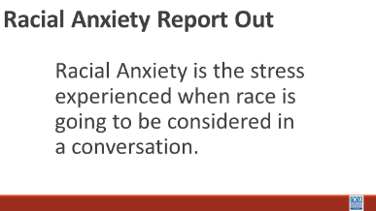    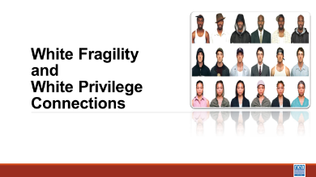  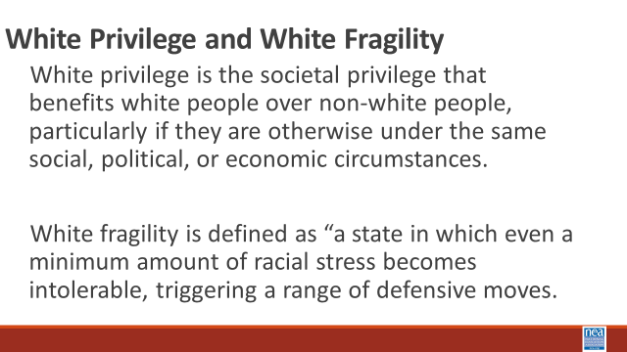    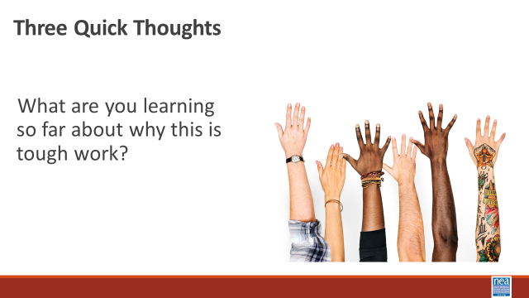  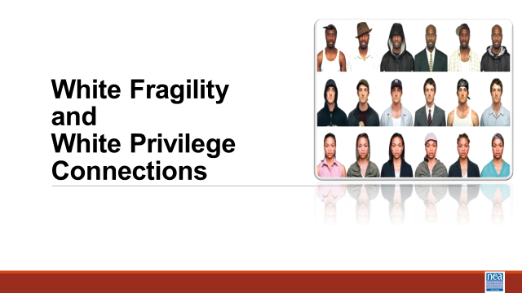  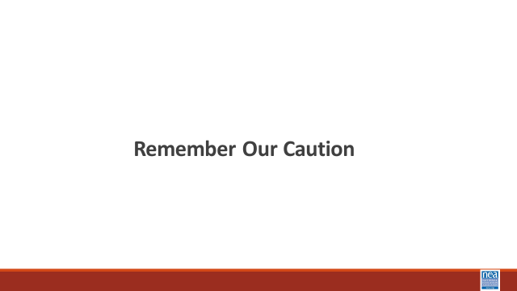  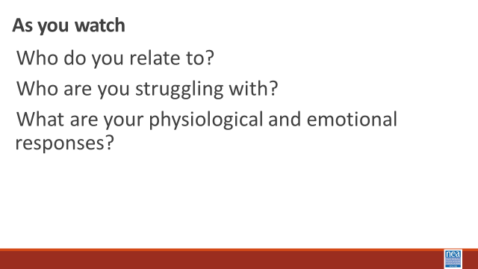  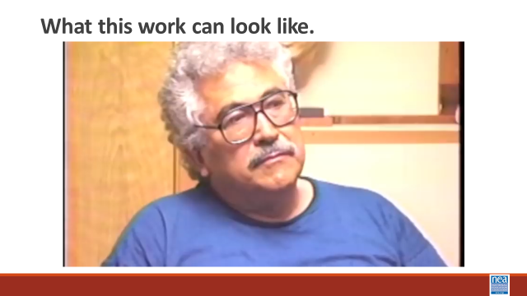  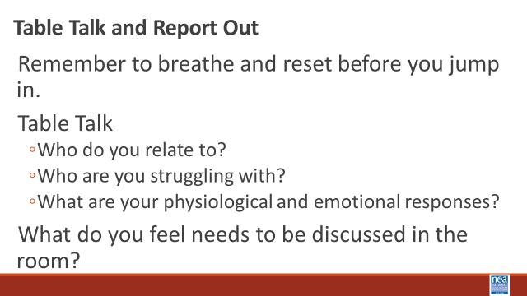  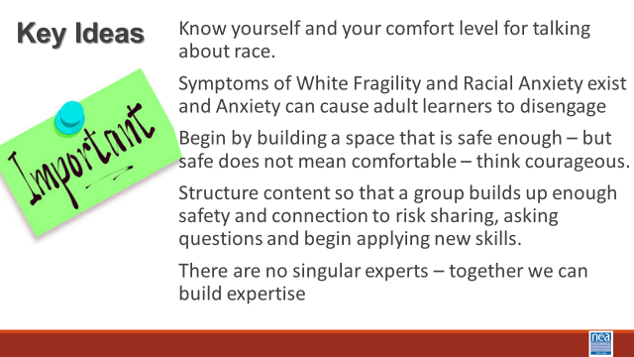 |  | Why we Must act Pg 69  Pre Attendance  Racial Anxiety Assessment. 4-8  Pre Attendance What is White Privilege? P. 43-53  Attention to White Culture and Privilege p. 18 |  | 15 Mins –Three Things to Know (NEW Why WE Must Act P. 69)  WE DID NOT DO THIS and the team feels like nothing was lost.  1 min intro - A useful framework of three sets of guiding questions you have a responsibility to investigate if you are going to do this work. IT follows Ice Cube’ sage advice - to check yourself before you wreck yourself.  2 Min -Show Slide – what is your truth? – I will wait while you read this -- What I want you to notice is that it is important to know what experiences you are bringing to the conversation.  2 min -Show Slide – What do you value?- I will wait while you read this -- What I want you to notice is that when we know our values it helps us be more sensitive and open during conversations that are tough  2 min -Show Slide – What is your privilege? I will wait while you read this -- What I want you to notice is each of us has an identity that has allowed for the oppression of others, and just because we have privilege does not mean that we have not experienced oppression.  There is a hadout on pg. 69 that can help support you as you begin tough conversations around Racial Justice that includes community agreements, and questions for deeper understanding. When we do this work, we begin by building a space that is safe enough – but safe does not mean comfortable.  1 Minute Key Points –  - You must know yourself and your comfort level for talking about race.  - You need to know that every other person is also assessing their own comfort level and trying to figure out who they are in this work.  25 Minutes – Why this Work is Tough – Privilege and Racial Anxiety (We significantly shortened this maybe used about 5 minutes of the content as a way to support the development of the affinity tables- the actual content was not really super necessary)  5 mins – Introduction and video -We are going to take a closer look at the concept of privilege as you watch, consider how Privilege and Racial Anxiety are Connected.  Show video (5 Mins) We did not do this and nothing was lost.  Racial Anxiety We showed this slide as a way to bring the affinity groups from their “table talk” to a whole group discussion. then immediately go to the slide about Racial Anxiety – ask them to access the Assessment that they took in their pre-attendance found on pages 4-8.  Did not do this section 10 Mins – Table Talk -With your own table, What Surprised you about your assessment? Why does this concept of White Fragility make facilitating this content tough?  5 Minutes - Report out and look for the following points that participants might report – and share these if they don’t explicitly or implicitly talk about them.  - Symptoms of Racial Anxiety exists  - Anxiety can cause adult learners to disengage  - Being transparent will feel difficult and there will be some degree of non-closure and imperfection  - Attending to community development requires intentionality  - Building from low risk to high risk takes time  - This is an ongoing process and we all arrive at different times  2 Minutes – as a wrap up to this small section – share the video “what is racial anxiety”  10 Minutes –Connecting White Privilege and White Fragility – Share the slide with these two critical concepts to understand –  White privilege is the societal privilege that benefits white people over non-white people, particularly if they are otherwise under the same social, political, or economic circumstances. White fragility is defined as “a state in which even a minimum amount of racial stress becomes intolerable, triggering a range of defensive moves.  WE did not do this and nothing is lost In this video the well-recognized author who has benefitted greatly from her own white privilege Robin D’Angelo, does a decent job of explaining the connection between white privilege and white fragility. (Share the video)  We used this to finalize the discussion as a whole room from Affinity groups. Move to slide – Three quick thoughts and take just three thoughts about what folks are learning about why this is tough work.  1 Minute – Key Points - White culture is ever-present in most organizations, and it can be especially invisible to white people.  White fragility is a kind of racial anxiety that makes it particularly difficult to discuss racial injustices.  We did all of this Following section  35 Mins – What this Work can Look Like  REMEMBER OUR CAUTION  8 Mins Intro and Video - We are going to watch a segment from the 1994 movie “Color of Fear” that shows how 8 North American born men have the conversations that many of us fear.  As you watch notice if and when you begin to feel uncomfortable. Notice your breathing and your what your brain begins to tell you. What would your comfort level be for hanging into this conversation. Notice Who do you relate to? Who are you struggling with? What are your physiological and emotional responses?  Show video (5 Minutes)  10 Minutes to discuss reactions in small groups -Remember to breathe and reset before you jump in. Table Talk  - Who do you relate to?  - Who are you struggling with?  - What are your physiological and emotional responses?  10 Minutes Whole Room Discussion - What do you feel needs to be discussed in the room?  - P. 268 Fighting Racism, Battling Burnout: Causes of Activist Burnout  2 Mins Key Ideas –  Know yourself and your comfort level for talking about race.  Symptoms of White Fragility and Racial Anxiety exist and Anxiety can cause adult learners to disengage  Begin by building a space that is safe enough – but safe does not mean comfortable – think courageous.  Structure content so that a group builds up enough safety and connection to risk sharing, asking questions and begin applying new skills.  There are no singular experts – together we can build expertise |  |  |  | Participants will learn about racial anxiety and assess their own level.  Participants will understand three  foundational concepts and their contributions to why this is work is tough, white culture, privilege, and anxiety.  Why is talking about race so difficult?  Participants will develop an understanding of what makes this work tough and learn basic steps to support their success in their future work.
12:00 to 1:00  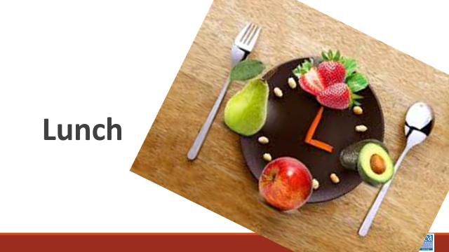 | LUNCH
1:00-2:15 Natasha |  | 75 Minutes Identity and Intersectionality
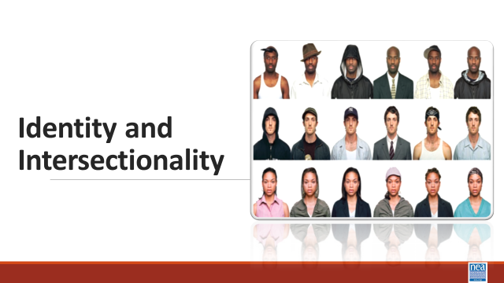  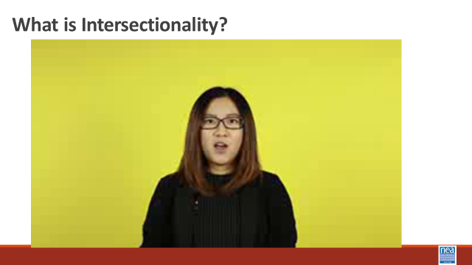  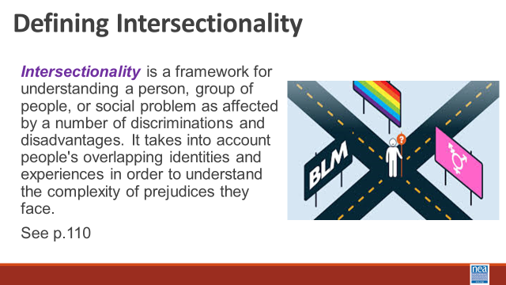  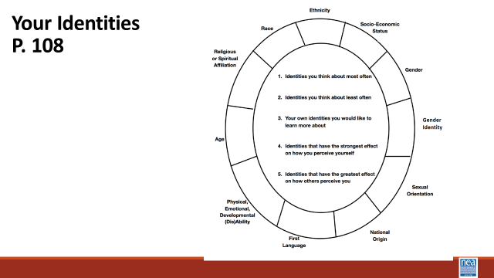  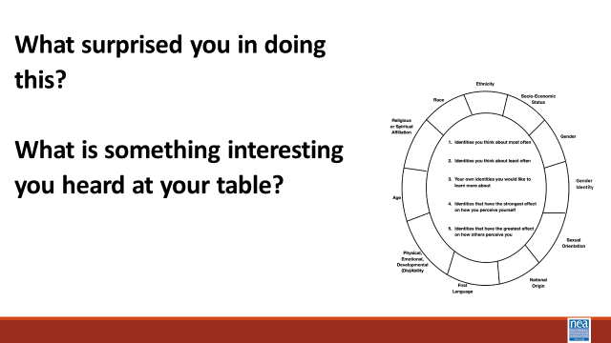  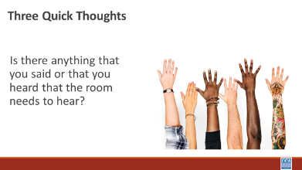  WE END TO GO TO MUSEUM NOW  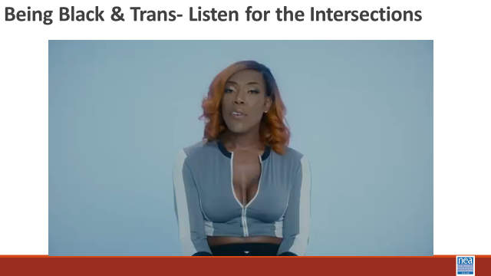  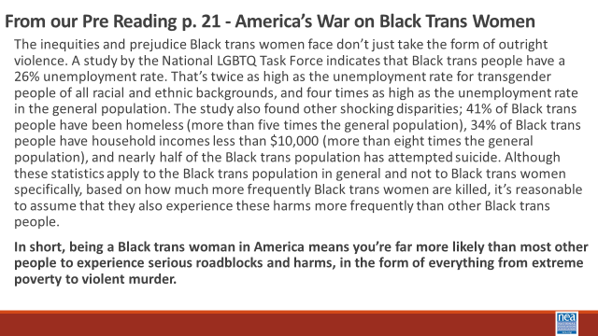  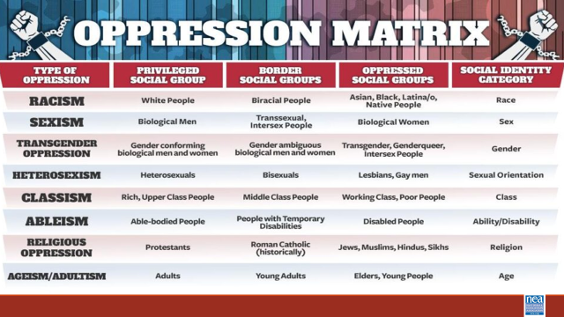  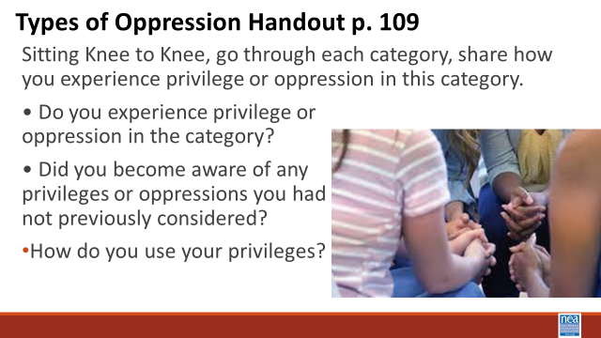    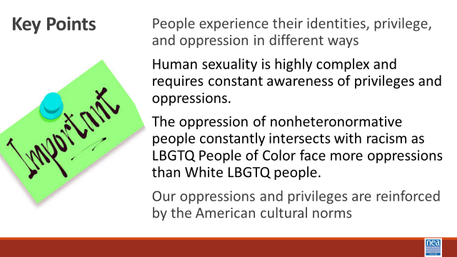 |  | Your Identities Circle worksheet p. 35  Teaching Tolerance: Intersectionality p 37  Pre Attendance America’s War on Black Trans Women p. 21 -26  Types of Oppression Chart p. 36 |  | 35 minutes for this first section ( We combined this as part of the above affinity group conversation and used about 10 minutes of the content – nothing of the learning outcomes were lost)  2 Minutes -Introduce topic with video and definition- What is Intersectionality?  We are going to move back into a couple of foundational concepts – identity and intersectionality.  Show intersectionality video  https://www.youtube.com/watch?v=EXJ4Dbdm1ks  Share the slide with the definition - Intersectionality is a framework for understanding a person, group of people, or social problem as affected by a number of discriminations and disadvantages. It takes into account people's overlapping identities and experiences in order to understand the complexity of prejudices they face. See p.37 for more information about this concept.  We did not do this shield because identity was the focus of the morning whole room restorative justice circle. 10 Mins – individual p then small group talk - Using the Personal Identities Handout p 35 –We are going to take a look at a number of the identities that make us who we are. Around the circle are a number of identities and in the middle are a number of questions. (*Notes to facilitators: the p. 35 on in the participant guide does not currently match the slide. It’s missing the questions. Check this during your prep.*)  For the first 5 to 6 minutes, you are going to do this exercise on your own. You will Place the number of the question in the box by the identity or identities that best answers that question.  Once you are finished, share your circles with your table mates. We are going to share at our tables for about 10 minutes  What surprised you in doing this?  What is something interesting you heard at your table?  5 Mins – Three quick thoughts- (Facilitator just pick three) Is there anything that you said or that you heard that the room needs to hear?  Did not do any of this due to museum visit - but I would suggest it be kept and discussed in affinity groups.  5 Mins – Intro and video watching - What Intersectionality is not– We have talked about what Intersectionality is. Let’s take a minute and talk about what it is not. It is important to understand that Intersectionality is NOT the “Oppression Olympics.” Due to the complexity of our identities, it is common for people to be privileged in some areas and oppressed in others. For example, a white woman may benefit from white privilege and may experience sexism because she is a woman. I am going to share video and I am asking you to listen for how the intersections of this person’s identity inform and compound the oppressions that they face.  Show the video of Black Trans Person  5 Mins – Share the America’s War on Black Trans Women – and ask folks to read it to themselves. As the facilitator just read the bold part out loud as a way to bring closure to this section.  “The inequities and prejudice Black trans women face don’t just take the form of outright violence. A study by the National LGBTQ Task Force indicates that Black trans people have a 26% unemployment rate. That’s twice as high as the unemployment rate for transgender people of all racial and ethnic backgrounds, and four times as high as the unemployment rate in the general population. The study also found other shocking disparities; 41% of Black trans people have been homeless (more than five times the general population), 34% of Black trans people have household incomes less than $10,000 (more than eight times the general population), and nearly half of the Black trans population has attempted suicide. Although these statistics apply to the Black trans population in general and not to Black trans women specifically, based on how much more frequently Black trans women are killed, it’s reasonable to assume that they also experience these harms more frequently than other Black trans people.  In short, being a Black trans woman in America means you’re far more likely than most other people to experience serious roadblocks and harms, in the form of everything from extreme poverty to violent murder.”  Facilitator says -This is what intersectionality helps us understand.  We did not do this section and it should be done in years when we don’t go to Museum. This is an affinity group conversation to whole group.  40 Mins for this section– 2 minutes Intro and Discussion -We are going to take some time to talk about identity, intersection, and oppression as you experience it in your workplace.  15 Minutes  • Do you experience privilege or oppression in your work? How does it show up?  • Have you become more aware of any privileges or oppressions you had not previously considered?  - How do you use your privileges in your work?  20 Mins – Whole Room Discussion – What have you been thinking about that you think the whole room needs to know about?  2 Minute – Key Points  Identities, privileges, and oppressions are intersectional.  The oppression of nonheteronormative people constantly intersects with racism as LBGTQ People of Color face more oppressions than White LBGTQ people.  Our oppressions and privileges are layered and reinforced by the American cultural norms |  |  |  | Participants will learn how intersectionality provides for an understanding of how overlapping identities inform our relationships with privilege and oppression.  What makes What is intersectionality? How do our identities intersect?  What are the oppressions that are involved with gender identity and sexual orientation? How do they intersect with racism?
2:15-2:30 | BREAK
4:15 – 4:30 Ellen |  | 15 Minutes – Closing and Connections
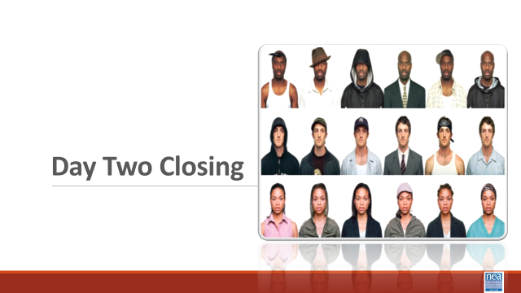  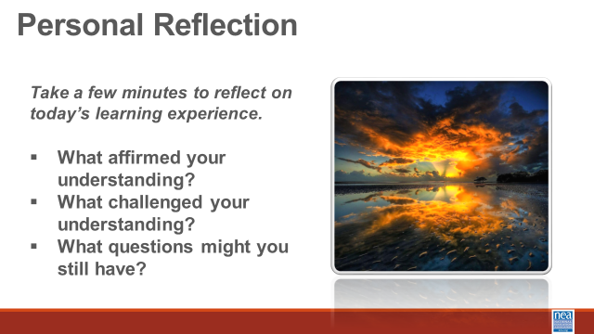  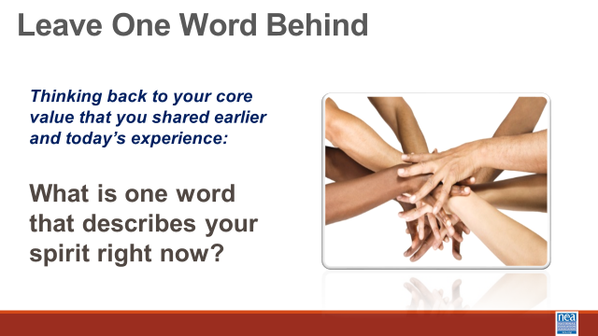 |  |  |  | 15 Minutes – Closing and Connections  What did you experience today that affirmed your understandings?  What did you experience that challenged your understandings?  What questions do you still have? |  |  |  | Participants will reflect on their learning and engage in a conversation with their colleagues.
4:30 | Choice Networking
5:00 | ADJOURN

