You at Your Intersections
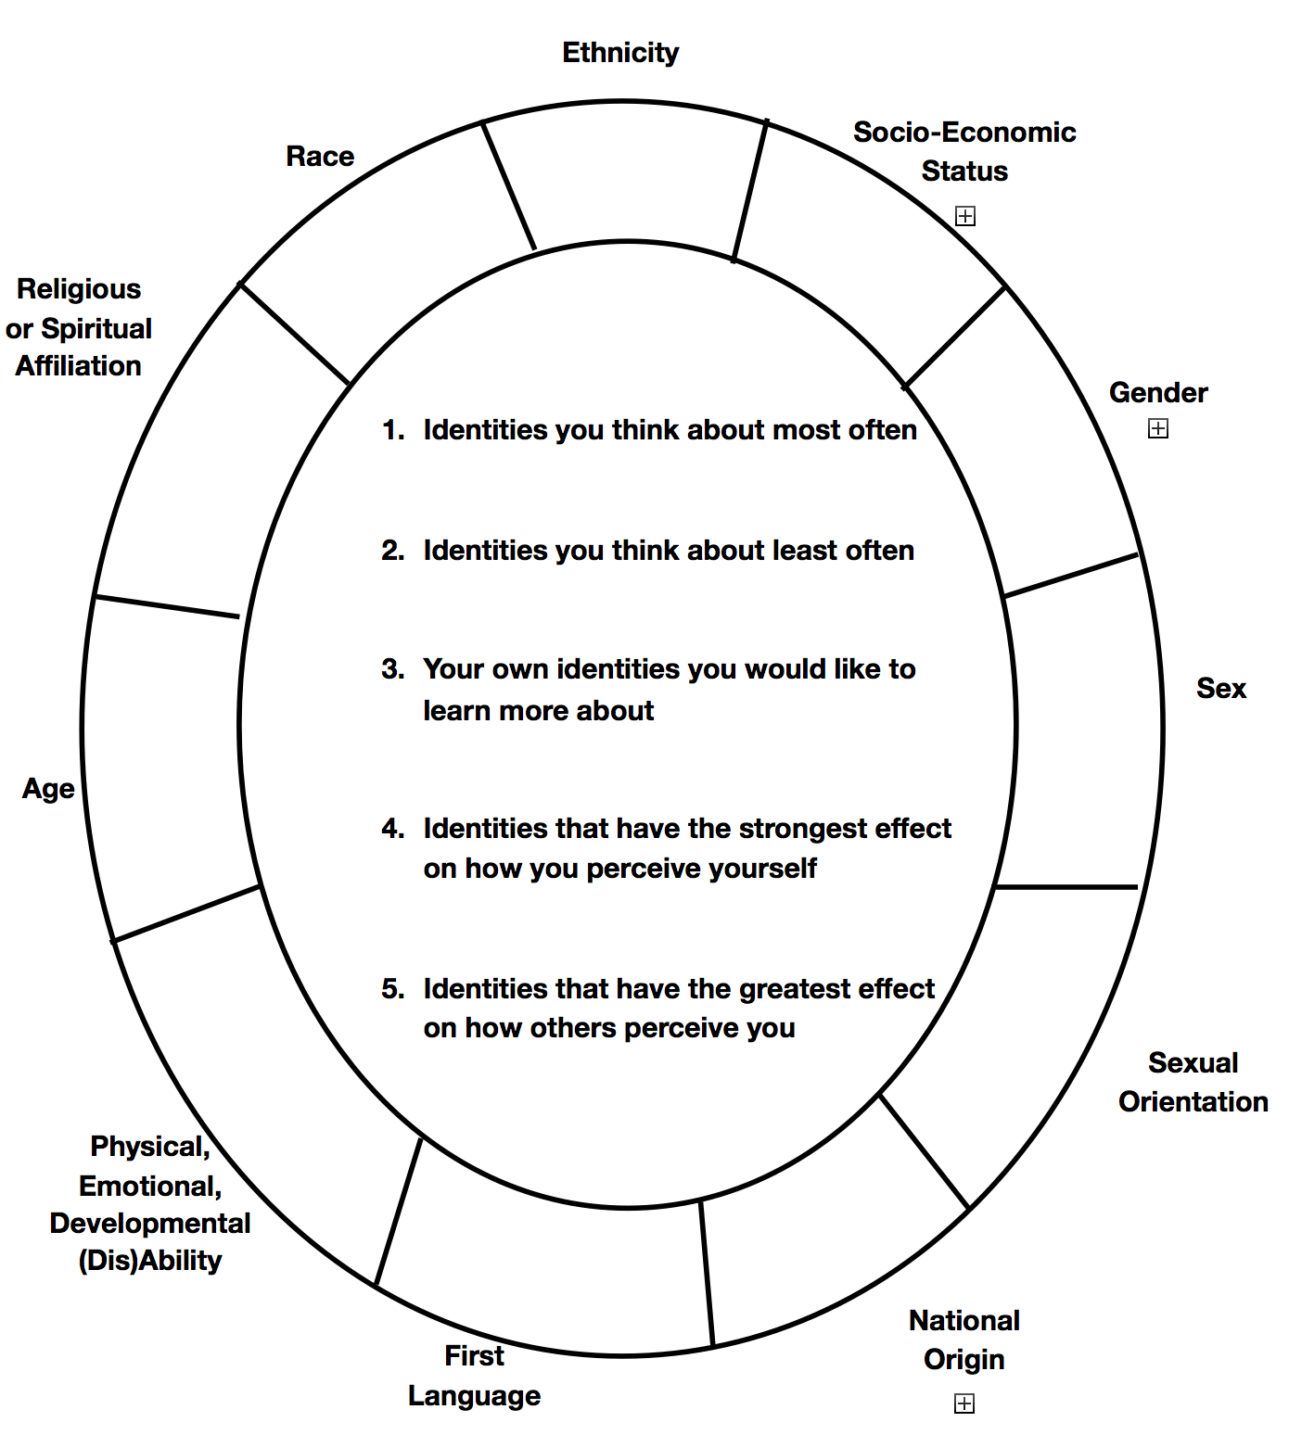
In the space provided for each category, please record how you identify.

Gender
Identity

