Levels of Racism
Individual
Internalized Racism lies within individuals. These are our private beliefs and biases about race and racism, influenced by our culture. | Interpersonal Racism occurs between individuals. Once we bring our private beliefs about race into our interactions with others, we are now in the interpersonal realm.
Systemic
Institutional Racism occurs within institutions and systems of power. It is the norms, policies and practices that are structured into political, societal and economic institutions that have the net effect of imposing oppressive conditions and denying rights, opportunity, and equality to identifiable groups based upon race or  ethnicity. | Structural Racism is racial bias across institutions and society. It’s the cumulative and compounded effects of an array of factors that systematically privilege white people and disadvantage people of color.

Key Points to Remember
Key Point 1 - There are not hard and fast lines between the levels - and changing one can affect another.

Key Point 2 - The way to effect change is by addressing institutional and structural racism - this is where injustice lives.

Expressions of Racism Exercise
INSTRUCTIONS: Please review the cases below and as a group, have a discussion on each case and decide which level of racism each case belongs to. Please ensure there is consensus in your group in your answers.

Scenario #1: Racism in Medicine
Expression of Racism:

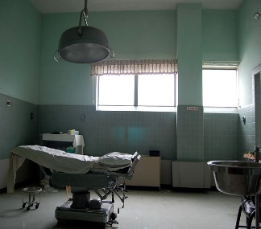
Racism has influenced U.S. health care in the past and continues to do so today. The most shameful chapters in American history involve the U.S. government funding studies that allowed poor black men in Alabama to succumb to syphilis or Guatemalan prison inmates, mental health patients and soldiers to be afflicted with the disease and other sexually transmitted infections.
Government agencies also played a role in sterilizing black women in North Carolina, Puerto Rican women and Native American women.

Reflections:

Scenario #2: Assault in Charlottesville
Expression of Racism:
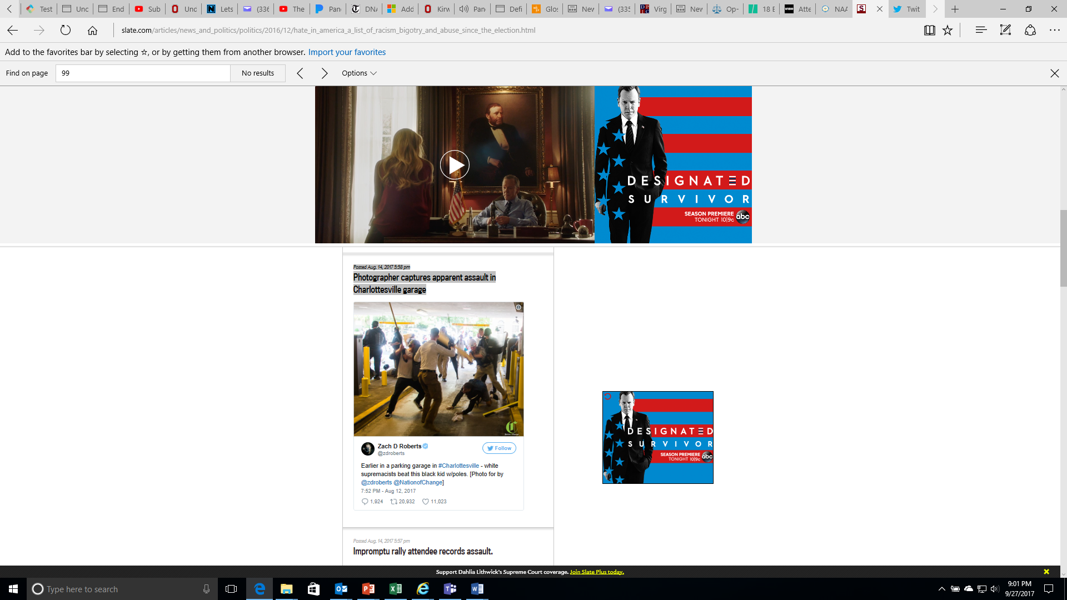
Reflections:
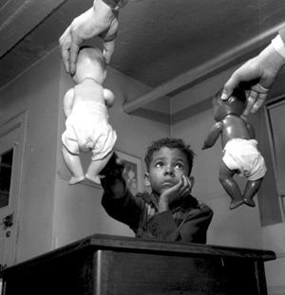
Scenario #3: The Doll Test
Expression of Racism:
In the 1940s, psychologists Kenneth and Mamie Clark designed and conducted a series of experiments known colloquially as “the doll tests” to study the psychological effects of segregation on African-American children.
Drs. Clark used four dolls, identical except for color, to test children’s racial perceptions. Their subjects, children between the ages of three to seven, were asked to identify both the race of the dolls and which color doll they prefer. A majority of the children preferred the white doll and assigned positive characteristics to it. The Clarks concluded that “prejudice, discrimination, and segregation” created a feeling of inferiority among African-American children and damaged their self-esteem.

Reflections:

Scenario #4: Looking Death Worthy
Expression of Racism:

According to a 2006 report, Looking Deathworthy, defendants with the most stereotypically Black facial features (i.e. dark skin, large/full lips, etc.) served up to 8 months longer in prison for felonies than defendants who possessed the least stereotypical features.

In this same study, researchers investigated the role of race in capital sentencing, and in particular, whether the race of the defendant or victim influences the likelihood of a death sentence. The study concludes that in cases involving a White victim, the more stereotypically Black a defendant is perceived to be, the more likely that person is to be sentenced to death.

Reflections:

Scenario #5: Biracial Boy Pushed Off Table
Expression of Racism:
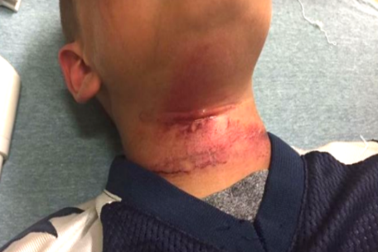
Associated Press September 12, 2017
CLAREMONT, N.H. — Teenagers in New Hampshire taunted an 8-year-old biracial boy with racial slurs and then pushed him off of a picnic table with a rope around his neck, injuring him, the boy’s family said.
The child was treated at a hospital for cuts to his neck following the near-hanging Aug. 28 in Claremont, the boy’s grandmother, Lorrie Slattery, told the Valley News of West Lebanon, N.H. He has since been released and has returned to school in Claremont.

Slattery said the children were in a backyard when some of the teens got on the table and grabbed a rope that held a tire swing. It’s not clear how the rope got around the child’s neck, but Slattery said the teens pushed him off the table. No adults are believed to have witnessed the incident.
An expert on abuse who spoke to the boy at the hospital said he swung from his neck three times before being able to remove the rope, Slattery said. None of the teens came to his aid, she said.

Reflections:

Scenario #6: The School-To-Prison Pipeline
Expression of Racism:

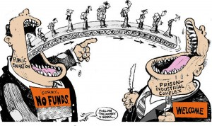
A significant number of Chicago students are pushed into the path of juvenile and adult prisons as a result of harsh disciplinary policies and high stakes testing. By harsh disciplinary policies, we mean excessive security procedures and police involvement as well as the overuse of suspensions and expulsion for minor infractions. These policies feed the “School to Prison Pipeline”, sometimes also called the “Schoolhouse to Jailhouse Track”. Research suggests that students of color, in particular African American students, are disproportionately impacted by these punitive policies.

As Matt Kelley has written: “Whether or not they realize it, the punishments school officials hand out can literally determine — and derail — the path of a student’s life. Which makes it even more critical that when schools make these decisions, they hand out discipline that’s fair.”
The “School to Prison Pipeline” describes a reality in which many young people are being pushed OUT of schools through zero tolerance policies, suspension, expulsion, discouragement and high stakes testing requirements; and INTO the juvenile and adult legal system. These zero tolerance policies involve the police in minor incidents and often lead to arrests, juvenile detention referrals, and even criminal charges and incarceration.

Reflections:

Scenario #7: Woke Girls
Expression of Racism:

Excerpts from an article written by educator Mickey Maki, creator of Woke Girls. https://medium.com/embrace-race/woke-girls-pushing-back-against-internalized-racism-in-children-of-color-ac048a599ab8

Before school started every morning a 1st-grader student in my class, with very dark skin would visit me so I could apply cocoa butter lotion to his skin. I assumed it was just about the lotion, but when I tried to give him a bottle he could keep in his classroom, he cried and told me I was the only one who thought his skin was beautiful.

Just down the hall in the 3rd-grade ESL class, two Mexican American girls got into a fight. The cause? One girl called the other a “little Mexican girl.”
It made me sad to see that little had changed since I was a child myself, when I was policed for not being black enough, while simultaneously taught that being black meant fewer options and bad hair.
Besides modeling self-love and loving my students, I made an effort to fill my classroom library with books that would support my students to be who they already were. That was quite the challenge.

Reflections:

Scenario #8: Doorway To A Better Life?
Expression of Racism:
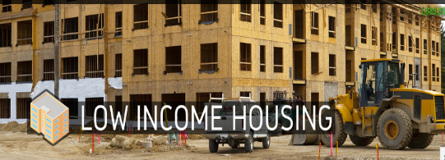
A state government agency decides that low-income housing must be built, which will house low-income Blacks and Latinos. The agency fails to look for locations near jobs and important infrastructures, like schools, decent public transportation, and other services. In fact, it is built in a poor, mostly Black and Latino part of town.

Often times the government locates the housing where it will have the least opposition. White neighborhoods tend to oppose public and affordable housing. Resources, whether public or private, often follow whites who flee urban problems for white suburbs
When the housing is built, the school district, already under-funded, has new residents too poor to contribute to its tax base. The local government spends its limited resources on transportation to connect largely white, well-to-do suburban commuters to their downtown jobs.

The public housing residents are left isolated, in under-funded schools, with no transportation to job centers. Whole communities of people of color lose opportunities for a good education, quality housing, living wage jobs, services and support-systems.

In this town, no one individual stands in front of the doorway to a better life and says, “No Blacks/Latinos/ Native Americans/Asians allowed.” Race, however, is the unspoken motivator behind a series of actions which lead to decisions about where to place the walls.

Reflections:

