https://prospect.org/article/why-unions-must-bargain-affordable-housing-and-how
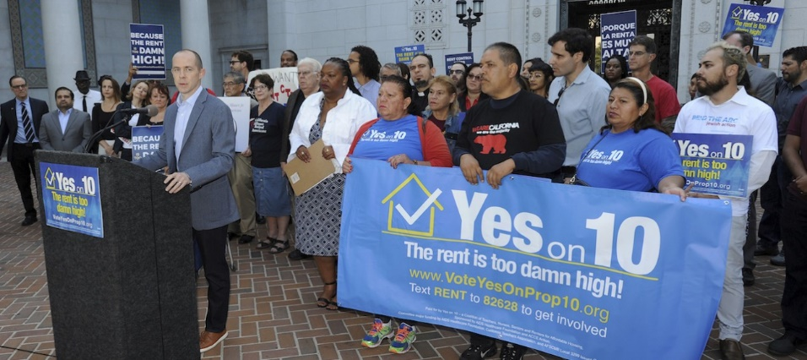
Why Unions Must Bargain for Affordable Housing—and How
With housing costs gobbling up wage increases for union members and almost everyone else, labor must prioritize housing affordability.
Stephen Lerner & Christina Livingston February 19, 2019
For many millions of Americans, winning decent, safe, and affordable housing is an urgent necessity. Housing costs are putting the squeeze on working families in urban and suburban settings alike, especially in communities of color that have long been targeted by predatory housing schemes. Since the financial crisis, housing affordability has grown even worse for workers, as gentrification, rising rents, and the corporatization of rental properties—both multifamily and single-family homes—displace communities of color and increase homelessness.
It’s time for the American union movement to put the issue of affordable housing at the center of its quest to better the lives of American workers. In much of the country, the wage gains that its members may win in their contracts lag far behind the increasing costs they confront when they rent or try to purchase a home. By expanding the scope of the issues they bargain for, by making common cause with the many community organizations demanding more affordable housing, unions can play a crucial role in creating more such housing for their members and the broader public, in the process establishing new connections with a working class badly in need of unions.
IN THE YEARS FOLLOWING the 2008 recession, developers and private-equity landlords such as Blackstone and Cerberus seized the opportunity to buy up recently foreclosed homes in key markets heavily populated by working-class and poor people of color. Residents in these communities have seen landlords raise rents to unreasonable levels, while systematically neglecting building maintenance to force out working-class tenants and gentrify their neighborhoods. These problems are markedly worse in communities hammered by hurricanes, rising oceans, wildfires, and other climate change–induced weather. After each climate-related disaster, profiteers have moved in, looking for ways to build luxury properties to replace the affordable housing destroyed by storms. Communities in Puerto Rico, Houston, North Carolina, Florida, the New Jersey Shore, and New York’s Rockaways have all witnessed this pattern.
Despite the acute shortage of affordable housing, national and local real-estate lobbies still advocate trickle-down housing solutions that mirror the failed theory of trickle-down economics. Finance and real-estate companies, often in partnership with so-called “nonprofit housing champions,” have won bipartisan political support for the idea that we can “build our way out” by removing “red tape” and giving tax breaks and incentives for developers to create “market rate” housing (which most people can’t afford) and luxury housing with minimal affordable housing requirements.
These forces have also used their wealth and political power to beat back progressive efforts like California’s 2018 Proposition 10, a citizen-led initiative that would have allowed local governments to expand rent control to cover more tenants. Adding insult to injury, developers and private-equity firms have tapped the capital of public-employee pension funds and college endowments—using workers’ retirement savings to oppose progressive legislation, buy up housing, and price workers out of the cities where they work.
Unions have an undeniable interest in confronting the housing crisis.
Unions have an undeniable interest in confronting the housing crisis. Raises won through collective bargaining aren’t keeping up with ballooning housing costs. All too often workers whose wages have stagnated are forced out of their communities and into sometimes hours-long commutes to work, leading to increased transportation costs, declines in mental and physical health, worsened traffic congestion, deteriorating roads, and greater air pollution. Nor can unions help their members borrow their way into better housing: Many are already saddled with crushing student debt that leaves them little disposable income to apply to a mortgage.
Yet while racial justice, housing, and community groups have been leading the fight for affordable housing in recent years, unions have been slow to join the struggle. We argue that labor should prioritize housing justice, partner with groups that are fighting for it, and build a broader housing movement that addresses inequality and racial injustice. Not only will reducing the cost of housing prevent landlords, lenders, and developers from pocketing the lion’s share of collectively bargained raises from union members, but it will also weaken the political power of those groups—a necessity if unions hope to build meaningful power of their own.

IN RECENT YEARS, coalitions across the country have been using an innovative tool we can apply to the housing issue: Bargaining for the Common Good (BCG). Built around the idea that unions, in partnership with community allies, need to expand collective bargaining demands to include issues that go beyond wages and benefits to confront the structural forces that are driving inequality and worker disempowerment, BCG first emerged among public-sector unions in the aftermath of the financial crisis. BCG campaigns have seen unions bring community partners into the bargaining process to help define the goals of bargaining and raise demands that confront structural inequalities and target the powerful financial interests that are invested in perpetuating them.

Recent months have witnessed an upsurge in strikes that include common-good demands, from the teacher walkouts of 2018, to AFSCME Local 3299’s work stoppage at the University of California, and most recently, the teachers strike in Los Angeles. Here, striking teachers rally in downtown LA. AP Photo/Damian Dovarganes

Recent months have witnessed an upsurge in strikes that include common-good demands, from the teacher walkouts of 2018, to AFSCME Local 3299’s work stoppage at the University of California, and most recently, the teachers strike in Los Angeles. These and other struggles have helped shape BCG demands on issues from creating community centers and green spaces in inner cities, to ending the school-to-prison pipeline, to hiring from disadvantaged communities and ending predatory banking relationships. The BCG approach is now expanding into the private sector as the Communications Workers of America (CWA) and the CWA-backed Committee for Better Banks organize around the idea that workers can play a central role in stopping banks from engaging in predatory lending practices.
Organizing and bargaining for common good on housing can build on and expand the work of developing broad labor-community alignments, and add a new dimension to the housing fight.
Why should community and tenant organizing groups and housing advocates include BCG campaigning in their housing justice fights?
- To win massive increases in affordable housing, they have to expand the base of housing advocates, and BCG campaigns bring in unions at a critical moment.
- BCG campaigns open up another arena in which to battle for affordable housing—the collective-bargaining table. Public-sector employers, universities, hospitals, and major corporations have not been confronted in contract negotiations or organizing campaigns with housing demands.
- The audacity of a well-run BCG fight, like the recent LA teachers strike, makes wins possible at a larger scale than we have been able to win through more-established housing campaign strategies.
Why should unions prioritize the housing issue? In addition to their obvious interest in preserving the value of the wage increases they win and ensuring their members can find affordable housing in the communities where they work, five reasons stand out:
- Fighting for affordable housing offers public-sector unions the opportunity to recruit and retain members in this post-Janus environment by addressing an issue vital to public workers’ lives.
- The same entities with which unions negotiate collective-bargaining agreements play a role in making housing unaffordable. The private-equity giant Blackstone, for example, employs 500,000 workers and is also the nation’s biggest landlord. Universities and hospitals where unions are either organized or organizing are often drivers of gentrification and destruction of affordable housing.
- Non-union corporations like Amazon and other “new economy” firms help drive rising rents and gentrification. By holding them accountable for their impact on housing, unions lay the groundwork for making them accountable for their labor policies as well.
Public pensions are currently investing workers’ capital in companies that are destroying affordable housing.
Public pensions are currently investing workers’ capital in companies that are destroying affordable housing. Redirecting that capital toward affordable housing will end this self-defeating practice.
- Focusing on housing will allow unions to partner with and support the work of racial and housing justice groups, recasting bargaining as not just for those covered by the contract but the entire community—strengthening the unions’ ability to win economic and other gains at the bargaining table.
WHAT WOULD A NATIONAL Bargaining for Housing Justice fight look like and what themes should inform it? Right to the City frames housing as a “human right”; People’s Action calls for “guaranteed housing”; the Partnership for Working Families asserts that housing is a necessity, not a commodity, and that everyone has a right to safe, affordable housing where they choose to live. These and other groups working on housing justice seek to lift up the idea that people’s access to housing shouldn’t be determined solely by “market forces.” This must also be one of any campaign’s central themes.
The campaign should include these six elements:
- Expanding and connecting city, state, and national work. In addition to robust statewide campaigns in New York and California for universal rent control, a growing consortium of groups is working on affordable housing all over the country. It is essential to ground labor’s efforts by supporting and expanding the ongoing work in cities like Detroit, Minneapolis, and Chicago, and other places where housing is now a priority for organizers on the ground. In these cities, the crisis gives organizers an opportunity to expand their bases and to connect to other cities fighting similar fights. Linking work in different geographies by focusing on common landlords, investors, developers, and banks that finance them offers the potential to magnify the work nationally and increase the power of local work.
- Organizing tenant unions to negotiate directly with corporate landlords. Private-equity landlords like Blackstone and Cerberus operate all over the country. Blackstone is the nation’s largest single-family landlord and the largest owner of housing more generally, with investments in tens of thousands of single-family homes, apartments, manufactured home communities, and mortgages. A number of private-equity companies have been buying up manufactured housing parks and then jacking up the rent on the land and inflating other charges for people unable to move their homes to new locations. Unions know how to confront corporate giants like these. Both Hilton Hotel workers and office-building janitors have successfully faced off against Blackstone before. Tenants who live in homes owned by Blackstone and similar entities have also successfully confronted these behemoths. In recent years, a number of tenant unions have pulled off successful rent strikes. MHAction, an organization of mobile-home tenants in rural and exurban areas from California to Florida to New York, has won rent victories in Humboldt County, California, and is conducting an ongoing rent strike in Akron, New York. Tenant unions can and should negotiate over rent control, needed repairs, and a grievance procedure to address ongoing disputes. Labor unions and tenant unions could partner on national campaigns demanding that private-equity companies respect the rights of unionized and non-union workers alike, and agree to bargain with newly formed tenant unions. Together, tenant unions and labor unions could pressure endowments and public-employee pension funds that invest in private equity to divest from companies that won’t respect the rights of their tenants and workers.
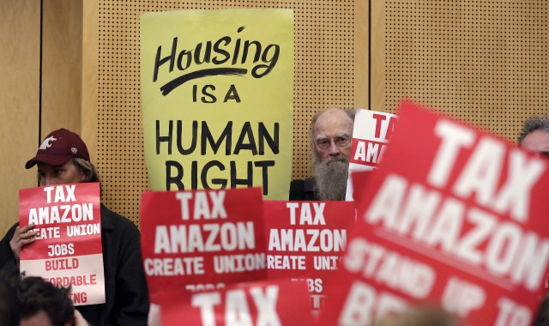
By holding large companies like Amazon accountable for their impact on housing, unions lay the groundwork for making them accountable for their labor policies as well. Here, members of the public voice support for a measure to tax large businesses like Amazon and Starbucks to fight homelessness during a Seattle City Council meeting. AP Photo/Elaine Thompson, File

- Fighting for universal rent control and state and local rent control laws. Rent control is critical to protecting the existing stock of affordable housing. There is growing support and political pressure to pass and expand rent control policies around the country. While California’s rent control initiative—Proposition 10—was defeated in 2018, it received nearly five million votes despite the misinformation spread by the landlord lobby and the more than $70 million raised by its corporate opponents. The Proposition 10 fight nonetheless lifted up the importance of rent control as a critical tool to save affordable housing. Other fights must follow. In New York, there is now a statewide effort to strengthen rent laws. Legislation for rent control is also being introduced in Illinois, Minneapolis, Philadelphia, and Orlando.
- Targeting corporate landlords’ reliance on tax breaks and public-pension-fund capital. Corporate landlords benefit from huge local and federal tax breaks and get much of their capital from public-employee pension funds. Both the local and national campaigns should prioritize persuading pension funds to divest from corporate landlords, invest in affordable housing, and push to change laws that subsidize luxury development at the expense of working-class communities. This effort must demonstrate the long-term economic benefit of increasing affordable housing, even if initial returns are lower than investing in predatory corporate landlords. Continued investment in predatory housing schemes threatens the long-term stability of pension funds and undermines the interests of the workers whose retirement incomes they invest.
- Experimenting with innovative community-centered solutions. Community organizations and policy partners over the past years have developed many strategies to reverse the housing crisis. A major part of the campaign will be expanding these efforts nationally. This includes but is not limited to strengthening the Community Reinvestment Act, developing stable community land trusts and housing trust funds, and funding and expanding public housing. In 2018, the California-based community organization Alliance of Californians for Community Empowerment (ACCE) was able to organize against a local predatory landlord and, working with the Oakland Community Land Trust, acquire that landlord’s properties for the trust—thereby making the housing permanently affordable and avoiding yet another Bay Area eviction for profit. Such efforts need to be duplicated in other settings.
- Working for federal housing legislation. Introducing a federal housing bill that addresses rent control and massively expands funding for public housing will help nationalize the issue, setting the stage for housing justice as a central theme in the 2020 elections. Such legislation will also help highlight the role corporations are playing in driving up rents and challenge the idea that the solution to the crisis in public housing is to privatize it or dismantle it altogether. Making housing a key issue in 2020 will be critical to building momentum and support for increased affordable housing.
We do not claim to offer a silver bullet by presenting these strategies, nor suggest that one initiative alone can address the overall housing crisis. Yet knitting together the elements of local and national housing fights, and illuminating how they interconnect, is crucial to figuring out where traditional housing groups and labor can work together to build the power necessary to address this issue.
Historically, unions have played a role in the development of affordable housing in cities with significant union membership.
THIS WOULD NOT BE the first time that unions have grappled with the housing issue. Historically, unions have played a role in the development of affordable housing in cities with significant union membership. In addition, unions are involved in a variety of ongoing efforts to fund and support affordable housing.
- The Amalgamated Clothing Workers and the International Ladies’ Garment Workers’ Union developed cooperative housing units for their members in New York in the late 1920s. Subsequent to this, IBEW Local 3 built upon their model in the late 1940s and 1950s, developing 38 buildings with roughly 2,500 units. In 1951, 19 unions worked alongside community organizations to create the United Housing Foundation, building tens of thousands of cooperative housing units over the ensuing two decades.
- The AFL-CIO’s Housing Investment Trust (HIT) fund has put Taft-Hartley pension funds to work in developing affordable housing and elderly housing, using an exclusively union workforce. Building upon the work of its predecessor, the Mortgage Investment Trust, the HIT has focused on Boston, Chicago, New York, Minneapolis-St. Paul, St. Louis, and the Bay Area, investing in more than 70,000 affordable units—some for designated groups of workers, such as teachers, others for that sector of the public priced out of much market-rate housing.
- In Seattle, locals of AFSCME, the Laborers, the Teamsters, SEIU, UAW, and UNITE HERE have worked together with community allies (including the Low Income Housing Institute, Transit Riders Union, Sierra Club, the Church Council of Greater Seattle, and the Coalition of Immigrants, Refugees and Communities of Color) as members of the U District Alliance for Equity and Livability, a coalition focused on ensuring that existing communities stand to benefit from the substantial growth and expansion of the University of Washington. The U District Alliance has won Seattle City Council support for a UW expansion plan that includes free transit passes for over 10,000 UW workers and 450 units of affordable workforce housing.
- The Chicago Teachers Union (CTU) has proposed in its upcoming contractual bargaining that the city’s Board of Education support rent control efforts and ensure the city enacts a real-estate transfer tax, a corporate head tax and a millionaire’s tax to fund more affordable housing.

CENTRAL TO ANY LABOR EFFORT to advance housing justice must be the development of bargaining campaigns that expose the role key employers may play in making housing unaffordable and identify ways they can contribute to creating affordable housing. In order to do this, unions must ascertain whether the employer’s expansion is eliminating affordable housing, whether its pension plan or endowment is invested in institutions (banks, private-equity firms) that are driving housing unaffordability, and whether the employer’s board members are involved in business activities that lead to displacement and higher rent.

Unions must also prepare their members for this kind of innovative, community-centered campaign so members are engaged and committed. Tacking on community demands that members haven’t invested in doesn’t work. If these demands are to be more than mere window dressing jettisoned when bargaining gets tough, the union must go deep with members long before negotiations begin to make clear how such demands could benefit them as both union members and members of the community.
Specific bargaining demands can then be tailored to employers of different kinds. Consider these possibilities:
- Universities and hospitals often eliminate affordable housing through expansion into surrounding neighborhoods. Unions could develop bargaining demands and bargaining campaigns that call on these institutions to finance and rebuild any affordable housing lost to expansion, develop workforce housing that allows workers to live closer to their jobs, and end support for or membership in business associations (such as the Chamber of Commerce or ALEC) that oppose rent control and affordable housing initiatives.
- Public-sector unions can expand their ongoing battle against privatization to fight the selling off of public property to private developers—often with additional tax subsidies that undermine government’s revenue streams. These unions could demand that public property be preserved for community land trusts and affordable housing, insist that governments secure workforce housing that allows their workers to live in the communities they serve, and use their pension funds to advance affordable housing.
- Amazon’s announcement that it is canceling its HQ2 in New York in the face of community and labor protests over the $3 billion in subsidies the company demanded shows how a community-labor alliance can flip the script. Future Amazon-targeted campaigns can link demands for better working conditions with demands that Amazon invest in affordable housing and other community benefits. This is already happening in Minneapolis and St. Paul. There, the Atwood Center has demanded that Amazon contribute millions of dollars to local initiatives determined by community groups in the Twins Cities’ East African community, which provides the majority of Amazon’s warehouse workers in the region.
- Banks have long played a major role in undermining affordable housing through foreclosures, redlining, and other forms of discrimination. As part of a campaign to organize bank workers, CWA and the Committee for Better Banks are exposing practices that force bank workers into selling products that aren’t in their customers’ best interest. Bank workers could demand the right to refrain from peddling predatory mortgages.
- As part of bargaining, unions can demand that employers stop investing in and partnering with private equity firms that destroy jobs and affordable housing.
Some might argue that it is foolhardy for unions to challenge corporations on multiple fronts beyond wages and benefits. To the contrary, we believe that an unambitious strategy condemns unions to a continued slide toward irrelevance, and that it was precisely the boldness of the teachers’, hotel workers’, and other campaigns over the past year that led to their successes. Only by engaging in campaigns that confront the unjust structures that increasingly dominate every part of workers’ lives can unions hope to rebuild power and transform the country. Organizing and bargaining for housing justice will be central to that task.

