Facilitator Agenda: Advancing Racial Justice 2027 Day #1
General Materials Needed: |  |  |  |  |  |  | Room Set-up:
1 Set of Handouts per Person  Name Tags and Name Tents  Sign-in Sheet  Pens and Pencils |  |  | Chart Paper  Markers  Post its  Index Cards |  |  |  | Round Tables  Projector, Screen and Speakers  Carousel stations and reporting stations around the perimeter  50 people
The NEA Center for Organizing and the NEA Center for Social Justice are partnering to provide a training designed to build participants’ skills through awareness of implicit bias, interpersonal racism and institutional racism. Participants will learn how to deepen this awareness in others, how to navigate issues of race that surface in our work, and how to access valuable resources on addressing racism. Participants will learn how to help themselves and others:
· Establish a common language for talking explicitly about race
· Develop a shared understanding of the levels of racism and its impact
Develop a common toolset for next steps in applying an equity lens to our work
8:30- 9:40 Getting Started  9:40-10:00 Move Up  10:00-10:15 Break  10:15-11:10 What is Oppression  11:10 -12:00 Race Ethnicity and Nationality  12:00-1:00 Lunch |  |  |  |  |  | 1:00-1:25: Expressions of Racism and Scenarios  1:25-1:55: Systems that Oppress  1:55-2:30: What is White Culture  2:30-2:45: Break  2:45-3:20: Identity and Intersectionality  3:20-3:45: Coconspirators  3:45-4:15: Disrupting Microaggressions  4:15-4:30: Closing
Time, Slides, Facilitator |  | Resources, Charts, Handouts |  | Total Time, Section Title Instructions, Activity and Debrief |  |  |  | Outcomes and Essential Questions
 |  | Charts, handouts, articles, materials, slide |  | What are you saying, what are they doing, what questions will you use to guide learning and make clear the important points  Include an estimate for how long each section of the learning will take |  |  |  | As a result of this section of learning, what will participants know or be able to do and what questions will they be able to answer?
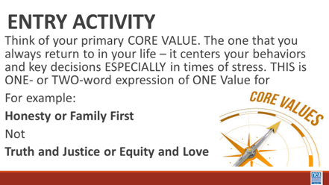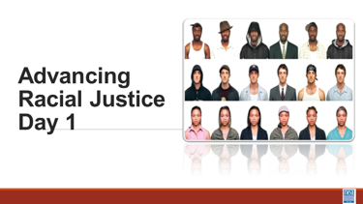 |  |  |  | Entry Activity – Think of Core Values  Core values are the fundamental beliefs of a person. These guiding principles dictate behavior and can help people understand the difference between right and wrong. These are going to be expressed in one or two words that support that SAME IDEA – example Honesty, Protect Home – NOT Love and Justice |  |  |  | What are our core values?
8:30 – 9:40 |  | 70 Minutes Total - Greet Gather Ground
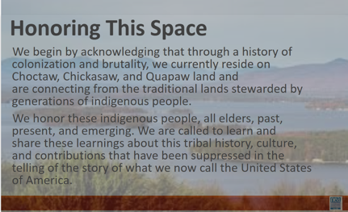  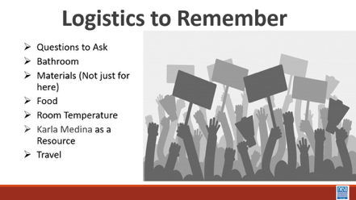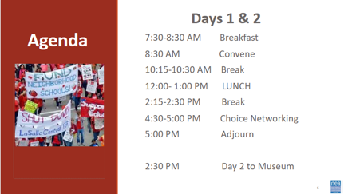  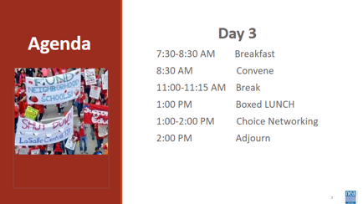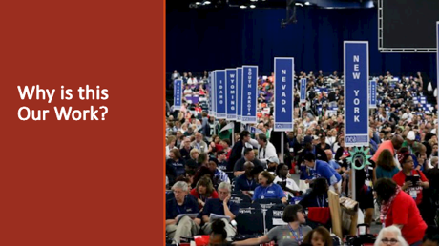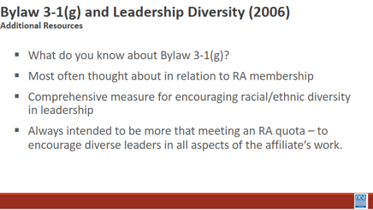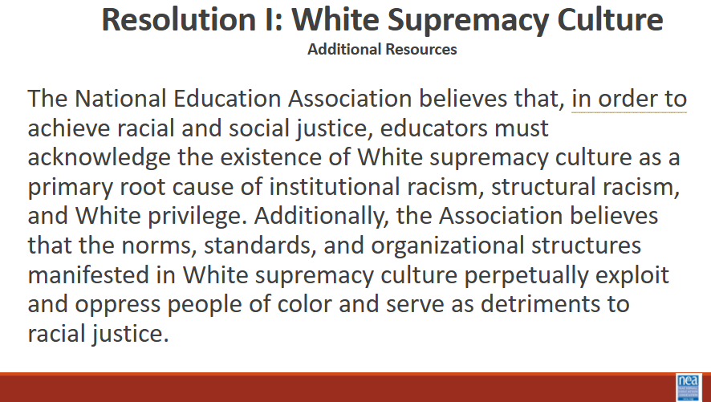  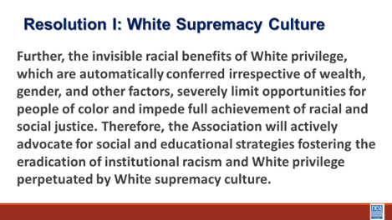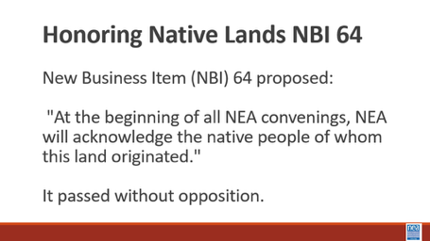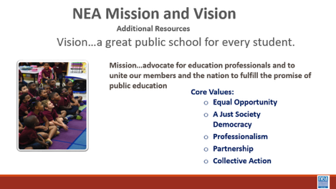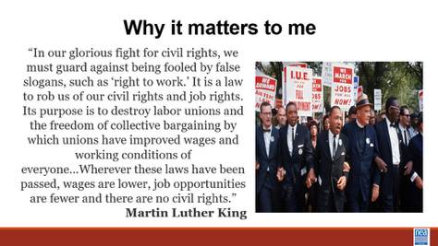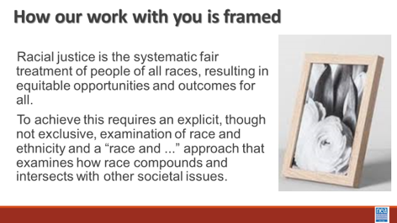  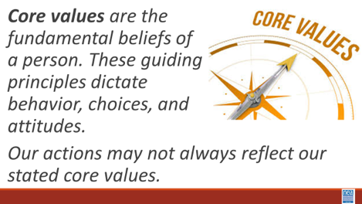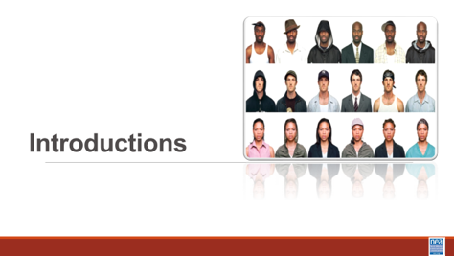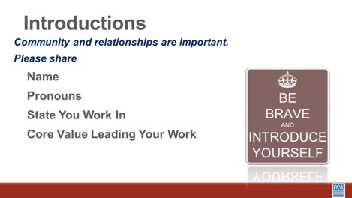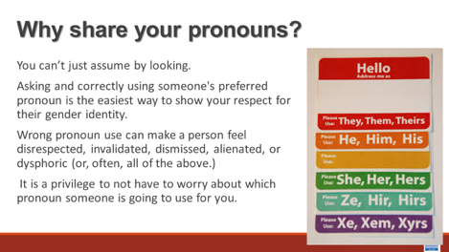  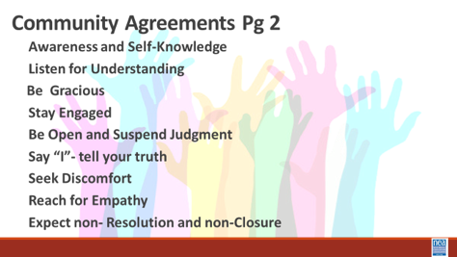 |  | 2 Charts for core Values  Participant Handouts:  Pronoun Guide that is a separate handout  Framework for Change p. 112  Community Agreements p. 2-3  Resolution 1 – Additional Res.  NBI b – P. 55  Additional Res.  Vision Mission Values – Additional Res  Bylaw 3-1(g) Additional Res.  Added handouts that are separate  Safe Just and Equitable schools |  | 15 Mins – Welcome, honor the space, overview of learning goals, overview of days agenda and logistics –  Why are we here - Framework for Change - P. 112  We move through stages of awareness, capacity building into action. In this training we are helping you become aware of where you are in regards to racial justice, we will be increasing our capacity by building our skills and understanding, and we will begin to make plans for actions we can take.  Acknowledgement - Before we dive into what this means to you; we begin with this acknowledgement. The content we are going to explore may bring up strong feelings. Throughout our time together, we will explore examples of racism, ableism, heterosexism, and sexism. By exploring these together, we can begin the process of unlearning our own internal oppression.  The purpose of unlearning isn’t about forgetting what we know or about being wrong; it’s a conscious act which requires critically examining the ideas and assumptions that influence our expectations, behaviors and beliefs about ourselves and other people. By doing this, we can challenge the cultural and  structural norms that perpetuate racism and oppression.  Unlearning is something we can all be committed to because we all  have a part to play in dismantling everything that helps maintain  racism within society.  It is not the responsibility of participants who represent marginalized communities to educate you. You must take responsibility for your own learning. You may hear us say *GTS—Google that shiz.  Family Meeting- Extra for ARJ with member/staff teams: Different space than what we are used to. Folks are members. Folks are staff. Maybe a new type of nervousness that we can’t predict? Try to solve problems in room, not by going to management at get.  Also: using affinity groups. Goal isn’t to stay separate but to avoid unintended harms that power and oppression can have in the room.  Identifying early: this is Advancing RACIAL justice. Not to say that other types of oppression aren’t valid. But race is the root of it all. Race is the prime. It cannot be divided. It is the most visible. So we use it as a core.  We are all coming from different space/place of privilege  How do we talk about this space? Expectations for confidentiality. Sharing learnings, not stories.  The administration has re-exposed the fissures between disparate people.  Natural Guard presence  Why are we here: NEA’s Framework for Change (p112)  8 Mins- Setting the Stage, in additional resources (7th file when scrolling)  30 secs: NBI vs. Resolutions  Resolutions: Feel good and not funded  NBIs: Have money and action behind it  2 minutes each on Resolution I – Overview of NEA 3.1 G, NBI B 2015, Build the understanding that NEA views racial justice as a priority. Provide a brief each overview of each: Resolution 1 - 3.1 G, NBI B 2015.  Safe, Just and Equitable Schools – Adopted in 2022  In our time together over the next couple of days, we will take a more in depth look at racial justice. Racial justice is the systematic fair treatment of people of all races, resulting in equitable opportunities and outcomes for all. In order to have this discussion, we need to do an explicit, though not exclusive, examination of race and all aspects of our identity and look at how it compounds and intersects with other societal issues.  Our essential question throughout this examination is this: as a Participant what does racial justice mean in your work?  10 Mins -Introductions around the room – Share Name, work location, pronouns, and core value (refer to pronoun sheet)  Pronoun explanation is dropped in by the facilitator just in case it is needed BEFORE THE facilitators model-We cannot assume how someone identifies, we must allow them to tell us their identity and honor that. We need to be inclusive of all genders and non-genders. Preferred pronouns is no longer the term used. Just “pronouns” We need to adapt this language and possibly the slide to delete the modifier of “preferred.” --Jackie  Show the Preferred Pronoun slide and say:  You can't always know what someone’s Gender Pronoun is by looking at them. · Asking and correctly using someone's pronoun is one of the most basic ways to show your respect for their gender identity. · When someone is referred to with the wrong pronoun, it can make them feel disrespected, invalidated, dismissed, alienated, or dysphoric (or, often, all of the above.) · It is a privilege to not have to worry about which pronoun someone is going to use for you based on how they perceive your gender. If you have this privilege, yet fail to respect someone else's gender identity, it is not only disrespectful and hurtful, but also oppressive.  Trainers will begin by modeling what is expected - briefly introduce themselves, their preferred pronoun, the state they are from and their Core Value (Core values are the fundamental beliefs of a person. These guiding principles dictate behavior and can help people understand the difference between right and wrong – one or two words) as a way of modeling for participants – less than 20 seconds per person.  Make sure that there is help for the facilitator in charting the Core Values. Charters places their own core value on chart.  2 Mins – After all have introduced themselves and the two charts have been populated – Facilitator points out - The opposite of these core values that I see gathered on our chart are – inequality, exclusion, division, dehumanization, and hate – these “opposites” from the basis for racism, sexism and other “isms”)  20 Mins - Community Agreements for Our Time – Give this about 5 to 10 minutes -Ask participants to review the community agreements sent in advance and to review the three questions that they were asked to think about. Have a small table conversation in preparation for a whole group commitment.  Encourage & Practice Awareness & Self-Knowledge  Listen for Understanding  Being Kind & Gracious  Stay Engaged  Staying Curious and Suspending Judgement  Say “I”- tell your truth  Leaning into Discomfort  Reach for Empathy  Expect Non-Resolution & Non-Closure  Allow about 5 to 10 Mins – Participants will share their responses, suggestions, changes, etc. Then facilitator will call for a visual community commitment. This is a shift from colonizer norms that aim to preserve the order of the conversation and maintain the focus of the power. These are commitments that we have each reviewed and will change as needed. By consensus we will agree to work with these until we need to make a change. Consensus means we all agree that these are good enough to get us moving. Show your thumbs and hold them up and keep them up until I have had a chance to view the whole room. Up thumb means – love it, nothing needs to change for me. Sideways thumb means – I can live with it for now. Down thumb means I cannot move forward until we discuss and come to a decision about…- and the down thumb leads the discussion on that UNTIL it can at least become a sideways thumb.  End each day with a return to the community agreements. Begin each day with the community agreements, use these to ground the participants and facilitators. Consider the community agreements as a way for frame the time together consistently throughout the time together. |  |  |  | Participants will understand how we are going to work together as a learning community.  Participants will understand that this priority is embedded in our core beliefs, policies, and budgets.  As a participant, what does racial justice mean in your work?  What are we going to be learning? Who are we as a community?  How will we agree to participate in this community?
9:40-10:00 |  | 20 Minutes Total: Move Up Activity –
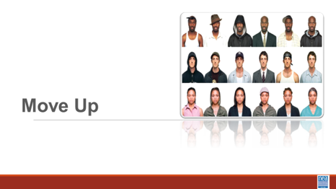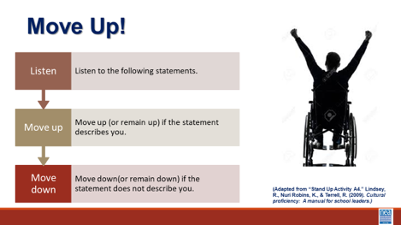  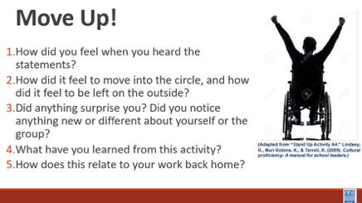  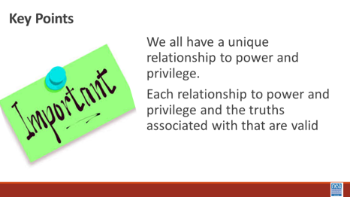 |  |  |  | 1 min intro - I am going to say a few statements. If you agree with the statement, move into the circle. If you do not, you are unsure, or you are not comfortable answering, stay in your spot. Please feel free to remain on the edge of the circle for all of the statements if you feel safe enough to vulnerably share your truth.  9 Mins of Activity - (Facilitator NOTE – you should work with the team to select low risk questions from this list. They should begin by being very low risk and move to higher risk. )  KEY INSTRUCTION FOR FACILITATOR - State the prompt – wait for the movement – and then ask folks to look around to see how the circle has moved – ask them to think- not respond just think – what does this tell me? REPEAT THIS WITH EACH SELECTED prompt.  - If you were able to access this space without any difficulty.  - Your family owned their own home.  - Your parents graduated from college or university.  - You studied the history and culture of your ethnic ancestors in elementary and secondary school.  - You can access washrooms easily without concern about finding a gender-­‐ neutral or accessible washrooms.  - You were raised by your parents.  - You have never had to tell anyone your sexual orientation (you never had to ‘come out’).  - Your family told you that you could do, or be, anything you wanted.  - You have never felt like an event is closed to you because you cannot access the space it is in.  - You attended art galleries, museums, or live theater performances growing up.  - You and your loved ones have never been questioned about your citizenship status.  - You have never felt judged because of the size or shape of your body.  - Most of your friends are the same racial or ethnic background as you.  - You live in a city where most of your leaders look like you.  - The holidays you get at work or school are holidays you celebrate.  - Your identity has not been challenged within any of the current administration’s executive orders.  - You are able to communicate verbally.  - You can walk down the street with your partner anywhere in our country without being afraid to hold hands.  - When people hear you speak, they don’t ask you where you are from.  - You feel pretty safe walking home at night regardless of what you are wearing.  10 Mins Debrief – Ask participants to return to their tables and select a number of the following that you want to debrief on.  - How did you feel when you heard the statements?  - How did it feel to move into the circle, and how did it feel to be left on the outside?  - Did anything surprise you? Did you notice anything new or different about yourself or the group?  - What have you learned from this activity? Share any insights or reflections if you’re comfortable.  - How does this relate to your work back home?  Key Points  We all have a unique relationship to power and privilege.  Each relationship to power and privilege and the truths associated with that are valid. |  |  |  | Participants will be reminded or become aware of our relationship to power and privilege, and the ways in which people experience advantages and disadvantages in our society.  What is THIS community’s relationship with power and privilege?
10:00-10:15 |  | Break
10:15-11:10 |  | 55 Minutes TOTAL -What is Oppression?
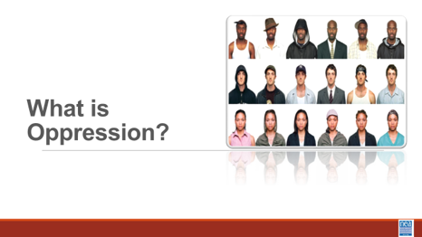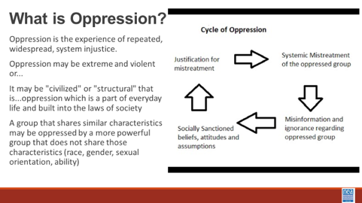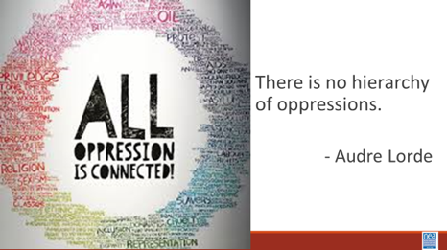  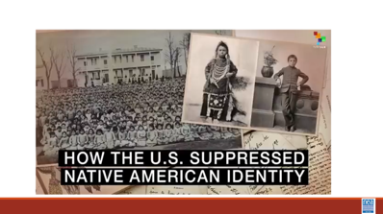  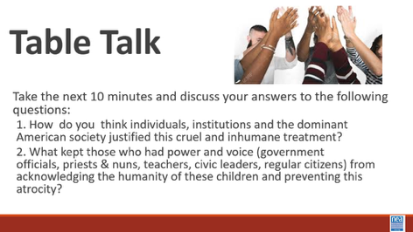  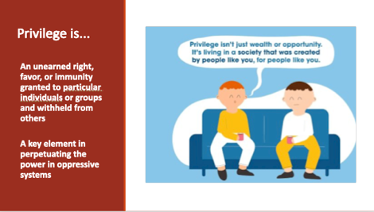    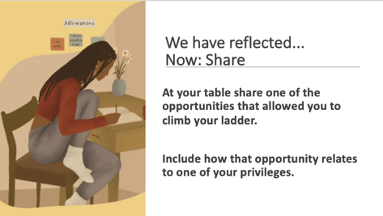  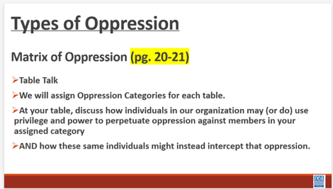  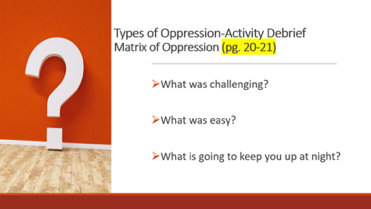  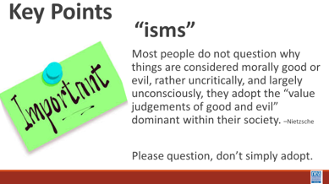 |  | Matrix of Oppression  p 21-22  Matrix of Oppression |  | 20 minutes Intro and video (3-4 minute)  Before we dive into what this means to you, we want to remember our disclaimer.  When we say words like oppression” and “oppressive ideas and assumptions” what exactly are we talking about? Oppression is the experience of repeated, widespread, system injustice.  It may be extreme and violent or...It may be "civilized" or "structural" that is...oppression which is a part of everyday life and built into the laws of society  A group that shares similar characteristics may be oppressed by a more powerful group that does not share those characteristics (race, gender, sexual orientation, ability)  How it works is cyclical. Misinformation and ignorance regarding an oppressed group leads to socially sanctioned beliefs, attitudes and assumptions which are used as justification for mistreatment and results in the systemic mistreatment of the oppressed group. Systemic mistreatment leads to misinformation and ignorance which becomes socially sanctioned, and on and on and on.  While there are many types of oppression, “Black, lesbian, mother, warrior poet” Audre Lord (her description not ours), said clarifies that there is no hierarchy of oppressions. All oppressions must be recognized and fought against simultaneously. Although we possess different identities, we are all connected.  Now we are going to take a look at this video and talk a little bit more about this cycle of oppression.  Video – How the US suppressed Native American Identity:  10 Minute Discuss  Take a moment and discuss with your tablemates the answers to the following questions.  - 1. How do you think individuals, institutions and the dominant American society justified this cruel and inhumane treatment?  - 2. What kept those who had power and voice (government officials, school teachers, civic leaders, regular citizens) from acknowledging the humanity of these children and preventing this atrocity.  Are any ideas that you want to put into the room? Allow 1-2 responses from each table.  Privilege is -An unearned right, favor, or immunity, granted to particular individuals or groups and withheld from others  A key element in perpetuating the power in oppressive systems  An agent in a justice system uses privilege to make change or prevent change—they are the power holder  5 minutes Reflect and-Share  Ask participants the following question, reflect on three opportunities you have received that were crucial to your climb.  At your table share one of the opportunities that allowed you to climb your ladder.  Include how that opportunity relates to one of your privileges.  (Anecdotal: Whiteness regardless of income or poverty is still white privilege.  Might be useful to give participants an example.)  So—Privilege doesn’t mean the road is easier, it means your road is not made harder by the particular identity. Notice that Oppression and Privilege are two sides of the same coin—one cannot exist without the other—it is positionally dependent and shift, depending on where you stand in a power dynamic. Page 108 has additional resources on this. Now...  Activity that references Matrix of Oppression P. 21-22  Turn to page 22 in your participant handouts; P. 21 is fillable.  10 minutes Activity – Have participants divide into group and assign them two/three oppression categories to discuss how members, local, and state affiliates can use privilege and power to oppresses members in each category and how the same group can intercept that oppression. Groups are given 10 minutes in their groups.  5 Minutes  What was challenging?  What was easy?  What is going to keep you up at night?  Key Points  Most people do not question why things are considered morally good or evil, rather uncritically, and largely unconsciously, they adopt the “value judgments of good and evil” dominant within their society.  - -Nietzsche  Please question. Do not just adopt it. |  |  |  | Participants will be able to describe what oppression is and how systems of justice construct and use oppression.  What is our relationship with systems of oppression?  Participants will be able to describe what oppression is and how systems of justice construct and use oppression.  What is our relationship with systems of oppression?
11:10 –12:00 |  | 50 Minutes Total – Race, Ethnicity, and Nationality
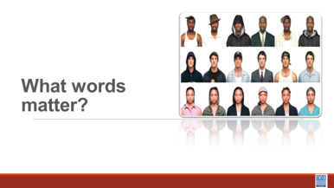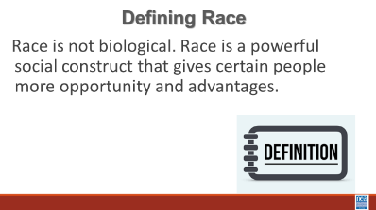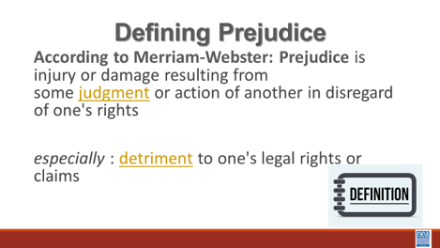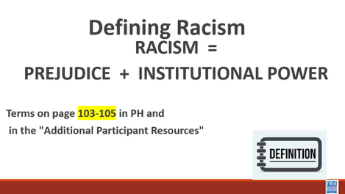    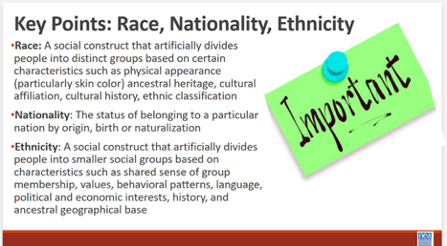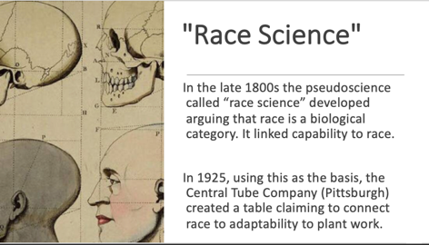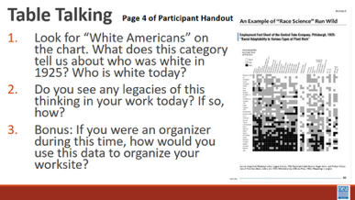  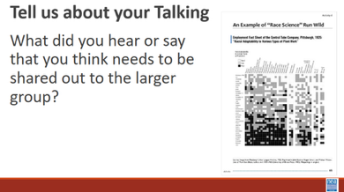  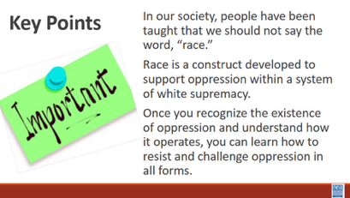 |  | Need to Make the Definitions and Terms for the Envelopes  Suggest using the terms found on either of the following files:  Handout Pages 23-24 Definitions for LGBTQ+ - Additional Res.  Vocabulary Exercise Answer Sheet  Racial Adaptability to Various Types of Plant Work” document (Race Science Gone Wild) |  | 10 minutes – Race, Ethnicity, Nationality  3 mins - Short Lecture using slides to define race, prejudice, and racism  Race is not biological. Race is a powerful social construct that gives certain people more opportunities and advantages.  Show and read the next two slides  We also need to define the term Prejudice: According to Merriam-Webster: Prejudice is injury or damage resulting from some judgment or action of another in disregard of one's rights especially : detriment to one's legal rights or claims  Prejudice is something we all likely recognize—those internal, preconceived judgments we hold about people based on their social group. Anyone, regardless of their background, can hold racial prejudice. It is an individual bias.  Racism is the combination of Prejudice and Institutional Power  The formula only becomes 'Racism' when you add the second variable: Institutional Power. When we think about racism, we often picture individual acts or personal hatred. But sociologists and activists use a different lens—one that focuses on how society actually functions. In the 1970s, Patricia Bidol-Padva proposed a paradigm-shifting formula: Prejudice plus Power equals Racism (R=P+P). This isn't just a math equation; it’s a tool for understanding how inequality becomes a permanent part of our landscape. This definition matters for social justice and systemic change.  Power is the ability of a dominant group to take those internal prejudices and weave them into the fabric of society. Think about laws, redlining, hiring practices, access to healthcare, and educational funding. When a dominant group codifies their biases into these systems, they create a machinery that works for them and against others.  Under this definition, we stop asking, 'Did that person mean to be racist?' and start asking, 'Does this system produce unequal results?' If a policy—like funding schools through property taxes—leads to unequal outcomes for different racial groups, then it is functioning as a racist system, regardless of the intentions of the people who created it.  This moves the conversation beyond individual attitudes. While everyone can be prejudiced, the R=P+P model clarifies that only those with institutional power can create a system of oppression. By understanding racism as a combination of bias and power, we can move past personal defensiveness and begin the real work of dismantling the systems that hold inequality in place.  Share the video (3 Min) defining Race, Ethnicity, Nationality  30 Minutes – How race and ethnicity impacts/influences labor  5 mins – Intro  “Racial Adaptability to Various Types of Plant Work” document (Page 25 of Participant Handout)  In the late 1800’s the pseudoscience called “race science” developed  arguing that race is a biological category. It linked capability to race.  In 1925, using this as the basis, the Central Tube Company (Pittsburgh) created a table claiming to connect race to adaptability to plant work.  20 minutes – Table Talking (page 25 in participant handout)  At your table, discuss this “data” (sarcastic) shared in this table centering on the following questions:  - Look for “White Americans” on the chart. What does this category tell us about who was white in 1925? Who is white today?  - Do you see any legacies of this thinking in your work today? If so, how?  - Bonus: If you were an organizer during this time, how would you use this data to organize your worksite?  5 minutes – DEBRIEF  Tell us about your talking  “The definition of whiteness changes, we are eating ourselves, not the dogs and cats.”  What did you hear or say that you think needs to be shared out to the larger group?  Key points – 5 minutes  In our society, people have been taught that we should not say the word, “race.”  Race is a construct developed to support oppression within a system of white supremacy. In America we tend to buy into “racial narratives” which are based on incorrect and often harmful stereotypes.  Once you recognize the existence of oppression and understand how it operates, you can learn how to resist and challenge oppression in all forms. |  |  |  | Participants will work on the development of their working vocabulary for race and racial justice concepts.  What are the words I need to know to talk about race?
12:00-1:00 | Lunch
1:00-1:25 |  | 25 Minute Total - Expressions of Racism
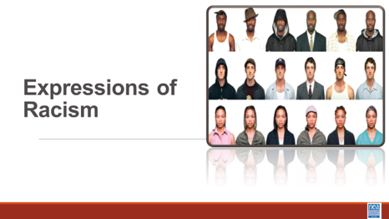  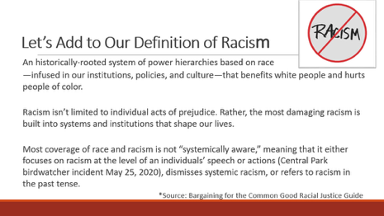  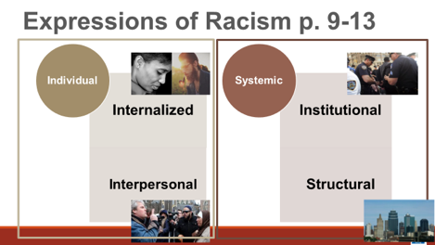  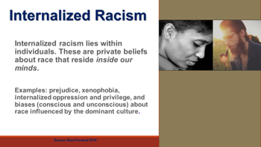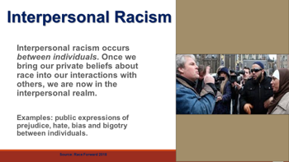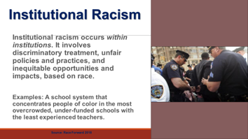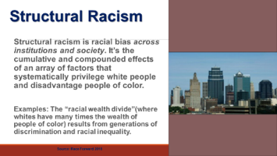  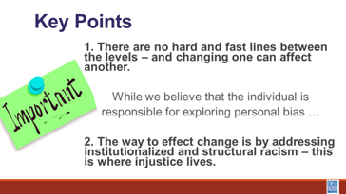  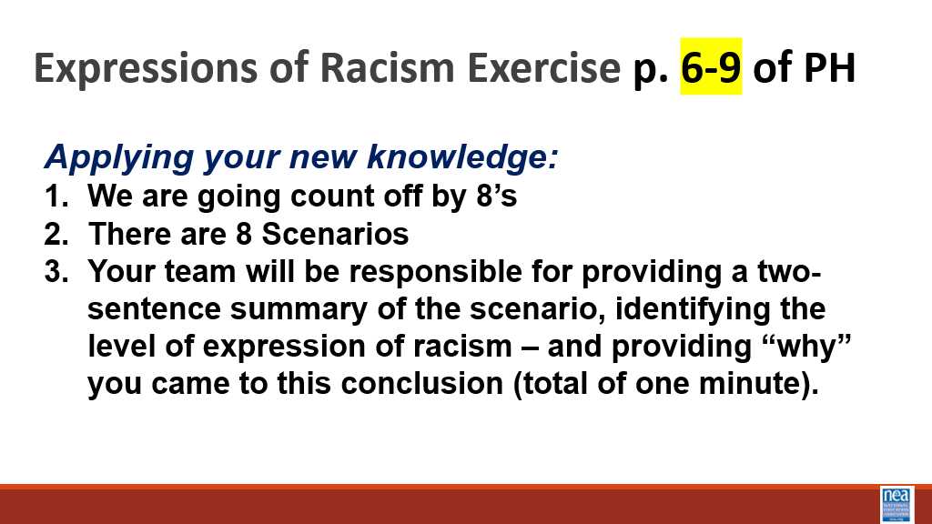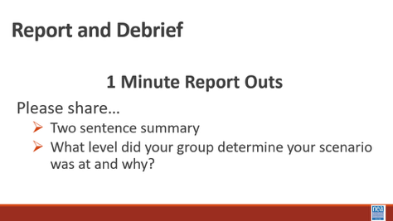  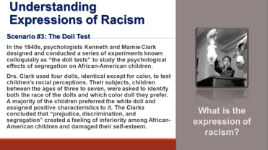  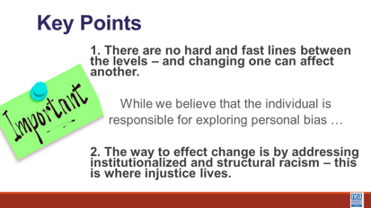  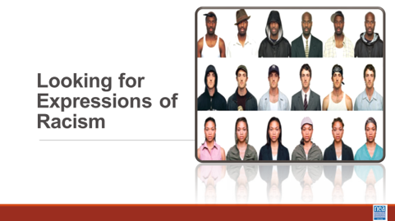 |  | Post 2 separate Poster(s) of the Foundation Points  Key Point 1 - "There are not hard and fast lines between the levels - and changing one can affect another".  Key Point 2 - "The way to effect change is by addressing institutional and structural racism - this is where injustice lives".  Levels of Racism Handout p. 6-10  Angel’s Story  “Everyday Racism in Union Work”-p. 11-12  Chart for each group |  | 5 Mins Using the slides – Remember our definition of racism – let’s add a little to that prejudice, discrimination, or antagonism directed against someone of a different race based on the belief that one’s own race is superior.  An historically rooted system of power hierarchies based on race are infused in our institutions, policies and culture. Racism isn’t limited to individual acts of prejudice, either deliberate or accidental. They are baked into the systems and institutions that shape our lives. This is a framework for how oppression is expressed and the reason why we are showing you this is to understand the level of resource and effort needed to address these issues.  We are going to look at the doll test for understanding how racism – or other oppressions are expressed. This framework is helpful not in IDENTIFYING the events of racism – but in understanding the magnitude of the solution we would need.  Share Definition and examples for each of the four levels.  Traditionally, institutions only focus on the individual side, NEA, takes the approach that if we don’t re-examine and change the systems, then we will be forever combatting all three of the other types of racism.  Internalized Racism lies within individuals. These are our private beliefs and biases about race and racism, influenced by our culture.  Interpersonal Racism occurs between individuals. Once we bring our private beliefs about race into our interactions with others, we are now in the interpersonal realm.  Institutional Racism occurs within institutions and systems of power. It is the norms, policies and practices that are structured into political, societal and economic institutions that have the net effect of imposing oppressive conditions and denying rights, opportunity, and equality to identifiable groups based upon race or ethnicity.  Structural Racism is racial bias across institutions and society. It’s the cumulative and compounded effects of an array of factors that systematically privilege white people and disadvantage people of color.  Key points – there are not hard and fast lines between the levels – and changing one can affect another. While we believe that the individual is responsible for exploring personal bias – the way to effect change is by addressing institutionalized and structural racism – this is where injustice lives. Remember that Resolution I new business item refers to the institutional racism (white supremacy is structural)  10 Min Defining Expressions of Racism Activity - Use the Handout Levels of Racism Scenarios p. 6-10.  - 1 Min Intro –Count off by 8, move to new group and bring your device with you. The number of your group is the expression of racism that you will use as a lens for examining the doll test. One and two will use internal racism as their lens, three and four will use interpersonal, five and six will use institutional, seven and eight will use structural. You will discuss and decide how your expression of racism applies or does not apply to the doll test. Please ensure that there is a consensus in your group for your answer.  - 5 Minutes to work on Activity- your outcome is an analysis of how your level of racism applies or does not apply to the doll test.  - 4 Mins: Debrief – Provide your reasoning for how your level of racism applies to the doll test. We are pairing up the two like groups—dueling microphones—to either agree or disagree with each other.  - The facilitator ends by pointing out what each group has historically realized – each analysis of a racist outcome requires all of the levels of racism – because it takes all the levels of racism to reinforce and ALLOW racism to happen. As examples: ICE raids require all levels of racism. Ignoring dangerous pollution in black and brown communities requires all levels. The murder of George Floyd by a police officer...  Key point - there are not hard and fast lines between the levels – and changing one can affect another. While we believe that the individual is responsible for exploring personal bias – the way to effect change is by addressing institutionalized and structural racism – this is where injustice lives.  20 Minutes of Work Time  NOW we are going to imagine how this might show up in our work. Through the story of Angel, a worker in one of our schools. Each group will focus on one of the expressions of racism in this story and discuss this question  As you read, consider whether Angel is thriving in their institutions (school/union). What are examples from the story that lead you to this conclusion?  1. What are some examples of Internal Racism? (private beliefs and opinions)?  2. What are some examples of Interpersonal Racism (within systems of power)?  3. What are some examples of Institutional Racism (between individuals)?  4. What are some examples of Structural Racism (across systems of power)?  10 Minutes Report Out  Group Discussion Question As union leaders what is our role in interrupting the instances of racism that you recognize?  If there is time, you should address what race or gender participants “saw” Angel. Their race and gender are intentionally never identified in the story.  Key points:  - Racial Oppression is always there.  - We have to be intentional in looking for expressions of racism if we are going to redress them.  - We have to recognize that we are likely unintentional contributors to the problem – and we have to choose to be intentional participants in the solution. |  |  |  | Participants will understand Key Point 1 - "There are not hard and fast lines between the levels - and changing one can affect another".  and  Key Point 2 - "The way to effect change is by addressing institutional and structural racism - this is where injustice lives".  And that it takes all levels to permit oppression.  How can you advance and improve racial justice beyond your own growth and development?  This was part of a pre-session handout. Check to see if participants have already read.  Questions in Participant handout need to be updated to match the Facilitator Guide and Power Pt.  Participants will be able to identify expressions of racism in particular scenarios.  How can you advance and improve racial justice beyond your own growth and development?  Facilitator Note: Participants need to learn to “see” so we can “do”
1:25-1:55 |  | 30 Mins – Systems that Oppress
5 minutes - Intro
We are going to look deeper into how racism manifests itself in the world around us (pop culture). How is it named? How is it repaired (if it is repaired)? And how is it addressed at the root of the issue (transformative) and not just the fruit (performative)?

15 minutes – Activity
You will be assigned a number 1 through 4. This number is the group you will be working with on an article and discussion. This article is an example of an expression of racism or injustice that involves an organization, corporation, or large group.

After reading the article, please discuss the following:
- Based on what you read, do you think the actions taken to repair the harm caused by the expression of racism addressed the problem at a systemic level? Why or why not?
- What, if anything, does your group think the organization, corporation, or larger group could have done differently to address the issue at a systemic level?

8 minutes – Debrief
Have each group share a 1-minute synopsis of the article they read and a 1-minute key takeaway(s) of the discussion in their small group

10 minutes – Key Points
- It is more important to address the underlying systems and structures that allow harm to occur, not just the immediate situation.
- Only meaningful, long-term change can prevent similar harm in the future.
1:55-2:30 |  |  |  | 35 Minutes Total – What is White Culture
 |  | Page 24 White Culture Handout |  | 15 mins- What is White Culture?  2 mins –Intro  We are going to dig into some thinking about what makes discussing race so difficult. To do that we are going to begin by looking through the window of White Culture. At your tables, read the following slide to yourselves – in about one minute – turn to those folks you are sitting with and discuss what stands out as things you agree with and things you don’t agree with – We will take a total of 5 minutes at your tables for this discussion.  (Give them 10 minutes to discuss – then 3 minutes to share out)  “6 Basic American Cultural Values  - The first is for Individual Freedom and the price for that is Self-Reliance. We cannot be truly free if we cannot take care of ourselves and be independent. The second is for Equality of Opportunity, and the price for that is Competition. If everyone has an equal chance for success, then we have to compete. The third is for The American Dream, the opportunity for a better life and a higher standard of living. The price for the American Dream has traditionally been Hard Work.  - The relationship among these values—the rights and the responsibilities—creates the fabric of the American society. It is this fabric that defines the American Dream—the belief that if people take responsibility for their lives and work hard, they will have the individual freedom to pursue their personal goals and a good opportunity to compete for success. Was found at https://vintageamericanways.com/american-values/ https://www.facebook.com/vintageamericanways/  https://spearsmarketing.com/work/vintage-american-ways/  During the 3-minute report out move to the Slide that defines white culture Report out - Ask for 3 to 4 people to share something that they heard or said at their table. –at this point you are simply getting people to discuss the concept of white culture. At this point, let them know that this comes from Vintage American Ways, a SS curriculum that is easily found and for use in teaching. GTS and be afraid. Additional Resource: What is White Privilege Article*  15 Mins – White Culture Where We Work  1 Min Intro - We are now going to extend our discussion to a set of questions about White Culture. Using the White Culture Handout found on page 28 we are going to get into groups. (no more than 4 or 5) – Once in groups we will give you the directions –  Show the slide with these directions.  - Each group will be assigned one section  - As a group, read the section.  - Develop a GROUP answer to the questions in the section.  - Be prepared with a two to three sentence report out.  8 Minutes in your groups  5 Mins - Group Sharing of your answers.  5 Min – Key Points  - Identifying how white culture is present within an organization’s internal and external practices is a critical dimension of racial equity work.  - It can be especially invisible to members of a dominant group, thus we must be skilled in how we identify and discuss the disconnect between virtuous ideals and their corrosive application |  |  |  | Participants will be able to describe the aspects of white culture – and actually recognize that there is a white culture.  Do white people have a culture?  What is the work that we need to do to become anti-racist?  How do we provide spaces where this work can be done?
2:30-2:45 |  | 15 minutes - Break
2:45 – 3:20 |  | 35 Mins – Identity and Intersectionality
35 minutes for this first section
Note: We need to ask participants to take their tech/laptops to their affinity spaces
2 Minutes -Introduce topic with video and definition- What is Intersectionality?
We are going to move back into a couple of foundational concepts – identity and intersectionality.
Show intersectionality video
https://www.youtube.com/watch?v=EXJ4Dbdm1ks
Share the slide with the definition - Intersectionality is a framework for understanding a person, group of people, or social problem as affected by multiple forms of discriminations and disadvantages. It takes into account people's overlapping identities and experiences in order to understand the complexity of prejudices they face. See the additional resource by Teaching Tolerance: “Teaching at the Intersections” for more information about this concept.

10 mins – individual p then small group talk - Using the Personal Identities Handout p 30 –We are going to take a look at a number of the identities that make us who we are. Around the circle are a number of identities and on the slide, you will see several questions.
For the first 5 to 6 minutes, you are going to do this exercise on your own. You will Place the number of the question in the box by the identity or identities that best answers that question.
Once you are finished, share your circles with your table mates. We are going to share at our tables for about 10 minutes

What surprised you in doing this?
What is something interesting you heard at your table?

5 Mins – Three (3) quick thoughts- (Facilitator just pick three) Is there anything that you said or that you heard that the room needs to hear?

5 Mins – Intro and video watching - What Intersectionality is not– We have talked about what Intersectionality is. Let’s take a minute and talk about what it is not. It is important to understand that Intersectionality is NOT the “Oppression Olympics.” Due to the complexity of our identities, it is common for people to be privileged in some areas and oppressed in others. For example, a white woman may benefit from white privilege and may experience sexism because she is a woman. I am going to share a video, and I am asking you to listen for how the intersections of this person’s identity inform and compound the oppressions that they face.
Show the video of Black Trans Person

5 mins – Share the America’s War on Black Trans Women – and ask folks to read it to themselves. As the facilitator just read the bold part out loud as a way to bring closure to this section.

“The inequities and prejudice Black trans women face don’t just take the form of outright violence. A study by the National LGBTQ Task Force indicates that Black trans people have a 26% unemployment rate. That’s twice as high as the unemployment rate for transgender people of all racial and ethnic backgrounds, and four times as high as the unemployment rate in the general population. The study also found other shocking disparities; 41% of Black trans people have been homeless (more than five times the general population), 34% of Black trans people have household incomes less than $10,000 (more than eight times the general population), and nearly half of the Black trans population has attempted suicide. Although these statistics apply to the Black trans population in general and not to Black trans women specifically, based on how much more frequently Black trans women are killed, it’s reasonable to assume that they also experience these harms more frequently than other Black trans people.
In short, being a Black trans woman in America means you’re far more likely than most other people to experience serious roadblocks and harms, in the form of everything from extreme poverty to violent murder.”
Facilitator says -This is what intersectionality helps us understand.

40 mins for this section– 2 minutes Intro and Discussion -We are going to take some time to talk about identity, intersection, and oppression as you experience it in your workplace at your table. Now that you have all this learning. All these different identities

15 Minutes
- Do you experience privilege and/or oppression in your work? How does it show up?
- Have you become more aware of any privileges or oppressions you had not previously considered?
- How do you use your privileges in your work?

20 Mins – Whole Room Discussion – What have you been thinking about that you think the whole room needs to know about?

2 Minute – Key Points
Identities, privileges, and oppressions are intersectional.

The oppression of nonheteronormative people constantly intersects with racism as LBGTQ+ People of Color face more oppressions than White LBGTQ people.

Our oppressions and privileges are layered and reinforced by the American cultural norms
3:20 – 3:45 |  | 25 mins - Coconspirator
 |  | Actor to Ally to Coconspirator Chart p. 54  The Action Continuum p. 59  So, You Call Yourself an Ally (Additional Resources)  Pre-Attendance  How to be an Ally if you are a person of privilege – section 7  Scaffolded Resources for White Allies  (Additional Resources) |  | 5 mins - What do you think?  What do you think an actor, ally, and coconspirator is?  (Quick table talk but no share out)  2 mins – Video  We are now going to watch a short clip that helps build your definition of what a coconspirator is.  5 mins – Lecturette  Define Actor, Ally, and Coconspirator (w/ slides)  10 mins – Moving from Actor to Coconspirator  Working in groups and using the Actor to Coconspirator handouts  Circle where you think you are in each of the categories.  3 mins - Key Points  - All three levels involve some level of action.  - Self-Identifying as an ally or coconspirator is problematic. These terms are given by folks in the groups to which one is claiming an alliance.  - This work involves constant listening, growth, and reflection. We are not free until all of us are free. |  |  |  | Participants will define and then assess where they currently stand as an Actor, Ally, or Coconspirator.  How do I support racial justice efforts?
3:45 – 4:15 |  | Disrupting Microaggressions
 |  | What can I Do at Work?  P Additional Resources  Interrupting Microaggressions pg. 48 |  | 2 Minute Intro – In a bit we are going to be exploring at one of the most prevalent forms of racism – the microaggression. The other most prevalent form of racism is bias. The research around our outward use of and acceptance of microaggressions says that they are the truest indicators of the unrecognized forms of bias we have. Microaggressions are the manifestations of bias.  3 Min video – Show video about how Microaggressions are like mosquito bites (2 minutes)  5 min - Before we get started, take a look at this video, listen: How do you respond to microaggressions? https://youtu.be/C3LFB4mJ0DI  P. 44-45 have some good suggestions for disrupting common types of microaggressions  5 mins – Introduce 4 step method for interrupting some common workplace microaggressions.  Interrupt, question, educate, ECHO if you are a bystander  Example - Wow, I can’t believe how well-spoken you are for an ESP Leader!  - Interrupt – why are you surprised?  - Question –what were you expecting?  - Educate – When I hear that it hurts. I am often  discounted because of the job I have. No one can believe that I have a college degree or that I can read, write, and speak.  - IF THERE WERE A BYSTANDER WHO DID THIS –  - Thanks for asking about that, it bothered me too. We need to have high expectations and high regard for each other – this work is too tough.  30 min - Responding to Microaggressions  Often participants will tell us that they are uncomfortable with addressing microaggressions when they occur because they don’t know what to say. Our next activity will give you the opportunity to practice what to say when you are a victim or witness to a microaggression.  1 min – Directions for Activity: The purpose of our next activity is to practice responding to microaggressions in a way that will ultimately lead to their reduction rather than reinforcement. This is extremely challenging, because it is hard to respond honestly without leading other people to become defensive or hostile.  This activity involves three roles – speaker, responder, and coach and all members should have at least one opportunity to play each role. The speaker is responsible for choosing a scenario (or making one up) and saying the remark that is a microaggression. The responder is given the challenge of responding to the remark in a way that reduces the likelihood of future microaggressions, and the coach is a social observer who provides candid feedback on the strengths and weaknesses of the response.  To get the most out of this exercise, it is important to spend as much time as possible practicing rather than simply discuss microaggression reduction, and the coaches should be as open as possible in their feedback. To begin the exercise, one person should play the role of the speaker, one should play the role of the responder, and the remaining group members should play the role of the coaches. Let the conversation build for a minute or so before the remark is made, and let it continue for a while after the response is given. Once the speaker and responder have concluded their interaction, the coaches should critique the response, and the roles should be rotated for another practice round with a new speaker and responder. Do not worry about getting through all the scenarios or adhering precisely to the scripted comments – the scenarios are simply designed as icebreakers to facilitate the activity.  20 min to work through scenarios in groups of 4. Facilitators will visit each of the groups to make certain that you are spending your time role playing and not holding a discussion. This is a time to practice so that you WILL know what to say.  We will now divide into four (4) person groups. All group members should play each of the roles at least once, and that speaker should choose a new scenario with each rotation.  7 Scenarios  #1  Speaker: Union Membership Chairperson  Responder: UniServ Director  Background: New Member Orientation meeting where the UniServ Director has been asked to speak. You observe the membership chair ask a potential member the question.  Comment: “What are you? Where are you really from?”  #2  Speaker: Participant in a training session  Responder: Workshop Facilitator  Background: Break time during the training session and the participant comes over to talk about how great the training is so far.  Comment: “Someone asking to touch your hair because it is exotic.  #3  Speaker: A high school student  Responder: A teacher  Background: Comment was overheard during after-school study hall  Comment: “You must be good in math; can you help me with this problem.”  #4  Speaker: Your best friend’s co-worker  Responder: A white bystander  Background: Comment was made by friend of a friend at happy hour.  Comment: “How do Black people feel about affirmative action?”  #4-a  Speaker: A fellow colleague  Responder: UniServ Director on the job for 5 years  Background: Comment was made during lunch time with several people at the table.  Comment: “Of course she’ll get the promotion, she’s a minority.”  #5  Speaker: Union member  Responder: Union President  Background: Union member approached officer at the end of general membership meeting  Comment: Being told you speak English well when it is your first language.  #6  Speaker: A middle-aged woman  Responder: Black woman  Background: Slightly busy hotel lobby with several people in line waiting to check in  Comment: Being mistaken for someone in a service role.  #7  Speaker: A middle-aged uncle  Responder: A family member  Background: Comment was made during a family dinner in which the conversation turned to the topic of LGBTQ+ rights.  Comment: “All that lesbians need is a good-looking man to convert them.”  5 min - Report out on which responses were most effective, and which strategies might minimize resistance on the part of the “mosquito”.  Facilitator Note: The Suggested strategies we are looking for in report out are below. If the groups do not come up with them on their own, then share with the group.  - Use questions such as “Why do you say that?” and “Do you feel that way about every person in that group?”  - Point out the difference between what the speaker said and how they behave or believe about themselves, “I’ve always thought of you as someone who is very open-minded”  - Tell the other person how you feel (it makes me uncomfortable to hear that) – it is a statement that cannot be refuted  - Approach the person with respect rather than indignation  Debrief questions:  Is the most effective response an immediate one, or is it better to wait?  Are public responses more effective than private responses?  Are there situations in which it is best to not respond?  1 min -Key Points:  It is a basic human right to demand a safe space.  Remember that you have the power to control the situation through your actions and reactions.  Need more time for practice, spend less on set up.  Apology slide and how to do it is missing.  Debrief slide is missing.  Perhaps think about refreshing a bit—more interaction if the set up isn’t shortened. We always think we can do this quickly. We can’t--but it is worth it because they NEED the practice. Share out of plans was INCREDIBLE. |  |  |  | Participants will understand the link to bias and microaggression.  Participants will practice interrupting microaggressions using a 4-step process.  How do I begin to interrupt the cycle of racism in my everyday work?
3:55-4:30 |  | 10 Minutes Day One Reflection and Connection
 |  |  |  | 10 mins -– Connections  Open Room discussion of the following questions. Record your thinking. What did you experience today that affirmed your understandings? What did you experience that challenged your understandings? What questions do you still have?  Community Agreement Check In: What did we do well? Where could we focus more? |  |  |  | Participants will reflect on their learning and engage in a conversation with their colleagues.
4:30 |  | Adult Choice Networking and Reflection
5:00 |  | Adjourn
NEEDS TO MOVE TO Day 2  1:55-2:30 |  | 35 Mins – Systems of Oppression – Income and Wealth
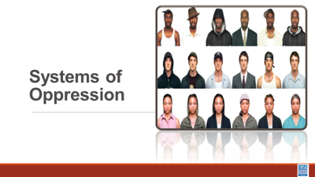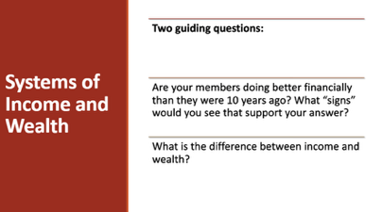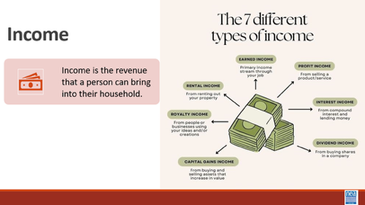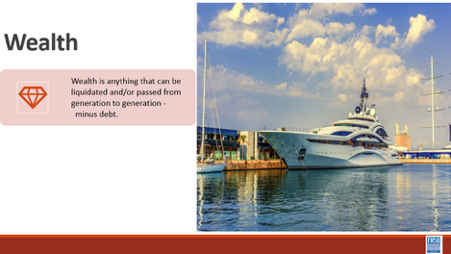  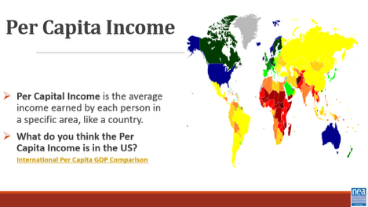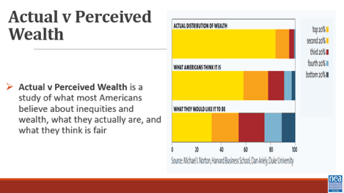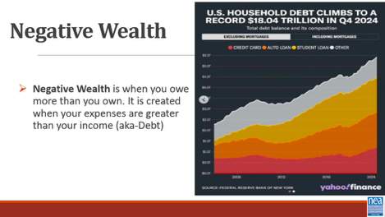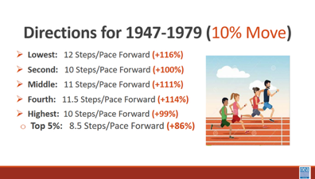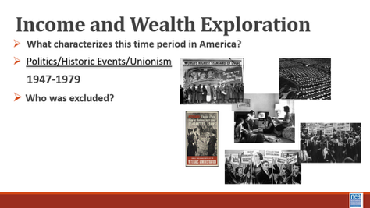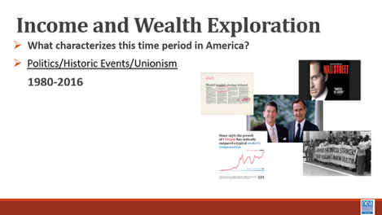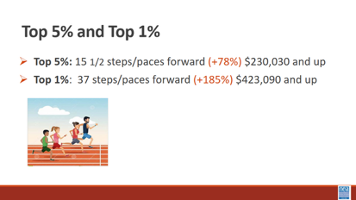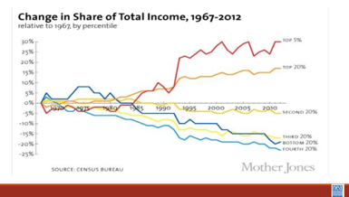  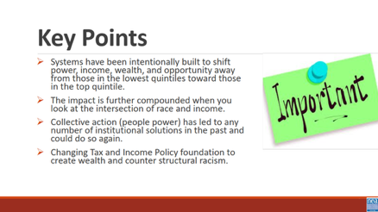 |  | Quintile Signs  Quintile Facilitator Guide  Economic System p. 14-18 |  | 2 Mins– We are going to take a look at one example of systemic racism that impacts our members and their jobs – income and wealth. Take just a moment in your mind and consider the following question –  - Are your members doing better financially than they were 10 years ago? What “signs” would you see that support your answer?  In the last decade, has the income your members earned enough to pay the bills? How do you know?  6 Mins- What is the difference between Income and Wealth?  What are some examples of income? (wages, salary, interest, social security check, rent from owning real estate, capital gains from selling investments, dividends from stocks, gifts, etc.)  - What are some examples of wealth? (savings, investment, property, etc.)  - How is wealth different from income and why is this important? Wealth can be passed on to future generations.  - What is Per Capital Income? How much each person receives from the yearly income generated in the country if the yearly national income is divided equally among everyone.  - In 2025, it is around $86,000/person (INCLUDING CHILDREN).  - Imagine if we distributed income this way, would it be enough for everyone?  - What is Actual v Perceived Wealth and what does this say about how American feel and thing about economic inequality?  A Harvard University Study asked people (Democrats and Republicans) what they think the wealth divide to be and what they think is fair. The actual weather inequality is far greater than what most people perceive it to be and even more so between what they think is fair.  - Think it is: Top 20% have 60% of the wealth  - Think it should be: Top 20% have 35% of the Wealth  - What it is: Top 20% have 85% of the Wealth  Mention the link a video demonstration of the study for additional information for comparison  - What is Negative Wealth and Why is this Important?  - Negative Wealth is when you owe more than you own. It is created when your expenses are greater than your income (aka-Debt)  - In 2019, 10 % of American have negative net (13 million) worth. In 2024, 31% of Americans have a net worth of $0 or less  - Black/Brown America-1 in 4 have negative wealth  - White America- 1 in 12 have negative wealth  - Student Loan, Auto, and Credit Card Debt is dragging down the wealth of Americans, particularly household of color  Share that this will only widen as health care costs continue to rise and student loan debt forgiveness programs end  18 Mins – The Quintile Quest (Economic Exploration) Activity (see full guide)  Now let’s have seven (one for each quintile and the 1 for top 5% and 1 for top 1%) volunteers come to the front of the room. Please stand shoulder to shoulder. Each gets a sign showing the income range — in pre-tax, year 2014 dollars — of the quintile they represent.  - What are Income Quintiles and why do economists use them?  Economists often talk about the income in the US as divided into "quintiles" or "fifths" of a population. They imagine the entire population of the U.S. lined up from the lowest income to the highest income. They then divide that line into five equal parts. A quintile can be thought of as a fifth of the population or 20%.  We are going to watch how income has changed over quintiles in the population. This activity looks at what happened to the incomes during two periods of economic growth: 1947-1979 and 1979-2014.  Take a look at the signs the volunteers are holding – this number represents median Family Income.  - What jobs would be in each of these?  - What economic challenges would each have?  - Where are our members – pay attention to job classes and state differences.  INCOME WALK  Each volunteer, representing a quintile or fifth (20 percent) of the U.S. population, will step forward or back according to whether their income gained or declined. They start in a line evenly together.  Have the non-participants stand in a line along the path of where the stepping will occur  Each step equals a 5% change. So, for example, two steps forward would indicate an income gain of 10%.  1947-1979  Lowest: 23 Steps/Pace Forward (+116%)  Second: 20 Steps/Pace Forward (+100%)  Middle: 22 Steps/Pace Forward (+111%)  Fourth: 22.5 Steps/Pace Forward (+114%)  Highest: 20 Steps/Pace Forward (+99%)  Top 5%: 17.5 Steps/Pace Forward (+86%)  Have the non-participants, who are lined up along either side of side of the “Income Walk” move forward with the participants. They should slide forward 15 steps to represent inflation over that time period. Notice that all quintile income outpaced inflation.  1 min-This one slide graphs what we just did. Show to visualize the economics beyond the activity and how income growth remained relatively equitable, and in fact the lower four quintiles actually did. better than the top 20%  What can you tell us about the history, policies, unions from 1947-1979?  One explicit goal of the federal government during the early post-war period was to build a middle class where people and families who could consume the output of the rapidly growing manufacturing capacity of the U.S.  Federal government programs like the GI Bill of Rights enabled hundreds of thousands of returned veterans to go to college and purchases homes, beginning the steps to accumulating family wealth.  It is important to note that people of color were largely excluded from middle class wealth gains. (redlining, job discrimination, ect). While acknowledging that post-war programs helped build the middle class, it's important to also acknowledge that these programs disproportionally favored white men.  For example, VA and FHA loan programs for housing utilized racially-restrictive underwriting criteria. Thus, assuring that hardly any of the $120 billion in housing equity loaned from the 1940s to 1960s would go to families of color.  While loan programs like FHA and the GI Bill helped finance over half of all suburban housing construction in the country during this period, less than 2% of this housing ended up being lived in by people of color  Next say that we will now look at income changes from 1979-2014. Many of you might remember what happened during that time period.  What can you tell us about 1979-2014? (Reaganomics, neo liberalism decline of unions) all contributed to declining middle class, greater poverty and extreme disparity in income and wealth.  1979-2014  Lowest: 2 1/2 steps/paces backward (-12%; $0 - 29,100)  Second: 1/2 step/pace forward (+3%; $29,101 - 52,697)  Middle: 2 steps/paces forward (+12%; $52,698 - 82,032  Fourth: 5 steps/paces forward (+26%; $82,033 - 129,006)  Highest: 10 1/2 steps/paces forward (+54%; $129,007+)  Top 5%: 15 1/2 steps/paces forward (+78%) $230,030 and up  Top 1%: 37 steps/paces forward (+185%) $423,090 and up  Have the non-participants, who are lined up along either side of side of the “Income Walk” move forward with the participants. They should slide forward 12 steps to represent inflation over that time period. Notice  Inflation outpaced all quintiles except the top 5% and 1%  - From 1979-2014, there was much growth in income, but the distribution of that growth was extremely uneven. Although the top 20% as a whole did well, the ones who really made out were the folks at the very top. The top 1 percent gained 185% between 1979 and 2014, and the top .1 percent gained 361% between 1979 and 2014 — the divide between the top income earners and everyone else is enormous!  - In other words, when looking at the historic data we see that the upper quintiles' income has grown exponentially faster than the lower quintiles.  - This can have many impacts on society but one of the most obvious ones it the GAP between the upper income levels and the lower income levels has been rapidly growing over time.  1 min-Show two slides that graph of what we just did. Show to visualize the economics beyond the activity and how income disparity widened during this time period.  1 min-Show slide which compares 2014 Median Income with 2022 Median Income and ask What do you notice? The first 4 Quintiles Median Incomes are actually LOWER in 2022 than in 2024. The Top Quintile is significantly higher.  1 Min-Discussions  - In which quintile do most of your members live?  - In which quintile do you live?  - In which quintile do the policy makers live? The business owners?  Income-Wealth Race and Gender  1 min-These three slides show the impact of these economic changes presently on race, gender and income and wealth. This income and wealth gap for people of color has grown even wider in the last decade  1 min-These two slides show how the Pandemic Anti-Poverty income programs temporarily leveled out poverty disparities by race. Federal government child tax credit and state/local basic income programs made a huge difference in temporarily providing income for people of color. Targeted programs in New York, Minnesota, California, Arizona, and other states made a difference. These ended in 2022 and disparity increased. These programs are further being cut by the Trump administration  Question for Consideration: Why would anyone want to prevent the equitable distribution of wealth?  Key Points  - Systems have been intentionally built to shift power, income, wealth, and opportunity away from those in the lowest quintiles toward those in the top quintile.  - The impact is further compounded when you look at the intersection of race and income.  - Collective action (people power) has led to any number of institutional solutions in the past and could do so again.  - Changing Tax and Income Policy foundation to create wealth and counter structural racism. |  |  |  | Participants will understand that policies have been adopted that intentionally limit the ability for people to acquire wealth – and that these policies can be intentionally undone  How do race and gender affect your income?  Might change to ½ steps for 1947-79 depending on room  Hide the quintile walk-top 1% slide
3:15 – 3:55 |  | 40 Minutes Total Systemic Level of Racism – Environmental Justice
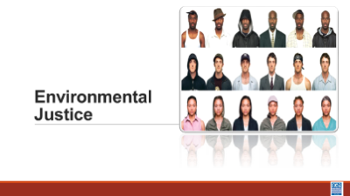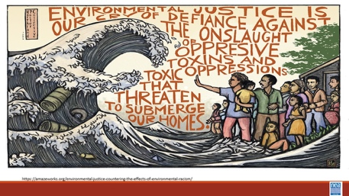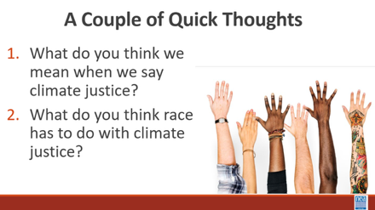  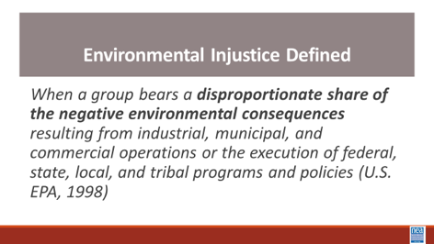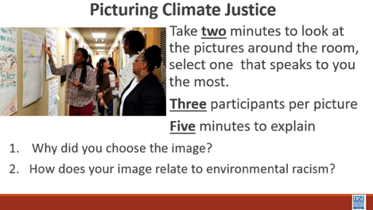  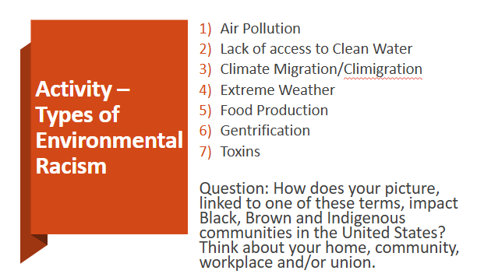  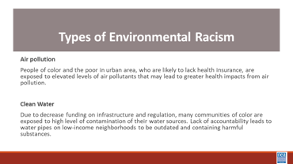  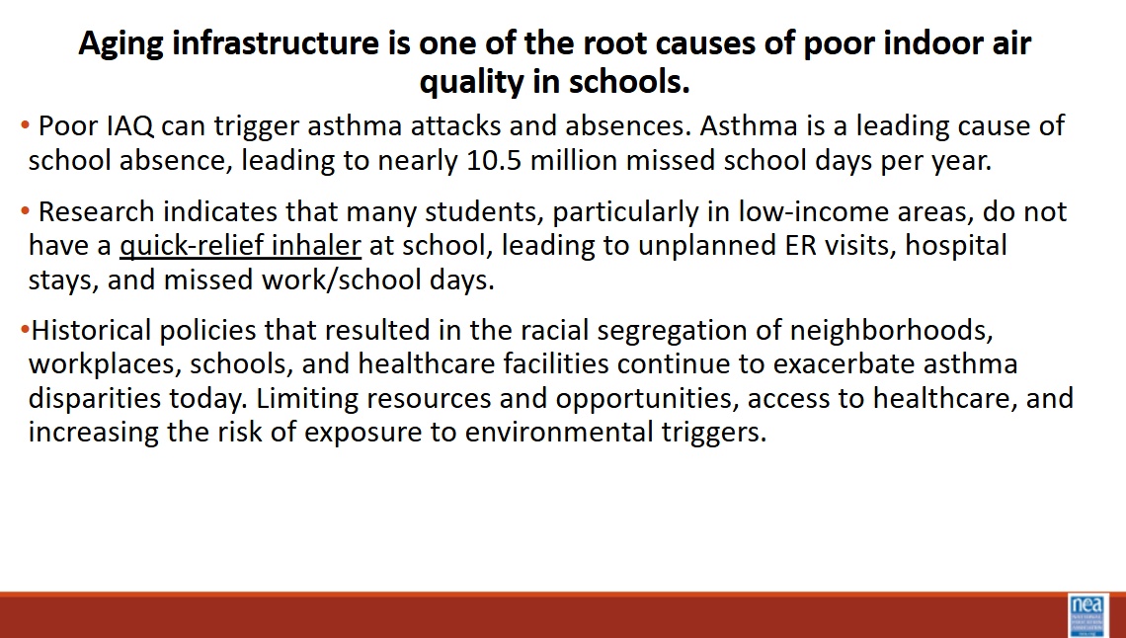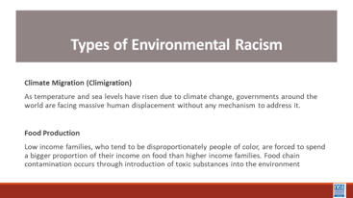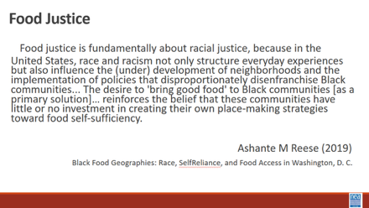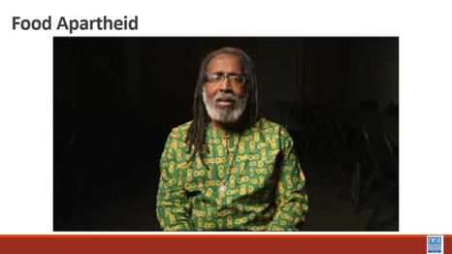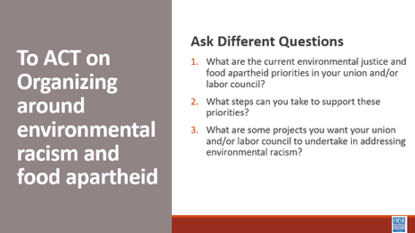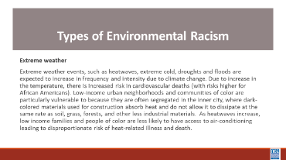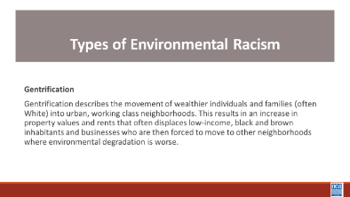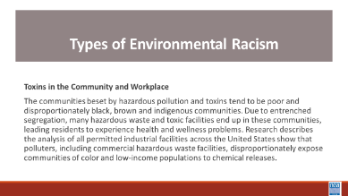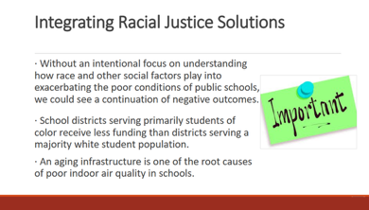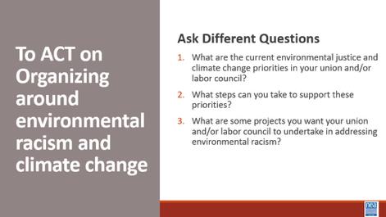  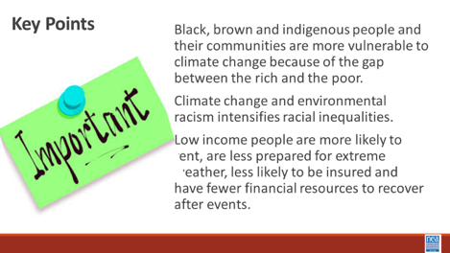 |  | Have images printed on letter size paper (8 ½ x 11 inches) or larger in color and have them posted around the workshop room.  Post a chart under each image for round  Types of Environmental Racism – PH p.23  Environmental Racism Explained Articles: “How Workers Can Demand Climate Justice” and “Climate Inequality: Forgotten History” in Additional Res. |  | 10 min intro - We are going to take a look at another system of oppression – Climate justice. Turn in at your tables and take just 3 minutes to have a quick conversation about these two questions:  What do you think we mean when we say climate justice?  What do you think RACE has to do with climate justice?  Let’s take about 5 minutes to hear three quick thoughts for each of the question  Show Video -History of Climate Justice Video (5 mins)  Show the slide with the following definition - When a group bears a disproportionate share of the negative environmental consequences resulting from industrial, municipal, and commercial operations or the execution of federal, state, local, and tribal programs and policies (U.S. EPA, 1998)  20 mins - Picturing Climate Justice Activity – Round 1  Intro – 2 mins -what is the best predictor that a person will be disproportionately, negatively impacted by environmental consequences? That is right, race.  Activity- 15 mins You have two (2) minutes to go around the room and look at each image. After you have seen them all, please take a seat by the image that speaks to you the most when you think about climate change and environmental racism.  No more than three (3) participants per picture.  With those at your image, you will have five (5) minutes to briefly do the following as a group: explain why you chose this image; how does this image relate to environmental racism? Don’t write on your chart yet-that is round 2.  10 min – Report out from each  Where are there any similarities?  40 minutes total for Round 2 -Types of Environmental Racism- Round 2  2 min- Intro  Stay in your image groups for round 2. Note: there should be at least seven (7) groups. As a small group, you will have ten (10) minutes to:  - Read term/definition  - Answer the question by writing and/or drawing on flip chart paper. Please draw in large letters so others can read your answers when the chart papers are posted.  - Prepare to present your definition and answer to the rest of the participants. Each group will present in under two (2) minutes. Groups should decide if they want to present as a group or have a spokesperson in advance.  Question: “How does your image linked to one of these terms impacting black, brown and indigenous communities in the United States? Think about your home, community, workplace and/union.”  7 Types:  - Air pollution  - Clean water  - Climate Migration/ “Climigration”  - Extreme weather  - Food production  - Gentrification  - Toxins  - POLICE (not official)  Encourage groups to address impact in terms of home, community, workplace and/or union rather than focus on one aspect.  10 min - Activity  New potential activity: 1) Video about food apartheid 2) table talk about how food apartheid could contribute to racial justice 3) what role can your affiliate play justice on this issue  Without an intentional focus on understanding how race and other social factors play into exacerbating the poor conditions of public schools, we could see a continuation of negative outcomes in school districts that primarily serve students of color. That is because it is more common for school districts serving primarily Native students or students of color to receive less funding than districts serving a majority white student population.  Districts serving white students living in poverty also tend to receive greater funding than districts serving students of color living in poverty. Those trends hold even when controlling for socioeconomic status. Inequitable financial resources contribute not only to inequitable academic resources such as educators, instructional materials, and technology but also to poor school facilities and critical infrastructure that directly affect student health.  A closer look at workplaces. Poor indoor air quality (IAQ) impacts learning conditions and working conditions. Poor IAQ in schools has been linked to cognitive deficits and negative economic impacts in the workplace, including impacts on the number of employee sick days and job retention.  Poor IAQ can trigger asthma attacks and absences. Asthma is a leading cause of school absence, leading to nearly 10.5 million missed school days per year. Research indicates that many students lack an asthma action plan and, particularly in low-income areas, do not have a quick-relief inhaler at school. This leads to unplanned emergency room visits, hospital stays and missed work and school days putting the greatest financial burden on people with asthma and their families.  Historical policies that resulted in the racial segregation of neighborhoods, workplaces, schools, and health care facilities continue to exacerbate asthma disparities today. Segregation limits resources and opportunities available to certain populations, affects access to health care, increases risk for exposure to environmental triggers, and increases chronic stress in certain populations.  15 minutes - Group report out  Key Points:  - Black, brown and indigenous people and their communities are more vulnerable to climate change because of the gap between the rich and the poor.  - Climate change and environmental racism intensifies racial inequalities.  - Low-income people are more likely to rent, are less prepared for extreme weather, less likely to be insured and have fewer financial resources to recover after events. |  |  |  | Participants will understand  Black, brown and indigenous people and their communities are more vulnerable to climate change because of the gap between the rich and the poor.  Climate change and environmental racism intensifies racial inequalities.  Low-income people are more likely to rent, are less prepared for extreme weather, less likely to be insured and have fewer financial resources to recover after events.  What does your experience with climate change have to do with race?

