Facilitator Agenda: Advancing Racial Justice 2027 Day #2
General Materials Needed: |  |  |  |  |  |  | Room Set-up:
1 Set of Handouts per Person  Name Tags and Name Tents  Sign-in Sheet  Pens and Pencils |  |  | Chart Paper  Markers  Post its  Index Cards |  |  |  | Round Tables  Projector, Screen and Speakers  Carousel stations and reporting stations around the perimeter  50 people
Key Outcomes for the Day
Participants will deepen their understanding of white dominant culture and how it shapes institutions and daily interactions
Participants will analyze how systems such as wealth inequality and immigration policy contribute to racial oppression
Participants will build skills for engaging in challenging conversations about race and identifying ways to disrupt systems of racism
8:30- 8:35: Getting Started  8:35-9:00: Movements of Resistance  9:00-10:15: What is White Culture  10:15-10:30: Break  10:30-12:00: Why this Work is Tough  12:00-1:00: Lunch |  |  |  |  |  | 1:00 – 1:45: Systems that Oppress: Income and Wealth  1:45 – 2:25: Immigration Policy and ICE  2:25 – 2:30: Closing  2:30 REAL STOP FOR National Civil Rights Museum
Time, Slides, Facilitator |  | Resources |  | Instructions, Activity and Debrief (Facilitators) |  |  |  | Outcomes and Essential Questions
 |  | Charts, handouts, articles, materials, slide |  | What are you saying, what are they doing, what questions will you use to guide learning and make clear the important points  Include an estimate for how long each section of the learning will take |  |  |  | As a result of this learning, what will participants know or be able to do? What questions will they be able to answer?
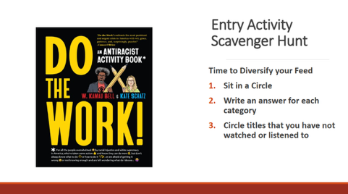 |  | Entry Activity—SCAVENGER HUNT: Diversify Your Feed
8:30 -8:35 |  | 10 Minutes – Regroup and Ground (IN A CIRCLE OF CHAIRS to Start)
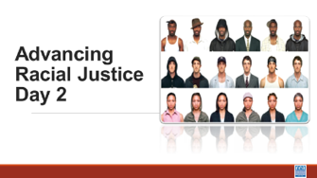  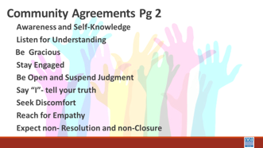  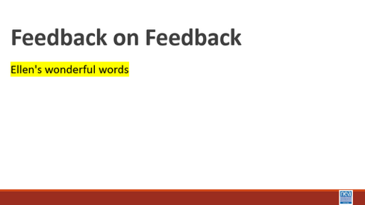   |  | Circle of Chairs for Participants  To be ready for next section |  | 5 minutes  Review the Community agreements:  Yesterday we said we would focus/consider more of ______ – is there something additional or different we should consider? Does where we left the conversation yesterday still land as a good focus of our time today?  Feedback on Feedback  Day 2 Agenda  Any logistics: Leaving for the National Civil Rights Museum at the Lorraine Hotel by 2:30 |  |  |  | Participants will reflect on Day 1 and understand any changes made for Day 2.  How will we work together?
8:35-9:20 |  | 45 Mins – Restorative Practices Introduction
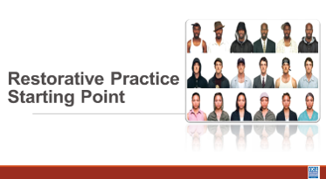  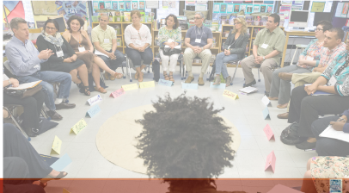  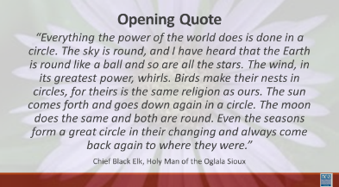 |  | 4 Circles of Chairs for Participants  Restorative Practices Resource p. 28-92  Talking piece  Circle norms same as group |  | 10 minutes  Ask participants to form 4 circles based on cards or count off.  “I’d like to welcome you to your circles. “  Read quote from Chief Black Elk aloud (slide)  “Everything the power of the world does is done in a circle. The sky is round, and I have heard that the Earth is round like a ball and so are all the stars. The wind, in its greatest power, whirls. Birds make their nests in circles, for theirs is the same religion as ours. The sun comes forth and goes down again in a circle. The moon does the same and both are round. Even the seasons form a great circle in their changing and always come back again to where they were.” --Chief Black Elk, Holy Man of the Oglala Sioux  “Resolving our issues and discussing our experiences is an indigenous practice that is still in use. At one point it was actually outlawed because it was so antithetical to the dominant culture. Think of how most classrooms have been arranged – rows – hierarchy. In a circle there is no hierarchy, and everyone is equal. The process that we are going to engage in is one that you can use to engage colleagues and members in deeper conversations. To engage in deeper conversations about race and social justice, we need to build a community of trust and respect. We will begin to build our community here in this circle. To ensure safety we say that what is said in the circle stays in the circle. Stories stay in the circle, but the lessons are taken out and shared with others.”  30 minutes--Circles: (Adia) (Scott/Linda) (Bekah/Greylor) (Albert/Ellen)  Pro Tip: First, ask participants to gage their feeling about the sharing using a “weather” descriptor as a metaphor (cloudy, sunny, etc.). Check in with participants 3x between the questions. Facilitators need to plan and be intentional. We need to model for them how to respond to the prompt (without bogarting).  Pro Tip: Use a squishy for the “talking stick” it's comforting for people to hold in front of them.  Reminder of Agreements-done by individual circles  “We will come to the circle throughout our time together, and just as we have norms for the training, we have norms for the circle.” Plus – the use of a talking stick, and the ability to pass.  Community Pass One  - The participants in this video mentioned that while avoiding certain labels or ways of identifying people might avoid surface-level conflict, we ignore people’s experiences that are connected to those labels. Are the labels that you hold most closely to your sense of self those that hold more privilege or less privilege? I’ll start to model this for us. *SHARE* (*For facilitator: focus on the more privilege/less privilege in general, not the specific labels in the modeling.*)  Community Pass Two  - Share an a-ha moment you had from one of the activities or videos yesterday. (pass the talking the piece)  Community Pass Three (pick one)  - When do you feel powerless and why?  Matt gives a one-minute warning ala Zoom room closing.  5 minutes Circle Closing – What are you taking away from this Circle about labels and recognizing our complexities? MOVE THE BREAK, 10 MINUNTES, WE ALL NEED DECOMPRESSION TIME  How can we transition from circles to the next? It worked, but it is always clunky to move from a vulnerable, sharing space back to an academic space. We acknowledge the need for these spaces in our work and the community that we choose to support us in this work. Often, our families are not those spaces, but our chosen families can be places where we get the support we need to do this work because of the common language and experiences, and creating or finding spaces like this in our work are valuable. |  |  |  | Participants will cultivate a reflective mindset.  Participants will begin to build a reflective, trusting community that allows for honest conversations about advancing racial justice.  Participants will be introduced to the Restorative Practices circle process and begin to make the connection about how to use this process as they work  What are Restorative Processes?  How can you use Restorative Processes to build Community?  How can you use Restorative Processes to build collective knowledge?
9:20 – 9:30 |  | 10 Minute Total - Timeline Bridge MOVE THE BREAK HERE!!! GROUNDING EXERCISE
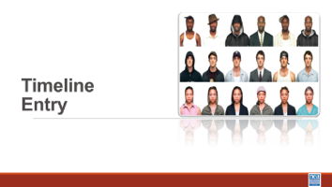  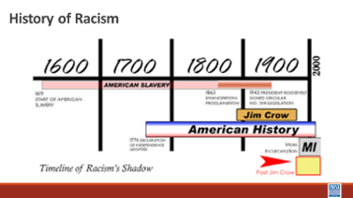  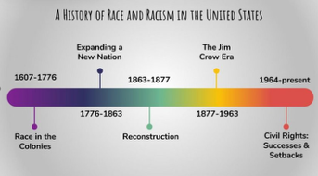  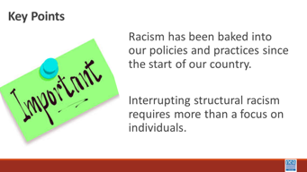 |  | Adia |  | Official Eurocentric Colonizer’s description of United States history begins with 1612, so when we hear people say, “Slavery ended a long time ago,” why are Black people still so upset? Think about this image. Within the context of 400 years, only the last 60 have had any type of progress, and as we are witnessing under the current administration, there is a concerted effort to erode all progress made by rolling back legislation.  In August 1619, a ship named the White Lion arrived at Point Comfort, Virginia, carrying '20 and odd' kidnapped Africans. This moment is often cited as the inception of what would become American chattel slavery—a system that transformed human beings into legal property. For the next 246 years, this institution was not just an economic engine; it was the foundation upon which the nation was built. Slavery was codified into law, ensuring that status was hereditary and that Black bodies remained the literal capital of a growing empire.  The 13th Amendment ended formal slavery in 1865, but it did not end oppression. Instead, oppression adapted. We saw the rise of 'Black Codes' and the Jim Crow era, which used the Supreme Court's 'separate but equal' doctrine to enforce a racial hierarchy. In the 20th century, this evolved into systemic hurdles like redlining, which barred Black families from the wealth-building power of the GI Bill. The Civil Rights Movement of the 1950s and 60s successfully dismantled legal segregation through the Civil Rights Act and the Voting Rights Act, yet the 'impact' of these centuries of exclusion remained embedded in the nation's DNA.  The modern era has been defined by a duality: profound progress alongside persistent systemic gaps. We have seen the first Black President and Vice President, yet we also witnessed the global Black Lives Matter protests that forced a reckoning with police violence and mass incarceration. History is not a straight line of progress; it is a cycle of action and reaction. We move beyond the intent of individuals to examine the impact of systems, understanding that the work of 2026 is still about dismantling the 'Power' part of the formula we discussed earlier.  1 Min – Key points  Racism has been baked into our policies and practices since the start of our country.  Interrupting structural racism requires more than a focus on individuals. |  |  |  | Participants will discuss illustrating the development of structuralized racism in what we now call the United States of America.
 |  | XX Minutes Total –
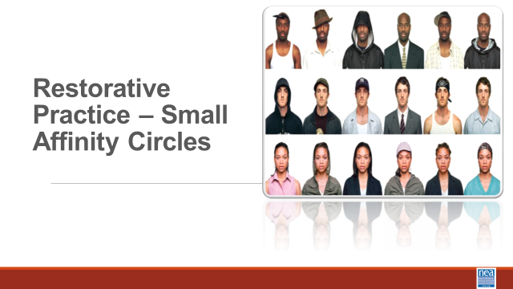  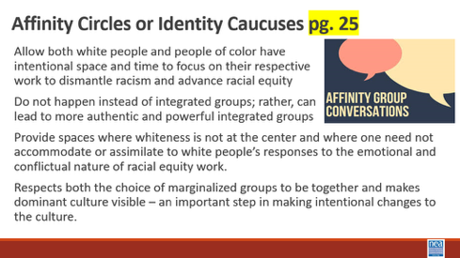  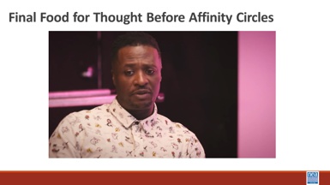  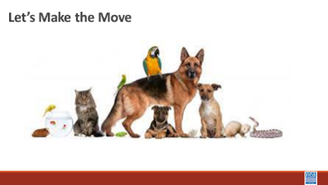 |  | Page 24 White Culture Handout  Paying Attention to White Culture and Privilege – P. 28-41 |  | Play the 5 minute video in the Food for Thought Slide then get folks prepped to be in affinity circles.  Facilitator Notes  Note: We need to ask participants to take their tech/laptops to their affinity spaces  Make a set of Possible Racial Affinity Group Names – Signs White, Black, Latin, Multi Race/ Ethnic, Asian After giving the content below ask people to claim a name sign and a space. Facilitation of this should allow for choice. Look for folks that are confused and help them navigate who to join. Make it clear that the goal is to find a community of learners who will benefit from a safer more respectful examination for their lived experiences. However, inappropriate ways of joining an affinity group would be, “I am a white woman, and I have married a black man, so I am going to sit with the black men’s table because I know the challenges. People will already have been warned this method is coming and will have been prompted to be thinking about the racial identity most visible to others and that most enables their relationship with privilege.  5 Mins – Move to Racial Identity Caucuses or Affinity Groups– pg. 29  5 Mins - Intro and Content (Facilitator needs to read the following and put it into their own words as they share the bulleted points slide.) - One tool we have found to be very helpful, especially in acknowledging and supporting some of the emotions that naturally occur in racial equity work, is racial identity caucusing.  - The value of caucusing is so both white people and people of color have intentional space and time to focus on their respective work to dismantle racism and advance racial equity.  - Caucusing does not happen instead of integrated groups; rather, caucusing can lead to more authentic and powerful integrated groups.  - Caucusing not only respects the choice of marginalized groups to be together, it also makes the dominant culture visible – an important step in making intentional changes to the culture.  - Further, working only in integrated groups puts an undue burden on people of color to be the teachers and obscures the responsibility of white people to do their own work. Both people of color and white people are needed to work collectively for racial equity. But they have different work to do, precisely because of their different experiences with and location relative to white culture and privilege. For people of color the caucus can be a space where whiteness is not at the center or a place where one need not accommodate or assimilate to white people’s responses to the emotional and conflictual nature of racial equity work.  - The caucus provides an opportunity to not only speak about the impact of racism and white culture within an organization, but also about how oppression is internalized on an individual, intergroup, and institutional level. This space can build solidarity among diverse people of color while at the same time allowing that full diversity to emerge and be celebrated. This caucus can be a liberating place for people of color to heal, bring their full selves, and consider how to collectively work for racial equity.  5 Minutes Play the Button Video and ask them to  5 Minutes – Make the move, claim a sign, and remember why we are making this move and discuss your feelings and reactions to the video.  (*For the facilitators: Keep an eye out for the potential for an “affinity group of one,” so none of our participants feel isolated or singled out.*) |  |  |  | Participants will be able to describe the aspects of white culture – and actually recognize that there is a white culture.  Do white people have a culture?  What is the work that we need to do to become anti-racist?  How do we provide spaces where this work can be done?
10:15-10:30  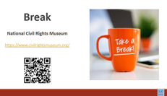 | BREAK
10:30 -12:00 |  | 90 Minutes Total - Why This Work is Tough
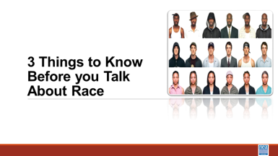  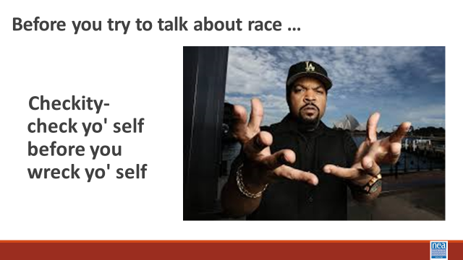  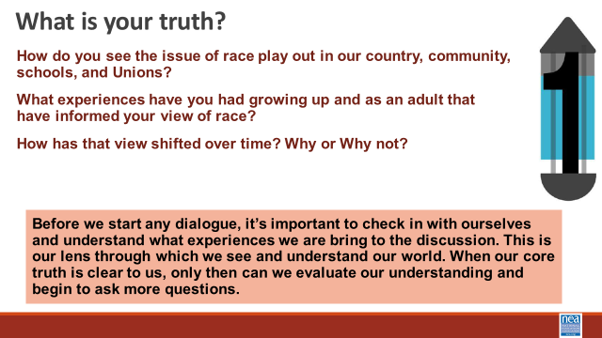  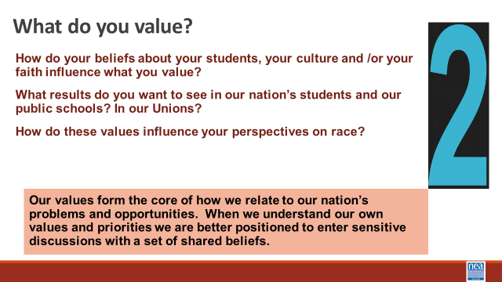  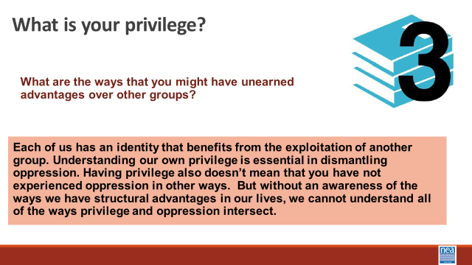  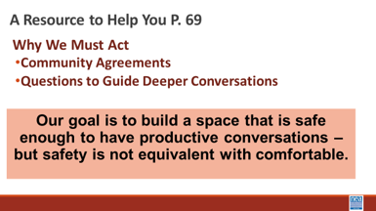  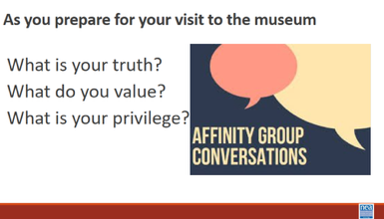  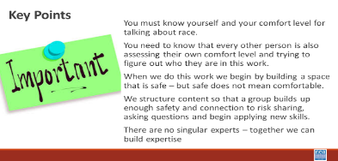  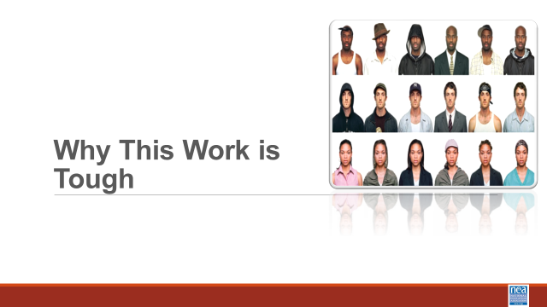  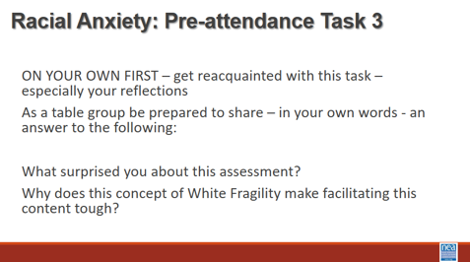  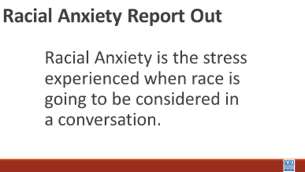  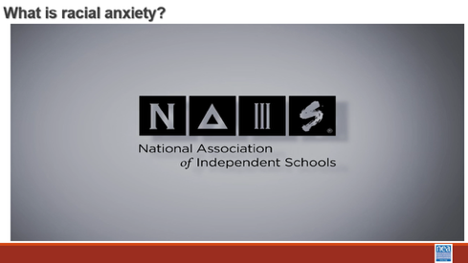  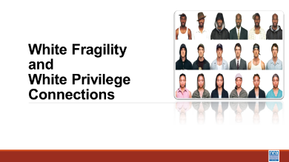  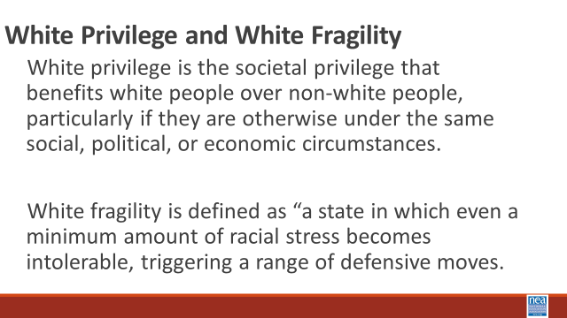    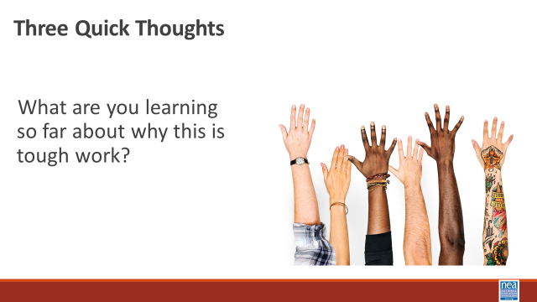  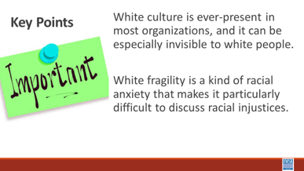  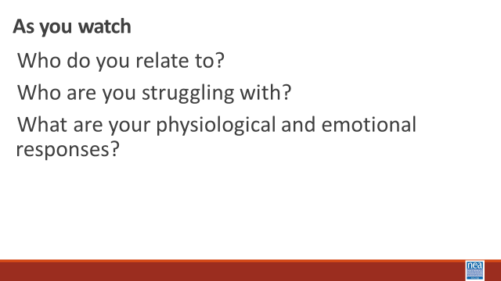    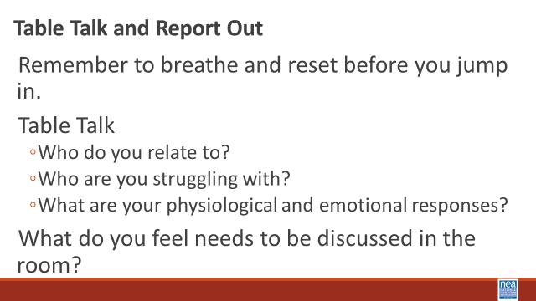  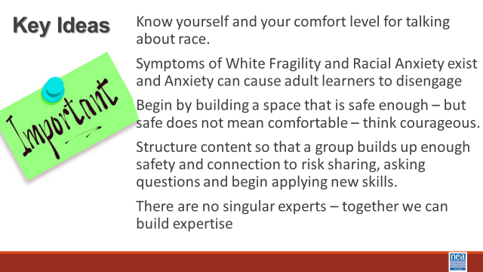 |  | Additional Resource: RJE Discussion Guide  Pre-Attendance Task 3:  Racial Anxiety Self-Assessment  Additional Resource: What is White Privilege?  Attention to White Culture and Privilege pgs. 28-41 |  | 15 Mins: Before you discuss---  Affinity Groups Topics—Each of these questions is asked of the full group for the affinity groups to discuss amongst themselves in chunked segments.  1 min intro - A useful framework of three sets of guiding questions you have a responsibility to investigate if you are going to do this work. IT follows Ice Cube’ sage advice - to check yourself before you wreck yourself.  2 Min -Show Slide – What is your truth? – I will wait while you read this -- What I want you to notice is that it is important to know what experiences you are bringing to the conversation.  2 min -Show Slide – What do you value? - I will wait while you read this -- What I want you to notice is that when we know our values it helps us be more sensitive and open during conversations that are tough  2 min -Show Slide – What is your privilege? I will wait while you read this -- What I want you to notice is each of us has an identity that has allowed for the oppression of others, and just because we have privilege does not mean that we have not experienced oppression.  There is a handout in your additional resources named RJE Discussion Guide that can help support you as you begin tough conversations around Racial Justice that includes community agreements, and questions for deeper understanding. When we do this work, we begin by building a space that is safe enough – but safe does not mean completely comfortable.  1 Minute Key Points –  - You must know yourself and your comfort level for talking about race.  - You need to know that every other person is also assessing their own comfort level and trying to figure out who they are in this work.  Return to your seats  25 Minutes – Why this Work is Tough – Privilege and Racial Anxiety  5 mins – Introduction and video -We are going to take a closer look at the concept of privilege as you watch, consider how Privilege and Racial Anxiety are Connected. That feeling of discomfort? It was more than just discomfort. More than just FOMO. The discomfort of feeling left out as a historically privileged group is not welcomed into a space—that can be an expression of fragility.  Show video (5 Mins)  “Racial Anxiety” We show this slide as a way to transition the self-made affinity groups from their “table talk” to a whole group discussion. Then immediately go to the slide about “Racial Anxiety” – ask them to access the “Assessment” that they took in their pre-attendance work, Task 3.  10 Mins – Table Talk -With your own table: what Surprised you about your assessment? Why does this concept of White Fragility make facilitating this content tough?  5 Minutes - Report out and look for the following points that participants might report – and share these if they don’t explicitly or implicitly talk about them.  - Symptoms of Racial Anxiety exists  - Anxiety can cause adult learners to disengage  - Being transparent will feel difficult and there will be some degree of non-closure and imperfection  - Attending to community development requires intentionality  - Building from low risk to high risk takes time  - This is an ongoing process, and we all arrive at different times  2 Minutes – as a wrap up to this small section – share the video “what is racial anxiety”  10 Minutes –Connecting White Privilege and White Fragility – Share the slide with these two critical concepts to understand –  White privilege is the societal privilege that benefits white people over non-white people, particularly if they are otherwise under the same social, political, or economic circumstances. White fragility is defined as “a state in which even a minimum amount of racial stress becomes intolerable, triggering a range of defensive moves.  In this video the well-recognized author who has benefitted greatly from her own white privilege Robin D’Angelo, does a decent job of explaining the connection between white privilege and white fragility. (Share the video)  Facilitator Note: We used this to finalize the discussion as a whole room from self-made affinity groups. Move to slide – three (3) quick thoughts and take just three thoughts about what folks are learning about why this is tough work.  1 Minute – Key Points - White culture is ever-present in most organizations, and it can be especially invisible to white people.  White fragility is a kind of racial anxiety that makes it particularly difficult to discuss racial injustices.  35 Mins – What this Work can Look Like  REMEMBER OUR CAUTION  8 Mins Intro and Video - We are going to watch a segment from the 1994 movie “Color of Fear” that shows how 8 North American born men have the conversations that many of us fear.  Today, we are going to the Civil Rights Museum. We will see the struggle of a movement not just for Equality but for Jobs and Freedom. This movement was more than one man, it was you and you and most importantly us. But it wasn’t just an event—or a year. Notice that this film is 30 years or so after. Now, we are 30 years past the film. What changes were expected and didn’t come to fruition by the time of the film? How does the lack of change add to his anger and the anxiety it may produce. How is it resonating now?  As you watch notice if and/or when you begin to feel uncomfortable. Notice your breathing and what your brain begins to tell you. What would your comfort level be for hanging into this conversation. Notice Who do you relate to? Who are you struggling with? What are your physiological and emotional responses?  Show video (5 Minutes)  10 Minutes to discuss reactions in small groups -Remember to breathe and reset before you jump in. Table Talk  - How do you relate to his emotions today?  - Does the anxiety generated then translate to today’s racial anxiety?  - What are your physiological and emotional responses?  10 Minutes Whole Room Discussion - What do you feel needs to be discussed in the room?  - Additional Resource: “Fighting Racism, Battling Burnout: Causes of Activist Burnout” article  2 Mins Key Ideas –  Know yourself and your comfort level for talking about race.  Symptoms of White Fragility and Racial Anxiety exist and Anxiety can cause adult learners to disengage  Begin by building a space that is safe enough – but safe does not mean comfortable – think courageously to prepare to act courageously.  Structure content so that a group builds up enough safety and connection to risk sharing, asking questions and begin applying new skills.  There are no singular experts – together we can build expertise |  |  |  | Participants will learn about racial anxiety and assess their own level.  Participants will understand three  foundational concepts and their contributions to why this is work is tough, white culture, privilege, and anxiety.  Why is talking about race so difficult?  Participants will develop an understanding of what makes this work tough and learn basic steps to support their success in their future work.  Make sure you prep the group for this video. I will be difficult to watch
12:00 to 1:00  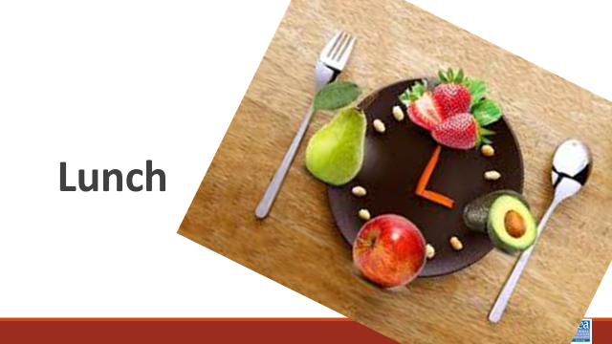 | LUNCH
1:00-2:35 | 35 Mins – Systems of Oppression – Income and Wealth
1:00-2:15 |  | 75 Minutes Identity and Intersectionality
_______________________________  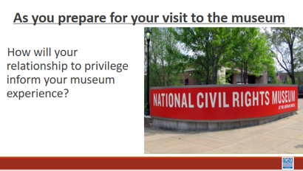 |  | Your Intersections Circle worksheet p. 30  Additional Resource:  Teaching Tolerance Article: “Teaching at the Intersections”  Additional Resource: “America’s War on Black Trans Women”  Levels of Racism P 6 |  | 2 Mins– We are going to take a look at one example of systemic racism that impacts our members and their jobs – income and wealth. Take just a moment in your mind and consider the following question –  - Are your members doing better financially than they were 10 years ago? What “signs” would you see that support your answer?  In the last decade, has the income your members earned enough to pay the bills? How do you know?  6 Mins- What is the difference between Income and Wealth?  What are some examples of income? (wages, salary, interest, social security check, rent from owning real estate, capital gains from selling investments, dividends from stocks, gifts, etc.)  - What are some examples of wealth? (savings, investment, property, etc.)  - How is wealth different from income and why is this important? Wealth can be passed on to future generations.  - What is Per Capital Income? How much each person receives from the yearly income generated in the country if the yearly national income is divided equally among everyone.  - In 2025, it is around $86,000/person (INCLUDING CHILDREN).  - Imagine if we distributed income this way, would it be enough for everyone?  - What is Actual v Perceived Wealth and what does this say about how American feel and thing about economic inequality?  A Harvard University Study asked people (Democrats and Republicans) what they think the wealth divide to be and what they think is fair. The actual weather inequality is far greater than what most people perceive it to be and even more so between what they think is fair.  - Think it is: Top 20% have 60% of the wealth  - Think it should be: Top 20% have 35% of the Wealth  - What it is: Top 20% have 85% of the Wealth  Mention the link a video demonstration of the study for additional information for comparison.  - What is Negative Wealth and Why is this Important?  - Negative Wealth is when you owe more than you own. It is created when your expenses are greater than your income (aka-Debt)  - In 2019, 10 % of American have negative net (13 million) worth. In 2024, 31% of Americans have a net worth of $0 or less  - Black/Brown America-1 in 4 have negative wealth  - White America- 1 in 12 have negative wealth  - Student Loan, Auto, and Credit Card Debt is dragging down the wealth of Americans, particularly household of color  Share that this will only widen as health care costs continue to rise and student loan debt forgiveness programs end  18 Mins – The Quintile Quest (Economic Exploration) Activity (see full guide)  Now let’s have seven (one for each quintile and the 1 for top 5% and 1 for top 1%) volunteers come to the front of the room. Please stand shoulder to shoulder. Each gets a sign showing the income range — in pre-tax, year 2014 dollars — of the quintile they represent.  - What are Income Quintiles and why do economists use them?  Economists often talk about the income in the US as divided into "quintiles" or "fifths" of a population. They imagine the entire population of the U.S. lined up from the lowest income to the highest income. They then divide that line into five equal parts. A quintile can be thought of as a fifth of the population or 20%.  We are going to watch how income has changed over quintiles in the population. This activity looks at what happened to the incomes during two periods of economic growth: 1947-1979 and 1979-2014.  Take a look at the signs the volunteers are holding – this number represents median Family Income.  - What jobs would be in each of these?  - What economic challenges would each have?  - Where are our members – pay attention to job classes and state differences.  INCOME WALK  Each volunteer, representing a quintile or fifth (20 percent) of the U.S. population, will step forward or back according to whether their income gained or declined. They start in a line evenly together.  Have the non-participants stand in a line along the path of where the stepping will occur  Each step equals a 5% change. So, for example, two steps forward would indicate an income gain of 10%.  1947-1979  Lowest: 23 Steps/Pace Forward (+116%)  Second: 20 Steps/Pace Forward (+100%)  Middle: 22 Steps/Pace Forward (+111%)  Fourth: 22.5 Steps/Pace Forward (+114%)  Highest: 20 Steps/Pace Forward (+99%)  Top 5%: 17.5 Steps/Pace Forward (+86%)  Have the non-participants, who are lined up along either side of side of the “Income Walk” move forward with the participants. They should slide forward 15 steps to represent inflation over that time period. Notice that all quintile income outpaced inflation.  1 min-This one slide graphs what we just did. Show to visualize the economics beyond the activity and how income growth remained relatively equitable, and in fact the lower four quintiles actually did. better than the top 20%  What can you tell us about the history, policies, unions from 1947-1979?  One explicit goal of the federal government during the early post-war period was to build a middle class where people and families who could consume the output of the rapidly growing manufacturing capacity of the U.S.  Federal government programs like the GI Bill of Rights enabled hundreds of thousands of returned veterans to go to college and purchases homes, beginning the steps to accumulating family wealth.  It is important to note that people of color were largely excluded from middle class wealth gains. (redlining, job discrimination, ect). While acknowledging that post-war programs helped build the middle class, it's important to also acknowledge that these programs disproportionally favored white men.  For example, VA and FHA loan programs for housing utilized racially-restrictive underwriting criteria. Thus, assuring that hardly any of the $120 billion in housing equity loaned from the 1940s to 1960s would go to families of color.  While loan programs like FHA and the GI Bill helped finance over half of all suburban housing construction in the country during this period, less than 2% of this housing ended up being lived in by people of color  Next say that we will now look at income changes from 1979-2014. Many of you might remember what happened during that time period.  What can you tell us about 1979-2014? (Reaganomics, neo liberalism decline of unions) all contributed to declining middle class, greater poverty and extreme disparity in income and wealth.  1979-2014  Lowest: 2 1/2 steps/paces backward (-12%; $0 - 29,100)  Second: 1/2 step/pace forward (+3%; $29,101 - 52,697)  Middle: 2 steps/paces forward (+12%; $52,698 - 82,032  Fourth: 5 steps/paces forward (+26%; $82,033 - 129,006)  Highest: 10 1/2 steps/paces forward (+54%; $129,007+)  Top 5%: 15 1/2 steps/paces forward (+78%) $230,030 and up  Top 1%: 37 steps/paces forward (+185%) $423,090 and up  Have the non-participants, who are lined up along either side of side of the “Income Walk” move forward with the participants. They should slide forward 12 steps to represent inflation over that time period. Notice  Inflation outpaced all quintiles except the top 5% and 1%  - From 1979-2014, there was much growth in income, but the distribution of that growth was extremely uneven. Although the top 20% as a whole did well, the ones who really made out were the folks at the very top. The top 1 percent gained 185% between 1979 and 2014, and the top .1 percent gained 361% between 1979 and 2014 — the divide between the top income earners and everyone else is enormous!  - In other words, when looking at the historic data we see that the upper quintiles' income has grown exponentially faster than the lower quintiles.  - This can have many impacts on society but one of the most obvious ones it the GAP between the upper income levels and the lower income levels has been rapidly growing over time.  1 min-Show two slides that graph of what we just did. Show to visualize the economics beyond the activity and how income disparity widened during this time period.  1 min-Show slide which compares 2014 Median Income with 2022 Median Income and ask What do you notice? The first 4 Quintiles Median Incomes are actually LOWER in 2022 than in 2024. The Top Quintile is significantly higher.  1 Min-Discussions  - In which quintile do most of your members live?  - In which quintile do you live?  - In which quintile do the policy makers live? The business owners?  Income-Wealth Race and Gender  1 min-These three slides show the impact of these economic changes presently on race, gender and income and wealth. This income and wealth gap for people of color has grown even wider in the last decade  1 min-These two slides show how the Pandemic Anti-Poverty income programs temporarily leveled out poverty disparities by race. Federal government child tax credit and state/local basic income programs made a huge difference in temporarily providing income for people of color. Targeted programs in New York, Minnesota, California, Arizona, and other states made a difference. These ended in 2022 and disparity increased. These programs are further being cut by the Trump administration  Question for Consideration: Why would anyone want to prevent the equitable distribution of wealth?  Key Points  - Systems have been intentionally built to shift power, income, wealth, and opportunity away from those in the lowest quintiles toward those in the top quintile.  - The impact is further compounded when you look at the intersection of race and income.  - Collective action (people power) has led to any number of institutional solutions in the past and could do so again.  - Changing Tax and Income Policy foundation to create wealth and counter structural racism  Community Agreement Check In: What did we do well? Where could we focus more?  ______________________________________________________ |  |  |  | Participants will understand that policies have been adopted that intentionally limit the ability for people to acquire wealth – and that these policies can be intentionally undone  How do race and gender affect your income?  Might change to ½ steps for 1947-79 depending on room  Hide the quintile walk-top 1% slide  ________________________________________  Participants will learn how intersectionality provides for an understanding of how overlapping identities inform our relationships with privilege and oppression.  What is intersectionality?  How do our identities intersect?  What are the oppressions that are involved with gender identity and sexual orientation? How do they intersect with racism?
2:15 – 2:30 Albert |  | 15 Minutes – Transactional Museum Stuff
3:00-5:00 | National Civil Rights Museum
5:00 | ADJOURN

