2Facilitator Agenda: Advancing Racial Justice 2027 Day #3
General Materials Needed: |  |  |  |  |  |  | Room Set-up:
1 Set of Handouts per Person  Name Tags and Name Tents  Sign-in Sheet  Pens and Pencils |  |  | Chart Paper  Markers  Post its  Index Cards |  |  |  | Round Tables  Projector, Screen and Speakers  Carousel stations and reporting stations around the perimeter  50 people
Key Outcomes for the Day
Participants will reflect on their experiences at the museum and connect historical context to present-day systems of oppression
Participants will examine environmental justice issues and understand how infrastructure (such as data centers) disproportionately impacts marginalized communities.
Participants will practice applying anti-racist principles and build skills for developing campaigns that challenge and disrupt inequitable systems.
8:30-9:30: Getting Started / Museum Reflection  9:30-10:05: Systems that Oppress: Environmental Justice-Data Centers  10:05-10:45: Practice of Becoming Anti-Racist  10:45-12:45: Campaign Building |  |  |  |  |  | 12:45 –1:00 Closing  1:00-2:00 Lunch
Time, Slides, Facilitator |  | Resources |  | Instructions, Activity and Debrief (Facilitators) |  |  |  | Outcomes and Essential Questions
 |  | Charts, handouts, articles, materials, slide |  | What are you saying, what are they doing, what questions will you use to guide learning and make clear the important points  Include an estimate for how long each section of the learning will take |  |  |  | As a result of this section, what will participants know or be able to do? What questions will they be able to answer?
8:30-9:30 |  | 1 hour total - 15 Minutes Greet, Gather & Ground and Entry Activity
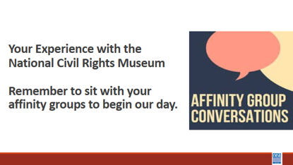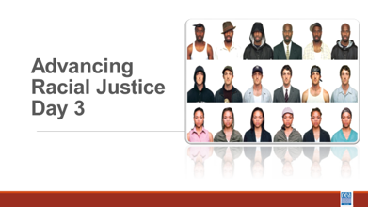  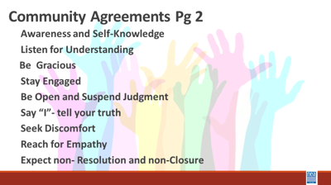  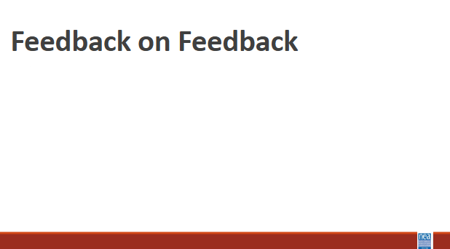  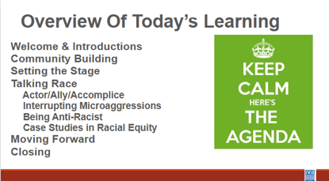  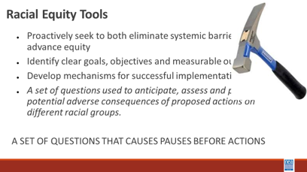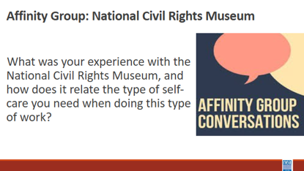 |  |  |  | Welcome,  overview of learning goals,  overview of days agenda,  feedback on feedback and  revisit community agreements.  Yesterday we said we would focus/consider more of ______ – is there something additional or different we should consider? Does where we left the conversation yesterday still land as a good focus of our time today?  45 MINUTES  Affinity Groups re: Museum Visit  Facilitator Notes: When facilitating affinity circles – consider holding back on sharing until the participants have shared (be mindful of taking up the allotted time)  When 2 people are presenting and we are talking about tasks that we want participants to do...let’s use “we” instead of “I”  Consider including more movement in the morning of Day 3// we had t2 chunks of work with no movement |  |  |  | What have we been learning? What is working and what is not?  What will today look like?
9:30 –10:15 |  | 45 Minutes Total –Planning and Prepping for Allyship
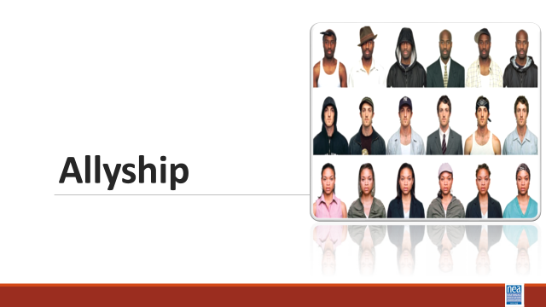  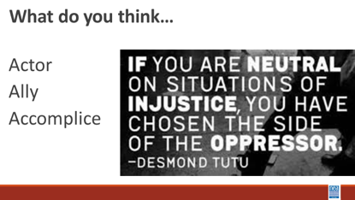  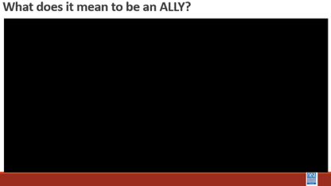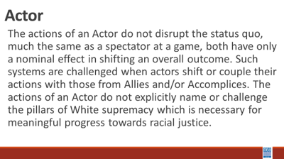  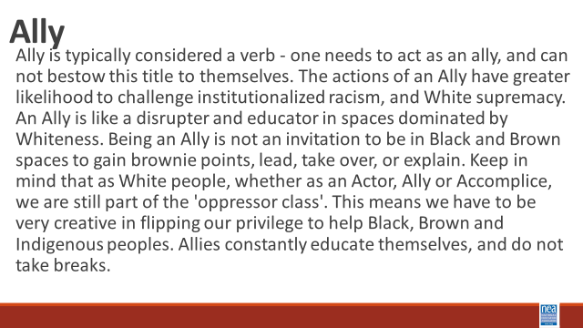  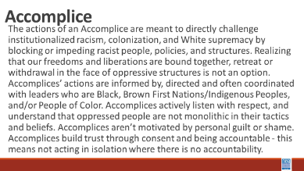  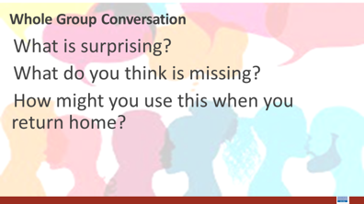 |  | Actor to Ally to Accomplice Chart p. 54  The Action Continuum p. 59  So, You Call Yourself an Ally (Additional Resources)  Pre-Attendance  How to be an Ally if you are a person of privilege – section 7  Scaffolded Resources for White Allies  (Additional Resources)  11-16  17-19 |  | 20 Mins intro and definitions –We are going to look at some continuums of growth towards becoming anti-racist. The first we are going to look at is the actor to accomplice. In small groups, let’ do some talking and development of “indicators and definitions” for each of the following - Actor, Ally and Accomplice. They will take 10 minutes to develop their definitions.  10 Mins Discussion and Sharing – Facilitator will take input from the room and THEN share the slide to see what the room added to or missed from the pre-written definitions on our slide –  Share actor definition – discuss how was this similar or different from your thinking.  Show What does it mean to be an ally? Video  Share Ally definition and discuss how this was similar or different from your thinking.  Share Accomplice Definition – Discuss how this was similar or different from your thinking.  15 mins – intro, exploration, and report out – Find the Actor to Accomplice charts- p. 156 Let’s work for 10 minutes on your own, then come together with your triad for about 5 minutes to talk about what you are seeing. - Read the descriptions for Actor, Ally and Accomplice in each of the following categories. Circle the description that best matches where you currently stand- what are you currently doing and THEN Focus on what you might consider doing to move the next column. Give them cues for the 10 minutes on their own and then 5 minutes in small groups. Then open up to whole room  3 Minutes – Share video of 5 things to remember about being an ally and then share the following key ideas - Actor, Ally, Accomplice – it’s a continuum  Authenticity comes from actions not announcements.  7 Mins Whole Group Discussion:  What is surprising?  What do you think is missing?  How might you use this when you return home? |  |  |  | Participants will define and then assess where they currently stand as an Actor, Ally or Accomplice.  How do I support racial justice efforts?
10:15-10:45 |  | 30 Minutes- Nativism and Immigration Policy
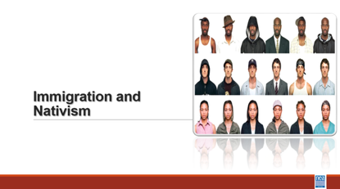    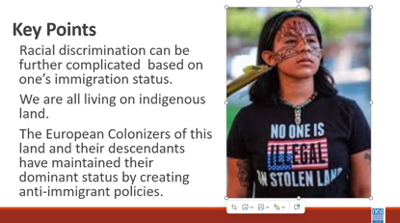 |  | What does it mean to be American? |  | 30 Minutes Total - Nativism and Immigration  2 minutes: Introduction  One of the “weapons” White Supremacy culture uses to empower racist policies and structures is Nativism, which is defined as (Britanica.com)  Nativism is an ideology, governmental policy, or political stance that prioritizes the interests and well-being of native-born or long-established residents of a given country over those of immigrants, typically by advocating or enacting restrictions on immigration. Those who hold this view tend to reject or avoid the term nativist and instead identify themselves as “patriots,” “nationalists,” or “populists.” However, nativism is not equivalent to patriotism, nationalism, or populism; indeed, it has more in common with xenophobia and racism.  We’re going to start our conversation by watching a video that explains the racist history of U.S. immigration policies.  5 minutes: Video  Show The Racist History of US Immigration Laws video - 5 min  5 Minute Table Discussion  - How does US immigration policy and race intersect?  - How does the labor movement show up for immigrants in this country?  - How can we participate in or engage with authentically advancing  racial justice if your affiliate isn't all in?  Introduce the next video: Let’s talk about how Nativism is impacting us today. The next video we are going to watch is about something called “The Great Replacement Theory.”  3 Minutes: Video  Show Professor Larissa Myrick-Harris clip explaining the Great Replacement Theory in the context of Anti-Immigration policy and violence today.  5 Minutes: Table Discussion Question  Modern Echoes: Looking at the landscape of 2026, how do current policies like denaturalization efforts or asylum holds mirror the 19th- century goal of protecting "long established residents" at the expense of human rights?  7 Minutes: Share and Discuss  “What We Can Do” Slides. Talk more in-depth about the following type of response we can take to resist and fight Nativism  - Being an Actor Keep Informed, Sharing KYR Cards, Refuting Disinformation  - Being an Ally: Grocery Shopping, driving kids to School, passing out Whistle Kits, Opposing 287g Agreements,  - Being an Accomplice: Canvassing Businesses, Migra Watch Patrolling  Key Points  - European colonizers of this land, and community descendants have maintained their dominant status by creating anti-immigrant policies  - Racial discrimination can be further complicated based on one’s immigration status  - We can act as allies and accomplices to protect immigrants in our communities by getting involved with immigrant rights work already going on. Look up online what’s already going on in your community and show up.  - Anti-immigrant rhetoric and policies are perpetuated by government and media endorsed fear of others in order to maintain the country’s white control over systems of power |  |  |  | Participants will explore the concept of Nativism.  Participants have already seen another section of the video
10:45-11:20
IN groups   | BREAK
11:20-12:30 |  | 70 Minutes -Practicing Becoming Anti-racist - Case Studies in Racial Equity
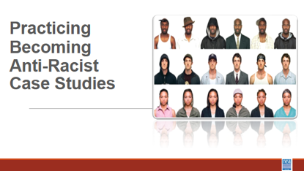  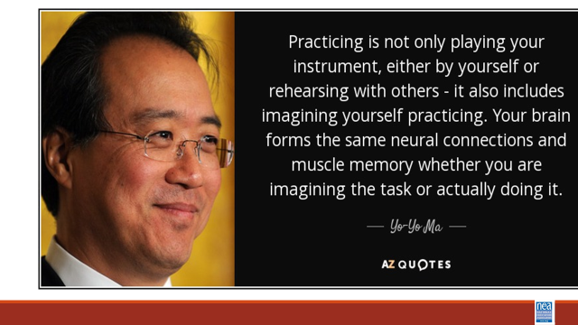  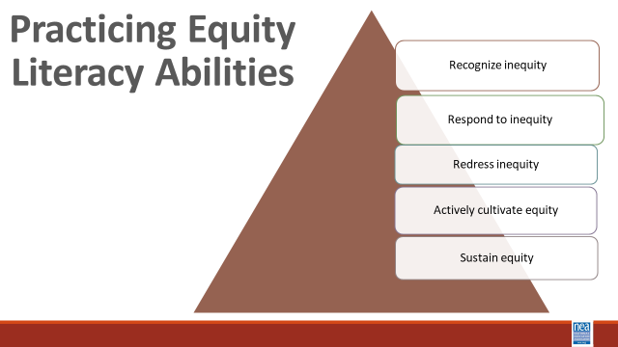  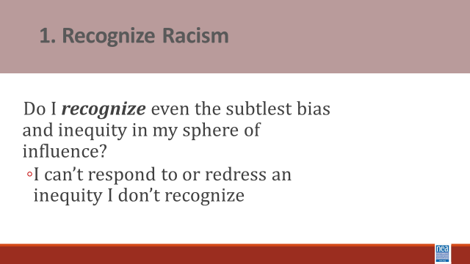  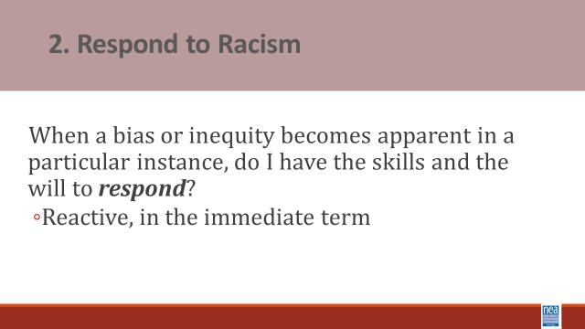  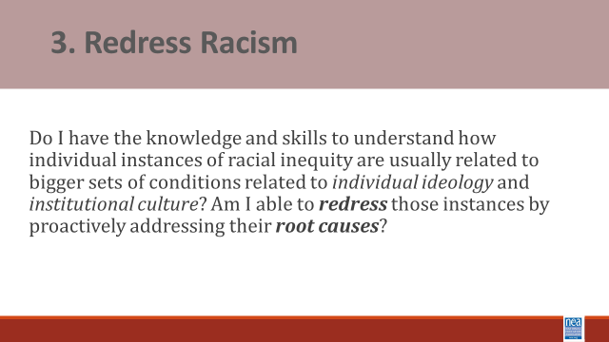  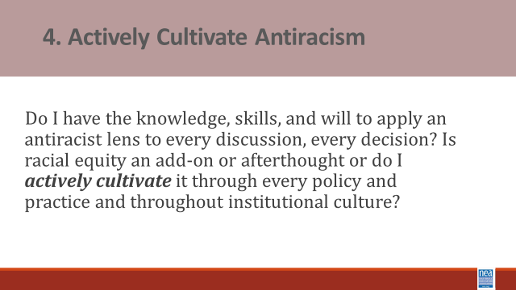  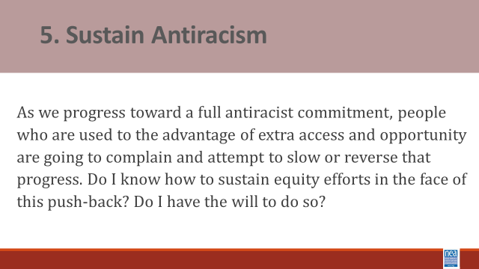  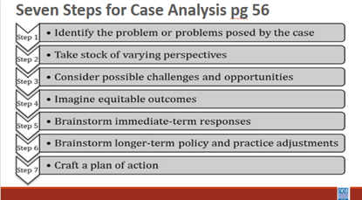  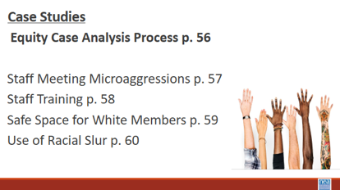   |  | Case studies framework  Case Studies |  | Campaign Lab Pitch—explanation and ask  10 mins Introduction and Content Sharing of what case studies are and the 5 abilities we are working to cultivate - The case method enables us to practice stepping through a process of considering a range of perspectives and angles, to practice seeing the full complexity of school and classroom situations, and as a result to consider a more focused manner in how we might respond.  Cases do not have ONE correct answer or obvious solution. We learn to think carefully, to listen to the points made by others and to evaluate those arguments, to review alternative courses of action and their efficacy, and to interpret real-world experience.  The case method provides opportunities to bolster our abilities to think, teach, lead, and advocate more equitably and justly.  Equity literacy refers to the knowledge and skills we need as educators to be a threat to the existence of bias and inequity in our spheres of influence. It refers to the knowledge and skills that prepare us to root bias and inequity of our classrooms, schools and communities.  Case studies allow us to practice what Paul Gorski of the Due East Educational Equity Collaborative calls the Equity Literacy abilities:  The purpose of the 5 abilities is to  - allow us to apply a strong equity lens to everything we do; and  - they provide an outline for what the thrust of equity professional learning ought to focus on important abilities:  - The ability to recognize even the subtlest bias and inequities. Equity literate people notice even subtle bias in classroom materials, classrooms interactions and school policies and they reject deficit views that associate outcome inequalities (test scores, graduation rates) with students’ “mindsets” or “cultures” rather than disparate levels of access to resources and experiences in and out of school.  - The ability to respond to biases and inequities in the immediate term. Equity literate people have facilitation skills and content knowledge needed to interview effectively when biases or inequities arise in classrooms, faculty meetings and other contexts. They also foster conversations with colleagues about bias and inequity concerns at their schools.  - The ability to redress biases and inequities in the long term. Equity literate people advocate against inequitable school practices and identify ways to mitigate structural barriers that impede educational engagement.  - The ability to actively cultivate and sustain a bias-free and equitable school environment. Equity literate people express high expectations for all people and demonstrate a willingness to withstand complaints about changes meant to redistribute educational access and opportunity more equitably.  5 Mins intro to - Seven Steps Script and Group Process - These case studies can be viewed through the following perspective – we often must help the people in our locals to problem solve around difficult issues. These cases allow us to practice the coaching, questioning, and problem solving we might use with those people. This is a process to help you practice using your unique insights, your knowledge about public schools, and our expertise with school and classroom dynamics in order to respond as effectively and equitably as possible, to the types of bias and inequities that inevitable crop up our schools.  We go through these exercises as a group because it is important to reflect upon why people with different combinations of identities and life experiences might interpret the cases differently.  Step 1 – Many biases and inequities students face in school are implicit and unintentional, hidden in day-to-day practices, school traditions, and quiet interactions. It can be especially difficult to recognize the sorts of challenges students or families face when you have never faced those challenges yourself. During this step, I urge you to read between the lines. Practice recognizing conditions and contexts you might not usually recognize or seeing what you might be conditioned not to see. Begin by naming biases, inequities, or otherwise troublesome conditions that are immediately apparent to you. Once you have a grasp of the more surface level dynamics, dig deeper. Look for less explicit, not so obvious examples of existing or potential bias, inequity, stereotypes or presumptions.  Ask yourself: What does the case tell us about school or classroom policy, about instructional or leadership practices, about individuals’ attitudes and perspectives that might hint at something deeper than surface-level biases and inequities?  Step 2 – The cases have at least a couple of obvious stakeholders who might have different perspectives on what is happening. In every case, we should consider not only the people immediately involved, but also those within earshot and eyeshot.  Start with the immediate participants and then, at the very least, the ring of constituents around them.  Focus on marginalized communities and privileged communities.  Then take it one step further. What if something was shared on social media – you have to consider the perspective of someone seeing this on SnapChat.  Step 3 – Our next task is to identify potential challenges and opportunities present by the situation. Start with the individuals involved. Remember to use your analysis from Steps 1 and 2 to inform your assessment of challenges and opportunities.  Step 4 – Building on the understandings we have gained by talking stock of stakeholders’ perspectives and considering possible challenges and opportunities, we begin imagining positive and equitable outcomes. [take time to clarify difference between equity (fair) and equality (same)].  Remember to think both immediate term and long term. What can be resolved right now, on the spot, and what will equity look like once it is resolved? Consider long-term outcomes as well. And finally, be specific – identify very specific, on-the-ground outcomes, how specifically will things be different in the school or classroom if we commit to resolving the issue and all its nuances equitably?  Step 5 – We begin brainstorming strategies to get us there.  Step 6 – We develop longer term strategies often for more substantive change. Record whatever ideas come to mind.  Step 7 – During our final step, we craft our brainstorms into specific actions we believe will result in the equitable outcomes we outlined in step 5 –  - What would we do in the immediate terms?  - What would we do that might a little longer term equity project?  - How would we respond to ensure, to the best of our knowledge and power, justice for everybody involved?  In summary, the point is not to memorize these steps or to step through them carefully in every instance, rather the ideas is to use them to practice our equity literacy skills by reflecting on classroom and school conditions through a social justice lens.  Count off to 4 to get the groups assigned  30 Minutes – Teams will work on assigned cases and be prepared to share their findings.  Albert begins here  30 Minutes – Group Reporting and Discussion |  |  |  | Participants will practice identification of bias, response to bias, redress structural reasons, and plan active cultivation of anti-racist practices through a 7 step case study process.  How do we practice our learning so we can coach our locals through anti-racist work?
12:30-1:00 |  | 30 Minutes Total - Campaign Lab and Closing
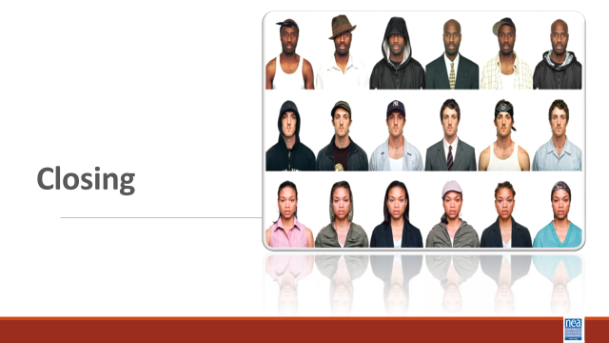  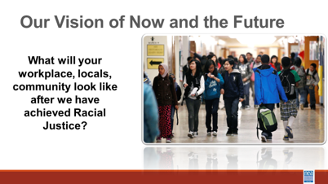  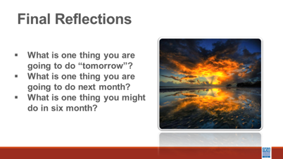  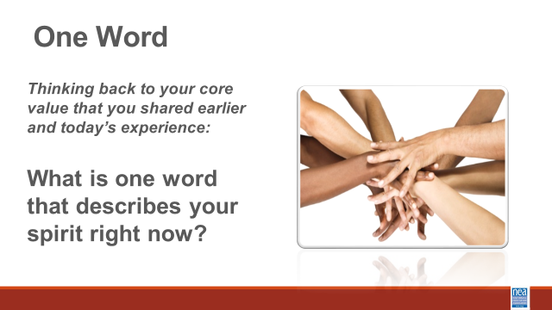 |  |  |  | Overview of Organizing  5 mins – What would it take to achieve a systemic solution for all of these scenarios?  5 Mins – What or who is preventing you from achieving the solution?  10 MIns- what does NEA focus on – Strength and Growth  Growth is necessary but does not build power  Strength is the abitlty to win and is all about the structures taht build power  There are 3 theories of change  Only organizing builds power  Campaign Lab  Campaign Coach  Closing asks  What will your workplace, locals, community look like after we have achieved Racial Justice?  - What is one thing you are going to do “tomorrow”?  - What is one thing you are going to do next month?  - What is one thing you might do in six months?
1:00-2:00 | Networking, 2:00 PM Adjourn

