Facilitator Agenda: Advancing Racial Justice 2026 MSEA Day #1
General Materials Needed: |  |  |  |  |  |  | Room Set-up:
1 Set of Handouts per Person  Name Tags and Name Tents  Sign-in Sheet  Pens and Pencils |  |  | Chart Paper  Markers  Post its  Index Cards |  |  |  | Round Tables  Projector, Screen and Speakers  Carousel stations and reporting stations around the perimeter  50 people
The NEA Center for Organizing and the NEA Center for Social Justice are partnering to provide a training designed to build participants’ skills through awareness of implicit bias, interpersonal racism and institutional racism. Participants will learn how to deepen this awareness in others, how to navigate issues of race that surface in our work, and how to access valuable resources on addressing racism. Participants will learn how to help themselves and others:
· Establish a common language for talking explicitly about race
· Develop a shared understanding of the levels of racism and its impact
Develop a common toolset for next steps in applying an equity lens to our work
8:30- 9:40 Getting Started  9:40-10:00 Museum Debrief  10:00-10:15 Break  10:15-11:10 What is Oppression  11:10 -12:00 Race Ethnicity and Nationality  12:00-1:00 Lunch |  |  |  |  | Ellen & Tina  Natasha & Rita  Taraja  Rita & Albert | 1:00 – 1:25 Expressions of Racism  1:25 – 1:55 Looking for Expressions of Racism  1:55 – 2:30 Systems of Oppression – Income & Wealth  2:30 – 2:45 Break  2:45 – 3:15 Shifting Perspectives  3:15-3:55 Systemic Levels of Racism Environmental Justice  3:55-4:30 Closing (this length of time is flexible) |  |  | Ellen & Natasha  Albert & Eric  Natasha  Rita & Albert  Rita & Ellen  Ellen
Time, Slides, Facilitator |  | Resources, Charts, Handouts |  | Total Time, Section Title Instructions, Activity and Debrief |  |  |  | Outcomes and Essential Questions
 |  | Charts, handouts, articles, materials, slide |  | What are you saying, what are they doing, what questions will you use to guide learning and make clear the important points  Include an estimate for how long each section of the learning will take |  |  |  | As a result of this section of learning, what will participants know or be able to do and what questions will they be able to answer?
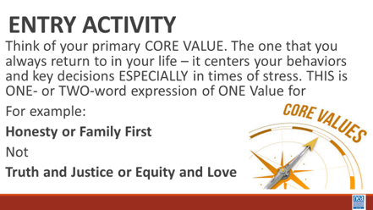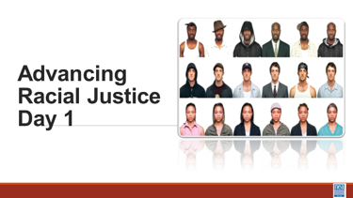 |  |  |  | Entry Activity – Think of Core Values  Core values are the fundamental beliefs of a person. These guiding principles dictate behavior and can help people understand the difference between right and wrong. These are going to be expressed in one or two words that support that SAME IDEA – example Honesty, Protect Home – NOT Love and Justice |  |  |  | What are our core values?
8:30 – 9:40 Ellen and Tina |  | 70 Minutes Total - Greet Gather Ground
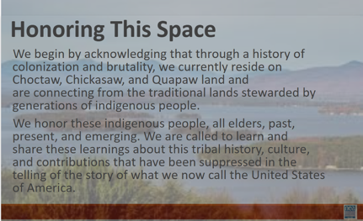  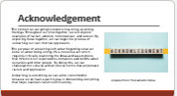  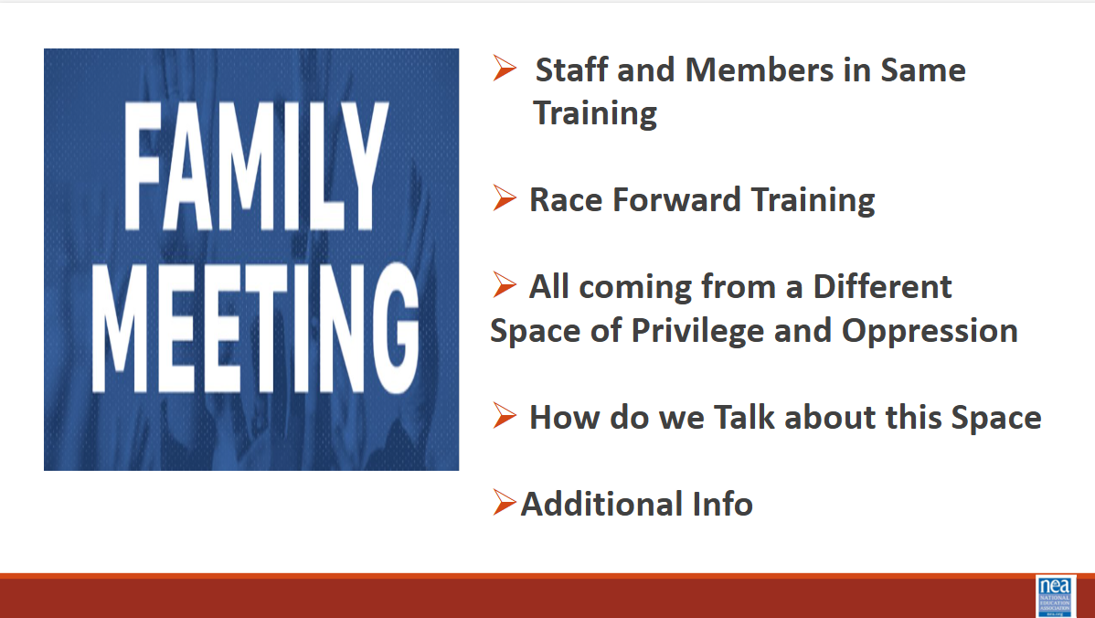  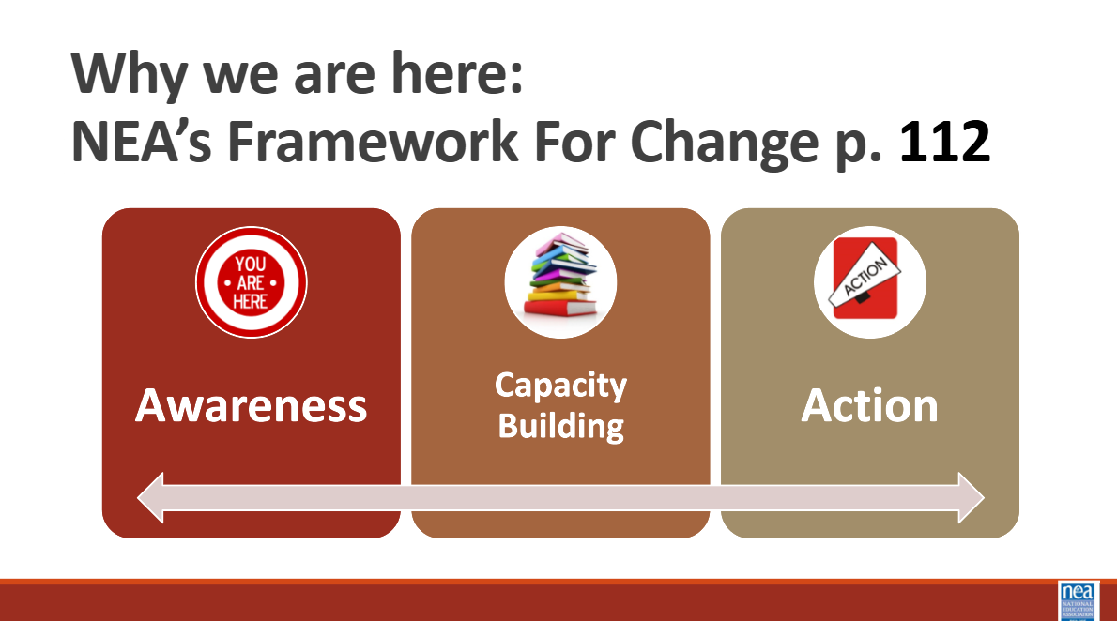  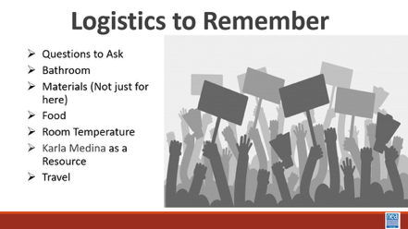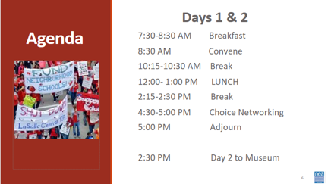  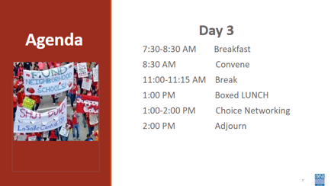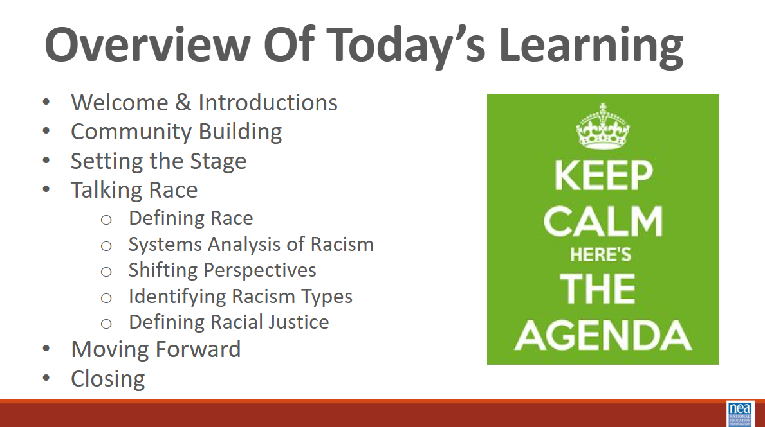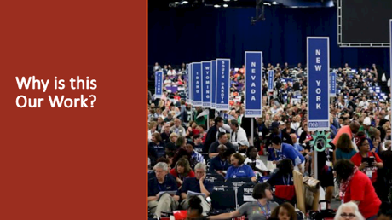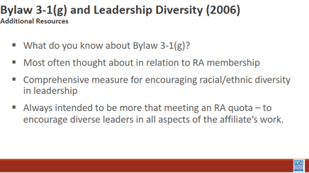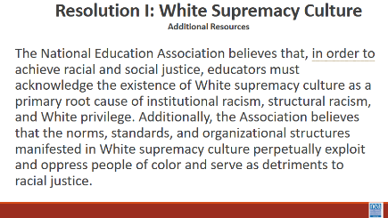  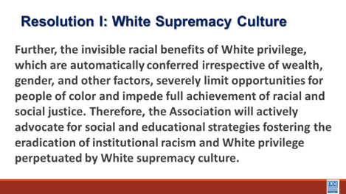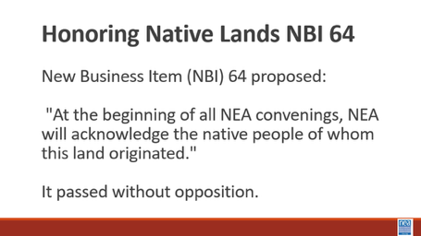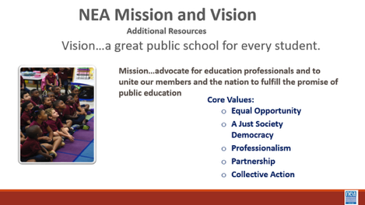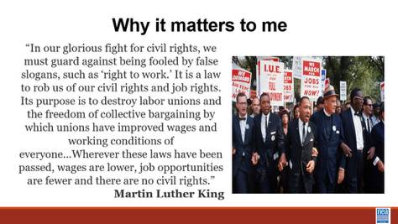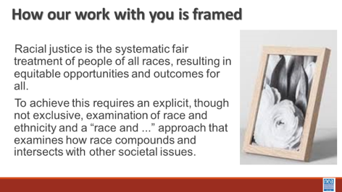  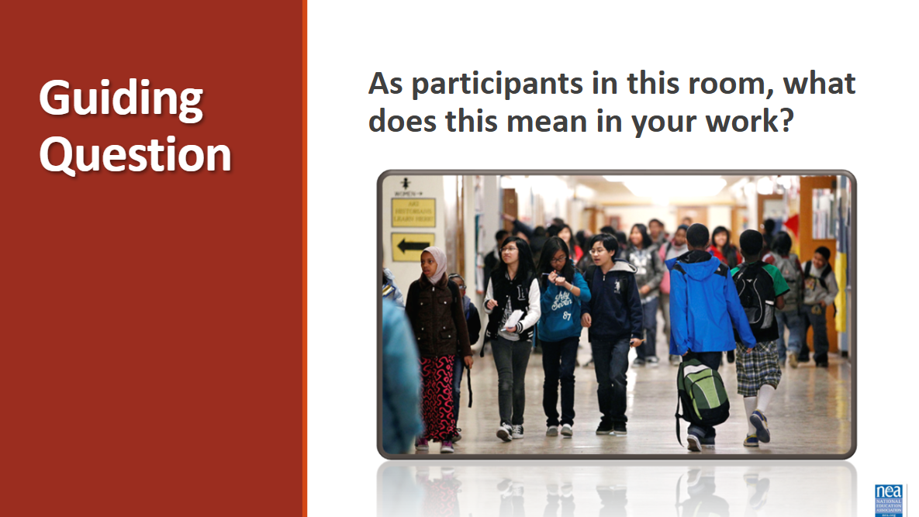  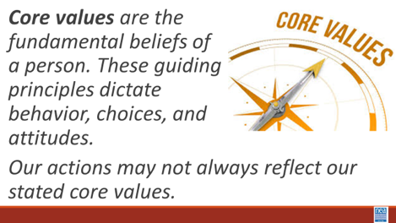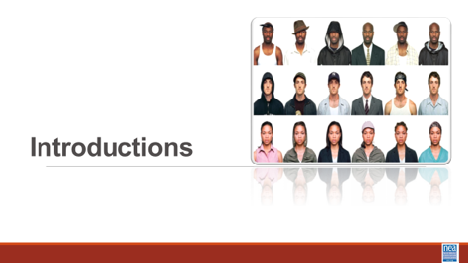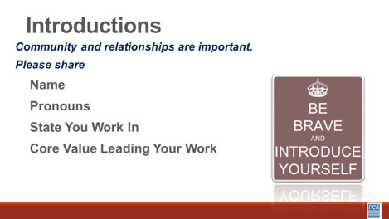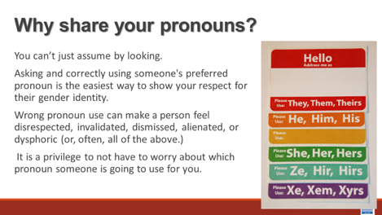  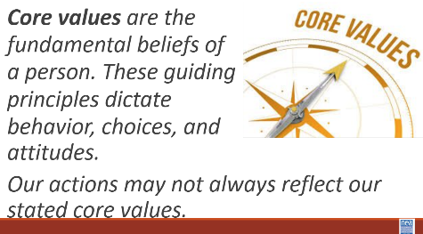  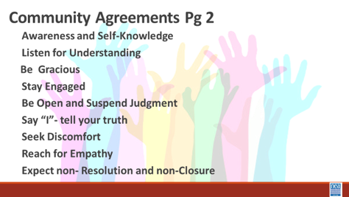 |  | 2 Charts for core Values  Participant Handouts:  Pronoun Guide that is a separate handout  Framework for Change p. 112  Community Agreements p. 2-3  Resolution 1 – Additional Res.  NBI b – P. 55  Additional Res.  Vision Mission Values – Additional Res  Bylaw 3-1(g) Additional Res.  Added handouts that are separate  Safe Just and Equitable schools |  | 15 Mins – Welcome, honor the space, overview of learning goals, overview of days agenda and logistics –  Why are we here - Framework for Change - P. 112  We move through stages of awareness, capacity building into action. In this training we are helping you become aware of where you are in regards to racial justice, we will be increasing our capacity by building our skills and understanding, and we will begin to make plans for actions we can take.  Acknowledgement - Before we dive into what this means to you; we begin with this acknowledgement. The content we are going to explore may bring up strong feelings. Throughout our time together, we will explore examples of racism, ableism, heterosexism, and sexism. By exploring these together, we can begin the process of unlearning our own internal oppression.  The purpose of unlearning isn’t about forgetting what we know or about being wrong; it’s a conscious act which requires critically examining the ideas and assumptions that influence our expectations, behaviors and beliefs about ourselves and other people. By doing this, we can challenge the cultural and  structural norms that perpetuate racism and oppression.  Unlearning is something we can all be committed to because we all  have a part to play in dismantling everything that helps maintain  racism within society.  It is not the responsibility of participants who represent marginalized communities to educate you. You must take responsibility for your own learning. You may hear us say *GTS—Google that shiz.  Family Meeting- Extra for ARJ with member/staff teams: Different space that what we are used to. Folks are members. Folks are staff. Maybe a new type of nervousness that we can’t predict? Try to solve problems in room, not by going to management at get.  Also: using affinity groups. Goal isn’t to stay separate but to avoid unintended harms that power and oppression can have in the room.  Identifying early: this is Advancing RACIAL justice. Not to say that other types of oppression aren’t valid. But race is the root of it all. Race is the prime. It cannot be divided. It is the most visible. So we use it as a core.  We are all coming from different space/place of privilege  How do we talk about this space? Expectations for confidentiality. Sharing learnings, not stories.  The administration has re-exposed the fissures between disparate people.  Why are we here: NEA’s Framework for Change (p112)  8 Mins- Setting the Stage, in additional resources (7th file when scrolling)  30 secs: NBI vs. Resolutions  Resolutions: Feel good and not funded  NBIs: Have money and action behind it  2 minutes each on Resolution I – Overview of NEA 3.1 G, NBI B 2015, Build the understanding that NEA views racial justice as a priority. Provide a brief each overview of each: Resolution 1 - 3.1 G, NBI B 2015.  Safe, Just and Equitable Schools – Adopted in 2022  In our time together over the next couple of days, we will take a more in depth look at racial justice. Racial justice is the systematic fair treatment of people of all races, resulting in equitable opportunities and outcomes for all. In order to have this discussion, we need to do an explicit, though not exclusive, examination of race and all aspects of our identity and look at how it compounds and intersects with other societal issues.  Our essential question throughout this examination is this: as a Participant what does racial justice mean in your work?  10 Mins -Introductions around the room – Share Name, work location, pronouns, and core value (refer to pronoun sheet)  Rita and Eric charting  Albert mic run  Pronoun explanation is dropped in by the facilitator just in case it is needed BEFORE THE facilitators model-We cannot assume how someone identifies, we must allow them to tell us their identity and honor that. We need to be inclusive of all genders and non-genders. Preferred pronouns is no longer the term used. Just “pronouns” We need to adapt this language and possibly the slide to delete the modifier of “preferred.” --Jackie  Show the Preferred Pronoun slide and say:  You can't always know what someone’s Gender Pronoun is by looking at them. · Asking and correctly using someone's pronoun is one of the most basic ways to show your respect for their gender identity. · When someone is referred to with the wrong pronoun, it can make them feel disrespected, invalidated, dismissed, alienated, or dysphoric (or, often, all of the above.) · It is a privilege to not have to worry about which pronoun someone is going to use for you based on how they perceive your gender. If you have this privilege, yet fail to respect someone else's gender identity, it is not only disrespectful and hurtful, but also oppressive.  Trainers will begin by modeling what is expected - briefly introduce themselves, their preferred pronoun, the state they are from and their Core Value (Core values are the fundamental beliefs of a person. These guiding principles dictate behavior and can help people understand the difference between right and wrong – one or two words) as a way of modeling for participants – less than 20 seconds per person.  Make sure that there is help for the facilitator in charting the Core Values. Charters places their own core value on chart.  2 Mins – After all have introduced themselves and the two charts have been populated – Facilitator points out - The opposite of these core values that I see gathered on our chart are – inequality, exclusion, division, dehumanization, and hate – these “opposites” from the basis for racism, sexism and other “isms”)  20 Mins - Community Agreements for Our Time – Give this about 5 to 10 minutes -Ask participants to review the community agreements sent in advance and to review the three questions that they were asked to think about. Have a small table conversation in preparation for a whole group commitment.  Awareness and Self-Knowledge  Listening for Understanding  Being Gracious  Stay Engaged  Be Open and Suspend Judgment  Say “I”- tell your truth  Lean into Discomfort  Reaching Empathy  Resolution and Closure  Allow about 5 to 10 Mins – Participants will share their responses, suggestions, changes, etc. Then facilitator will call for a visual community commitment. This is a shift from colonizer norms that aim to preserve the order of the conversation and maintain the focus of the power. These are commitments that we have each reviewed and will change as needed. By consensus we will agree to work with these until we need to make a change. Consensus means we all agree that these are good enough to get us moving. Show your thumbs and hold them up and keep them up until I have had a chance to view the whole room. Up thumb means – love it, nothing needs to change for me. Sideways thumb means – I can live with it for now. Down thumb means I cannot move forward until we discuss and come to a decision about…- and the down thumb leads the discussion on that UNTIL it can at least become a sideways thumb. |  |  |  | Participants will understand how we are going to work together as a learning community.  Participants will understand that this priority is embedded in our core beliefs, policies, and budgets.  As a participant, what does racial justice mean in your work?  What are we going to be learning? Who are we as a community?  How will we agree to participate in this community?
9:40-10:00 Eric |  | 20 Minutes Total: Museum Debrief Activity –
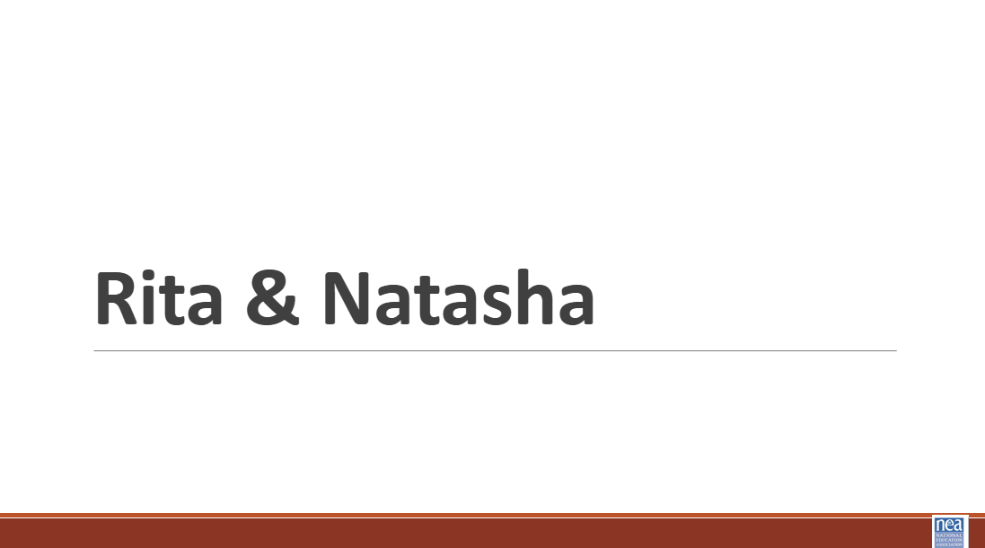  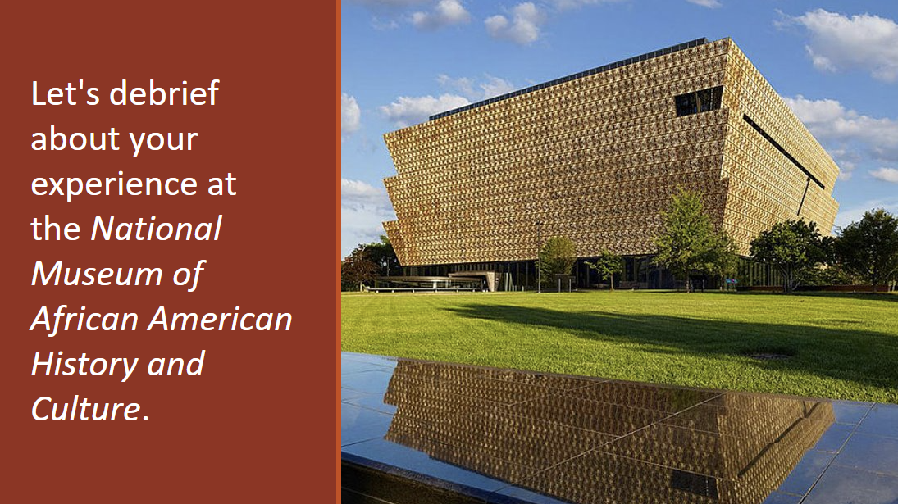  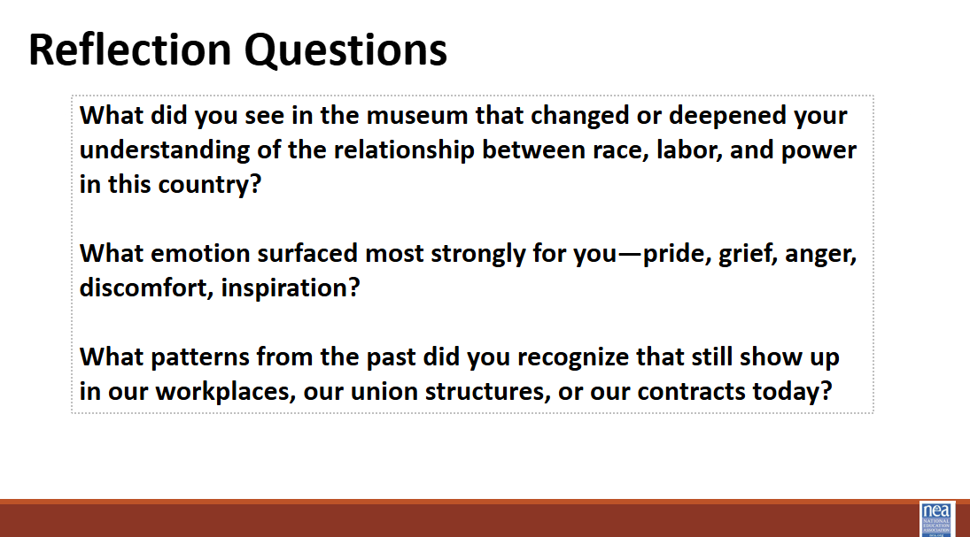  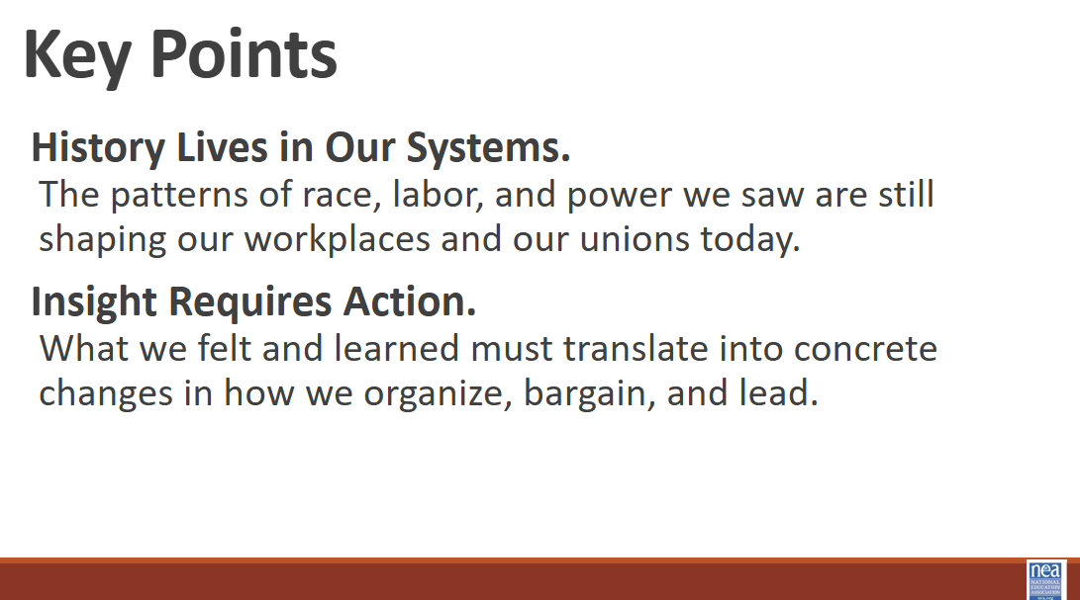 |  | Rita starts out and introduces the reflection questions.  Natasha does the share out |  | 1. Frame the Activity (2 Minutes)  Say:  “We just walked through a powerful historical experience. Before we move into strategy and racial justice work inside our union, we need to pause and reflect. This activity is designed to help us connect history to identity, emotion, and responsibility.”  Explain that participants will write reflections anonymously and move into discussion groups.  2. Individual Reflection & Posting (5 Minutes)  Instructions:  Give each participant three post-it notes.  Ask them to respond to all three questions — one response per post-it.  Responses should be brief but specific.  After writing, participants place each note on the corresponding poster.  Facilitator Tip:  Encourage honesty and clarity. Remind them that this is about reflection, not perfection.  3. Self-Selection Into Discussion Groups (1 Minute)  Instructions:  Ask participants to stand by the poster that resonates most strongly with them right now — the question they feel most compelled to discuss further.  This will organically divide the group into three smaller groups.  If one group is significantly larger, gently redistribute by inviting a few volunteers to shift to another question to balance conversation.  4. Small Group Discussion (7 Minutes)  Once groups are formed:  Instruct each group to:  Read several of the post-it notes aloud.  Identify common themes.  Discuss what stands out and why.  Discussion prompts for groups:  What patterns are emerging in these responses?  What feels urgent?  How does this reflection connect to our role as union members?  Ask each group to select one spokesperson to report back. Encourage them to summarize themes, not individual comments.  5. Share-Out (3–4 Minutes)  Bring the full group back together.  Each group spokesperson has approximately 1 minute to share:  The key themes from their discussion  One insight that feels important for the whole group to carry forward  Keep the pacing tight. Gently interrupt if needed to stay within time.  Closing the Activity (2–3 Minutes)  Project or state the two key takeaways:  History Lives in Our Systems.  The patterns of race, labor, and power we saw are still shaping our workplaces and our unions today.  Insight Requires Action.  What we felt and learned must translate into concrete changes in how we organize, bargain, and lead.  Close with:  “We cannot unsee what we saw. The question now is not whether history matters. It is how we respond to it in our union practice.”  Transition directly into the next section of your training (strategy, policy, bargaining, or racial justice framework).
10:00-10:15 |  | Break
10:15-11:10 Dr. Taraja |  | 55 Minutes TOTAL -What is Oppression?
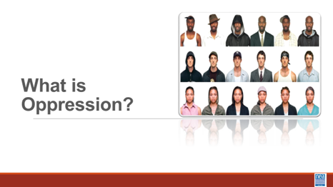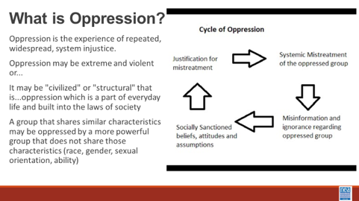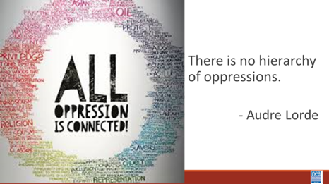  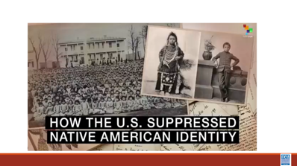  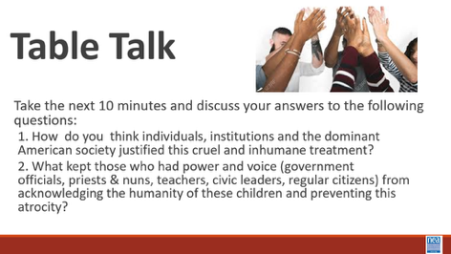  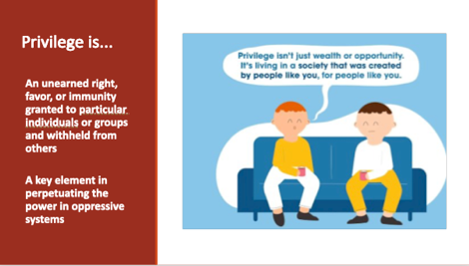    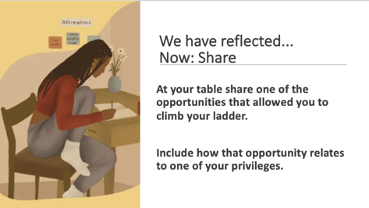  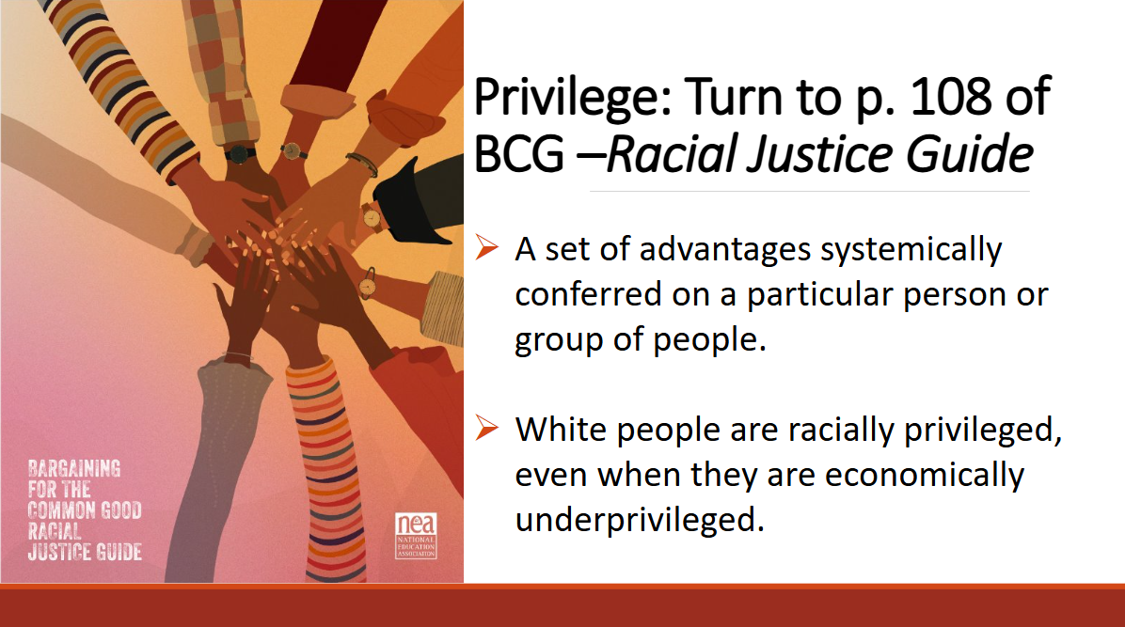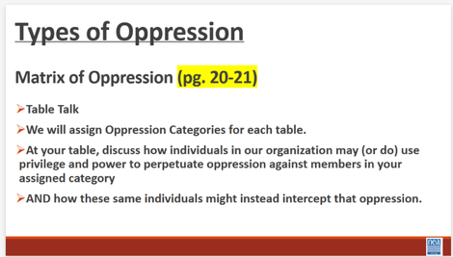  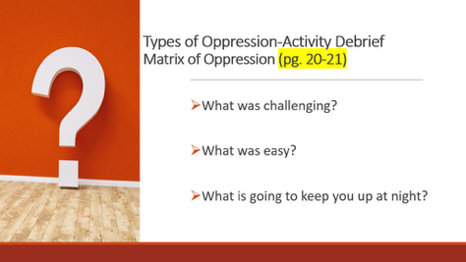  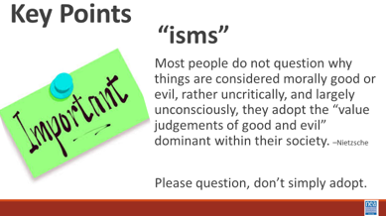 |  | Matrix of Oppression  p 21-22  Matrix of Oppression |  | 20 minutes Intro and video (3-4 minute)  Before we dive into what this means to you, we want to remember our disclaimer.  When we say words like oppression” and “oppressive ideas and assumptions” what exactly are we talking about? Oppression is the experience of repeated, widespread, system injustice.  It may be extreme and violent or...It may be "civilized" or "structural" that is...oppression which is a part of everyday life and built into the laws of society  A group that shares similar characteristics may be oppressed by a more powerful group that does not share those characteristics (race, gender, sexual orientation, ability)  How it works is cyclical. Misinformation and ignorance regarding an oppressed group leads to socially sanctioned beliefs, attitudes and assumptions which are used as justification for mistreatment and results in the systemic mistreatment of the oppressed group. Systemic mistreatment leads to misinformation and ignorance which becomes socially sanctioned, and on and on and on.  While there are many types of oppression, “Black, lesbian, mother, warrior poet” Audre Lord (her description not ours), said clarifies that there is no hierarchy of oppressions. All oppressions must be recognized and fought against simultaneously. Although we possess different identities, we are all connected.  Now we are going to take a look at this video and talk a little bit more about this cycle of oppression.  Video – How the US suppressed Native American Identity:  10 Minute Discuss  Take a moment and discuss with your tablemates the answers to the following questions.  - 1. How do you think individuals, institutions and the dominant American society justified this cruel and inhumane treatment?  - 2. What kept those who had power and voice (government officials, school teachers, civic leaders, regular citizens) from acknowledging the humanity of these children and preventing this atrocity.  Are any ideas that you want to put into the room? Allow 1-2 responses from each table.  Privilege is -An unearned right, favor, or immunity, granted to particular individuals or groups and withheld from others  A key element in perpetuating the power in oppressive systems  An agent in a justice system uses privilege to make change or prevent change—they are the power holder  5 minutes Reflect and-Share  Ask participants the following question, reflect on three opportunities you have received that were crucial to your climb.  At your table share one of the opportunities that allowed you to climb your ladder.  Include how that opportunity relates to one of your privileges.  (Anecdotal: Whiteness regardless of income or poverty is still white privilege.  Might be useful to give participants an example.)  So—Privilege doesn’t mean the road is easier, it means your road is not made harder by the particular identity. Notice that Oppression and Privilege are two sides of the same coin—one cannot exist without the other—it is positionally dependent and shift, depending on where you stand in a power dynamic. Page 108 has additional resources on this. Now...  Activity that references Matrix of Oppression P. 21-22  Turn to page 22 in your participant handouts; P. 21 is fillable.  10 minutes Activity – Have participants divide into group and assign them two/three oppression categories to discuss how members, local, and state affiliates can use privilege and power to oppresses members in each category and how the same group can intercept that oppression. Groups are given 10 minutes in their groups.  5 Minutes  What was challenging?  What was easy?  What is going to keep you up at night?  Key Points  Most people do not question why things are considered morally good or evil, rather uncritically, and largely unconsciously, they adopt the “value judgments of good and evil” dominant within their society.  - -Nietzsche  Please question. Do not just adopt it. |  |  |  | Participants will be able to describe what oppression is and how systems of justice construct and use oppression.  What is our relationship with systems of oppression?  Participants will be able to describe what oppression is and how systems of justice construct and use oppression.  What is our relationship with systems of oppression?
11:10 –12:00 Rita & Albert |  | 50 Minutes Total – Race, Ethnicity, and Nationality
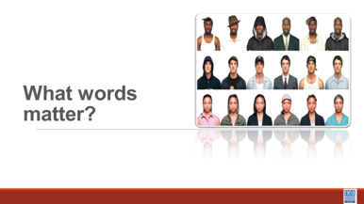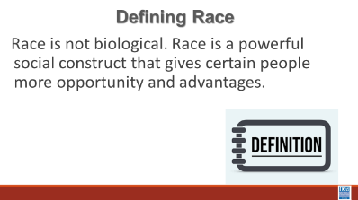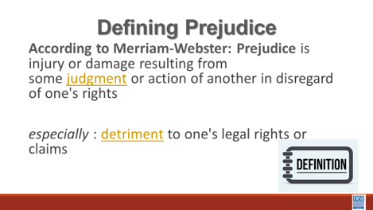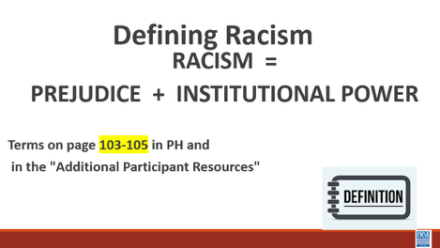    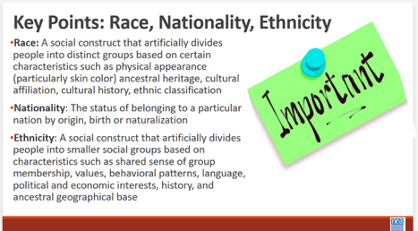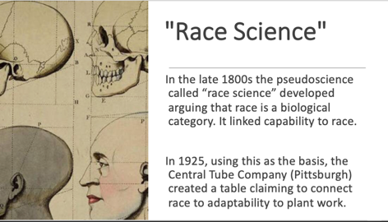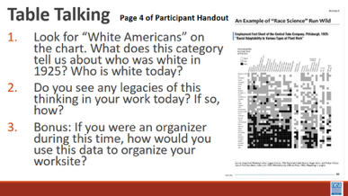  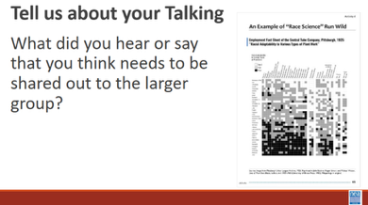  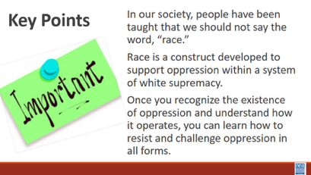 |  |  |  | 10 minutes – Race, Ethnicity, Nationality  3 mins - Short Lecture using slides to define race, prejudice, and racism  Race is not biological. Race is a powerful social construct that gives certain people more opportunities and advantages.  Show and read the next two slides  We also need to define the term Prejudice: According to Merriam-Webster: Prejudice is injury or damage resulting from some judgment or action of another in disregard of one's rights especially : detriment to one's legal rights or claims  Prejudice is something we all likely recognize—those internal, preconceived judgments we hold about people based on their social group. Anyone, regardless of their background, can hold racial prejudice. It is an individual bias.  Racism is the combination of Prejudice and Institutional Power  The formula only becomes 'Racism' when you add the second variable: Institutional Power. When we think about racism, we often picture individual acts or personal hatred. But sociologists and activists use a different lens—one that focuses on how society actually functions. In the 1970s, Patricia Bidol-Padva proposed a paradigm-shifting formula: Prejudice plus Power equals Racism (R=P+P). This isn't just a math equation; it’s a tool for understanding how inequality becomes a permanent part of our landscape. This definition matters for social justice and systemic change.  Power is the ability of a dominant group to take those internal prejudices and weave them into the fabric of society. Think about laws, redlining, hiring practices, access to healthcare, and educational funding. When a dominant group codifies their biases into these systems, they create a machinery that works for them and against others.  Under this definition, we stop asking, 'Did that person mean to be racist?' and start asking, 'Does this system produce unequal results?' If a policy—like funding schools through property taxes—leads to unequal outcomes for different racial groups, then it is functioning as a racist system, regardless of the intentions of the people who created it.  This moves the conversation beyond individual attitudes. While everyone can be prejudiced, the R=P+P model clarifies that only those with institutional power can create a system of oppression. By understanding racism as a combination of bias and power, we can move past personal defensiveness and begin the real work of dismantling the systems that hold inequality in place.  Share the video (3 Min) defining Race, Ethnicity, Nationality  30 Minutes – How race and ethnicity impacts/influences labor  5 mins – Intro  “Racial Adaptability to Various Types of Plant Work” document (Page 25 of Participant Handout)  In the late 1800’s the pseudoscience called “race science” developed  arguing that race is a biological category. It linked capability to race.  In 1925, using this as the basis, the Central Tube Company (Pittsburgh) created a table claiming to connect race to adaptability to plant work.  20 minutes – Table Talking (page 25 in participant handout)  At your table, discuss this “data” (sarcastic) shared in this table centering on the following questions:  - Look for “White Americans” on the chart. What does this category tell us about who was white in 1925? Who is white today?  - Do you see any legacies of this thinking in your work today? If so, how?  - Bonus: If you were an organizer during this time, how would you use this data to organize your worksite?  5 minutes – DEBRIEF  Tell us about your talking  “The definition of whiteness changes, we are eating ourselves, not the dogs and cats.”  This reflected shifting boundaries about who as counted as white and who did not. The definition of whiteness expanded to absorb certain groups while continuing to exclude others. It’s about power, labor, access, and control. The way we count people shapes how we govern them.  What did you hear or say that you think needs to be shared out to the larger group?  Key points – 5 minutes  In our society, people have been taught that we should not say the word, “race.”  Race is a construct developed to support oppression within a system of white supremacy. In America we tend to buy into “racial narratives” which are based on incorrect and often harmful stereotypes.  Once you recognize the existence of oppression and understand how it operates, you can learn how to resist and challenge oppression in all forms. |  |  |  | Participants will work on the development of their working vocabulary for race and racial justice concepts.  What are the words I need to know to talk about race?
12:00-1:00 | Lunch
1:00-1:25 Ellen and Natasha |  | 25 Minute Total - Expressions of Racism
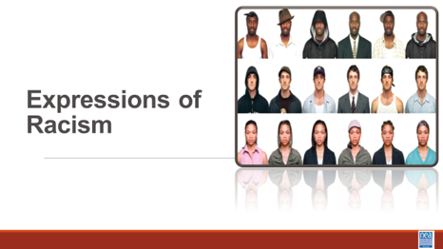  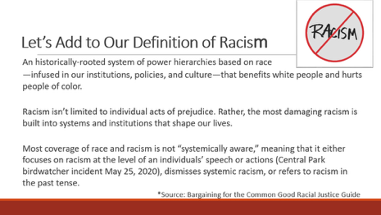  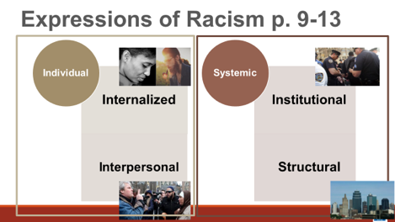  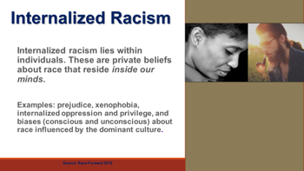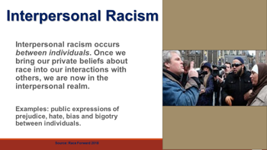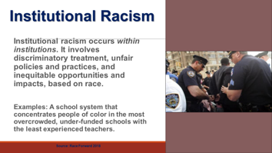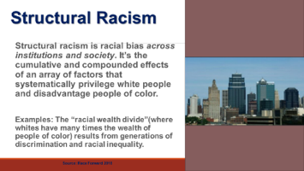  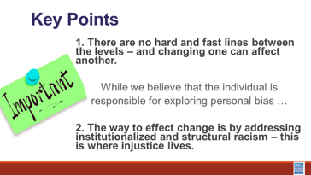  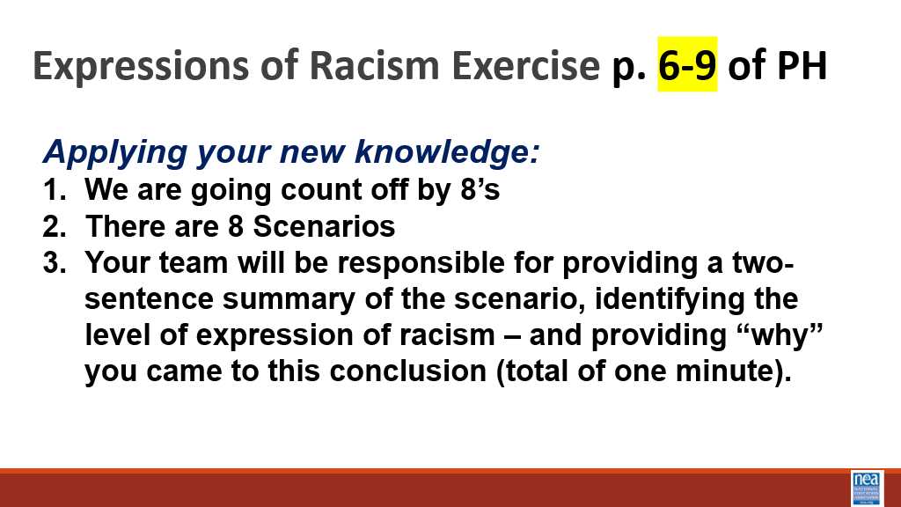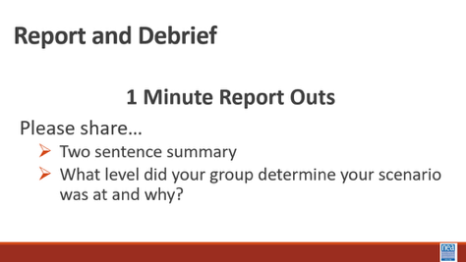  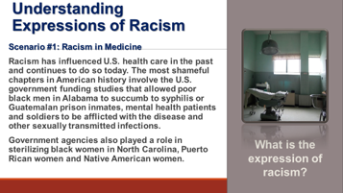  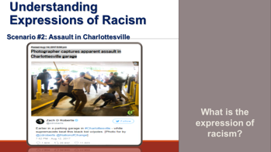  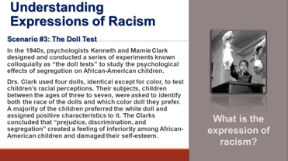  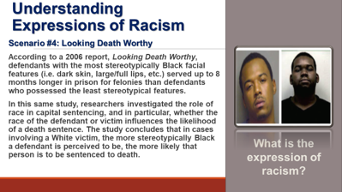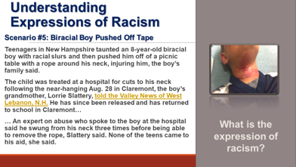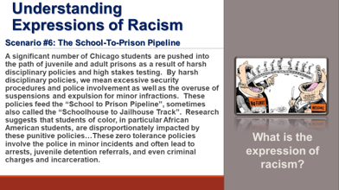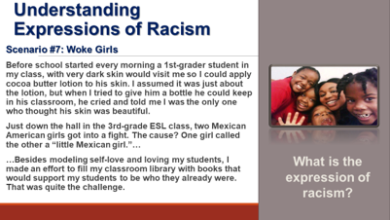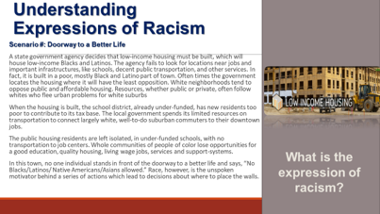  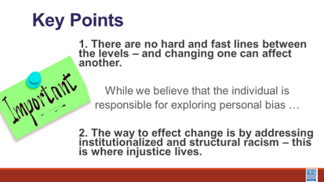 |  | Post 2 separate Poster(s) of the Foundation Points  Key Point 1 - "There are not hard and fast lines between the levels - and changing one can affect another".  Key Point 2 - "The way to effect change is by addressing institutional and structural racism - this is where injustice lives".  Levels of Racism Handout p. 6-10 |  | 5 Mins Using the slides – Remember our definition of racism – let’s add a little to that prejudice, discrimination, or antagonism directed against someone of a different race based on the belief that one’s own race is superior.  An historically rooted system of power hierarchies based on race are infused in our institutions, policies and culture. Racism isn’t limited to individual acts of prejudice, either deliberate or accidental. They are baked into the systems and institutions that shape our lives. This is a framework for how oppression is expressed and the reason why we are showing you this is to understand the level of resource and effort needed to address these issues.  We are going to look at four-tiered framework for understanding how racism – or other oppressions are expressed. This framework is helpful not in IDENTIFYING the events of racism – but in understanding the magnitude of the solution we would need.  Share Definition and examples for each of the four levels.  Traditionally, institutions only focus on the individual side, NEA, takes the approach that if we don’t re-examine and change the systems, then we will be forever combatting all three of the other types of racism.  Internalized Racism lies within individuals. These are our private beliefs and biases about race and racism, influenced by our culture.  Interpersonal Racism occurs between individuals. Once we bring our private beliefs about race into our interactions with others, we are now in the interpersonal realm.  Institutional Racism occurs within institutions and systems of power. It is the norms, policies and practices that are structured into political, societal and economic institutions that have the net effect of imposing oppressive conditions and denying rights, opportunity, and equality to identifiable groups based upon race or ethnicity.  Structural Racism is racial bias across institutions and society. It’s the cumulative and compounded effects of an array of factors that systematically privilege white people and disadvantage people of color.  Key points – there are not hard and fast lines between the levels – and changing one can affect another. While we believe that the individual is responsible for exploring personal bias – the way to effect change is by addressing institutionalized and structural racism – this is where injustice lives. Remember that Resolution I new business item refers to the institutional racism (white supremacy is structural)  20 Min Defining Expressions of Racism Activity - Use the Handout Levels of Racism Scenarios p. 6-10.  - 2 Min Intro –Count off by 8, move to new group and bring your device with you. The number of your group is the scenario that you will review. You will discuss and decide which level of racism each case belongs to. Please ensure there is consensus in your group in your answers.  - 10 Minutes to work on Activity- your outcome is a 2 Sentence summary of the scenario and which level you identified that it represents and WHY – not longer than 60 seconds.  - 8 Mins: Debrief – (Facilitator will show the slide that goes with each group BUT nothing is said about the slide) Provide the summary of the scenario to the larger group, what level your group determines your scenario was at and why.  - The facilitator ends by lifting up what every group always comes to – each of these can be representatives for all the levels – because it takes all the levels to ALLOW these to happen.  Key point - there are not hard and fast lines between the levels – and changing one can affect another. While we believe that the individual is responsible for exploring personal bias – the way to effect change is by addressing institutionalized and structural racism – this is where injustice lives. |  |  |  | Participants will understand Key Point 1 - "There are not hard and fast lines between the levels - and changing one can affect another".  and  Key Point 2 - "The way to effect change is by addressing institutional and structural racism - this is where injustice lives".  And that it takes all levels to permit oppression.  How can you advance and improve racial justice beyond your own growth and development?
1:25 –1:55 Albert & Eric |  | 30 Mins Looking for Expressions of Racism
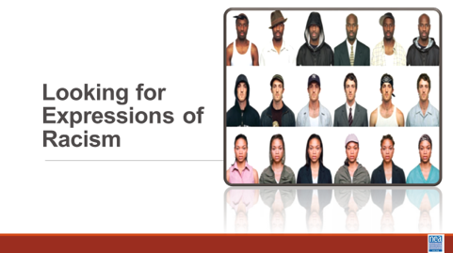  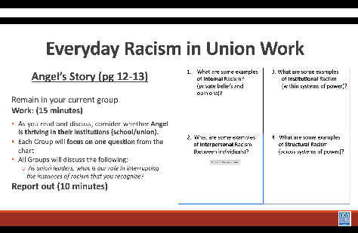  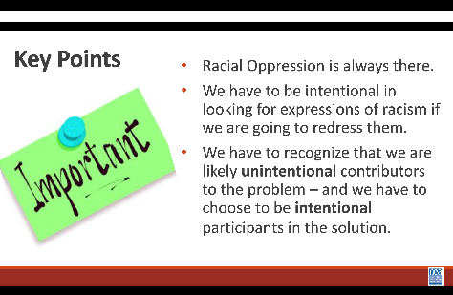 |  | Angel’s Story  “Everyday Racism in Union Work”-p. 11-12  Chart for each group |  | 5 Minutes Introduction  This morning, we worked on some of the foundational understandings needed to advance racial justice. We are going to begin thinking about how to apply them. We said this morning that an NEA core belief of this work is an intentional focus, though not explicit focus on the ways that race is used to oppress others. We just looked at how racism is expressed on 4 levels.  15 Minutes of Work Time  NOW we are going to imagine how this might show up in our work. Through the story of Angel, a worker in one of our schools. Each group will focus on one of the expressions of racism in this story and discuss this question  As you read, consider whether Angel is thriving in their institutions (school/union). What are examples from the story that lead you to this conclusion?  1. What are some examples of Internal Racism? (private beliefs and opinions)?  2. What are some examples of Interpersonal Racism (within systems of power)?  3. What are some examples of Institutional Racism (between individuals)?  4. What are some examples of Structural Racism (across systems of power)?  10 Minutes Report Out  Group Discussion Question As union leaders what is our role in interrupting the instances of racism that you recognize?  If there is time, you should address what race or gender participants “saw” Angel. Their race and gender are intentionally never identified in the story.  Key points:  - Racial Oppression is always there.  - We have to be intentional in looking for expressions of racism if we are going to redress them.  - We have to recognize that we are likely unintentional contributors to the problem – and we have to choose to be intentional participants in the solution. |  |  |  | This was part of a pre-session handout. Check to see if participants have already read.  Questions in Participant handout need to be updated to match the Facilitator Guide and Power Pt.  Participants will be able to identify expressions of racism in particular scenarios.  How can you advance and improve racial justice beyond your own growth and development?  Facilitator Note: Participants need to learn to “see” so we can “do”
1:55-2:30 Natasha |  | 35 Mins – Systems of Oppression – Income and Wealth
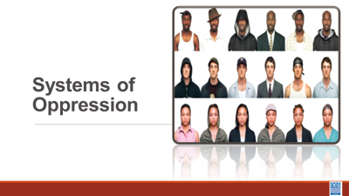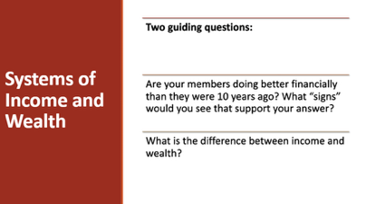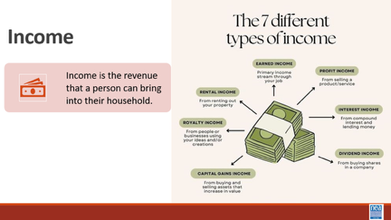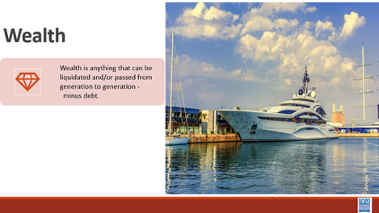  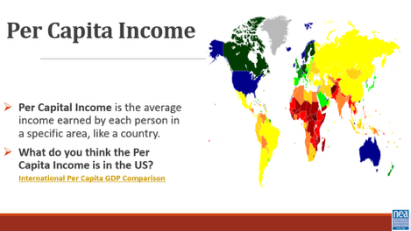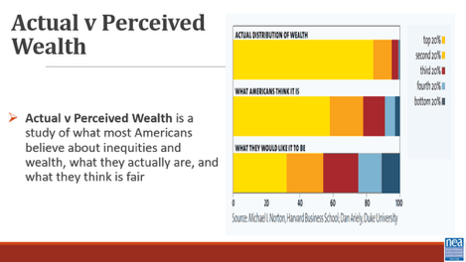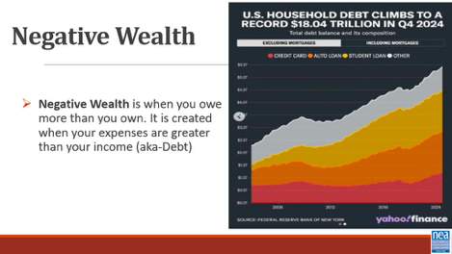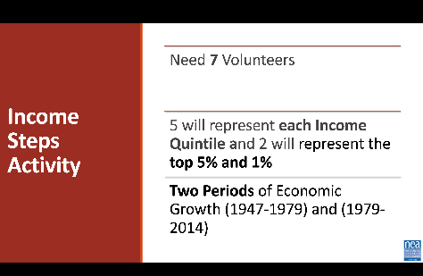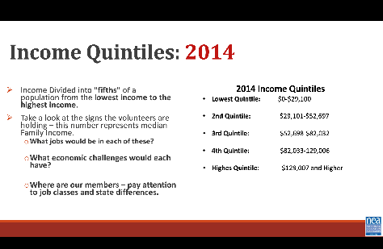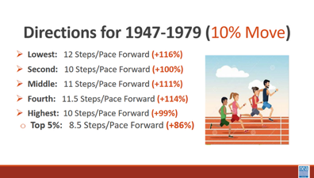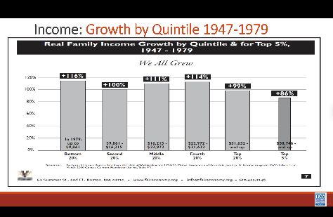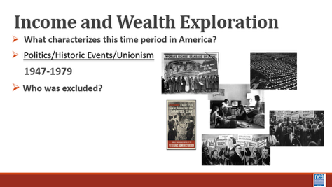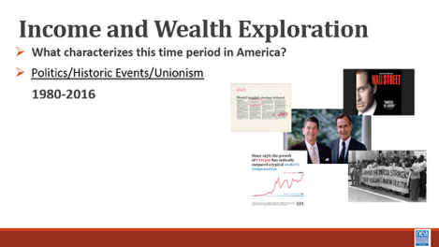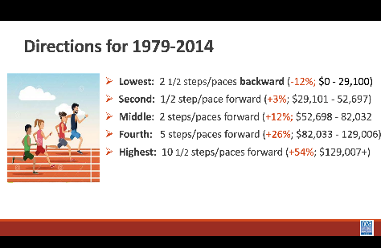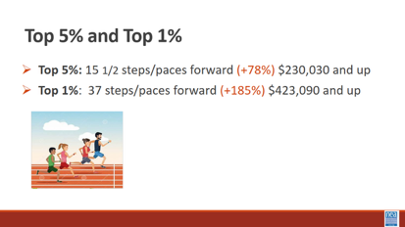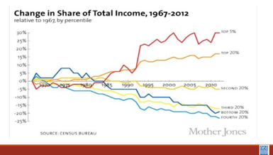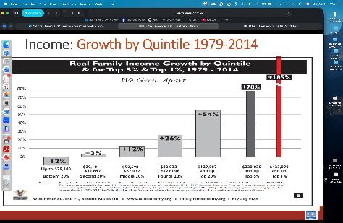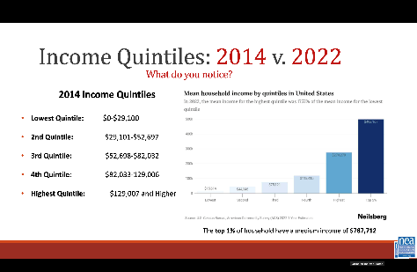  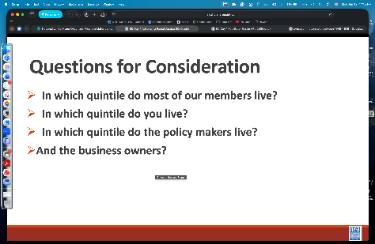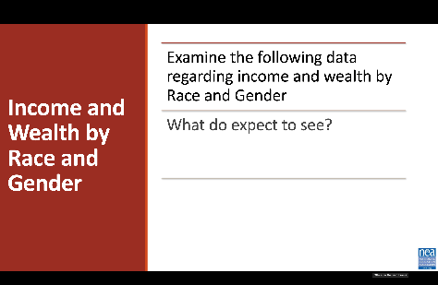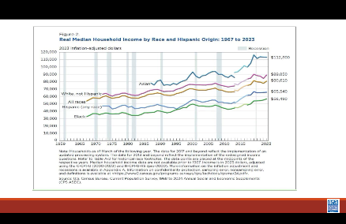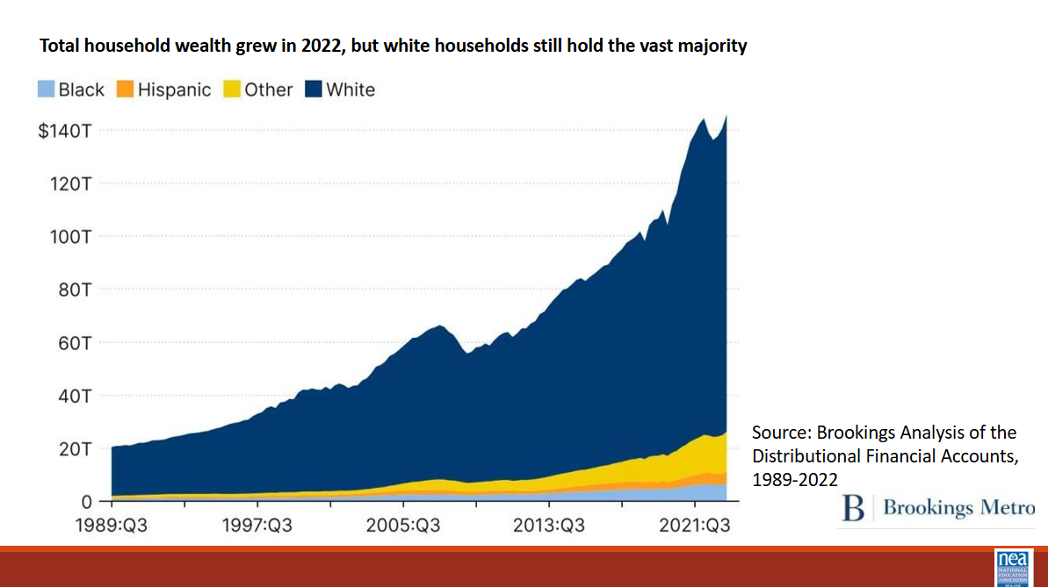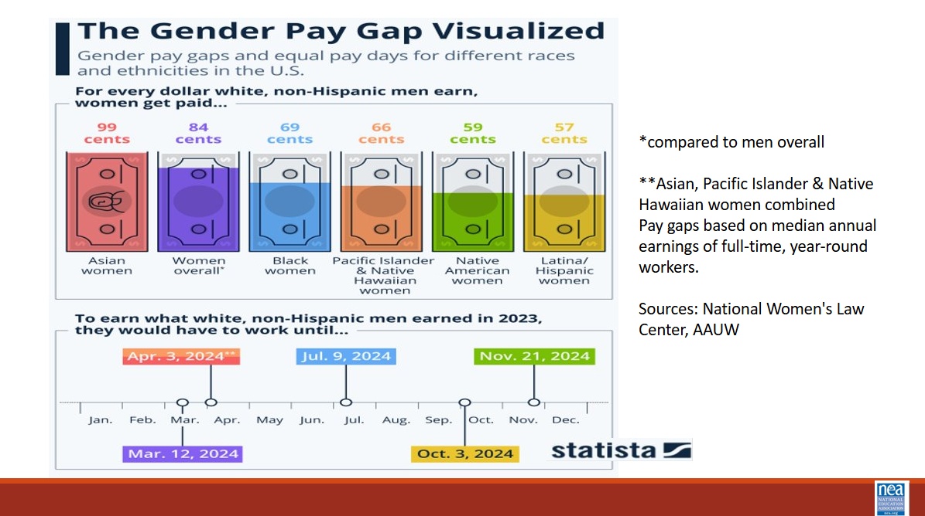  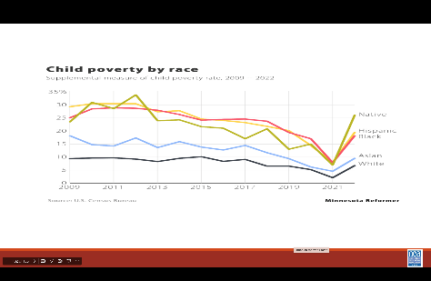  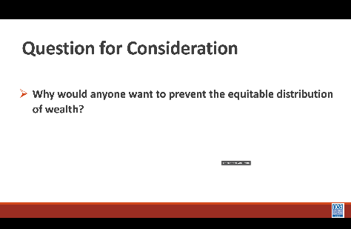  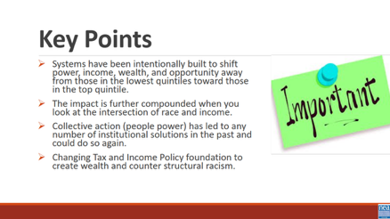 |  | Quintile Signs  Quintile Facilitator Guide  Economic System p. 14-18 |  | Slides 82-88 8 minutes  2 Mins– We are going to take a look at one example of systemic racism that impacts our members and their jobs – income and wealth. Take just a moment in your mind and consider the following question –  - Are your members doing better financially than they were 10 years ago? What “signs” would you see that support your answer?  In the last decade, has the income your members earned enough to pay the bills? How do you know?  6 Mins- What is the difference between Income and Wealth?  What are some examples of income? (wages, salary, interest, social security check, rent from owning real estate, capital gains from selling investments, dividends from stocks, gifts, etc.)  - What are some examples of wealth? (savings, investment, property, etc.)  - How is wealth different from income and why is this important? Wealth can be passed on to future generations. Seriously impacted by race  - What is Per Capital Income? How much each person receives from the yearly income generated in the country if the yearly national income is divided equally among everyone.  - In 2025, it is around $86,000/person (INCLUDING CHILDREN).  - Imagine if we distributed income this way, would it be enough for everyone?  - What is Actual v Perceived Wealth and what does this say about how American feel and thing about economic inequality?  A Harvard University Study asked people (Democrats and Republicans) what they think the wealth divide to be and what they think is fair. The actual weather inequality is far greater than what most people perceive it to be and even more so between what they think is fair.  - Think it is: Top 20% have 60% of the wealth  - Think it should be: Top 20% have 35% of the Wealth  - What it is: Top 20% have 85% of the Wealth  - Top 1% have 40% of the nations wealth  - 15.1% of nation live below the poverty line  Mention the link a video demonstration of the study for additional information for comparison  - What is Negative Wealth and Why is this Important?  - Negative Wealth is when you owe more than you own. It is created when your expenses are greater than your income (aka-Debt)  - In 2019, 10 % of American have negative net (13 million) worth. In 2024, 31% of Americans have a net worth of $0 or less  - Black/Brown America-1 in 4 have negative wealth  - White America- 1 in 12 have negative wealth  - Student Loan, Auto, and Credit Card Debt is dragging down the wealth of Americans, particularly household of color  Share that this will only widen as health care costs continue to rise and student loan debt forgiveness programs end  Slides 89-100  20 Mins – The Quintile Quest (Economic Exploration) Activity (see full guide)  Now let’s have seven (one for each quintile and the 1 for top 5% and 1 for top 1%) volunteers come to the front of the room. Please stand shoulder to shoulder. Each gets a sign showing the income range — in pre-tax, year 2014 dollars — of the quintile they represent.  - What are Income Quintiles and why do economists use them?  Economists often talk about the income in the US as divided into "quintiles" or "fifths" of a population. They imagine the entire population of the U.S. lined up from the lowest income to the highest income. They then divide that line into five equal parts. A quintile can be thought of as a fifth of the population or 20%.  We are going to watch how income has changed over quintiles in the population. This activity looks at what happened to the incomes during two periods of economic growth: 1947-1979 and 1979-2014.  Take a look at the signs the volunteers are holding – this number represents median Family Income.  - What jobs would be in each of these?  - What economic challenges would each have?  - Where are our members – pay attention to job classes and state differences.  INCOME WALK  Each volunteer, representing a quintile or fifth (20 percent) of the U.S. population, will step forward or back according to whether their income gained or declined.  - Lowest2 quintiles start behind the line  - 3 quintile starts at the line  - 4 and 5 quintiles start ahead of the line  Have the non-participants stand in a line along the path of where the stepping will occur  Each step equals a 5% change. So, for example, two steps forward would indicate an income gain of 10%.  1947-1979  Lowest: 23 Steps/Pace Forward (+116%)  Second: 20 Steps/Pace Forward (+100%)  Middle: 22 Steps/Pace Forward (+111%)  Fourth: 22.5 Steps/Pace Forward (+114%)  Highest: 20 Steps/Pace Forward (+99%)  Top 5%: 17.5 Steps/Pace Forward (+86%)  Have the non-participants, who are lined up along either side of side of the “Income Walk” move forward with the participants. They should slide forward 15 steps to represent inflation over that time period. Notice that all quintile income outpaced inflation.  1 min-This one slide graphs what we just did. Show to visualize the economics beyond the activity and how income growth remained relatively equitable, and in fact the lower four quintiles actually did. better than the top 20%  Hold slides 91-96 until after the walk is over  What can you tell us about the history, policies, unions from 1947-1979?  One explicit goal of the federal government during the early post-war period was to build a middle class where people and families who could consume the output of the rapidly growing manufacturing capacity of the U.S.  Federal government programs like the GI Bill of Rights enabled hundreds of thousands of returned veterans to go to college and purchases homes, beginning the steps to accumulating family wealth.  It is important to note that people of color were largely excluded from middle class wealth gains. (redlining, job discrimination, ect). While acknowledging that post-war programs helped build the middle class, it's important to also acknowledge that these programs disproportionally favored white men.  For example, VA and FHA loan programs for housing utilized racially-restrictive underwriting criteria. Thus, assuring that hardly any of the $120 billion in housing equity loaned from the 1940s to 1960s would go to families of color.  While loan programs like FHA and the GI Bill helped finance over half of all suburban housing construction in the country during this period, less than 2% of this housing ended up being lived in by people of color  Next say that we will now look at income changes from 1979-2014. Many of you might remember what happened during that time period.  What can you tell us about 1979-2014? (Reaganomics, neo liberalism decline of unions) all contributed to declining middle class, greater poverty and extreme disparity in income and wealth.  1979-2014  Lowest: 2 1/2 steps/paces backward (-12%; $0 - 29,100)  Second: 1/2 step/pace forward (+3%; $29,101 - 52,697)  Middle: 2 steps/paces forward (+12%; $52,698 - 82,032  Fourth: 5 steps/paces forward (+26%; $82,033 - 129,006)  Highest: 10 1/2 steps/paces forward (+54%; $129,007+)  Top 5%: 15 1/2 steps/paces forward (+78%) $230,030 and up  Top 1%: 37 steps/paces forward (+185%) $423,090 and up  Have the non-participants, who are lined up along either side of side of the “Income Walk” move forward with the participants. They should slide forward 16 steps to represent inflation over that time period. Notice  Inflation outpaced all quintiles except the top 5% and 1%  - From 1979-2014, there was much growth in income, but the distribution of that growth was extremely uneven. Although the top 20% as a whole did well, the ones who really made out were the folks at the very top. The top 1 percent gained 185% between 1979 and 2014, and the top .1 percent gained 361% between 1979 and 2014 — the divide between the top income earners and everyone else is enormous!  - In other words, when looking at the historic data we see that the upper quintiles' income has grown exponentially faster than the lower quintiles.  - This can have many impacts on society but one of the most obvious ones it the GAP between the upper income levels and the lower income levels has been rapidly growing over time.  1 min-Show two slides that graph of what we just did. Show to visualize the economics beyond the activity and how income disparity widened during this time period.  1 min-Show slide which compares 2014 Median Income with 2022 Median Income and ask What do you notice? The first 4 Quintiles Median Incomes are actually LOWER in 2022 than in 2024. The Top Quintile is significantly higher.  1 Min-Discussions  - In which quintile do most of your members live?  - In which quintile do you live?  - In which quintile do the policy makers live? The business owners?  Slides 101-107: 7 minutes  Income-Wealth Race and Gender  1 min-These three slides show the impact of these economic changes presently on race, gender and income and wealth. This income and wealth gap for people of color has grown even wider in the last decade  1 min-These two slides show how the Pandemic Anti-Poverty income programs temporarily leveled out poverty disparities by race. Federal government child tax credit and state/local basic income programs made a huge difference in temporarily providing income for people of color. Targeted programs in New York, Minnesota, California, Arizona, and other states made a difference. These ended in 2022 and disparity increased. These programs are further being cut by the Trump administration  Question for Consideration: What are the implications for your union as it relates to this data? What actions must your union take for an equitable distribution of wealth?  Key Points  - Systems have been intentionally built to shift power, income, wealth, and opportunity away from those in the lowest quintiles toward those in the top quintile.  - The impact is further compounded when you look at the intersection of race and income.  - Collective action (people power) has led to any number of institutional solutions in the past and could do so again.  - Changing Tax and Income Policy foundation to create wealth and counter structural racism. |  |  |  | Participants will understand that policies have been adopted that intentionally limit the ability for people to acquire wealth – and that these policies can be intentionally undone  How do race and gender affect your income?  Might change to ½ steps for 1947-79 depending on room  Hide the quintile walk-top 1% slide
Break |  | Break 2:30-2:45
2:45-3:15 Rita and Albert |  | 30 min – Shifting Perspectives
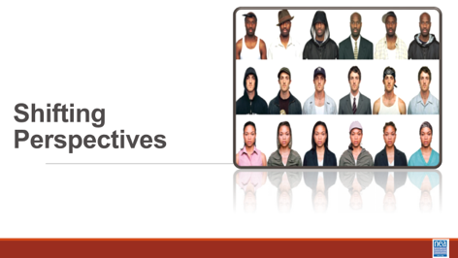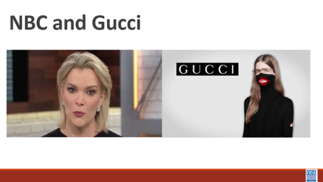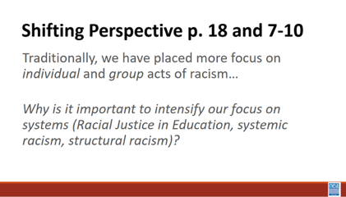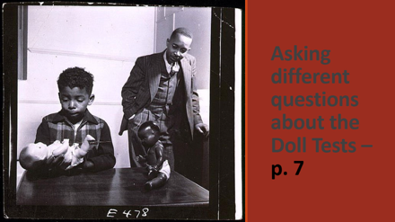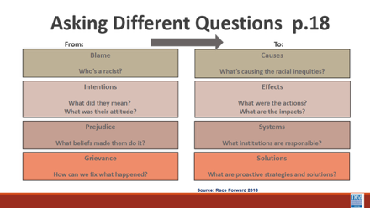  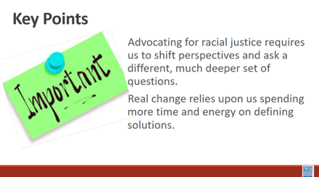 |  | Shifting Perspective Handout  Albert 110-113  Rita 114-115 |  | 5 mins Asking Different Questions  Some of us do battle with dandelions in our lawns each summer. We have two choices: mow them down or dig them up by the roots. Which method will permanently remove the weed?  In order to completely eradicate the weed, any weed, you have to remove it by the root. They are a persistent perennial  When we do the work of advancing racial justice, we act to remove the “weed” that is racism by the root. The way to do that is to shift our perspective and ask different questions. We have to refocus our analysis to a systems level.  An example of how to shift perspective can be seen in the way that a “blackface” controversy was handled by to different companies. [Provide brief background if participants do not know what blackface is: The origins of blackface dates back to the minstrel shows of mid-19th century. White performers darkened their skin with polish and cork, put on tattered clothing and exaggerated their features to look stereotypically “Black.” The first minstrel shows mimicked enslaved Africans on Southern plantations, depicting Black people as lazy, ignorant, cowardly or hypersexual, according to the Smithsonian’s National Museum of African American History and Culture (NMAAHC). The performances were intended to be funny for white audiences. But to the Black community, they were demeaning and hurtful.]  In 2019 Megan Kelly made the remark that she did not know why Blackface was so offensive – NBC did not know what to do at first – eventually they let Kelly go with a big contractual payout, she was terminated. Gucci in the same year came out with this shirt design – and they took a multi-level multi-prong approach – When Gucci advertised a Blackface sweater for sale, the company issued an apology letter; had a meeting with Harlem designer Dapper Dan and other community leaders; implemented a global cultural awareness program in the company and created a scholarship to increase diversity in the design ranks. Which company has a better chance addressing racism at the root?  We shift perspectives by asking different questions.  Instead of looking to place BLAME, we look at what is the CAUSE of the inequity.  Instead of looking at INTENTIONS, we look at the IMPACT of the action.  Instead of focusing on the PREJUDICE of the individual, we look at the SYSTEM that allowed the prejudice to occur.  Finally, instead of focusing all our energy on the GRIEVANCE, we spend substantial energy on SOLUTIONS.  10 Mins Practice the Shift-  Let’s return to the original scenarios and all look at Scenario #3: Let’s try asking different questions that would allow us to shift our perspective from one of identifying the problems to defining solutions. Take a couple of minutes to write down some questions that would get to the root and then we will come together and talk a bit more about it. Get started on this.  From To  Blame – Who’s a racist Causes – What is causing the racial inequity?  Intentions – What did they mean? Effects - What were the actions?  What was the their attitude? What are the Impacts?  Prejudice- What beliefs made them do it? Systems – What institutions are responsible?  Grievances- How can we fix what happened? Solutions- What are proactive strategies?  Give participants five (5) minutes to review the scenario and write questions. For report out, acknowledge that this type of analysis is much more challenging and start with members from the group that originally looked at this scenario to begin discussion. Seek at least one question for cause, effect, systems and solutions.  What would it require for a system to produce children who do not associate whiteness with superiority?  Key points to remember:  Advocating for racial justice requires us to shift perspectives and begin asking different and deeper questions.  Real change occurs when we move from saying what or who the problem is to identifying what caused the problem and addressing that root. |  |  |  | Participants will apply a racial justice lens to strategy and problem-solving conversations.  Why is it still so hard for us to get this right?
3:15 – 3:55 Rita and Ellen |  | 40 Minutes Total Systemic Level of Racism – Environmental Justice
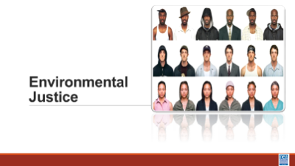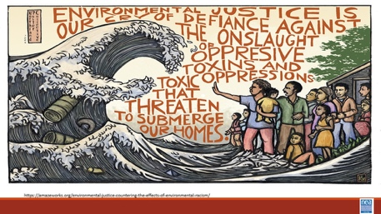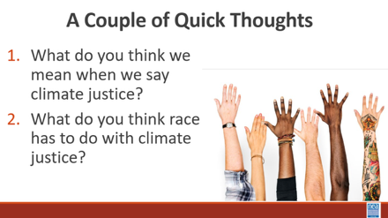  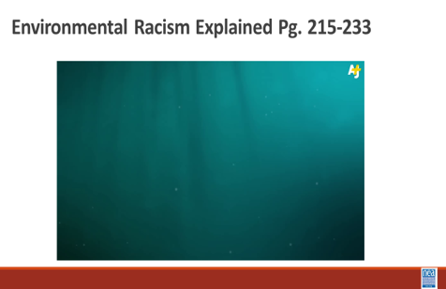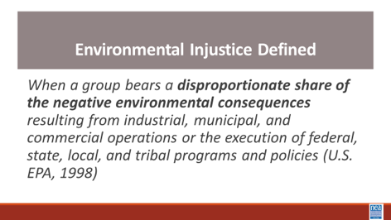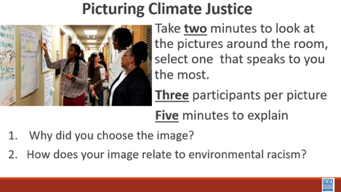  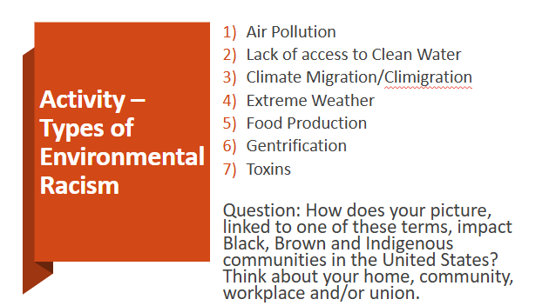  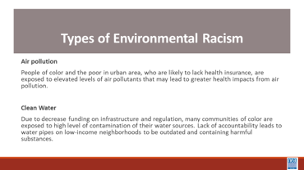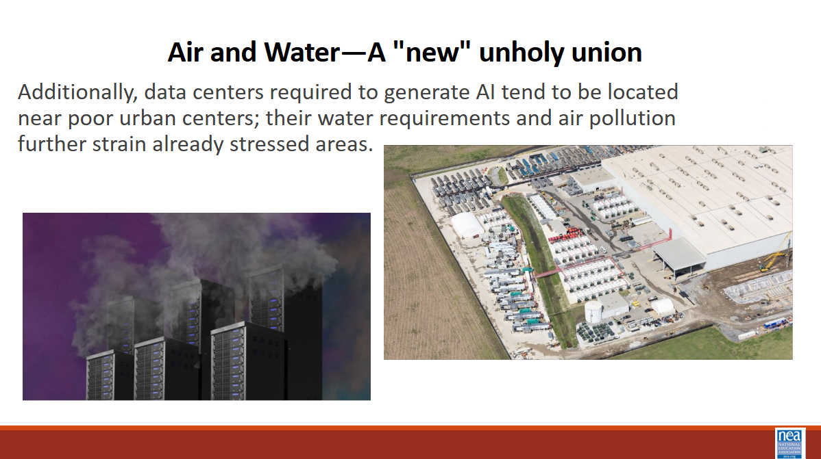  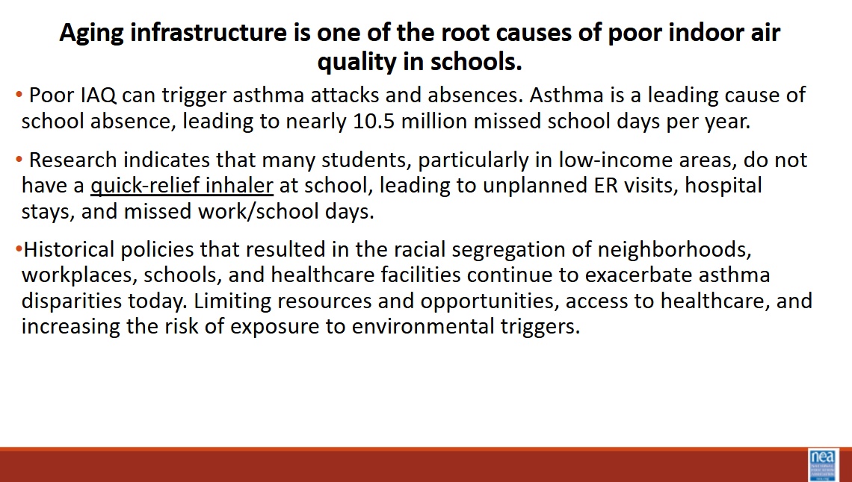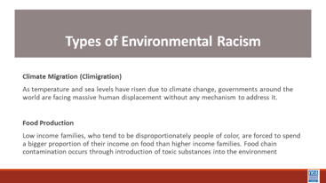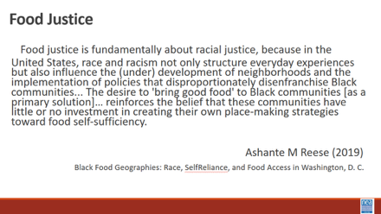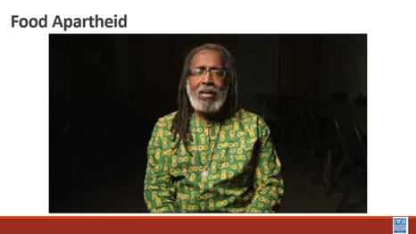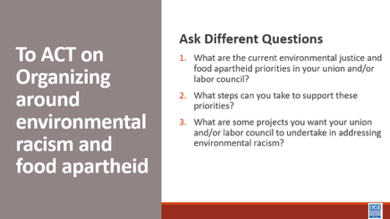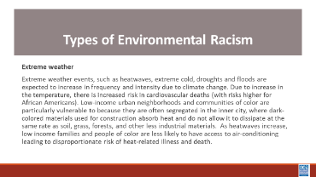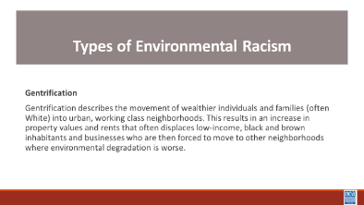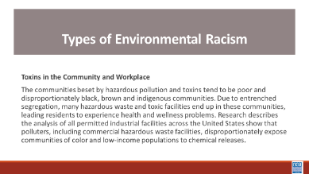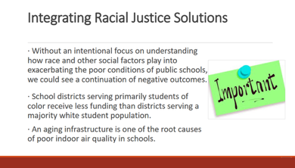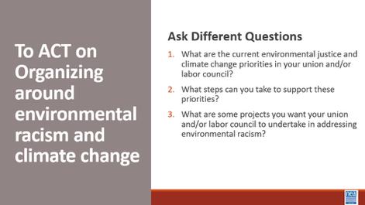  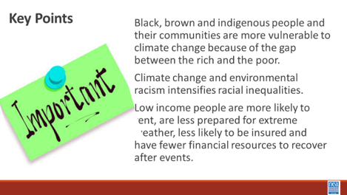 |  | Have images printed on letter size paper (8 ½ x 11 inches) or larger in color and have them posted around the workshop room.  Post a chart under each image for round  Types of Environmental Racism – PH p.23  Environmental Racism Explained Articles: “How Workers Can Demand Climate Justice” and “Climate Inequality: Forgotten History” in Additional Res.  Rita 117-124  Data center in MD, Prince County and Montgomery County has hold on them. Research this. |  | 10 min intro - We are going to take a look at another system of oppression – Climate justice. Turn in at your tables and take just 3 minutes to have a quick conversation about these two questions:  What do you think we mean when we say climate justice?  What do you think RACE has to do with climate justice?  Let’s take about 5 Ritminutes to hear three quick thoughts for each of the question  Show Video -History of Climate Justice Video (5 mins)  Show the slide with the following definition - When a group bears a disproportionate share of the negative environmental consequences resulting from industrial, municipal, and commercial operations or the execution of federal, state, local, and tribal programs and policies (U.S. EPA, 1998)  20 mins - Picturing Climate Justice Activity – Round 1  Intro – 2 mins -what is the best predictor that a person will be disproportionately, negatively impacted by environmental consequences? That is right, race.  Activity- 15 mins You have two (2) minutes to go around the room and look at each image. After you have seen them all, please take a seat by the image that speaks to you the most when you think about climate change and environmental racism.  No more than three (3) participants per picture.  With those at your image, you will have five (5) minutes to briefly do the following as a group: explain why you chose this image; how does this image relate to environmental racism? Don’t write on your chart yet-that is round 2.  10 min – Report out from each  Where are there any similarities?  40 minutes total for Round 2 -Types of Environmental Racism- Round 2  2 min- Intro  Stay in your image groups for round 2. Note: there should be at least seven (7) groups. As a small group, you will have ten (10) minutes to:  - Read term/definition  - Answer the question by writing and/or drawing on flip chart paper. Please draw in large letters so others can read your answers when the chart papers are posted.  - Prepare to present your definition and answer to the rest of the participants. Each group will present in under two (2) minutes. Groups should decide if they want to present as a group or have a spokesperson in advance.  Question: “How does your image linked to one of these terms impacting black, brown and indigenous communities in the United States? Think about your home, community, workplace and/union.”  7 Types:  - Air pollution  - Clean water  - Climate Migration/ “Climigration”  - Extreme weather  - Food production  - Gentrification  - Toxins  - POLICE (not official)  Encourage groups to address impact in terms of home, community, workplace and/or union rather than focus on one aspect.  10 min - Activity  New potential activity: 1) Video about food apartheid 2) table talk about how food apartheid could contribute to racial justice 3) what role can your affiliate play justice on this issue  Without an intentional focus on understanding how race and other social factors play into exacerbating the poor conditions of public schools, we could see a continuation of negative outcomes in school districts that primarily serve students of color. That is because it is more common for school districts serving primarily Native students or students of color to receive less funding than districts serving a majority white student population.  Districts serving white students living in poverty also tend to receive greater funding than districts serving students of color living in poverty. Those trends hold even when controlling for socioeconomic status. Inequitable financial resources contribute not only to inequitable academic resources such as educators, instructional materials, and technology but also to poor school facilities and critical infrastructure that directly affect student health.  A closer look at workplaces. Poor indoor air quality (IAQ) impacts learning conditions and working conditions. Poor IAQ in schools has been linked to cognitive deficits and negative economic impacts in the workplace, including impacts on the number of employee sick days and job retention.  Poor IAQ can trigger asthma attacks and absences. Asthma is a leading cause of school absence, leading to nearly 10.5 million missed school days per year. Research indicates that many students lack an asthma action plan and, particularly in low-income areas, do not have a quick-relief inhaler at school. This leads to unplanned emergency room visits, hospital stays and missed work and school days putting the greatest financial burden on people with asthma and their families.  Historical policies that resulted in the racial segregation of neighborhoods, workplaces, schools, and health care facilities continue to exacerbate asthma disparities today. Segregation limits resources and opportunities available to certain populations, affects access to health care, increases risk for exposure to environmental triggers, and increases chronic stress in certain populations.  15 minutes - Group report out  Key Points:  - Black, brown and indigenous people and their communities are more vulnerable to climate change because of the gap between the rich and the poor.  - Climate change and environmental racism intensifies racial inequalities.  - Low-income people are more likely to rent, are less prepared for extreme weather, less likely to be insured and have fewer financial resources to recover after events. |  |  |  | Participants will understand  Black, brown and indigenous people and their communities are more vulnerable to climate change because of the gap between the rich and the poor.  Climate change and environmental racism intensifies racial inequalities.  Low-income people are more likely to rent, are less prepared for extreme weather, less likely to be insured and have fewer financial resources to recover after events.  What does your experience with climate change have to do with race?
3:55-4:30 Ellen |  | 10 Minutes Day One Reflection and Connection
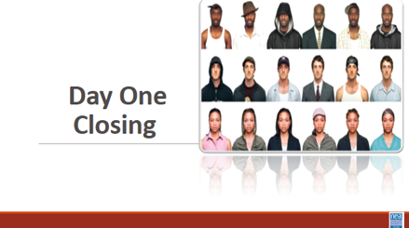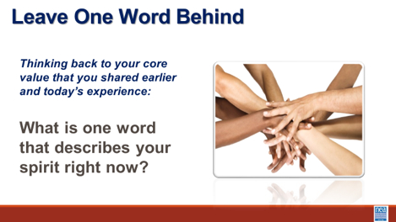 |  |  |  | 10 mins -– Connections  Open Room discussion of the following questions. Record your thinking. What did you experience today that affirmed your understandings? What did you experience that challenged your understandings? What questions do you still have? |  |  |  | Participants will reflect on their learning and engage in a conversation with their colleagues.
4:30 | Adult Choice Networking and Reflection
5:00 | Adjourn

Videos – adjust videos to be similar in volume/ Ally vide is too dated/ Anthony had another resource about allyship/ element of saviorism that may be added/ 2nd color of fer video of nativism is outdated (30 years ago)

Implications within your own internal organizations/ members have the power to change the organization; staff only have influence

Pronouns that we use – using we language instead of I

Content team and Facilitator team – need to have meeting to bridge – so that knowledge about changes is shared
Nativism block needs to be revamped

Thank you Scott for building out the Income/Wealth section

Team lead – let's make sure the lead knows about allergies and other important info about participants in case

Rethink how Intersectionality section works – weird the way it is laid out – lean into Bayard Rustin aspect/ show more examples/ risk / in these marginalized communities some people are still using their privileges to oppress folks inside their communities – Bobby Jindall and Greg Abbott are great examples of it

Make up oof team – being able to draw it out

2026—Everything went fairly well UNTIL the environmental section. We need to look at the whole section time and the round 2 time which is identical—and doesn’t make sense. The pictures should perhaps be shown on the screen so that it is larger. I also think we need to rethink about what we do in the environmental part—some of it is feeling a bit dated. Add in fires—fires in Alaska.

Think about how to visualize wealth at the start of the walk. Perhaps they start apart... Scott has ideas about how to improve this to make it more relevant to the average participant while also giving a nod to historical context. While we state that B/B people don’t benefit from the GI Bill... one of the facilitators could stand in to demonstrate it... so failed policy builds in wealth caps.

