Facilitator Agenda: Advancing Racial Justice 2026 MSEA Day #2
General Materials Needed: |  |  |  |  |  |  | Room Set-up:
1 Set of Handouts per Person  Name Tags and Name Tents  Sign-in Sheet  Pens and Pencils |  |  | Chart Paper  Markers  Post its  Index Cards |  |  |  | Round Tables  Projector, Screen and Speakers  Carousel stations and reporting stations around the perimeter  50 people
Key Outcomes for the Day
Participants will practice restorative circles
Participants will understand the connection between identity, intersectionality and oppression
Participants will understand systems of racism and explore possible ways to disrupt them
8:30- 8:35 Getting Started  8:35-9:20 Restorative Practices  9:20-9:30 Timeline Bridge  9:30-10:15 What is White Culture  10:15-10:30 Break  10:30-12:00 Why this Work is Tough  12:00-1:00 Lunch |  |  |  |  | Ellen & Tina  Rita  Rita  Ellen & Eric  Taraja | 1:00 – 2:15 Identity and Intersectionality  2:15-2:30 Break  2:30-3:15 Allyship  3:15-3:45 Nativism and Immigration Policy  3:45-4:20 Disrupting Microaggressions  4:20-4:30 Closing |  |  | Natasha  Eric  Natasha  Taraja  Ellen
Time, Slides, Facilitator |  | Resources |  | Instructions, Activity and Debrief (Facilitators) |  |  |  | Outcomes and Essential Questions
 |  | Charts, handouts, articles, materials, slide |  | What are you saying, what are they doing, what questions will you use to guide learning and make clear the important points  Include an estimate for how long each section of the learning will take |  |  |  | As a result of this learning, what will participants know or be able to do? What questions will they be able to answer?
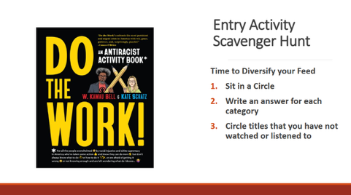 |  | Entry Activity—SCAVENGER HUNT: Diversify Your Feed
8:30 -8:45 Ellen and Tina |  | 10 Minutes – Regroup and Ground (IN A CIRCLE OF CHAIRS to Start)
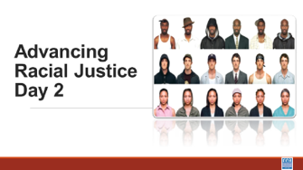  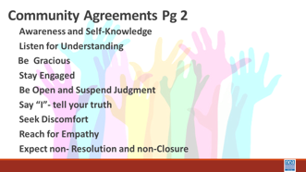  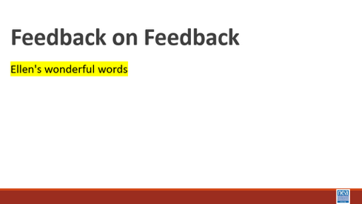   |  | Circle of Chairs for Participants  To be ready for next section |  | 5 minutes  Review the Community agreements  Feedback on Feedback  Day 2 Agenda  Any logistics: Leaving for the National Civil Rights Museum at the Lorraine Hotel by 2:30 |  |  |  | Participants will reflect on Day 1 and understand any changes made for Day 2.  How will we work together?
8:45-9:20 Rita |  | 45 Mins – Restorative Practices Introduction
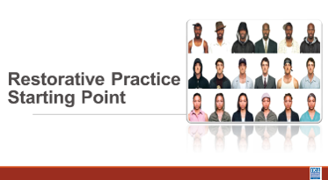  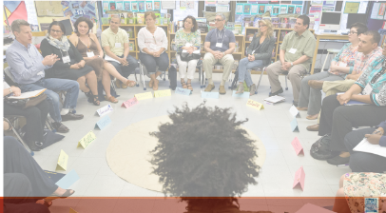  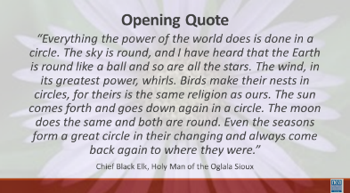 |  | 4 Circles of Chairs for Participants  Restorative Practices Resource p. 28-92  Talking piece  Circle norms same as group |  | 845-850– Introduce circle, count off, move to circle  850-915 – Circle  9:15-9:17 – Bring back, take 1 minute to think of what you are taking away from the circle  9:17-9:20 – What is one word you are taking away from the circle experience.  ----------------------------------  5 minutes - Ask participants to form 4 circles based on cards or count off.  “I’d like to welcome you to your circles.”  Read quote from Chief Black Elk aloud (slide)  “Everything the power of the world does is done in a circle. The sky is round, and I have heard that the Earth is round like a ball and so are all the stars. The wind, in its greatest power, whirls. Birds make their nests in circles, for theirs is the same religion as ours. The sun comes forth and goes down again in a circle. The moon does the same and both are round. Even the seasons form a great circle in their changing and always come back again to where they were.” --Chief Black Elk, Holy Man of the Oglala Sioux  Gathering in circle to resolve conflict and speak truth is not new. It is an Indigenous practice rooted in community accountability, collective wisdom, and shared humanity. There was a time when even that practice was outlawed because it disrupted the dominant culture’s attachment to hierarchy and control. Consider how most classrooms are structured. Rows. Front of the room. One voice elevated above the rest. The architecture reinforces authority. A circle does the opposite. In a circle, there is no front. No back. No one above and no one beneath. Everyone can see and be seen. Everyone carries equal weight.  The process we are entering is intentional. It is a method you can take back to your colleagues and members to foster deeper, more courageous conversations. Conversations about race and social justice require more than opinions. They require trust, respect, and shared responsibility. We begin building that here, in this circle. To create safety, we hold to a simple agreement: what is said in the circle stays in the circle. Stories remain here. The lessons, however, leave with us. The learning moves outward.  25 minutes--Circles: (Taraja) (Ellen) (Eric) (Natasha) Tina on back up  Pro Tip: We need to model for them how to respond to the prompt (without bogarting).  Pro Tip: Use a squishy for the “talking stick” it's comforting for people to hold in front of them.  Reminder of Agreements-done by individual circles  “We will come to the circle throughout our time together, and just as we have norms for the training, we have norms for the circle.” Plus – the use of a talking stick, and the ability to pass.  Community Pass One - Take a moment and check-in with yourself. Using one “weather” indicator, how are you right now? Check in with participants 3x between the questions. Facilitators need to plan and be intentional. We need to model for them how to respond to the prompt (without bogarting).  Community Pass Two - Do the identities that feel most important to you come with more power or less power.? I’ll start to model this for us. *SHARE* (*For facilitator: focus on the more privilege/less privilege in general, not the specific labels in the modeling.*)  Community Pass Three - When do you feel powerless and why?  Matt gives a one-minute warning ala Zoom room closing.  5 minutes: Circle Closing – What are you taking away from this Circle about labels and recognizing our complexities? MOVE THE BREAK, 10 MINUNTES, WE ALL NEED DECOMPRESSION TIME  How can we transition from circles to the next? It worked, but it is always clunky to move from a vulnerable, sharing space back to an academic space. We acknowledge the need for these spaces in our work and the community that we choose to support us in this work. Often, our families are not those spaces, but our chosen families can be places where we get the support we need to do this work because of the common language and experiences, and creating or finding spaces like this in our work are valuable. |  |  |  | Participants will cultivate a reflective mindset.  Participants will begin to build a reflective, trusting community that allows for honest conversations about advancing racial justice.  Participants will be introduced to the Restorative Practices circle process and begin to make the connection about how to use this process as they work  What are Restorative Processes?  How can you use Restorative Processes to build Community?  How can you use Restorative Processes to build collective knowledge?
9:20 – 9:30 Rita |  | 10 Minute Total - Timeline Bridge
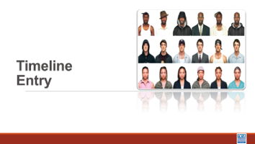  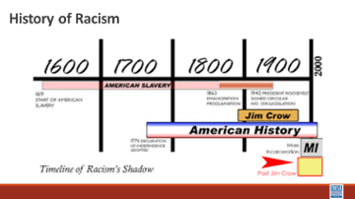  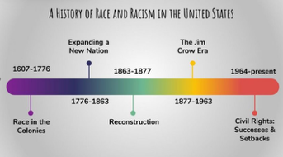  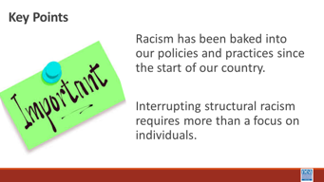 |  |  |  | Official Eurocentric Colonizer’s description of United States history begins with 1612, so when we hear people say, “Slavery ended a long time ago,” why are Black people still so upset? Think about this image. Within the context of 400 years, only the last 60 have had any type of progress, and as we are witnessing under the current administration, there is a concerted effort to erode all progress made by rolling back legislation.  In August 1619, a ship named the White Lion arrived at Point Comfort, Virginia, carrying '20 and odd' kidnapped Africans. This moment is often cited as the inception of what would become American chattel slavery—a system that transformed human beings into legal property. For the next 246 years, this institution was not just an economic engine; it was the foundation upon which the nation was built. Slavery was codified into law, ensuring that status was hereditary and that Black bodies remained the literal capital of a growing empire.  The 13th Amendment ended formal slavery in 1865, but it did not end oppression. Instead, oppression adapted. We saw the rise of 'Black Codes' and the Jim Crow era, which used the Supreme Court's 'separate but equal' doctrine to enforce a racial hierarchy. In the 20th century, this evolved into systemic hurdles like redlining, which barred Black families from the wealth-building power of the GI Bill. The Civil Rights Movement of the 1950s and 60s successfully dismantled legal segregation through the Civil Rights Act and the Voting Rights Act, yet the 'impact' of these centuries of exclusion remained embedded in the nation's DNA.  The modern era has been defined by a duality: profound progress alongside persistent systemic gaps. We have seen the first Black President and Vice President, yet we also witnessed the global Black Lives Matter protests that forced a reckoning with police violence and mass incarceration. History is not a straight line of progress; it is a cycle of action and reaction. We move beyond the intent of individuals to examine the impact of systems, understanding that the work of 2026 is still about dismantling the 'Power' part of the formula we discussed earlier.  1 Min – Key points  Racism has been baked into our policies and practices since the start of our country.  Interrupting structural racism requires more than a focus on individuals. |  |  |  | Participants will discuss illustrating the development of structuralized racism in what we now call the United States of America.
9:30-10:15 Eric and Ellen |  | 45 Minutes Total – What is White Culture
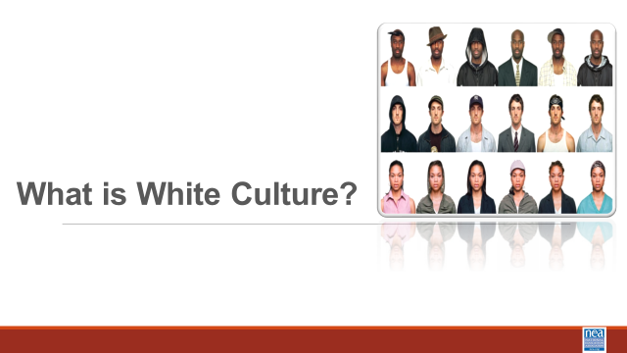  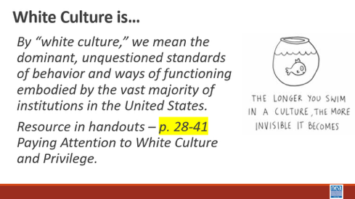  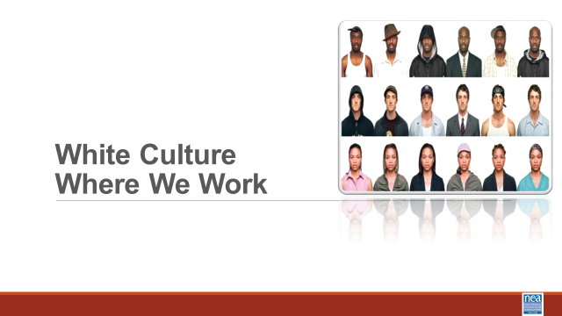  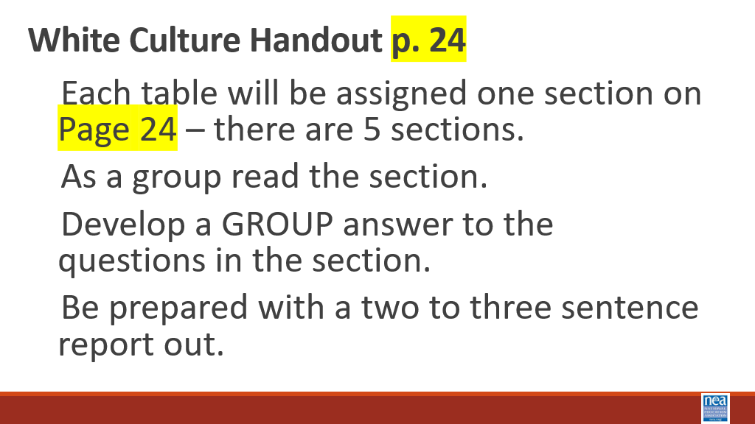  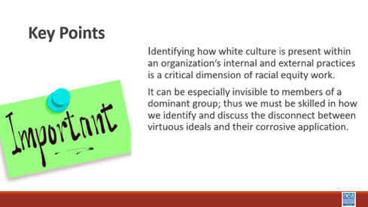  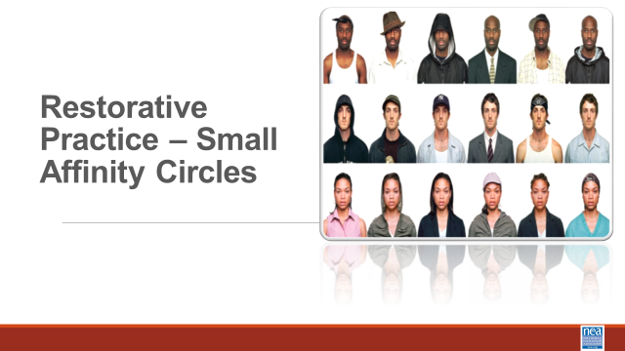  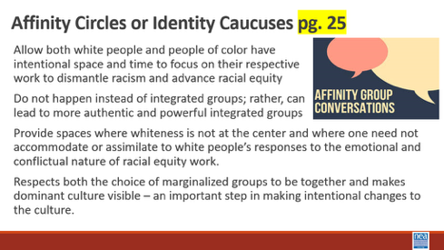  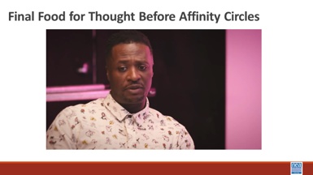   |  | Page 28 White Culture Handout  Paying Attention to White Culture and Privilege – P. 28-41 |  | 15 mins- What is White Culture?  2 mins –Intro  We are going to dig into some thinking about what makes discussing race so difficult. To do that we are going to begin by looking through the window of White Culture. At your tables, read the following slide to yourselves – in about one minute – turn to those folks you are sitting with and discuss what stands out as things you agree with and things you don’t agree with – We will take a total of 5 minutes at your tables for this discussion.  (Give them 10 minutes to discuss – then 3 minutes to share out)  “6 Basic American Cultural Values  - The first is for Individual Freedom and the price for that is Self-Reliance. We cannot be truly free if we cannot take care of ourselves and be independent. The second is for Equality of Opportunity, and the price for that is Competition. If everyone has an equal chance for success, then we have to compete. The third is for The American Dream, the opportunity for a better life and a higher standard of living. The price for the American Dream has traditionally been Hard Work.  - The relationship among these values—the rights and the responsibilities—creates the fabric of the American society. It is this fabric that defines the American Dream—the belief that if people take responsibility for their lives and work hard, they will have the individual freedom to pursue their personal goals and a good opportunity to compete for success. Was found at https://vintageamericanways.com/american-values/ https://www.facebook.com/vintageamericanways/  https://spearsmarketing.com/work/vintage-american-ways/  During the 3-minute report out move to the Slide that defines white culture Report out - Ask for 3 to 4 people to share something that they heard or said at their table. –at this point you are simply getting people to discuss the concept of white culture. At this point, let them know that this comes from Vintage American Ways, a SS curriculum that is easily found and for use in teaching. GTS and be afraid. Additional Resource: What is White Privilege Article*  15 Mins – White Culture Where We Work  1 Min Intro - We are now going to extend our discussion to a set of questions about White Culture. Using the White Culture Handout found on page 28 we are going to get into groups. (no more than 4 or 5) – Once in groups we will give you the directions –  Show the slide with these directions.  - Each group will be assigned one section  - As a group, read the section.  - Develop a GROUP answer to the questions in the section.  - Be prepared with a two to three sentence report out.  8 Minutes in your groups  5 Mins - Group Sharing of your answers.  1 Min – Key Points  - Identifying how white culture is present within an organization’s internal and external practices is a critical dimension of racial equity work.  - It can be especially invisible to members of a dominant group, thus we must be skilled in how we identify and discuss the disconnect between virtuous ideals and their corrosive application  Play the 5 minute video in the Food for Thought Slide then get folks prepped to be in affinity circles.  Facilitator Notes  Note: We need to ask participants to take their tech/laptops to their affinity spaces  Make a set of Possible Racial Affinity Group Names – Signs White, Black, Latin, Multi Race/ Ethnic, Asian After giving the content below ask people to claim a name sign and a space. Facilitation of this should allow for choice. And you should be looking for folks that are confused and help them navigate who to join. Make it clear that the goal is to find a community of learners who will benefit from a safer more respectful examination for their lived experiences. However, inappropriate ways of joining an affinity group would be, “I am a white woman, and I have married a black man, so I am going to sit with the black men’s table because I know the challenges. People will already have been warned this method is coming and will have been prompted to be thinking about the racial identity most visible to others and that most enables their relationship with privilege.  5 Mins – Move to Racial Identity Caucuses or Affinity Groups– pg. 29  5 Mins - Intro and Content (Facilitator needs to read the following and put it into their own words as they share the bulleted points slide.) - One tool we have found to be very helpful, especially in acknowledging and supporting some of the emotions that naturally occur in racial equity work, is racial identity caucusing.  - The value of caucusing is so both white people and people of color have intentional space and time to focus on their respective work to dismantle racism and advance racial equity.  - Caucusing does not happen instead of integrated groups; rather, caucusing can lead to more authentic and powerful integrated groups.  - Caucusing not only respects the choice of marginalized groups to be together, it also makes the dominant culture visible – an important step in making intentional changes to the culture.  - Further, working only in integrated groups puts an undue burden on people of color to be the teachers and obscures the responsibility of white people to do their own work. Both people of color and white people are needed to work collectively for racial equity. But they have different work to do, precisely because of their different experiences with and location relative to white culture and privilege. For people of color the caucus can be a space where whiteness is not at the center or a place where one need not accommodate or assimilate to white people’s responses to the emotional and conflictual nature of racial equity work.  - The caucus provides an opportunity to not only speak about the impact of racism and white culture within an organization, but also about how oppression is internalized on an individual, intergroup, and institutional level. This space can build solidarity among diverse people of color while at the same time allowing that full diversity to emerge and be celebrated. This caucus can be a liberating place for people of color to heal, bring their full selves, and consider how to collectively work for racial equity.  5 Minutes Play the Button Video and ask them to  5 Minutes – Make the move, claim a sign, and remember why we are making this move and discuss your feelings and reactions to the video.  (*For the facilitators: Keep an eye out for the potential for an “affinity group of one,” so none of our participants feel isolated or singled out.*) |  |  |  | Participants will be able to describe the aspects of white culture – and actually recognize that there is a white culture.  Do white people have a culture?  What is the work that we need to do to become anti-racist?  How do we provide spaces where this work can be done?
10:15-10:30   | BREAK
10:30 -12:00 Taraja |  | 90 Minutes Total - Why This Work is Tough
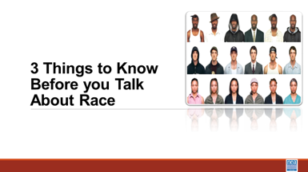  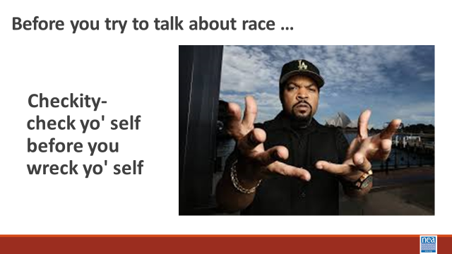  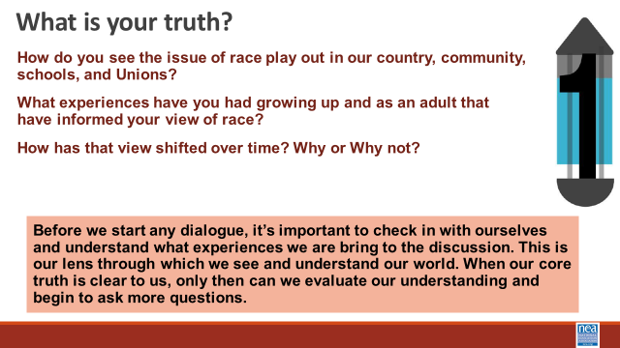  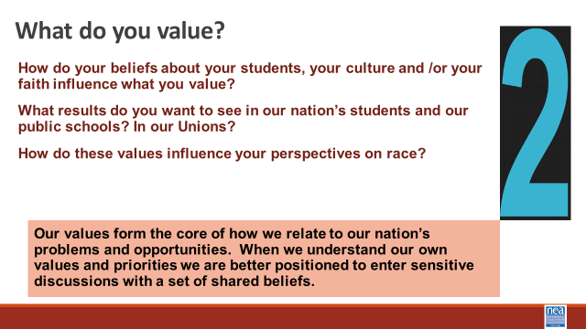  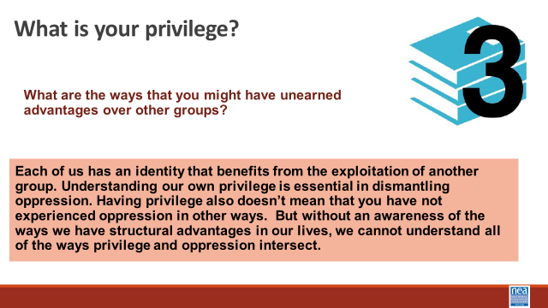  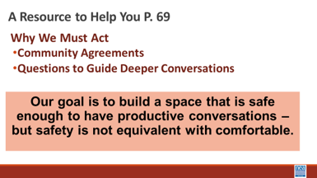  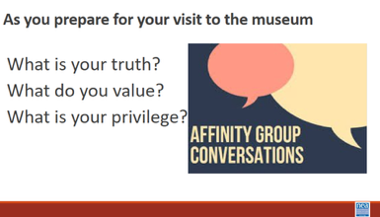  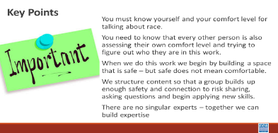  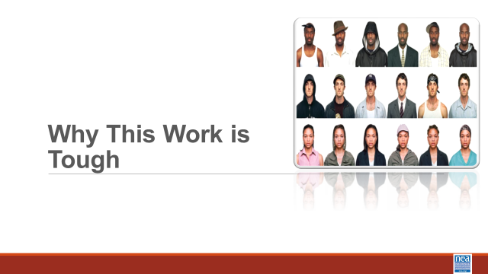  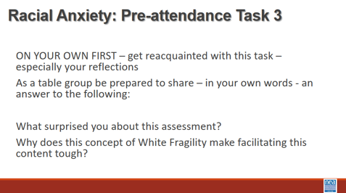  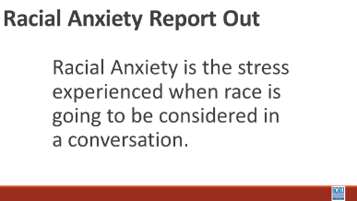  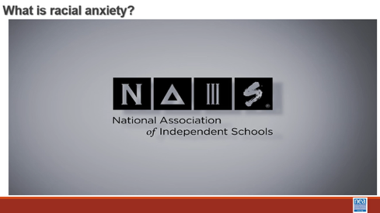  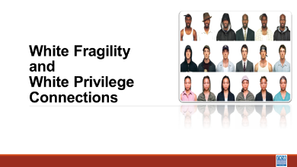  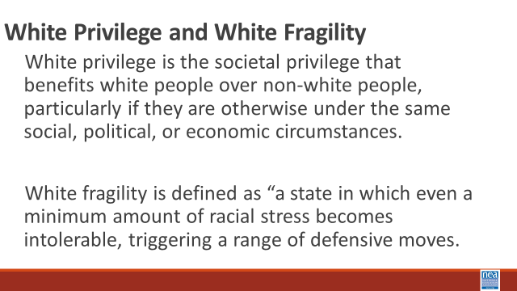    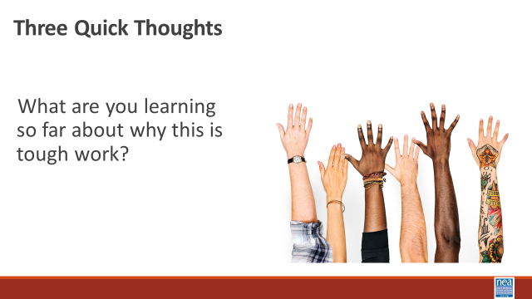  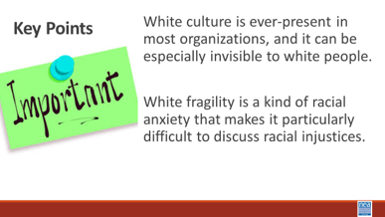  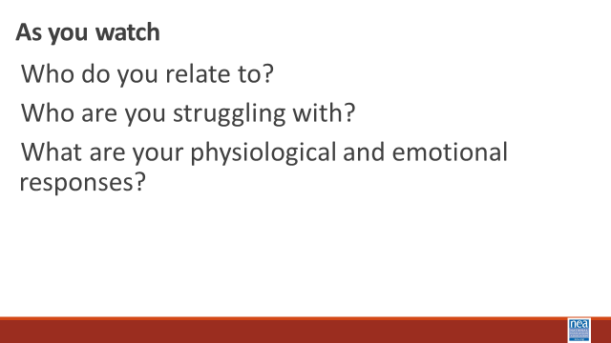    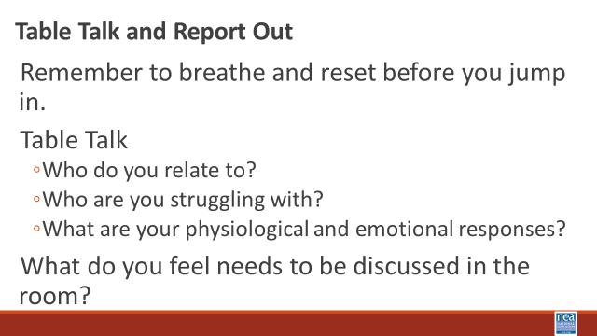  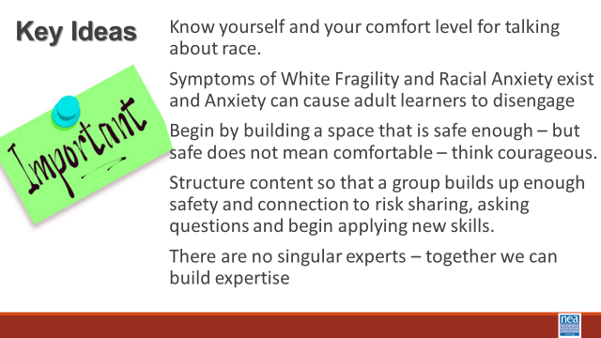 |  | Additional Resource: RJE Discussion Guide  Pre-Attendance Task 3:  Racial Anxiety Self-Assessment  Additional Resource: What is White Privilege?  Attention to White Culture and Privilege pgs. 28-41 |  | 15 Mins: Before you discuss---  Affinity Groups Topics—Each of these questions is asked of the full group for the affinity groups to discuss amongst themselves in chunked segments.  1 min intro - A useful framework of three sets of guiding questions you have a responsibility to investigate if you are going to do this work. IT follows Ice Cube’ sage advice - to check yourself before you wreck yourself.  2 Min -Show Slide – What is your truth? – I will wait while you read this -- What I want you to notice is that it is important to know what experiences you are bringing to the conversation.  2 min -Show Slide – What do you value? - I will wait while you read this -- What I want you to notice is that when we know our values it helps us be more sensitive and open during conversations that are tough  2 min -Show Slide – What is your privilege? I will wait while you read this -- What I want you to notice is each of us has an identity that has allowed for the oppression of others, and just because we have privilege does not mean that we have not experienced oppression.  There is a handout in your additional resources named RJE Discussion Guide that can help support you as you begin tough conversations around Racial Justice that includes community agreements, and questions for deeper understanding. When we do this work, we begin by building a space that is safe enough – but safe does not mean completely comfortable.  1 Minute Key Points –  - You must know yourself and your comfort level for talking about race.  - You need to know that every other person is also assessing their own comfort level and trying to figure out who they are in this work.  25 Minutes – Why this Work is Tough – Privilege and Racial Anxiety  5 mins – Introduction and video -We are going to take a closer look at the concept of privilege as you watch, consider how Privilege and Racial Anxiety are Connected. That feeling of discomfort? It was more than just discomfort. More than just FOMO. The discomfort of feeling left out as a historically privileged group is not welcomed into a space—that can be an expression of fragility.  Show video (5 Mins)  “Racial Anxiety” We show this slide as a way to transition the self-made affinity groups from their “table talk” to a whole group discussion. Then immediately go to the slide about “Racial Anxiety” – ask them to access the “Assessment” that they took in their pre-attendance work, Task 3.  10 Mins – Table Talk -With your own table: what Surprised you about your assessment? Why does this concept of White Fragility make facilitating this content tough?  5 Minutes - Report out and look for the following points that participants might report – and share these if they don’t explicitly or implicitly talk about them.  - Symptoms of Racial Anxiety exists  - Anxiety can cause adult learners to disengage  - Being transparent will feel difficult and there will be some degree of non-closure and imperfection  - Attending to community development requires intentionality  - Building from low risk to high risk takes time  - This is an ongoing process, and we all arrive at different times  2 Minutes – as a wrap up to this small section – share the video “what is racial anxiety”  10 Minutes –Connecting White Privilege and White Fragility – Share the slide with these two critical concepts to understand –  White privilege is the societal privilege that benefits white people over non-white people, particularly if they are otherwise under the same social, political, or economic circumstances. White fragility is defined as “a state in which even a minimum amount of racial stress becomes intolerable, triggering a range of defensive moves.  In this video the well-recognized author who has benefitted greatly from her own white privilege Robin D’Angelo, does a decent job of explaining the connection between white privilege and white fragility. (Share the video)  Facilitator Note: We used this to finalize the discussion as a whole room from self-made affinity groups. Move to slide – three (3) quick thoughts and take just three thoughts about what folks are learning about why this is tough work.  1 Minute – Key Points - White culture is ever-present in most organizations, and it can be especially invisible to white people.  White fragility is a kind of racial anxiety that makes it particularly difficult to discuss racial injustices.  35 Mins – What this Work can Look Like  REMEMBER OUR CAUTION  8 Mins Intro and Video - We are going to watch a segment from the 1994 movie “Color of Fear” that shows how 8 North American born men have the conversations that many of us fear.  Today, we are going to the Civil Rights Museum. We will see the struggle of a movement not just for Equality but for Jobs and Freedom. This movement was more than one man, it was you and you and most importantly us. But it wasn’t just an event—or a year. Notice that this film is 30 years or so after. Now, we are 30 years past the film. What changes were expected and didn’t come to fruition by the time of the film? How does the lack of change add to his anger and the anxiety it may produce. How is it resonating now?  As you watch notice if and/or when you begin to feel uncomfortable. Notice your breathing and what your brain begins to tell you. What would your comfort level be for hanging into this conversation. Notice Who do you relate to? Who are you struggling with? What are your physiological and emotional responses?  Show video (5 Minutes)  10 Minutes to discuss reactions in small groups -Remember to breathe and reset before you jump in. Table Talk  - How do you relate to his emotions today?  - Does the anxiety generated then translate to today’s racial anxiety?  - What are your physiological and emotional responses?  10 Minutes Whole Room Discussion - What do you feel needs to be discussed in the room?  - Additional Resource: “Fighting Racism, Battling Burnout: Causes of Activist Burnout” article  2 Mins Key Ideas –  Know yourself and your comfort level for talking about race.  Symptoms of White Fragility and Racial Anxiety exist and Anxiety can cause adult learners to disengage  Begin by building a space that is safe enough – but safe does not mean comfortable – think courageously to prepare to act courageously.  Structure content so that a group builds up enough safety and connection to risk sharing, asking questions and begin applying new skills.  There are no singular experts – together we can build expertise |  |  |  | Participants will learn about racial anxiety and assess their own level.  Participants will understand three  foundational concepts and their contributions to why this is work is tough, white culture, privilege, and anxiety.  Why is talking about race so difficult?  Participants will develop an understanding of what makes this work tough and learn basic steps to support their success in their future work.  Make sure you prep the group for this video. I will be difficult to watch
12:00 to 1:00   | LUNCH
1:00-2:15 Natasha |  | 75 Minutes Identity and Intersectionality
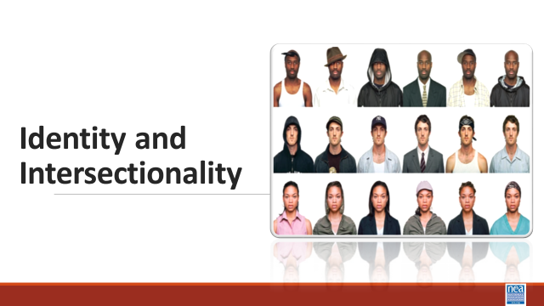  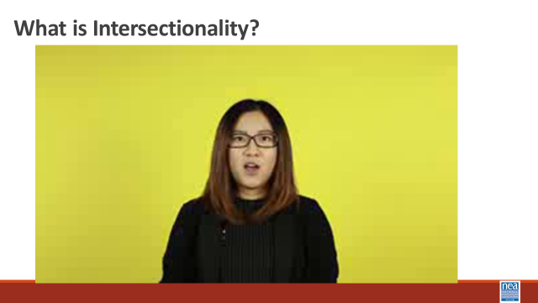  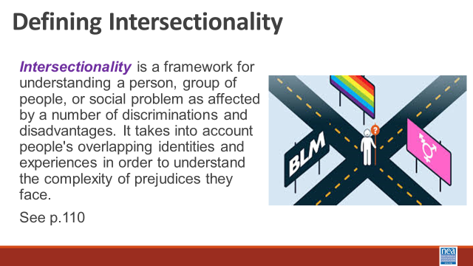  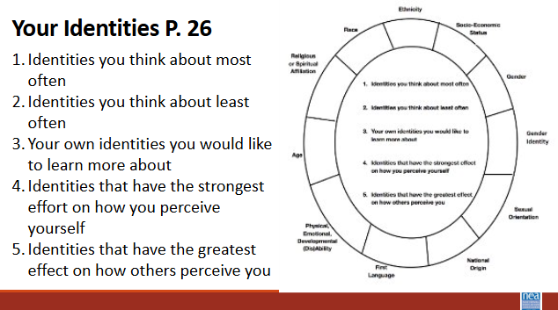  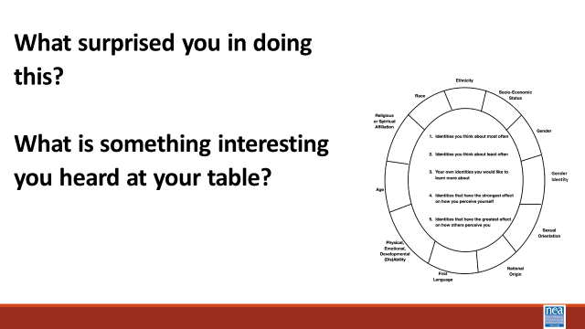    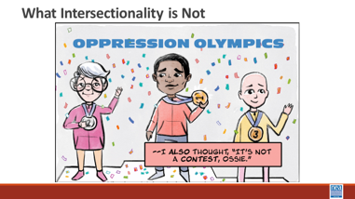  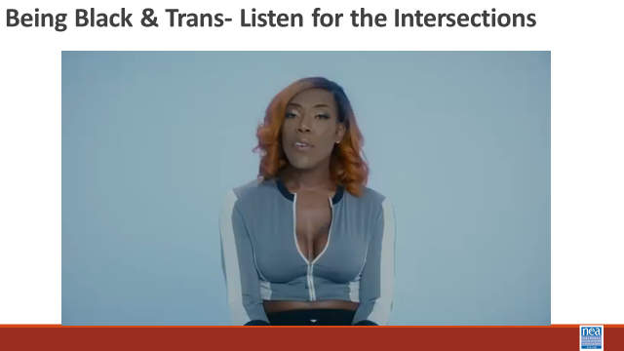  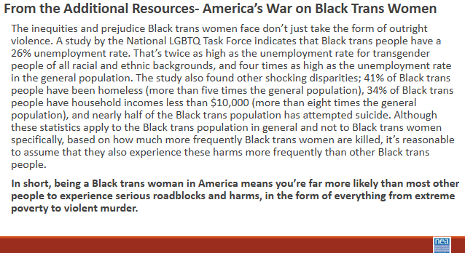  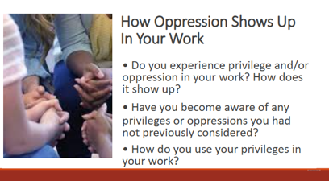    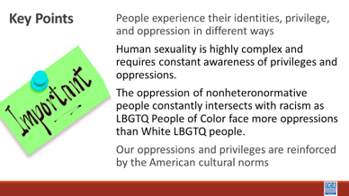 |  | Your Intersections Circle worksheet p. 30  Additional Resource:  Teaching Tolerance Article: “Teaching at the Intersections”  Additional Resource: “America’s War on Black Trans Women”  Levels of Racism P 6 |  | 35 minutes for this first section  Note: We need to ask participants to take their tech/laptops to their affinity spaces  2 Minutes -Introduce topic with video and definition- What is Intersectionality?  We are going to move back into a couple of foundational concepts – identity and intersectionality.  Show intersectionality video  https://www.youtube.com/watch?v=EXJ4Dbdm1ks  Share the slide with the definition - Intersectionality is a framework for understanding a person, group of people, or social problem as affected by multiple forms of discriminations and disadvantages. It takes into account people's overlapping identities and experiences in order to understand the complexity of prejudices they face. See the additional resource by Teaching Tolerance: “Teaching at the Intersections” for more information about this concept.  10 mins – individual p then small group talk - Using the Personal Identities Handout p 30 –We are going to take a look at a number of the identities that make us who we are. Around the circle are a number of identities and on the slide, you will see several questions.  For the first 5 to 6 minutes, you are going to do this exercise on your own. You will Place the number of the question in the box by the identity or identities that best answers that question.  Once you are finished, share your circles with your table mates. We are going to share at our tables for about 10 minutes  What surprised you in doing this?  What is something interesting you heard at your table?  5 Mins – Three (3) quick thoughts- (Facilitator just pick three) Is there anything that you said or that you heard that the room needs to hear?  5 Mins – Intro and video watching - What Intersectionality is not– We have talked about what Intersectionality is. Let’s take a minute and talk about what it is not. It is important to understand that Intersectionality is NOT the “Oppression Olympics.” Due to the complexity of our identities, it is common for people to be privileged in some areas and oppressed in others. For example, a white woman may benefit from white privilege and may experience sexism because she is a woman. I am going to share a video, and I am asking you to listen for how the intersections of this person’s identity inform and compound the oppressions that they face.  Show the video of Black Trans Person  5 mins – Share the America’s War on Black Trans Women – and ask folks to read it to themselves. As the facilitator just read the bold part out loud as a way to bring closure to this section.  “The inequities and prejudice Black trans women face don’t just take the form of outright violence. A study by the National LGBTQ Task Force indicates that Black trans people have a 26% unemployment rate. That’s twice as high as the unemployment rate for transgender people of all racial and ethnic backgrounds, and four times as high as the unemployment rate in the general population. The study also found other shocking disparities; 41% of Black trans people have been homeless (more than five times the general population), 34% of Black trans people have household incomes less than $10,000 (more than eight times the general population), and nearly half of the Black trans population has attempted suicide. Although these statistics apply to the Black trans population in general and not to Black trans women specifically, based on how much more frequently Black trans women are killed, it’s reasonable to assume that they also experience these harms more frequently than other Black trans people.  In short, being a Black trans woman in America means you’re far more likely than most other people to experience serious roadblocks and harms, in the form of everything from extreme poverty to violent murder.”  Facilitator says -This is what intersectionality helps us understand.  40 mins for this section– 2 minutes Intro and Discussion -We are going to take some time to talk about identity, intersection, and oppression as you experience it in your workplace at your table. Now that you have all this learning. All these different identities  15 Minutes  - Do you experience privilege and/or oppression in your work? How does it show up?  - Have you become more aware of any privileges or oppressions you had not previously considered?  - How do you use your privileges in your work?  20 Mins – Whole Room Discussion – What have you been thinking about that you think the whole room needs to know about?  2 Minute – Key Points  Identities, privileges, and oppressions are intersectional.  The oppression of nonheteronormative people constantly intersects with racism as LBGTQ+ People of Color face more oppressions than White LBGTQ people.  Our oppressions and privileges are layered and reinforced by the American cultural norms |  |  |  | Participants will learn how intersectionality provides for an understanding of how overlapping identities inform our relationships with privilege and oppression.  What is intersectionality?  How do our identities intersect?  What are the oppressions that are involved with gender identity and sexual orientation? How do they intersect with racism?
2:15-2:30 |  | Break
2:30-3:15 Eric |  | 45 Minutes Total –Planning and Prepping for Allyship
 |  | Actor to Ally to Accomplice Chart p. 54  Definitions p. 58  The Action Continuum p. 59  So, You Call Yourself an Ally (Additional Resources)  Pre-Attendance  How to be an Ally if you are a person of privilege – section 7  Scaffolded Resources for White Allies  (Additional Resources) |  | Eric begins  5Mins intro – TABLE TALK  Opening Question:  “When I think of the term “ally”, I think of …?”  “What references immediate come to mind?”  “Who uses it?”  “Who does it help?”  “Who does it hurt?”  Show What does it mean to be an ally? Video  10 minute intro and definitions  Today, we are going to explore allyship, actors, and accomplice, and the roles they play in campaigns, causes, and organizing opportunities. Participants will read the definitions and identify one phrase for each definition that sticks out with them.  5 minutes share:  Participants will be asked to share key phrases from each term that stand out to them.  15 min  Most think of race when thinking of allyship, in what other areas of life do these terms show up? Share slide with other causes. Each table is provided one campaign | cause to evaluate their personal and association involvement. Participants will take 3 minutes to reflect on their respective involvement [as well as the local association involvement] on actor, allyship, and accomplice.  5 min  Whole Group Report Out  What did you hear?  What did you learn?  How does our individual comfort does our individual comfort impact our role in out association?  5 min  Share Key Points |  |  |  | Participants will define and then assess where they currently stand as an Actor, Ally or Accomplice.  How do I support racial justice efforts?
3:15-3:45 Natasha |  | 30 Minutes- Nativism and Immigration Policy
 |  | What does it mean to be American? |  | 30 Minutes Total - Nativism and Immigration  2 minutes: Introduction  One of the “weapons” White Supremacy culture uses to empower racist policies and structures is Nativism, which is defined as (Britanica.com)  Nativism is an ideology, governmental policy, or political stance that prioritizes the interests and well-being of native-born (white folks) or long-established residents of a given country over those of immigrants, typically by advocating or enacting restrictions on immigration. Those who hold this view tend to reject or avoid the term nativist and instead identify themselves as “patriots,” “nationalists,” or “populists.” However, nativism is not equivalent to patriotism, nationalism, or populism; indeed, it has more in common with xenophobia and racism.  We’re going to start our conversation by watching a video that explains the racist history of U.S. immigration policies.  5 minutes: Video  Show The Racist History of US Immigration Laws video - 5 min  1924: Immigration Act civil authority, not criminal authority, still has an impact and enables ICE to act as they are  At one level, the new immigration law differentiated Europeans according to nationality and ranked them in a hierarchy of desirability. At another level, the law constructed a White American race, in which persons of European descent shared a common Whiteness distinct from those deemed to be not White.^{[60]}  In 1928, Nazi leader Adolf Hitler praised the act for banishing "strangers of the blood".^{[61]} U.S. immigration law was cited favorably by the framers of Nazi legislation due to its excluding "wholly foreign racial population masses".^{[62}  5 Minute Table Discussion  - How does US immigration policy and race intersect? (AFTER 1ST VIDEO)  Introduce the next video: Let’s talk about how Nativism is impacting us today. The next video we are going to watch is about something called “The Great Replacement Theory.”  3 Minutes: Video  Show Professor Larissa Myrick-Harris clip explaining the Great Replacement Theory in the context of Anti-Immigration policy and violence today.  5 Minutes: Table Discussion Question  - How does the labor movement show up for immigrants in this country?  - How can we participate in or engage with authentically advancing racial justice if your affiliate isn't all in?  WHITE NEED TO BE AWARE OF BLACKA ND BROWN PEOPLE TAKING OVER THE WHITE RACE (PROJECT 2025)  7 Minutes: Share and Discuss  “What We Can Do” Slides. Talk more in-depth about the following type of response we can take to resist and fight Nativism  - Being an Actor Keep Informed, Sharing KYR Cards, Refuting Disinformation  - Being an Ally: Grocery Shopping, driving kids to School, passing out Whistle Kits, Opposing 287g Agreements, lobbying  - Go to link and see if municipality has an agreement  - City of Burlington just signed executive order that Police will not assist ICE, nor will they impede with lawful operations, they will ensure medical care and document events  - Being an Accomplice: Canvassing Businesses, Migra (Meegra) Watch Patrolling  - VT Migrant Justice: training  Key Points  - European colonizers of this land, and community descendants have maintained their dominant status by creating anti-immigrant policies  - Racial discrimination can be further complicated based on one’s immigration status  - We can act as allies and accomplices to protect immigrants in our communities by getting involved with immigrant rights work already going on. Look up online what’s already going on in your community and show up.  - Anti-immigrant rhetoric and policies are perpetuated by government and media endorsed fear of others in order to maintain the country’s white control over systems of power |  |  |  | Participants will explore the concept of Nativism.
3:45-4:20 Taraja |  | 35 Minutes - Disrupting Microaggressions
 |  | What can I Do at Work?  P Additional Resources  Interrupting Microaggressions pg. 48 |  | 2 Minute Intro – In a bit we are going to be exploring at one of the most prevalent forms of racism – the microaggression. The other most prevalent form of racism is bias. The research around our outward use of and acceptance of microaggressions says that they are the truest indicators of the unrecognized forms of bias we have. Microaggressions are the manifestations of bias.  3 Min video – Show video about how Microaggressions are like mosquito bites (2 minutes)  5 min - Before we get started, take a look at this video, listen: How do you respond to microaggressions? https://youtu.be/C3LFB4mJ0DI  P. 48-51 have some good suggestions for disrupting common types of microaggressions  5 mins – Introduce 4 step method for interrupting some common workplace microaggressions.  Interrupt, question, educate, ECHO if you are a bystander  Example - Wow, I can’t believe how well-spoken you are for an ESP Leader!  - Interrupt – why are you surprised?  - Question –what were you expecting?  - Educate – When I hear that it hurts. I am often  discounted because of the job I have. No one can believe that I have a college degree or that I can read, write, and speak.  - IF THERE WERE A BYSTANDER WHO DID THIS –  - Thanks for asking about that, it bothered me too. We need to have high expectations and high regard for each other – this work is too tough.  30 min - Responding to Microaggressions  Often participants will tell us that they are uncomfortable with addressing microaggressions when they occur because they don’t know what to say. Our next activity will give you the opportunity to practice what to say when you are a victim or witness to a microaggression.  1 min – Directions for Activity: The purpose of our next activity is to practice responding to microaggressions in a way that will ultimately lead to their reduction rather than reinforcement. This is extremely challenging, because it is hard to respond honestly without leading other people to become defensive or hostile.  This activity involves three roles – speaker, responder, and coach and all members should have at least one opportunity to play each role. The speaker is responsible for choosing a scenario (or making one up) and saying the remark that is a microaggression. The responder is given the challenge of responding to the remark in a way that reduces the likelihood of future microaggressions, and the coach is a social observer who provides candid feedback on the strengths and weaknesses of the response.  To get the most out of this exercise, it is important to spend as much time as possible practicing rather than simply discuss microaggression reduction, and the coaches should be as open as possible in their feedback. To begin the exercise, one person should play the role of the speaker, one should play the role of the responder, and the remaining group members should play the role of the coaches. Let the conversation build for a minute or so before the remark is made, and let it continue for a while after the response is given. Once the speaker and responder have concluded their interaction, the coaches should critique the response, and the roles should be rotated for another practice round with a new speaker and responder. Do not worry about getting through all the scenarios or adhering precisely to the scripted comments – the scenarios are simply designed as icebreakers to facilitate the activity.  20 min to work through scenarios in groups of 4. Facilitators will visit each of the groups to make certain that you are spending your time role playing and not holding a discussion. This is a time to practice so that you WILL know what to say.  We will now divide into four (4) person groups. All group members should play each of the roles at least once, and that speaker should choose a new scenario with each rotation.  7 Scenarios  #1  Speaker: Union Membership Chairperson  Responder: UniServ Director  Background: New Member Orientation meeting where the UniServ Director has been asked to speak. You observe the membership chair ask a potential member the question.  Comment: “What are you? Where are you really from?”  #2  Speaker: Participant in a training session  Responder: Workshop Facilitator  Background: Break time during the training session and the participant comes over to talk about how great the training is so far.  Comment: “Someone asking to touch your hair because it is exotic.  #3  Speaker: A high school student  Responder: A teacher  Background: Comment was overheard during after-school study hall  Comment: “You must be good in math; can you help me with this problem.”  #4  Speaker: Your best friend’s co-worker  Responder: A white bystander  Background: Comment was made by friend of a friend at happy hour.  Comment: “How do Black people feel about affirmative action?”  #4-a  Speaker: A fellow colleague  Responder: UniServ Director on the job for 5 years  Background: Comment was made during lunch time with several people at the table.  Comment: “Of course she’ll get the promotion, she’s a minority.”  #5  Speaker: Union member  Responder: Union President  Background: Union member approached officer at the end of general membership meeting  Comment: Being told you speak English well when it is your first language.  #6  Speaker: A middle-aged woman  Responder: Black woman  Background: Slightly busy hotel lobby with several people in line waiting to check in  Comment: Being mistaken for someone in a service role.  #7  Speaker: A middle-aged uncle  Responder: A family member  Background: Comment was made during a family dinner in which the conversation turned to the topic of LGBTQ+ rights.  Comment: “All that lesbians need is a good-looking man to convert them.”  5 min - Report out on which responses were most effective, and which strategies might minimize resistance on the part of the “mosquito”.  Facilitator Note: The Suggested strategies we are looking for in report out are below. If the groups do not come up with them on their own, then share with the group.  - Use questions such as “Why do you say that?” and “Do you feel that way about every person in that group?”  - Point out the difference between what the speaker said and how they behave or believe about themselves, “I’ve always thought of you as someone who is very open-minded”  - Tell the other person how you feel (it makes me uncomfortable to hear that) – it is a statement that cannot be refuted  - Approach the person with respect rather than indignation  Debrief questions:  Is the most effective response an immediate one, or is it better to wait?  Are public responses more effective than private responses?  Are there situations in which it is best to not respond?  1 min -Key Points:  It is a basic human right to demand a safe space.  Remember that you have the power to control the situation through your actions and reactions.  Need more time for practice, spend less on set up.  Apology slide and how to do it is missing.  Debrief slide is missing.  Perhaps think about refreshing a bit—more interaction if the set up isn’t shortened. We always think we can do this quickly. We can’t--but it is worth it because they NEED the practice. Share out of plans was INCREDIBLE. |  |  |  | Participants will understand the link to bias and microaggression.  Participants will practice interrupting microaggressions using a 4-step process.  How do I begin to interrupt the cycle of racism in my everyday work?
4:20-4:30 Ellen | Closing

