Facilitator Agenda: Advancing Racial Justice 2026 MSEA Day #3
General Materials Needed: |  |  |  |  |  | Room Set-up:
1 Set of Handouts per Person  Name Tags and Name Tents  Sign-in Sheet  Pens and Pencils |  | Chart Paper  Markers  Post its  Index Cards |  |  |  | Round Tables  Projector, Screen and Speakers  Carousel stations and reporting stations around the perimeter  50 people
Key Outcomes for the Day
Understanding the indicators of becoming anti-racist
Understanding what Allyship Is
Applying Learning in a Case Study Format
8:30-9:30 Getting Started, Campaign Lab  9:30-10:15 Practicing Becoming Anti-Racist  10:15-10:45 Team Building/Campaign Overview |  |  |  | Ellen & Tina  Rita & Taraja  Natasha | 10:45-11:00 Break  11:00-1:00 Campaign Planning |  |  | Eric, Ellen, Albert & Natasha
Time, Slides, Facilitator | Resources |  | Instructions, Activity and Debrief (Facilitators) |  |  |  | Outcomes and Essential Questions
 | Charts, handouts, articles, materials, slide |  | What are you saying, what are they doing, what questions will you use to guide learning and make clear the important points  Include an estimate for how long each section of the learning will take |  |  |  | As a result of this section, what will participants know or be able to do? What questions will they be able to answer?
8:30-9:30 Ellen | 1 hour total - 15 Minutes Greet, Gather & Ground and Entry Activity
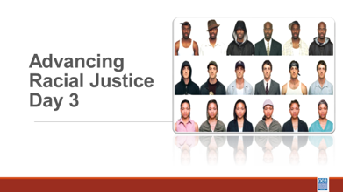  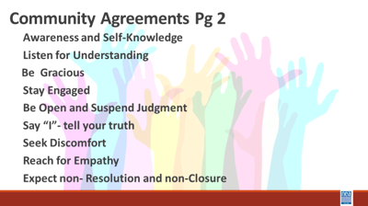  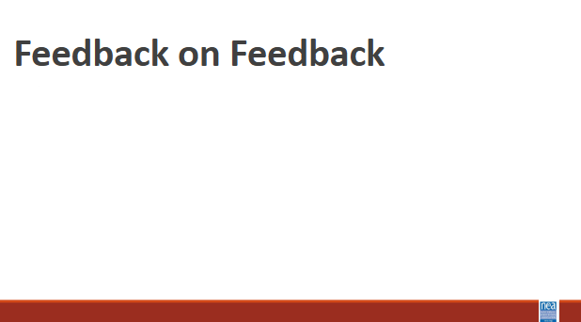  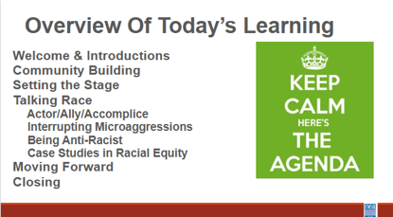  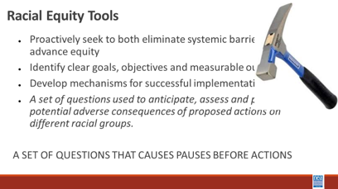  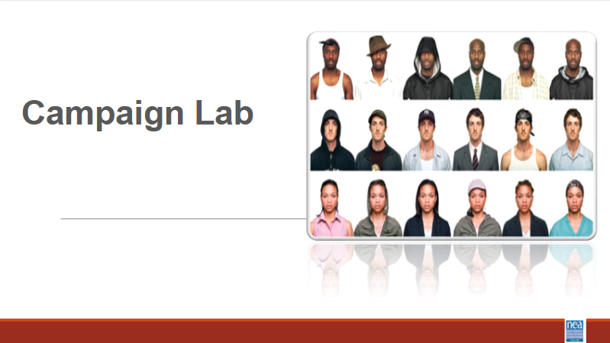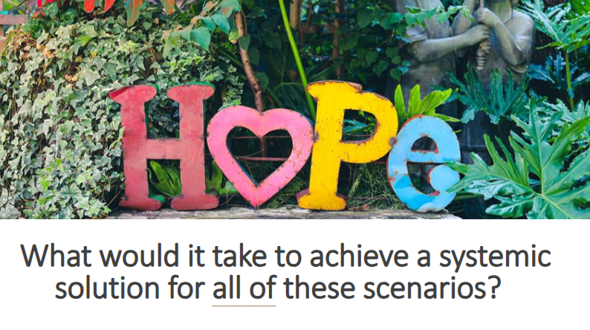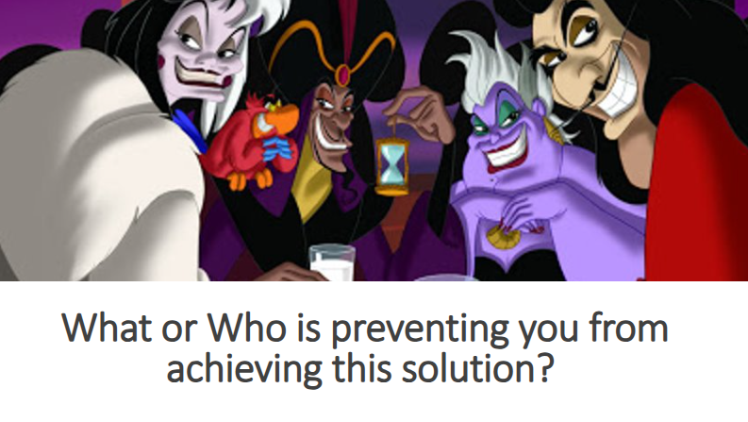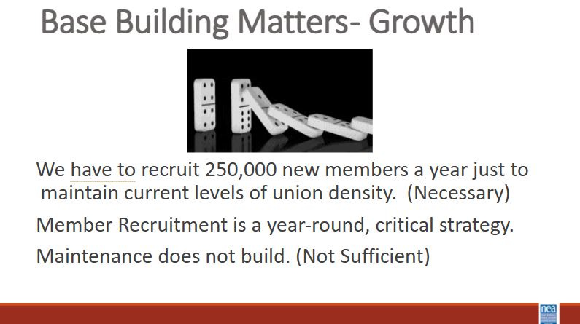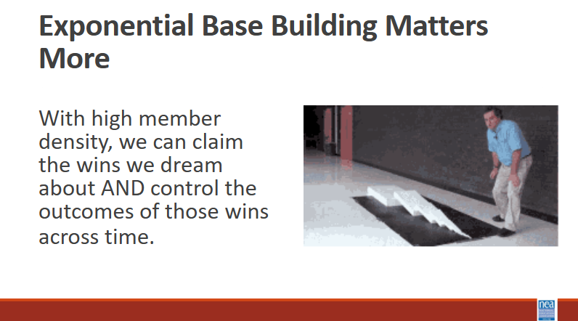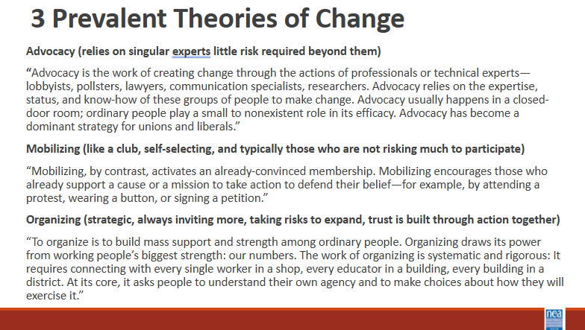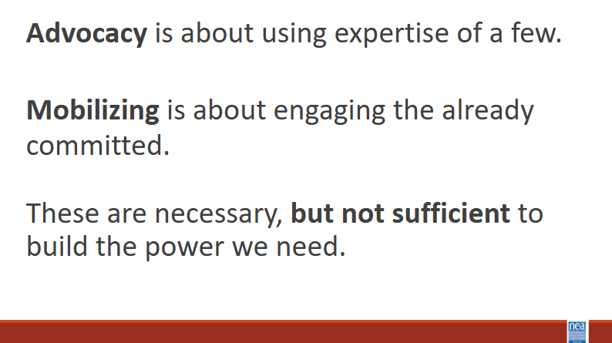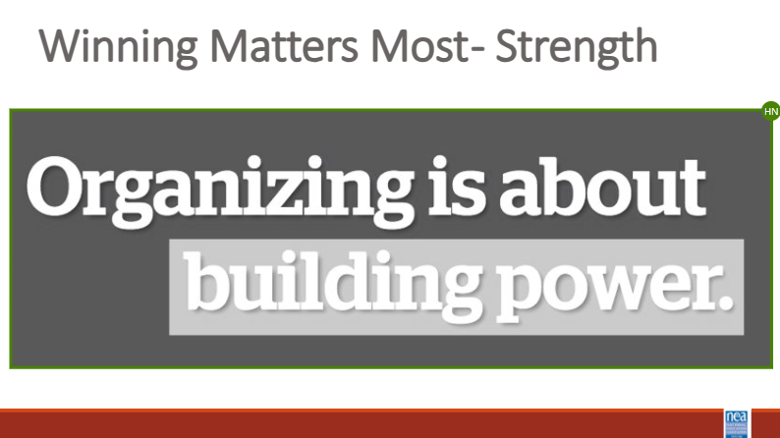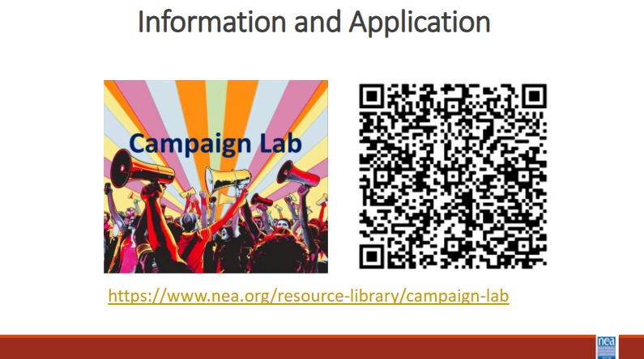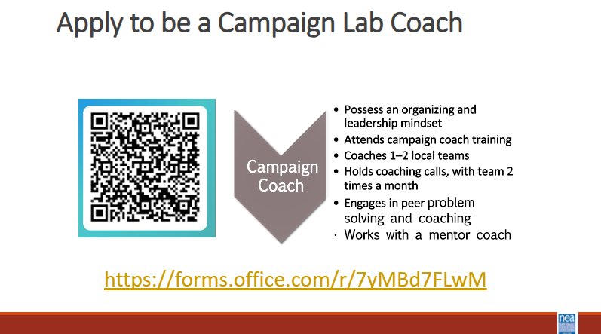 |  |  | Welcome,  overview of learning goals,  overview of days agenda,  feedback on feedback and  revisit community norms.  45 MINUTES  Affinity Groups re: Museum Visit  Facilitator Notes: When facilitating affinity circles – consider holding back on sharing until the participants have shared (be mindful of taking up the allotted time)  When 2 people are presenting and we are talking about tasks that we want participants to do...let’s use “we” instead of “I”  Consider including more movement in the morning of Day 3// we had t2 chunks of work with no movement  Ellen: Campaign Lab Pitch—explanation and ask  Overview of Organizing  5 mins – What would it take to achieve a systemic solution for all of these scenarios?  5 Mins – What or who is preventing you from achieving the solution?  10 Mins- what does NEA focus on – Strength and Growth  Growth is necessary but does not build power  Strength is the ability to win and is all about the structures that build power  There are 3 theories of change  Only organizing builds power  Campaign Lab  Campaign Coach |  |  |  | What have we been learning? What is working and what is not?  What will today look like?
9:30-10:15 Rita and Taraja | 45 Minutes -Practicing Becoming Anti-racist - Case Studies in Racial Equity
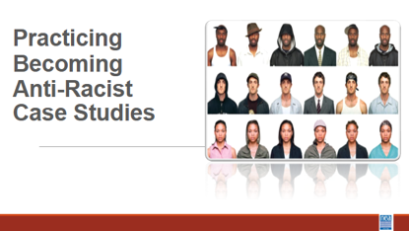  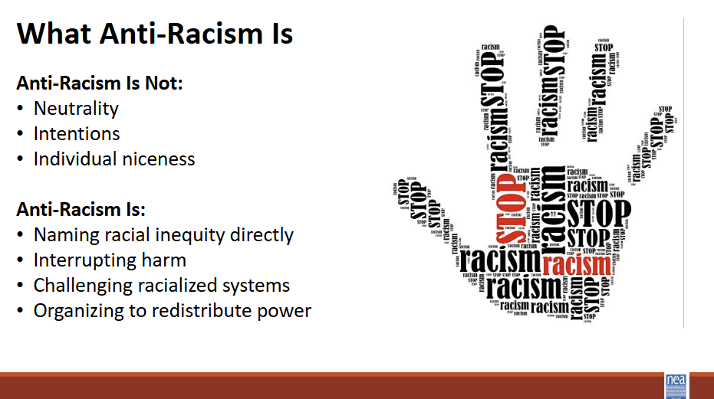  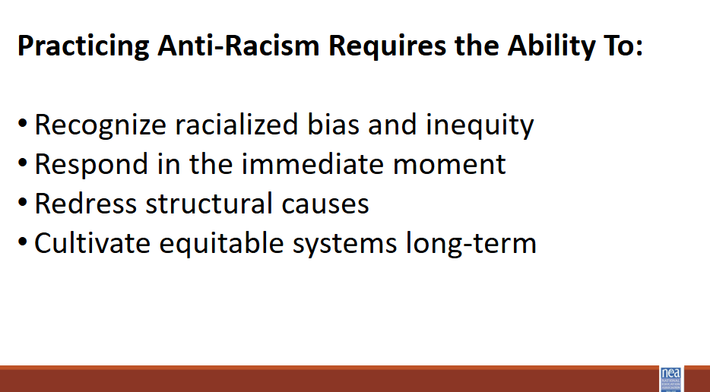  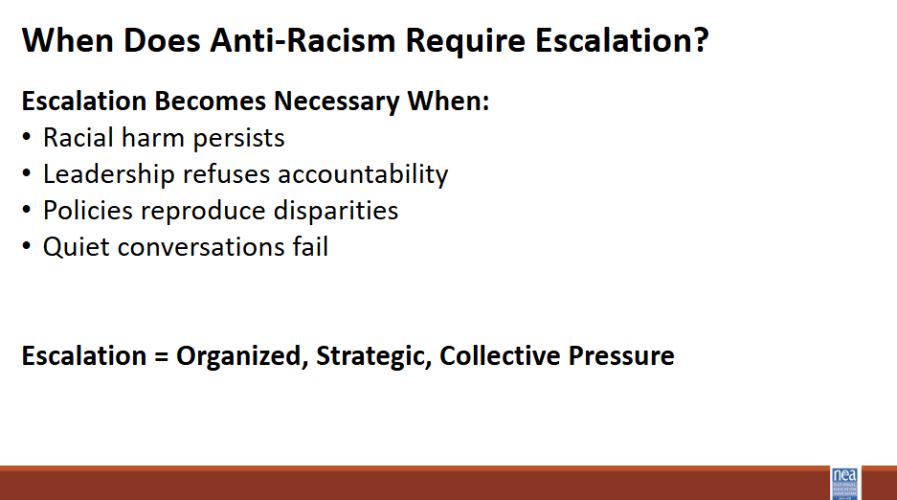  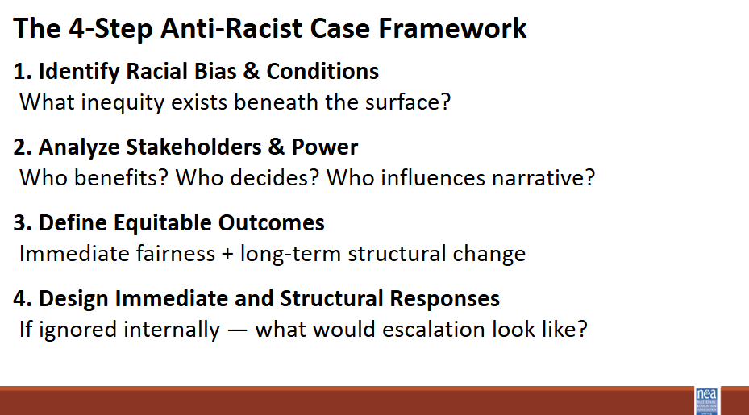  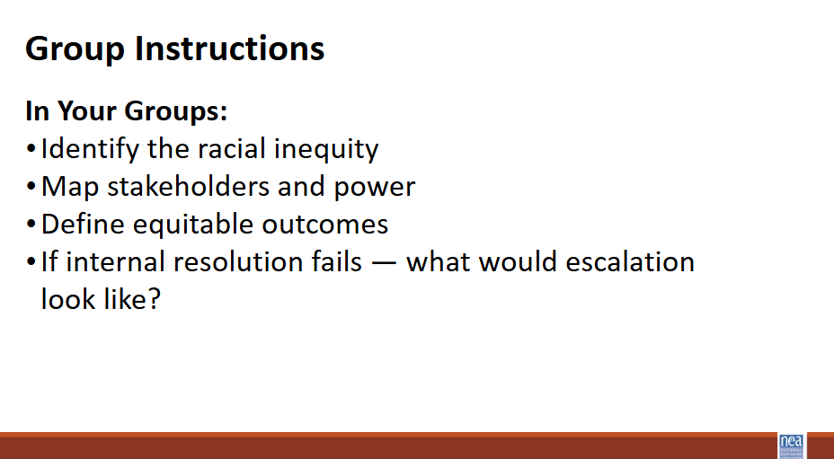  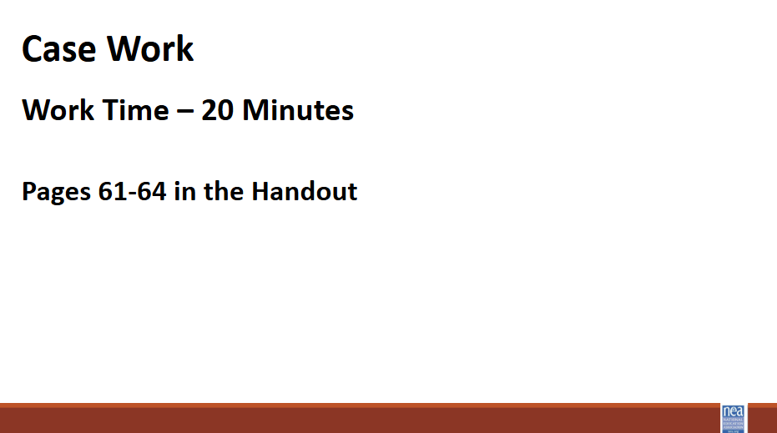  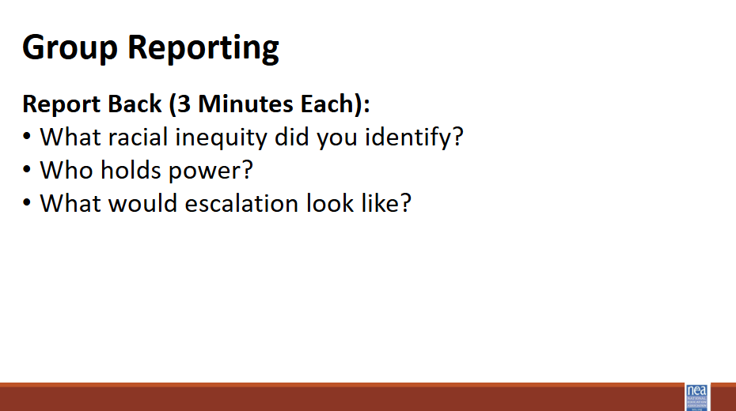  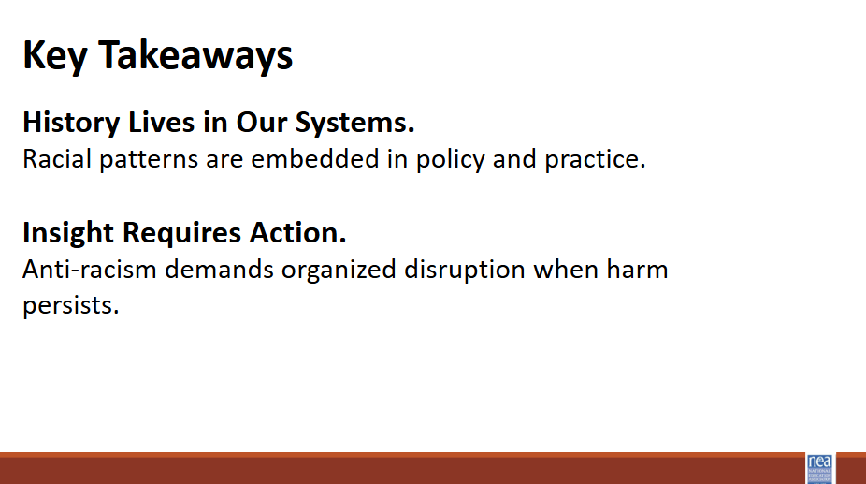 | Case studies framework  Case Studies |  | Anti-Racism as Practice (5 minutes)  Open by grounding the room:  Anti-racism is not an identity or a personal declaration. It is a discipline. It requires skill, analysis, and collective action.  Clarify that this section is about practice. We are not labeling ourselves. We are sharpening our ability to disrupt racial inequity in our schools and unions.  Make clear: Most racial inequity in schools is subtle, normalized, and embedded in policy and practice. Practicing anti-racism requires learning to see it and organize against it.  The Four Anti-Racist Abilities (5 minutes)  Briefly walk through the four abilities:  - Recognize racialized bias and inequity  - Respond in the moment  - Redress structural causes  - Cultivate equitable systems long-term  Keep this concise. Do not over teach theory.  Emphasize that escalation happens at the redress and cultivate levels. When racial inequity persists or is protected by power, organized disruption becomes necessary.  When Anti-Racism Requires Escalation (5 minutes)  Frame the shift clearly:  Not every issue requires escalation. But when racial harm persists, leadership refuses accountability, or policies reproduce disparities, quiet conversations are not enough.  Escalation is structured, strategic, collective pressure to create change. Tell participants that the case analysis they are about to do is the diagnostic phase of escalation.  Introduce the 4-Step Anti-Racist Case Framework (5 minutes)  Explain the four moves:  - Identify racial bias and underlying conditions.  Look beneath the surface. Ask how race is operating even if it is not explicitly named.  - Analyze stakeholders and power.  Who benefits? Who decides? Who influences narrative? Consider administration, union leadership, school board, community, and public perception.  - Define equitable outcomes.  What would fairness look like immediately? What would structural change look like long-term?  - Design responses.  What can be done internally? If ignored, what would escalation look like?  Stress that this is not about memorizing steps. It is about practicing an equity and power lens.  Redirect groups away from surface-level problem solving and toward structural analysis.  Small Group Case Work (20 minutes)  Divide participants into groups (count off to 4) and assign each group a case study.  Instruct groups to work through the case questions in order. Remind them:  - Keep race explicit in your analysis.  - Name the racial inequity clearly.  - Consider how identity shapes perspective.  - Distinguish individual behavior from structural inequity.  - Identify immediate responses and longer-term structural changes.  - Ask: If internal resolution fails, what would escalation require?  As you circulate, push deeper analysis:  - How is race operating here?  - Who holds decision-making power?  - Who benefits from the status quo?  - What are the union’s obligations?  - What would winning look like?  Keep groups focused on structural thinking, not surface-level problem solving.  Remind them: You are practicing anti-racist leadership inside a union context where representation and racial justice intersect.  Group Reporting (10 minutes)  Each group reports briefly:  - What racial inequity did you identify?  - Who holds power?  - What would escalation look like?  Keep reports tight. Push specificity.  After each report, ask:  “What would winning look like?”  Avoid vague answers. Push toward structural change, not awareness.  Close and Bridge to Escalation (5 minutes)  Close with two anchor ideas:  - History lives in our systems.  Racial patterns are embedded in policy and practice.  - Insight requires action.  Anti-racism demands organized disruption when harm persists.  Make the transition explicit:  - What you just practiced was diagnosing inequity and mapping power.  - Escalation campaigns take that analysis and organize it into strategy.  - The next section will focus on building that strategy.
10:15-10:45 Natasha | Team Building
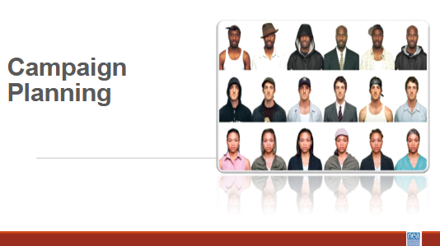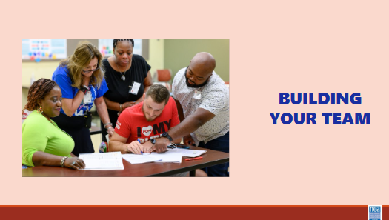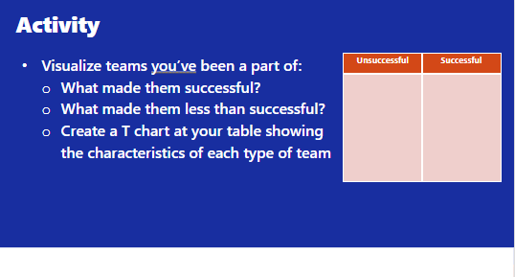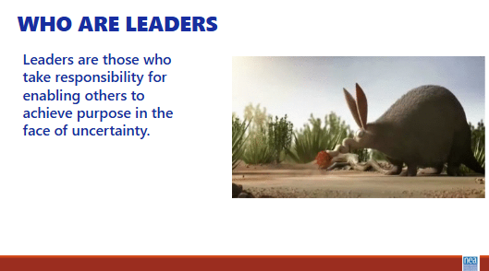  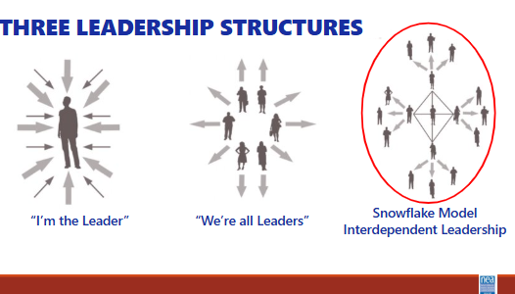  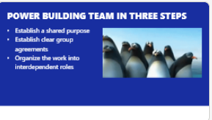  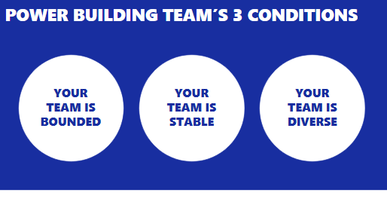  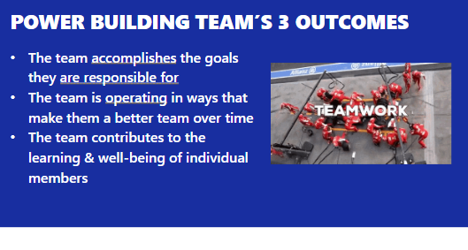  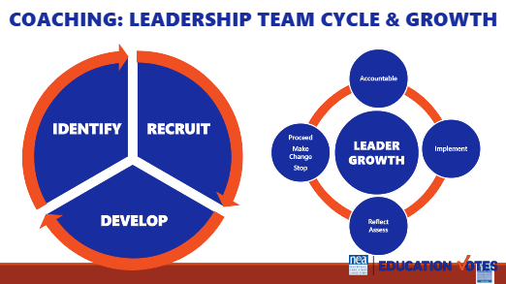  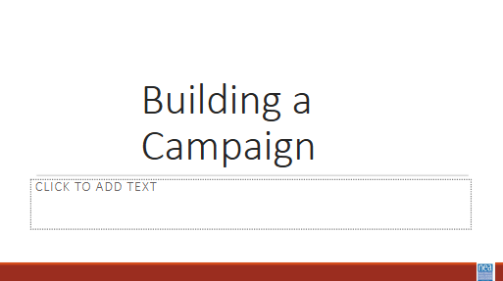  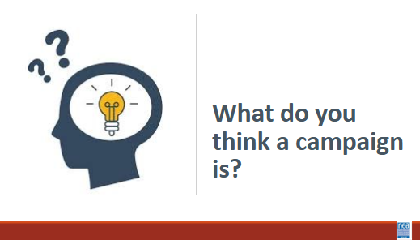  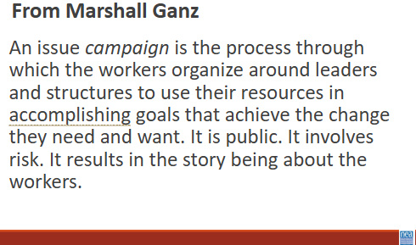  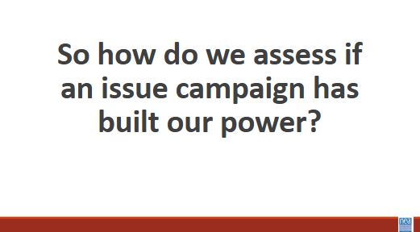  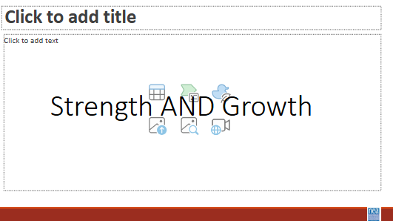  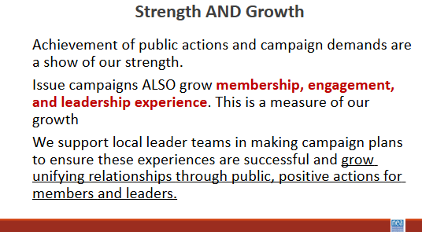  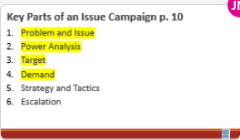  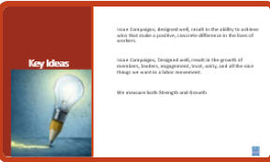 | Building Your Team: 20 minutes  Table Talk 10 min  - Visualize teams you have been a part of  - What made them successful?  - What made them less than successful?  - Create a T chart at your table showing the characteristics of each type of team  What makes an effective team 10 min  Leaders are those who enable others to achieve purpose in the face of uncertainty.  We are always coaching away from single leaders/authorities towards interconnected leadership/ teams.  - Establish a shared purpose. What are you fighting for and can you clearly articulate your common purpose as a team. It is clear, challenging, and matters. You have defined your goal, whom you work with, and the kinds of things you will do?  - Establish clear ground rules or norms. Your team sets explicit expectations of how you will work together: how you will make decisions, manage your time, and honor your commitments. What are things you will always do and what are the things you will never do. And how will you correct yourselves if you do them. Perhaps you most important norm is how you will make decisions. Steps that can guide effective decision making are: defining the problem, establishing criteria, brainstorming possibilities, synthesizing ideas, formulating options, evaluation options against the criteria, deciding. Some prefer deciding by vote; others, by consensus; others by delegating the decision to an individual.  - Organize the work into interdependent roles. Everyone should have responsibility for their own share of the leadership work needed to achieve the goal. Role requirements need to be clearly described. Team members need to assess their strengths and limitations, to the greatest extent possible, matching individual capabilities with role requirements. Because roles are designed to be interdependent, everyone has a stake in everyone else’s  Three Conditions  - Your team is bounded. It is clear who is on the team and who is not on the team. It is clear how new people can join the team and what is expected of those who must leave the team.  - Your team is stable. People commit to clear terms of service: regular meetings, length of time, etc. Your team is not a revolving door, never knowing who will show up.  - Your team is diverse. Your team has the appropriate diversity of skills, talents, viewpoints, and constituencies that will be needed to do a good job.  Three outcomes  - The team accomplishes the goals for which it is responsible.  - The team is operating in ways that make it better as a performing unit over time  - The team contributes the learning and well-being of individual members  Leadership Team and Leadership Growth Cycle  - As an organizer your job is to recognize and then help the team recognize that in order to build power, there is a continual identify, recruit, and develop cycle of new folks into the team.  - A team that does not continual recognize that one of their jobs is to continue to make space for new leaders, perspectives, diversity, and talents is a team that is not intent on base building and power development.  - Further a team grows in capacity to strategically achieve outcomes using everyone’s unique talents by attending to a continual cycle of implementation, reflection/assessment, proceed-change-stop, and accountability for the outcomes. We do a disservice to teams, the constituencies they are from, and the local as a whole when we don’t identify non-growing, non-power building teams. An even great disservice is done when we jump in to do it ourselves.  Organizing Campaigns: 10 minutes of content: Natasha  5 Minutes – Defining Campaigns (Turn and Talk and Lecture)  Turn and talk to the person next to and say the first thing you think of when asked – What do think a campaign is?  Campaigns are defined as the following (From Marshall Ganz) A campaign is a process through which your constituency can organize itself to create the power it needs to accomplish goals that will achieve the change they need. And turning their campaign into an organization gives them access to the capacity to build on their successes into the future.  *Collective action.  How do you know if a campaign has built power?  We measure campaign success by two metrics - Strength and growth.  This is how we define strength and growth.  - Achievement of a campaign demand is a show of our strength.  - Successful campaigns ALSO grow membership, engagement, and leadership experience. This is a measure of our growth  - We make campaign plans to ensure these experiences are successful and grow unifying relationships through public, positive actions for members and leaders.  We are going to do a quick little overview of the parts of a well designed campaign. This will set us up for the following sessions with you.  There are six main parts to building a campaign. We are going to go through each-  Problem and Issue - The problem and issue is the spark! Why we are coming together, why we want a contract etc.  Power Analysis – What power do the decision makers have? Who has power over them? What power do we have?  Target- Who has the power to make a change? Who is the PERSON who can make the change.  Demand - What needs to be changed? By when? By who?  1 Minutes Key Points  - Campaigns, designed well, result in both ability to achieve wins that make a positive, concrete difference in the lives of workers.  - Campaigns, Designed well, result in the growth of members, leaders, engagement, trust, unity, and all the nice things we want in a labor movement.
10:45-11:00 | Break
11:00-1:00 Eric, Ellen & Natasha | Campaign Planning
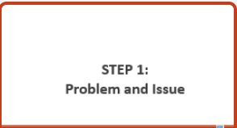  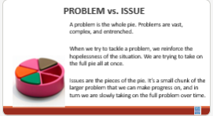  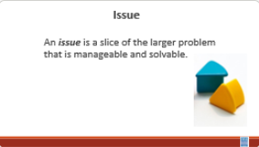  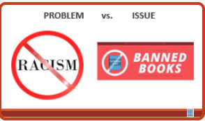  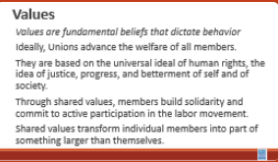  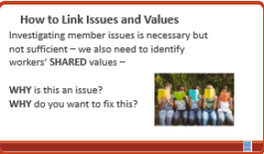  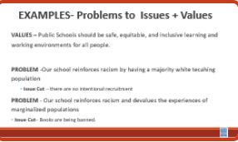  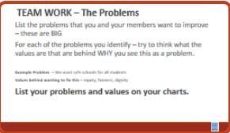  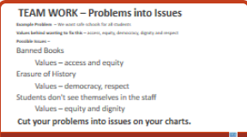  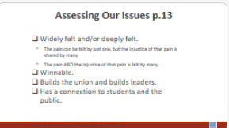  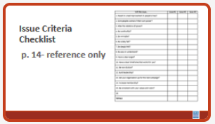  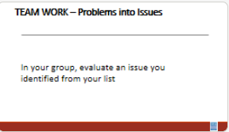  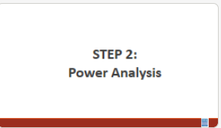  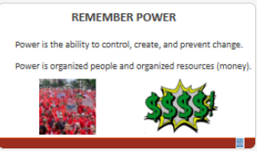  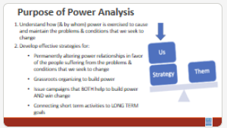  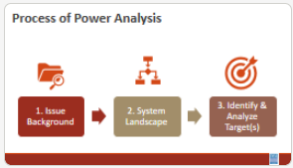  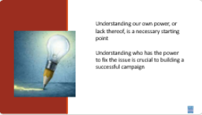  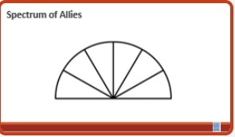  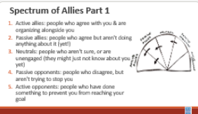  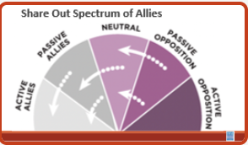  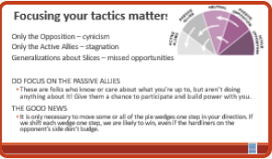  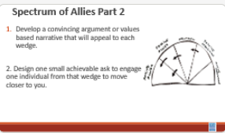  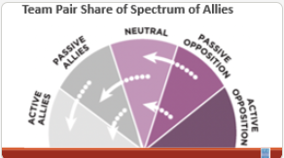  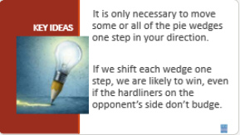  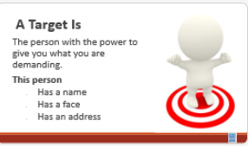  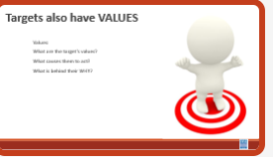  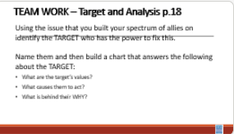  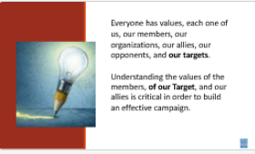  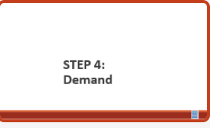  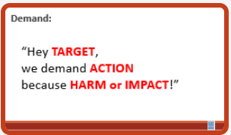  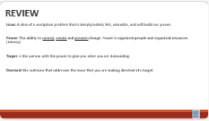  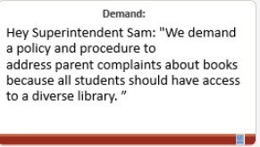  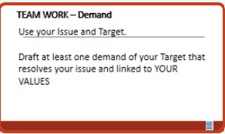  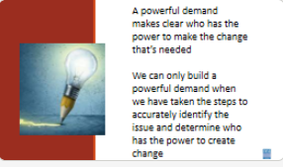  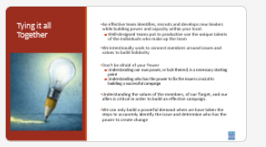 |  |  | Problem and Issue: 30 Minutes  - Content- 15 minutes  - Cutting an Issue Activity- 15 minutes  10 Minutes PROBLEM , ISSUES and Values  - Campaigns start with issues that people have value-based solidarity around.  - An issue is a slice of a workplace problem.  - Often a problem can have different issues depending on the perspective of the people we are working with.  - It is KEY to get enough input on what the issues are that make up the problem so that YOU do not drive the solution.  - Investigating the issue is necessary but not sufficient – we also need to identify workers’ SHARED values – WHY is this an issue? WHY do you want to fix this?  For example:  A problem is- Racist behaviors create an unsafe environment for our students and staff.  An Issues – Parents are demanding that certain books be banned from our classrooms and libraries.  We Begin to Get to Values when we ask WHY?  VALUES are  - Values are deeply-held beliefs that shape who you are.  - Ideally, Unions advance the welfare of all workers.  - They are based on the universal ideal of human rights, the idea of justice, progress, and betterment of self and of society.  - Through shared values, workers build solidarity and commit to active participation in the labor movement.  - Shared values transform individual members into part of something larger than themselves.  Have participants think about the core values they shared on day one, and link the issue organizing to their core values  How to Link Issues and Values – The Organizing Conversation Magic  You might ask, Do you want to fix this problem? Which of these do you think you can fix? Which one matters the most to you? Why does it Matter?  Book banning is something that matters to me and my colleagues, and it matters because it impacts the worth of my students.  The book banning can be fixed by implementing policies and procedures. Is an issue that allows me to see the solution.  We can get to values by asking how do you feel about racist behaviors creating unsafe learning environments? Do you think others feel the same way about our schools? Why do you want to fix this problem?  We deserve safe and healthy schools  We deserve access to books that share multiple perspectives  Share slide of examples of Problems, the Values, and the issue Cut  5 minutes Team Work - List of Problems and the values that might be linked to those  You and your team are going to make a list of problems that you and your members want to improve – these are big  For each of the problems you identify – try to think what the values are that are behind WHY you see this as a problem.  What is the Problem?  What are some Unifying Values?  5 Minutes - Cutting our Problems into Issues  Using the charts you made as we started pick one of your big problems and think about the issues that might be built into that.  Example Problem – We want safe schools for everyone  Values behind wanting to fix this – access, equity, democracy, dignity and respect  Possible Issues –  Banned Books, Erasure of History, Students don't see themselves in the staff  Cut your problems into issues on your charts.  5 Minutes -Assessing Our Issues  So how can we determine – assess what issues make the best organizing issues. We can work them through a couple of processes. Using these processes with them keeps us from taking over and allows for leadership development opportunities. They build their confidence and trust and solidarity through a shared process.  At the very least a good issue  - It is widely felt and/or deeply felt.  - The pain can be felt by just one, but the injustice of that pain is shared by many.  - The pain AND the injustice of that pain is felt by many.  - It is winnable.  - It builds their union and builds leaders.  - It has a values-based connection to our workers, students, and the public.  Using the issues you charted at the beginning of this section about issues – Spend just a few minutes using the simplified screener from Labor Notes on p. 13 of the PG– and see how it would allow you to screen out issues that might not be good for  Organizing. (Page 14 has a good checklist for reference @ home.)  ^{Team Work: 5 Minutes}  In your group, evaluate an issue you identified from your list  Power Analysis and Spectrum of Allies: 60 minutes  - Power- 10 minutes (ERIC)  Once you’ve identified the Problem and Issue, we need to do a power analysis.  Look around your table, write the name of teh person at the table who has the most power on a post-it note. Fold it up. Hand it to that person.  What do you notice?  Who wrote their own name?  What happened when you handed your post-it note to another person?  REMEMBER what power is (share slide)  Purpose of Power Analysis:  Power analysis is a systematic approach to understanding our own power and the power of our allies and opponents on the issue that we have identified. Doing a power analysis allows us to understand how and by whom power is being exercised to cause and maintain the problems and conditions that we seek to change. This allows us to identify and understand the decision maker who can give us what we want and to develop effective strategies for:  - Permanently altering power relationships in favor of our communities & the conditions that we seek to change  - Grassroots organizing to build power  - Developing Issue campaigns that BOTH help to build power AND win change  - Connecting short term activities to LONG TERM goals  - Understanding who can help us build power  Process of Power Analysis (p. 15 for reference)  Now that you’ve identified issues and values you need to look at three areas as part of your power analysis. We are going to do a deep dive into one part of Step 1 looking at allies and opponents, and the third step about Targets – but know that after this, you have to complete the full analysis to implement a successful campaign the first two steps must be done.  Power Analysis Part 1: Issue Background  Once we’ve identified an issue, what might we need to find out about it in order to build an effective campaign?  - History and current status?  - Competing agendas or positions?  - Narratives?  - Allies on the issue? Opponents on the issue? (Deep dive next)  Power Analysis Part 2: System Landscape  - Next step is researching the system landscape. The two main questions are:  - Processes?  - Decision-makers? (Whether allies/opponents, who is making the decisions)  Power Analysis Part 3: Identify and Analyze the Target(s)  - Moving into Part 3 of the Power Analysis, identifying and analyzing the Target(s). (Deep dive later)  Key Ideas  Understanding our own power, or lack thereof, is a necessary starting point.  Understanding who has the power to fix the issue is crucial to building a successful campaign.  Spectrum of Allies (Complete this all in 50 minutes) Albert  content- 5 minutes  In 2001 when Reverand Al Sharpton was considering running for president in 2004 he said the following:  “...to seriously look at a strategy that would lead toward making sure the unheard and the unnoticed are both heard and paid attention to.”  “There are those in the Democratic Party who have driven the party further and further to the right in the name of a winning strategy,” Sharpton said. “And it seems that it is their presumption that the only way to be electable is that progressive forces and people of color must voluntarily turn into invisible people.”  Often, we invite people to engage with your campaign that show up in the ways that you are typically in agreement with. This perpetuates the “invisible people” Sharpton references. Imagine your campaign if every person impacted was truly invited to be engaged and involved.  Let’s do that deep dive into step 1 of the power analysis that includes a look at the spectrum of folks that support or oppose the change you want to make.  As you do this analysis we want you to intentionally think about the following:  - Your urgent message – why people need a solution to this issue as much as you do- what your shared values?  - Your structure (leaders and teams)  - Your linked communities (not just YOUR people, but who they are connected with through shared values and commitments)  5 minutes -  We are going to begin by learning a method Called Spectrum of Allies. All of our campaigns CAN include a wide range of groups, but particularly in the campaigns we are thinking about that you will be part of, you MUST include others outside of your constituency.  These include a wide range of groups that can be put on a kind of spectrum, from those closest to the point of view of the advocates to those who actively oppose change. Draw a horizontal line to represent that. Those who advocate change are represented by a point at one end of the line (say, on the left), and the opponents by a point at the other end.  Activity- 15 minutes  Use the issue that your group identified.  Begin by asking, who might be inclined to be most supportive, least supportive, or neutral. Some examples of groups: ‘unions?’, ‘poor  people’s groups?’, ‘business community?’. In your teams, identify these (AND WHY) and put them on your spectrum on the spectrum, and write them into the ‘pie’. Be as specific as possible – names, make them up to match the vignettes you are working with. Identify why people are placed where you placed them.  5 Minutes Whole Group Share – Do a little share out – as the facilitator, focus on the sharing of why the teams placed certain people in certain places.  5 Minutes of Content – Where do you focus your tactics?  Focusing only on the opposition leads to becoming disheartened or cynical, which means you ignore potential allies and support. Focusing only on how to convince the important power-holder who is against you leads to ignoring all of the potential support you could build that could overpower her opposition  Focusing only on active allies leads to being an isolated interest-group, which also means you ignore potential allies and support Always doing events with the same group of individuals or organizations isolates you from creative, powerful community-building that can arise from new alliances and partnerships  Generalizing about whole groups of people risks misunderstanding the nuances of communities If you think about "students" as an entire group, you ignore the huge number of different groups & organizations (potential allies!) that exist in a student community  DO focus on passive allies. These are folks who know or care  about what you’re up to, but aren’t doing anything about it! Give them a chance to participate and build power with you.  Good news, In most social change campaigns, it is not necessary to win the opponent to your point of view, even if the powerholders are the opponent. It is only necessary to move some or all of the pie wedges one step in your direction. If we shift each wedge one step, we are likely to win, even if the hardliners on the opponent’s side don’t budge.  10 Minutes of worktime for Step 2 Activity -  For each of the wedges, your team is going to :  - Develop a convincing argument or values-based narrative that will appeal to each wedge.  - Design one small achievable ask to engage one individual from that wedge to move closer to you  - When you design tactics, this will also be where you consider where the target is on your Spectrum of Allies  5 Minutes – Pair Share  Two teams will come together to share their work with each other  5 Minutes Whole Group Discussion  How did it feel to present your arguments for how to move your wedges?  What is something new you learned from this or from another team?  What do you think you could apply to your current work?  1 Minutes – Key Points  - It is only necessary to move some or all of the pie wedges one step in your direction.  - If we shift each wedge one step, we are likely to win, even if the hardliners on the opponent’s side don’t budge.  Definition of Target : Natasha  Content (5 minutes)  Ask group: Who has an idea of what we mean by a target in the context of a campaign?  A target is the person who can make the decision to give you what you want. The target is the person who can meet your demands. We need to be very specific in identifying the target. A target is not an organization or a committee. A target is a person with a face, name, and an address.  Understanding OUR values that are connected to our issues can help us to analyze the target. We’ll walk through an example together.  It is key to remember that just as you and your members have values and relationships that cause you to act – Targets do to and you have to understand these.  Team Work (10 mins ) 10 minutes work Using the issue that you built your spectrum of allies on identify the TARGET who has the power to fix this.  Name them and then build a chart that answers the following about the TARGET:  - What are the target’s values?  - What causes them to act?  - What is behind their WHY?  Key Points (1 min)  - Everyone has a values that drive our decisions, each one of us, our members, our organizations, our allies, our opponents, and our targets.  - Understanding how values influence the use of power is critical in order to build an effective campaign.  Demand 15 Minutes: Eric  Content- 5 minutes  A demand is the outcome that addresses the issue that you are making of a target.  The demand should have the 3 components: the target, the action, and the harm or impact.  So thinking about drafting a demand, we want to make sure that we include these concepts: what is the issue, who is the person who holds the power, and what is teh demand we are asking of them?  So here is an example of a demand: “Hey Superintendent Sam: We demand a policy and procedure to address parent complaints about books because all students should have access to a diverse library. ”  This example clearly articulates the Target (Superintendent Sam), the action that we want the target to take (implement policy and procedures in every school), and the harm or impact (that this will allow students to feel safe and included).  The demand is usually the first thing that your supporters or potential supporters will hear about the campaign. This is why it is important to include the harm or impact, because it creates a moral crisis in the listener and move them to act in support of the campaign.  The demand should be measurable in that we can clearly know whether the target takes the action in the demand or not  Team work – 10 Minutes  Return to your charts and draft a demand of your Target that resolves your issue and linked to YOUR VALUES  Key Ideas  A powerful demand makes clear who has the power to make the change that’s needed  We can only build a powerful demand when we have taken the steps to accurately identify the issue and determine who has the power to create change  Tying it all together: Natasha  An effective team identifies, recruits and develops new leaders while building power and capacity within your local.  Well-designed teams put to productive use the unique talents of the individuals who make up the team  We intentionally work to connect members around issues and values to build Solidarity  Don't be afraid of your Power  Understanding our own power, or lack thereof, is a necessary starting point  Understanding who has the power to fix the issue is crucial to building a successful campaign  Understanding the values of the members, of our Target, and our allies is critical in order to build an effective campaign.  We can only build a powerful demand when we have taken the steps to accurately identify the issue and determine who has the power to create change
1:00-2:00 | Closing, Networking, 2:00 PM Adjourn
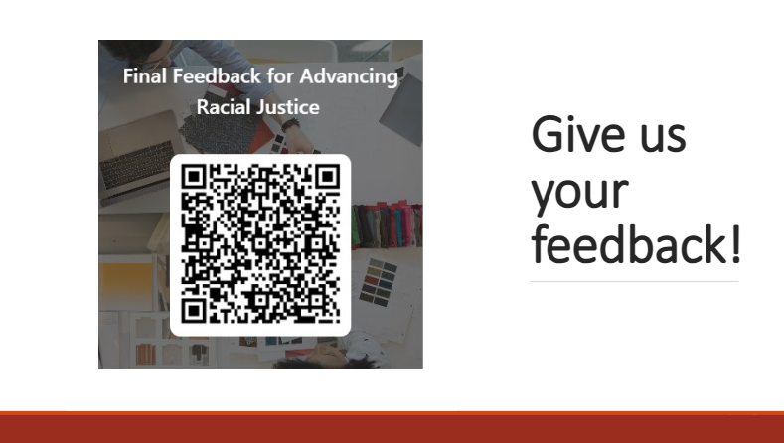  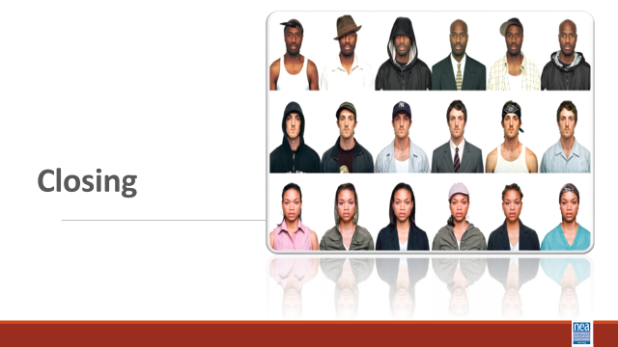  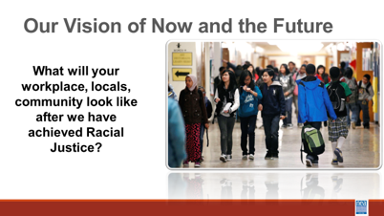  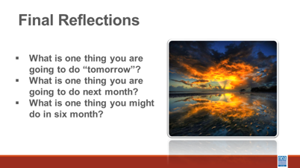  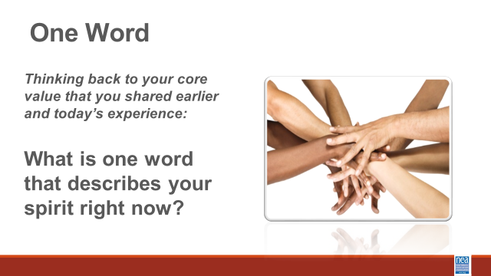 |  |  | Overview of Organizing  5 mins – What would it take to achieve a systemic solution for all of these scenarios?  5 Mins – What or who is preventing you from achieving the solution?  10 MIns- what does NEA focus on – Strength and Growth  Growth is necessary but does not build power  Strength is the abitlty to win and is all about the structures taht build power  There are 3 theories of change  Only organizing builds power  Campaign Lab  Campaign Coach  Closing asks  What will your workplace, locals, community look like after we have achieved Racial Justice?  - What is one thing you are going to do “tomorrow”?  - What is one thing you are going to do next month?  - What is one thing you might do in six months?

Nativism: Does it make sense to include this map: Trump administration to suspend immigrant visa processing for 75 countries | Donald Trump News | Al Jazeera

Remember: break on day 3 is usually embedded in the campaign work. We do not need to build it into the activity. Helps with time which is often short on day 3.
2026—Mosquito video was referenced, not watched. Not because it didn't work (it didn't) but because EVERYONE knows microaggressions. Keep in the image to fly through (no pun intended) and then move on to how to respond. 35-40 minutes is enough time if the activity is explained well. Groups of 3 make more sense.

From Ellen: Shrink the about you stuff. Safe entity is the identity wheel and intersectionality. Racial Anxiety COULD go. Move nativism to day one or day 2...

Then perhaps expressions of oppression. Start with identity... move into identifying terms...levels of racism... then maybe income and wealth then nativism. So do it at the system level—the steps. THen environment.
What could a possible direct action look like for working on these systems if your association worked towards action and change?

Centering equity in the campaign.

If we are going to continue to do mixed spaces, we need to have the staff go in one space and members in another.

If staff-what is your role in this work

Non-violent civil action—women's washroom strike—san antonio pecan pickers

Scott’s video needs fixed.

TImeline of the history of resistance

Check out November campaign lab training...
Greylor’s in charge
Bekah will work on the timeline

