Facilitator Agenda: Advancing Racial Justice 2025 Day #3
General Materials Needed: |  |  |  |  |  |  | Room Set-up:
1 Set of Handouts per Person  Name Tags and Name Tents  Sign-in Sheet  Pens and Pencils |  |  | Chart Paper  Markers  Post its  Index Cards |  |  |  | Round Tables  Projector, Screen and Speakers  Carousel stations and reporting stations around the perimeter  50 people
Key Outcomes for the Day
Understanding the indicators of becoming anti-racist
Understanding what Allyship Is
Applying Learning in a Case Study Format
8:10-8:20 Getting Started  8:20-9:00 Nativism & Immigration  9:00-9:45 Allyship  9:45-10:00 Break  10:00-10:45 Disrupting Microaggressions |  |  |  |  | Jessica  Jessica  Halimah  Shelly | 10:45 – 11:30 Racial Equity Tools  11:30-12:30 Lunch  12:30-2:00 Practicing Becoming Anti-Racist (with built-in 15-minute break)  2:00-2:15 Our Closing  2:15-3:00 Local Closing |  |  | Taraja  Shelly  Jessica  Chris
Time, Slides, Facilitator |  | Resources |  | Instructions, Activity and Debrief (Facilitators) |  |  |  | Outcomes and Essential Questions
 |  | Charts, handouts, articles, materials, slide |  | What are you saying, what are they doing, what questions will you use to guide learning and make clear the important points  Include an estimate for how long each section of the learning will take |  |  |  | As a result of this section, what will participants know or be able to do? What questions will they be able to answer?
8:10-8:20 Jessica |  | 1 hour total - 15 Minutes Greet, Gather & Ground and Entry Activity
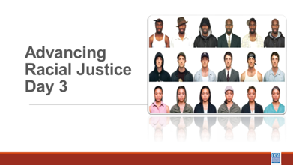  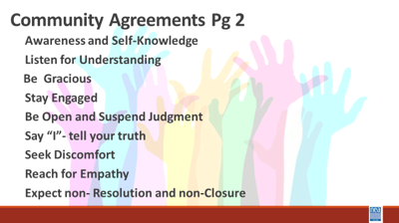  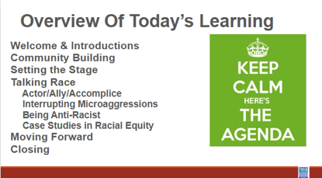 |  |  |  | Welcome,  overview of learning goals,  overview of days agenda, and  revisit community norms. |  |  |  | What have we been learning? What is working and what is not?  What will today look like?
8:20 –9:00 Jessica |  | 40 minutes -- Nativism & Immigration
 |  | What does it mean to be American? |  | 30 Minutes Total - Nativism and Immigration  2 minutes intro and video  One of the “weapons” White Supremacy culture uses to empower racist policies and structures is Nativism, which is the policy of protecting the inhabitants of established inhabitants against those of immigrants.  We’re going to start our conversation by watching a video that explains the racist history of U.S. immigration policies.  Show The Racist History of US Immigration Laws video - 5 min  5 Mins - How does all this intersect with race?  Key Points  - U.S. immigration policies have fluctuated and been shaped by world events and economics  - Anti-immigrant rhetoric and policies are perpetuated by government-endorsed fear of others and of maintaining the country’s white supremacist status quo  5 Mins Let’s look at how nativism shows up in this conversation  Show video from Color of Fear.  Share that thought this video is 20 years old, the same racist nativist views are being used to justify anti-immigration actions and polices today. Ask What did you hear in the video that exemplifies nativism?  15 min Discussion  - What does this mean for our work?  - What does this look like for our students & their families?  Help move the conversation that being anti-racist, we should become allies and accomplishes to work with immigrants and immigrant groups in our communities  1 min: Share “What We Can Do” Slide  Explain this slide contains links which you can use resources. No need to discuss. Just sharing  These links are resources for the group to use but there is no need to go into depth or share beyond this. Leaders can search through this information as needed.  Key Points  - Racial discrimination can be further complicated based on one’s immigration status  - We are living on indigenous land  - European colonizers of this land and their descendants have maintained their dominant status by creating anti-immigrant policies  - We can take action as allies to protect immigrants in our communities and school districts.  Participants will explore the concept of Nativism.
9:00 –9:45 Halimah |  | 45 Minutes Total –Planning and Prepping for Allyship
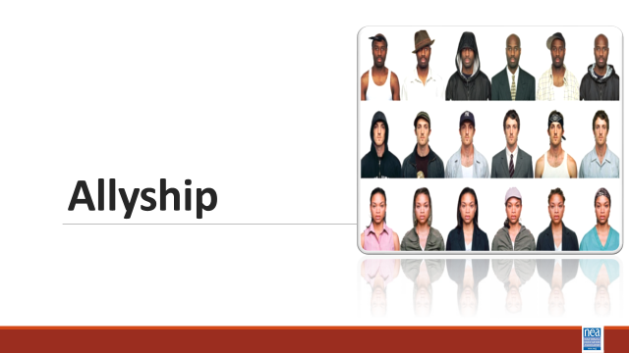  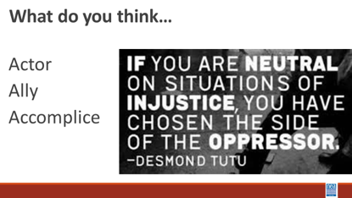  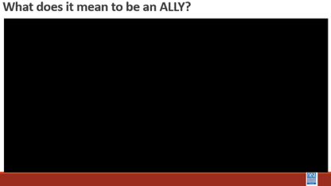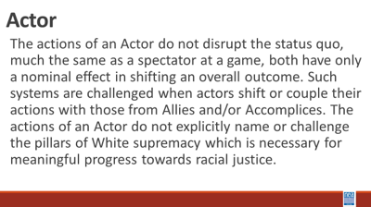  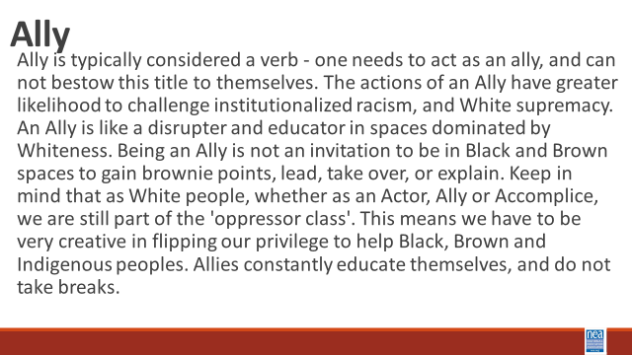  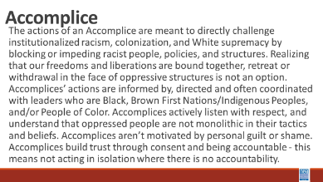  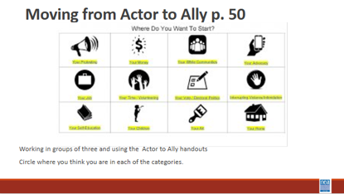  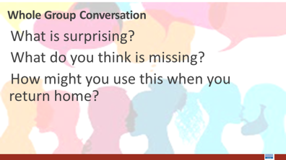 |  | Actor to Ally to Accomplice Chart p. 54  The Action Continuum p.50  So, You Call Yourself an Ally (Additional Resources)  Pre-Attendance  How to be an Ally if you are a person of privilege – section 7  Scaffolded Resources for White Allies  (Additional Resources) |  | 20 Mins intro and definitions –We are going to look at some continuums of growth towards becoming anti-racist. The first we are going to look at is the actor to accomplice. In small groups, let’ do some talking and development of “indicators and definitions” for each of the following - Actor, Ally and Accomplice. They will take 10 minutes to develop their definitions.  10 Mins Discussion and Sharing – Facilitator will take input from the room and THEN share the slide to see what the room added to or missed from the pre-written definitions on our slide –  Share actor definition – discuss how was this similar or different from your thinking.  Show What does it mean to be an ally? Video  Share Ally definition and discuss how this was similar or different from your thinking.  Share Accomplice Definition – Discuss how this was similar or different from your thinking.  15 mins – intro, exploration, and report out – Find the Actor to Accomplice charts- p. 156 Let’s work for 10 minutes on your own, then come together with your triad for about 5 minutes to talk about what you are seeing. - Read the descriptions for Actor, Ally and Accomplice in each of the following categories. Circle the description that best matches where you currently stand- what are you currently doing and THEN Focus on what you might consider doing to move the next column. Give them cues for the 10 minutes on their own and then 5 minutes in small groups. Then open up to whole room  3 Minutes – Share video of 5 things to remember about being an ally and then share the following key ideas - Actor, Ally, Accomplice – it’s a continuum  Authenticity comes from actions not announcements.  7 Mins Whole Group Discussion:  What is surprising?  What do you think is missing?  How might you use this when you return home? |  |  |  | Participants will define and then assess where they currently stand as an Actor, Ally or Accomplice.  How do I support racial justice efforts?
9:45-10:00 |  | BREAK
10:00-10:45 Shelly |  | 45 Minutes - Disrupting Microaggressions
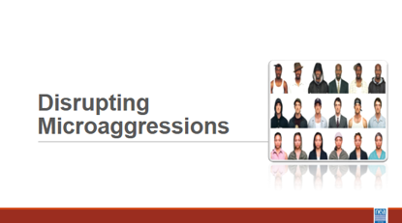  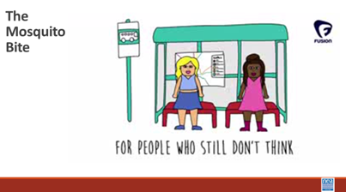    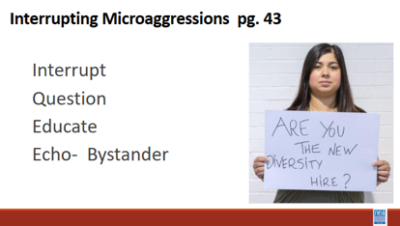  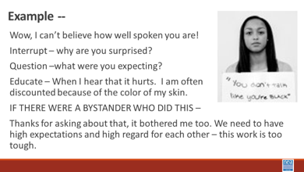  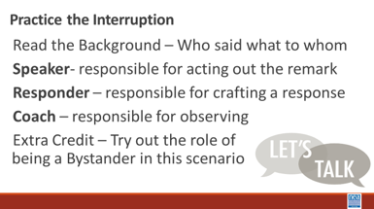  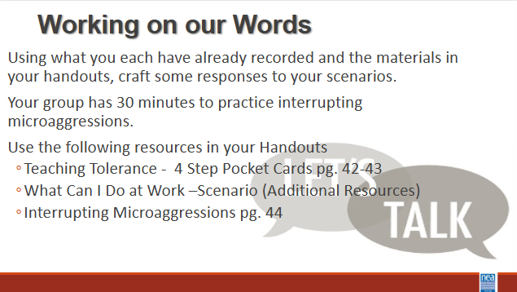  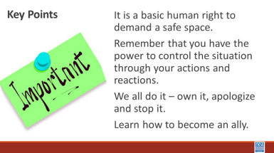 |  | What can I Do at Work?  P Additional Resources  Interrupting Microaggressions pg. 44 |  | 2 Minute Intro – In a bit we are going to be exploring at one of the most prevalent forms of racism – the microaggression. The other most prevalent form of racism is bias. The research around our outward use of and acceptance of microaggressions says that they are the truest indicators of the unrecognized forms of bias we have. Microaggressions are the manifestations of bias.  3 Min video – Show video about how Microaggressions are like mosquito bites (2 minutes)  5 min - Before we get started, take a look at this video, listen: How do you respond to microaggressions? https://youtu.be/C3LFB4mJ0DI  P. 44-45 have some good suggestions for disrupting common types of microaggressions  5 mins – Introduce 4 step method for interrupting some common workplace microaggressions.  Interrupt, question, educate, ECHO if you are a bystander  Example - Wow, I can’t believe how well-spoken you are for an ESP Leader!  - Interrupt – why are you surprised?  - Question –what were you expecting?  - Educate – When I hear that it hurts. I am often  discounted because of the job I have. No one can believe that I have a college degree or that I can read, write, and speak.  - IF THERE WERE A BYSTANDER WHO DID THIS –  - Thanks for asking about that, it bothered me too. We need to have high expectations and high regard for each other – this work is too tough.  30 min - Responding to Microaggressions  Often participants will tell us that they are uncomfortable with addressing microaggressions when they occur because they don’t know what to say. Our next activity will give you the opportunity to practice what to say when you are a victim or witness to a microaggression.  1 min – Directions for Activity: The purpose of our next activity is to practice responding to microaggressions in a way that will ultimately lead to their reduction rather than reinforcement. This is extremely challenging, because it is hard to respond honestly without leading other people to become defensive or hostile.  This activity involves three roles – speaker, responder, and coach and all members should have at least one opportunity to play each role. The speaker is responsible for choosing a scenario (or making one up) and saying the remark that is a microaggression. The responder is given the challenge of responding to the remark in a way that reduces the likelihood of future microaggressions, and the coach is a social observer who provides candid feedback on the strengths and weaknesses of the response.  To get the most out of this exercise, it is important to spend as much time as possible practicing rather than simply discuss microaggression reduction, and the coaches should be as open as possible in their feedback. To begin the exercise, one person should play the role of the speaker, one should play the role of the responder, and the remaining group members should play the role of the coaches. Let the conversation build for a minute or so before the remark is made, and let it continue for a while after the response is given. Once the speaker and responder have concluded their interaction, the coaches should critique the response, and the roles should be rotated for another practice round with a new speaker and responder. Do not worry about getting through all the scenarios or adhering precisely to the scripted comments – the scenarios are simply designed as icebreakers to facilitate the activity.  20 min to work through scenarios in groups of 4. Facilitators will visit each of the groups to make certain that you are spending your time role playing and not holding a discussion. This is a time to practice so that you WILL know what to say.  We will now divide into four (4) person groups. All group members should play each of the roles at least once, and that speaker should choose a new scenario with each rotation.  7 Scenarios  #1  Speaker: Union Membership Chairperson  Responder: UniServ Director  Background: New Member Orientation meeting where the UniServ Director has been asked to speak. You observe the membership chair ask a potential member the question.  Comment: “What are you? Where are you really from?”  #2  Speaker: Participant in a training session  Responder: Workshop Facilitator  Background: Break time during the training session and the participant comes over to talk about how great the training is so far.  Comment: “Someone asking to touch your hair because it is exotic.  #3  Speaker: A high school student  Responder: A teacher  Background: Comment was overheard during after-school study hall  Comment: “You must be good in math; can you help me with this problem.”  #4  Speaker: Your best friend’s co-worker  Responder: A white bystander  Background: Comment was made by friend of a friend at happy hour.  Comment: “How do Black people feel about affirmative action?”  #4-a  Speaker: A fellow colleague  Responder: UniServ Director on the job for 5 years  Background: Comment was made during lunch time with several people at the table.  Comment: “Of course she’ll get the promotion, she’s a minority.”  #5  Speaker: Union member  Responder: Union President  Background: Union member approached officer at the end of general membership meeting  Comment: Being told you speak English well when it is your first language.  #6  Speaker: A middle-aged woman  Responder: Black woman  Background: Slightly busy hotel lobby with several people in line waiting to check in  Comment: Being mistaken for someone in a service role.  #7  Speaker: A middle-aged uncle  Responder: A family member  Background: Comment was made during a family dinner in which the conversation turned to the topic of LGBTQ+ rights.  Comment: “All that lesbians need is a good-looking man to convert them.”  5 min - Report out on which responses were most effective, and which strategies might minimize resistance on the part of the “mosquito”.  Facilitator Note: The Suggested strategies we are looking for in report out are below. If the groups do not come up with them on their own, then share with the group.  - Use questions such as “Why do you say that?” and “Do you feel that way about every person in that group?”  - Point out the difference between what the speaker said and how they behave or believe about themselves, “I’ve always thought of you as someone who is very open-minded”  - Tell the other person how you feel (it makes me uncomfortable to hear that) – it is a statement that cannot be refuted  - Approach the person with respect rather than indignation  Debrief questions:  Is the most effective response an immediate one, or is it better to wait?  Are public responses more effective than private responses?  Are there situations in which it is best to not respond?  1 min -Key Points:  It is a basic human right to demand a safe space.  Remember that you have the power to control the situation through your actions and reactions.  Need more time for practice, spend less on set up.  Apology slide and how to do it is missing.  Debrief slide is missing.  Perhaps think about refreshing a bit—more interaction if the set up isn’t shortened. We always think we can do this quickly. We can’t--but it is worth it because they NEED the practice. Share out of plans was INCREDIBLE. |  |  |  | Participants will understand the link to bias and microaggression.  Participants will practice interrupting microaggressions using a 4-step process.  How do I begin to interrupt the cycle of racism in my everyday work?
 | BREAK
10:45-11:30 Taraja |  | 45 Minutes Racial Equity Tools
30 Minutes – Group Work with Continuum for Becoming an Anti-Racist Organization (2-min intro)

– Take 2 minutes to introduce this tool – it is a way to BEGIN a conversation in an organization.

This exact tool has been used in several places – a group of non-profits including the area NEA affiliates used this at one time to develop a stakeholder-wide approach to becoming anti-racist.

Steps:

- Take 10 minutes on your own first to look at each column and circle the indicators of where YOUR school district currently is.
- Take the next 15 minutes to talk as a group about what this means
  - The column in which you circle the greatest number of indicators is the column that YOU think the organization is currently operating – others might have a different perspective. Share your findings with your group and be ready for a short share out.

Whole Room Discussion
What did you find?
Do you think that there would be different “ratings” from others in your organization?
What might cause those differences?

2 Minutes – Key Points
Racial Equity is something that has to be intentionally and explicitly planned for, implemented and monitored within an organization.
You cannot move forward as an organization without honestly and openly assessing where you are.
Change happens, intentional change happens with a plan.

11:30-12:30 |  | Lunch
12:30-2:00 Shelly |  | 90 Minutes -Practicing Becoming Anti-racist - Case Studies in Racial Equity  75 minutes plus a folks need to build in their own break
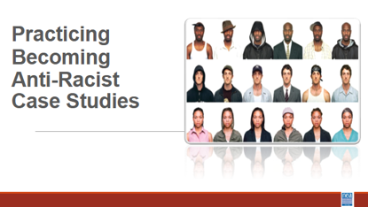  Picture  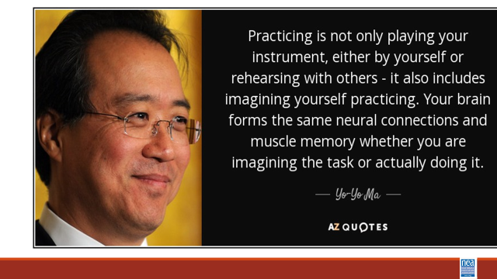  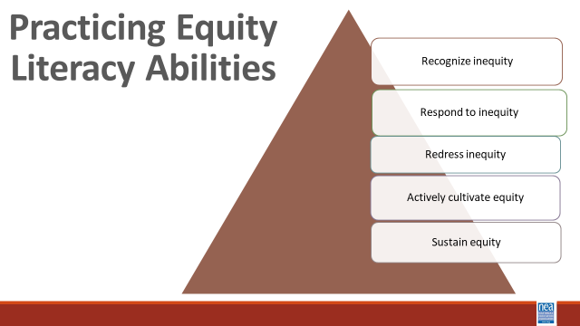  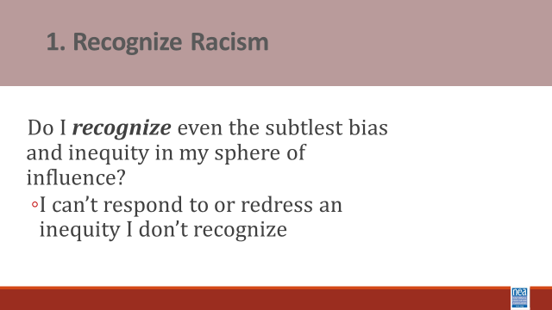  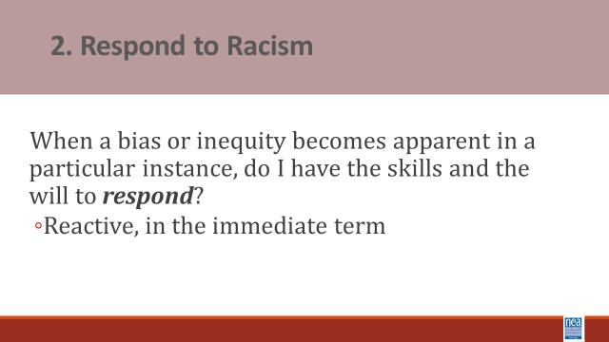  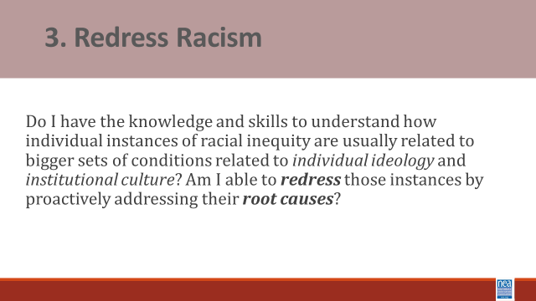  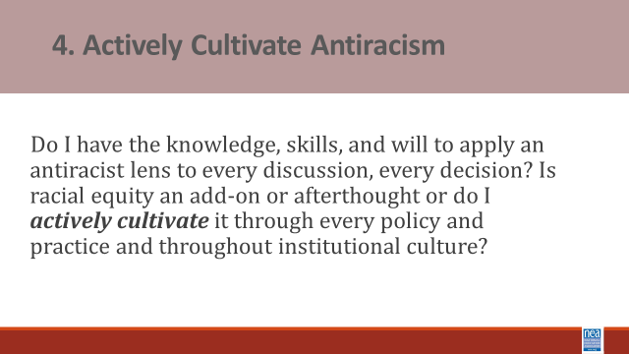  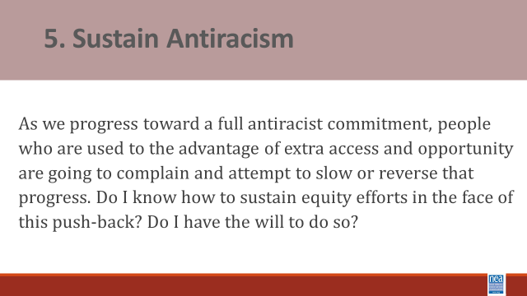  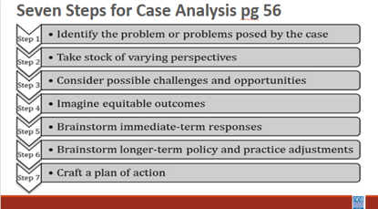  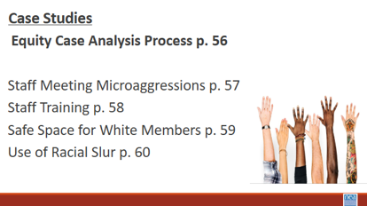   |  | Case studies framework  Case Studies |  | 10 mins Introduction and Content Sharing of what case studies are and the 5 abilities we are working to cultivate - The case method enables us to practice stepping through a process of considering a range of perspectives and angles, to practice seeing the full complexity of school and classroom situations, and as a result to consider a more focused manner in how we might respond.  Cases do not have ONE correct answer or obvious solution. We learn to think carefully, to listen to the points made by others and to evaluate those arguments, to review alternative courses of action and their efficacy, and to interpret real-world experience.  The case method provides opportunities to bolster our abilities to think, teach, lead, and advocate more equitably and justly.  Equity literacy refers to the knowledge and skills we need as educators to be a threat to the existence of bias and inequity in our spheres of influence. It refers to the knowledge and skills that prepare us to root bias and inequity of our classrooms, schools and communities.  Case studies allow us to practice what Paul Gorski of the Due East Educational Equity Collaborative calls the Equity Literacy abilities:  The purpose of the 5 abilities is to  - allow us to apply a strong equity lens to everything we do; and  - they provide an outline for what the thrust of equity professional learning ought to focus on important abilities:  - The ability to recognize even the subtlest bias and inequities. Equity literate people notice even subtle bias in classroom materials, classrooms interactions and school policies and they reject deficit views that associate outcome inequalities (test scores, graduation rates) with students’ “mindsets” or “cultures” rather than disparate levels of access to resources and experiences in and out of school.  - The ability to respond to biases and inequities in the immediate term. Equity literate people have facilitation skills and content knowledge needed to interview effectively when biases or inequities arise in classrooms, faculty meetings and other contexts. They also foster conversations with colleagues about bias and inequity concerns at their schools.  - The ability to redress biases and inequities in the long term. Equity literate people advocate against inequitable school practices and identify ways to mitigate structural barriers that impede educational engagement.  - The ability to actively cultivate and sustain a bias-free and equitable school environment. Equity literate people express high expectations for all people and demonstrate a willingness to withstand complaints about changes meant to redistribute educational access and opportunity more equitably.  10 Mins intro to - Seven Steps Script and Group Process - These case studies can be viewed through the following perspective – we often must help the people in our locals to problem solve around difficult issues. These cases allow us to practice the coaching, questioning, and problem solving we might use with those people. This is a process to help you practice using your unique insights, your knowledge about public schools, and our expertise with school and classroom dynamics in order to respond as effectively and equitably as possible, to the types of bias and inequities that inevitable crop up our schools.  We go through these exercises as a group because it is important to reflect upon why people with different combinations of identities and life experiences might interpret the cases differently.  Step 1 – Many biases and inequities students face in school are implicit and unintentional, hidden in day-to-day practices, school traditions, and quiet interactions. It can be especially difficult to recognize the sorts of challenges students or families face when you have never faced those challenges yourself. During this step, I urge you to read between the lines. Practice recognizing conditions and contexts you might not usually recognize or seeing what you might be conditioned not to see. Begin by naming biases, inequities, or otherwise troublesome conditions that are immediately apparent to you. Once you have a grasp of the more surface level dynamics, dig deeper. Look for less explicit, not so obvious examples of existing or potential bias, inequity, stereotypes or presumptions.  Ask yourself: What does the case tell us about school or classroom policy, about instructional or leadership practices, about individuals’ attitudes and perspectives that might hint at something deeper than surface-level biases and inequities?  Step 2 – The cases have at least a couple of obvious stakeholders who might have different perspectives on what is happening. In every case, we should consider not only the people immediately involved, but also those within earshot and eyeshot.  Start with the immediate participants and then, at the very least, the ring of constituents around them.  Focus on marginalized communities and privileged communities.  Then take it one step further. What if something was shared on social media – you have to consider the perspective of someone seeing this on SnapChat.  Step 3 – Our next task is to identify potential challenges and opportunities present by the situation. Start with the individuals involved. Remember to use your analysis from Steps 1 and 2 to inform your assessment of challenges and opportunities.  Step 4 – Building on the understandings we have gained by talking stock of stakeholders’ perspectives and considering possible challenges and opportunities, we begin imagining positive and equitable outcomes. [take time to clarify difference between equity (fair) and equality (same)].  Remember to think both immediate term and long term. What can be resolved right now, on the spot, and what will equity look like once it is resolved? Consider long-term outcomes as well. And finally, be specific – identify very specific, on-the-ground outcomes, how specifically will things be different in the school or classroom if we commit to resolving the issue and all its nuances equitably?  Step 5 – We begin brainstorming strategies to get us there.  Step 6 – We develop longer term strategies often for more substantive change. Record whatever ideas come to mind.  Step 7 – During our final step, we craft our brainstorms into specific actions we believe will result in the equitable outcomes we outlined in step 5 –  - What would we do in the immediate terms?  - What would we do that might a little longer term equity project?  - How would we respond to ensure, to the best of our knowledge and power, justice for everybody involved?  In summary, the point is not to memorize these steps or to step through them carefully in every instance, rather the ideas is to use them to practice our equity literacy skills by reflecting on classroom and school conditions through a social justice lens.  30 Minutes – Teams will work on assigned cases and be prepared to share their findings.  30 Minutes – Group Reporting and Discussion |  |  |  | Participants will practice identification of bias, response to bias, redress structural reasons, and plan active cultivation of anti-racist practices through a 7 step case study process.  How do we practice our learning so we can coach our locals through anti-racist work?
2:00-2:15 Jessica |  | 15 Minutes Total - Closing
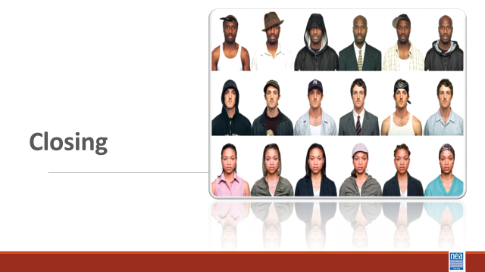  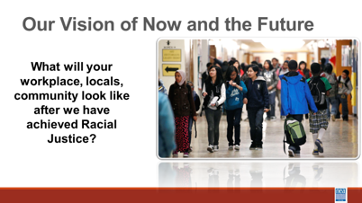  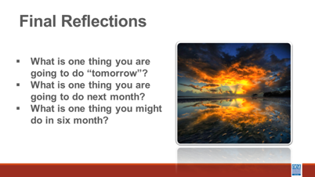 |  |  |  | What will your workplace, locals, community look like after we have achieved Racial Justice?  - What is one thing you are going to do “tomorrow”?  - What is one of your school or District policies/practices that feels like the “water” you swim in that needs changing?  - Who is one person that can support you in moving this work forward?  - What is one relevant question you still have and want to explore?
2:15-3:00 | Jessica Closing

