Facilitator Agenda: Day 3 Coaching Campaign Cycles (WITH LEADS)
General Materials Needed: |  |  |  | Room Set-up: 50 people max
1 Set of Handouts per Person  Name Tents with the Norms  Room signs, Stick on Name Tags  Chart Paper (4 to 5 full w Sticky Strip) |  | Materials Box for each table with:  Markers (Mr. Sketch variety)  Post its – 3x3” and 4X5” sizes  One ream of white photocopy paper |  | No podium, table with projector big enough for laptop  Long Rectangle table at back for facilitators  Round Tables for participants  Projector, Screen, mics, and Speakers  Carousel stations and reporting stations
Key Outcomes for the Event:
Participants will understand a high level overview of the purpose of the Campaign Lab
Participants will understand that Leads, Coaches, and Campaign Coaches all have different roles in the Campaign Lab
Coaches and Mentor Coaches will understand each step of a homogeneous campaign cycle
Coaches and Mentor Coaches will be able to identify possible challenges for each stage of the cycle and develop coaching questions
Coaches and Mentor Coaches will apply coaching practices for leads that allow them the agency to design, implement, troubleshoot, and measure progress of each part of the campaign cycle.
Team Leads will understand how to introduce and lead their organizing teams through each step of a homogenous campaign cycle
Team Leads will dig deeply into how to build an organizing team, identify a theory of change, and cut an issue
Team Leads will learn how to calculate the people needed to achieve the demands of their campaign cycle
Team Leads will be introduced to power analysis, strategy, and design of tactic escalation

Overview of Content, Time, and Facilitator Assignment
8:30-9:15 Entry and Welcome  Coaches will serve as table facilitators  9:15-10:30 Campaign Lab  Why and structure  Levels of Campaigns  Cohorting (what do you want to learn)  Q&A  What issues do we face?’  Bigger Vision/Picture BCG and May Day  10:30-10:45 Break  10:45am- 11:30 Centering Equity  (when you write your content include an intentional role for the coach to facilitate)  11:30am-12:00pm Organizing around Issues  Asking the why?  Forming our demands  Lunch – 12:00-1:00  1:00- 1:45 Leadership Team -Distributed leadership, Team development roles, norms, purpose, Task design (when you write your content include an intentional role for the coach to facilitate)  1:45-2:00 RELATIONSHIPS AND ROLES (Ellen and Albert) | Ellen  Albert and Ellen  Amanda/ Carrie  Amanda/ Carrie  Ellen/ Albert  Amanda /Zac  Ellen / Halimah |  | 2:00 – 3:15  Targets and Demands  Power Analysis of Target  (when you write your content include an intentional role for the coach to facilitate)  Include Break  3:15-4:15 Theory of Change - mention  What is Strategy  Tactics  Timeline, Compression Points  (when you write your content include an intentional role for the coach to facilitate)  4:15 – 4:30  What is the opportunity to dream bigger  Reflection  Discussion  4:30 -5:00 Adult Choice Networking  5:00 Adjourn |  | Zac /Amanda  Zac /Amanda  Carrie/
Time Slides Facilitator | Resources | Instructions, Activity and Debrief (Facilitator Script) | Essential Questions and Outcomes
 | Charts, handouts, articles, materials, slide | What are you saying, what are they doing, what questions will you use to guide learning and make clear the important points  Include an estimate for how long each section of the learning will take | What question(s) will this learning answer? What will participants know or be able to do?
7:00 -8:30 – Team prep, practice, room set up, sound check, etc.

8:30 -9:15 Ellen |  | 45 Mins TOTAL Getting Started
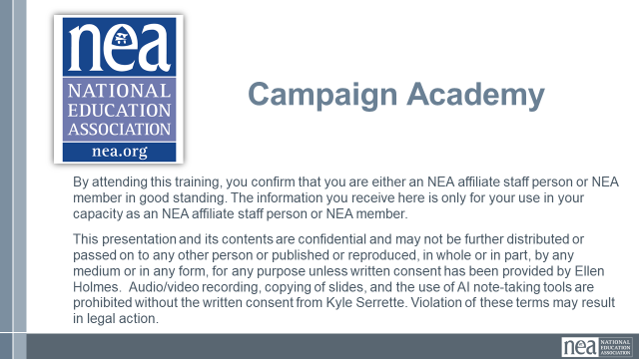  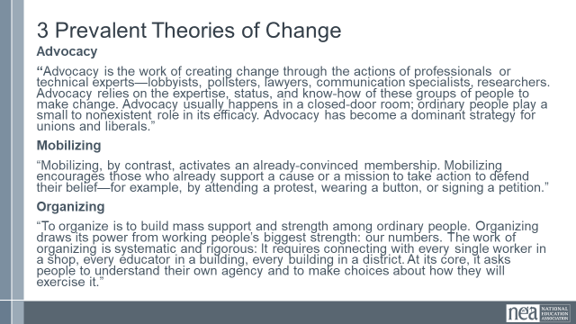  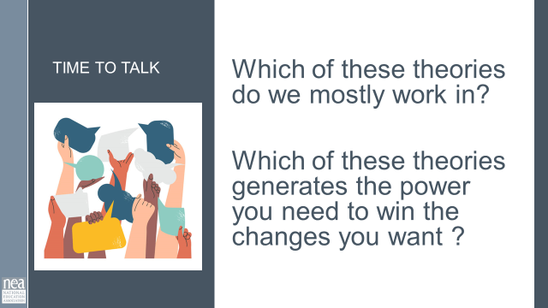  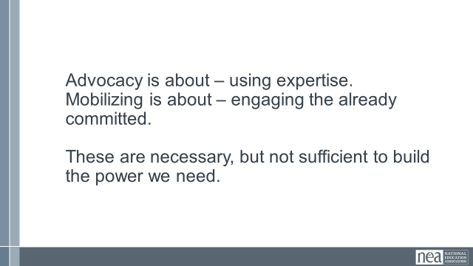  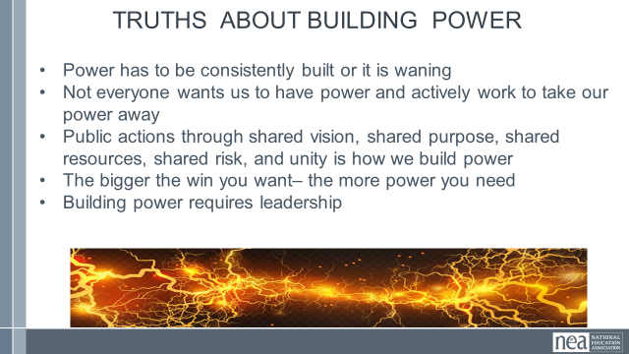  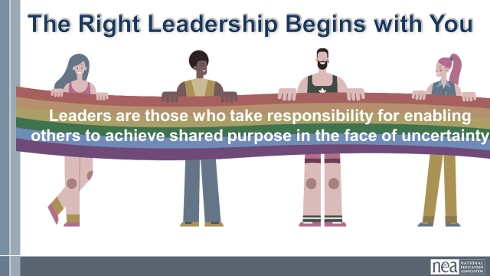  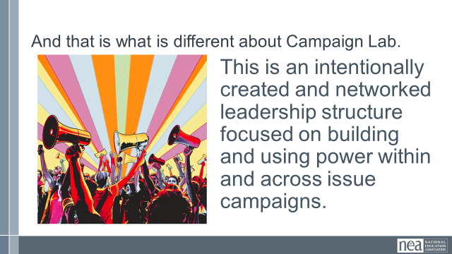  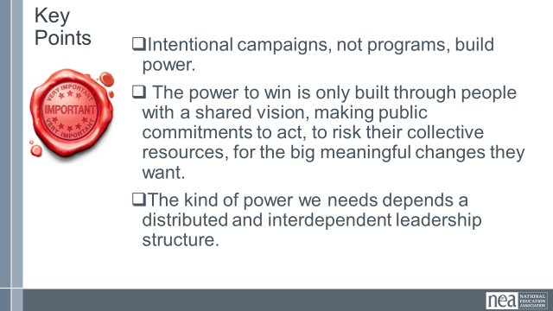 | Norms in Handouts  Agenda on Slides  Parking Lot Chart  Name Tents  Handout Package | 2 Minutes Welcome – basic intro and reading of the confirmation of membership  2 Minutes Land Acknowledgement  We begin by acknowledging that through a history of colonization and brutality, we are currently on the traditional lands stewarded by generations of the Indigenous people(BE SPECIFIC TO AREA). We honor these indigenous people, all elders, past, present, and emerging. We are called to learn and share these learnings about this tribal history, culture, and contributions that have been suppressed in the telling of the story of what we now call the United States of America  .  5 Minutes Outcomes and Agenda Overview  Review Agenda reminder about meals, Karla for Logistics, etc.  5 Minutes – Shout out from your team and around the room -  Very quick and simple name, pronouns, and work location  10 Minutes – Community Agreements  Take 5 minutes and Review the agreements from your pre attendance – at your tables discuss how you answered the final three questions. Return as a whole group and ask what needs to be added, changed, highlighted, etc. Then take a thumbs up, side, or down – looking for near concensus – the goal, all up or sideways thumbs.  Up, Completely agree as is  Sideways, Can commit, not perfect, but I am confident we can revisit if this is not working  Down, I am not yet ready to commit and this is what I need more discussion about….  20 Minutes - What makes the Campaign Lab different?  1 Minutes Introduce - In your Pre Attendance Pack you were asked to read Three Theories of change. These theories out lined in that are - Advocacy Mobilizing Organizing.  5 minutes Talk -Give participants time to discuss  Which of these theories do we mostly work in?  Which of these theories generates the power you need to win the changes you want ?  .  1 Minutes – key ideas –  Advocacy is about – using expertise.  Mobilizing is about – engaging the already committed.  These are necessary, but not sufficient to build the power we need.  Organizing is about continuously building a bigger and bigger base of people that want to share their resources to win a shared goal. They are building their power to use it.  5 Minutes total – in Power  Definition of power  - Power is the ability to create, control, and prevent change.  - Power is made up of organized people and organized resources  - Power is not static, it is either growing or waning.  Understanding Power  Power is neutral. Power is simply the ability to make change. Society has biased our beliefs and feelings about who should have and how they should use power – but ultimately power is neutral – we bring all our feels and biases to that.  Our values affect the way we use power. If we are in relationship with people with a certain set of values we would find it easier to risk our resources and personal agency to advance an agenda based on our shared values. Power of the people is always grounded in our values and relationships.  Truths About Building Power  - Power has to be consistently built or it is waning  - Not everyone wants us to have power and will actively work to take our power away  - Public actions through shared vision, shared purpose, shared resources, shared risk, and unity is how we build power  - The bigger the win – the more power you need  - Building power requires leadership  Moving to another lane starts with you  5 Minutes on Leaders  Leaders who try to do everything for everyone set themselves up to be THE single point of power and when they leave the structure falls apart. Leaders who ONLY work with “the already willing” only continue the status quo – to grow you have to continually reach out and include others – invite them to do something not simply come to something you have developed- Leaders who are organizing are constantly making room for new people and allowing them to lead – taking in new ideas and building new work together. In your reading about Ella Baker – we are following her tradition of Group Centered Leadership.  The campaign lab is built on the principles of coaching that the mentor coaches and coaches worked on before you arrived. Their goal is to help team leads become Campaigners – they are constantly making room for new people and allowing them to lead and build new work together  Do a conversational piece here – What does this definition of campaigns mean to you in your roles in the Campaign Lab  1 Minute Defining Campaigns  Campaigns are defined as the following (From Marshall Ganz) A campaign is a process through which your constituency can organize itself to create the power it needs to accomplish goals that will achieve the change they need. And turning their campaign into an organization gives them access to the capacity to build on their successes into the future. When you focused portions in the Pre Attendance from Three Theories, the Taking Stock Report, Justice for All, and the Chapter from Practical Radicals, all indicate that it is only through well constructed, well networked, campaigns that we can generate the power we need.  *Collective action.  2 Minutes – That is the Campaign Lab  And that is how the campaign lab is different.  This is an intentionally created and networked leadership structure focused on building and using power within and across issue campaigns.  Key Points  Intentional campaigns, not programs, build power.  The power to win is only built through people with a shared vision, making public commitments to act, to risk their collective resources, for the big meaningful changes they want.  The kind of power we needs depends a distributed and interdependent leadership structure. | Participants will know how we are going to work, the basic schedule, and the logistics relevant to the training.  Participants will be introduced to the theory of the Campaign Lab.
9:15- 10:30 Amanda/Carrie |  | 75 Mins TOTAL – Campaign Lab/Meeting the Moment
 |  | Amanda 2 Intro – As part of the intro – make sure you can inoculate the room about the beliefs between what is a union and what is an association) Amanda  15 minutes - Getting to Know each other Mixer  Participants will get up and find someone you have not talked to and discuss the following -  - Who has shown the power of their union to their school board or trustees? This could be a vote, a strike, a rally, a petition?  - Who has brought the issues of the community or students into their union work?  - Who has advocated for change as a union or coalition with elected officials?  5 minutes - Whole Room Report out of what you heard in your conversation  Amanda 20 Minutes – Affinity Wall Process  If your school community could have three things right now what would they be?  Write these on separate post notes- take these and put them on the wall, the group organizes these into themes and names the themes.  Whole group discussion what do we see?  Carrie- 5 Minutes – Overview of the Campaign Lab  That is why we are here together, working in a way that is really different than we are used to.  How does Campaign Lab Work? (slide) Campaign Lab has growing capacity and vision for what we can build together.  - ^{COACHING}  - ^{PEER LEARNING}  - ^{TRAINING}  - ^{NETWORKING}  - ^{COLLABORATION}  - ^{POWER-BUILDING}  Show the structure of the Lab and talk through each part  25 Minutes - Learning Activity - Carrie  Two butcher paper:  One will be labeled “What you bring” and one will be labeled “what you want to learn or connect with”  Participants will write their answers and names and put them on the the butcher paper. Take a moment to ask that everyone do the survey if you haven’t yet.  Debrief-  What are the organizing, campaign or advocacy skills, vision, commitment and/or experience you bring with you to Campaign Lab that you feel you could share with others?  Networking through Campaign Lab:  What people do you want to connect with, learn from and organize with? We don't mean names – but rather types of folks. Could be people from the south, folks doing school board elections, people who want to figure out a kind of strategy – like protecting LGBTQ or immigrant students – or how to prepare for a strike?  Key Points -  - The peer network is what makes Campaign Lab work.  - All of you are here to learn; All of you have something to share.  - We are up against a bigger fight than any of us can face on our own, so we need each other.  - To sustain movements across time, we have to continually support and grow with each other. | Participants will begin to dream about the possibilities that organizing and networking can provide.  Participants will develop an understanding that they have resources and capacity to share with each other.
10:30- 10:45 BREAK
10:45-11:30 Ellen and Albert |  | 45 Mins TOTAL Centering Equity
Albert  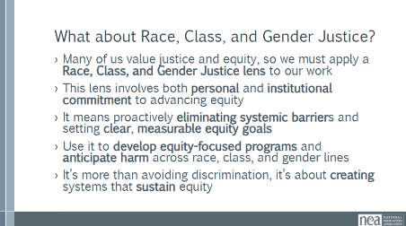  Ellen  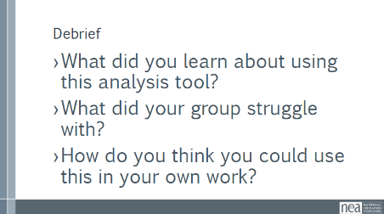  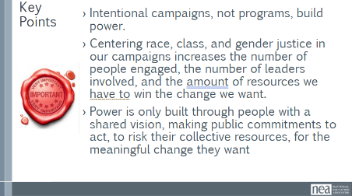 | Pre Attendance  1 Ella Baker Leadership.pdf  1.01 Centering Equity in your Campaigns.docx  Handouts  2 CRSJ Centering Race.pdf  5 Campaign Cycle Planning Workbook.pdf  In additional Resources  1.020 Cycle of Socialization Handout.pdf  1.021 Socialization Reflection Activity.pdf  1.022 Cycle-of-Liberation.pdf | Sitting in your teams (mentor coach, campaign coach, team lead[s]) is the most ideal set up  pg. 30 in Participant Handouts and pg. 3 in the Campaign Cycle Planning Tool  Albert  2-minute Turn and Talk - What will it take to achieve equity for the people who work and learn on our campuses/worksites?  3 minutes – Union Work that Builds Power  For all of those things, to make meaningful lasting STRUCTURAL change we need power. Power is defined as that ability to create, control, and prevent change. That typically means organized people and organized money or resources – your work is a resource.  What type of union builds power?  Programs, such as professional learning, staff led advocacy, social focused events, even policy advocacy do little to build power.  Why is that?  Well all of these programs are self-selected with little risk to join or leave them. I want to improve my classroom management, so I come to the Union led training on that. I might even lead one – but I have done little to build power with others. Also in a program, I am choosing to solve a “me” Problem and it does not require any other collective commitment.  Campaigns put people at the center of solving the problems they are experiencing. They name the issue, they decide the solution, they decide who they follow, and they determine what the are willing to risk. When we center people in a campaign – staff move to a coaching role. When people are at the center they use their agency and decide how to act, who they will act with, and what they are willing to risk to win. This is when members and leaders feel powerful in their union.  To begin a campaign you have to ask what the people want to solve, ask what they are willing to risk to solve that, and form demands that they think will provided the solution to their problem.  3 minutes – What about Race, Class, and Gender Justice?  - Potential quotes to frame this conversation: In 2001 when Reverand Al Sharpton was considering running for president in 2004 he said the following:  - “...to seriously look at a strategy that would lead toward making sure the unheard and the unnoticed are both heard and paid attention to.”  - “There are those in the Democratic Party who have driven the party further and further to the right in the name of a winning strategy,” Sharpton said. “And it seems that it is their presumption that the only way to be electable is that progressive forces and people of color must voluntarily turn into invisible people.”  - Often, we invite people to engage with your campaign that show up in the ways that you are typically in agreement with. This perpetuates the “invisible people” Sharpton references. Imagine your campaign if every person impacted was truly invited to be engaged and involved.  - We often say we value justice and that equity is central to our work. But values alone aren’t enough. To live them out, we have to use a Race, Class, and Gender Justice lens, something that helps us systematically examine and transform our actions and structures.  - This isn’t a box to check; it’s a deep commitment. It means we, as individuals and institutions, take responsibility to advance equity through intentional strategies, not just good intentions."  - Equity work isn’t vague. We need to identify and remove barriers, but also define clear goals, objectives, and outcomes. Otherwise, we won’t know if we’re actually making progress.  - We must design programs with mechanisms for success. And we should be using guiding questions to predict and prevent harm across marginalized groups. These tools help us avoid unintended consequences.  - Equity isn’t just about what we eliminate; it’s also about what we build. Race, class, and gender justice means putting systems in place that deliberately create and protect fairness, inclusion, and opportunity for all.  22 Minutes TOTAL – Group Practice – Applying a race, class, and gender lens to your campaign - Ellen  2 minutes intro  On page 3 of the Campaign Planning Workbook, you will see a Centering Equity tool. To engage in a systems analysis of race, class, and gender issues and develop solutions or to assess if the campaign centers equity. These questions focus on reflection and building bigger, bolder movements together.  • Problems: What inequities are you noticing or experiencing? What are the impacts on different racial groups? Who benefits most  and who is hurt most?  • Causes: What institutions, policies, or practices are causing or contributing to the inequities? What social norms, popular myths, or cultural biases may be contributing?  • History: How did things get this way and are things worsening or improving?  • Solutions: What solutions could address the root causes and eliminate the inequities? How would different racial groups be impacted by the  proposed solutions?  • Strategies: What strategies and actions could be used to advance the solutions?  • Leadership: Who are the stakeholders most affected by the inequities? Are they involved in naming the issues and solutions? What kinds of active leadership roles could they take to advance the proposed solution?  • Additional Equity Tools: Who is most directly impacted? Who has been left out? How can they be directly engaged? How do our demands center race, class, and gender justice?  Group Work – Applying Your Learning – (20 minutes)  As a group (ideally mentor coach, campaign coach, team lead[s]) take a moment reflecting on these questions and what answers surface as it relates to your campaigns. Mentor and Campaign Coaches, this is a great opportunity to coach with the three frames (head, heart, hand ) that we previously discussed and practiced.  ---  10 Minutes – Debrief Resources and Key Points  What did you learn about using this analysis tool?  What did your group struggle with?  How do you think you could use this in your own work?  What is a good coaching question you were asked that shifted your thinking?  5 minute - Key Points-  - Intentional campaigns, not programs, build power.  - Centering race, class, and gender justice in our campaigns increases the number of people engaged, the number of leaders involved, and the amount of resources we have to win the change we want.  - Power is only built through people with a shared vision, making public commitments to act, to risk their collective resources, for the meaningful change they want. | Participants will review the conditions for centering equity in their campaigns and process that supports them in that work.  Team Leads and Coaches will assess what next steps might be to move locals and plans along a continuum.
11:30 -12:00 Amanda and Zac |  | 30 Mins – Organizing Around Issues
 | Problem to Issue worksheets and analysis  5 Campaign Cycle Planning Workbook.pdf  3 Problem to Issue Analysis.pdf | This is very tight – doable, but tight – at 30 min.  5 Minutes PROBLEM , ISSUES and Values  Campaigns start with issues that people have value-based solidarity around.  An issue is a slice of a workplace problem.  Often a problem can have different issues depending on the perspective of the people we are working with.  It is KEY to get enough input on what the issues are that make up the problem so that YOU do not drive the solution.  For example, A problem My Car is a piece of JUNK --- Issues – broken radiator hose, bad brakes, smelly interior, hole in the muffler.  Investigating the issue is necessary but not sufficient – we also need to identify workers’ SHARED values – WHY is this an issue? WHY do you want to fix this?  Values are fundamental beliefs that dictate behavior  Ideally, Unions advance the welfare of all members.  They are based on the universal ideal of human rights, the idea of justice, progress, and betterment of self and of society.  Through shared values, members build solidarity and commit to active participation in the labor movement.  Shared values transform individual members into part of something larger than themselves.  For my example, my car has bad brakes and that is a safety issue. Everyone on the road deserves to have safe transportation.  I want to be safe and I want others to be safe – they likely share that value and interest.  Key Ideas  Problems are big conditions that have several smaller solutions  - Issues are the components that make up the problem  - Issues indicate a path to action  - Values build a relatable why across people experiencing the pain of the problem  - We intentionally work to connect people around issues and values to build Solidarity  10 Minutes - Cutting our Problems into Issues  Page  (5 min step 1)  First, on your chart paper, you’re going to brainstorm the BIG problems facing you and your colleagues. These don’t have to be just what you’re working on right now.  As you add problems to the chart, think about what values move you to work on these problems – why are they problems? What values are being challenged, ignored, violated?  Leave space to add infromation about issues – that will come next.  (5 min step 2)  Using the charts you made as we started pick one of your big problems and think about the issues that might be built into that.  Example Problem – We want quality health care for everyone  Values behind wanting to fix this – equity, fairness, dignity  Possible Issues –  Not enough providers in our rural system  benefits don’t cover specialists  Drugs are not sourced in ways that make them affordable  No coverage for home health options  10 Minutes -Assessing Our Issues  2-3 minutes on content, 10 minutes on group work - 2-3 minutes on report out.  So how can we determine – assess what issues make the best organizing issues. We can work them through a couple of processes. Using these processes with them keeps us from taking over and allows for leadership development opportunities. They build their confidence and trust and solidarity through a shared process.  Issue criteria checklist, page  At the very least a good issue  - It is widely felt and/or deeply felt.  - The pain can be felt by just one, but the injustice of that pain is shared by many.  - The pain AND the injustice of that pain is felt by many.  - It is winnable.  - It builds their union and builds leaders.  - It has a values-based connection to our workers, students, and the public.  Using the issues you charted at the beginning of this section about issues – Spend just a few minutes using the simplified screener from Labor Notes – and see how it would allow you to screen out issues that might not be good for Organizing.  CIRCLE those that you think meet the criteria. CROSS OUT those that don’t meet the criteria.  5 Minutes Report out - what did you find? Why did you keep the issues you kept? Why did you eliminate issues? (if it doesn’t come out, reemphasize the earlier Key Point – Not every issue is an organizing issue) | Participants will understand how to lead the process of problem to issue identification, cutting, and assessment.  Team Leads and Coaches will assess what next steps might be if locals have not done this.
12:00 - 1:00 LUNCH
1:00 – 1:45 Ellen and Halimah |  | 45 Mins Total – Leadership Team and Relationship and Roles
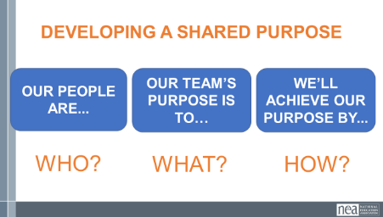  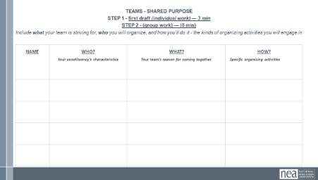  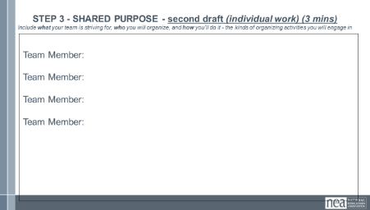 | Team Purpose  Team Roles  Team Community Agreements  5 Campaign Cycle Planning Workbook.pdf  3 Creating Leadership Teams.pdf | 5 Minutes Review and content –  Team leads, coaches, and mentor coaches all need to know how to set up effective leadership teams. Even if you have have been “teaming” for a while it is never too late to reflect, revise, and reset. If you find that you have been doing everything yourself, likely you need to do a reset on your leadership team.  Effective Teams Content  When looking at effective teams, we should be paying attention to the conditions that make a great team, the steps to get there, and the measures that help us know we got there  Let’s start with the measures of an effective team  MEASURES  - GOALS: A good team has goals AND takes action together to achieve the goal and effect the change they want to see.  - CAPACITY: An effective team also builds capacity. Learns how to work together and how to develop new leadership to replace them when their gone.  - LEARNING: Lastly, an effective team also includes a learning component. One way to know if your team is effective is if you walk away with a new skill or perspective on how to do the work.  CONDITIONS  - Your team is bounded. You can name the people on it; they don’t come and go, whoever shows up doesn’t have the automatic right to participate in the team.  - Your team is stable. It meets regularly. It’s not a different, random group of people every time. Membership of the team remains constant long enough that the team learns to work together better and better; each member is fully committed to be on the team and commits consistent time and effort to it.  - Your team is interdependent. As on an athletic team, a string quartet, or an airplane cabin crew, the contribution that each person makes is critical to the success of the whole. Team members have a vital interest in each other’s success, looking for ways to offer support.  Finally, there are 3 Steps to reach these measures.  - Crafting a SHARED PURPOSE.  - Developing SHARED COMMUNITY AGREEMENTS.  - And establishing INTERDEPENDENT ROLES.  25 Minutes - Developing a Shared Purpose - Activity  The first step is developing a shared purpose.  How many of you have had an experience trying to create a purpose statement for a team or organization you’ve been a part of?  Was that like a walk in the park? No.  Once you got there, did it give your team clarity about the goals you were working towards?  So definitely worthwhile. In teams, you’ll have a chance to try this out. We’ll develop a statement FOR US IN THE CAMPAIGN LAB using the What, How, and Who. Focusing on the shared purpose – why we’re together doing the work, how we want to achieve that purpose together, and who our people are.  Purpose is an interaction between these three things  - Who – Who are we engaging to do this work with? How can we be specific in naming our people?  - What — what is our north star? What broadly must occur in our world for it to look a little more like what we want? What part of that work are we taking on as a team? This should feel motivational to you as a team.  - How – What kinds of activities will engage them in?  - (organizing activities) – in an organizing language, what kinds of activities allow for our group to achieve the purpose we’ve set forth.  Not so broad that it’s meaningless. Nor is it so specific that it becomes a strategic goal.  Whole Group Report out – Shared Purpose -  2 Minutes – Developing Community Agreements Activity  Only providing an overview of why a team needs agreements.  2 Minutes: Developing Team Roles  Only providing an overview of why a team needs agreements.  All of these are located in a much fuller docuement with the processes listed in the Teams module  3 Minutes Key Points  Leadership Teams Are  Structures for working together interdependently.  Strategic capacity that produce more vibrant, engaging strategy than any individual could create alone  Intentionally created around shared purpose, shared commitments, and accountable through shared agreements | Team Leads and Coaches would understand the measures, conditions, and formation steps that make up an effective team.  Coaches and leads would be able to lead teams through the 3 steps.  Team Leads and Coaches will assess what next steps might be if locals have not done this.
1:45-2:00 Ellen and Albert |  | 15 minutes – Relationships and Roles in Campaign Lab
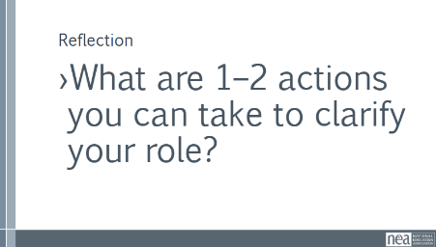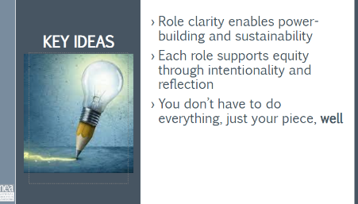 |  | In this work, ambiguity is the enemy of sustainability. We need structures that allow us to develop leadership without reinforcing hierarchy or burnout. Role clarity is not bureaucracy; it’s liberation in action.  All three roles are interdependent. The Campaign Lab is designed like a network, no one role is more important than the others. They all enable shared leadership and campaign effectiveness.  - Mentor Coaches help build coaches’ capacity. Think of them like scaffolding. They are mostly staff and experienced organizers, not the boss, not evaluators, but strategic thought partners  - Campaign Coaches are the frontline support for local organizing teams. They do a lot, but they’re not alone. They’re part of a larger structure that includes Mentor Coaches and other peer supports. They are our primary sensor – and researcher about the labs  - Team Leads anchor the day-to-day work of the team. They aren’t doing all the work; they’re ensuring others can. They model distributed leadership and build team cohesion.  Reflection (This will not be shared): What are 1–2 actions you can take to clarify your role?  Key Points:  - Role clarity enables power-building and sustainability  - Each role supports equity through intentionality and reflection  - You don’t have to do everything, just your piece, well | Participants will clearly delineate the difference between Mentor Coaches, Campaign Coaches, and Team Leads.
2:00 – 3:15 Zac/Amanda  Include a break in this section |  | 75 Minutes - Targets and Demands & Power Analysis of Target  Moved from Day 4
 |  | Content 5 Minutes Part 3: Identify and Analyze the Target(s)  Now we’ll move into Part 3 of the Power Analysis, identifying and analyzing the Target(s).  Definition of Target- Amanda (10 minutes)  Ask group: Who has an idea of what we mean by a target in the context of a campaign? Page 130  - A target is the person who can make the decision to give you what you want. The target is the person who can meet your demands. We need to be very specific in identifying the target. A target is not an organization or a committee. A target is a person with a face, name, and an address.  - Question- What if there are multiple targets? Like you have to win a school board vote? Are all of them targets? How do you focus (popcorn answers)  10 Minutes – Teamwork Identify Potential Targets for your Issues  Who are the targets for your problems? Take a moment to list them by name. Talk with your coach about how you know they are the right targets. (5 minutes)  Share out of targets (5 minutes)  - Question- What if there are multiple targets? Like you have to win a school board vote? Are all of them targets? How do you focus (popcorn answers)  - Later you are going to learn how to individually analyze targets, but what you always have to keep in mind is what is your most likely path to a majority vote.  5 Minutes of Content  A demand is the outcome that addresses the issue that you are making of a target. In your campaign you can have a very simple demand or you can include community needs and think bigger. In your packet is an article about how states that have bargaining use negotiations for common good bargaining and focus on things like climate justice, public service and immigration. (Panel We Need More Chairs article in participants packet referenced below.)  Agitational phrase that creates a moral crisis for the listener and demands action  An example demand from the article is : No ICE Collaboration. We demand that the university not collaborate with ICE, insist that ICE produce a valid warrant before entering university premises, not impose additional requirements  for work authorization, and not participate with any federal worker registry.  The demand should have the 3 components: the target, the action, and the harm or impact.  “Hey Superintendent Sam: We demand gender affirming bathrooms in every school because all students need to feel safe and included in our schools. ”  This example clearly articulates the Target (Superintendent Sam), the action that we want the target to take (implement gender affirming bathrooms in every school), and the harm or impact (that this will allow students to feel safe and included).  The demand is usually the first thing that your supporters or potential supporters will hear about the campaign. This is why it is important to include the harm or impact, because it creates a moral crisis in the listener and move them to act in support of the campaign.  - Measurable  - Achievable  The demand should be measurable in that we can clearly know whether the target takes the action in the demand or not  Team work – 10 Minutes  Return to your charts and draft a demand of your Target that resolves your issue and linked to YOUR VALUES  We will address the above when talking to coaches  Debrief – 5 minutes  Key Ideas  - A powerful demand makes clear who has the power to make the change that’s needed  - We can only build a powerful demand when we have taken the steps to accurately identify the issue and determine who has the power to create change | How do you determine the demand?  Participants will understand how to determine a measurable and winnable demand.
 |  | 30 Minutes -Power Assessment / JWJ Values Triangle  5 Minutes – Coaching Implications, Question Development  5 min – Overview of power analysis and refresher on targets  Once we have a demand, we need to be clear about how we can leverage our power to get the outcome we want (or know what power we need to build).  We need to think about and get clear on both the sources of our target’s power and how we can interrupt and change the power dynamics at play. We do that through a process of understanding first the issue (we did that when we developed our demand), the system landscape (who can give us what we want), and finally how we can put pressure on the target.  Remember, the target we analyze should have a FACE, a NAME, and an ADDRESS.  Values Triangle Overview (10 mins) (shortened JWJ Values Triangle)  In order to understand how we can interrupt our opponent’s power, we need to understand our own power. There is a helpful tool for power analysis that we call the Values Triangle.  Say: The triangle works from the bottom up and the inside out. Draw the outline of a triangle  Point to the bottom line of the triangle. Label it RELATIONSHIPS  - At the bottom of the triangle, we have relationships.  - Everything starts with relationships because everything we do happens in, through, with and because of who we know and how we trust them.  Draw: a “V” inside the triangle. Label it VALUES  - Inside the triangle is where we have values.  - Do you remember how we defined values this morning? Values are deeply-held beliefs that shape who you are.  - We are our best possible selves when we have clarity on our values. The world we want to see and how we define ourselves are based on our values. A person who is clear on their values knows who they are and what they believe in.  Point to the left side of the triangle. Label it SELF-INTEREST  - On the left of the triangle, we have self-interest. Self-interest is what our values look like in the world, the tangible manifestation of our values. When you understand your values you can discover your self-interest. Your self-interest is what you’re willing to fight for.  - For example, if one of your values is people over profits, one of your self-interests could include stronger unions, living wage policies, hazard pay for essential workers, and more.  Point to the right side of the triangle. Label it POWER.  - On the right side of the triangle is Power. Who remembers our definition of Power?  - Power is the ability to create, control, and prevent change. Power is made up of organized people and organized resources.  - Bringing it all together, we build relationships, so that we can agitate people to live up to their values and get clear on their self-interest so that we can build the power we need to make the world reflect our values.  Say:  - This is the Values Triangle.  - Every person and organization has one of these.  - Understanding this triangle is key to your work and to making change.  - Remember that we build the Values Triangle from the bottom up and the inside out.  Add: the point where the ”V” intersects the relationship line is the agitation point. This is where we consider how the pieces on the top (self-interest, power, values) are brought to bear on the relationships.  Example: if we want to impact a Superintendent’s relationship with parents, it needs to factor in a self-interest that actually matters to them (e.g., public appeal/support).  Suggestion from participant: may be video from Mean Girls to use example of taking down Regina George.  Now we will look at examples of a real life campaign usage of this Triangle. (We will do this again with team leads – today is an opportunity to practice coaching others.)  Lets start with NEA. What is NEA’s value triangle?  Relationships  - Where do we begin on the triangle? The bottom of the triangle, with relationships.  - What relationships does the NEA have?  - Who influences them, who are their allies and opponents, to whom are they accountable, who is their base of support?  Values  - Where do we go next in the triangle? Values.  - What are some NEA values?  - Gather values from the group and write inside triangle  Self-Interest  - What is on the left side of the triangle? Self-Interest  - What are some of our self-interests? What are some ways that we want to make their values real in the world?  Power  - Last but not least, what is on the right side of the triangle? Power  - Remember that Power is made up of organized people and organized resources.  - How does the NEA organize their people and resources?  - Gather responses from group and write on triangle  (10 min) values triangle practice  At our table groups, we’re going to take time to practice. Each group will have two volunteers to analyze a target (two rounds). The rest of the group will act as coaches.  Consider: What questions can you ask to help develop a more complete values triangle?  (5 min) Next, we’re going to consider our target triangles alongside the NEA triangle. What resources, relationships, or power do we have that we can leverage to interrupt a target’s power?  2 rounds: 1 min thinking from volunteers w/ target triangles. 3 min coaching from group.  (5 min) mini debrief  What are some paths to disrupting a target’s values triangle that you identified? | Participants will learn what is a values triangle is and its value in understanding power and targeting in a campaign.  Participants will work in groups to assess and practice the NEA values triangle.  Participants will understand the function of courage and unity
3:15-4:15 Zac/Amanda |  | 60 Minutes – Strategy, Tactics, Timeline, Compression Points
 |  | 20 min strategy/tactics (Zac)  30 min escalation (Amanda)  5 Minutes Strategy vs Tactics 130 -137  Ask group: What do you think is the difference between a strategy and a tactic?  A strategy is the way we use our power to win our demand. It is a series of tactics aimed at putting pressure on the target to meet our demand. We need a strategy because we cannot just implement tactics in a random way, we need to plan and order our tactics strategically according to an escalation plan.  Tactics are actions we take as part of an escalation plan that increases pressure on the target to win our demand. We design tactics based on our power analysis on the target. Each tactic should put pressure on the target’s self-interest, relationships, or power that we identified in the power analysis.  What makes good Tactics?  Let’s hear from a few people. Who wants to share about their favorite tactic and what made it a good tactic?  Tactics must:  - Put pressure on your Target. Tactics must put pressure on the Target’s Self-Interests, Relationships, or Power. Tactics should put the Target out of their comfort zone - we don’t want to use tactics that the Target is expecting or is used to seeing already, because that won’t put pressure on them.  - Build your Power. We should always be thinking about how each tactic can help us develop our leaders and brings more people into the campaign.  - Be Strategic. We don’t do tactics just for the sake of doing them. We need to make sure that our tactics make good use of our resources in order to put the most amount of pressure on the Target and as part of an escalation plan.  Power is a Function of Courage and Unity  The amount of Courage or Effort that is needed to commit to act  And the relationship to the Number of people feeling the pain, sharing the values, and participating in the change (unity and shared responsibility) is what gets us to our ultimate power to win the demand.  The more the courage and the more people who are acting – the more power we have.  Show the example online petition – high participation, low effort and courage – low power to cause the target to concede the demand  Show the example of storming the superintendent's office – a lot of courage and effort but low participation – low power to cause the target to concede the demand.  Group Activity (TOTAL For both charting activities 10 mins)  Let’s return to our issue charts.  Review your spectrum of allies AND your target’s power analysis  Based on the power analysis, brainstorm in your groups as many creative tactics as you can! Take 5 mins.  After 5 mins:  Now, take the next 5 mins in your groups to circle the tactics that meet the evaluation critera outlined below -  Coaches role is to coach during this activity.  Tactics must:  - Put pressure on your Target. Tactics must put pressure on the Target’s Self-Interests, Relationships, or Power. Tactics should put the Target out of their comfort zone - we don’t want to use tactics that the Target is expecting or is used to seeing already, because that won’t put pressure on them.  - Build your Power. We should always be thinking about how each tactic can help us develop our leaders and brings more people into the campaign.  - Be Strategic. We don’t do tactics just for the sake of doing them. We need to make sure that our tactics make good use of our resources in order to put the most amount of pressure on the Target and as part of an escalation plan. WE WILL DO THIS IN OUR NEXT SECTIOn  Key Points (5 min)  Tactics allow workers to:  - Share Resources, Values, and Commitment  - Take risks together and achieve shared wins  Build trust in their own agency and the collective effectiveness of their union  Amanda’s Part  Content- 5 minutes  How many of you are familiar with the concept of campaign mountain?  (Show of hands to gauge the room)  What does a campaign mountain show you? (popcorn answers- An escalation of tactics, a timeline marked by compression points and structure tests).  What’s a structure test? (a test to see if the worksite structures you are building actually do what they are supposed to do)  What’s a compression point? I think of it like a blood pressure check on your target. Are you raising it or not? It’s a fixed point in time, like a school board meeting where a vote is supposed to happen, or a countdown like UAW’s “tick tock” strike threat to force management to agree to a contract. If you can get a concession from your target, even a small one, it’s a sign what you are doing is working. If not, you probably haven’t turned up the heat enough yet.  Let’s look at a picture of a campaign mountain.  What do you notice about this picture? (popcorn answers- there is a long time for low escalation tactics, then clustered higher escalation actions before going to the peak)  What is the reason for running a campaign this way- a long time for low risk escalation before you start to escalate?  (popcorn answers)  - Less escalated actions prepare our people for more escalated actions  - Give the target a point to do the right thing before things escalate to the next tactic  - Use the threat of escalation  - Allows more people to join our base  Escalation Activity  (10 minutes) Here is how I use campaign mountain. I start at the top. At the peak should be a tactic that causes such a big crisis for your target that they have almost no possible way out except to capitulate to your demands. For example, they may lose their job or be removed from office. Take a moment and think of what kind of tactic that might involve.  After 5 minutes- If you can’t think of anything, imagine a massive citywide rally demanding your target be removed from their position. Maybe there are bands performing at the rally followed by a march through town. Maybe this day begins with a full scale walkout by your coworkers joined by other unions. Sounds exciting! I want to be there too!  (10 minutes) Now, how many people would have to be involved in this final tactic? And which people? Which other organizations or leaders would have to be present? Which constituencies would need to show their full support? Discuss this with your coach.  (After 5 minutes) So what did you decide? How many people would you need? (popcorn out answers- which will likely be in the 100s if not 1000s) Yikes! How many of you can wield that support right now? Show of hands? Right, none of us can do that right now. But it can be done. You’ve seen it happen before, right? So how do you get there?  (5 minutes) Now go back to where you are now in your campaign, which is at the very lowest point on the mountain, because you are just starting. You notice how much time is spent on that section? Why is that?  ,  What would happen if you skipped all that and started at the highest point? Because, let’s be clear, that rally and strike and march with all the bands and folks cheering you on sounds really fun! And you know that is what it would take, so why not just start there? Discuss at your table.  (5 minutes) Share outs  Key points  - You need time to build your base and get them aligned and ready to face possible risk  - You have to spend the time to identify leaders and get them on board. Everything moves at the speed of trust.  - Jumping ahead without those two steps risks showing how weak you are. If you call for a walkout and rally and only you and your 3 besties participate you look weak and you take on incredible risk.  3 Minutes Key Points – An escalating campaign is held together by a set of values and shared commitment to a demand.  Escalating tactics are how we develop leaders, identify new leaders, move more people into our base.  If we are organizing, we are always climbing campaign mountain | What are strategy and tactics?  What makes effective tactics?  Participants will understand the difference between strategy and tactics and the criteria for effective tactics.
4:15-4:30 Carrie |  | 15 Minutes - What is the opportunity to dream bigger
 |  | Reflection  Discussion  Questions, Connections, Reflections  Housekeeping announcements  Plus/Delta at the Door  FOR TOMORROW – | Participants will be able to bring a little closure to their learning and provide feedback on the day.
4:30 – 5:00 |  | 30 Minutes – Ending it Right and Choice Networking Activities –
 |  | This is a time for participants to meet and discuss any issues they are thinking about with other members of the group. This is not led by facilitators and highly encourage to occur in any other space besides the conference room. | Participants will make useful connections with staff from other affiliates.
5:00 ADJOURN

