Creating Leadership Teams
What is our purpose and what are our norms and roles?

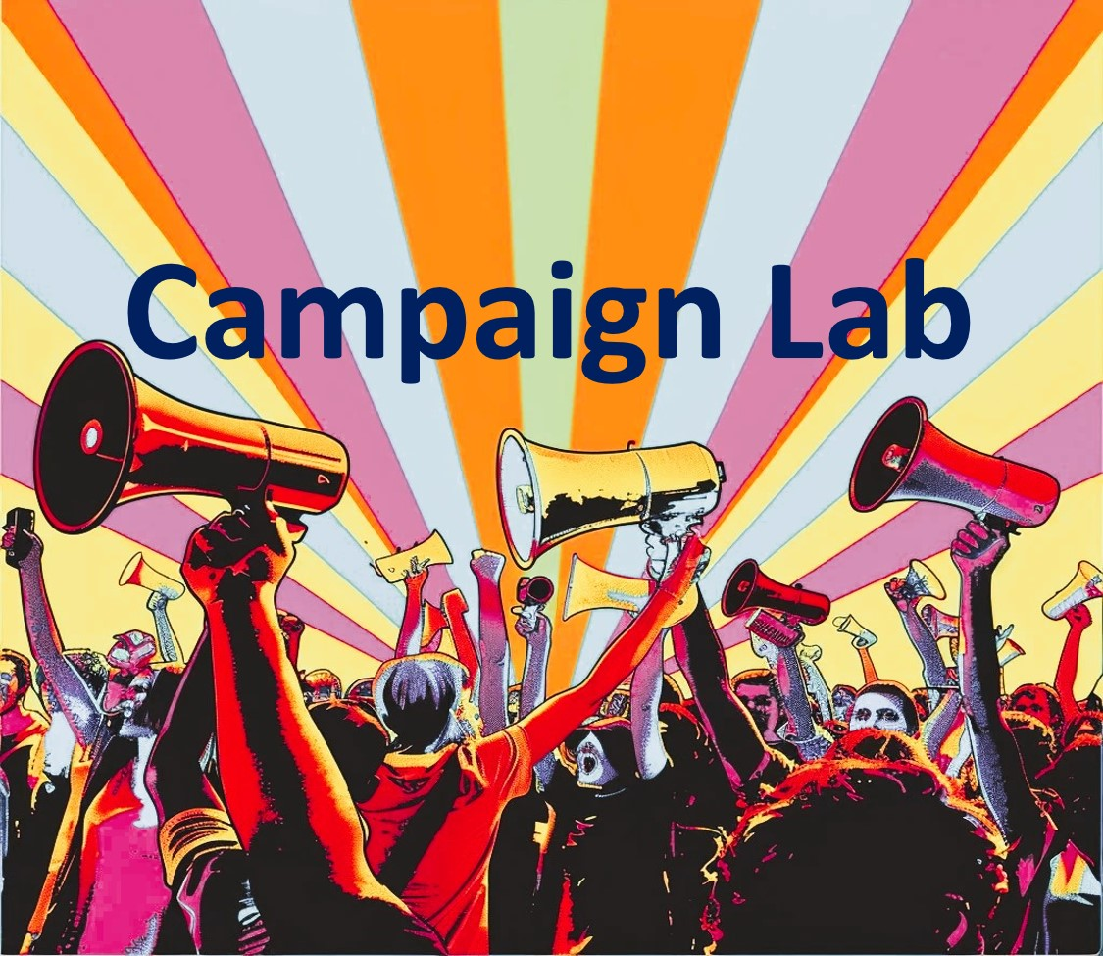

Acknowledgements
We welcome your suggestions for improving this guide further for future training. We also welcome you to use it and adapt it for your own training, subject to the restrictions below.

This workshop guide has been developed over the course of many trainings by Liz Pallatto, Joy Cushman, Jake Waxman, Devon Anderson, Rachel Anderson, Adam Yalowitz, Kate Hilton, Lenore Palladino, New Organizing Institute staff, Leading Change Network, MoveOn Organizers, Center for Community Change staff, Jose Luis Morantes, Carlos Saavedra, Esther Handy, Lucia Moritz, Zac Willette, Matt Lewis, Tiffany Steinwert, Rachel Goldstein, Meredith Mira, Inbal ben Ezer, Sean Thomas-Breitfeld, Shuya Ohno, Petra Falcon, Michele Rudy, Hope Wood, Vandinika Shukla, Josh Daneshforooz, Melanie Vant, Uyen Doan, Abel R. Cano, Nisreen Haj Ahmad, Mais Irqsusi, Sarah El Raheb, Rawan Zeine, Art Reyes II, Dan Grandone, Aprajita Pandey, Emily S Lin, Junko Yoda, Noorulain Masood, Rosi Greenberg, Helen “Hui” Huang, Voop de Vulpillieres, Ana Babovic, Kate O’Gorman, Tanvi Girotra, Roohi Rustum, Anita Krishnan, Céline Lebrun Shaath, Anjali Rodrigues, Noa Yammer, Celina Barrios-Millner, Shivani Kumar, Xiaodi Chen, Jeff Rousset, Nneka Akubeze, Pedja Stojicic, Robert Martin, Benedict Hugosson, Jens Kristian Rasmussen and many others.

Restrictions of use
The following work [this workshop guide] is provided to you pursuant to the following terms and conditions. Your acceptance of the work constitutes your acceptance of these terms:

- You may reproduce and distribute the work to others for free, but you may not sell the work to others.
- You may not remove the legends from the work that provide attribution as to source (i.e., “originally adapted from the works of Marshall Ganz of Harvard University”).
- You may modify the work, provided that the attribution legends remain on the work, and provided further that you send any significant modifications or updates to the Leading Change Network at info@leadingchangenetwork.org or/and upload the resource to the resource center
- https://leadingchangenetwork.org/resource-center-add-resource/
- You hereby grant an irrevocable, royalty-free license to Marshall Ganz and the Leading Change Network, and their successors, heirs, licensees and assigns, to reproduce, distribute and modify the work as modified by you.
- You shall include a copy of these restrictions with all copies of the work that you distribute and you shall inform everyone to whom you distribute the work that they are subject to the restrictions and obligations set forth herein.

If you have any questions about these terms, please contact Mais Irqsusi, Leading Change Network, 30 Bow Street, Cambridge, MA 02138, mais.irqsusi@leadingchangenetwork.org or Marshall Ganz, Center for Public Leadership, Harvard Kennedy School, 79 JFK Street, Cambridge, MA 02138 marshall_ganz@hks.harvard.edu.Modified by Ellen Holmes, Spring of 2025 For Use with NEA Campaign Labs

Creating Leadership Teams
What is our purpose and what are our norms and roles?
Goals for this session

- To develop an understanding of the core practices of successful leadership teams
- To practice those skills by developing a shared purpose, clarifying team roles and responsibilities, and creating norms and practices of coordination

Why do leadership teams matter?
Most effective leaders create teams to work with them and to lead with them. Take for example Moses, Aaron and Miriam in the story of Exodus, or Jesus and the twelve disciples in the New Testament, or Martin Luther King, Ralph Abernathy, Rosa Parks, Jo Ann Robinson and E D Nixon during the Montgomery Bus Boycott.

A leadership team offers a structured way to work together interdependently, each person taking leadership on during part of the team’s activity. At their best leadership teams recognize and put to productive use the unique talents of the individuals who make up the team.

Team structures also help create strategic capacity—the ability to strategize creatively together in ways that produce more vibrant, engaging strategy than any individual could create alone. In the Obama campaign, the field structure created multiple layers of leadership teams to engage people creatively and strategically at all levels of the campaign. Each state had a state leadership team that coordinated regional leadership teams (of Regional Directors and Organizers), which coordinated local neighborhood leadership teams of volunteer leaders.

At every level the people on leadership teams had a clear mission with clear goals and the ability to strategize creatively together about how to carry out their mission and meet their goals. This structure created multiple points of entry for volunteers, and multiple opportunities to learn and to exercise leadership.

Leadership teams provide a foundation from which an organization can expand its reach. Once a team is formed, systems can be created to establish a rhythm of regular meetings, clear decisions and visible accountability, increasing the organization’s effectiveness. One person alone cannot organize 500 people. It is built by finding people willing and able to commit to helping build it, and creating relationships and a solid structure from which it can be built.

So why don’t people always work in teams?
We have all been part of volunteer teams that have not worked well. They fall into factions, they alienate each other, or all the work falls on one person. Some aim to keep the pond small so they can feel like big fish. So many of us come to the conclusion: I’ll just do it on my own; I hate meetings, just tell me what to do; I don’t want any responsibility; just give me stamps to lick. There’s just one problem: we can’t become powerful enough to do what we need to do if we can’t even work together to build campaigns we can take action on.

The challenge is to create conditions for our leadership teams that are more likely to generate successful collaboration and strategic action. When groups of people come together, conflict is always present. Effective teams are structured in a way to channel that conflict in productive ways, allowing the team to achieve the goals it needs to win.

Three measures of an effective team:
- OUTPUT (WORLD): The success of your team in taking the action required to achieve its valued goals – winning the game, winning the campaign, putting on the play, etc.
- CAPACITY (TEAM): Over time your team is learning how to work more effectively as a team, and developing more leadership.
- LEADERSHIP DEVELOPMENT (INDIVIDUAL): Individuals who participate on your team learn and grow as a result of their participation.

Three conditions that make for a “real” team:
- Your team is bounded. You can name the people on it; they don’t come and go, whoever shows up doesn’t have the automatic right to participate in the team. Most highly effective teams have no more than 4 – 8 members.
- Your team is stable. It meets regularly. It’s not a different, random group of people every time. Membership of the team remains constant long enough that the team learns to work together better and better; each member is fully committed to be on the team and commits consistent time and effort to it.
- Your team is interdependent. As on an athletic team, a string quartet, or an airplane cabin crew, the contribution that each person makes is critical to the success of the whole. Team members have a vital interest in each other’s success, looking for ways to offer support.

Three steps to launching an effective team:
- You have a shared – and engaging – purpose. You are clear on what you have created your team to do (purpose), who you will be doing it with (constituency), and what kinds of activities your team will participate in. The work you have to do is readily understood, it’s challenging, it matters and you know why it matters. Team members need to be able to articulate for themselves and others this “purpose”.
- You have created clear interdependent roles. Each team member must have their own responsibility, their own “chunk” of the work, on which the success of the whole depends. No one is carrying out activity in a silo that’s secretive to others. A good team will have a diversity of identities, experiences and opinions, ensuring that everyone is bringing the most possible to the table.
- Your team has explicit ground rules. Your team sets clear expectations for how to govern itself in your work together. How will you manage meetings, regular communication, decisions, and commitments? And, most importantly, how will you correct ground-rule violations so they remain real ground rules? Teams with explicit operating rules are more likely to achieve their goals. Some team norms are operational, such as how often will we meet? How will we share and store documents? Communicate with others outside the team? etc. Others address expectations for member interaction with each other. Initial norms guide your team in its early stages as members learn how to work together. Norms can be refined through regular group review of how well the team is doing.

 | TYPICAL TEAMWORK SESSION  Building your team

Goals for this session

- Develop your team purpose
- Identify the norms you will practice as a team, including a decision-making norm
- Define your leadership roles; then discuss the roles relative to the talents of those in your team
- Develop a team name and chant

Agenda:
Total time: 55 minutes (5 min transition time)

1. | Gather and review agenda. Choose a timekeeper for this session. | 2 min.
2. | Review the simulation campaign context. | 5 min.
2. | Develop your shared purpose using the worksheet that follows. Review your shared interests from the last session, and focus on how you as a team will work together on your campaign. | 20 min
3. | Decide on collaborative norms that will enable you to function with shared commitment. Use the worksheet that follows. | 10 min.
4. | Determine team roles. Brainstorm possible responsibilities as you work together beyond this workshop. For example, who will coordinate the meetings? Talk about how these roles might match up with the talents of those on your team. See an example of team roles below. | 8 min.
5. | Create a team name and chant. | 5 min.
6 | Wrap up: Share reflections and key learning. Choose a representative and bring in your team name, chant, and shared purpose! | 5 min.



WORKSHEET:
DEVELOPING SHARED PURPOSE
Agenda: Total Time: 20 minutes
- In the first part, as individuals, you will take 5 minutes to clarify your own thinking about what the purpose of your team could be as you work on a campaign together.

- In the second part, as a team, you will take 10 minutes to share your ideas, look for the common focus, and discern a purpose you can all support.

- You then have 5 more minutes to write a new sentence that you think captures the sense of your team.

- And finally, as a team, you will have 5 minutes to consider the second round of sentences and decide on one that best articulates your team’s perspective.
Step 1: Individual Work (5 min.)

- In the first column, based on the work you did on common interests and values in the relationship session, write down the unique purpose or purposes of your team.
- In the second column, write down whom your team serves: What are the people like and what are their interests?
- In the third column, write down the kinds of activities that your team could engage in to fulfill its purpose by serving this community? What is the unique work that your team could do?

Chart your Individual Responses
WHAT? | WHO? | HOW?
Our team’s shared purpose is to…  (briefly describe your team’s unique reason for coming together) | The constituency we organize is…  (briefly describe your constituency’s characteristics) | We will achieve our shared purpose by…  (list the specific activities that your team would undertake)

After brainstorming answers to all three questions, take a few moments to write a sentence that you think best describes your team’s purpose, its constituency, and its activities. Draw on all three columns above.

Examples of a shared purpose sentence:
We share the purpose of educational justice by organizing high school students in Milwaukee to develop their capacity for collective action through providing them with coaching, training, and mentoring.

We share the purpose of gaining water access for organic farming by organizing farmers and community activists through holding 1:1 meetings, community meetings, proposing and passing legislation.

Step 2: Team Work (7 minutes)
As each person reads their sentence, the facilitator notes the key words on the wall poster under purpose, constituency, or work. Note specific words to which you respond, that spark your curiosity, or that give you energy. When you are done, your facilitator circles the words that seem to resonate most strongly with your team.
Our team’s shared purpose is to:

Step 3: Individual Work (3 minutes)
In light of what you learned from the last session, write a new sentence that you think can articulate a shared purpose, using some of the key words and themes.
YOUR draft Our team’s shared purpose is to:
Step 4: Team Work (5 minutes)
We will read our sentences again and choose—or combine—one that can best articulate the shared sense of your team.
Final Team draft Our team’s shared purpose is to:

WORKSHEET:
DEVELOPING TEAM NORMS
Agenda: Total Time: 10 minutes
Review the sample team norms below. Add, subtract or modify to create norms for your team. Be sure to include group norms on each theme below and how you will self-correct if the norm is broken. (If you don’t self-correct, the new norm will be breaking the norms.)

Decision-making: What is the process by which we will make decisions?
- Majority rules: Whatever gets the most votes wins.
- Consensus: Everyone must agree.
- Delegation: Nominate one or two people on your team to be the ultimate decision-makers.
  - Coin flip: Leave the decision to fate!
  - Other:
Discussion and Decision-making: How we will discuss options and reach decisions as a team to ensure vigorous input and debate?
Always Do  Engage in open, honest debate  Ask open-ended questions  Balance advocacy with inquiry | Never Do  Engage in personal attacks  Fail to listen to what others say  Jump to conclusions
Meeting Management: How will we manage meetings to respect each other’s time?
Always Do  Start on time; stay on time  Be fully present throughout the meeting | Never Do  Come to meetings unprepared  Answer cell phones or do email
Accountability: How we will delegate responsibilities for actions and activities? How will we follow through on commitments?
Always Do  Clarify understanding  Provide follow-up on action items  Ask for/offer support when there is a need  Weekly check-in | Never Do  Assume you have agreement  Assume tasks are getting done  Commit to a task that you know you  won’t do
How will you "self-correct" if norms are not followed?
Teams work best when you have a regular, reliable time to coordinate together. What will your team’s regular meeting time and place be?

WORKSHEET:
DEVELOPING TEAM ROLES
Agenda: Total Time: 8 minutes
Review the Team Coordinator role below as an example of what roles might look like in your individual campaigns. Thinking about how you should organize the next event/meeting, discuss how your roles would fit together to create an interdependent leadership team that supports one another in your individual projects. What would each role have to be good at?
Based on the discussion about the roles, go around the circle and ask each person to tell others:
- What experience and talents they have that might contribute to the leadership team
(30 sec.)
- What specifically they want to learn in more detail (30 sec.)
How might these talents match up to particular roles? Are there any clear “fits?” Note: These team roles should not be seen as permanent. For the team to be strong, all leaders should have to earn leadership by carrying out responsibilities relevant to the role they seek.
ROLE | RESPONSIBILITIES | YOU WOULD BE GOOD FOR THIS ROLE IF YOU… | INTERESTED TEAM MEMBERS & RELATED SKILLS/TALENTS
Ex. Team Lead | Coordinate the work of the leadership team. Prepare for meetings; give support and coaching to the team. | Organized, experienced, good people skills, can make good snacks | Jesse, Queenie, Vera
Ex. Communications | Coordinates the messages sent out to other people in the campaign. | Access to technology, good design skills, attention to detail | Jorge, Mia, Jack

Your Team Workspace
ROLE | RESPONSIBILITIES | YOU WOULD BE GOOD FOR THIS ROLE IF YOU… | INTERESTED TEAM MEMBERS & RELATED SKILLS/TALENTS
Team Name & Chant (5 min.)
Team Roster:
NAME | PHONE | EMAIL ADDRESS

