Developing Your Script for One on One Conversations
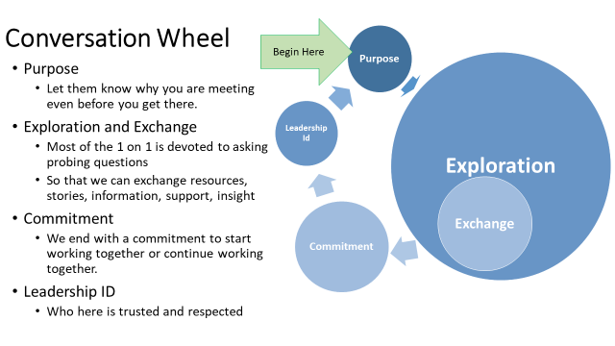
Example of a Relationship Building Script (Based on 25 Minutes)
Purpose VERY BRIEF 1 minutes:
Hello my name is ______________. I am with the _________________. I am excited that we could meet today to talk about ___________. We scheduled (amount of time) so I want to jump right in. (In your Script think about 2 or 3 BRIEF sentences about you that allow you to be more relatable – for example what are your values related to this conversation, purpose for your work, who you are working with.)
Exploration and Exchange 80% OF THE CONVERSATION 20 Minutes:
Exploration -Ask probing questions to learn about the other person’s values and interests, as well as resources they might hold. In response, it’s up to you to share enough about your own values, interests, and resources so that it can be a reciprocal exchange – relatable. But remember the focus is on them.
Start by asking questions like:
- “Why is this issue important enough for you to act?”
- “Can you remember the first time you stood up for something you believed in?”
- “Did you always feel strongly about this issue? Why / why not and what changed that?”
Exchange -once you have an understanding of their story and motivations, briefly share yours. Wherever you
find similarities between their story and yours, make a connection.
Commitment 3 Minutes:
A good one on one meeting ends with a commitment to work together. This commitment is best secured through a direct ask:
• Stress the urgency of the commitment you are asking for:
“Your colleagues need more people like you to join them in making this school a better place to work”
• Emphasize the values you have in common:
“To achieve a better place to work we both know it is going to take hard work and standing together.”
• Frame it so that it seems the person you’re asking is the solution to the problem:
“Would you join the union today to help your colleagues make this a better place to work?”
• Be specific, make sure they understand what it is you are asking them. Provide time and space for them to ask questions until they’re clear.
• End the meeting with an understanding of next steps – that is, they should leave knowing the next time you will meet or how and when they will hear from you
Leadership Identification 1 Minute: Who here is trusted and respected?

