Under new leadership, Nashville's teachers union hopes to use leverage gained after protests over pay
Jason Gonzales, Nashville Tennessean Published 10:00 p.m. CT Oct. 20, 2019

Spread throughout the warehouse-like building housing Nashville's teachers union hang photos of last school year's teacher pay protests (/story
/news/2019/05/16/nashville-teachers-absent-again-part-mnps-sick-out/3691484002/).

At the time, the protests where educators marched and called out sick were led by union and non-union members. But they weren't backed by Metro Nashville Education Association leadership, the city's educators union. Now, a group that helped spearhead the city's teacher demonstrations leads the association. And it is determined not to just memorialize the protests in the South Nashville building that overlooks Metro Nashville Public Schools headquarters, but use the recent action — and future action, if necessary — to better the conditions for educators in Music City.

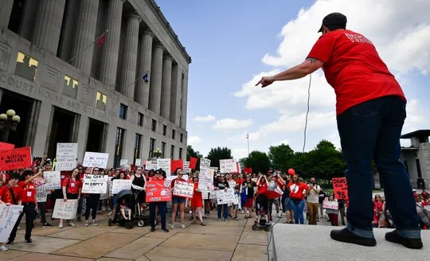
"I think that we came in with a pretty clear mandate from the people who voted for us to go out there and make some big changes," MNEA President Amanda Kail said. The goals so far are uncomplicated: Get teachers more involved in the union, elevate the voice of teachers, push for better working conditions, and fight for increased pay.

If they feel they are not heard, Kail said the new leadership knows what it
means to take to the streets. That's a major change for a union in a state
where teacher strikes are illegal
(/story/news/education/2019/03/12/tn-teachers-united-public-education-funding-school-testing-union/3131729002/) and Collective bargaining rights have been stripped. But Kail said teachers have leverage.

"I think we kind of shook the city up a little bit (through the protests), and that needed to happen," Kail said. "And I think that going forward when we talk to people at (Metro Nashville Public Schools), when we talk to people at the city, when we talk to the mayor, they know we have that in our back pocket."

Amanda Kail leads a protest of teachers demanding higher wages May 16 at City Hall in Nashville. (Photo: George Walker IV / The Tennessean)

Teacher pay and planning time

A goal to increase wages is central to the union. The new leadership wants to renegotiate the union's memorandum of understanding with the district to prioritize teacher step raises, or pay based on experience. But there are other issues besides pay. One sticking point for Kail and MNEA Vice President Michele Sheriff since taking over the union this summer is to ensure teachers have time to plan. As teachers recently serving in the classroom, they said it is important to ensure teachers can prepare for students. They said interim Director of Schools Adrienne Battle has been receptive to their asks. The hope is their advocacy makes the climate better for teachers and, in turn, better for students. "We want teachers to know they're not just a teacher in a classroom," Sheriff said. "They're an integral part of the district, and all the decisions that the district makes affect teachers directly."

Nashville's teachers union wins supporters

The union's recent work is being noticed. "I feel like they are going to do everything they can to help us," said Lillian Baird, a McGavock teacher and member of Sick Teachers. The Sick Teachers group led "sick-outs" during which educators missed work to advocate for more money in the budget for schools and wages. Baird said Kail and Sheriff supported Sick Teachers even when previous MNEA leaders would not. Although not every Sick Teacher member is part of the union, Baird said she gets the feeling the association's new leadership stands for all teachers.

Meanwhile, school Board Chair Anna Shepherd said she's maintained a good relationship with MNEA leaders. But she sees where Kail and Sheriff are willing to rally teachers. "After speaking with Amanda (Kail), I see how they are trying to get every school with a union representative, get active members organized and work as a change agent. I applaud that," Shepherd said.

Discontent spawns protests

Nashville teachers complained about problems with pay for years before protests in the 2018-19 school year. But the issue became center stage this past year. Teachers argued pay is causing teachers to leave and exacerbating the issue of understaffed schools throughout the district in a recruitment climate where it is tough to hire educators. Teachers organized a march, rallies and the "sick-outs." The 4.5% cost of living raise is a minor victory, educators said. They received it in this year's budget.

Kail and Sheriff want the union to play a key role in whatever comes this year and beyond. The union's committee positions are fully filled for the first time in years, Kail said. "Hopefully, we can put the systems in place where other people can come behind us, improve the union, and they can then continue to work to improve the climate and culture in the district so it is able to attract and retain great teachers," she said.

Reach Jason Gonzales (https://www.tennessean.com/staff/33783/jason-gonzales/)at jagonzales@tennessean.com and on Twitter @ByJasonGonzales (https://twitter.com/ByJasonGonzales).

