USE/NEW - Day 2 Coaching a Campaign Leader Facilitator Agenda
General Materials Needed:
Name Tents with the Norms  Room signs, Stick on Name Tags  Chart Paper (10 full w Sticky Strip) |  |  | Materials Box for each table with:  Markers (Mr. Sketch variety)  Post its – 3x3” and 4X5” sizes
Key Outcomes for the Event:
Participants will: Feel prepared to coach a leader towards deeper clarity and growth.
Participants learn coaching skills and practices that includes:
- Coaching the shift from a services to organizing model of unionism
- Using an assessment for local growth and strength in the union to surface goals and priorities for coaching.
- Exploring coaching different parts of a campaign.

DAY 2: SATURDAY March 14th Overview of Content, Time, and Facilitator Assignment
7:30- 8:30 Light Breakfast  8:30-9 Welcome + Grounding  9-10 Heart Hand Head Diagnosis  10-10:15 Break  10:15-10:50 Practice  10:50am-12pm Services to Organizing  Lunch – 12:00 -1:00  1:00 - 1:10 - Grounding |  | Participant  Carrie  Katie  Bekah  Katie  Carrie |  |  | 1:10-1:55pm Using Assessments in Coaching  1:55pm-2:15pm Present: Coaching a Campaign Leader  2:15-2:30 - Break  2:30-3:15 Activity: Coaching Campaign Leaders  3:15-4:05pm Coaching Practice  4:05pm-4:30pm Debrief and Wrap Up  4:30 -5:00 Adult Choice Networking  5:00 Adjourn |  | Bekah  Kristin  Kristin  Melissa  Carrie
Time Slides Facilitator | Resources |  |  | Instructions, Activity and Debrief (Facilitator Script) |  |  |  | Essential Questions and Outcomes
 | Charts, handouts, articles, materials, slide |  |  | What are you saying, what are they doing, what questions will you use to guide learning and make clear the important points  Include an estimate for how long each section of the learning will take |  |  |  | What question(s) will this learning answer? What will participants know or be able to do?
7:00 -8:30 – Team prep, practice, room set up, sound check, etc. and Breakfast
Entry Activity

8:30 -9:00 | Carrie |  |  | 30 Mins TOTAL Getting Started
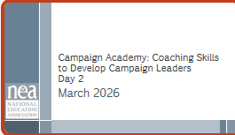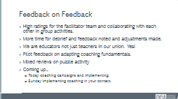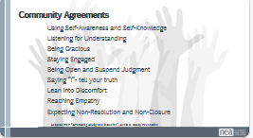  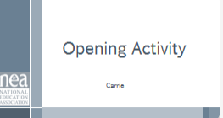 |  |  |  | Opening:  Grounding/Ice Breaker  Review what we covered yesterday  Pair share what resonated for you  Agenda for the day  Check in on shared agreements  - A core coaching skill is knowing how to take a deep breath and how to guide someone else in taking in a deep breath.  So let’s breathe!  Find a comfortable position. In your seat, standing, or evening on the floor.  Close your eyes, and begin take inhales and exhales at your own pace.  Once your find the rhythm of your breath, become more intentional with your breath.  Inhale through your nose, exhale through your mouth.  Try this on for about 4 cycles of breathing (ex. one cycle of breath is a  full inhale and exhale)  Now that you’ve gotten in tune with your breath, let's slow down your  breathing even more.  Take an inhale hold it for 4, 3, 2, 1— exhale let it go 4, 3, 2, 1.  Let’s talk a moment to debrief our breathing. Take a moment to reflect.  What stood out for you in mindful breathing?  What shifted in your body? How do you know?  Would anyone like to share? |  |  |  | Norms in Handouts  Agenda on Slides  Parking Lot Chart  Name Tents  Handout Package
9-10am | Katie |  |  | Diagnosis Head, Heart, Hands – 60 min
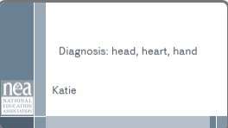  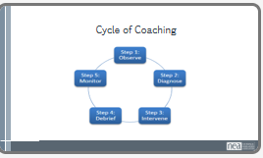  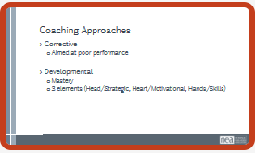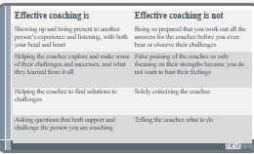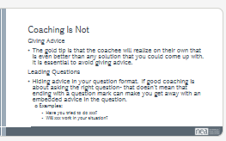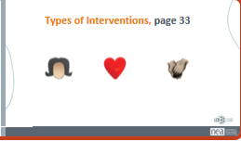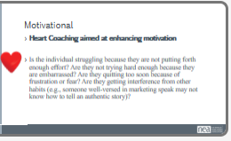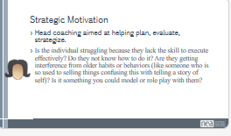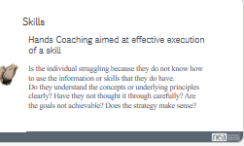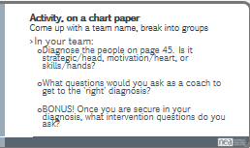  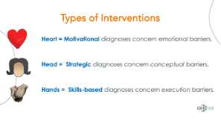  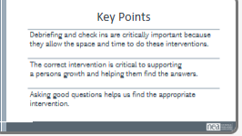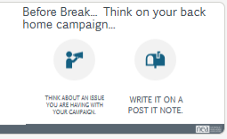  Pg 9 in PEP | 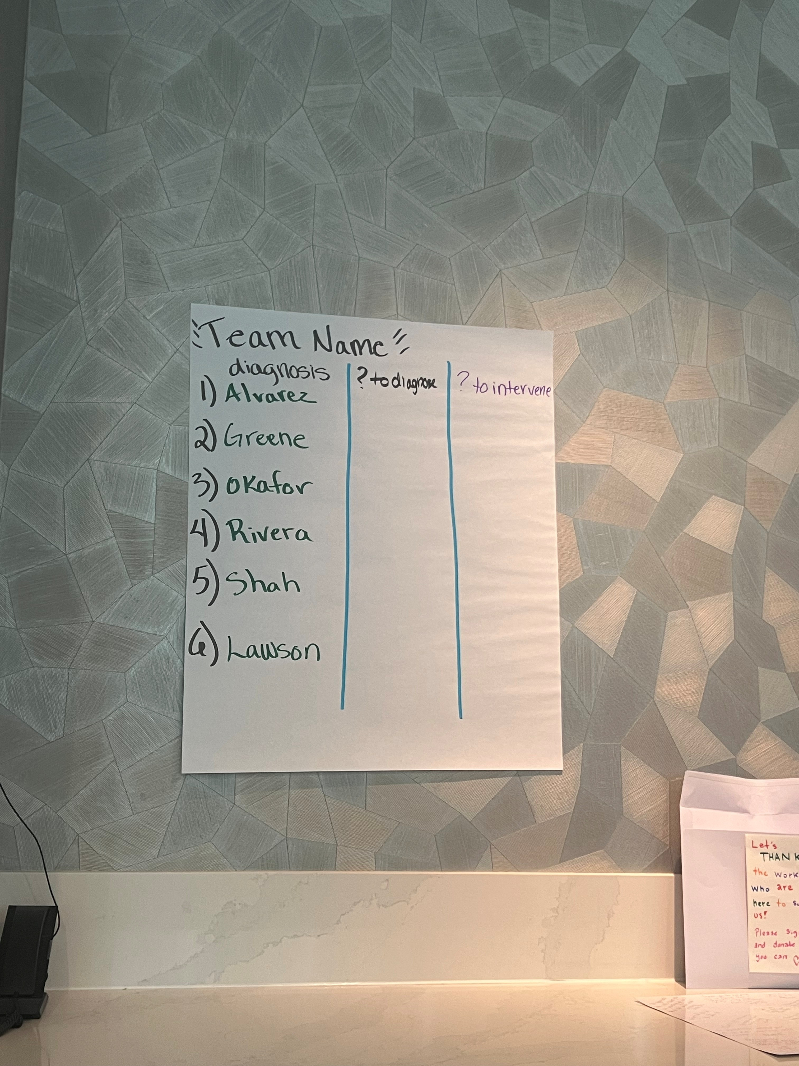 |  |  | Diagnosis: Head, Heart, Hand in Coaching.  Diagnosis of a Coaching issue is critical. Providing the correct intervention allows members to reflect accurately and help them adjust their tactics. Below are 3 typical interventions in coaching.  Issue:  - Motivational (heart): Is the individual struggling because they are not putting forth enough effort? Are they not trying hard enough because they are embarrassed? Are they quitting too soon because of frustration or fear?  - Ask participants to share out, what might this sound like in your 1-1?  - I am worried... I tried... What if...  - Strategic (head): Is the individual struggling because the goals are not achievable? Or because they’re not thinking creatively enough about how to use the resources they have to meet goals? Or because the overall strategy doesn’t make sense and needs to be clarified or adapted to their situation?  - Ask participants to share out, what might this sound like in your 1-1?  - I have done everything I can....It is too much... this list is bad.  - Skills-based (hands): Is the individual struggling because of not being able to muster the behavioral skill to execute effectively? Do they not have the skill in their repertoire? Is the person getting interference from other habits and behaviors (like someone well-versed in marketing speak may think that skill set is a substitute for authentic story-telling skills)? Is there something you could model, or that this person that just needs more help practicing and debriefing?  - Ask participants to share out, what might this sound like in your 1-1?  - I talked to them and they were just not interested.... I put the petition in the staff room... I told them the benefits of membership...  Diagnosing Activity (40minutes, time broken out below):  We will break folks into groups of 6. And spend 25 minutes charting the following:  - Come up with a team name  - diagnosing the appropriate intervention (head/heart/hands)  - What questions might you ask to help determine your diagnosis  - What questions might you ask to help with the intervention? (If they are having a heart/hands/head issue- what question do you ask to help them correct or mastery the needed intervention.)  Scenarios:  1. Ms. Alvarez – Asking a Colleague to Join the Union  Ms. Alvarez believes strongly that educators need collective power to address stagnant pay. She agrees to ask newer teachers to join the union but keeps postponing the conversations. When she finally brings it up, she rushes through it and quickly changes the subject. In coaching, she admits she’s afraid colleagues will see her as “political” or confrontational. She understands the benefits of membership and knows the talking points, yet she avoids deeper follow-up conversations that might actually move someone to join.  2. Mr. Greene – Organizing Around Pay Inequity  Mr. Greene is outraged after discovering inconsistencies in how stipends are distributed. He immediately urges staff to demand a 15% across-the-board raise and circulate a petition within a week. However, he hasn’t researched district budget constraints, mapped decision-makers, or clarified whether inequity stems from policy or implementation. Colleagues hesitate because the plan feels reactive and disconnected from how decisions are actually made.  3. Ms. Okafor – Encouraging Colleagues to Vote in a School Board Election  Ms. Okafor wants staff to turn out for a school board election that could impact contract negotiations. She sends long emails filled with policy details and links to candidate platforms. Few colleagues respond. When she talks in person, she overwhelms them with information rather than asking what issues matter most to them. She leaves conversations feeling frustrated that people “just don’t get it,” even though she hasn’t created space for dialogue.  4. Coach Rivera – Inviting a Colleague to the Picket Line  During a contract dispute, Coach Rivera commits to asking teammates to join the picket line. After one colleague says, “I can’t risk admin noticing,” he stops asking others. He decides people probably aren’t interested and shifts his energy elsewhere. In coaching, he shares that he doesn’t want to strain friendships or make anyone uncomfortable, especially if they disagree.  5. Dr. Shah – Considering a Run for Union Office  Dr. Shah is frustrated by a lack of transparency in leadership and wants to run for union vice president. She announces her candidacy but hasn’t clarified her platform beyond saying, “We deserve better.” Potential supporters ask what specific changes she would pursue and how she would build majority support. Conversations stall because colleagues aren’t sure what she’s actually proposing or how it would realistically succeed.  6. Mr. Lawson – Addressing Workplace Fairness  Mr. Lawson wants to confront inconsistent enforcement of evaluation policies that seem to target newer teachers. In staff meetings, he raises the issue bluntly, citing policy language and naming administrators directly. While his concerns are valid, colleagues grow uncomfortable and disengage. Some privately agree with him but say they don’t feel invited into the conversation. He leaves meetings feeling isolated and confused about why others won’t stand with him.  Key:  Ms. Alvarez – Heart  Mr. Greene – Head  Ms. Okafor – Hand  Coach Rivera – Heart  Dr. Shah – Head  Mr. Lawson – Hand  Have each team write on chart paper their appropriate diagnosis, questions to determine the diagnosis, and the questions for intervention.  Have them put their charts close together so they can see what they did.  What is the big learning you had from this process? (as they re  Final question to reflect on... if you misdiagnose this, what might go wrong? Have participants share out. Note it is not fatal- but wrong diagnosis can lead to frustration. However, with good check ins- you can catch your wrong diagnosis and correct.  (If time: If we keep pushing someone with a effort intervention who is already trying a lot- that leads to burn out. “Just try harder”  If we push someone who has the skills with a skills intervention- they feel like they are a failure. “Nothing works”  If we push some to just reinforcing an existing strategy- the work then feels impossible. “It is impossible”)  Key Points:  - Debriefing and check ins are critically important because they allow the space and time to do these interventions.  - The correct intervention is critical to supporting a persons growth and helping them find the answers.  - Asking good questions helps us find the appropriate intervention.  Before we break think about an issue you are having with your campaign. Write it on a post it note. Once you are done give me a thumbs up. |  |  |  | Participants will learn how to diagnose/intervene when coaching.  How do we support members when they are struggling in union work?  Participants will understand what occurs when they have the wrong intervention.
10-10:15am  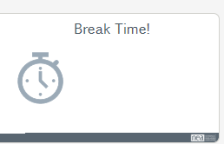 |  |  |  | BREAK
10:15am10:55am | Bekah |  |  | 40 min – Practice: Diagnosis Heart Hand Head
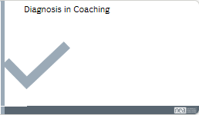  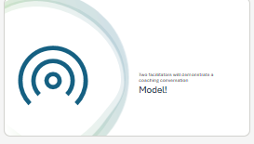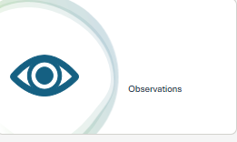  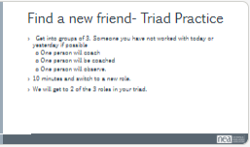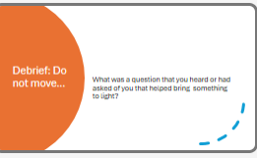 |  |  |  | MODEL: Diagnosis in Coaching  10 min Model a coaching conversation.  Carrie will coach a participant  - Bring two facilitators up front to model the conversation. Should be based on a real work place issue. Avoid any advice and help them process through the issue.  - 5 min- Observations. What did you see in the coaching work? What good questions did they ask? Did they give any stories? Was this a head, heart, hands issue?  20 min - You need to find a new friend! Get into groups of 3.  Someone you have not worked with today.  - Self diagnose your issue.  - Get into mixed groups (or same groups of similar issues).  One person will coach, one person will share, one person will observe. 8 minutes and switch to a new role. We will get to 2 of the three roles in your tirade.  5 min - Debrief- from where you are. What was a quest that you heard or had asked of you that helped bring something to light? |  |  |  | What does effective coaching look like in real time?  Participants will observe, practice, and debrief coaching.
10:55-12pm | Katie |  |  | Coaching the Shift from a Services to Organizing Model
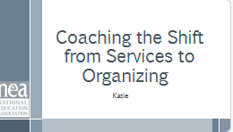  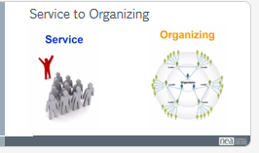  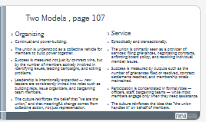  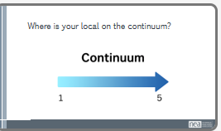  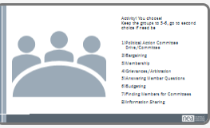  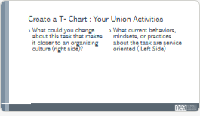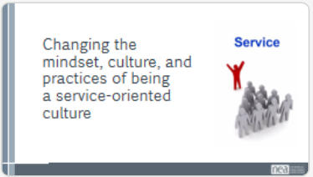  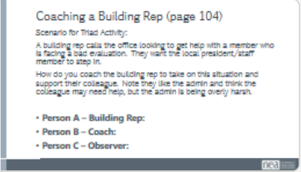  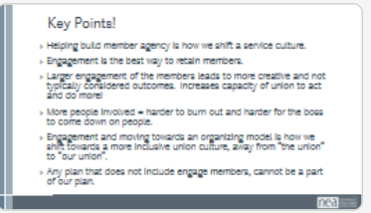 |  |  |  | Services to Organizing: 20 min  We spend a lot of time talking about the need to shift from service to organizing. However, the reality is- members have expectations of their union. They want services and help. Which is reasonable and will always be a core of our unions' work. However- how we respond to or structure supporting members with their concerns/requests can help transform our unions. Let's start by examining the hall marks of a service culture and an organizing culture. If we are going to shift our systems towards being more inclusive/centering people/and involving them- the move towards an organizing model is critical.  Service model is episodic. Focused on numbers- members, grievances solved/filed, bargaining, participation is linked closely to established roles, information is funneled through only a few select positions, focused on delivery of support or contract/board policy enforcement. Bargaining is led by staff and a few members.  Organizing model is continual- it shares a vision that is developed by members, it is the number of new leaders invited into the work of the union, the number of building reps taking on grievances/issues, its focused on the number of members involved in solving problems. The message is carried forward by a large group of people. Bargaining is lead by member committees with many many members involved.  Looking at the slide and the definitions, on the spectrum- where would you place your local. Hold up a hand that reflects where your local is. 1 being total organizing model 5 being complete service model.  Quick Share out from the group- why did you rate yourself this way- share out one function that you believe show cases your personal rating.  Activity: Take an activity your local consistently does. Allow people to self select to review the following topics (or have them choose):  - PAC Drives,  - Bargaining,  - Membership,  - Grievances/Arbitration,  - Answering Member Questions,  - Budgeting,  - Finding Members for Committees.  - Information Sharing  Create a T-Chart for each activity: What are some current hallmarks of this task that are a service culture (left side)? What could you change about this task that makes it more of an organizing culture (right side)?  Each group shares out what marks these for service and what they could change about them to move into an organizing culture.  Changing the mindset, culture and practices of being a services (30 minutes)  Say out loud: Who here as gotten the call from a member that wants their time and energy right now? Many of us have. Quick turn and share, what is so hard about this moment? How could we change this moment to reflect an organizing culture? How might we coach a leader navigating this shift?  Refer to Problem Solving: From Good Service to Centering Worker Agency  Activity: A building rep calls the office looking to get help with a member who is facing a bad evaluation. They want the local president/staff member to step in. How do you coach the building rep to take on this situation and support their colleague. Note they like the admin and think the colleague may need help, but the admin is being overly harsh.  Get into triads- 1 person is the building rep calling, 1 person is the coach, 1 person observes.  Share out- what was something you heard that resonated/changed your mindset?  Key Points (5 minutes):  - Helping build member agency is how we shift a service culture.  - Engagement is the best way to retain members.  - Larger engagement of the members leads to more creative and not typically considered outcomes.  - Engagement and moving towards an organizing model is how we shift towards a more inclusive union culture, away from “the union” to “our union”.  - Any plan that does not include engage members, cannot be a part of our plan. |  |  |  | Participants will learn the difference between the service and organizing models. They will learn how to take a task and change it from a service model to fit into organizing model culture.  Participants will learn to coach members/leaders into building their own agency. Rather than doing for the members (service) they will learn how to coach members to use their agency (orgnaizing).
12pm-1pm  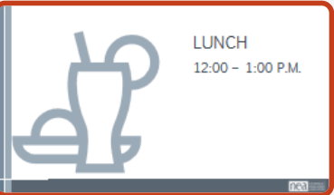 |  |  |  | LUNCH
1pm-1:10pm | Carrie |  |  | Grounding + Check in
1:10pm-1:55pm | Bekah |  |  | Assessments to Guide Coaching – 45 min
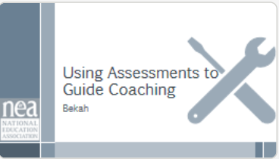  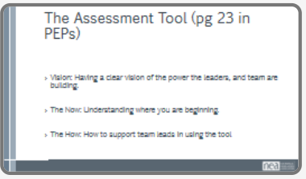  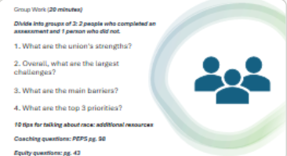  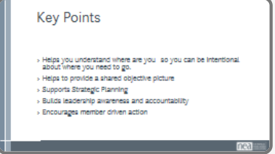 |  |  |  | - Assessment Tool  Present and Discuss Tool: 10 min  Winning impactful change requires a certain amount of membership and community power. Using that strength and achieving wins in ways that are visible helps us with another factor in building power – growing membership, developing leaders, building organizing structures, and stronger community alliances.  This Assessment Tool for Local Strength and Growth helps a team in a local understand where they are at and develop sharpened goals and priorities for the work ahead.  This proactive evaluation can identify strengths and weaknesses, highlight areas for growth, and ensure the union remains relevant and powerful.  Emphasize: The assessment is a critical tool to building a strong union no matter where you are at. Unions with success in campaigns and organizing need to conduct assessments to know where to prioritize areas for improvement and buid plans for the organizing structures to be maintained. The assessment can help locals unions that are just in the early stages of deepening member participation organizing to get to majority or win their first contract know what to prioritize.  In the Campaign Lab, we are using the Self Assessment of Local Strength and Growth Framework. This is a compilation from a number of “effectiveness tools” and input from folks like you.  Here is how you use it. First it is simply a planning tool. There are five broad categories  - Organizing and Engaged Membership  - Bargaining and Worksite Advocacy  - Communications  - Member Education  - Infrastructure  Each Category is separated into key components and then into descriptors. Each member of the Local’s team selects the descriptor in each row that BEST describes their local – nothing is going to be a 100% match. The total your ratings for each category. Low score indicates a strength and a high score indicates an area for growth.  These questions are at the end of the assessment and are critical to development an analysis. They can also be helpful coaching questions:  1. Has your local set goals for membership growth and participation? If yes, what are they?  2. What do you think are your organization’s main strengths that will allow you to build a strong union and effective campaign?  3. Overall, which of the areas in the assessment do you think are the largest challenges for your local?  4. In the areas that you’ve identified as your biggest challenges, what are the main barriers your local faces?  5. Which of the above areas do you think should be the top three priorities for your local to address?  Small Group Activity: 20 min  Thank you to the volunteers who completed the assessment tool and agreed to be coached. We are going to break up into groups of 3 (two people with a completed assessment and one without) to practice coaching a leader in understanding what is surfaced in the assessment and develop actionable steps. This will be a fish bowl small group activity where someone will start coaching, and then others in the group will tap into becoming the coach. When a new coach taps in they need to build upon where ever the coaching conversation is at to move it forward.  Everyone get’s a copy of the completed tool that the volunteer participant completed.  Debrief  Key Points

1:55-2:15pm | Kristin | Coaching a Campaign Leader
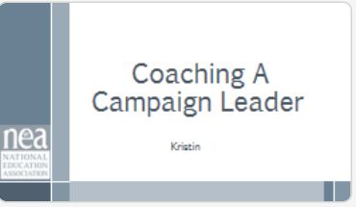  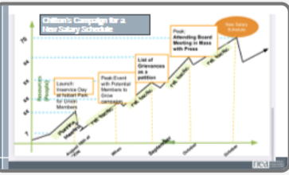  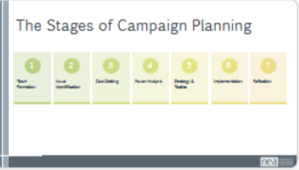  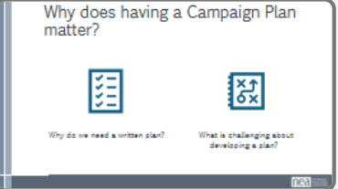  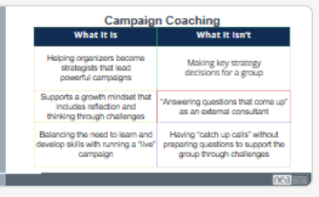  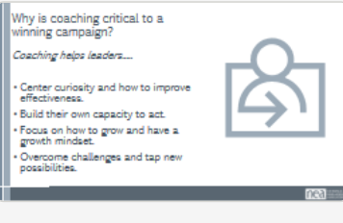  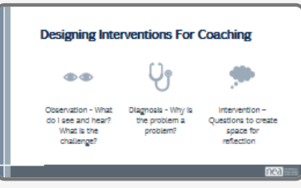  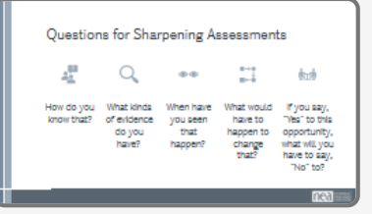  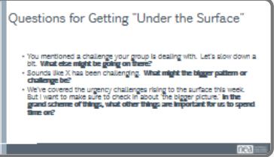  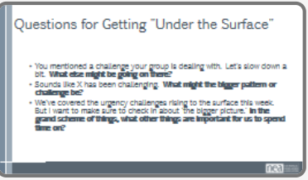  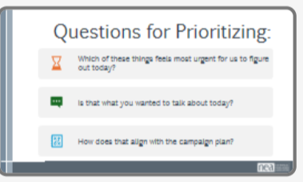  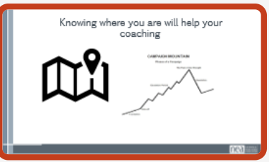  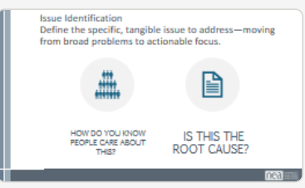  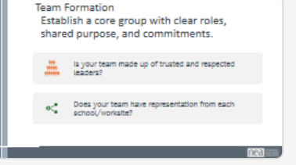  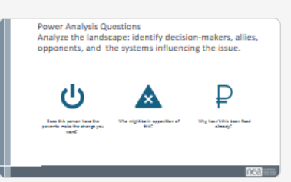  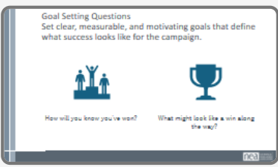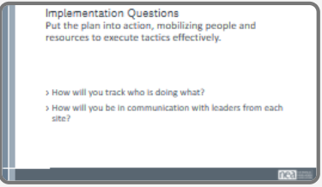  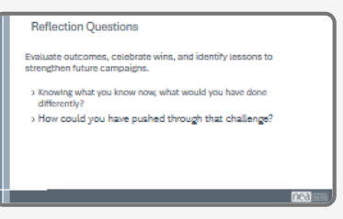  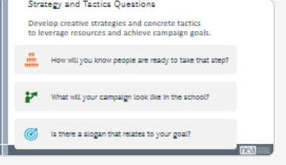 |  | Presentation: 20 min  - Assessment will surface core priorities to incorporate into the campaign such as developing skilled leadership, forming accountable committees, growing and activating the base, including members and communities into decision-making.  - Campaign Plan: Why, How, What  - Campaign Plan is another critical tool needed to support campaign leaders. Why do we need a written plan? What is challenging about developing a plan?  - Share campaign plan tool: Core components of the campaign plan. Acknowledge more training will be available.  - Have participants identify where in the campaign stages the questions are directed to. | Participants understand that a campaign plan is a commitment from their team that they can use as a road map to keep the team on course. Coaches understand they may not SEE the plan but they should know how a campaign should escalate to incorporate more members.
2:15-2:30pm  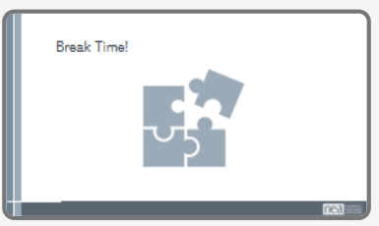 |  | BREAK (or we can do a break at 2pm before Small Groups)
2:30pm-3:15pm | Kristin – 45 min | Activity: Coaching Campaign Leaders
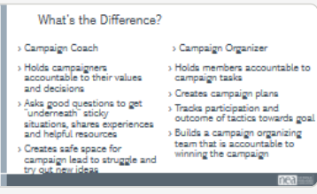  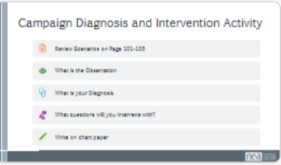  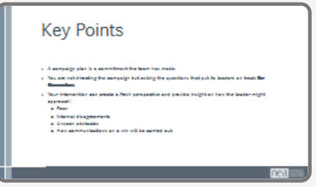 |  | - Post break refresh on the goals of coaching a campaign leader. You are not the organizer of the campaign.  - Activity: 25 min Small Groups  How might a coach support a leader in developing a campaign plan?  Count off the participants by 3 or 6 depending on the size of the group. Have the participants read their coordinating scenario at their table. Then seperate into their groups.  Each person will then discuss the scenario they read with their group.  On a chart paper each group will collectively identify the Observation, Diagnosis and then write out questions for their intervention with that specific leader that get at the diagnosis the group created.  - Share Out: 15 min  Groups will share observation so that the other attendees who did not read the scenario will understand the story of what’s happening.  Groups will share diagnosis and the questions they created. (If there are multiple groups doing the same scenario have them split the share out and ask if each group wants to add anything after the other team gives their feedback.)  Ask the group to identify where the leader is on:  The Campaign Planning stage  And  What they need with head, hands, heart diagnosis  All participants should share the questions they created to intervene with the leaders in their scenarios. | Participants discuss how member involvement. Sharing work and ASKS are the major driver in moving forward.
3:15-4:05pm | Melissa | Coaching Practice- 50 min
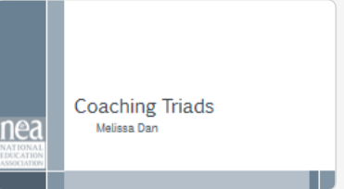  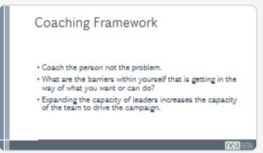  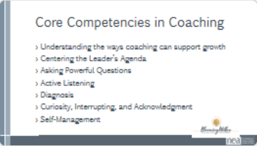  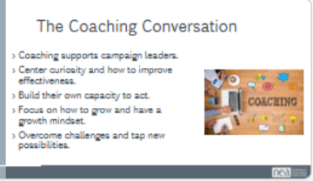  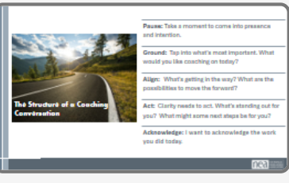  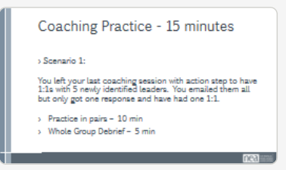  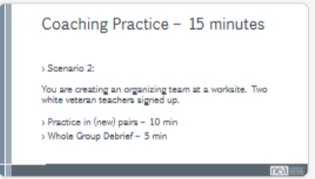  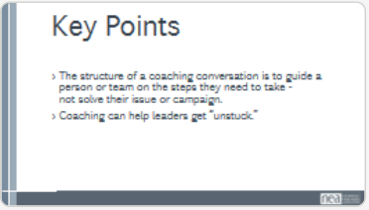 |  | - Framing - 10 min (look up coaching prompts in guide)  (Present/large group discussion)  From a coaching framework: Coach the person not the problem. What are the barriers within yourself that’s getting in the way of what you want to or what you can do.  Expanding the capacity of leaders increases the capacity of the team to drive the campaign.  Slide: Let’s review the core coaching competencies  Slide: Let’s review the structure of a coaching conversation  - Small Groups Activity - 30 min  Tackle a common challenge in leadership moving towards building a strong organizing culture and taking risks or addressing fear in a campaign.  Coaching Pairs Activity: 30 min  - (15 mins.) Round 1 – Scenario: You left last coaching session with action step to have 1:1s with 5 newly identified leaders. You emailed them all, but only got one response and have had one 1:1.  - Practice in pairs (10 mins.)  - Whole Group Debrief (5 mins.)  - (15 mins.) Round 2 – Scenario: You are creating an organizing team at a worksite. Two white veteran teachers signed up.  - Practice in pairs (10 mins.)  - Whole Group Debrief (5 mins.)  Wrap up: 5 min  What is coming up for you as you practice your coaching skills? What challenges did you face coaching through these scenarios?  Key Points: 5 min  - The structure of a coaching conversation is to guide a person/team on the steps they need to take - not solve their issue/campaign.  - Coaching can help leaders get “unstuck.”  - Guide on the side vs. Sage on the stage
4:05-4:30pm | Carrie | Debrief day and what’s ahead for next day
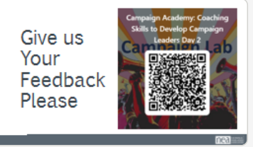  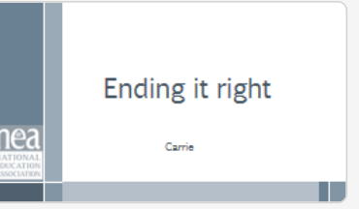 |  | Questions, Connections, Reflections  Housekeeping announcements  Plus/Delta at the Door  FOR TOMORROW –  Outcome: Participants will be able to bring a little closure to their learning and provide feedback on the day.
4:30 – 5:00pm | Carrie | Networking
 |  | This is a time for participants to meet and discuss any issues they are thinking about with other members of the group. This is not led by facilitators and highly encourage to occur in any other space besides the conference room. , Participants will make useful connections with staff from other affiliates.

- Finished 30 minutes early. Add 30 more minutes of content.
- Cut out grounding after lunch to add content.

