Facilitator Agenda – DAY 1 Coaching Skills for Developing Campaign Leaders
General Materials Needed: |  |  |  | Room Set-up: 80 people max
Name Tents with the Norms  Room signs, Stick on Name Tags  Chart Paper (10 full w Sticky Strip) | Materials Box for each table with:  Markers (Mr. Sketch variety)  Post its – 3x3” and 4X5” sizes |  |  | Long Rectangle table at back for facilitators  Round Tables for participants  Projector, Screen, mics, and Speakers  Carousel stations and reporting stations
Key Outcomes for the Event:
(Campaign Lab Team Leads and Coaches) March 13-15, 2026 Oklahoma City, OK
- Explore how coaching can be a leadership development practice that expands the capacity of leaders to build organizing power and impactful campaigns.
- Develop core coaching skills including asking powerful questions, learning to self-manage and centering the agenda of those being coached.
- Learn how to coach common challenges in leadership, centering equity and shifting from a service to organizing model of unionism.
- Learn how to assess affiliate readiness and capacity to focus on multi-issue, multi-constituency work, and coach a leader to define goals and priorities for growing the strength of their local union.
- Develop a shared understanding of institutionalized and structural systems of oppression and apply power analysis and research methods.

Overview of Day Time, and Facilitator Assignment - Bekah, Salina, Zac, Melissa, Katie, Carrie, Kristin
7:0-8:30 Breakfast  8:30 -9:00 Welcome  9:10-10:00 1.1 Coaching Overview  10:00-10:15 Break  10:15-11:30 1.2 Coaching Towards Alignment  11:30-12:00 1.3 Self Management  Lunch – 12:00 -1:00 |  | ALL  Carrie  Salina  Zac & Kristen  Bekah  ALL | 1:00 -1:30 Curiosity  1:30-2:15 1.4 Head Heart Hands Diagnosis  2:15-2:30 Break  2:30-3:15 Coaching Leadership Challenges  3:15-4:10 Diagnosis in Coaching  4:10-4:30 Closing  4:30 -5:00 Adult Choice Networking  5:00 Adjourn |  | Melissa  Katie  Melissa  Katie  Carrie  All

Time Slides Facilitator | Resources | Instructions, Activity and Debrief (Facilitator Script) | Essential Questions and Outcomes
 | Charts, handouts, articles, materials, slide | What are you saying, what are they doing, what questions will you use to guide learning and make clear the important points  Include an estimate for how long each section of the learning will take | What question(s) will this learning answer? What will participants know or be able to do?
7:00 -8:30 – Team prep, practice, room set up, sound check, etc. and Breakfast
Entry Activity

8:30 -9:00Carrie |  | 30 Mins TOTAL Getting Started
 | Norms in Handouts  Agenda on Slides  Parking Lot Chart  Name Tents  Handout Package | Welcome: Land Acknowledgement, Review Agenda, Shared Agreements, Introductions  Framing: As coaches we are supporting leaders as a whole person. We can deepen a leader’s vision, determination and capacity to lead. As Campaign Lab Coaches, we are also guides to support the Team Lead to be rigorous about the process of building a strong union and campaign. | Participants will know how we are going to work, the basic schedule, and the logistics relevant to the training.
9:00-10:00 Salina |  | 60 Mins TOTAL – Coaching
  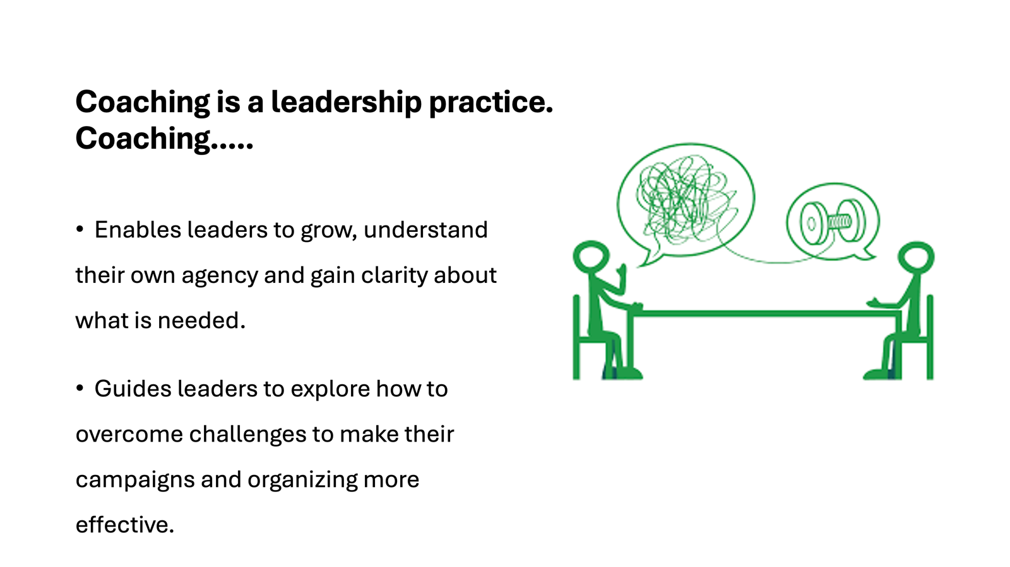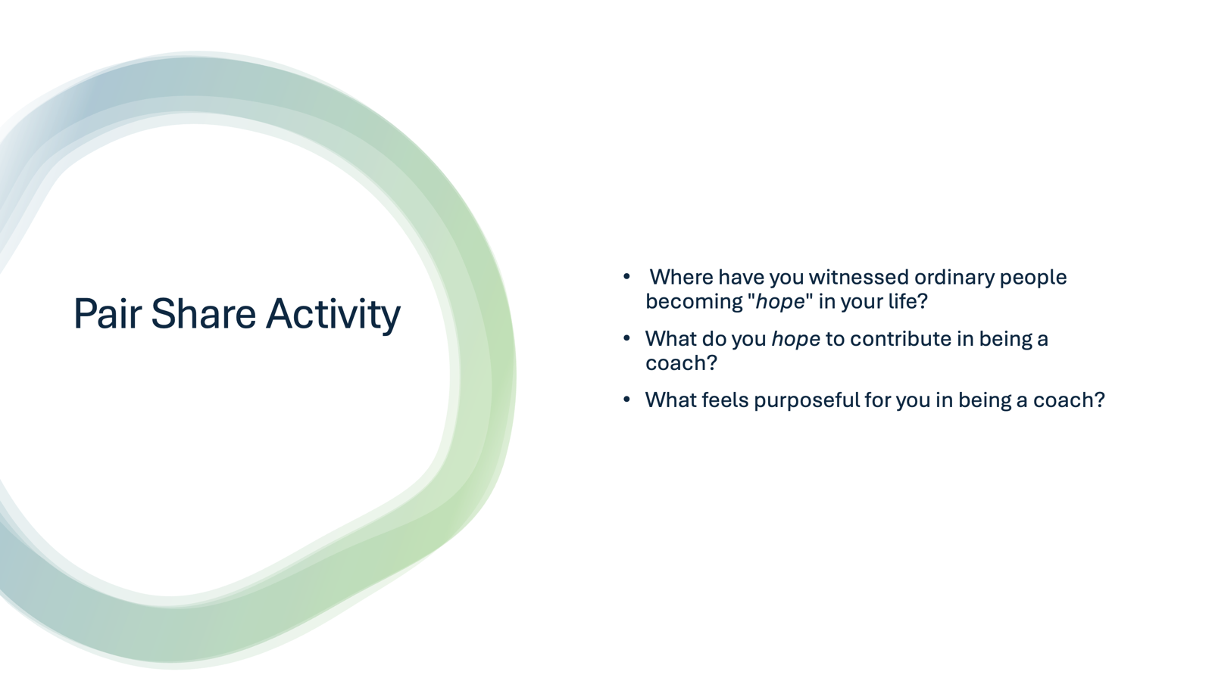  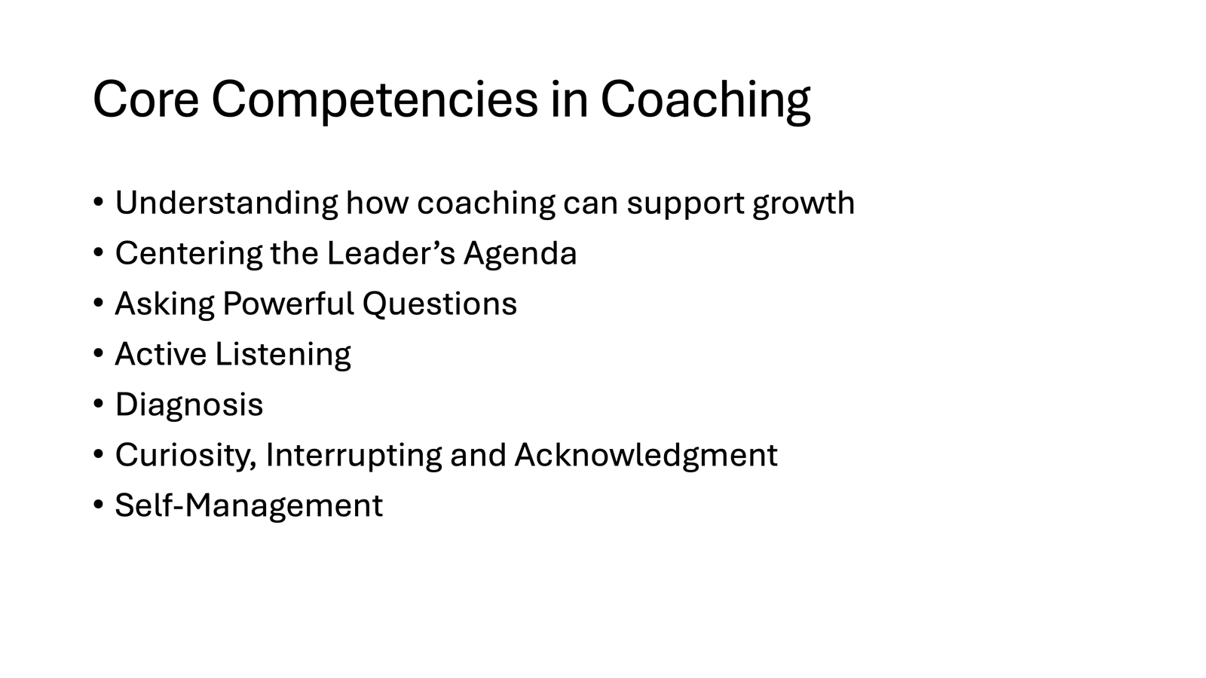  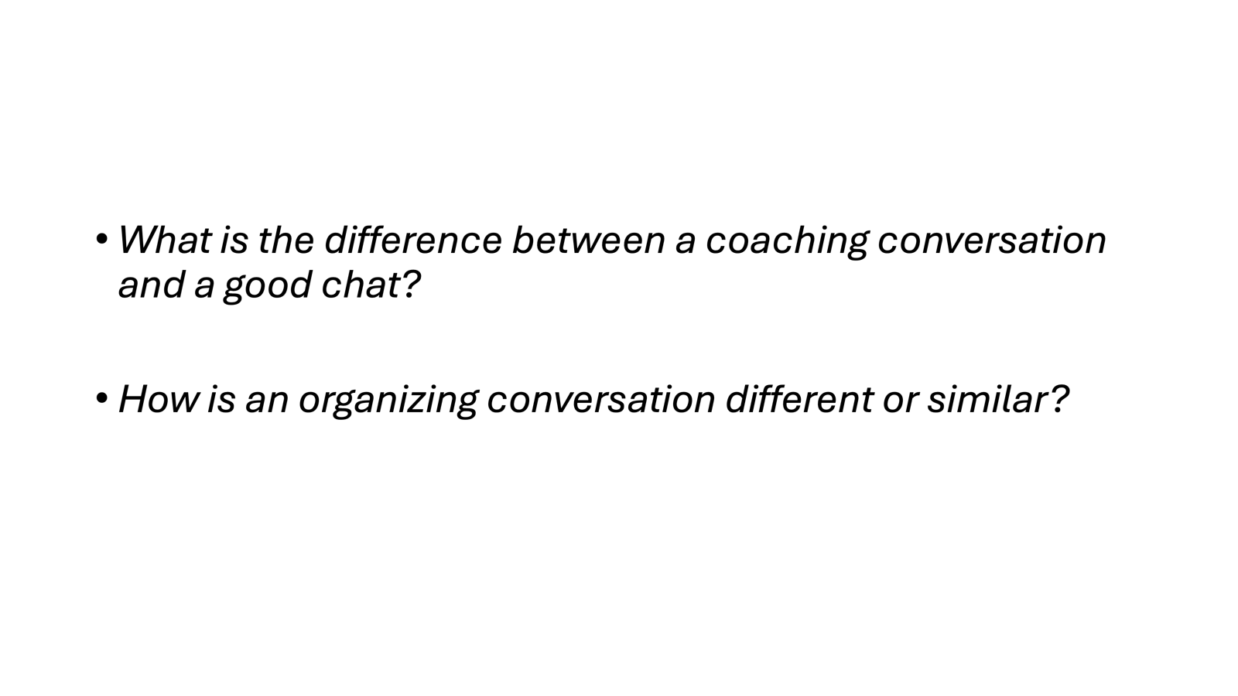  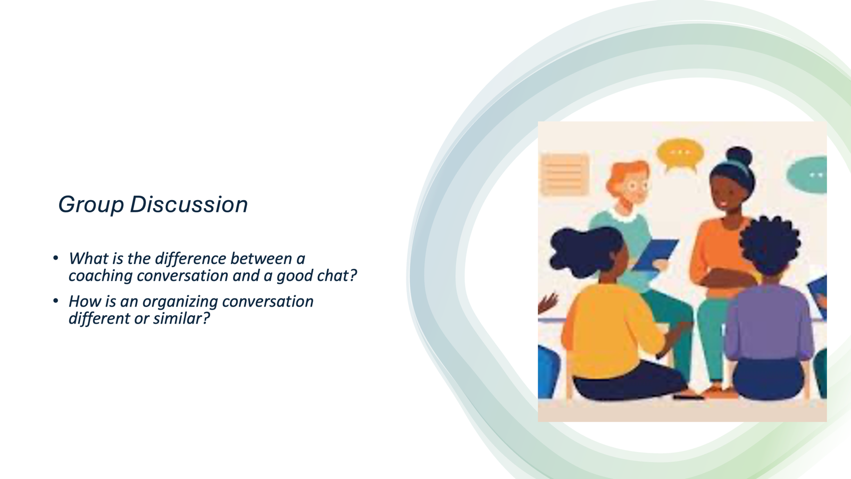  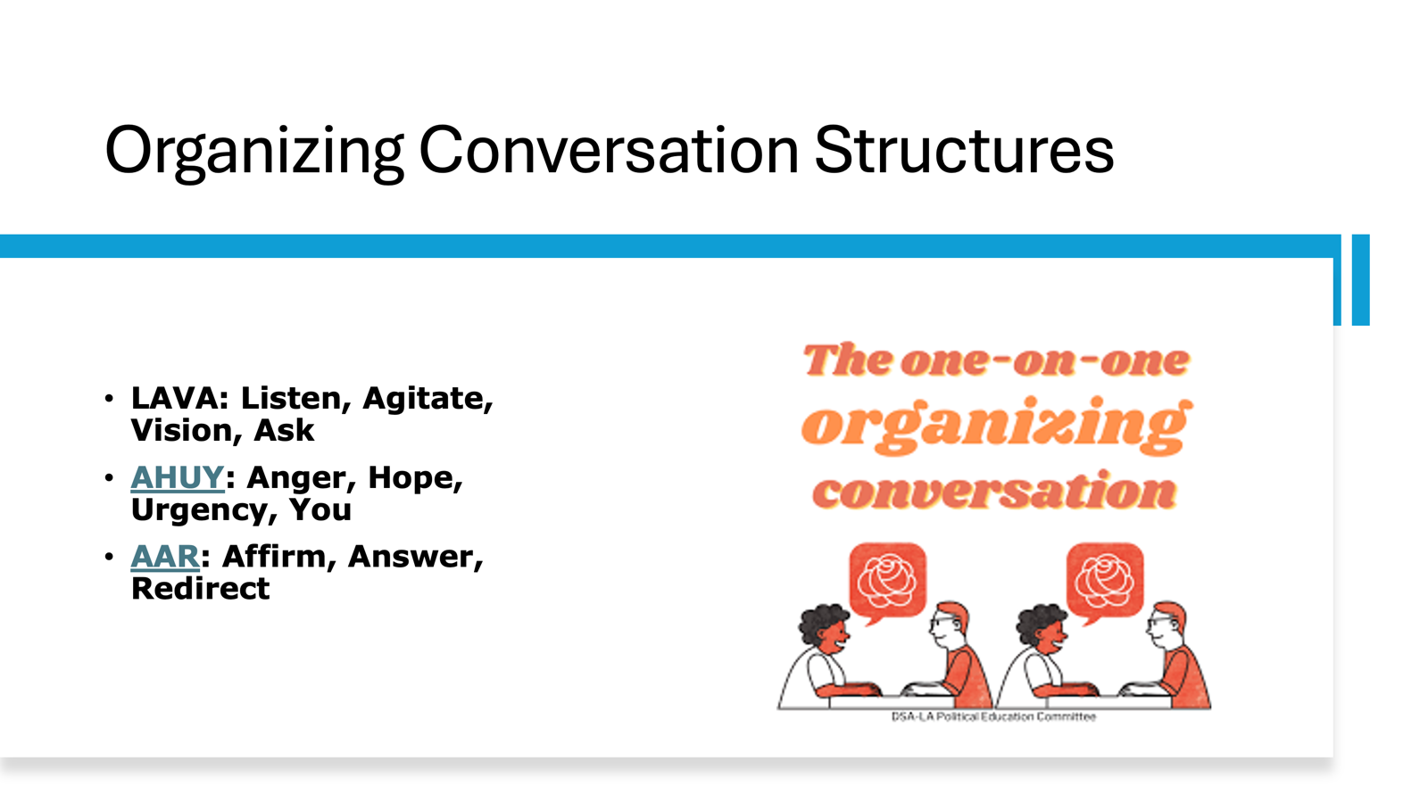  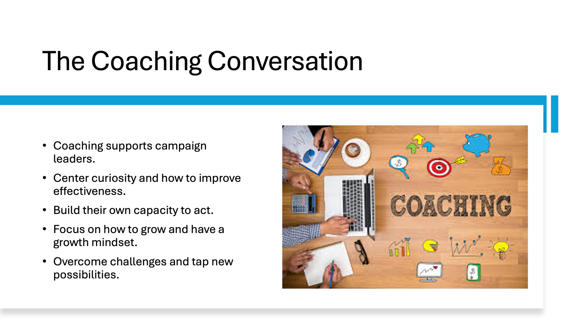  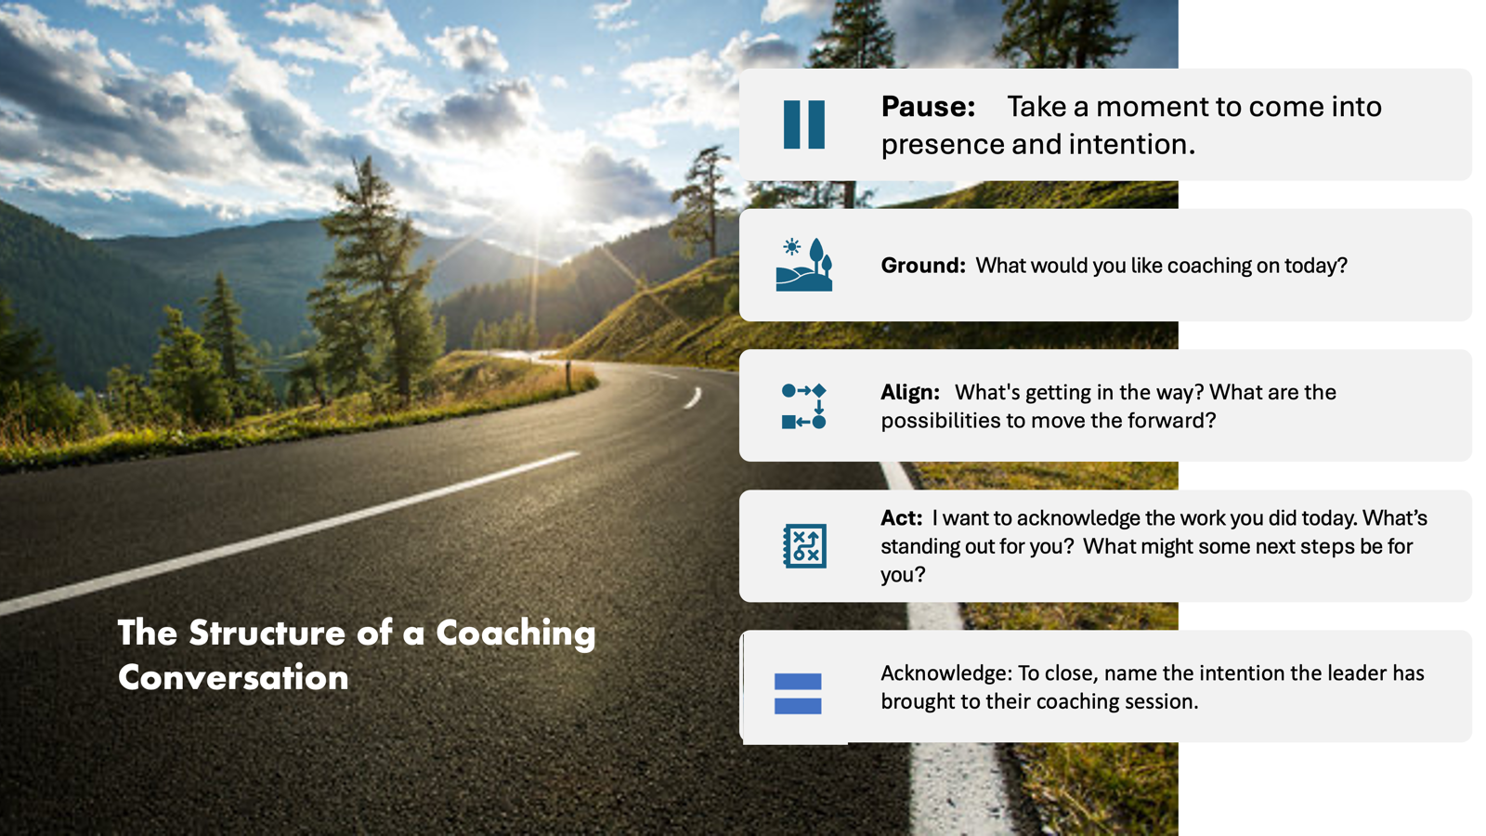  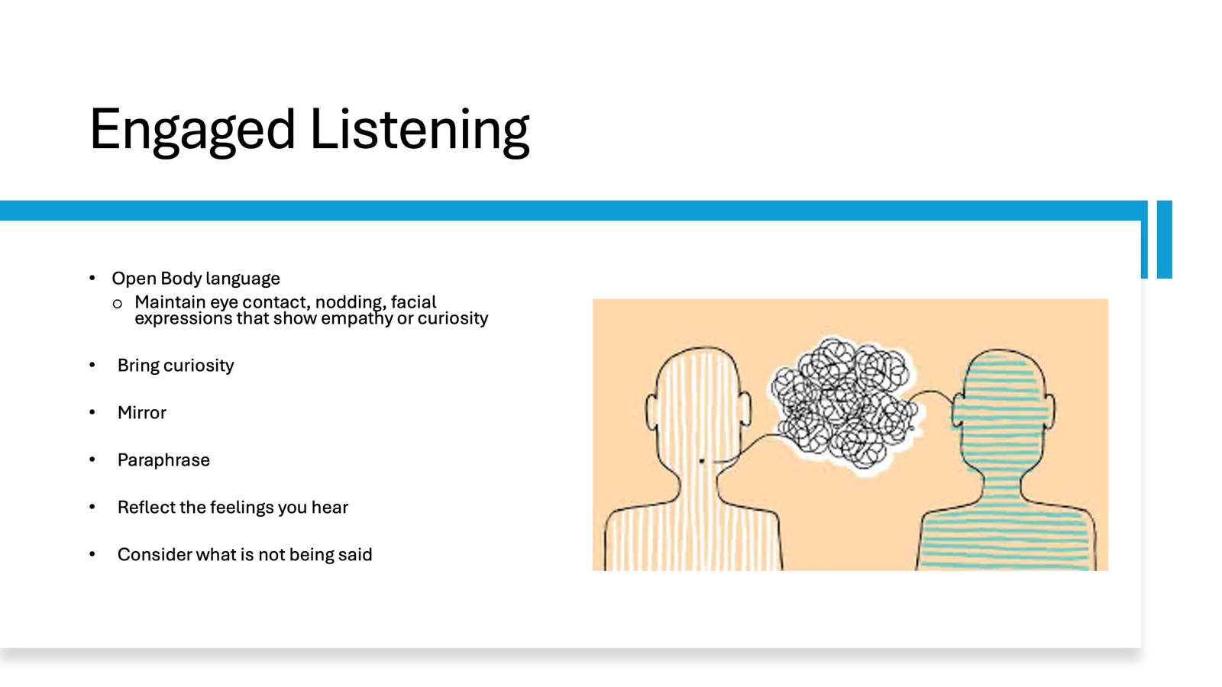  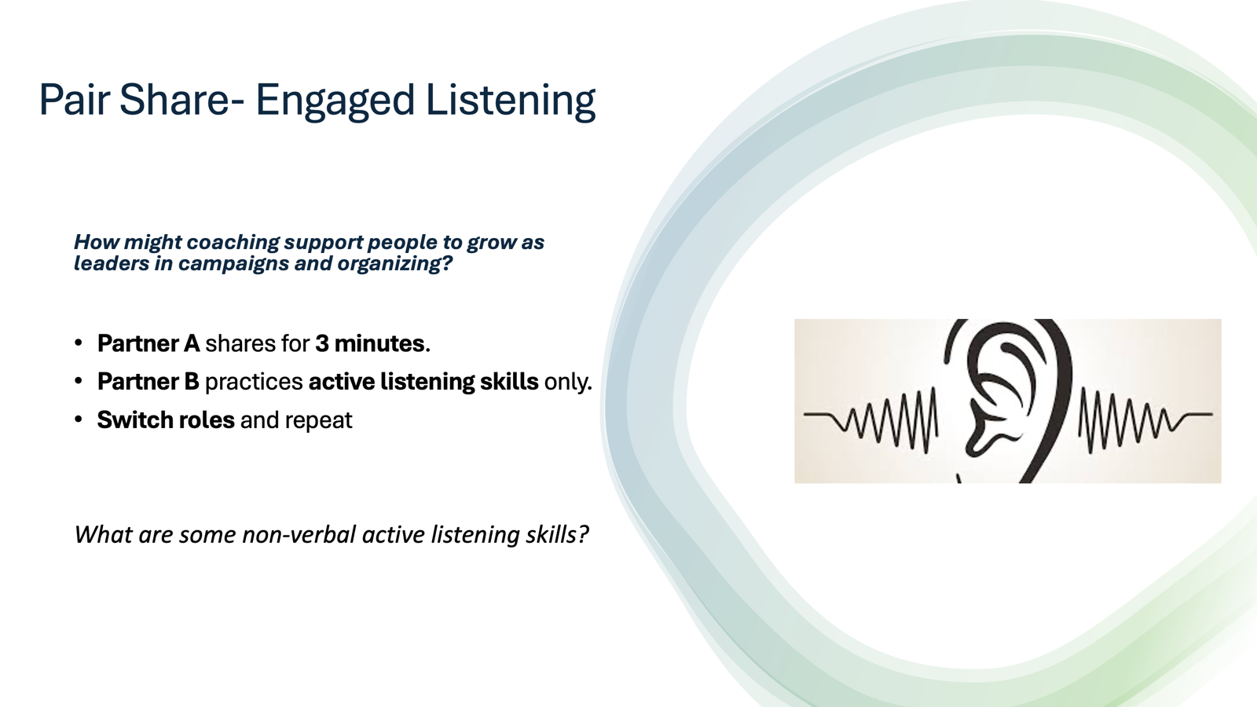 | . | Slide 1: Coaching is a Leadership Practice  Coaching....  Enables leaders to grow, understand their own agency and gain clarity about what is needed.  Guides leaders to explore how to overcome challenges to make their campaigns and organizing more effective.  Slide 2: Poem  People who speak of hope  Are themselves hope.  People looking for a new way  Are themselves a new way.  In truly good people  Is already a good world.  It is within people  It begins with people.  Again  People are the only hope.”  By Park No-Hae – Korean labor activist/poet/former political prisoner  (Translation by the amazing coach of movement leaders who recently passed: Helen S. Kim)  Slide 3:  Take a moment to reflect.  Where have you witnessed ordinary people becoming "hope" in your life?  What do you hope to contribute in being a coach?  What feels purposeful for you in being a coach?  Pair with someone you don’t know and share.  Slide 4: Core Competencies in Coaching 10 min  What are some of the core competencies that we need to develop as coaches?  [Share this slide and ask someone to read]  - Understanding how coaching can support growth  - Centering the Leader’s Agenda  - Asking Powerful Questions  - Active Listening  - Diagnosis  - Curiosity, Interrupting and Acknowledgment  - Self-Management  We are going to focus on all of these competencies over the course of the next 2.5 days.  Slide 5: Group Discussion (10 min interactive)  What is the difference between a coaching conversation and a good chat?  How is an organizing conversation different or similar?  Slide 6: The Organizing Conversation  LAVA: Listen, Agitate, Vision, Ask  AHUY: Anger, Hope, Urgency, You  AAR: Affirm, Answer, Redirect  Slide 6: The Coaching Conversation  Coaching helps campaign leaders.....  Center curiosity and how to improve effectiveness.  Build their own capacity to act.  Focus on how to grow and have a growth mindset.  Overcome challenges and tap new possibilities.  Slide: Structure of an Organizing Conversation  Slide 7: The Structure of a Coaching Conversation:  - Pause: Take a moment to come into presence.  - Ground: Establishing the agenda of the leader. What would you like coaching on today?  - Align: Centering their agenda, Ask questions to support greater clarity  - Act: Moving towards action.  - Acknowledge: Acknowledge the intention the leader has brought to their coaching session.  Slide 7: Engaged Listening  Before we go in an activity, let's revisit on a foundational practice to both organizing and coaching conversations - engaged listening.  Open body language. Maintaining eye contact, Nodding. Facial expressions that show empathy or curiosity  Let’s get started. One the person is done. They can indicate by thanking the person for listening. Then the listener can just simple say thank you for sharing.  Slide 8  Engaged Listening Pair Share Framing – 1 min  We are going to do a pair share, and practice active listening.  Reflect: 3 min  Pair Share: 6 min  One person will share for 3 minutes and the other person will just use active listening skills. What are some non-verbal active listening skills?
10:00-10:15 BREAK

10:15-11:30 Zac and Kristin |  | 75 Mins – Coaching Towards Alignment
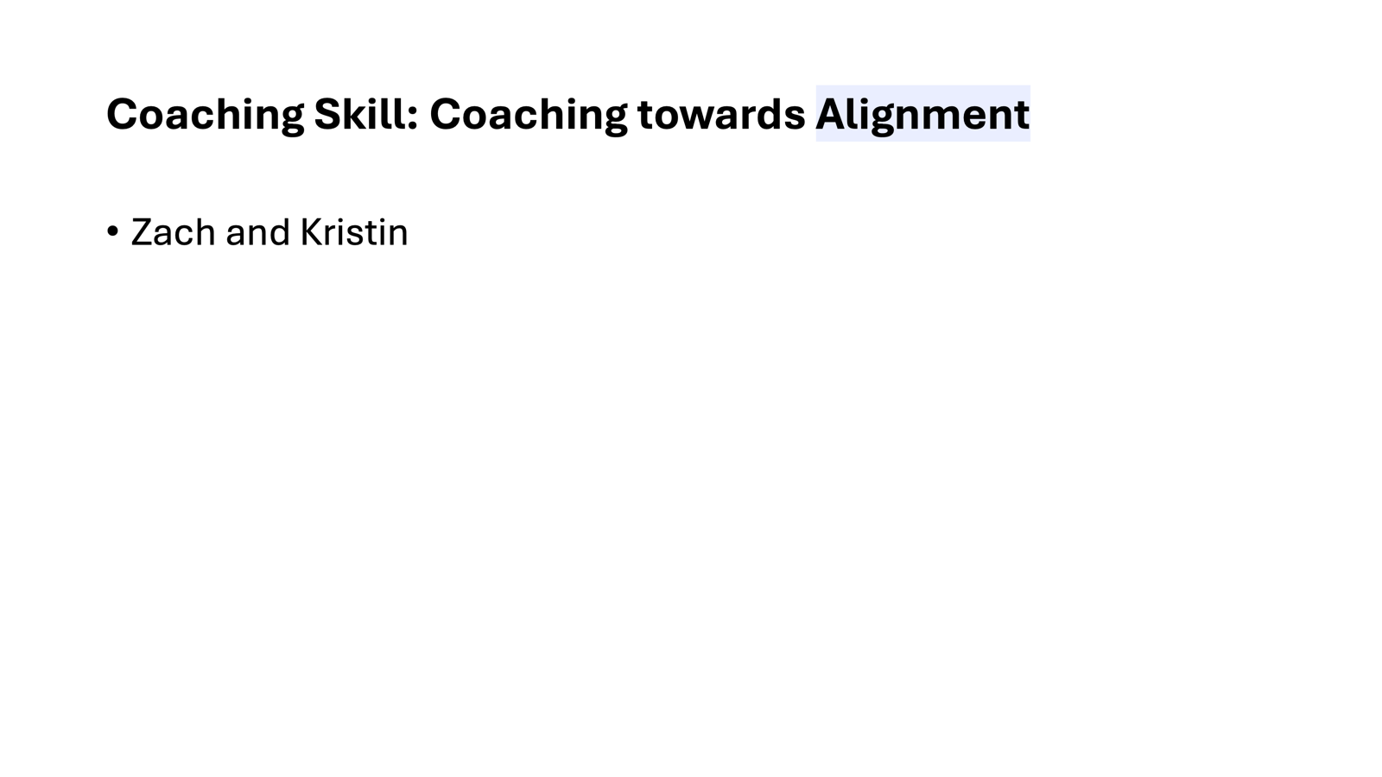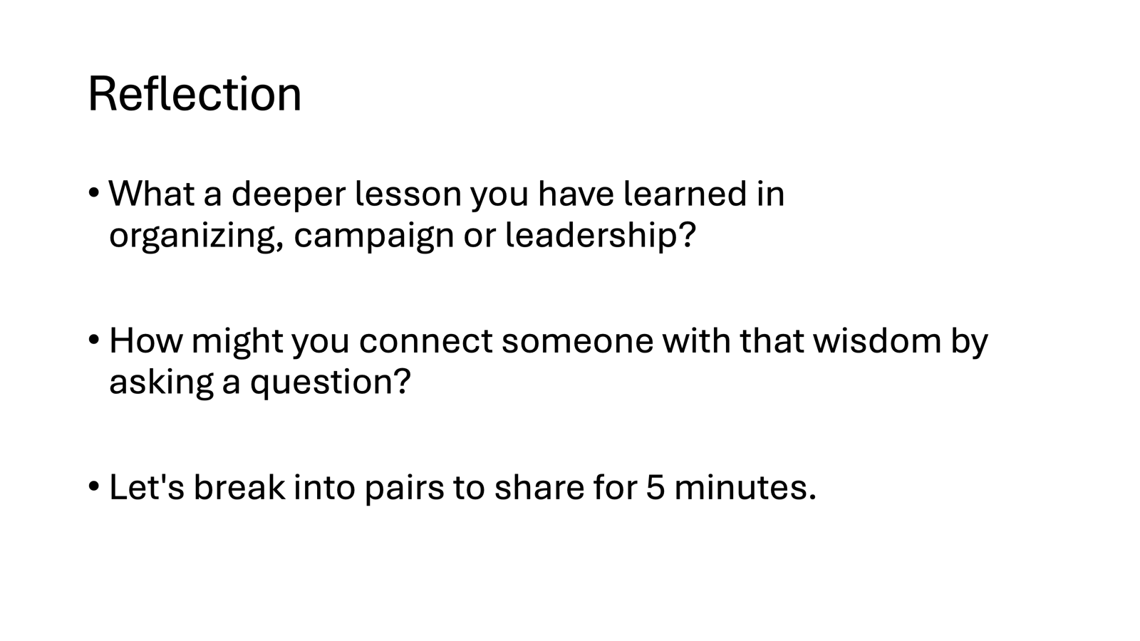  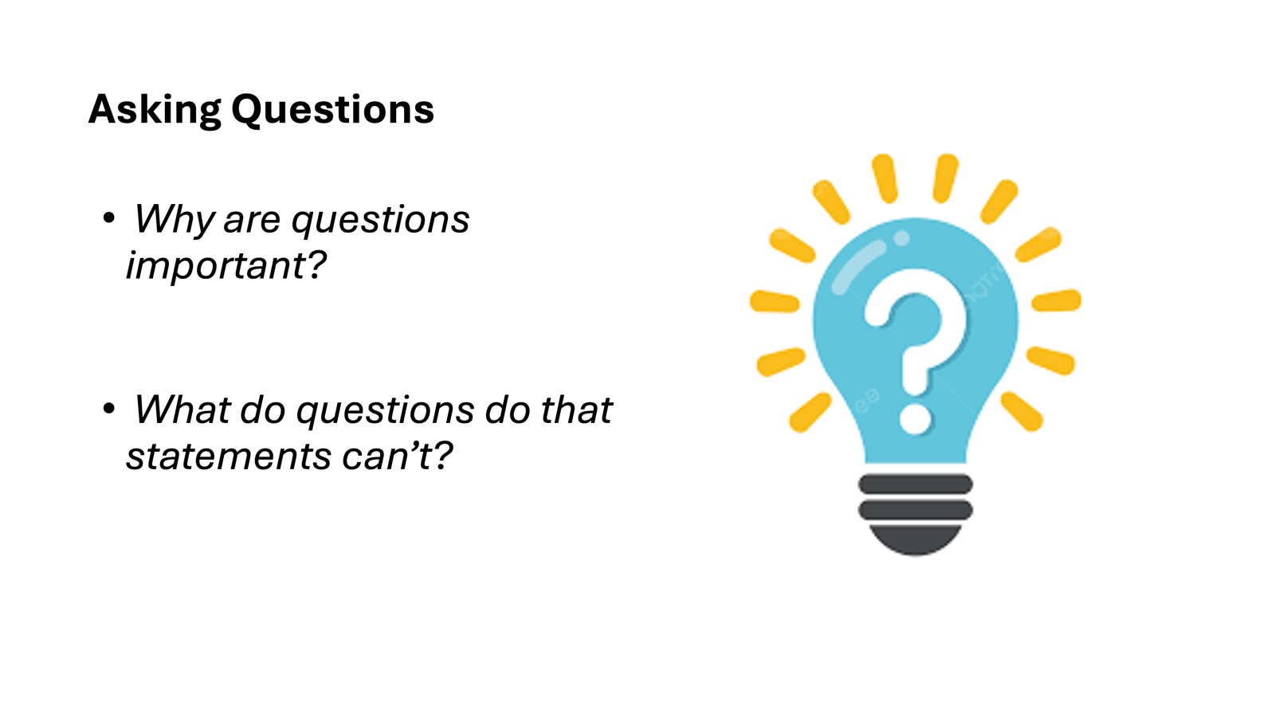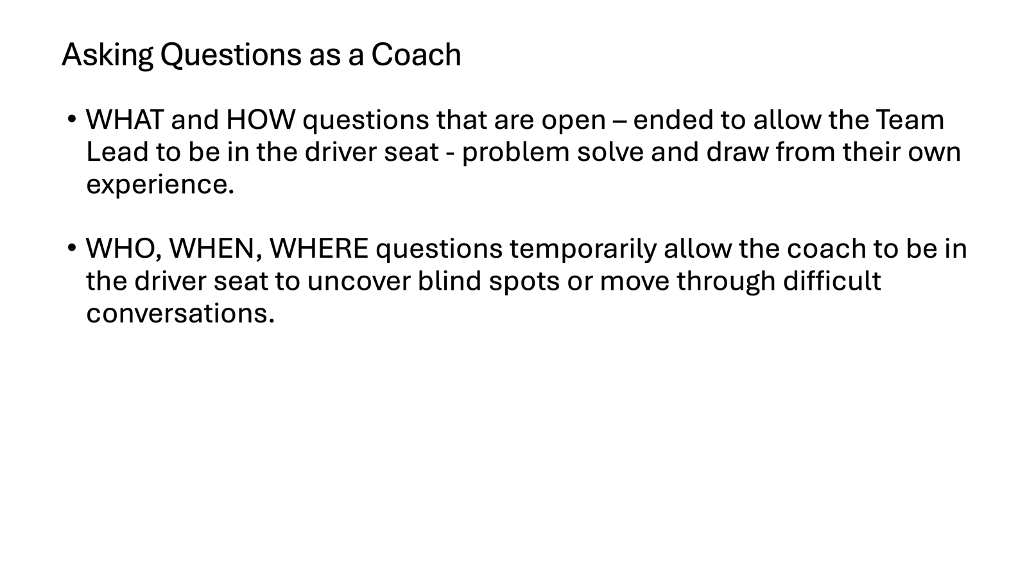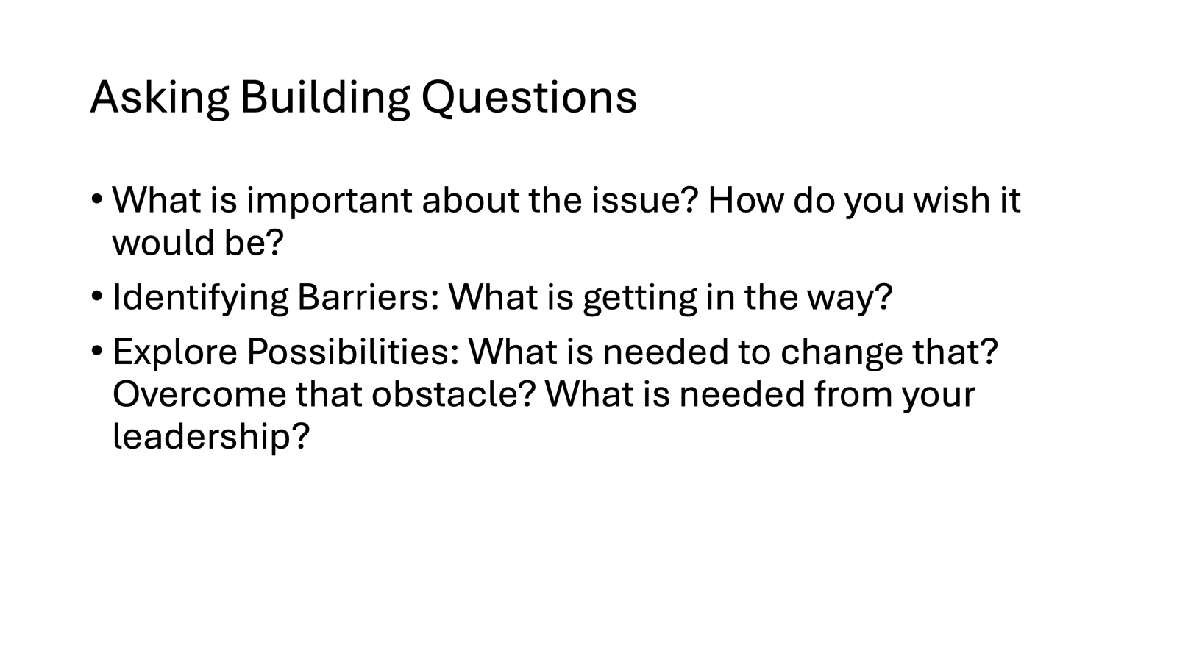  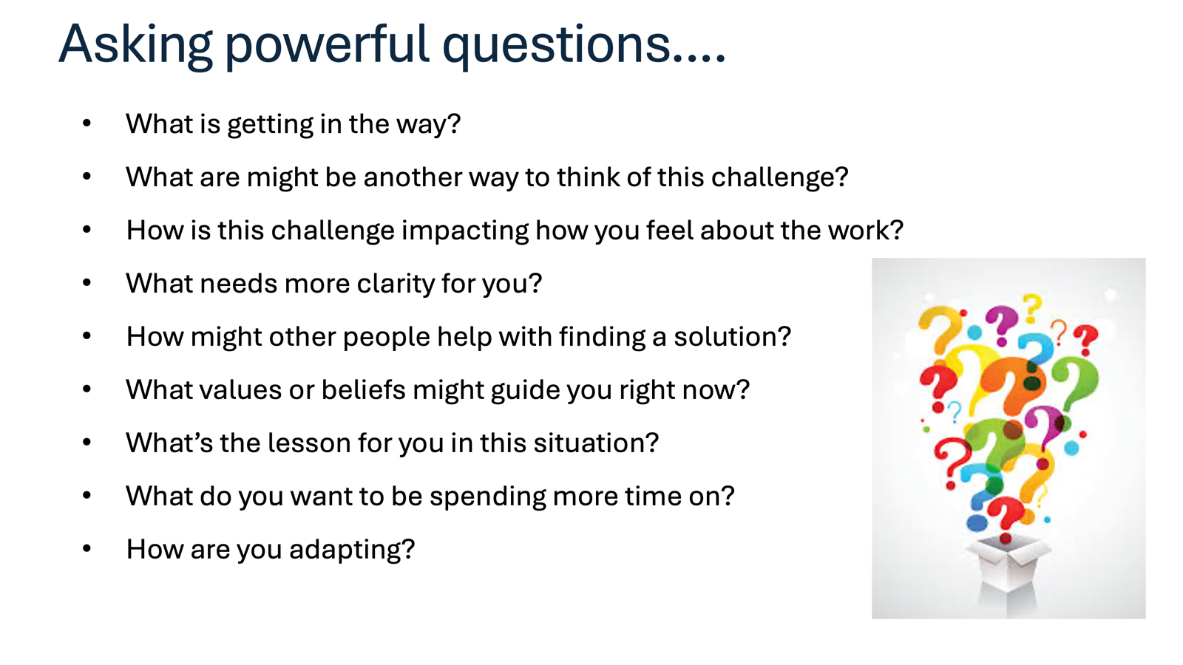  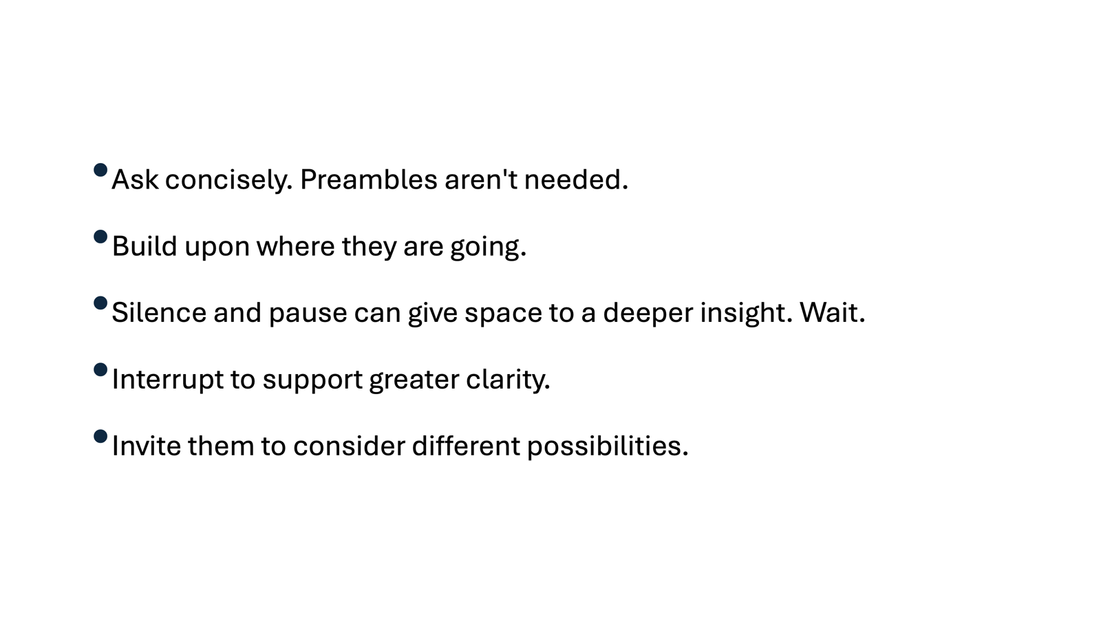  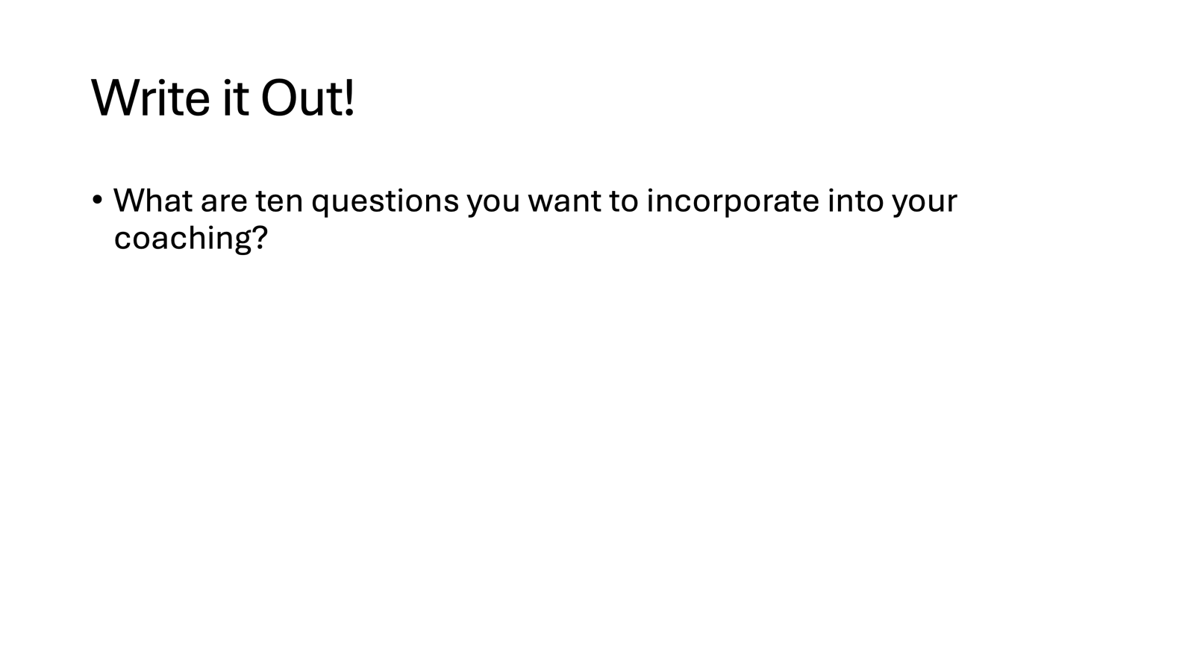  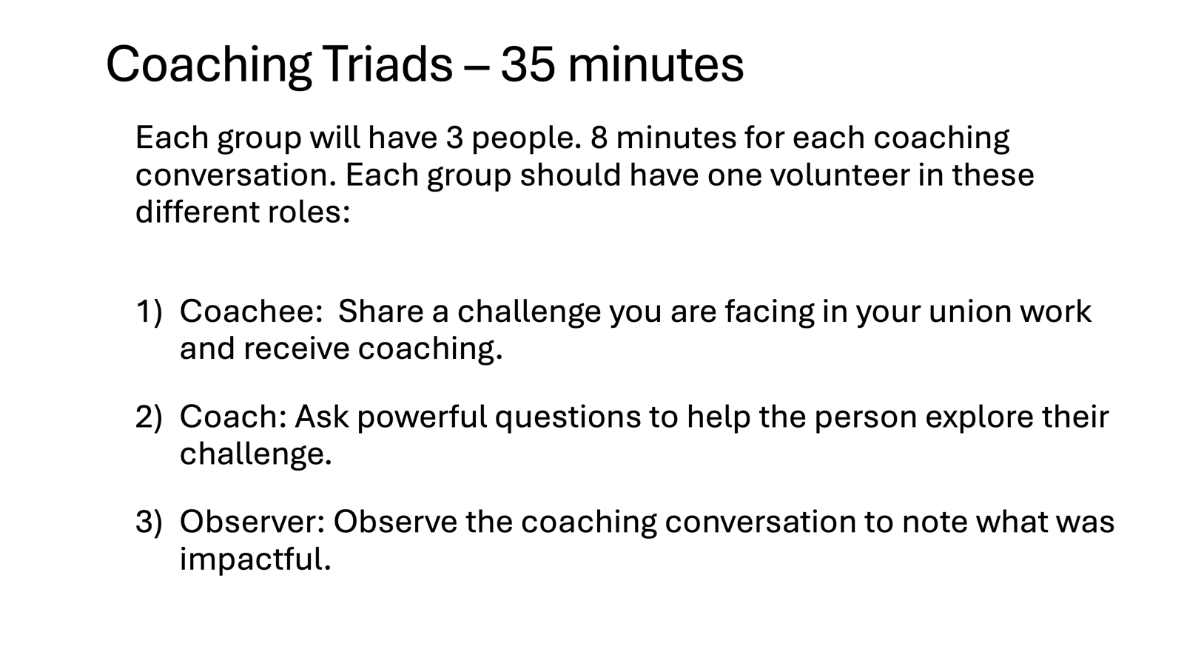  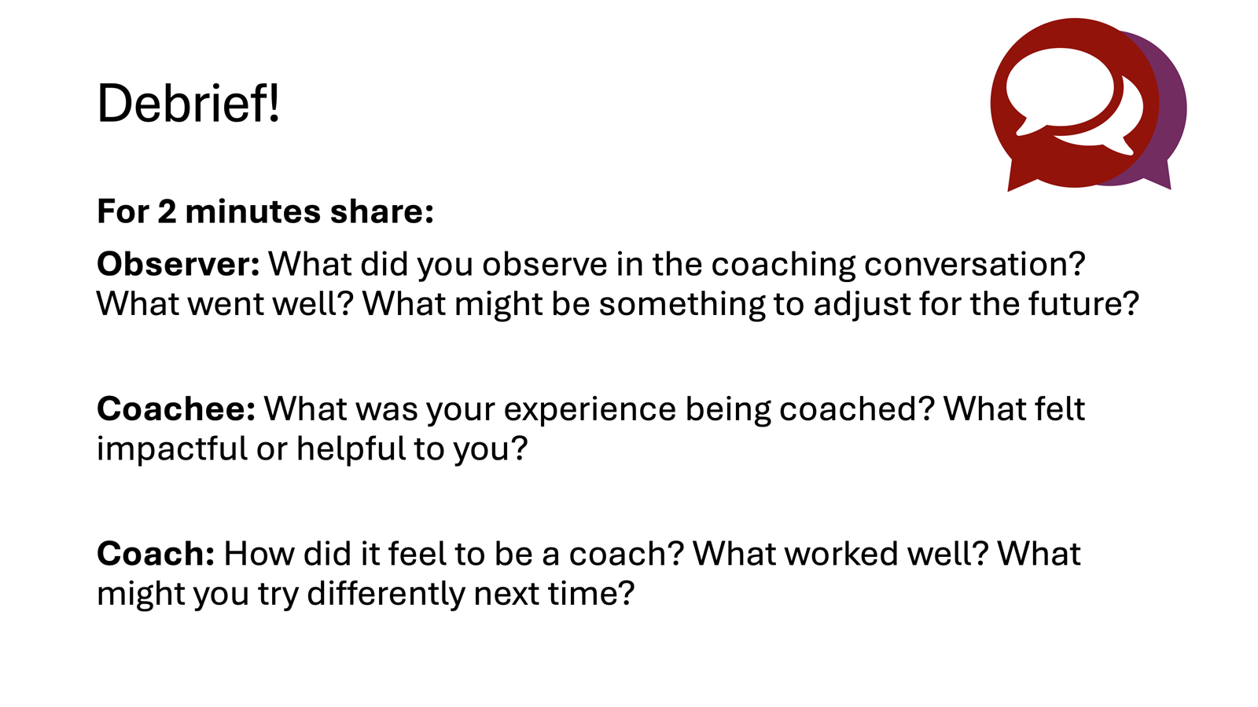  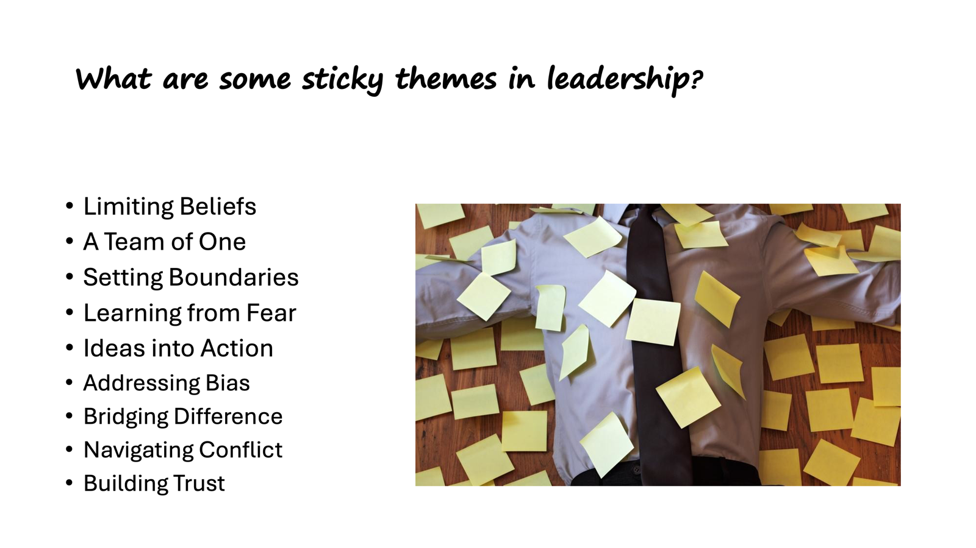 |  | - Coaching Skill: Coaching towards Alignment - 25 min  - Let's start with a moment of reflection. We encourage you to write it down on a sticky note. 10 min (Zac)  - What a deeper lesson you have learned in organizing, campaign or leadership?  - How might you connect someone with that wisdom by asking a question?  - Let's break into pairs to share for 5 minutes.  - Present, Large Room Discussion - 10 min (Kristin)  - ASK: Why are questions important? What do questions do that statements can’t? (brief discussion)  - WHAT and HOW questions that are open – ended to allow the leader to be in the driver seat - problem solve and draw from their own experience.  WHO, WHEN, WHERE questions temporarily allow the coach to be in the driver seat to uncover blind spots or move through difficult conversations.  Ask concisely. Preambles aren't needed.  Build upon where they are going.  Silence and pause can give space to a deeper insight. Wait.  Interrupt to support greater clarity.  Invite them to consider different possibilities.  - Asking Powerful Questions to support deeper insights and clarity, move through limiting beliefs, and fears or deeper issues holding them back.  What is getting in the way?  What are might be another way to think of this challenge?  How is this challenge impacting how you feel about the work?  What needs more clarity for you?  How might other people help with finding a solution?  What values or beliefs might guide you right now?  What’s the lesson for you in this situation?  What do you want to be spending more time on?  How are you adapting?  - Asking Building Questions  What is important about the issue? How do you wish it would be?  Identifying Barriers: What is getting in the way?  Explore Possibilities: What is needed to change that? Overcome that obstacle? What is needed from your leadership?  - Activity: 5 min (Zac)  Write down at least 10 questions that you might like to incorporate into your coaching.  - PRACTICE – 50 min (Zac)  - Center room Role Play Asking Powerful Questions 10 min  - Role play example (Zac coach, Kristen coachee, other facilitator give coaching feedback?)  - Create group count by 15  - Asking Questions: Coach is only allowed to ask questions, and can ask for a life line if they are stuck. Practice coaching.  - Review coaches conversation structure and questions  Triad: 40 minutes
11:30 -12:00 Bekah |  | 30 Mins TOTAL– Learning to Self-Manage
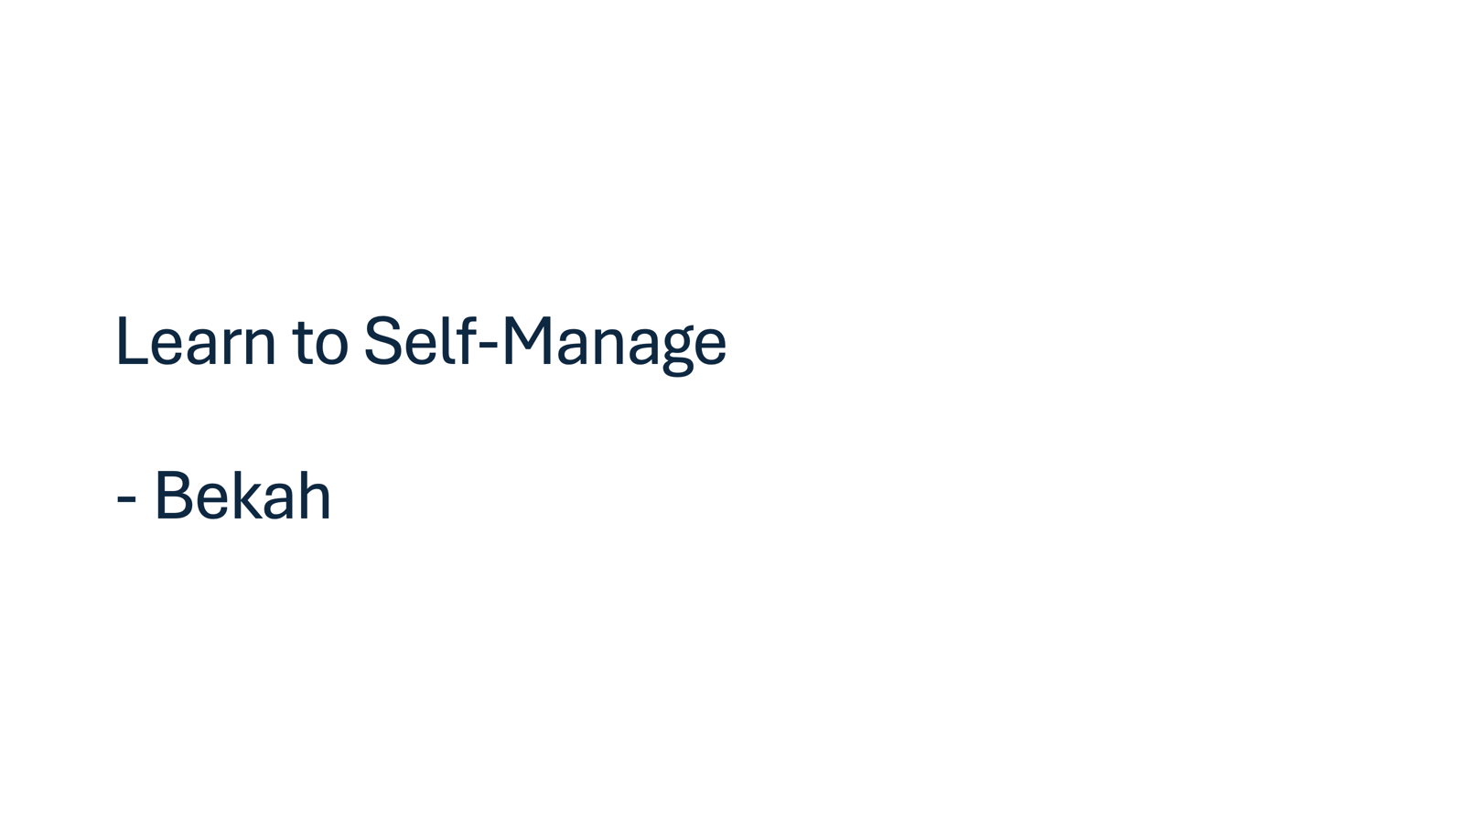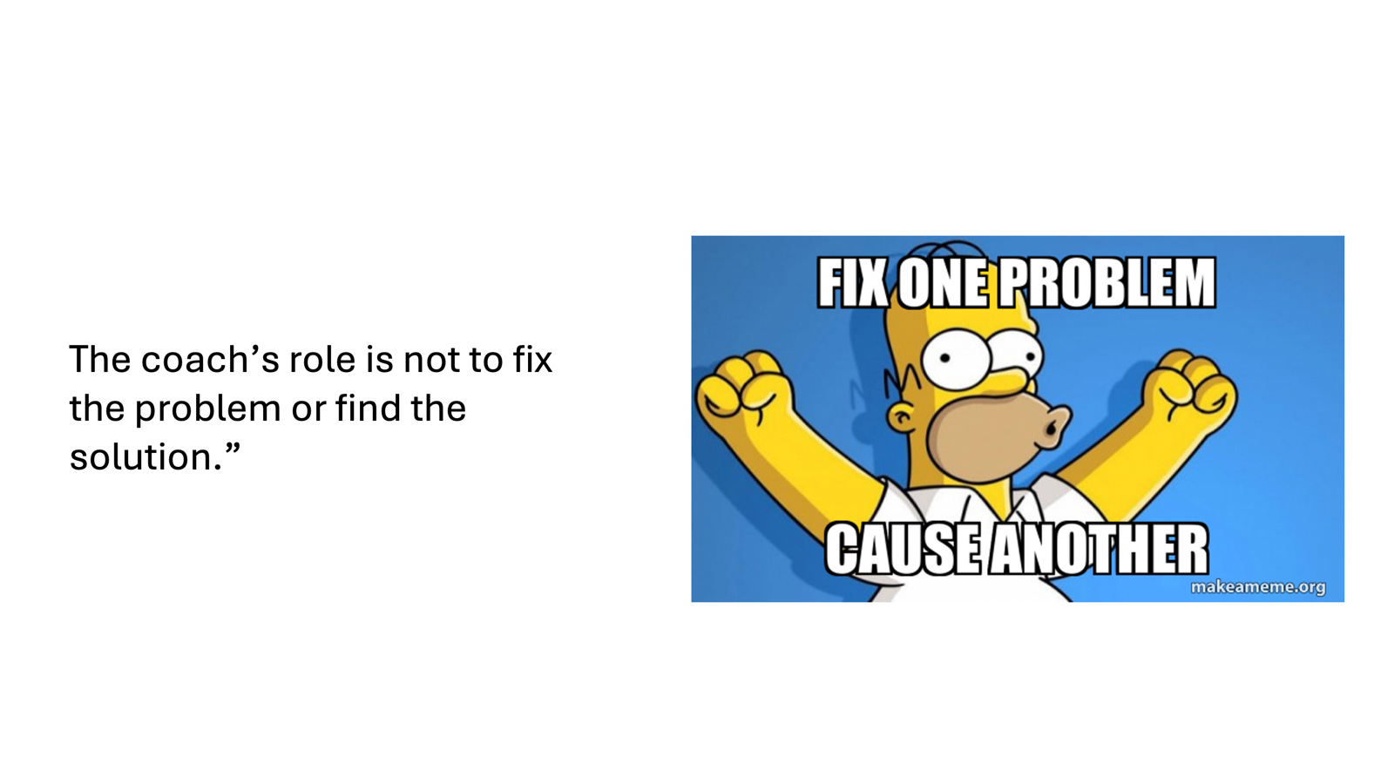  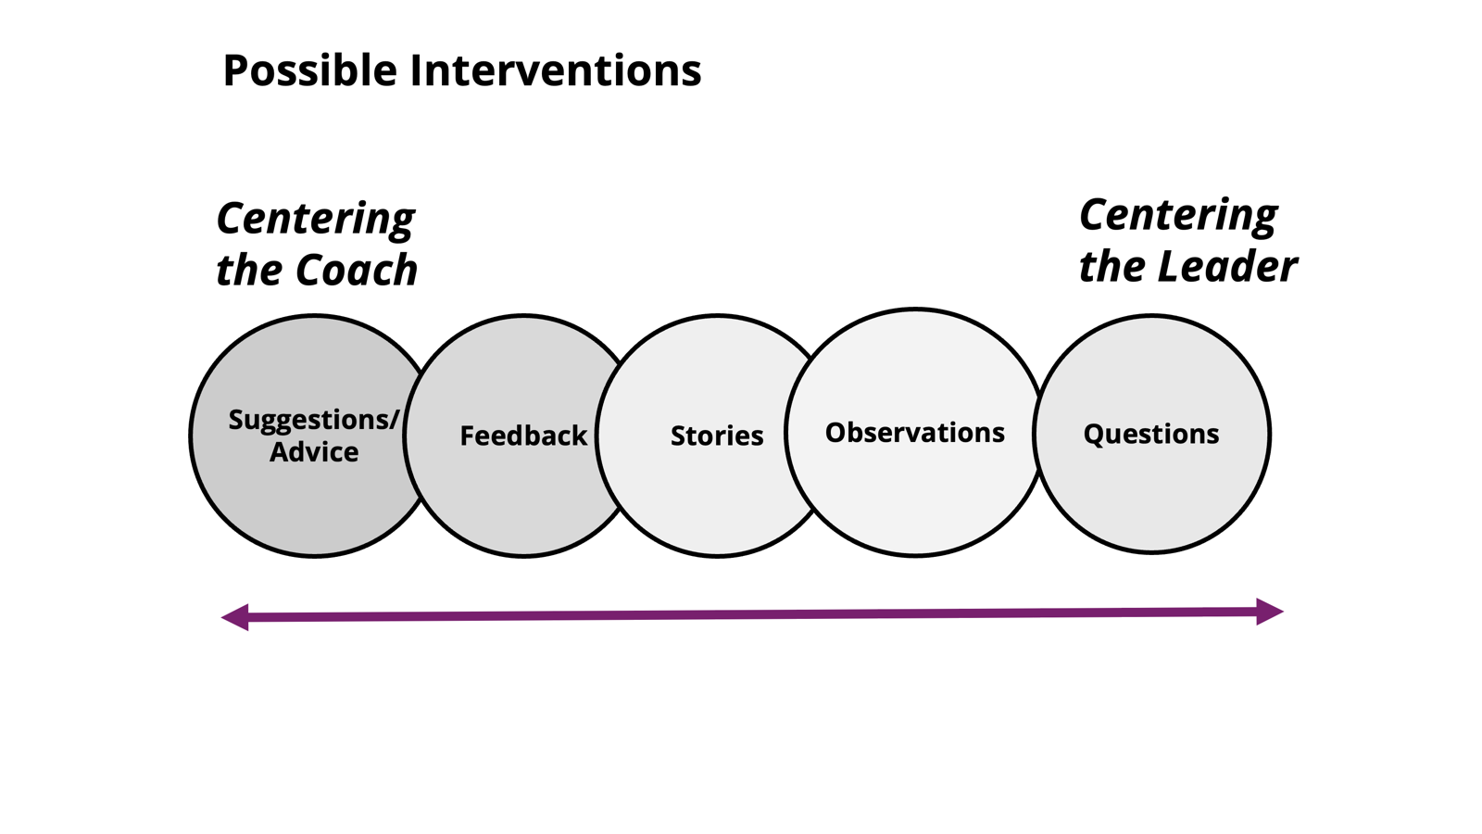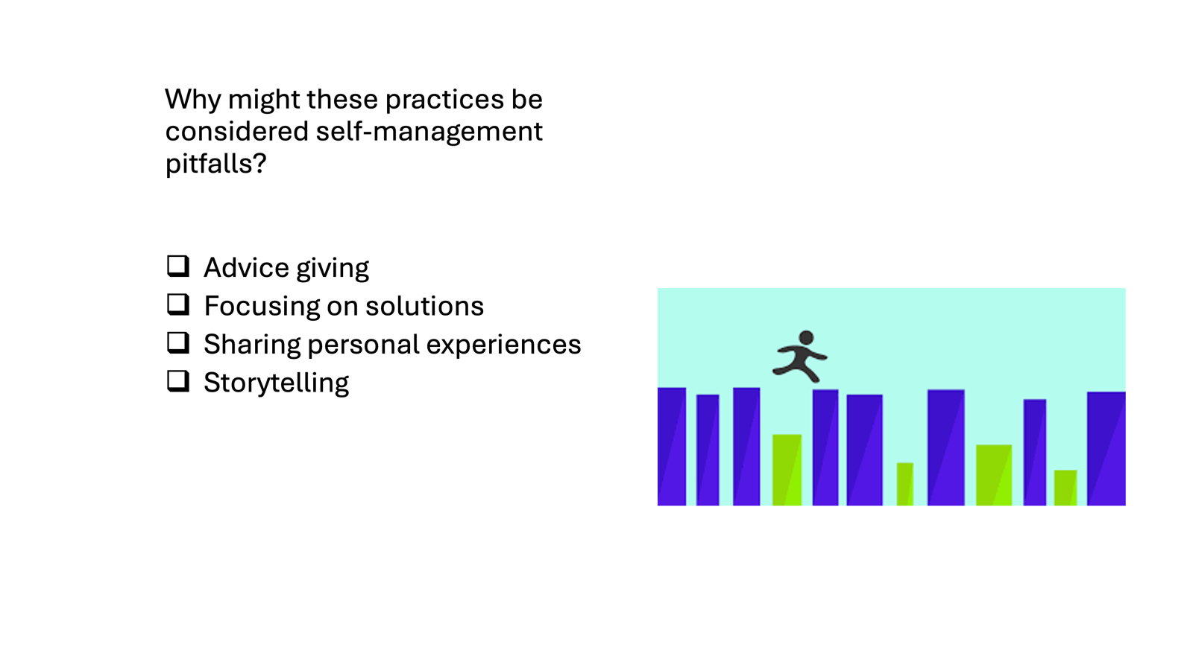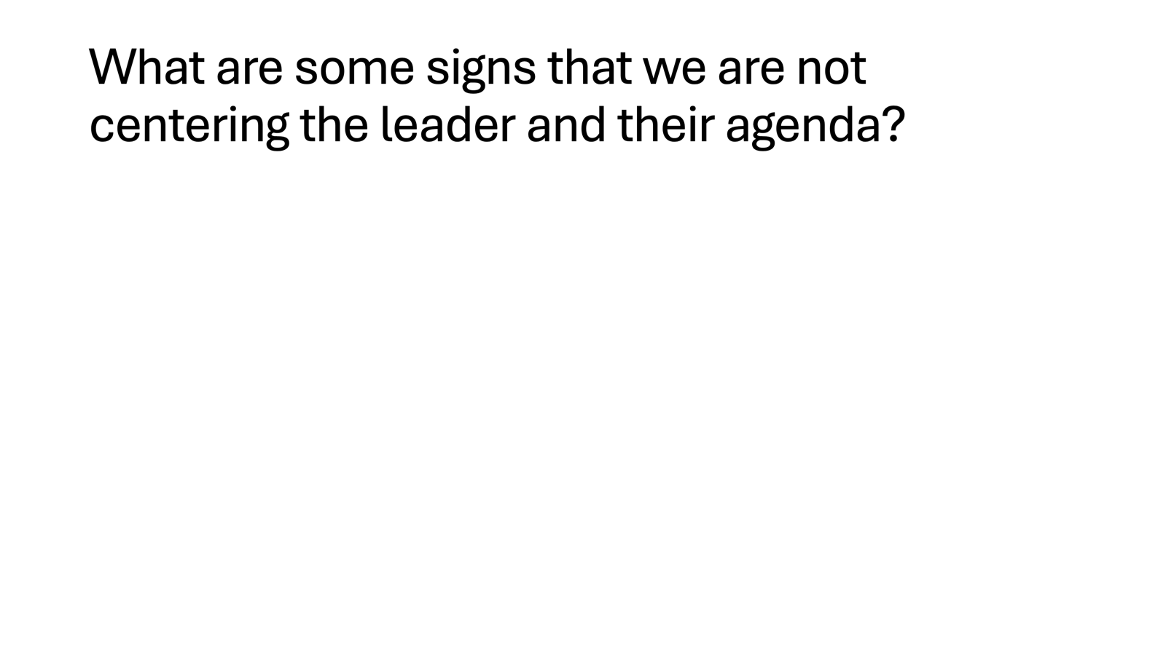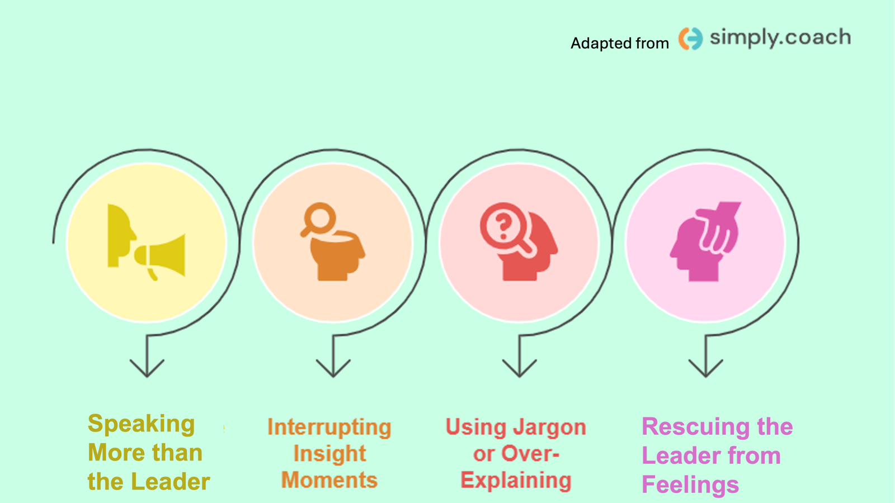  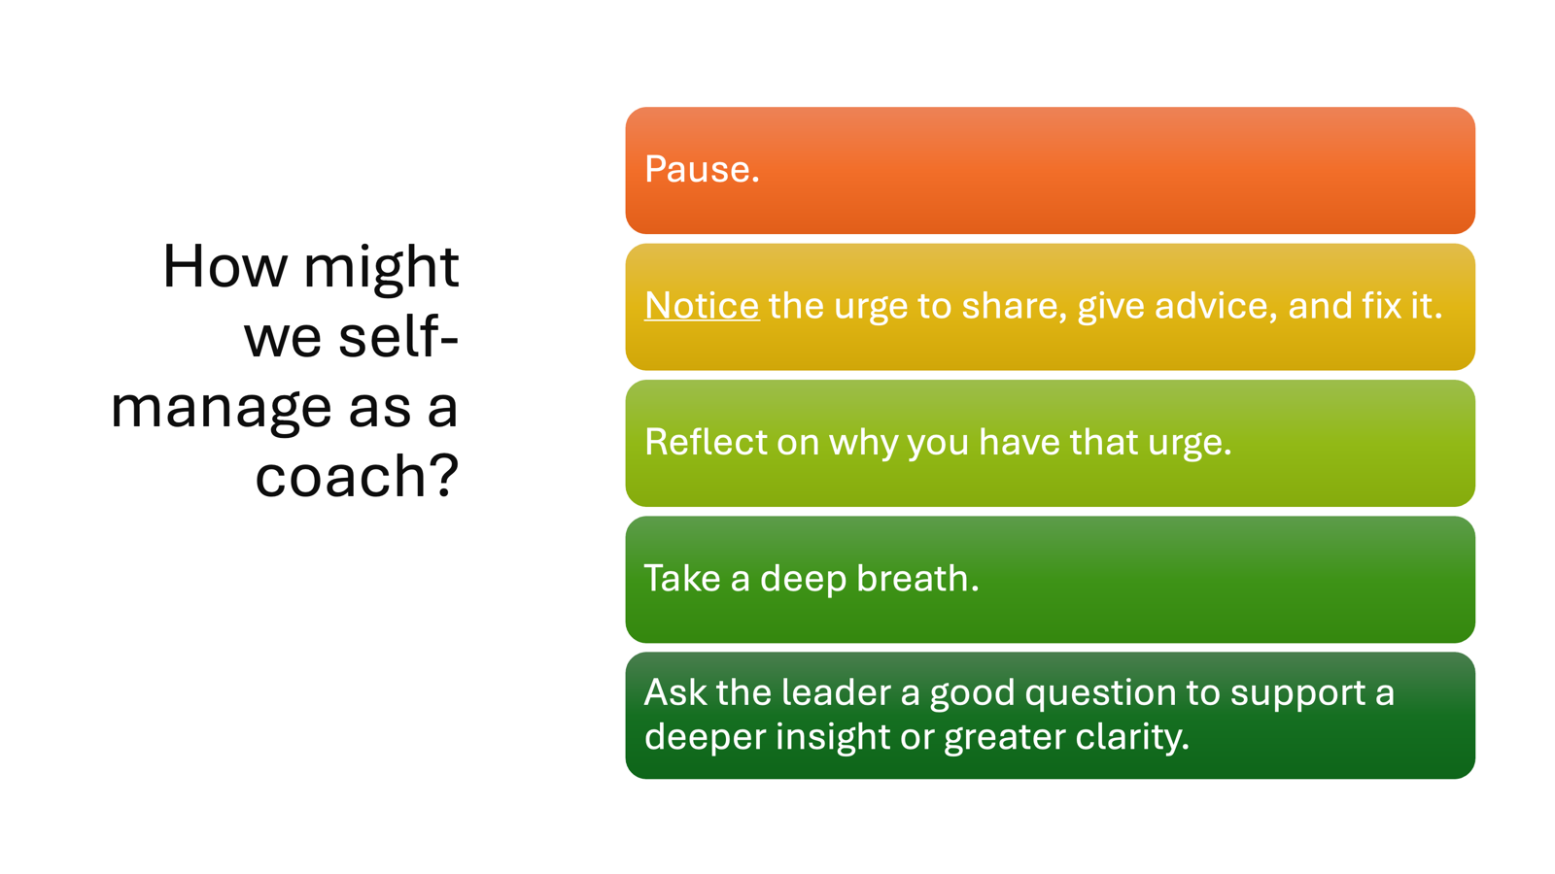 |  | - Coaching Skill: Self-Management (Slides were added to the main deck)  - Slide: As a coach you don’t have to fix it!  - Slide: The good news? Coaches don’t have to be experts – and they don’t have to guarantee the outcome of the coaching. The leader is responsible for their own growth. The coach supports them in this process.  - Slide: Spectrum of centering the coach and the leader.  We can do that most effectively when we self-manage. Why might some of the practices on the side that center the coach be considered pitfalls for a coach? (large group discussion 5 min)  - Advice giving  - Focusing on solutions  - Sharing personal experiences  - Storytelling  Coaching at its essence is “about asking rather than telling.” Our role as a coach is to center the agenda, the process of the leader.  For many of us, self-management is a skill we have to practice as a coach in order to learn it. Ask folks to raise their hands on when they have used this skill. Has anyone used this skill as an educator? A facilitator? organizer? leader? in your relationships? As a parent?  It’s a practice many of use across different parts of our lives. In this case, it’s a foundational skill of coaching someone.  - Slide: Centering the Leader’s Agenda – 10 min  - What are some signs that we are not centering the leader’s coaching agenda?  - (Crowdsource from group) Some to shared if they aren’t mentioned:  - The topic dramatically changes and the coach doesn't’ confirm that’s the direction the leader wants to take  - Speaking more than the leader  - Interrupting insight moments  - Over-explaining or using jargon  - Rescuing the leader from feelings  What is the potential impact of some of these pitfalls on the leader and your coaching conversation? (large room conversation (5 min)  (Share these takeaways if participants don’t bring them up.)  When you speak too much, it centers the coach not the leader. Coaching is 10/90 ratio of talking to listening.  The coach should let the leader lead the session: Don’t rescue them from exploring pain or insecurities.  Over-explaining isn’t necessary. You can just ask the question. The leader can ask for clarification if they need it.  - In coaching you also need to manage your own beliefs, fears, judgements, opinions and reactions. You can do this through the practice of self-awareness and skill of self-management.  - How might we self-manage as a coach?  Pause.  Notice the urge to share, give advice, and fix it.  Take a deep breath.  Ask a good question that brings the leader into deeper insight or clarity.
12:00 - 1:00 LUNCH
1:00 – 1:30 Melissa |  | 30 Mins TOTAL– Practice | .
Now we are going to explore and practice these concepts and skills: Curiosity, Diagnosis, Interrupting.
Coaching Skill: Curiosity – 10 min.
  - Coaching with curiosity to support deeper reflection
  - Curiosity is a posture of openness and genuine interest in the thoughts, feelings, and experiences of another individual.
  - Add line judgement
  - Curiosity (Blooming Willow)
    - Curiosity: Invites feelings of safety, Encourages authentic self to emerge, invites “not knowing, encourages exploration, invites discovery.

    - Coaching Skill: Transformational Coaching Stem by Elena Aguilar

Activity: - Change to engagement activity with questions created and questions by Elena Aguilar
10 min
- List common judgements, and identify how they might take a posture of curiosity
- Ask coaches to develop powerful coaching questions or select coaching stems that feel authentic without judgement.
I don't know what we should do.
The members don't want to do any of the work it takes to win.
Certain people are just not leaders.
The people in my school just don't care.
There is not enough money.
It's just a helpless situation.

5 min: Pair Share

1 min: Key Points
1:30 – 2:15pm Katie |  | 45 Mins Total – Diagnosis Head, Heart, Hands
2:15 -2:30 BREAK

2:30-3:15 Melissa |  | 45 Minutes Total – Coaching Challenges in Leadership
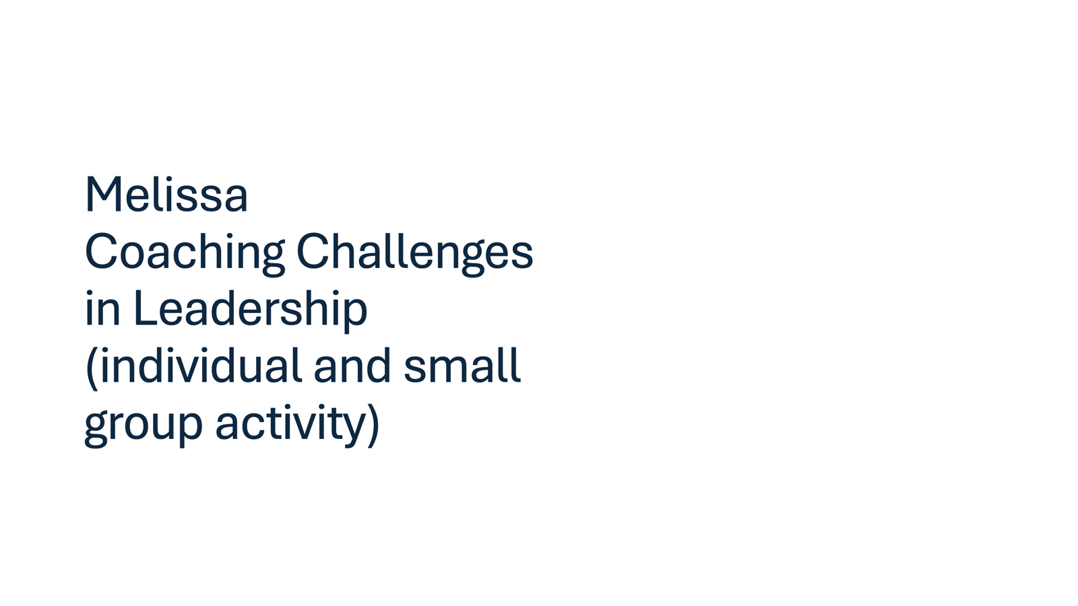 |  | Activity: Coaching Challenges in Leadership  Individual and Small Group Activity: 15 min  What are some common sticky issues in leadership? Or in other words, common challenges in leadership? -  - A Team of One  - Setting Boundaries  - Managing Crisis and Moving the Ball Forward  - Limiting Beliefs - We can’t do that  - Learning from Fear  - Ideas into Action  - Addressing Bias  - Bridging Difference  - Navigating Conflict  - Trusting Others  Small Group Activity:  What are the common leadership challenges you have experienced personally or with others in your campaign and organizing work?  Individually: Write a few sticky issues down on sticky notes.  Small Group: Look at the issues you have named. Take a moment to briefly share how some of these issues show up in the work.  Individually: What might be some questions you could ask when coaching a leader through these challenges?  Small Group: Discuss the questions, and brainstorm additional questions you could ask.  We are going to come back to some of these themes over the course of a few days. These are some of the issues that could come up in your coaching of others.  We are going to shift into coaching triads.  Reflection: Think of one example of a sticky issue in leadership you faced, or maybe are currently facing that you could be coached on.
3:15- 4:10 Melissa (+ Katie) |  | 55 Minutes – Diagnosis in Coaching
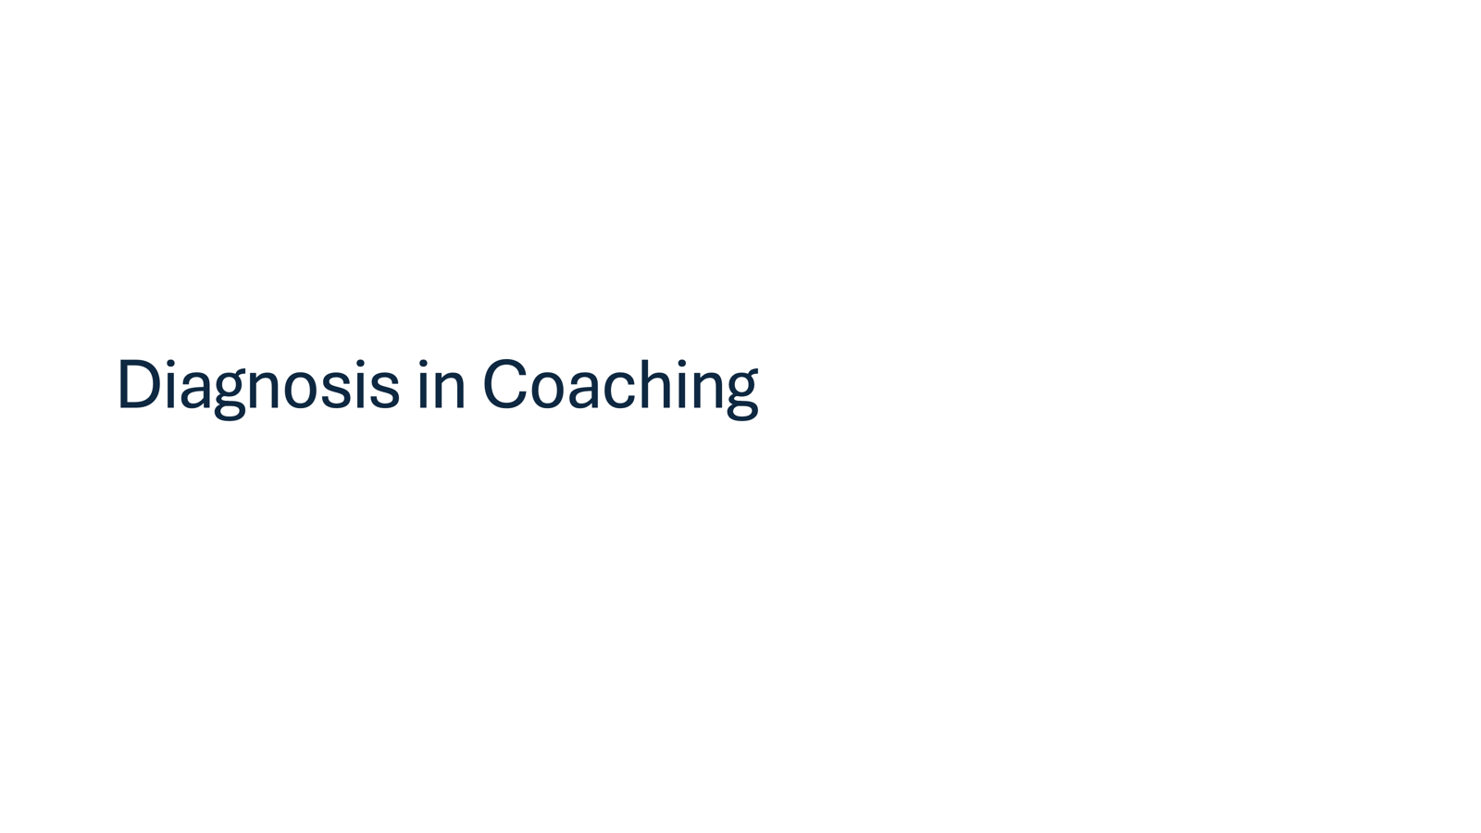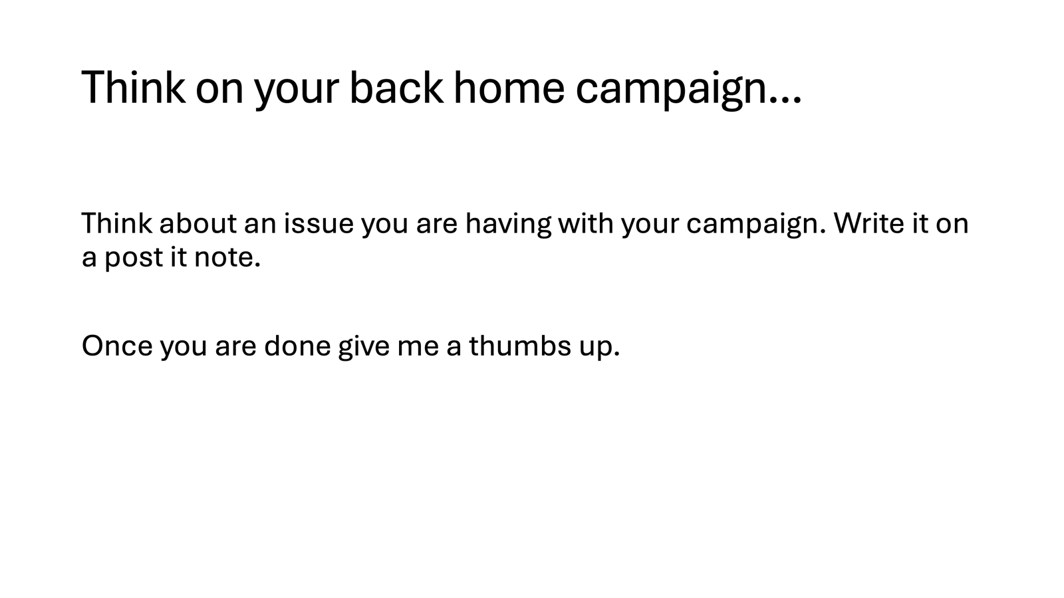  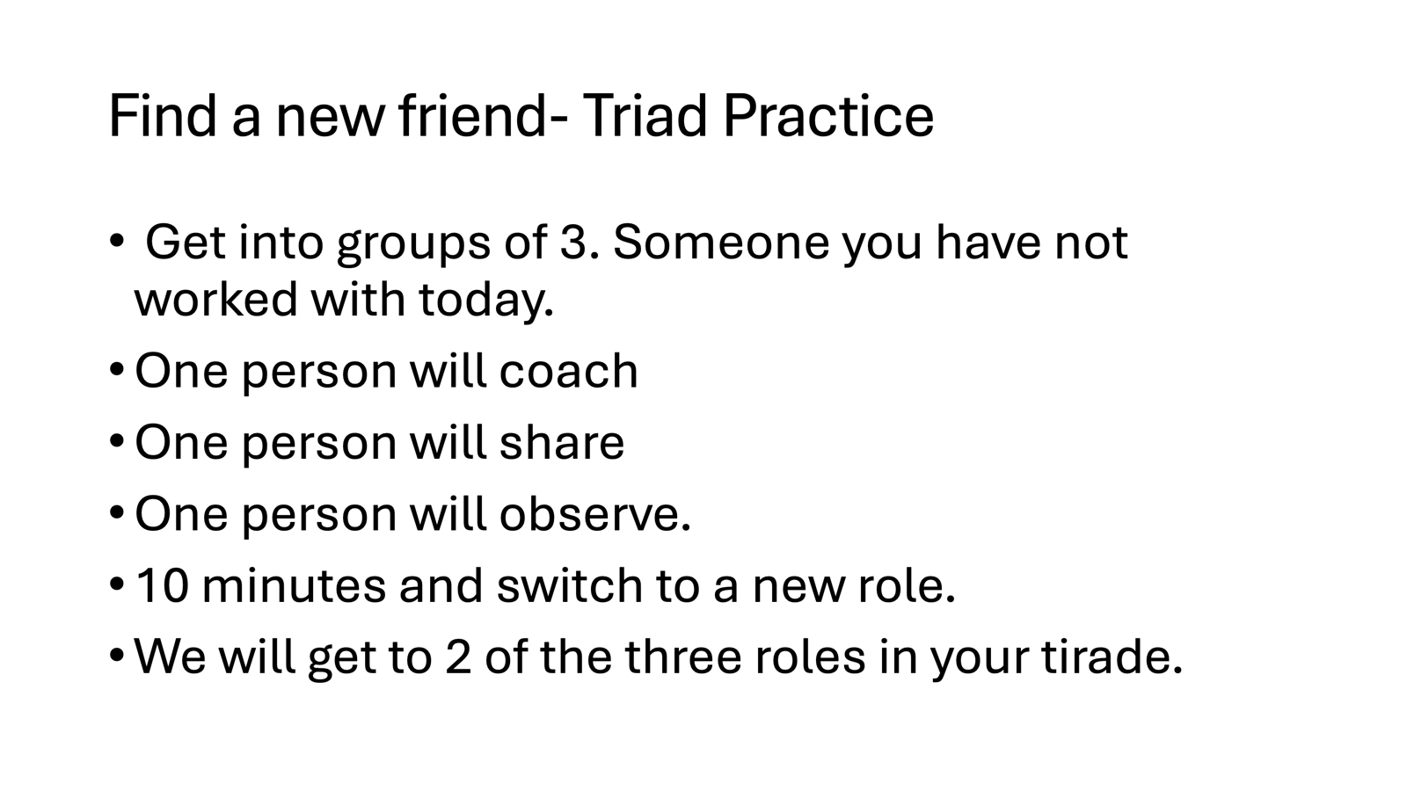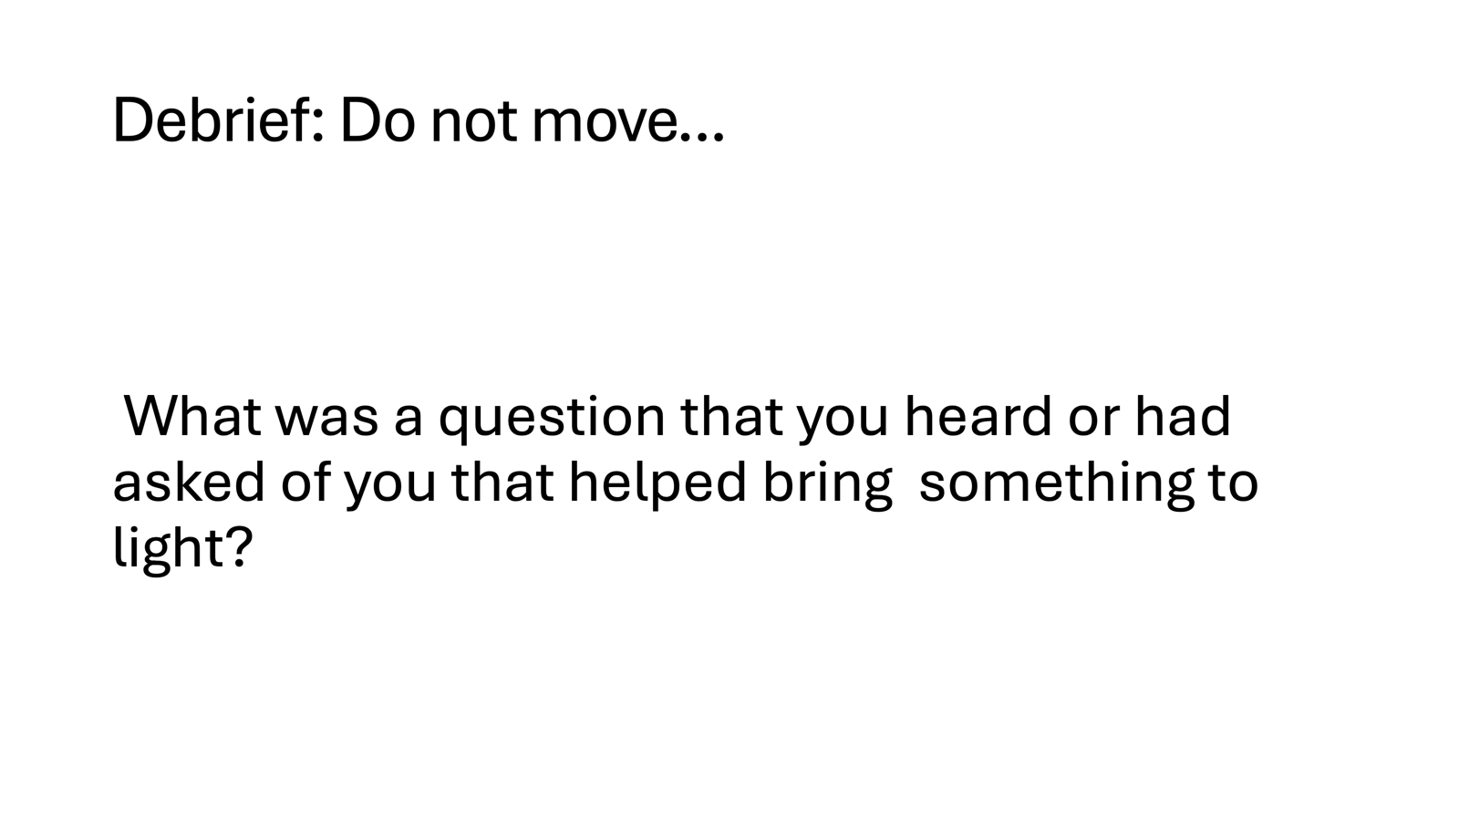 |  |  | What does effective coaching look like in real time?  Participants will observe, practice, and debrief coaching.
4:10-4:30 |  | 20 Minutes - Closing
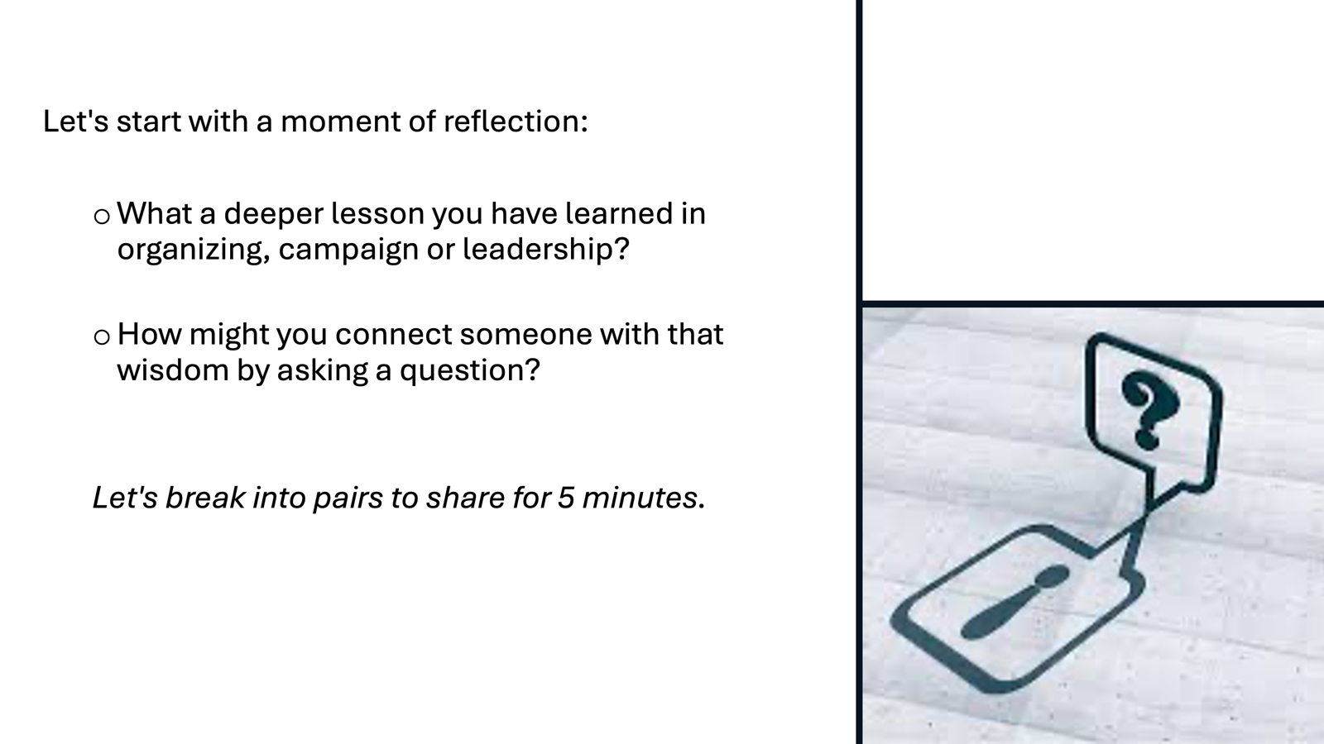 |  | 5 min Reflection  We are going to take a moment for reflection. We encourage you to write. Explore these two questions:  - Which skill do you feel will be challenging for you?  - What makes this skill or practice challenging for you?  FOR TOMORROW –  Any housekeeping or reminders about feedback form or reminders about what is needed next day | Participants will be able to bring a little closure to their learning and provide feedback on the day.
4:30 – 5:00 |  | 30 Minutes - Choice Networking Activities –
 |  | This is a time for participants to meet and discuss any issues they are thinking about with other members of the group. This is not led by facilitators and highly encourage to occur in any other space besides the conference room. | Participants will make useful connections with staff from other affiliates.
5:00 ADJOURN

