Facilitator Agenda: Day 1 “The What”- Values, Vision, Equity Analysis, and Putting It All Together
General Materials Needed:  Online Course Link https://neapartnera.learnupon.com/content-details/4449849/0 |  |  |  | Room Set-up: 50 people max
1 Set of Handouts per Person  Name Tents with the Norms  Room signs, Stick on Name Tags  Chart Paper (4 to 5 full w Sticky Strip) | Materials Box for each table with:  Markers (Mr. Sketch variety)  Post its – 3x3” and 4X5” sizes  One ream of white photocopy paper |  |  | No podium, table with projector big enough for laptop  Long Rectangle table at back for facilitators  Round Tables for participants  Projector, Screen, mics, and Speakers  Carousel stations and reporting stations
Pre Academy Assignments: 00 Pre Academy Full.pdf
Key Outcomes for the Event:
- Analyze their current situation in the context of a broader political landscape
- Build a vision based on shared values and analyze that vision through an equity lens
- Articulate solidarity as a strategic choice as well as a union value
- Understand why a team is vital to a campaign
- Learn the strategy of base-building
- Learn key skills to build a team: 1:1 organizing conversation, worksite mapping and charting, and leader identification
- Learn about examples of how to troubleshoot common problems with organizing teams.
- Create a plan to build the strongest, tightest, most resilient organizing committee possible

Overview of Content, Time, and Facilitator Assignment (Timer)
8:30-9:00 Introduction and Overview (Required Content)  9:00-9:15 Values Ice Breaker  9:15-9:45 Personal Vision Exercise  9:45-10:30 Building a Shared Vision  10:30-10:45 Break  10:45-12:00 Equity Tool Overview/Analysis Activity |  | Ellen  (Alan timing)  Matt (Pete)  Amanda  (Kristin)  Kristin (Alan)  Dr. Taraja (Katie) | 12:00-1:00 Lunch  1:00-2:00 Solidarity as a Core Strategy Activity and Overview  2:00-2:30 Putting it All Together Activity  2:30-2:45 Break  2:45-3:00 Energizer Activity- Why do you need a team?  3:00-4:00 Putting together your team and Intro to Base-Building Strategy  4:00-4:30 Ending it Right |  | Katie (Matt)  Alan (Taraja)  Kristin  Pete C (Taraja)  Amanda
Time Slides Facilitator | Resources | Instructions, Activity and Debrief (Facilitator Script) | Essential Questions and Outcomes
 | Charts, handouts, articles, materials, slide | What are you saying, what are they doing, what questions will you use to guide learning and make clear the important points  Include an estimate for how long each section of the learning will take | What question(s) will this learning answer? What will participants know or be able to do?
Noon-5:00 – Team prep, practice, room set up, sound check, etc.
Entry Activity
8:30-9:00 | Ellen | 30 Mins TOTAL Getting Started
  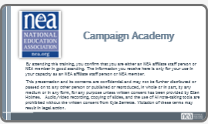  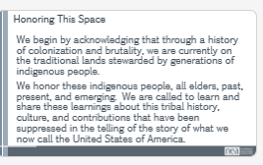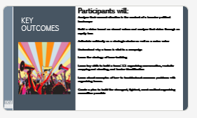  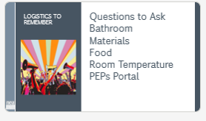  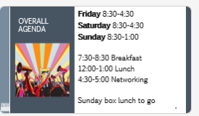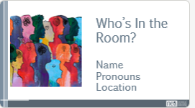  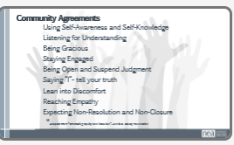 | Norms Online Pre Attendance  Agenda on Slides  Name Tents  Handout Package online  01 Community Agreements 8.27.pdf | 2 Minutes Welcome – basic intro and reading of the confirmation of membership  2 Minutes Land Acknowledgement  We begin by acknowledging that through a history of colonization and brutality, we are currently on the traditional lands stewarded by generations of the Indigenous people(BE SPECIFIC TO AREA). We honor these indigenous people, all elders, past, present, and emerging. We are called to learn and share these learnings about this tribal history, culture, and contributions that have been suppressed in the telling of the story of what we now call the United States of America  5 Minutes Outcomes and Agenda Overview  Begin the understanding that the first two nights are about HOW we will achieve the Change that the Campaign Lab represents. We are coaching people into their agency to make decisions about their campaigns – we are not advising or consulting. More about that.  Review Agenda reminder about meals, Karla for Logistics, etc.  Member volunteer to collect “thank you” for our staff working in the hotel. | Participants will know how we are going to work, the basic schedule, and the logistics relevant to the training.
9:00-9:15 | Matt | Values Ice Breaker
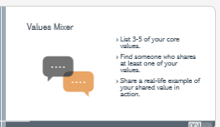 | Values handout | Core Values are the things that guide us when things are getting difficult or challenging. Core Values are important to discuss with your core leadership team so that you understand and they understand what will motivate them and what will motivate you in times of difficulty. It is why you are willing to do this work-  I added a slide defining values with your words above- AK  Definition I used (from Practical Radicals) What you believe about the world and how you decide what is and is not important.  Examples: teamwork, compassion, curiosity, integrity, courage, faith, sustainability, competition, loyalty, kindness...  10 Min – Values Mixer  - List 3-5 of your core values on your own.  - Uset the chart paper near your table to list the core values ferom your table.  - We will be referring back to this throughout the day.  (If time) 5 minutes-  Call out a few of the values from across the room.  Key Points:  Values are how we develop connections between people.  Values are the fundamental guiding principals and deeply held beliefs that shape our behavior and the behavior of our institutions. | Participants will know what values are.  Participants will know their own values and how it connects us to other people.
9:15-9:45 | Amanda | 30 Minutes- Vision
  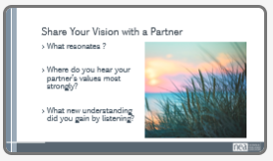 |  | 20 minutes- Think about the values and scenarios you just described. We are going to imagine a horizon, distant, but not too distant, where we are living those values in ways that feel true to you. You will have a good chunk of time to write and/or draw what you would like your life to be like in 10 years.  Think about everyday experience more than specific policy changes. How will you be living? What will it be like to arrive at work? What will your workday feel like? What will you be doing in your free time? How will you be interacting with family and friends? With neighbors? What will your community be like? What will you see when you are out and about in your community?  Remember this is a world governed by those values we all just shared. We aren’t going to trouble ourselves with how we get to that world just yet. Just, what it would look like, feel like, sound like, taste like. Make it a place we can experience through your telling.  10 minutes- Depending on the number of participants, let everyone share their story in small groups or pairs.  After each story, other participants share what resonated the strongest for them. Where did they see the clearest examples of their values being expressed?  What is one thing you heard from your partner that you wouldn’t have necessarily thought of? | Participants will learn how to create a vision based on shared values.  Participants will be introduced the concept of power.
9:45-10:30 | Kristin | 45 Minutes – Building a Shared Vision
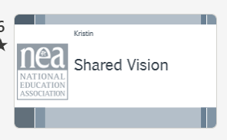  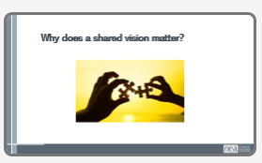  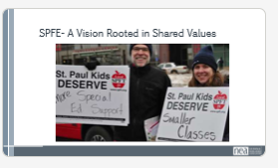  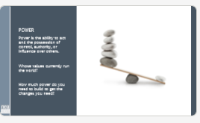  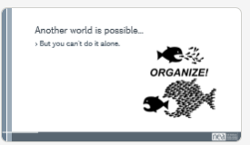  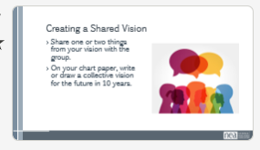  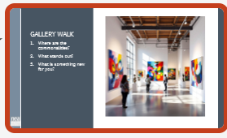  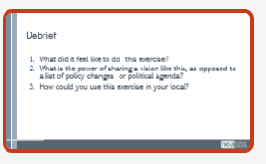  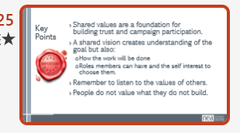 |  | Building a Shared Vision  9 minute lecture: Why does a larger vision matter? Using St. Paul as an example- not just wanting to change a policy or school board member, but at the systems hurting their schools, etc. They took a larger vision for themselves. Not only did they have a bigger vision, but they also asked members to step into these roles to accomplish this work. Members willing to step into these roles because of the vision of the world they want and that their work in the union makes the difference. So we will focus on building a vision today.  ( Use Video https://youtu.be/D2m5ro3-ErI?si=ASqz52tQ4ynF7nOt  How does SPFE use vision and values to drive their organizing and build their power?  Shared values are a foundation for building trust and campaign participation through a shared vision.  - A shared vision creates understanding of the goal but also:  - How the work will be done  - Roles members can have and the self interest to choose them.  - Member ownership of the work creates a stronger union!  They have money, we have members.  We often say there is strength in numbers.  We have to have a shared vision to engage members. They will take action based on their values we lift up and that is where our power lies.  When we put our values into action people will want to join us!  When we sell membership as insurance it is isolating and focusses on the individual. When we ask them to join because we need them to win a goal the ask now focusses on the collective power we can build.  18 minutes- Each small group (AT THEIR TABLE the group you came with) shares a few examples from their stories of what they want their world to be in 10 years and writes/draws their examples on chart paper.  8 minutes- Gallery walk a  10 minutes- Whole group discussion- what did it feel like to do this exercise? What do they think of the shared vision they have created on the chart paper? What is the power of sharing a vision like this, as opposed to a list of policy changes or political agenda?  Key Points:  Shared values are a foundation for building trust and campaign participation.  Building a shared vision helps others find their self-interest in your goals and helps them see where you are going with your campaign  A shared vision creates understanding of the goal but also how the work will be done, what roles members can have and creates an ability to choose those roles.  Members owning the work creates pride and strengthens the union.  People cannot value what they do not build.  Be open to the perspective and values of others to create that shared vision. | Participants will articulate the advantages of creating a shared vision based on shared values
10:30-10:45  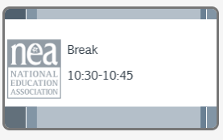 |  | 15 Minutes- Break
10:45-12:00 | Dr. Taraja | 1:15 Minutes- Equity Analysis
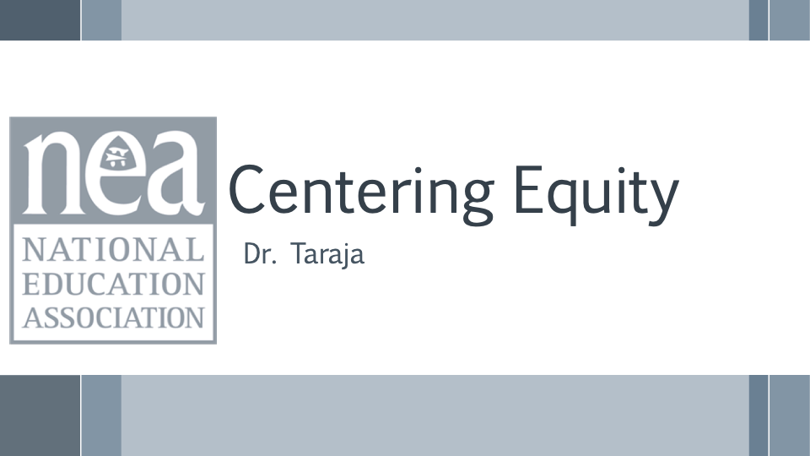  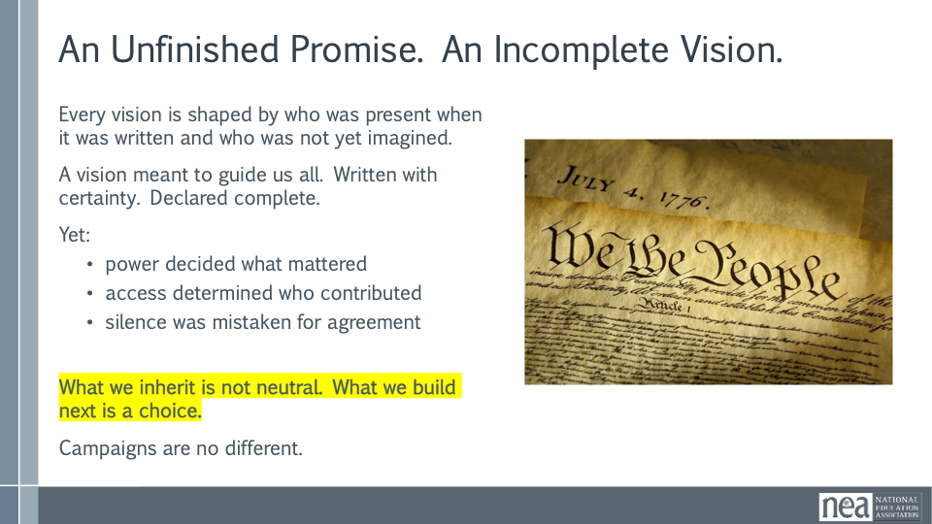  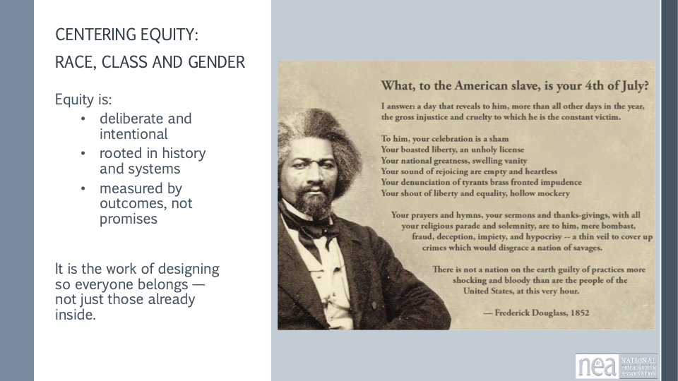  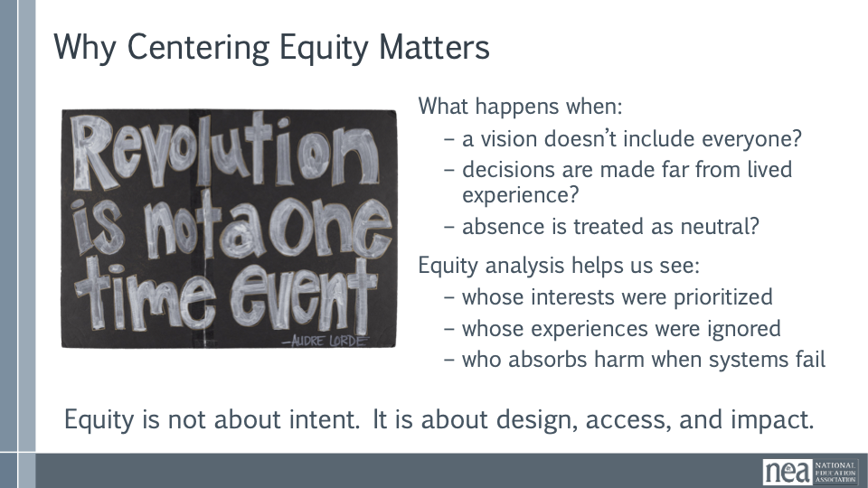  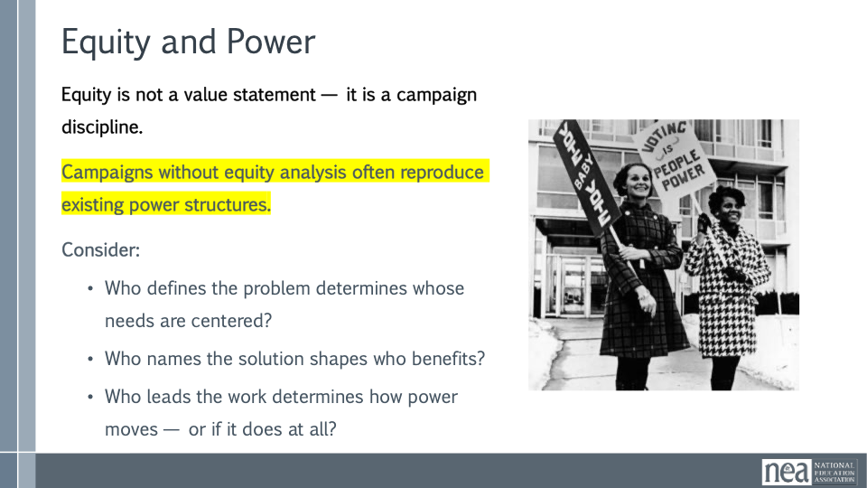  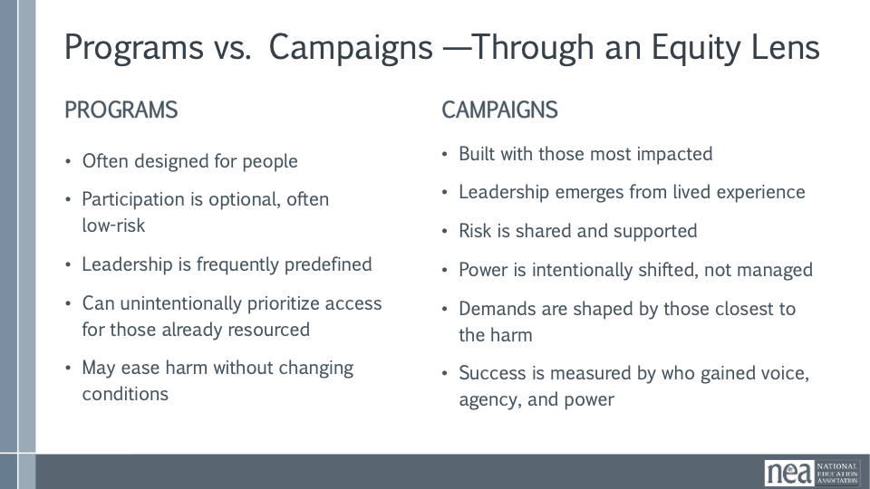  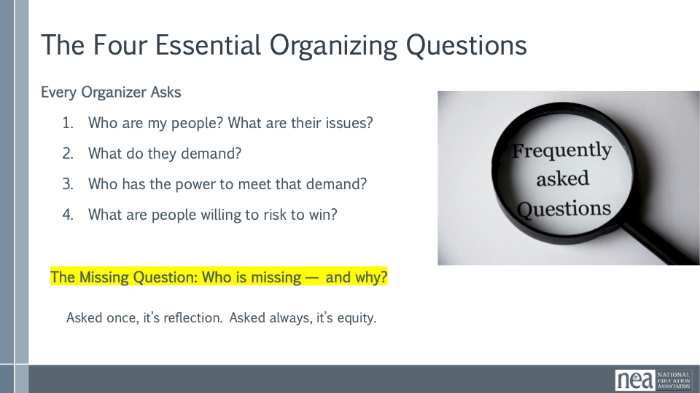  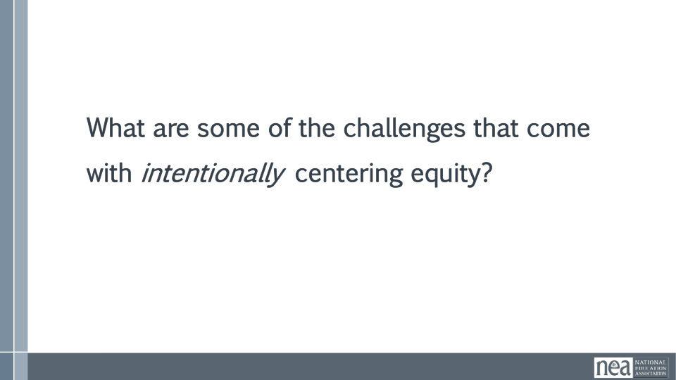  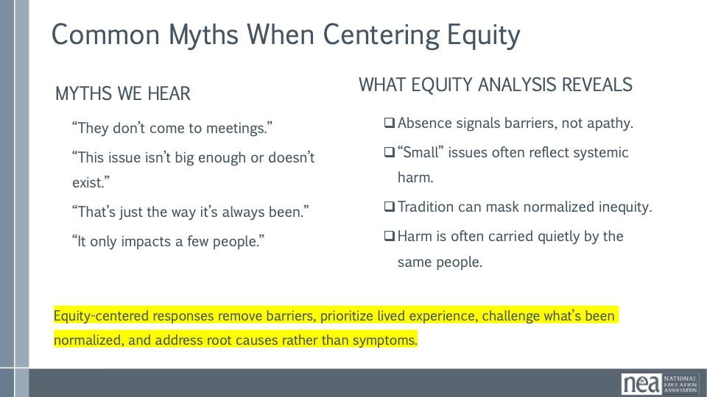  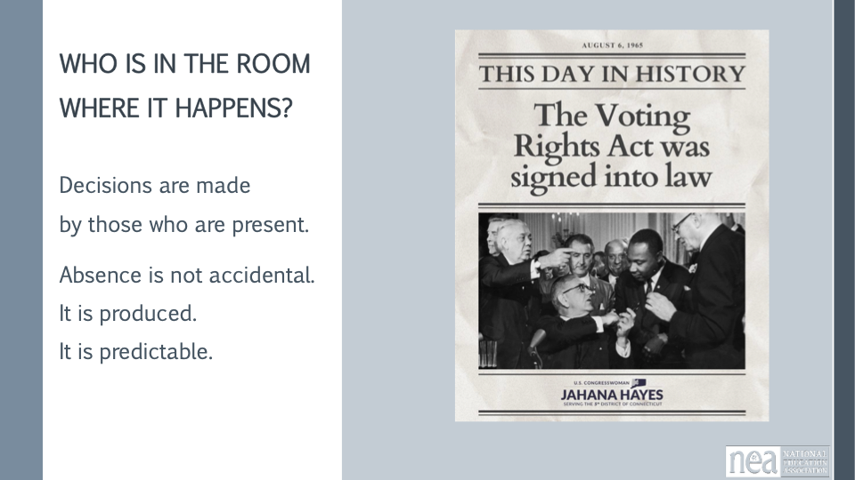  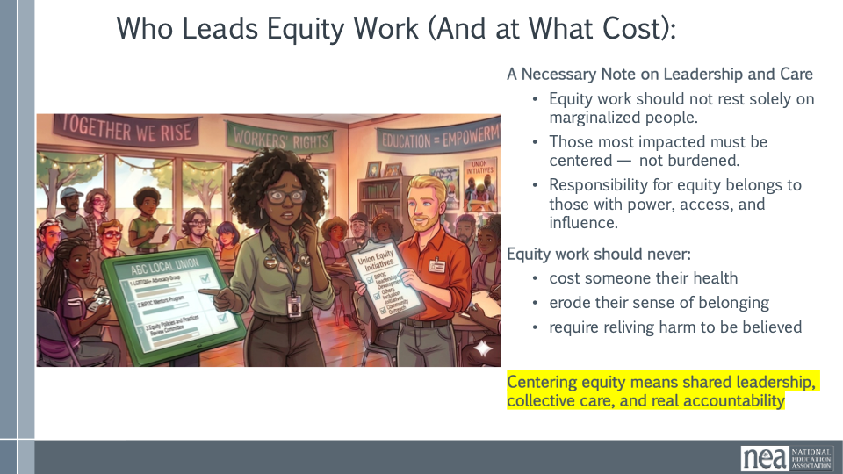  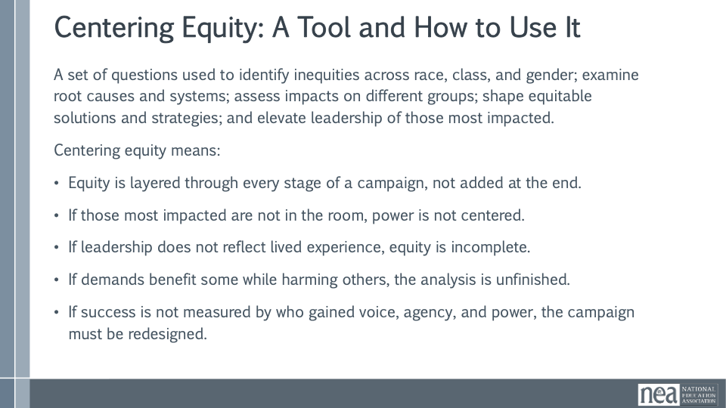  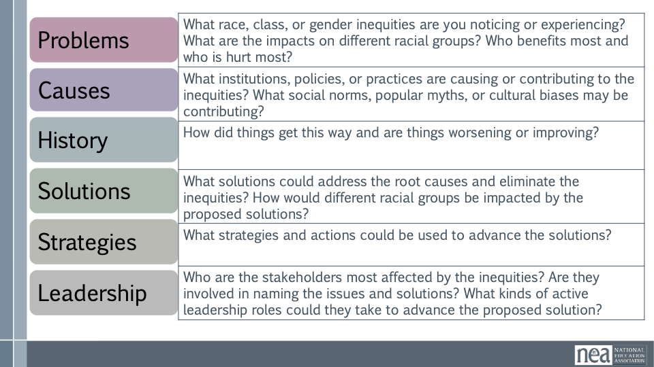  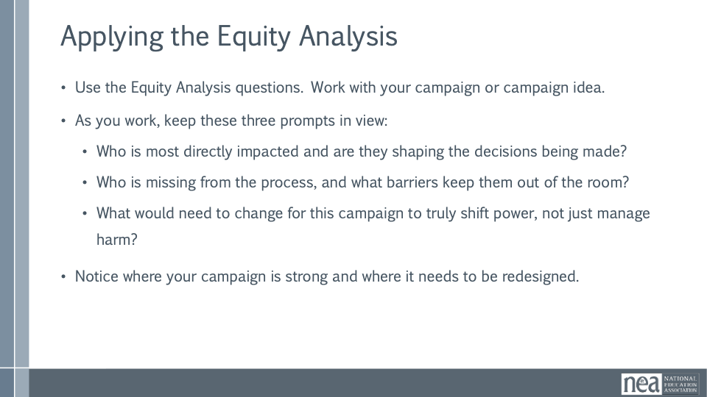  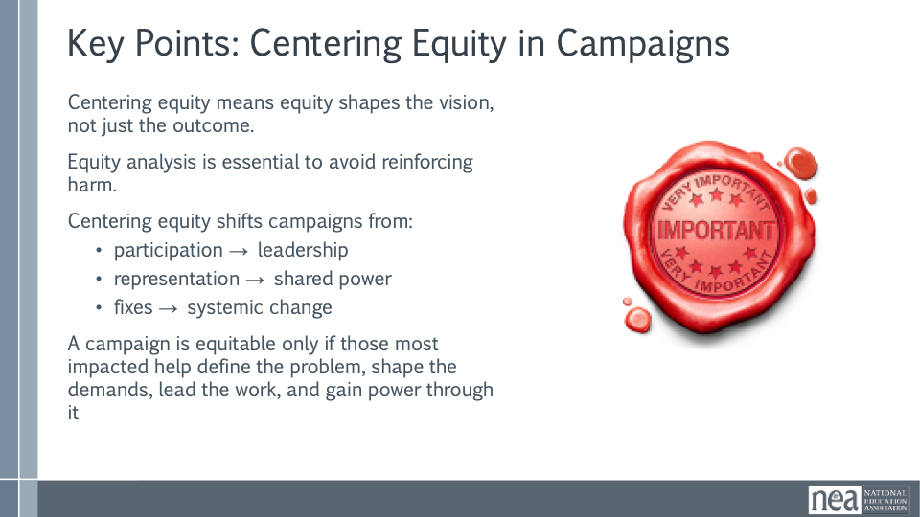 | Equity tool handout | Centering Equity in Campaigns (75 Minutes)  This session focuses on how campaigns are designed, not just what they aim to win. Participants will arrive with different levels of readiness, all of which belong here. The guiding question throughout the session is: Who is in the room where it happens — and who is not?  Opening Framing  Centering equity is not a values exercise. It is an organizing discipline that shapes how problems are named, demands are formed, leadership develops, and power moves. This work is about intentional design, not perfection.  An Unfinished Promise  Every vision is shaped by who is present, who has decision-making power, and who is imagined as the audience. Campaigns are no different. Centering equity means refusing to treat absence as neutral.  Why Centering Equity Matters  Equity is not about intent. It is about design, access, and impact. Equity analysis helps us see whose interests were prioritized, whose experiences were ignored, and who absorbs harm when systems fail. This is about clarity, not blame.  Equity, Power, and Campaign Discipline  Equity is a campaign discipline. Power operates through who defines problems, names solutions, and leads the work. Campaigns that skip equity analysis often reproduce existing power structures, even with good intentions.  Programs and Campaigns Through an Equity Lens  Programs often focus on support and stability. Campaigns aim to change conditions and shift power. Equity-centered campaigns are built with those most impacted and measure success by leadership development, shared risk, and power shifts.  Organizing Questions and the Missing Question  Beyond the four organizing questions, equity demands a fifth: Who is missing and why? Absence is rarely accidental. Asking this question is design repair, not criticism.  Resistance and What It Reveals  Group share-out: What are some common challenges that you encounter when you try to intentionally center equity in this work?  Common Myths When Centering Equity  Noting some common resistance statements point to barriers, not apathy. Equity-centered responses remove barriers and redesign systems based on lived experience and root causes.  Who Leads Equity Work and at What Cost  Equity work should not rest solely on marginalized people. Responsibility belongs to those with power and access. Equity work should never cost someone their health or sense of belonging  Small-Group Equity Analysis (25–30 Minutes)  Participants work in groups of three to five using the equity tool to examine an active campaign or campaign idea. Gaps and uncertainty are information.  Guiding Prompts  Who is most directly impacted and are they shaping decisions? Who is missing and what barriers may be keeping them out? What would need to change to truly shift power?  Whole-Group Shakeout and Harvest (15 Minutes)  Invite short reflections: one equity gap, one assumption that shifted, or one design question that emerged. Name patterns and reinforce these as organizing opportunities.  Closing Anchor  Centering equity means shaping vision, leadership, and strategy. Campaigns are equitable only when those most impacted help define problems, shape demands, lead the work, and gain power through it. | Participants will learn how and why to use an equity tool to evaluate their vision.  Participants will articulate what achieving their goal would look like if it was rooted in equity.
12:00-1:00   |  | 1 hour- Lunch
1:00-2:00 | Katie | 1 hour- Solidarity as a Core Value and Strategy
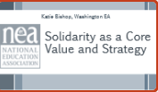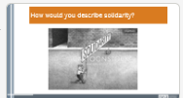  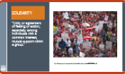  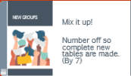  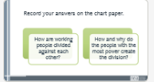    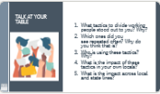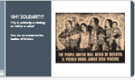  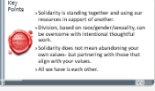 |  | 5 minutes-  How would you describe solidarity to a lay person? (Popcorn out).  We are going to focus on solidarity and how we have been divided and how we can overcome and build solidarity. First lets talk about what solidarity is. Solidarity is Unity or agreement of feeling or action, especially among individuals with a common interest; mutual support within a group: using your own resources to reach and support other groups.  In standing together- we are stronger. Divided some might do better, but collectively we all do worse.  15 minutes- Heterogenous Regroup- one person from each issue group from before lunch to form a new group.  Small Group Discussion- Using examples from the issue you just analyzed before the break? how are working people divided against each other? What specific stories or tactics are used? Record answers on chart paper.  10 minutes- Gallery walk. Each individual gets one marker. Each group moves one table over. As an individual, put a dot next every tactic you see happening in your local. Rotate tables until you are back to your own.  15 minutes- Assign each table one of the following questions: What tactics to divide working people stood out to you? Which ones did you see repeated often? Who is using these tactics? What is the impact of these tactics in your own locals? What is the impact across local and state lines?  Give them 5 minutes to talk and 5 minutes to share out.  5 minutes- Whole group discussion- why do unions focus so strongly on solidarity? Why is solidarity a strategy as well as a value? How do we overcome the tactics of division?  Key learning Point:  - Solidarity is standing together and using our resources in support of another.  - Division, based on race/gender/sexuality, can be overcome with intentional thoughtful work.  - Solidarity does not mean abandoning your own values- but partnering with those that align with your values.  - All we have is each other. | Participants will understand how those in power use tactics to divide working people against each other in order to maintain their power. And, how unions intentionally build solidarity to defeat these tactics.
2-2:30 | Alan | 30 minutes- Putting it All Together
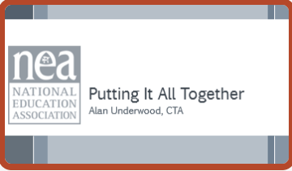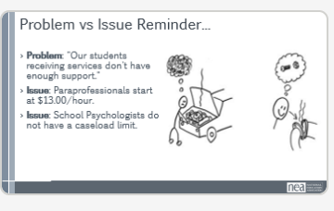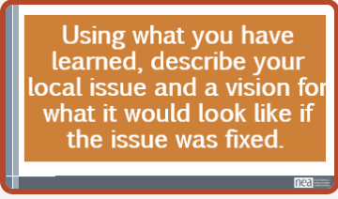 |  | 10 minutes- Have spent a lot of time thinking globally together. Now we are going to focus on our work back home. Actual tangible things in your back home life/work, goal is to be descriptive.  Remember, a problem is “my car won’t go” an issue is “I need gas” or “my spark plugs are not doing the thing.”  How does this show up in education: Problem: "Our students receiving services don't have enough support."  Issue: Paraprofessionals start at $13.00/hour.  Issue: School Psychologists don't have a caseload limit.  Reminder: What is an issue? Are you promoting equity?  Using an issue you think will be the focus of your campaign, write how you now understand the issue and a vision for what it would be like to have that issue fixed. What would you see, feel, hear, etc. How would you know you had really won? Think about painting the picture of that horizon you want others to see in the near future.  Let’s make sure we are hearing from someone we haven’t heard from today.  10 minutes- Share-outs at your table  10 minutes- Highlight share-out from each table | Participants will be able to describe their proposed campaigns and goals in terms of a vision that promotes equity and solidarity between workers.
2:30-2:45   |  | 15 Minutes- Break
2:45-3:00 | Kristin | 15 Minutes- Energizer Activity- Why Do you Need a Team?
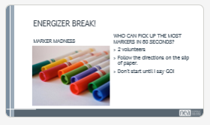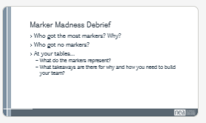  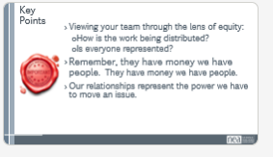 |  | Why do you need a team to have a campaign?  Why do you need to have power?  Activity to spark conversation. Ask for 2 volunteers. Give each volunteer a piece of paper with the different directions. They shouldn’t show anyone else the directions, but instead should only do what it says. Give each person a minute to read and act accordingly when you say go. The directions will say:  - When you are told to start, pick up as many markers as you can in the amount of time you are given.  - Before the activity officially starts, find three friends who agree to help you. Ask them to find at least three more friends who will also help, and those folks can bring friends if they want. When you are told to start, everyone you have recruited will try to pick up as many markers as possible.  Run the activity. Obviously person 2 will pick up the most markers because they have a team.  Whole Group Debrief  Who got the most markers? Why?  Who got no markers (who wasn’t asked to join a team)?  Table discussion- What takeaways are there for why and how to build a team?  What do your markers represent? (In terms of what a team could achieve.)  Key Point- Viewing your team through the lens of equity:  How is the work being distributed?  Is everyone represented?  Remember, they have money we have people.  Our relationships represent the power we have to move an issue.  - Power is critical to getting what you want. | Tie to equity analysis  Tie back to power  People are proud of their union’s work when they are a part of it. Creates buy in.
3:00-4:00 | Pete C | 1 hour - Intro to Base Building
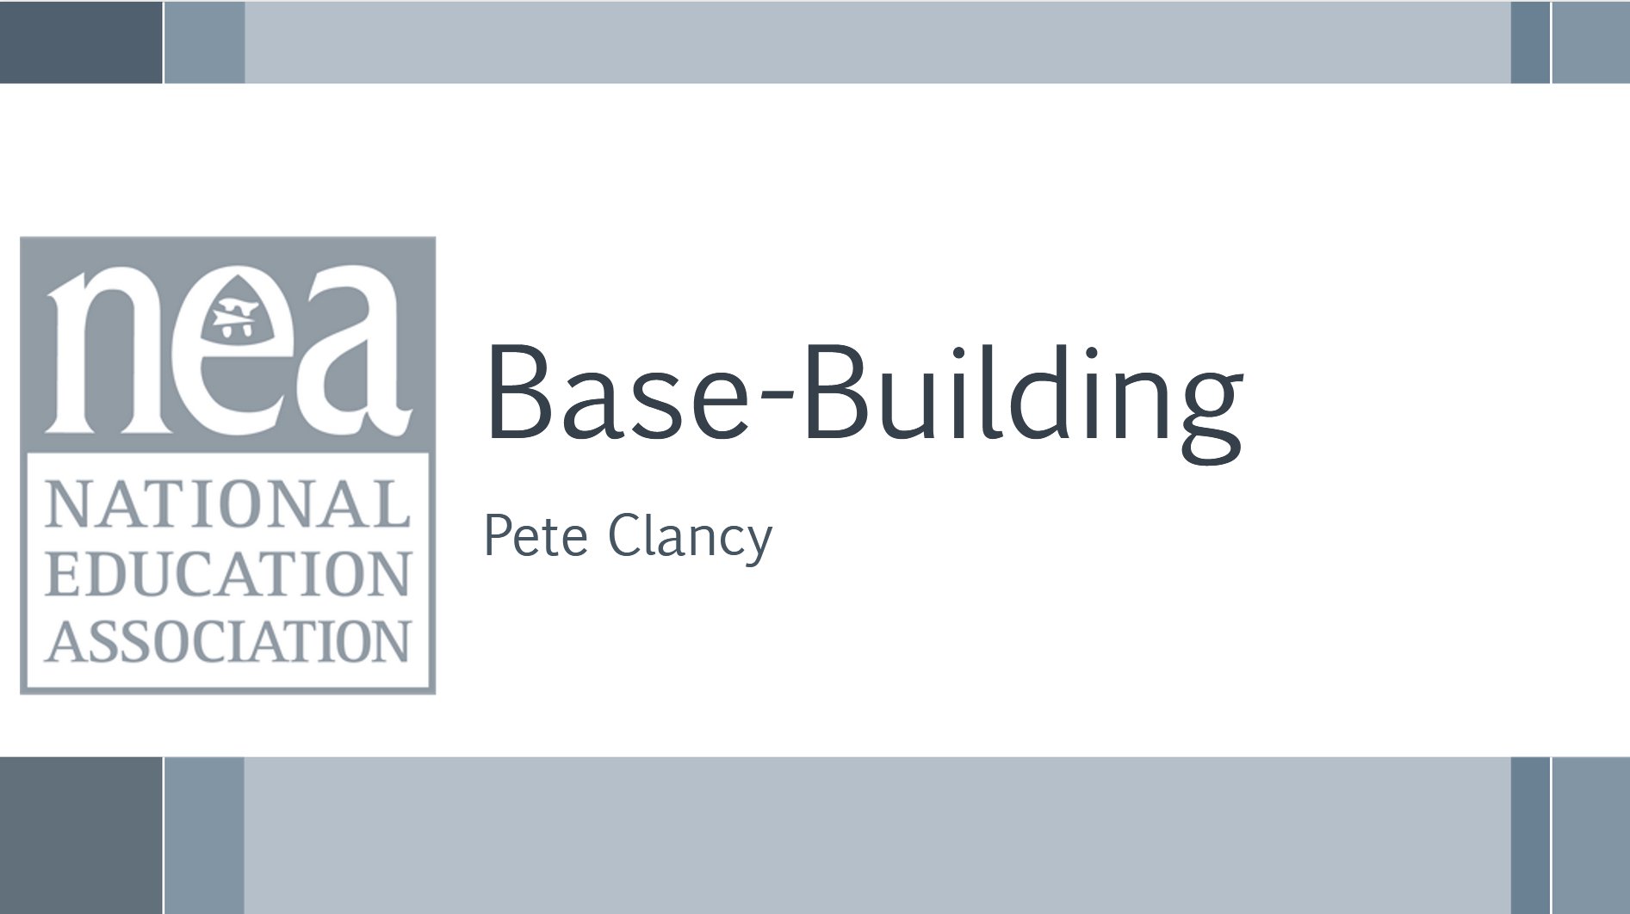  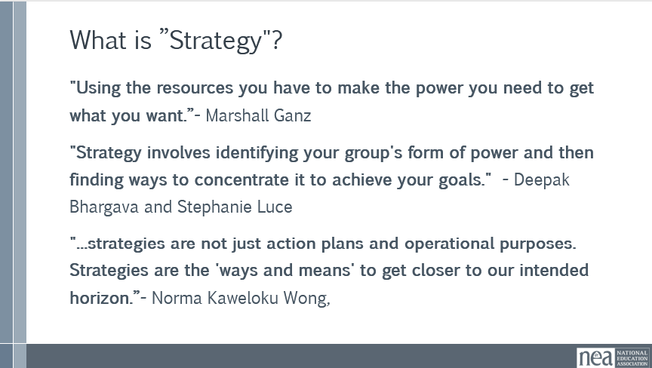  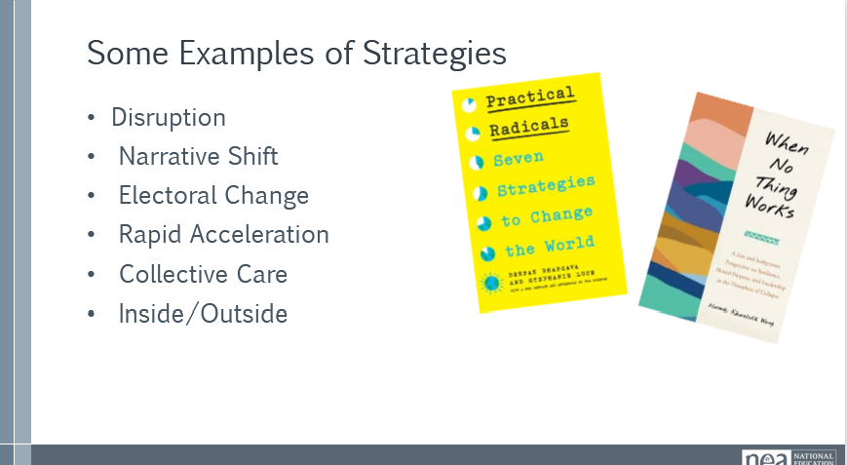  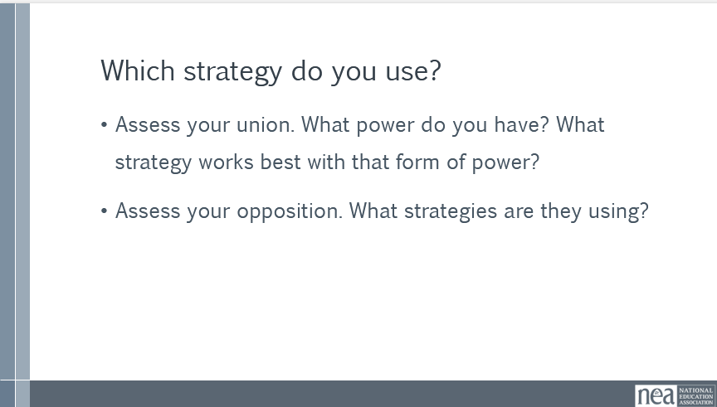  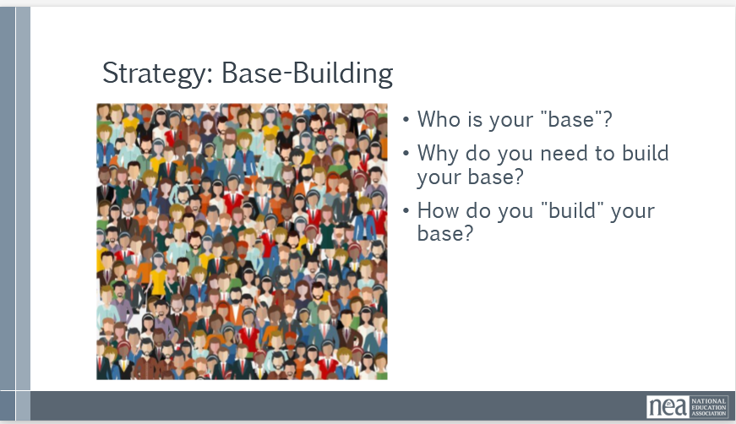  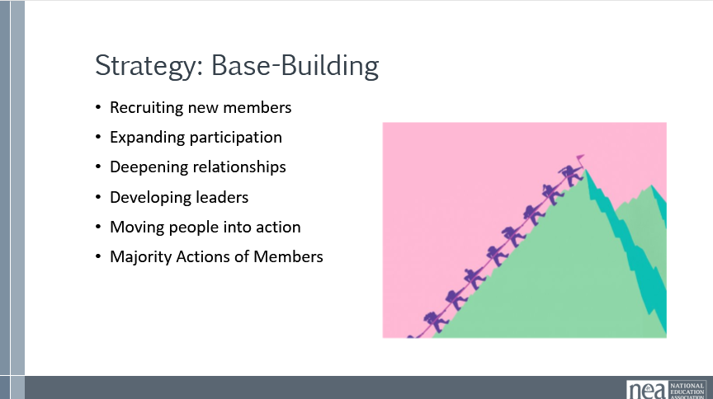  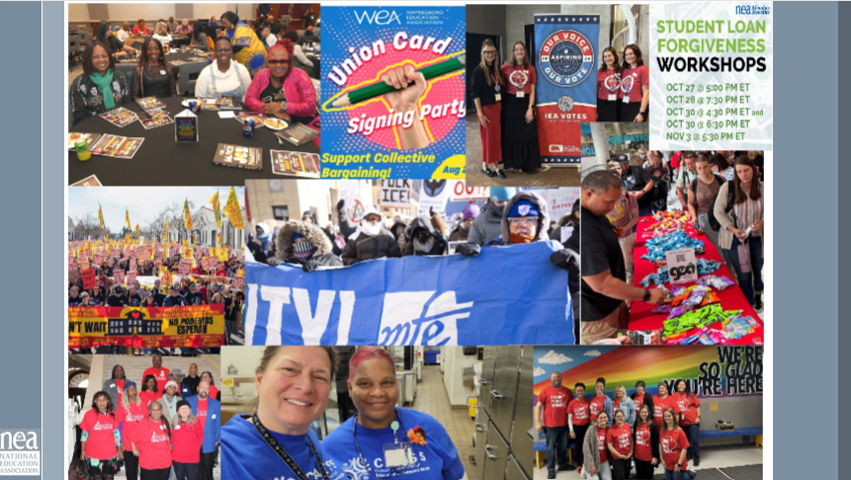  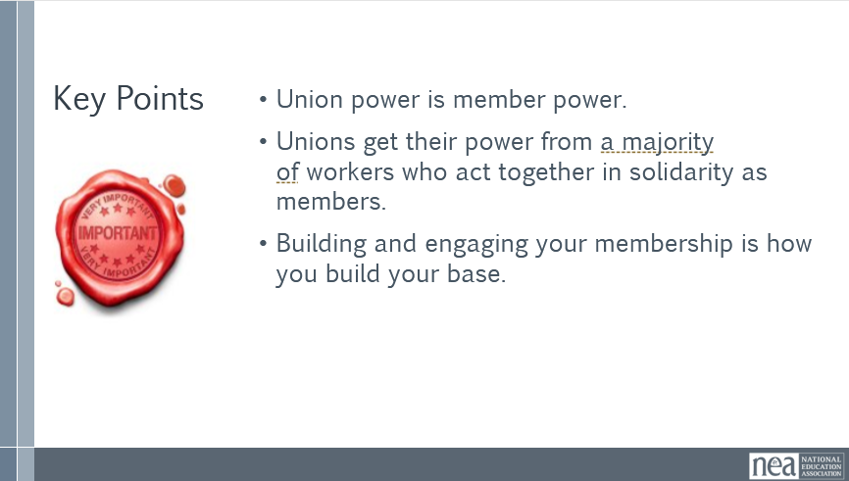  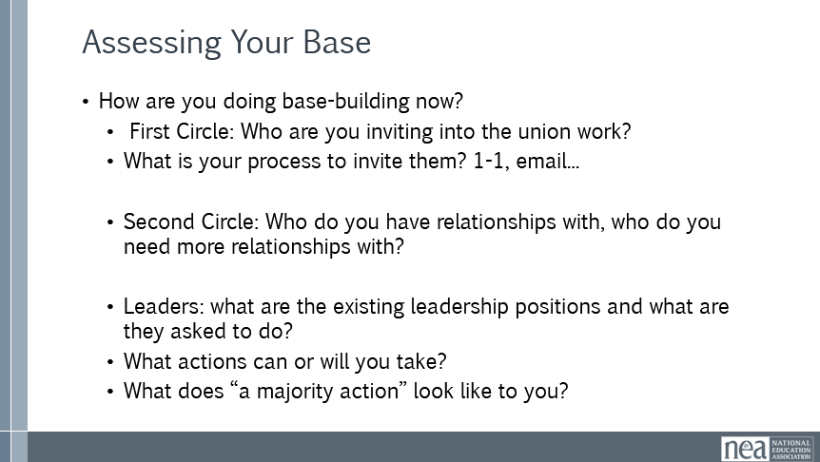  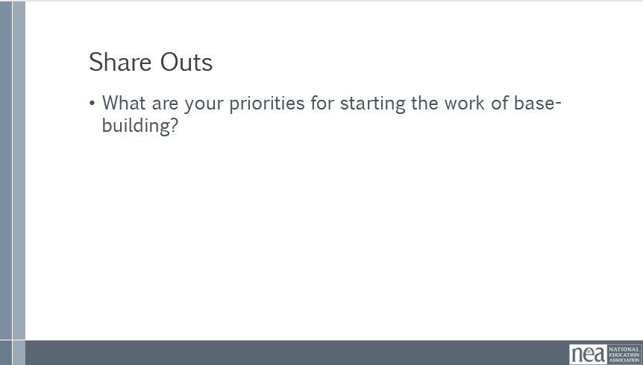  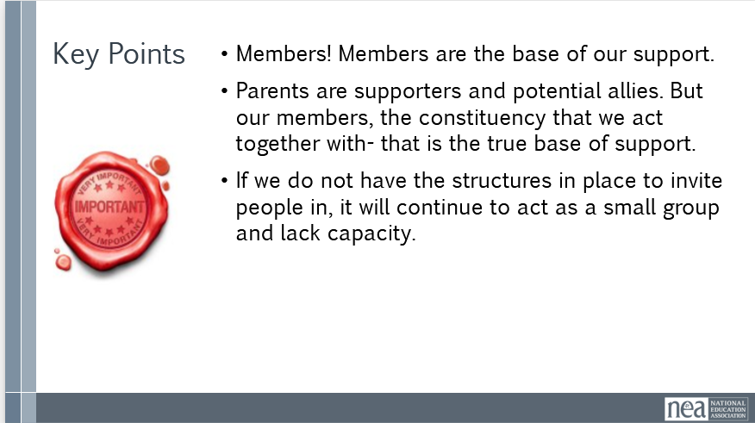  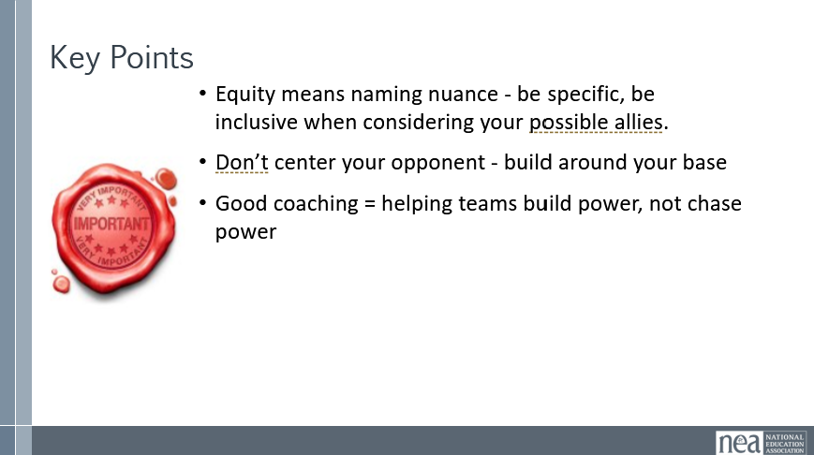 |  | Intro: 10 minutes  Say: Before we talk about base-building as a strategy, we need to define strategy. Here are three definitions. (Read or ask volunteer to read slide.)  Ask: Which of these definitions do you like the best and why?  Popcorn a few answers.  Say: There are many different strategies out there. Here are a few common ones. Can anyone think of examples of these strategies in action?  Popcorn a few answers.  Say: How do you know which strategies to choose? There are some key questions to ask before you decide.  First, what is your main source of power? And how strong is that source?  Second, what strategies are your opposition using and how are they using them? How will you neutralize their strategies? Keep in mind the different oppositions we’ve discussed earlier today.  Those are all questions you will get into once you have a team that is ready to plan. For now, we are going to focus on the strategy of base-building, because it is what unions use the most, and what makes many other strategies possible.  Defining Base-Building 5 minutes  Say: So now we are going to talk about base-building and what that means.  Ask:  - Who is your "base"?  - Why do you need to build your base?  - How do you "build" your base?  (Popcorn answers)  (Show slide with picture examples)  What does base-building look like?:  At its core, base building is about:  - Recruiting new members (to increase your density)  - Expanding participation (getting more members involved)  - Deepening relationships (trust, shared identity, leadership)  - Developing leaders (so the work isn’t dependent on a few people)  - Moving people into action (meetings, campaigns, collective actions)  - Majority Actions of Members (Joining, Acting together to pressure decision makers, admin, politicians, applying pressure to achieve change.)  Assessment- 40 minutes (NOTE TO SUMMER PLANNING TEAM: This section needs reworking, particularly with the assessment. What is the purpose of doing the assessment? May facilitation team thought we could have done this earlier in the day and used it to guide conversations for the rest of the day.)  Say: We are going to start thinking about how we’re functioning at the local level. This assessment will help you think about what are your local’s areas of strength and opportunities for growth, especially in context of base-building and power. We will take a self-assessment of your local association. You can find this on page on pages 6-12 in your participant handbook.  5 minutes to reflect- where is some of the priority base building for you back home?  Key Points:  - Members! Members are the base of our support.  - Parents are supporters and potential allies. But our members, the constituency that we act together with- that is the true base of support.  - If we do not have the structures in place to invite people in, it will continue to act as a small group and lack capacity. | Participants will understand who their base is and who it is not a part of their base.  Participants will understand how power is central to base building work.
4:00-4:30 | Ellen | Ending it right  - Reminder to read your articles about the case studies to be prepared for tomorrow.
 |  | Closing stuff

