Facilitator Agenda: Day 2 “The How”- Base-Building Skills
General Materials Needed:  Online Course Link |  |  |  | Room Set-up: 50 people max
1 Set of Handouts per Person  Name Tents with the Norms  Room signs, Stick on Name Tags  Chart Paper (4 to 5 full w Sticky Strip) | Materials Box for each table with:  Markers (Mr. Sketch variety)  Post its – 3x3” and 4X5” sizes  One ream of white photocopy paper |  |  | No podium, table with projector big enough for laptop  Long Rectangle table at back for facilitators  Round Tables for participants  Projector, Screen, mics, and Speakers  Carousel stations and reporting stations
Pre Academy Assignments:
Key Outcomes for the Event:
- Analyze their current situation in the context of a broader political landscape
- Build a vision based on shared values and analyze that vision through an equity lens
- Articulate solidarity as a strategic choice as well as a union value
- Understand why a team is vital to a campaign
- Learn the strategy of base-building
- Learn key skills to build a team: 1:1 organizing conversation, worksite mapping and charting, and leader identification
- Learn about examples of how to troubleshoot common problems with organizing teams.
- Create a plan to build the strongest, tightest, most resilient organizing committee possible

Overview of Content, Time, and Facilitator Assignment
8:30-9:00 Introduction and Overview (Required Content)  9:00-9:45 What’s the difference between a vision and a goal? Uniting people around visions vs goals- pros, cons  9:45-10:30 Analyzing Vision and Goals in Campaign Lab Locals  10:30-10:45 Break  10:45- 11:30 Skills for Building Your team- Leader ID  11:30-12:00 Semantics for Recruiting Leaders |  | Ellen (Kristin)  Katie (Kristin)  Alan (Kristin)  Pete (Matt)  Amanda (Alan) | 12:00-1:00 Lunch  1:00-2:00 Structured Organizing Conversations (overview and practice)  2:00-3:00 Mapping and Charting  3:00-3:15 Break  3:15-3:30 Energizer Activity- Power Rock, Paper, Scissors  3:30-4:00 What could go wrong?  4:00-4:30 Ending it Right |  | Matt (Pete)  Dr. Taraja and Alan (Amanda)  Katie (Pete)  Kristin L (Alan)  Amanda
Time Slides Facilitator | Resources | Instructions, Activity and Debrief (Facilitator Script) | Essential Questions and Outcomes
 | Charts, handouts, articles, materials, slide | What are you saying, what are they doing, what questions will you use to guide learning and make clear the important points  Include an estimate for how long each section of the learning will take | What question(s) will this learning answer? What will participants know or be able to do?
Noon-5:00 – Team prep, practice, room set up, sound check, etc.
Entry Activity - Remember to Read your scenarios that were in your email last night and in the pre attendance
8:30-9:00 | Ellen | 30 Mins Required Content
 | Norms Online Pre Attendance  Agenda on Slides  Name Tents  Handout Package online | 2 Minutes Welcome – basic intro and reading of the confirmation of membership  5 Minutes Outcomes and Agenda Overview  Begin the understanding that the first two nights are about HOW we will achieve the Change that the Campaign Lab represents. We are coaching people into their agency to make decisions about their campaigns – we are not advising or consulting. More about that.  Review Agenda reminder about meals, Karla for Logistics, etc.  5 minutes – Community Agreements review  Take 5 minutes and Review the agreements from your pre attendance – at your tables discuss how you answered the final three questions. Return as a whole group and ask what needs to be added, changed, highlighted, etc. Then take a thumbs up, side, or down – looking for near consensus – the goal, all up or sideways thumbs.  Up, Completely agree as is  Sideways, Can commit, not perfect, but I am confident we can revisit if this is not working  Down, I am not yet ready to commit and this is what I need more discussion about….  15 minutes - Feedback on Feedback  *** Hell dependent ***  REMEMBER inoculating people that a lot of what we are learning must be repeated with a team back home. No single person should be developing all the parts of a campaign | Participants will know how we are going to work, the basic schedule, and the logistics relevant to the training.
9:00-9:45 | Katie | 45 Minutes- Visions, Goals, and Using them to Build Your Base
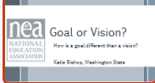  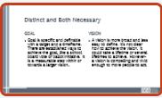  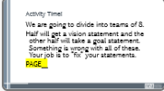  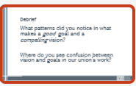  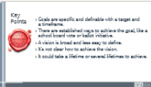  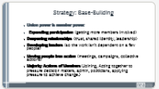    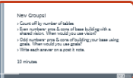  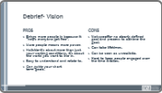  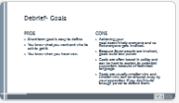     | Need to create a handout of the visions to fix | 5 minutes: 5 minutes- Popcorn Answers: How is a goal different than a vision?  Goal is specific and definable with a target and a timeframe. There are established ways to achieve the goal, like a school board vote or ballot initiative. It is a measurable step within or towards a larger vision.  A vision is more broad and less easy to define. It’s not clear how to achieve the vision. It could take a lifetime or several lifetimes to achieve. However- a vision is compelling and vivid enough to move people to act.  Activity (15 minutes):  Every table is divide into two. Assign them a statement to work on.  Half will get a vision statement and the other half will take a goal statement. Something is wrong with all of these. Your job is to “fix” your statements.  Spot the Problem (Revised Set)  Vision Issues to Fix (1–4)  ID problem and fix  1. Statement: “Our vision is to win a 6% raise in this year’s contract.”  Problem: This is actually a goal (too specific, measurable, and time-bound).  2. Statement: “Our vision is to hire 10 more special education teachers by next fall.”  Problem: This is a goal, not a vision (specific number + deadline).  3. Statement: “Our vision is better schools.”  Problem: Too vague and weak—doesn’t inspire or paint a clear picture of the future.  4. Statement: “Our vision is to improve working conditions.”  Problem: Still too broad and generic—not vivid or compelling enough to guide action.  Goal Issues to Fix (5–8)  5. Statement: “Our goal is equitable schools for all students.”  Problem: This is actually a vision (too broad, not measurable).  6. Statement: “Our goal is to support educators better.”  Problem: Too vague—no specifics, metrics, or timeline.  7.Statement: “Our goal is to reduce class sizes.”  Problem: Missing how much and by when—not measurable or time-bound.  8. Statement: “Our goal is to someday improve staff retention.”  Problem: “Someday” makes it non-actionable—no clear timeline or accountability.  Share out 1 of each.  Debrief: What patterns did you notice in what makes a good goal and a strong vision? Where do you see confusion between vision and goals in our union’s work?  20 minutes- Pros and cons of narrow goal focus vs uniting around an expansive vision.  10 minutes- Count off the tables  Even numbers will write the pros/cons of using goals for base building. Odd numbers will write the pros/cons of using vision for base building. Use post it notes to capture the conversation.  When finished, add your post-it a chart paper with a pro and con column. Group your post-its next to others with the same answers.  5 minutes- Have the team walk over to the other side and review the post it notes.  5 minutes- Have them debrief what was shared.  Key Points to pull out.  Goal  - Pros: Short term goal is easy to define. You know what you want and who to ask to get it. You know when you have won.  - Cons: Achieving your goal doesn’t help everyone and so not everyone gets involved. Because fewer people are involved, goals build less power. Goals are often based in policy and can be hard to explain to potential supporters because of technical language. Goals are usually smaller wins and smaller wins can be chipped away by your opposition if you don’t build enough power to defend them.  Vision:  - Pros: Brings more people in because it “helps everyone get free”. More people means more power. Holistic-it's about more than just your working conditions, it’s about the world you want to live in. Visions are easy to understand and don’t require understanding technical details or policy. Can guide your short term goals.  - Cons: not specific- no clearly defined goal and process to achieve the goal. Can take lifetimes. Can be seen as unrealistic. Hard to keep people engaged over time.  10 minutes-  Write Down your visions for your local. Reminder- this is vivid, compelling and will likely take a lot of time to accomplish. Not specific, but not so general as to make it not compelling.  On your own, right down one goal for your local you would like to accomplish in the next year. Now, write down who you would like to see helping you accomplish that goal. Be specific- don’t just say “members”, say what percentage of members. Don’t just say “parents”, say “at least 100 parents”. Share your answers at your table. Think of who your base will be. | Participants will learn the difference between a goal and a vision.  Participants will learn what base building is.  Participants will learn how a vision builds a base of support and goals engage members initially.  Participants will write down a goal for their time.
9:45-10:30 | Alan | 45 Minutes – Analyzing Vision and Goals in Campaign Lab Locals
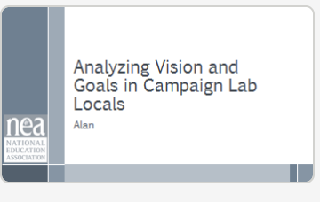  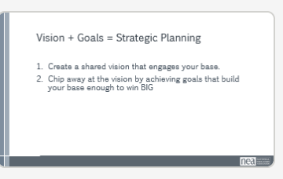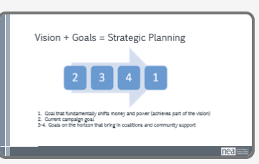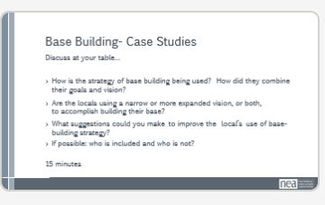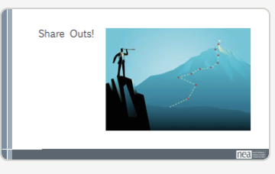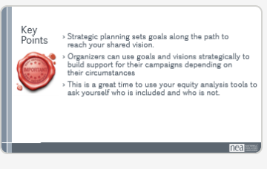 |  | 5 minutes- How to use them together (AKA “Strategic Planning”)  What is strategic planning and how do you do it?  Create the shared vision first to build your base so you are strong enough to win and protect your wins.  Chip away at achieving your vision through short and mid-term goals that make your vision real. This is called strategic planning.  Show example of 4 box planning tool from Grassroots Power Project:  In box 1, write a big goal that could fundamentally shift power and money towards your vision  In box 4, write immediate goals on the horizon, such as this year’s school budget.  In boxes 2 and 3, think about bigger goals that will build your power by increasing your base. These goals should matter to more than just your members and should include coalition building and strengthening, because there is no way you can achieve your vision on your own.  Popcorn answers- why is it numbered like this?  Answer (if not given)- you start with the goal that actually gets you closer to your vision and work back from there on how to achieve it, starting with where you are at right now.  (NOTE- we are intentionally not spending a lot of time on strategic planning because they shouldn’t be working on a strategic plan if they don’t have a team yet. The goal is just for them to understand what it is and basically how it works.)  30 minutes- Read and discuss case studies from Campaign Lab Locals  - North Carolina Association of Educators (NCAE)  - We Can’t Wait Campaign- United Teachers of Richmond (CA)  - Colorado Springs Education Association  Participants should have read these articles ahead of time. They will be assigned one of the case studies to discuss at their table. The group will share what they read and their answers/thoughts/a-ha moments.  - How do they see the strategy of base building being used? How did they combine their goals and vision?  - Are the locals using a narrow or more expanded vision, or both to accomplish building their base?  - What suggestions could you make to improve the local’s use of base-building strategy?  - Who is included and who is not?  10 minutes- share outs by table.  - What did you notice about how they combined their goals and visions?  - What suggestions would you make to improve the base building strategies?  - Who did you notice was included, who is not?  - If short on time skip to #3  Key Points: Strategic planning sets goals along the path to reach your shared vision.  Organizers can use goals and visions strategically to build support for their campaigns depending on their circumstances.  This is a great time to use your equity analysis tools to ask yourself who is included and who is not. | Participants will know how a vision and goals work to create a strategic plan.  Participants will analyze real world examples to identify how a local used a vision and goals to build their base. Participants will be able to identify the strategy used and how it might be improved.
10:30-10:45 |  | 15 Minutes- Break
10:45-11:30 | Pete C | 45 minutes- Leader ID
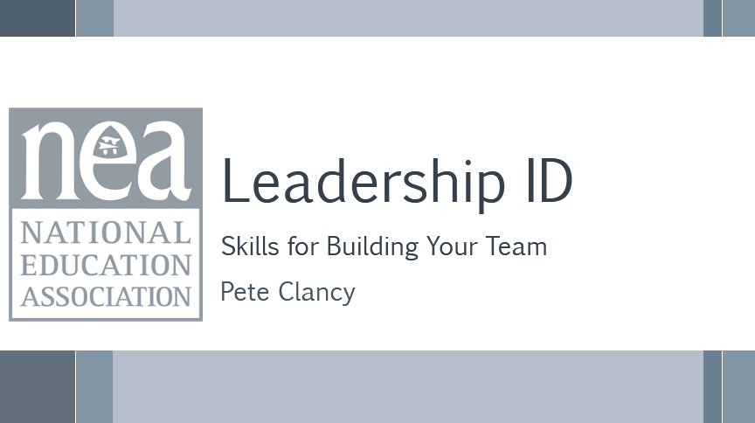  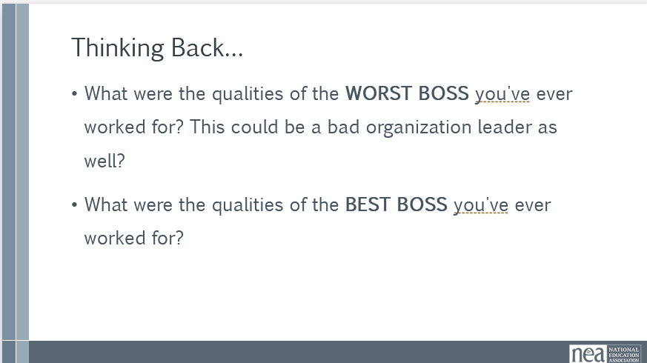  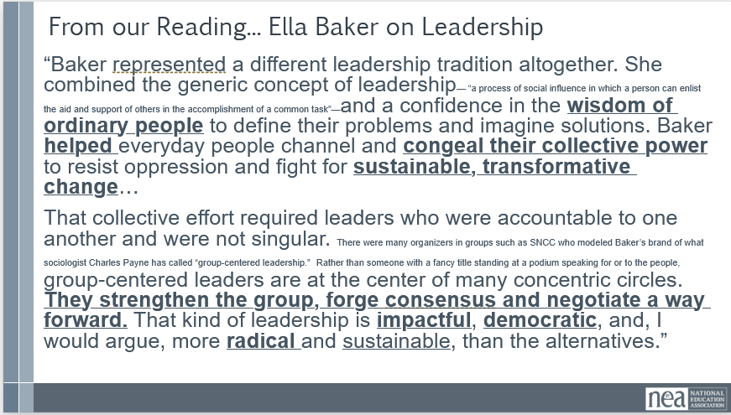  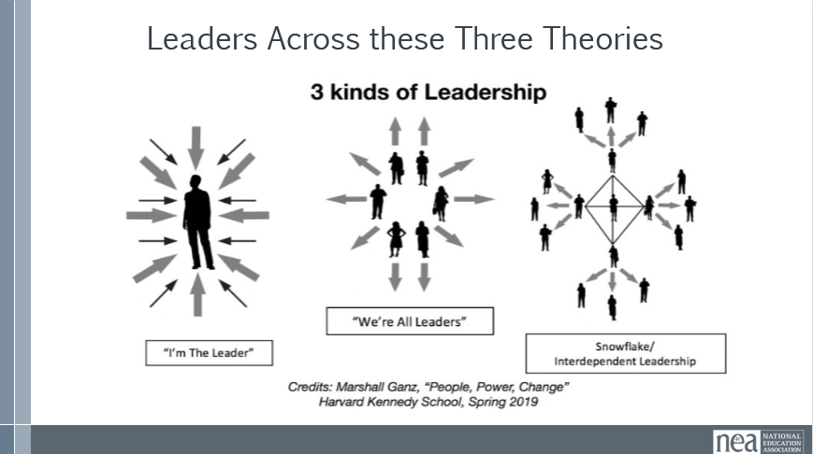  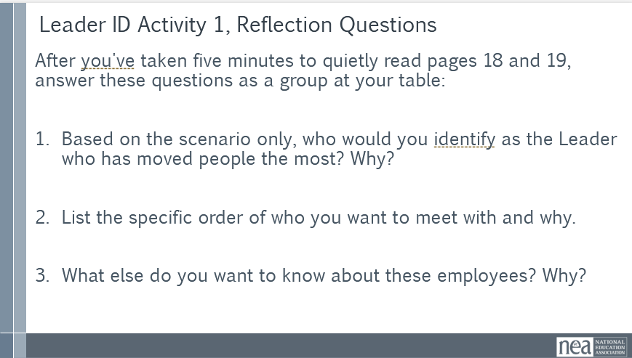  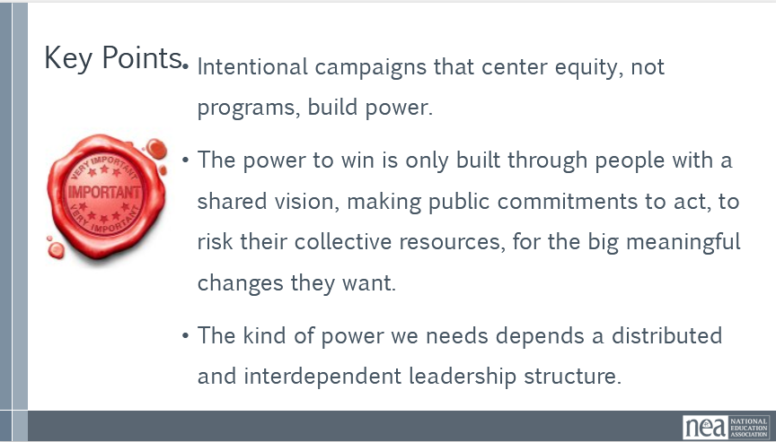 |  | 10 minutes:  Ask: what are the qualities of some of the worst leaders and bosses who’ve worked for?  Ask: what are the qualities of some of the best leaders and bosses you’ve worked for?  Review, Ella Baker quote in PPT. What resonates with you when you reflect on how Baker approached leadership?  We also can think about different leadership structures, and how they contribute to campaign health. From the “I’m the leader” to the “we’re all leaders” to the “interdependent snowflake” model, I am sure all of us have some experience in each of these structures. What do you notice either from the illustrations or your experience about leadership in each of these structures?  (Looking for: too much responsibility for an independent leader, herding cats for we’re all leaders, and distributed power for snowflake.)  We are trying to building interdependent campaign structures.  How do we use what we believe about strong leadership characteristics to help us identify member-leaders?  We are going to read a scenario that discusses several different potential leaders in a school work site. We are going to take 5 minutes to silently read pages 18 and 19 in your participant handout packet.  Once everyone has read, you will answer the questions at the bottom of page 19. You will have a total of 10 minutes for independent reading and then group discussion at your tables.  END OF TABLE TIME: Say, now I am going to ask each table to share one answer to one of the questions.  WRAP UP  Reviewing our key points, as we develop intentional campaign, we are trying to building the power of our associations. We build this power through a shared vision, having commitments to action, and risk to our collective resources to make big lasting change. This all depends on a distributed, interdependent, leadership structure. | Participants will be able to identify the characteristics of trusted, respected leaders that power for winning long term sustainable campaigns.
11:30-12:00 | Amanda | 30 Minutes- Semantics for Recruiting Leaders
  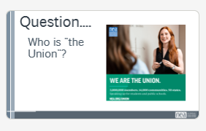  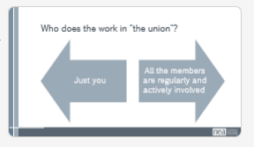  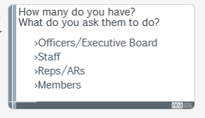  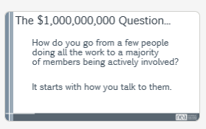  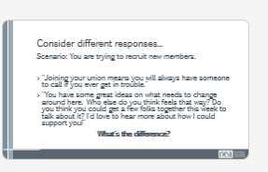  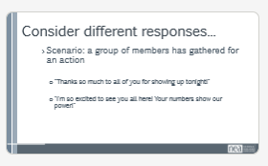  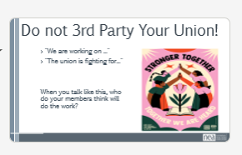  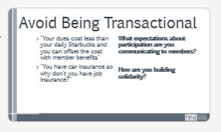  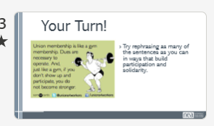  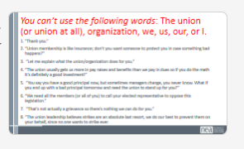  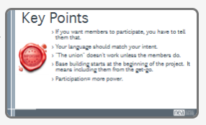 | For the future include the “Don’t third party the union Semantics” | Intro- 15 minutes  Say: Once you ID a leader, how do you get them involved? What do you say?  First, how would you answer the question “Who is the union?” (Popcorn answers)  Say: Who does the work in your union? We’re going to do an activity to explore that answer.  Imagine there is a line that goes from one end of the room to the other. One end, it’s just you doing the work. On the other, all the members are active at some level in doing union work. Stand up and place yourself on the line.  Allow participants to place themselves. Most people will likely clump towards the “just you” side.  Ask: What happens as a result of just one or a few people doing all the work?  (Popcorn answers- answers will probably include burnout, exhaustion, being overwhelmed, feeling resentful towards members who are never satisfied, etc)  Ask people to return to their seats.  Say: On a piece of paper, I want you to write down how many of the following people do you have in your local? And then next to that, I want you to jot down all the things you ask those people to do. Not what you WISH they would do, but what you actually ask them to do on a regular basis.  (Give them 3 minutes to write)  Ask: What did you notice?  (Popcorn answers- most will say they are really only asking a few people to do the majority of the work).  Say: So how do you get your members to shoulder some of that work? That is the million dollar question! There isn’t one simple answer, but it does matter how you talk to people.  Content and practice: 15 minutes  Let’s practice. Read the scenario on the slide. Discuss at your table what you think the difference is in the two responses?  (Let them discuss for 3 minutes). Popcorn out responses from tables. If they don’t mention it, point out that the first response sounds like the members are doing you a favor, while the second response makes members notice that their participation is what makes their union powerful.)  Ask: Has anyone ever heard someone say “Don’t 3rd party your union”? (Ask for a show of hands- if anyone raises their hand, ask them to share what it means.)  Say: It’s important never to talk about your union as if it was something besides you and your coworkers, because if you let them believe it is something else, then they don’t have to do the work. “The union” will do it.  There’s a lot of ways we inadvertently let members believe they don’t have to do anything when we talk this way.  In fact, many members only ever talk directly to other union members when they are recruited. And what do we say to them in our recruitment pitch? Do we create any expectation that they should be actively involved?  Unlearning to say the things we are used to saying is hard and requires practice, so that’s what we are going to do.  (Assign every table one phrase from the slide).  You will have 5 minutes to come up with something you can say that is better than the phrase you have, because it clearly communicates to the member or potential member an understanding that their participation is what give them power.  To be clear, there’s nothing wrong with thanking people. But members can hear it as transactional. You are thanking them for joining or participating as a favor to you. If you want to build an active engaged base, how can you communicate that more clearly?  You can’t use the following words: The union (or union at all), organization, we, us, our, or I.  - "Thank you.”  - “Union membership is like insurance; don’t you want someone to protect you in case something bad happens?”  - “Let me explain what the union/organization does for you.”  - “The union usually gets us more in pay raises and benefits than we pay in dues so if you do the math it’s definitely a good investment!”  - “You say you have a good principal now, but sometimes managers change, you never know. What if you end up with a bad principal tomorrow and need the union to stand up for you?”  - “We need all the members (or all of you) to call your elected representative to oppose this legislation.”  - “That’s not actually a grievance so there’s nothing we can do for you.”  - “The union leadership believes strikes are an absolute last resort, we do our best to prevent them on your behalf, since no one wants to strike ever.  5 minutes share outs.  Key points:  If you want members to participate, you have to tell them that.  The union doesn't work unless the members do.  Base building starts at the beginning of the project. It means including them from the get-go.  Participation= more power. | Participants will learn how to build expectations of member engagement and solidarity in how they talk to members and potential members as a key part of base building.
12:00-1:00 |  | 1 hour- Lunch
1:00-2:00 | Matt | 1 hour- Structured Organizing Conversations
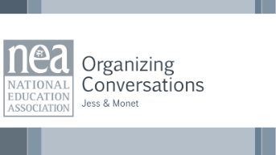  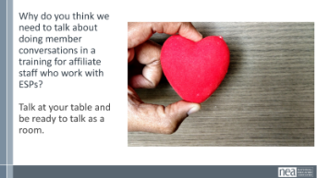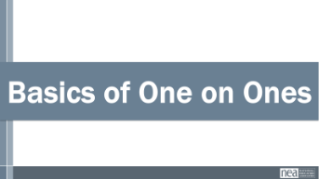  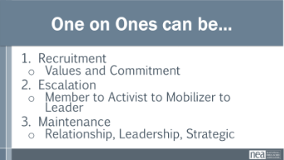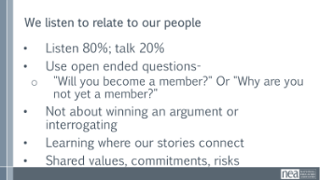  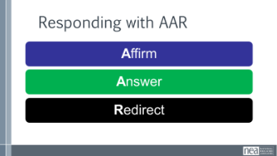  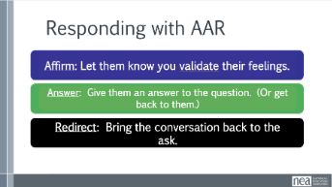  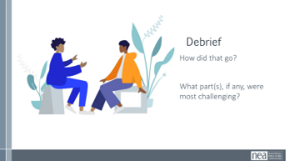  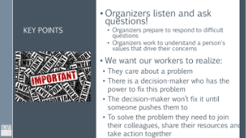 | Is there a handout for this section? | 1:1 Content  Example Script  Practice  Feedback  15 Min - How do we identify members’ issues and build relationships?  We are going to do structured organizing conversations. How does this relate to base building?  Take some time – about 5 mins – and be ready to talk as a room  What did you come up with?  Points to Make as you debrief: These conversations are also about building leaders. We will touch on the definition of leaders.  Who are we meeting - We meet people who are activists, mobilizers, or leaders – or not even sure yet?  Definitions of who are leaders, mobilizers, activists  We only build a base when we are able to use our leaders to expand beyond the mobilizers and activists that they already turn out. All roles are necessary to a strong campaign but are not sufficient to continue to build the power we need to win what we want.  When one person talks to another person  And it’s primarily to get to know each other, but can be used for  Recruitment, Escalation, Maintenance  - Recruitment  - Values and Commitment  - Escalation  - Member to Activist into Mobilizer into Leader  - Maintenance  - Relationship, Leadership, Strategic  We listen to relate to our people  - Listen 80%; talk 20%  - Use open ended questions  - Not about winning an argument or interrogating  - Learning where our stories connect  As Organizers we are listening to identify their issues and values, not TELL them what the issues are  We use probing questions such as:  •Use probing questions  What’s not right here?  What would you change?  Why is this an issue for you?  Why do you care about this?  •Use direct and specific language – Are you ready to sign this pledge cards, will you bring 5 people with you  •Stress the shared values you have exchanged - Like you, I have been low paid person that has felt disrespected by my managers  •Frame it so that the person IS the solution to the ask – We can’t win this if you do not show up. You are critical to the success of this action.  •Move them towards the next level of action – You joined us last month at Happy Hour, can you bring 5 people  We do not organize worksites, worksites are already organized by natural leaders  We have to ask who is trusted and respected  Even if they are not a member, we need to be in contact  We cannot identify leaders based on our own observations and bias's -  They wear the swag, they have been here 20 years but no one talks to them  We have to ask our people who they trust.  Ex: The attendance at the most recent Conference  5 Min - Affirm/Answer/Redirect: Intro  You will often experience conversations where concerns, incorrect information, tensions, and disagreements come up. One strategy we are going to explore involves suspending assumptions; instead of immediately disagreeing or responding, what are some more probing questions we could ask to get at the CORE VALUES of their objections? In the slide, we see some broad categories of barriers, such as political differences and an aversion to collective action. But, if we try to dig deeper, maybe we will find that their aversion to the collective is really about their valuing of individualism or that they prefer control. If we can identify those values, we will be better positioned to respond in a productive and engaging way.  Another strategy to answer challenging questions and statements is to use the framework of Affirm, Answer and Redirect; this approach can be very helpful.  AFFIRM: Let them know you’re listening, you understand, and their feelings are valid. Don’t get mad at them—validate and educate them.  ANSWER: Give a truthful, concise answer to the question. If you don’t know the answer, don’t guess. Tell them you’ll find out and get back to them.  REDIRECT: Once you’ve answered the question, bring the conversation back to ask them to join your membership.  Example:  Statement: Unions are too aggressive.  Response:  AFFIRM: I was nervous too. I’m also an educator so my first instinct is to work together and help students—not agitate.  ANSWER: I have actually found our union to be very collaborative and supportive. We are working together with administrators and lawmakers from both major political parties to find a shared path forward, and I know we can be even more successful with a voice like yours at the table.  REDIRECT: Together, our voice can be even stronger to improve our daily lives and give students our best. Will you join ____________________ as a member?  20 Min - Practice  - Imagine you are in the middle of a 1:1 conversation with a worker; the organizer asks “Can you share why you haven’t yet joined our union as a member?”  - The worker will reply with one of these:  - I’d like to join but the fees are too high.  - I just have a hard time believing that joining a union will make a real difference in my life.  - Unions are too political  - Unions don’t focus on issues that matter to custodians like me  - Organizer uses AAR to continue conversation and return to an ask  15 Min – Debrief & Key Points [If previous section ran long, only 10 minutes]  - What was challenging?  Key points:  - Organizers prepare for difficult conversations and work to understand what values may be underlying a person’s concern or hesitation or disagreement.  - Thinking about making a commitment to be part of campaigns, actions, and leadership positions is the goal of asking members when you are base building  - Action among the membership is key to strategic planning. | Participants identify the types of one-to-one organizing conversations  How can we find out our people’s issues?  How do we have effective organizing conversations to identify member’s issues?
1:55-2:10 | BREAK
2:10-2:45 pm | Dr. Taraja and Alan | 30 minutes- Mapping and Charting
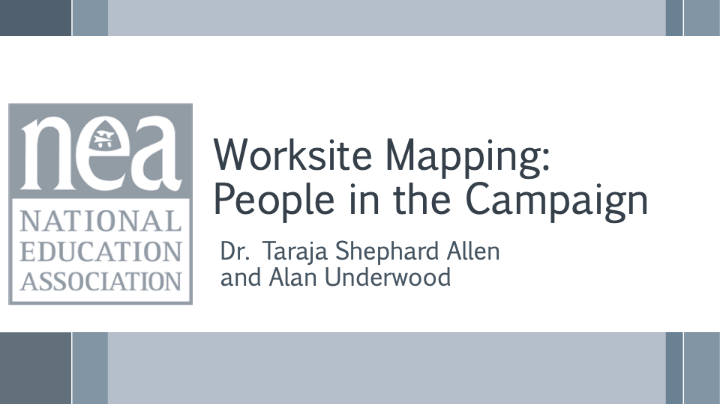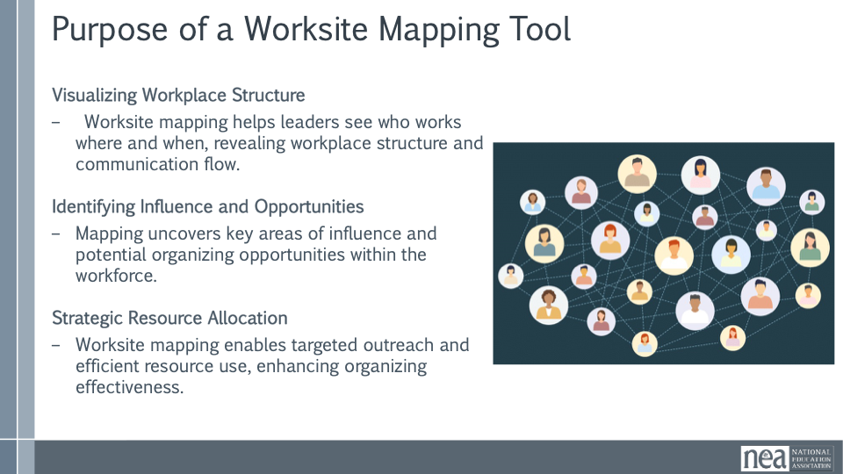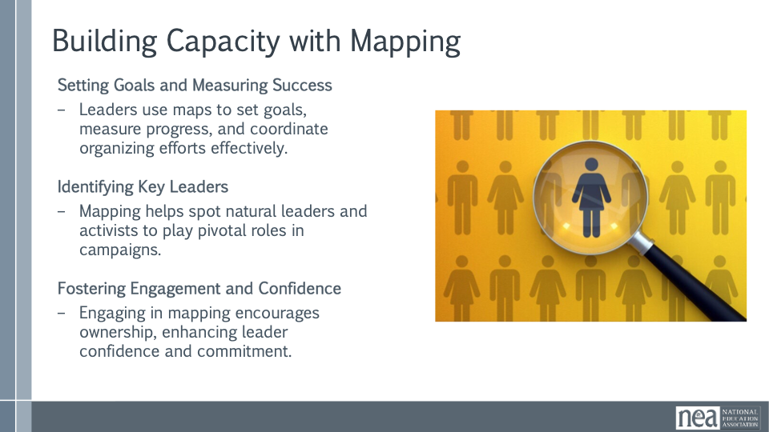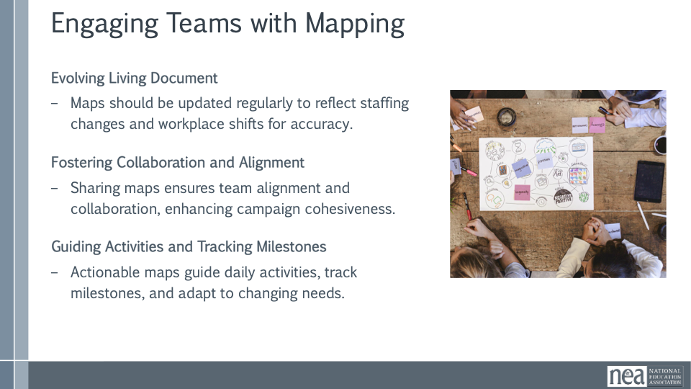  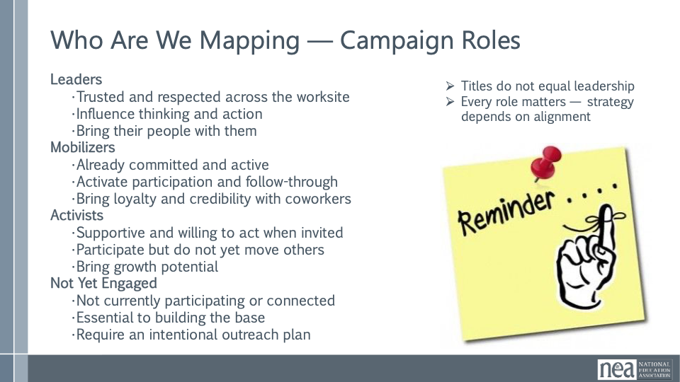  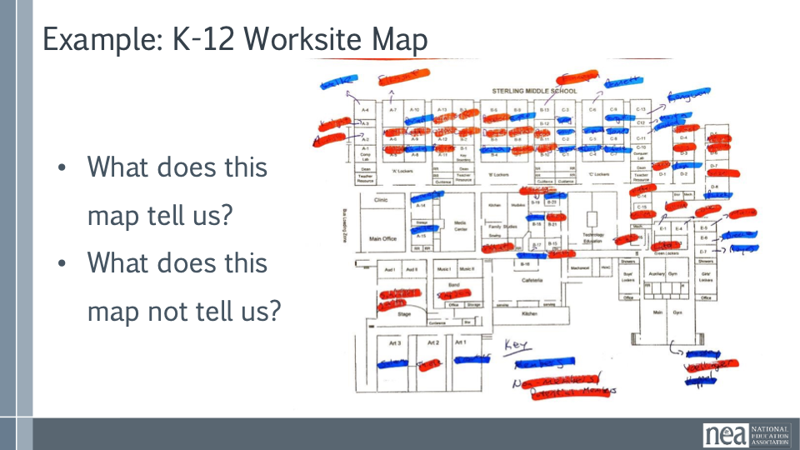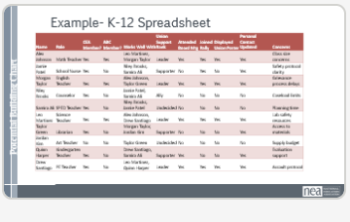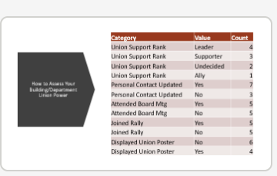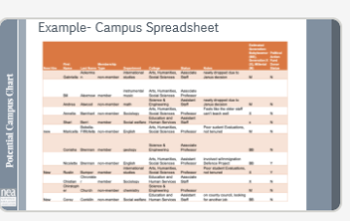 |  | Note here- important to build your team so that you are not the only leader or you are not the only one doing the work.  5 min — Welcome & Session Frame  Today is about seeing our people clearly.  Mapping helps us move from good intentions to real strategy.  This isn’t about perfection — it’s about being honest about what we know and what we still need to learn.  7 min — What Is Worksite Mapping & Why It Matters  When we map, we’re making the invisible visible.  It shows who works where, when, and who’s connected to whom.  Mapping helps us stop guessing and start being intentional with our time and energy.  6 min — Mapping as Leadership Development  Mapping isn’t just a tool — it’s a way leaders learn to see the worksite differently.  It helps us spot informal leaders, not just people with titles.  When leaders can see the whole picture, they organize with more confidence.  4 min — Who We Map & Campaign Roles  Not everyone plays the same role — and that’s a strength.  Leaders move people. Mobilizers activate participation. Activists bring potential.  And ‘not yet engaged’ isn’t a problem — it’s a plan waiting to happen.  Remember: titles do not equal leadership.  Ask participants to note the differences of what is being tracked and not being tracked with the various types of charts? | Participants will understand the importance of mapping and charting. They will understand how to make a physical representation of both who their people are and where they are located. They will understand that mapping and charting are living documents that represent where the local is and where they can target for action and improvement.
2:45-3:15 (Cont.) | Alan and Dr. T | 30 Minutes - Charting and Mapping Activity
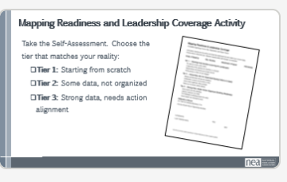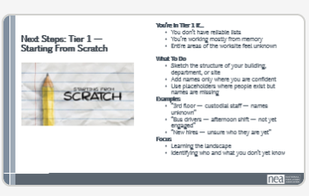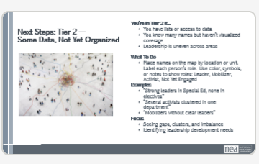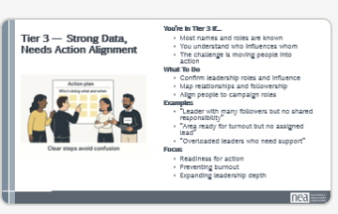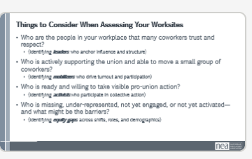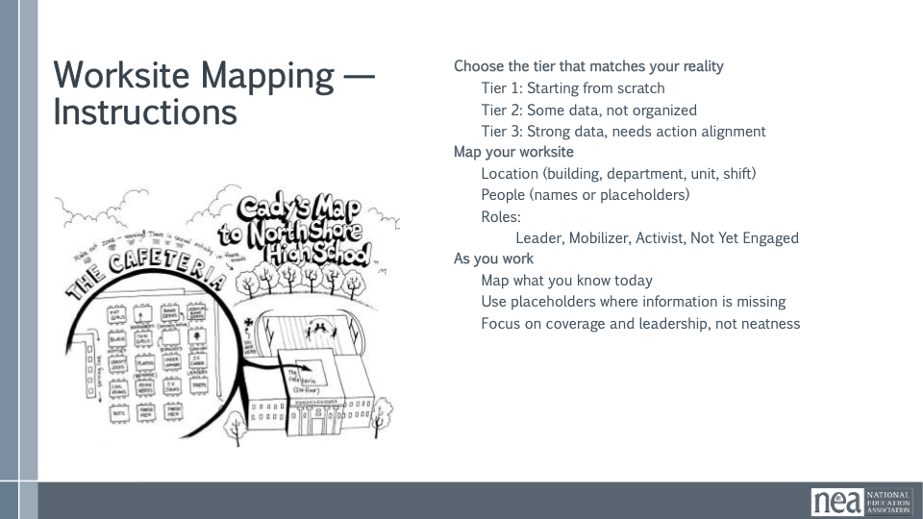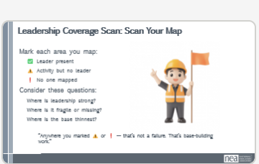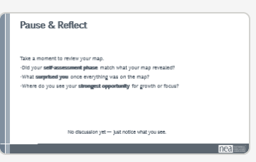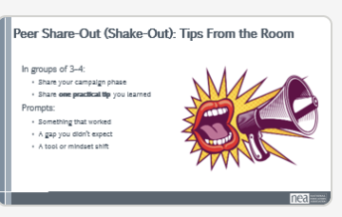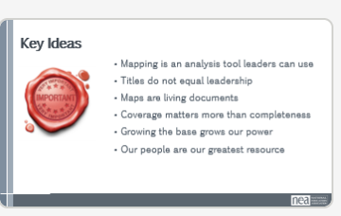 | There is a digital fillable PDF to complete their quick self-assessment. The rest of the info is provided by the participants | 3 min — NEA Campaign Phase Self-Assessment  Quick self-check — no discussion, no judgment.  This helps you be honest about where your worksite is right now.  Different phases are normal. Mapping looks different depending on where you are.  5 min — Mapping Instructions & Tier Selection  Too much for one slide  Choose the tier that matches your reality, not your aspiration.  Use whatever tools you have — paper, building maps, or digital tools.  You’re mapping location, people, and roles — names or placeholders are both okay.  10 min — Hands-On Worksite Mapping Activity  Map what you actually know today.  If something’s missing, that’s information — not failure.  Focus on coverage and leadership, not neatness.  5 min — Leadership Coverage Scan  Now let’s pause and scan the map.  Where do you see leadership present?  Where is there activity but no leader?  Where is no one mapped at all?  These are organizing priorities, not criticisms.  10 min — Peer Share-Out, Tip Exchange, & Key Points  In small groups, share one practical tip you learned today.  What helped you see your site more clearly?  What would you tell another leader just starting this?  Key Points to Close:  Mapping is an analysis tool leaders can use  Titles do not equal leadership  Maps are living documents  Work with what you got.  Growing the base grows our power  Our people are our greatest resource | Participants will evaluate where they are (tier 1,2, or 3) and do a mapping activity to strengthen their position. This hands-on activity will give them a resource to take back to their locals and continue to build their base and understanding of their people.  Participants will learn how they can use this with their teams back home. Participants can adapt this activity to use with their whole unit or focus on a smaller portion of their union.
3:15-3:30 pm | Katie | Energizer- ROCK PAPER SCISSORS  Participants square off in pairs to do “rock, paper, scissors”. Loser of competition joins the winner as their team and cheers on the winner. Contest continues until there are only 2 people left for the ultimate showdown. This will get noisy!

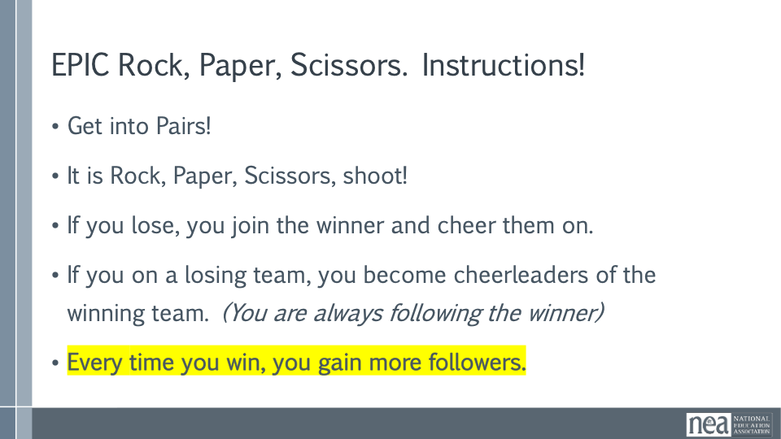

3:30-4:00 | Kristin | Real Talk- “What Could Go Wrong?”
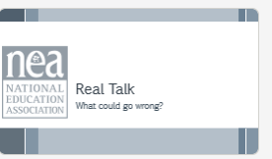  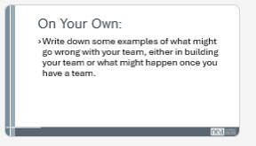  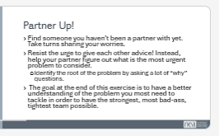  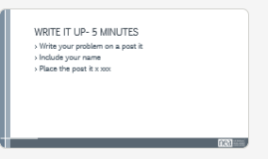  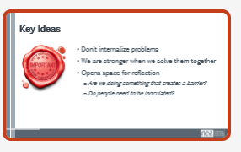 |  | 5 minutes- Now you have the skills to build your team. But we all know things usually don’t go according to plan. Let’s take a minute to talk through all the ways you are afraid your team won’t work out. Maybe your fears are based in experience. Or maybe you are just worried about doing something new.  On your own, write down some examples of what might go wrong with your team, either in building your team or what might happen once you have a team.  20 minutes- Find someone you haven’t been a partner with yet. Take turns sharing your worries. Resist the urge to give each other advice! Instead, help your partner figure out what is the most urgent problem to consider, and try to identify the root of the problem by asking a lot of “why” questions. The goal at the end of this exercise is to have a better understanding of the problem you most need to tackle in order to have the strongest, most bad-ass, tightest team possible.  5 minutes- on a post-it, write the problem and your name and place in dedicated spot. We will be using these examples to work through problems together tomorrow.  Key Points- Internalizing problems creates fear, distrust and isolation. Problem solving together strengthens your team and should be a welcome opportunity to reflect, inoculate and re-strategize. | Participants confront fears that could arise with planning and open up to their partner about them.  Through this vulnerability we understand that plans will go awry when we confront management and our power lies in strategizing together.
4:00-4:30 | Amanda | Ending it right  Lift it up!  And close it out.
4:30-5:00 | All | Adult Choice Networking
5:00 Adjourn

