https://forgeorganizing.org/article/plan-2028-bringing-labor-and-social-movements-together/

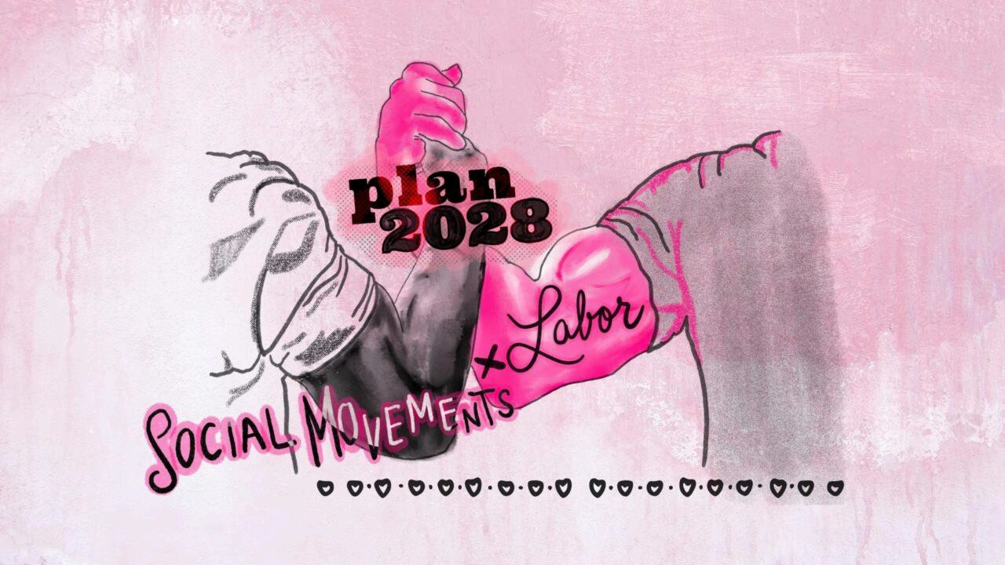
The  Forge

March 14, 2025
Plan 2028: Bringing Labor and Social Movements Together - Stephanie Luce

Plan 2028 isn't just another general strike call-it's a strategic, long-term push to unite labor and social movements in a coordinated fight against rising authoritarianism.
The Trump Administration has come in with brute force, attacking working people and institutions from all angles. Their "flood the zone" strategy has left many feeling confused and powerless. But MAGA forces are not unstoppable. Strong coalitions among labor and social movement organizations offer one of the best hopes for blocking the rise of white Christian nationalist forces, and for countering authoritarianism with progressive power.
In fall 2023, United Auto Workers (UAW) President Shawn Fain called for unions around America to align their contracts with a May l, 2028 expiration date, in order to align with the UAW's next round of bargaining with the Big Three: Ford, General Motors (GM), and Chrysler (now Stellantis). This was, in part, a call for class solidarity: to bring workers together across unions, labor and social movements, and geography. It was also an acknowledgment that some of the biggest demands that UAWmembers have-strong pensions and healthcare-cannot be won alone. Workers will need to build broad alliances that can leverage greater pressure on employers and the state.
Over the last year, Fain's call has spread. Unions, base-building organizations, and political organizations are talking about how they can use Mayl, 2028 as a compression point: bringing together a broad coalition of groups with bold demands, to share collaborative corporate campaigns and electoral work.
Long-time labor organizer, strategist, and In These Times executive director Alex Han coined the term "Plan 2028," which highlights the need to plan for such a coordinated action. There is a need to build power, grow our impact, and increase our capacity: through elections, issue and/or pol icy cam paig ns, and street heat in the buildup to May2028. But we can't wait until 2028 to take action! "Plan 2028" can begin with MayDay2025.
Will labor pull off a general strike?
Anyone who has been around the Left is used to regular calls for a general strike. But actual general strikes are rare in the United States and difficult to pull off. Only 10% of workers belong to a union, and even where workers are unionized, they face barriers to striking. For many public sector workers, it is illegal to strike, and while some unions have defied the laws and struck anywa there can be heavy penalties and consequences. Union contracts usually include no-strike clauses, meaning that workers can only strike under certain conditions once the contract is up. Workers lose money while on strike, and in some cases they are replaced and lose their jobs permanently. Many unions don't have adequate strike funds or other forms of support in place.
Given the challenges, it seems unrealistic to picture May 1, 2028 as a full-blown general strike. Rather, Plan 2028 could look more like a series of escalating actions over the next several years, including engagement in the 2026 elections and coordinated fights against the implementation of Project 2025. Those actions could build up to a month or several months of national protests in early 2028; that could include big strikes, rallies, protests, and legislative campaigns. Disruptions may take other forms beyond a strike­ workplace actions like slow-downs, sit-downs and walk-outs, or the kinds of community boycotts and direct action seen in the Civil Rights movement. Any real disruption will still involve risks­ arrest, harassment, and surveillance for example-and, whether strikes or otherwise, disruptions must come with careful planning and collective ca re.
Plan 2028 is more realistic than many previous calls for a general strike because it comes from the UAW: a large union with major contracts expiring in May 2028. Whatever happens, there's a possibility that some or all of the 150,000 UAW members at the Big Three auto companies will strike.
Unions with a history of successful strikes are aligning with Fain's call. Most notably, the Chicago Teachers Union (CTU) endorsed it, and are working to line up their contract talks with UAW's dates. CTU worked with the Baltimore Teachers Union to support a resolution at the 2024 American Federation of Teachers (AFT) national convention, calling on AFT locals to support the call. The resolution passed overwhelmingly. The American Postal Workers Union (APWU) also passed a resolution in support. Other unions and labor councils are joining in.
There are plenty of unions who can't set up their contract expiration dates for May 2028. Perhaps their agreement expires in the months before or after, or not in the same year. The 2028 date gives unions time to do the slow and steady organizing work needed to build capacity in order to pull off coordinated action of other kinds, such as support for legislative campaigns aligned with May2028.

Bringing in social movement organizations
Plan 2028 needs to build a coordinated national effort going beyond unions, and beyond the usual suspects. This could begin with May Day committees in cities around the country that are led by union, social movement and political organization leaders ready to work together against shared electoral and non-electoral targets. Ideally, Plan 2028 would carve a path to building visionary and strategic partnerships between unions and organizations with a substantial base, like Mijente, SURJ, the Working Families Party, faith-based organizations, and more. We must also involve unions that haven't been engaging in progressive coalitions, and union members who have voted for MAGA candidates.
We've had a few examples of unions coordinating contract expiration dates in the last decade; in some of those cases, from Connecticut to California, the unions also aligned with social movement organizations around shared demands that benefitted all. This approach, known as Bargaining for the Common Good (BCG), opens up exciting opportunities for unions and social movement organizations to find common targets and overlapping demands. Many teachers' unions have used BCG, fighting alongside parents and students for better working and learning conditions.
In Minnesota, 70 unions and base-building organizations have worked together over the past 10 to 15 years to align union contracts and community demands. This alliance also conducts a shared power analysis, identifies common targets, builds trust, develops leaders and takes coordinated action. These unions aligned their contracts to expire around March 2024. Working with one another and local social movement organizations, they developed coordinated contract and legislative campaigns around four shared themes: stable housing, good schools, dignified work, and a livable planet.
While not all of the unions ended up striking, the groups in the alliance used contract expiration dates as a compression point. The alliance held a week of action with protests, rallies, leadership training and picket lines. And the unions and organizations won many of their demands, including substantial wage increases for janitors, teachers, and city maintenance workers. Base-building groups representing low-income renters and the worker center Centro De Trabajadores Unidos En La Lucha (CTUL) joined the weekly actions and called on developers to join their Building Dignity and Respect Program, which creates an independent monitoring group to examine working conditions in the residential construction industry.
Bargaining for the Common Good invites a long-term approach that builds trust over time and takes on demands no group could win on their own. But the work is challenging. Unions usually have more power and resources in these relationships, and the legal framework of labor law and collective bargaining can dictate the timeline. It is easy for one partner to cut a deal and leave others out, or to exit an alliance. To build durable coalitions, relationships between organizations must go deeper by including members, rather than just being leader-to-leader.
The Minnesota alignment attempted to preempt some of those pitfalls with guidelines on how to work together. For example, they agreed that if anyone partner in the alignment got a deal from their target, they were allowed to take it, rather than having to wait until everyone got a deal. But each organization still had to participate in the Week of Action, support other groups' pickets and actions, and send members to leadership schools.
Bargaining for the Common Good is not a magical solution for unity; rather it is a tool or framework that can be used wel I or used poorly to deepen alignment among social movements and labor. The examples of where it has been used well are inspiring, and provide a model of what we might see building towards 2028.

Some union leaders may be slow to join in. However, it's possible that a labor upsurge can come from militant leaders at the local level. The late Dan Clawson, scholar and union leader, argued that upsurges don't tend to come from the top leadership, but in spite of it. Mark Meinster of the United Electrical, Radio and Machine Workers of America (UE) suggests that upsurges are more likely when you have a large number of "politically conscious working­ class leaders who have experience in militancy .... and a view that the existing system is illegitimate." If successful, the concept could quickly spread beyond the communities or workplaces where we've been working.
There are many constituencies skeptical of working with unions, and for good reason. Their organizations may have been cut out of deals union leaders made with politicians, or they've even had a negative experience of their own with a bureaucratic or inept union. And the vast majority of people don't belong to unions.
Plan 2028 could provide a way to bring new life to the labor movement: giving energy to militant members and leaders, and inspiration to workers looking to organize their own workplace.

Coordinate actions from 2025 to 2028
Starting this May Day, local labor and social movement leaders are encouraged to begin planning coordinated actions in cities across the country, united around key demands or themes. We can start by focusing on a handful of regions where union and social movement leaders are willing to take risks and think creatively, and where they have a real base. The Chicago Teachers Union is working with ARISE Chicago and over 80 organizations to plan for May Day 2025. Leaders in other cities are joining the call to action. These aligned forces will ideally move toward a shared analysis of long-term targets and a shared infrastructure to support collective organizing in the coming years.
These shared actions will necessarily take a defensive character as Project 2025 is implemented, immigrants are attacked, and public jobs and services are cut; but it is crucial that this effort includes visionary demands as well. The UAW's demands are not just to defend Social Security and Medicaid, for example, but to expand it.
The UAW calls for strikes, but Plan 2028 should also include an electoral strategy. We must make demands on employers as well as the state, at the local, state, and federal level. Plan 2028 activities could include building independent political organizations and supporting progressive midterm candidates.
It's too early to predict what might be the most pressing need in 2028. Rather, an organized leadup to 2028 could be a vehicle for surfacing demands, candidates, and engaged bases that build the counterweight to corporate Democrats; something we will need to effectively challenge the Right's faux populism. Given the growing authoritarian threat in the US and globally, a militant politicized labor movement working with social movement organizations needs to take leadership in defending and expanding democracy, just as they have done in other countries.

What's Needed?
We learn from labor-community alignments in Minnesota, Connecticut, California, and elsewhere about the components that make these efforts more likely to succeed:

A consolidated core of social movement organizations and unions
In the last 70 years in particular, the center of gravity for doing powerful electoral and non-electoral work has shifted and grown. It will be imperative that, in addition to UAW, some of these organizations will become the nucleus that can align and steer the broader Plan 2028 effort. Without a powerful and reliable
center, Plan 2028 has less of a chance to maximize its national and state level impacts.

Organizations with real bases
We cannot pull off a strike of any kind without real membership involvement. Union and workplace leaders need to build internally, using workplace mapping, structure tests and leadership development. Social movement organizations must also have real bases. While think tanks and advocacy non-profits might be allies, they cannot anchor a true alignment that is about building power.

Organizations that are clear about their self-interest
Plan 2028 is exciting and many people are eager to jump on board for political and visionary ideas. But organizations need to have a concrete way to tie the 2028 actions to building their own power. The most successful alignments happen when organizations understand that they have big goals that they cannot win on their own.

Involvement from members and the rank-and-file
Building coalitions or alignments requires making the time and space to bring in members. Offer political education and skills training. Involve them in decision-making. Run practice pickets or policy negotiations; pair up labor and community members to knock on doors.

Shared research
We need to conduct power analyses of our communities and states. Who holds power? What are favorable or unfavorable trends that are shaping our terrain? Who controls production, who lends money, who makes decisions, who pressures politicians? Where do we have common targets?

Shared calendars, staff, lists, and resources
Working together long-term goes better if we move beyond shallow ad-hoc coalitions and into deep alignment. We need to be able to look under the hood of each other's organizations to increase trust as well as capacity.

Strike funds and mutual aid
Direct action is risky and can be expensive. We need to collectivize the funds, childcare, food, healthcare and other care work needed to help people take risks. They need to know someone has their back. We'II also need legaI support and a sober assessment of potential infiltration and backlash.

Guidelines for working in coalition
There have been countless labor-social movement coalitions over the years; we've learned a lot about potential pitfalls. Especially when labor-who often is the most well-resourced partner at the table-has not always participated through an equity lens in respect to other partners. The Minnesota alignment's guidelines provide one model. Madeline Talbott, formerly with Association of Community Organizations for Reform Now (ACORN), has additional advice for working in coalition, such as: establish an agenda-setting committee, be clear about who has decision-making power, and talk about how to address power differentials between groups.

Preparation for an upsurge
It's hard to predict an upsurge, but it is possible to prepare for one. We can train thousands of workplace and community leaders to be organizers, strike captains, alliance builders, and strategists. We can use tools like tabletop exercises to predict how bosses and the state might try to infiltrate, divide us, co-opt us, or crush our actions. We can find on-ramps to bring in new people at any level.
In contrast to many calls for general strikes that are defensive reactions to attacks, the Plan 2028 call is a push to go on offense. Labor and social movement organizations working in close alignment can build power inside and outside of workplaces. We begin our joint work this May Day.
None of this is just about a day in 2028. That date provides a natural compression point for coordinated action, but building power will require a long-term strategy that starts with organizing now and that goes beyond 2028; that aspires to build a strong, militant, and aligned labor and social movement, as well as building governing power that changes the rules of the game altogether.

About The Author
Stephanie Luce is a professor of labor studies at the CU NV School of Labor and Urban Studies. Her books include Labor Movements: Global Perspectives and Fighting for a Living Wage.

