Facilitator Agenda – DAY 1 Campaign Academy
General Materials Needed: |  |  |  | Room Set-up: 80 people max
Name Tents with the Norms  Room signs, Stick on Name Tags  Chart Paper (10 full w Sticky Strip)  Printer paper (enough for each participant) | Materials Box for each table with:  Markers (Mr. Sketch variety)  Crayons OR Colored Pencils  Post its – 3x3” and 4X5” sizes |  |  | Long Rectangle table at back for facilitators  Round Tables for participants  Projector, Screen, mics, and Speakers  Carousel stations and reporting stations
Key Outcomes for the Event:
- Understand and apply the coaching cycle, the diagnosis framework, and the spectrum of interventions campaign coaches use
- Develop core coaching skills including asking powerful questions, learning to self-manage and centering the agenda of those being coached.
- Learn how to coach common challenges in leadership, centering equity and shifting from a service to organizing model of unionism.
- Assess and coach team leads and locals along the high-participation local continuum

Outcomes for Day 1
- Understand the coaching cycle
- Develop core coaching skills including asking powerful questions, learning to self-manage, cooperative interruption, harnessing curiosity and unpacking judgement and centering the agenda of those being coached.
- Coaching for equity in union and campaign work.

Overview of Day, Time, and Facilitator Assignment -
7:00 - 8:30 - Breakfast  8:30 –9:00 - Welcome  9:00 – 9:40 - Community Building  9:40 – 10:05 – Intro to Lab and Coaches  10:05 - 10:25 – Effective Coaching  10:25-10:40 – Break  10:40-11:30 - Centering Equity in Coaching  11:30-12:00 – Diagnosis Framework  12:00 -1:00 - Lunch  - Future Revision- Extend Centering Equity, put Diagnosis Framework all together after lunch* |  | All  Melissa and Amanda  Yvie  Melissa and Amanda  Scott  Dr. Taraja and Katie B.  Joshua and Serafina | 1:00-1:30 Diagnosis Framework Continues  1:30-2:00 – Team lead Centered Interventions  2:00-2:30 – Crafting Questions  2:30-2:45 Break  2:45-3:20 – Coaching Cycle and Agenda Structure  Feels less like a section and more like we need to give them the sample agenda in another section and use this time to make the change to equity  3:20-4:20 -Self Management and Centering the Team lead  4:20 – 4:30 - Closing  4:30 -5:00 - Adult Choice Networking  5:00 - Adjourn |  | Joshua and Serafina  Rita  Katie B.  Jeny  Scott and Yvie  Melissa and Amanda  All

Time Slides Facilitator | Resources | Instructions, Activity and Debrief (Facilitator Script) | Essential Questions and Outcomes
 | Charts, handouts, articles, materials, slide | What are you saying, what are they doing, what questions will you use to guide learning and make clear the important points  Include an estimate for how long each section of the learning will take | What question(s) will this learning answer? What will participants know or be able to do?
7:00 -8:30 – Team prep, practice, room set up, sound check, etc. and Breakfast
8:30 -9:00 | Melissa | 30 Mins TOTAL – Getting Started
  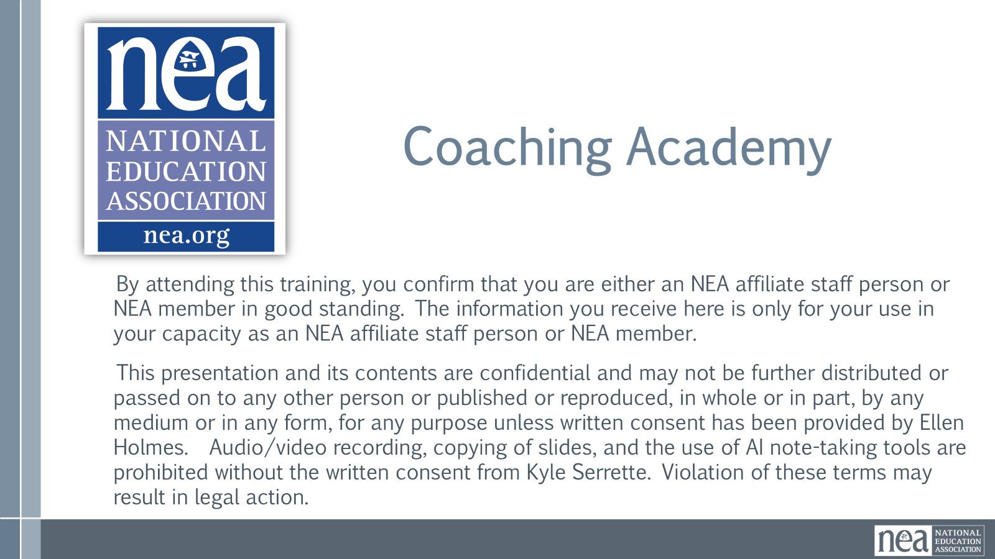  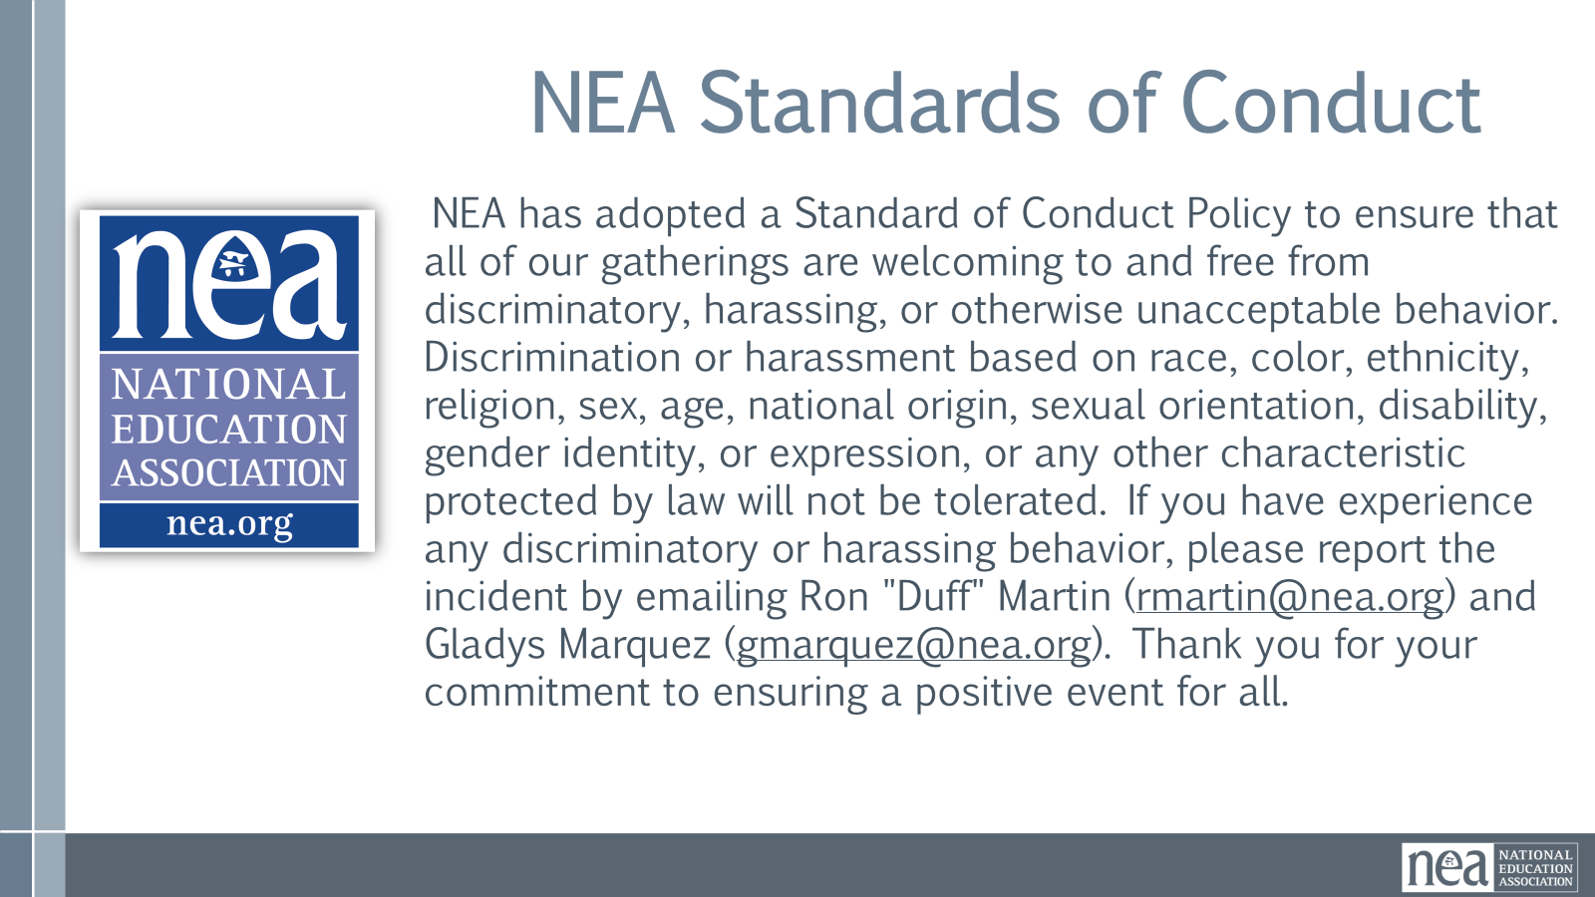  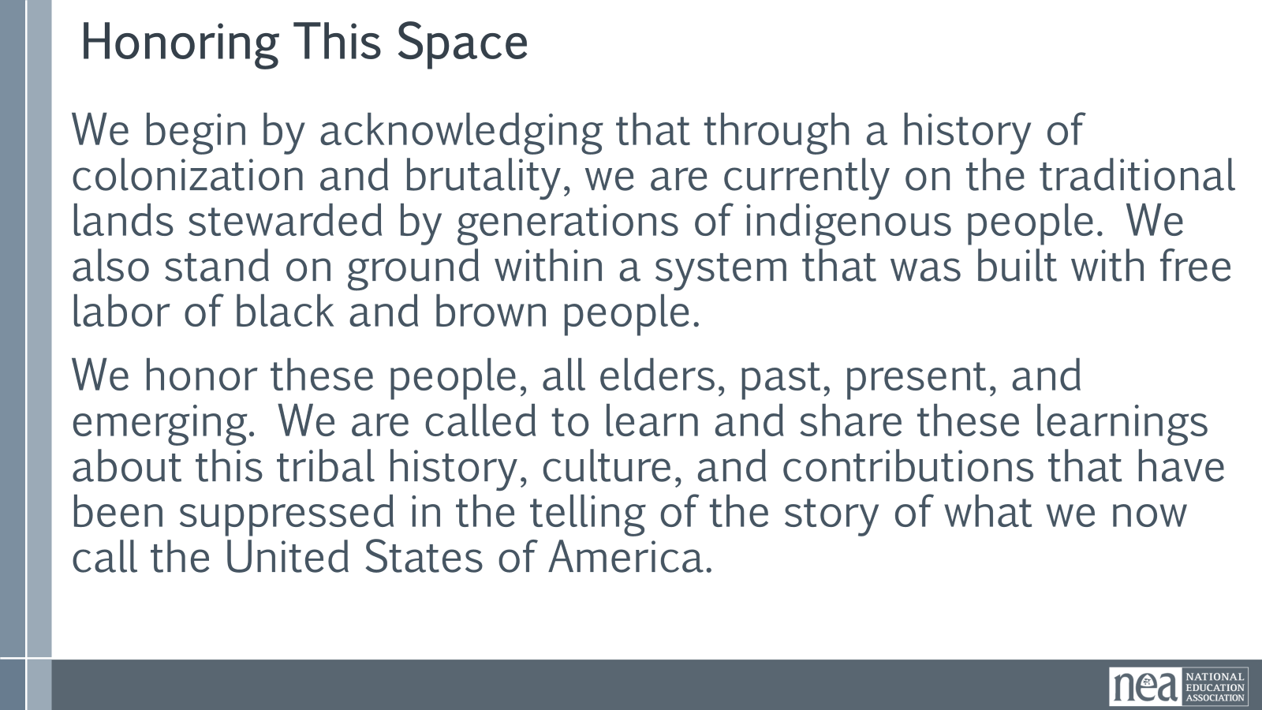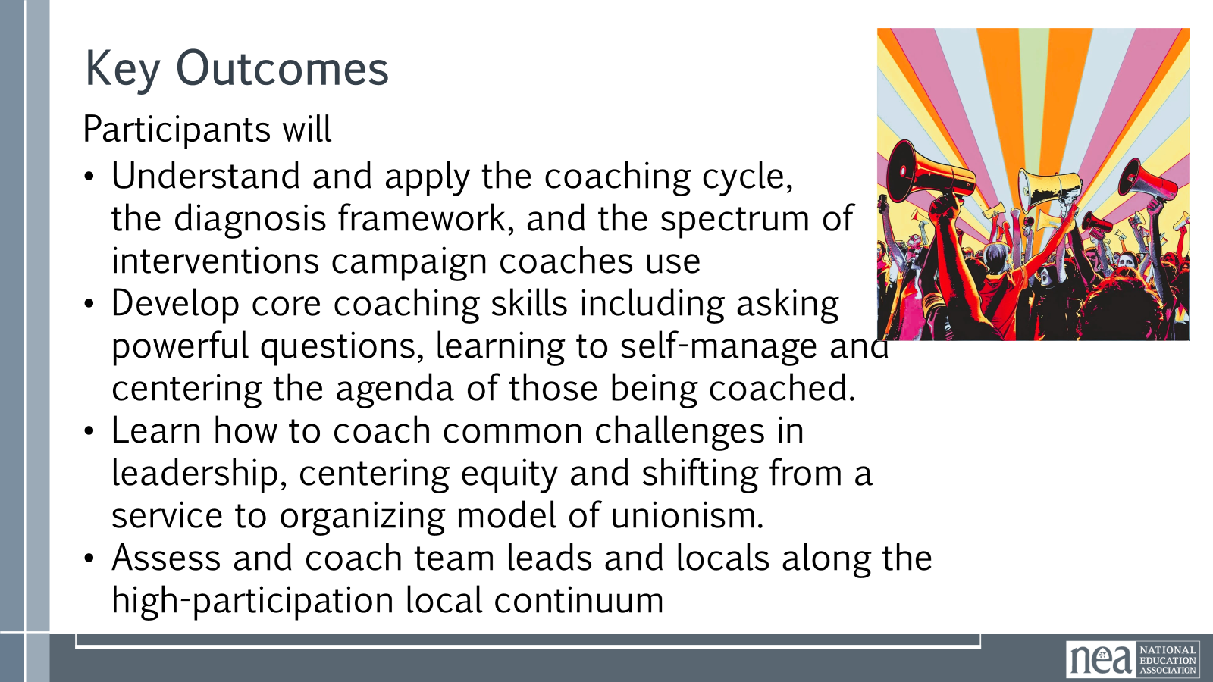  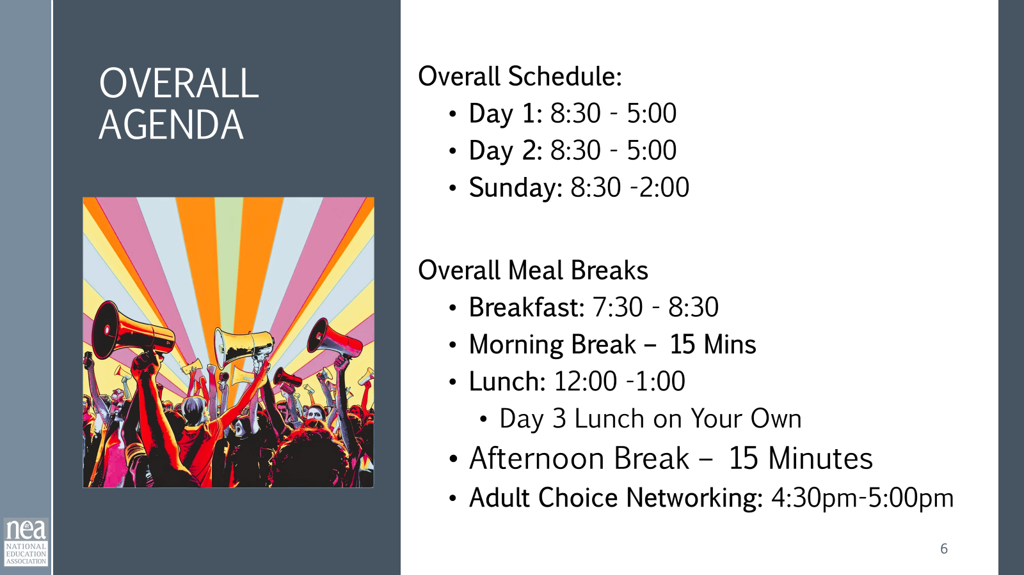  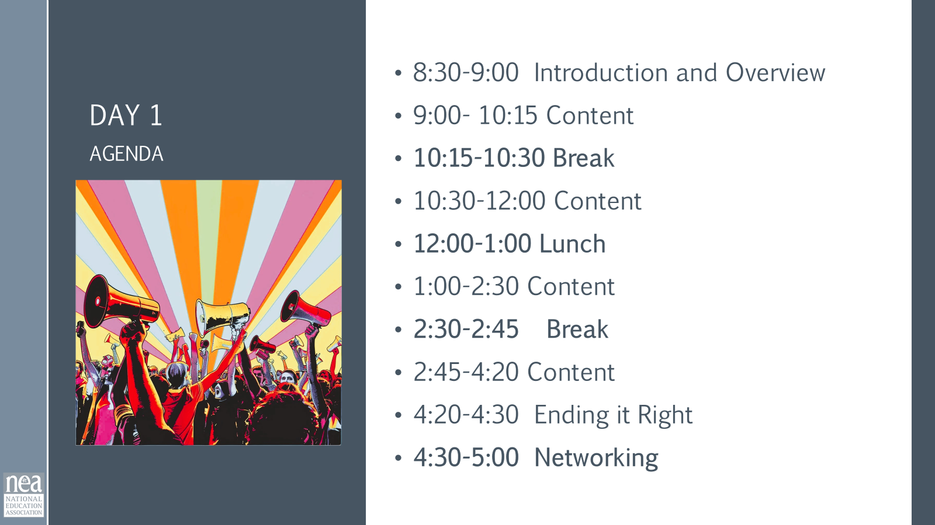  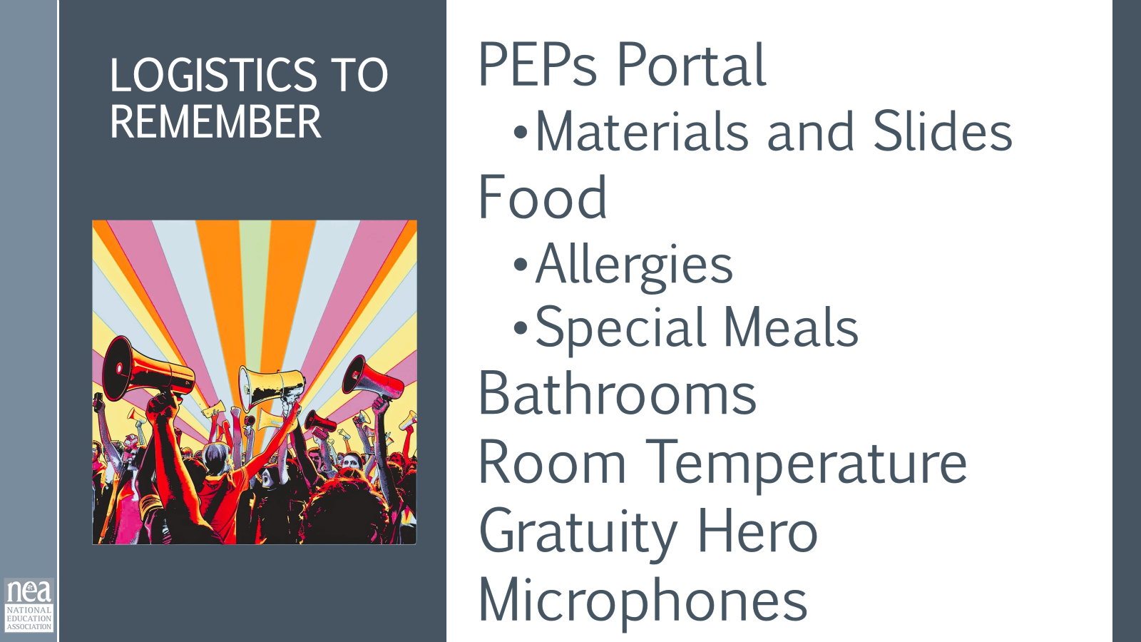  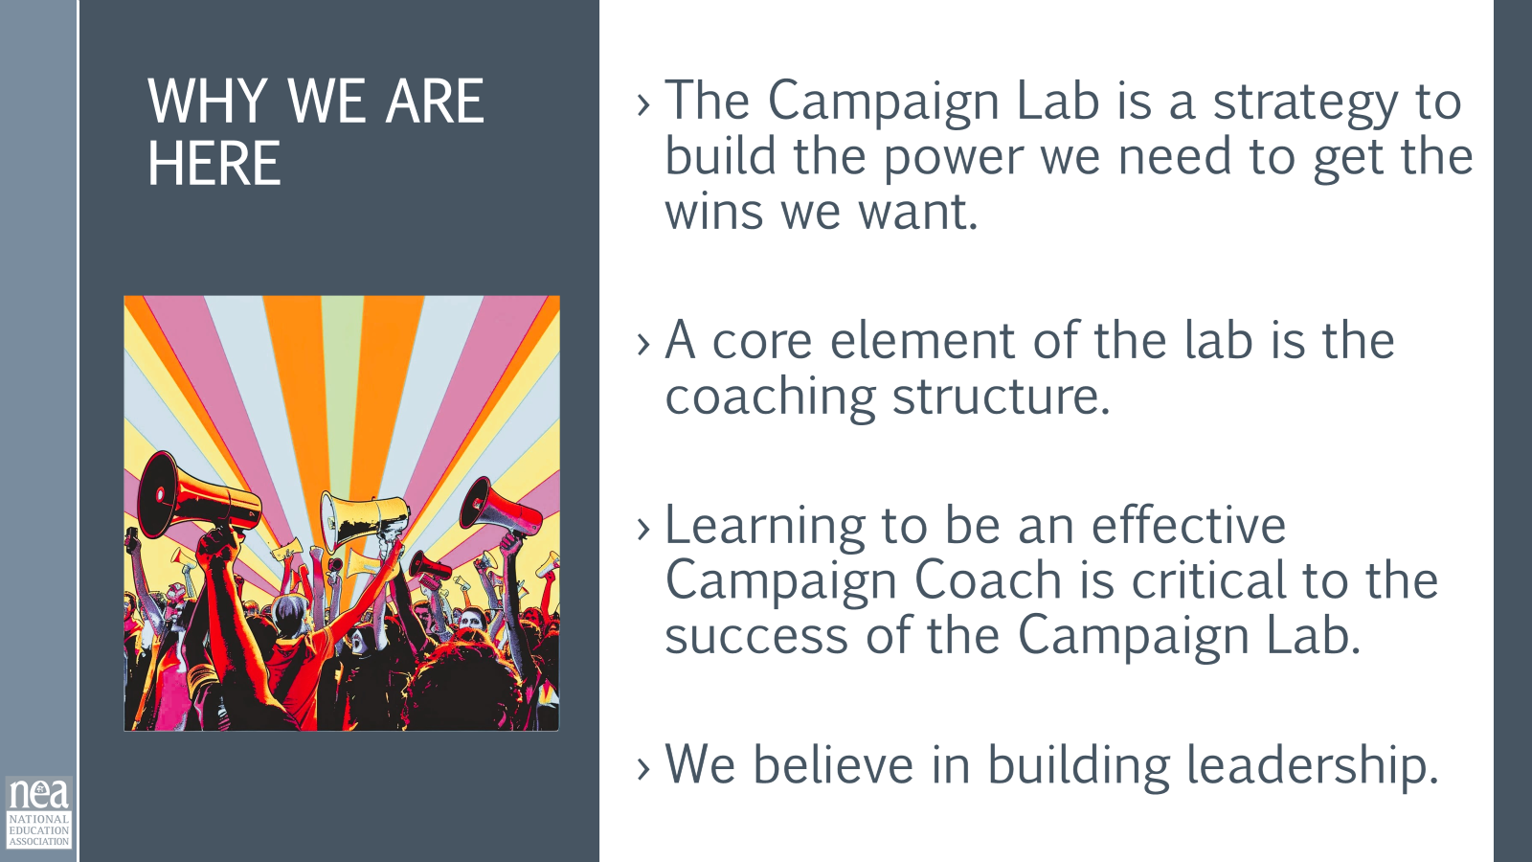  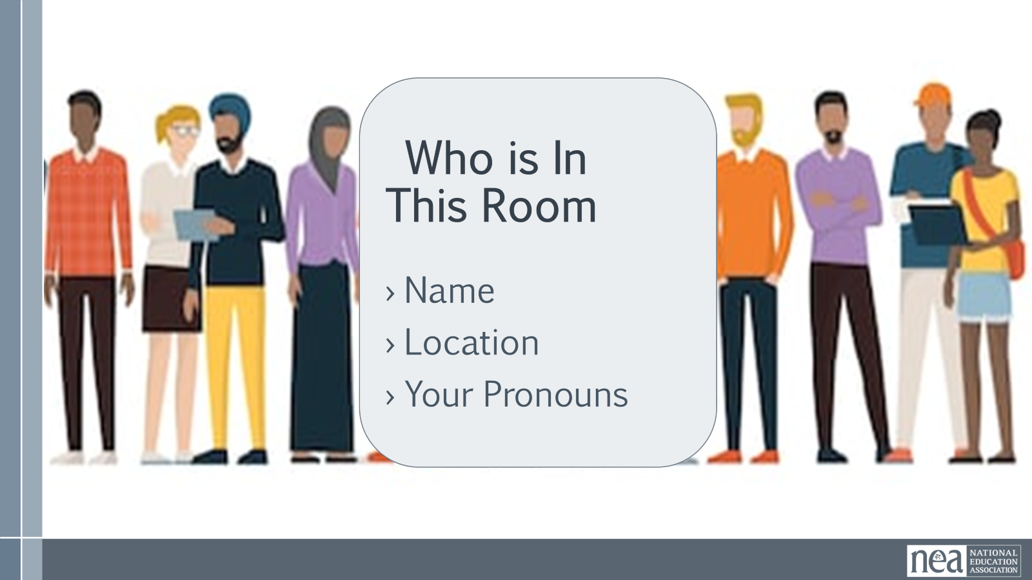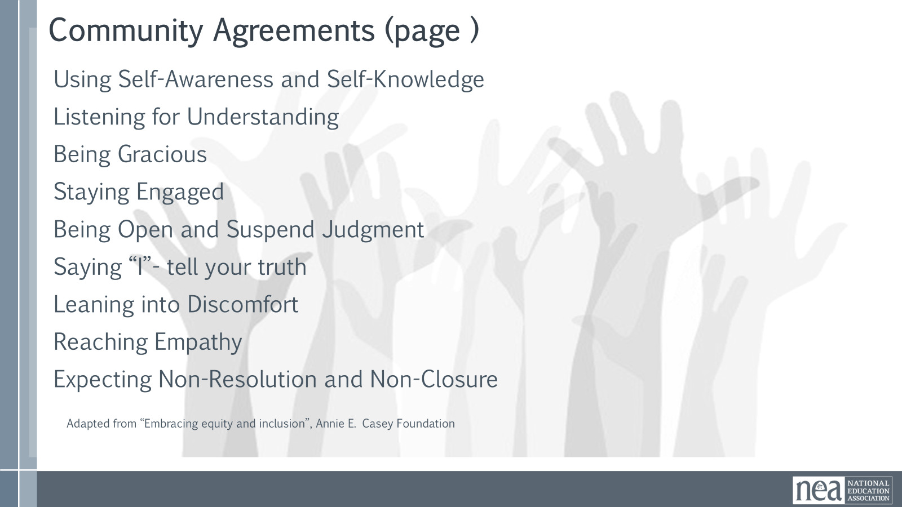 | Community Agreements on Back of Name Tags  Agenda on Slides  Parking Lot Chart  Handout Package in PEPs | 8 Minutes of Intro  NEA Standards of Conduct - check with Karla that those are the latest versions for 2026  1 Minute Land Acknowledgement - it is very general as written on the slide; you can add the names of the local tribes if you wish.  We begin by acknowledging that through a history of colonization and brutality, we are currently on the traditional lands stewarded by generations of indigenous people. We also stand on ground within a system that was built with free labor of black and brown people. We honor these people, all elders, past, present, and emerging. We are called to learn and share these learnings about this tribal history, culture, and contributions that have been suppressed in the telling of the story of what we now call the United States of America.  2 Minutes Review Agenda and Outcomes - go over the overall and the day 1 agenda  3 Minutes Logistics to remember - Ensure that folks know that they are expected to be in PEPs and that they have brought their handouts with them or that they are downloaded to their devices. Make sure that you highlight food allergies and food needs, especially if there are any severe ones- Karla has this info. If folks have specific food needs, make sure they have indicated that to Karla. Ask someone to be willing to gather a gratuity to celebrate the service of the workers for our session – Karla will have a thank you card and will coordinate with the "gratuity hero" who collects the money and leads the BRIEF celebration of the workers on the last day.  We use microphones to support anyone with hearing differences; there are PDF versions of the slides in PEPs in Participant Resources Module so that anyone with trouble viewing the screen can see them on their devices.  3 Minutes - Why we are here  The Campaign Lab is an intentional organizing and capacity building strategy. It is about changing how locals, leaders, and members engage with their union and participate in the change they want to see in the world. What makes Campaign Lab different from other strategies is the coaching structure. Each team lead is promised a campaign coach that helps them plan, implement and assess their local campaigns. As coaches, we are supporting leaders as a whole person. We can deepen a leader’s vision, determination, and capacity to lead. As Campaign Lab Coaches, we are guides to support the Team Lead to be rigorous about the process of building a strong union and campaign.  10 Minutes Intro – who is in the room – whip around the room, begin with facilitators to model the behavior – short and sweet – make sure everyone gets to introduce.  8 Minutes Community Agreements (5 minutes to Review at Tables on Page – and 3 Minutes to do whole room discussion and adoption)  You have already completed a module on the Community Agreements and have access to the full description of these in PEPs and in your Handouts on the two pages following the cover. You were directed to review these and answer three questions on that second page. Take the next 5 minutes at your tables to discuss what you think might be missing, what you have questions about, and what you could not agree to. At the end of 5 minutes, we will continue as a whole room.  Using Self-Awareness and Self-Knowledge  Listening for Understanding  Being Gracious  Staying Engaged  Being Open and Suspend Judgment  Saying “I”- tell your truth  Leaning into Discomfort  Reaching Empathy  Expecting Non-Resolution and Non-Closure  Now we are going to answer any questions you might still have that did not get clarified at your table, or suggestions for additions that you need in order to support your learning in this space. (once you have addressed any of these, move to the adoption process) Now we are going to use an "up-side-down" visual showing of your thumbs to indicate where you are agreeing to these. Up - totally on board. Sideways – I can live with them, and I know we can revisit them if we need to, or down – I cannot yet live with these until we discuss the following ______  Show me your thumbs and keep them up until I have scanned the room. (Facilitator makes sure that each person is either up or sideways – if there is a Down, ask the person to speak into the room about why they are down and what they require to move at least to sideways.) NOTE – this could go on longer than the allotted time, but it rarely does. It is useful to make connections of any suggestions back to one of the headings of the Community Agreements – or simply say to the room – that is an addition for us to keep in mind as we adopt these agreements. This is an important process to not skimp on. | Participants will know how we are going to work, the basic schedule, and the logistics relevant to the training.
9:00-9:40 | Yvie | 40 mins TOTAL – Community Experiences
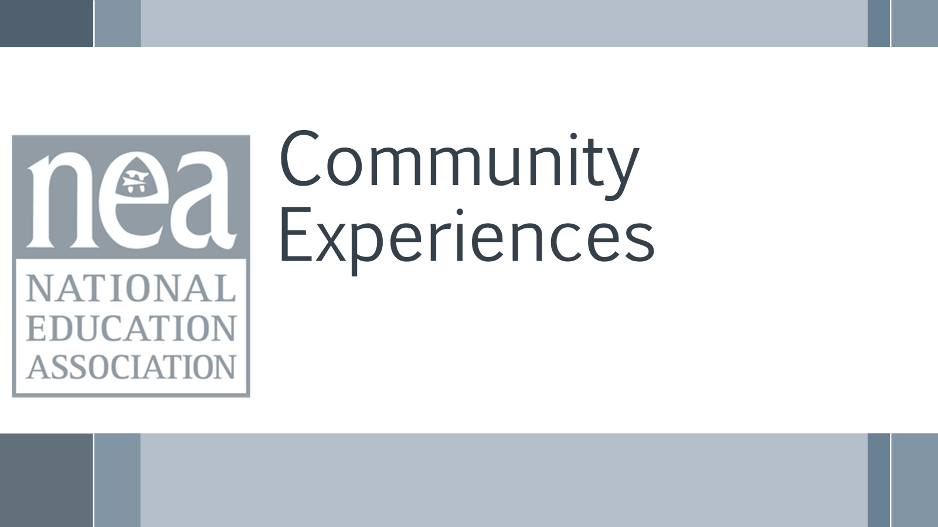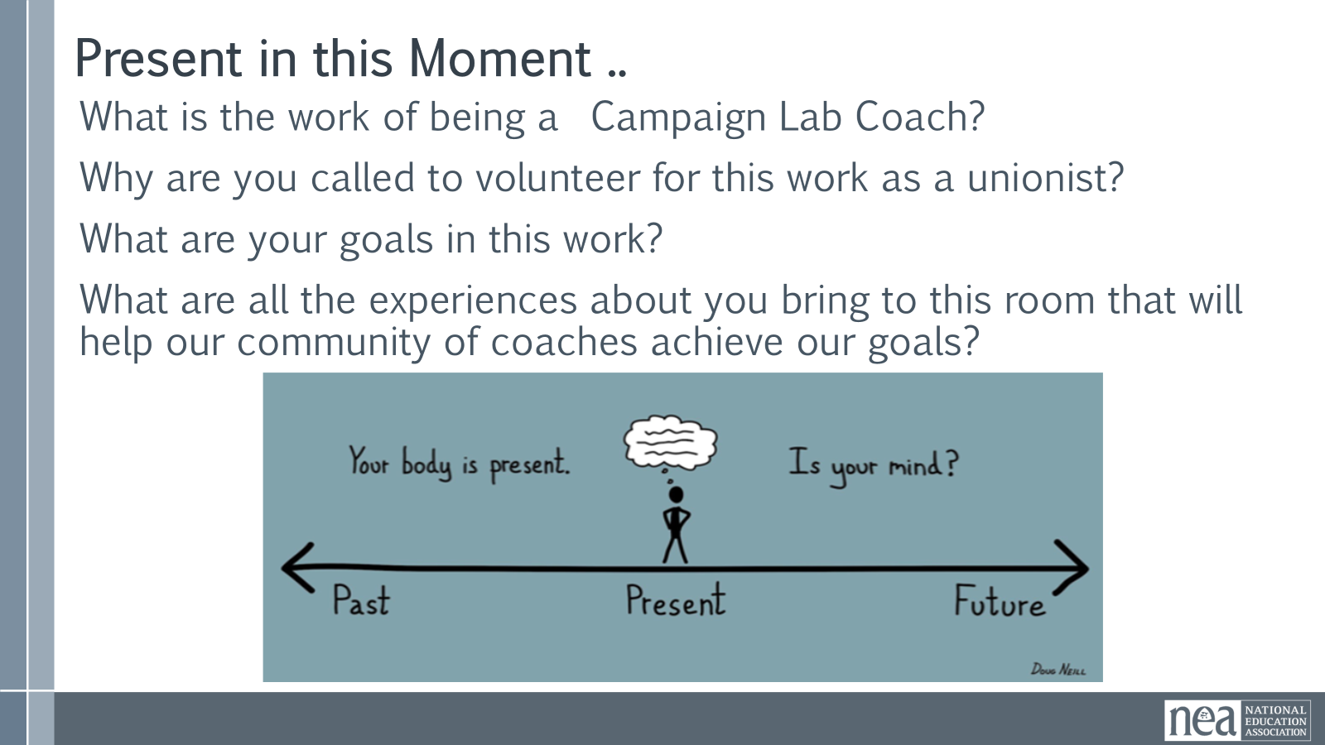  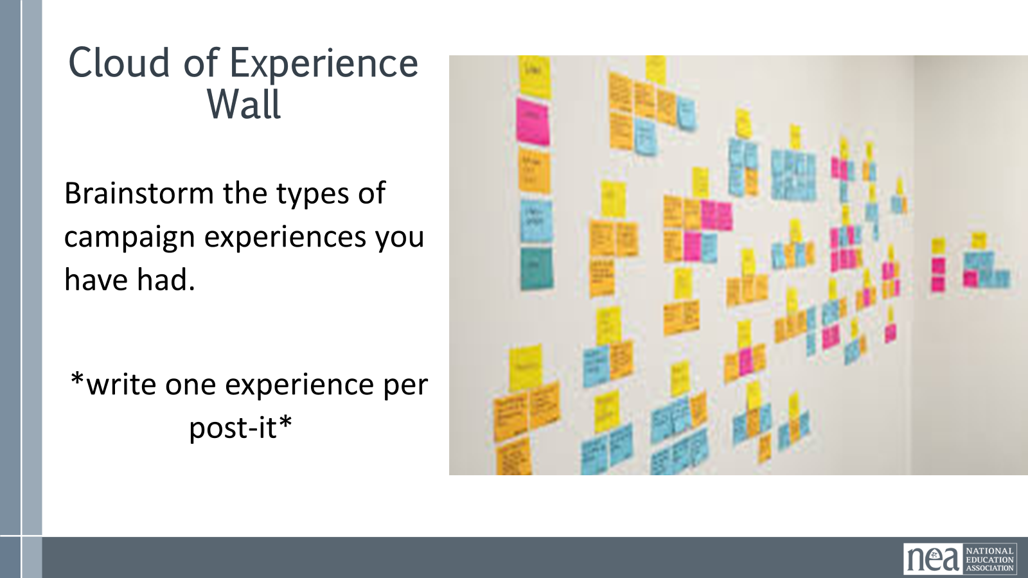  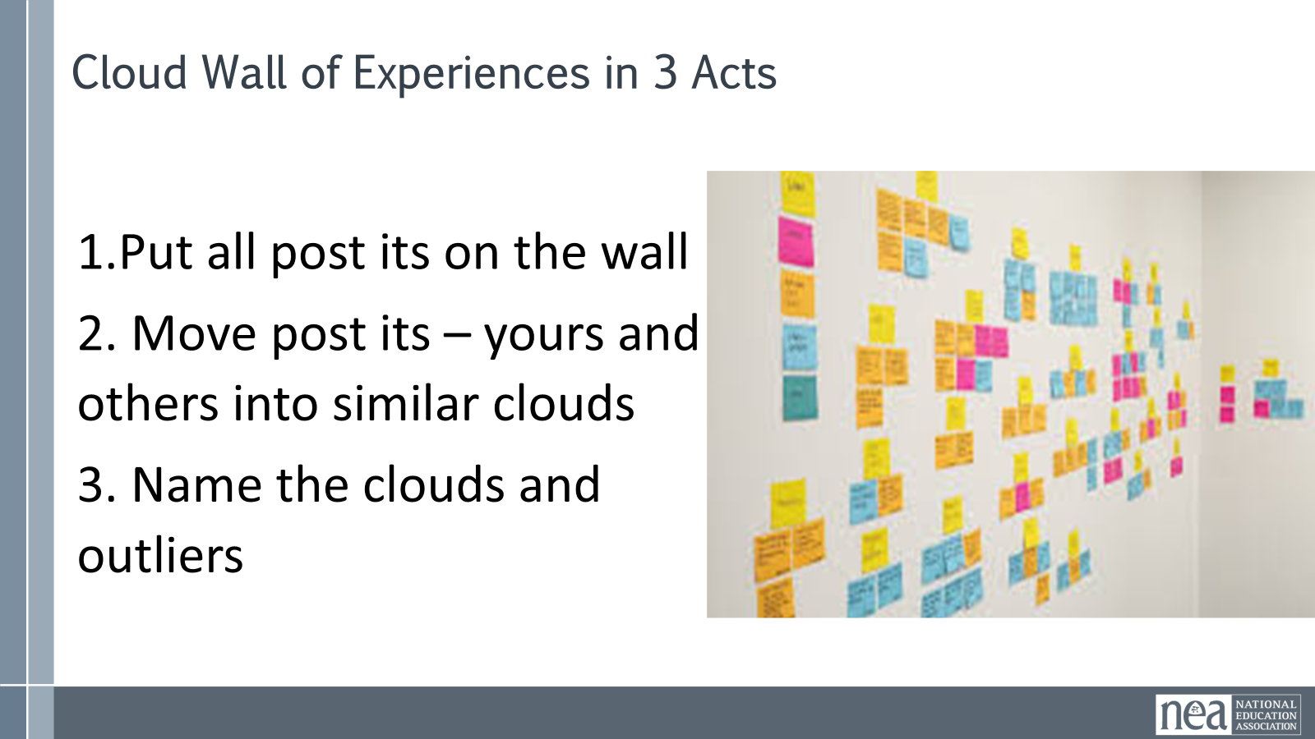  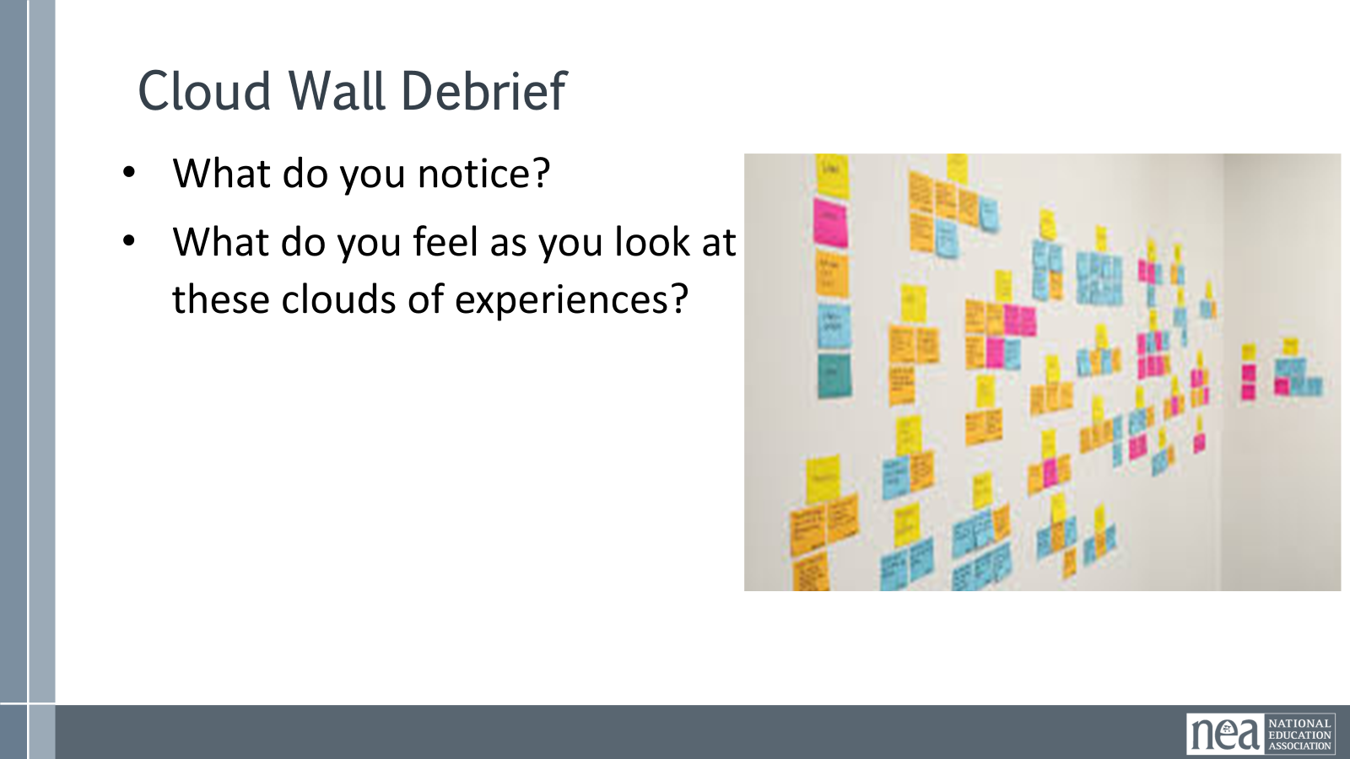  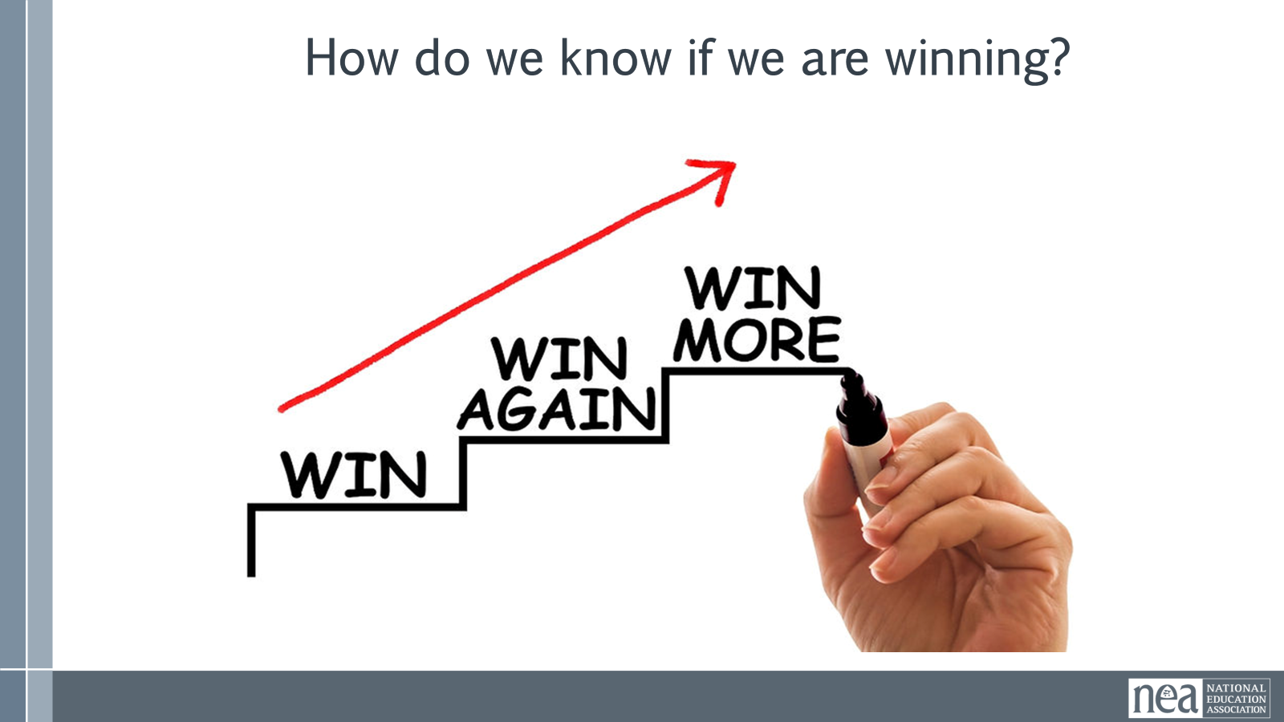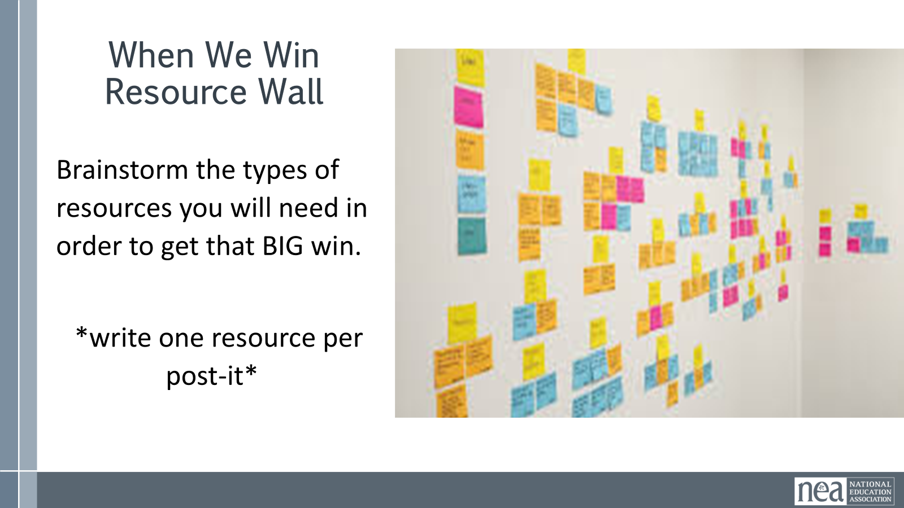  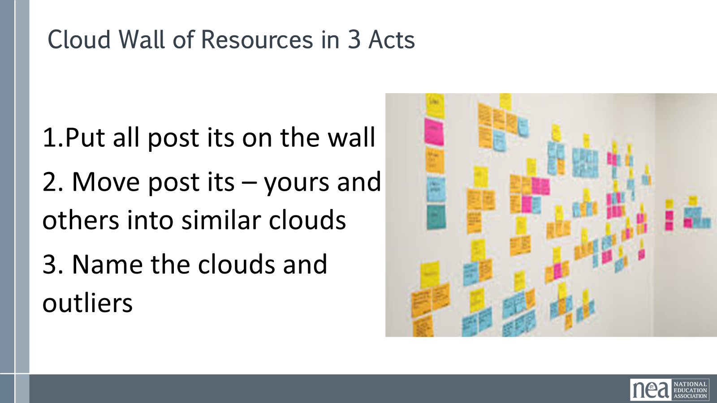  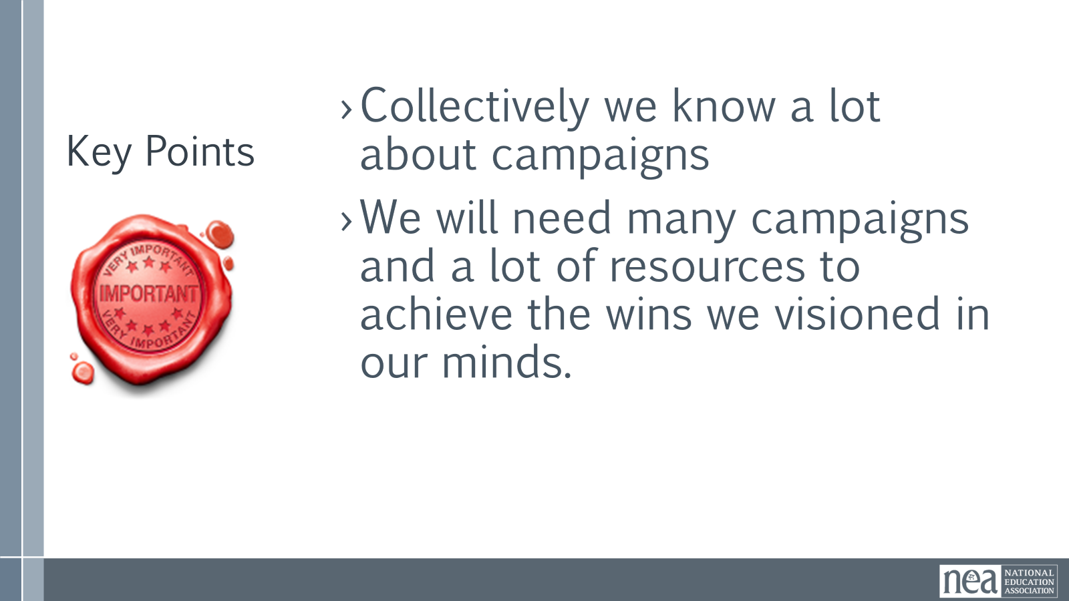 | Post-it notes  Chart Paper – Wall Cloud | Part 1- 15 minutes Campaign Experience Wall Cloud  To start things off, I want to center us in this moment, let's just close your eyes if you are comfortable doing so and quiet your mind. Think about the following - What is the work of being a Campaign Lab Coach?  Why are you called to volunteer for this work as a unionist?  What are your goals for this work?  What are all the experiences you bring to this room that will help our community of coaches achieve our goals?  5 Minutes Brainstorm - First, I want you to think about the kinds of campaign experience you have. What kinds of campaigns have you been a part of up to this point? For example: bargaining campaigns, budget fights, school board elections, issue campaigns... It could also include campaigns you have been involved with outside of NEA. Using the post it notes at your table, write down your answers, using a different post it for each answer. The goal is to create a stack of campaign experiences.  5 Minutes at the wall - Once you are done, bring your post its up to the wall (indicate central location) and put them up. You can begin to read and organize them into groups that are similar. I suspect a number of you will have similar answers – these go into a clump. The goal is for us to see which clumps of experiences are the largest. You will have 5 minutes to post and sort.  5 Minutes – What do you notice? How do you feel when you look at this wall of experience?  Part 2- 25 minutes - When We Win Resource Wall Cloud  Directions 5 minutes - We have a lot of collective campaign experience in this room! This brings me to my next question, experienced team leads- How do we know if we are winning? I want you to leave behind thoughts like “when we win this specific proposal at the bargaining table or elect this specific candidate”. I don’t want you to reference specific policies or specific political candidates. I want you to think about what our schools and our communities will be like if we are winning. I’m being deliberately vague in defining “winning” here because I want you to have the freedom to define what that looks like from your perspective.  Ask participants: Close your eyes if comfortable, and let’s build a school together in a world where we have already won. As you move through the school,  - What sounds do you hear?  - Where is the light coming from?  - Peek in. What does the learning environment look like?  - Who do you pass along your way?  - Move outside. What does the schoolyard or campus look like?  - How are students spending their time?  - Where do you sit as you observe?  - Head back in for lunch. What do you smell?  - What do you notice about how students are grouped or seated?  - It’s time to go home. How do students seem to feel as they move past you to leave? What about staff?  15 minutes: What do you need in order to win (directions and activity)  I’m going to go back to the question I asked you earlier. How do we know if we are winning? The answer is, we will know we are winning when we have what we need to make what you envisioned real. What are all the resources you need to get that big win you just envisioned. Write your answers on post it notes again and put them (indicate place). You will have 5 minutes to write, then 5 minutes to post and group just like you did the first time.  4 Minutes - What stands out to you about these resource clouds? What do you feel when you look at this?  Key points – 1 minutes  Collectively we know a lot about campaigns  We will need many campaigns and a lot of resources to achieve the wins we visioned in our minds. | Participants will create a shared listing of their experiences and then will identify a bank of shared resources that they think are needed to build winning campaigns.
9:40- 10:05 | Amanda & Melissa | 25 Minutes TOTAL – Introduction to Campaign Lab and Campaign Coaches
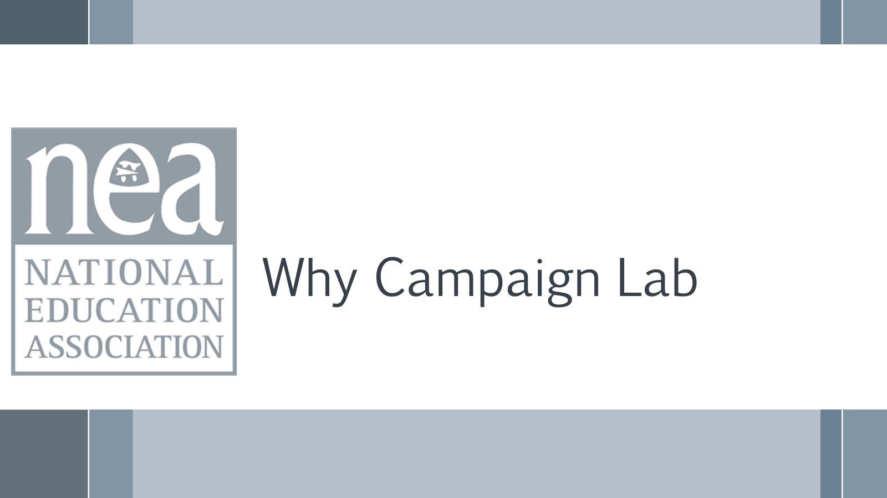  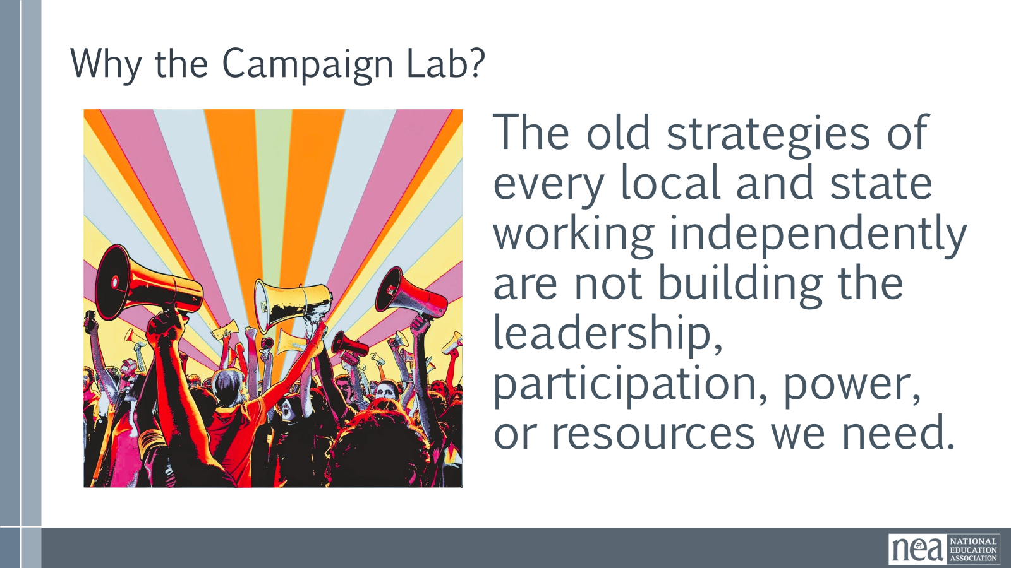    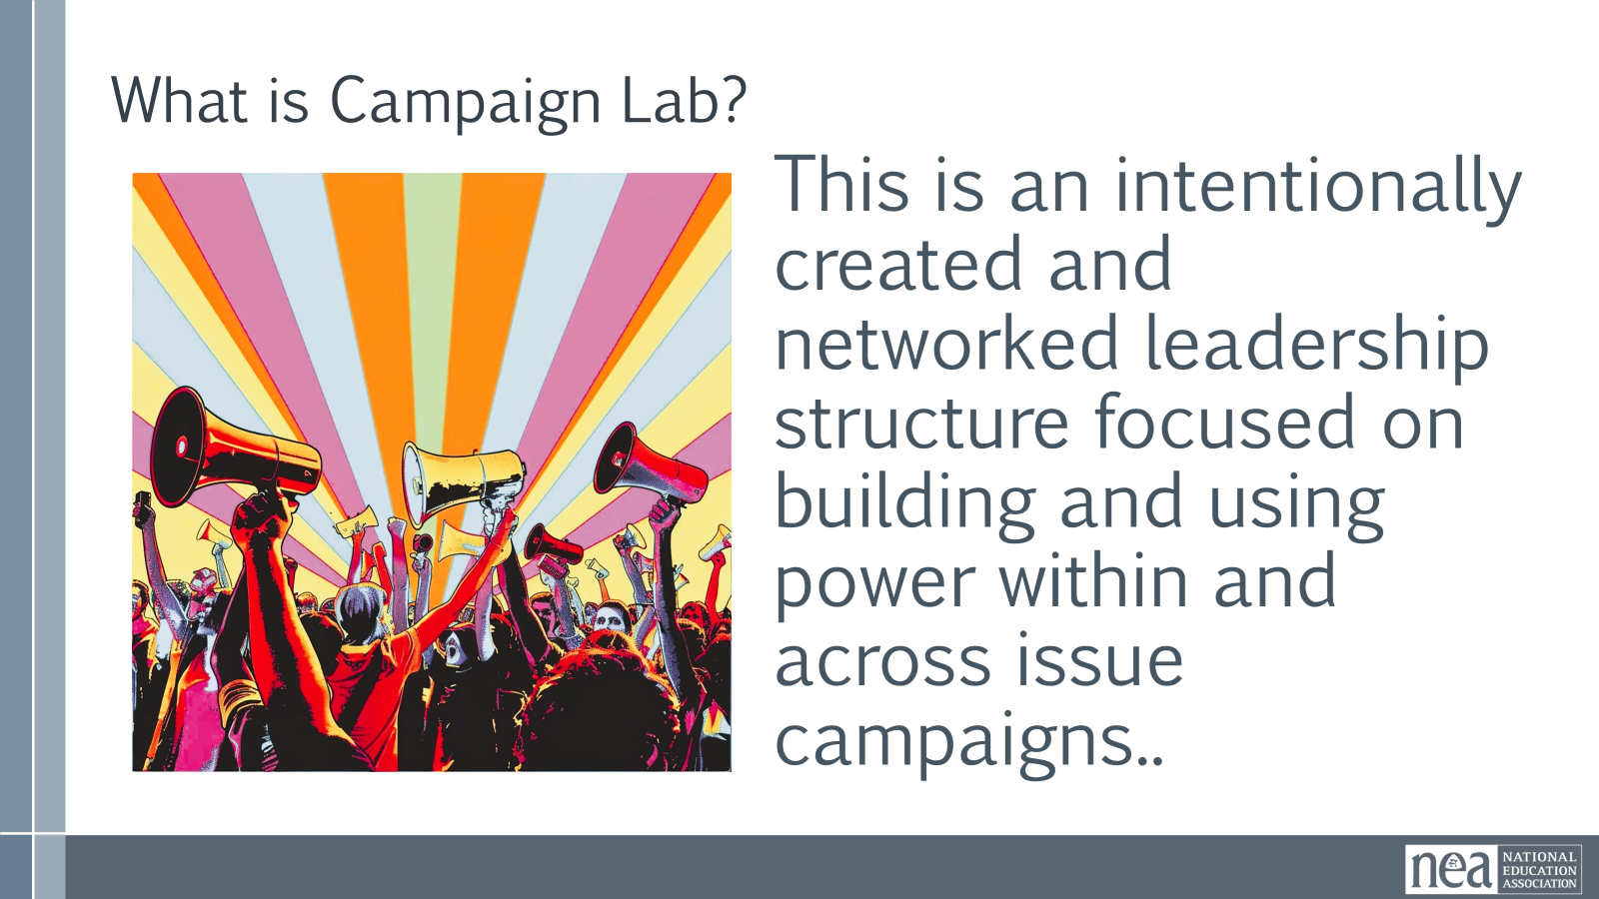  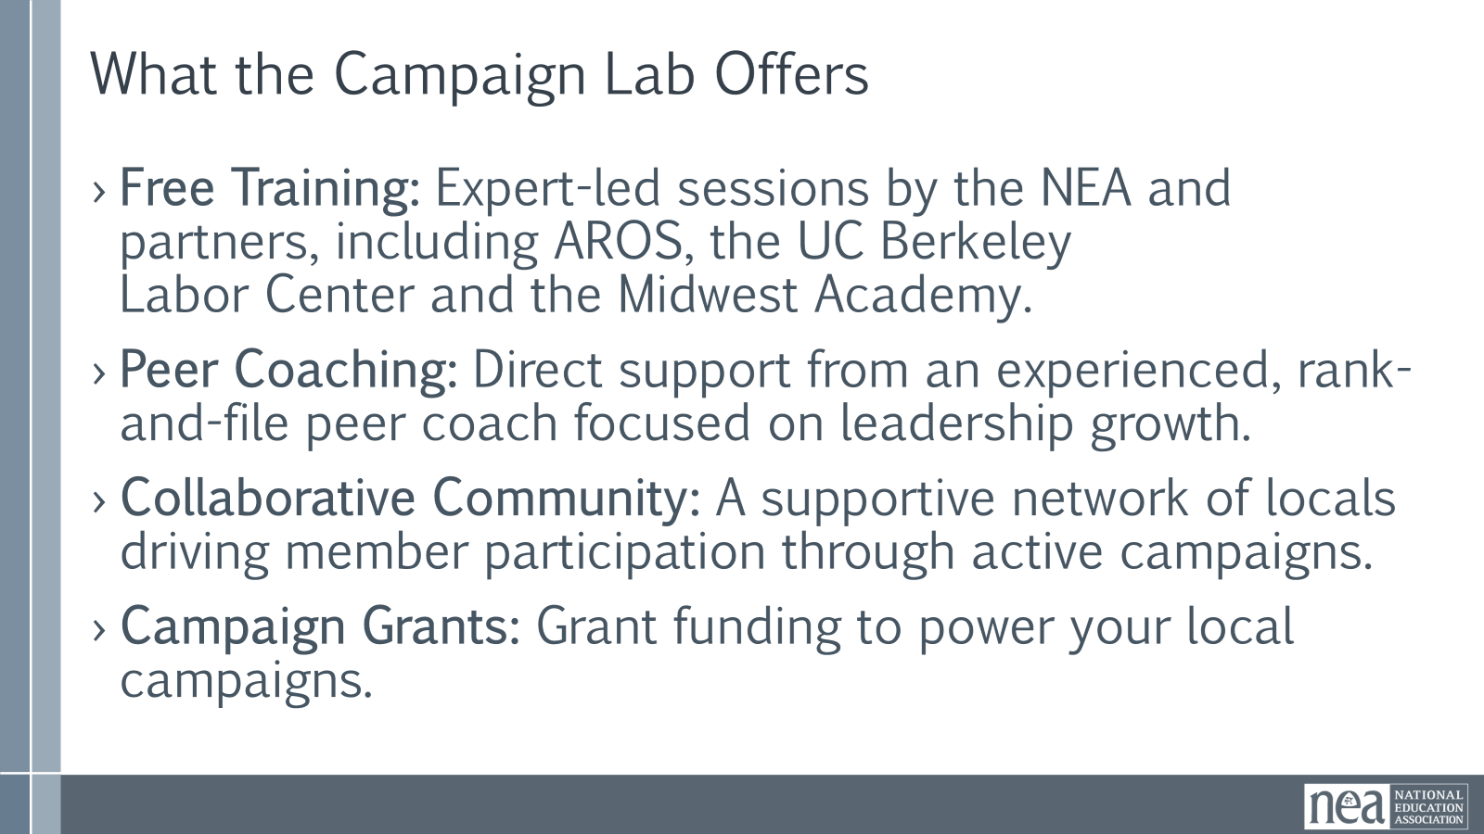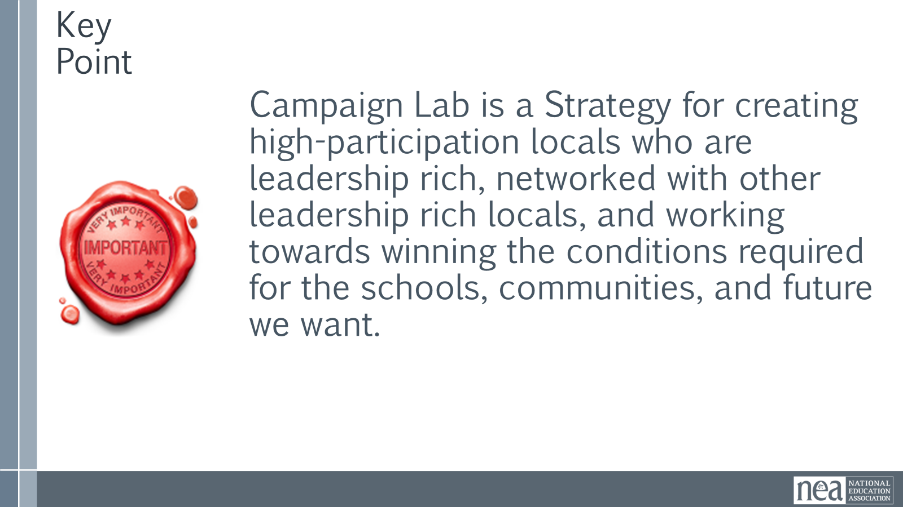  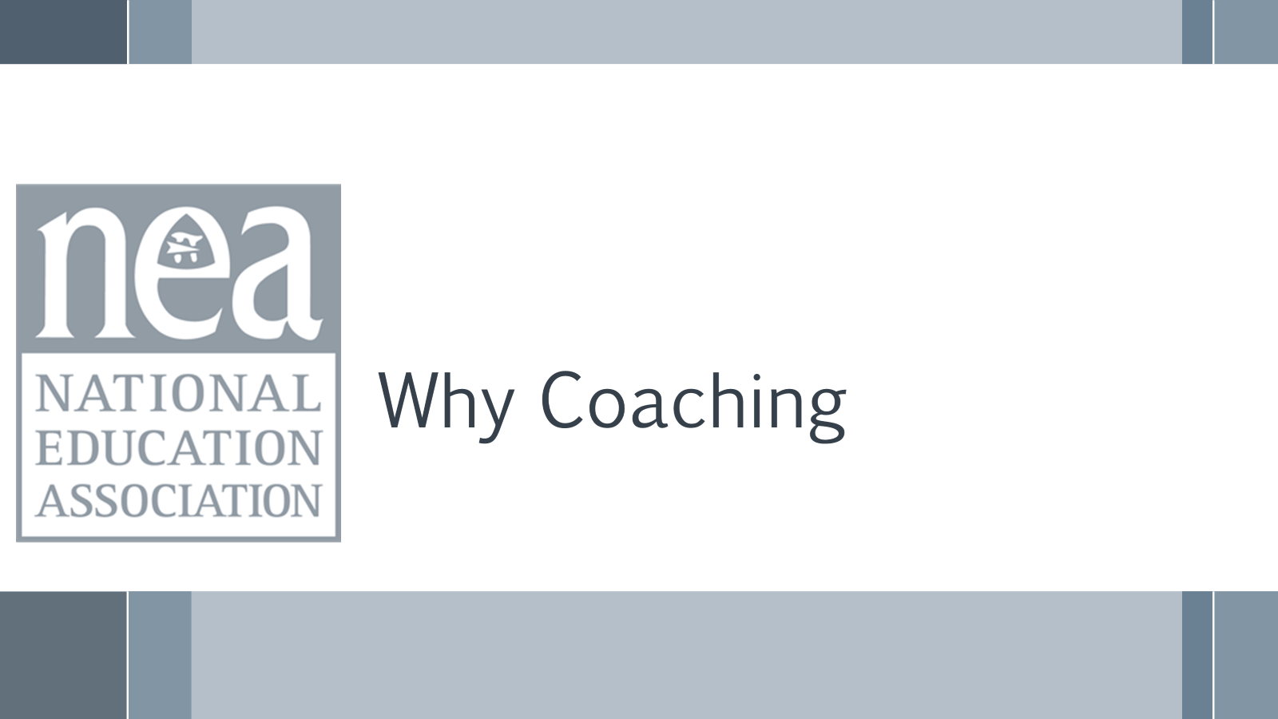  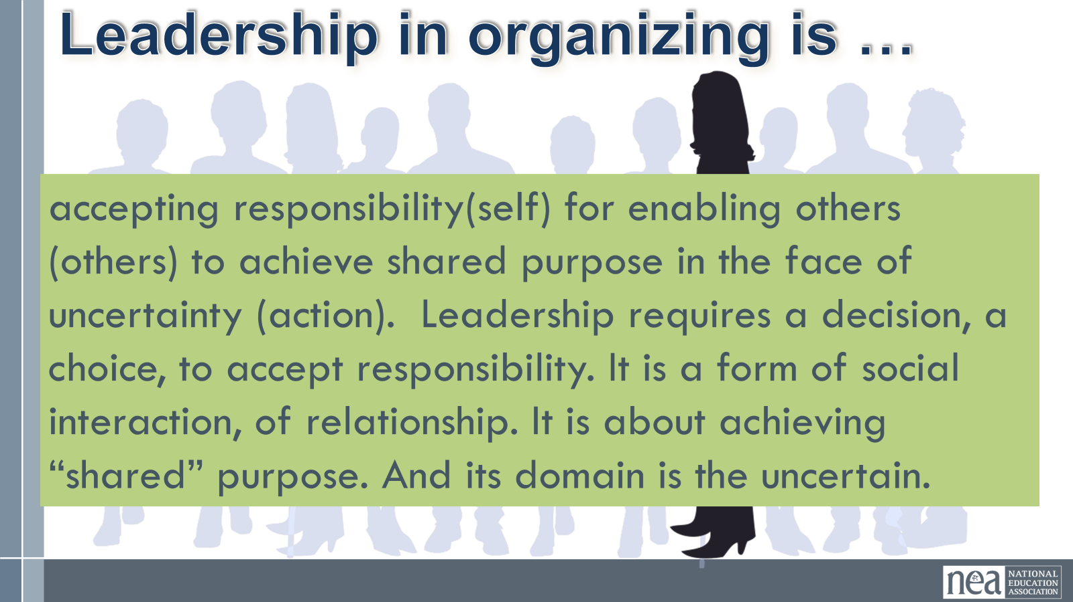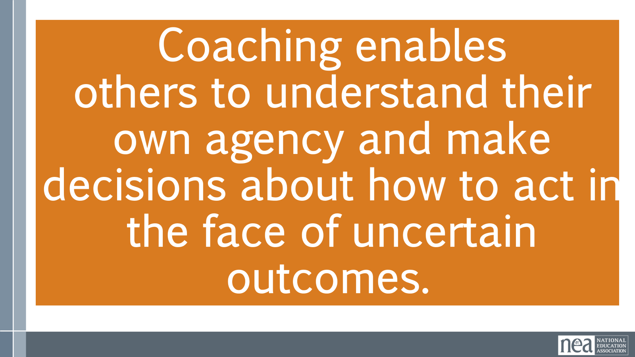  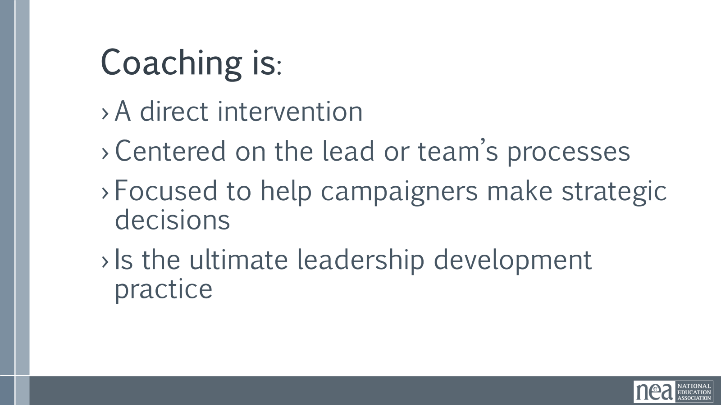  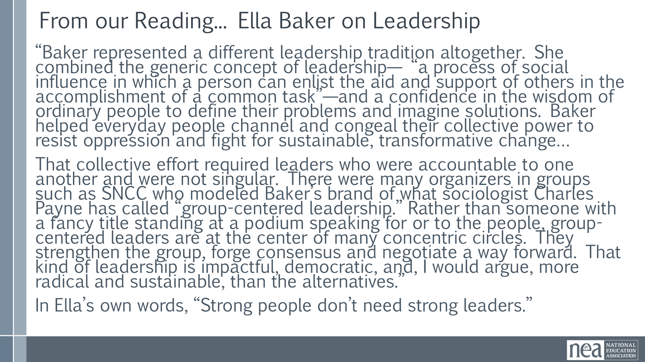  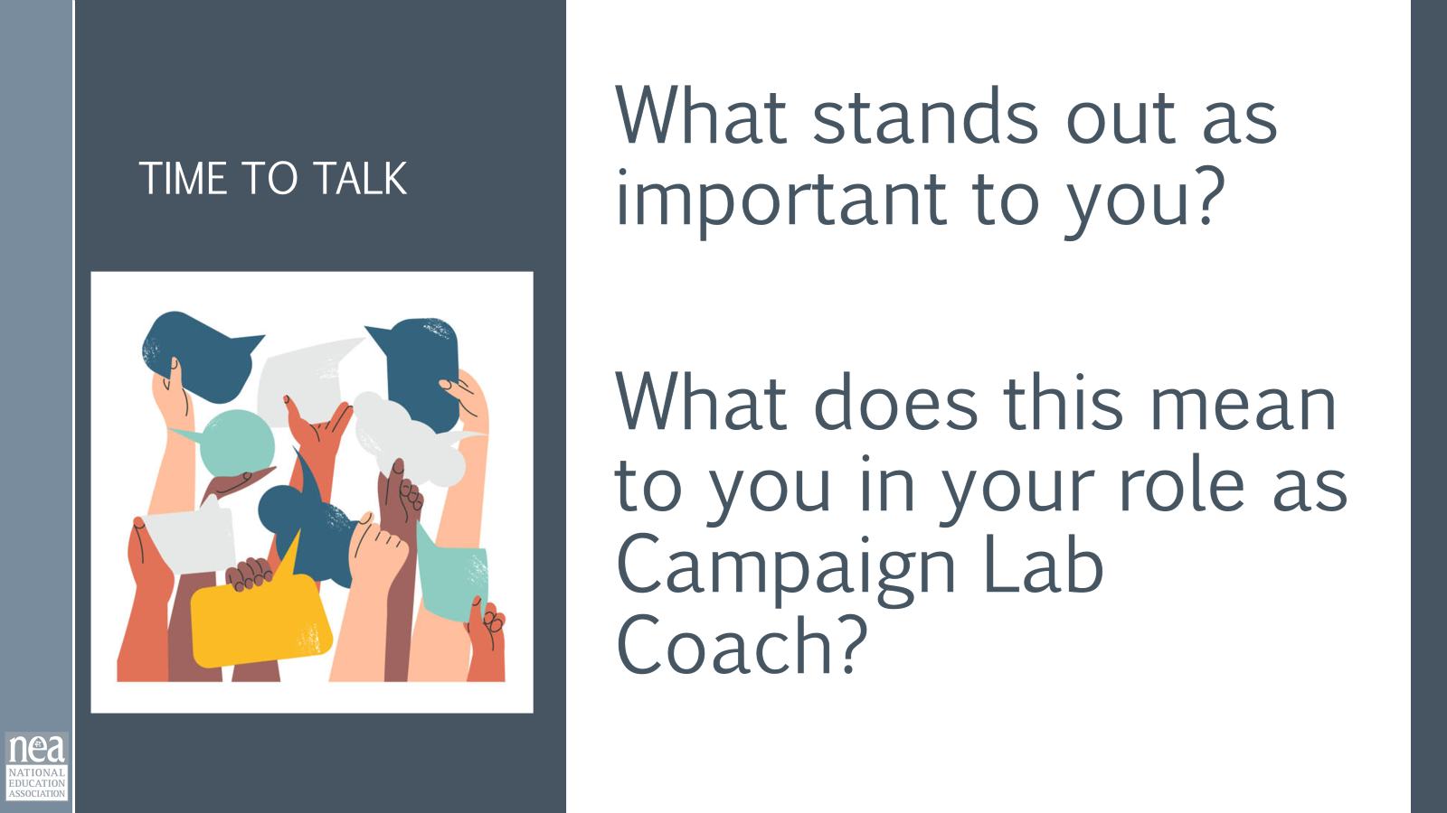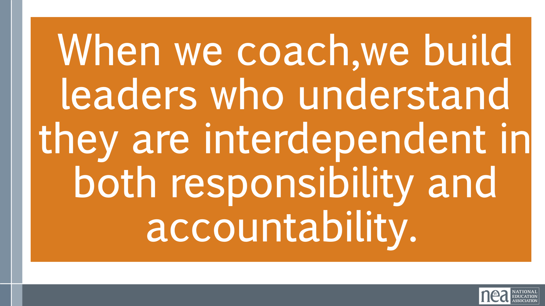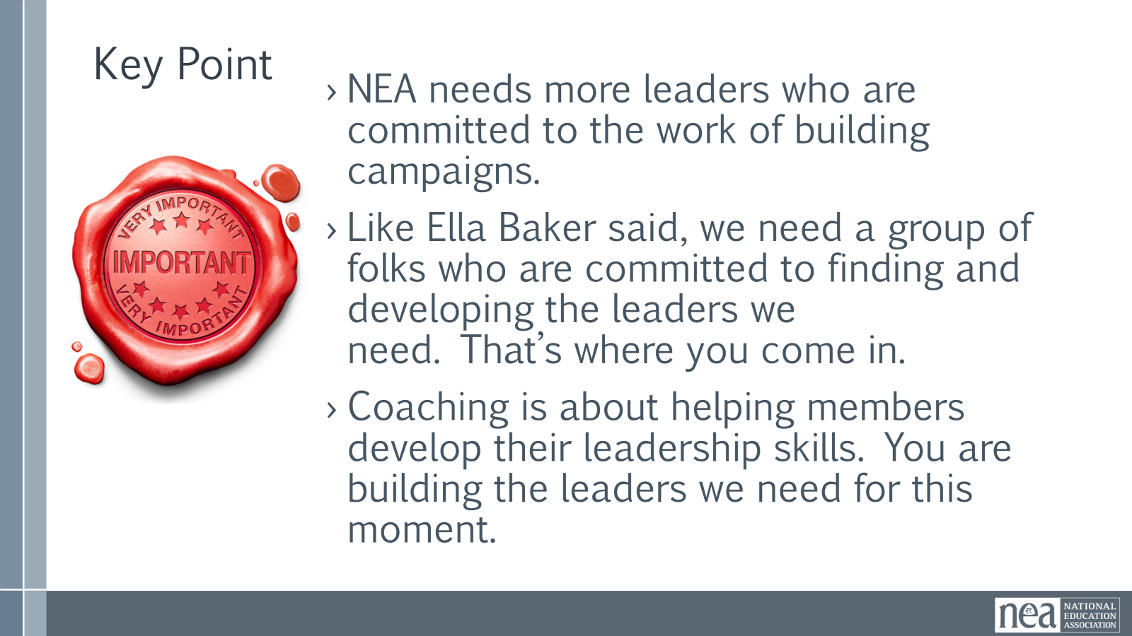  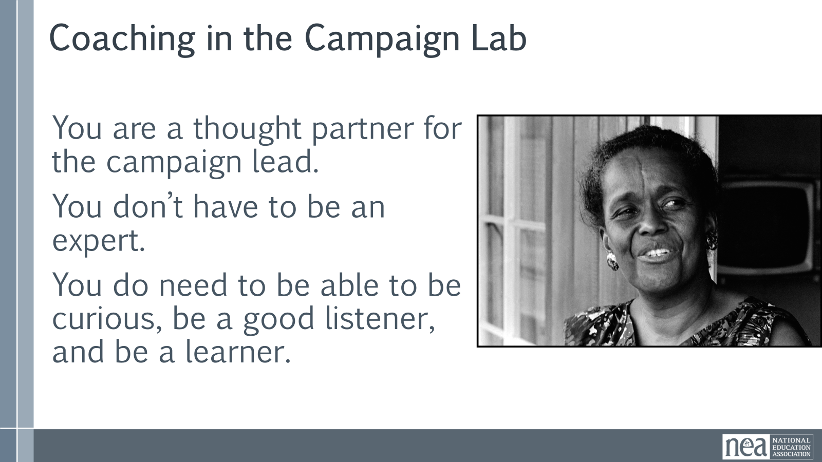  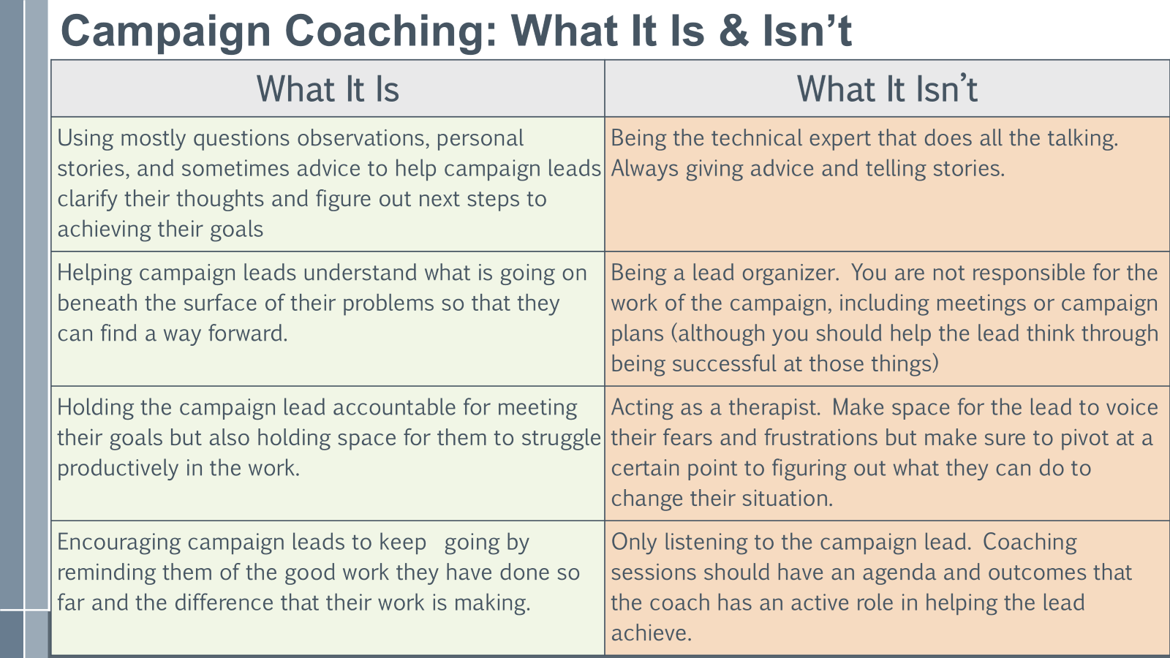    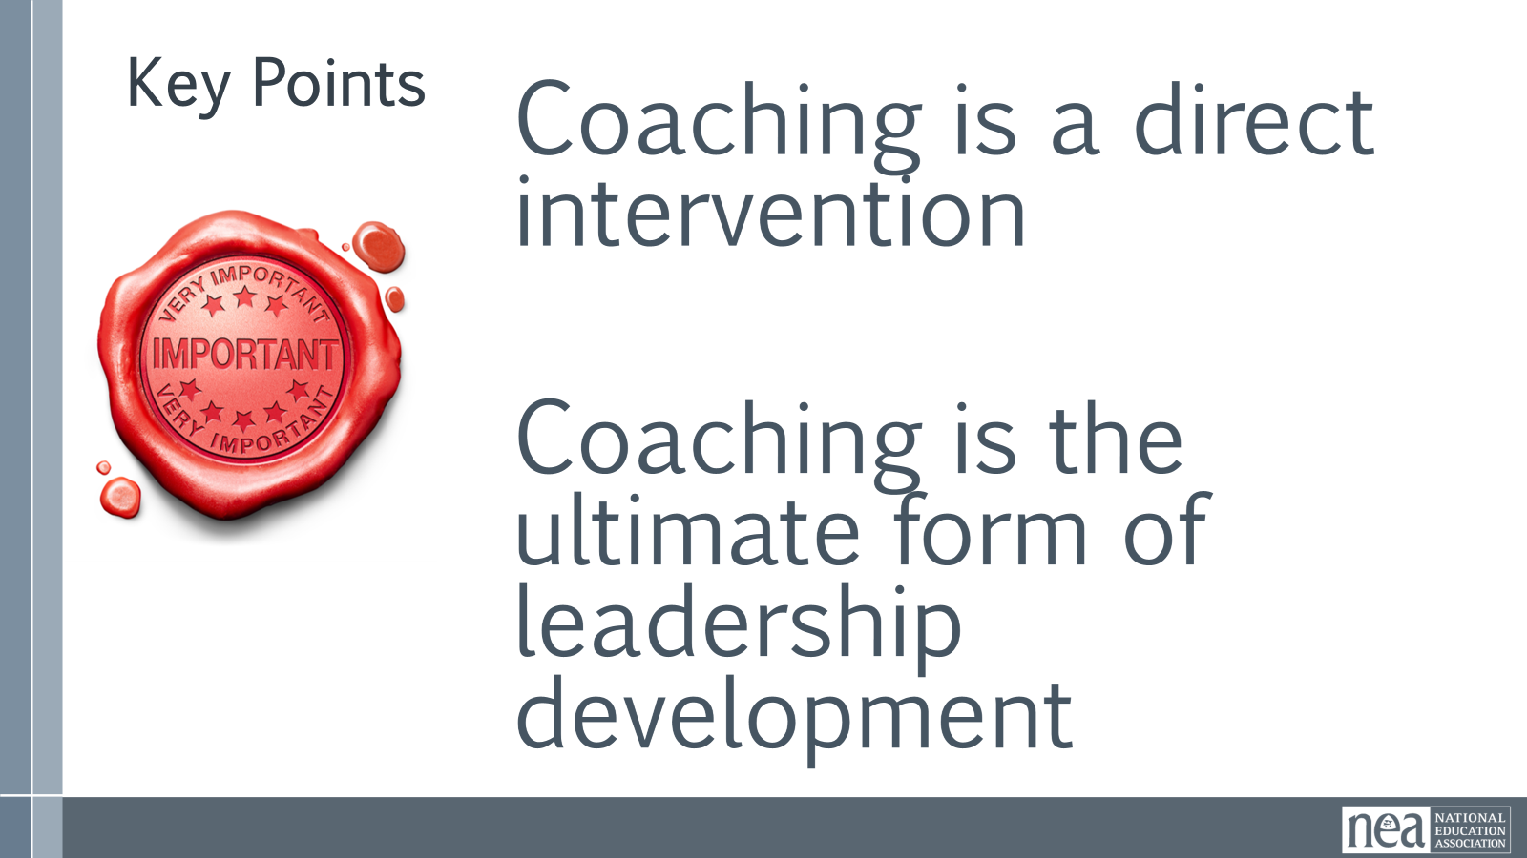 | Melissa  Complete Coach’s Guidebook – Page 7 | Big Picture: Why Campaign Lab? 3 minutes Intro  For many years, NEA locals have more or less operated independently when it comes to campaigns. They have battled their own school boards and bargained their own contracts. Local presidents and their staff have taken on the lion’s share of this work. And they have done so with the resources available to them.  Meanwhile, those who oppose public education, unions, and everything they represent have been built highly organized networks with long-term strategic plans with almost limitless funding to privatize our schools and capture our school boards and state legislatures. Now those forces control our federal government.  To win under these conditions, we have to do something different than what we have been doing. We know that many locals don’t have the capacity to run and win campaigns, so Campaign Lab attempts to address that in four key ways:  - Free Training: Expert-led sessions by the NEA and partners, including AROS, the UC Berkeley Labor Center and the Midwest Academy.  - Peer Coaching: Direct support from an experienced, rank-and-file peer coach.  - Collaborative Community: A supportive network of locals driving member engagement through active campaigns.  - Campaign Grants: Grant funding to power your local campaigns.  Key Point – 1 Minute  - Campaign Lab is a Strategy for creating high-participation locals who are leadership rich, networked with other leadership rich locals, and working towards winning the conditions required for the schools we want.  Why coaching? Intro 2 Minutes – Leadership in organizing is accepting responsibility(self) for enabling others (others) to achieve shared purpose in the face of uncertainty (action). Leadership requires a decision, a choice, to accept responsibility. It is a form of social interaction, of relationship. It is about achieving “shared” purpose. And its domain is the uncertain.  Building Leadership in organizing is about enabling others to achieve purpose in the face of uncertainty. Coaching enables others. Organizing campaigns are rich with challenges and learning opportunities, but leaders get mired down in challenges and problems. Coaching in organizing helps to alleviate this. Coaching helps individuals to overcome motivational, strategic, and informational challenges that might otherwise hinder the progress of the individual, and/or the team, and thus the campaign or training. Coaching is a direct intervention centered on an individual or team’s work process to help them decide how they can best improve their effectiveness. Coaching is the ultimate leadership development practice.  Small group discussion 5 minutes - Read this excerpt on page 5 from the Ella Baker article that says:  “Baker represented a different leadership tradition altogether. She combined the generic concept of leadership— “a process of social influence in which a person can enlist the aid and support of others in the accomplishment of a common task”—and a confidence in the wisdom of ordinary people to define their problems and imagine solutions. Baker helped everyday people channel and congeal their collective power to resist oppression and fight for sustainable, transformative change…  That collective effort required leaders who were accountable to one another and were not singular. There were many organizers in groups such as SNCC who modeled Baker’s brand of what sociologist Charles Payne has called “group-centered leadership.” Rather than someone with a fancy title standing at a podium speaking for or to the people, group-centered leaders are at the center of many concentric circles. They strengthen the group, forge consensus, and negotiate a way forward. That kind of leadership is impactful, democratic, and, I would argue, more radical and sustainable, than the alternatives.”  In Ella's own words, "Strong people don’t need strong leaders."  Discuss at your table:  - What stands out as important to you?  - What does this mean to you in your role as Campaign Lab Coach?  Report out – 5 minutes – What did you hear at your table?  Key Points- Coaching is a Leadership Practice -2 minutes  - NEA needs more leaders who are committed to the work of building campaigns.  - Like Ella Baker said, we need a group of folks who are committed to finding and developing the leaders we need. That’s where you come in.  - Coaching is about helping members develop their leadership skills. You are building the leaders we need for this moment.  Introduction to Campaign Coaching- 1 minutes  Different organizations think about the role of a campaign coach differently. For the purposes of the NEA Campaign Lab, you are a thought partner for a campaign lead. You don’t have to be an expert at all things campaigning, but you do need to be able to be curious about the lead and their needs, have good active listening skills and be willing to learn what you don’t know.  Share and give some time to read (5 minutes) - What Campaign Coaching is and is not  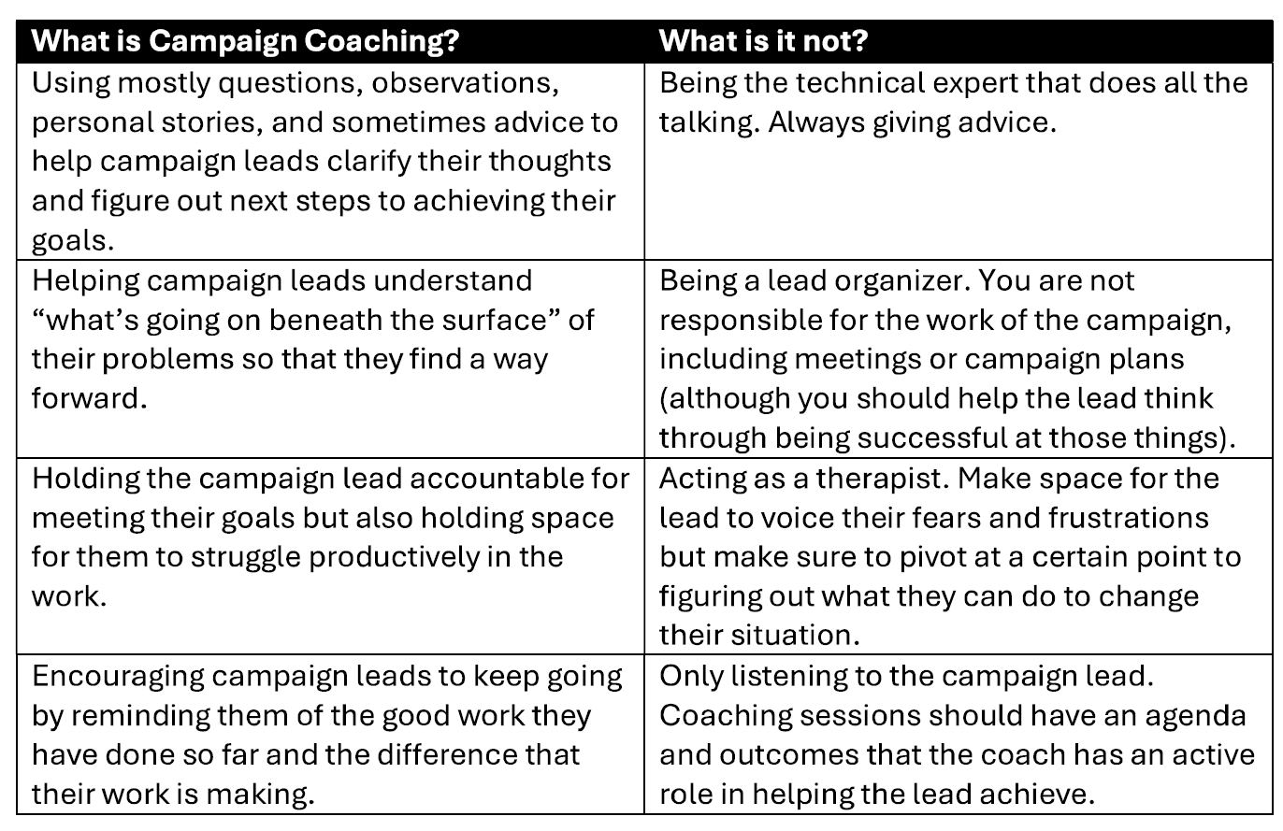  Small Group Discussion and Popcorn Responses – 5 Minutes  What on this chart stands out to you?  Popcorn answers  Key Points – 1 minute  Coaching is a direct intervention centered on an individual or team’s goals  Coaching is the ultimate leadership development practice. | Participants will learn how Campaign Lab works along with their role as coaches to be a key leadership development strategy.
10:05-10:25 | Scott | 20 mins TOTAL – What is effective coaching?
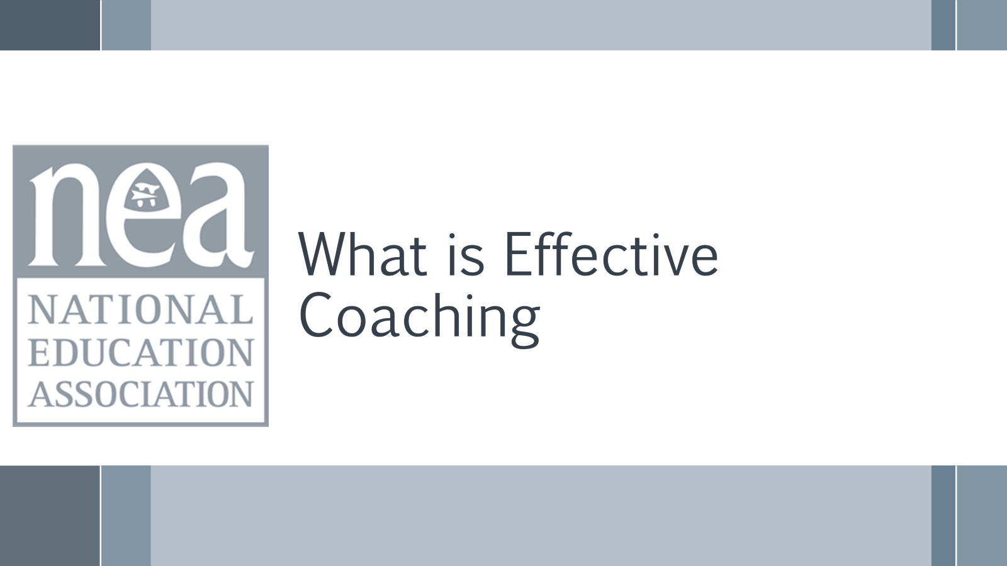  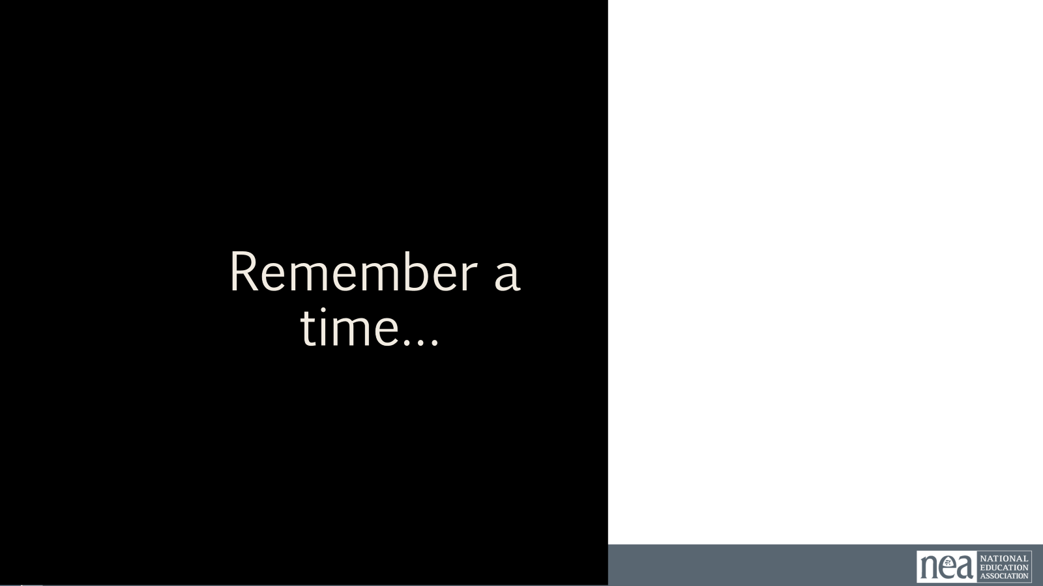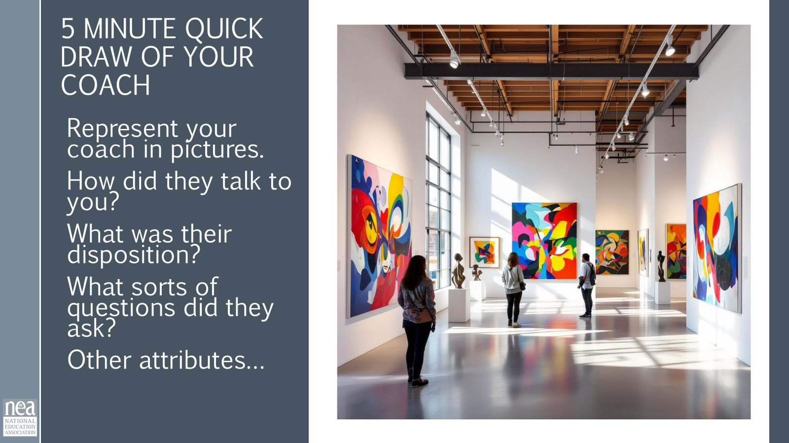  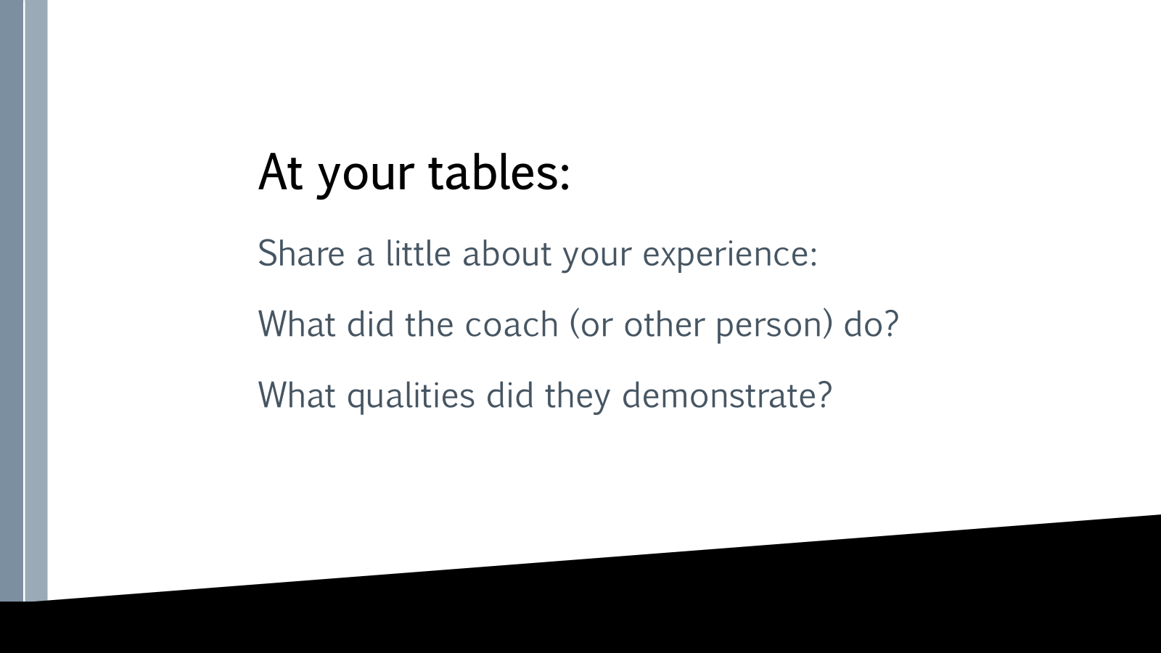  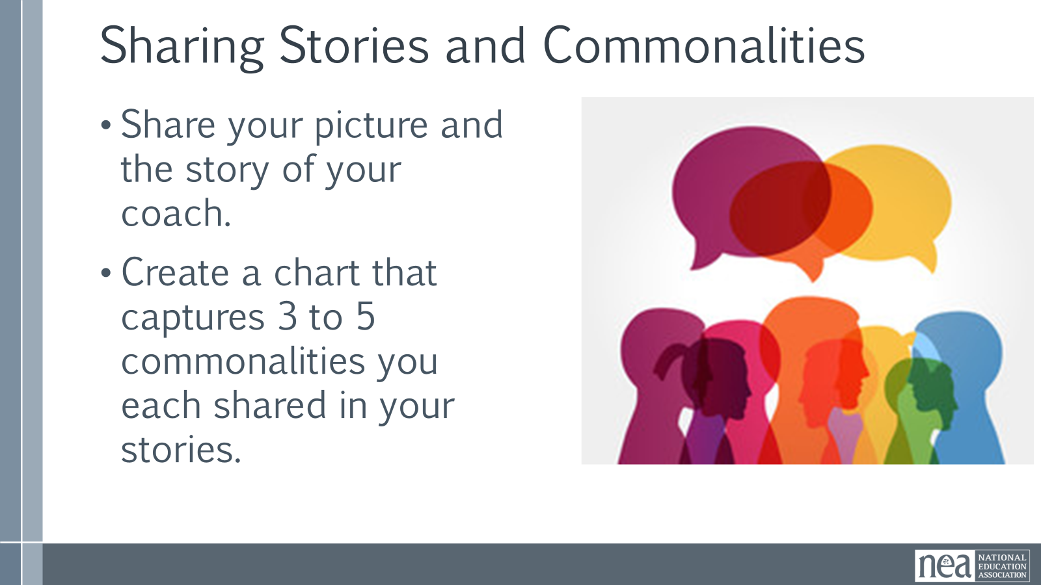  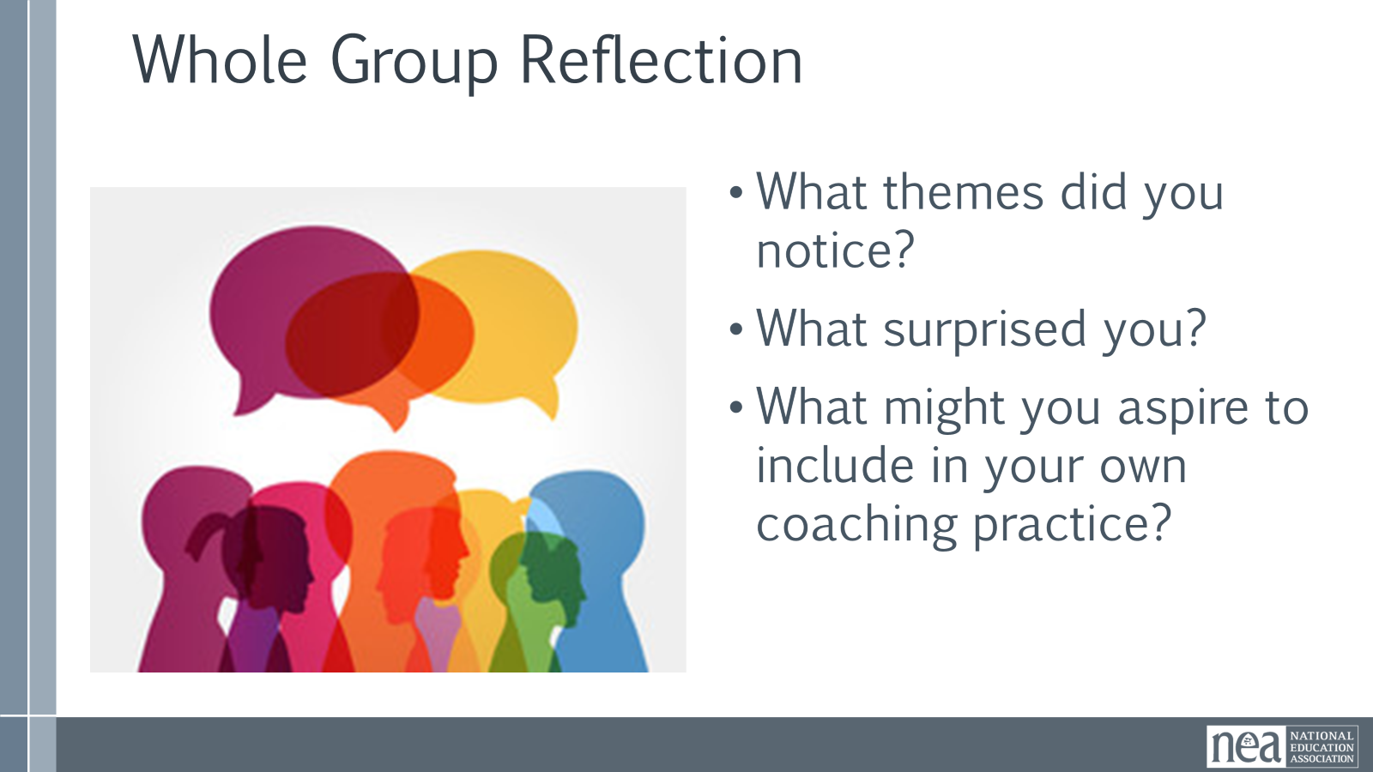  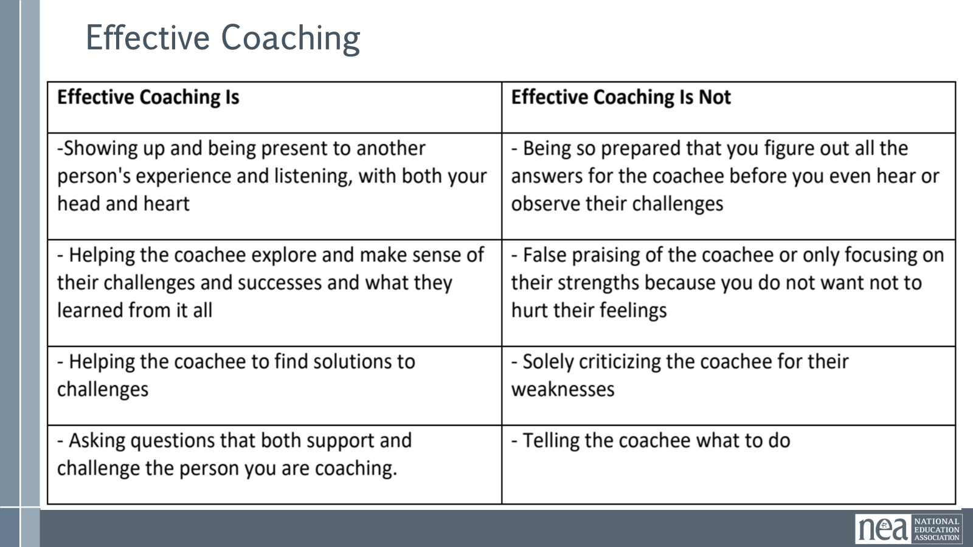  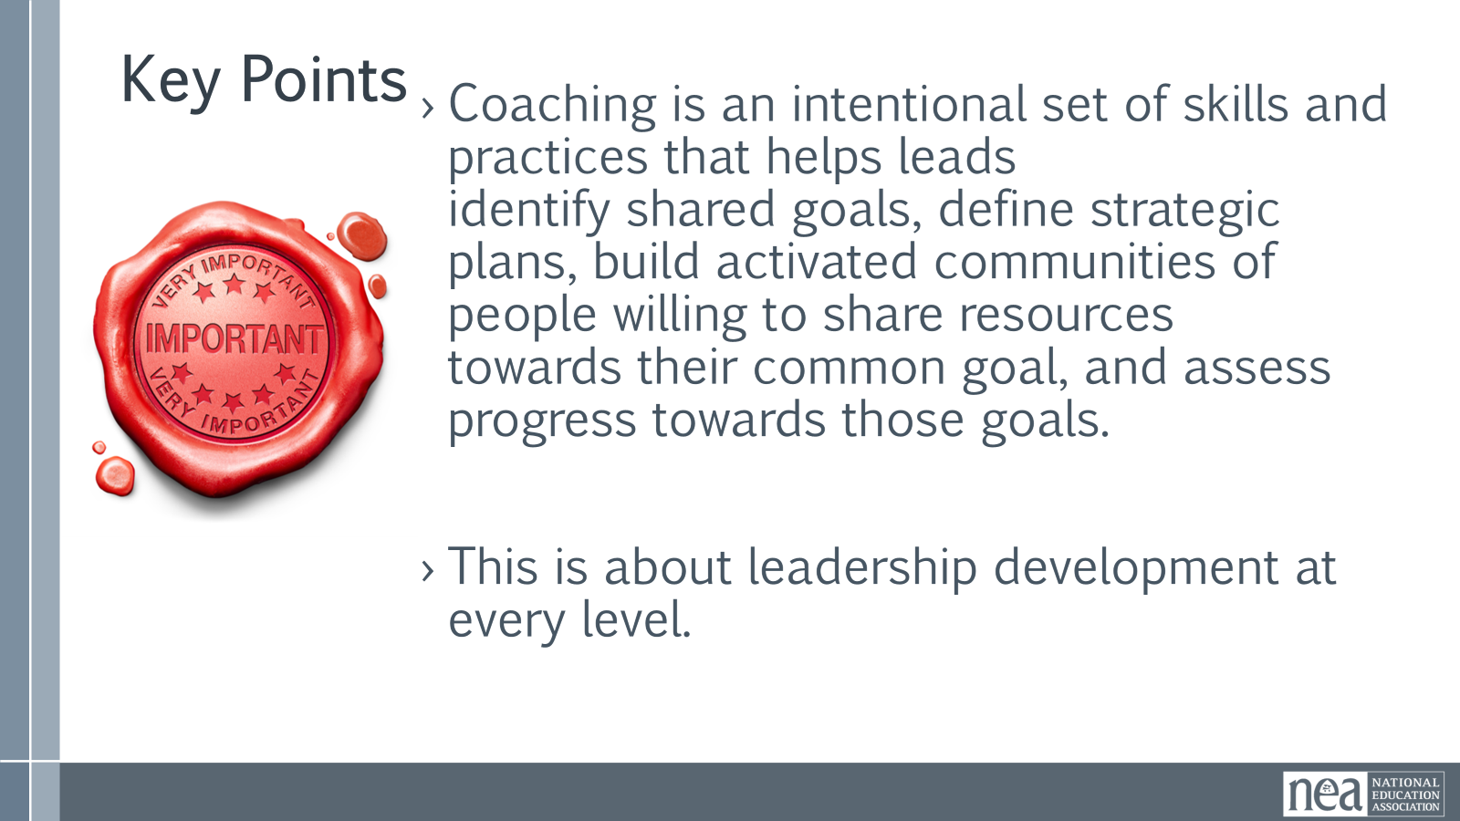 | Photo copy sized Paper- Drawing Activity  Chart Paper for each table to Capture Commonalities  Complete Coach’s Guidebook – Page 28 | What is Effective Coaching? Introduction 20 Minutes - Take a minute to identify someone who has been an influential coach for you at some time in your life. This could be someone who was a formal coach to you, a mentor; or it could someone who did not hold a formal coaching role but impacted you, nevertheless.  Think about what made them an impactful coach for you. How did they talk to you? What did they make you think about? What were the types of questions they asked you? How did they offer you feedback?  Drawing – 5 minutes  On a piece of printer paper, represent this person and how they coached you. This isn’t an art contest, so feel free to represent this individual and their coaching however works best for you. For example, I would identify X person and draw Y to represent how they did Z coaching for me. This is nothing fancy. Take 5 minutes to do this.  Small Group Discussion – 5 minutes  Now, in your table groups, share a little about the coach you thought of; each person should share for a minute each. After everyone has shared, identify 3-5 common things that your group heard across all of these impactful coaches. Create a chart of these commonalities and be prepared to share them out.  Whole Group Share Out – 5 minutes  We’ll start with this table and then go around to each table to share out the 3-5 common themes you named. When it is your turn to share – ONLY BE ADDITIVE – don't share something that has already been said.  Whole Group Reflection – 3 minutes  Now, let’s take a look at our commonalities. •What themes did you notice? •What surprised you? •What might you aspire to include in your own coaching practice?  [Assumption is that participants will see commonalties about the disposition of the coach (supportive, intentional, engaged, direct, etc.]  Key Points - 5 minutes (review this chart and share the key points)  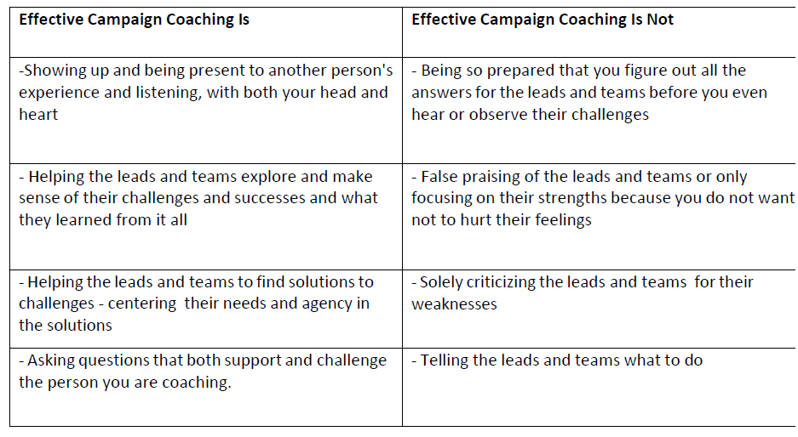  - Coaching is an intentional set of skills and practices that helps teams identify their shared goals, define their strategic plans, build activated communities of people willing to share their resources towards their common goal, and assess progress towards achieving those common goals.  - This is about leadership development at every level. | Participants will learn how Campaign Lab works along with their role as coaches to be a key leadership development strategy.
10:25-10:40 |  | BREAK – TOTAL 15 Minutes (check with Karla to see if there is food to be served)
10:40 -11:30 | Dr. Taraja & Katie | 60 minutes TOTAL – Centering Equity in Coaching
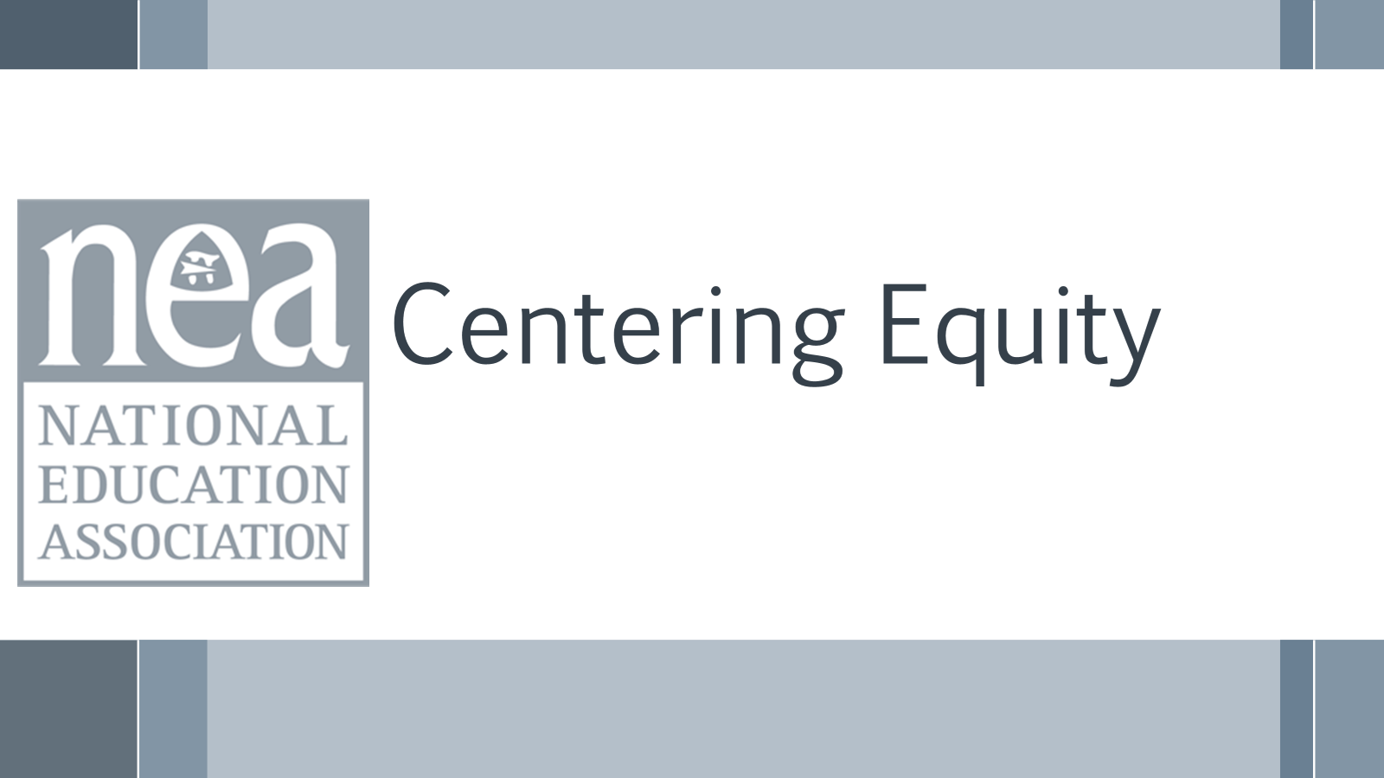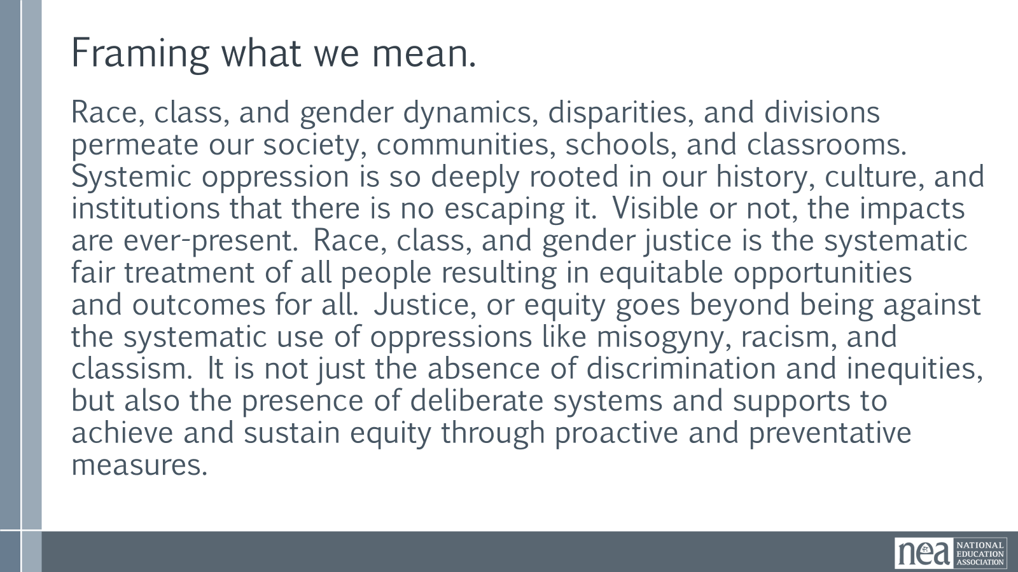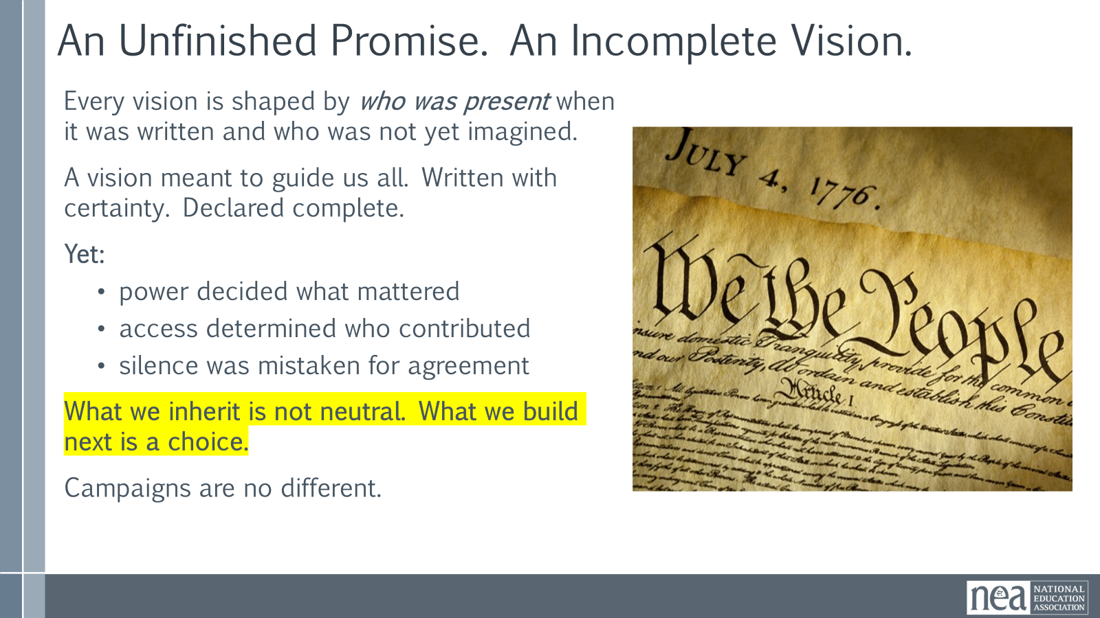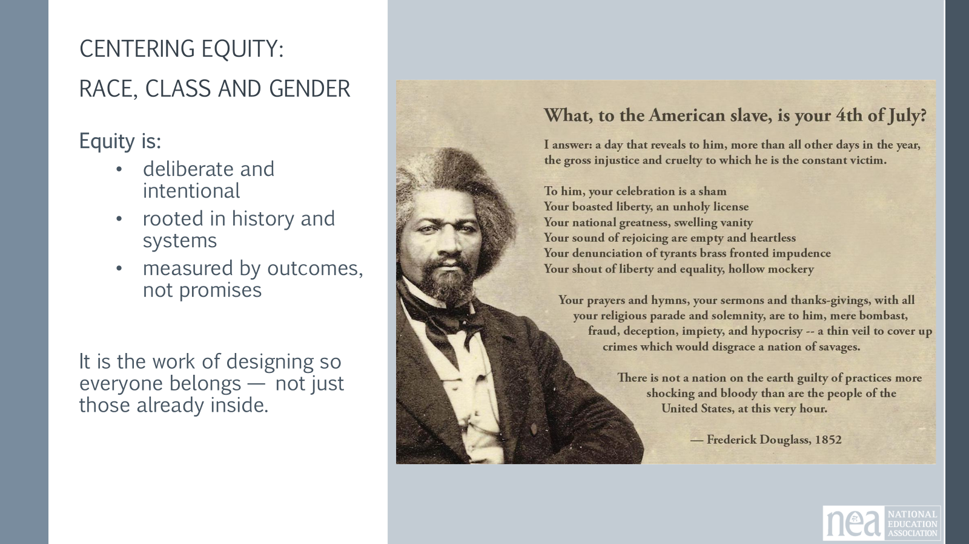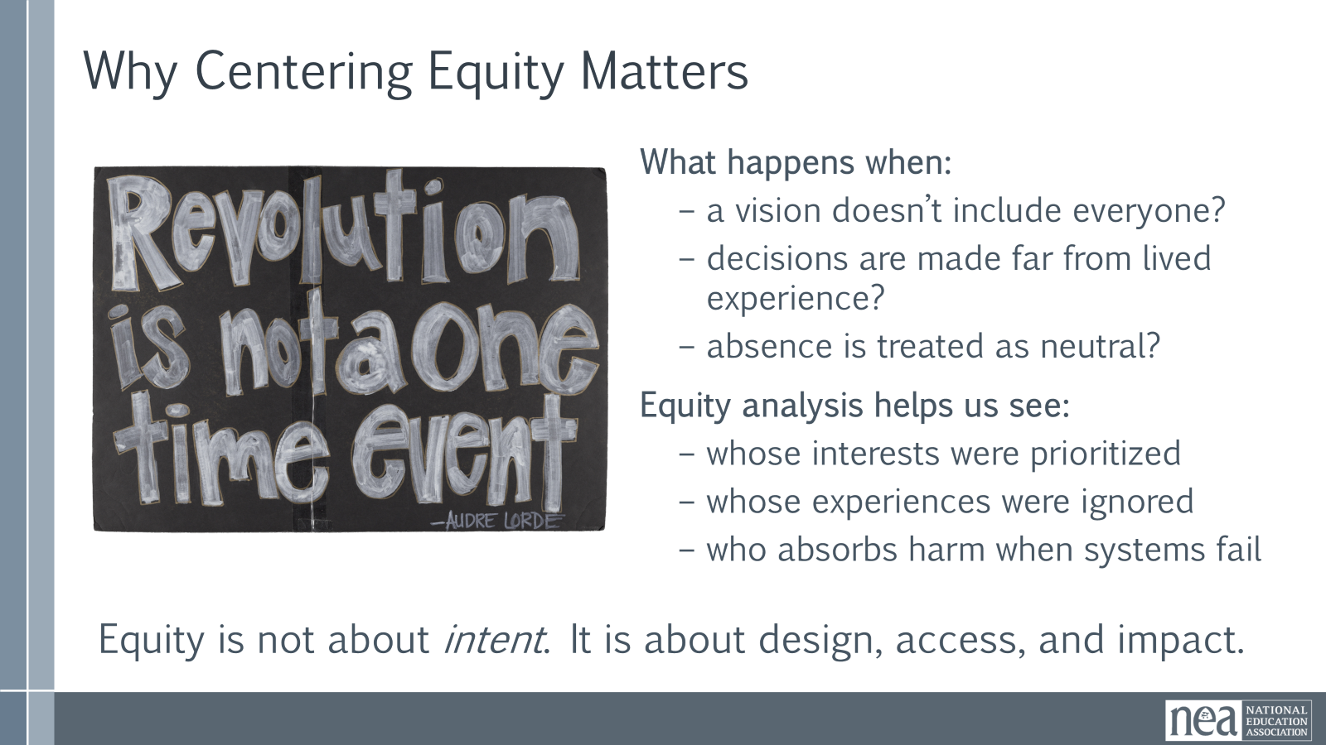  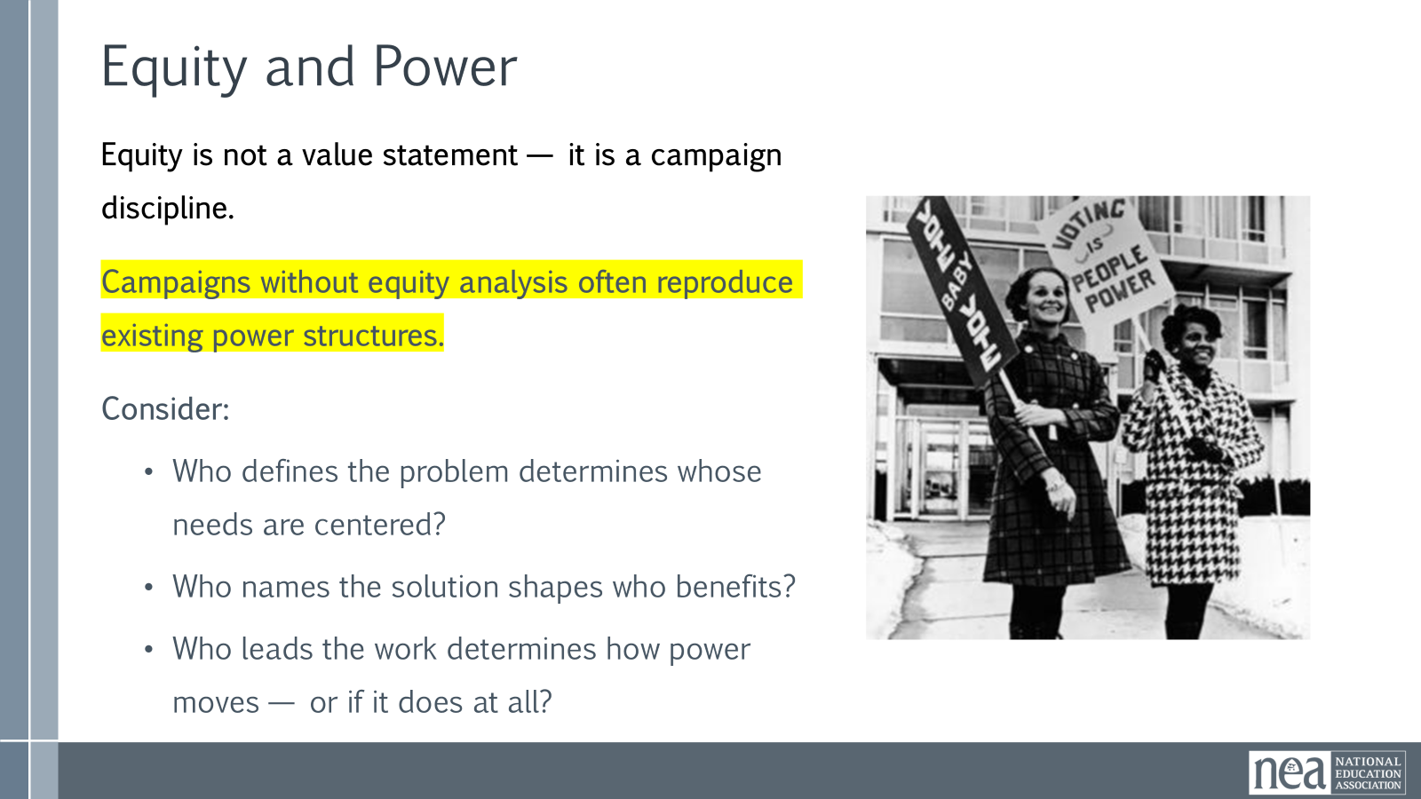  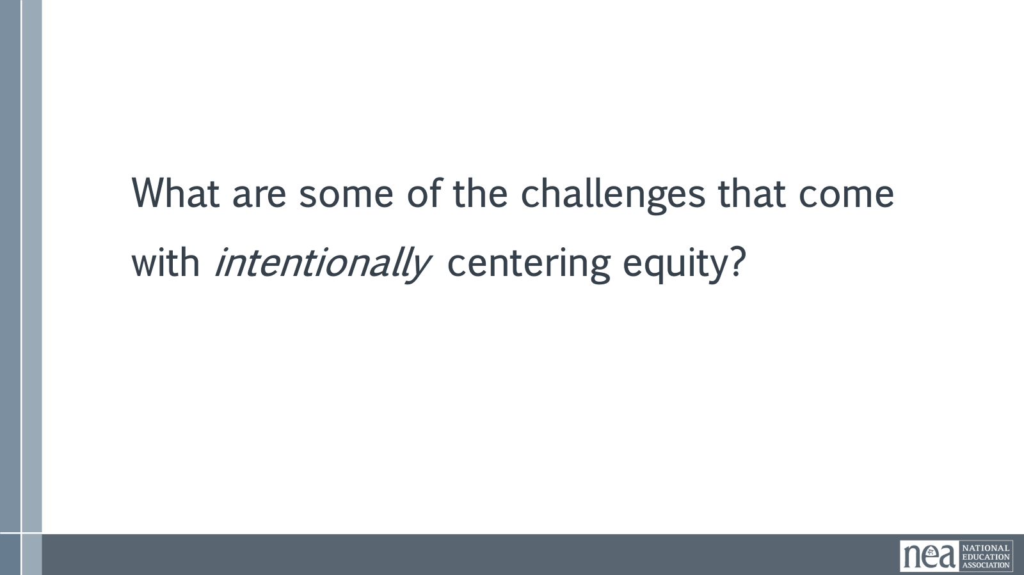  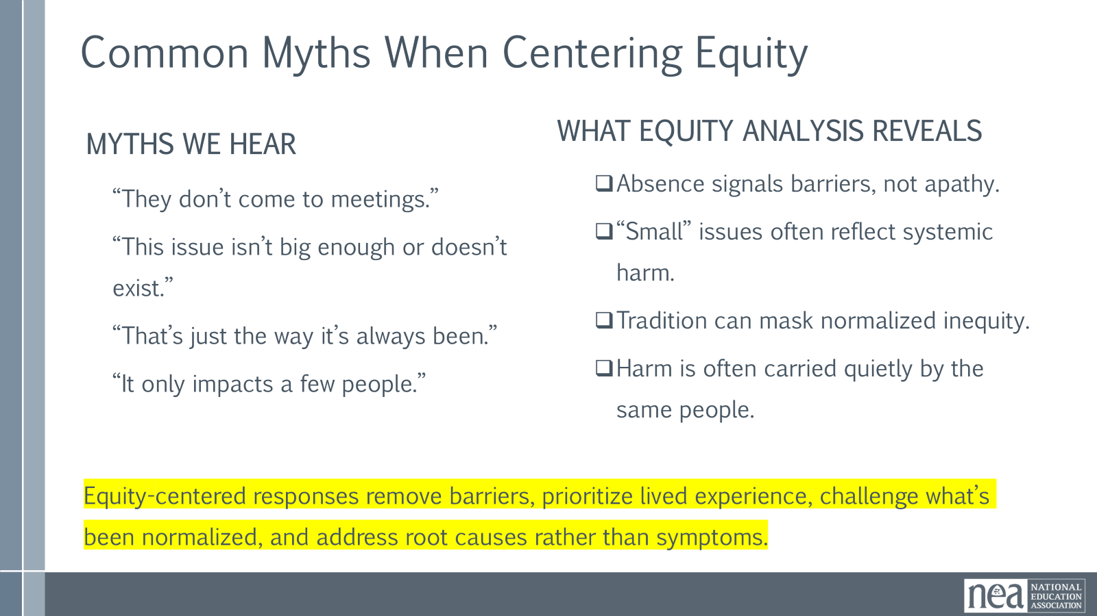  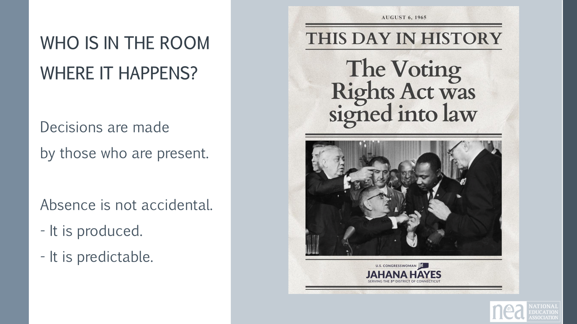  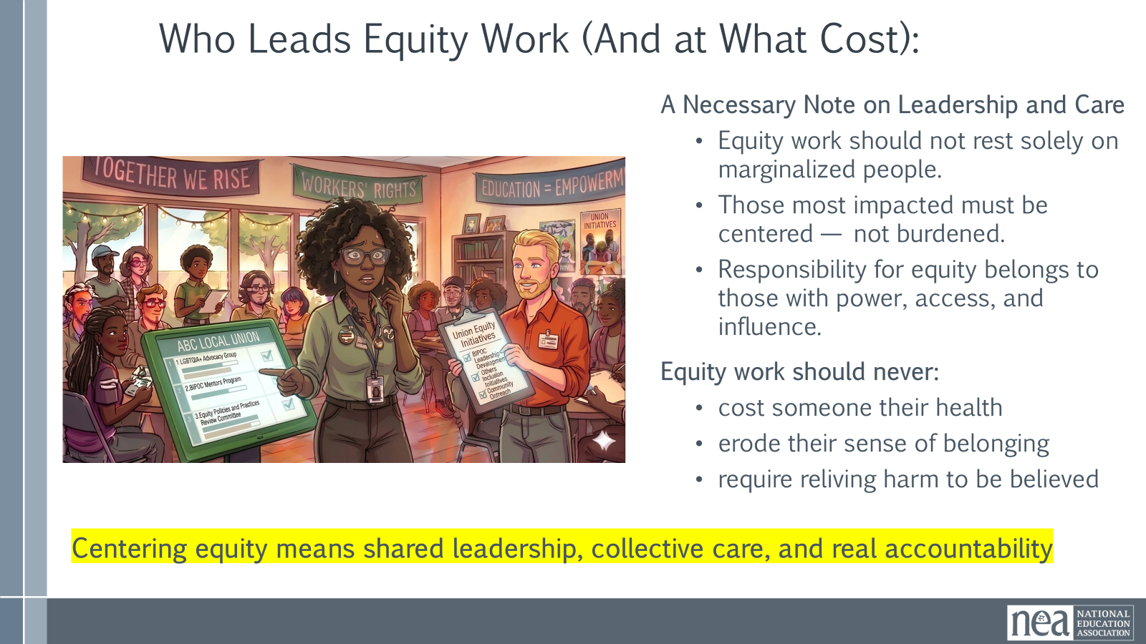  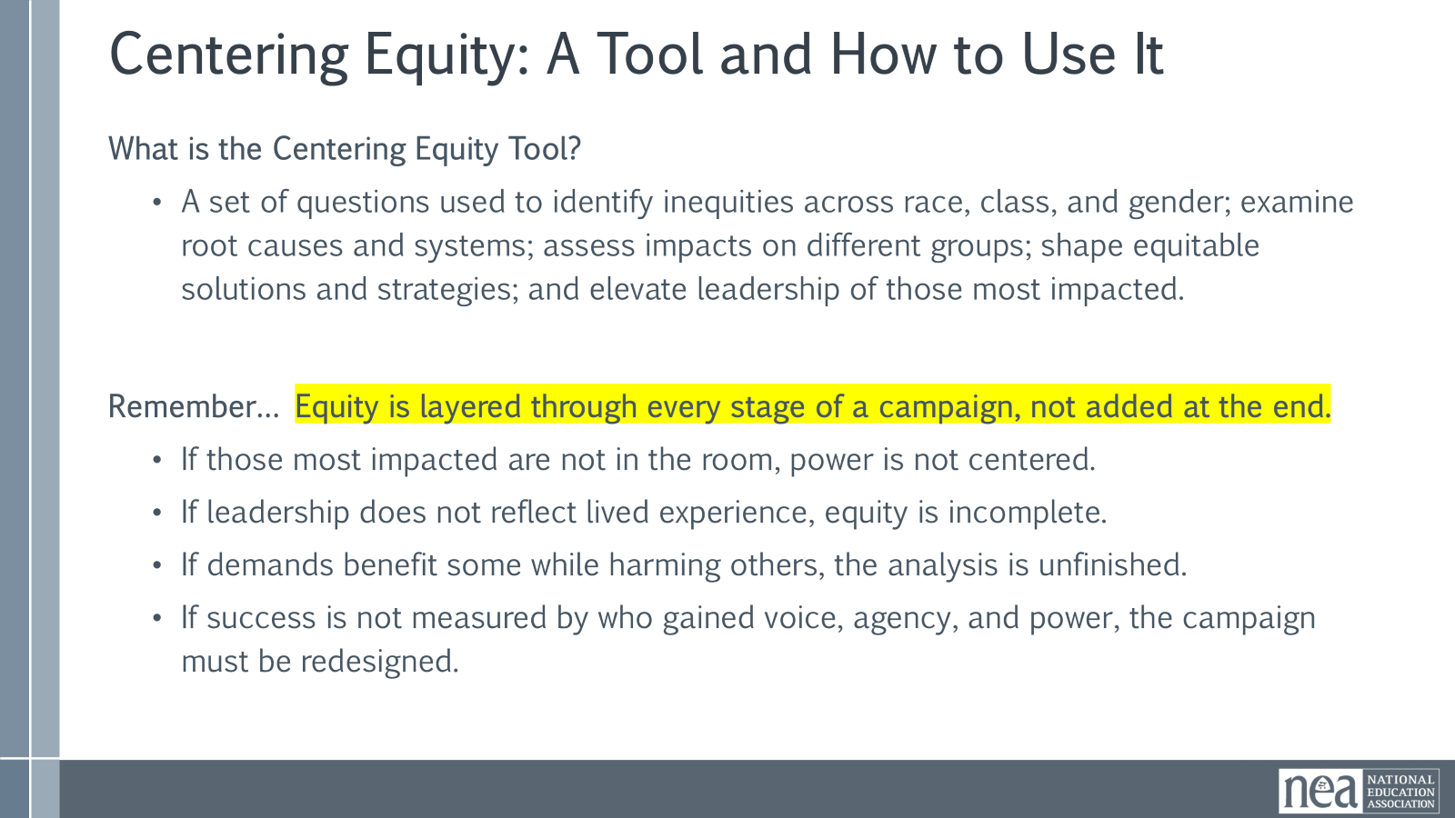  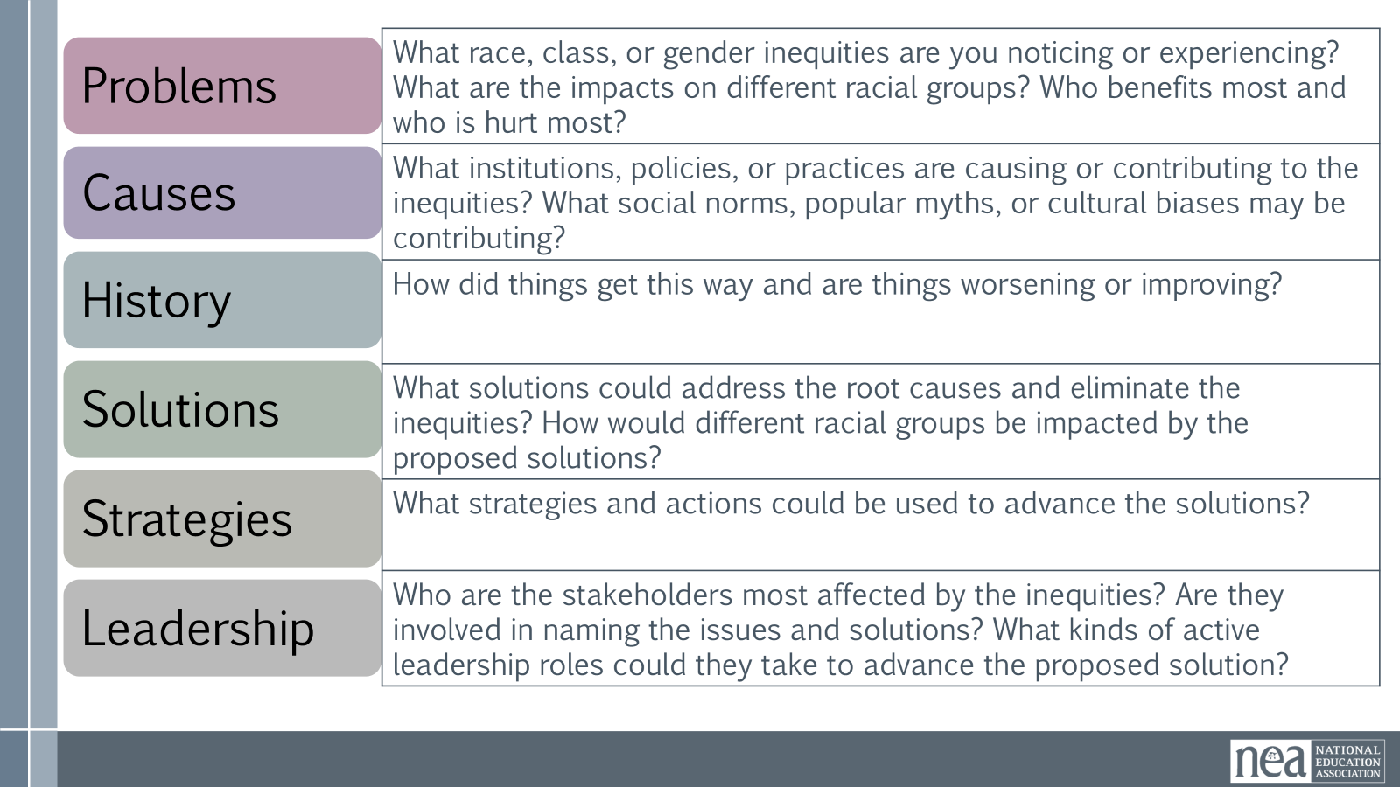  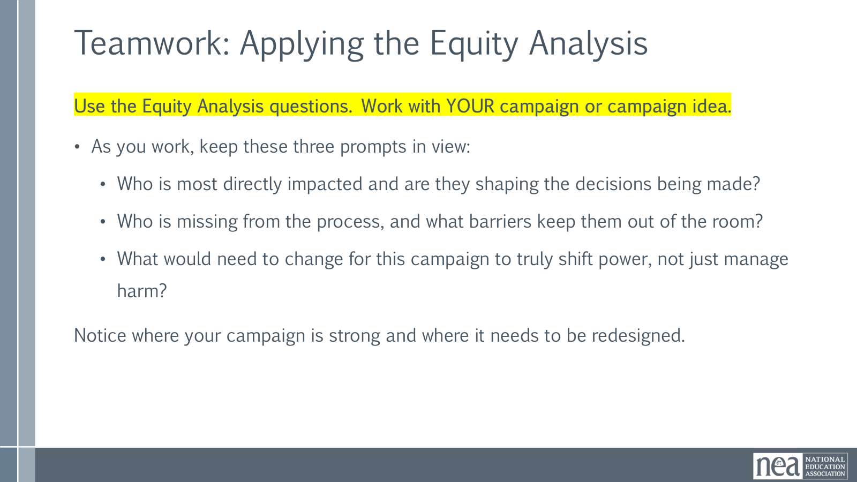  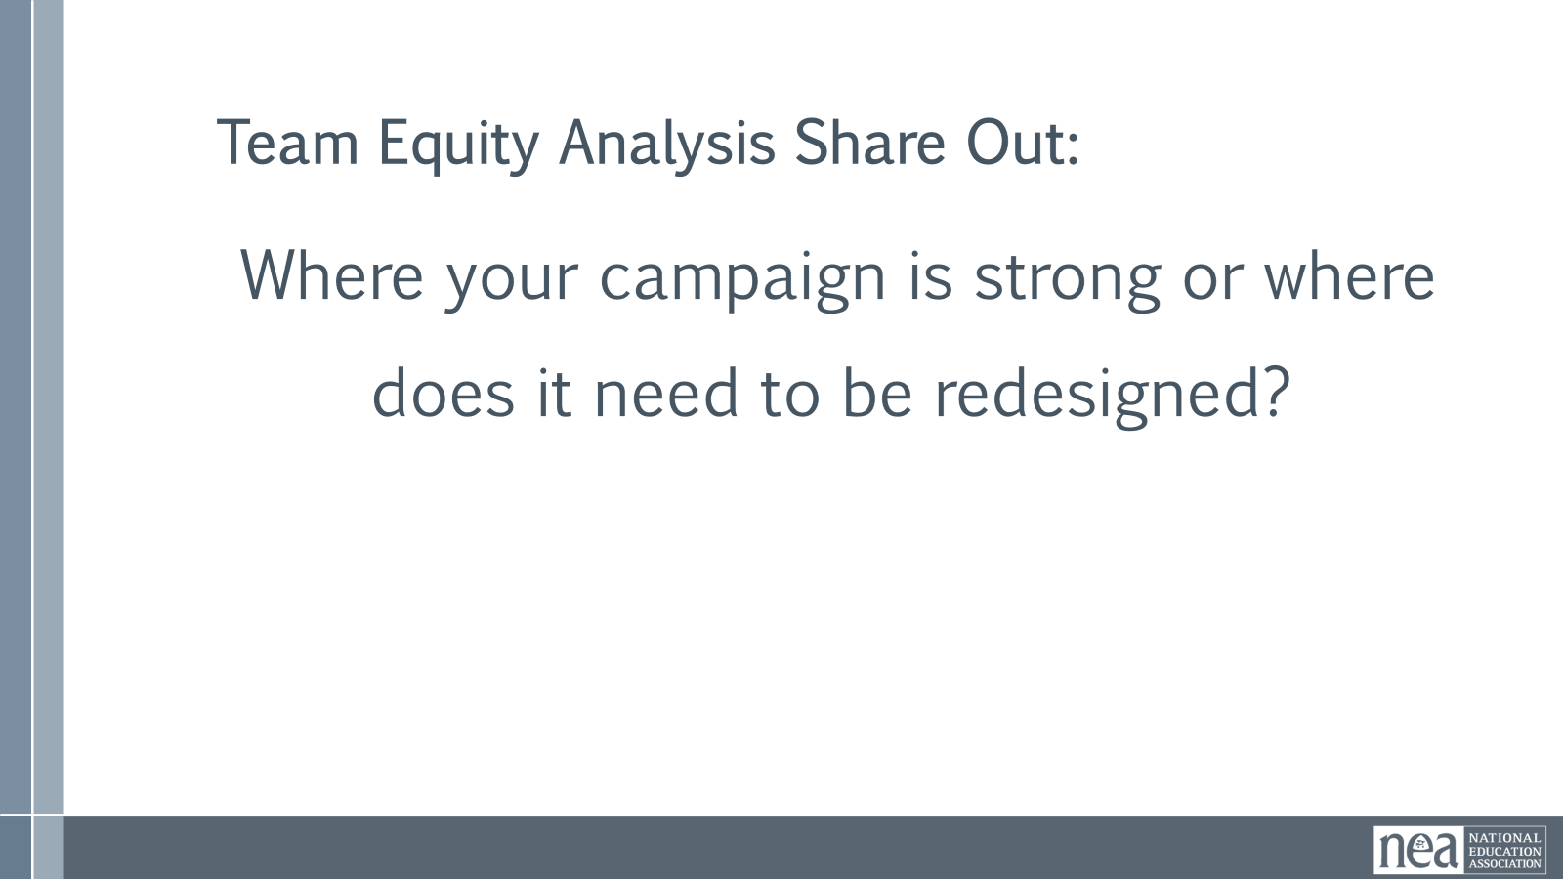  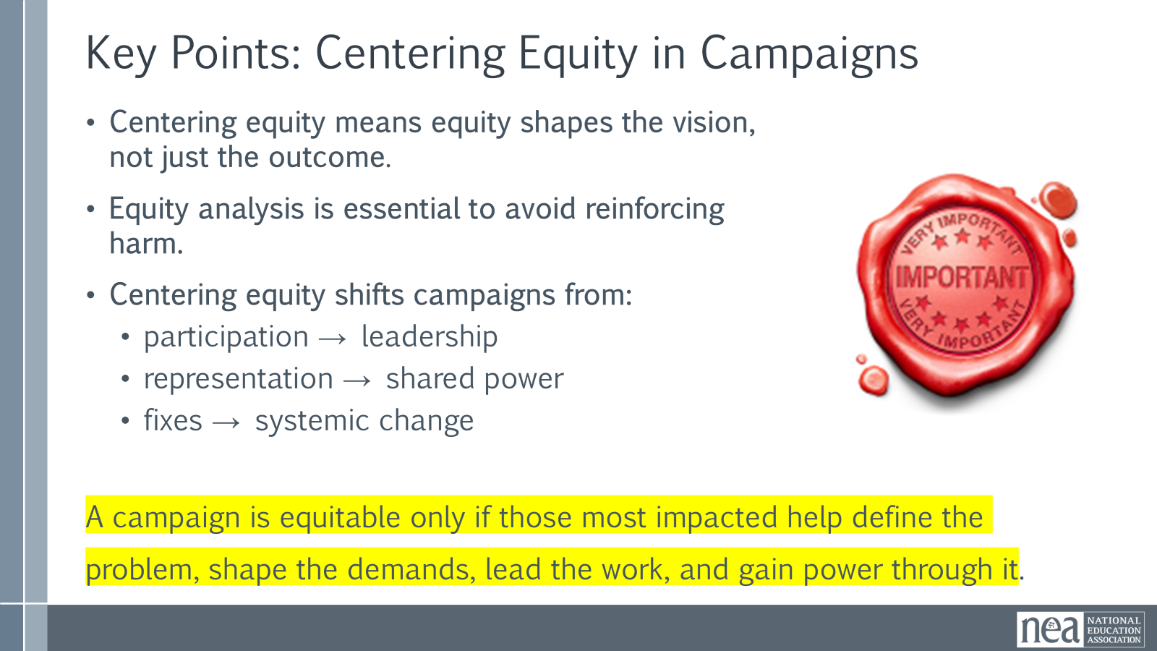 | Equity tool handout  1.3 Centering Equity in your Campaigns | Centering Equity in Campaigns (75 Minutes)  This session focuses on how campaigns are designed, not just what they aim to win. Participants will arrive with different levels of readiness, all of which belong here. The guiding question throughout the session is: Who is in the room where it happens — and who is not?  Opening Framing  Race, class, and gender dynamics, disparities, and divisions permeate our society, communities, schools, and classrooms. Systemic oppression is so deeply rooted in our history, culture, and institutions that there is no escaping it. Visible or not, the impacts are ever-present. Race, class, and gender justice are the systematic fair treatment of all people resulting in equitable opportunities and outcomes for all. Justice, or equity goes beyond being against the systematic use of oppressions like misogyny, racism, and classism. It is not just the absence of discrimination and inequities, but also the presence of deliberate systems and supports to achieve and sustain equity through proactive and preventative measures.  Centering equity is not a values exercise. It is an organizing discipline that shapes how problems are named, demands are formed, leadership develops, and power moves. This work is about intentional design, not perfection.  An Unfinished Promise  Every vision is shaped by who is present, who has decision-making power, and who is imagined as the audience. Campaigns are no different. Centering equity means refusing to treat absence as neutral.  Why Centering Equity Matters  Equity is not about intent. It is about design, access, and impact. Equity analysis helps us see whose interests were prioritized, whose experiences were ignored, and who absorbs harm when systems fail. This is about clarity, not blame.  Equity, Power, and Campaign Discipline  Equity is a campaign discipline. Power operates through who defines problems, names solutions, and leads the work. Campaigns that skip equity analysis often reproduce existing power structures, even with good intentions.  Organizing Questions and the Missing Question  Beyond the four organizing questions, equity demands a fifth: Who is missing and why? Absence is rarely accidental. Asking this question is design repair, not criticism.  Group share-out: What are some common challenges that you encounter when you try to intentionally center equity in this work?  Common Myths When Centering Equity  Noting some common resistance statements point to barriers, not apathy. Equity-centered responses remove barriers and redesign systems based on lived experience and root causes.  Who Leads Equity Work and at What Cost  Equity work should not rest solely on marginalized people. Responsibility belongs to those with power and access. Equity work should never cost someone their health or sense of belonging. If we are truely centering equity and creating systems within our unions to include and uplift all members- it should not cost them their health and should create a sense of belonging.  Small-Group Equity Analysis (25–30 Minutes) pg 10 in handouts  Using the scenario on page 8, River City EA, you will count 1-6. We will count off by 1-6, once we hit 6 that is your group. This will be your home group for this activity.  Leave your home group and to find your 1s.  In your group of 1’s, you will discuss the part of the equity analysis. So 1’s will discuss the problem, the 2’s will discuss causes, etc. You will have 5 minutes to share your piece of the equity analysis.  Once you are done, head back to your original home group of 6.  As a table- discuss what you heard. Have one person compile your responses. (10 minutes)  Whole-Group Shakeout and Harvest (15 Minutes)  As a group of 6; make a chart that has one equity gap your team agrees on, one assumption that shifted as you did your analysis, or one design question that emerged.  (Faciliator) Name patterns and reinforce these as organizing opportunities.  Key points:  Centering equity means shaping vision, leadership, and strategy. Campaigns are equitable only when those most impacted help define problems, shape demands, lead the work, and gain power through it. | Participants will learn how and why to use an equity tool to evaluate their vision.  Participants will articulate what achieving their goal would look like if it was rooted in equity.
11:30-12:00 then 1:00 –1:30 |  | 60 Mins TOTAL – Campaign Coaching Cycle and Step 2 – Diagnosis – 30 Minutes before Lunch and 30 Minutes After
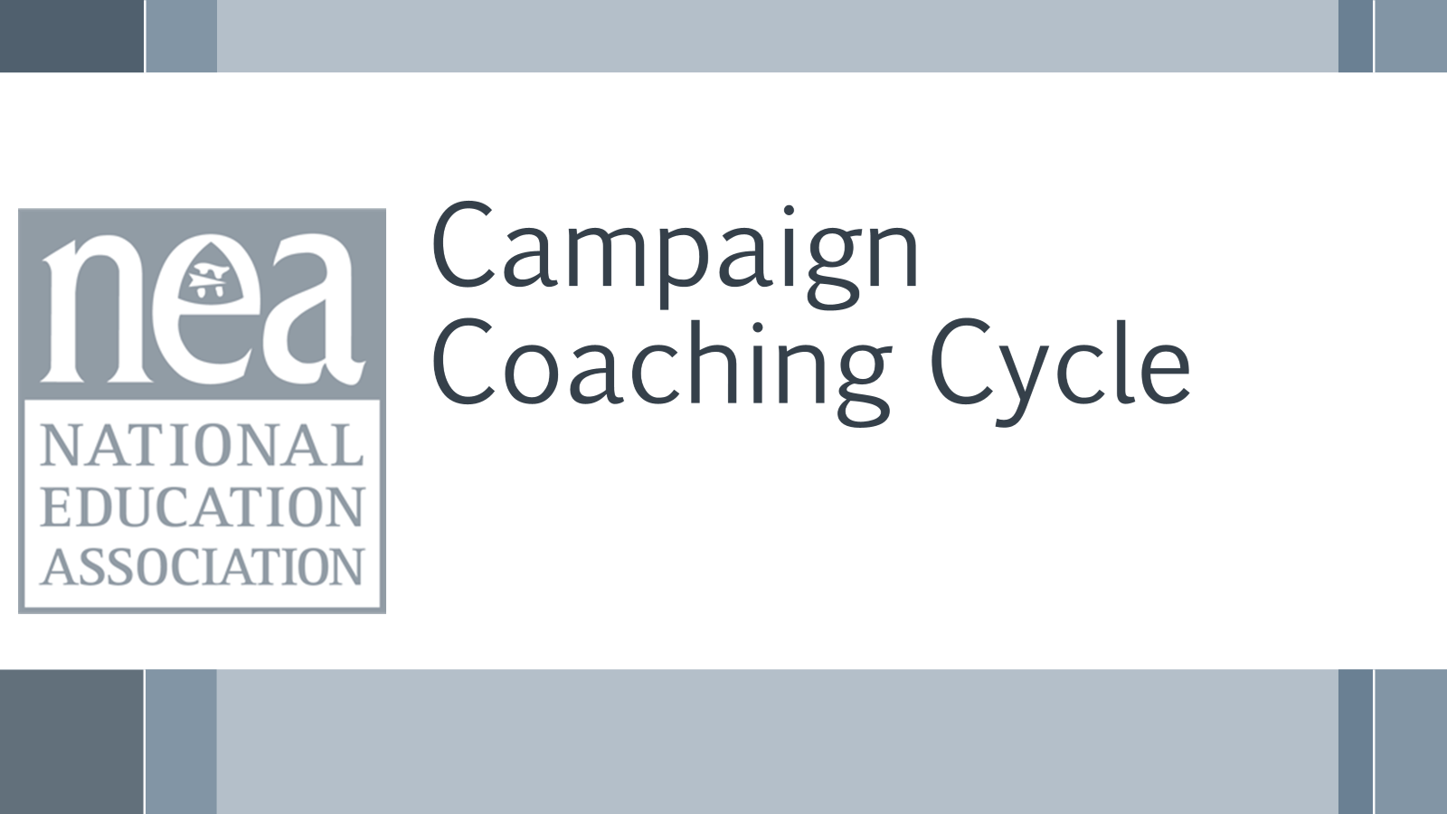  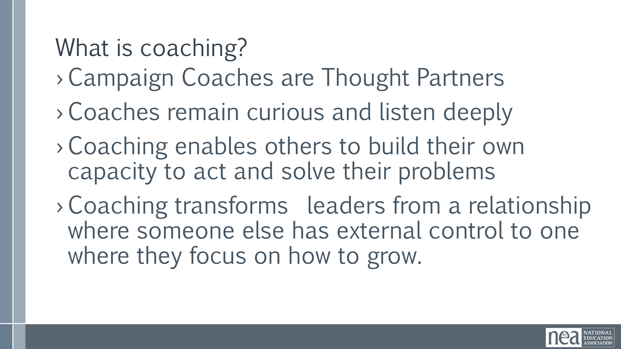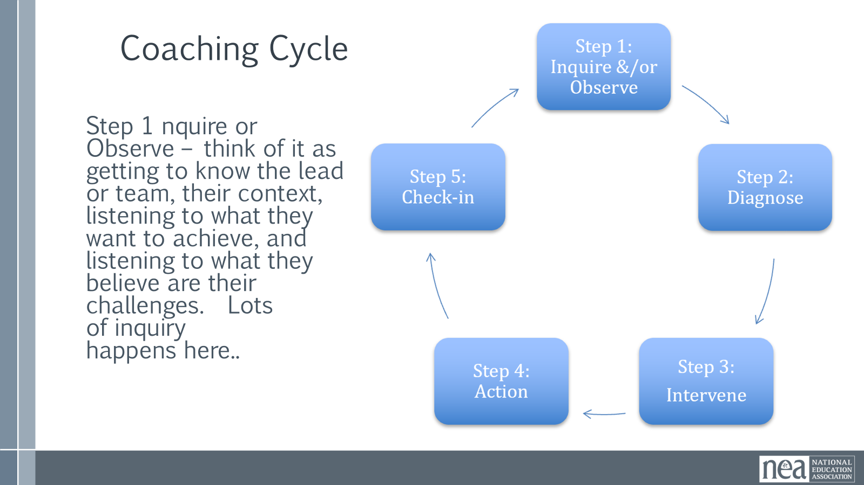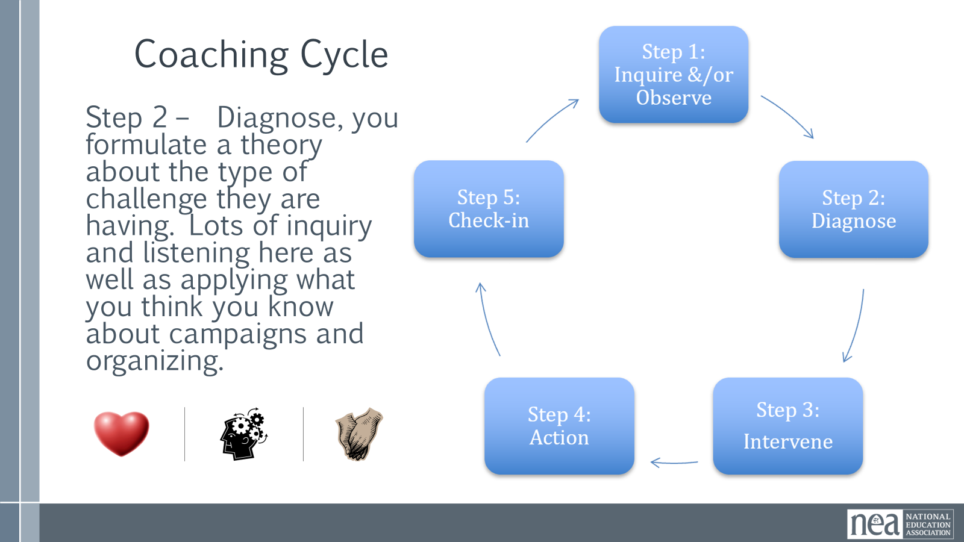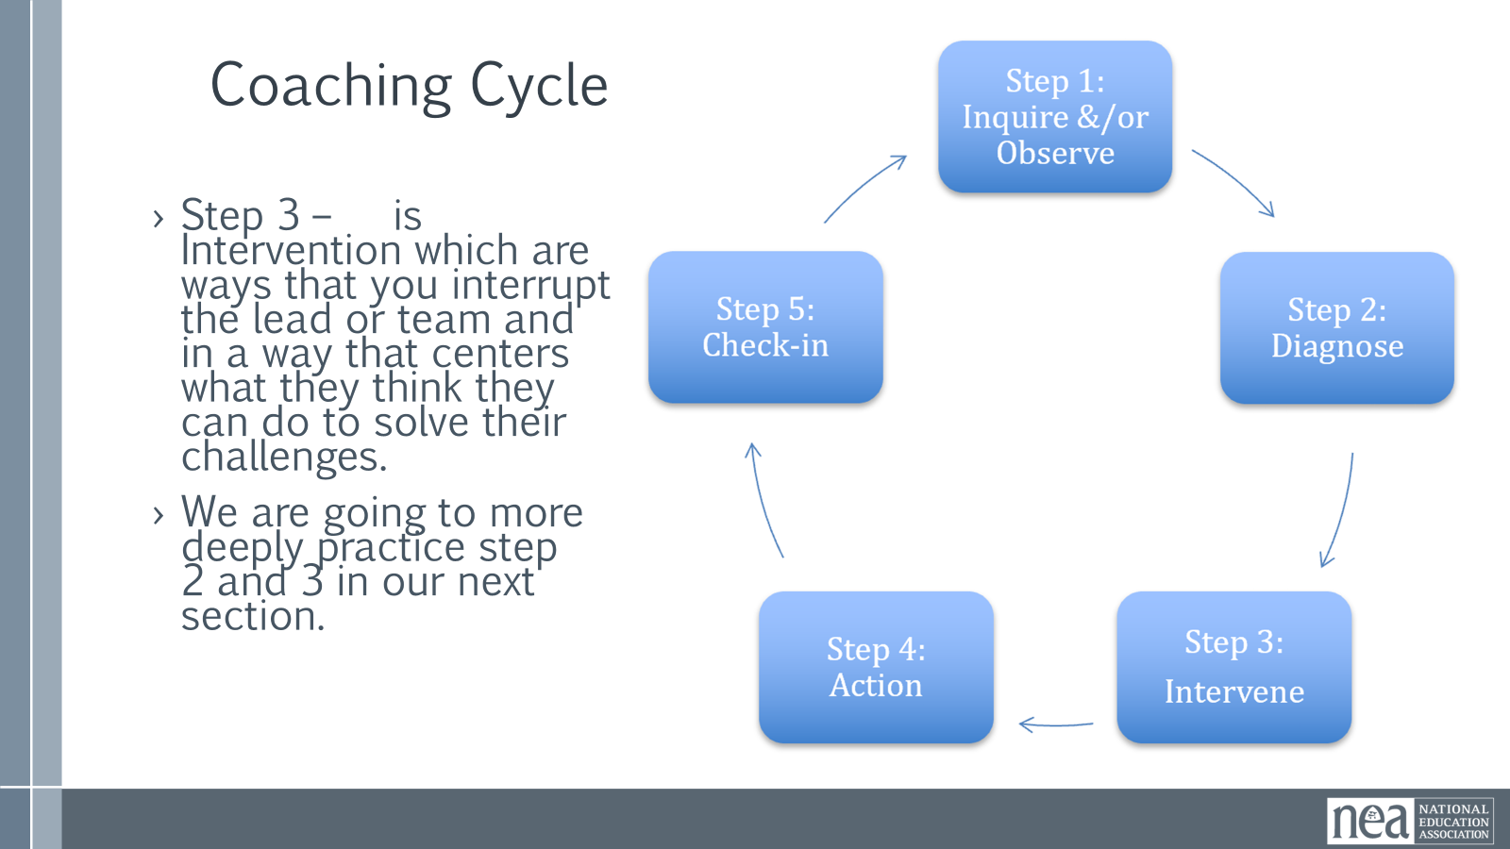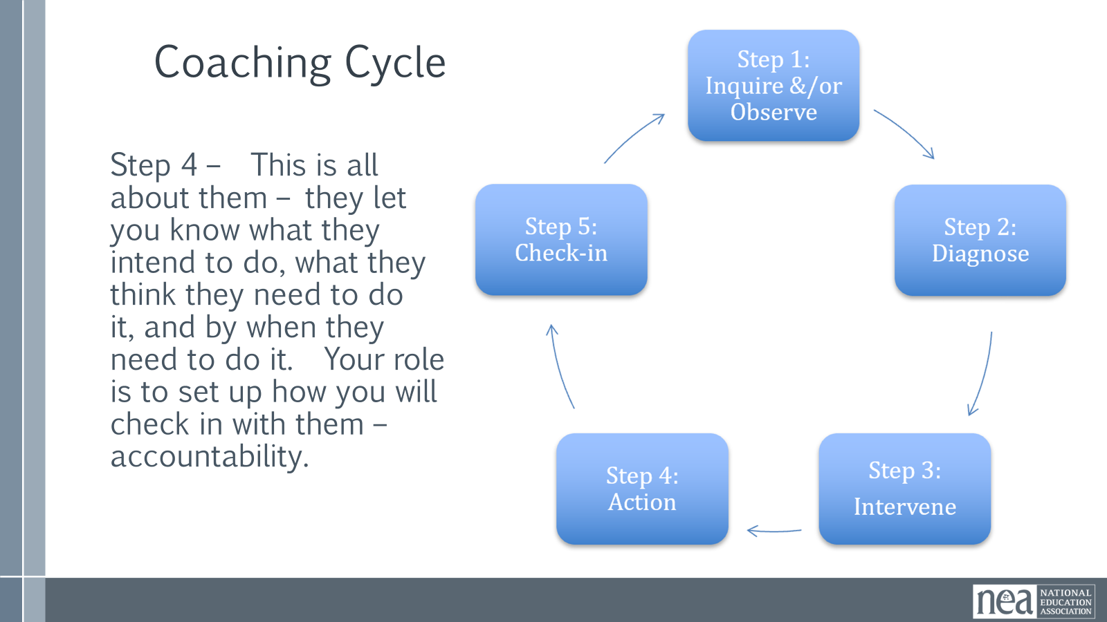  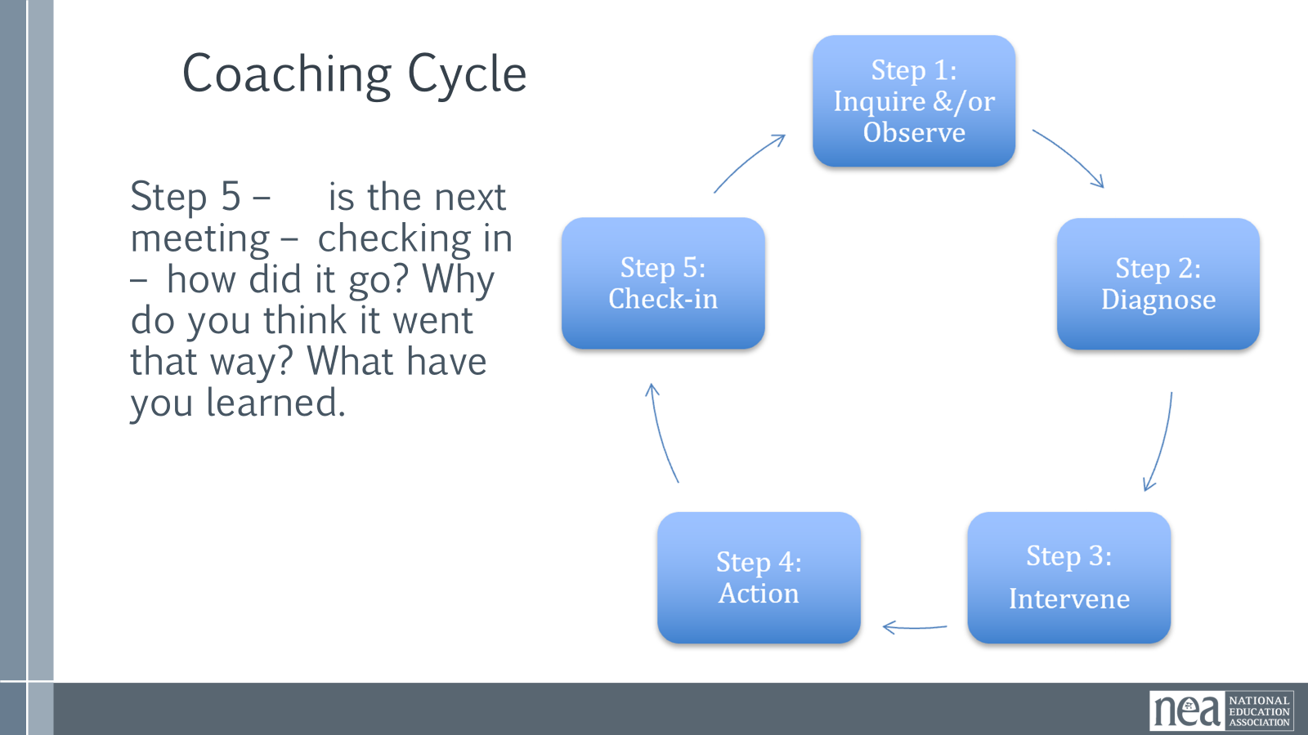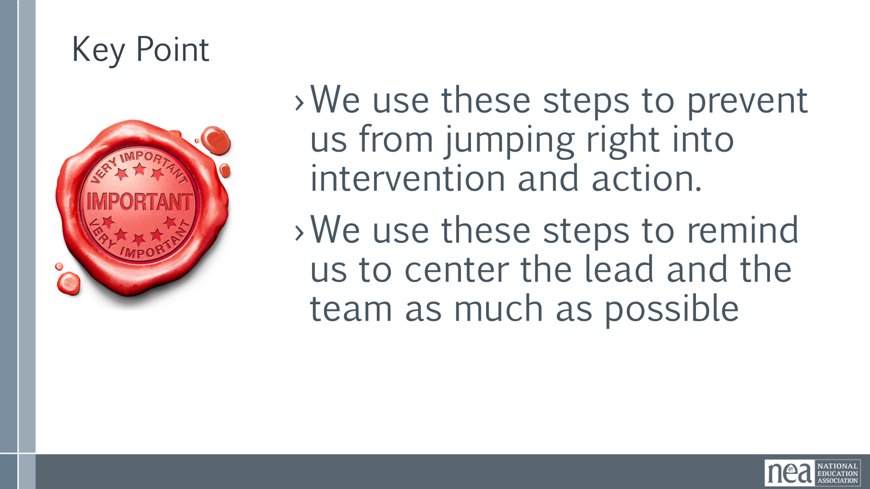  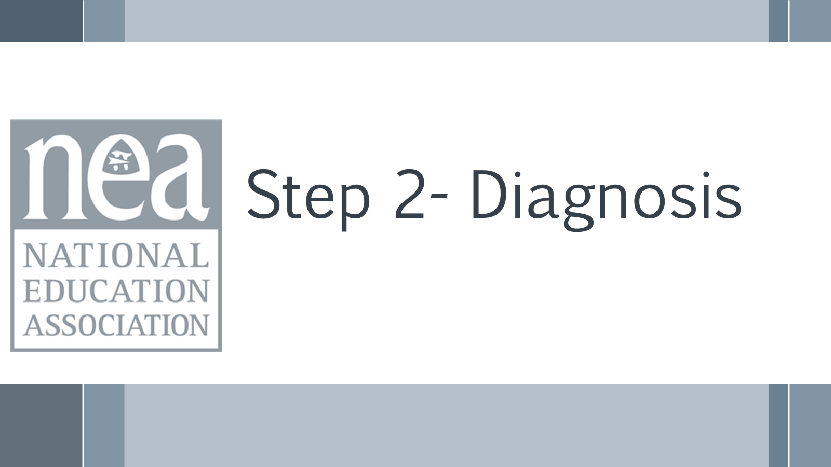  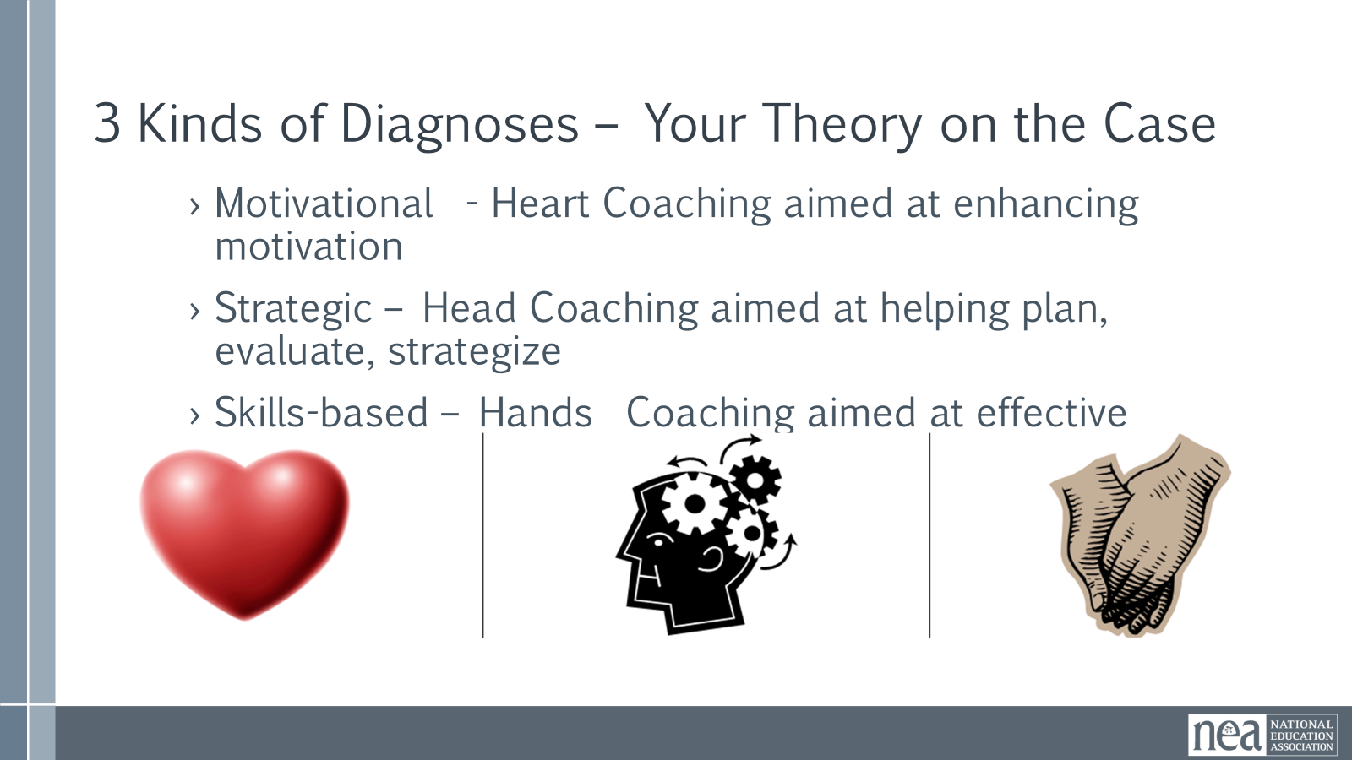  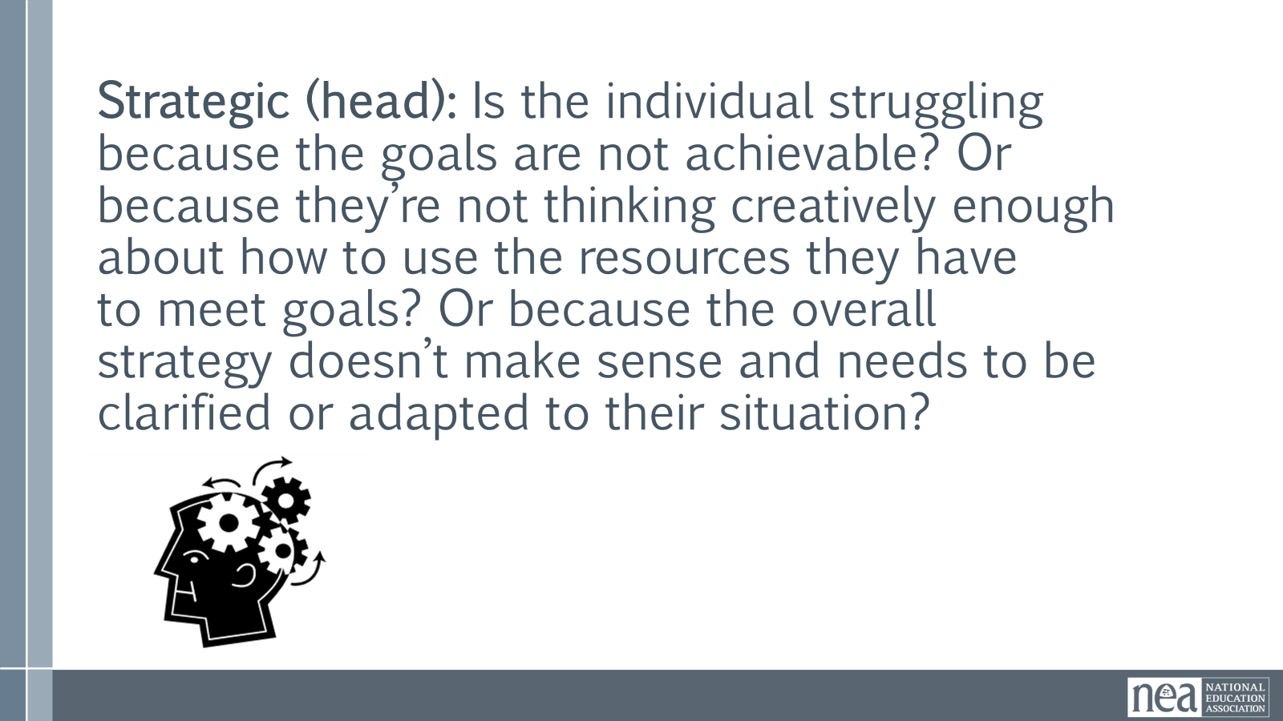  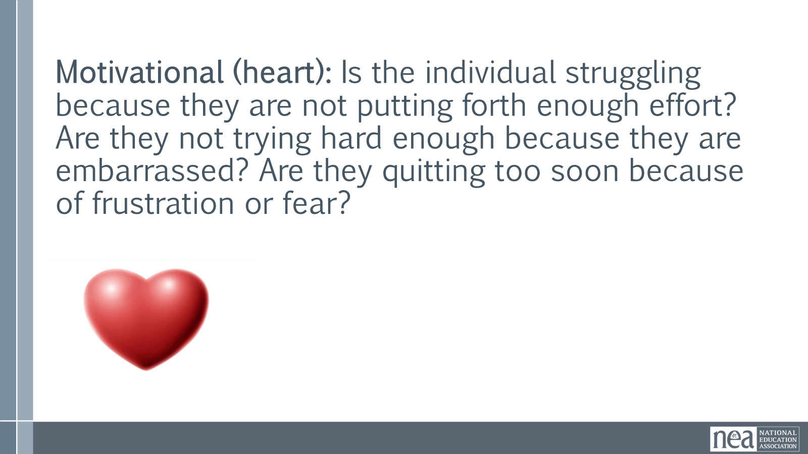  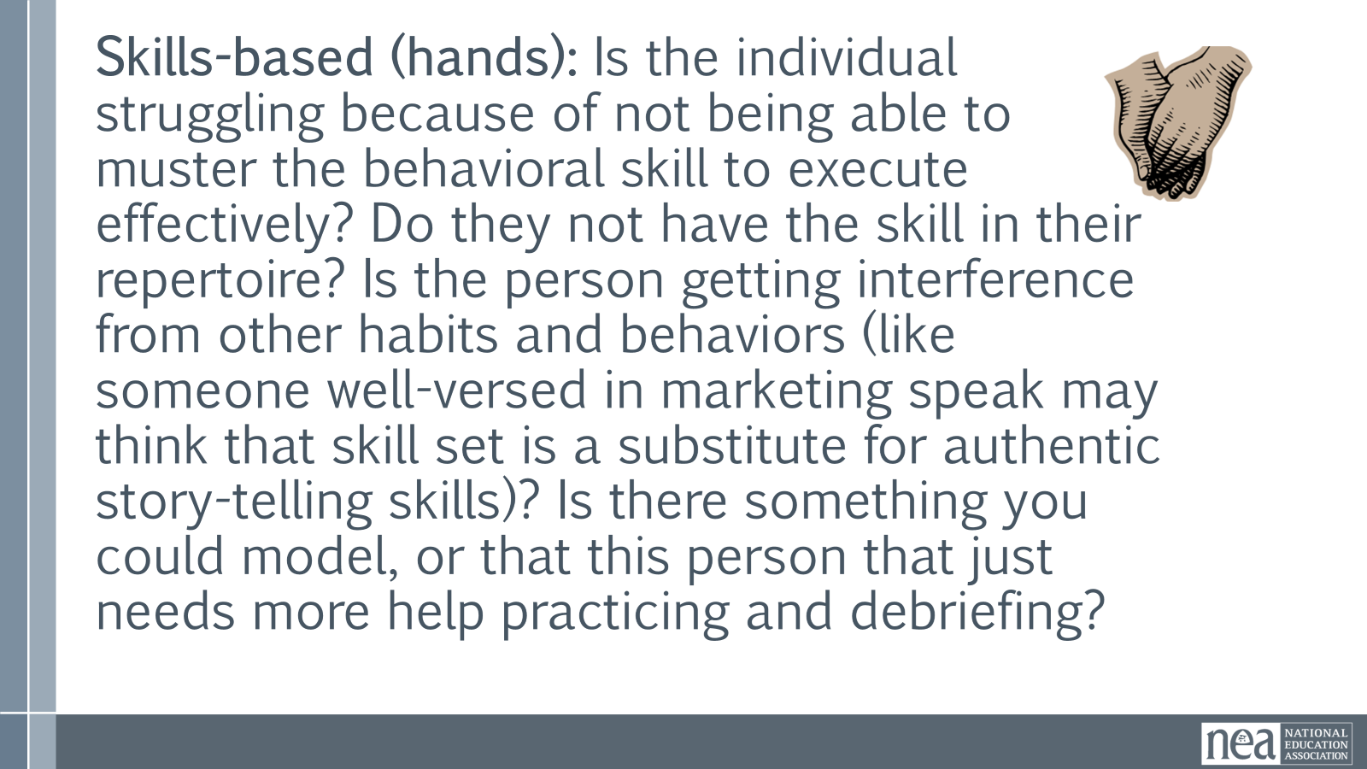  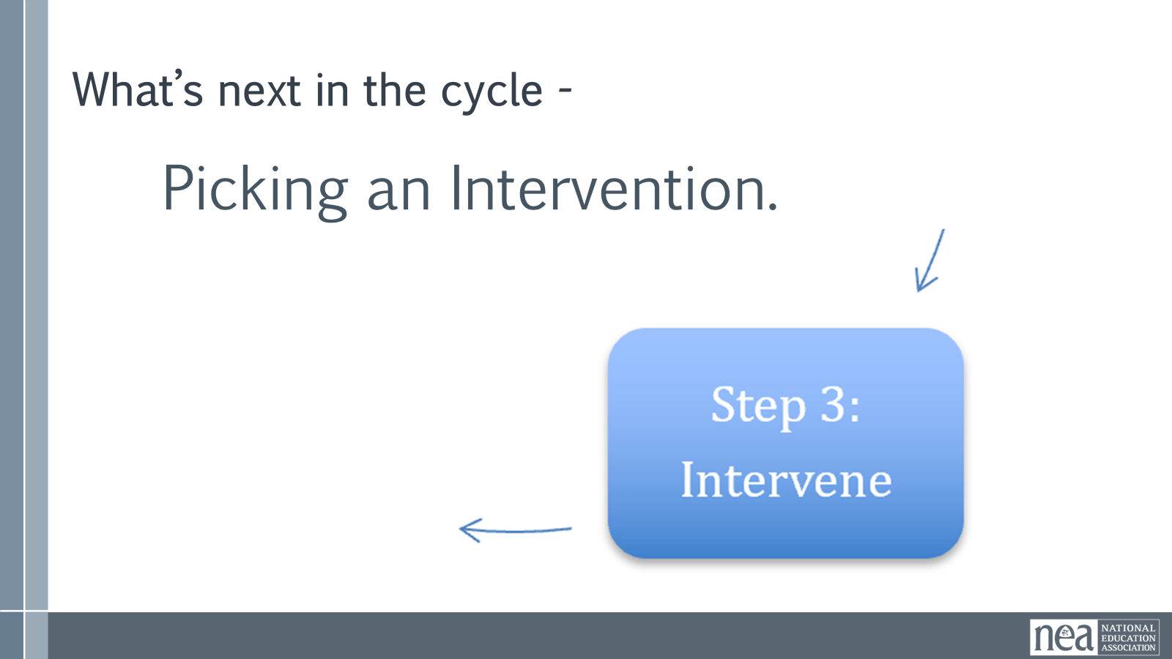  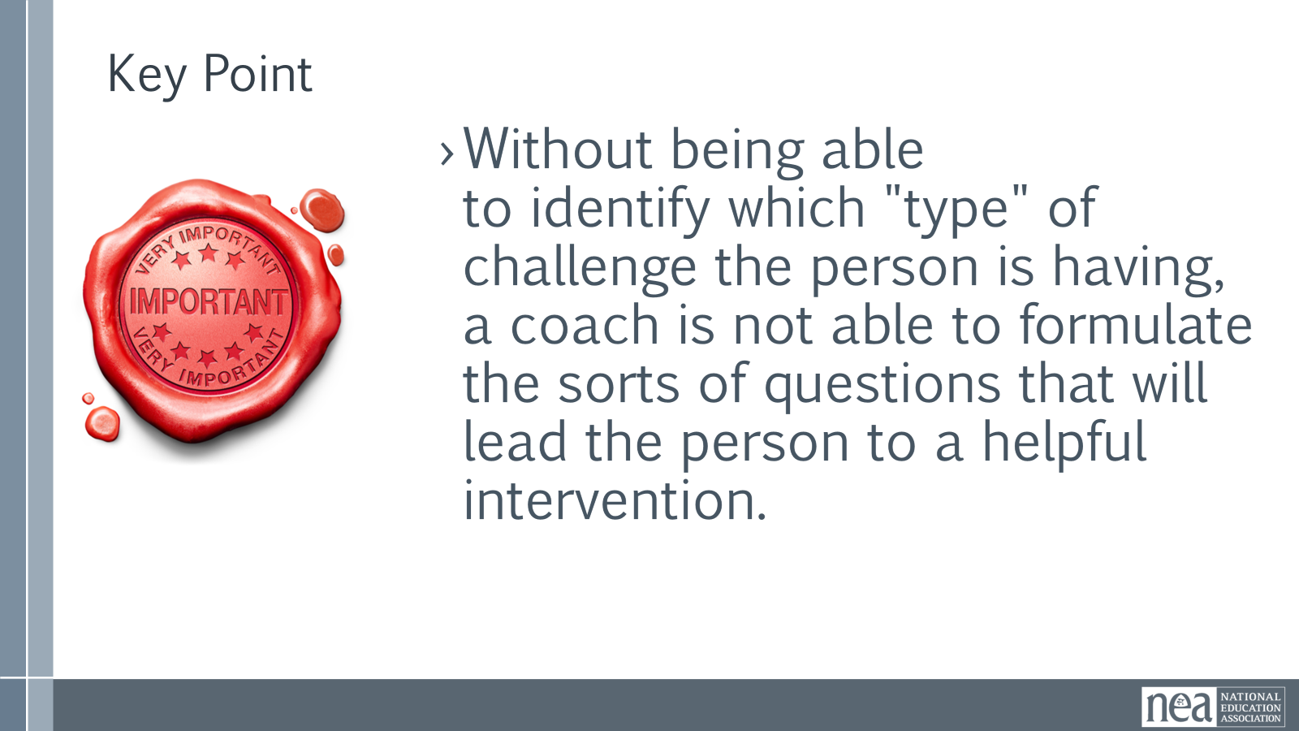  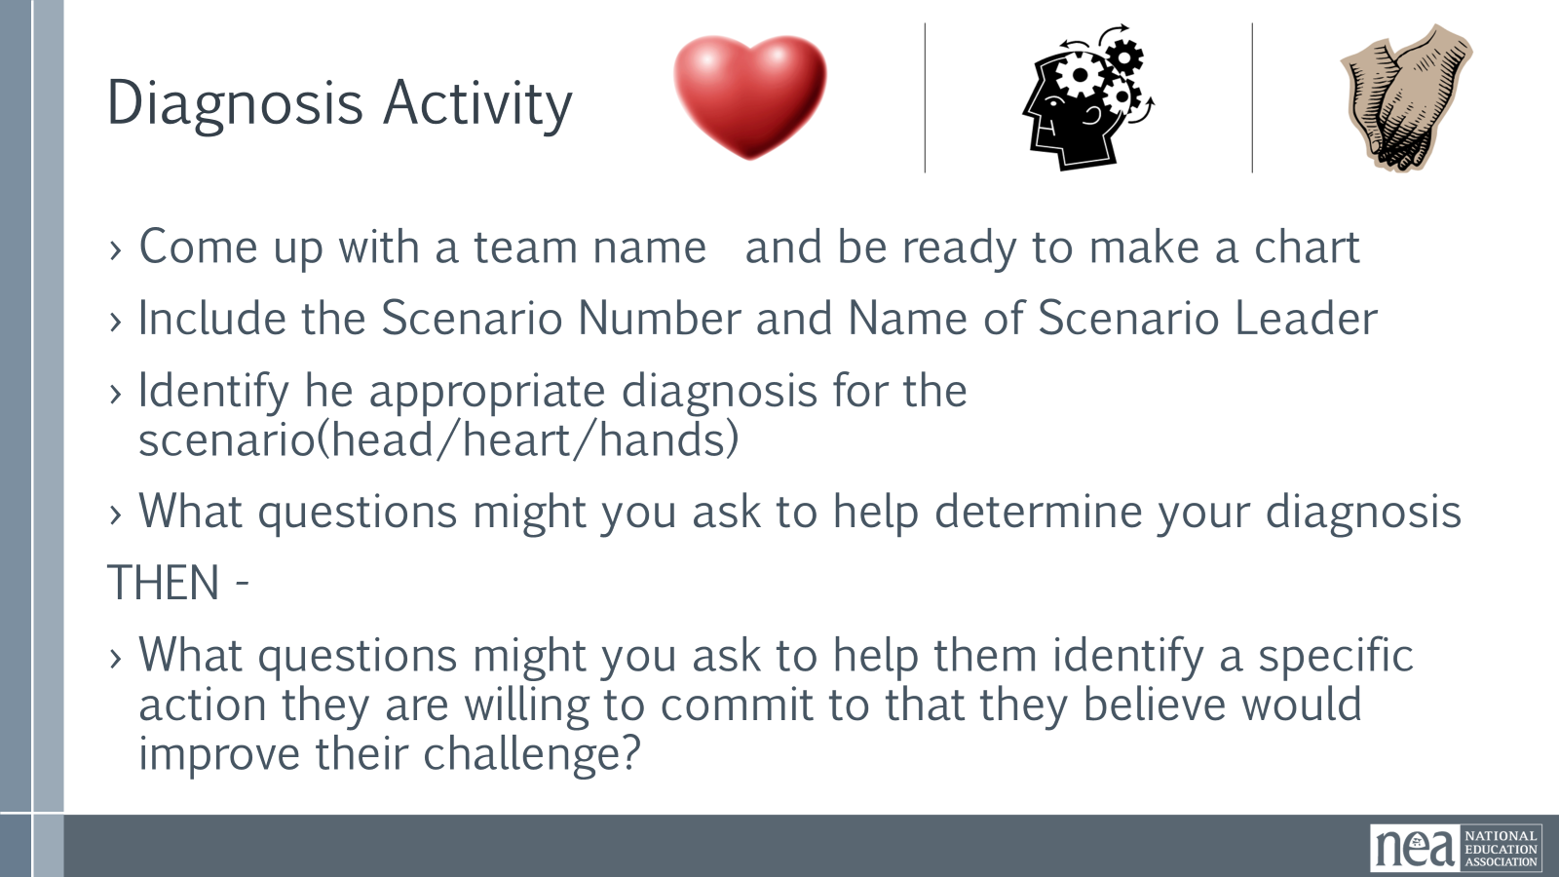  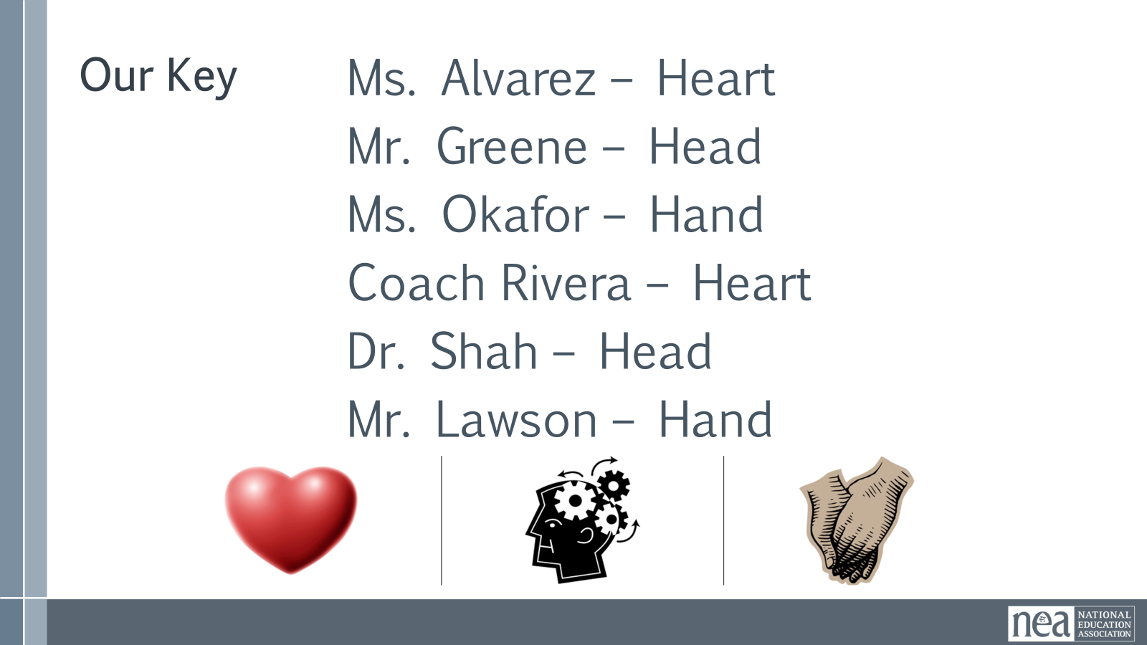  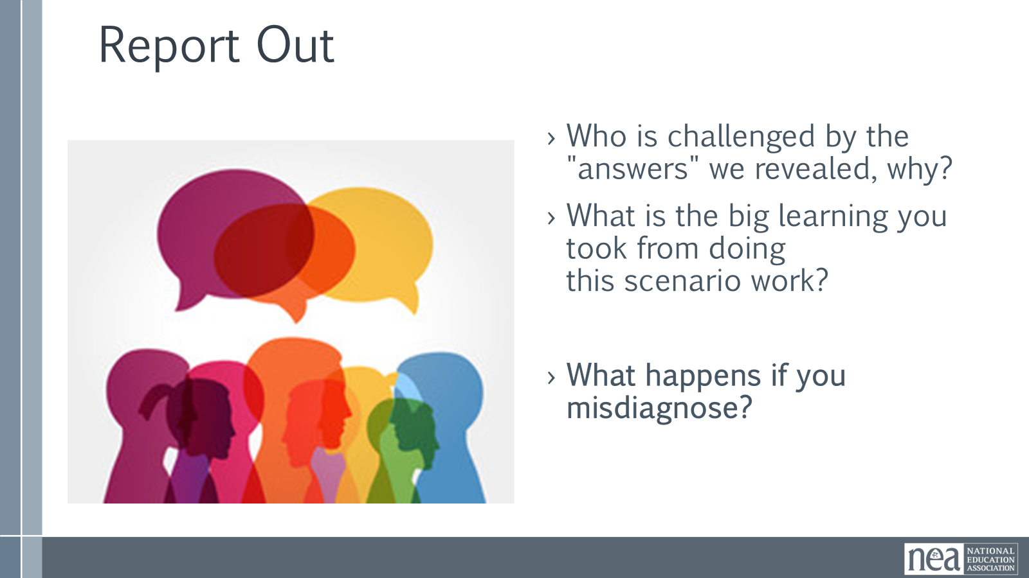  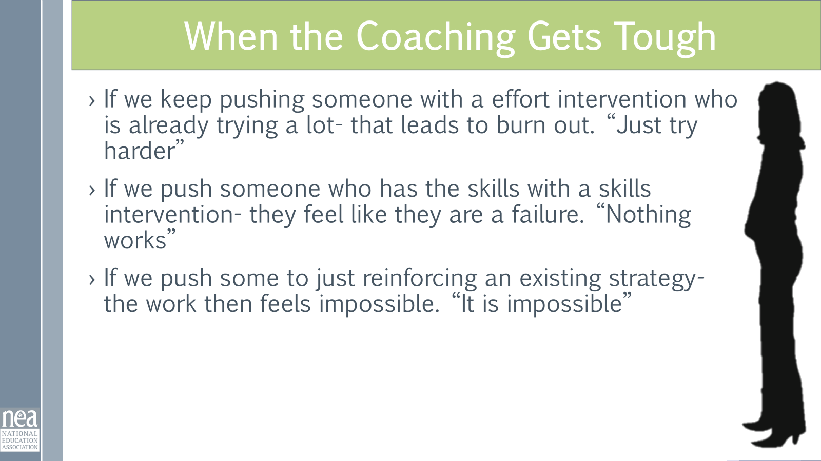  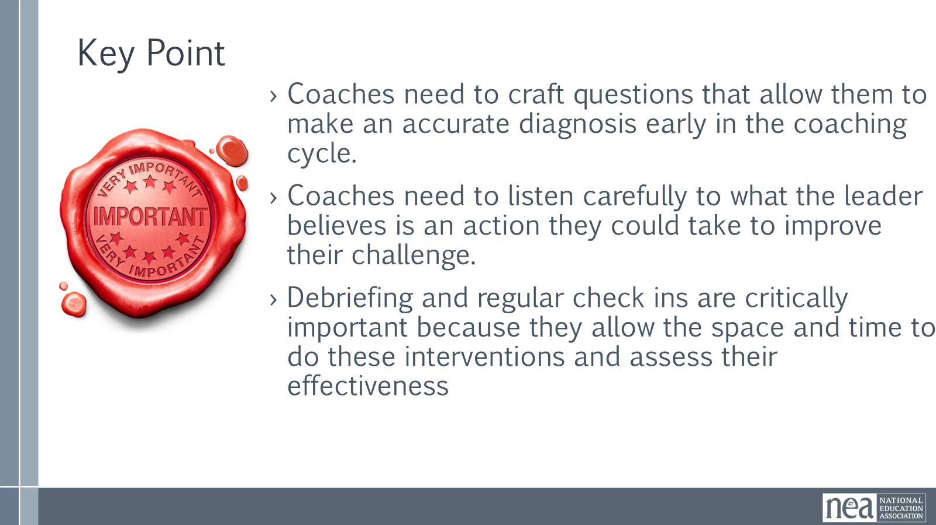 | . Heart Hand Head Diagnosis and Questions Group Activity  Added to participants handouts | Overview – Lecture – 5 Minutes We’ve talked about why we have coaches and what coaches in the Campaign Lab do, now we are going to turn to HOW they do it.  Campaign coaches hold space for a campaign lead by acting as a thought partner. Coaches are able to remain curious about what the lead wants to achieve. They actively listen and manage their tendency to "fix it" for someone else. They create the conditions in which the listener is able to identify their own solution to the challenge that they are experiencing. Above all else, coaches recognize that leaders develop through struggling towards actions they are willing to take and lead. We are going to be working our way around a 5 part cycle of coaching.  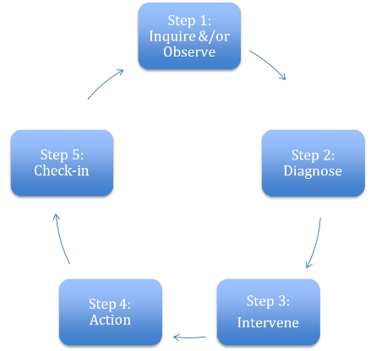  Step 1 Inquire or Observe – think of it as getting to know the lead or team, their context, listening to what they want to achieve, and listening to what they believe are their challenges. Lots of inquiry happens here.  Step 2 is Diagnose, you formulate a theory about the type of challenge they are having. Lots of inquiry and listening here as well as applying what you think you know about campaigns and organizing.  Step 3 is Intervention which are ways that you interrupt the lead or team and in a way that centers what they think they can do to solve their challenges.  We are going to more deeply practice step 2 and 3 in our next section.  Step 4 is Action. This is all about them – they let you know what they intend to do, what they think they need to do it, and by when they need to do it. Your role is to set up how you will check in with them – accountability.  Step 5 is the next meeting – checking in – how did it go? Why do you think it went that way? What have you learned.  Key Points – 1 Minute  We use these steps to prevent us from jumping right into intervention and action.  We use these steps to remind us to center the lead and the team as much as possible  Introduction of Step 2 - Diagnosis – 12 Minutes Total (You will take about 10 minutes to introduce the diagnosis framework, this includes brief questions at each of the Head, Heart, Hand sections. So, you have about 4 minutes of content to present and about 6 minutes for questions as broken out below and 1 -2 minutes for key point )  We make our diagnoses through three frames - Head, Heart, Hands  Diagnosis of a Coaching issue is critical. Without being able to identify which "type" of challenge the person is having, a coach is not able to formulate the sorts of questions that will lead the person to a helpful intervention. For example, if someone is simply not motivated to join a phone bank, giving them the advice of hosting a training on how to run a phone bank is not going to improve their participation. Providing the correct diagnosis allows leaders to reflect accurately and help them adjust their tactics. Below are 3 typical diagnoses in coaching.  Strategic (head): Is the individual struggling because the goals are not achievable? Or because they’re not thinking creatively enough about how to use the resources they have to meet goals? Or because the overall strategy doesn’t make sense and needs to be clarified or adapted to their situation?  2 Minutes - Ask participants to share out, what might this sound like in your 1-1?  (If no responses - Ex - I have done everything I can....It is too much... this list is bad)  Motivational (heart): Is the individual struggling because they are not putting forth enough effort? Are they not trying hard enough because they are embarrassed? Are they quitting too soon because of frustration or fear?  2 minutes - Ask participants to share out, what might this sound like in your 1-1?  (if no responses ex. I am worried... I tried... What if... )  Skills-based (hands): Is the individual struggling because of not being able to muster the behavioral skill to execute effectively? Do they not have the skill in their repertoire? Is the person getting interference from other habits and behaviors (like someone well-versed in marketing speak may think that skill set is a substitute for authentic story-telling skills)? Is there something you could model, or that this person that just needs more help practicing and debriefing?  2 Minutes - Ask participants to share out, what might this sound like in your 1-1?  (If no responses - Ex -I talked to them and they were just not interested.... I put the petition in the staff room... I told them the benefits of membership... )  Once you have formulated your theory of which diagnosis (head, heart, hand) – now you are able to use a coaching intervention that allows the leader to move into identifying what they are willing to commit to do about it - you use a coaching intervention that allows the leader to identify an intervention that the they believe will help improve the challenge.  Key Point – 1 Minute  Without being able to identify which "type" of challenge the person is having, a coach is not able to formulate the sorts of questions that will lead the person to a helpful intervention.  Diagnosis Activity (40minutes, time broken out below):  Introduction – 5 Minutes  Let's practice what the diagnosis into an intervention portion of the coaching cycle looks like.  We will break folks into 6 groups and you will be given a scenario. Your team will spend about 25 minutes discussing and charting the following:  - Come up with a team name  - Indicate their Scenario Number and Name of Leader  - Identifying the appropriate diagnosis for the scenario(head/heart/hands)  - What questions might you ask to help determine your diagnosis  THEN -  - What questions might you ask to help them identify a specific action they are willing to commit to that they believe would improve their challenge?  LUNCH BREAK WILL LIKELY COME HERE  Group Work Time – 15 Minutes  Scenarios (handout):  1. Ms. Alvarez – Asking a Colleague to Join the Union  Ms. Alvarez believes strongly that educators need collective power to address stagnant pay. She agrees to ask newer teachers to join the union but keeps postponing the conversations. When she finally brings it up, she rushes through it and quickly changes the subject. In coaching, she admits she’s afraid colleagues will see her as “political” or confrontational. She understands the benefits of membership and knows the talking points, yet she avoids deeper follow-up conversations that might actually move someone to join.  2. Mr. Greene – Organizing Around Pay Inequity  Mr. Greene is outraged after discovering inconsistencies in how stipends are distributed. He immediately urges staff to demand a 15% across-the-board raise and circulate a petition within a week. However, he hasn’t researched district budget constraints, mapped decision-makers, or clarified whether inequity stems from policy or implementation. Colleagues hesitate because the plan feels reactive and disconnected from how decisions are actually made.  3. Ms. Okafor – Encouraging Colleagues to Vote in a School Board Election  Ms. Okafor wants staff to turn out for a school board election that could impact contract negotiations. She sends long emails filled with policy details and links to candidate platforms. Few colleagues respond. When she talks in person, she overwhelms them with information rather than asking what issues matter most to them. She leaves conversations feeling frustrated that people “just don’t get it,” even though she hasn’t created space for dialogue.  4. Coach Rivera – Inviting a Colleague to the Picket Line  During a contract dispute, Coach Rivera commits to asking teammates to join the picket line. After one colleague says, “I can’t risk admin noticing,” he stops asking others. He decides people probably aren’t interested and shifts his energy elsewhere. In coaching, he shares that he doesn’t want to strain friendships or make anyone uncomfortable, especially if they disagree.  5. Dr. Shah – Considering a Run for Union Office  Dr. Shah is frustrated by a lack of transparency in leadership and wants to run for union vice president. She announces her candidacy but hasn’t clarified her platform beyond saying, “We deserve better.” Potential supporters ask what specific changes she would pursue and how she would build majority support. Conversations stall because colleagues aren’t sure what she’s actually proposing or how it would realistically succeed.  6. Mr. Lawson – Addressing Workplace Fairness  Mr. Lawson wants to confront inconsistent enforcement of evaluation policies that seem to target newer teachers. In staff meetings, he raises the issue bluntly, citing policy language and naming administrators directly. While his concerns are valid, colleagues grow uncomfortable and disengaged. Some privately agree with him but say they don’t feel invited into the conversation. He leaves meetings feeling isolated and confused about why others won’t stand with him.  Key to be Revealed During Whole Group Discussion:  Ms. Alvarez – Heart  Mr. Greene – Head  Ms. Okafor – Hand  Coach Rivera – Heart  Dr. Shah – Head  Mr. Lawson – Hand  Have teams put their charts close together so everyone can view during the next section.  Reveal Answers Report Out – 15 Minutes  Who is challenged by the "answers" we revealed, why?  What is the big learning you took from doing this scenario work?  What happens when you do misdiagnose?  Note it is not fatal- but wrong diagnosis can lead to frustration. However, with good check ins- you can catch your wrong diagnosis and correct.  Considerations for when the Coaching Gets Tough – 2 MInutes  ( If we keep pushing someone with a effort intervention who is already trying a lot- that leads to burn out. “Just try harder”  If we push someone who has the skills with a skills intervention- they feel like they are a failure. “Nothing works”  If we push some to just reinforcing an existing strategy- the work then feels impossible. “It is impossible”)  Key Points - 5 Minutes:  - Coaches need to craft questions that allow them to make an accurate diagnosis early in the coaching cycle.  - Coaches need to listen carefully to what the leader believes is an action they could take to improve their challenge.  - Debriefing and regular check ins are critically important because they allow the space and time to do these interventions and assess their effectiveness  Before we break think about an issue you are having with your campaign. Write it on a post it note. Once you are done give me a thumbs up. | Participants will understand that there is a cycle to their coaching work. They will work through scenarios and examples of the Head, Heart, Hand diagnosis framework. They will explore the types of questions required to make a diagnosis and help a leader identify an action they are willing to try.
12:00-1:00 |  | Lunch
1:00-1:30 |  | 60 Mins TOTAL – Campaign Coaching Cycle and Step 2 – Diagnosis – 30 Minutes before Lunch and 30 Minutes After
1:30 - 2:00 |  | 30 Minutes TOTAL Coaching Interventions
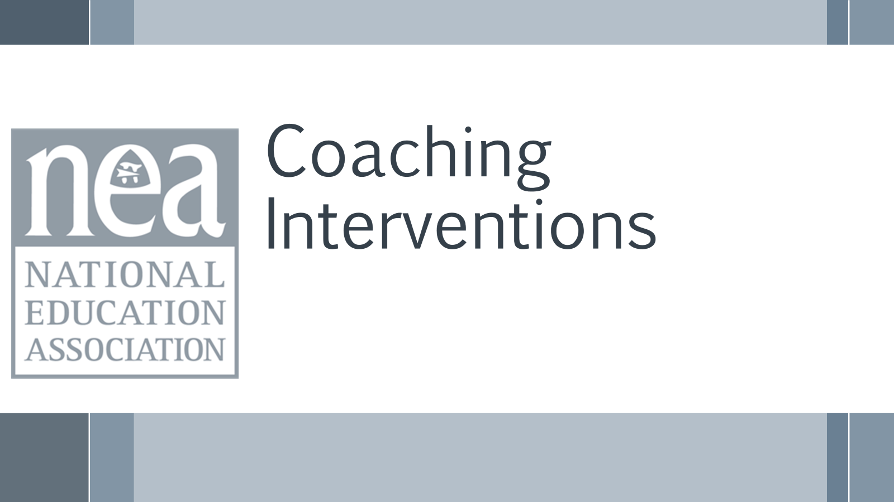  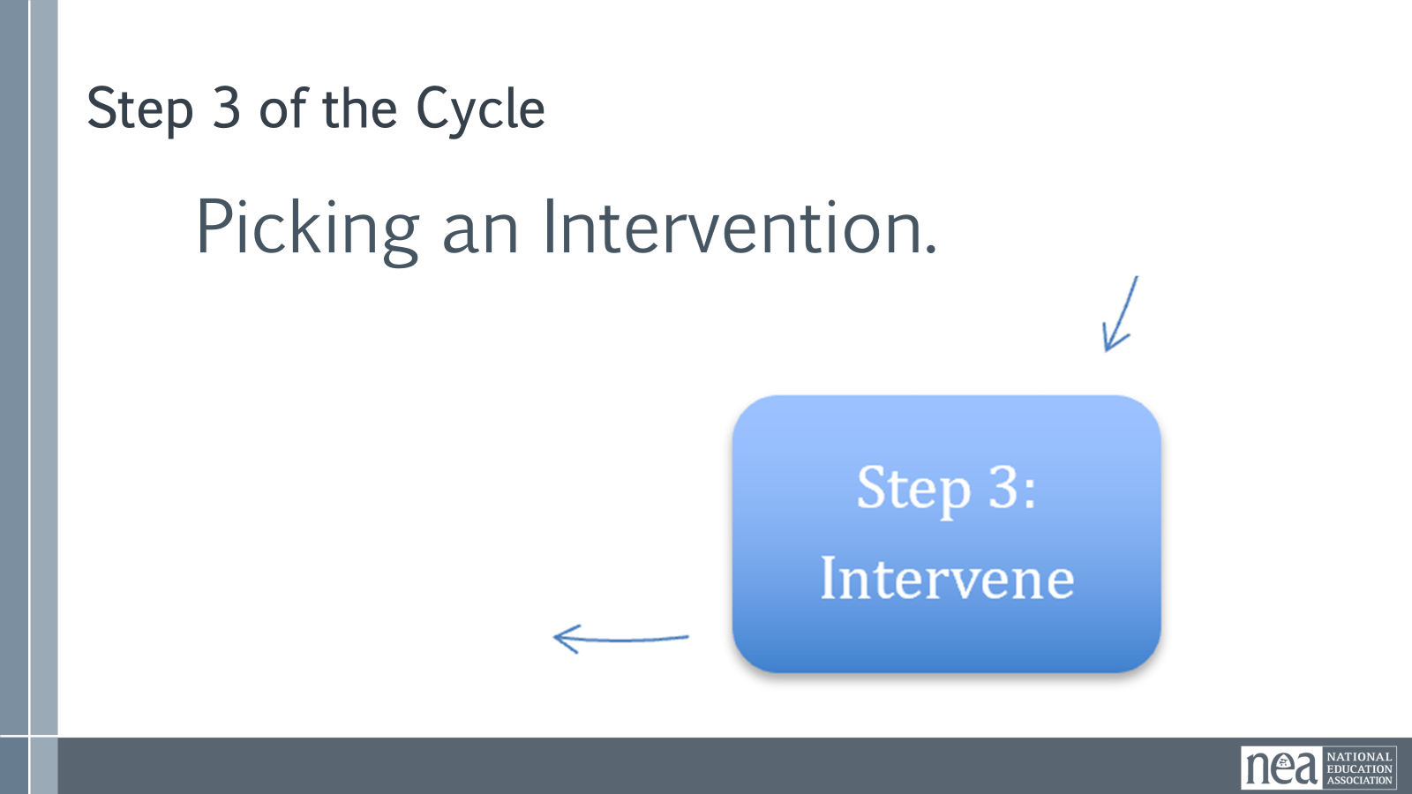  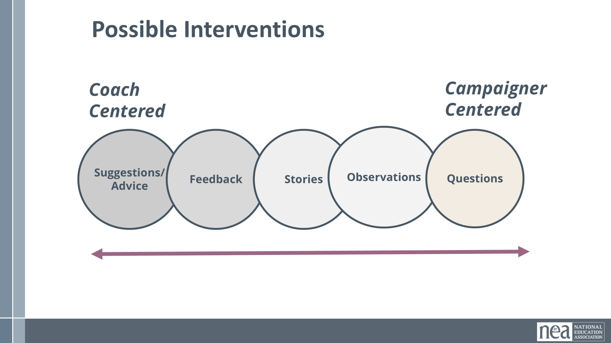  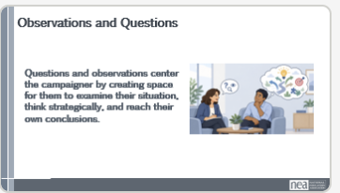  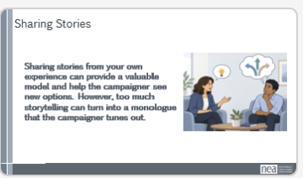  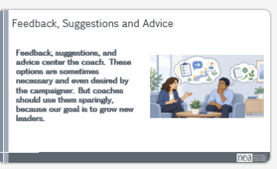  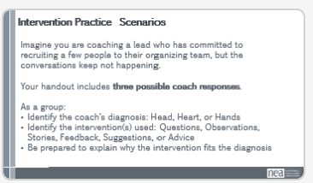  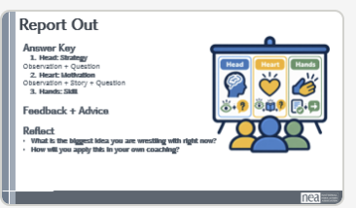  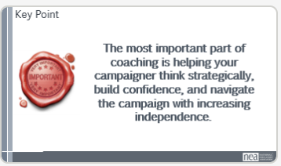 | Need a handout for the scenarios. Add the intervention content to the coaching guide.  Complete Coach’s Guidebook – Page 33  Page 21 in PH | Introduction: 10 Minutes  Slide 85: We have talked about the coaching cycle, making diagnoses, and dipped a toe into the intervention phase. Now let’s move into what coaching interventions can actually look like.  Once we have diagnosed whether the challenge is head, heart, or hands, we must decide how to respond. Diagnose First. Intervene Second.  Slide 86: Coaches have a variety of interventions they can use:  Think of these as tools in your coaching toolbox. The goal isn't to use all five. The goal is to choose the intervention that best matches what the team lead needs.  Most coaches have a favorite intervention. Some jump straight to advice. Others ask questions or tell stories. Effective coaches learn to use the intervention the team lead needs, not simply the one they prefer.  That's why diagnosis comes first. Once we've identified whether we're dealing with a Head, Heart, or Hands challenge, we can be much more intentional about how we respond.  Slide 87: Questions and observations center the team lead. You are helping them examine their own situation, think through the problem, and come to their own conclusions.  Slide 88: Stories from your own experience can provide a useful model and help the team lead see new possibilities. But stories should be brief and purposeful. If every coaching conversation becomes a story about us, the team lead may tune out.  Slide 89: Feedback, suggestions, and advice center the coach more directly. Sometimes these are exactly what the team lead needs, especially when the issue is a skill gap. But they should be used intentionally, because our goal is not simply to give people answers.  The diagnosis should help determine the intervention. A strategy problem may benefit from questions. A motivation problem may need an observation or story. A skill problem may need feedback or advice.  The most important part of coaching is helping your team lead become strategic in their thinking and confident in their ability to navigate campaigns.  Slide 90: Scenario Practice Small Group: 10 Minutes (Need Handout)  What do these interventions sound like in practice? Let’s work through a few examples in small groups at your table.  Imagine you are coaching a lead who has said in previous meetings that they are going to talk with a couple of people they want to recruit to their organizing team, but the conversations keep not happening.  For each scenario, identify:  - How did the coach diagnose the problem: head, heart, or hands?  - Which intervention or interventions did the coach use: questions, observations, stories, feedback, suggestions, or advice?  - Why does that intervention fit the diagnosis?  Scenario 1 - “You’ve mentioned a few times that it’s hard to connect with the person you want to recruit because they are never in their classroom when you drop by. You’ve also said you feel like they may be a bit of a lost cause. Is there another way you could connect?”  Scenario 2 “It seems like talking to this person is stressful for you. I remember when I first started doing one-on-ones, and honestly, I’m an introvert, so it was hard. I used to write out what I wanted to say ahead of time, and that helped me. Is there something you could do to make the situation less stressful?”  Scenario 3 - “It sounds like you may not have done an organizing one-on-one before. Am I right? Okay, these conversations are different from regular conversations. I’m going to walk through the basic parts with you, and then we can practice.”  Slide 91: Report Out – 10 Minutes  Let’s come back together and compare what you identified.  Answer Key  - Strategy (Head): Observation, Question - "This is Head because the leader is stuck on strategy. The coach doesn't solve the problem. They help the leader think through other options.  - Motivation (Heart): Observation, Story, Question - This is Heart because the leader is anxious and avoiding the conversation. The story helps normalize the challenge and the question helps them find a way forward.  - Skill (Hands): Feedback, Advice - This is Hands because the person lacks a skill. At some point questions won't build a skill they don't have. The coach needs to teach and practice.  As you look at these examples, notice that the intervention changes based on the diagnosis. The goal is not to use every coaching tool. The goal is to use the tool that best matches what the team lead needs.  Before we move on: What is the biggest idea you are wrestling with right now?  Slide 92: Key Point: 1 Minute  The most important part of coaching is helping your team lead become strategic in their thinking and confident in their ability to navigate campaigns.  Coaching is not choosing the smartest answer. Coaching is choosing the intervention that best helps the team lead grow. It is about knowing when to ask, when to observe, when to share, and when to step in more directly so the team lead can continue growing as a leader. | Participants will be able to identify and apply coaching interventions. They will understand which interventions are more team lead centered and which are more coach centered.
2:00-2:30 |  | 30 mins TOTAL – Crafting Questions
  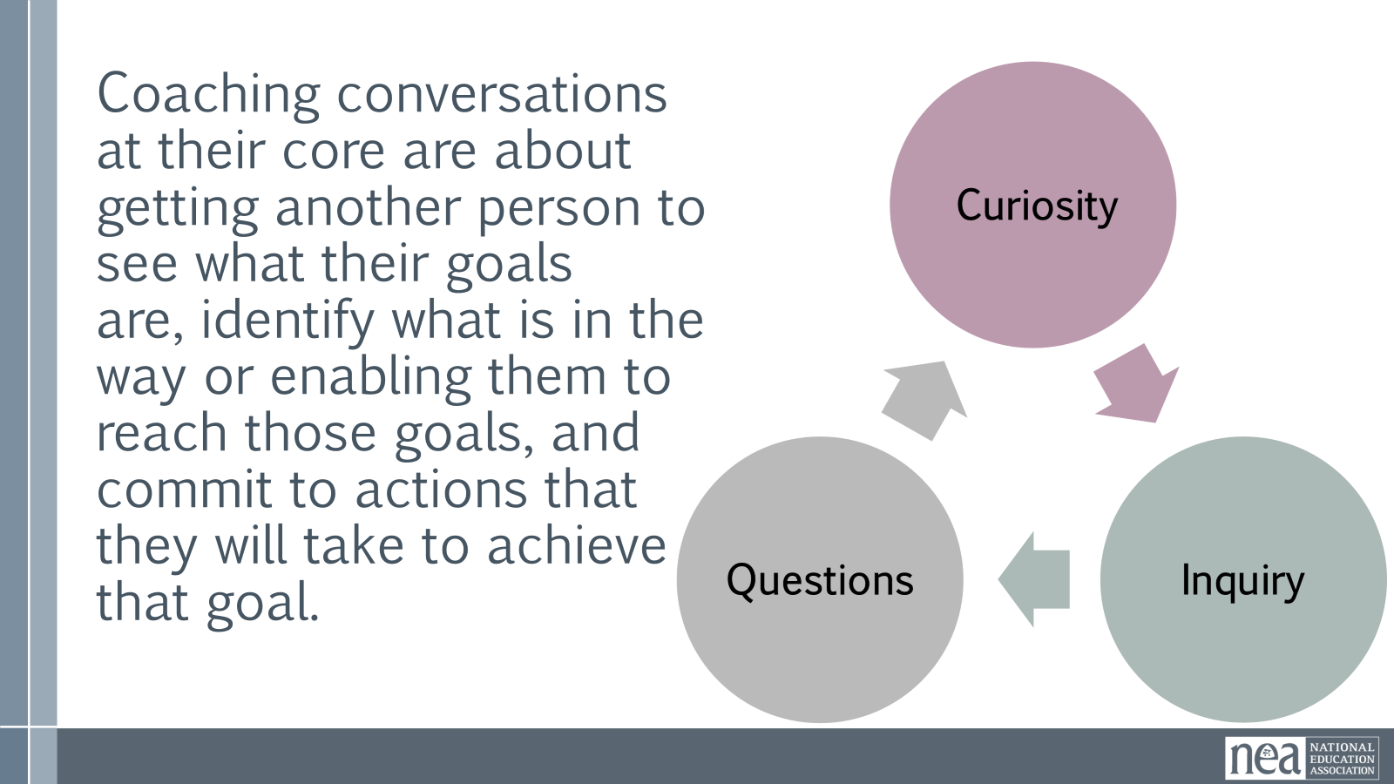  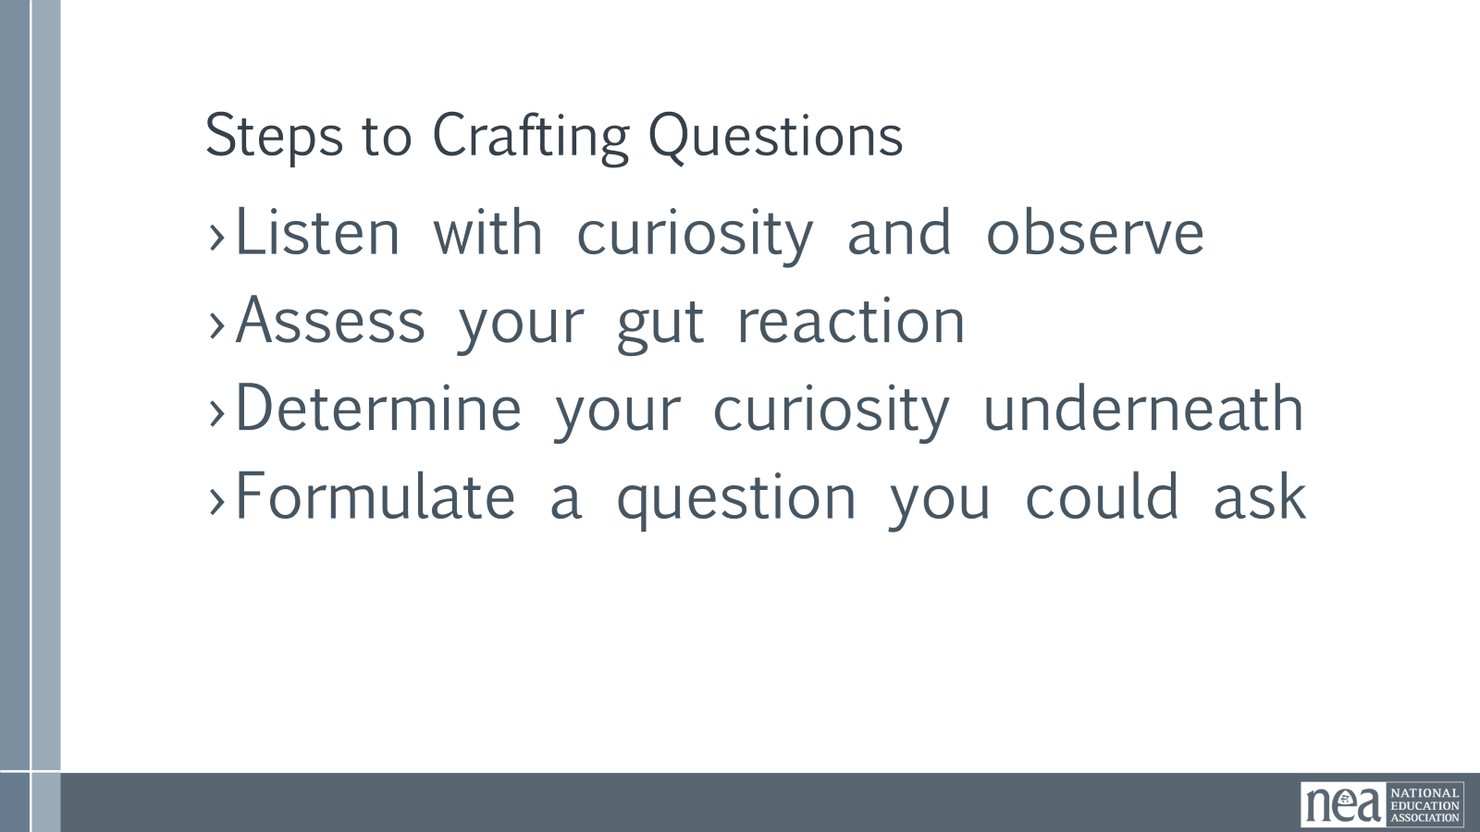  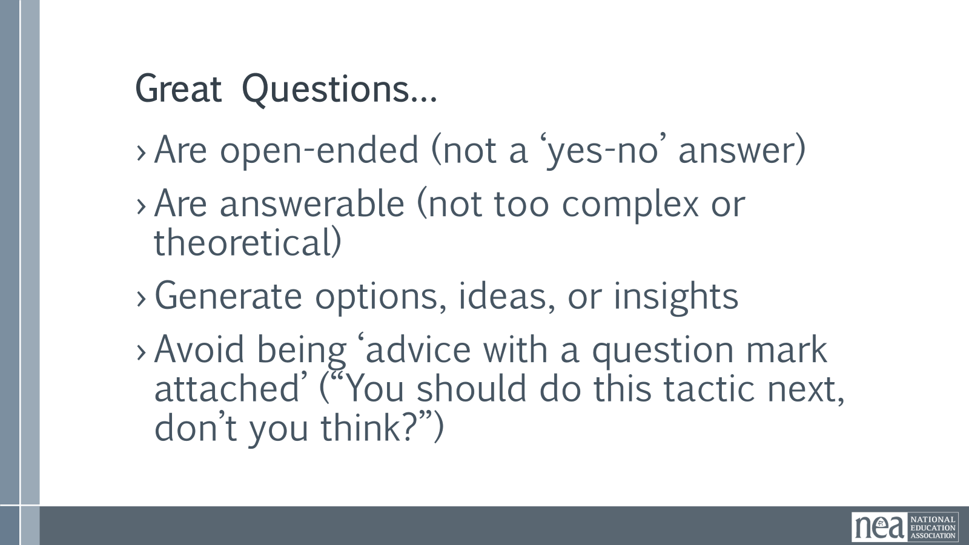  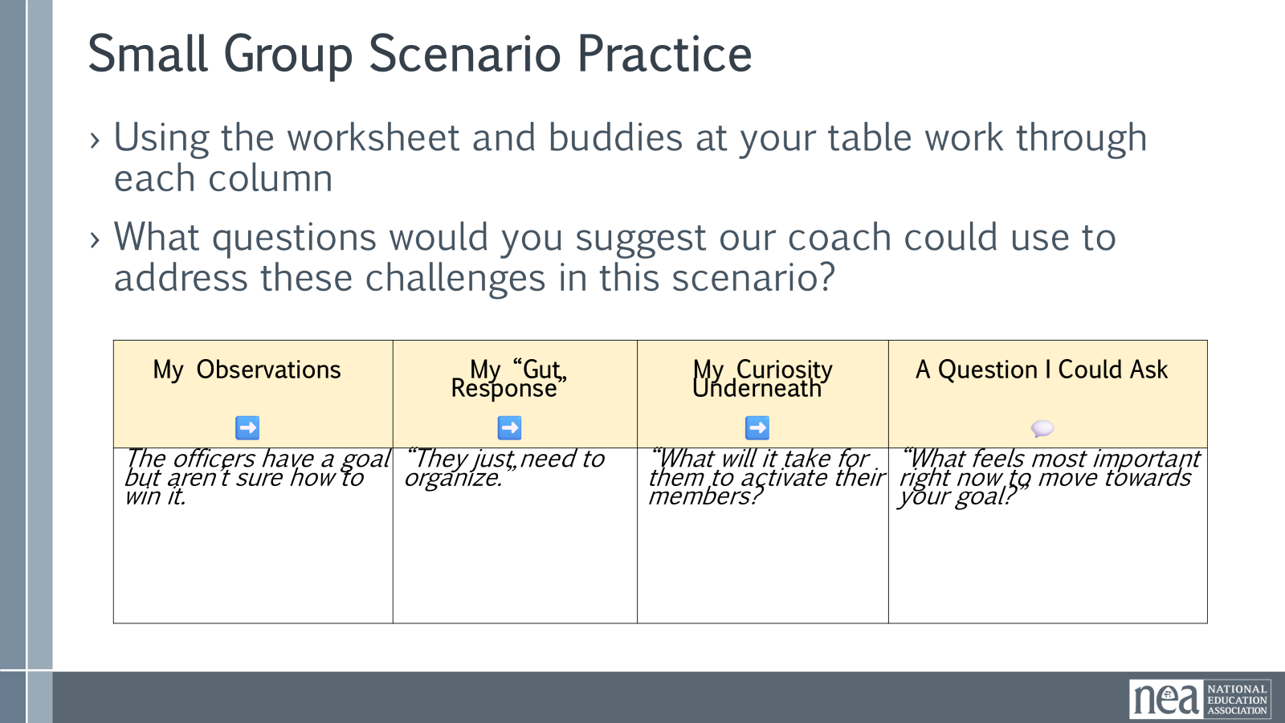  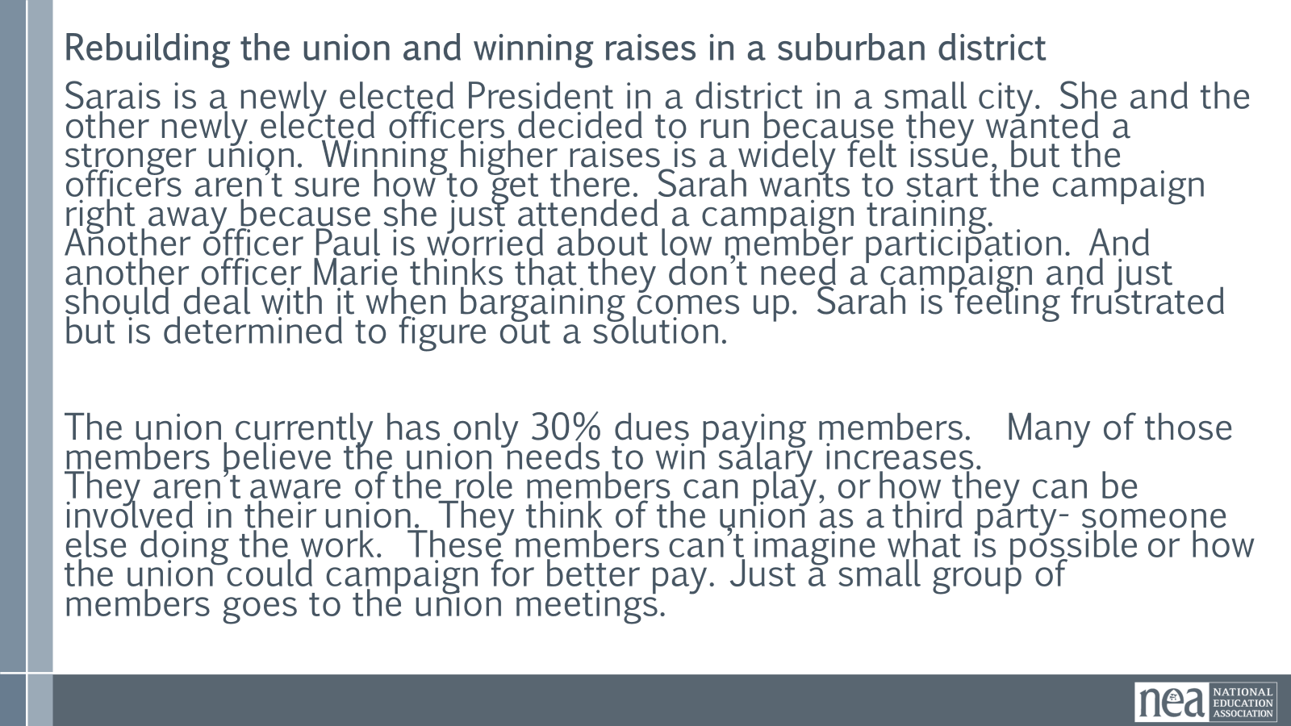  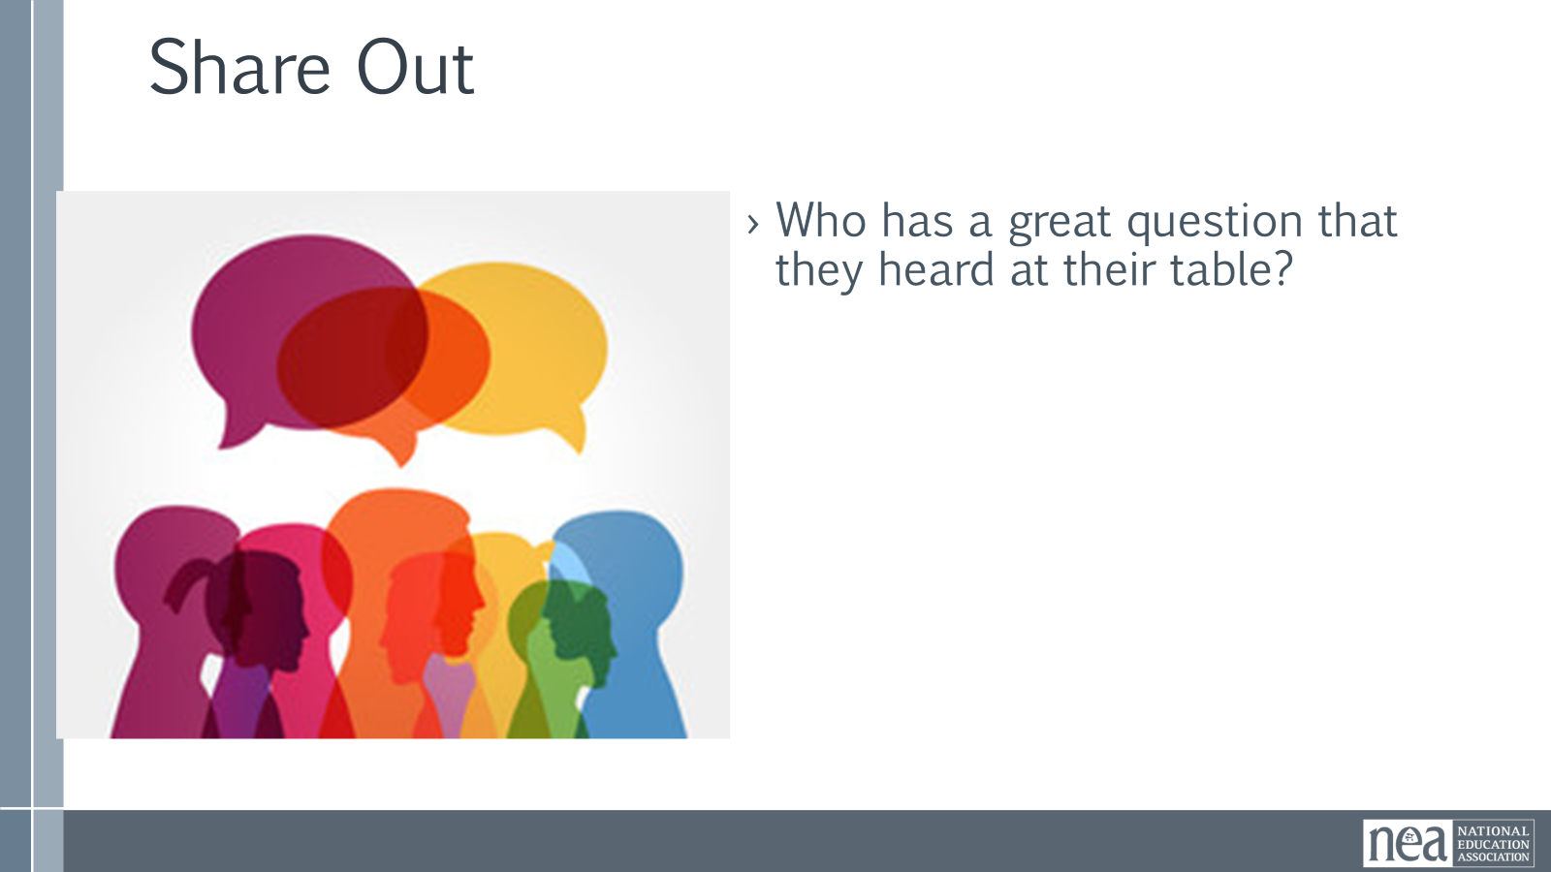  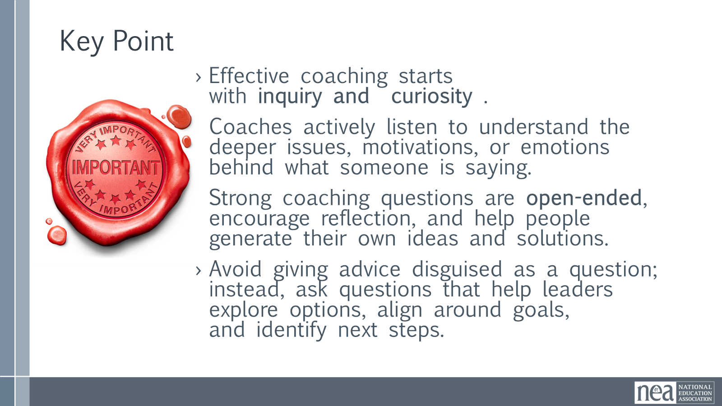 | Complete Coach’s Guidebook – Pages 36-37  Complete Coach’s Guidebook – Page 12  Complete Coach’s Guidebook – Page 42  Complete Coach’s Guidebook – Page 41 | Intro - 1 Minute  Coaching conversations at their core are about getting another person to see what their goals are, identify what is in the way or enabling them to reach those goals, and commit to actions that they will take to achieve that goal. It is a lot of them and very little you. This requires you remain extremely curious about the other person. We don't go into a coaching meeting to lecture; we use disciplined curiosity to ask the questions that help team leads realize their own power. Good coaching questions are used at all points of the coaching cycle – and they keep us in the habit of inquiry instead of the habit of determining another’s actions.  Crafting Coaching Questions 8 Minutes Content  Because questions are the best tool in our coaching tool box, we are going to spend some time learning how to craft good ones.  The first step is to listen with curiosity to get at what’s going on underneath. Let’s say your team lead is spending a lot of time talking about how disappointed and upset they are about getting a no from someone they thought would be an easy yes.  Your first "gut" reaction might be “So what! Big deal! Happens all the time!”  If you lead with curiosity however, you might wonder WHY this is such a big deal to your team lead.  One question you could ask is, “I’m curious about how this landed for you. I’m wondering what about this situation makes it feel so awful?”  And after your team lead has explored that question, another question you might ask is, “It feels like this really derailed you. I’m wondering what it would take to get back on track?”  Great questions…  - Are open-ended (not a ‘yes-no’ answer)  - Are answerable (not too complex or theoretical)  - Generate options, ideas, or insights  - Avoid being ‘advice with a question mark attached’ (“You should do this tactic next, don’t you think?”)  Crafting Coaching Questions Practice (15 minutes activity)  We are going to do some scenario work, we are all going to use the same scenario. We are practicing the art of curiosity and inquiry – learning to pose great questions. Using the worksheet and buddies at your table work through each column.  What questions would you suggest our coach could use to address these challenges in this scenario?  Scenario: Rebuilding the union and winning raises in a suburban district  Sarais is a newly elected President in a district in a small city. She and the other newly elected officers decided to run because they wanted a stronger union. Winning higher raises is a widely felt issue, but the officers aren’t sure how to get there. Sarah wants to start the campaign right away because she just attended a campaign training. Another officer Paul is worried about low member participation. And another officer Marie thinks that they don’t need a campaign and just should deal with it when bargaining comes up. Sarah is feeling frustrated but is determined to figure out a solution.  The union currently has only 30% dues paying members. Many of those members believe the union needs to win salary increases. They aren’t aware of the role members can play, or how they can be involved in their union. They think of the union as a third party- someone else doing the work. These members can’t imagine what is possible or how the union could campaign for better pay. Just a small group of members goes to the union meetings.  Use this chart to process your thinking as it is a way for you to resist the urge to "announce" your gut reaction and stay aligned with the coaching mindset of curiosity and inquiry.  5 Minutes Debrief – Whole Room - ]  Who has a great question that they heard at their table?  Key Points - 1 minutes  - Effective coaching starts with inquiry and curiosity .  - Coaches actively listen to understand the deeper issues, motivations, or emotions behind what someone is saying.  - Strong coaching questions are open-ended, encourage reflection, and help people generate their own ideas and solutions.  - Avoid giving advice disguised as a question; instead, ask questions that help leaders explore options, align around goals, and identify next steps. | Participants will practice constructing questions that help a team lead focus on identifying challenges, solutions, and next step actions
  My Observations  ➡️ | My “Gut Response”  ➡️ | My Curiosity Underneath  ➡️ | A Question I Could Ask  💬
  The officers have a goal but aren’t sure how to win it. | “They just need to organize.” | “What will it take for them to activate their members? | “What feels most important right now to move towards your goal?”
2:30-2:45 |  | 15 Minutes BREAK – Ask Karla if food will be served
2:45-3:20 |  | 35 Minutes TOTAL – Coaching Cycle and Agenda Structure
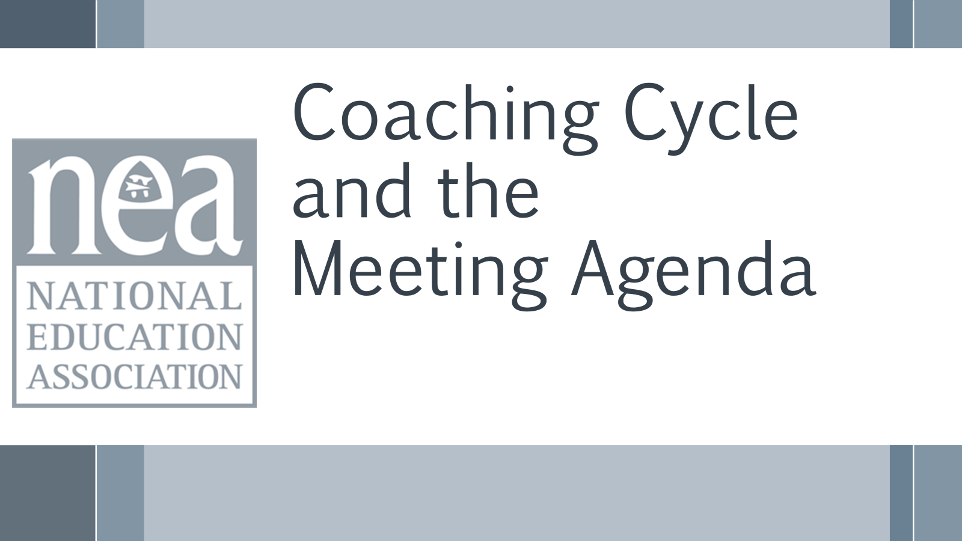  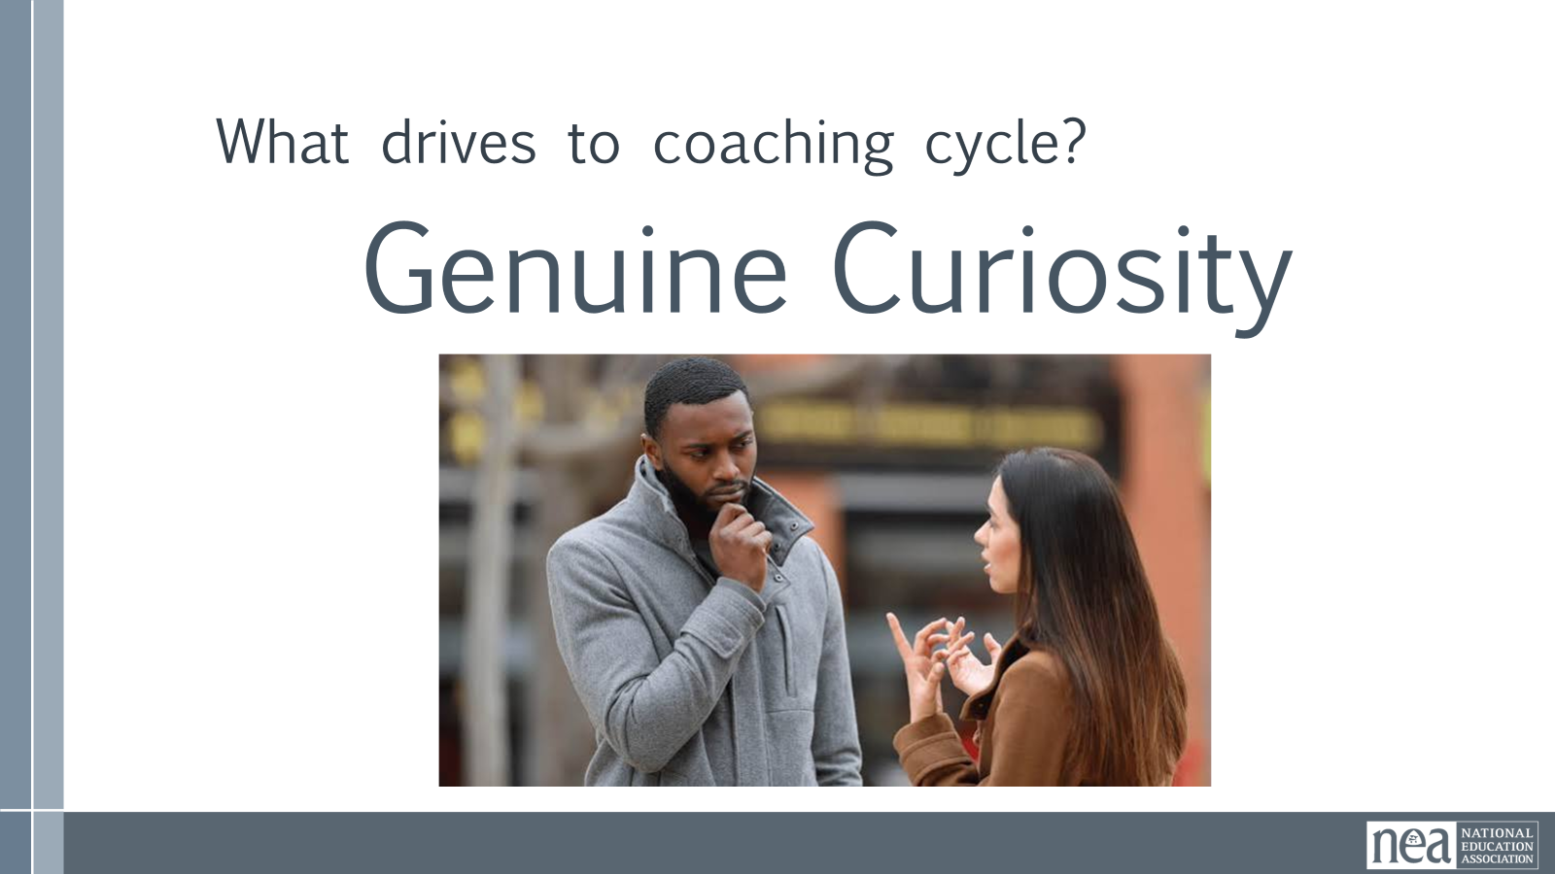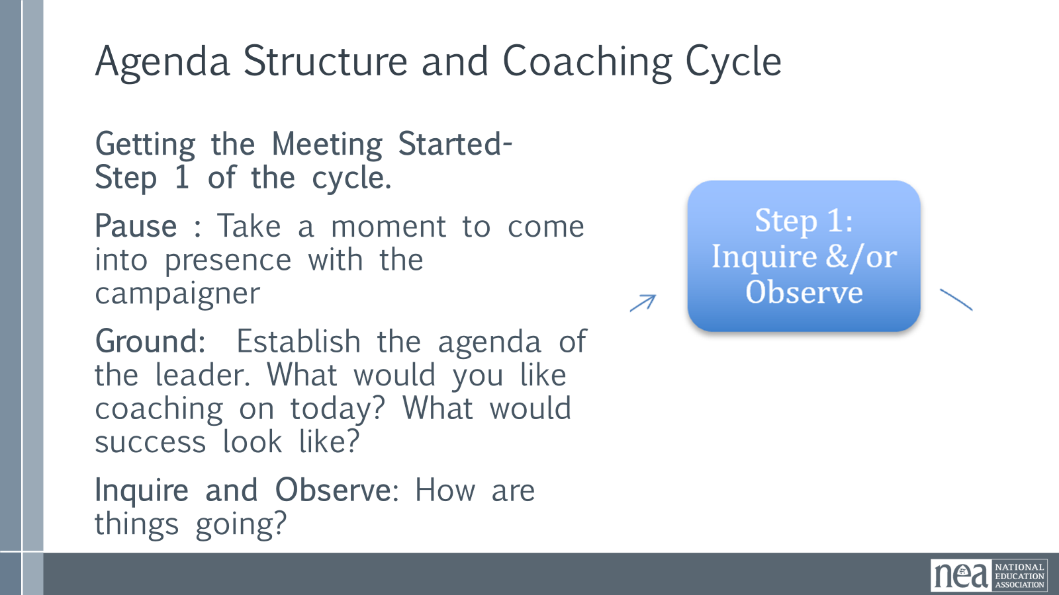  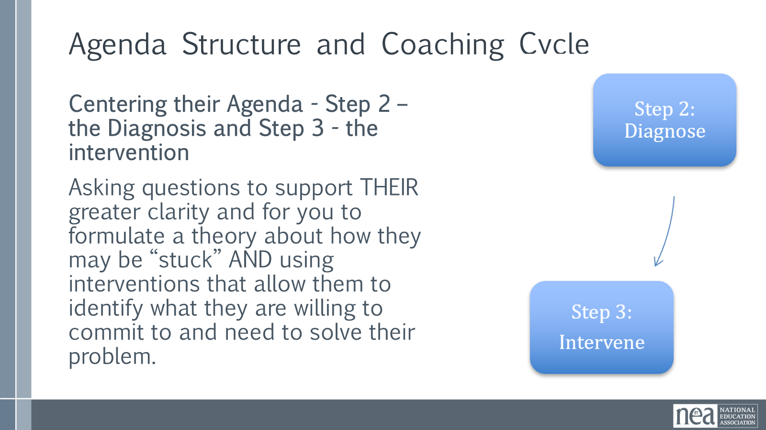  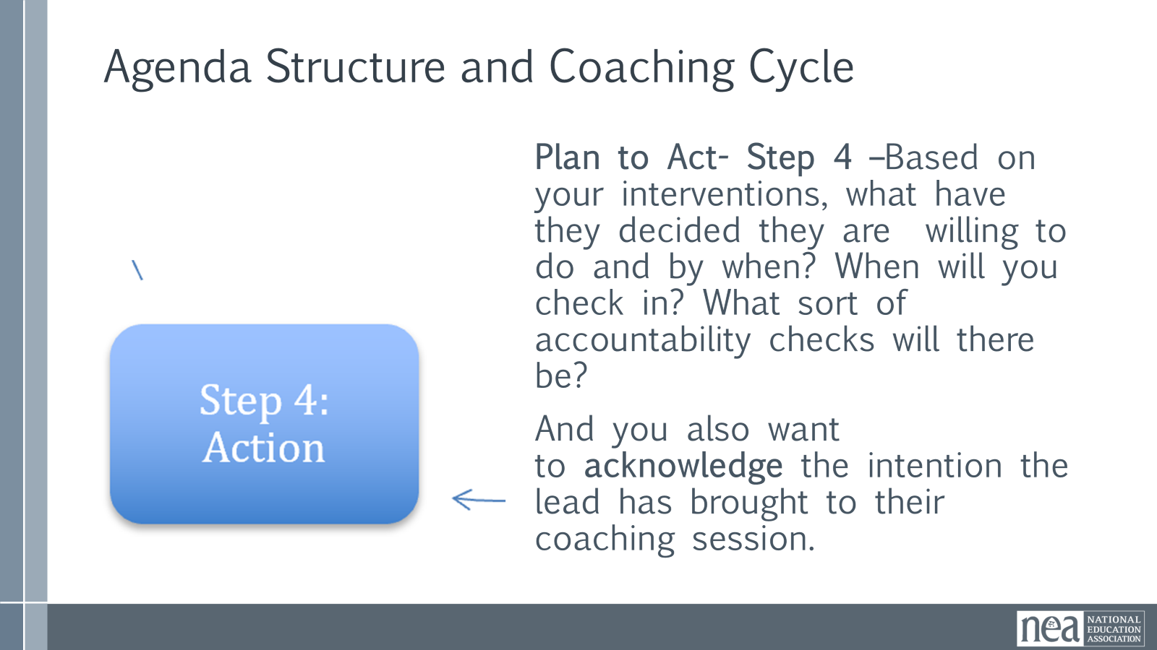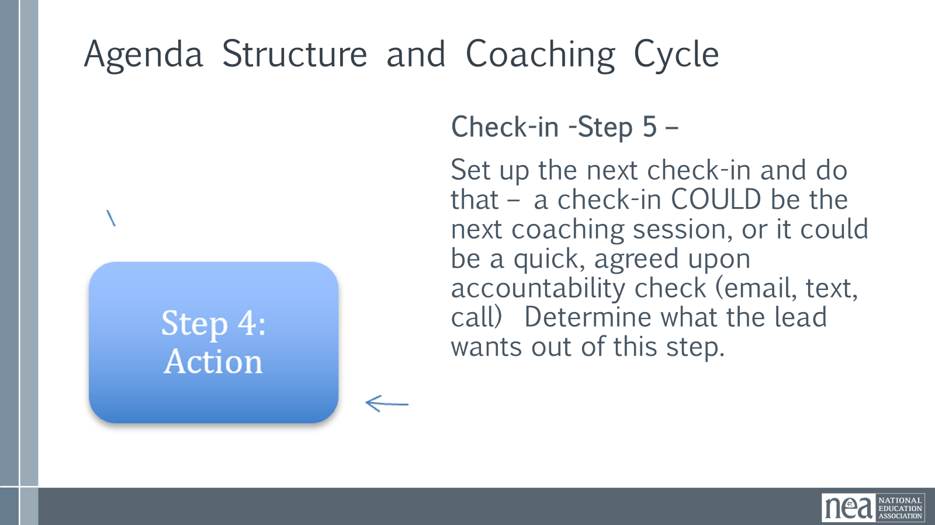  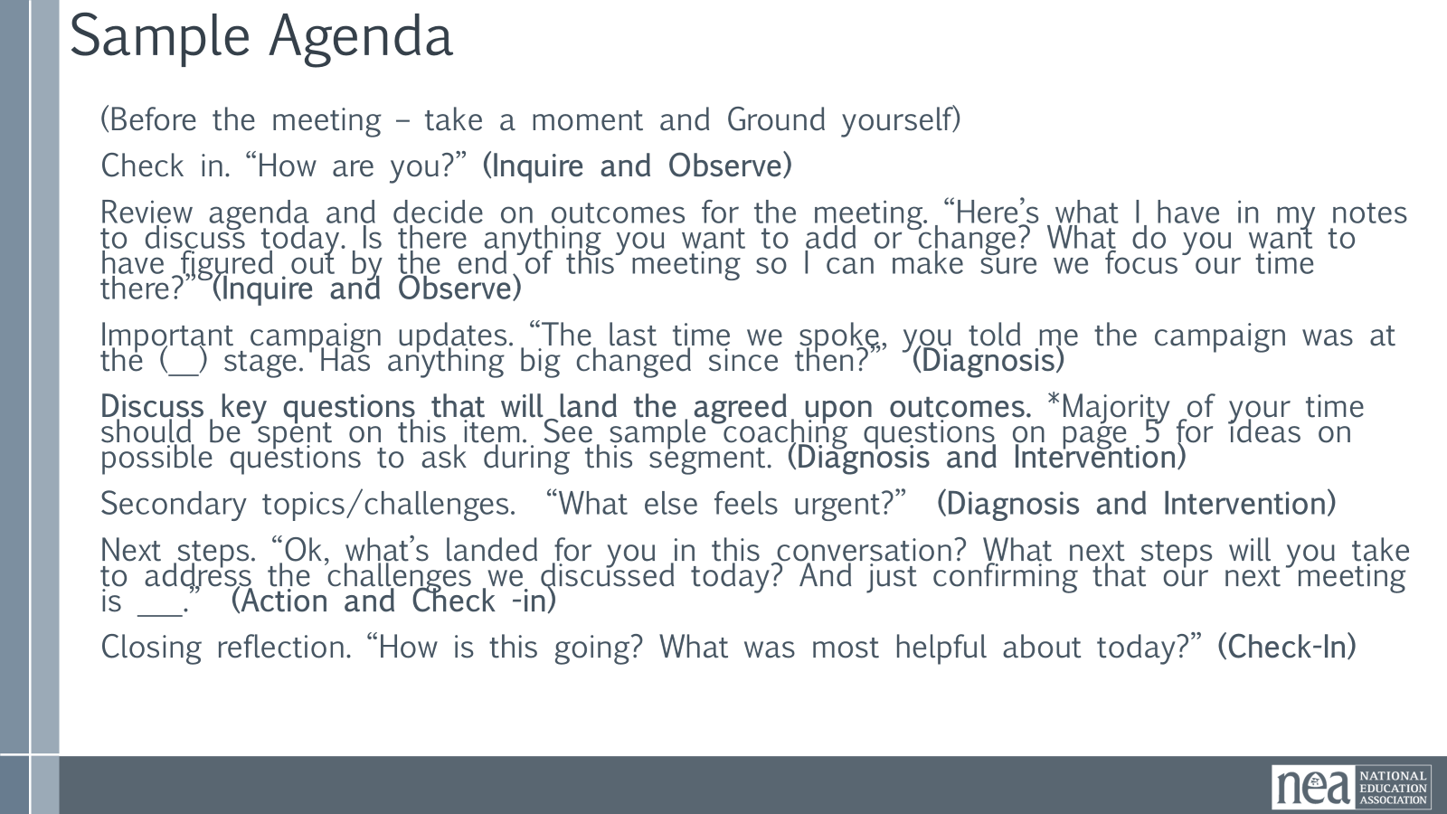  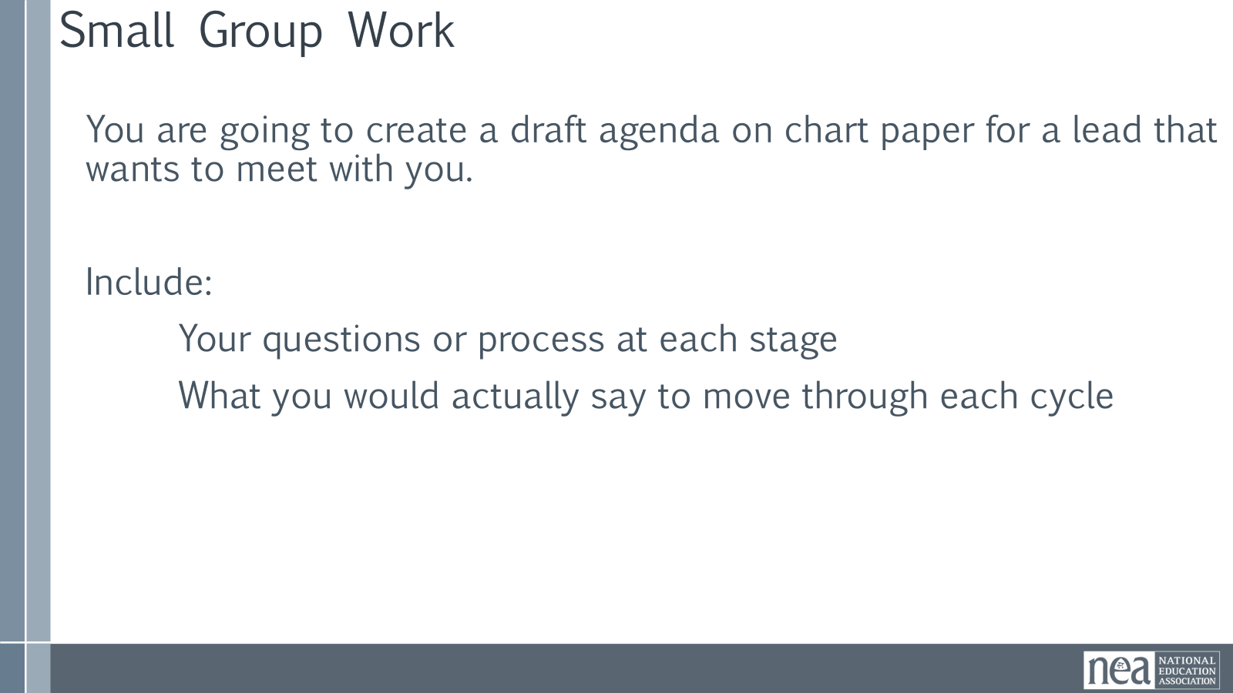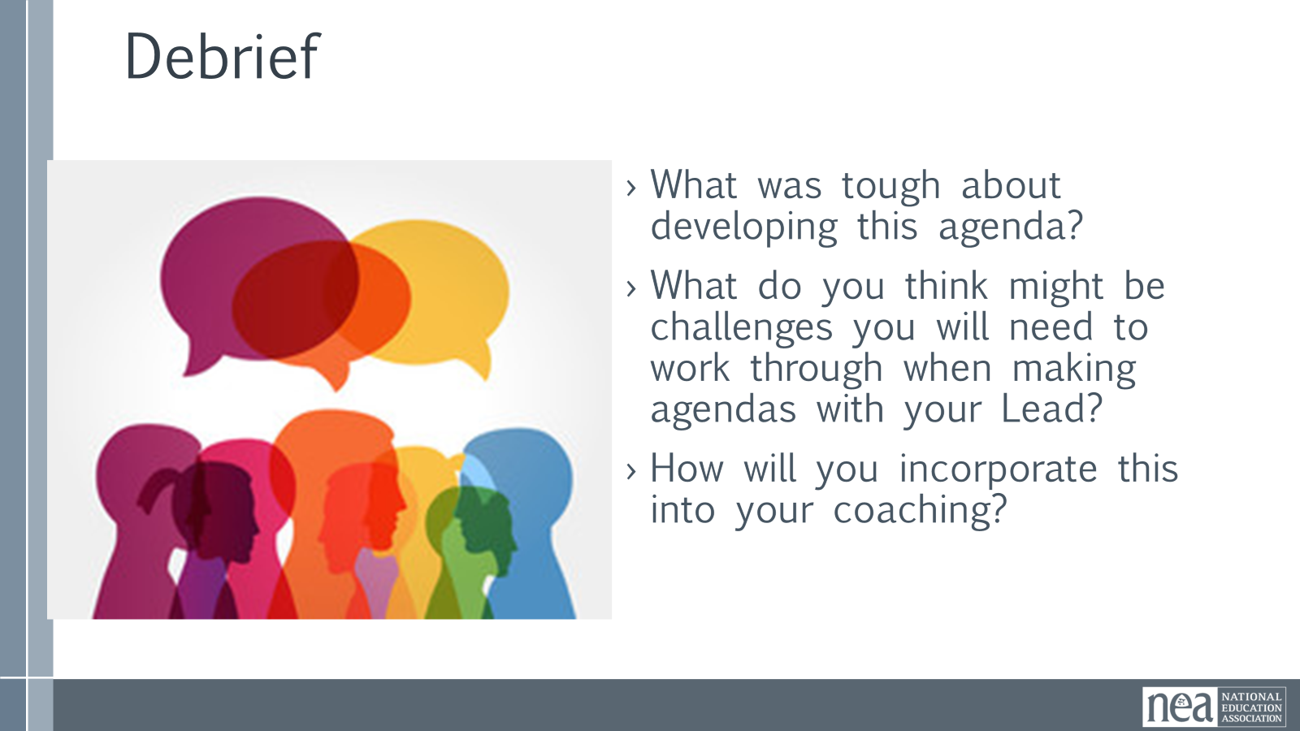  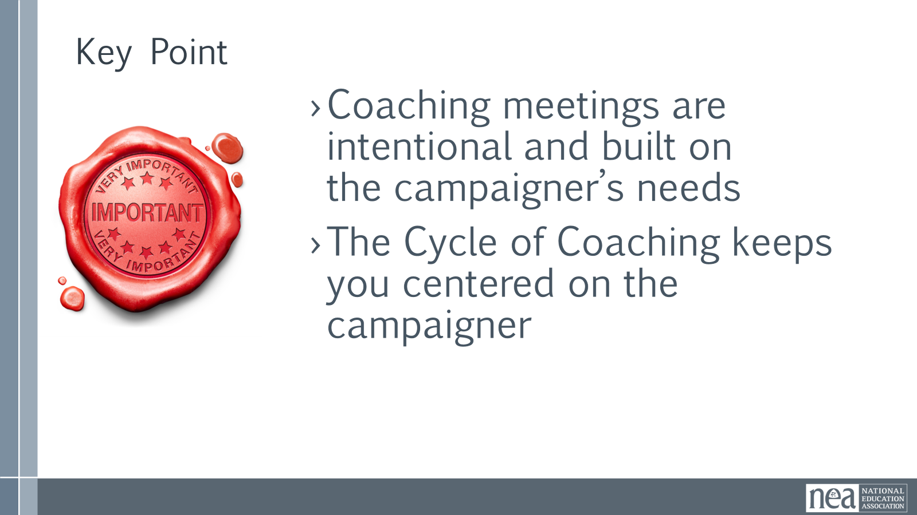 | Complete Coach’s Guidebook – Pages 30-35 | Coaching Cycle and Coaching Agendas Intro – 5 Minutes  We did a dive into step 2 and 3 – Diagnose and Intervene. We also took a look at the key skill you need for all steps of the cycle – disciplined curiosity that centers the lead and teams. And now we are going to look at how the cycle works within a coaching agenda.  Step 1 of the Cycle Inquire and Observe– Getting the Meeting started  Pause: Take a moment to come into presence. As a coach, you have to have your mind focused on the person/people in front of you. Make your mind quiet enough to be able to hold onto what they are saying. This is often the check- in with yourself.  Ground: Establish the agenda of the leader. What would you like coaching on today? What would success look like? Sometimes this happens in advance, but you are not setting their agenda. You are curious about what they are doing, what they believe they need help with, and what they think they need to get to where they want to go. This step includes a check -in , but the goal is for them to be able identify what they came to the coaching session to explore.  Step 2 – the Diagnosis and Step 3 - the intervention are all about Centering their agenda - Asking questions to support THEIR greater clarity and for you to formulate a theory about how they may be “stuck” AND using interventions that allow them to identify what they are willing to commit to and need to solve their problem.  Step 4 – is the plan to act – and this is all about them. What are they willing to do and by when. When will you check in? What sort of accountability checks will there be? And you also want to acknowledge the intention the lead has brought to their coaching session.  Step 5- Set up the next check-in and do that – a check-in COULD be the next coaching session, or it could be a quick, agreed upon accountability check (email, text, call)  So what does this look like in practice – here is a sample agenda that has the parts of the cycle bolded to help you see how the cycle of practice overlays on a meeting agenda.  5 Minutes Share this example – Show the Example below and Ask –what do you notice?  (Before the meeting – take a moment and Ground yourself)  - Check in. “How are you?” (Inquire and Observe)  - Review agenda and decide on outcomes for the meeting. “Here’s what I have in my notes to discuss today. Is there anything you want to add or change? What do you want to have figured out by the end of this meeting so I can make sure we focus our time there?” (Inquire and Observe)  - Important campaign updates. “The last time we spoke, you told me the campaign was at the (__) stage. Has anything big changed since then?” (Diagnosis)  - Discuss key questions that will land the agreed upon outcomes. *Majority of your time should be spent on this item. See sample coaching questions on page 11 for ideas on possible questions to ask during this segment. (Diagnosis and Intervention)  - Secondary topics/challenges. “What else feels urgent?” (Diagnosis and Intervention)  - Next steps. “Ok, what’s landed for you in this conversation? What next steps will you take to address the challenges we discussed today? And just confirming that our next meeting is ___.” (Action and Check -in)  - Closing reflection. “How is this going? What was most helpful about today?” (Check-In)  15 Minutes – Activity As a table create an agenda on chart paper for a lead that wants a coaching session with you. Include your questions or a process – what would you actually say to move through the cycle.  5 Minutes – Debrief the process  What was difficult about this?  What do you think might be challenges you will need to work through when making agendas with your Lead?  What is something new you learned?  Key Points – 1 Minute  Coaching meetings are intentional and built on the team lead's needs  The Cycle of Coaching keeps you centered on the team lead | Participants will create an agenda that centers the team lead and recognizes the 5 steps of the Coaching Cycle
3:20-4:20 | Yvie | 60 Minutes TOTAL - Self-Management and Centering the Leader's Agenda
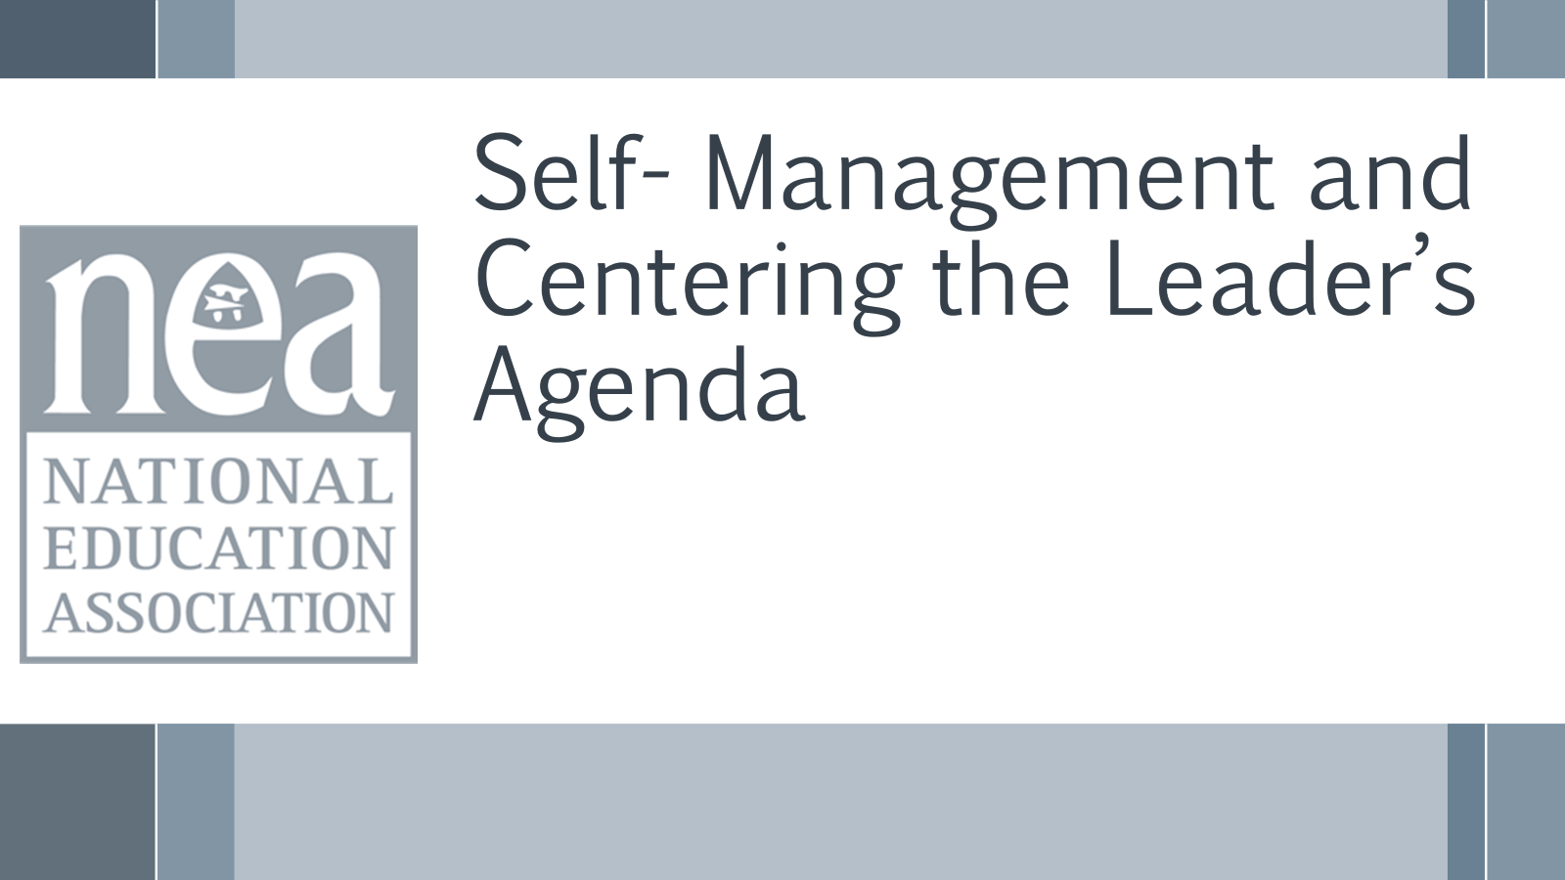  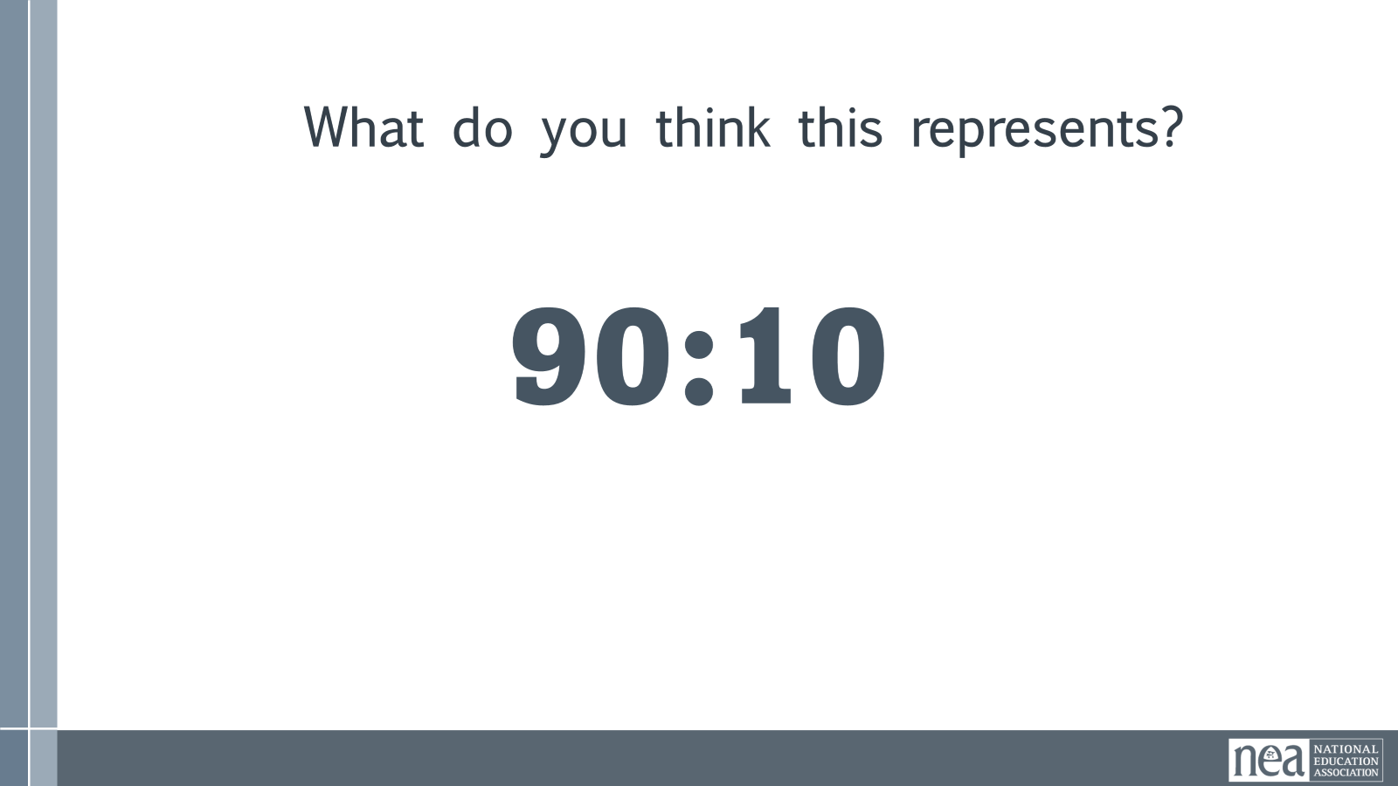  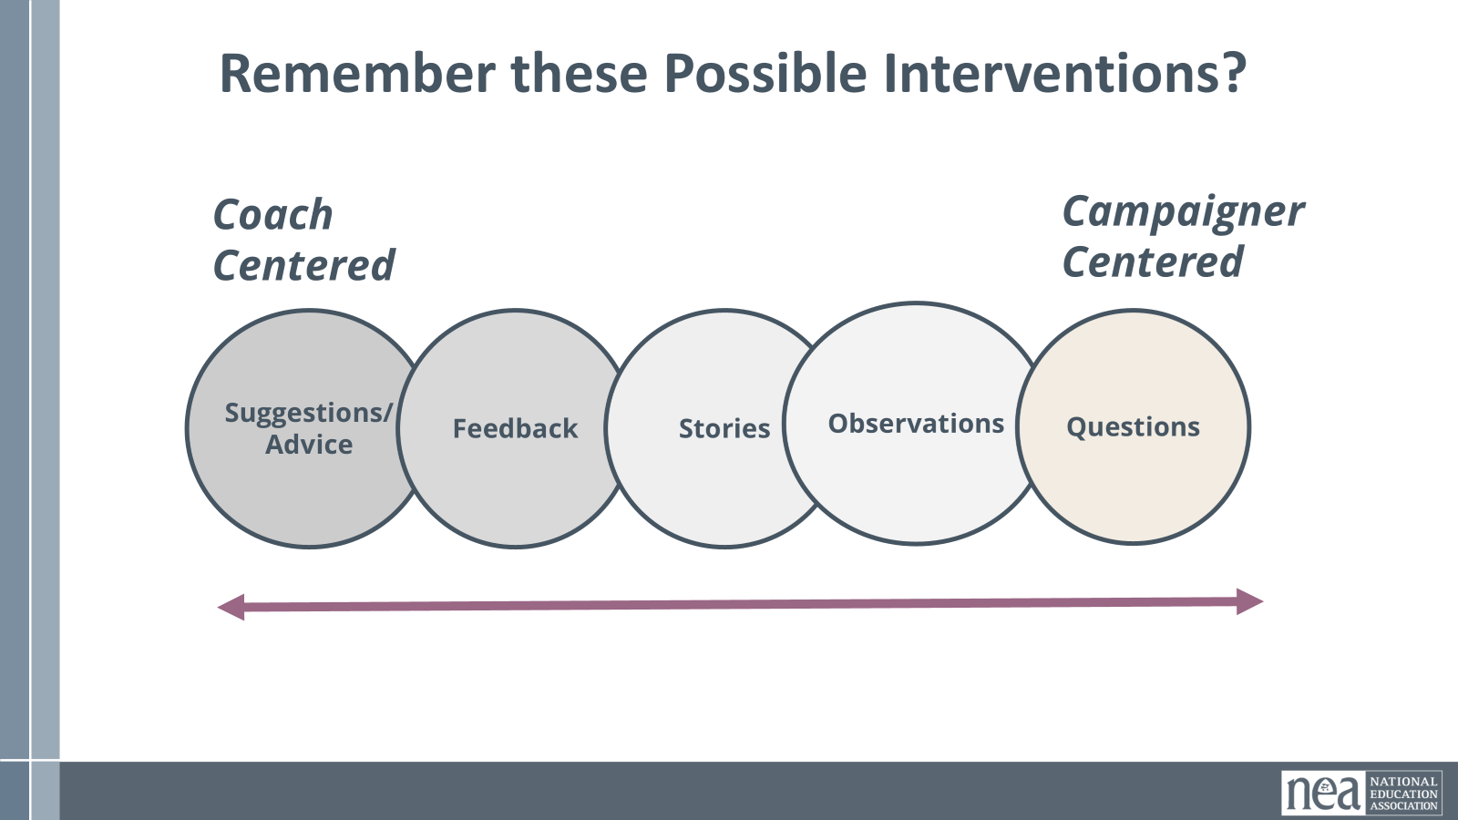  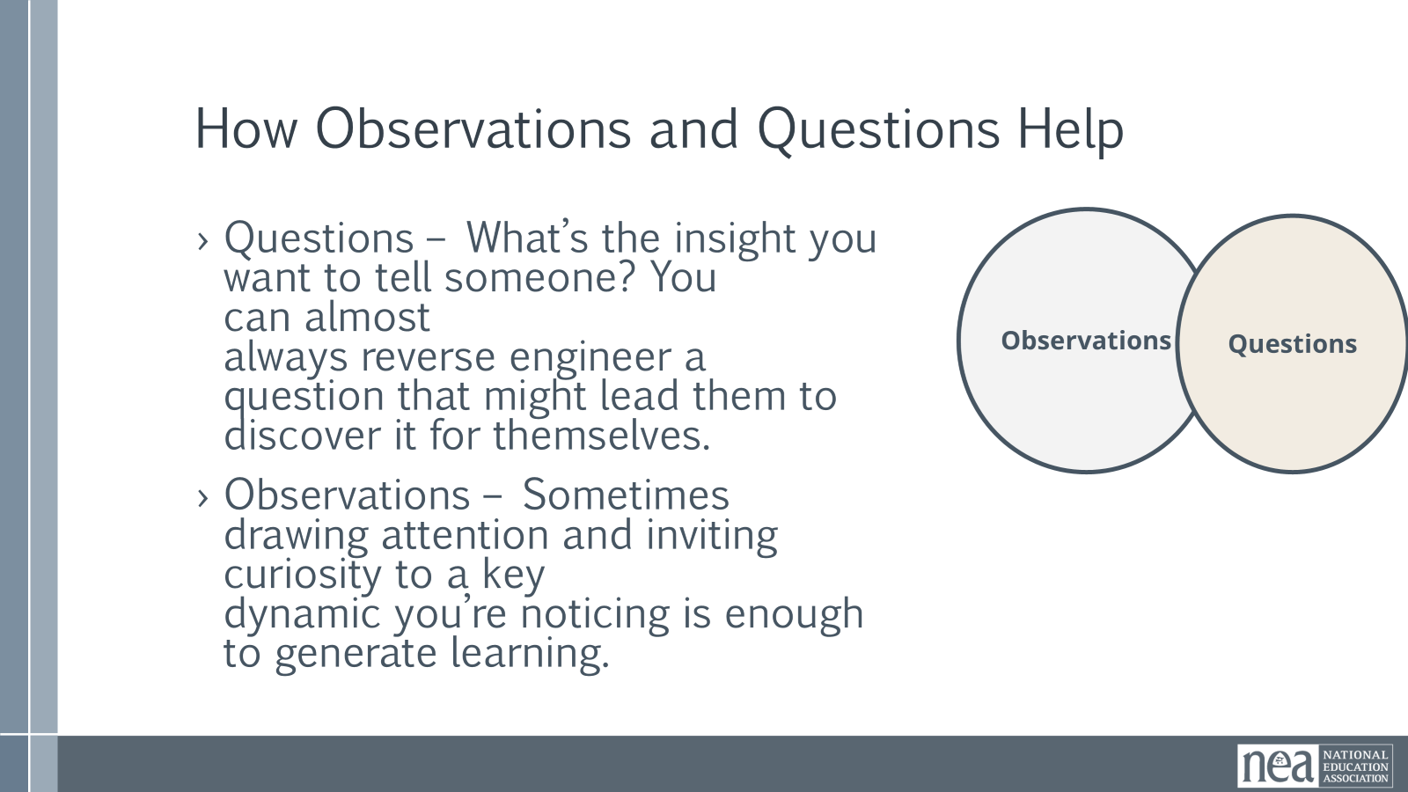  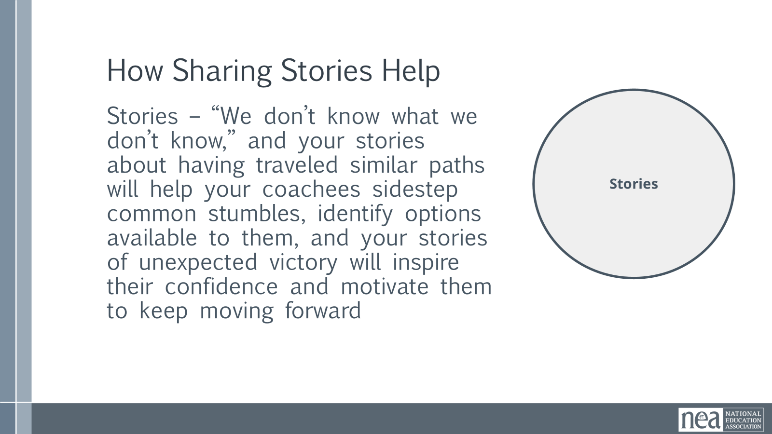  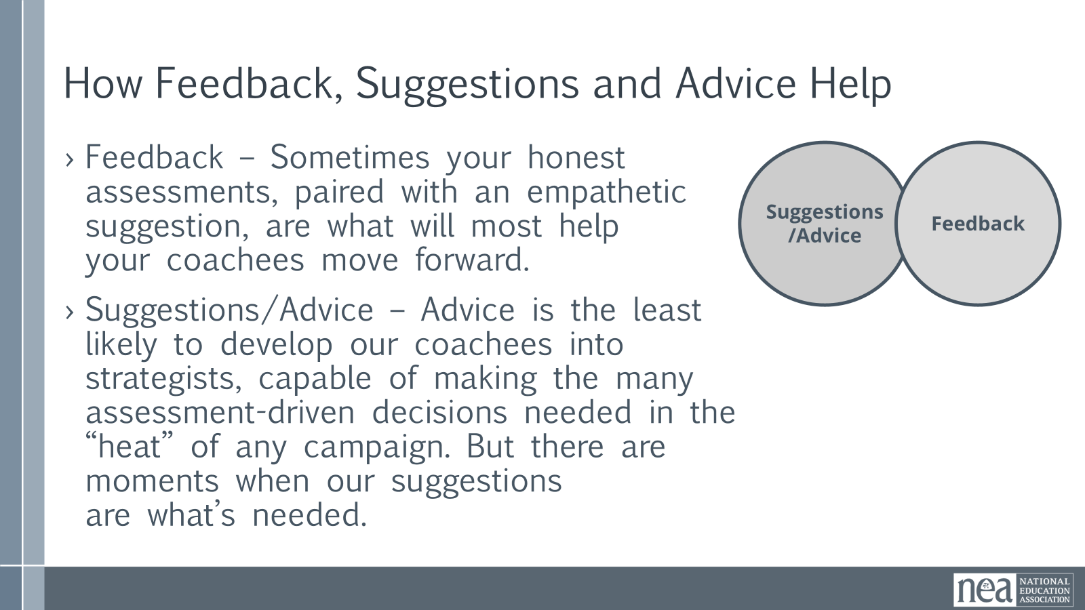  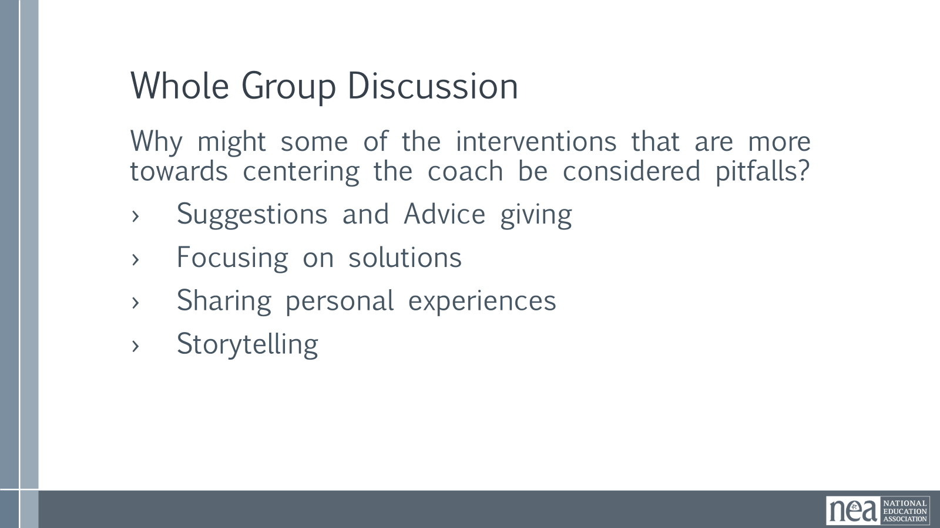  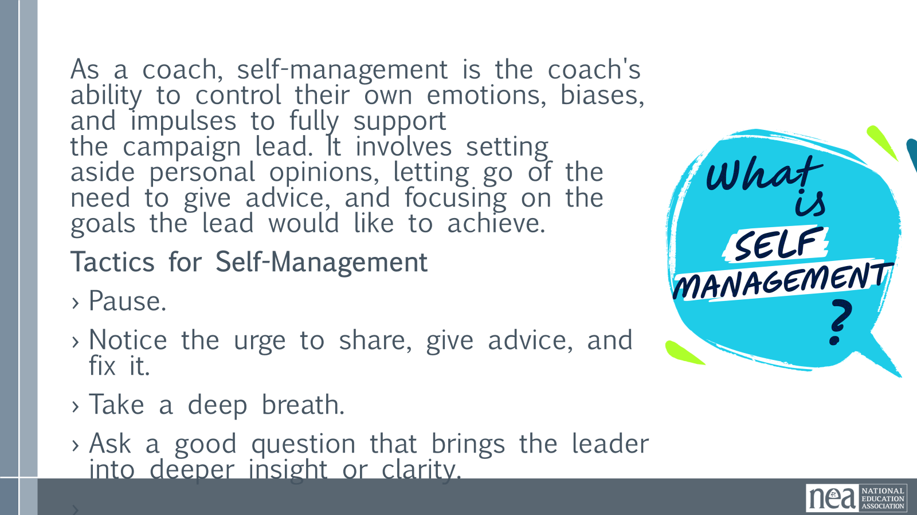  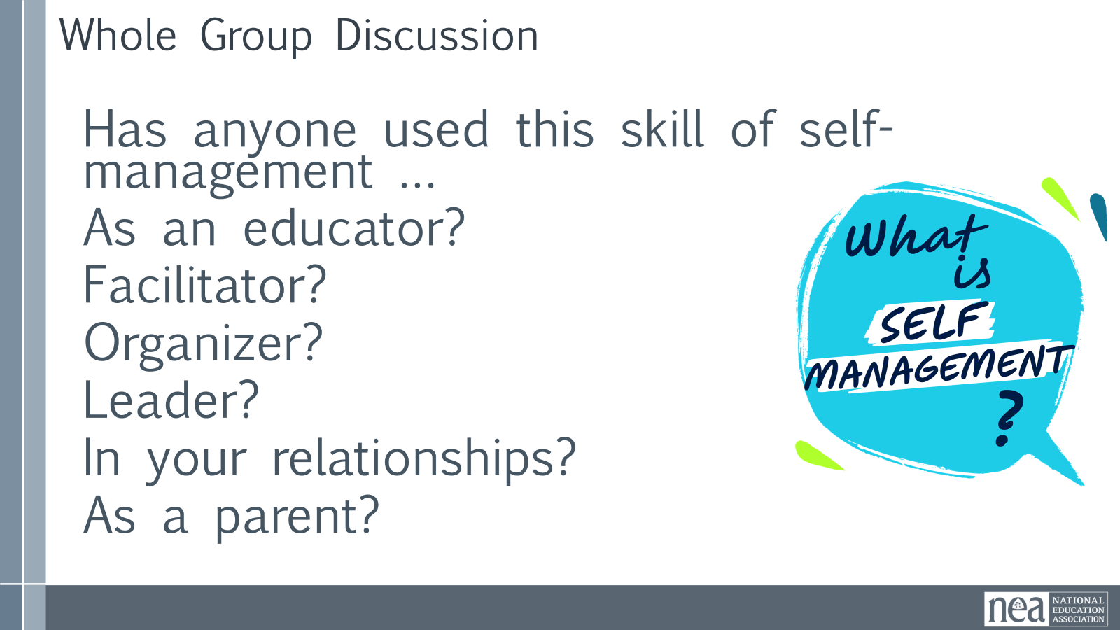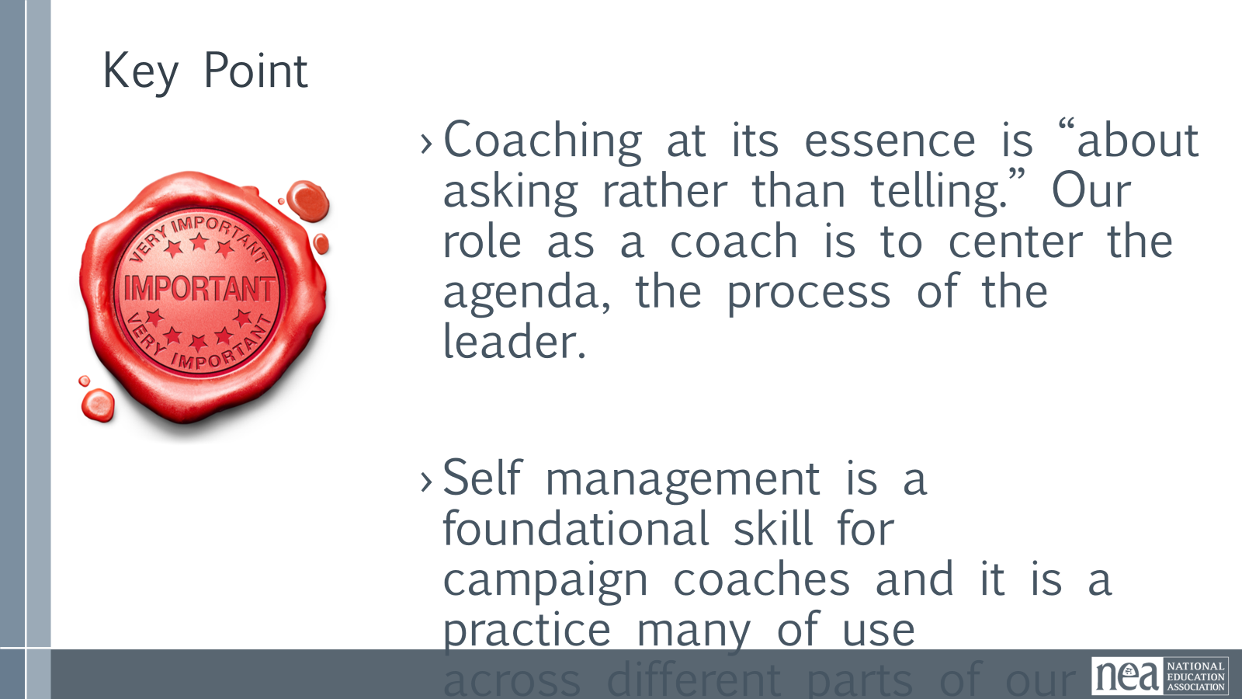  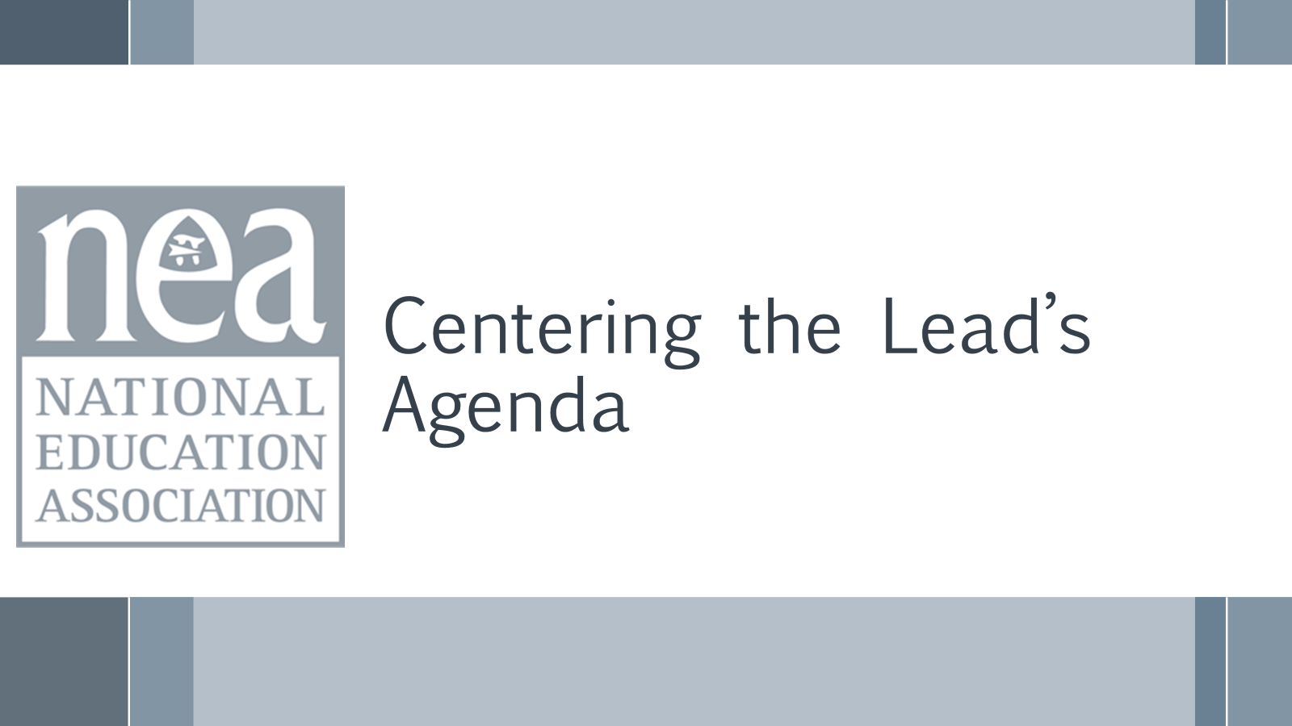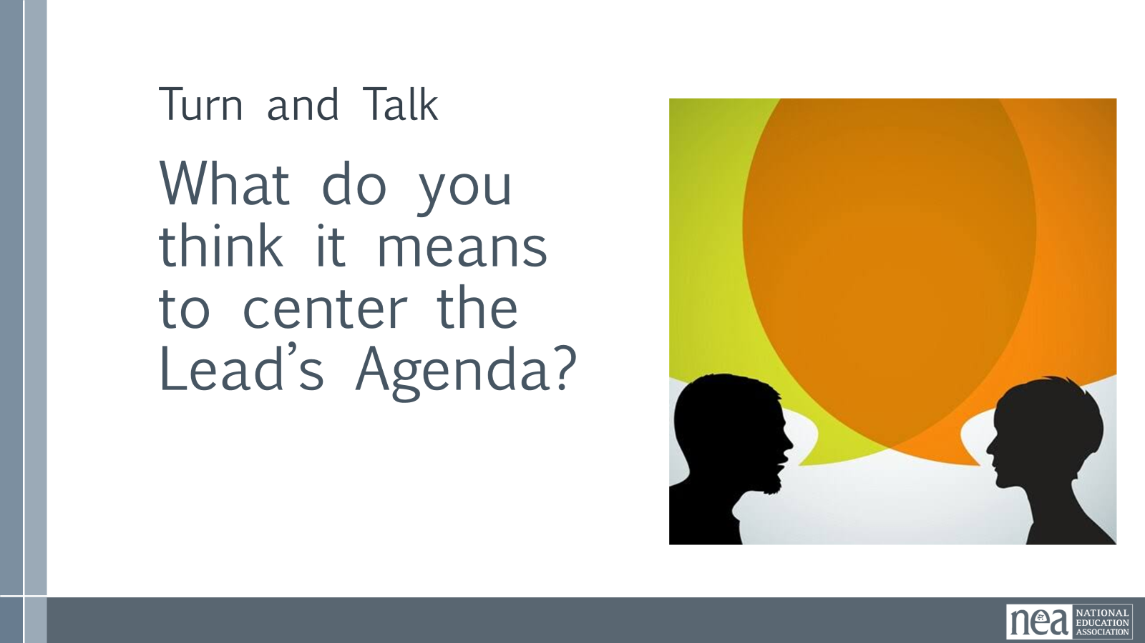  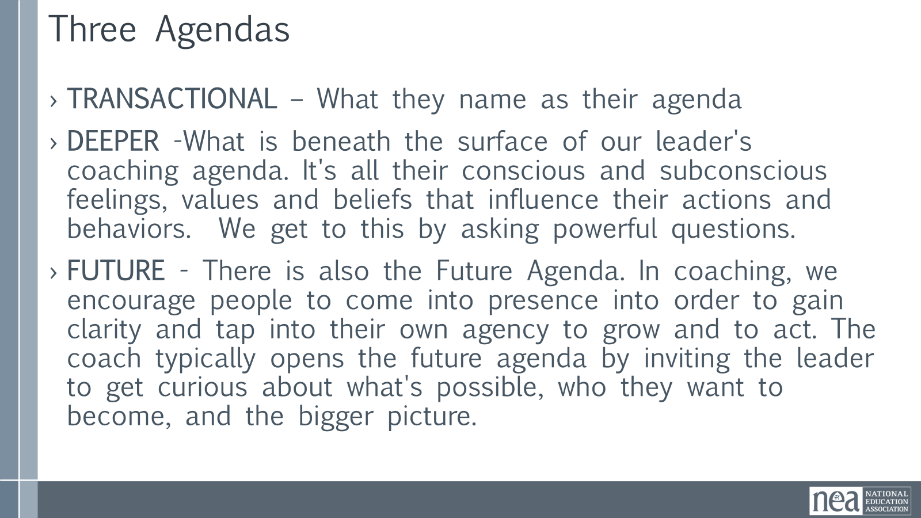  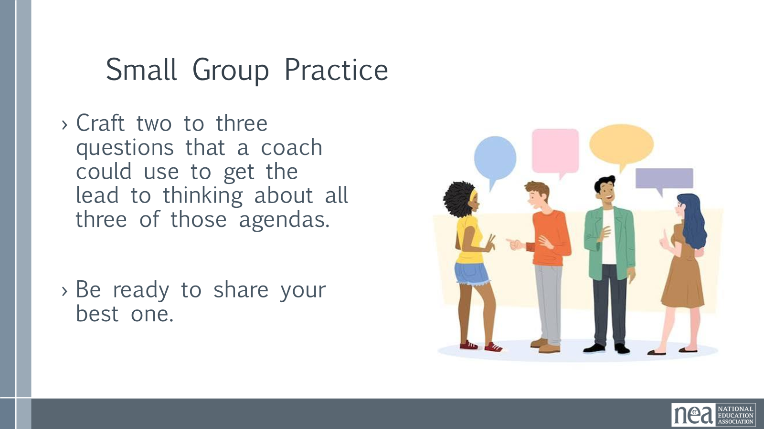  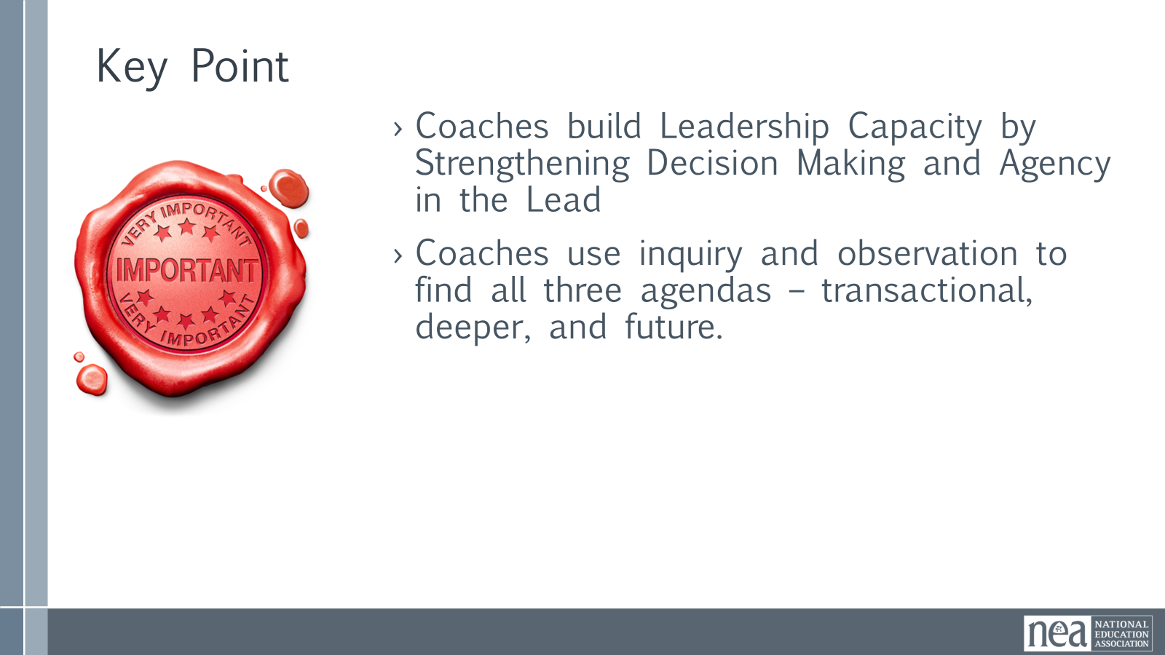  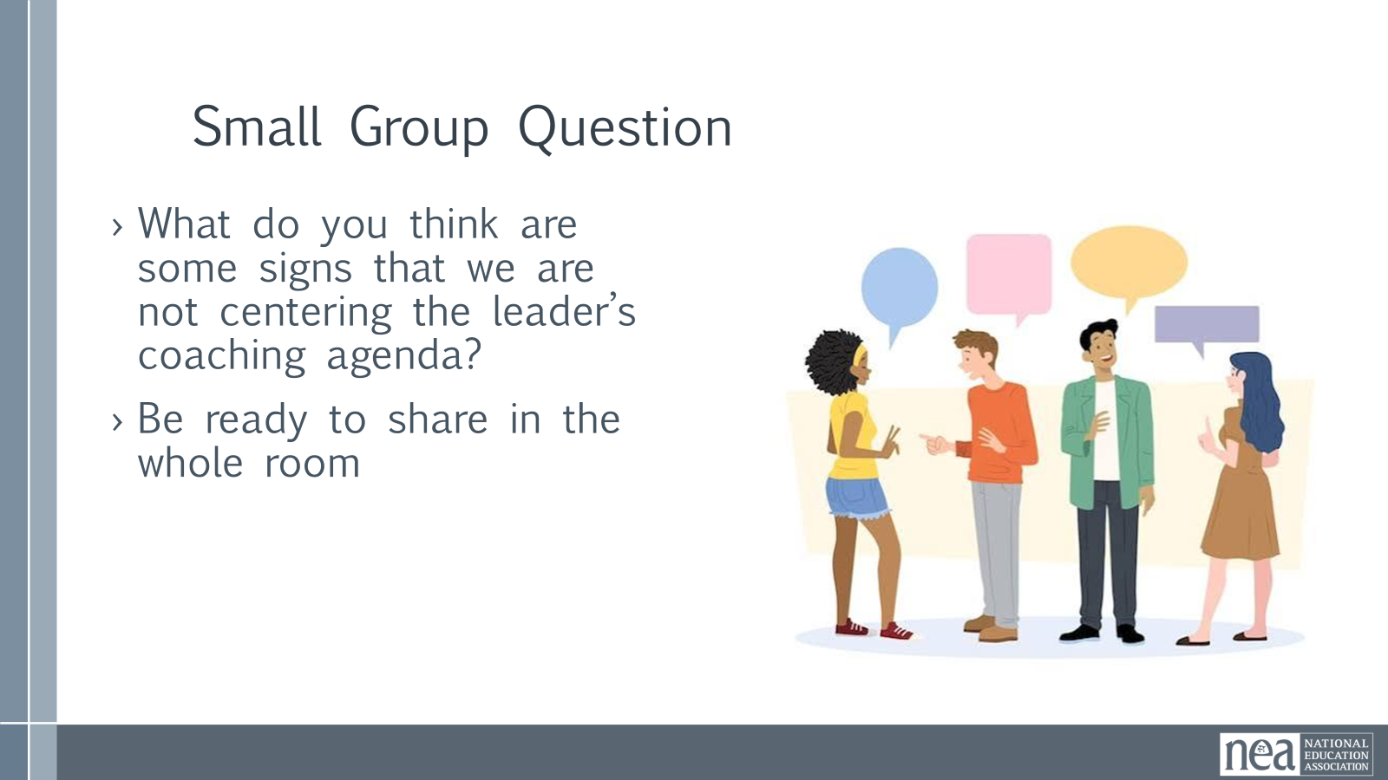  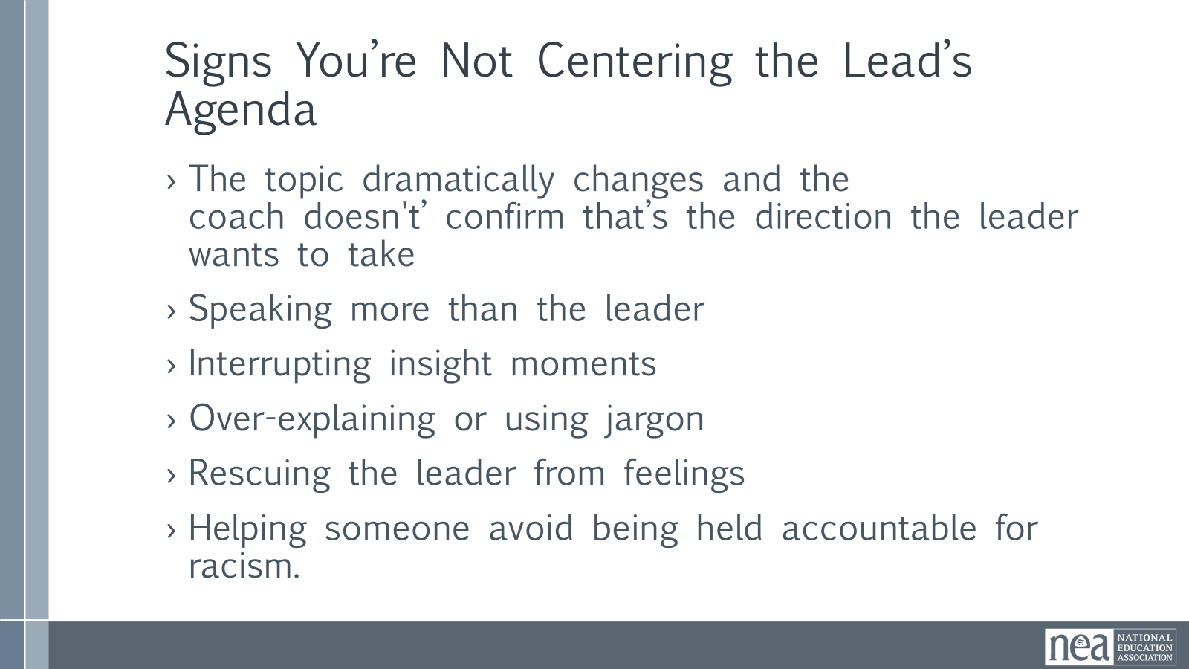  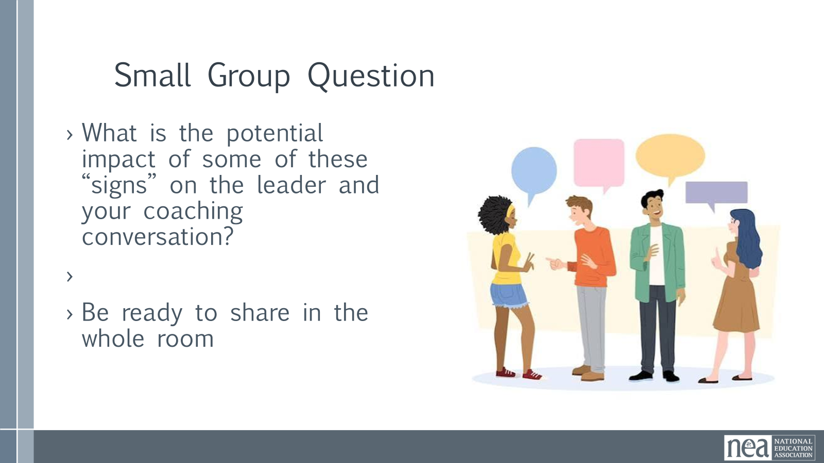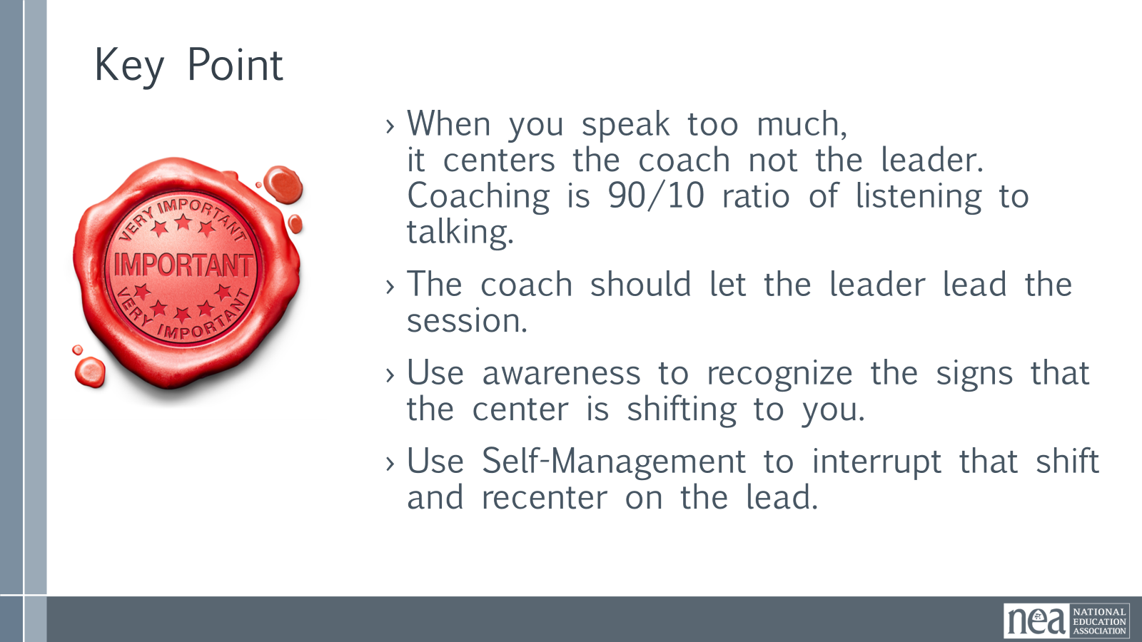 | Complete Coach’s Guidebook – Page 4 | Introduction and Content – 5 Minutes  Show the slide 90:10 -- ask the room what they think it means -take a few responses  Coaching conversations are 90 percent the lead’s voice and 10 percent of the time the coach – and of that 10 percent, most of it should be inquiry. Coaching is not the same thing as being a lead organizer. Nearly all of us have been in roles that require us to direct others, it can take some getting used to shifting into acting primarily as an inquisitive and active listener. Coaches don’t have to be experts – and they don’t have to guarantee the outcome of the coaching. The leader is responsible for their own growth and actions. The coach supports them in this process.  We are moving from a sage on the stage to a guide on the side. Take a look at this Spectrum of interventions of centering the coach and the leader.  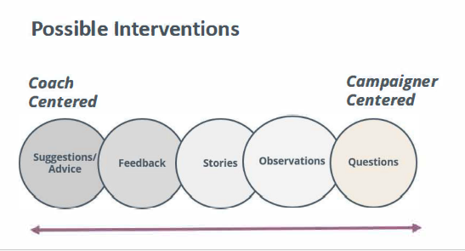  Coaches have plenty of interventions for helping leads and teams develop insights, identify options, and implement solutions. These are the five interventions we focus on.  - Questions – What’s the insight you want to tell someone? You can almost always reverse engineer a question that might lead them to discover it for themselves.  - Observations – Sometimes drawing attention and inviting curiosity to a key dynamic you’re noticing is enough to generate learning.  - Stories – “We don’t know what we don’t know,” and your stories about having traveled similar paths will help your team lead sidestep common stumbles, identify options available to them, and your stories of unexpected victory will inspire their confidence and motivate them to keep moving forward  - Feedback – Sometimes your honest assessments, paired with an empathetic suggestion, are what will most help your team lead move forward: “I’m really worried this is going to come off wrong, but I see you getting in your own way, by constantly focusing on what’s not working here. I’ve been there! We’re often surrounded by negativity in our school buildings. But unless you find a way to focus on what’s going right, I don’t think a lot more coworkers are going to say ‘yes’ to taking action…”  - Suggestions/Advice – Advice is the least likely to develop our coachees into strategists, capable of making the many assessment-driven decisions needed in the “heat” of any campaign. But there are moments when our suggestions are what’s needed, particularly when “coaching for performance” rather than “coaching for learning.”  Whole Group Discussion Point – 5 minutes –Why might some of the interventions that are more towards centering the coach be considered pitfalls?  Suggestions and Advice giving  Focusing on solutions  Sharing personal experiences  Storytelling  Define Self-Management 2 Minutes:  Our goal is to remain centered on the team lead and not on our expertise. We do this most effectively when we self-manage. As a coach, self-management is the coach's ability to control their own emotions, biases, and impulses to fully support the campaign lead. It involves setting aside personal opinions, letting go of the need to give advice, and focusing on the goals the lead would like to achieve.  How might we self-manage as a coach?  - Pause.  - Notice the urge to share, give advice, and fix it.  - Take a deep breath.  - Ask a good question that brings the leader into deeper insight or clarity.  Whole Group Discussion– 5 Minutes -  -Why is your self-management as a coach important to the team lead?  -Why is self-management important to the practice of centering equity?  Key Points – 2 Minutes  Coaching at its essence is “about asking rather than telling.” Our role as a coach is to center the agenda, the process of the leader.  Self management is a foundational skill for campaign coaches and it is a practice many of us use across different parts of our lives  Scott  Centering the Leaders Agenda – 5 Minutes Intro  What do we think it means as a coach to center the leader's agenda?  It means - Meeting someone where they are at. Creating a shared understanding of the leader's needs. Simply ask – What do you want coaching on today?  There are 3 types of Agendas that Leaders bring to their coaching  TRANSACTIONAL – What they name as their agenda  DEEPER -What is beneath the surface of our leader's coaching agenda. It's all their conscious and subconscious feelings, values and beliefs that influence their actions and behaviors. We get to this by asking powerful questions.  FUTURE - There is also the Future Agenda. In coaching, we encourage people to come into presence in order to gain clarity and tap into their own agency to grow and to act. The coach typically opens the future agenda by inviting the leader to get curious about what's possible, who they want to become, and the bigger picture.  Group Practice –10 Minutes  Craft 2 great questions that would help you get a leader thinking about all three agendas.  Report Out - 5 minutes  Key Points – 1 minute  Coaches build Leadership Capacity by Strengthening Decision Making and Agency  Coaches help leaders Navigates Challenges and Improve Campaign and Organizing Impact  Coaches use inquiry and observation to find all three agendas – transactional, deeper, and future.  Yvie  Centering the Leader's Agenda - Small Group Discussion: 10 Minutes  What do you think are some signs that we are not centering the leader’s coaching agenda?  Have groups discuss – and then show the following slide – what did you mention that is not here – and what is here you didn't think of? Not really a report out.  Show Slide -Signs you're not centering their agenda  - The topic dramatically changes and the coach doesn't’ confirm that’s the direction the leader wants to take  - Speaking more than the leader  - Interrupting insight moments  - Over-explaining or using jargon  - Rescuing the leader from feelings  - Helping someone avoid being held accountable for racism.  Scott  Whole Group discussion: 5 Minutes  What is the potential impact of some of these “signs” on the leader and your coaching conversation?  Key Points – 2 minutes  When you speak too much, it centers the coach not the leader. Coaching is 90/10 ratio of listening to talking.  The coach should let the leader lead the session.  Use awareness to recognize the signs that the center is shifting to you.  Use Self-Management to interrupt that shift and recenter on the lead. | Participants will be able to recognize the signs that they are not keeping the leader at the center of the coaching session. They will understand the pitfalls of this shift and apply some self-management practices.
4:20-4:30 |  | 10 Minutes TOTAL – Closing
  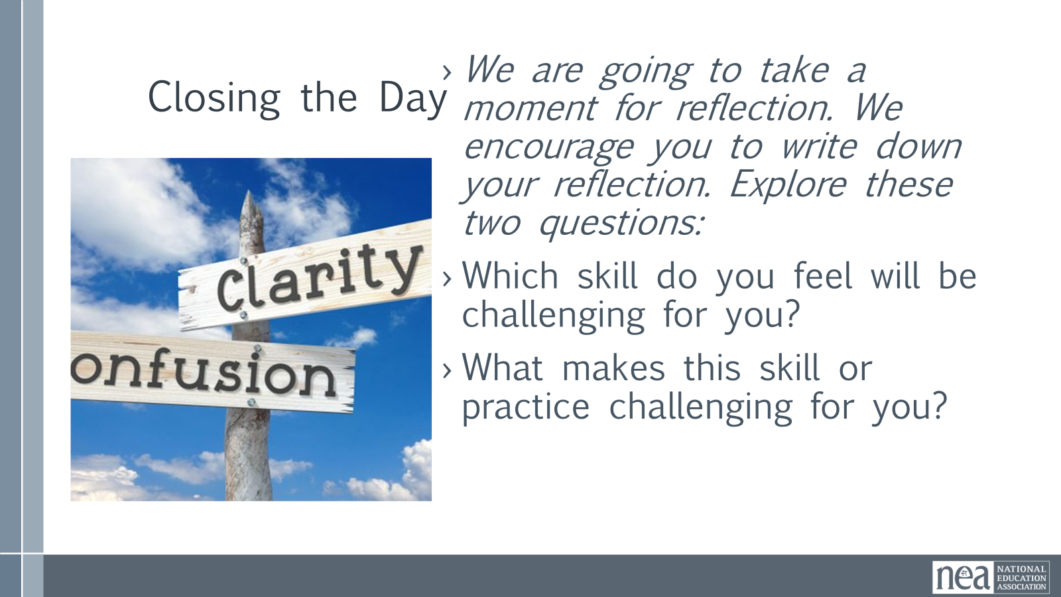  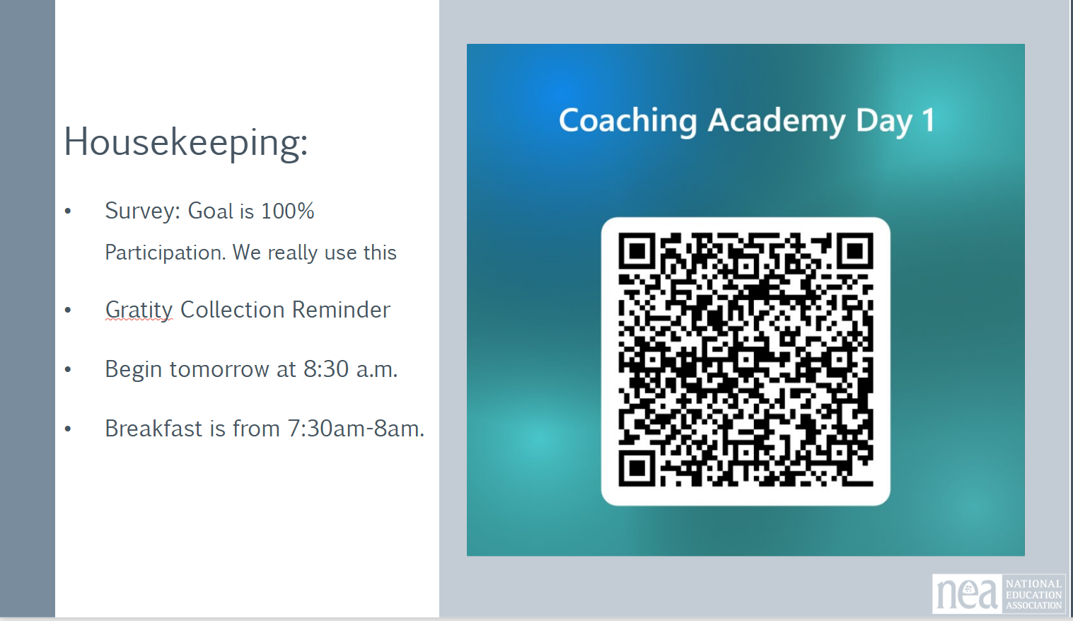 |  | 5 min Reflection  We are going to take a moment for reflection. We encourage you to write down your reflection. Explore these two questions:  - Which skill do you feel will be challenging for you?  - What makes this skill or practice challenging for you?  5 min FOR TOMORROW  Any housekeeping or reminders about feedback form or reminders about what is needed next day  Slide with QR code for daily feedback – need to create the form and the QR code  PLEASE MAKE SURE YOU COMPLETE THE COACHING SELF-ASSESSMENT. You will get a link to it in our email this evening. We will be using the information tomorrow. | Participants will be able to bring a little closure to their learning and provide feedback on the day.
4:30 – 5:00 |  | 30 Minutes TOTAL – Choice Networking Activities
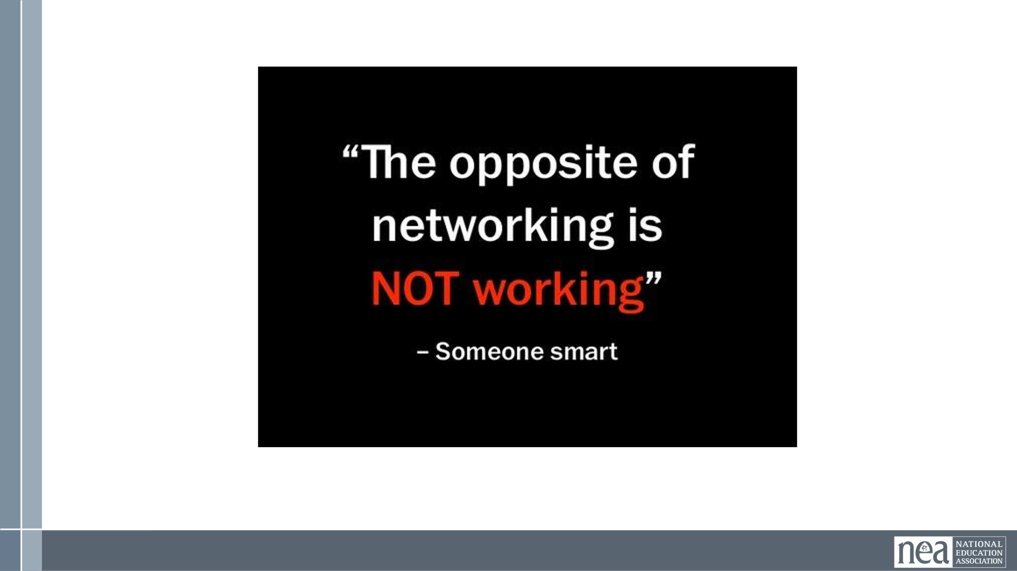 |  | This is a time for participants to meet and discuss any issues they are thinking about with other members of the group. This is not led by facilitators and highly encourage to occur in any other space besides the conference room. | Participants will make useful connections with staff from other affiliates.
5:00 |  | ADJOURN

