Day 3 Facilitator Agenda – Facilitator Agenda - Coaching Academy
General Materials Needed: |  |  |  | Room Set-up: 80 people max
Name Tents with the Norms  Room signs, Stick on Name Tags  Chart Paper (10 full w Sticky Strip) |  | Materials Box for each table with:  Markers (Mr. Sketch variety)  Post its – 3x3” and 4X5” sizes |  | Long Rectangle table at back for facilitators  Round Tables for participants  Projector, Screen, mics, and Speakers  Carousel stations and reporting stations
Key Outcomes for the Day:
Participants will be able to:
- Understand the role of a growth mindset in coaching.
- Understand the need to coach towards uncovering awareness and reflection on systems, beliefs, and root causes.
- Identify and utilize principles of awareness-based systems change to drive meaningful change as a coach

Overview of Day, Time, and Facilitator Assignment Nearly all Page numbers listed in the facilitator agenda are incorrect, check for page numbers in the 00 Participants Handouts file
7:30-8:30 - Breakfast  8:30 – 8:45 – Welcome, Feedback, Travel Logistics, Campaign Assignments  8:45-9:45 Coaching across Differences  9:45– 11:00 – Coaching Practice  11:00—11:15 Break  11:15– 11: 45 – Coaching Debrief | Melissa  Scott and Dr. Taraja  Serafina and Jeny  Katie B. and Joshua |  | 11:45 – 12:15 Structure, Requirements for Coaching Academy Certificate and Requirements for Coaches  12:15– 12:30- Training Opportunities  12:30 –1:00 Closing & Travel/Reimbursement Logistics  1:00-2:00 Adult Choice Networking – Lunch on Your Own |  | Amanda  Yvie  Melissa
Time Slides Facilitator | Resources | Instructions, Activity and Debrief (Facilitator Script) | Essential Questions and Outcomes
 | Charts, handouts, articles, materials, slide | What are you saying, what are they doing, what questions will you use to guide learning and make clear the important points  Include an estimate for how long each section of the learning will take | What question(s) will this learning answer? What will participants know or be able to do?
7:00 -8:30 – Team prep, practice, room set up, sound check, etc.
Entry Activity - Have on Screen as people walk in

8:30 – 8:45 | Melissa | 15 Mins TOTAL - Welcome, Feedback, Travel Logistics and Changing Relationships
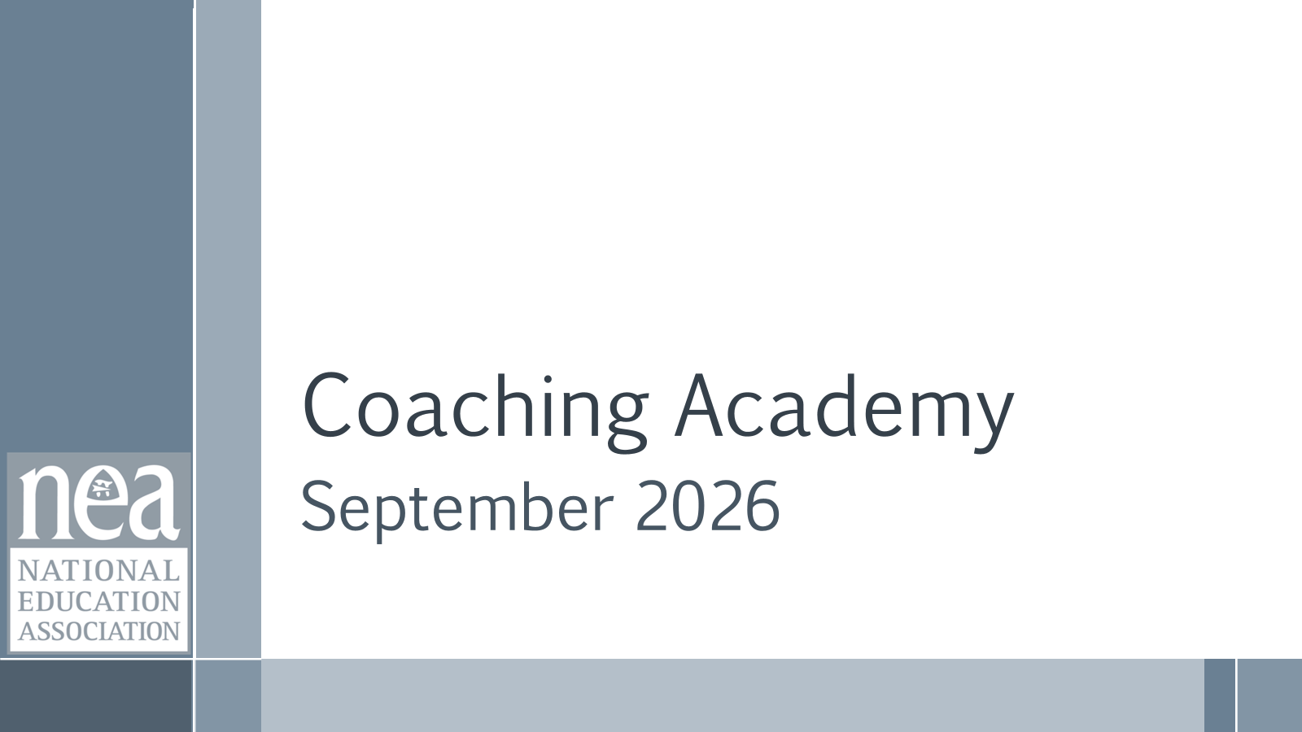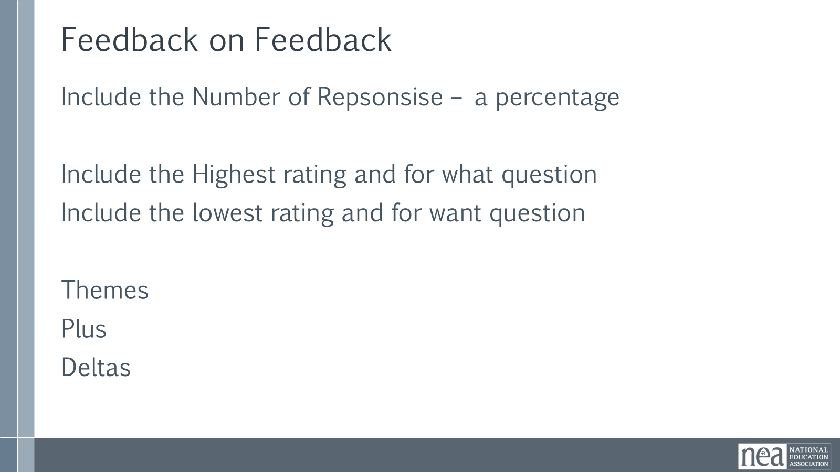    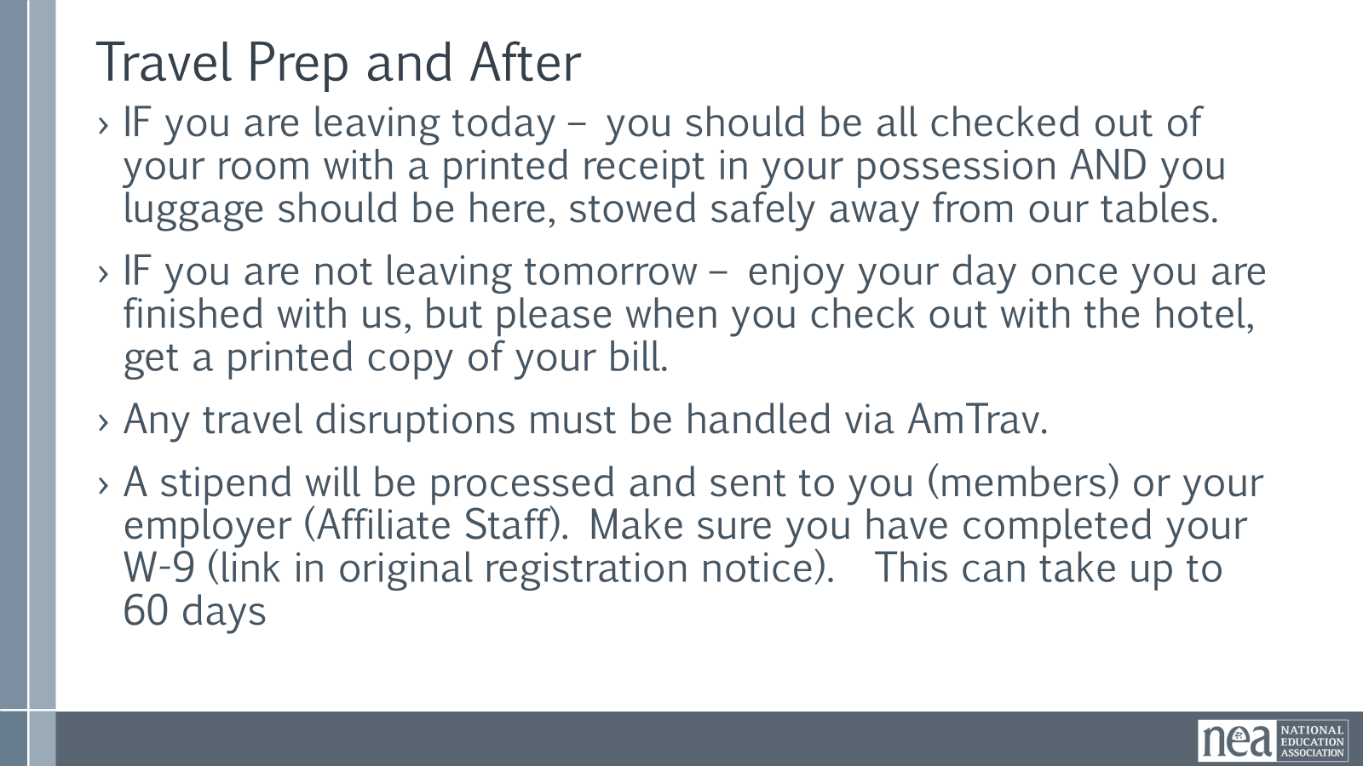 | Norms in Handouts and on Name tags  Agenda on Slides  Parking Lot Chart  Handout Package is in PEP | 1 Minute Welcome  1 Minute to show both slides Standards of Conduct  1 Minute Reminder  Did you remember to do your homework? (Share the QR CODE slide for Application List and Top three Choices Spreadsheet  1 Minute Review Community Agreements  What have we been doing well?  What we still need some work on?  5 Minutes Feedback on Feedback  Results and Your words slides  2 Minutes Agenda for the day  5 Minutes Travel and After Reminders  IF you are leaving today – you should be all checked out of your room with a printed receipt in your possession AND you luggage should be here, stowed safely away from our tables.  IF you are not leaving tomorrow – enjoy your day once you are finished with us, but please when you check out with the hotel, get a printed copy of your bill.  Any travel disruptions must be handled via AmTrav. If you need another day, email Karla so she can add to your stipend.  A stipend will be processed and sent to you (members) or your employer (Affiliate Staff). Make sure you have completed your W-9 (link in original registration notice). If you haven't submitted a W9, it can take more than 30 days to process so submit asap.  If you haven't checked out do so at the break.  10 Mins - We are going to use the information you entered on your homework and our knowledge of the applicants to make pairings of coaches and campaigns.  Guidelines for campaign assignment  - Skill  - Experience  - Level of comfort  - Geographic location/time zone  We will finalize the pairings and email you very shortly | Participants will know how we are going to work, the basic schedule, and the logistics relevant to the training.
8:45-9:45 |  | 60 Minutes Total – Coaching Across Differences
 |  | 5 Minutes – Let's do a quick 3 minute talk at our table about all the differences you think you will encounter when you are coaching others. At the end of 3 minutes  Campaign Lab coaches build high participation locals through equity-centered coaching.  To coach for equity and with equity you have to be able to fully do the following:  See the person, see the system, and see the interaction between the two.  We believe that requires the following 3 Commitments  - Curiosity over Assumption  - Impact over Intent  - Awareness over Neutrality  5 Minutes – Discuss at your tables, As a coach, what do you think this looks like in practice?  10 Minutes Content - (Much of this is in their Coaching Across Differences Guide – There are too many slides and too much script – with the exception of the Intersectionality and how the Wheel is put together, the rest of this until the activity can be treated as review. )  This next section involves the pre attendance work you were asked to do that included a guided reflection using the Wheel of Intersectionality. This work \invites us to reflect on how our identities shape how we show up in spaces, how we interact with others, and how power operates through us—often without our awareness.  Intersectionality, a concept coined by legal scholar and civil rights activist Kimberlé Crenshaw describes how multiple social identities intersect to shape experiences of privilege and oppression. Building on Crenshaw's framework, educators and social justice organizations later developed visual tools such as Sylvia Duckworth's 2020 Wheel of Power and Privilege to illustrate how overlapping identities interact with systems of power, advantage, and marginalization.  Definition of Intersectionality is a framework for understanding a person, group of people, or social problem as affected by a number of discriminations and disadvantages. It takes into account people's overlapping identities and experiences in order to understand the complexity of prejudices they face.  Let's go over how the Wheel is organized  - Power: Identities in this inner most ring are seen as valued and their voices, ideas, and opinions are respected in a room.  - Erased: People who exist in this ring the are often the forgotten ring or have their identities erased or are marginalized in unique ways. Some these people can “pass” and “choose” to be marginalized or privileged when it benefits them  - Marginalized: People who exist in this ring experience more overt discrimination and are most impacted by systemic discrimination. Underrepresented in media unless they serve negative purpose: ( mascots, jokes, criminals, etc)  Key Reminders  • Remind participants that the rings describe how identities are valued by systems, not the worth of individuals.  • Emphasize that power is contextual and fluid—identities may move across rings depending on space and setting.  • Invite participants to focus on self-reflection, not labeling or analyzing others.  • Name that most people hold identities across multiple rings, including both power and marginalization.  • Clarify that “passing” often relates to safety and survival, not ease or advantage.  • Encourage reflection on how identities influence who speaks, who is heard, and who takes up space.  • Reinforce that privilege is about impact and responsibility, not intent or guilt.  • Prompt awareness of how unexamined power can silence, erase, or marginalize others unintentionally.  • Set a boundary: this is not a space to compare oppression, disclose others’ identities, or justify harm.  Considerations When Coaching Across Differences  1. Coaching Is Never Separate From Power  The relationship is not just Coach ↔ Leader.  It is also:  - Race ↔ Race  - Gender ↔ Gender  - Staff ↔ Member  - Manager ↔ Employee  - HQ ↔ Field  - Older ↔ Younger  - Credentialed ↔ Non-credentialed  People enter coaching conversations carrying their lived experiences with power.  A useful coaching question:  "How might the power differences between us be shaping what is easy or difficult to talk about today?"  Communication and trust are influenced by race, class, gender, role seniority, and power dynamics.  2. Assume Difference Matters, But Don't Assume You Know How  Common coaching mistakes is:  Minimizing Difference  "We're all the same."  Overgeneralizing Difference  "Because you're a woman/person of color/support professional, you must experience X."  Instead:  - Stay curious  - Ask rather than assume  - Let the leader define their experience  Examples:  - "How does your identity show up in this situation?"  - "Do you think race, gender, role, or another factor is affecting what is happening?"  - "What dynamics am I not seeing?"  3. Separate Behavior From Identity, While Still Paying Attention to Identity  Strong coaches avoid two traps:  Trap A  Explaining everything through identity.  Trap B  Ignoring identity completely.  Good coaching asks:  - What happened?  - What behavior occurred?  - What systemic dynamics may also be present?  For example:  A woman leader receiving feedback about being "too direct."  A coach should explore:  - What specific behavior occurred?  - What impact did it have?  - Would a man displaying the same behavior receive similar feedback?  - How might gender assumptions be influencing interpretation?  4. Watch for Credibility and "Prove-It-Again" Dynamics  Leaders from historically marginalized groups often carry additional burdens:  - Needing to demonstrate competence repeatedly  - Being scrutinized more closely  - Having expertise questioned  - Being interrupted or overlooked  A coach should help the leader:  - See the pattern clearly  - Avoid internalizing systemic problems as personal failures  - Identify what is within their control  - Develop strategies while also naming inequitable dynamics  5. Be Alert to Common Misreads  Several predictable misinterpretations show up repeatedly:  - Directness becomes "aggressive."  - Emotion becomes "unstable."  - Reserved behavior becomes "disengaged."  - Informal communication becomes "unprofessional."  - Relational leadership becomes "soft."  The coach's role is to help the leader evaluate:  Is this a performance issue, a communication issue, a perception issue, a bias issue, or some combination?  6. Listen for Adaptations  Sometimes what looks like a weakness is actually an adaptation.  Examples:  - Over-preparation  - Being hyper-careful  - Avoiding conflict  - Excessive deference  - Controlling details  Before coaching someone to change the behavior, ask:  "What has this behavior helped you survive, navigate, or accomplish?"  7. Create Psychological and Identity Safety  A leader should not have to choose between:  - Being authentic  - Being successful  Coaches build safety by:  - Listening before advising  - Being willing to hear difficult truths  - Acknowledging mistakes  - Inviting correction  - Naming uncertainty  One of the most powerful coaching moves is:  "I may be missing something because of my own experience. Help me understand."  8. Practice Cultural Humility Rather Than Expertise  The coach is not expected to know everything about another person's experience.  The expectation is:  - Humility  - Curiosity  - Accountability  - Learning  Rather than:  "Let me explain your experience."  Try:  "Help me understand how you're experiencing this."  9. Focus on Impact, Not Intent  Differences often create misunderstandings.  When they occur:  - Explore impact first.  - Explore intent second.  Questions:  - "What impact did that have on you?"  - "What impact do you think it had on others?"  - "What would repair look like?"  This keeps coaching grounded in learning and growth rather than blame.  10. Help Leaders Navigate Systems, Not Just Individual Behaviors  Coaching should not only ask:  "How could you do better?"  It should also ask:  "What is the system rewarding, discouraging, or making difficult?"  Examples:  - Who gets speaking time?  - Who gets stretch assignments?  - Who gets second chances?  - Whose expertise is trusted?  Why Coaching across Differences Matters  Power, credibility, communication, trust and identity shape coaching relationships - your ability to do this well increases your effectiveness and builds stronger leaders who can do the same.  Inclusive, Democratic relationships build high participation and shift culture within locals.  30 Minutes – Small Group Discussion  You will need your guided reflection you completed before you arrived.  Form groups between 2 and 5, you choose – but they should be small enough and brave enough for good conversation.  Begin your sharing about your experience with tool and guided reflection in any way that you like. However, be sure to discuss how you intend to incorporate this into you your coaching practice.  10 Minutes – Whole Group Discussion and Key Points  Coaching is never separate from power  Assume difference matters  Create psychological and identity safety  Focus on impact not intent  The goal is not perfection—but greater awareness, so we can choose to show up in ways that reduce harm and expand belonging between our coaching community and our campaign leads | Participants will understand the relationship between power and intersectionality. They will reflect on how this may show up in their coaching sessions and the practices that they can employ to address this.
9:45– 11:00 | Serafina | 75 minutes TOTAL – Second Coaching Practice – Applying it all
 |  | 10 Minutes Prepping for Coaching Practice  We are going to have another sustained coaching practice in which we are observed. We have added to our skillset since the first practice, so let's see if you can include some of those new concepts this time. You will take the next few minutes to gather what you like to use when you are coaching, or what you think you would like to use, and you are going to get your head set in being a team lead who came to receive some coaching. Take time to think about the following: What is a real challenge you are experiencing your coaching work or in moving a union campaign along, or in doing something that leads your union work. REMEMBER - don't be stuck on – I don’t have anything yet – we all have challenges in our union and coaching work. So, think about what you want to be coached on that would get you moving towards the “yet.” Keep in mind, this is real, as most of the team leads you will coach are exactly there -they have turned in an application to the Lab, and don’t really know what to do next. That is a perfectly coachable moment.  Coaching Practice – 60 Minutes (18 minutes per round with 1 minute transition)  We are going to create groups of three by counting off by 15 [or whatever number makes sense]. Let’s start here. [Count off.] Move to your group but stay in this room.  For this practice, please try these three things. One, the coach is only allowed to ask questions. Second, they can ask the observer for a lifeline if needed. Third, try to be curious about how equity may be explored with the coachee.  One person will be the coach, one the lead, and one the observer. The observer should use the observer feedback questions on PAGE 92 to frame their observations and offer feedback at the end.  You’ll have 13 minutes for the coaching conversation and 5 minutes for feedback from the observer and discussion. Then, you’ll repeat this twice more, shifting roles as you do. We’ll keep time for you. What questions do we have before we start?  Each Round: 13 minutes coaching, 5 minutes debrief – I minute transition  5 minutes – Individual Reflection  Now that you’ve finished your coaching practice, return to your seats. [1 minute for transition time].  Grab a piece of paper or open a document up. Take 4 minutes to free write about that experience.  How did it feel to coach?  What did you learn by coaching?  What did you learn by being coached?  What did you learn by observing coaching? | Participants will apply all parts of the coaching framework – cycle, diagnosis, interventions
11:00 – 11:15 |  | BREAK
11:15-11:45 |  | 30 Minutes Total – Debriefing the Coaching Practice
 | Need 1 chart paper for each table group | 1 minute - Directions  Now, we’re going to discuss in your table groups using what you just wrote. Take about 10 minutes to discuss in your group. Come to consensus on 3-5 reflections or learnings about coaching that your group wants to bring into the whole group conversation. Make sure that one person is prepared to share out.  14 minutes – table group conversations  15 minutes – whole group conversation  Now, we’ll have each group share out the reflections or learnings they identified. Let’s start here. What did your group share about? | Participants will hold a debrief.
11:45-12:15 | Amanda | 30 Minutes Total – Structure - Coaching Academy Requirements and Practicum Overview
Structure of the Campaign Lab – 5 Minutes- UPDATE TO CURRENT
Team Leads are local member leaders who have submitted a Campaign Lab application and have been working with a Campaign Lab Coach. They are focused on developing an Organizing Team and leading that team in designing and implementing an issue campaign cycle. h
Campaign Coaches are members who have experience leading an organizing team through at least two issue campaign cycles. Campaign Coaches commit to growing the capacity of at least one Team Lead to successfully implement a campaign cycle.
Mentor Coaches are affiliate staff who have broader experience with leading teams and locals implementing issue campaigns. Mentor Coaches are committed to growing the capacity of coaches to move their Team Leads through campaign cycles.

Coaching Academy Requirements: 10 Minutes

- Attend the in-person Coaching Academy training.
- Practicum - You will be assigned a mentor coach who will meet with you to scaffold the learning process: (Pulled this concept from the "3 types of meetings" section of the old draft facilitator guide.
  - Meeting 1 - Meet with you and discuss the coaching process and provide feedback
  - Meeting 2 - Meet with you and the campaign lead to support the coaching process and provide feedback
  - Meeting 3 - Observe you coaching the lead and provide feedback
3. Attend the OL Coaching Academy Series, be assigned a mentor coach, and go through the 3 types of meetings

Either option will allow you to receive a Campaign Lab Coaching Academy certificate to be a certified Campaign Lab Coach.

SHOULD YOU INCLUDE ANYTHING ABOUT THE PAPERWORK?
Coaching application- QR Code Slide

Contract W9
Notes doc

What Coaches Do
- Meet with mentor coach twice per month. - update
- Meet with lead twice per month.
- Monthly all call meetings –
  - August 18
  - September 22
  - October 27
  - November 17

The Commitment (what you give)
- Remotely coach 1-2 participating Campaign Lab teams; coaching 1 team is a ~ 5 hour per month commitment; coaching 2 teams is a ~9 per month commitment.
- Engage in the following activities: Coach local team leads; plan, reflect on, and document coaching calls; participate in virtual trainings and workshops; participate in peer-to-peer problem solving calls with other coaches; engage in follow-up check-ins with local teams between coaching sessions.- updates
- Attend monthly all-call meetings and assist with facilitation for at least one meeting.
The Opportunity (what you receive)
- A stipend of $1,100 for coaching 1 local team or $1,800 for coaching 2 local teams for one year, with the option to extend.
- Foundational training in methods and tools for coaching campaigns.
- Biweekly (twice per month) coaching from an experienced organizing coach that will work with you to sharpen your coaching skills and navigate coaching challenges in ways that build the skills, motivation, and strategic capabilities of local team leads.
- The opportunity to participate in a historic national campaign committed to promoting, protecting, and strengthening public education.

Successful coaches will have:
- Demonstrated experience in foundational organizing practices associated with building organizing teams and planning campaigns. Additional experience in strategic planning and coalition-building is a plus.
- A willingness to grow and develop your organizing and coaching practice through completion of the NEA Coaching Academy training and practicum.
12:15-12:30 |  | 15 Minutes Total – Training Opportunities
 |  | 1 minute intro  You have done a number of assessments and reflections on your practice as a campaign coach. There are a number of ways that you can improve your skills and knowledge.  NEA Trainings – Both in person and Online – scan the URL and explore the tabs at the top.  Share the slides and the QR Codes – thy have them in the PDF of the PPT on PEPS and can explore for the next few minutes | Participants will explore a range of learning opportunities available to them as Campaign Lab Coaches
12:30-1:00 | Melissa | 30 Minutes TOTAL - Closing
  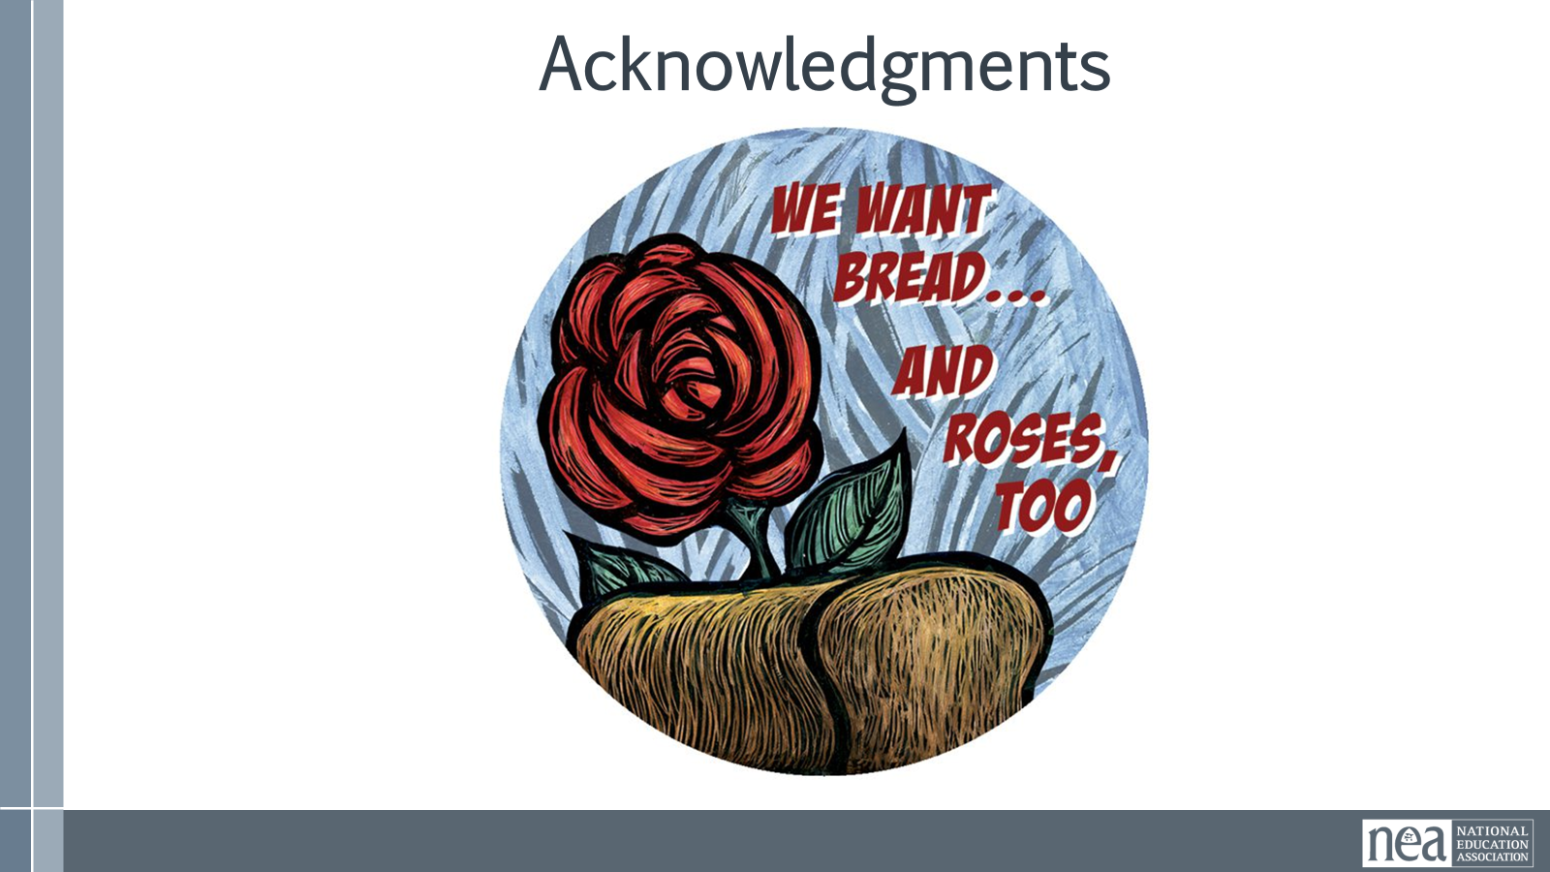  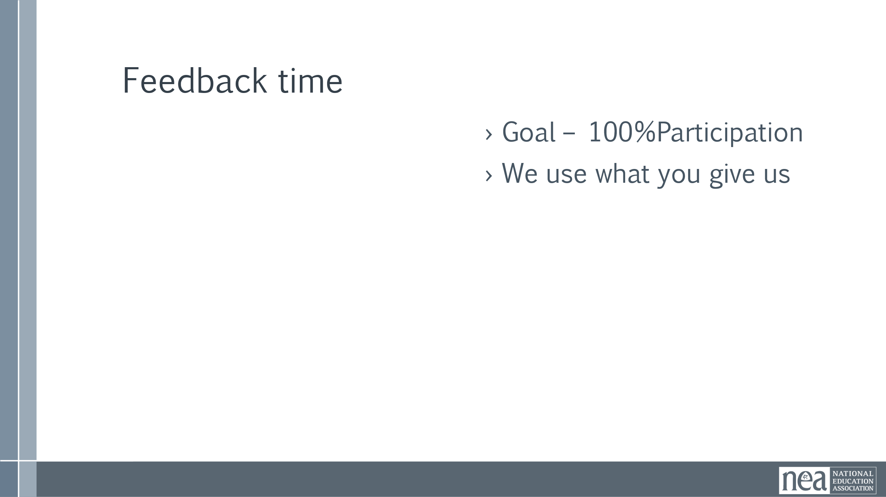  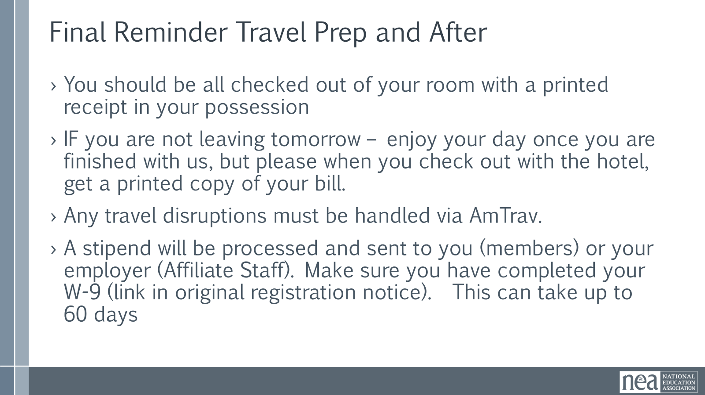 |  | We want to acknowledge the work you have done these past few days.  As a table, come up with one thing that you agree you are all taking away from this training.  Share the evaluation QR Code  Make sure the Campaign Lab QR Codes work  Final Reminder – Travel and After
1:00 -2:00 Adult Choice Networking – lunch is on your own
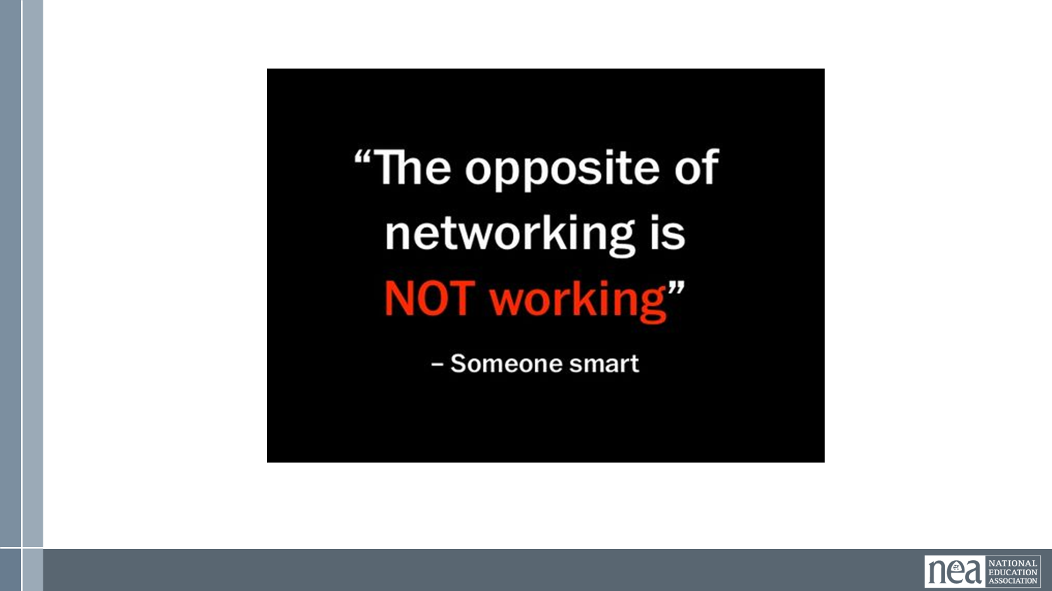
2:00 ADJOURN

