Day 2 Facilitator Agenda - Coaching Academy
General Materials Needed: |  |  |  |  |  | Room Set-up: 80 people max
Name Tents with the Norms  Room signs  Chart Paper (10 full w Sticky Strip)  Printer paper (enough for each participant) |  |  | Materials Box for each table with:  Markers (Mr. Sketch variety)  Lots of Post its – 3x3” and 4X5” sizes |  |  | Long Rectangle table at back for facilitators  Round Tables for participants  Projector, Screen, mics, and Speakers  Carousel stations and reporting stations
Key Outcomes for the Event:
Participants will: Feel prepared to coach a leader towards deeper clarity and growth.
DAY 2 Outcomes
- How to move from service to a high participation model.
- Understanding the steps and stages of a campaign.
- Practicing coaching to a campaign (diagnosis, intervention, & guiding questions to ask).
- Using an assessment to assess your skills as a coach.
- Exploring coaching different parts of a campaign.

DAY 2: SATURDAY March 14th Overview of Content, Time, and Facilitator Assignment Nearly all page numbers listed in the facilitator agenda are incorrect- please check with the 00 Participants Handouts File
7:30 - 8:30 - Breakfast  8:30 - 9:00 – Getting Started  9:00-10:00 – Coaching Practice  10:00- 10:30 Coaching Debrief  10:30 -10:45 BREAK  10:45-11:45 - Service to High Participation Model  11:45-12:00 Overview Campaign Cycle |  | Melissa and Amanda  Jeny  Dr. Taraja  Katie B. and Serafina  Rita |  |  | 12:00 -1:00 - Lunch  1:00 – 1:45 – Curiosity and the Campaign Cycle  1:45 – 2:15 - Stages of a Campaign Practice  2:15 – 2:30 – Break  2:30 – 3:15- Coaching High Participation  3:15 – 4:00 - Coaching Self-Assessment  4:00 - 4:30 - Homework & and Wrap Up  4:30 - 5:00 - Adult Choice Networking  5:00 - Adjourn |  | Joshua and Rita  Yvie  Katie B.  Scott  Melissa and Amanda
Time Slides Facilitator | Resources |  |  | Instructions, Activity and Debrief (Facilitator Script) |  |  |  | Essential Questions and Outcomes
 | Charts, handouts, articles, materials, slide |  |  | What are you saying, what are they doing, what questions will you use to guide learning and make clear the important points  Include an estimate for how long each section of the learning will take |  |  |  | What question(s) will this learning answer? What will participants know or be able to do?
7:00 -8:30 – Team prep, practice, room set up, sound check, etc. and Breakfast
Entry Activity
8:30 -9:00 |  |  |  | 30 Mins TOTAL - Welcome and Feedback
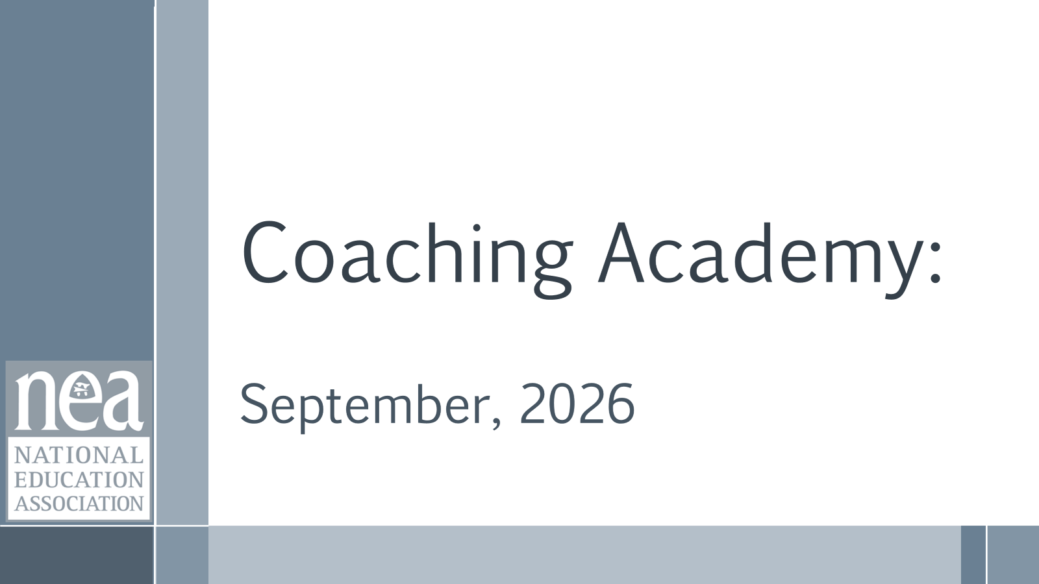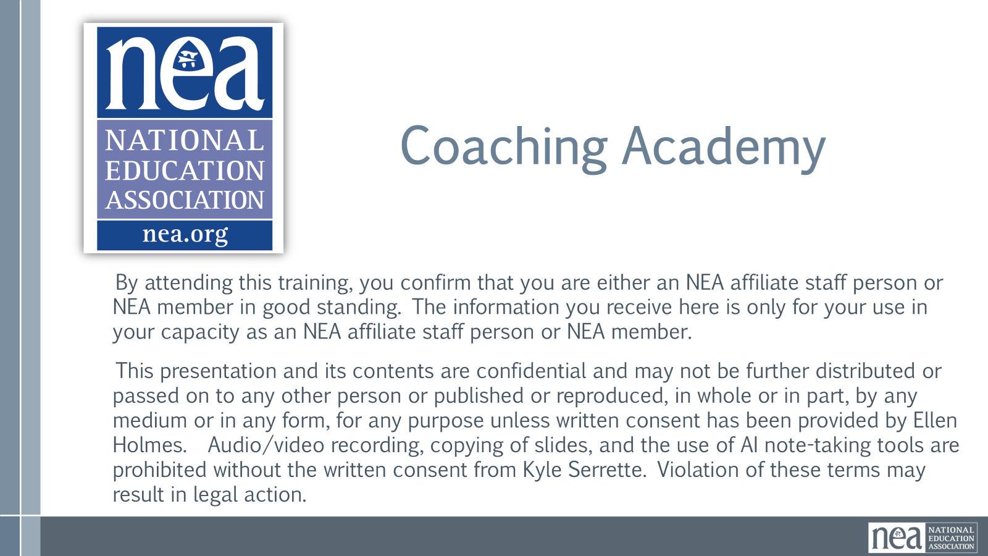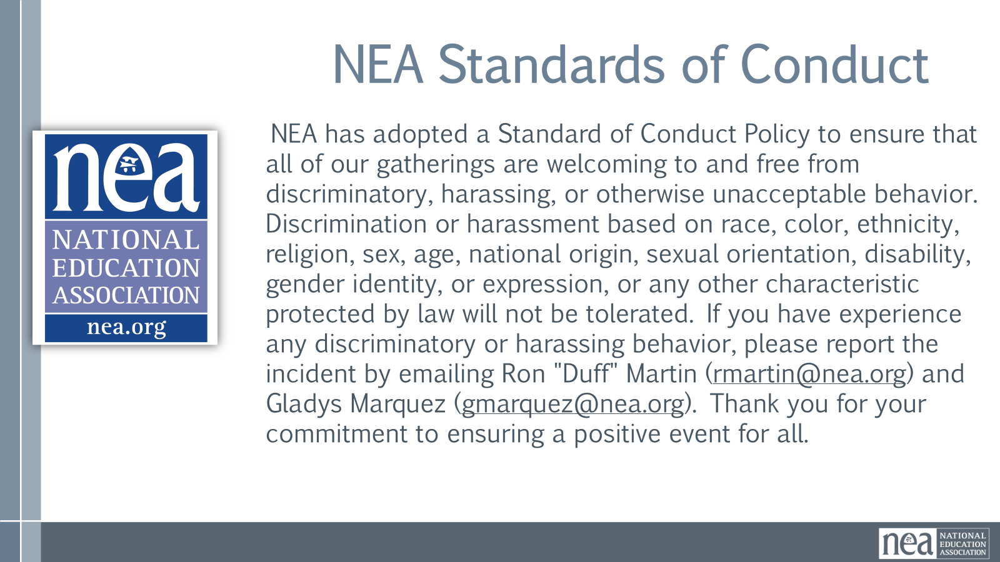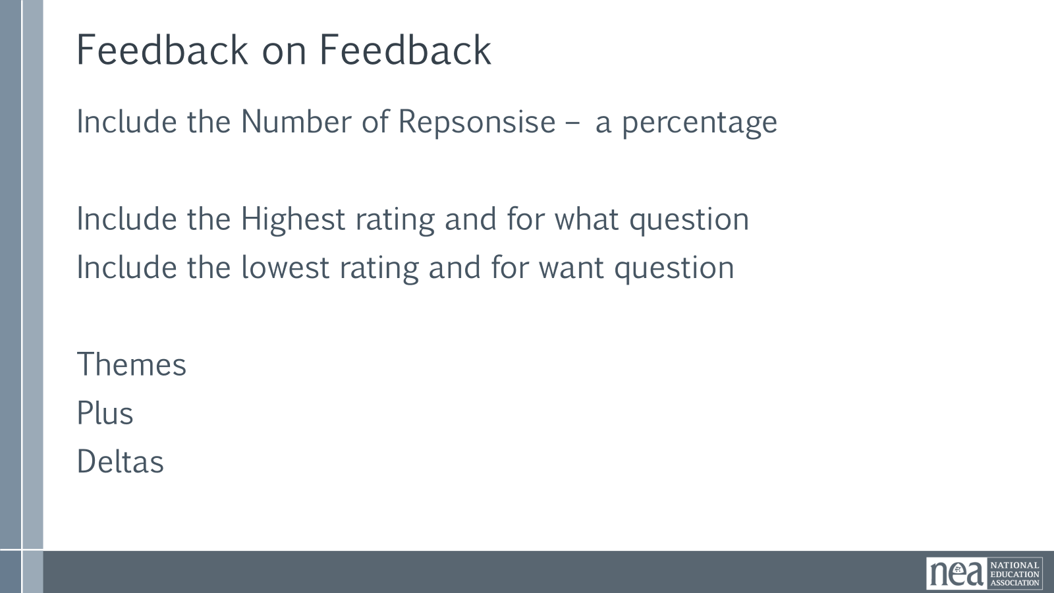  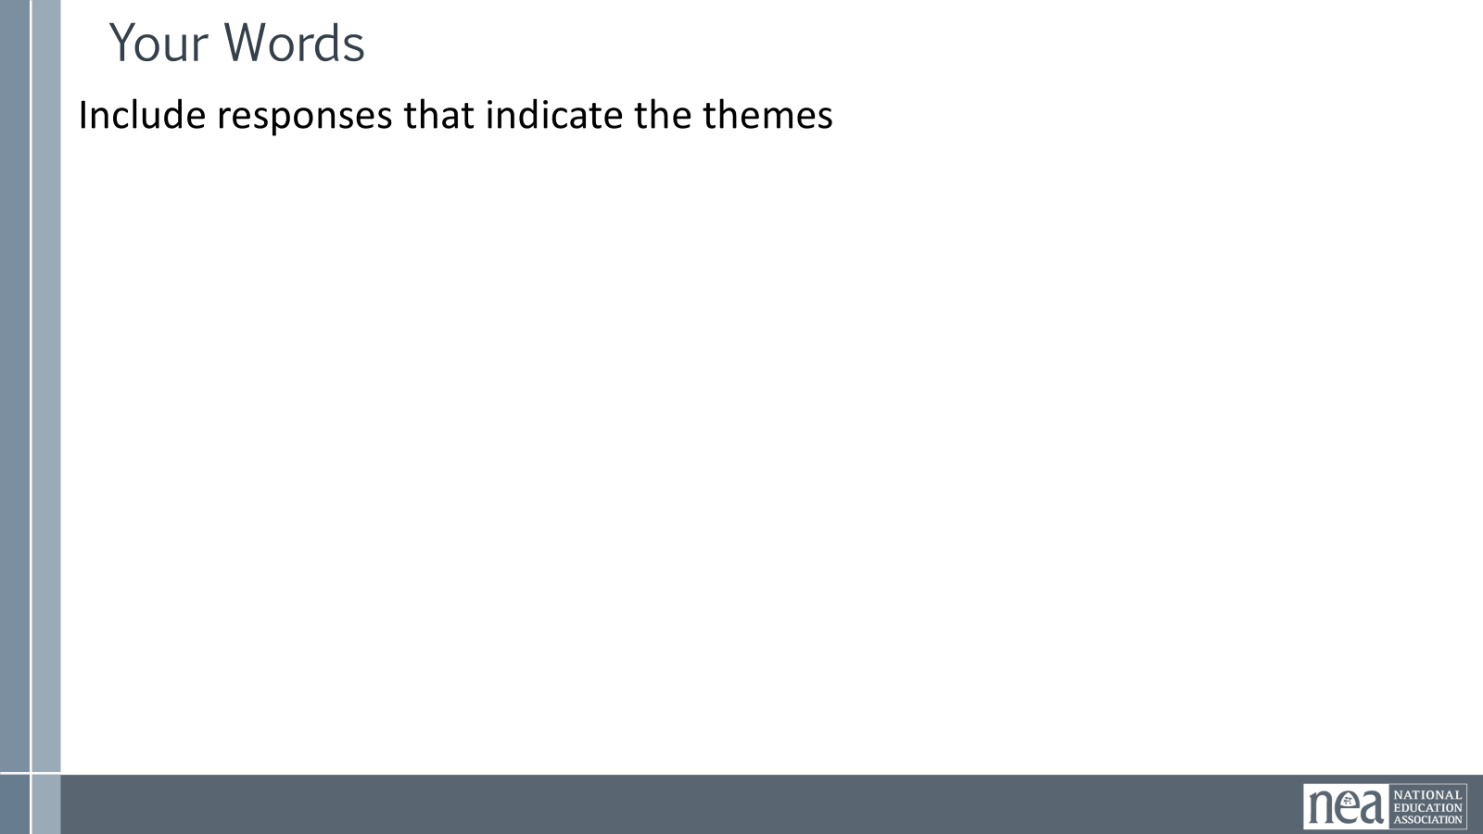    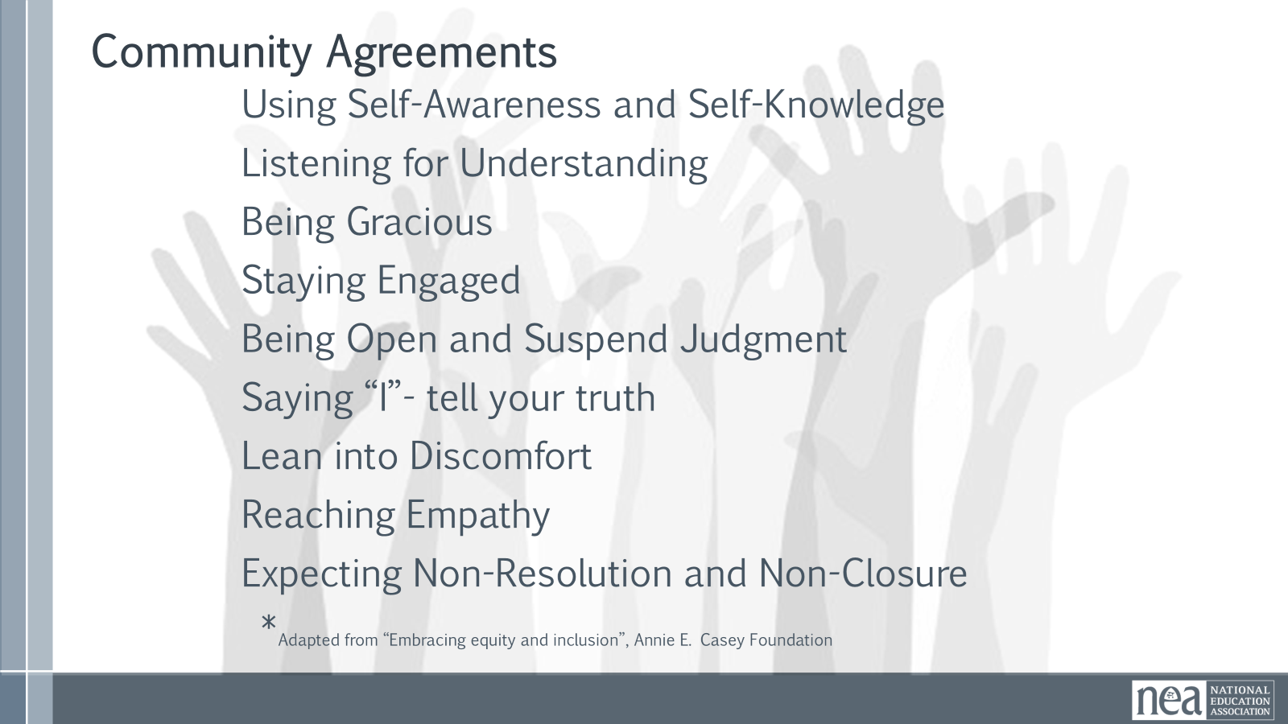  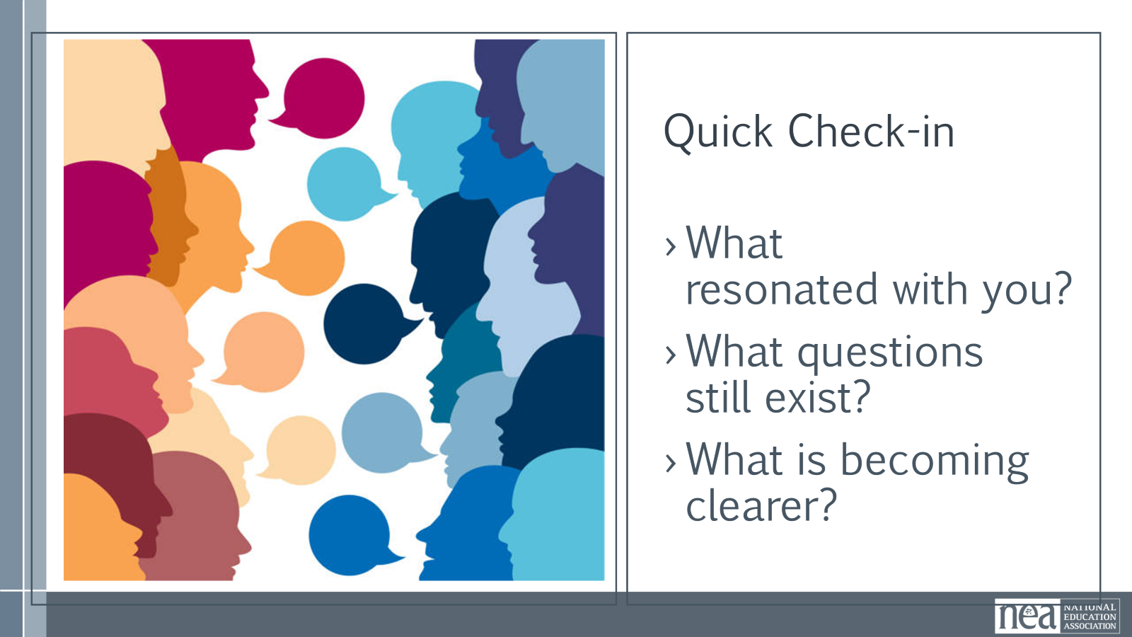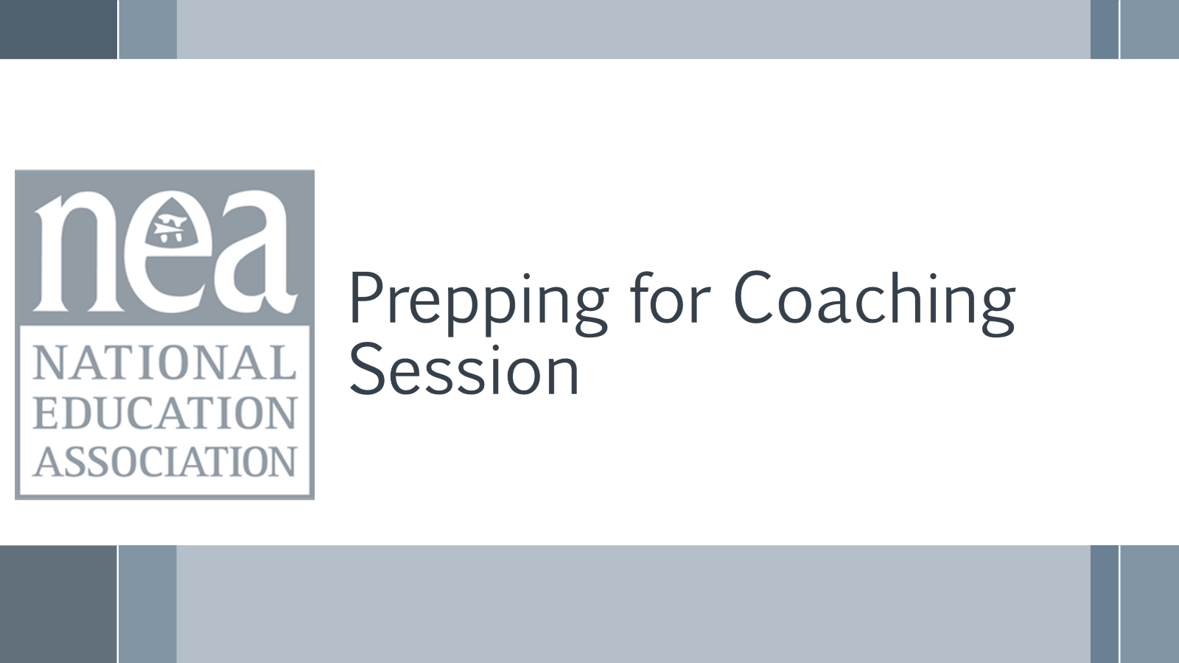  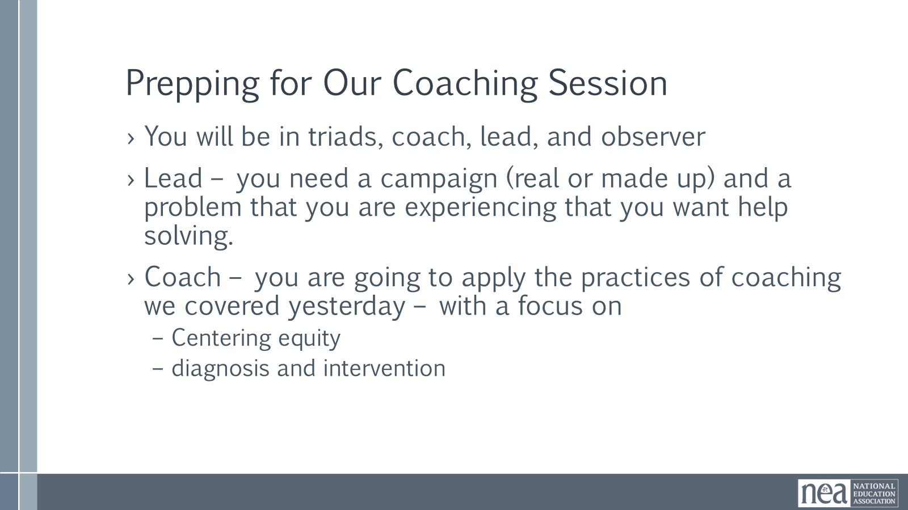 |  |  |  | 10 Minutes Opening:  Feedback on Feedback  Review Agenda for the day  Review Community Agreements  Quick Check in  - What resonated with you?  - What questions still exist?  - What is becoming clearer?  Prepping for Coaching Practice  Now is the time to get yourself ready for applying what we discussed yesterday: centering equity in your coaching, the coaching meeting, applying the coaching cycle, determining a diagnosis, and identifying an intervention. You will take the next few minutes to gather what you like to use when you are coaching, or what you think you would like to use, and you are going to get your head set in being a team lead who came to receive some coaching. Take time to think about the following: What is a real challenge you are experiencing your coaching work or in moving a union campaign along, or in doing something that leads your union work. Some of you are going to be stuck on – I don’t have anything yet – and that in and of itself is a challenge. So, think about what you want to be coached on that would get you moving towards the “yet.” Keep in mind, this is real, as most of the team leads you will coach are exactly there -they have turned in an application to the Lab, and don’t really know what to do next. That is a perfectly coachable moment.  10 mins:  Model Coaching Example by Ellen: Coaching and Dr. Taraja: Lead  10mins:  Debrief on Caoching Example |  |  |  | Participants will move into their learning space.
9:00-10:00 |  |  |  | 60 Mins TOTAL–Coaching Practice In Triads
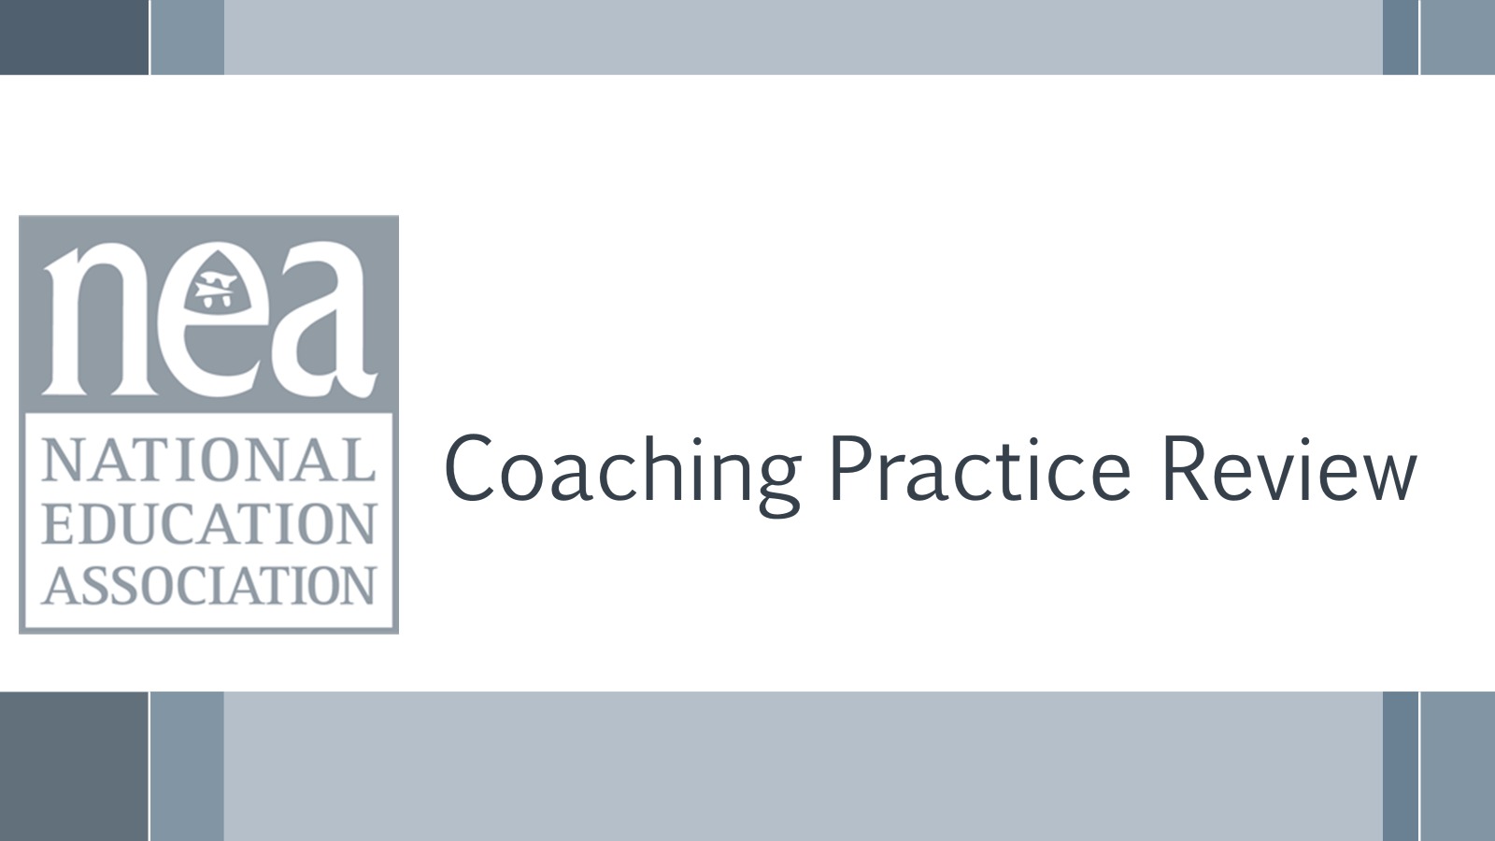  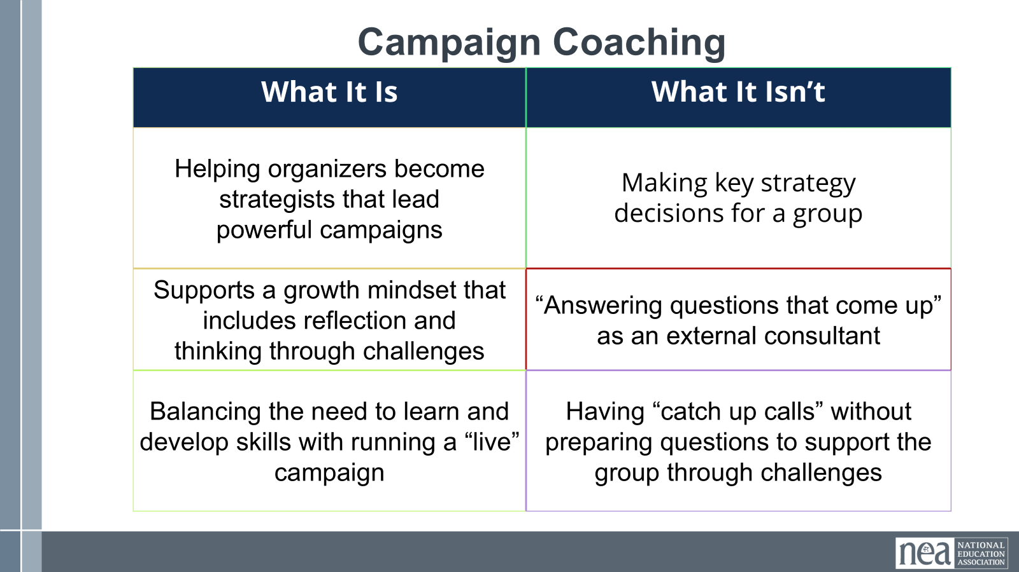  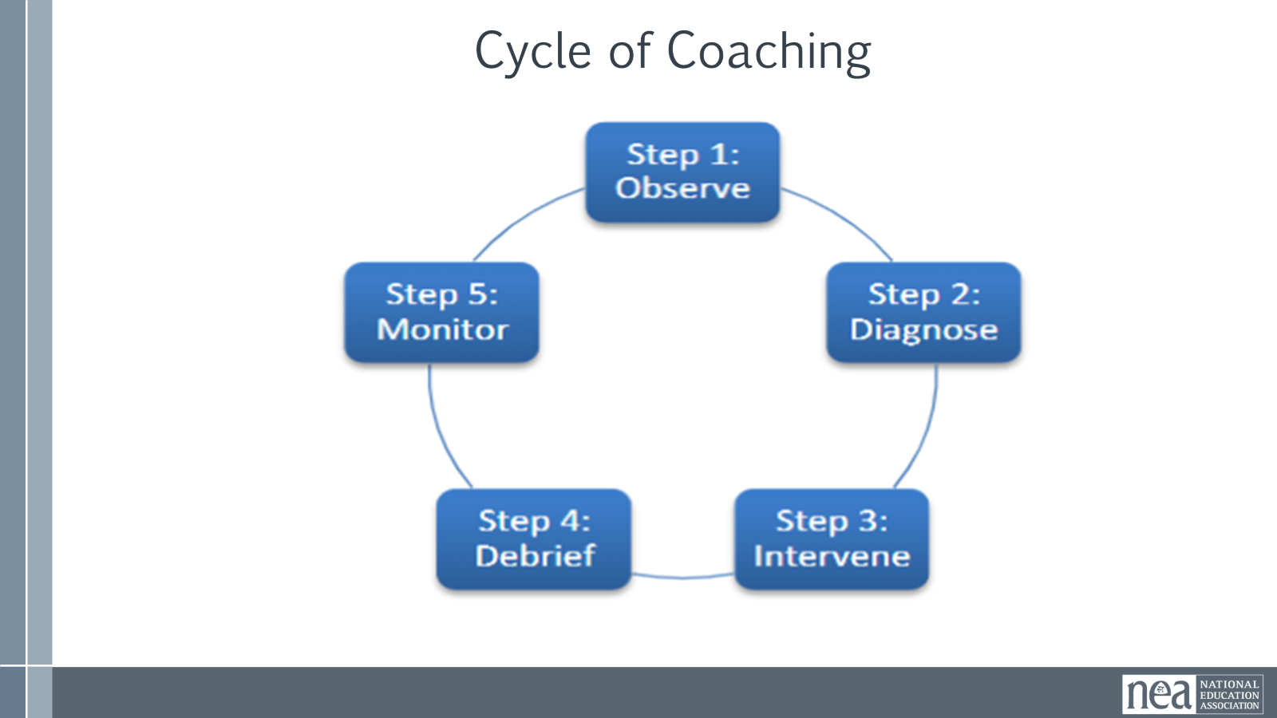  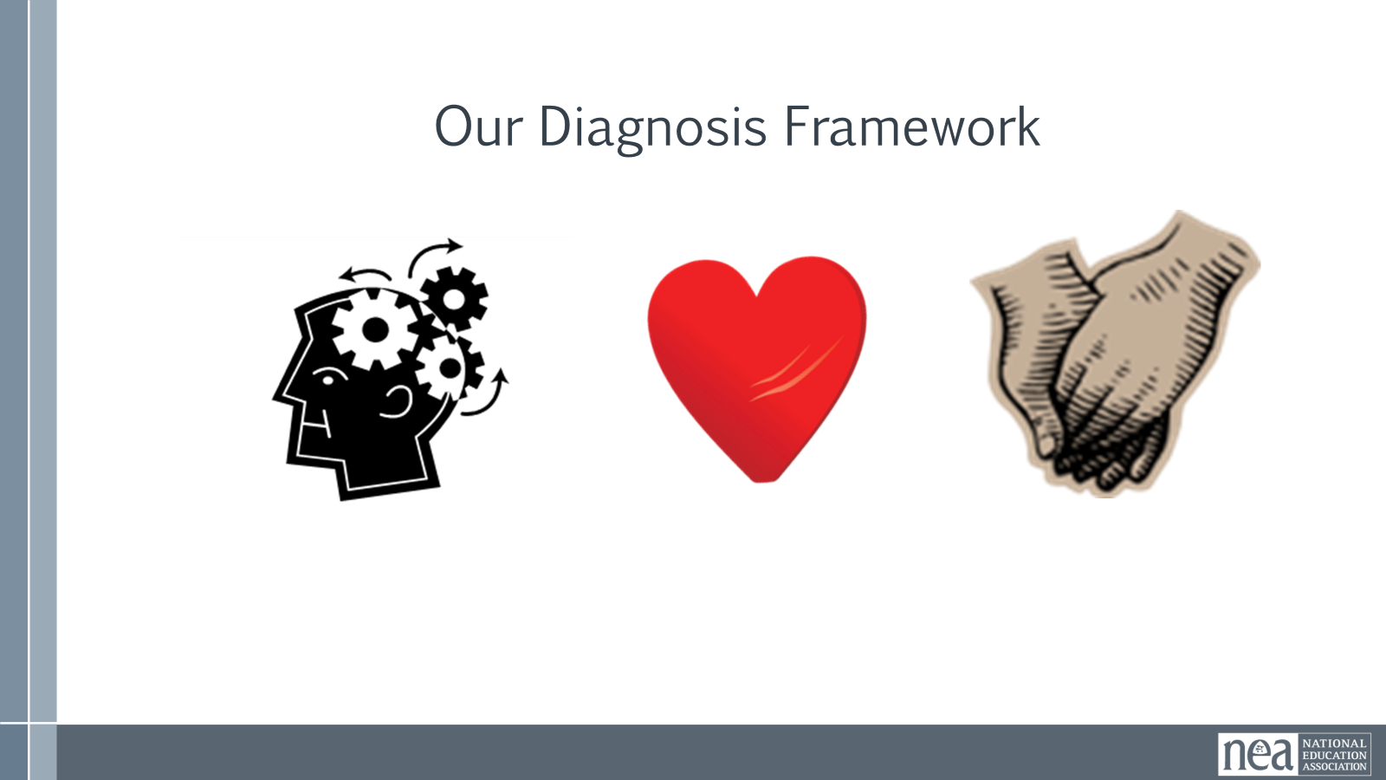  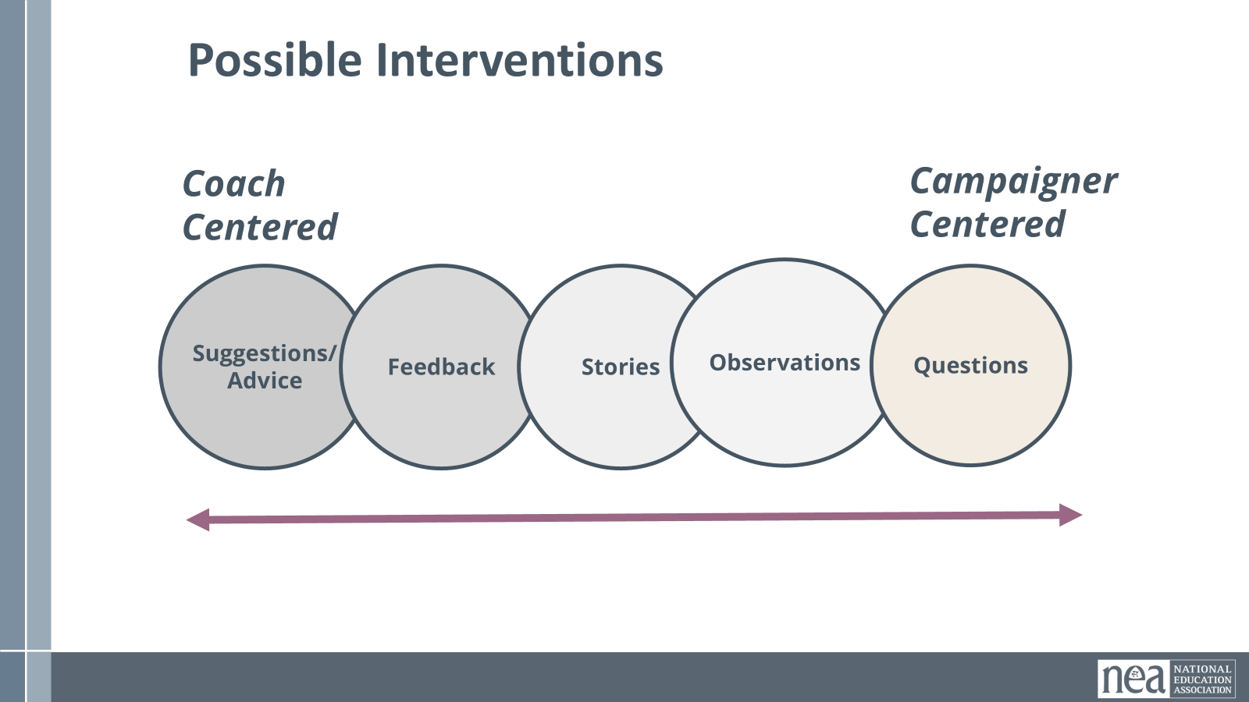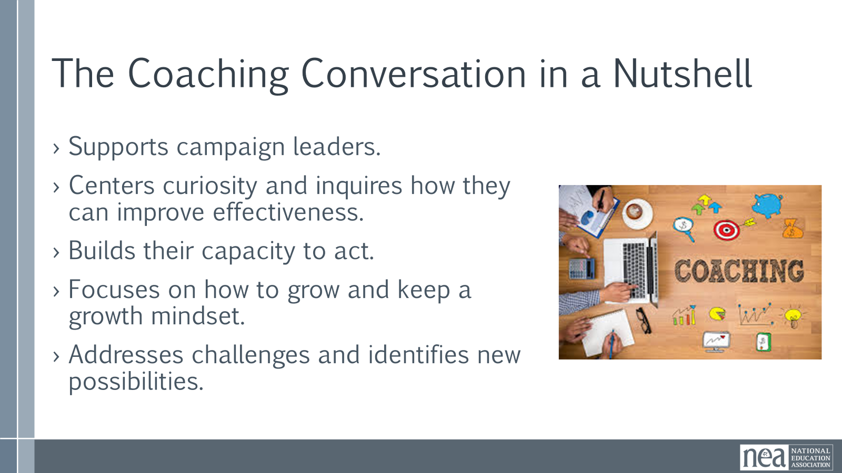  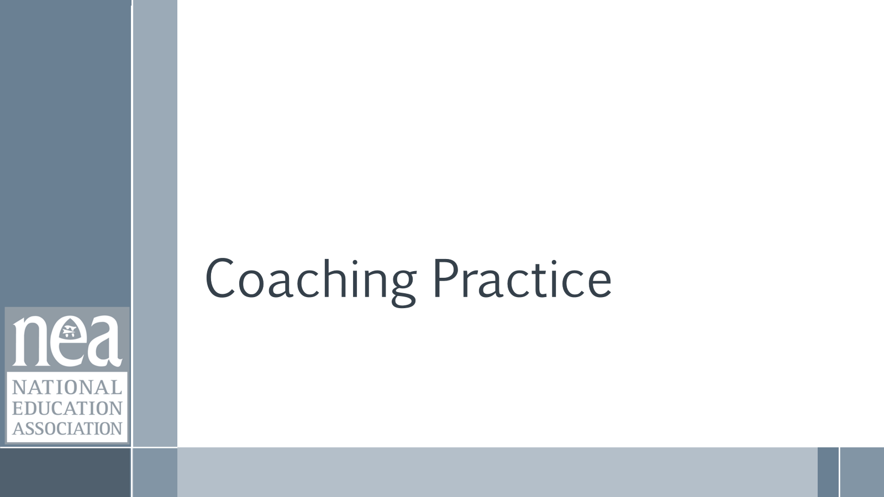  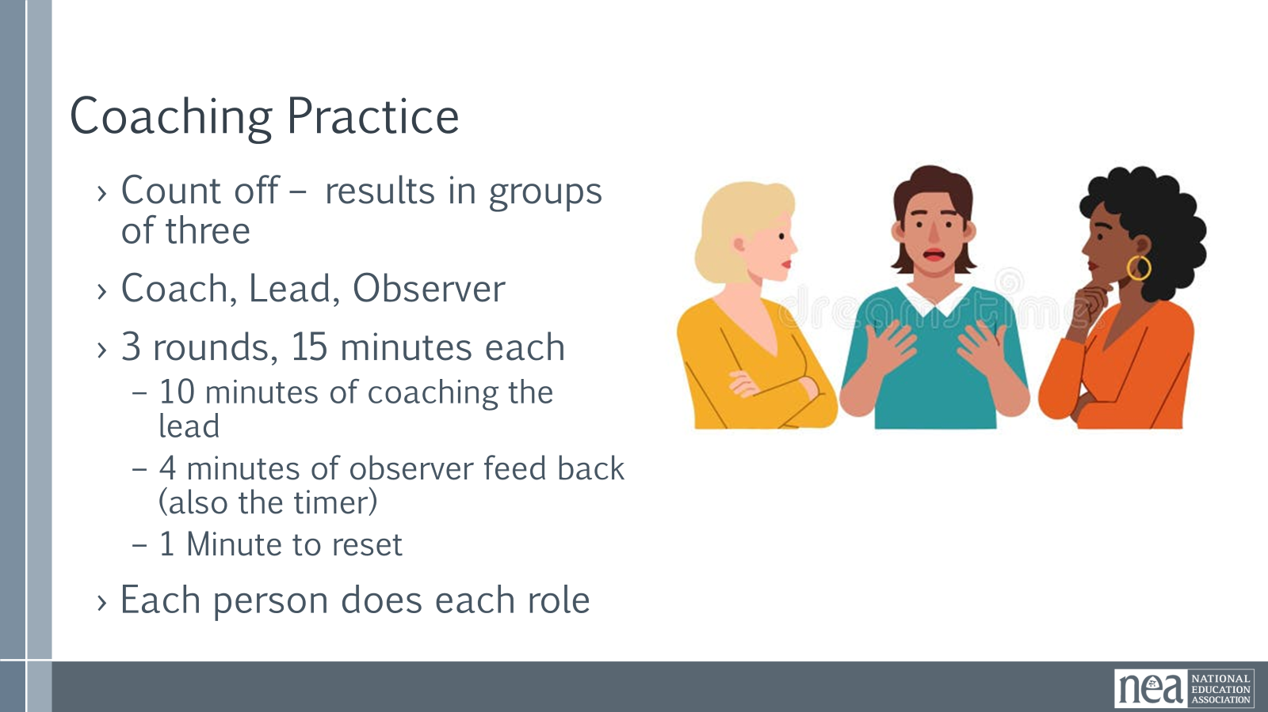  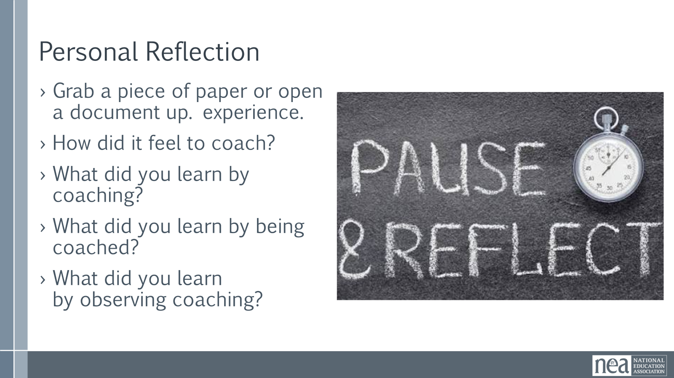 | HP Local Scenario Guide |  |  | 8 minutes – Directions  Let’s review what we discussed.  - Campaign coaching is...and is not...  - Our coaching cycle is…  - Our diagnosis framework is...  - Our interventions are...  - What else?  Coaching Practice in a Nutshell  Supports campaign leaders.  ›Centers curiosity and inquires how they can improve effectiveness.  ›Builds their capacity to act.  ›Focuses on how to grow and keep a growth mindset.  ›Addresses challenges and identifies new possibilities.  Coaching Practice – 60 Minutes  We are going to create groups of three by counting off by 15 [or whatever number makes sense]. Let’s start here. [Count off.] Move to your group but stay in this room.  For your practice this afternoon, please try two things. One, the coach is only allowed to ask questions. Second, they can ask the observer for a lifeline if needed.  One person will be the coach, one the coachee, and one the observer. The observer should use the observer feedback questions on PAGE 90 to frame their observations and offer feedback at the end.  You’ll have 10 minutes for the coaching conversation and 4 minutes for feedback from the observer and discussion. Then, you’ll repeat this twice more, shifting roles as you do. We’ll keep time for you. What questions do we have before we start?  42 minutes – Practice [facilitator keeps time, giving 1-minute warnings for both coaching and debrief]  Round 1: 10 minutes coaching, 4 minutes debrief  Round 2: 10 minutes coaching, 4 minutes debrief  Round 3: 10 minutes coaching, 4 minutes debrief  5 minutes – Individual Reflection  Now that you’ve finished your coaching practice, return to your seats. [1 minute for transition time].  Grab a piece of paper or open a document up. Take 4 minutes to free write about that experience.  How did it feel to coach?  What did you learn by coaching?  What did you learn by being coached?  What did you learn by observing coaching? |  |  |  | Participants will apply all parts of the coaching framework – cycle, diagnosis, interventions.
10:00-10:30 |  |  |  | 30 mins TOTAL - Whole Group Debrief on Coaching Practice
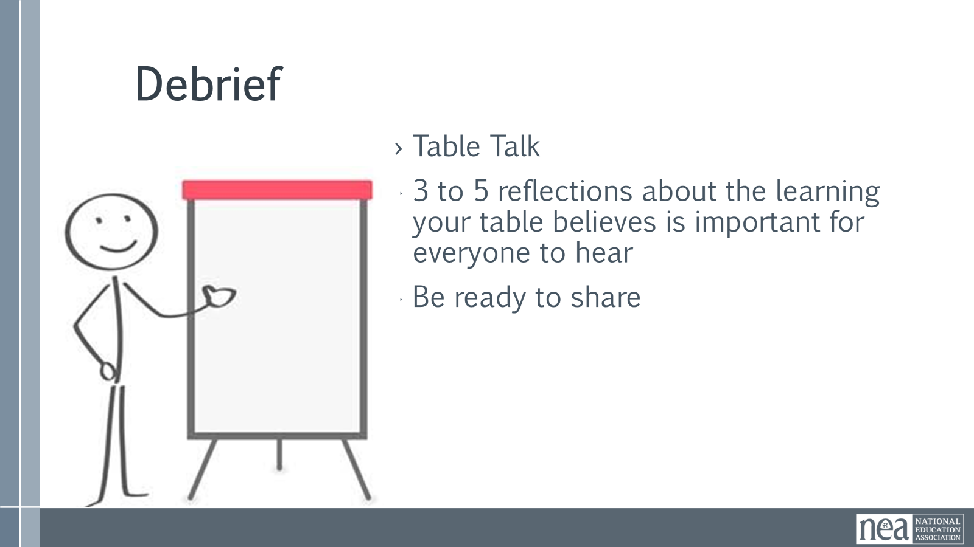 | Need 1 chart paper for each table group |  |  | 1 minute - Directions  Now, we’re going to discuss in your table groups using what you just wrote. Take about 10 minutes to discuss in your group. Come to consensus on 3-5 reflections or learnings about coaching that your group wants to bring into the whole group conversation. Make sure that one person is prepared to share out.  10 minutes – table group conversations  19 minutes – whole group conversation  Now, we’ll have each group share out the reflections or learnings they identified. Let’s start here. What did your group share about? |  |  |  | Participants will hold a debreif.
10:30-10:45 |  |  |  | 15 Minute TOTAL - Break
10:45-11:45 |  |  |  | 60 Mins TOTAL - Service to High Participation model
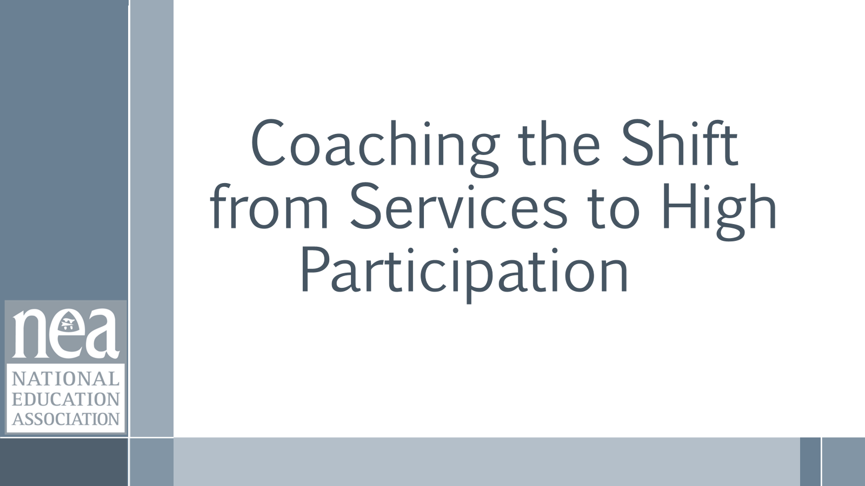  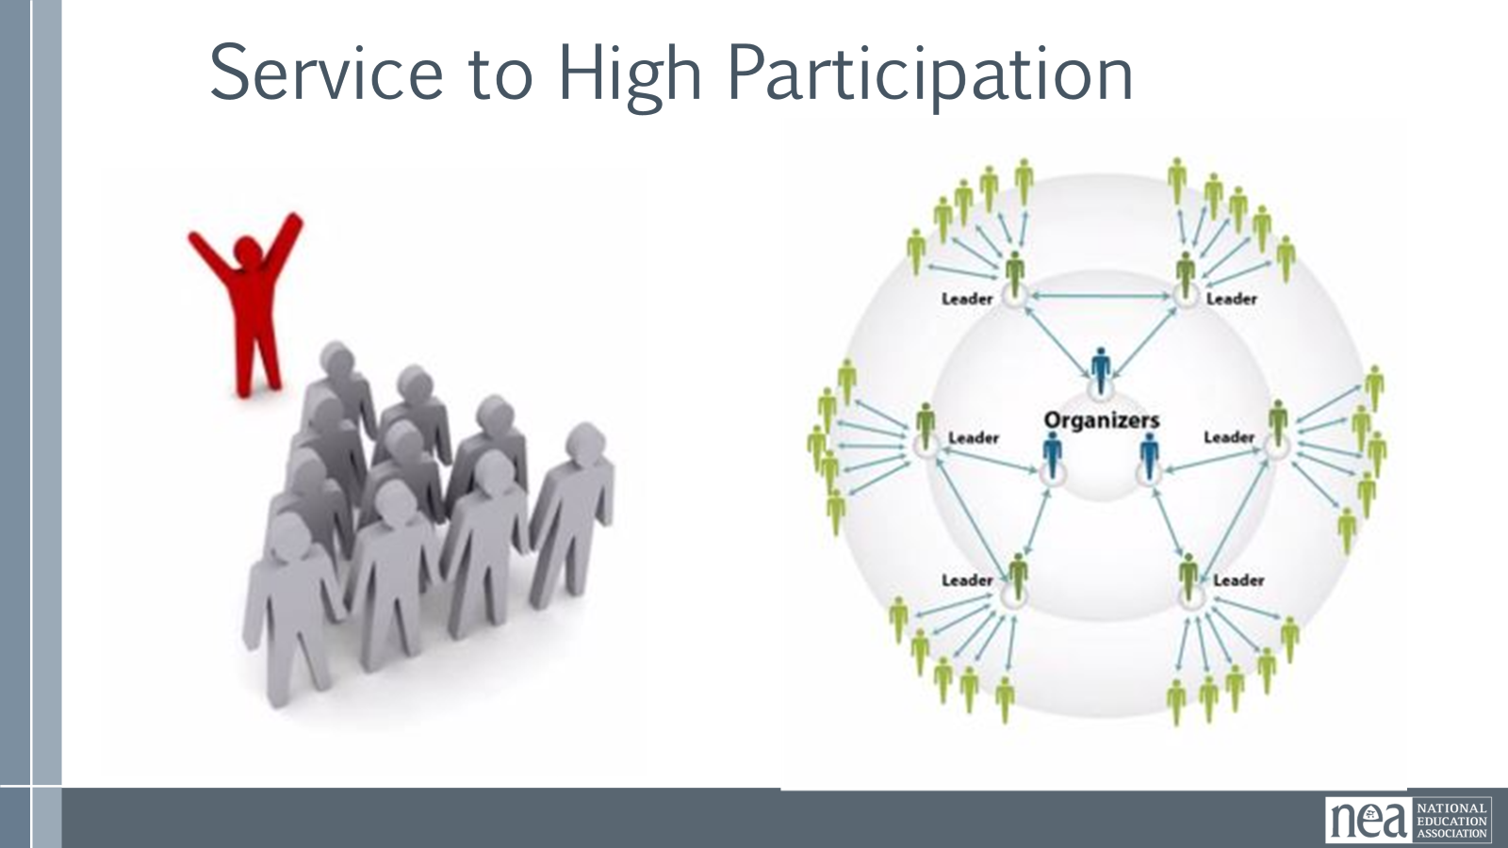  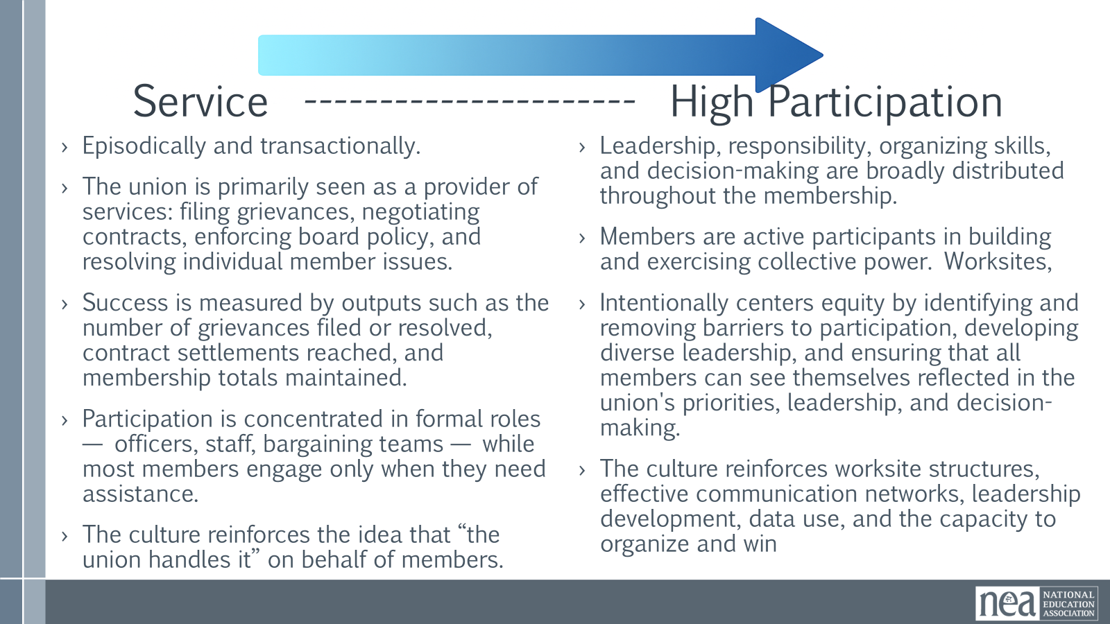  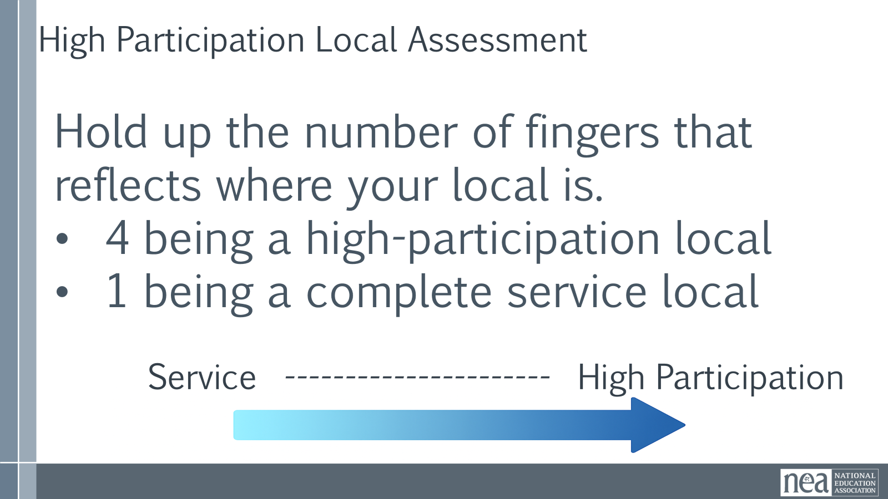  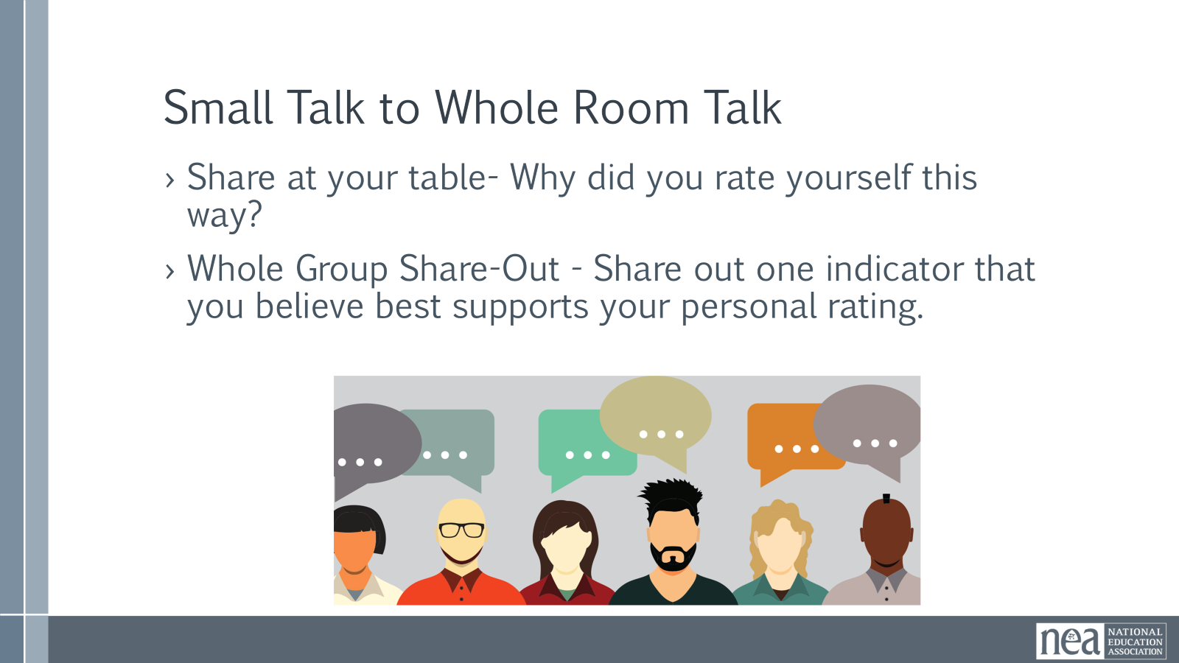  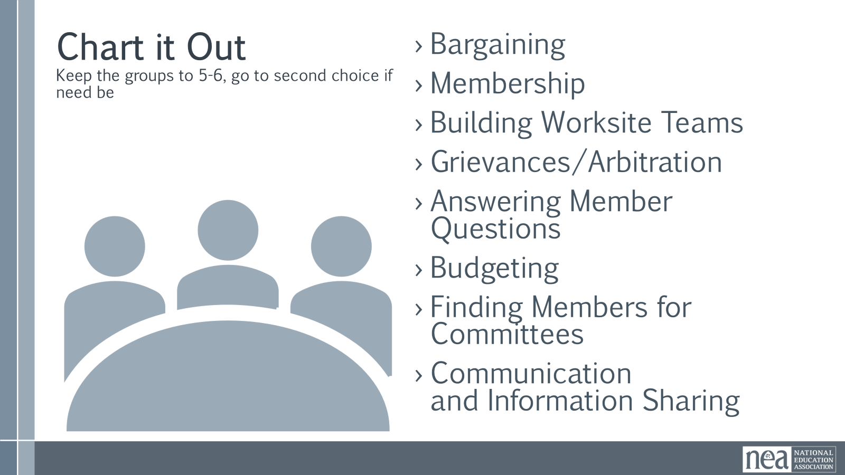  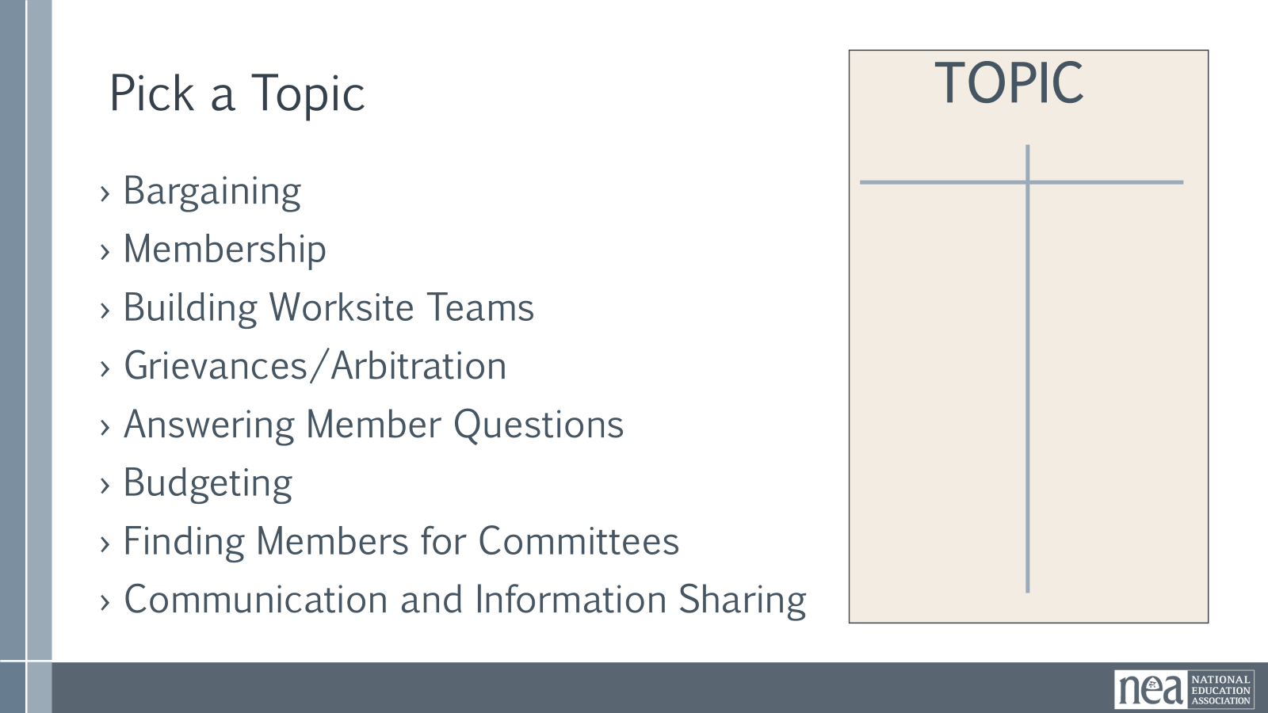  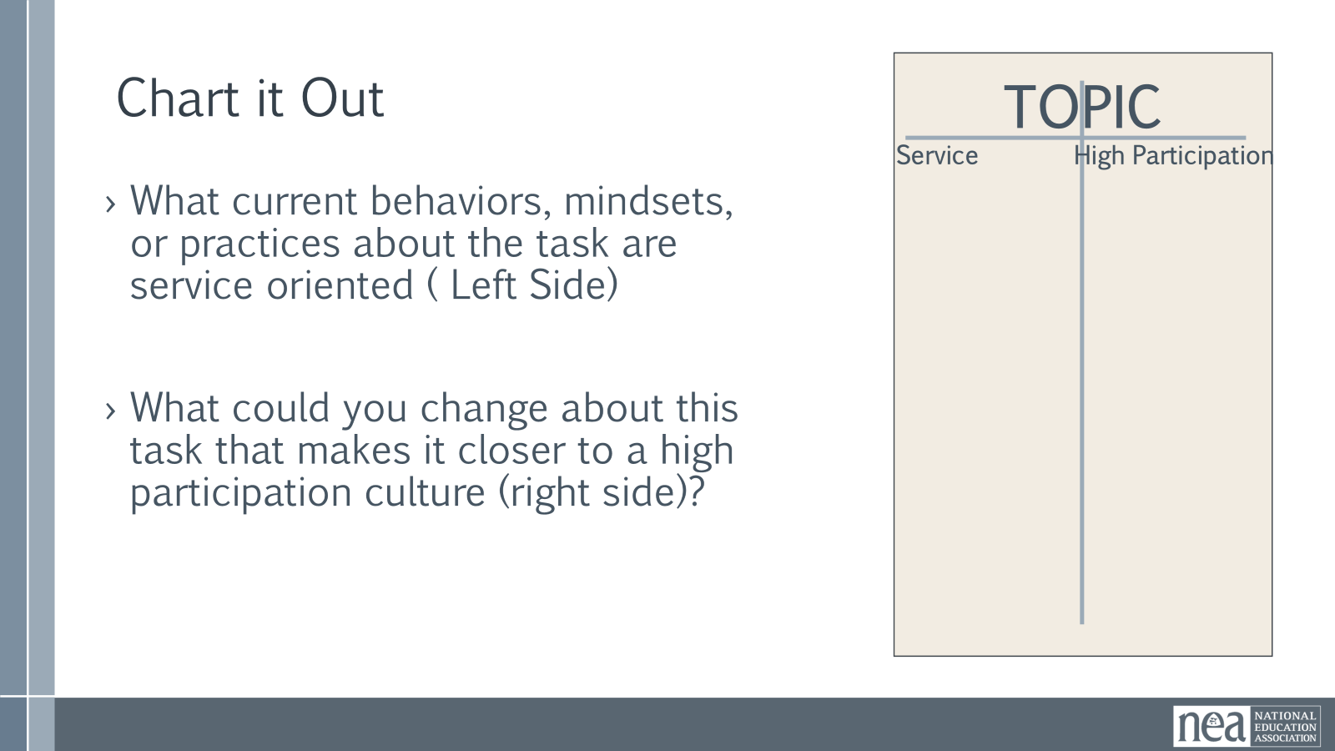  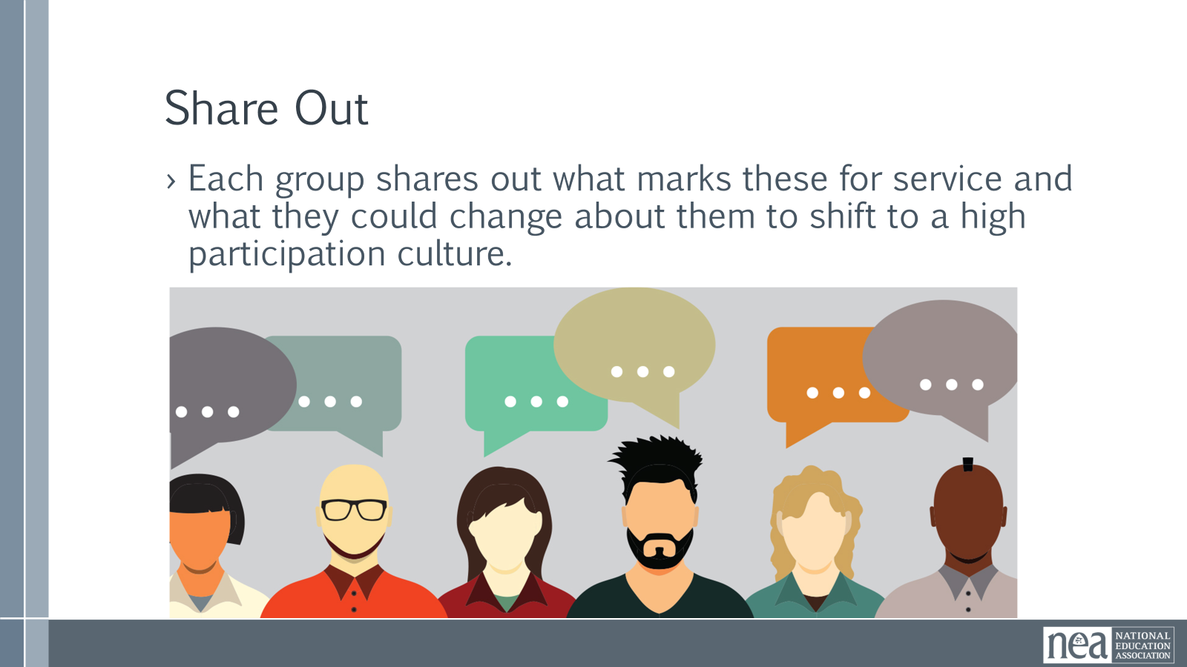  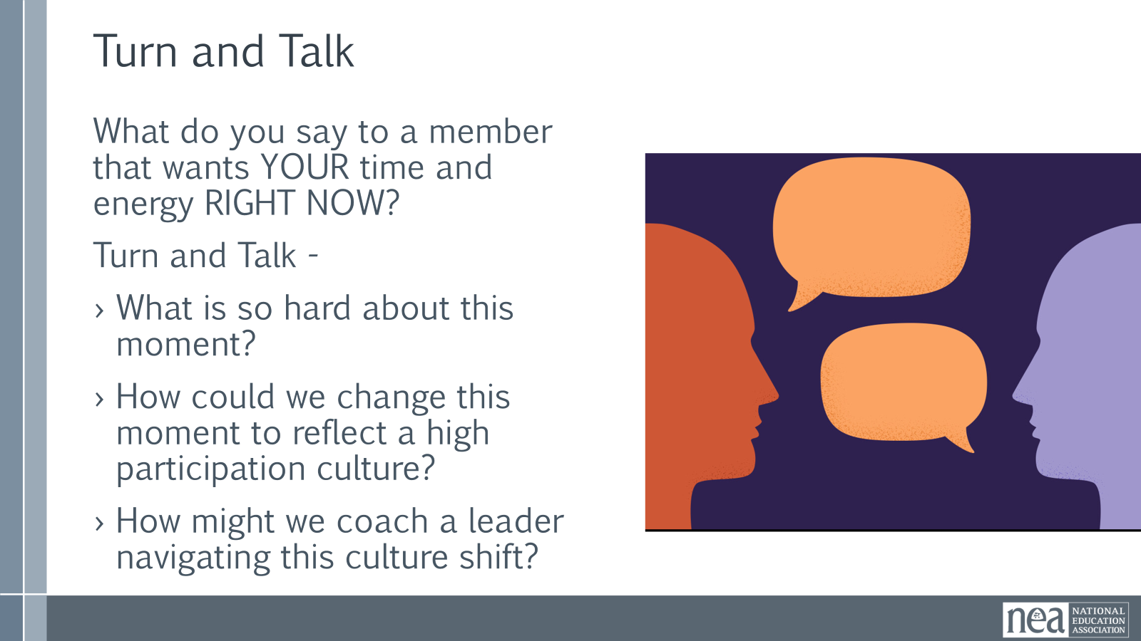  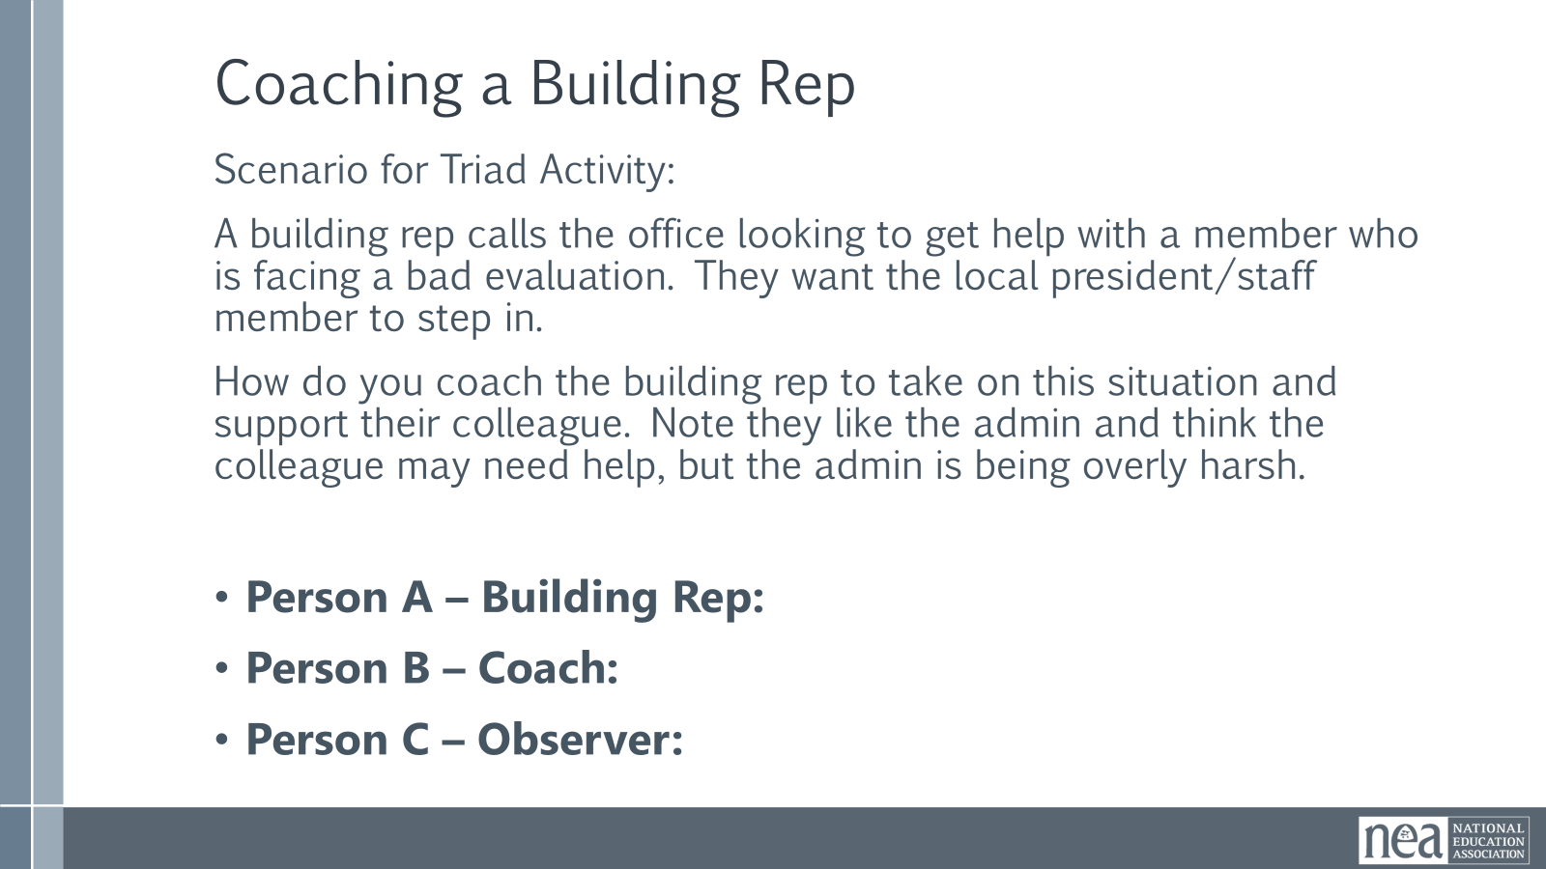  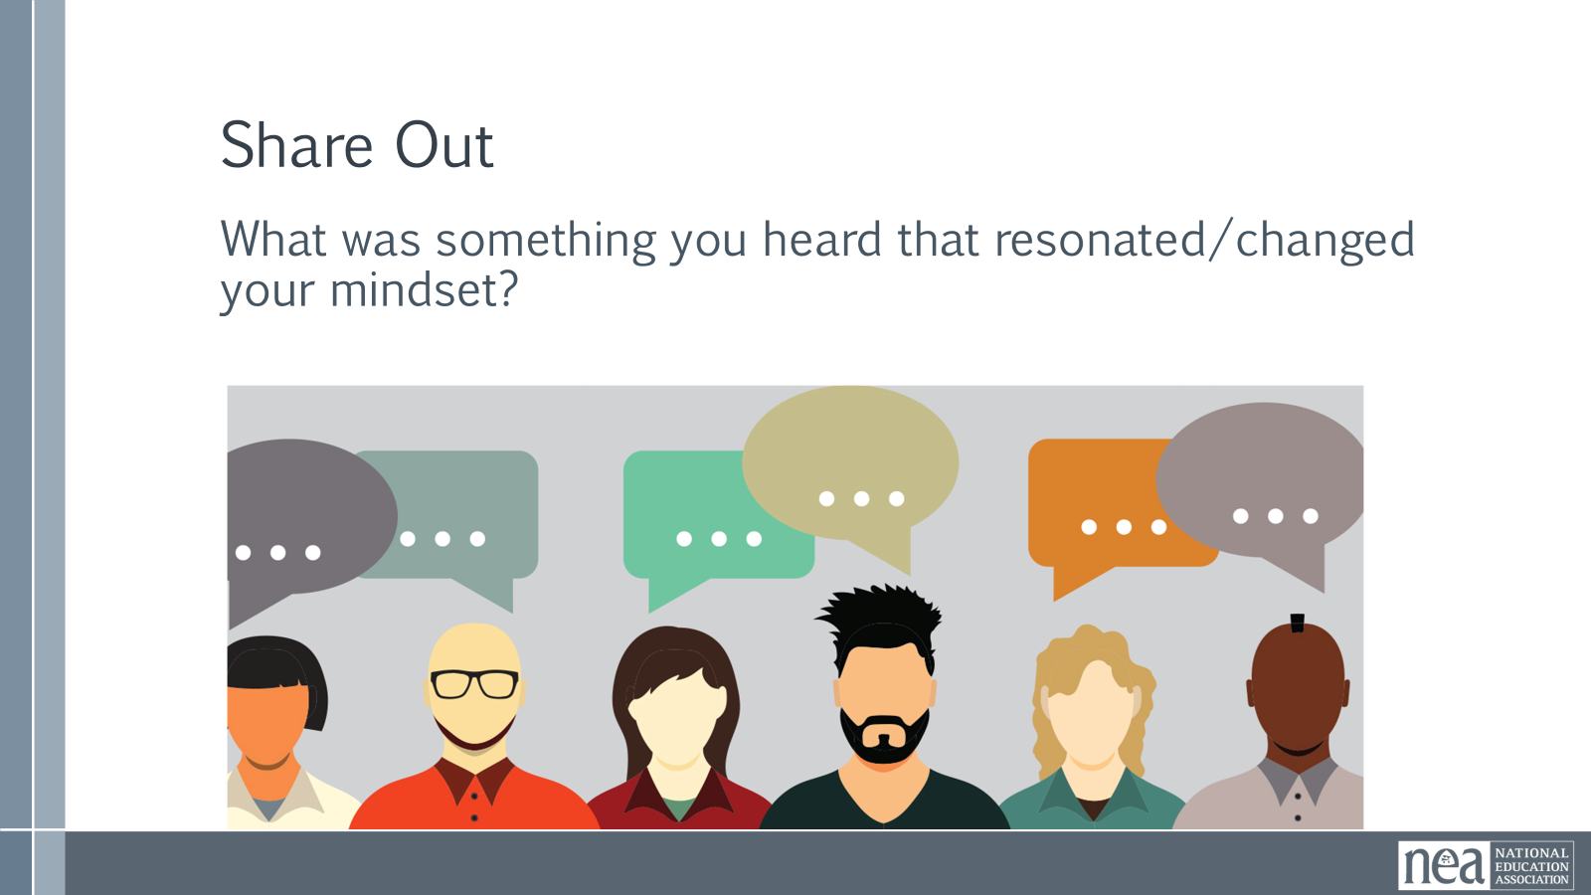  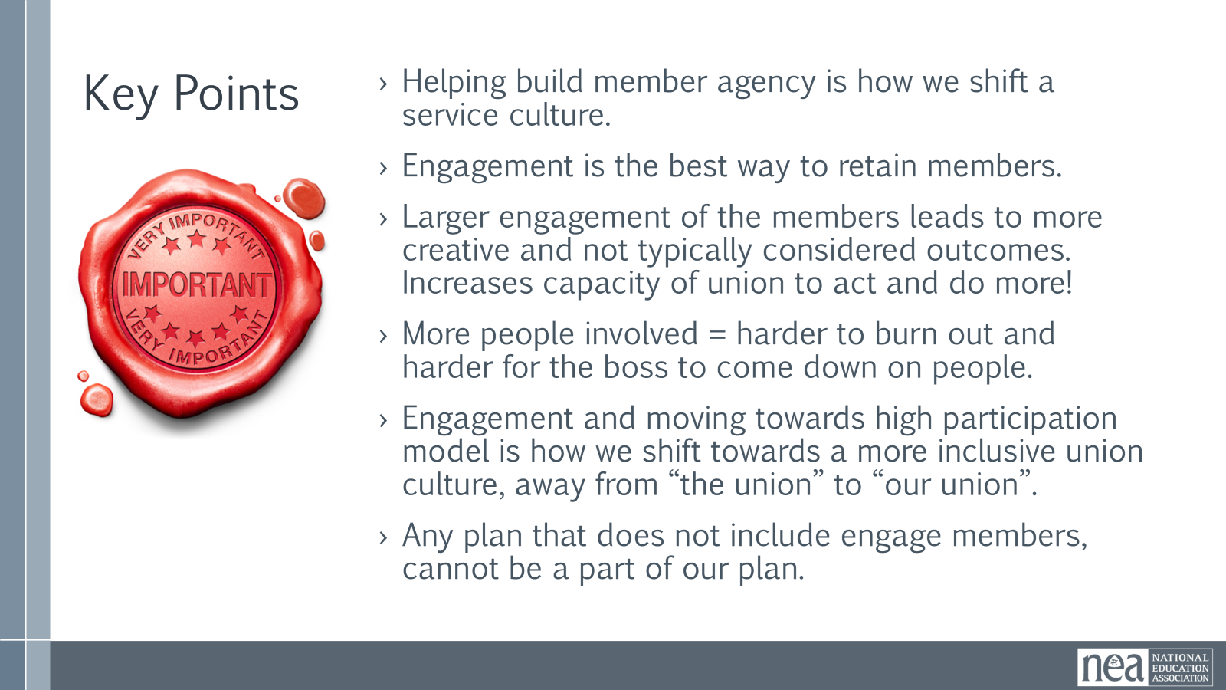 | Need 1 chart paper for each table group  High Participation Local Assessment Tool  Problem Solving: From Good Service to Centering Worker Agency |  |  | Service to High Participation Model – 10 Mins. TOTAL  Introduction – 5 Mins.  Members have expectations of their union. They want services and help. Which is reasonable and will always be a core of our unions' work. However- how we respond to or structure supporting members with their concerns/requests can help transform our unions. Let's start by examining the hall marks of a service culture and a high participation local. If we are going to shift our systems towards being more inclusive, empowering members, increasing engagement, and getting members to own the work, the move towards a high participation model is critical.  Service model is episodic. Focused on numbers - members, grievances solved/filed, bargaining, participation is linked closely to established roles, information is funneled through only a few select positions, focused on delivery of support or contract/board policy enforcement. Bargaining is led by staff and a few members.  A High Participation Local is a union where leadership, responsibility, organizing skills, and decision-making are broadly distributed throughout the membership rather than concentrated in a small group of officers, staff, or activists. Members are not simply recipients of union services; they are active participants in building and exercising collective power. The local has strong worksite structures, effective communication networks, ongoing leadership development, strategic use of data, and the capacity to organize around workplace, political, and community issues. A high-capacity local also intentionally centers equity by identifying and removing barriers to participation, developing diverse leadership, and ensuring that all members can see themselves reflected in the union's priorities, leadership, and decision-making.  Share Out – 5 Mins.  Looking at the slide and the definitions, on the spectrum- Where would you place your local?  Hold up a hand that reflects where your local is. 4 being a high participation model and 1 being a complete service model.  Share at your table- Why did you rate yourself this way?  Whole Group Share-Out - Share out one function that you believe show cases your personal rating.  Activity – 20 Mins. TOTAL  Instructions – 5 Mins.  Take an activity your local consistently does. Allow people to self-select to review the following topics (or have them choose):  - Bargaining  - Membership  - Building Worksite Teams  - Grievances/Arbitration  - Answering Member Questions  - Budgeting  - Finding Members for Committees  - Communication and Information Sharing  Activity – 10 Mins.  Create a T-Chart for each activity: What are some current hallmarks of this task that are a service culture (left side)? What could you change about this task that makes it more of a high participation local (right side)?  Debrief – 5 Mins.  Each group shares out what marks these for service and what they could change about them to shift to a high participation culture.  Shifting the Mindset & Culture – 25 Mins. TOTAL  Intro – 5 Mins.  Say out loud: Who here as gotten the call from a member that wants their time and energy RIGHT NOW? Many of us have.  Quick Turn and Talk - What is so hard about this moment? How could we change this moment to reflect a member-led high participation culture? How might we coach a leader navigating this culture shift?  Refer to Problem Solving: From Good Service to Centering Worker Agency article in handouts  Activity - 15 Mins.  A campaign lead is looking to get help with increasing membership and engagement at their local. The local campaign team is willing to build out a strategic plan around bargaining issues but is top-heavy, relying on governance and staff leading the work.  Get into triads- 1 person is the campaign lead, 1 person is the coach, 1 person observes.  Debrief – 3 Mins.  Share out- What was something you heard that resonated/changed your mindset?  Key Points – 2 Mins.  - Helping build member agency is how we shift a service culture.  - Engagement is the best way to retain members.  - Larger engagement of the members leads to more creative and not typically considered outcomes.  - Engagement and moving towards a high participation model is how we shift towards a more inclusive, member-led union culture, away from “the union” to “our union”.  - Any plan that does not include actively engaging members and getting members to lead the work, cannot be a part of our plan. |  |  |  | Participants will learn the difference between the service and organizing models. They will learn how to take a task and change it from a service model to fit into organizing model culture.  Participants will learn to coach members/leaders into building their own agency. Rather than doing for the members (service) they will learn how to coach members to use their agency (organizing).
11:45-12:00 | Rita |  |  | 15 Minutes TOTAL – Overview of Campaign Cycle
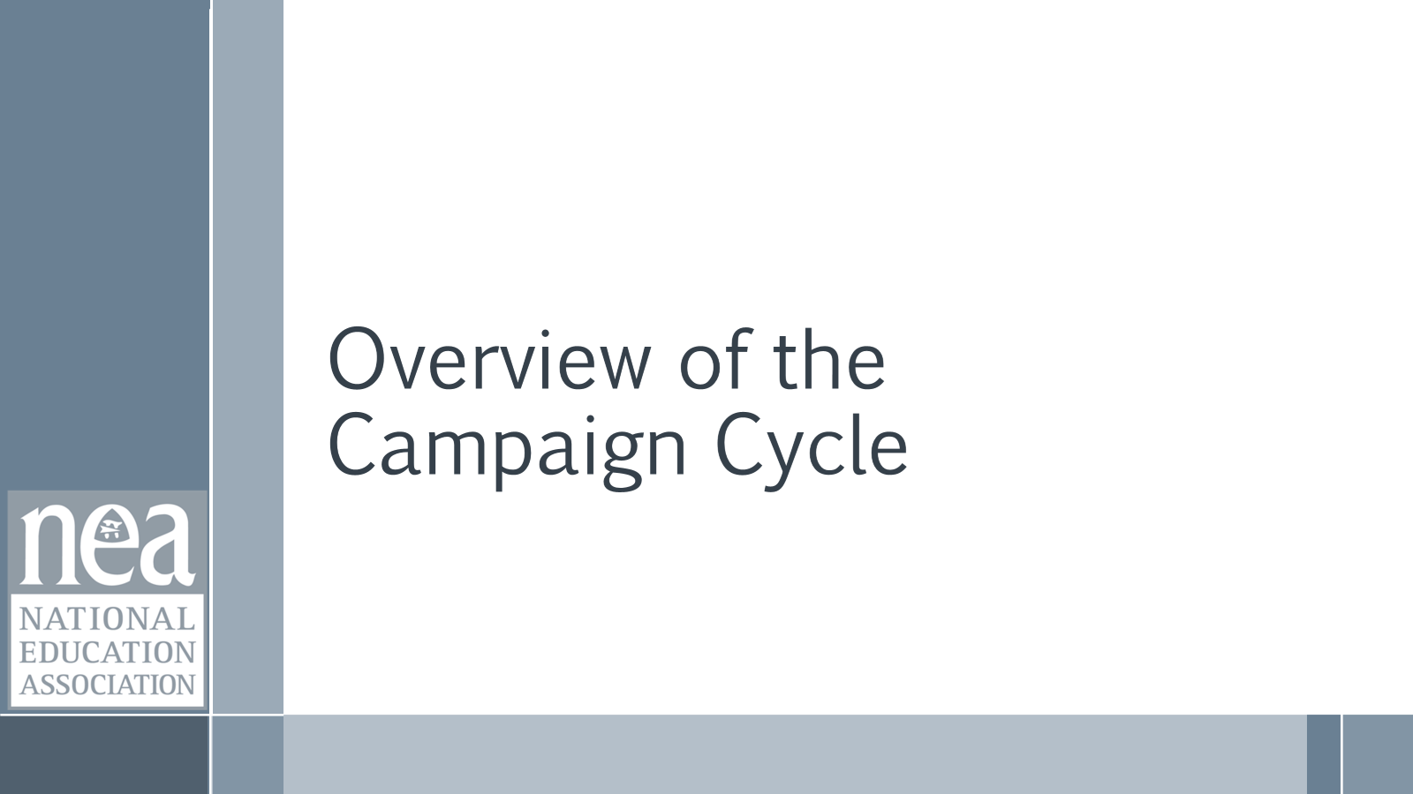  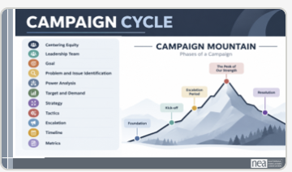  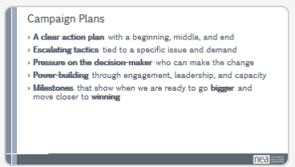  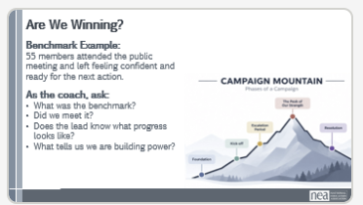  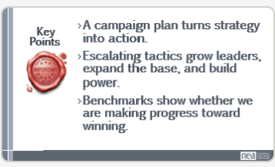  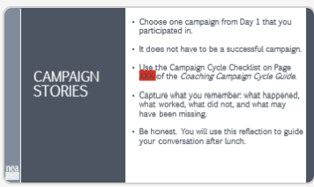 | Pre Attendance – Write your campaign story |  |  | 10 Mins – Introduction  We are going to quickly review the key parts of a well-designed campaign so we can better coach to the campaign cycle. KEY POINT: Campaigns are not perfectly linear. We plan, act, pause, assess our progress, and then decide whether to move forward, escalate, or pivot. That is why Campaign Mountain is an imperfect picture of how campaigns move.  Slide 36: REMEMBER: We Center Equity at Every Phase  - Goal – Define a clear, measurable outcome that tells you whether you have won and addresses a challenge your constituency is facing.  - Problem and Issue – A problem is the larger condition or challenge. An issue is a specific, manageable piece of that problem that people can act on and solve. The same problem may produce different issues depending on who is impacted and how they experience it.  - Power Analysis – Who has decision-making power? Who influences them? What power do they hold, and what power do we have?  - Demand – What specifically needs to change, who must make the change, and by when?  - Strategy and Tactics – How will we win our demand, and who needs to be involved in the fight?  - Target – Who has the authority to make the change? The target must be a person, not an institution. They should have a face, a name, and an address.  - Strategy – The plan for using our power to win the demand. Strategy connects and sequences our tactics so they intentionally build pressure on the target rather than becoming a series of disconnected actions.  - Tactics – The specific actions we take to increase pressure on the target. Tactics should come from our power analysis and put pressure on the target’s self-interest, relationships, influence, or power.  - Escalation – Always plan for what comes next. What will we do if the target says no, delays, or does not respond?  - Timeline – By when do we intend to achieve the goal? The timeline should be specific enough to create urgency, accountability, and measurable progress.  Slide 37: Campaign plans are simple at their core. Every strong campaign should:  - Have a clear beginning, middle, and end focused on winning a specific demand.  - Use a series of escalating tactics that work together to solve a defined issue.  - Increase pressure on the decision-maker (the person with a face and email) who has the power to make the change.  - Build power by engaging more people, developing leaders, and strengthening capacity around shared values and common concerns.  - Identify milestones along the way that show when the campaign has built enough power to do something bigger, stronger, and closer to winning.  Slide 38: Part of our role as coaches is to check in, ask guiding questions, and reflect on progress. Benchmarks help us do that by giving us clear indicators of whether the campaign is moving in the right direction. Most benchmarks are quantitative, but qualitative measures matter too.  Example: 55 members attended the public meeting, and participants reported feeling confident and ready for the next action.  Ask: Are We Building Power?  - What was the benchmark?  - Did we meet it?  - Does the team leader know what progress looks like?  - What tells us we are building power?  Building a culture into our work and our plans of debrief/reflection and being nimble to adjust as needed helps keep us honest. Remember, the numbers tell us a story and checking them is important.  Key Points 1 Minute  - A campaign plan is an action plan for winning a specific demand.  - Escalating tactics build leaders, expand participation, and grow collective power.  - Benchmarks tell us whether we are making progress, building power, and moving closer to winning.  5 minutes - Prep for after lunch  When we return from lunch, we are going to look at the campaign cycle through a real campaign experience.  Choose a campaign you participated in or know about. It does not have to be a successful campaign. You may have led it, supported it, or participated in another role,or read about.  Use the campaign-cycle checklist on Page 26 of the Participant Handout to capture what you remember. Be honest about what happened, what worked, what did not, and what may have been missing. You will use this reflection to guide your conversation after lunch.  (I SUGGEST THAT THEY WRITE THEIR CAMPAIGN STORY BEFORE THEY ARRIVE) |  |  |  | Participants will be able to name the parts of the campaign cycle and discuss the importance of benchmarks for each step.
12:00-1:00 |  |  |  | Lunch
1:00-1:45 |  |  |  | 45 Mins TOTAL – Practicing Curiosity with the Campaign Cycle
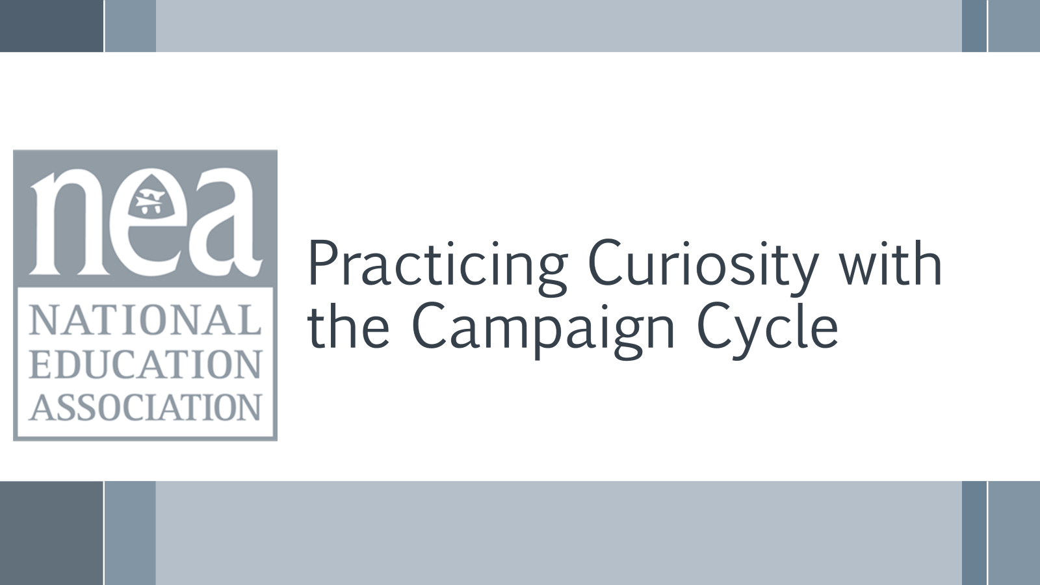  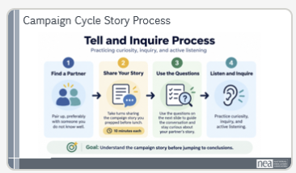  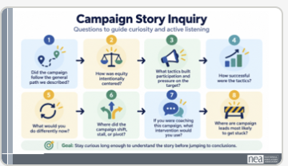  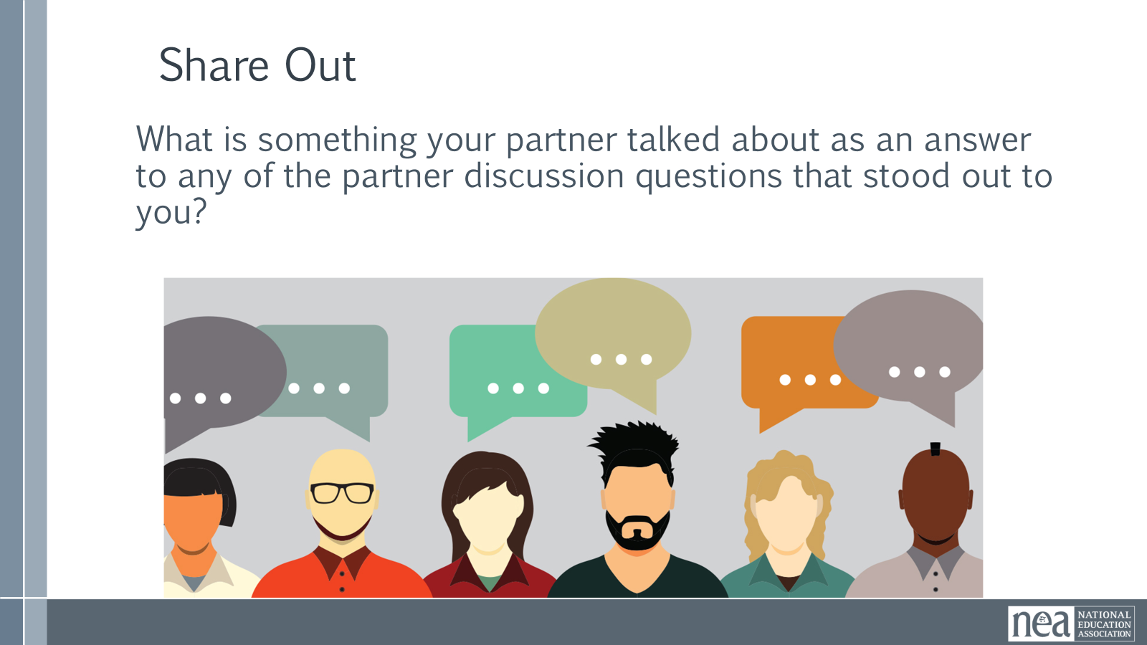  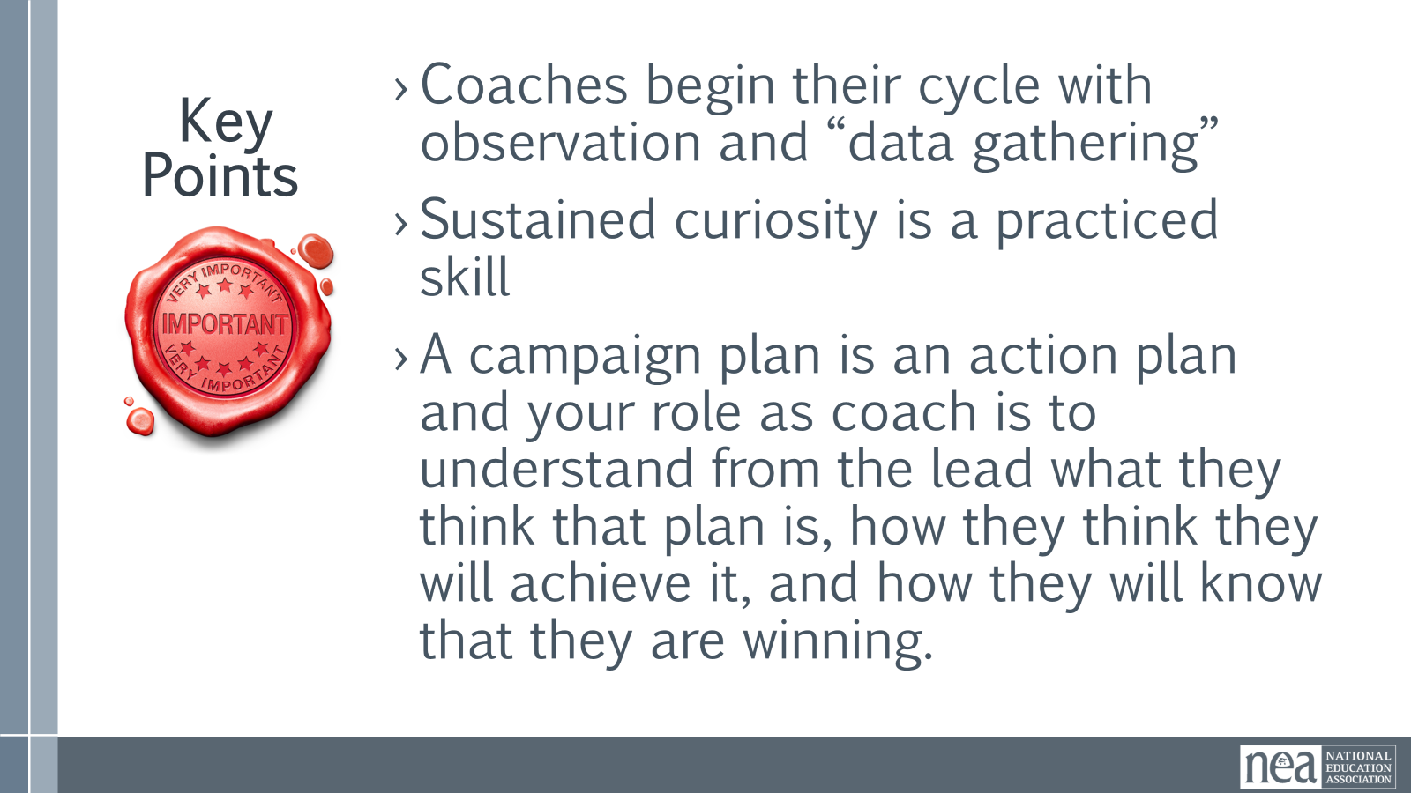 |  |  |  | Reminder Introduction – 3 minutes (Rita)  Before lunch, we used the campaign cycle as a map. We looked at what a campaign is trying to win, who has the power to make the change, how we build pressure and participation, and how benchmarks tell us whether we are making progress.  You also chose a real campaign and began looking at it through that framework. Now we are going to use that campaign story to practice coaching curiosity.  I’m going to hand it over to Joshua, who will take us into the Tell and Inquire practice.  20 Minutes Activity –Tell and Inquire (10 minutes each person for story and questions) - (Joshua)  Find a partner, preferably someone you do not know well. Each person will have 10 minutes to share their campaign story and respond to the inquiry questions, and then you will switch.  As you listen, use the inquiry questions on the slide to guide your conversation. Your job is not to critique the campaign or rush to an intervention. Your job is to stay curious and understand what happened, what worked, where the campaign shifted or stalled, and what you would need to know before coaching forward.  Again, before lunch, we learned the map. Now we practice using that map to know what to get curious about.  10 Minutes- Share outs (Rita)  Ask one person to share something their partner talked about as an answer to any of the partner discussion questions.  5 Mins - KEY POINTS (Both)  Coaches begin their cycle with observation and “data gathering”  Sustained curiosity is a practiced skill  A campaign plan is an action plan and your role as coach is to understand from the lead what they think that plan is, how they think they will achieve it, and how they will know that they are winning. |  |  |  | Participants will use their own experiences to and practice curiosity and inquiry to get build an understanding..
1:45-2:15 |  |  |  | 30 Mins TOTAL - Stages of a Campaign Leadership Team
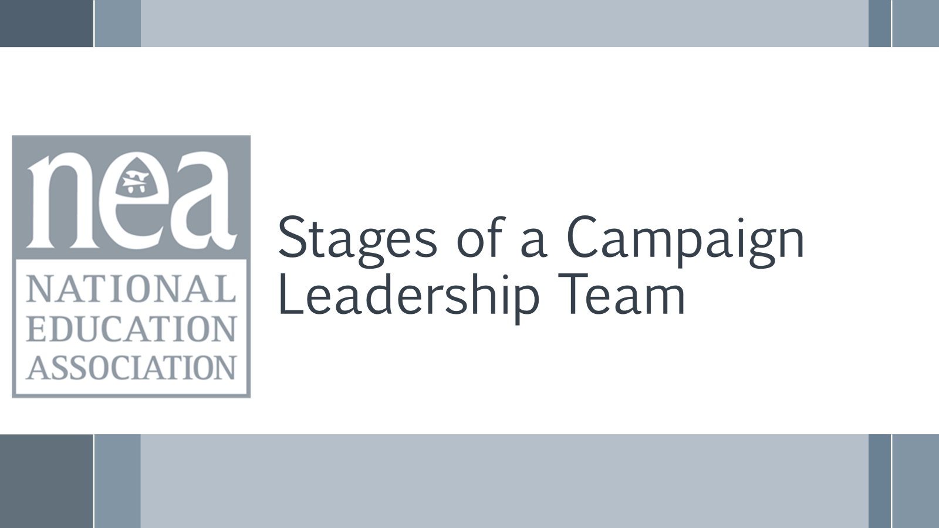  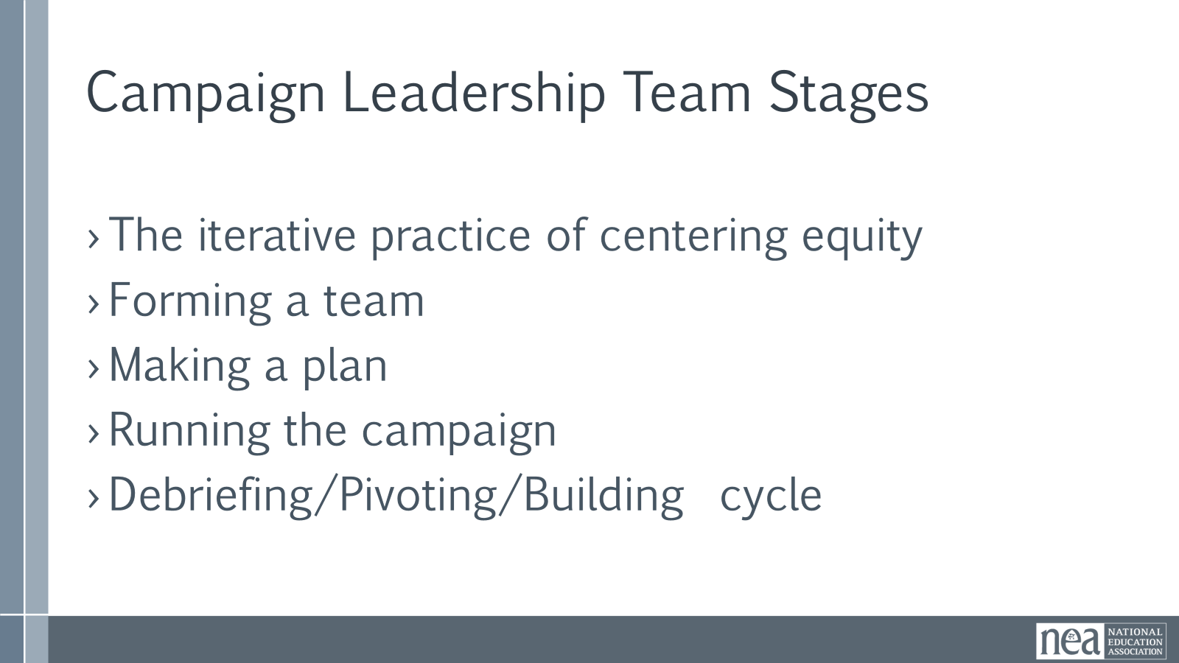  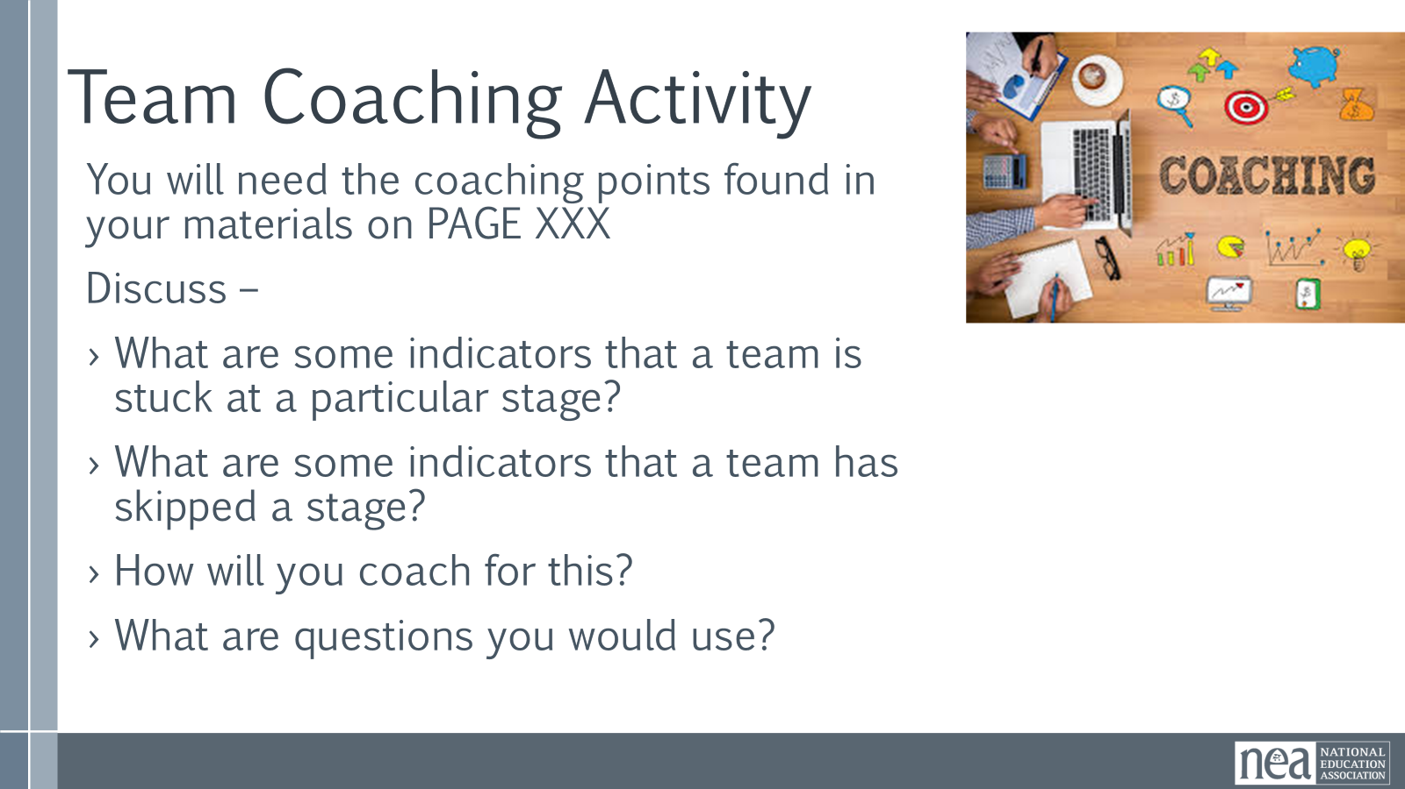  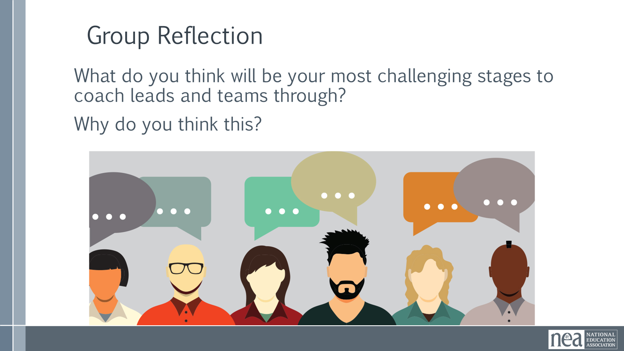  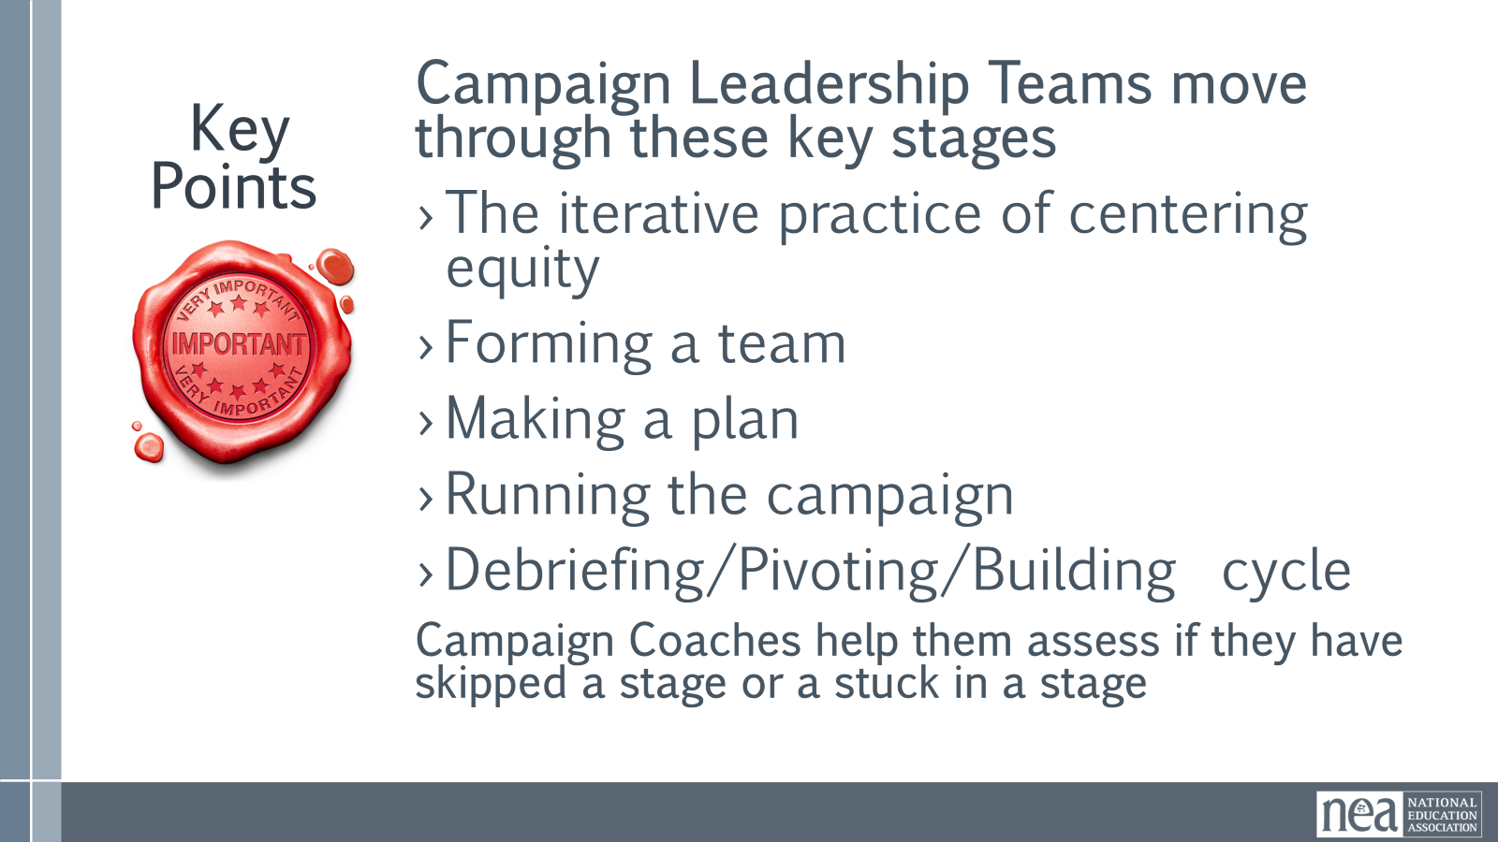 | 0 Coaching Campaign Planning |  |  | Introduction 2 minutes  You will be coaching team leads and teams. It is important that you know the stages of the campaign cycle that we listed above, but also equally important that you know the key stages that the team moves through and how to coach those:  - The iterative practice of centering equity p.27  - Forming a team p.28  - Issue Cut and Target Identification (pp.29-32)  - Making a Plan (pp.37-38)  - Tactics (pp.37,41)  - Debriefing/Pivoting/Building cycle (p.44)  These are indicated in your participant handouts.  14 Mins - Practice - How do you coach to the next phase?  We will break up into small groups and each group will take one key stage.  - You will need the coaching points found in your materials on the pages noted on the slide.  - Discuss –  - What are some indicators that a team is stuck at a particular stage?  - What are some indicators that a team has skipped a stage?  - How will you coach for this?  - What are questions you would use?  12 Mins – Group Reflection  What do you think will be your most challenging stages to coach leads and teams through?  Why do you think this?  2 Mins – Key Points  Teams move through these key stages  - The iterative practice of centering equity  - Forming a team  - Issue cutting and target identification  - Making a plan  - Tactics  - Debriefing/Pivoting/Building cycle  Campaign coaches help them assess if they have skipped a stage or are stuck in a stage. |  |  |  | Participants will understand that campaigns are a that teams have stages and that they can use good coaching techniques to move teams and leads to the next stage.
2:15-2:30 |  |  |  | Break
2:30- 3:15 | Katie B. |  |  | 45 Mins TOTAL - Coaching High Participation
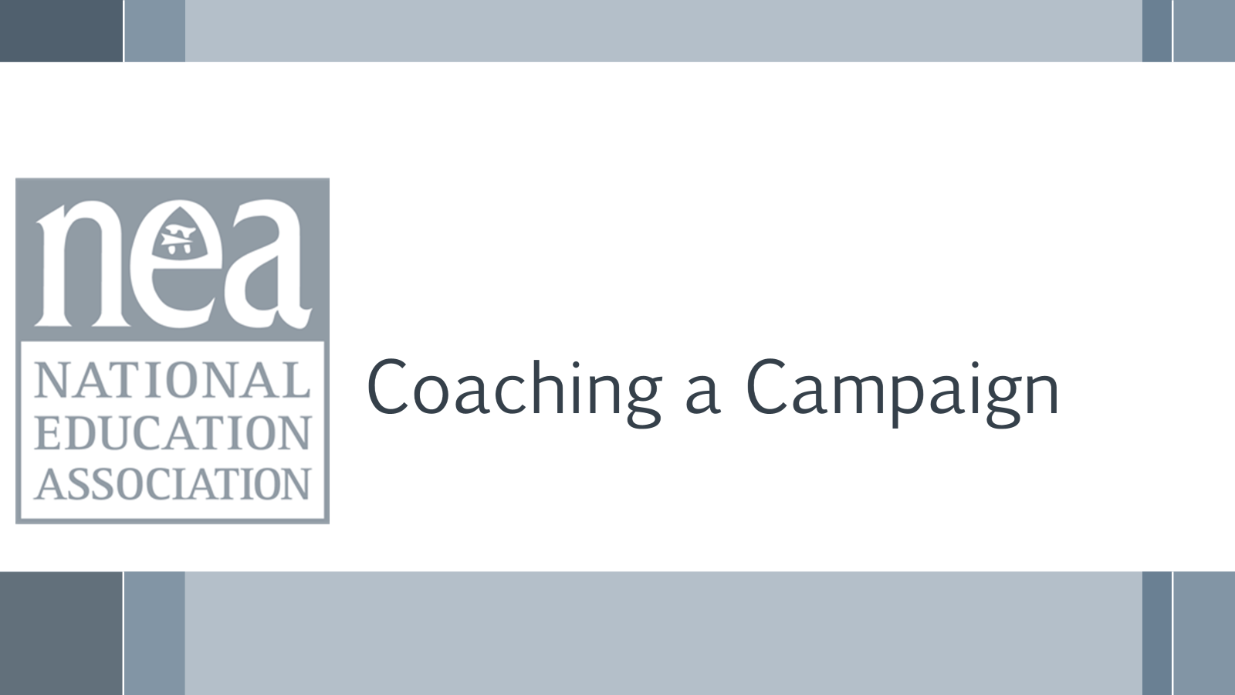  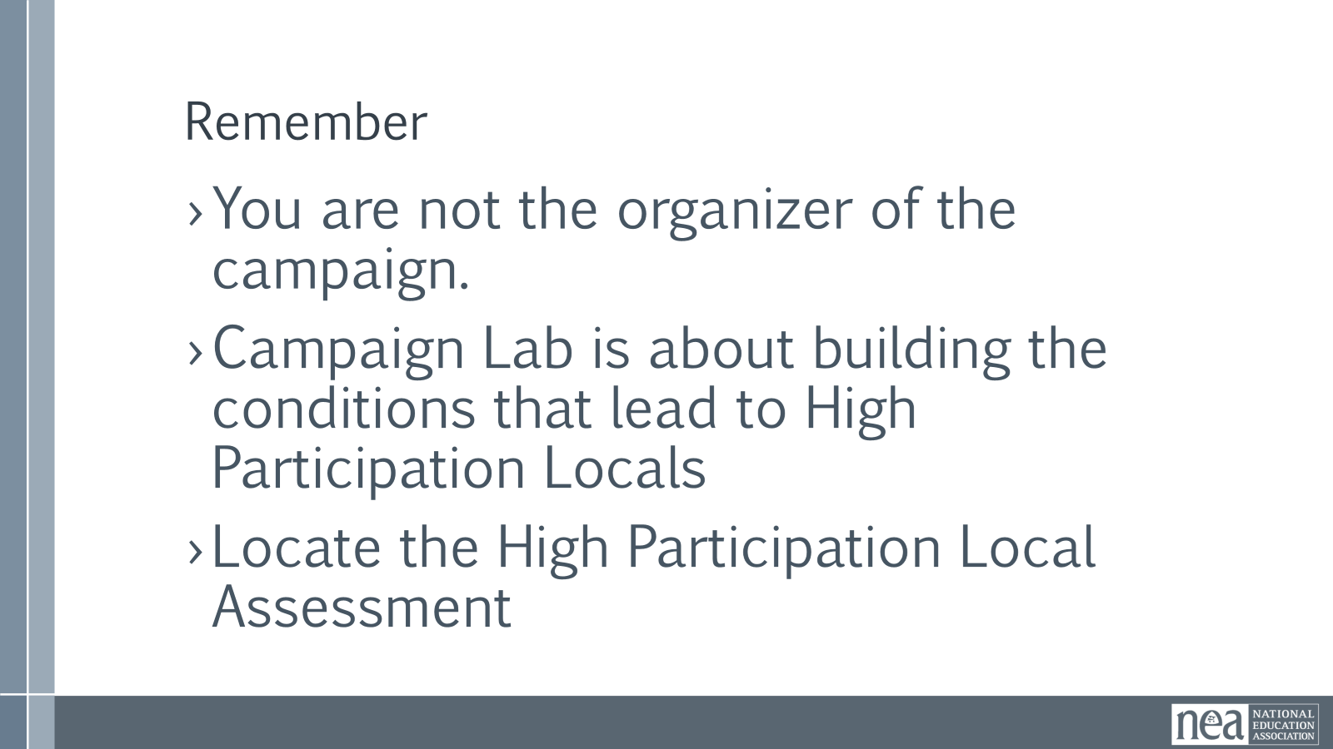  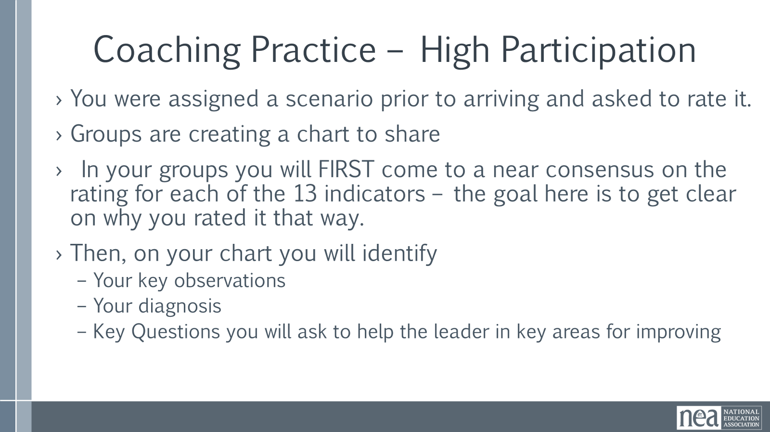    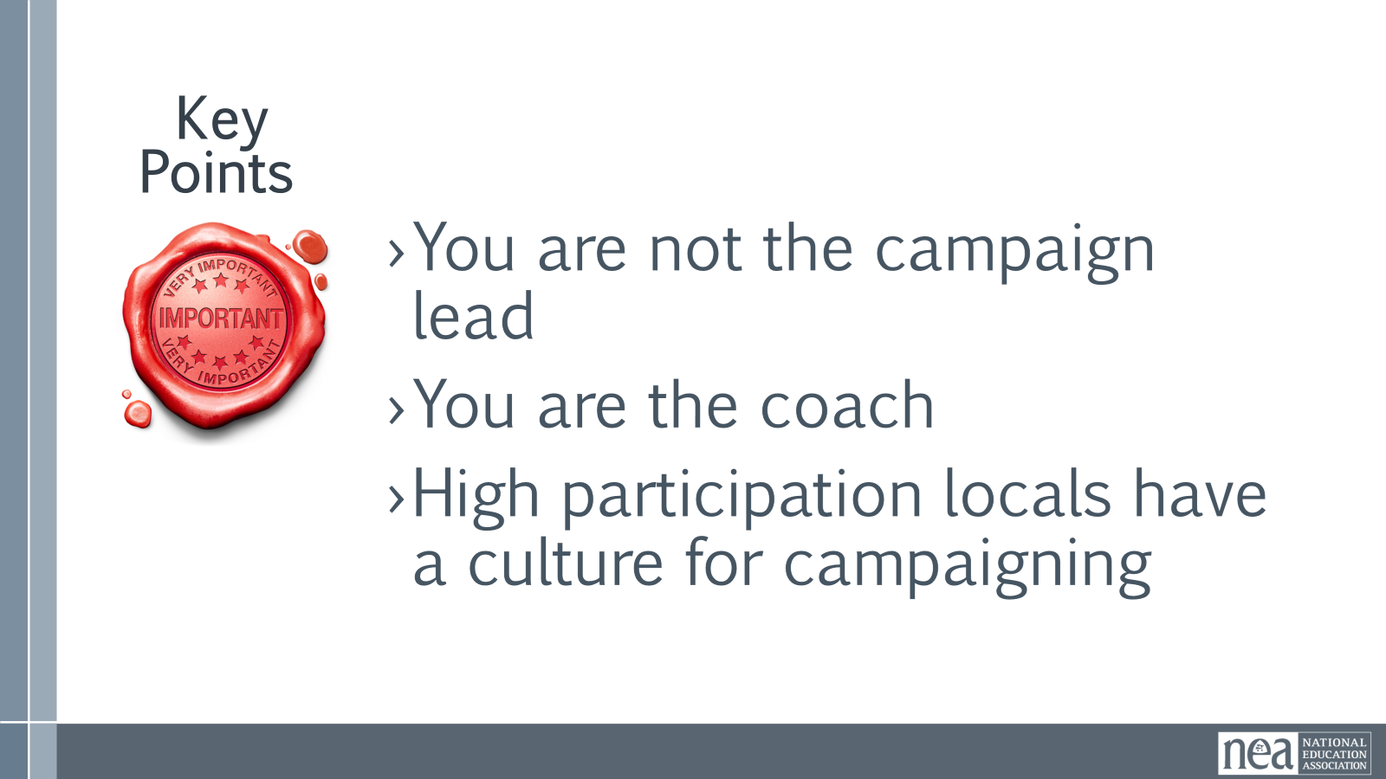 | High Participation Local Rubic  Pre attendance assign scenario and have them rate the scenario before they arrive. |  |  | 3 Mins – Intro  Refresh on the goals of coaching a campaign leader.  You are not the organizer of the campaign.  Campaign Lab is about building the conditions that lead to high participation locals  Review High Participation Local Rubic  - At your table, you will find a scenario. As a table group, you are going to read the scenario and practice rating the scenario using the rubric. You will then discuss the diagnosis and intervention.  Activity: 25 min Small Groups  How might a coach support a leader in developing a campaign plan?  Count off the participants by 3 or 6 depending on the size of the group. Have the participants read their coordinating scenario at their table. Then separate into their groups. (I SUGGEST THAT THESE ARE PRE ASSIGNED BEOFRE ARRIVING)  ›You were assigned a scenario prior to arriving and asked to rate it.  ›Groups are creating a chart to share  › In your groups you will FIRST come to a near consensus on the rating for each of the 13 indicators – the goal here is to get clear on why you rated it that way.  ›Then, on your chart you will identify  –Your key observations  –Your diagnosis  –Key Questions you will ask to help the leader in key areas for improving  Share Out: 15 min  Groups will share observation so that the other attendees who did not read the scenario will understand the story of what’s happening.  Groups will share diagnosis and the questions they created. (If there are multiple groups doing the same scenario have them split the share out and ask if each group wants to add anything after the other team gives their feedback.  All participants should share the questions they created to intervene with the leaders in their scenarios.  2 Mins - Key Points  You are not the campaign lead  You are the coach  High participation locals have a culture for campaigning |  |  |  | Practice coaching a leader through the development of a campaign plan that moves their local towards the High Participation Local indicators.  Coaches will practice asking questions that link the campaign plan to the building of the local's power.
3:15 – 4:15 | Scott |  |  | 60 Minutes TOTAL - Campaign Coach Self-Assessment
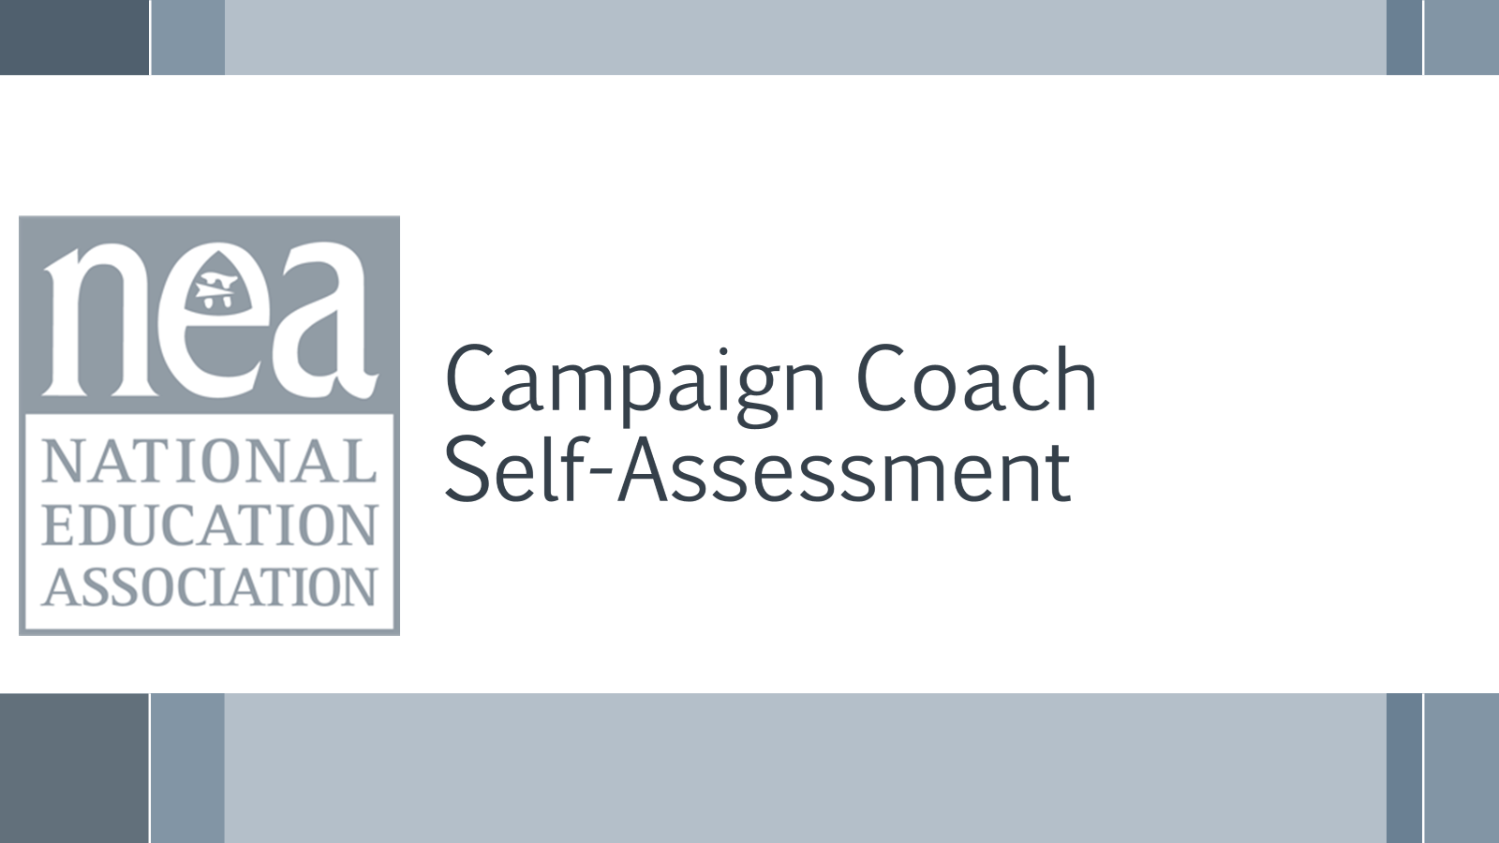  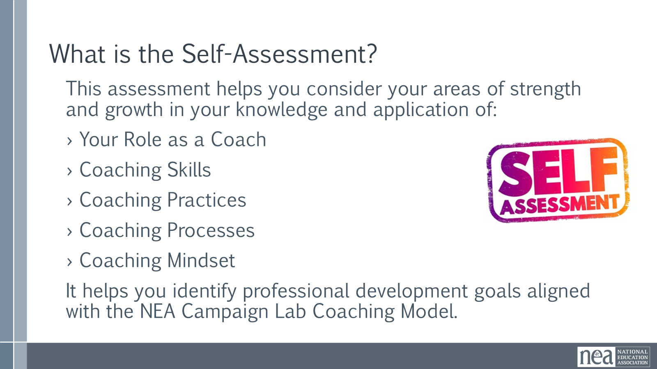  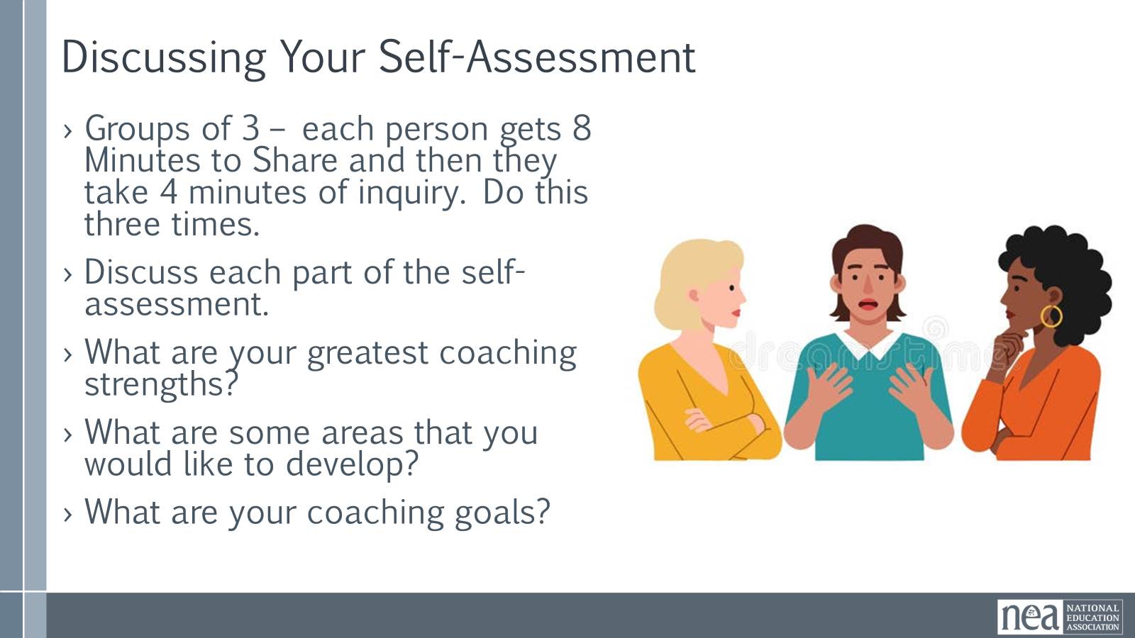  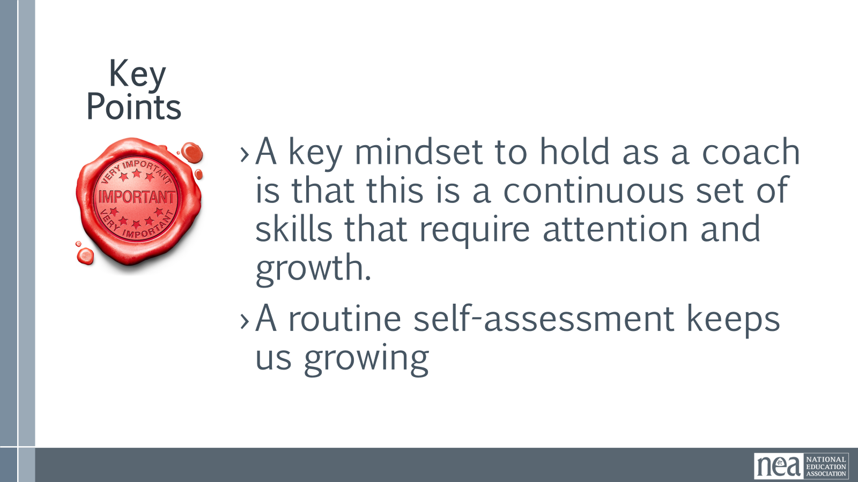 | Pg 17 of Coaching Guide  This should be a Pre Attendance Activity  Yvie on mic |  |  | 5 Mins - Introduction  We are going to complete an assessment of what your skills are, your level of experience with campaigns, and comfort level on how to run a campaign. Good coaches, the best coaches know that the more they learn about coaching, the more that have to learn. Coaching is a continuous, connected, complicated set of interpersonal skills and you only get better by doing it, reflecting on your doing, and identifying what you need to grow into.  - Show Coach Self-Assessment  - Purpose - This self-assessment is designed to help Campaign Coaches reflect on their coaching practice, identify strengths, and create professional development goals aligned with the NEA Campaign Lab coaching model.  10 Minutes – Review the assessment you did prior to coming, and make and adjustments you would like before we get into our groups. Allow participants time to complete the individual self-assessment.  40 Mins – Discussion on Self-Assessment  - Get into groups of 3 and discuss each part of the self-assessment.  - What are your greatest coaching strengths?  - What are some areas that you would like to develop?  - What are your coaching goals?  5 Mins – Key Points  A key mindset to hold as a coach is that this is a continuous set of skills that require attention and growth.  A routine self-assessment keeps us growing |  |  |  | Participants will complete a self assessment of their coaching skills.
4:15 – 4:30 |  |  |  | 15 Minutes TOTAL- , Homework & and Wrap Up
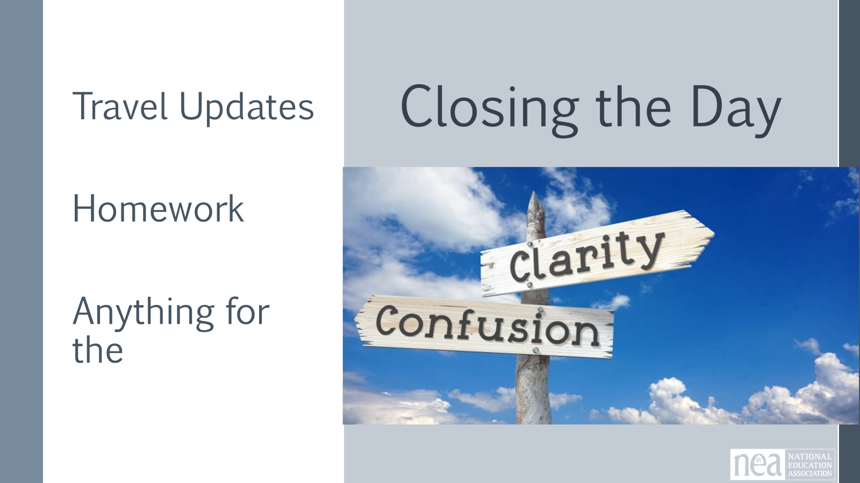  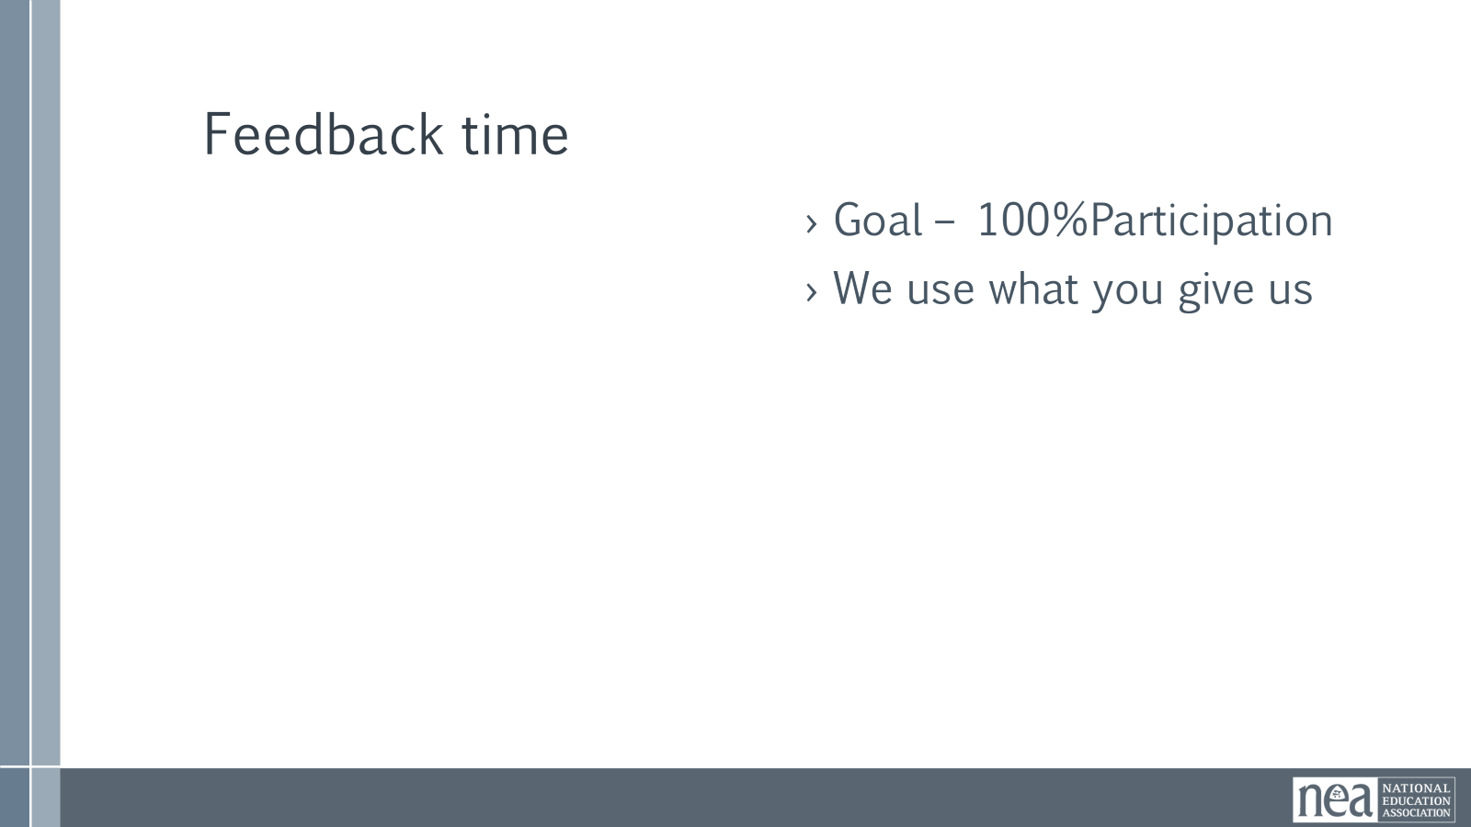  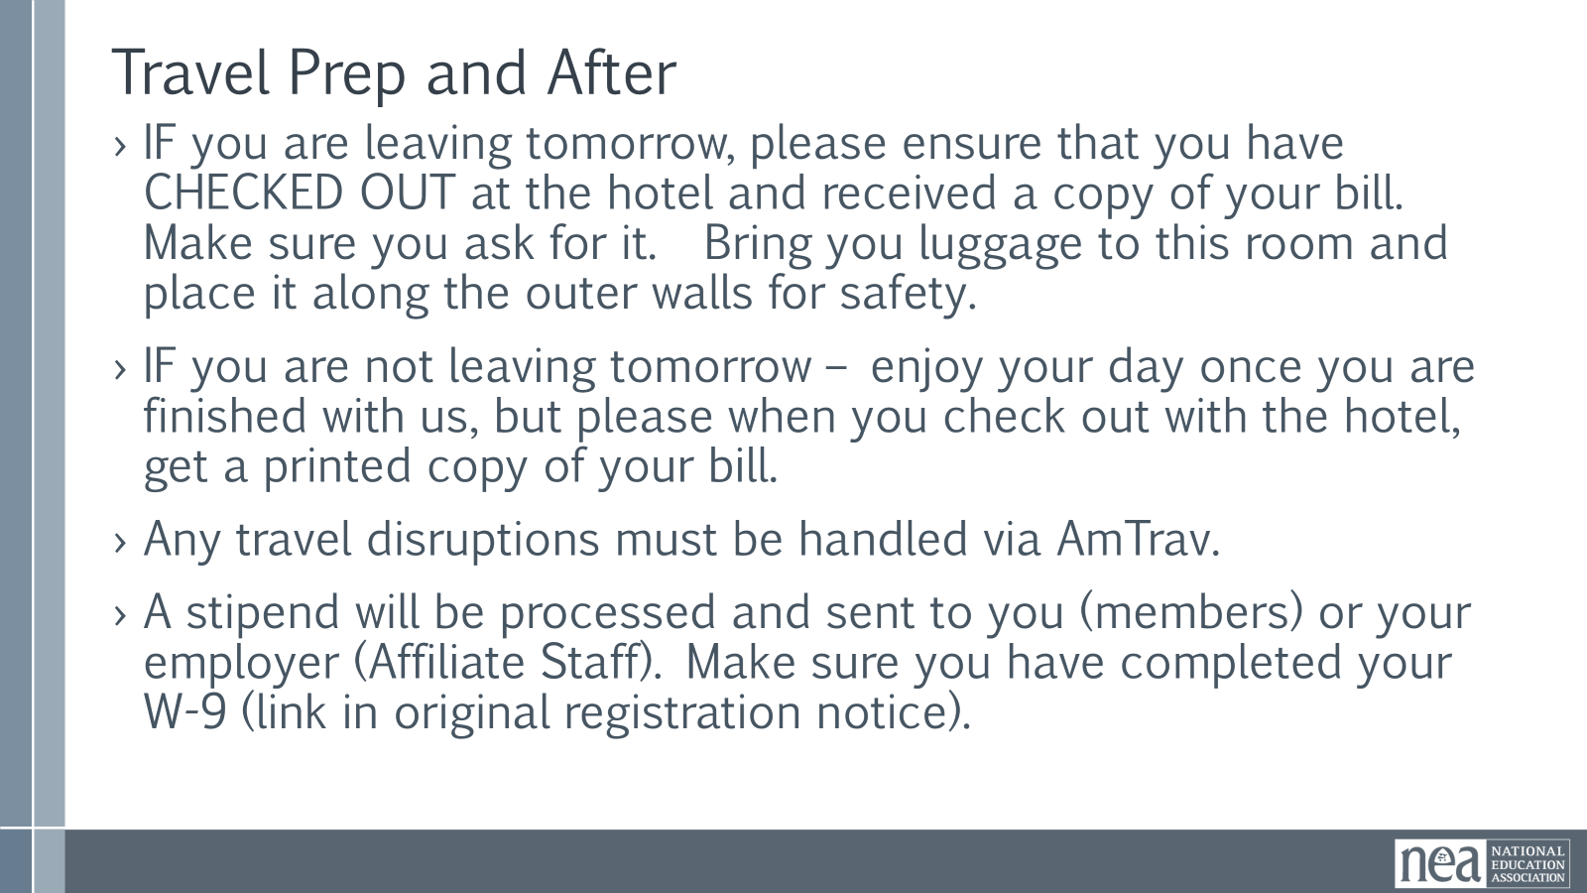  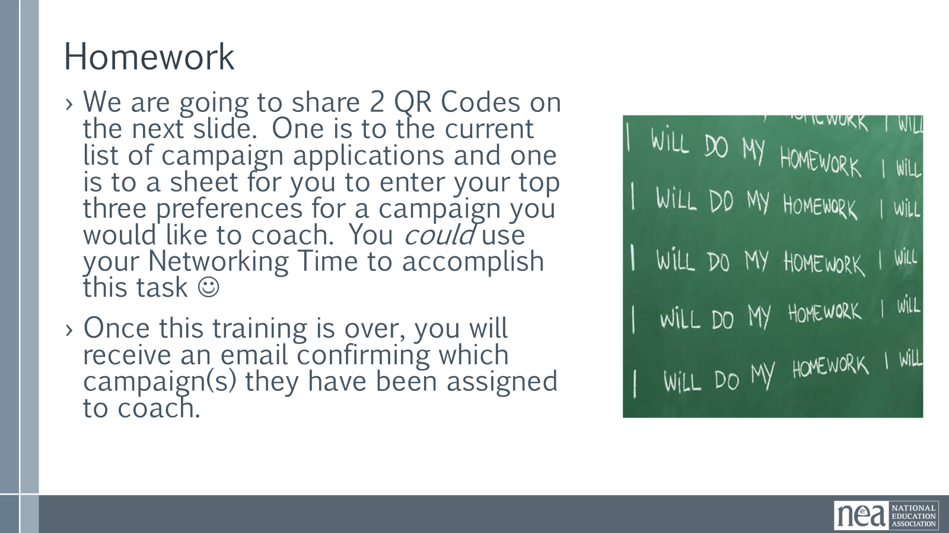  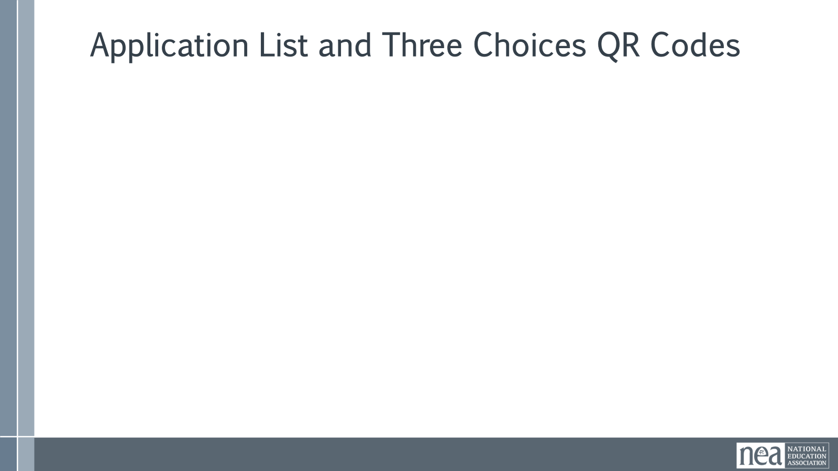   | Campaign Lab Applications (1).xlsx  Need to make a QR code for the Daily Feedback Form  Need to make a QR code for the link to the applications  And one for the Spreadsheet to sign up , listing their top three preferences. |  |  | Closing the Day  Travel and After  ›IF you are leaving tomorrow, please ensure that you have CHECKED OUT at the hotel and received a copy of your bill. Make sure you ask for it. Bring you luggage to this room and place it along the outer walls for safety.  ›IF you are not leaving tomorrow – enjoy your day once you are finished with us, but please when you check out with the hotel, get a printed copy of your bill.  ›Any travel disruptions must be handled via AmTrav.  ›A stipend will be processed and sent to you (members) or your employer (Affiliate Staff). Make sure you have completed your W-9 (link in original registration notice).  Remember to do the Feedback Form – Scan the QR CODE  Homework For Tomorrow-  You will receive an email with a link to the current Campaign Lab applications that have not been assigned a coach. Included in the email, there will be a spreadsheet for you to begin inserting your top 3 preferences of campaigns you would like to coach. (Leave some time at the beginning of Day 3 if possible to also provide time for participants to insert their top 3 preferences of teams to coach).  - Link to applications  - Link to spreadsheet to sign up – list of preferences 1-3  - Inform participants that after the conclusion of this training, they will receive an email confirming which team(s) they have been assigned to coach (finalized version).  Any other questions? |  |  |  | Participants will be able to bring a little closure to their learning and provide feedback on the day.
4:30 – 5:00 |  |  |  | Adult Choice Networking
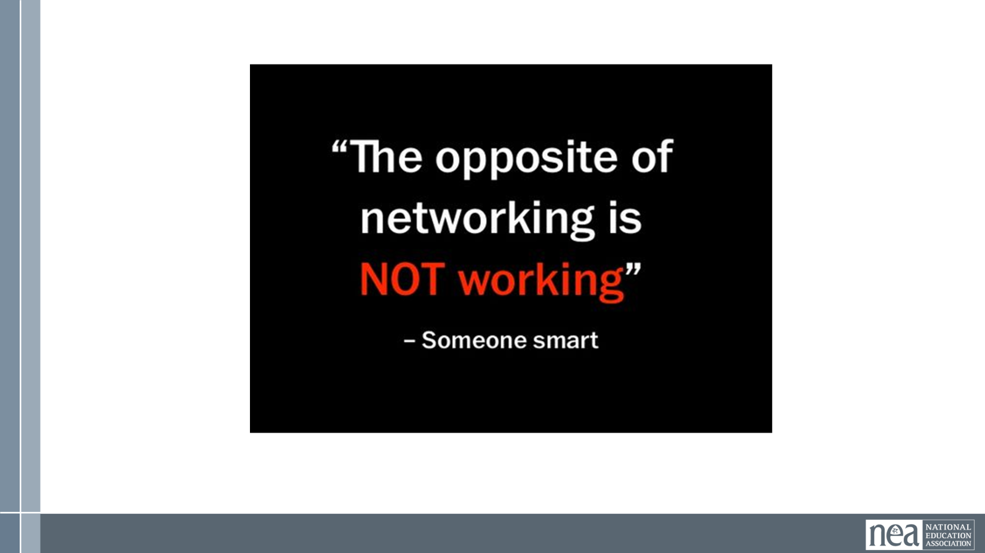 |  |  |  | This is a time for participants to meet and discuss any issues they are thinking about with other members of the group. This is not led by facilitators, and we highly encourage you to take this to any other space beside the conference room. Participants will make useful connections with staff from other affiliates. |  |  |  | Participants will make useful connections with staff from other affiliates.
5:00 ADJOURN

