Use - Facilitator Agenda – DAY 1 Coaching Skills for Developing Campaign Leaders
General Materials Needed: |  |  |  | Room Set-up: 80 people max
Name Tents with the Norms  Room signs, Stick on Name Tags  Chart Paper (10 full w Sticky Strip) | Materials Box for each table with:  Markers (Mr. Sketch variety)  Post its – 3x3” and 4X5” sizes |  |  | Long Rectangle table at back for facilitators  Round Tables for participants  Projector, Screen, mics, and Speakers  Carousel stations and reporting stations
Key Outcomes for the Event:
(Campaign Lab Team Leads and Coaches) March 13-15, 2026, Oklahoma City, OK
- Explore how coaching can be a leadership development practice that expands the capacity of leaders to build organizing power and impactful campaigns.
- Develop core coaching skills including asking powerful questions, learning to self-manage and centering the agenda of those being coached.
- Learn how to coach common challenges in leadership, centering equity and shifting from a service to organizing model of unionism.
- Learn how to assess affiliate readiness and capacity to focus on multi-issue, multi-constituency work, and coach a leader to define goals and priorities for growing the strength of their local union.
- Develop a shared understanding of institutionalized and structural systems of oppression and apply power analysis and research methods.

Outcomes for Day 1
- Develop core coaching skills including asking powerful questions, learning to self-manage, cooperative interruption, harnessing curiosity and unpacking judgement and centering the agenda of those being coached.
- Coaching for equity in union and campaign work.

Overview of Day Time, and Facilitator Assignment - Bekah, Melissa, Katie, Carrie, Kristin, Fabricio
7:00 - 8:30 - Breakfast  8:30 –9:00 - Welcome  9:00 - 10:30 - 1.1 Systems Thinking + Puzzle  10:30-10:45 - Break  10:45 - 11:15 - Coaching Overview  11:15- 12:00 - Coaching Towards Alignment  12:00 -1:00 - Lunch |  | ALL  Carrie  Fabricio & Katie  Carrie  Kristin | 1:00 -1:40 - Coaching Towards Alignment Activity  1:40-2:10 - Self-Management  2:15 - 2:25 - Break  2:25 - 2:55 - Curiosity and Unpacking Judgement  2:55 - 3:25 - Interrupting  3:25 - 4:20 - Coaching Equity  4:20 – 4:30 - Closing  4:30 -5:00 - Adult Choice Networking  5:00 - Adjourn |  | Kristin  Bekah  Melissa  Kristin & Melissa  Bekah  Carrie  All

Time Slides Facilitator | Resources | Instructions, Activity and Debrief (Facilitator Script) | Essential Questions and Outcomes
 | Charts, handouts, articles, materials, slide | What are you saying, what are they doing, what questions will you use to guide learning and make clear the important points  Include an estimate for how long each section of the learning will take | What question(s) will this learning answer? What will participants know or be able to do?
7:00 -8:30 – Team prep, practice, room set up, sound check, etc. and Breakfast
Entry Activity
8:30 -9:00 Carrie |  | 30 Mins TOTAL Getting Started
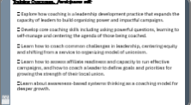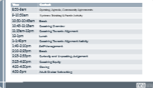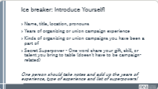 | Norms in Handouts  Agenda on Slides  Parking Lot Chart  Name Tents  Handout Package | Welcome: Land Acknowledgement, Review Agenda, Shared Agreements, Introductions. Gratuity volunteer.  Use mics. There are people in the room who need you to use the mics.  Framing: As coaches we are supporting leaders as a whole person. We can deepen a leader’s vision, determination and capacity to lead. As Campaign Lab Coaches, we are also guides to support the Team Lead to be rigorous about the process of building a strong union and campaign. | Participants will know how we are going to work, the basic schedule, and the logistics relevant to the training.
9:00-10:30am Fabricio, Katie and Fabricio Activity |  | Awareness Based Systems Thinking Concept and Puzzle Activity
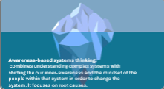    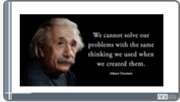      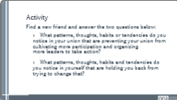          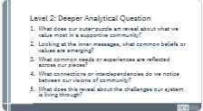     |  | - Awareness Based Systems Thinking Concept – 30 min 9-9:30am  Awareness-based Systems Thinking combines the understanding of complex systems with shifting inner-awareness and mindsets of people within the system in order to change the system. It addresses root causes.  In order to change the conditions outside, we need to change the conditions inside.  The NEA has existed for 169 years. The version that we are all familiar with has existed for a couple decades.  Over our history, we have ratified, who knows how many contracts. We have gained the right to collectively bargain in a couple of places, and have lost the right in a few more. We have advanced the cause of public education with the shared belief that teaching conditions are learning conditions.  We have also been shifting more and more to organizing and campaigns as a union.  INSTRUCTIONS: I am going to make 6 statements. If you agree with the statement I make, please stand up.  - On the whole, our union has improved the work lives of educators.  That is amazing. Take a look around. Let’s take a moment and celebrate your hard work and our union.  Take a seat.  - On the whole, YOUR LOCAL has improved the work lives of teachers and support staff.  Again. Amazing.  Take a seat.  - Workers’ rights and unions have gotten stronger.  NOTICE CHANGE.  Ok. Thanks. Take a seat.  - Since you started teaching, the political environment has improved for educators and public education.  Thank you. Take a seat.  - Student outcomes, have gotten better since you started teaching.  Thank you. Take a seat.  - Teaching has become easier since you started.  Thank you.  Our union has been able to improve working conditions, but we see that the student outcomes aren’t following the same successful path.  Despite our work in the union, the job is getting harder every year.  WHAT DOES THAT MEAN TO YOU?  WHAT DOES THAT MEAN ABOUT OUR THEORY OF CHANGE? A theory of change describes what we believe and why we do what we do. For example, as teachers...  We believe that teaching conditions are learning condition. Because we believe that, we organize teachers to improve those conditions.  WHAT DOES THAT MEAN ABOUT OUR THEORY OF CHANGE?  These opposing trends tell us that achieving good outcomes for students and teachers is more complex. This conflict, the gap between what we do and the outcomes we are trying to achieve, is shared with other large complex problems such as racism, the environment and democracy.  It’s not enough to just learn the skills of organizing or the practice of campaigns.  SLIDE Quote  We are Change-Makers in this room.  A " Change Maker" believes the systems, patterns, structures, values, and beliefs around us need to shift to create the change we need.  SLIDE with ICEBERG  I want to introduce the concept of Awareness-Based Systems Thinking. You can see in this iceberg. Above is what we see - yet underneath what appears are the structures, patterns of behaviors, the deeper values, beliefs and mindsets that are enabling the problems.  We need to understand the root causes of the challenges we are facing.  This can help us understand points of leverage where we can intervene to advance change.  “We cannot solve our problems with the same thinking we used when we created them.” Albert Einstein  Our ability to create transformative change is enabled and limited by our ability to see, understand and change what is taking place within us.  If MLK could not not only “HAVE A DREAM” but also feel it, and make millions of other feel it, as if it were real and possible, we never could have taken one step closer too it.  Let’s take a moment or two to try to UNDERSTAND the CURRENT SYSTEM.  This Iceberg model is used to illustrate the current system and the invisible dimensions of leadership that are available to us.  Let’s look at the top of the Iceberg. The first rule is to UNDERSTAND the system.  We are not going to spend a lot of time on this. I am just sharing it with you to see if this pattern sounds familiar to you.  Who has ever heard the someone say, "This is just how it is.”?  If someone feels powerless, are they going to organize?  RAISE YOU HAND IF you’ve had some refuse to join the union because they did not believe that we could improve things?  RAISE YOUR HAND IF you’ve been in union meetings and seen people shutting down new ideas because “it won’t work, because our members won’t act?”  This is a pattern of people closing their minds to new ideas and information, closing their hearts to the suffering of others and closing their will to try to improve the situation.  If our processes, within the union, have become shaped by fear, doubt and disbelief, if those are the condition we are cultivating WITHIN, how can we create transformative change in the outside world?  If we, as change-makers, set our INTENTION of moving away from the old patterns, we are taking the first step toward transformative change.  Our ability to change systems is enabled and limited by the conditions within each of us. That’s why coaching leaders is so powerful.  Awareness-Based Systems Thinking is a way of analyzing the world as it is, AND a process of disrupting our old patterns to get different results. Awareness-Based systems thinking is a process of OPENING.  So is organizing.  Integrating awareness based systems thinking can help leaders:  Shift Beyond an individual perspective into sensing the broader system.  Notice Recurring patterns and our own role in creating them.  Move away From "reacting to the past" towards "sensing the future" and what is emerging.  Help Leaders test new ways of acting, learning quickly from failures rather than fearing them.  Build New structures that support and sustain the change.  We are going to go deeper this approach on Sunday. But let’s work with what we have covered so far.  Get up.  Go find a new friend.  Answer two questions below.  1. What patterns, thoughts, habits or tendencies do you notice in your union that are preventing your union from cultivating more participation and organizing more leaders to take action?  2. What patterns, thoughts, habits and tendencies do you notice in yourself that are holding you back from trying to change that?  Share out- 2-3 teams if there is less time. More share outs if more time.  If you can successfully disrupt the old patterns, what does that inspire inside of you?  With an open mind, heart and will, what change in the world becomes possible?  Puzzle Activity - 60 minutes – 9:30-10:30am – Katie + Fabricio  Break out teams to start.  Step 1: Silent Reflection (5 minutes)  Prompt 1 – 2.5 minutes  Make sure it is quiet during this silence reflection. On a blank piece of paper, write or sketch whatever comes to mind as you reflect on this question:  “What does it feel like to belong to a supportive community that shows up for everyone?”  Use words, images, colors, or symbols — anything that expresses that feeling.”  (Pause 2.5 minutes)  Prompt 2 – 2.5 minutes  Now take a few more minutes to reflect on the next question:  ‘What belief, value, or mindset — within us or within the system — would need to shift so that a “supportive community” could become possible?’  Again, write or visualize whatever surfaces.  There’s no right or wrong way to do this — just honest reflection.  (Pause 2.5 minutes)  Step 2: Puzzle Art Creation (20 minutes)  Now we’re going to turn your reflections into visual expression.  Each of you has a puzzle piece in front of you.  As you begin creating, remember:  - This is not about artistic ability.  - You do not need to draw well or make something pretty.  - This is about expression, insight, and imagination.  - Use color, words, lines, metaphors, shapes — anything that helps you express your thinking.  - Challenge here you to limit stick figures.  Share art materials options.  Outer Part of the Puzzle  On the outer edges or border of your puzzle piece, express your reflections from the first question:  “What does it feel like to belong to a supportive community that shows up for everyone?”  Inner Part of the Puzzle  Now, use the inner area of your puzzle piece to express your reflections from the second question:  ‘What belief, value, or mindset must change — within us or within the system — for a supportive community to be possible?’”  Your puzzle piece is a visual representation of:  - the community we want, and  - the mindset shifts needed to move toward that vision.  Take your time. Let the art lead you wherever it needs to go.  (Begin 30-minute art creation)  Step 3: Group Debrief (40 minutes)  Split the group into 2 groups.  When you’re finished, in your group place all your puzzle pieces together to create one large puzzle for your group.  There should be have two large, assembled puzzles — one for each group.  Please gather around your group’s puzzle so everyone can see the full picture.  Debrief Instructions  Choose from the questions below but be sure to touch all three levels:  Level 1: Surface Questions (10 minutes)  - What patterns or colors do you see?  - Do you notice anything about the textures used?  - Do you notice any shared themes across the pieces?  Level 2: Analytical Questions (10 minutes)  - What does our outer‑puzzle art reveal about what we value most in a supportive community?  - Looking at the inner messages, what common beliefs or values are emerging?  - What common needs or experiences are reflected across our pieces?  - What connections or interdependencies do we notice between our visions of community?  - What does this reveal about the challenges our system is living through?  Level 3: Evaluating & Creating Questions (10 minutes)  - What do these puzzle pieces say about the future we’re ready to step into together?  - What strengths, hopes, or sources of power become visible when all of our pieces come together?  - Based on our shared artwork, what elements of a supportive community must we prioritize first as a union?  - Which parts of our shared vision feel most achievable if we work together — and which require deeper system change?  - What leverage points or opportunities do we see that could move us toward the community we envisioned?  - How might we turn these visual themes into commitments or next steps that we take together?  Step 4: Swap & Whole Group Debrief (10 minutes)  Now take a few minutes to walk over to the other group’s puzzle.  Observe what stands out to you. Notice similarities, differences, surprises, or insights.”  (Give groups 3–5 minutes to rotate)  Let’s come back together as a whole group.  Who would like to share what you noticed between the two collective pieces?  What themes stood out?  What surprised you?  Key Take Aways:  - We can see that there is a shared vision and experience across our experiences.  - We can find patterns across all of our individual experiences.  - Achieving change requires opening up to new mindsets and disrupting old patterns.  - Awareness-Based Systems Thinking allows us to develop a deeper sense and understanding of the system and identify where we might intervene for change.
10:30am-10:45am |  | BREAK (15 mins.)
10:45am-11:15am Carrie | Carrie | 30 Mins TOTAL – Coaching Overview
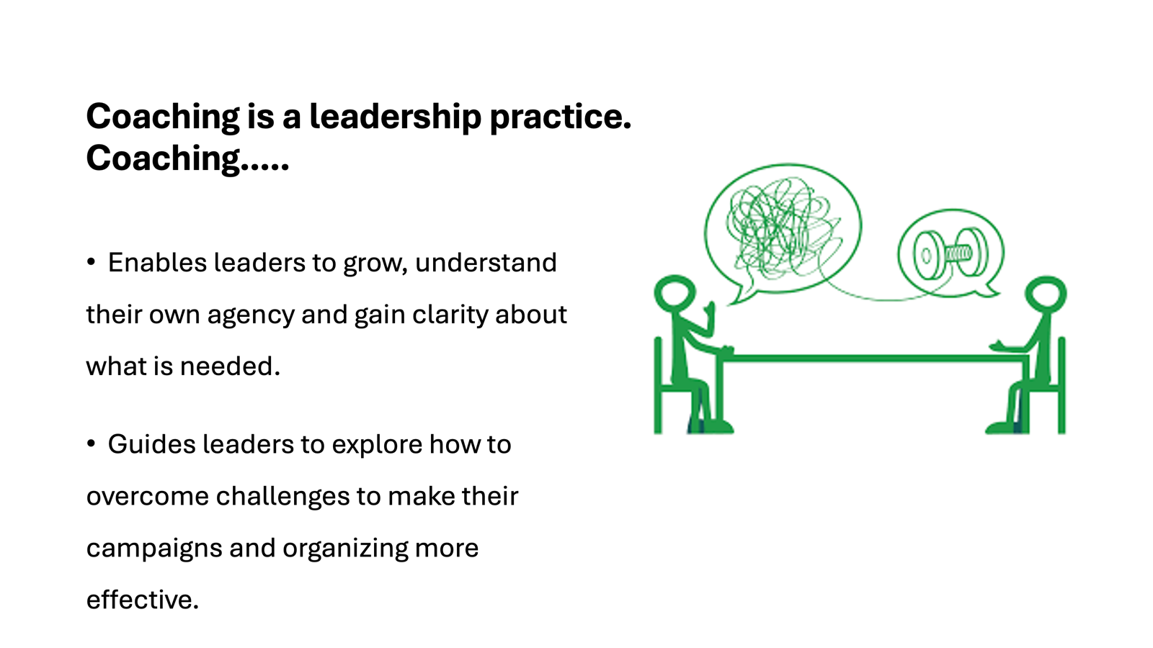    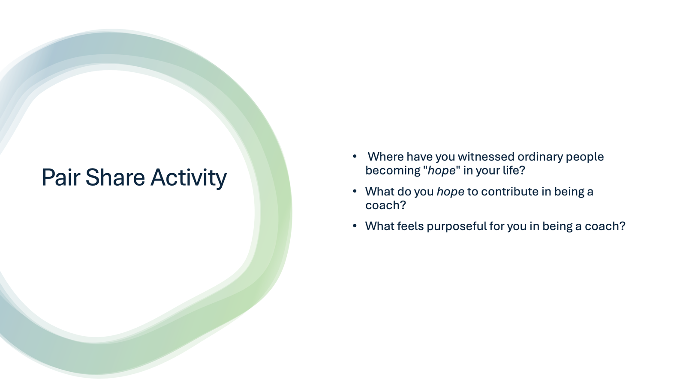    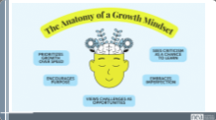    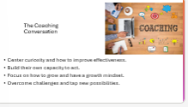  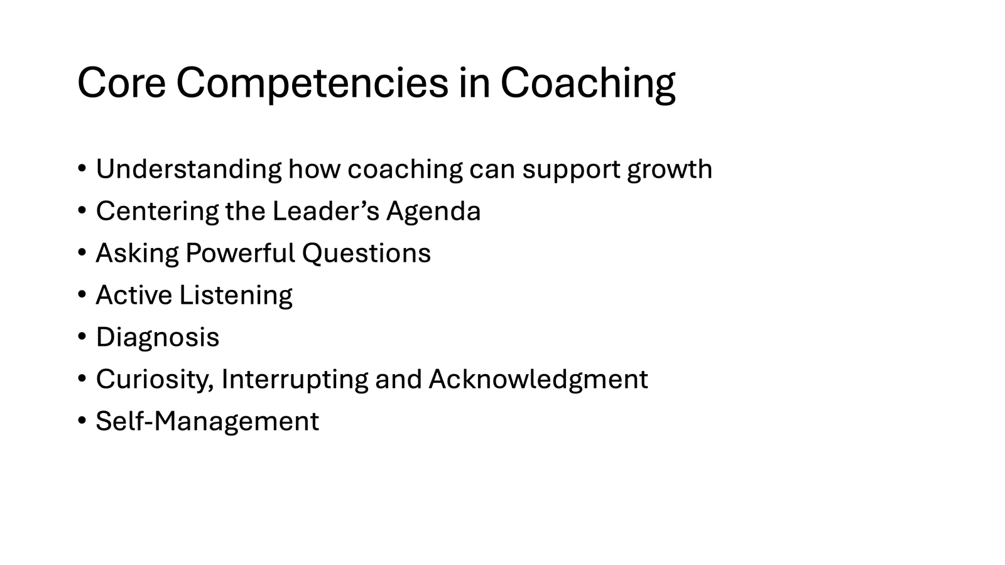  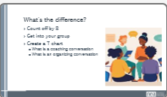  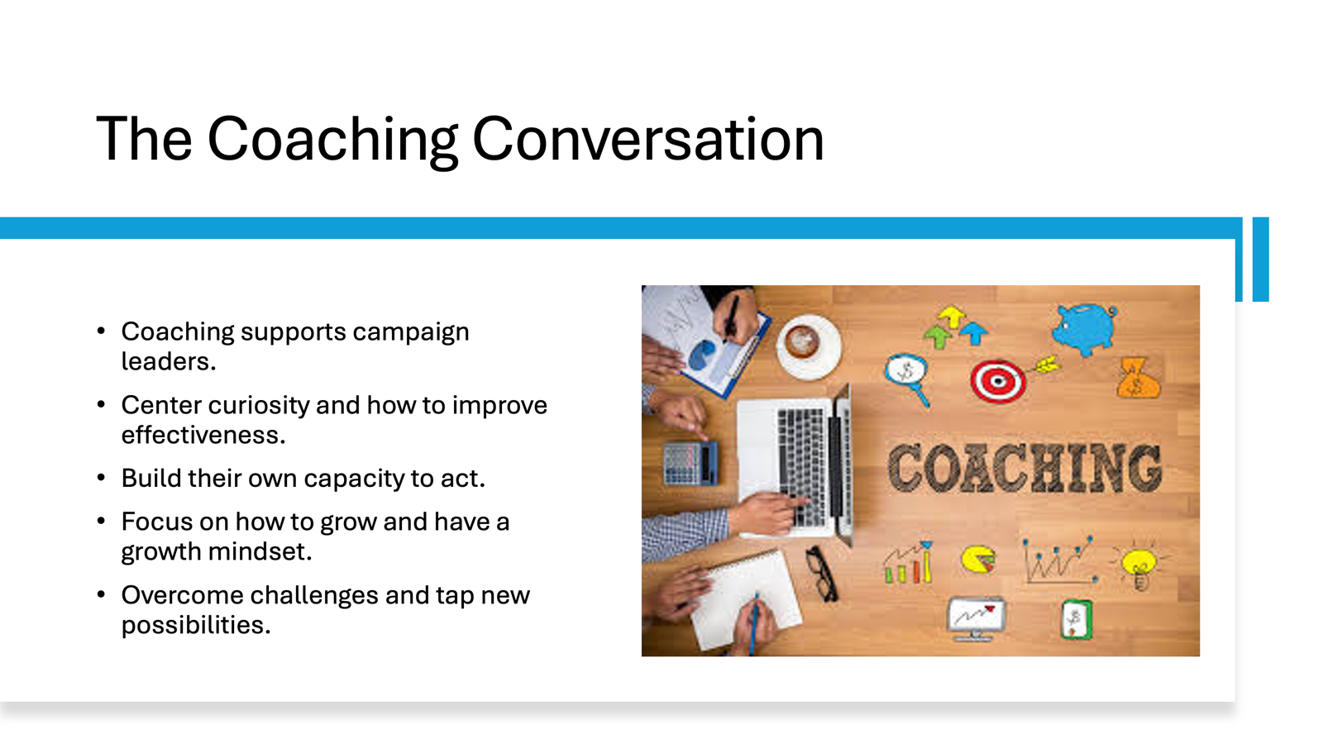  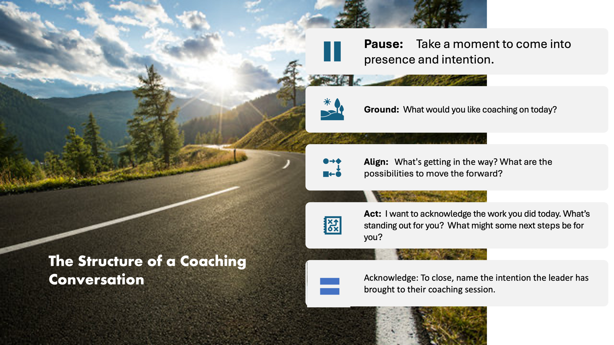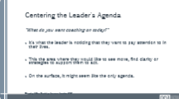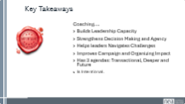 | . | Slide 1: Coaching is a Leadership Practice – 2 min  We all have a tremendous vision for how we can achieve lasting, impactful change. We know we can achieve that vision through organizing and campaigns. But it all starts with expanding the capacity of leaders to lead in that work. Coaching is a leadership practice.  Coaching....  Enables leaders to grow, understand their own agency and gain clarity about what is needed.  Guides leaders to explore how to overcome challenges to make their campaigns and organizing more effective.  Slide 2: Poem – 2 min  People who speak of hope  Are themselves hope.  People looking for a new way  Are themselves a new way.  In truly good people  Is already a good world.  It is within people  It begins with people.  Again  People are the only hope.”  By Park No-Hae – Korean labor activist/poet/former political prisoner  (Translation by the amazing coach of movement leaders who recently passed: Helen S. Kim)  Slide 3: - 10 min  Take a moment to reflect.  Where have you witnessed ordinary people becoming "hope" in your life?  What do you hope to contribute in being a coach?  Pair with someone you don’t know and share.  Use engaged listening skills. (engaged skills)  Slide: Having a Growth Mindset in Coaching: 5 min  Group Discussion:  When a leader has a growth mindset, how do they approach being coached?  What are some signs that you might be coaching someone with a more fixed mindset?  A part of our role when coaching another person is moving them to orient towards a growth mindset.  Slide : The Coaching Conversation –2 min  Coaching helps campaign leaders.....  Center curiosity and how to improve effectiveness.  Build their own capacity to act.  Focus on how to grow and have a growth mindset.  Overcome challenges and tap new possibilities.  [ADD back the organizing convo stuff]  Activity: Drive home difference between coaching and organizing conversation – Count off – correct  They know what they need to do. Your jobs is coaching person not problem.  Slide: The Structure of a Coaching Conversation: - 5 min  - Pause: Take a moment to come into presence.  - Ground: Establishing the agenda of the leader. What would you like coaching on today? Whqt would success look like?  - Align: Centering their agenda, Ask questions to support greater clarity  - Act: Moving towards action.  - Acknowledge: Acknowledge the intention the leader has brought to their coaching session.  Slide: Centering the Agendas 5 min  - Coaching at it’s core – is meeting someone where they are at. Understanding the leader’s agenda is a shared understanding of what the coach and the leader are doing.  - We have talked about centering the leader’s agenda in coaching. We start coaching by asking, "What do you want coaching on today?"  It's what the leader is noticing that they want to pay attention to in their lives.  This the area where they would like to see move, find clarity or strategies to support them to act.  On the surface, it might seem like the only agenda.  But there are actually 3 agendas of the leader that we need to center in coaching.  TRANSACTIONAL – What they name as their agenda  DEEPER: What is beneath the surface of our leader's coaching agenda. It's all their conscious and subconscious feelings, values and beliefs that influence their actions and behaviors. We do this by asking powerful questions, something we will focus on in an upcoming section.  FUTURE: There is also the Future Agenda. In coaching, we encourage people to come into presence into order to gain clarity and tap into their own agency to grow and to act.  The coach typically opens the future agenda by inviting the leader to get curious about what's possible, who they want to become, and the bigger picture.  Key Takeaways:  Coaching....  Builds Leadership Capacity  Strengthens Decision Making and Agency  Helps leaders Navigates Challenges  Improves Campaign and Organizing Impact  Has 3 agendas: Transactional, Deeper and Future  Is Intentional.
11:15 - 12:00pm Kristin |  | Present– Coaching Towards Alignment – (after lunch is practice)
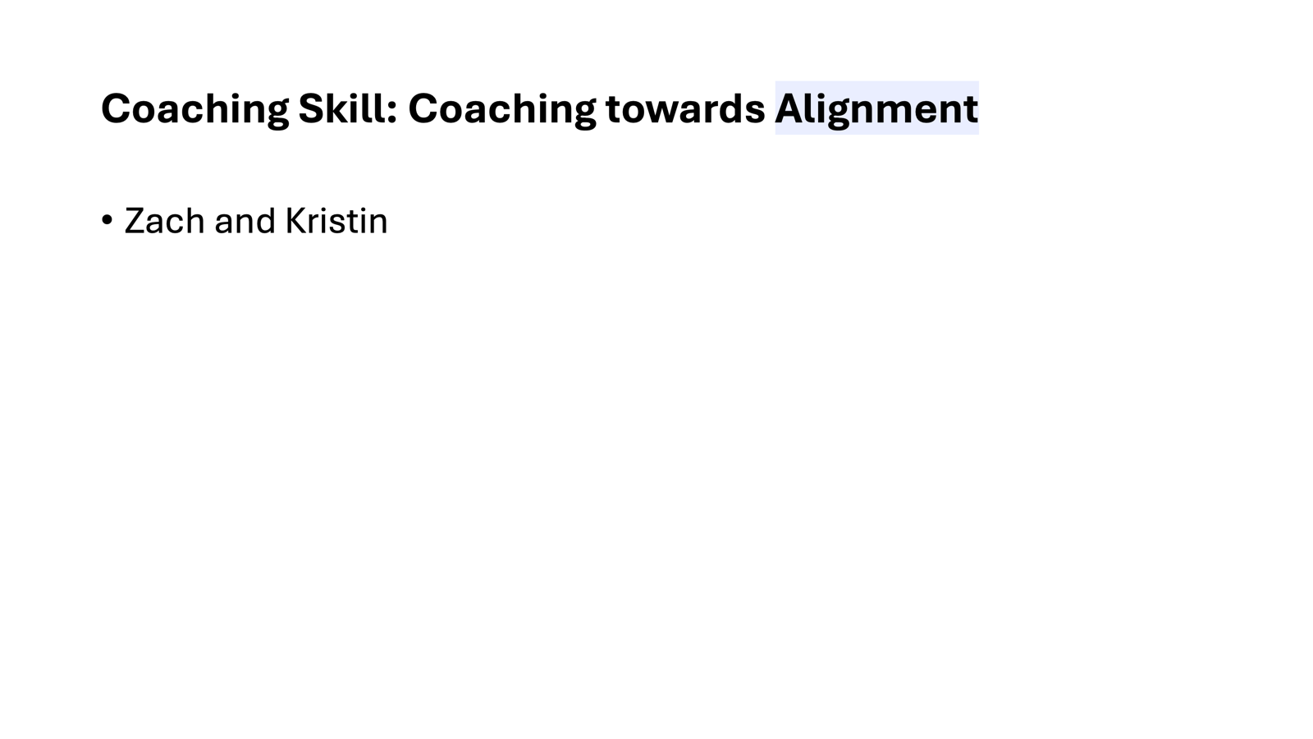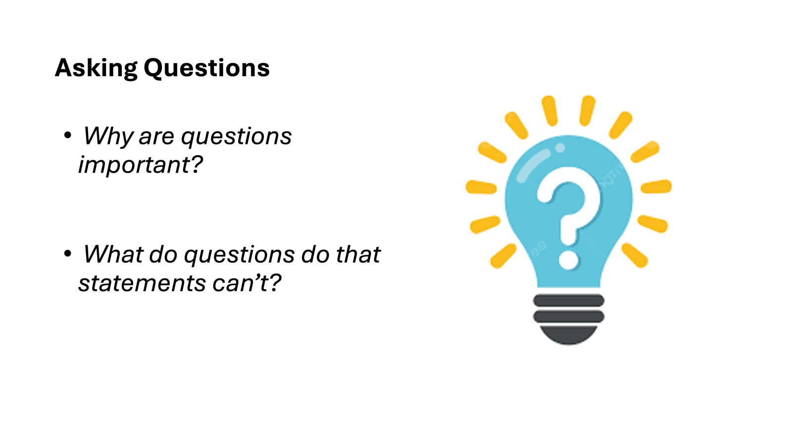  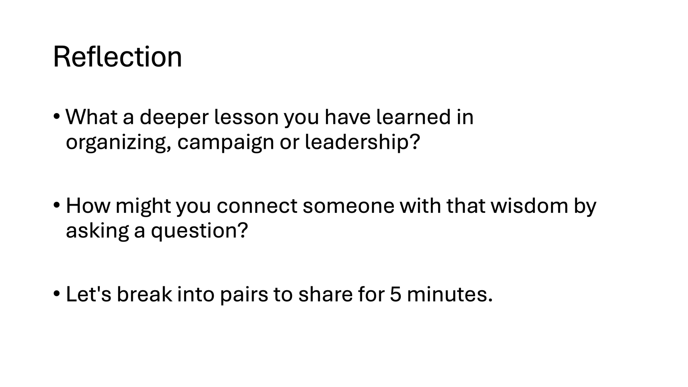  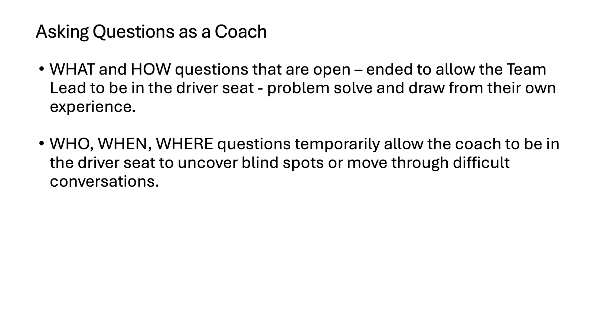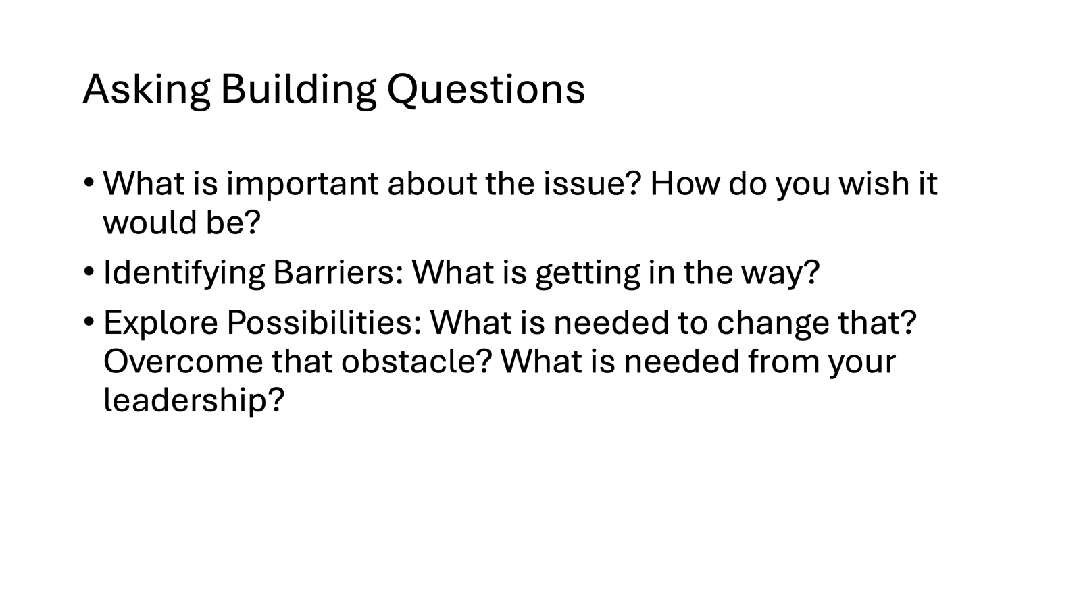  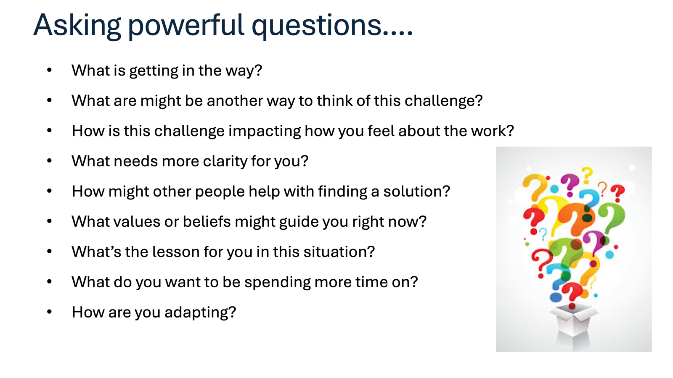  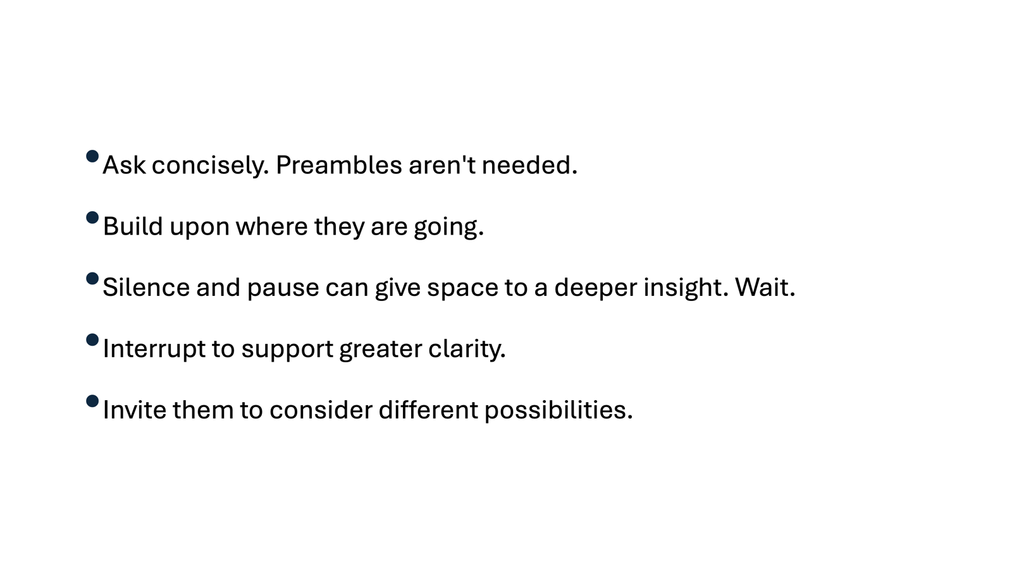 |  | - Coaching Skill: Coaching towards Alignment - (25 min total)  Questions are the foundation of coaching. When you as a coach tell a story, or give advice who are you centering?  ASK: Why are questions important? What do questions do that statements can’t? (brief discussion) ( I switched these slides so that people will understand why framing their wisdom as a question is important.  Let's reflect on that. We encourage you to write it down on a sticky note. 10 min  - What a deeper lesson you have learned in organizing, campaign or leadership?  - How might you connect someone with that wisdom by asking a question?  - Put on wall for gallery share  Present, Large Room Discussion - 10 min (Kristin)  - WHAT and HOW questions that are open – ended to allow the leader to be in the driver seat - problem solve and draw from their own experience.  WHO, WHEN, WHERE questions temporarily allow the coach to be in the driver seat to uncover blind spots or move through difficult conversations.  Ask concisely. Preambles aren't needed.  Build upon where they are going.  Silence and pause can give space to a deeper insight. Wait.  Interrupt to support greater clarity.  Invite them to consider different possibilities.  - Asking Powerful Questions to support deeper insights and clarity, move through limiting beliefs, and fears or deeper issues holding them back.  What is getting in the way?  What are might be another way to think of this challenge?  How is this challenge impacting how you feel about the work?  What needs more clarity for you?  How might other people help with finding a solution?  What values or beliefs might guide you right now?  What’s the lesson for you in this situation?  What do you want to be spending more time on?  How are you adapting?  - Asking Building Questions  What is important about the issue? How do you wish it would be?  Identifying Barriers: What is getting in the way?  Explore Possibilities: What is needed to change that? Overcome that obstacle? What is needed from your leadership?  - Coaching Skill: Transformational Coaching Stem by Elena Aguilar  - Activity: 5 min  Write down at least 10 questions that you might like to incorporate into your coaching.  - Center room Role Play Centering 3 agenda + Asking Powerful Questions 15 min  - Role play example (Fabricio coaching, Kristen coachee, other facilitator give coaching feedback?)  - Coaching 3 agenda  - Debrief – 5 min Katie Debrief  We are going to have lunch now and then practice coaching when we get back! | Part B.  Participants understand that questions get coachees to think deeply for themselves instead of being “told the right answer.”  Silence is a tool and a space for coachees to think things through. It’s ok, they don’t need to fill it.  The participants understand that powerful questions are helping coachees unlock what’s holding them back, how to build their team and in general think about the problem in a more wholistic way.  Participants understand that building questions help coachees about how to reach the goal.
12:00 – 1:00 P.M. |  | LUNCH
1pm-1:40pm  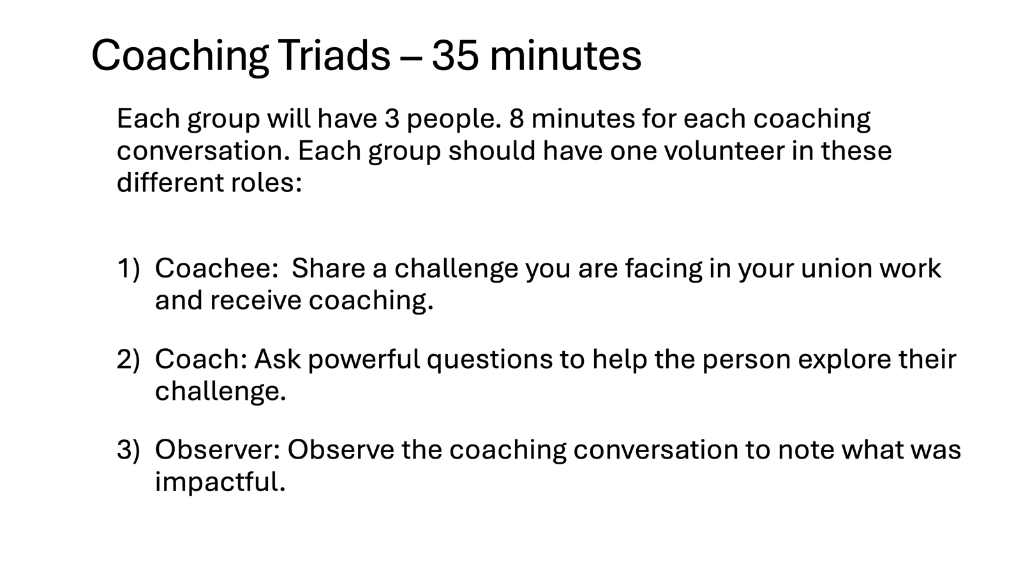  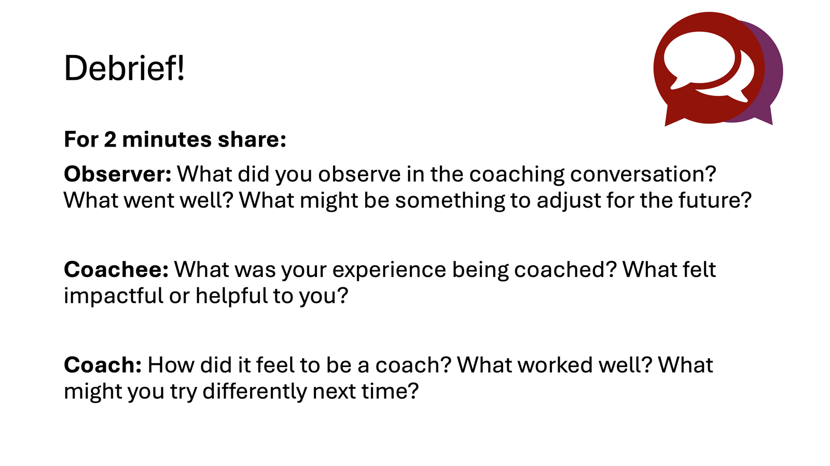 |  | PRACTICE – 40 min (Kristen)  - Reinforce structure and reminders to avoid yes/no  - How/Why  - 10 min talk, 2 debrief  - Create group count by 15  - Asking Questions: Coach is only allowed to ask questions, and can ask for a life line if they are stuck. Practice coaching.  - Review coaches conversation structure and questions  4 min big group process  Triad: 40 minutes
1:40 -2:10 - Bekah |  | 30 Mins TOTAL– Learning to Self-Manage
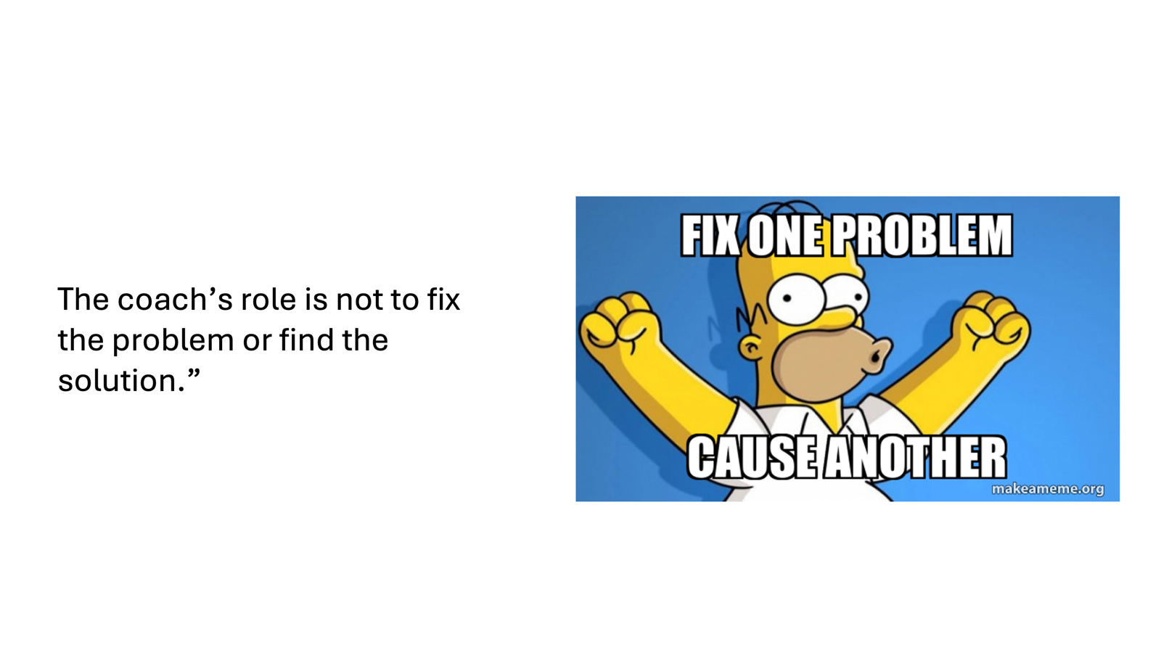  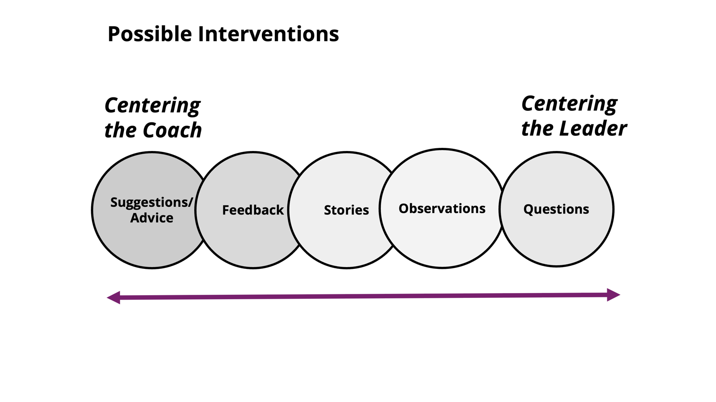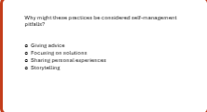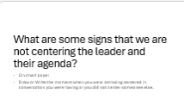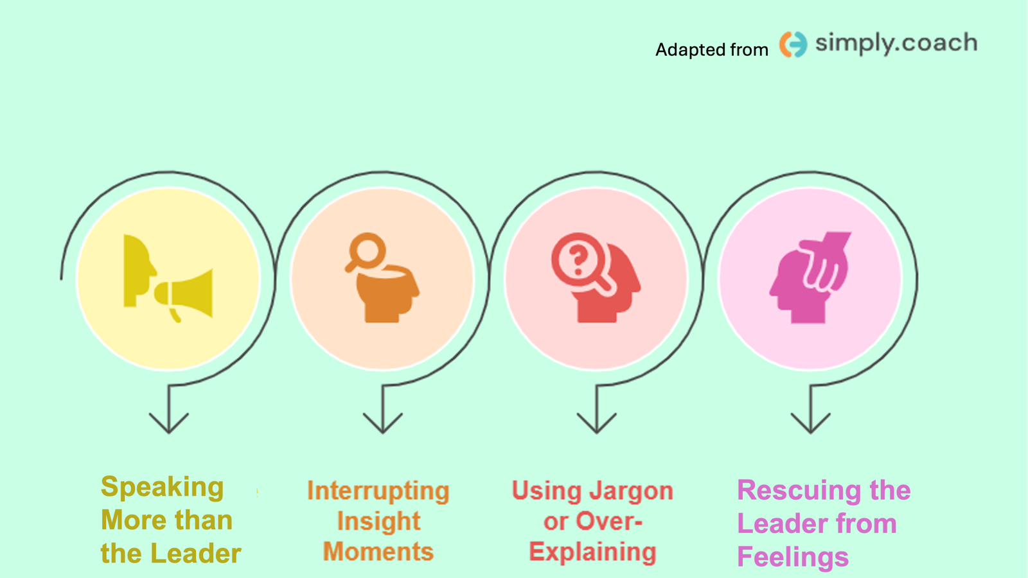  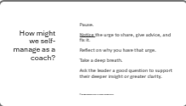  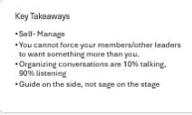 |  | - Coaching Skill: Self-Management  - Slide: As a coach you don’t have to fix it!  - Slide: The good news? Coaches don’t have to be experts – and they don’t have to guarantee the outcome of the coaching. The leader is responsible for their own growth. The coach supports them in this process.  - We are moving from a sage on the stage to a guide on the side.  - Slide: Spectrum of centering the coach and the leader.  We can do that most effectively when we self-manage. Why might some of the practices on the side that center the coach be considered pitfalls for a coach? (large group discussion 5 min)  - Advice giving  - Focusing on solutions  - Sharing personal experiences  - Storytelling  Coaching at its essence is “about asking rather than telling.” Our role as a coach is to center the agenda, the process of the leader.  For many of us, self-management is a skill we have to practice as a coach in order to learn it. Ask folks to raise their hands on when they have used this skill. Has anyone used this skill as an educator? A facilitator? organizer? leader? in your relationships? As a parent?  It’s a practice many of use across different parts of our lives. In this case, it’s a foundational skill of coaching someone.  - Slide: Centering the Leader’s Agenda – 10 min  - What are some signs that we are not centering the leader’s coaching agenda?  Small Group Activity:  - How did you feel when you were in a conversation and the person was centering them and making the issue about them?  - Or how have you decentered the other person and center yourself in a conversation.  Drawing activity.  - (Crowdsource from group) Some to shared if they aren’t mentioned:  - The topic dramatically changes and the coach doesn't’ confirm that’s the direction the leader wants to take  - Speaking more than the leader  - Interrupting insight moments  - Over-explaining or using jargon  - Rescuing the leader from feelings  Who here is a local president? Have you ever tried to rescue a person from their feelings.  Equity: Or helping someone avoid being held accountable for racism.  What is the potential impact of some of these pitfalls on the leader and your coaching conversation? (large room conversation (5 min)  (Share these takeaways if participants don’t bring them up.)  When you speak too much, it centers the coach not the leader. Coaching is 10/90 ratio of talking to listening.  The coach should let the leader lead the session: Don’t rescue them from exploring pain or insecurities.  Over-explaining isn’t necessary. You can just ask the question. The leader can ask for clarification if they need it.  Manage our own feelings.  - In coaching you also need to manage your own beliefs, fears, judgements, opinions and reactions. You can do this through the practice of self-awareness and skill of self-management.  - How might we self-manage as a coach?  Pause.  Notice the urge to share, give advice, and fix it.  Take a deep breath.  Ask a good question that brings the leader into deeper insight or clarity.  KEY TAKEAWAYS  Manage your own feelings somewhere else.  Self Manage  You cannot force someone to want something as much as you.  Talking 10/90  Guide on side not sage on stage.
2:10-2:25 PM |  | BREAK (15 mins.)
2:25-2:55 PM Melissa |  | 25 Mins - Coaching Skill: Curiosity and Unpacking Judgement | .
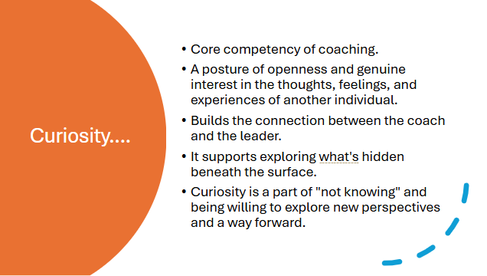  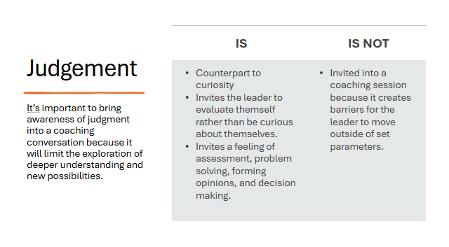  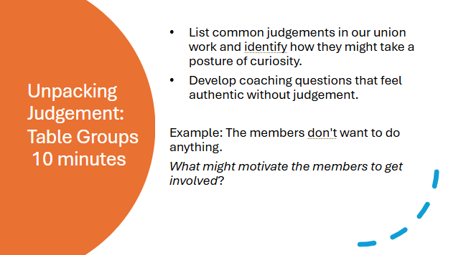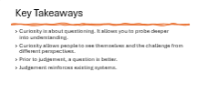 | Need 1 chart paper for each table group | - Opening - 5 min.  - Curiosity is a core competency of coaching. It’s a posture of openness and genuine interest in the thoughts, feelings, and experiences of another individual.  (INHERENT TO CURIOSITY IS CORE TO LEARNING AND CENTRERING THE COACHEE and not the COACH)  - Builds the connection between the coach and the leader.  - It supports what’s hidden beneath the surface.  - Curiosity is a part of “not knowing” and being willing to explore new perspectives and a way forward.  - Judgement is the counterpart to curiosity. Let’s unpack judgement. Judgement invites the leader to evaluate themself rather than be curious about themselves.  It invites a feeling of assessment, problem solving, forming opinions, and decision making. In our lives, judgement is a core part of our lives.  However, judgement is not invited into a coaching session because it creates barriers for the leader to move outside of set parameters. It’s important to bring awareness of judgment into a coaching conversation because it will limit the exploration of deeper understanding and new possibilities.  - Table Group Activity - 10 min.  - On chart paper:  - List common judgements, and identify how they might take a posture of curiosity  - Ask coaches to develop powerful coaching questions or select coaching stems that feel authentic without judgement.  - Table groups share out – 9 min.  - Key Points – 1 min.
2:55-3:25 PM – Kristin & Melissa |  | Interrupting – 30 min
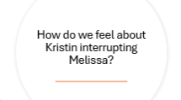  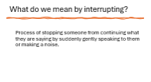  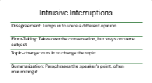  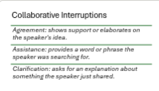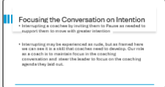  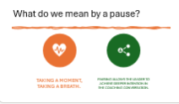      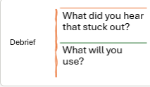 |  | [Sources: Blooming Willow + Teal Burrell, March 2018, The Science Behind Interrupting ]  - (role play interrupting....one facilitator begins the section while another facilitator interrupts rudely/unconstructively)  - Our role in coaching a campaign leader does involve guiding someone towards intentional action. For example, to build a committee, work with a team to develop a plan, take risks in a campaign, drive a focused campaign, deepen organizing and participation?  - Today we will introduce some tools to support a structured approach to coaching. However first we are going to start with a key technique you will need in coaching to develop a campaign leader.  - Types of Interruption  We are going to explore the practice of “Interrupting.” When we hear the idea of interrupting, how does that make us feel? (encourage honest responses, feels disrespectful, silencing, triggering, etc). These are called intrusive interruptions - and not the kind of best practices in interruption we want to perpetuate :)  SLIDE: Intrusive interruptions:  - Disagreement: Jumps in to voice a different opinion  - Floor-Taking: Takes over the conversation, but stays on same subject  - Topic-change: cuts in to change the topic  - Summarization: Paraphrases the speaker’s point, often minimizing it  There is another kind of interruption. Has anyone heard of “Cooperative Interruption”?  {If no one has heard of it, you could invite some volunteers to make an educated guess.}  SLIDE:  Cooperative Interruptions  Agreement: shows support or elaborates on the speakers idea  Assistance: provides a word or phrase the speaker was searching for  Clarification: asks for an explanation about something the speaker just shared.  - Show SLIDE: “Interrupting a coachee by inviting them to Pause as needed to support them to move with greater intention.” Blooming Willow  Interrupting may be experienced as rude, but as framed here we can see it is a skill that coaches need to develop. Our role as a coach is to maintain focus in the coaching conversation and steer the leader to focus on the coaching agenda they laid out.  What do we mean by pause?  Taking a moment, taking a breath. Pausing allows the leader to achieve deeper intention in the coaching conversation.  - WHY might we need to interrupt when coaching someone? (Ask the room, encourage discussion)  Summarize: The coach sometimes will need to interrupt the leader “pause and focus on themselves instead of others, move away from obligatory storytelling, stop negative self-talk, and receive support to focus on their coaching agenda.  Our role as a coach is to be the guide, and when someone gets them off track, bring them back into clarity so they can find their way.  - WHAT do we mean by interrupting the person being coached?  SLIDE: “Process of stopping someone from continuing what they are saying by suddenly gently speaking to them, or making a noise” Blooming Willow  - WHEN: When should we interrupt? To support someone to move forward, focus or go deeper such as: (Brief Slide). Coaches get permission to interrupt when the leader goes into.....  - Background info: We just need to know the impact on the coachee, not what led to it.  - Long stories: Only need to know what’s important about it, not all of it in detail  - Details about Others: Should focus on the coachee, not the people around them.  - Loops – Repeating same thoughts, stories, words, phrases  - Confusion – Coachee is lost and needs a moment to reset  - Boredom – Coachee doesn’t seem interested in the direction of the conversation.  Coaching Tips:  - A coach supports greater clarity – and helps someone tap into their own wisdom.  - Help an individual discover new thoughts, beliefs, emotions that strengthen their ability to take action and achieve what’s important to them.  - “Bottom-line” or understand the essence of the person’s communication and support them to get there rather than engaging in long stories.  10 min Activity: Let’s try it!  Table group activity  (Adapt...) Interrupting can be challenging, In this exercise, you are going to develop prompts that are authentic to you to interrupt a leader to support them to pause for deeper reflection – “without throwing them off energetically.”  Count off by 5. Go to a chart on the wall.  Write down some potential prompts you could use to cooperatively interrupt someone.  ^{For example:}  - Let’s take a moment to breathe  - I don’t want what you just shared to get lost  Chart with group. Select two people in your group to role play an issue. One person should be a member/leader with an issue. The other person should be the coach constructively interrupting to keep the member/leader on track and focused on the coaching process and the goal.  Debrief: 5 min  Reflection and reminder. Be mindful of who are interrupting. If you are a white person interrupting a person of color, ground yourself in the principals and check your bias if you are doing cross race coaching.
3:25-4:20pm Bekah |  | Centering Equity in Coaching – 55 min
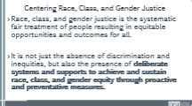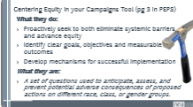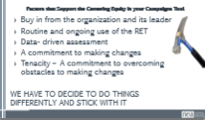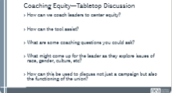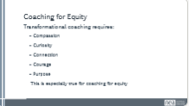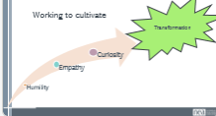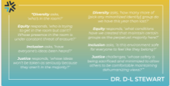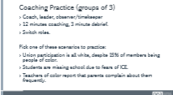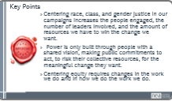 |  | - Framing Equity  Interrupting to support the leader to explore equity is sometimes needed. What do we mean by centering equity? Ask group.  In this next session, we are going to explore core concepts in equity, review a helpful equity tool, and practice coaching equity.  We center equity because it is the only way we will achieve equity – by being explicit, intentional and engage in a continuous process to center it.  II. Introduce Centering Equity Tool  To center equity, we want to be explicit about asking direct questions that center race, gender and equity. What are some common equity themes in leadership? Small group activity or large group?  III. Coaching Equity  Group Activity: 15 min Small table discussion with a facilitator at each table.  How might we coach leaders on centering, navigating, and advancing equity? How might the tool assist? Using the tool? What might be some questions a coach could ask that centers equity? What might come up for the leader as they explore issues of race, gender, culture, etc  IV. Practice Coaching Equity – 25 min  One person brings a problem of practice that involves issues of equity (something specific to how systemic inequities play out in their local union, campaign or worksite) 10 min for each coaching session, 3 minutes of debrief
4:20-4:30 Carrie |  | 10 Minutes - Closing
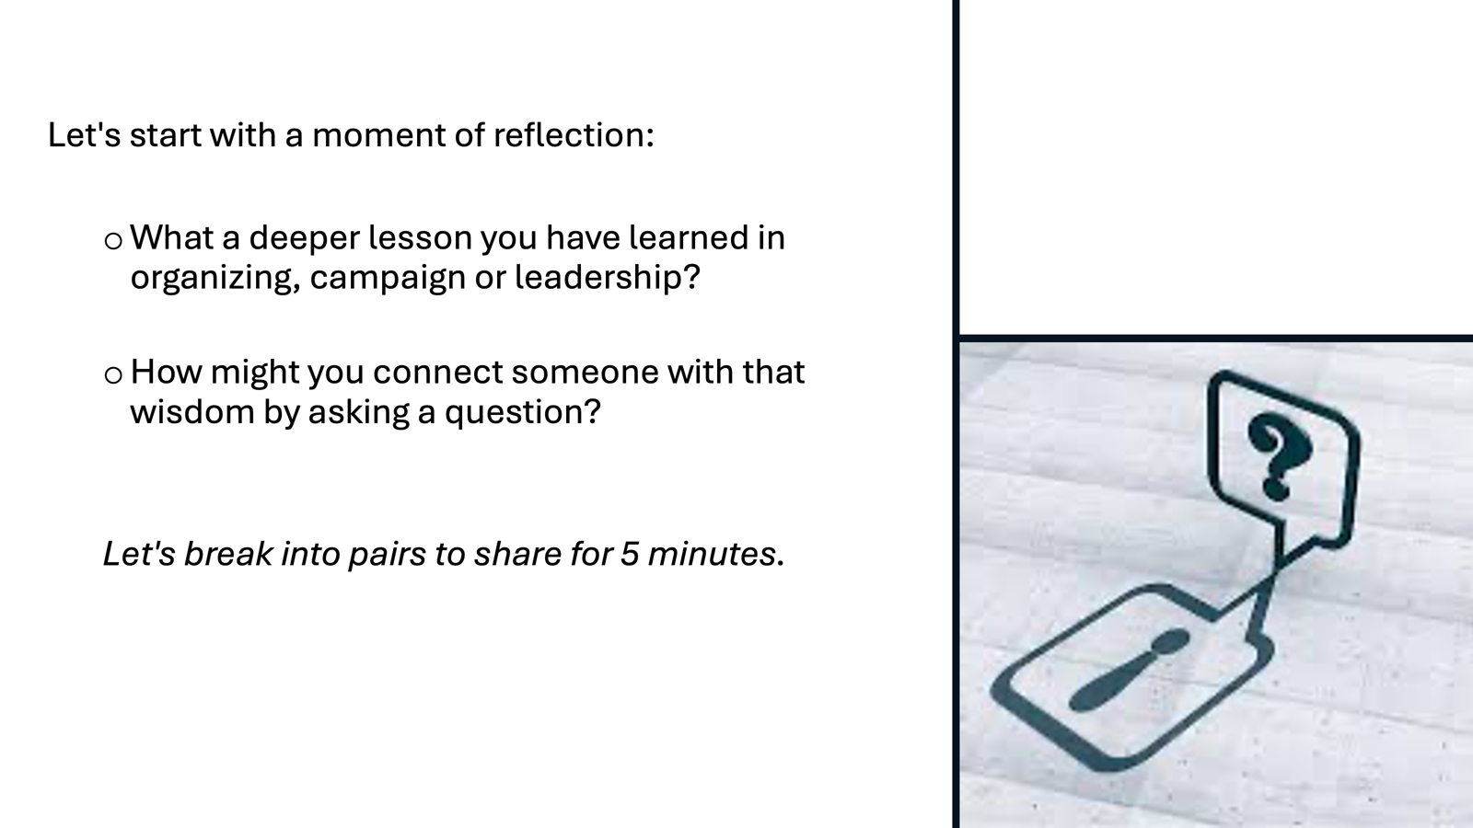 |  | 5 min Reflection (MOVE TO OPENING DAY 2  We are going to take a moment for reflection. We encourage you to write. Explore these two questions:  - Which skill do you feel will be challenging for you?  - What makes this skill or practice challenging for you?  FOR TOMORROW –  Any housekeeping or reminders about feedback form or reminders about what is needed next day | Participants will be able to bring a little closure to their learning and provide feedback on the day.
4:30 – 5:00 |  | 30 Minutes - Choice Networking Activities
 |  | This is a time for participants to meet and discuss any issues they are thinking about with other members of the group. This is not led by facilitators and highly encourage to occur in any other space besides the conference room. | Participants will make useful connections with staff from other affiliates.
5:00 ADJOURN
NOTES
Slide 6: The Organizing Conversation (5 min interactive)
Let’s take a moment at thinking about another approach to an intentional conversation that might be familiar to us. The Organizing Conversation! Many of us have learned the practice of having an organizing conversation. Do any of these organizing conversation formats look familiar to you? How is an organizing conversation different or similar to a coaching conversation?

