Strategic Planning and Coalition Building Facilitator Agenda: Day 2
General Materials Needed: |  |  |  | Room Set-up:
1 Set of Handouts per Person  Name Tents with the Norms  Room signs,  One ream of white photocopy paper  Chart Paper (4 to 5 full w Sticky Strip) |  | Materials Box for each table with:  Markers (Mr. Sketch variety)  Post its – 3x3” and 4X5” sizes  Index Cards  Highlighters – 4 colors  Pens and Pencils  Participant “toys” |  | Long Rectangle table at back for facilitators  Round Tables for participants  Projector, Screen, mics, and Speakers  Carousel stations and reporting stations  No podium, table with projector big enough for laptop  50 people max
Key Outcomes for the Event:
Participants will
Move pillars of power after 1432 plan
X Core Values
X World as it is/world as it should be
6 Box SWOT-
Union assessment/ (club to fighting union?) / equity tool/ power shield (organizational level)
Pillars of Power
Expressions of oppression: internal, interpersonal, institutional, systemic (One slide before pillars)
Very brief target identification review (maybe: ID decision-maker> how much power do you need to move them?> election campaign training plug)
Build a 2-4-3-1 plan
X Spectrum of Allies
Community mapping MELISSA
Case study analysis- linked needs scripting
Base building: Structured organizing conversations and Story of Self/Us/Now (Alabama Foundations 1.4) tie back to power shield and shared values (unboxing video?)
Very brief intro to elections (You cannot win big wins on an interpersonal level)
Inside/Outside strategy and worksheets (accountability for elected friendlies)
Participants can

Overview of Content, Time, and Facilitator Assignment
8:30-9:00 Entry, Feedback on Feedback  9:00-10:00 Spectrum of Allies  10:00-10:15 ???  10:15-10:30 Break  10:30-11:15 2-3-4-1 Plan/ Pillars of Power  11:15-12:00 Community Mapping  12:00 -1:00 Lunch | People at each point of the day |  | 1:00-2:00 Case Studies  2:00-2:15 Break  2:15-4:15 Public Narrative  4:15-4:30 Ending It Right  4:30 -5:00 Adult Choice Networking  5:00 Adjourn |  | Key Outcomes for the Event:

Time Slides Facilitator | Resources | Instructions, Activity and Debrief (Facilitators) | Essential Questions and Outcomes
Time and name of facilitators go in the banner for each section  Pictures of slides in the columns aligned with script – to the extent possible | Charts, handouts, articles, materials, slide | Total time and name of section go in the banner for each section of “script” . Write nearly all of what are you saying, what are they doing, what questions will you use to guide learning and make clear the important points Include an estimates within the script for how long each section of the learning will take | What question(s) will this learning answer? What will participants know or be able to do?
7:00 -8:30 – Team prep, practice, room set up, sound check, etc.
Entry Activity

8:30 -9:00 |  | 30 Mins TOTAL Getting Started
 |  | 5 Min – Welcome  Welcome participants back into the space, review the community agreements, spirals, and today’s agenda. Review feedback on feedback from the previous day’s evaluations.  Graphic Summary of reviews  15 Min  - Ask participants to reflect on yesterday’s learning.  - Each table will have 15 minutes to create a poster that summarizes the key points learned the previous day.  - There are 3 rules: 1) only one sheet of chart paper can be used, 2) Only pictures can be used, no words, letters or numbers, 3) must be a joint effort, all table members should contribute.  8 Min - Quick report out  2 Min - Facilitators to connect to today’s learning. Set the stage for the organizing conversation at the end of the day. [dependent on the worksite organizing ask]  Key Points  - Connecting the learning and experiences in the room | What have you learned so far?  This opening activity will allow for participants to reflect on the previous days learning and give the trainers the opportunity to tie the previous days learning to what will be covered today.
9:00-10:00 |  | 60 Mins TOTAL– Spectrum of Allies
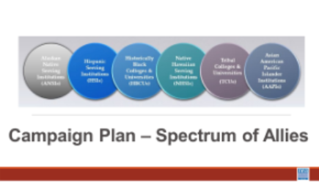  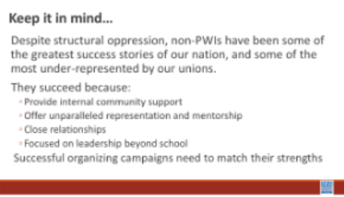  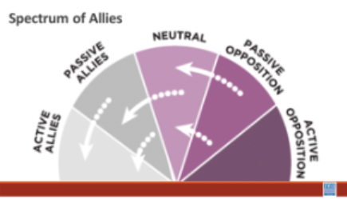  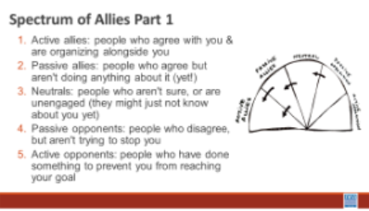  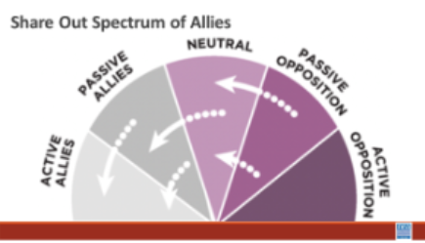  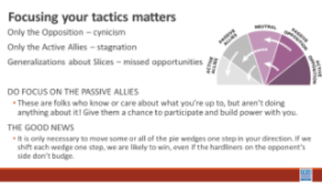  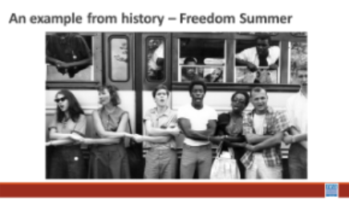  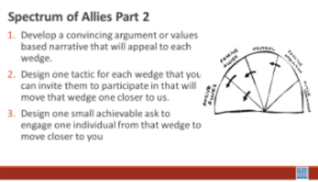  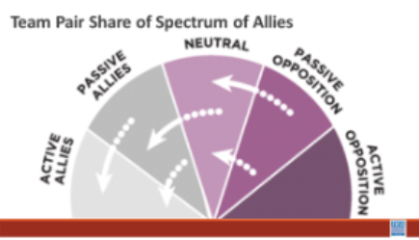  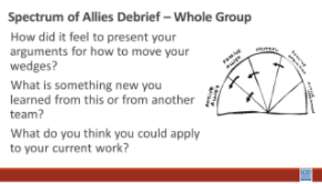  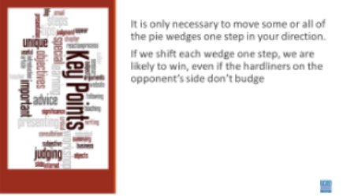 | Reframe intro | 5 Minutes Introduction- Your team just identified an Issue, a win, and a target based on our Vignettes. We are going to look at building a campaign plan. The methods and skills we are going to continue to apply here are linked to why we believe HBCUs and other non PWIs are successful – they are strong because of all the ways they are connected to various communities. So, as we build this plan, at each step of the escalation of a campaign from foundation, kick-off- through tactics to the BIG Win, we want you to intentionally think about the following:  - Your urgent message  - Your structure (leaders and teams)  - Your linked communities (not just YOUR people, but who they are connected with through shared values and commitments)  Our theory is that organizing on campuses like the one we visited have to include enough power to challenge and dismantle the expressions of oppression that exist.  15 Minutes of work time For Step 1 Activity - We are going to begin by learning a method Called Spectrum of Allies. All of our campaigns CAN include a wide range of groups, but particularly in the campaigns we are thinking about they must include that. These include a wide range of groups that can be put on a kind of spectrum, from those closest to the point of view of the advocates to those who actively oppose change. Draw a horizontal line to represent that. Those who advocate change are represented by a point at one end of the line (say, on the left), and the opponents by a point at the other end.  Draw a semicircle with wedges. The wedges closest to either end are the active allies and opponents, next in are passive allies. The group in the middle are neutral.  Use the issue that your group identified and the demand you came up with. Begin by asking, who might be inclined to be most supportive, least supportive, or neutral. Some examples of groups: ‘unions?’, ‘poor people’s groups?’, ‘business community?’. In your teams, identify these (AND WHY) and put them on your spectrum on the spectrum, and write them into the ‘pie’. Be as specific as possible – names, make them up to match the vignettes you are working with. Identify why people are placed where you placed them.  5 Minutes Whole Group Share – Do a little share out – as the facilitator, focus on the sharing of why the teams placed certain people in certain places.  5 Minutes of Content – Where do you focus your tactics?  Focusing only on the opposition leads to becoming disheartened or cynical, which means you ignore potential allies and support. Focusing only on how to convince the important power-holder who is against you leads to ignoring all of the potential support you could build that could overpower her opposition  Focusing only on active allies leads to being an isolated interest-group, which also means you ignore potential allies and support Always doing events with the same group of individuals or organizations isolates you from creative, powerful community-building that can  arise from new alliances and partnerships  Generalizing about whole groups of people risks misunderstanding the nuances of communities If you think about "students" as an entire group, you ignore the huge number of different groups & organizations (potential allies!) that exist in a student community  DO focus on passive allies. These are folks who know or care  about what you’re up to, but aren’t doing anything about it! Give them a chance to participate and build power with you.  Good news, In most social change campaigns, it is not necessary to win the opponent to your point of view, even if the powerholders are the opponent. It is only necessary to move some or all of the pie wedges one step in your direction. If we shift each wedge one step, we are likely to win, even if the hardliners on the opponent’s side don’t budge.  An example from history -  In 1964, the Student Nonviolent Coordinating Committee (SNCC), a major  driver of the civil rights movement in the U.S. South, conducted a spectrum of-allies"-style analysis. They had a lot of passive student allies in the North: they were sympathetic, but had no entry point into the movement. They didn’t need to be “educated” or convinced, they needed an invitation to enter. SNCC sent buses north to bring folks down to “Freedom Summer.” Students became active allies -- they came in droves, and many were deeply radicalized in the process, witnessing lynching & violent police simply because black folks were trying to vote.  Many wrote letters home to their parents, who suddenly had a personal  connection to the struggle. This triggered another shift: their families became passive allies as they learned about the struggle from those letters. The students went back to school in the fall and proceeded to organize their campuses. More shifts. The result: a profound transformation of the political landscape of the U.S., resulting from a deliberate movement strategy.  15 Minutes of worktime for Step 2 Activity -  For each of the wedges, your team is going to :  - Develop a convincing argument or values based narrative that will appeal to each wedge.  - Design one tactic for each wedge that you can invite them to participate in that will move that wedge one closer to us.  - Design one small achievable ask to engage one individual from that wedge to move closer to you  9 Minutes – Pair Share  Two teams will come together to share their work with each other  5 Minutes Whole Group Discussion  How did it feel to present your arguments for how to move your wedges?  What is something new you learned from this or from another team?  What do you think you could apply to your current work?  1 Minutes – Key Points  - It is only necessary to move some or all of the pie wedges one step in your direction.  - If we shift each wedge one step, we are likely to win, even if the hardliners on the opponent’s side don’t budge. | Participants will apply the Spectrum of Allies method to map focused tactics, narratives, and asks designed to move people toward their overall goal of the campaign.
10:15-10:30 |  | Break
10:30 – 11:00 |  | Mins TOTAL– 1-4-3-2 Plan, Target ID, Revisit Pillars of Power | .
Amanda reframe intro- Should also reference SWOT

What is strategic planning and how do you do it?

Create the shared vision first to build your base so you are strong enough to win and protect your wins.

Chip away at achieving your vision through short and mid-term goals that make your vision real. This is called strategic planning.

Show example of 4 box planning tool from Grassroots Power Project:

In box 1, write what you are currently working on, or the next thing you are planning to work on. This should be something that will engage a majority of your base so lots of member (and potential member) activity. Examples might be a contract fight, a budget fight, or an issue campaign, as long as the issue is deeply and widely felt.

In box 2, write a goal that would mean structural transformation. This goal would have to fundamentally shift money and power in favor of public schools and probably have to happen at the state level. One example might be a massive increase in investment in public education for your state funded by a tax on billionaires.

Now there is no way you can accomplish that goal on your own. So you will have to bring a lot of coalition partners and allies with you. You may not even end up being the lead organization in that campaign, but you will be critical to its success. So who else do you know of has a shared interest in that goal? Think about your spectrum of allies as well. These might be organized groups, like the NAACP or the state PTA. Or they might be unorganized constituents, like parents and families. To win, you are going to need all of them to play a role.

Now in boxes 3 & 4, you have to figure out how you are going to get from here to there. You also need to think about goals that are going to connect you with the larger groups of people and organizations that will be necessary to win goal 2. Who do you need to bring with you and what do they want? You may want to reference your spectrum of allies for this.

For box 3, what is a stepping stone fight? This should be something that starts to bring in support beyond just your fellow members and coworkers. What is a fight that will engage family and community members, and maybe a possible coalition partner or two? It should also connect at least somewhat to your previous goal and help lay the foundation for the biggest goal in box 2.

Underneath box 3, write down some of the groups you wish to engage in that campaign.

For box 4, what is a milestone reform that builds off of the stepping stone in box 3 and sets you up for the goal in box 2? At this point, you need to be thinking about your local and you should definitely be working in a coalition. If you want to fund the schools by taxing the billionaires, who else wants that? What laws, or elected leaders are currently preventing you from doing that? Who has a stake in those fights and what are your shared interests? Under box 4, write down any groups you are hoping to add towards winning your big goal.

11:15-12:00 |  | min: Community Mapping
Melissa will add
Amanda note: Individual members’ connections dont get pulled in until high on campaign mountain first, so that its connected to strategic escalation. Too early without established public relationship, not enough trust built yet for personal questions.

12:00-1:00 |  | Lunch
1:00- 2:00 |  | Case Studies
Amanda will add

https://www.ncae.org/strategic-plan
https://wecantwait.info/
https://inthesetimes.com/article/minneapolis-stpaul-minnesota-unions-labor-strike

https://grassrootspowerproject.org/tool/understanding-crisis/

2:00-2:15 |  | Break
2:15-4:15 |  | 120 Min: Personal and Public Narrative
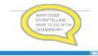  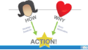  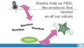  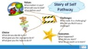  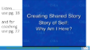  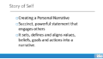  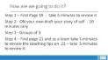  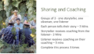  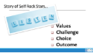     | Unboxing video  Public Narrative handouts | Min  Introduce: Who you are in this work  - The next part of our time together will be focused on getting to know you, how it presents in the work you do, and how you see and relate to other people. (The emphasis will be on how we see other people) Building our base requires moving past labels and assumptions to find our shared values. Shared values ground us in why we do the work we do with one another, and informs who we form coalitions with and why. Shared values keep us showing up together, often with people we might otherwise assume are not a good fit.  - This video from Denmark is a good bridge from what we are doing to get to know each other, and a reminder for how we approach “getting to know our people” in our work. What can happen when we unbox each other?  Amanda content note: No one cares or trusts you “because you’re union”. They need to see and relate to your shared values.  20 Mins Storytelling in Organizing – Focus on Story of Self  15 Minute Intro and Video  Why does storytelling have to do with leadership? And why do we focus on this in our academies?  Organizers often encounter individuals or groups where mindful action is inhibited by inertia, fear, self-doubt, isolation, and apathy. The job of a leader is not to tell people to stop feeling this way but rather use storytelling to move people from feelings of stagnation to feelings of motivation - urgency, hope, YCMAD (you can make a difference), solidarity, and anger. The language of emotion is the language of movement—they actually share the same root word. Stories mobilize emotions of action to overcome emotions that inhibit us from mindful action.  Organizers use stories to teach values, morals, and lessons, and to connect with each other. In organizing, well-constructed stories also help to engage others in our work. They inspire others to join us. They motivate others to ACT with us to create positive change and move us toward the world that should be. By telling a “story of self” you can communicate the values that move you to lead. Public leaders face the challenge of enabling others to “get” the values that move them to lead. Effective communication of motivating values can establish grounds for trust, empathy, and understanding. In its absence, people will infer our motivations, often in ways that can be very counterproductive. Telling our story of self can help establish firm ground for leadership, collaboration and discovering common purpose. Every one of us has a compelling story of self to tell. We all have people in our lives (parents, grandparents, teachers, friends, colleagues) or characters we love, whose stories influence our own values. And we all have made choices in response to our own challenges that shape our life’s path— confrontations with pain, moments of hope, calls to action.  The key focus is on our choices, those moments in our lives when our values moved us to act in the face of challenge. When did you first care about being heard? When did you feel you had to act? Why did you feel you could act? What were the circumstances, the place, the colors, sounds? What did it look like? The power in your story of self is to reveal something of those moments that were deeply meaningful to you in shaping your life—not your deepest private secrets, but the events that shaped your public life. Learning to tell a good story of self demands the courage of introspection, and of sharing some of what you find.  Review the Anatomy of your organizer’s story --  Character - (that’s you), moral – (where do we connect with you, what did you learn), plot – (you had a challenge, you made a choice and there was a hopeful outcome). Keep in mind, everyone has a story to tell. Your challenge is to use your story to connect with those you are trying to organize - move them to action, join you in the cause, or inspire them to have hope in their own ability to make change.  A key guideline – your story is brief – no more than 3 minutes.  This is not a speech. We all have multiple stories to tell. Knowing when to share our or not to share our public stories becomes crucial.  7 Mins –  Marshall Ganz video – leadership story of self with coaching as a group (only the first 5 mins) to demonstrate how this works. (p. 6 and pg 10 for coaching tips__)  Quick Debrief of video  - Notice the length?  - What else do you notice about the coaching that Marshall Provided?  75 Mins – Story of Self Writing, Coaching and Practicing, and Whole Group Share of 4 to 5  1 Min -Now that we have seen a model of a story of self and some good coaching we are going to write and share a story of self.  5 Mins – Review page 7-8  10 Mins - Writing a Story of Self - You will draft your story of self. Keep in mind the structure and purpose – your audience will be us. You will be expected to share your story in a small group and receive some coaching. Use pages 7-8  30 Mins  Sharing and coaching (pg. 10)  In groups of three, you will each share your story – no more than 3 minutes, and then will receive up to 6 minutes of coaching and critical feedback. For each round, one person will be the STORYTELLER, one the COACH and one the OBSERVER. Just as when we watched the video, we had the STORYTELLER, Marshall the Coach, and then we discussed what he did well in the coaching. To help support you in your coaching refer to the coaching questions found in your handouts on PAGE 26. We are also looking for up to 5 people who are a good, willing models to share their story to the whole group. So at the end of your group’s sharing time, please incorporate the feedback that your colleagues provided you. Let’s review, take 3 to 5 minutes to locate and review the coaching questions, Then Each person shares a three minute story, in which they receive 3 mins of coaching and then the coach receives up to 3 minutes of feedback on their coaching. and receives up to 6 minutes of feedback. Once your group has finished, then make adjustments to your story based on the feedback.  20 Mins  Large Group Sharing – (pg. 11 )  Up to 5 People will share their stories to the whole group. As you listen please use the listening guide found in the handouts on page 11.  I will be giving the following signals to the speaker – 2 fingers, 2 mins left, 1 finger is the 1 minute warning, circular wave means to wrap it up your time is up.  (Facilitator note -As you look for people to share a story of self – be mindful of differences in age, race, gender etc. – pay attention for examples of power and privilege and “overcoming” and the organizing that happened to gain justice- to make connections on day 2 to power-privilege- oppression  Debrief after each story quickly with these two questions  - What are the common values that you hear in the stories?  - What coaching would you provide?  20 Minutes – Adding Us and Now and Debrief - page 7  Remember that telling a “story of self” you can communicate the values that move you to lead. One of our primary purposes is to “move” people to act. WE often face the challenge of enabling others to “get” the values that move them to lead. Effective communication of motivating values can allow us to be “relatable” to others at the values level. This helps establish grounds for trust, empathy, and understanding. The Us in public narrative are the people who share your hopes and values that you are calling to act. The action is in direct reference to an URGENT NOW. What do they need to do now to achieve your common purpose?  Before you write let’s listen for the Story of Self Us and Now – use page 6 to track when and if the storyteller switches from Self to US to Now - think about coaching questions you would have.  A story of now: What urgent challenge are you calling on others to join you in facing. What is the source of hope that action could be fruitful? What action can they take together to achieve a clear outcome? And how can they begin now, at this moment? Spend about 5 minutes thinking about and writing down your story of now in only 2-3 sentences.  A story of us: Who is the “us” that you will call upon? What shared values, experiences, or hopes will you draw upon when you ask them to join you in action? What stories can you share that express these values? Spend about 5 minutes thinking about and writing down your story of us in only 2-3 sentences.  5 Minutes Key Points  - Our story is how we present a “relatable” self that allows someone else to want to join in a public relationship with you.  - It is how you and the people who have a shared purpose and shared values communicate about the work you want to do and encourage others to join with you.  - This takes practice  - COACHING is a required skill to be successful. Coaching is not giving advice, it is asking good guiding questions.  - COACHING AND LISTENING TAKE PRACTICE
4:15-4:30 |  | 15 Minutes - Ending it Right
 |  | Questions, Connections, Reflections  Housekeeping announcements  Plus/Delta at the Door  FOR TOMORROW – | Participants will be able to bring a little closure to their learning and provide feedback on the day.
4:30 – 5:00 |  | 30 Minutes - Choice Networking Activities –
 |  | This is a time for participants to meet and discuss any issues they are thinking about with other members of the group. This is not led by facilitators and highly encourage to occur in any other space besides the conference room. | Participants will make useful connections with staff from other affiliates.
5:00 ADJOURN

