Facilitator Agenda: Day 1 “The What”- Values, Vision, Equity Analysis, and Putting It All Together
General Materials Needed:  Online Course Link https://neapartnera.learnupon.com/content-details/4449849/0 |  |  |  | Room Set-up: 50 people max
1 Set of Handouts per Person  Name Tents with the Norms  Room signs, Stick on Name Tags  Chart Paper (4 to 5 full w Sticky Strip) | Materials Box for each table with:  Markers (Mr. Sketch variety)  Post its – 3x3” and 4X5” sizes  One ream of white photocopy paper |  |  | No podium, table with projector big enough for laptop  Long Rectangle table at back for facilitators  Round Tables for participants  Projector, Screen, mics, and Speakers  Carousel stations and reporting stations
Pre Academy Assignments: 00 Pre Academy Full.pdf
Key Outcomes for the Event:
- Analyze their current situation in the context of a broader political landscape
- Build a vision based on shared values and analyze that vision through an equity lens
- Articulate solidarity as a strategic choice as well as a union value
- Understand why a team is vital to a campaign
- Learn the strategy of base-building
- Learn key skills to build a team: 1:1 organizing conversation, worksite mapping and charting, and leader identification
- Learn about examples of how to troubleshoot common problems with organizing teams.
- Create a plan to build the strongest, tightest, most resilient organizing committee possible

Overview of Content, Time, and Facilitator Assignment (Timer)
8:30-9:00 Introduction and Overview (Required Content)  9:00-9:45 Our History and Our Values—the work that has been done and what values brought you here. Teams share what they’re after.  9:45 10:30 WE INTERUPT THIS PROGRAM- YOUR NEWSPAPER SHOWS YOUR VISION AND VALUES  10:30-10:45 Break  10:45-12:00 Equity Tool Overview/Analysis Activity |  |  | 12:00-1:00 Lunch  1:00-2:00 Solidarity as a Core Strategy Activity and Overview  2:00-2:45 Vision vs Goal  2:45-3:00 Break  3:00-3:15 Energizer Activity- Why do you need a team?  3:15-4:00 STOP THE PRESSES- reflection and edit  4:00-4:30 Ending it Right
Time Slides Facilitator | Resources | Instructions, Activity and Debrief (Facilitator Script) | Essential Questions and Outcomes
 | Charts, handouts, articles, materials, slide | What are you saying, what are they doing, what questions will you use to guide learning and make clear the important points  Include an estimate for how long each section of the learning will take | What question(s) will this learning answer? What will participants know or be able to do?
Noon-5:00 – Team prep, practice, room set up, sound check, etc.
Entry Activity
8:30-9:00 |  | 30 Mins TOTAL Getting Started
  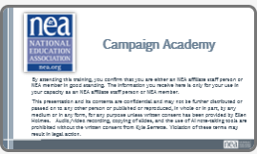  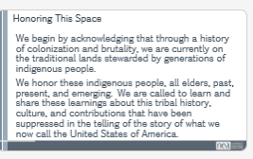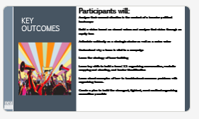  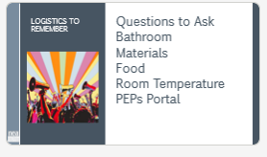  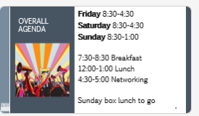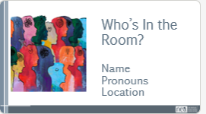  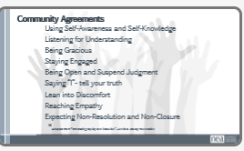 | Norms Online Pre Attendance  Agenda on Slides  Name Tents  Handout Package online  01 Community Agreements 8.27.pdf | 2 Minutes Welcome – basic intro and reading of the confirmation of membership  2 Minutes Land Acknowledgement  We begin by acknowledging that through a history of colonization and brutality, we are currently on the traditional lands stewarded by generations of the Indigenous people(BE SPECIFIC TO AREA). We honor these indigenous people, all elders, past, present, and emerging. We are called to learn and share these learnings about this tribal history, culture, and contributions that have been suppressed in the telling of the story of what we now call the United States of America  5 Minutes Outcomes and Agenda Overview  Begin the understanding that the first two nights are about HOW we will achieve the Change that the Campaign Lab represents. We are coaching people into their agency to make decisions about their campaigns – we are not advising or consulting. More about that.  Review Agenda reminder about meals, Karla for Logistics, etc.  Member volunteer to collect “thank you” for our staff working in the hotel.  Community Agreements:  1 Min - Review  Review these Community Agreements with a reminder that it was  a part of their Preattendance work:  1. Using Self-Awareness and Self-Knowledge  2. Listening for Understanding  3. Being Gracious  4. Staying Engaged  5. Being Open and Suspend Judgment  6. Saying “I”- tell your truth  7. Lean into Discomfort  8. Reaching Empathy  9. Expecting Non-Resolution and Non-Closure  6 Min  Prompt table groups to review the agreements.  • Give them 6 minutes to scan the agreements looking for  items that they don’t understand.  • They should also be tracking what they think is  Missing.  3 Min - Debrief  Check to see if tables are on track or need clarity of the agreements.  Before moving on - ask the group to show thumbs:  • Thumbs up is I totally agree  • Thumbs sideways is I can live with it and I am fine to  move on  • Thumbs down – I simply cannot move on AND I have questions or something different to propose.  o A thumbs down comes with the responsibility of working until your thumb can at least be sideways. | Participants will know how we are going to work, the basic schedule, and the logistics relevant to the training.
9:00-9:45 |  | 45 Minutes- THOSE WHO CAME BEFORE AND WHY WE’RE HERE NOW
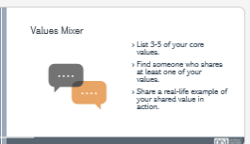 | Values handout | REWRITE THIS TO INCORPORATE BLACK AND BROWN VOICES THAT CAME BEFORE AND THE VALUES OF TEAMS THAT BROUGHT THEM TO THIS TRAINING  Step ONE IS TEAM FORMATION IN A CAMPAIGN SHOW ALL STEPS OF A CAMPAIGN  Core Values are the things that guide us when things are getting difficult or challenging. Core Values are important to discuss with your core leadership team so that you understand and they understand what will motivate them and what will motivate you in times of difficulty. It is why you are willing to do this work-  I added a slide defining values with your words above- AK  Definition I used (from Practical Radicals) What you believe about the world and how you decide what is and is not important.  Examples: teamwork, compassion, curiosity, integrity, courage, faith, sustainability, competition, loyalty, kindness...  Introduction:  - Name  - State  - Pronouns  - Name the values that brought your team to care about the issue you want to work on/or are working on.  - One team member report on what does your team hope to accomplish?  . | Participants will know what values are.  Participants will know their own values and how it connects us to other people.
9:45-10:30 |  | - Vision and Values
  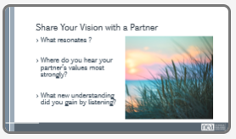 | Chart paper  Markers | 35 minutes-  “Was it difficult to name your teams’ goal?” Having a shared vision takes effort. We don’t come to the conversation with the same ideas, goals or values. Our work is creating that vision together.  Think about the values and scenarios you just described. We are going to imagine a horizon, distant, but not too distant, where we are living those values in ways that feel true to you. You will have a good chunk of time to write and/or draw what your success would look like through the eyes of your local newspaper. Create a headline and story on a piece of chart paper.  Think about everyday experience more than specific policy changes. How will you be living? What will it be like to arrive at work? What will your workday feel like? What will you be doing in your free time? How will you be interacting with family and friends? With neighbors? What will your community be like? What will you see when you are out and about in your community?  Remember this is a world governed by those values we all just shared. We aren’t going to trouble ourselves with how we get to that world just yet. Just, what it would look like, feel like, sound like, taste like. Make it a place we can experience through your telling.  5 minutes-  Gallery walk of newspapers  5 minutes- Debrief  What moved you? | Participants will learn how to create a vision based on shared values by creating their newspaper.  Participants will be introduced the concept of power.
10:30-10:45  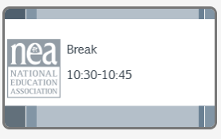 |  | 15 Minutes- Break
10:45-12:00 |  | 1:15 Minutes- Equity Analysis
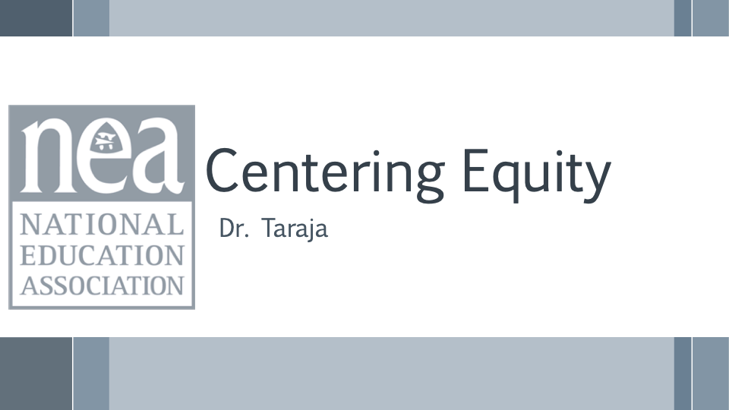  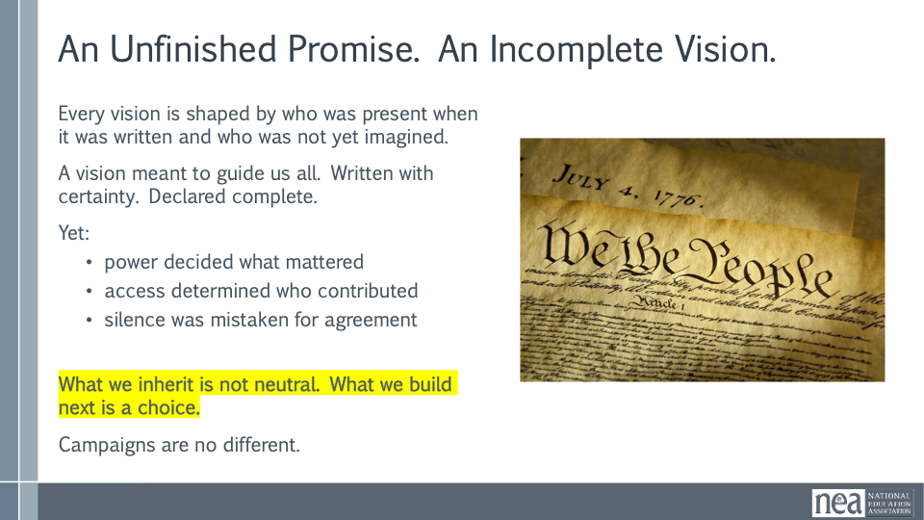  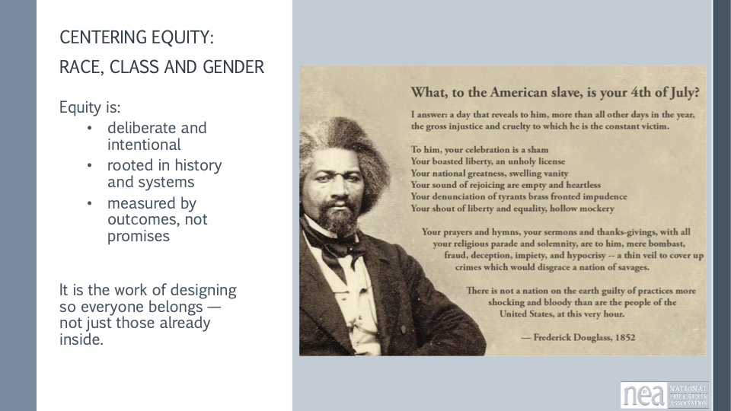  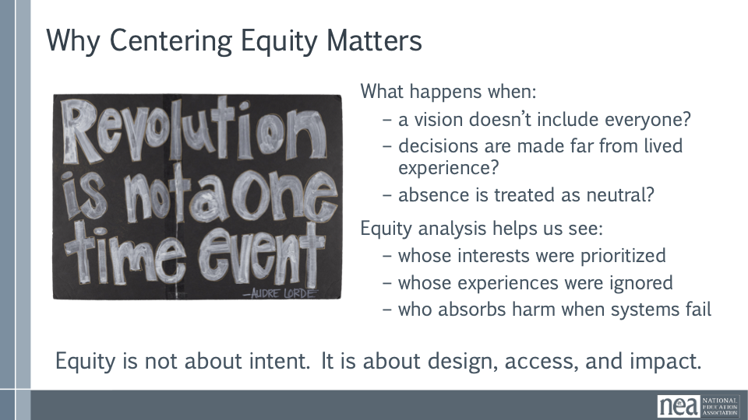  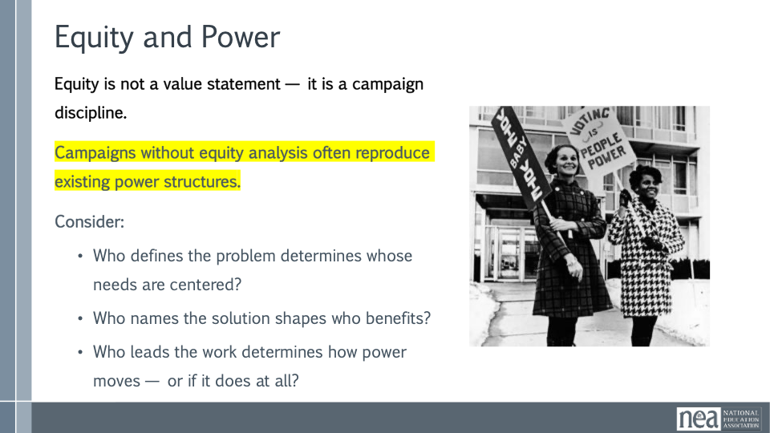  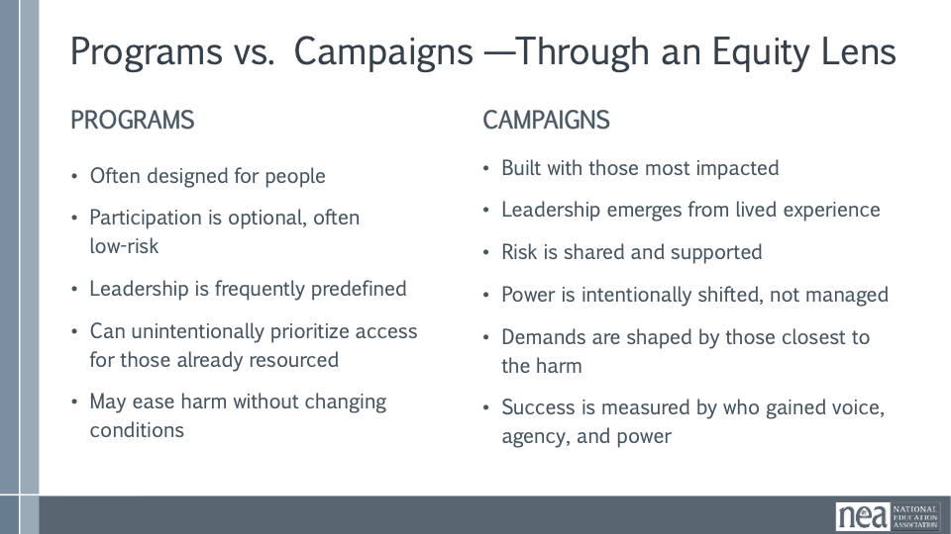  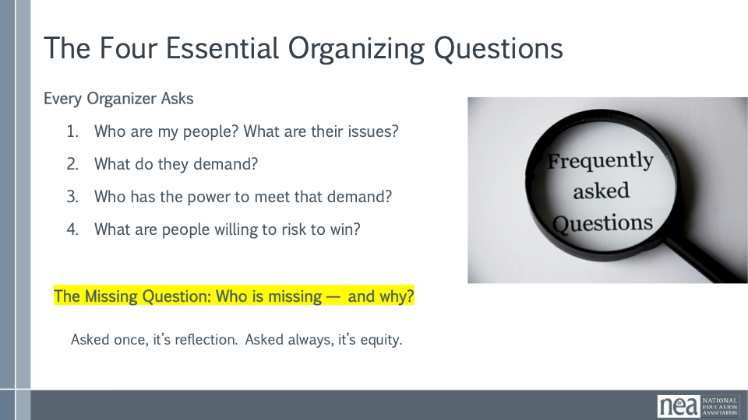  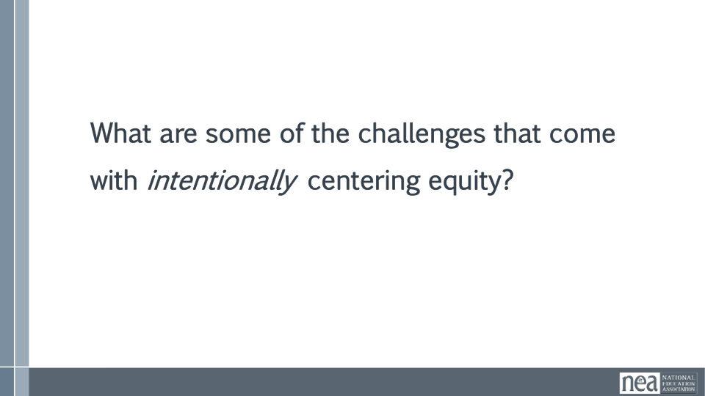  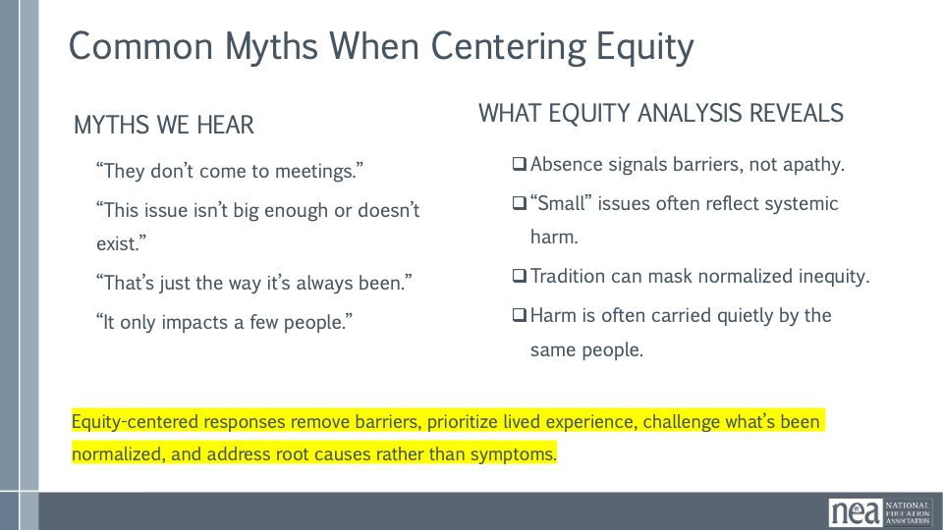  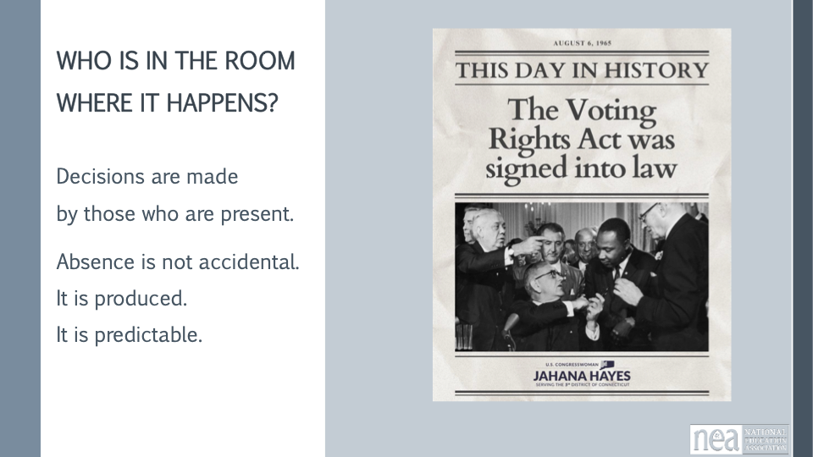  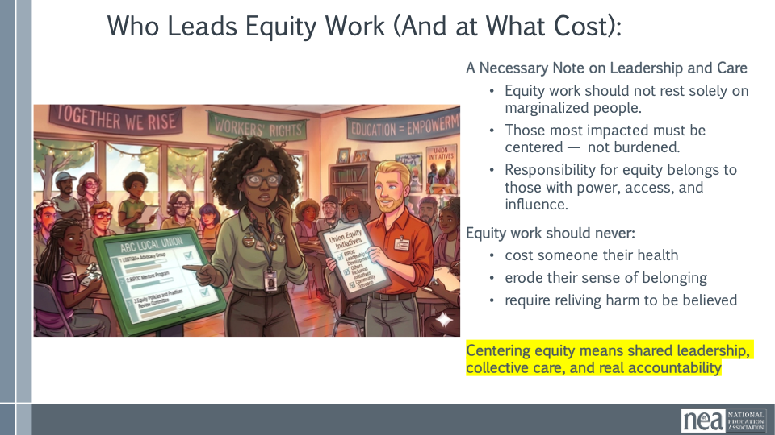  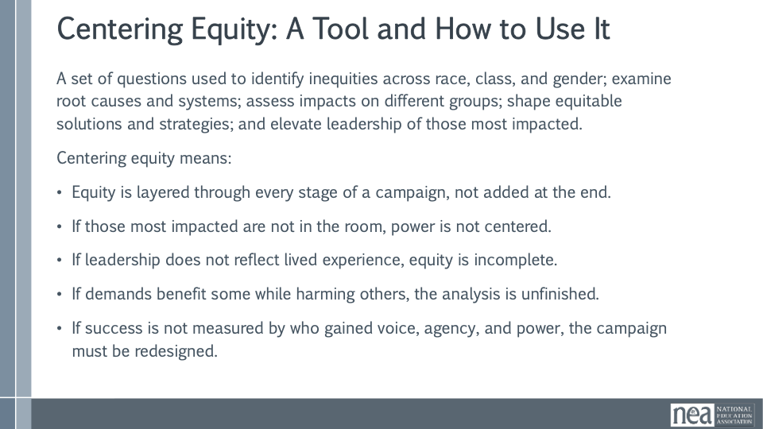  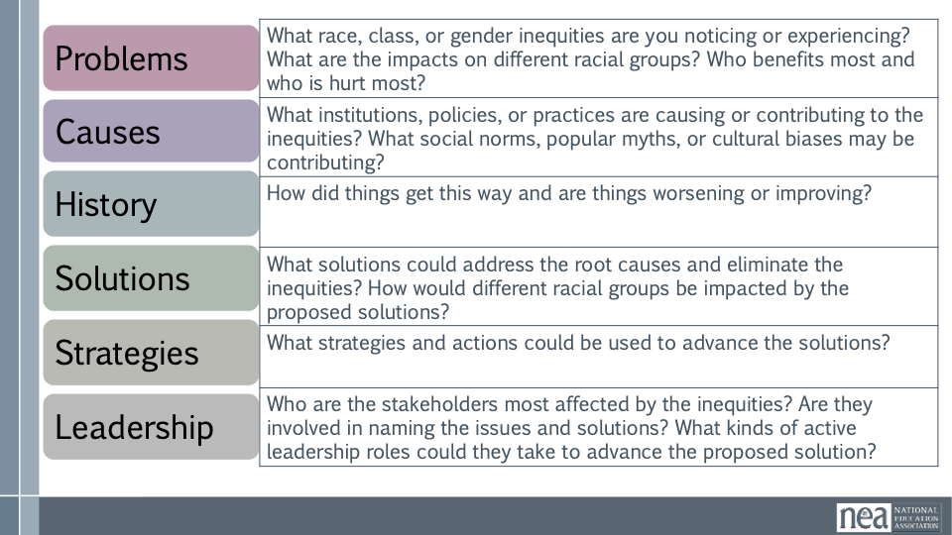  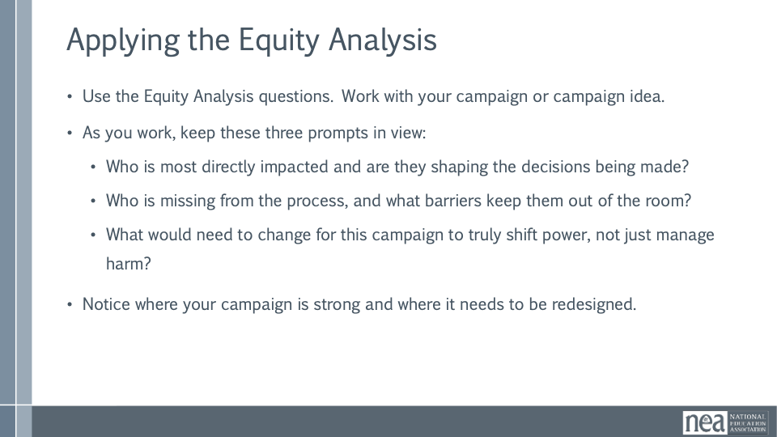  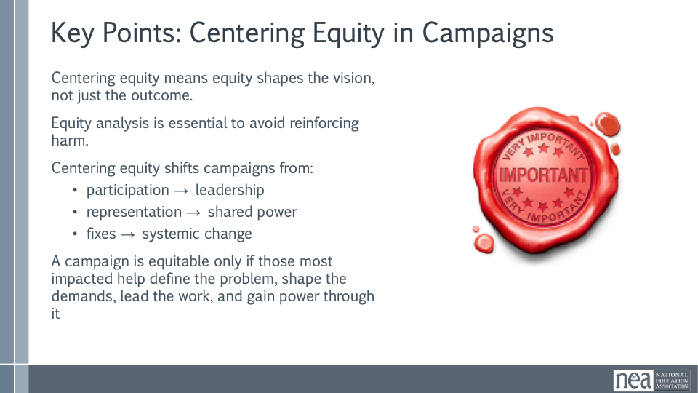 | Equity tool handout | Centering Equity in Campaigns (75 Minutes)  This session focuses on how campaigns are designed, not just what they aim to win. Participants will arrive with different levels of readiness, all of which belong here. The guiding question throughout the session is: Who is in the room where it happens — and who is not?  Opening Framing  Centering equity is not a values exercise. It is an organizing discipline that shapes how problems are named, demands are formed, leadership develops, and power moves. This work is about intentional design, not perfection.  An Unfinished Promise  Every vision is shaped by who is present, who has decision-making power, and who is imagined as the audience. Campaigns are no different. Centering equity means refusing to treat absence as neutral.  Why Centering Equity Matters  Equity is not about intent. It is about design, access, and impact. Equity analysis helps us see whose interests were prioritized, whose experiences were ignored, and who absorbs harm when systems fail. This is about clarity, not blame.  Equity, Power, and Campaign Discipline  Equity is a campaign discipline. Power operates through who defines problems, names solutions, and leads the work. Campaigns that skip equity analysis often reproduce existing power structures, even with good intentions.  Programs and Campaigns Through an Equity Lens  Programs often focus on support and stability. Campaigns aim to change conditions and shift power. Equity-centered campaigns are built with those most impacted and measure success by leadership development, shared risk, and power shifts.  Organizing Questions and the Missing Question  Beyond the four organizing questions, equity demands a fifth: Who is missing and why? Absence is rarely accidental. Asking this question is design repair, not criticism.  Resistance and What It Reveals  Group share-out: What are some common challenges that you encounter when you try to intentionally center equity in this work?  Common Myths When Centering Equity  Noting some common resistance statements point to barriers, not apathy. Equity-centered responses remove barriers and redesign systems based on lived experience and root causes.  Who Leads Equity Work and at What Cost  Equity work should not rest solely on marginalized people. Responsibility belongs to those with power and access. Equity work should never cost someone their health or sense of belonging  Small-Group Equity Analysis (25–30 Minutes)  Participants work in groups of three to five using the equity tool to examine an active campaign or campaign idea. Gaps and uncertainty are information.  Guiding Prompts  Who is most directly impacted and are they shaping decisions? Who is missing and what barriers may be keeping them out? What would need to change to truly shift power?  Whole-Group Shakeout and Harvest (15 Minutes)  Invite short reflections: one equity gap, one assumption that shifted, or one design question that emerged. Name patterns and reinforce these as organizing opportunities.  Closing Anchor  Centering equity means shaping vision, leadership, and strategy. Campaigns are equitable only when those most impacted help define problems, shape demands, lead the work, and gain power through it. | Participants will learn how and why to use an equity tool to evaluate their vision.  Participants will articulate what achieving their goal would look like if it was rooted in equity.
12:00-1:00   |  | 1 hour- Lunch
1:00-2:00 |  | 1 hour- Solidarity as a Core Value and Strategy
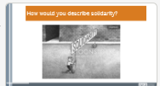  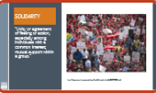  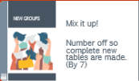  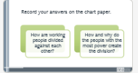    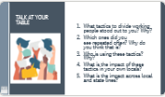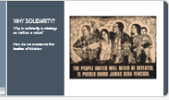  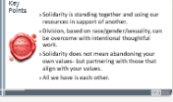 |  | 5 minutes-  How would you describe solidarity to a lay person? (Popcorn out).  We are going to focus on solidarity and how we have been divided and how we can overcome and build solidarity. First lets talk about what solidarity is. Solidarity is Unity or agreement of feeling or action, especially among individuals with a common interest; mutual support within a group: using your own resources to reach and support other groups.  In standing together- we are stronger. Divided some might do better, but collectively we all do worse.  15 minutes- Heterogenous Regroup- one person from each issue group from before lunch to form a new group.  Small Group Discussion- Using examples from the issue you just analyzed before the break? how are working people divided against each other? What specific stories or tactics are used? Record answers on chart paper.  10 minutes- Gallery walk. Each individual gets one marker. Each group moves one table over. As an individual, put a dot next every tactic you see happening in your local. Rotate tables until you are back to your own.  15 minutes- Assign each table one of the following questions: What tactics to divide working people stood out to you? Which ones did you see repeated often? Who is using these tactics? What is the impact of these tactics in your own locals? What is the impact across local and state lines?  Give them 5 minutes to talk and 5 minutes to share out.  5 minutes- Whole group discussion- why do unions focus so strongly on solidarity? Why is solidarity a strategy as well as a value? How do we overcome the tactics of division?  Key learning Point:  - Solidarity is standing together and using our resources in support of another.  - Division, based on race/gender/sexuality, can be overcome with intentional thoughtful work.  - Solidarity does not mean abandoning your own values- but partnering with those that align with your values.  - All we have is each other. | Participants will understand how those in power use tactics to divide working people against each other in order to maintain their power. And, how unions intentionally build solidarity to defeat these tactics.
2-2:45 |  | 45 Minutes - Vision Vs. Goal and Issue vs. Problem
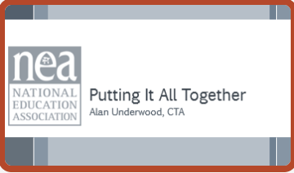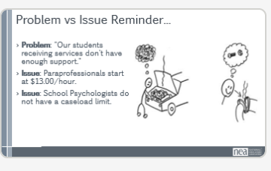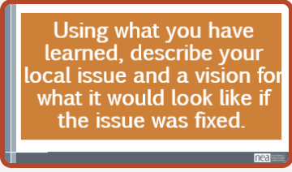 |  | GO BACK TO YOUR NEWSPAPER AND EDIT TO REFLECT ON WHAT YOU’VE LEARNED ABOUT EQUITY, SOLIDARITY AND PROBLEM VS. ISSUE USE POST IT NOTES TO SIGNIFY CHANGES MADE TO REFLECT THE EDITS  10 minutes- Have spent a lot of time thinking globally together. Now we are going to focus on our work back home. Actual tangible things in your back home life/work, goal is to be descriptive.  Remember, a problem is “my car won’t go” an issue is “I need gas” or “my spark plugs are not doing the thing.”  How does this show up in education: Problem: "Our students receiving services don't have enough support."  Issue: Paraprofessionals start at $13.00/hour.  Issue: School Psychologists don't have a caseload limit.  Reminder: What is an issue? Are you promoting equity?  Using an issue you think will be the focus of your campaign, write how you now understand the issue and a vision for what it would be like to have that issue fixed. What would you see, feel, hear, etc. How would you know you had really won? Think about painting the picture of that horizon you want others to see in the near future.  Let’s make sure we are hearing from someone we haven’t heard from today.  10 minutes- Share-outs at your table  10 minutes- Highlight share-out from each table | Participants will be able to describe their proposed campaigns and goals in terms of a vision that promotes equity and solidarity between workers.
2:45-3:00   |  | 15 Minutes- Break
3:00-3:15 |  | 15 Minutes- Energizer Activity- Why Do you Need a Team?
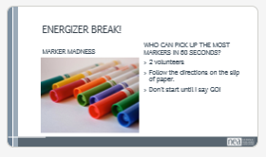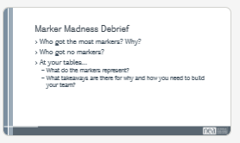  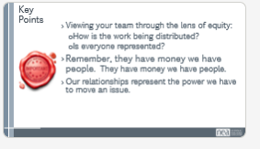 | WHERE ARE THE MARKERS GOING TO BE? MAKE SURE NOTE REFLECTS TABLE OR FLOOR. | Why do you need a team to have a campaign?  Why do you need to have power?  Activity to spark conversation. Ask for 2 volunteers. Give each volunteer a piece of paper with the different directions. They shouldn’t show anyone else the directions, but instead should only do what it says. Give each person a minute to read and act accordingly when you say go. The directions will say:  - When you are told to start, pick up as many markers as you can in the amount of time you are given.  - Before the activity officially starts, find three friends who agree to help you. Ask them to find at least three more friends who will also help, and those folks can bring friends if they want. When you are told to start, everyone you have recruited will try to pick up as many markers as possible.  Run the activity. Obviously person 2 will pick up the most markers because they have a team.  Whole Group Debrief  - Who got the most markers? Why?  - Who got no markers (who wasn’t asked to join a team)?  Table discussion-  - What takeaways are there for why and how to build a team?  - What do your markers represent? (In terms of what a team could achieve.)  Key Point- Viewing your team through the lens of equity:  How is the work being distributed?  Is everyone represented?  Remember, they have money we have people.  Our relationships represent the power we have to move an issue.  - Power is critical to getting what you want. | Tie to equity analysis  Tie back to power  People are proud of their union’s work when they are a part of it. Creates buy in.
3:15-4:00 |  | 45 Minutes – STOP THE PRESSES!!!
5 minutes- Given everything that we’ve discussed since our first edition came out, we may need to rethink some things.

Time to edit your newspaper. As a group look over what you’ve created and think about the following:

Does our headline project a goal?
Is it radiating our values?
How did we win-- was there solidarity or did one person move the issue?

25 Minutes work time to rethink with the new lenses

15 Minutes- (If there’s time have each group present their newspaper)

Debrief the changes that were made after the discussion happened. What things did groups change? Were new groups/people/coalitions included?

4:00-4:30 | Ellen | Ending it right  End each day with a return to the community agreements. Begin each day with the community agreements, use these to ground the participants and facilitators. Consider the community agreements as a way for frame the time together consistently throughout the time together.  Question at the end of each day: What did we do well? Where could we focus more?  - Reminder to read your articles about the case studies to be prepared for tomorrow.
 |  | Closing stuff

