Facilitator Agenda: Day 1 Making a Plan to Win
General Materials Needed:  Online Course Link: |  |  |  | Room Set-up: 50 people max
1 Set of Handouts per Person  Name Tents with the Norms  Room signs, Stick on Name Tags  Chart Paper (4 to 5 full w Sticky Strip) | Materials Box for each table with:  Markers (Mr. Sketch variety)  Post its – 3x3” and 4X5” sizes  One ream of white photocopy paper |  |  | No podium, table with projector big enough for laptop  Long Rectangle table at back for facilitators  Round Tables for participants  Projector, Screen, mics, and Speakers  Carousel stations and reporting stations
Pre Academy Assignments:  Need to bring lists  Have a description of their campaign ready  Completed the course work |  |  | End each day with a return to the community agreements. Begin each day with the community agreements, use these to ground the participants and facilitators. Consider the community agreements as a way for frame the time together consistently throughout the time together.
Key Outcomes for Day 1
Participants will understand a high level overview of the purpose of the Campaign Lab
Participants will understand that Leads, Coaches, and Campaign Coaches all have different roles in the Campaign Lab
Participants will learn key concepts of power building through the development of Leaders and Structures
Participants will use their stated campaign description to move into a number of possible networking groups
Participants will use lists of members and partners to begin mapping possible leaders
Participants will use an assessment tool to help understand the internal structure of their local
Participants will identify the internal and external parts of their campaign

Overview of Content, Time, and Facilitator Assignment
8:30 – 9:15 Intros, Agenda, Agreements, Logistics  9:15 –9:30 Hopes and Dreams  9:30 –9:45 Role Clarity  9:45 –10:30 Campaign Lab and Network Building  10:30-10:45 Break  10:45-11:30 Centering Equity  11:30 – 11:40 Leaders and Structures  11:40-12:00 People Mapping  12:00-1:00 Lunch |  | Ellen | 1:00 – 1:30 People Mapping  1:30 – 1:50 Power  1:50 – 3:05 Self-Assessment (Includes Break) @ 2:30pm)  3:05-4:05 Internal and External Campaigns  4:05-4:30 Ending it Right  4:30-5:00 Choice Networking  5:00 Adjourn
Time Slides Facilitator | Resources | Instructions, Activity and Debrief (Facilitator Script) | Essential Questions and Outcomes
 | Charts, handouts, articles, materials, slide | What are you saying, what are they doing, what questions will you use to guide learning and make clear the important points  Include an estimate for how long each section of the learning will take | What question(s) will this learning answer? What will participants know or be able to do?
7:00-8:30 Team prep, practice, room set up, sound check, etc.
Entry Activity
8:30-9:15 Ellen |  | 45 Mins TOTAL
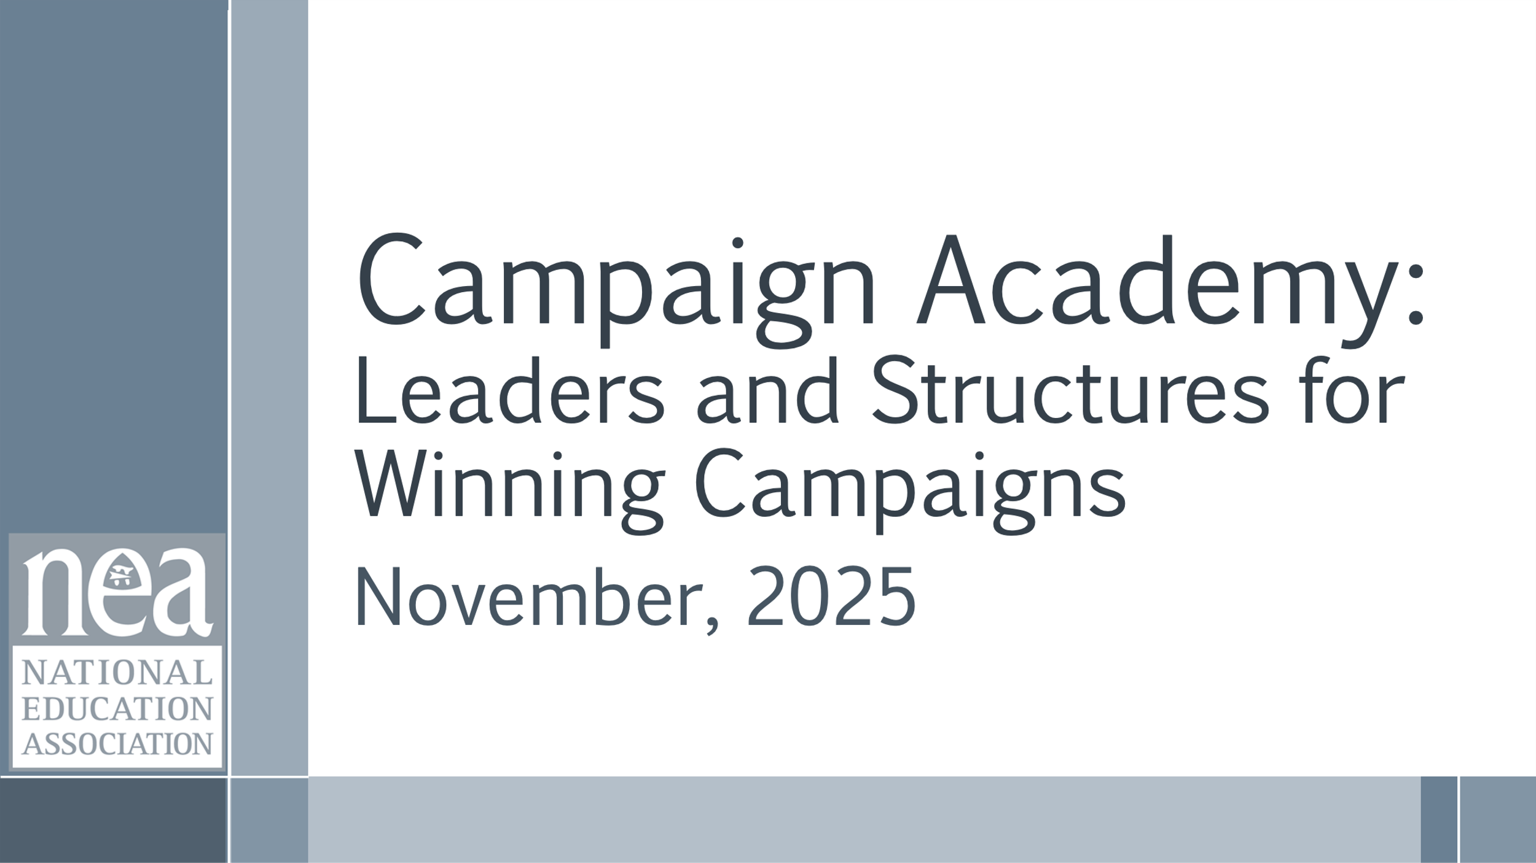  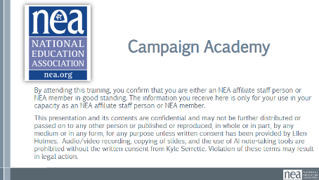  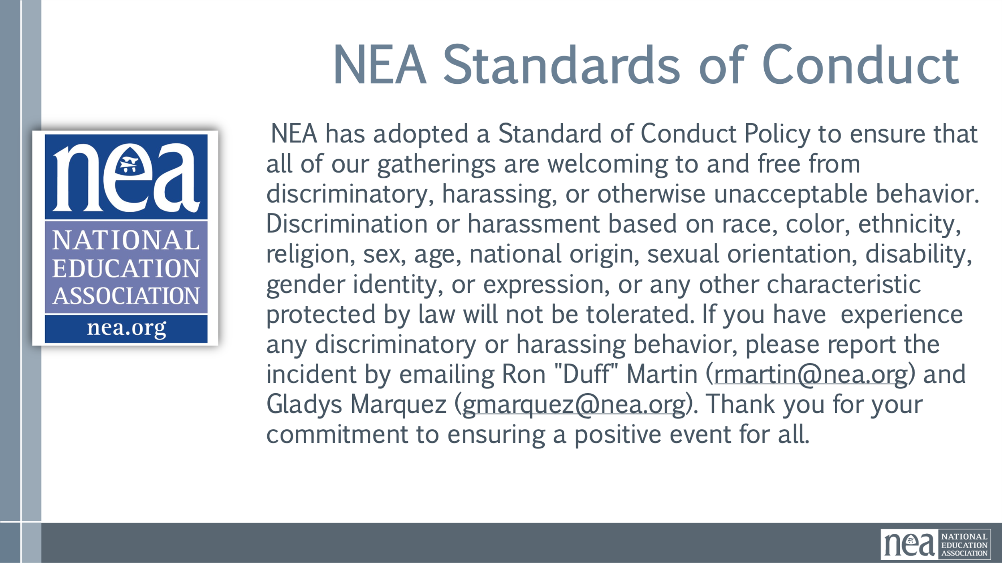  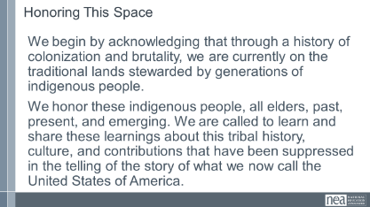  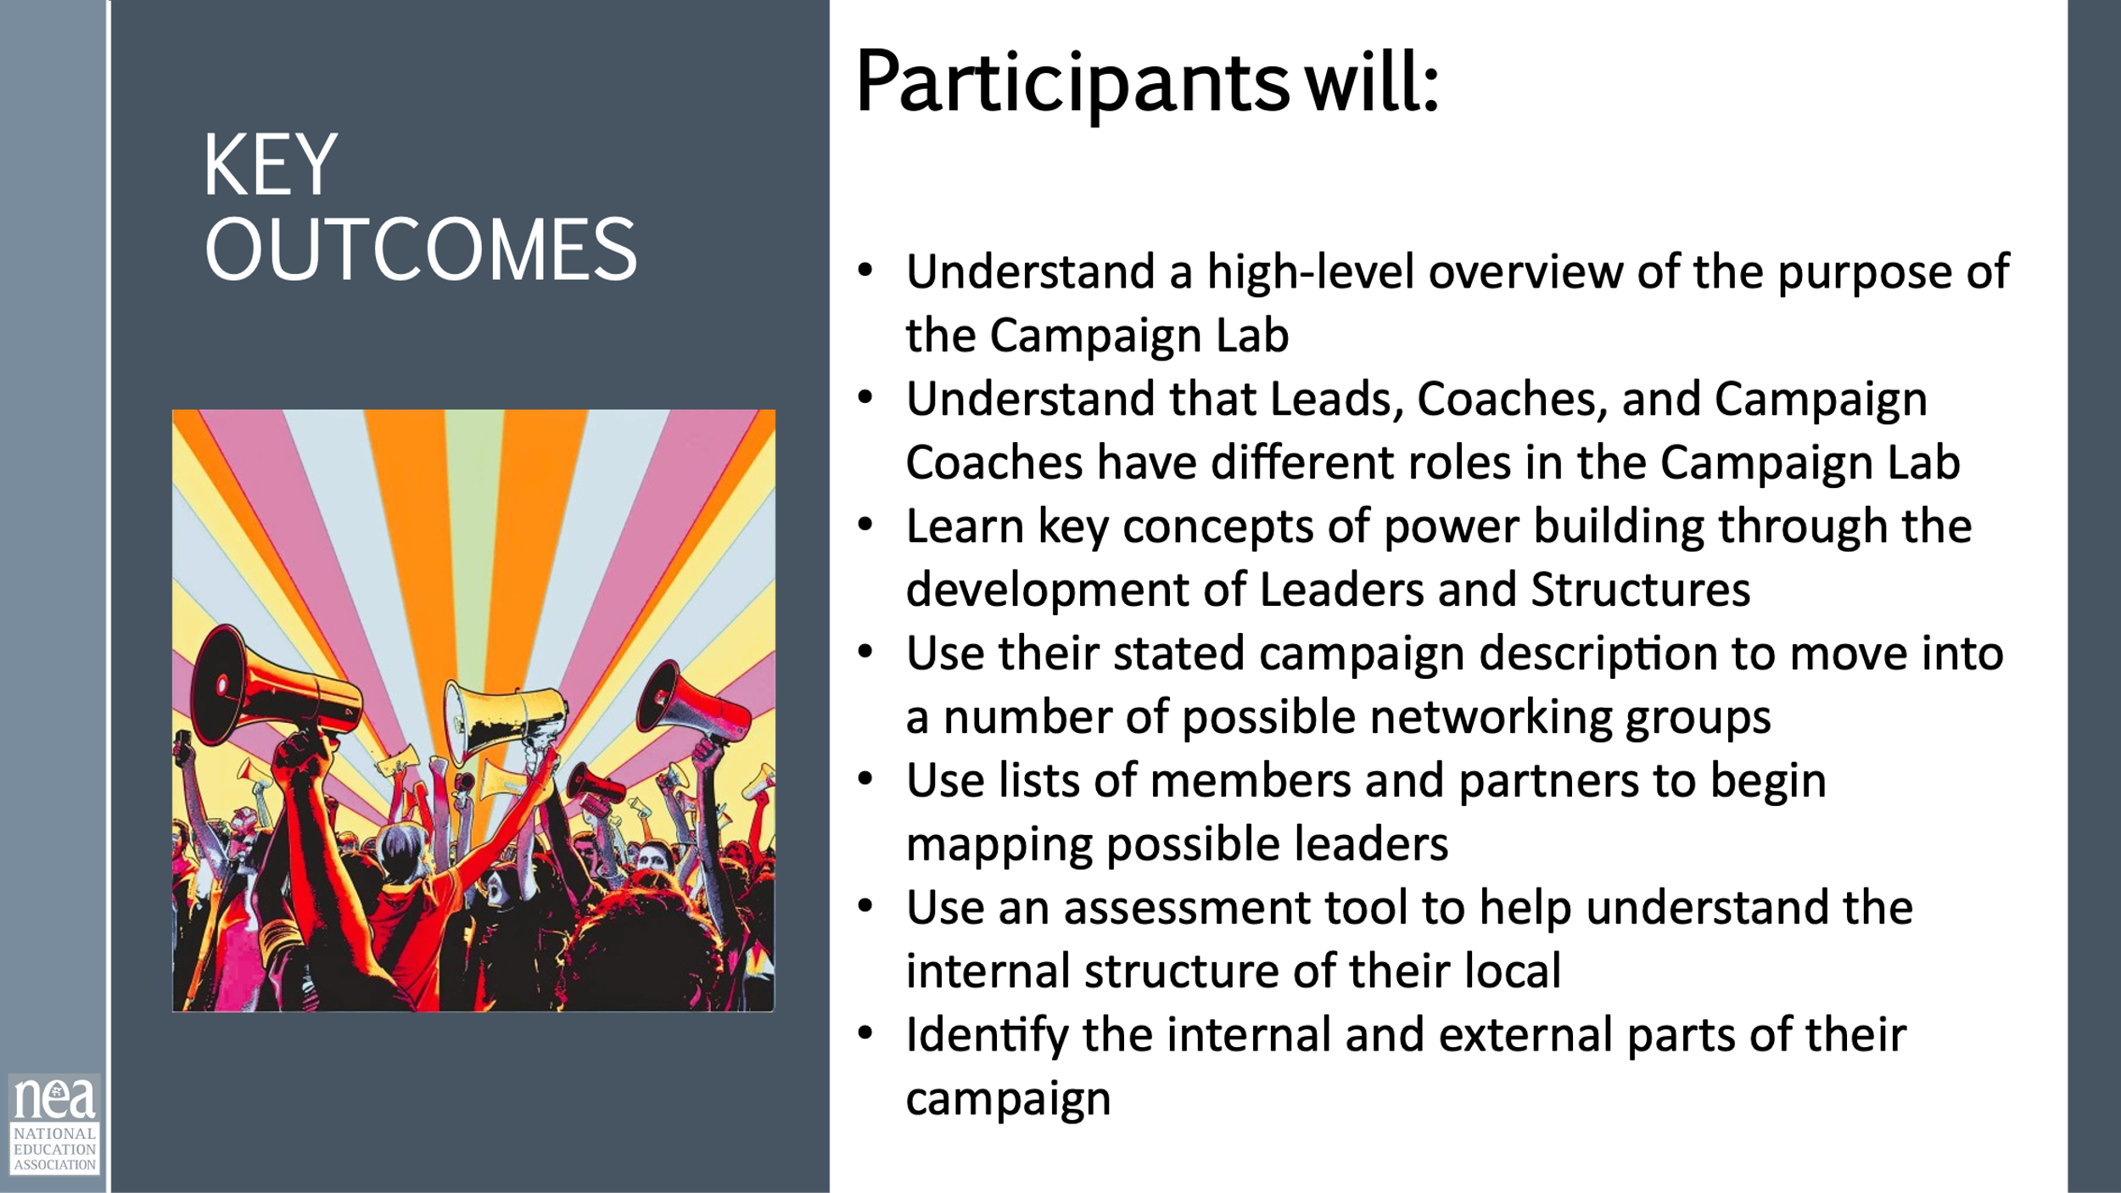  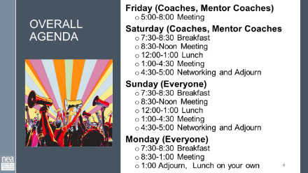  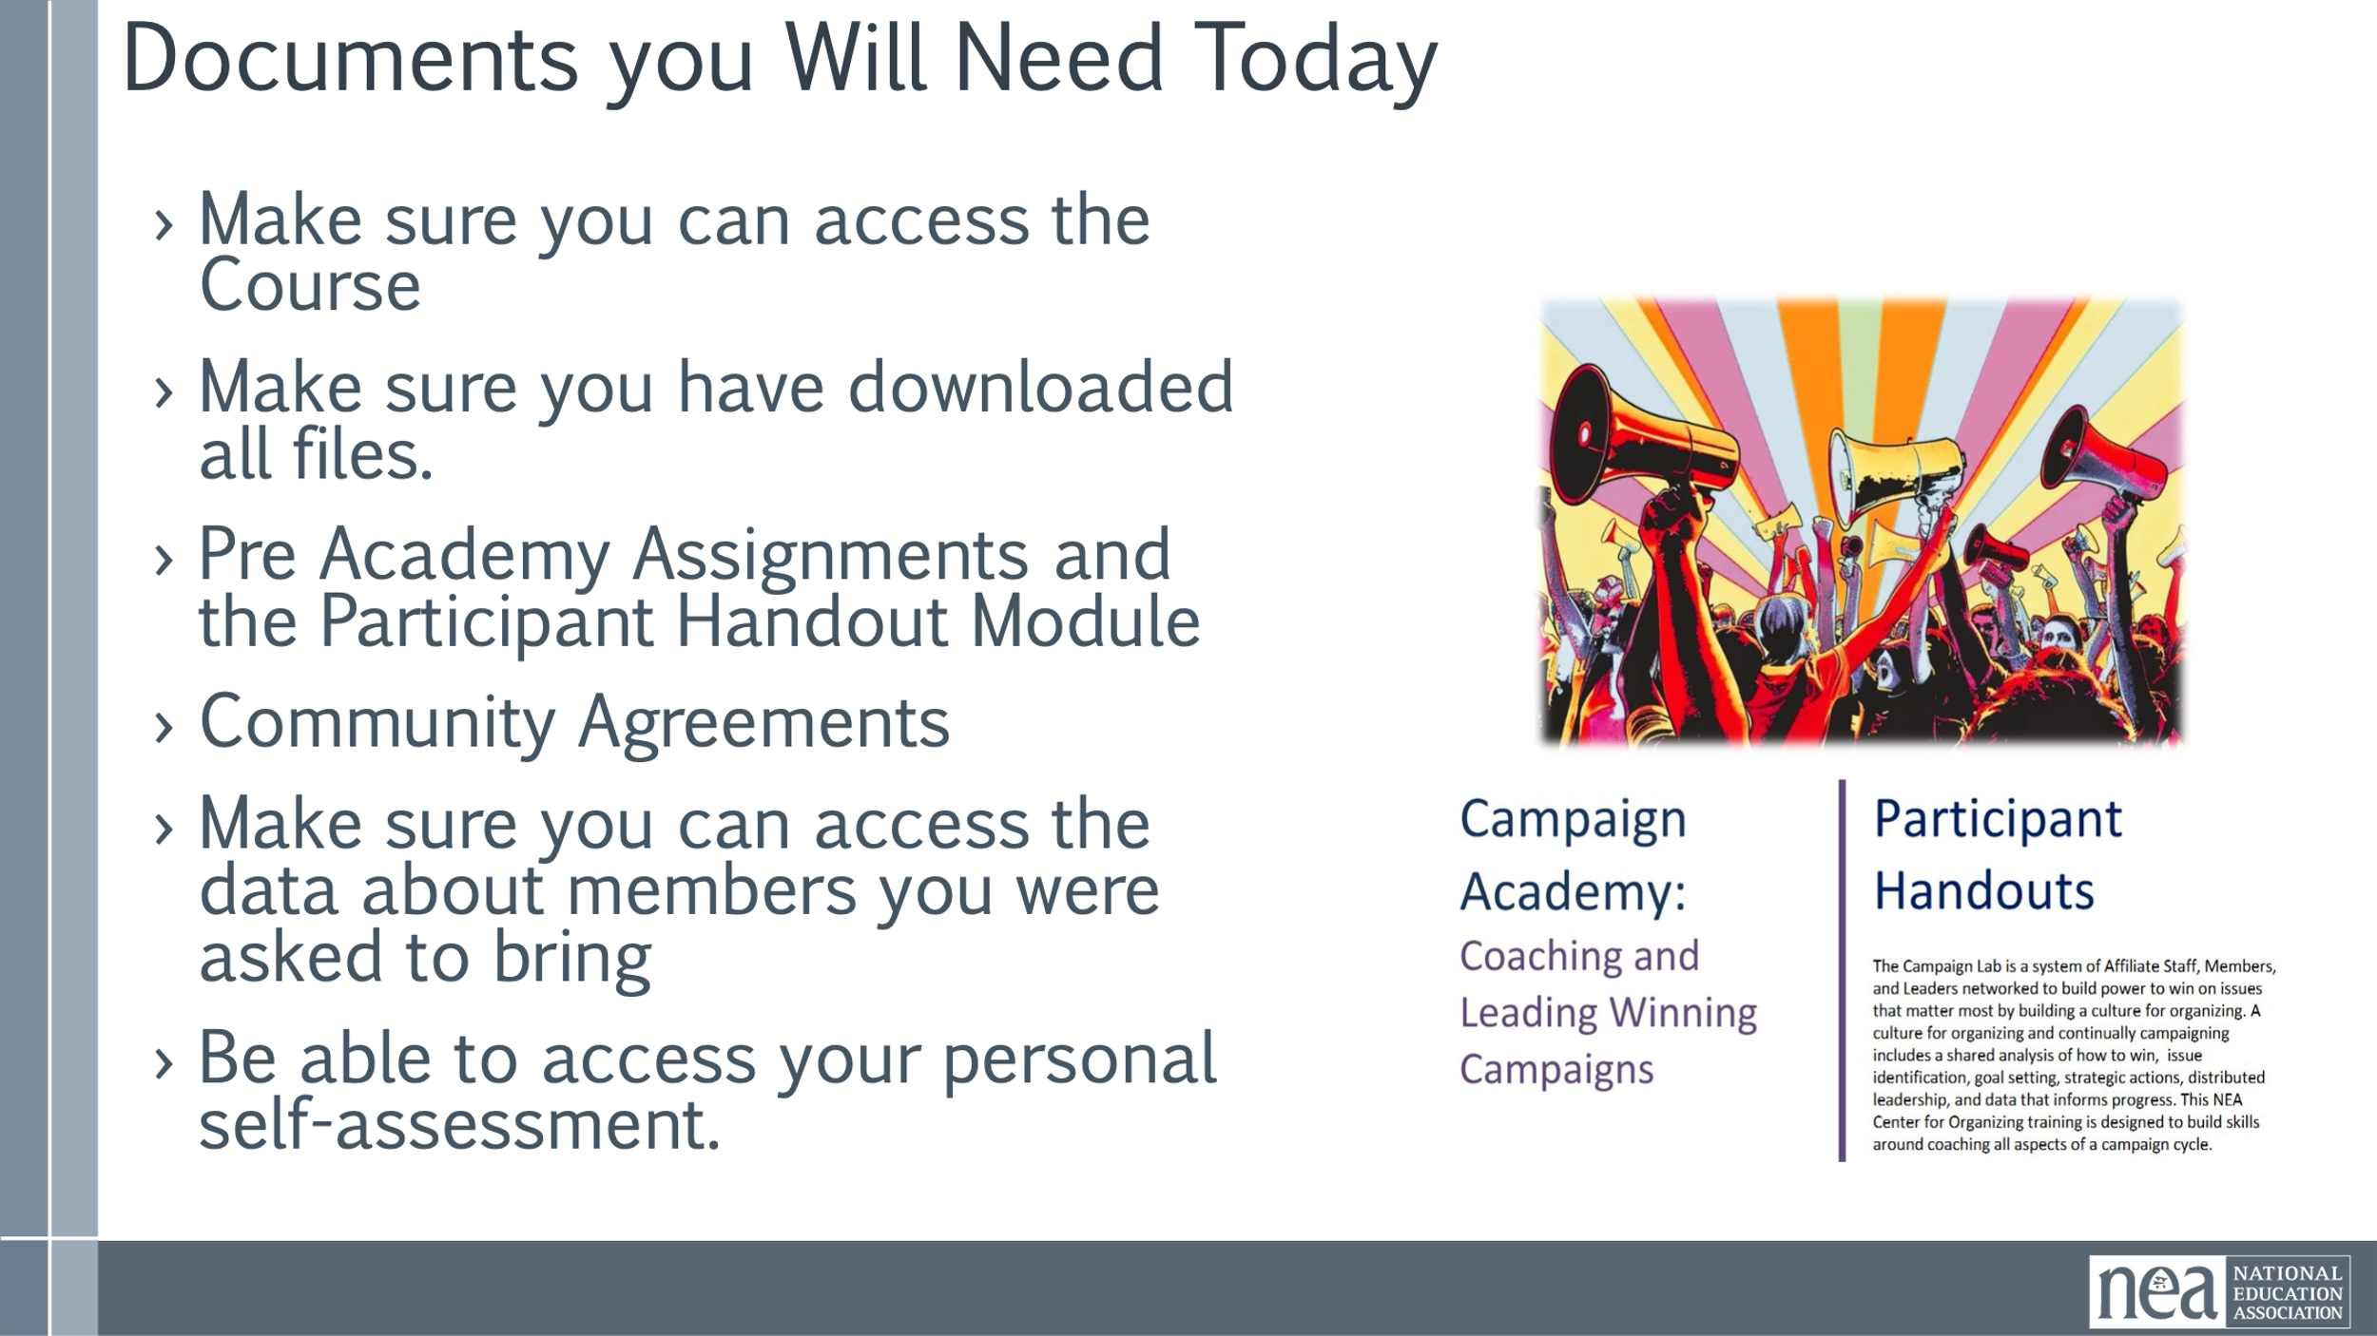  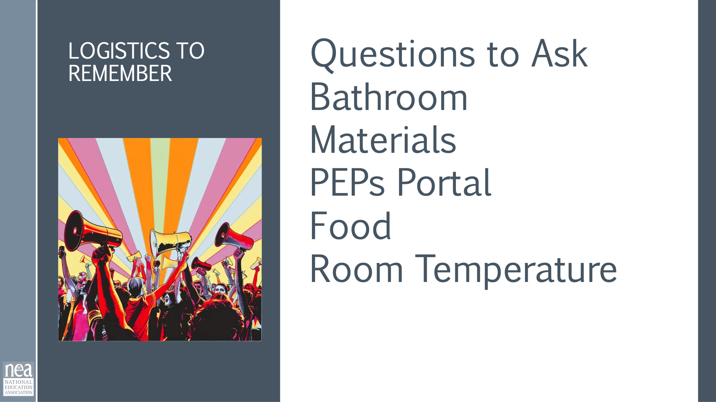  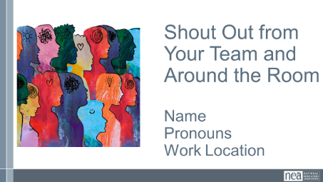  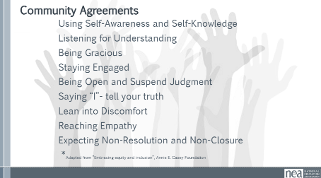    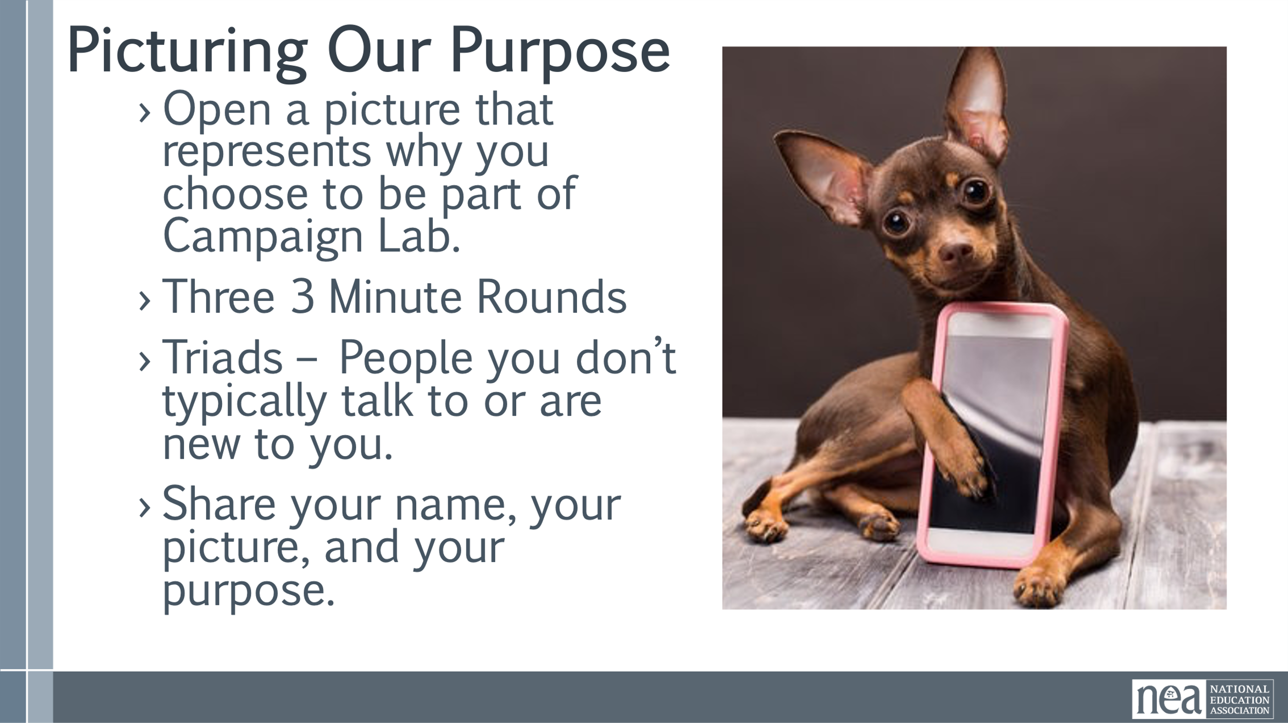  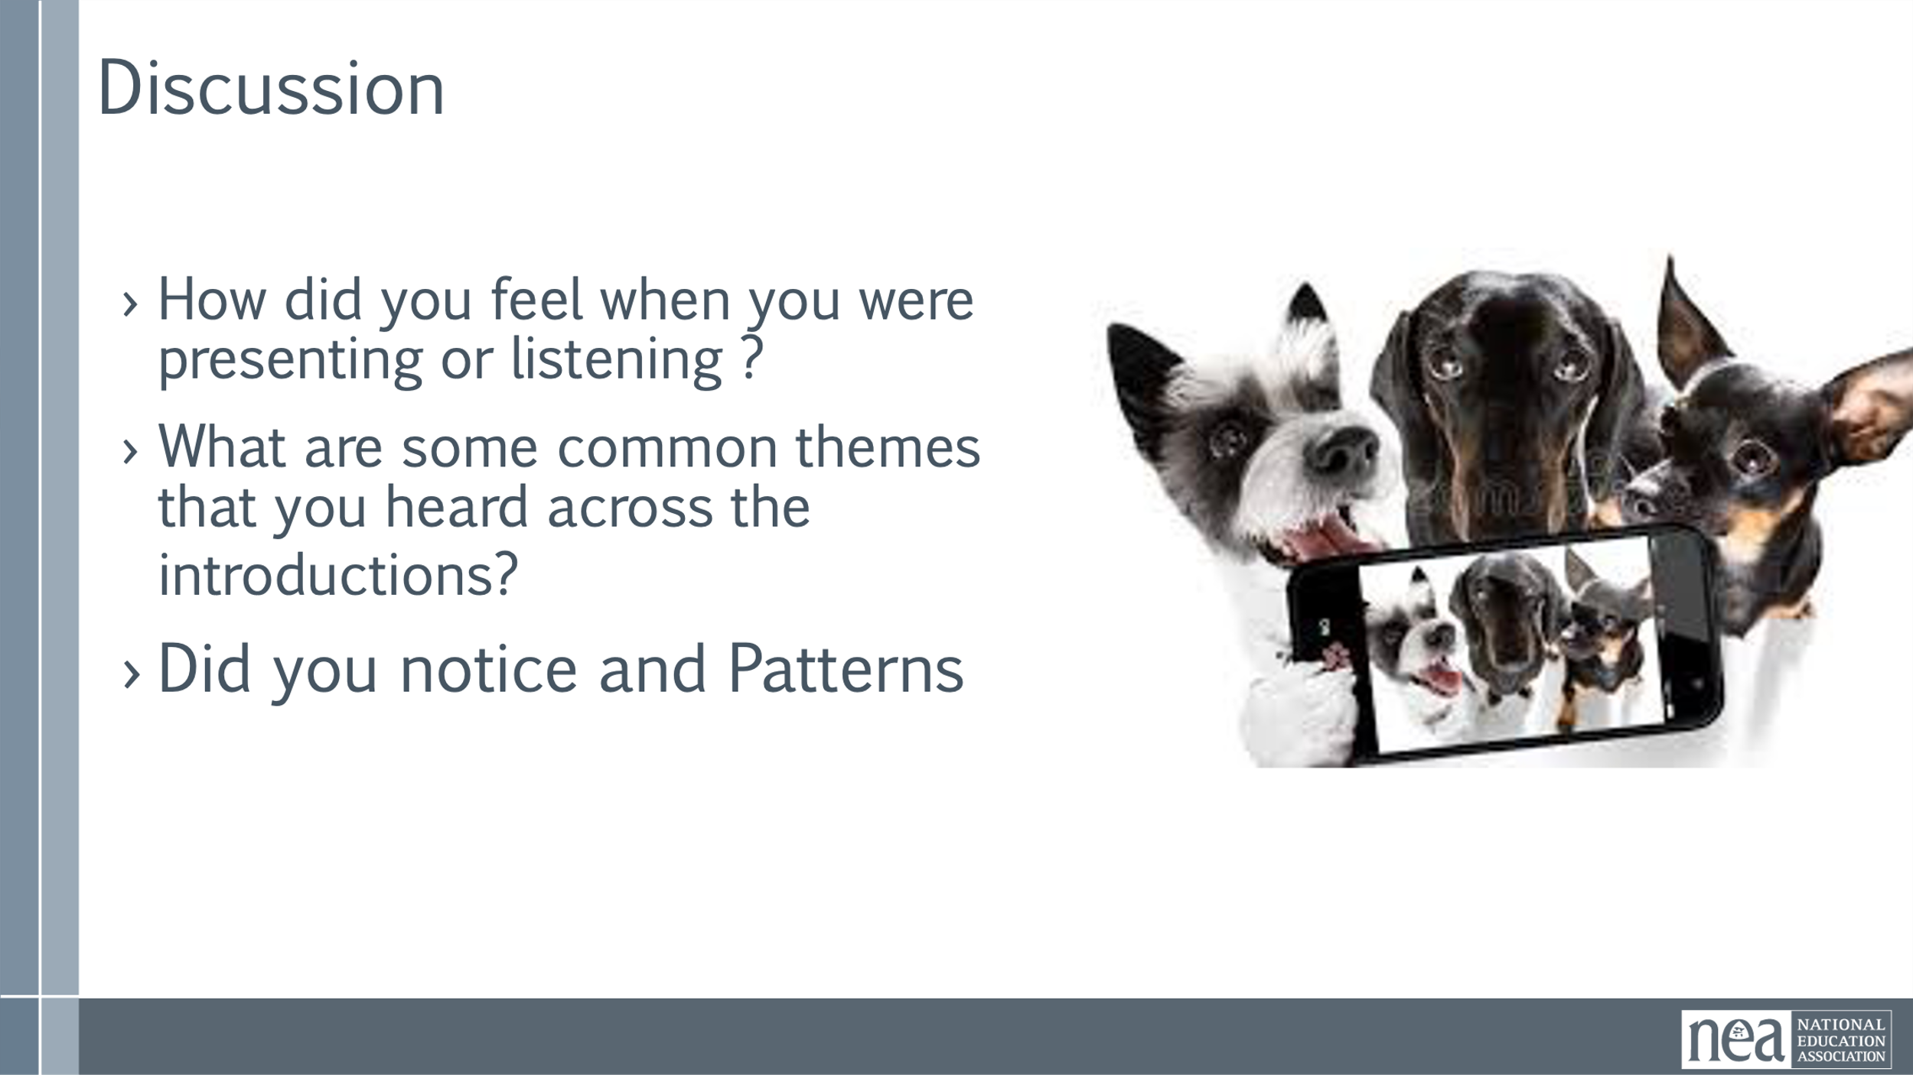 | Norms Online Pre Attendance  Agenda on Slides  Name Tents  Handout Package online | 2 Minutes Welcome – basic intro and reading of the confirmation of membership  2 Minutes Land Acknowledgement  We begin by acknowledging that through a history of colonization and brutality, we are currently on the traditional lands stewarded by generations of the Indigenous people(BE SPECIFIC TO AREA). We honor these indigenous people, all elders, past, present, and emerging. We are called to learn and share these learnings about this tribal history, culture, and contributions that have been suppressed in the telling of the story of what we now call the United States of America  5 Minutes Outcomes and Agenda Overview  Begin the understanding that the first two nights are about HOW we will achieve the Change that the Campaign Lab represents. We are coaching people into their agency to make decisions about their campaigns – we are not advising or consulting. More about that.  Review Agenda reminder about meals, Karla for Logistics, etc.  5 Minutes – Shout out from your team and around the room -  Very quick and simple name, pronouns, and work location  5 Minutes – Community Agreements  Take 5 minutes and Review the agreements from your pre attendance – at your tables discuss how you answered the final three questions. Return as a whole group and ask what needs to be added, changed, highlighted, etc. Then take a thumbs up, side, or down – looking for near consensus – the goal, all up or sideways thumbs.  Up, Completely agree as is  Sideways, Can commit, not perfect, but I am confident we can revisit if this is not working  Down, I am not yet ready to commit and this is what I need more discussion about….  10 Min - Cell Phone Artifact Mixer  We will be repeating at least up to 3 rounds of the following:  - Open a picture that represents your purpose for being part of the Campaign Lab  - For each round you and your partner will have three minutes TOTAL – 90 seconds each- to share  - Your name  - Where you are from  - WHY you selected this picture as a representation of of why you are part of the campaign lab.  - Find a partner and begin – make sure it is someone new to you  - Share and repeat  10 Min - Debrief  - How did you feel when you were presenting or listening ?  - What are some common themes that you heard across the introductions?  - Did you notice any patterns?  1 Min - Key Point  - Our commitments in work and life are best when we understand why we do them.  - Sharing your "why“ with others allows them to connect with your values, understand your passion, and build deeper relationships  5 Min - What we will learn about Winning Campaigns | Participants will know how we are going to work, the basic schedule, and the logistics relevant to the training.
9:15 – 9:30 | Melissa | 15 Minutes – Dreams and Challenges
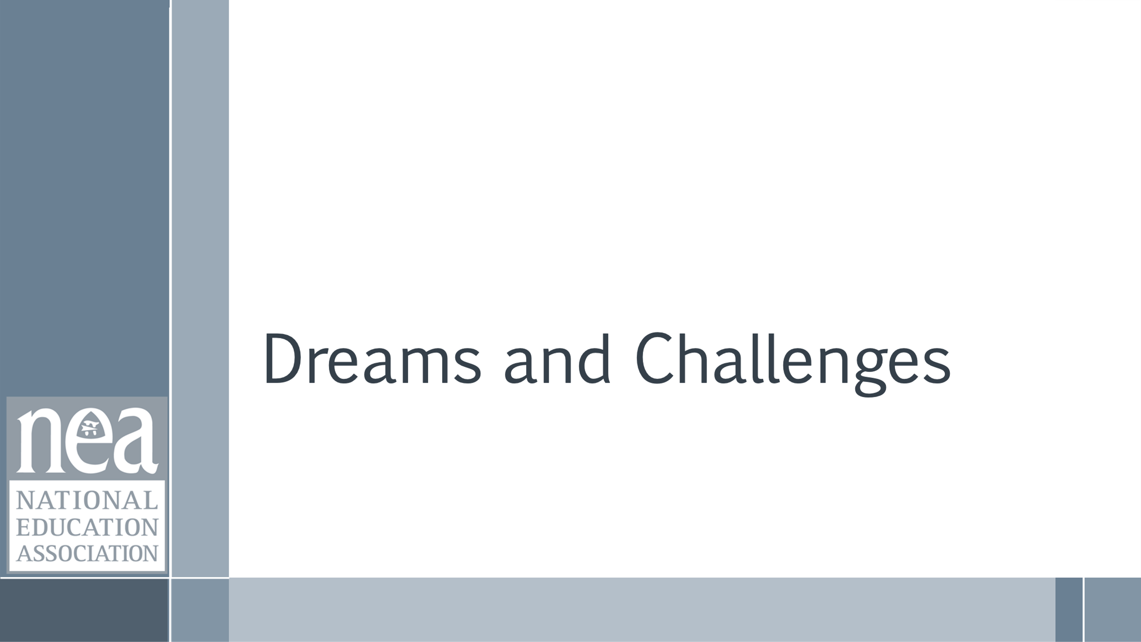  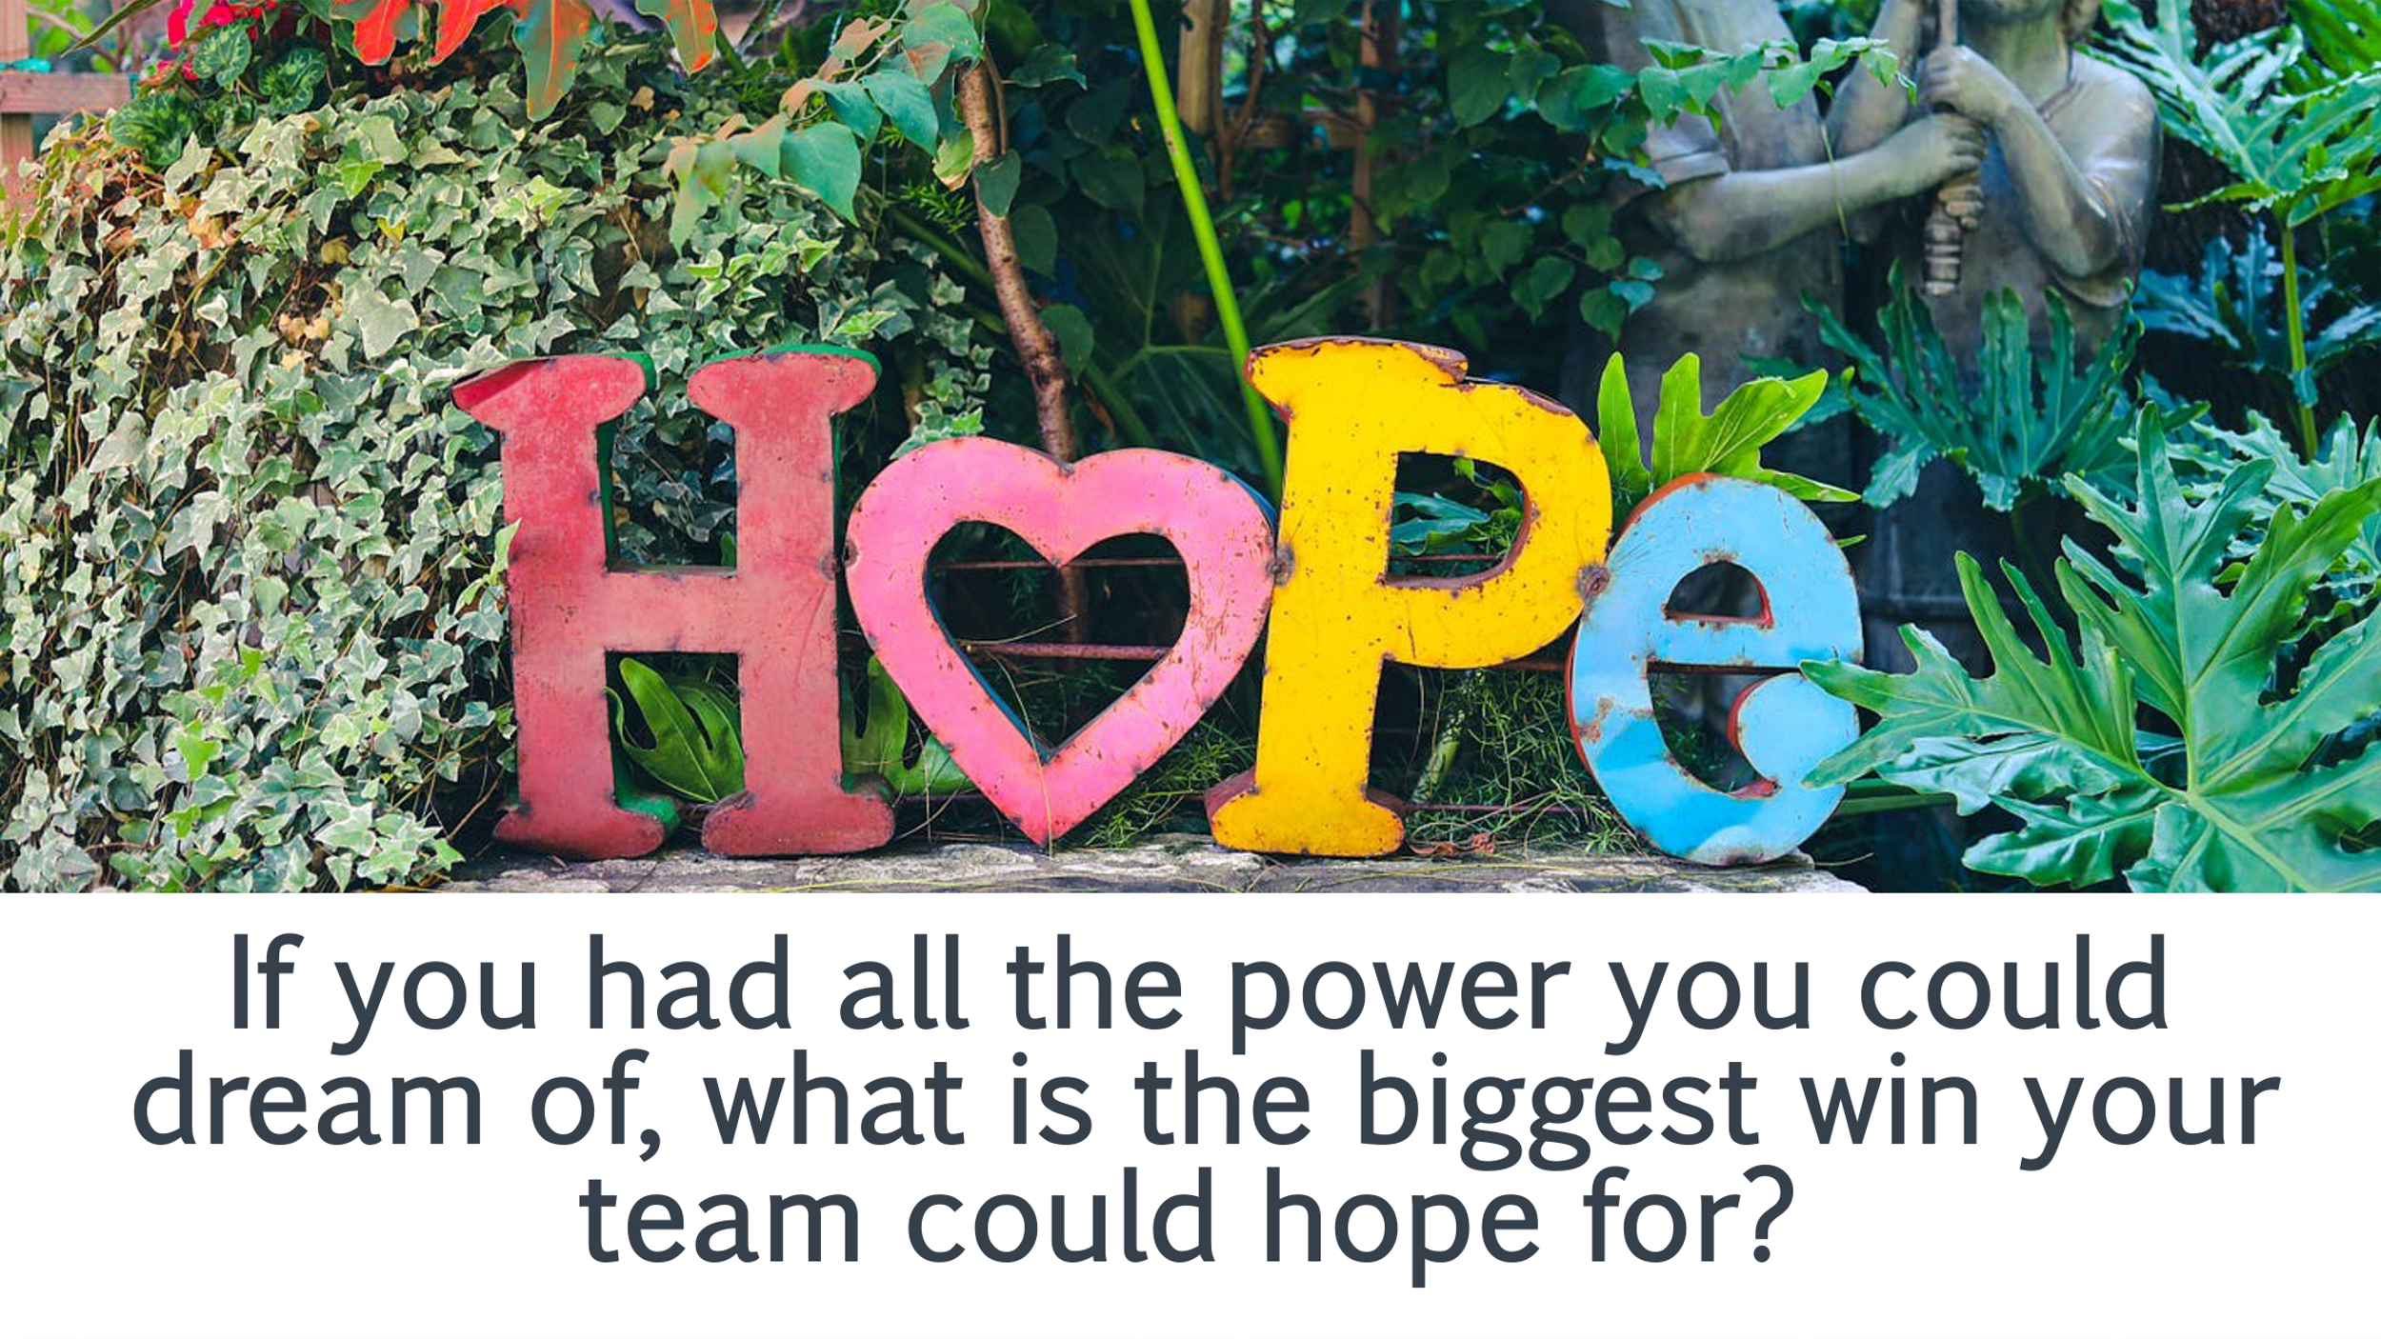    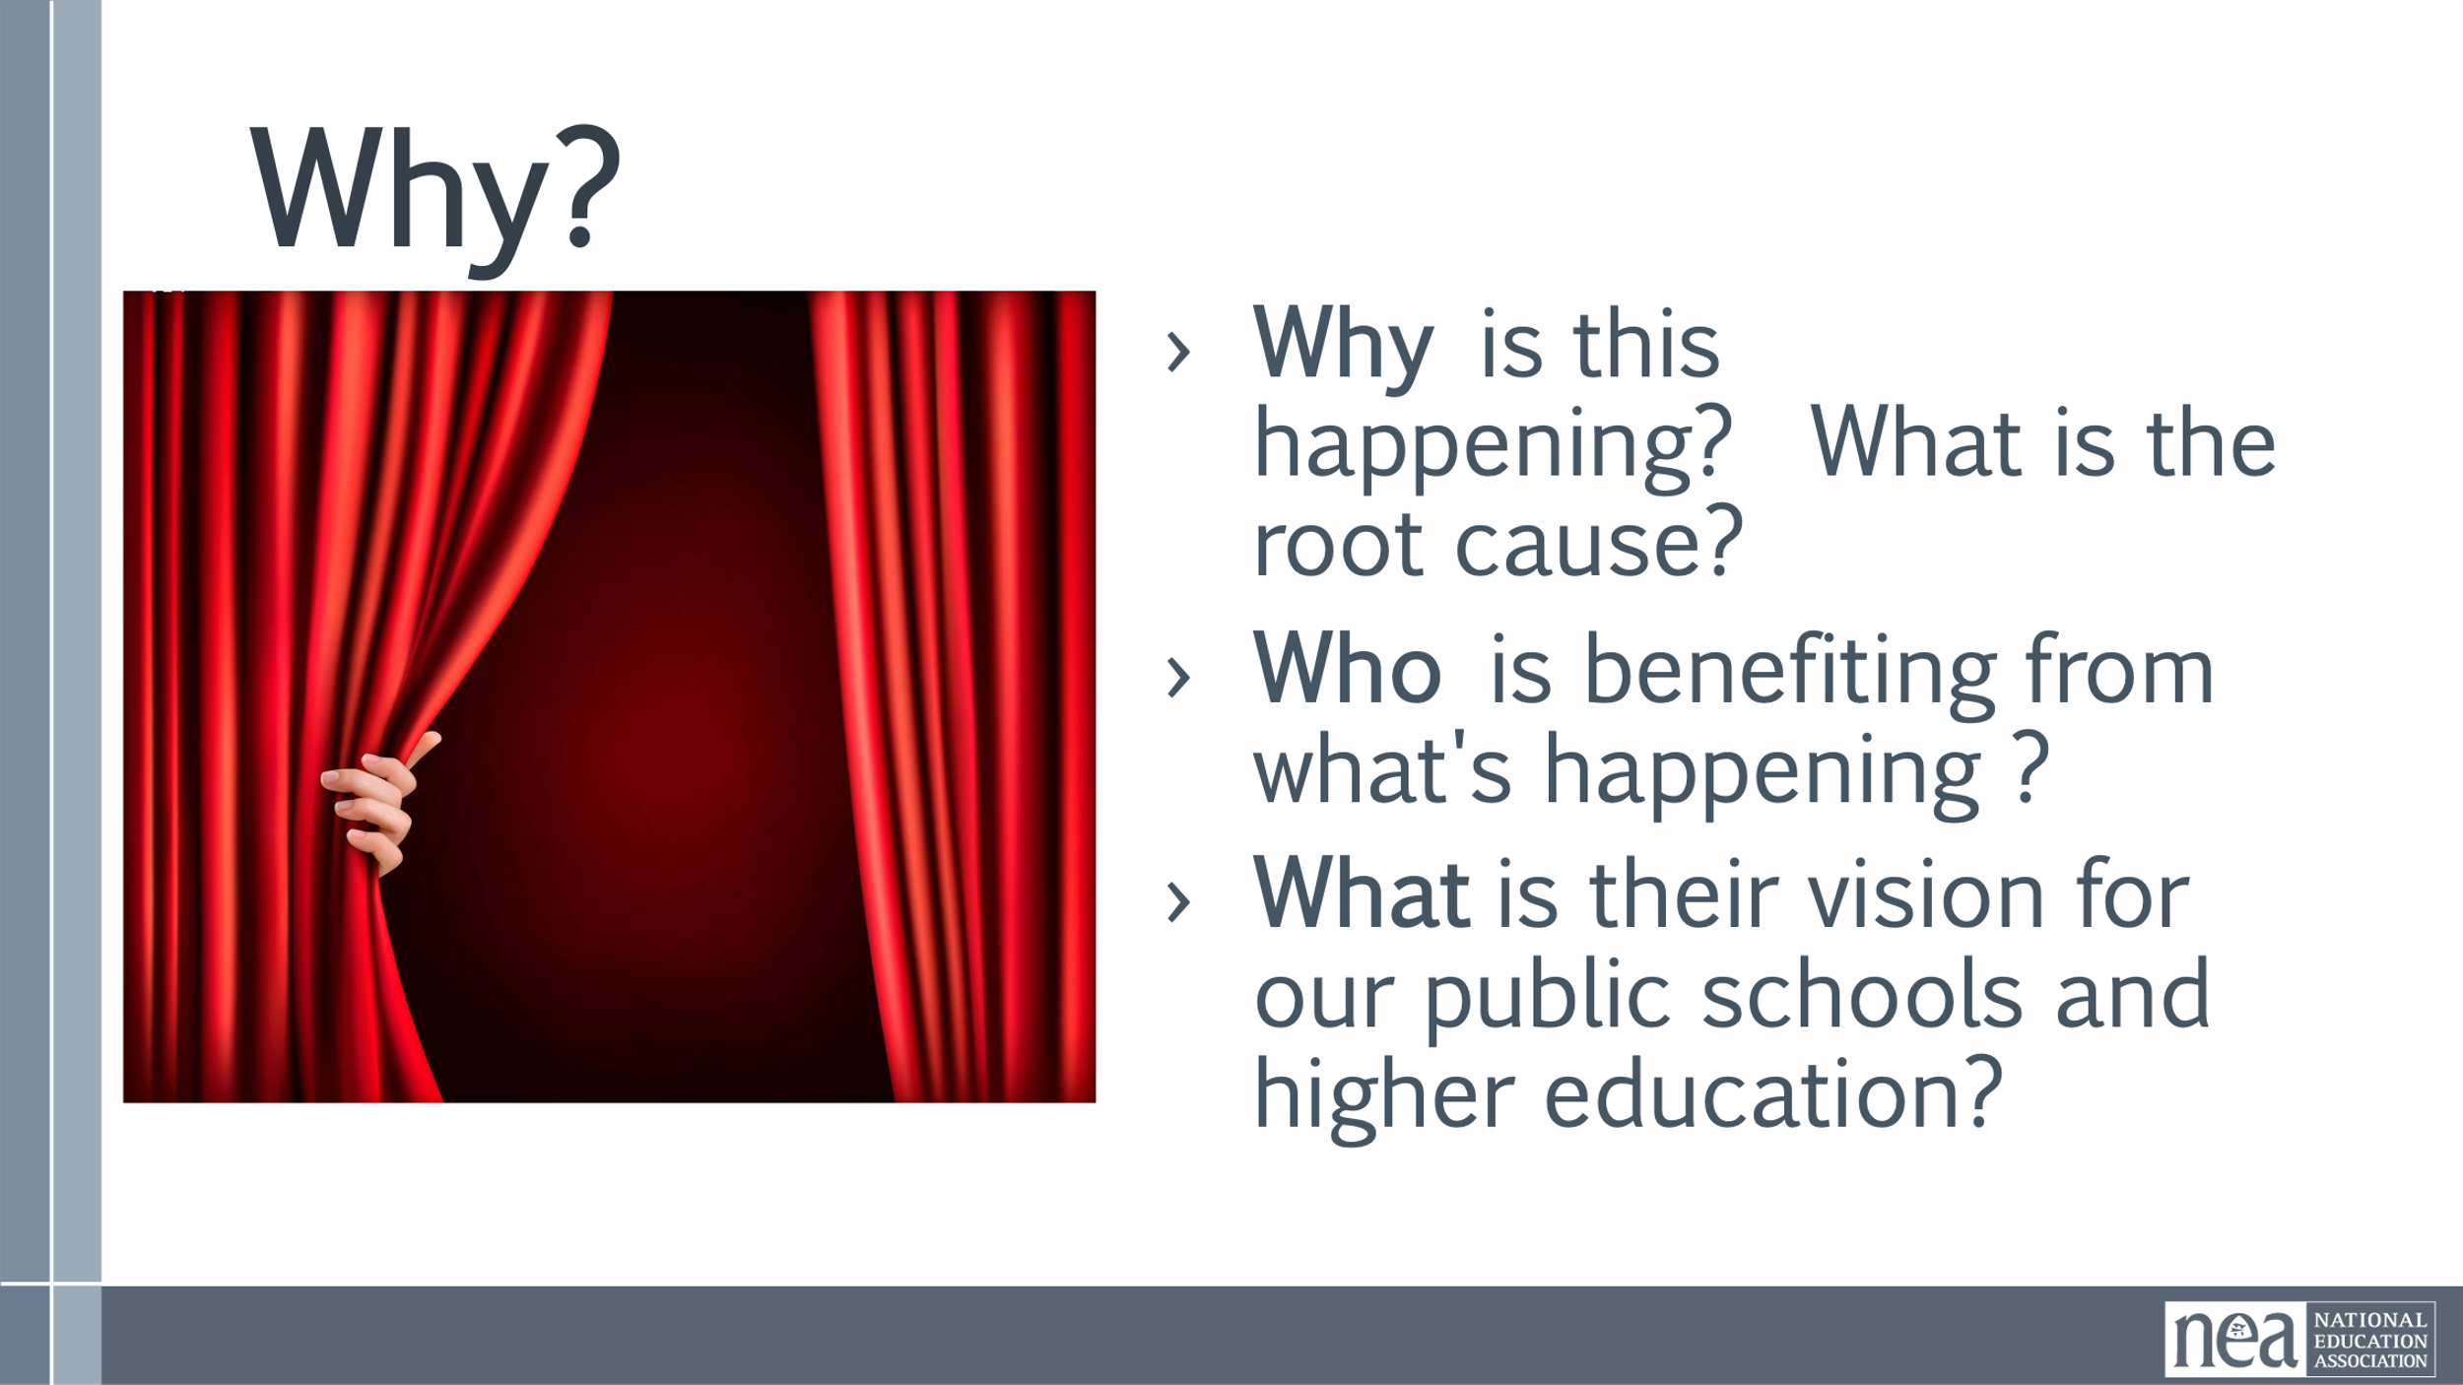  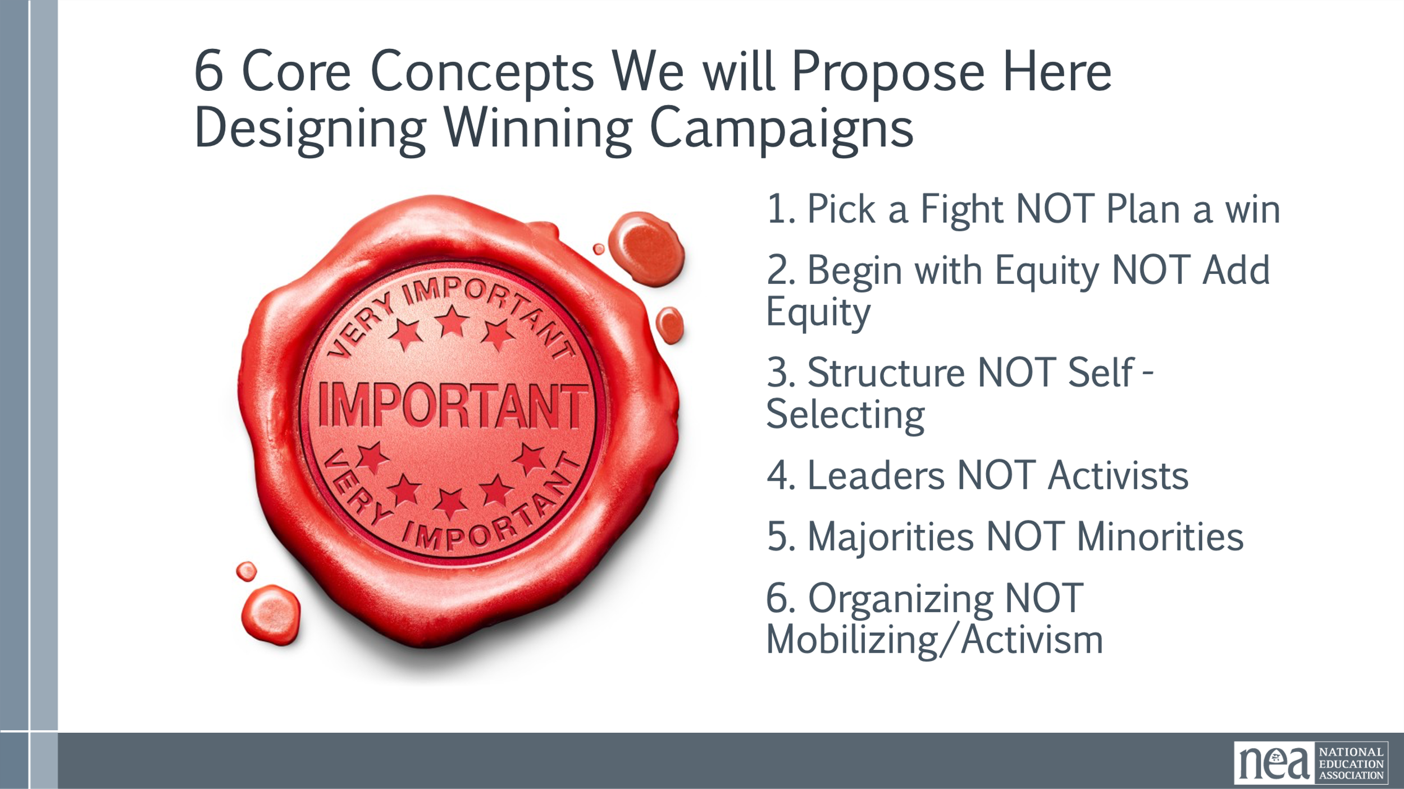 | Chart Paper | Charting in Small Groups (Charting in teams)  5 Minutes - You just did this in your cell phone mixer groups – now let’s have you go to charts and divide those charts in half  Select one of the questions below to ask the room:  - What does a loving school community look like?  - If you had all the power you could dream of, what is the biggest win you and your team could hope for?  5 Minutes - Now on the other side of the chart out  Who is the villain preventing you from achieving this win? (Name a person)  Now as a whole group – 5 minutes Discussion  Why is this happening? (Tables discussion)  - Who is benefiting from what's happening ?  What is the villain's vision for our public schools and higher education?  Short report out about the above  Key Points  Begin by saying -Business as usual will keep us in the current status  Disrupting the current status will require a change in how we do business.  6 Core Concepts we will Propose Here Designing Winning Campaign  - Pick a Fight Not Plan a Win (We get caught up in long terms wins, people join a fight – need a visible fight that has a vision)  - Begin with Equity NOT Add Equity ( When equity is added at the end, you have still designed a program for the people who have the most access to power. Centering equity means designing your work around those with the least access to power and privilege from the start. )  - Structure NOT Self-Selecting (Clubs risk nothing so, when people join programs they are doing it for themselves not necessarily building solidarity. When we have structure people have goals that lead toward a win)  - Leaders Vs. Activists (Activists just show up – leaders own the union)  - Majorities NOT Minorities (Focus on those that have yet to engage, we already have a majority of those that know about us – we need to shift to our focus to the majority)  - Organizing Vs. Mobilizing/Activism (Short term and episodic actions don’t build the power we need. Long term strategic ongoing organizing is how we build the resources, structures and leaders we need to win.) | Participants will explore a shared analysis of what their challenges are in achieving the public schools they want.
9:30-9:45 | Melissa | 15 Minutes – Defining the Roles
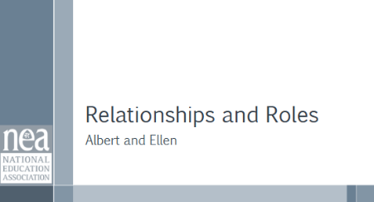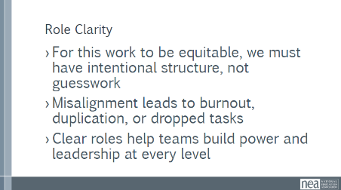  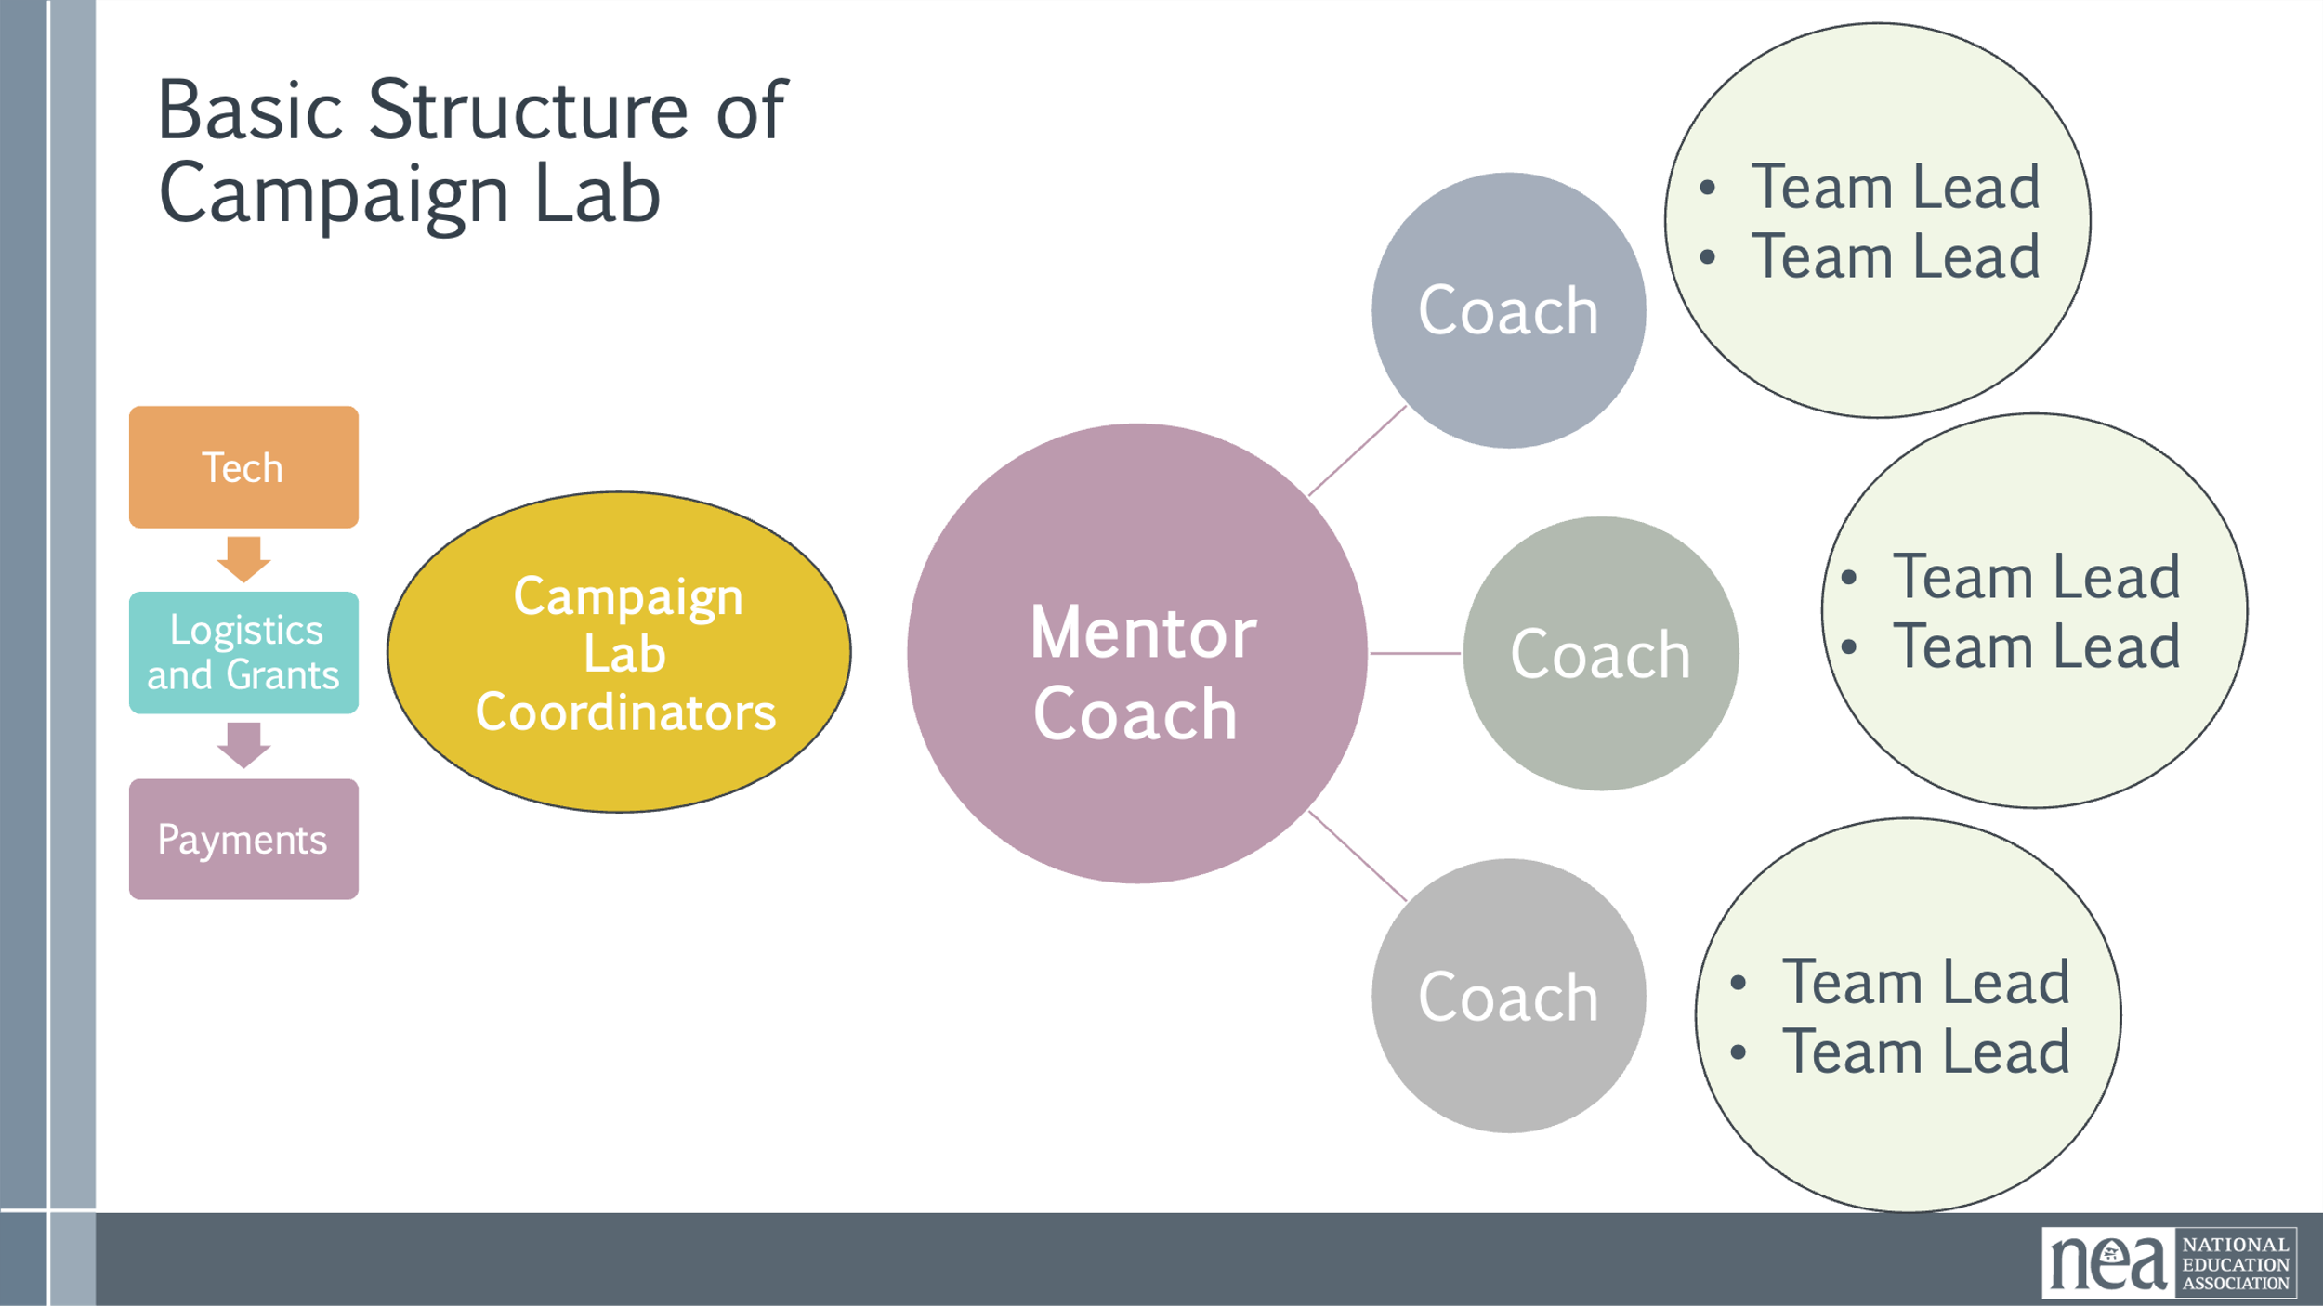  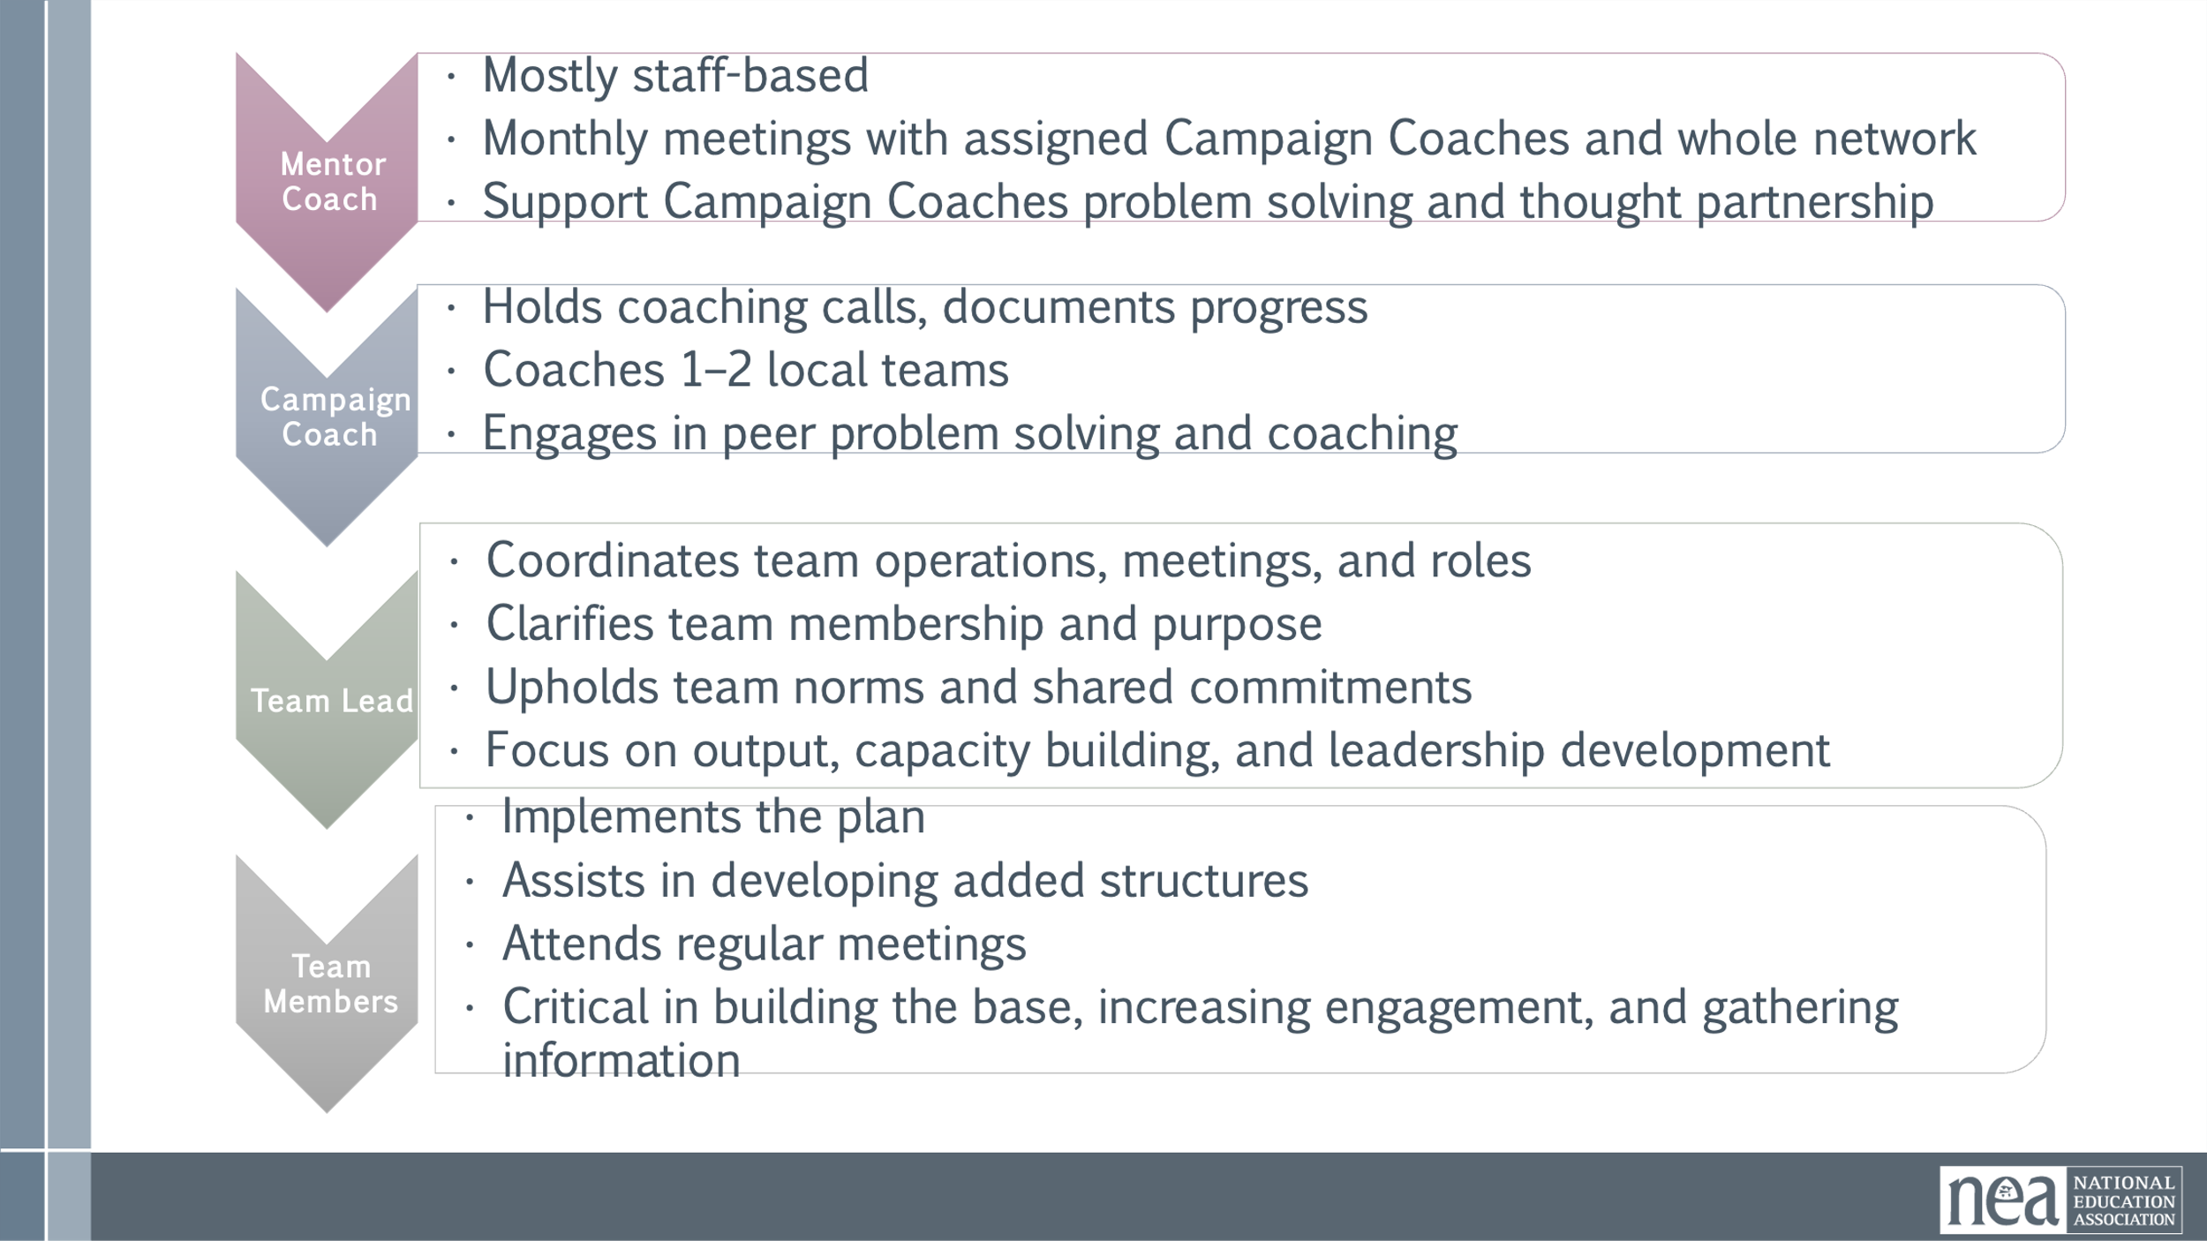  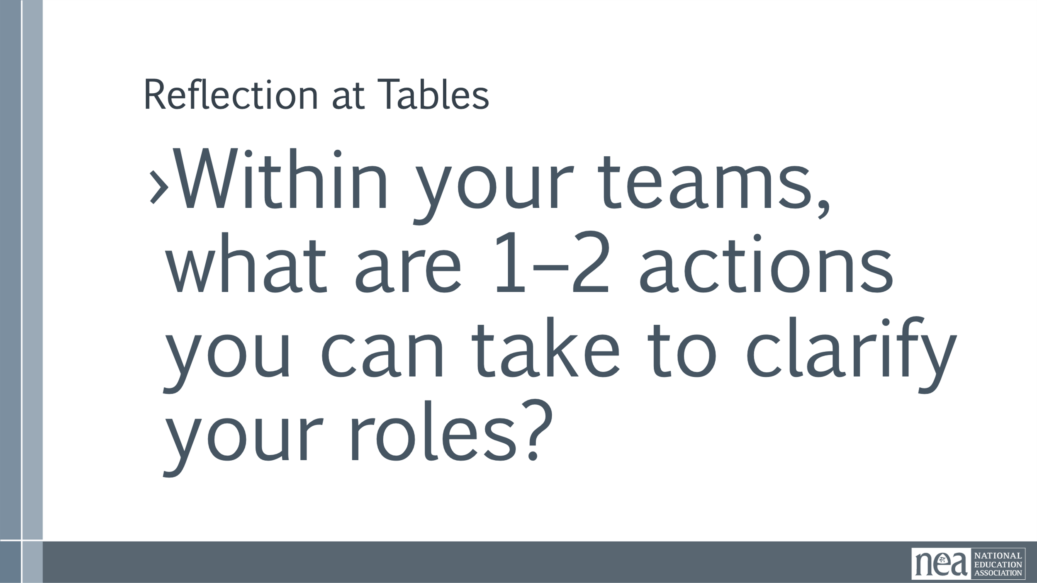  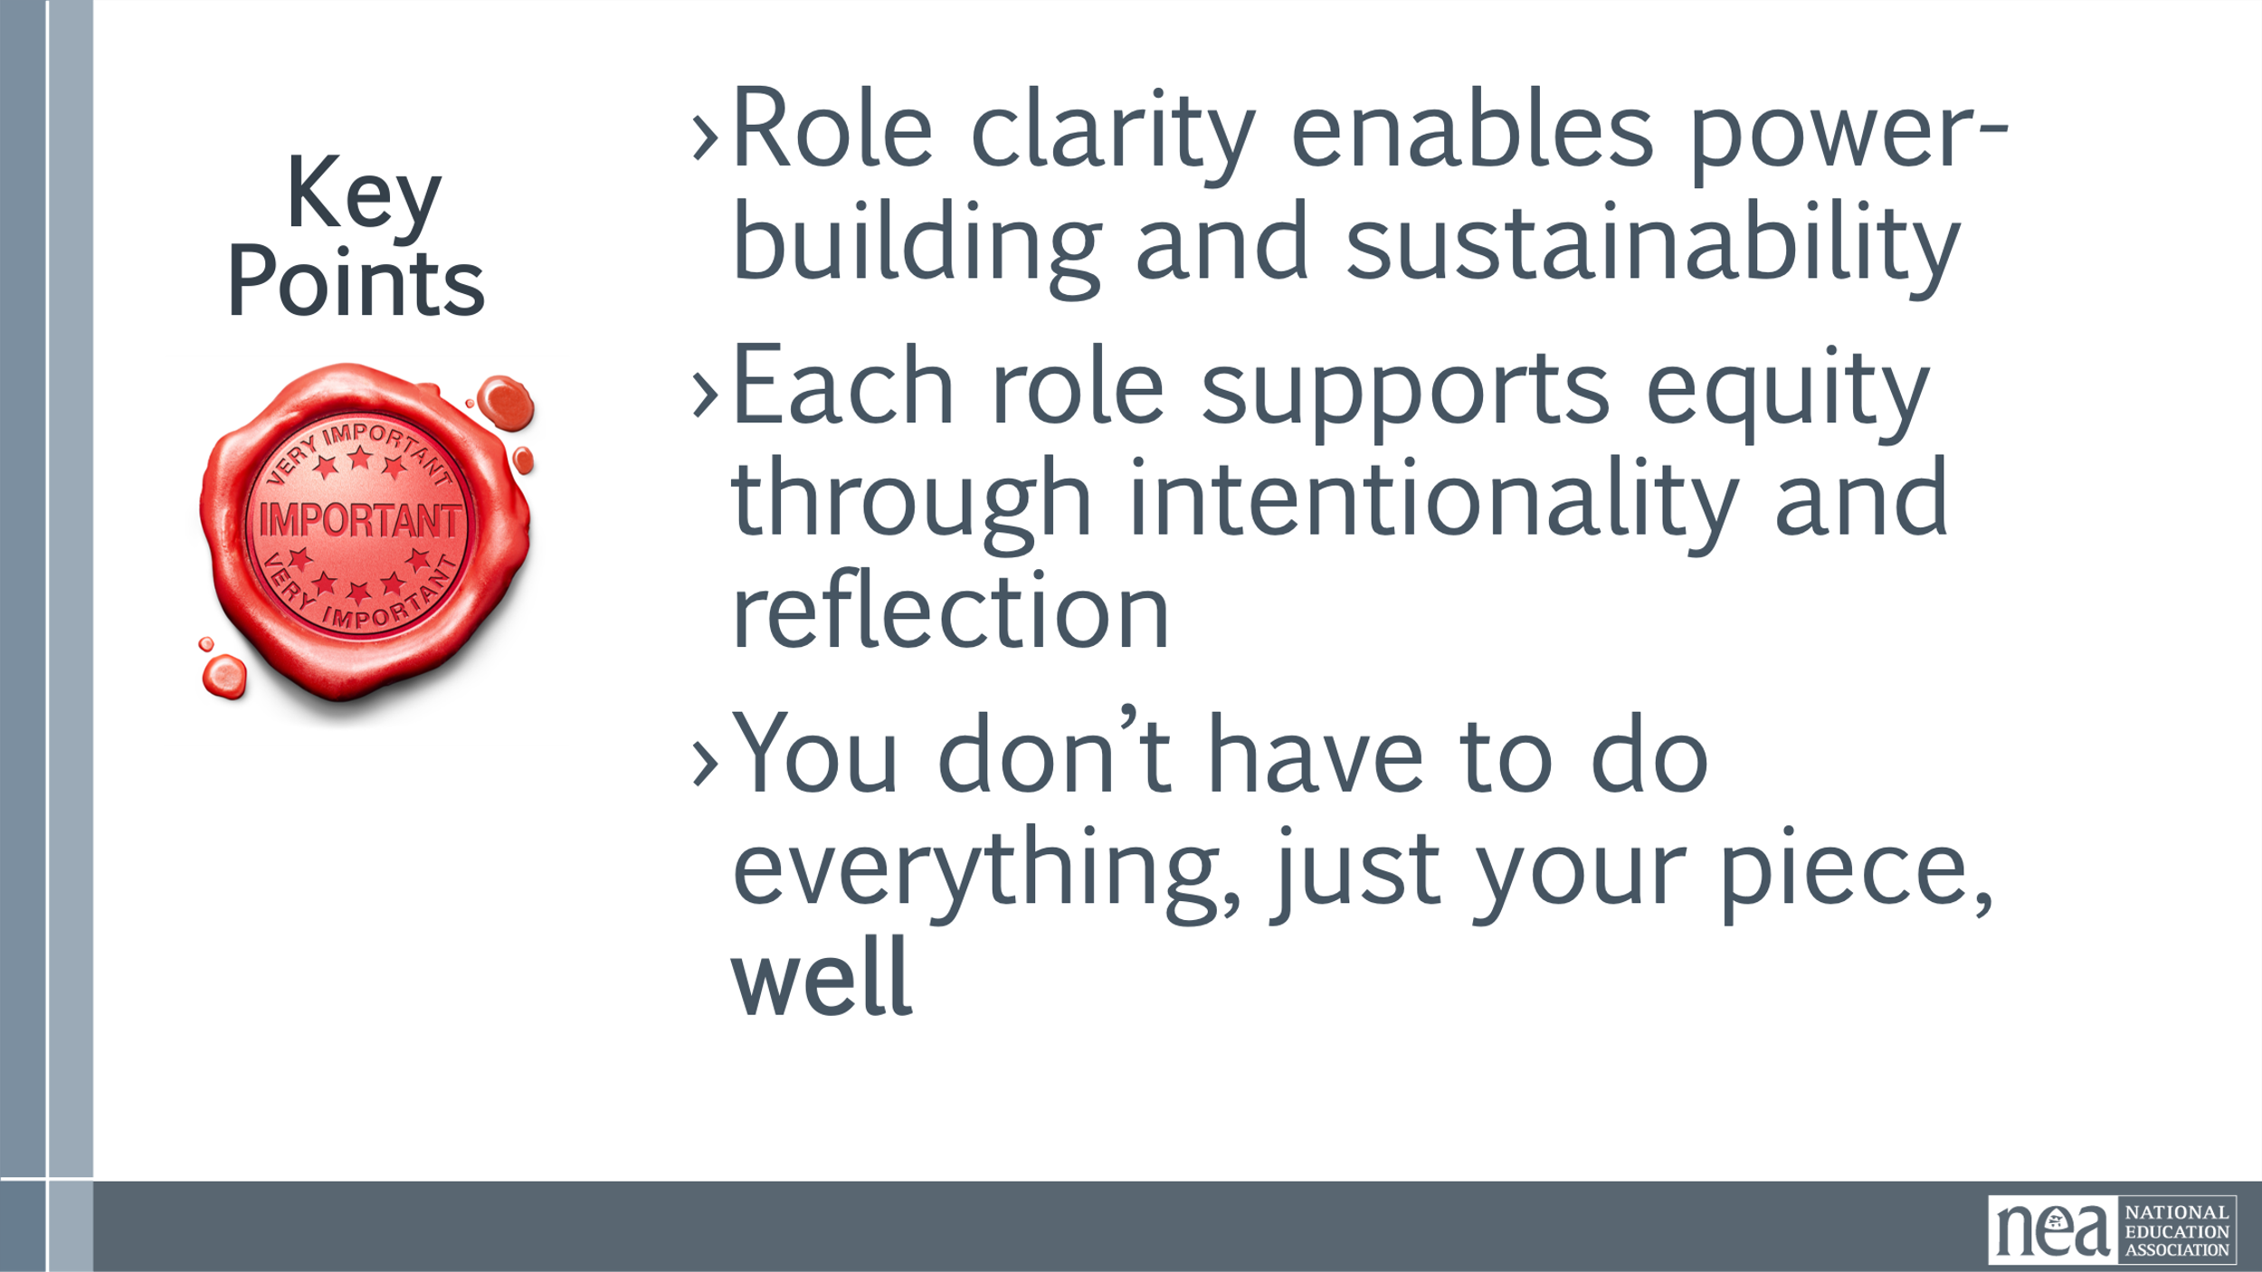 | One pager on roles | To achieve the big dreams that you have discussed, we know that we need structures that allow us to develop leadership without reinforcing hierarchy or burnout. We need to keep those structures continuously connected and networked and that is what is different about the campaign lab. These structures rely on 4 four core roles. And we want to make sure we are very clear about those roles. Role clarity is not bureaucracy; it’s liberation in action.  Relationships and roles as it relate to the campaign lab – reference slide 20.  Intentionally created structure to give support to teams – team leads get support by mentor coaches, entire structure is supported by coordinators (NEA) that provide tech, logistics, grants etc.  Camp coach - member stipend  Staff coach – no stipend  All four roles are interdependent. The Campaign Lab is designed like a network, no one role is more important than the others. They all enable shared leadership and campaign effectiveness.  - Mentor Coaches help build coaches’ capacity. Think of them like scaffolding. They are mostly staff and experienced organizers, not the boss, not evaluators, but strategic thought partners  - Campaign Coaches are the frontline support for local organizing teams. They do a lot, but they’re not alone. They’re part of a larger structure that includes Mentor Coaches and other peer supports. They are our primary sensor – and researcher about the labs  - Team Leads anchor the day-to-day work of the team. They aren’t doing all the work; they’re ensuring others can. They model distributed leadership and build team cohesion.  - Team Members Implement the Plan and Primary contact with Rank and File. Assists in developing added structures  Attends regular meetings, Critical in building the base, increasing engagement, and gathering information  In the next section you are going to be doing some work within and across your role groups.  Reflection : Within your teams what are 1–2 actions you can take to clarify your role?  Key Points:  - Role clarity enables power-building and sustainability  - Each role supports equity through intentionality and reflection  You don’t have to do everything, just your piece, well | Participants will clearly delineate the difference between Mentor Coaches, Campaign Coaches, and Team Leads.
9:45 -10:30 | Amanda | 45 Minutes – Campaign Lab Network Building
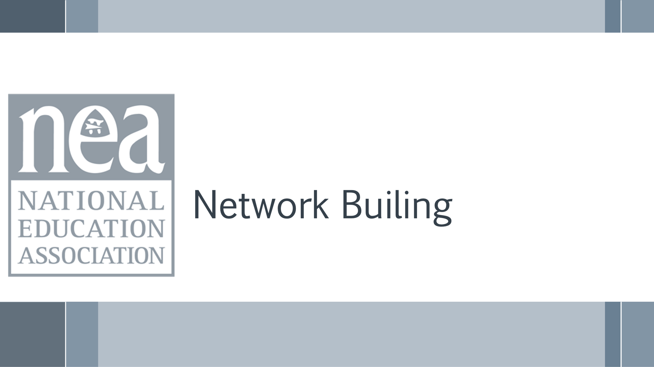  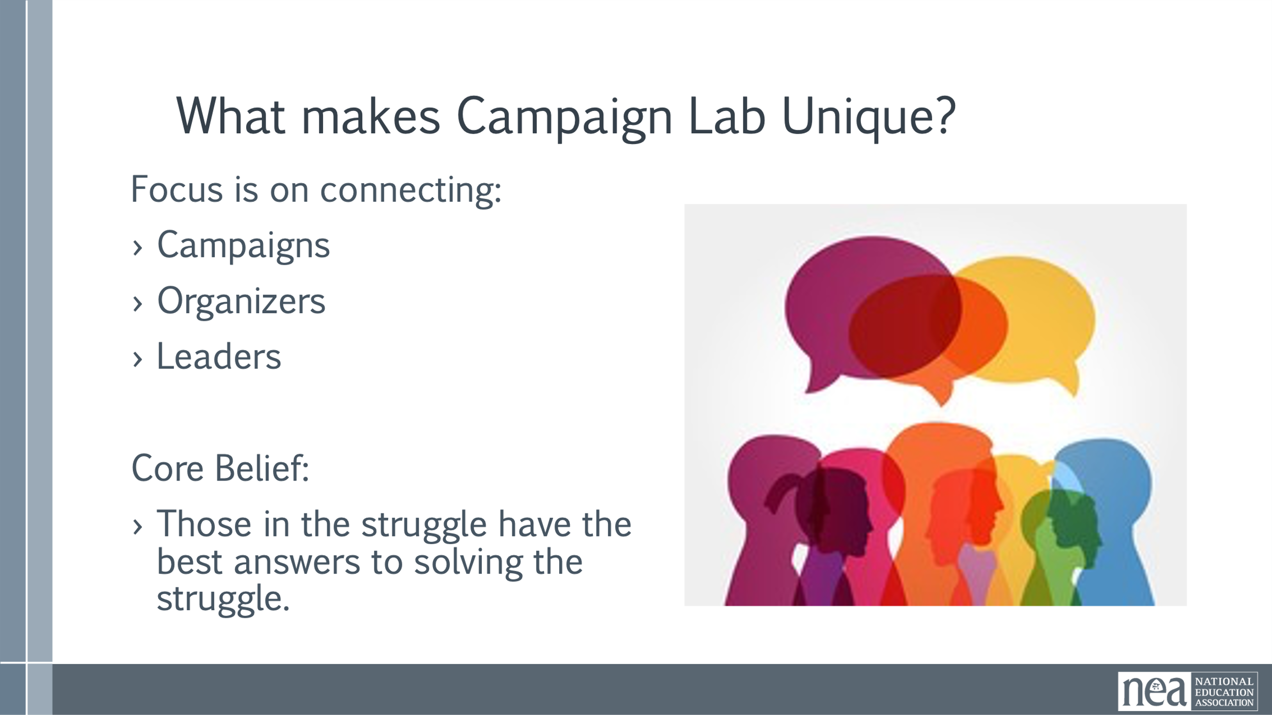  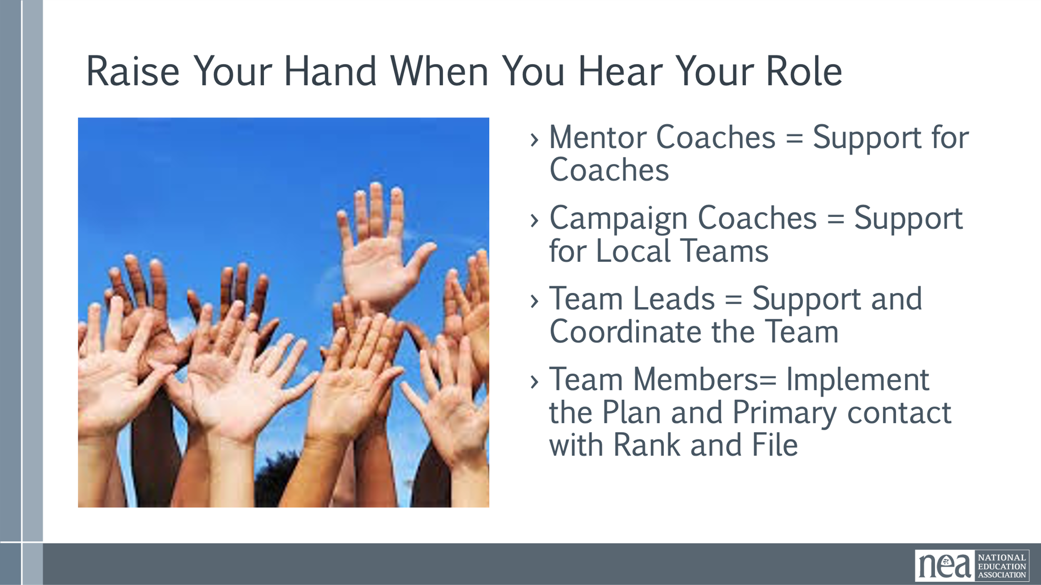  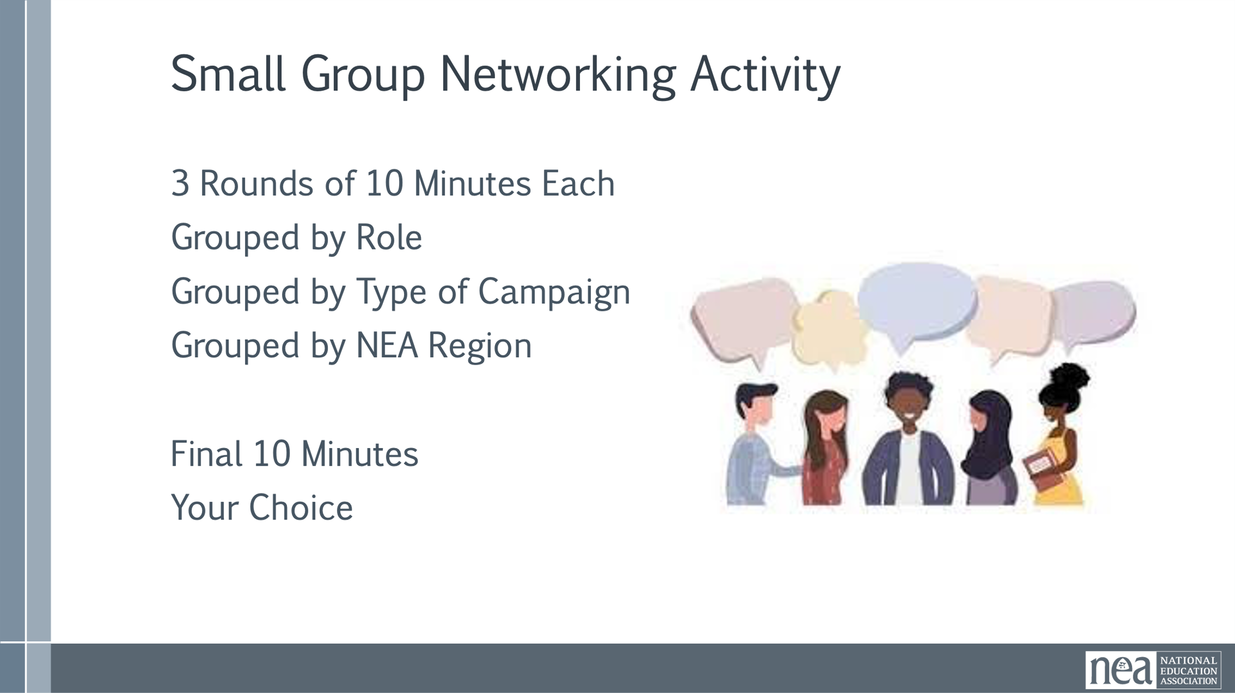  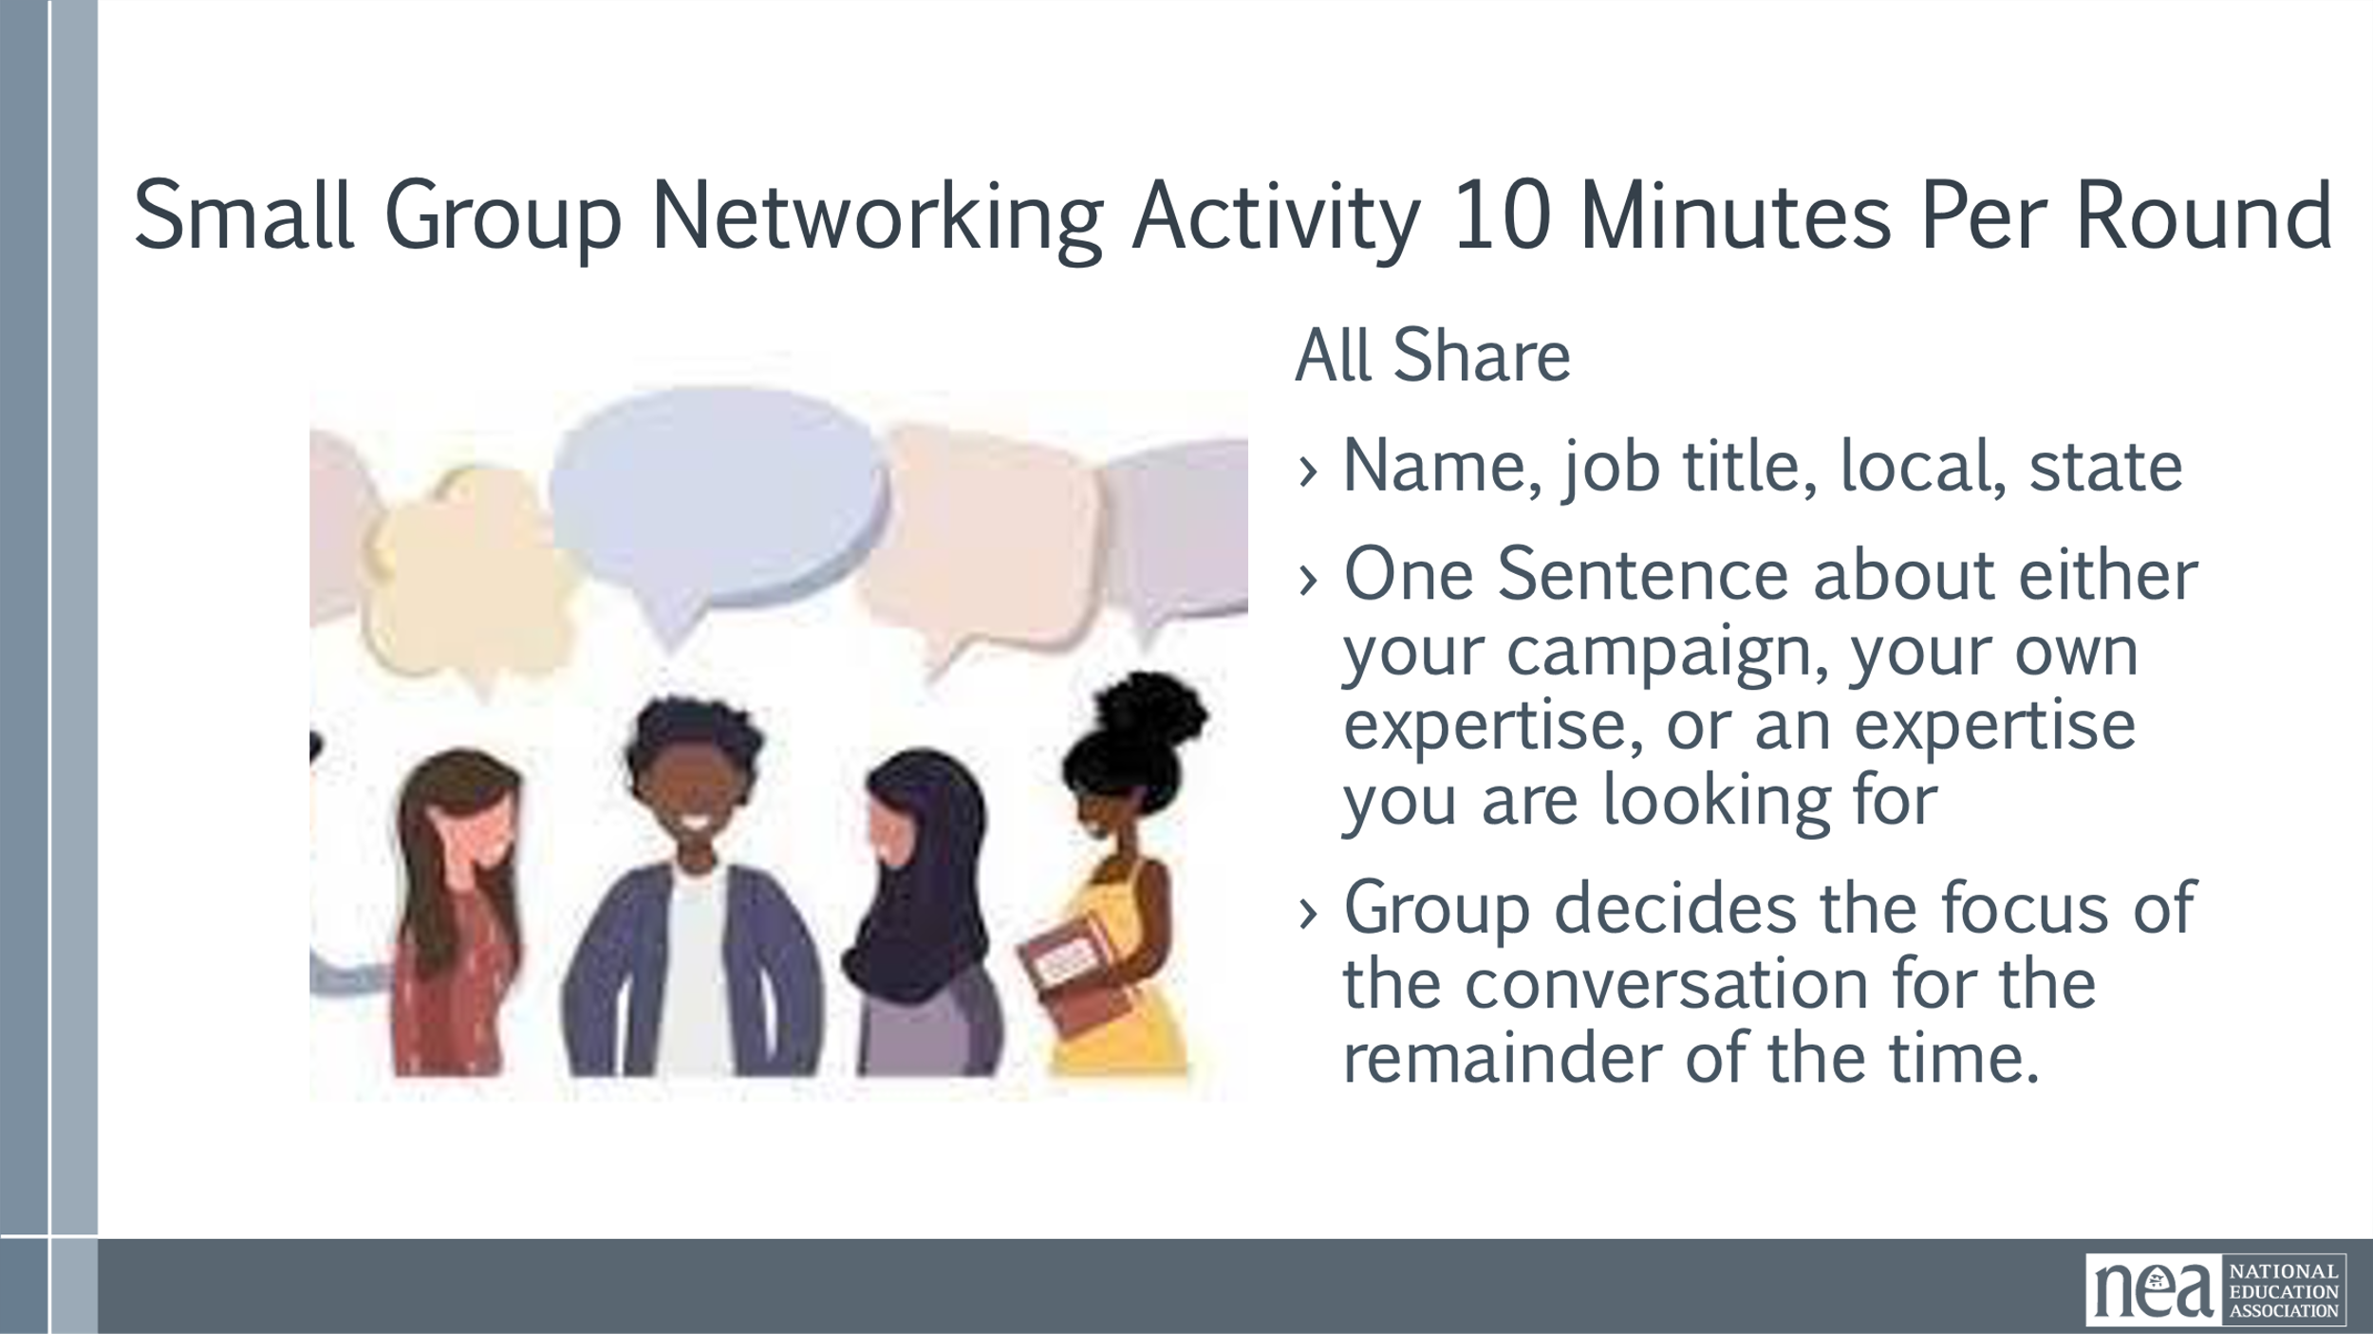  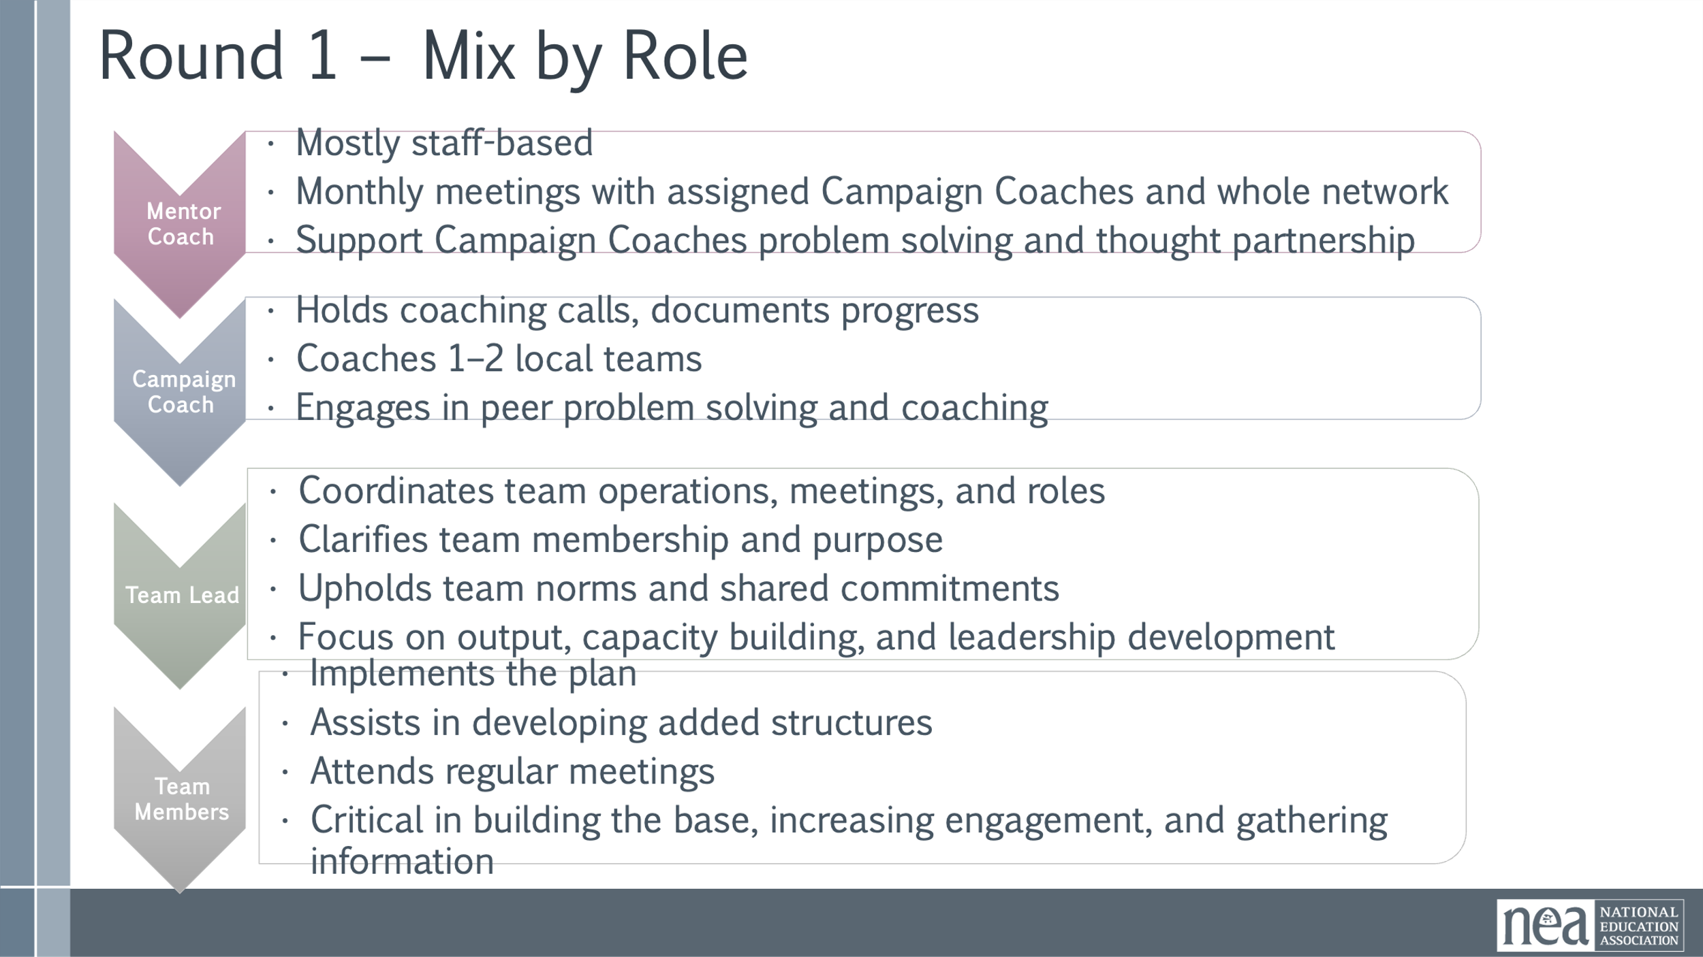  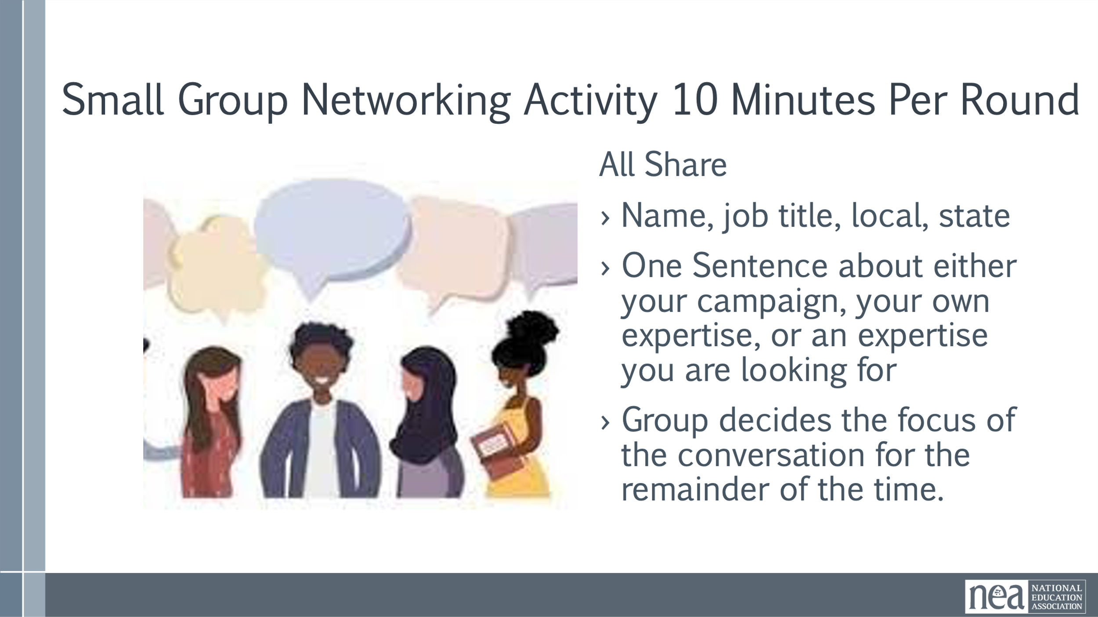  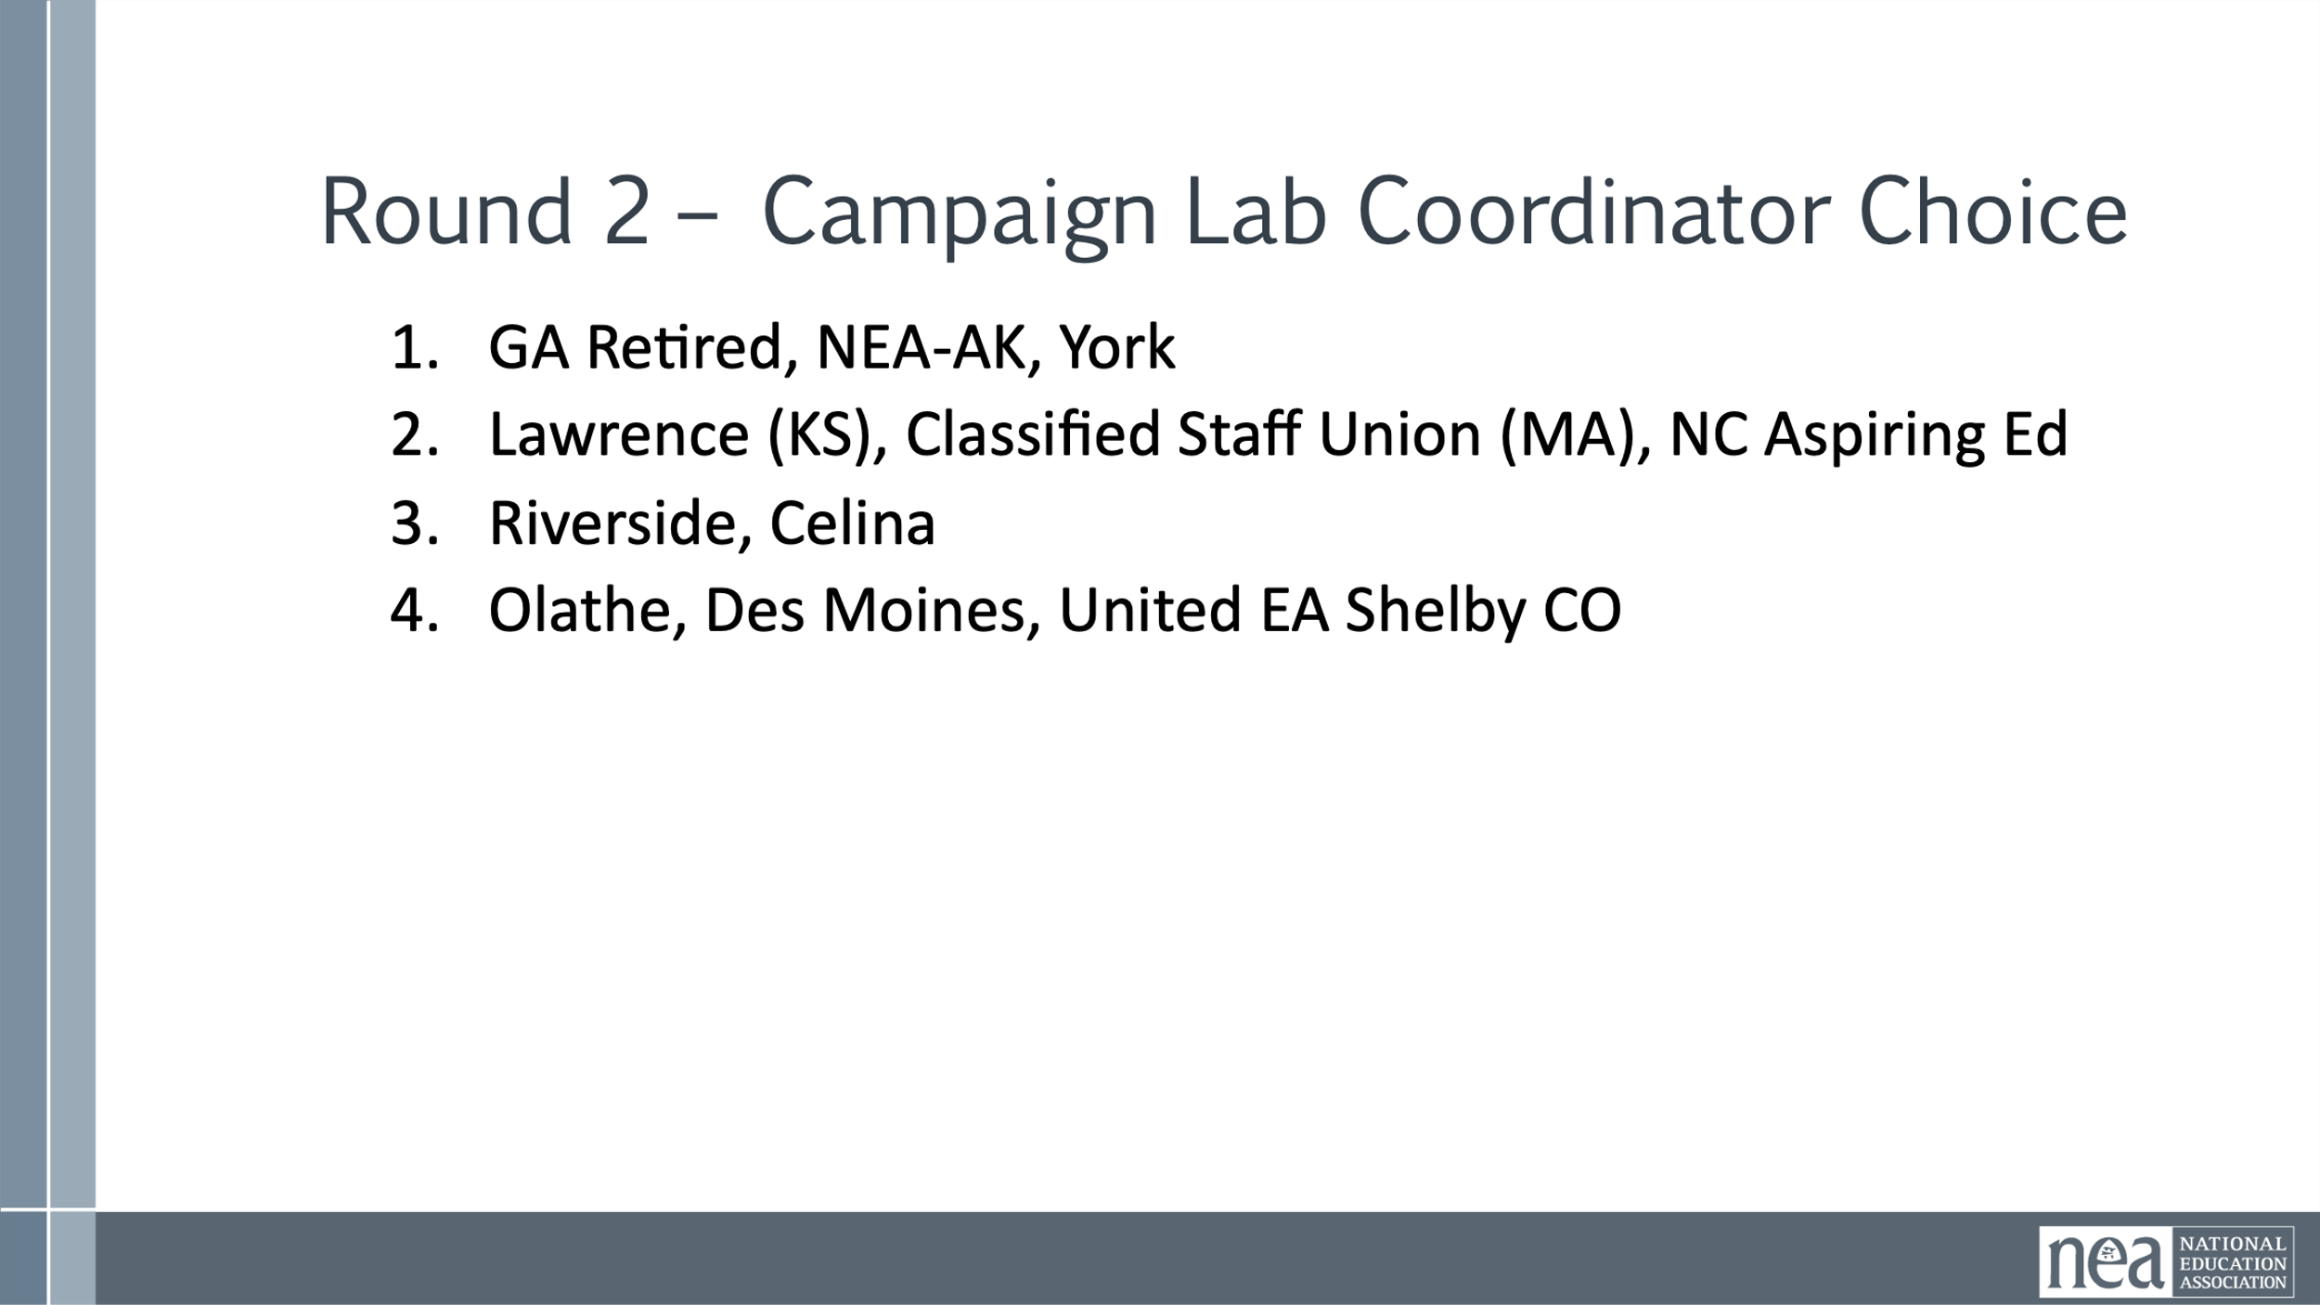  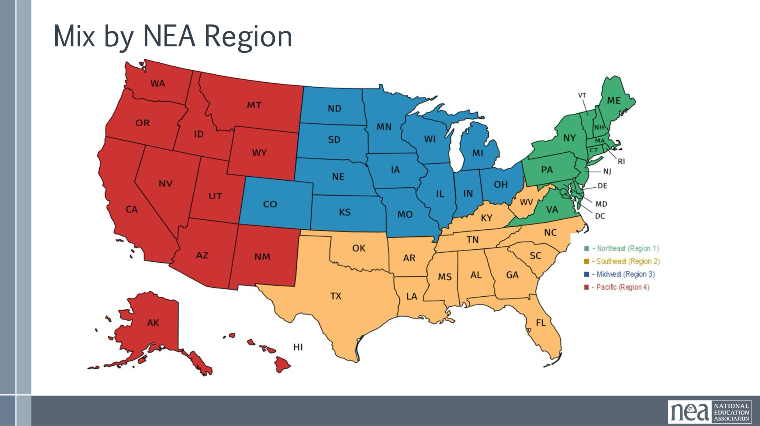    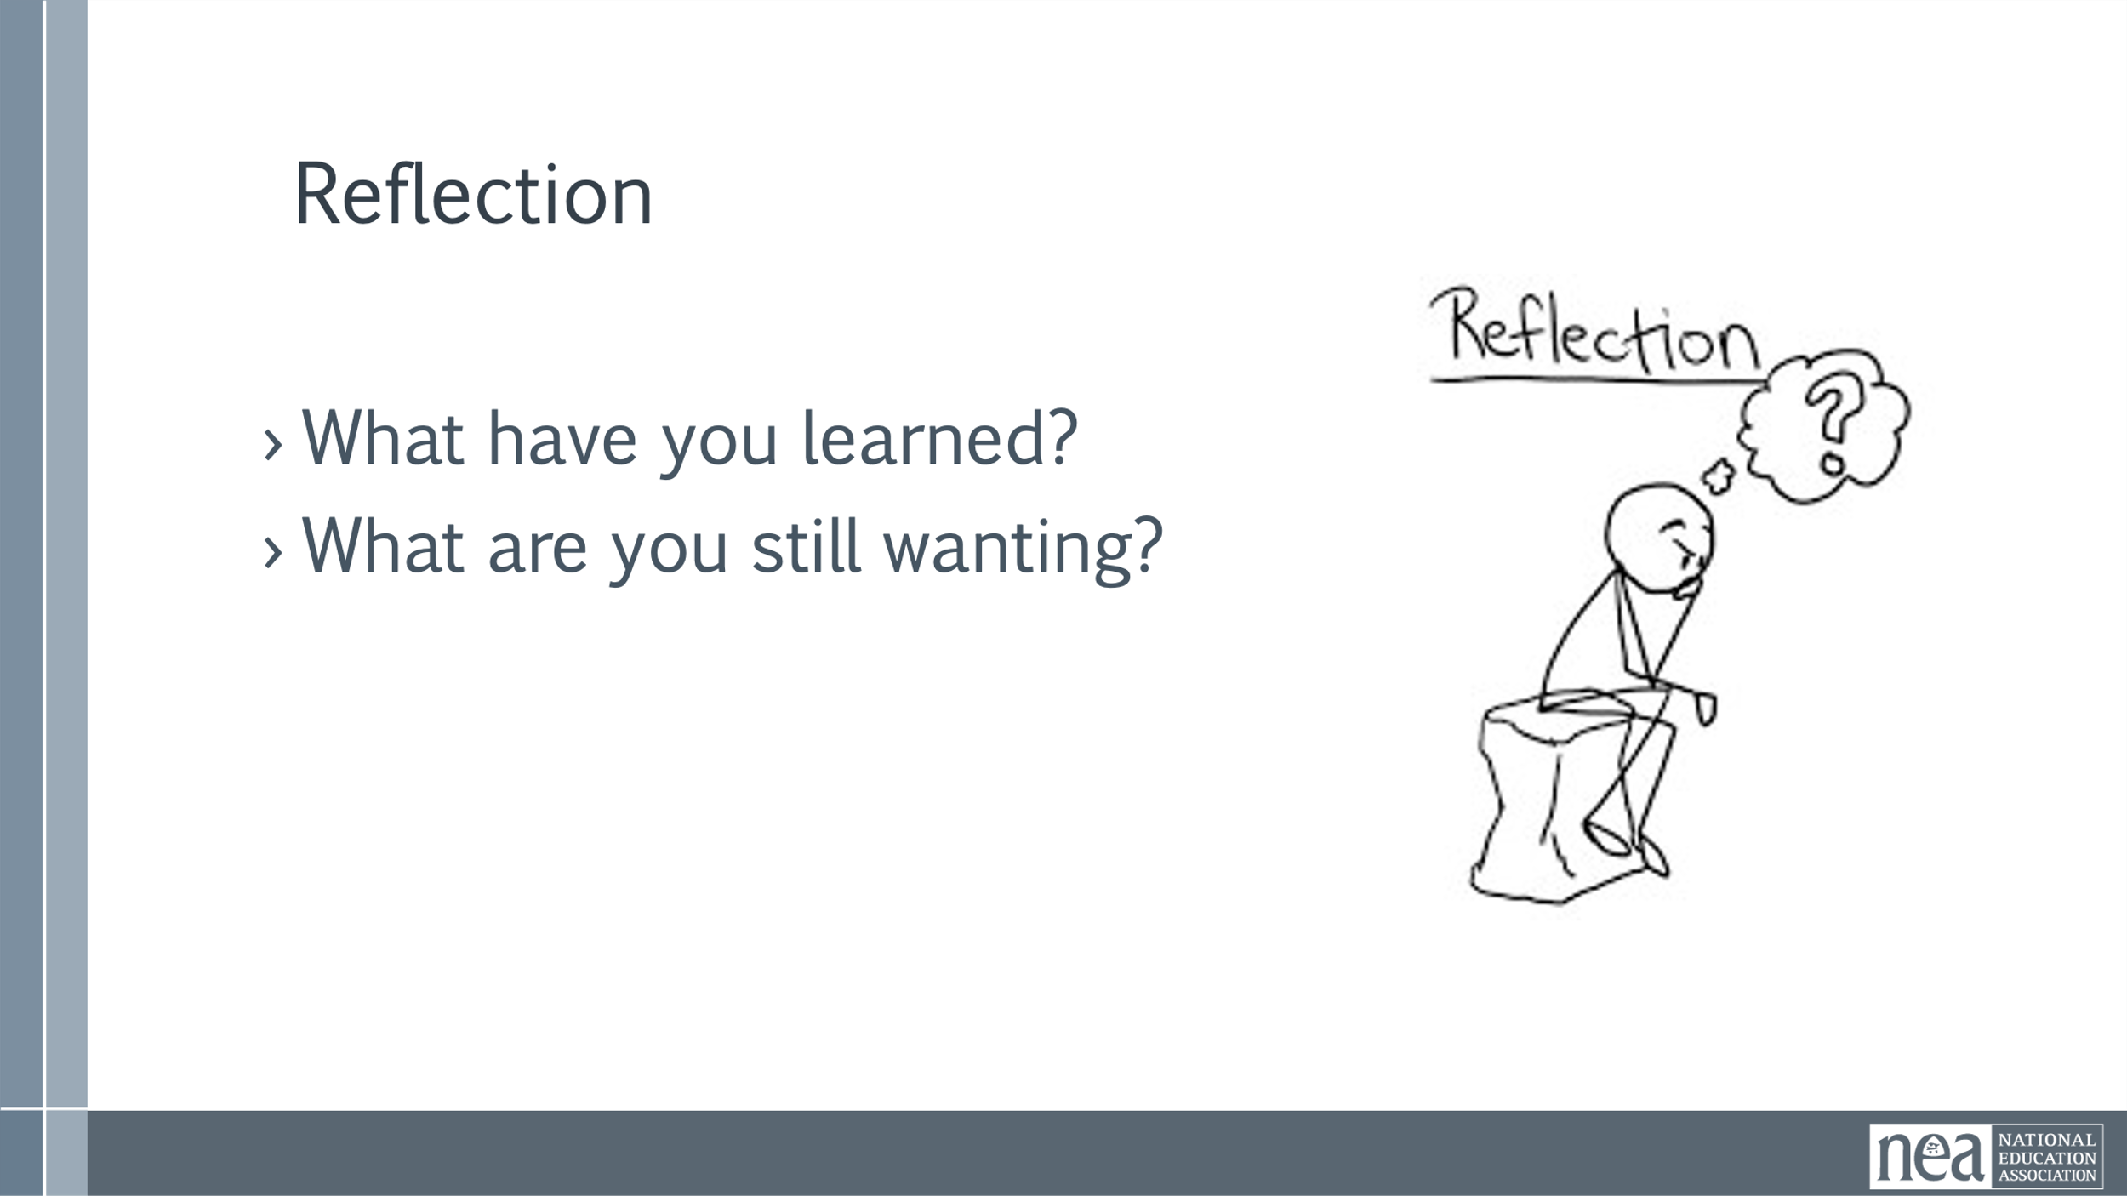  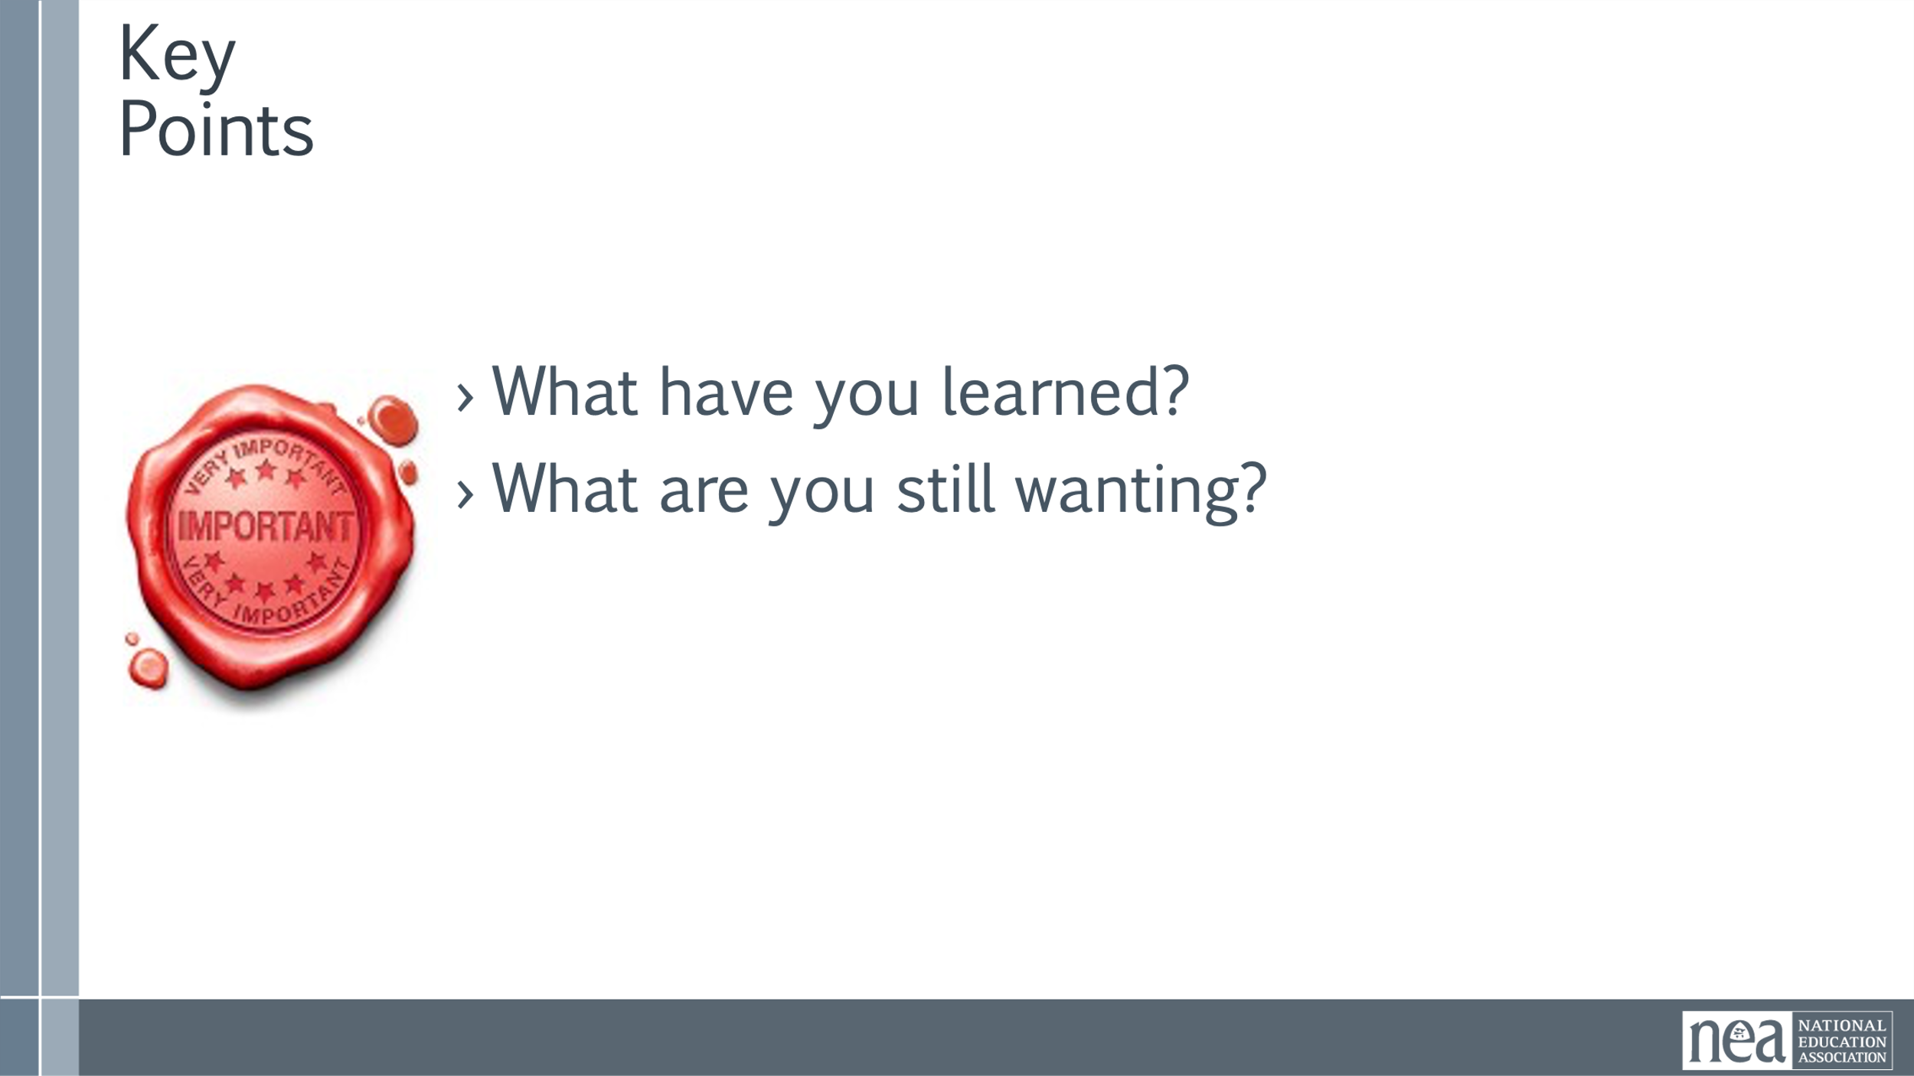 |  | 5 min- What makes Campaign Lab unique is the focus is on connecting campaigns, organizers (both staff and member), and leaders from across the country. We believe all the answers y’all are seeking about how to build strong campaigns can be found right here in this room.  Everyone in Campaign Lab has a role. Raise your hand when I read off your role.  - Campaign Leads  - Campaign Team Members  - Campaign Coaches  - Mentor Coaches  Regardless of your role, we want you all to know each other, so that you can expand your network of folks you can reach out to when you are organizing.  In the next activity, we are going to group you in multiple ways so you can learn more about what each other is working on, and so you can find people with experience and expertise you'd like to hear more about. Once you find your group, you will share out in the following way:  We will do 3 rounds of 10 minutes each. Then at the end you will have 10 minutes to connect with whoever you please. So don’t worry if the person you really wanted to hear more from didn’t get to share in your group.  For EACH ROUND YOU WILL DO THE FOLLOWING  - Name, Job title, Local, state.  - ONE SENTENCE that describes something you want to share, like a recent campaign victory or some part of campaigning in which you have expertise, OR who you would like to connect with, as in “I’m looking to connect with folks who have experience with winning school board races in rural, conservative places.”  - After everyone has shared, decide as a group how you would like to focus your conversation for the rest of the time. You can either choose to hear more about one person’s campaign or expertise, or to focus on one question of practice. If you can’t decide, you can also break into smaller groups to discuss more.  Direct them into their groups by role. Each group has 10 mins to talk within their groups.  - min- (10 mins per group)  - Mixer by role: Team Leads, Team Members, Campaign Coaches, Mentor Coaches  - Mixer by Coordinator (see if you can figure out the connection)  - GA Retired, NEA-AK, York  - Lawrence (KS), Classified Staff Union (MA), NC Aspiring Ed  - Riverside, Celina  - Olathe, Des Moines, United EA Shelby CO  - Mixer by region- Northeast, Southeast, Midwest, Southwest, Northeast  - Mixer by choice  Reflection  - What have you learned?  - What are you still wanting?  Key Points  The goal of the Campaign Lab is to be an intentional network to support organizing nationwide. | Participants will understand the roles in Campaign Lab and identify others they would like to connect with.
10:30-10:45 BREAK
10:45- 11:30 | Beth /Vanessa | 45 Mins TOTAL Centering Equity (Not just an add on)
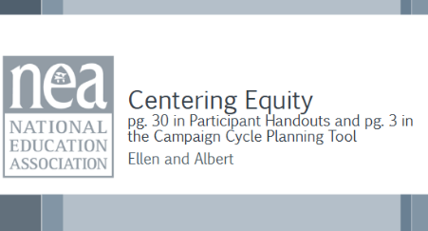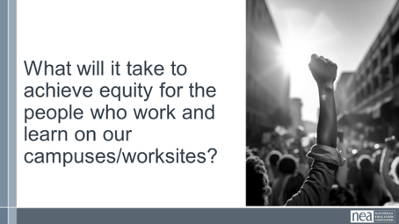  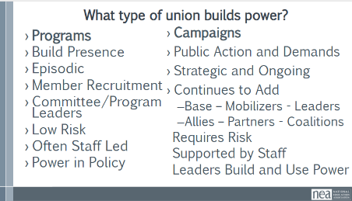  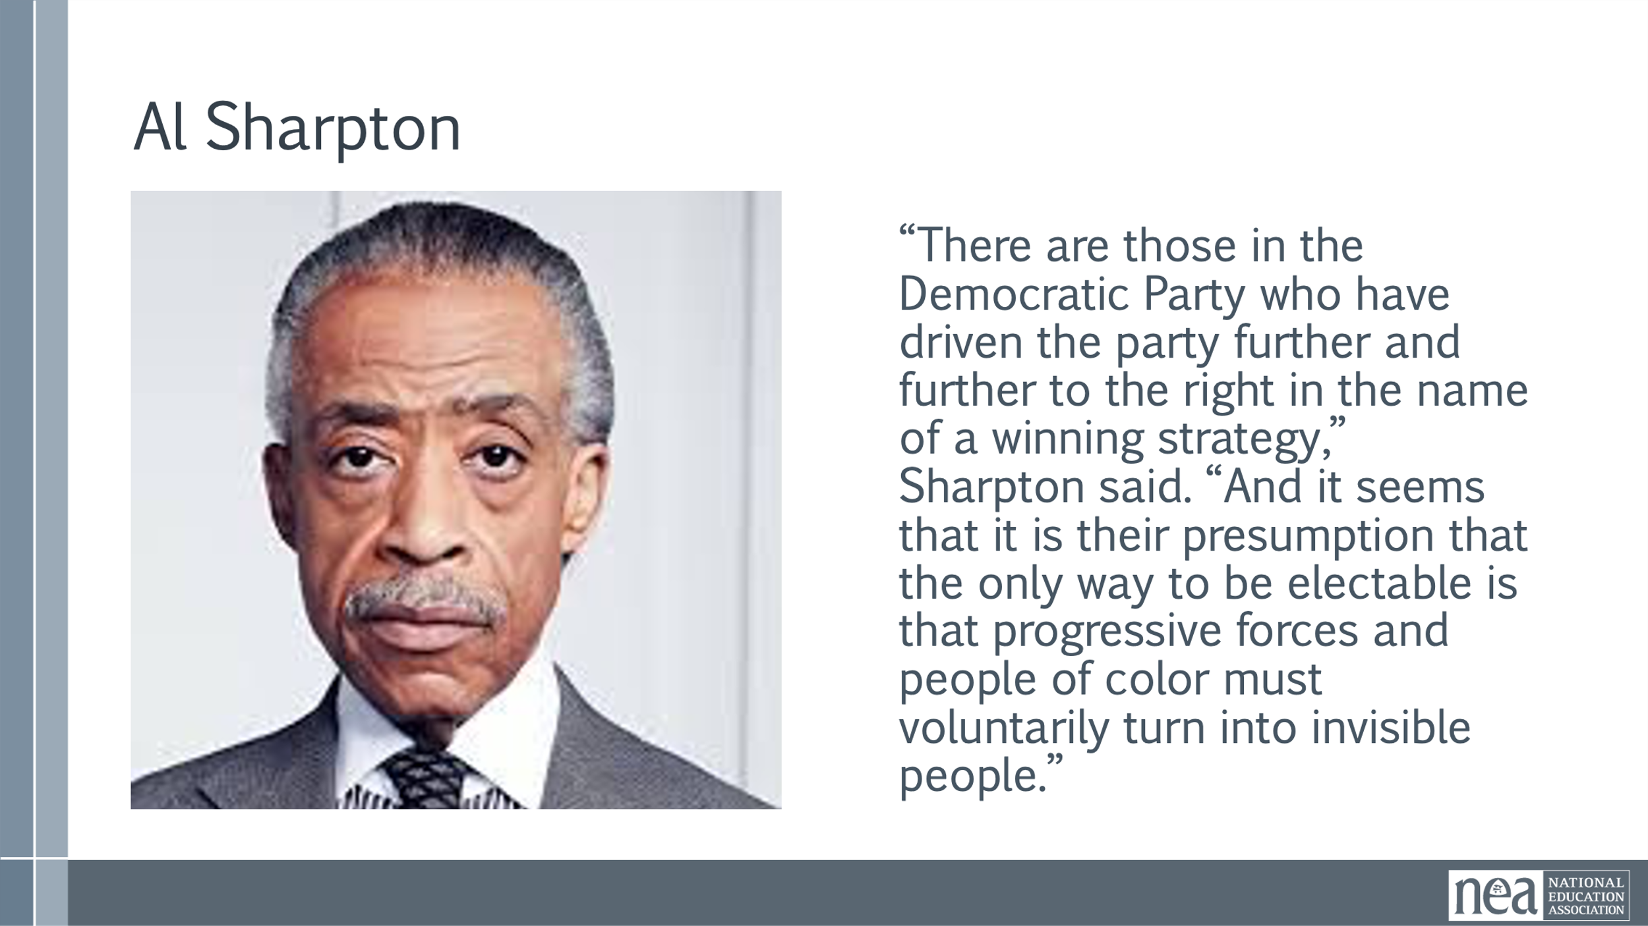  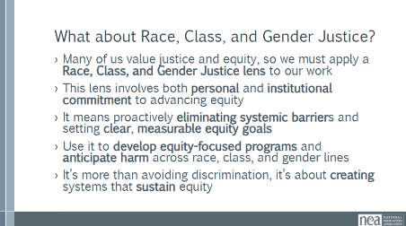  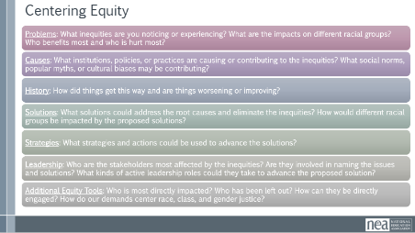  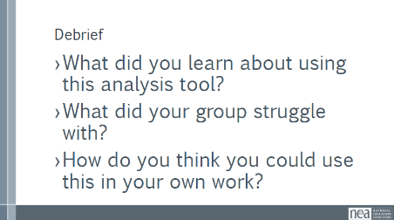  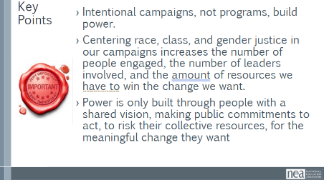 | Pre Attendance  1 Ella Baker Leadership.pdf  1.01 Centering Equity in your Campaigns.docx  Handouts  2 CRSJ Centering Race.pdf | Sitting in their campaign teams  Participant Handouts pg. 5  2-minute Turn and Talk - What will it take to achieve equity in the “Big Dreams” you have for your campaigns, your schools, and your communities?  -MAKE THE FOCUS ON LEADERS AND STRUCTURES Maybe go to the challenges and dreams that were listed in the previous section-  3 minutes – Union Work that Builds Power  For all of those things, to make meaningful lasting STRUCTURAL change we need power. Power is defined as that ability to create, control, and prevent change. That typically means organized people and organized money or resources – your work is a resource.  What type of union builds power?  Programs, such as professional learning, staff led advocacy, social focused events, even policy advocacy do little to build power. These ARE types of structures, but they are not the structures that build the leadership we need to win what we need in these times.  Why is that?  Well all of these programs are self-selected with little risk to join or leave them. I want to improve my classroom management, so I come to the Union led training on that. I might even lead one – but I have done little to build power with others. Also in a program, I am choosing to solve a “me” Problem and it does not require any other collective commitment.  Campaigns and the structures required to implement them intentionally put people at the center of solving the problems they are experiencing. They name the issue, they decide the solution, they decide who they follow, and they determine what the are willing to risk. When we center people in a campaign – staff move to a coaching role. When people are at the center they use their agency and decide how to act, who they will act with, and what they are willing to risk to win. This is when members and leaders feel powerful in their union.  To begin a campaign you have to ask what the people want to solve, ask what they are willing to risk to solve that, and form demands that they think will provided the solution to their problem.  3 minutes – What about Social Justice?  - Potential quotes to frame this conversation: In 2001 when Reverand Al Sharpton was considering running for president in 2004 he said the following:  - “...to seriously look at a strategy that would lead toward making sure the unheard and the unnoticed are both heard and paid attention to.”  - “There are those in the Democratic Party who have driven the party further and further to the right in the name of a winning strategy,” Sharpton said. “And it seems that it is their presumption that the only way to be electable is that progressive forces and people of color must voluntarily turn into invisible people.”  - Often, we invite people to engage with your campaign that show up in the ways that you are typically in agreement with. This perpetuates the “invisible people” Sharpton references. Imagine your campaign if every person impacted was truly invited to be engaged and involved.  - We often say we value justice and that equity is central to our work. But values alone aren’t enough. To live them out, we must start by examining race, class, gender, and ability in order to systematically examine and transform our actions and structures.  - For those who don’t know, ability justice means advocating for folks with both physical and mental disabilities, including changing our systems so they have equal access to resources and live lives of joy and dignity. It can also include affirming neurodivergence; neurodivergence refers to folks whose brains process information differently from the societal standard (including but not limited to autism, ADHD, etc).  - This isn’t a box to check; it’s a deep commitment. It means we, as individuals and institutions, take responsibility to advance equity through intentional strategies, not just good intentions."  - Equity work isn’t vague. We need to identify and remove barriers, but also define clear goals, objectives, and outcomes. Otherwise, we won’t know if we’re actually making progress.  - We must design programs with mechanisms for success. And we should be using guiding questions to predict and prevent harm across marginalized groups. These tools help us avoid unintended consequences.  - Equity isn’t just about what we eliminate; it’s also about what we build. Race, class, and gender justice means putting systems in place that deliberately create and protect fairness, inclusion, and opportunity for all.  22 Minutes TOTAL – Group Practice – Applying a race, class, and gender lens to your campaign -  2 minutes intro  On page 3 of the Campaign Planning Workbook, you will see a Centering Equity tool. To engage in a systems analysis of race, class, and gender issues and develop solutions or to assess if the campaign centers equity. These questions focus on reflection and building bigger, bolder movements together.  • Problems: What inequities are you noticing or experiencing? What are the impacts on different racial groups? Who benefits most  and who is hurt most?  • Causes: What institutions, policies, or practices are causing or contributing to the inequities? What social norms, popular myths, or cultural biases may be contributing?  • History: How did things get this way and are things worsening or improving?  • Solutions: What solutions could address the root causes and eliminate the inequities? How would different racial groups be impacted by the  proposed solutions?  • Strategies: What strategies and actions could be used to advance the solutions?  • Leadership: Who are the stakeholders most affected by the inequities? Are they involved in naming the issues and solutions? What kinds of active leadership roles could they take to advance the proposed solution?  • Additional Equity Tools: Who is most directly impacted? Who has been left out? How can they be directly engaged? How do our demands center race, class, and gender justice?  Group Work – Applying Your Learning – (20 minutes)  As a campaign team take a moment reflecting on these questions and what answers surface as it relates to your campaigns.  10 Minutes – Debrief Resources and Key Points  What did you learn about using this analysis tool?  What did your group struggle with?  How do you think you could use this in your own work?  5 minute - Key Points-  - Intentional campaigns, not programs, build power.  - Centering race, class, and gender justice in our campaigns increases the number of people engaged, the number of leaders involved, and the amount of resources we have to win the change we want.  - Power is only built through people with a shared vision, making public commitments to act, to risk their collective resources, for the meaningful change they want. | Participants will review the conditions for centering equity in their campaigns and process that supports them in that work.  Team Leads and Coaches will assess what next steps might be to move locals and plans along a continuum.
11:30-11:50 | Hedy | 20 Minutes – Defining Structures and Leaders
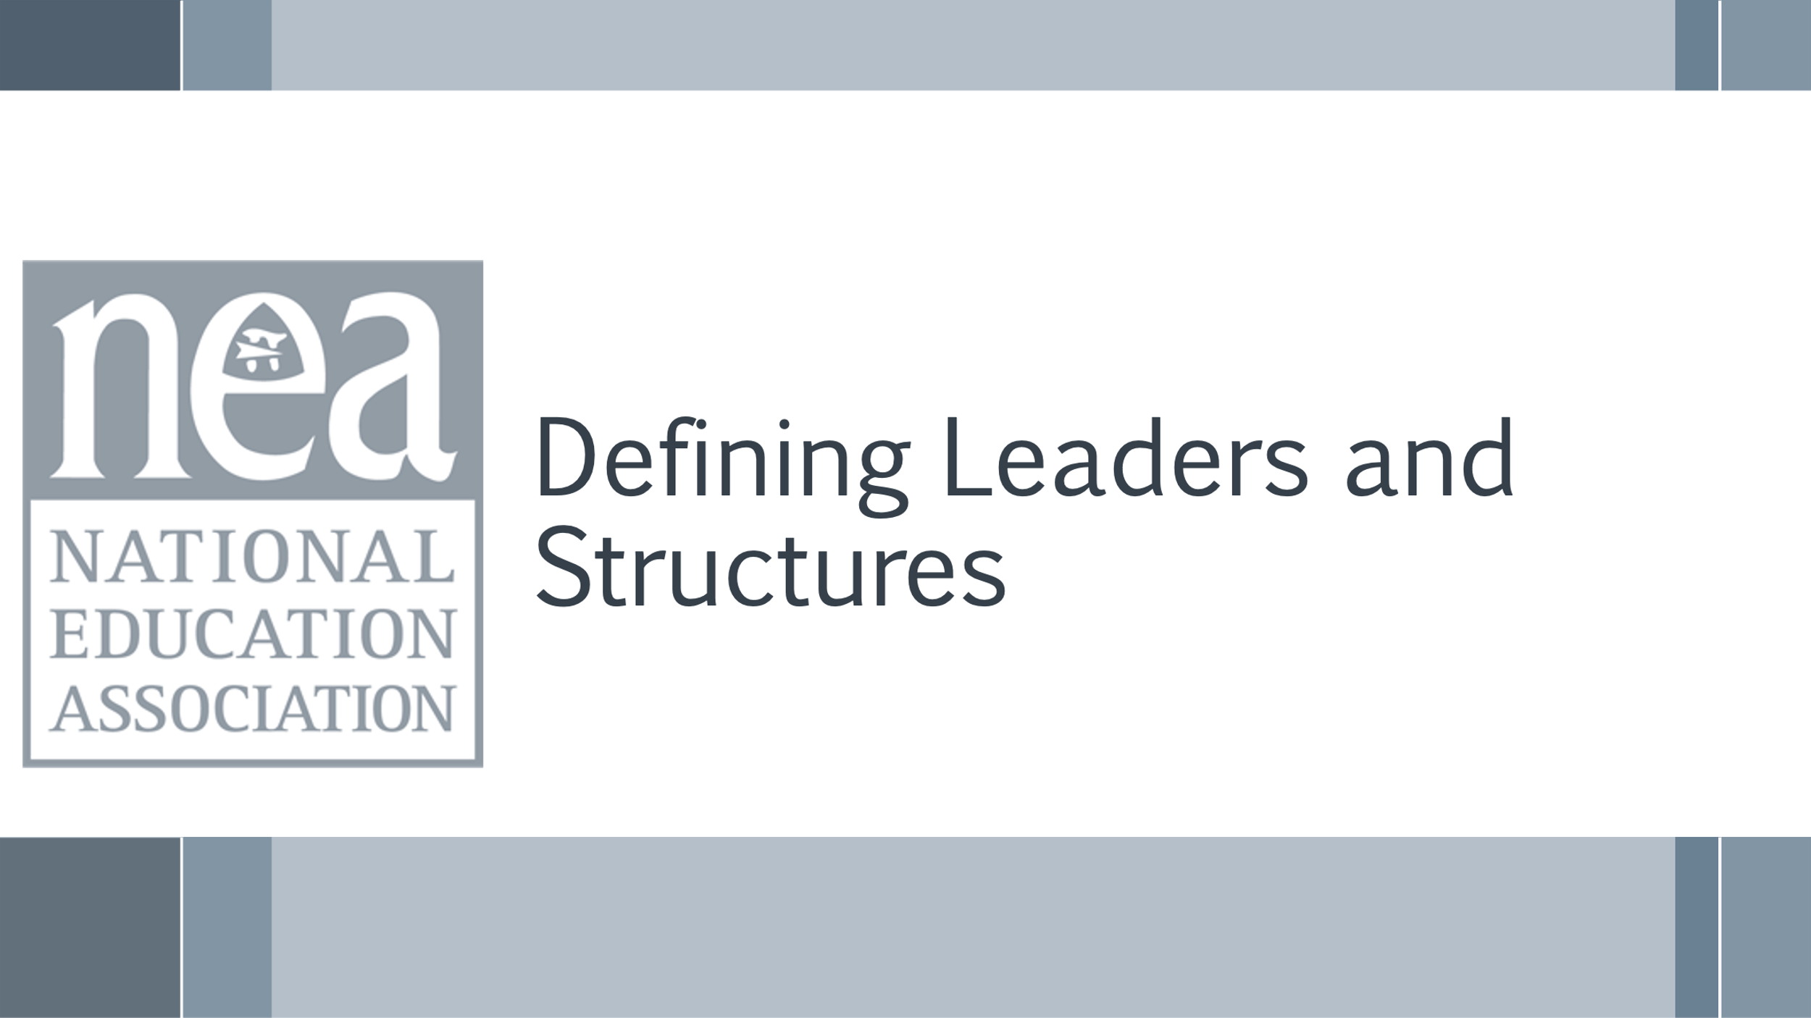  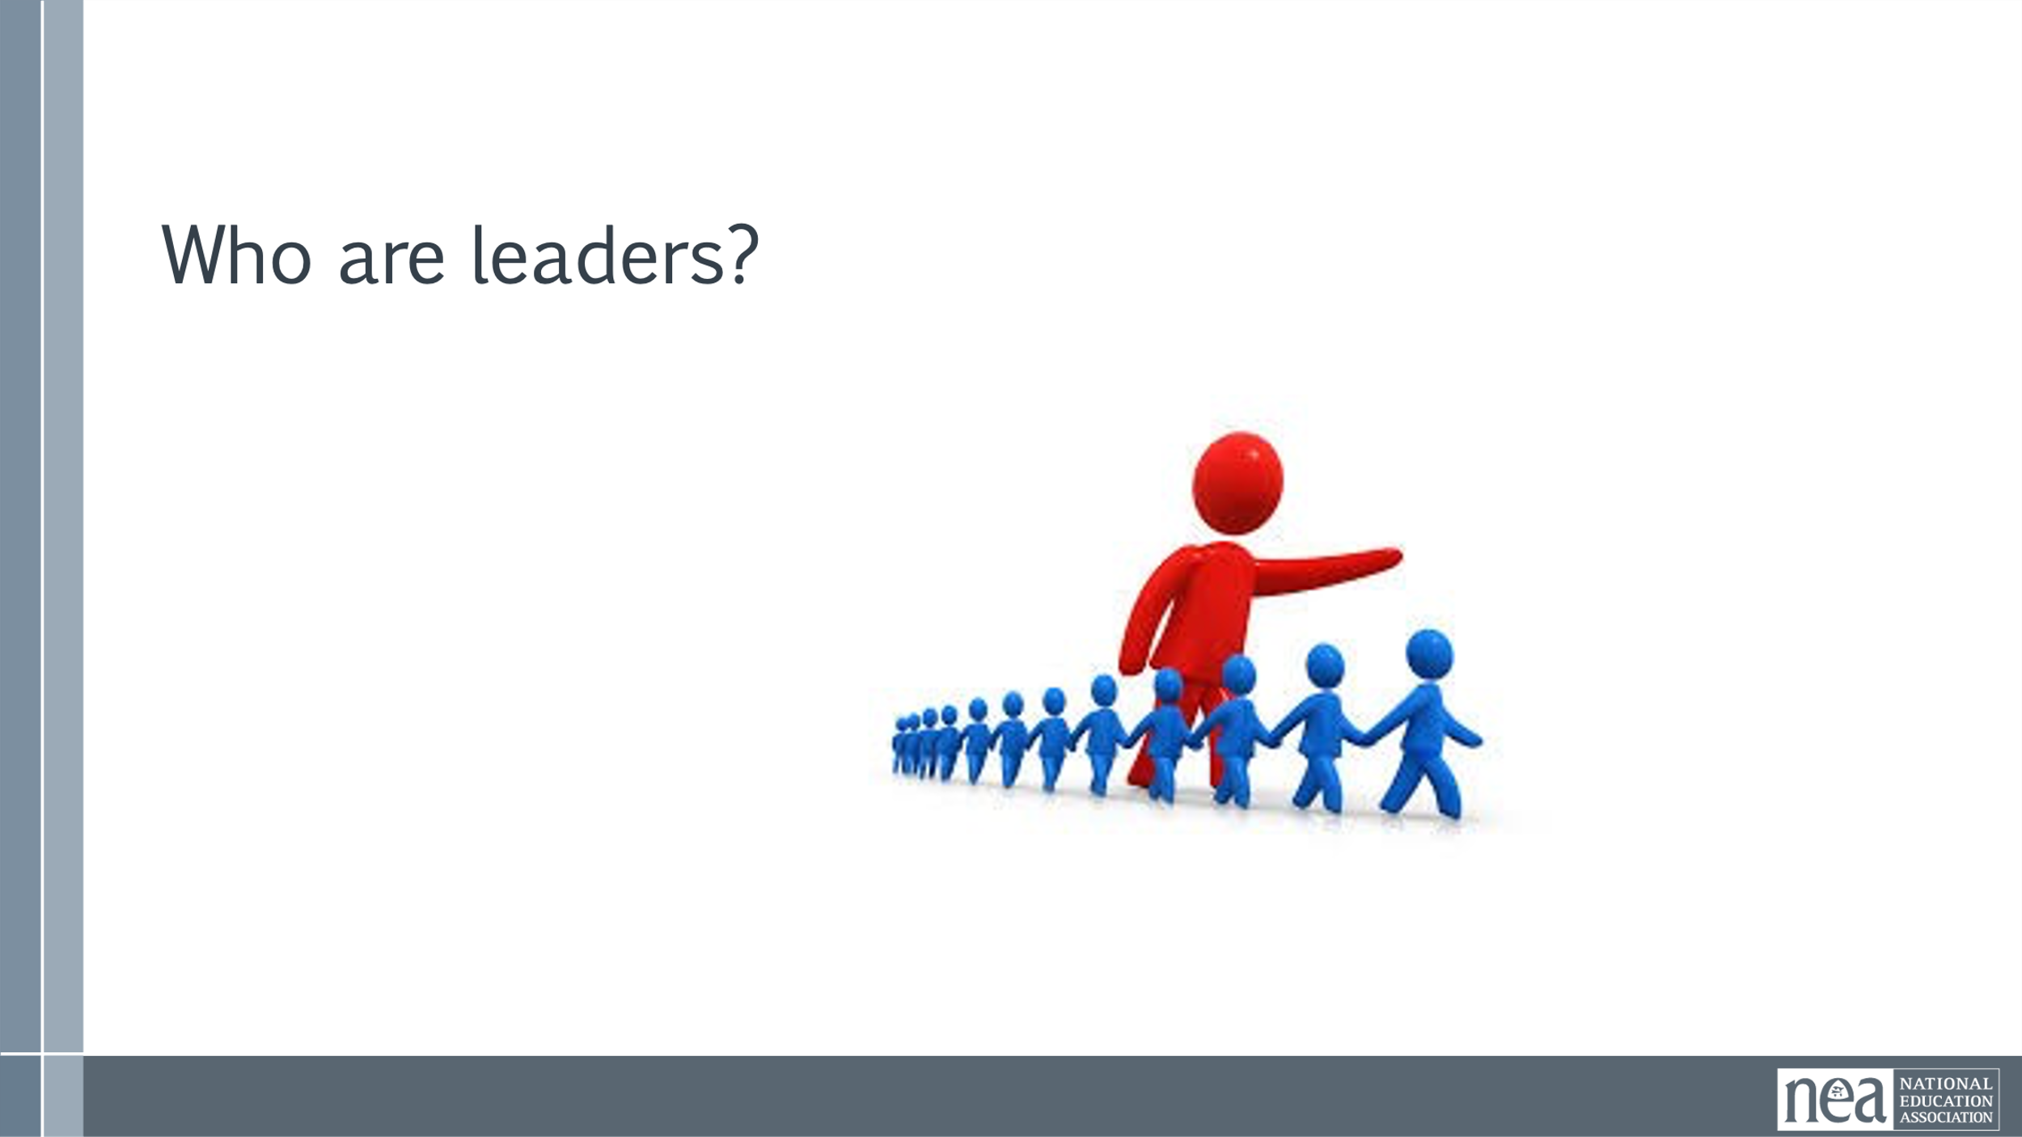  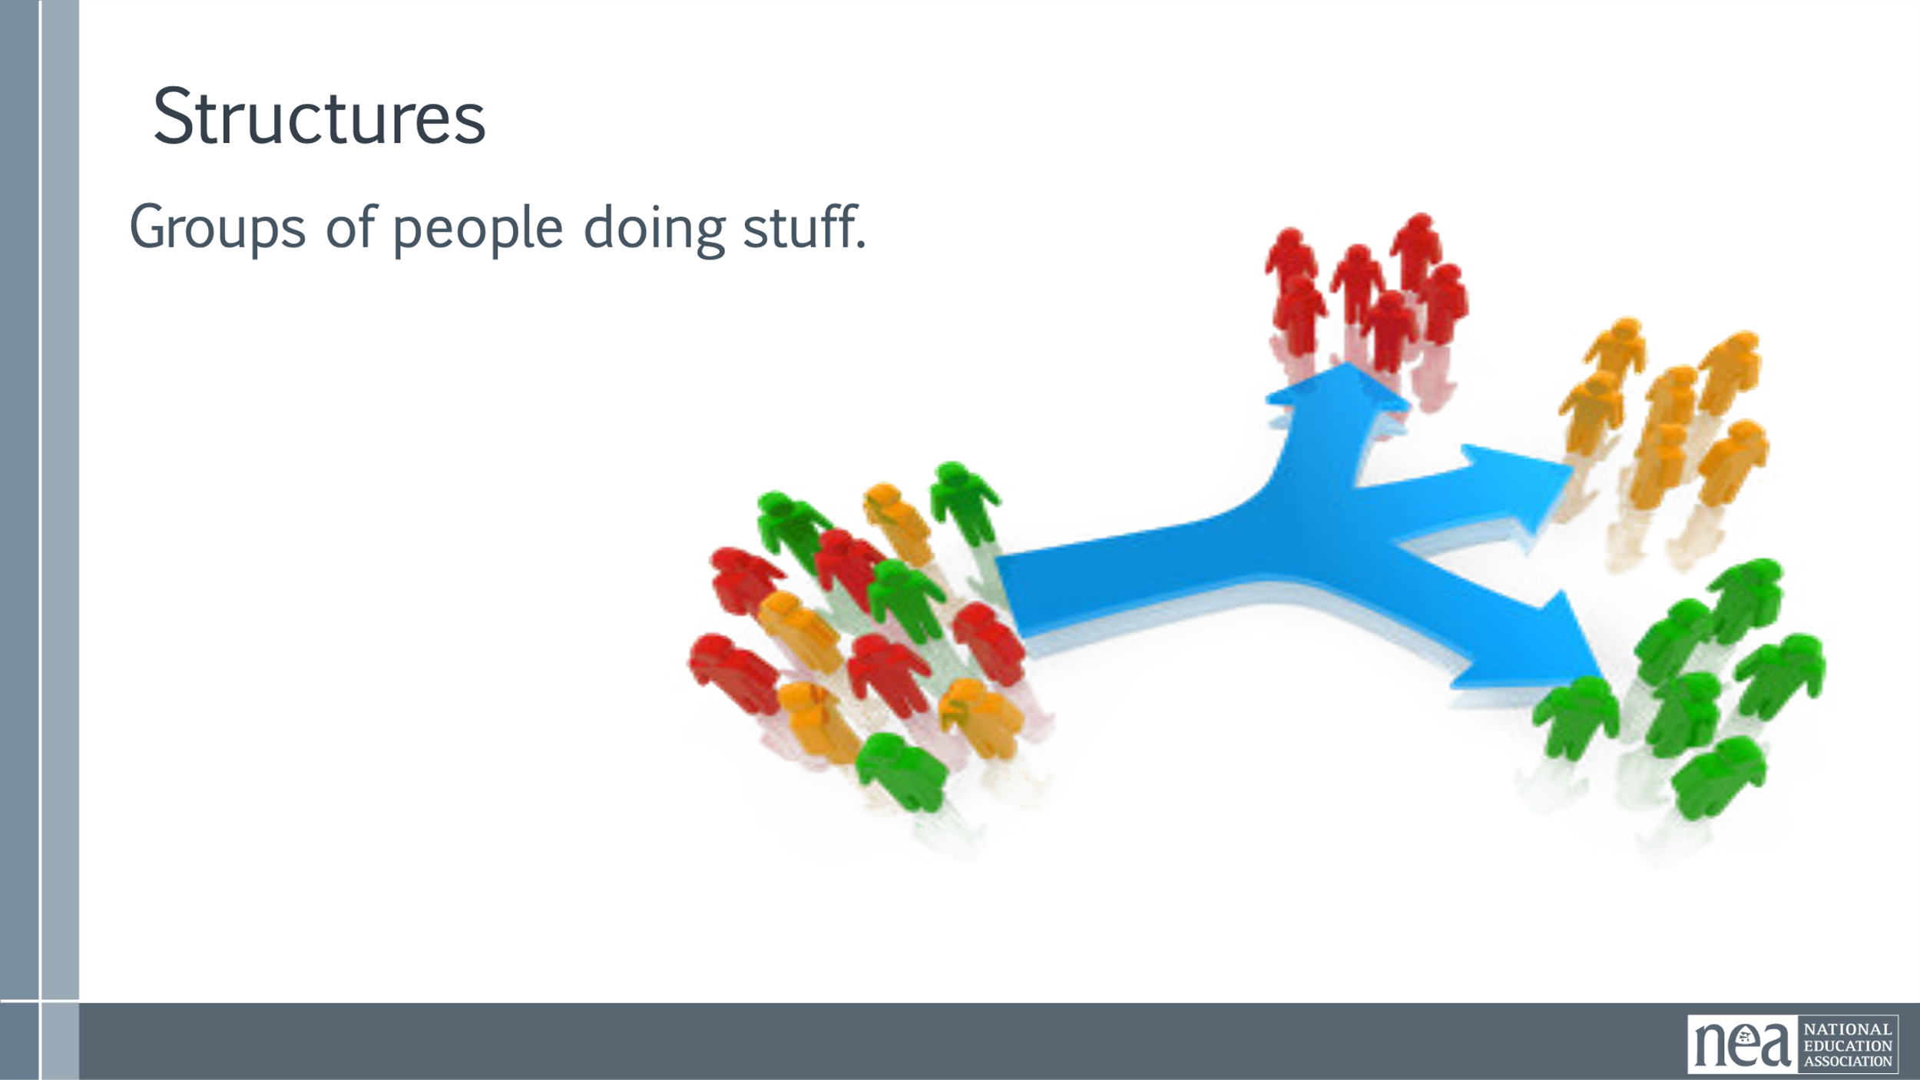  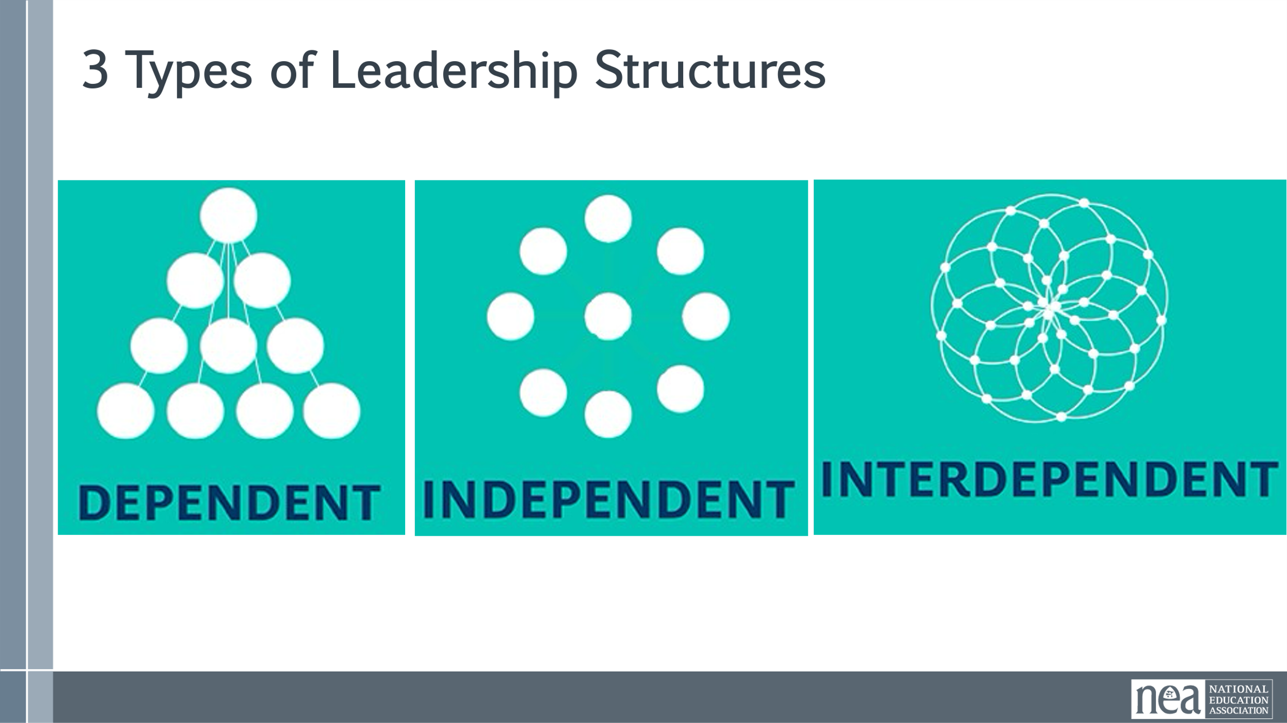  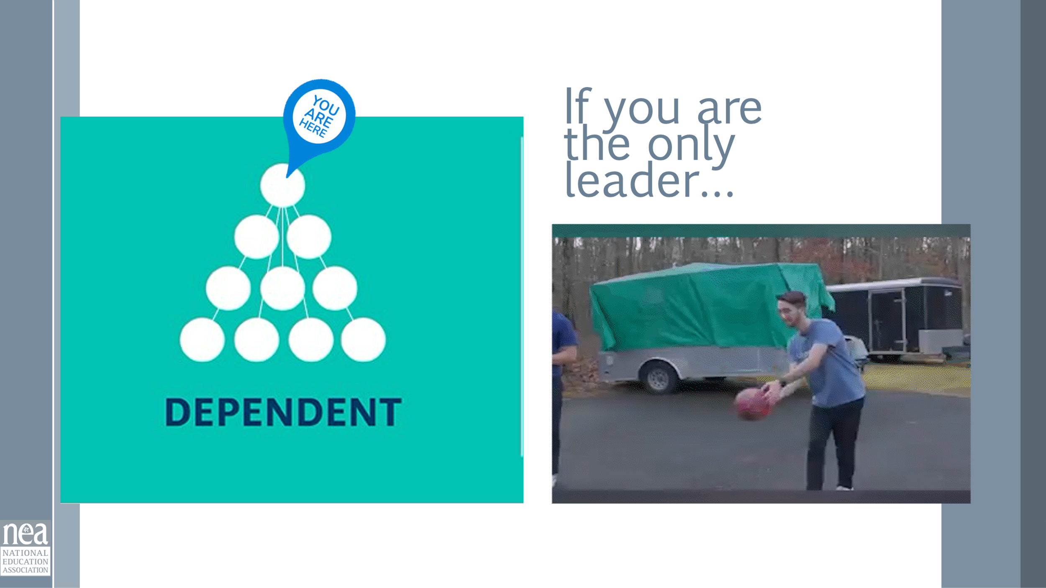  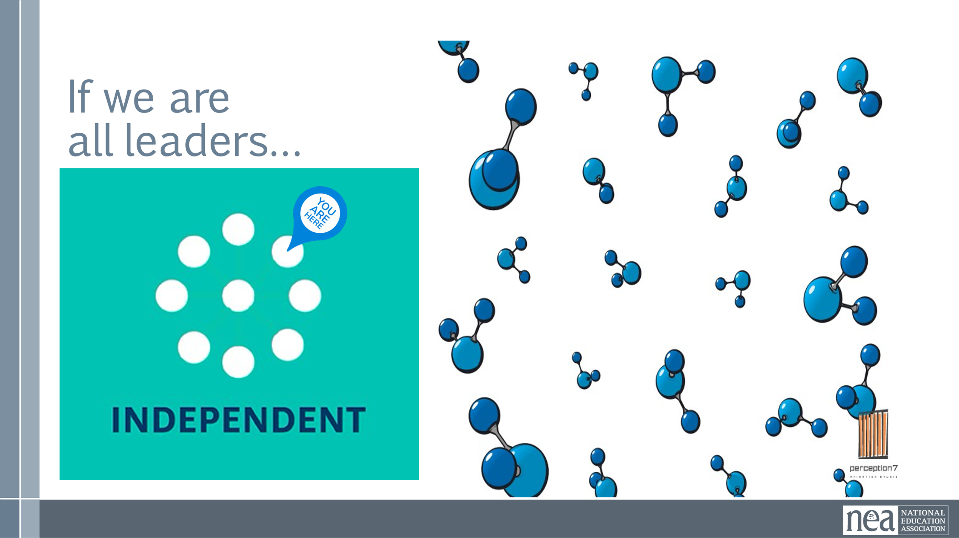  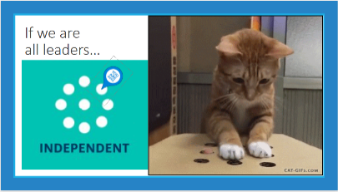  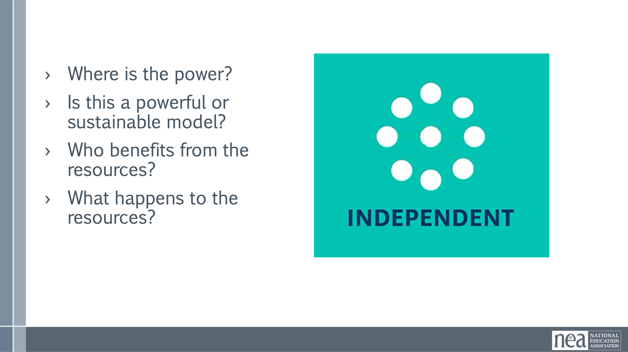  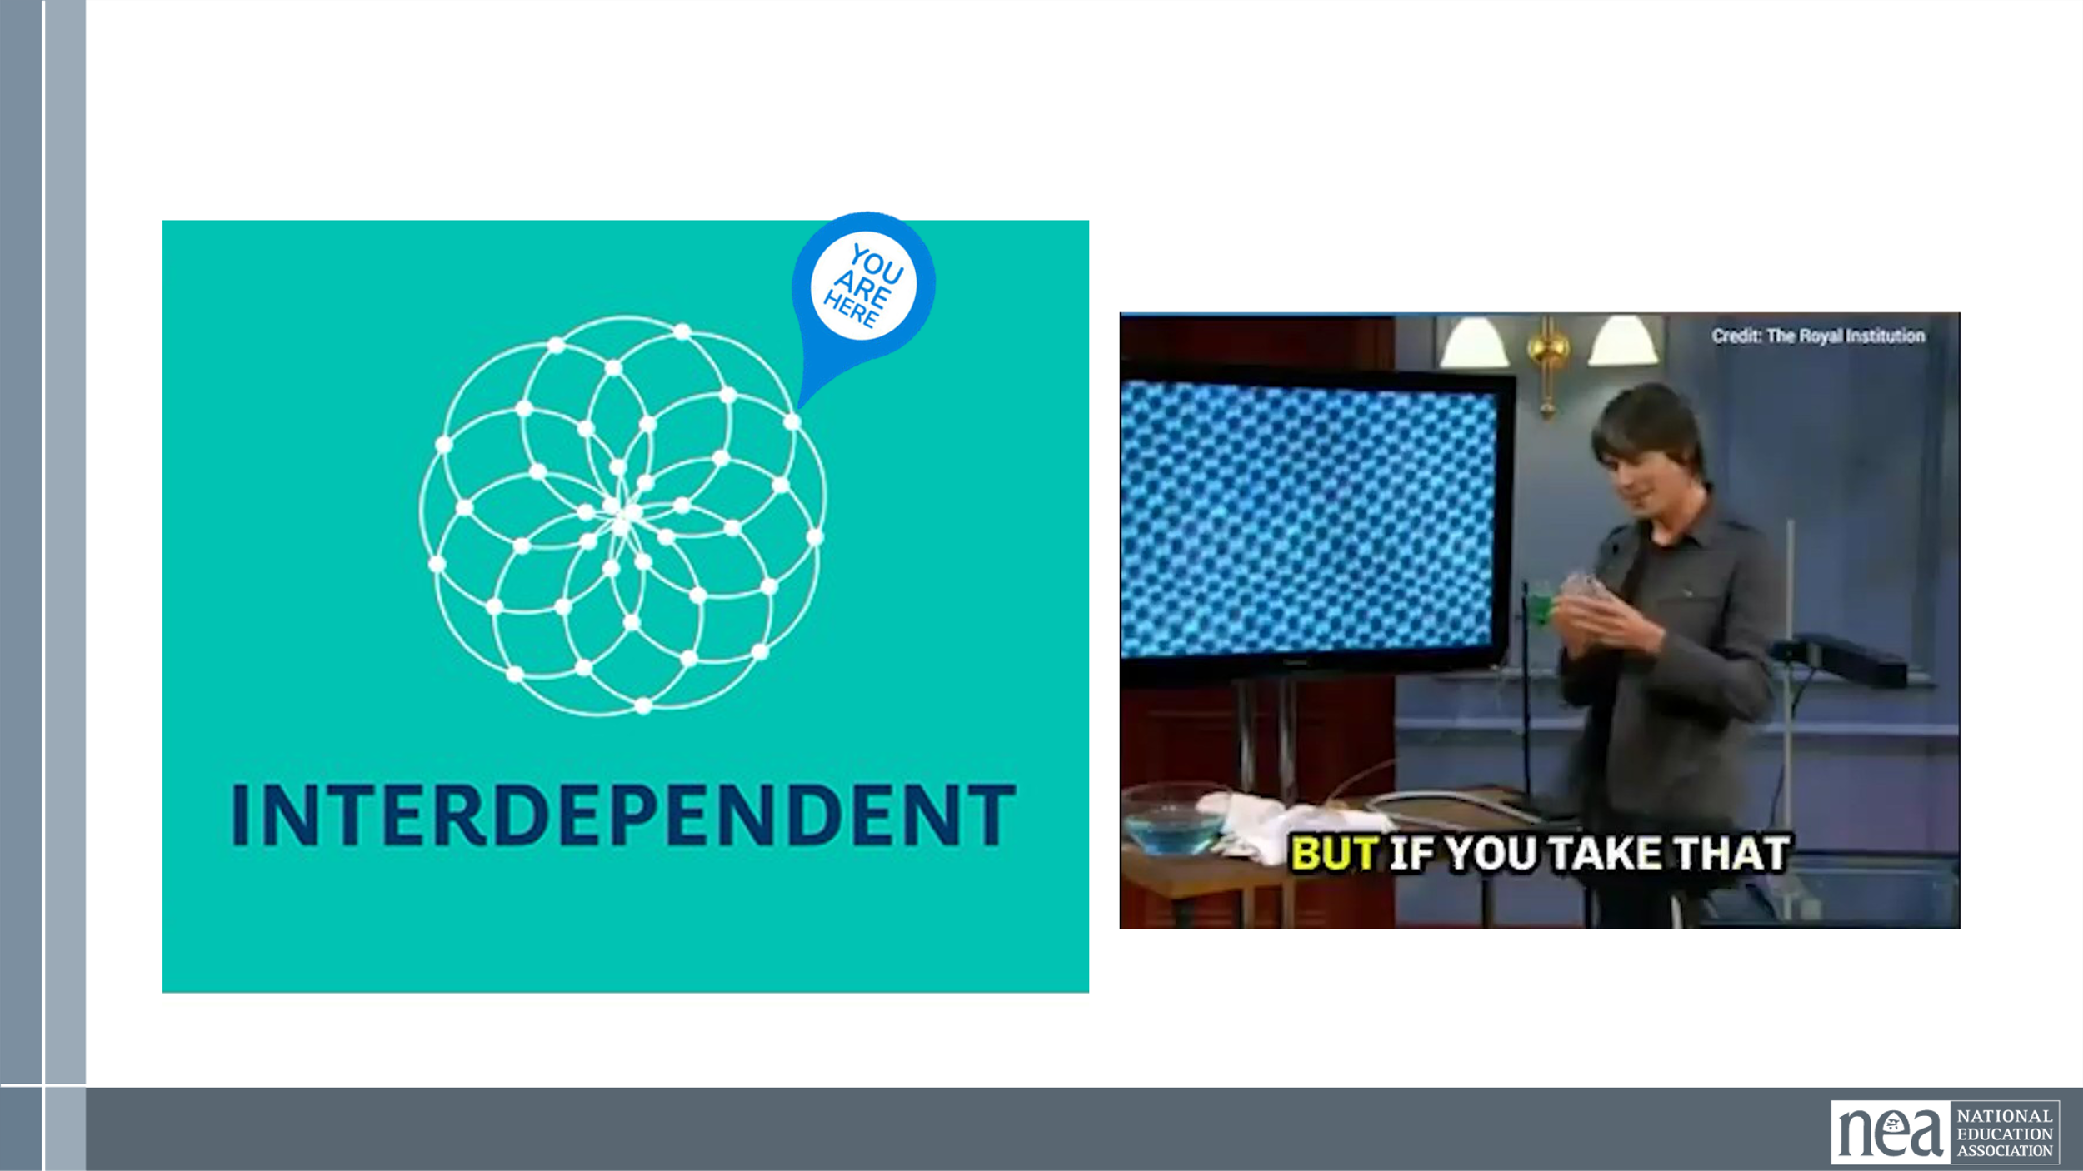  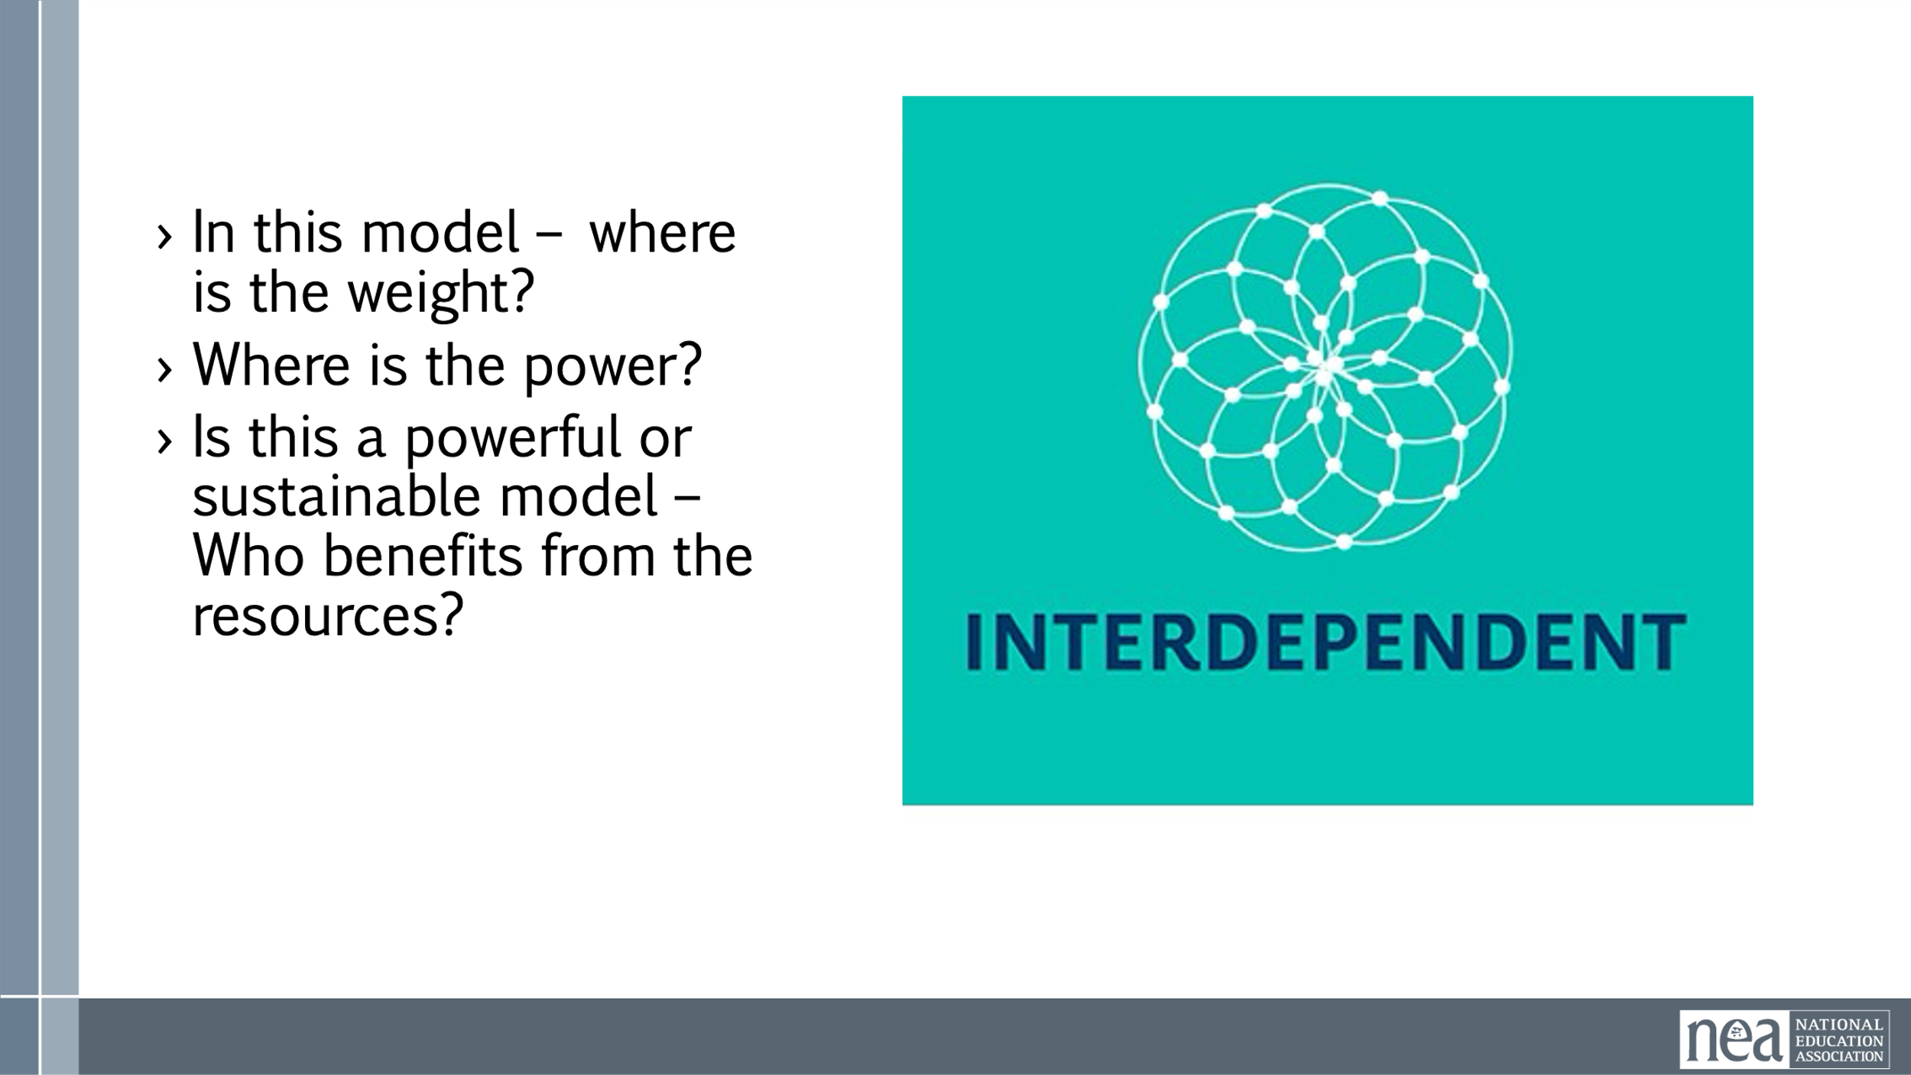  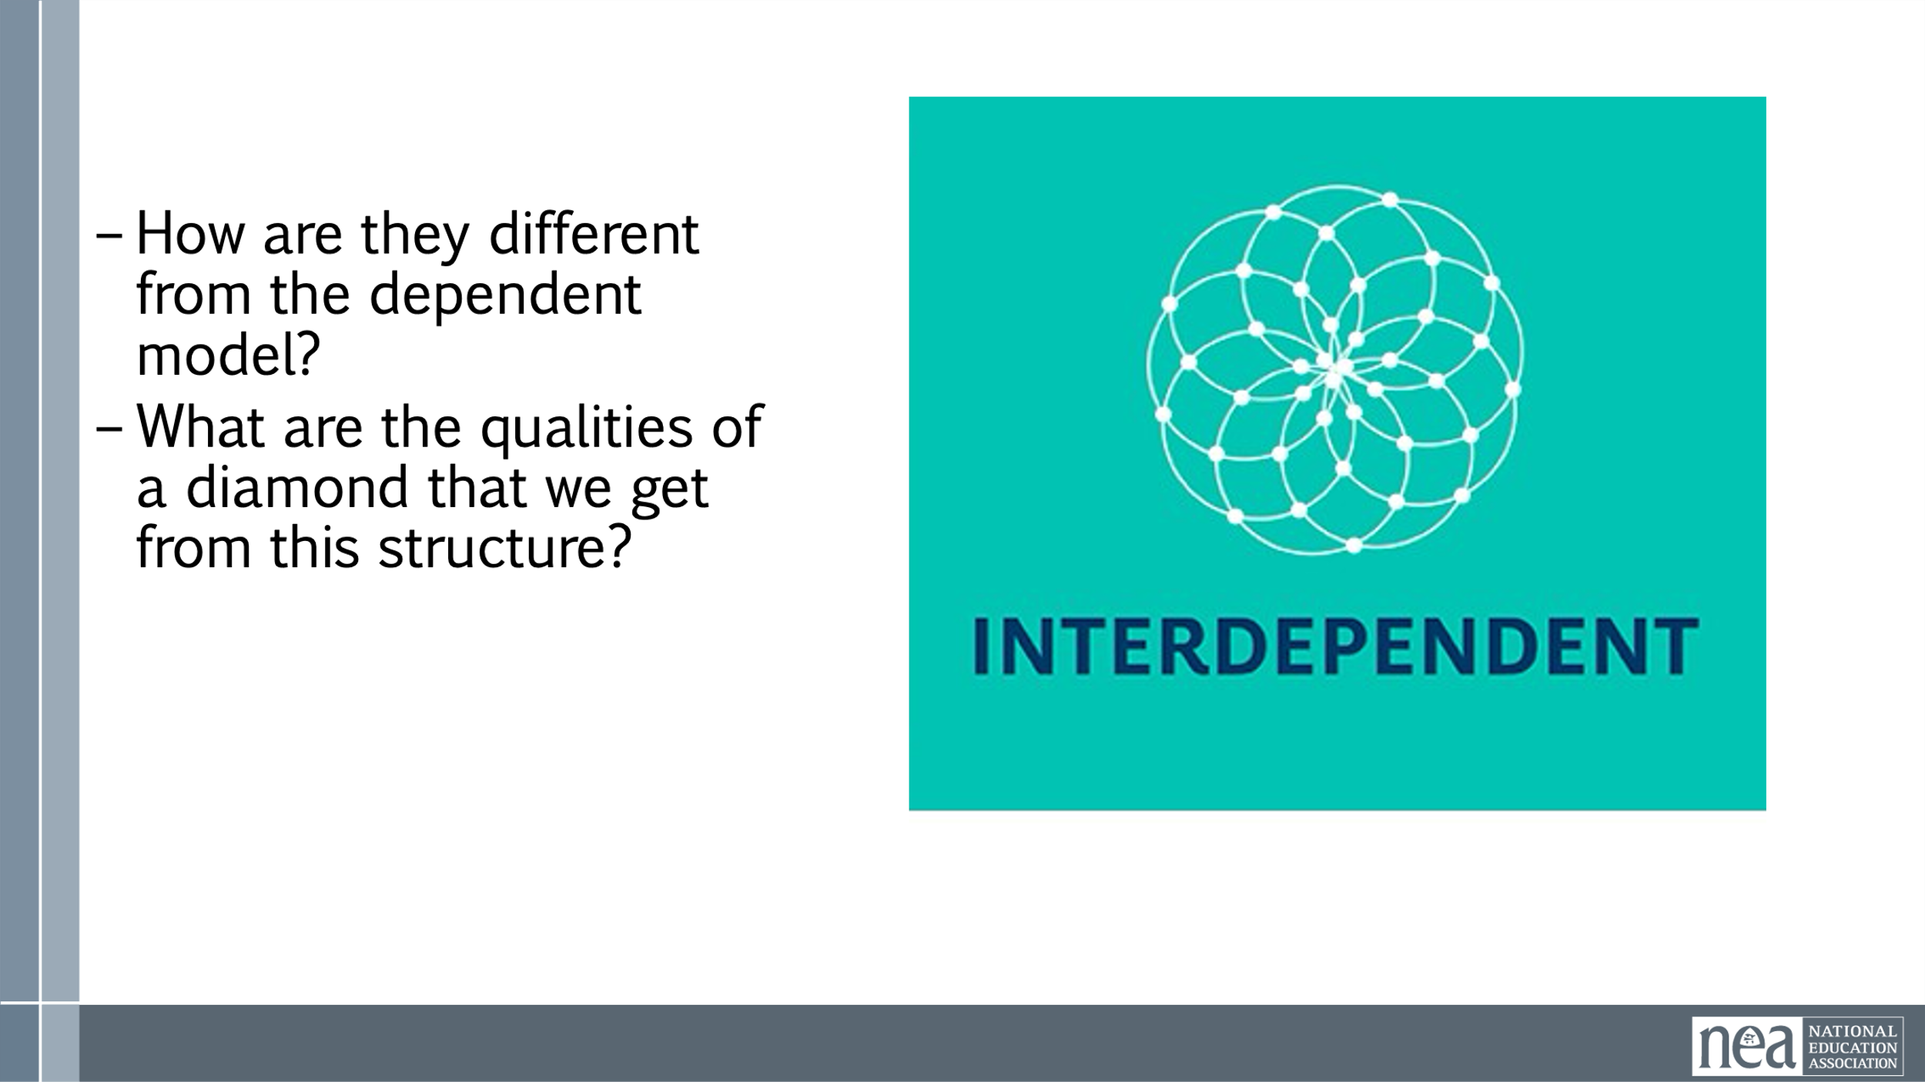  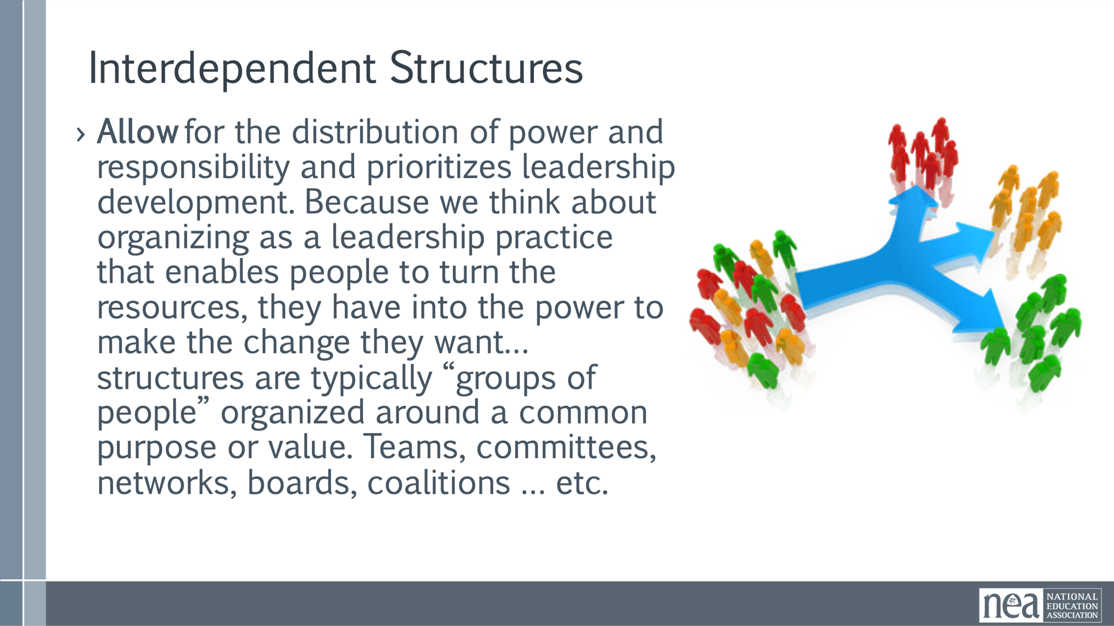  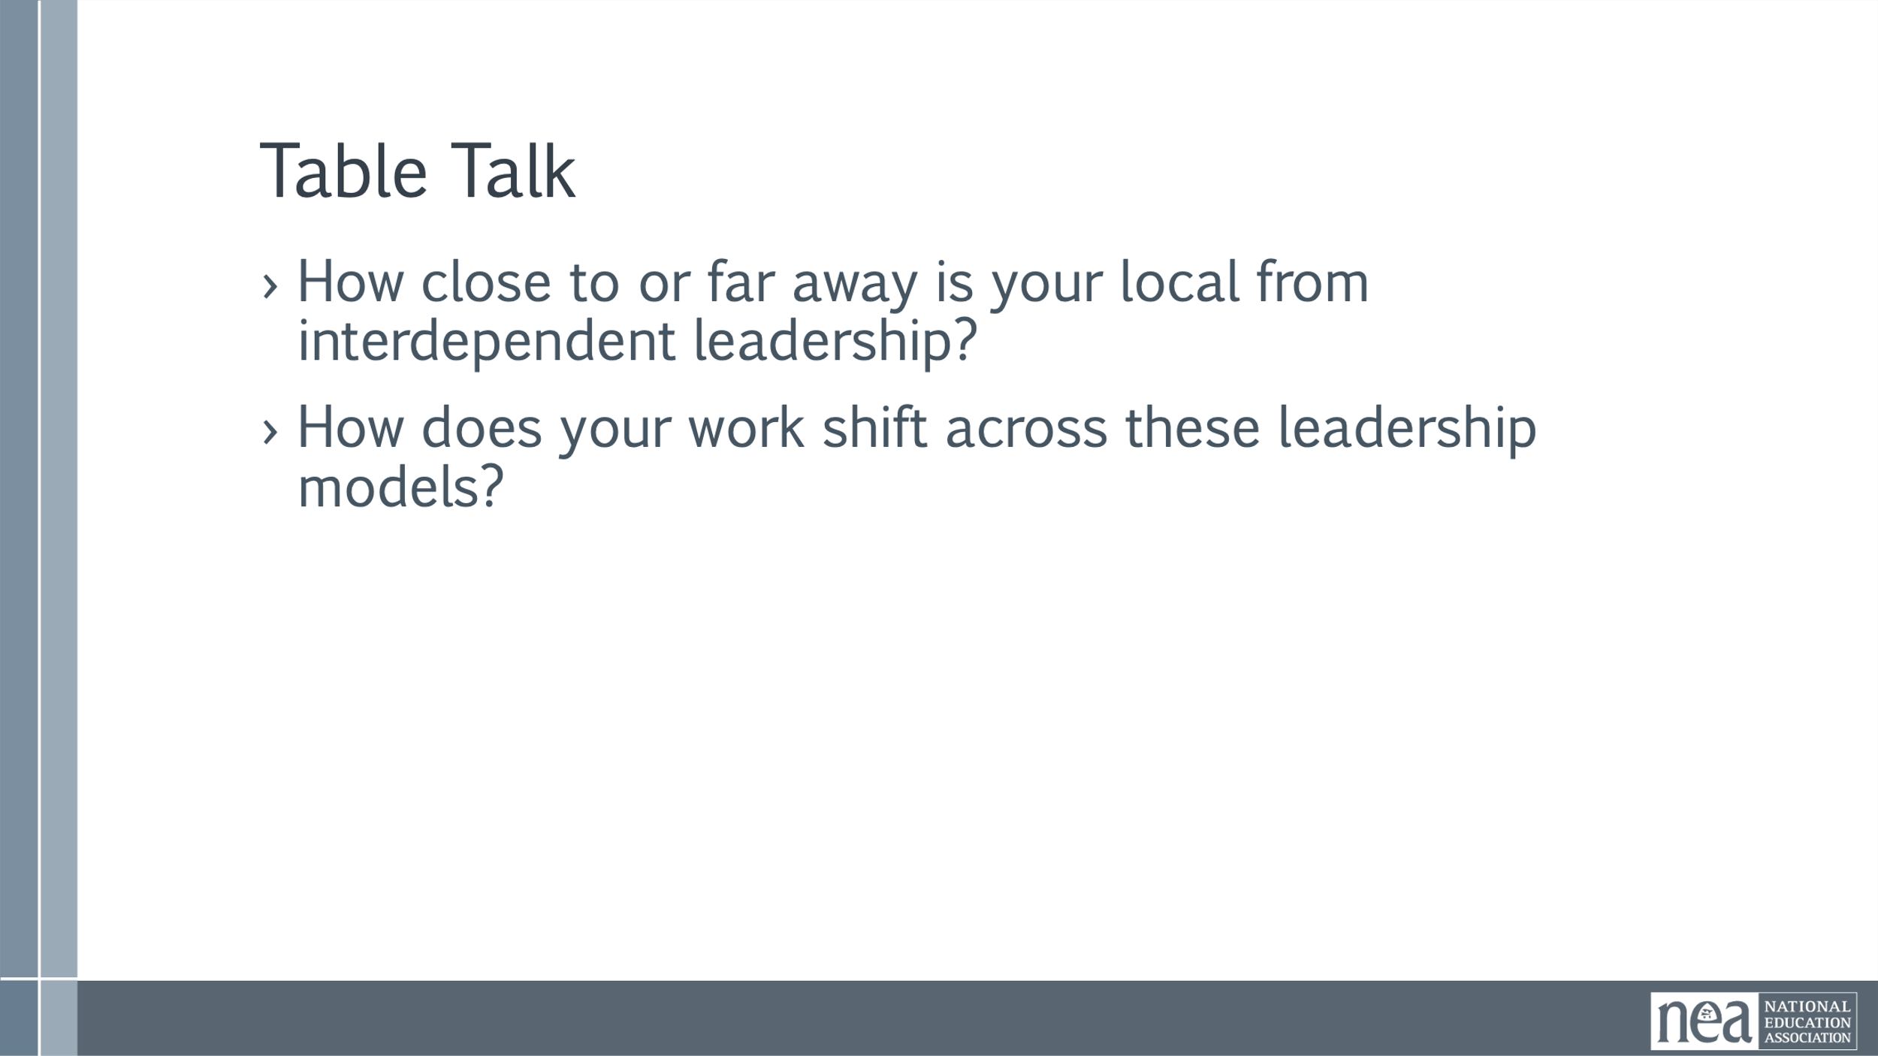  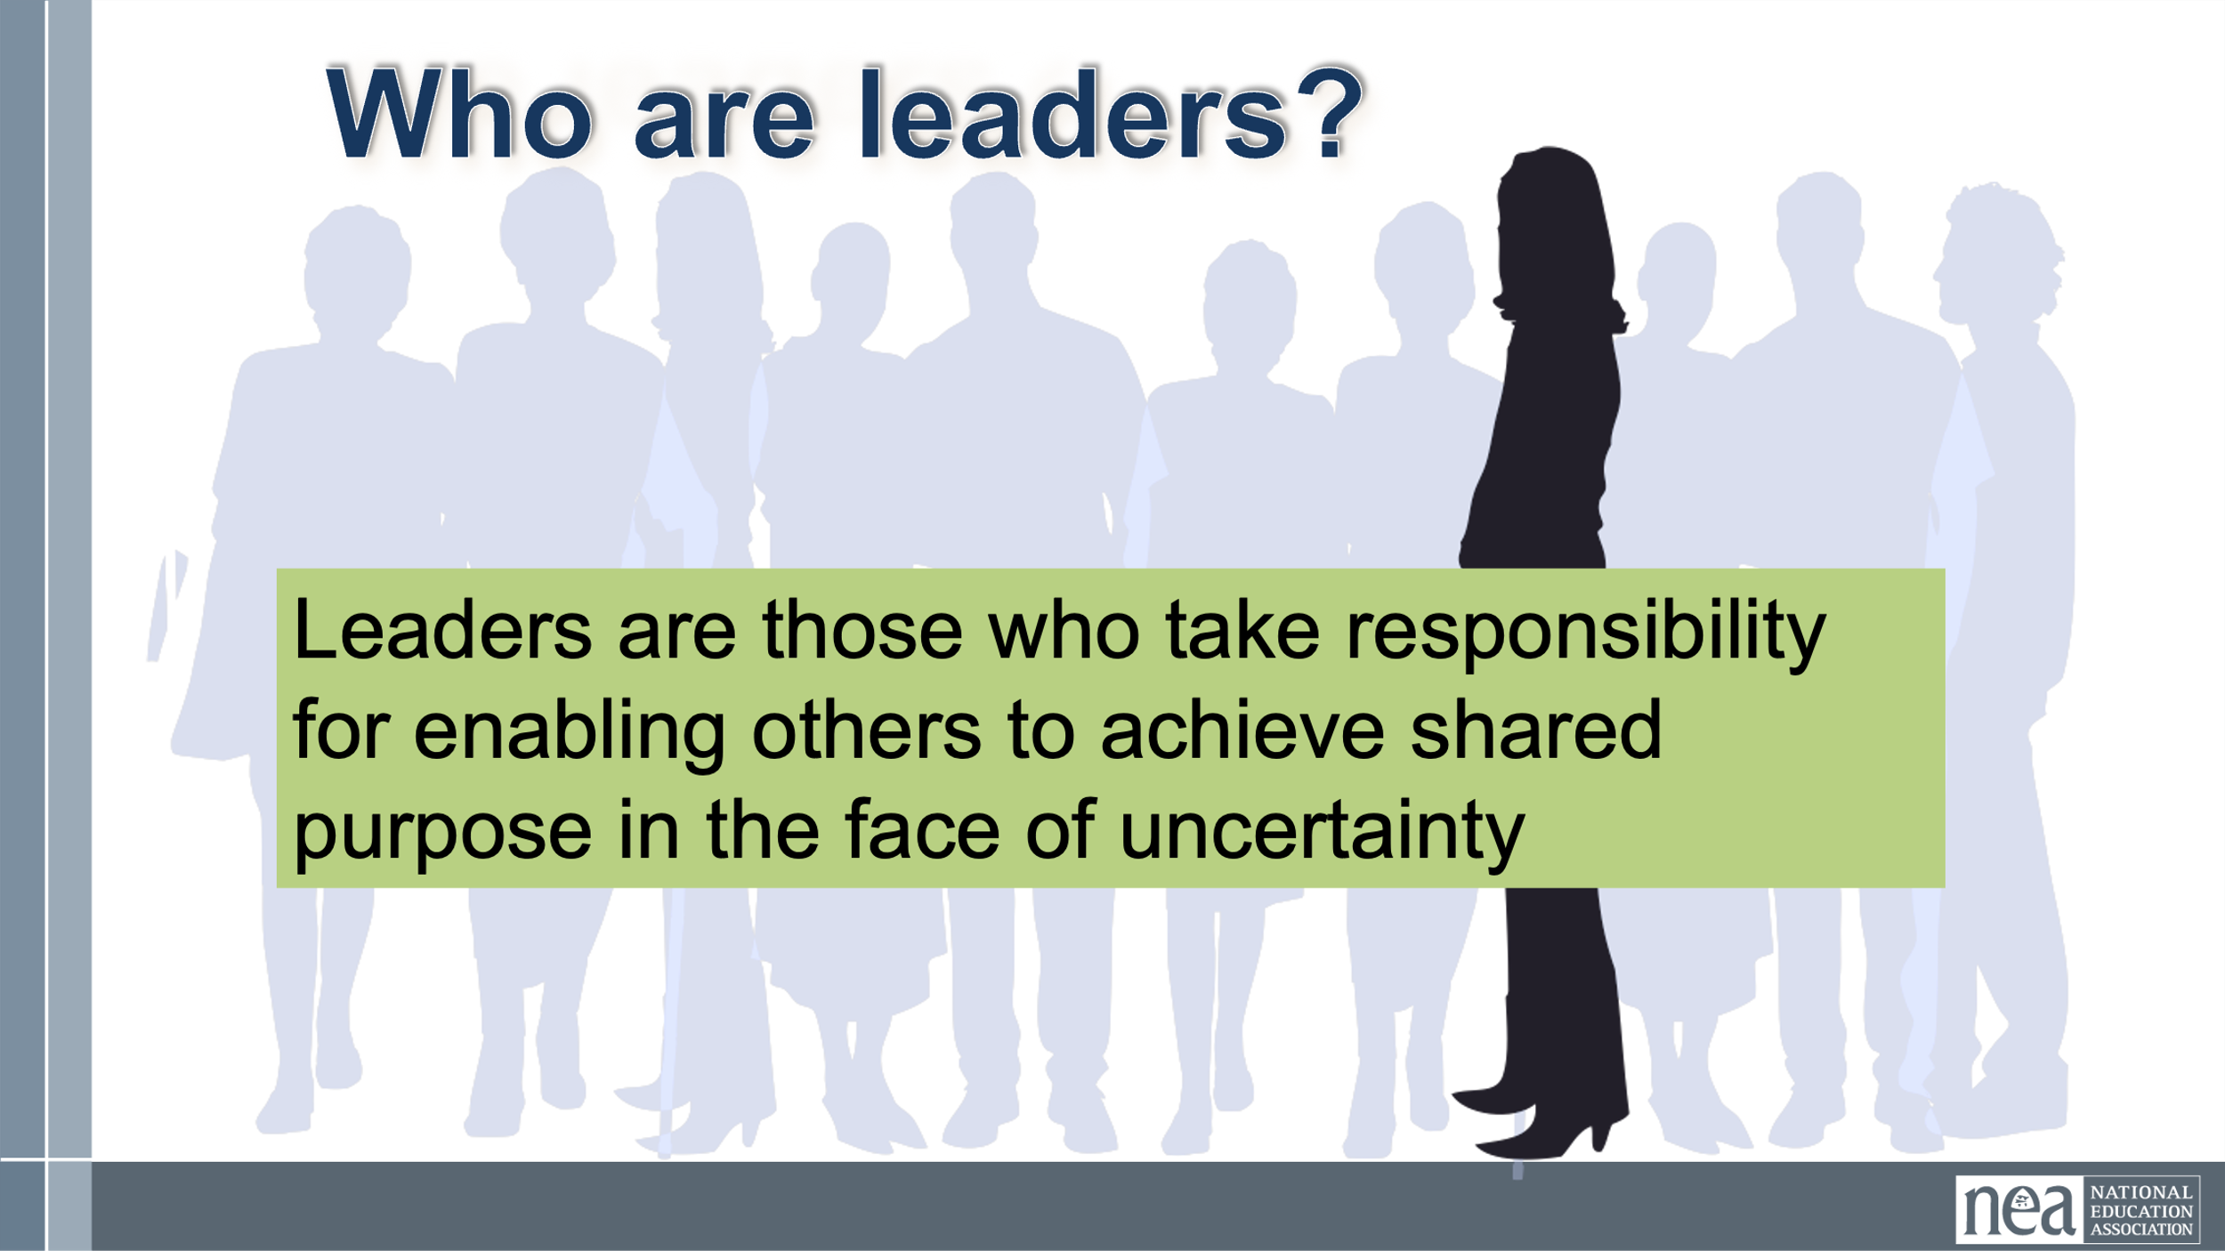  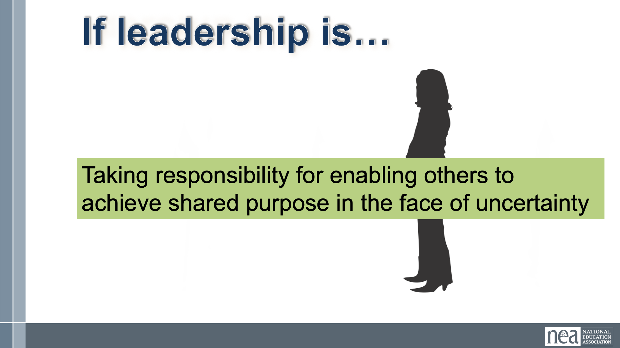  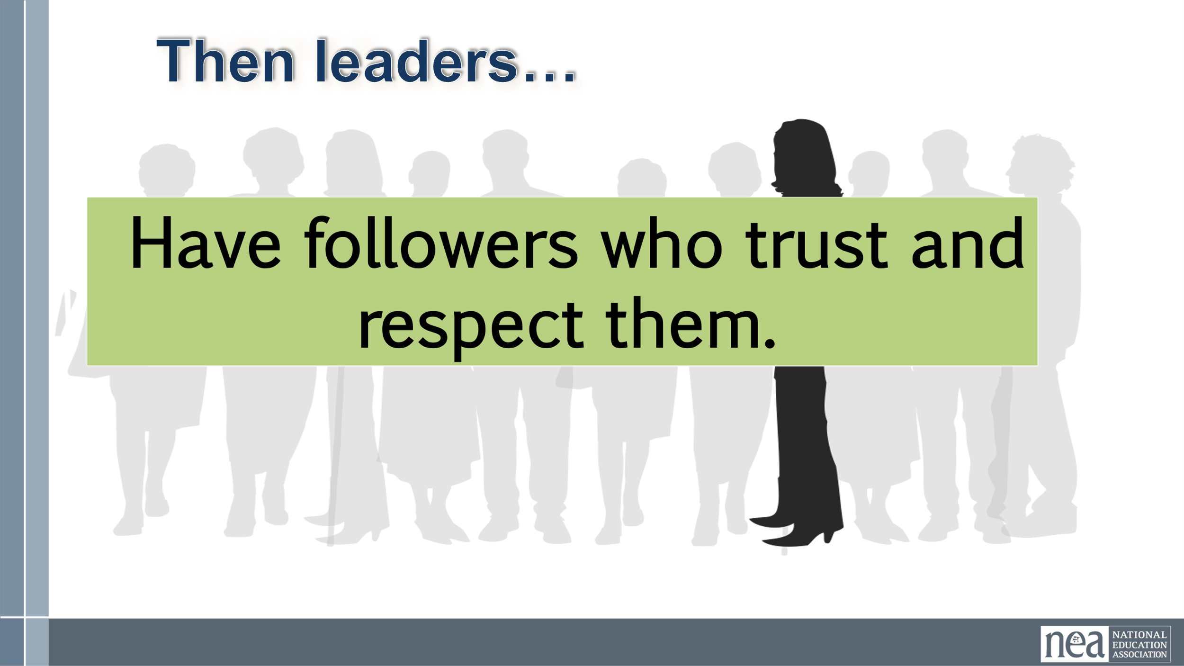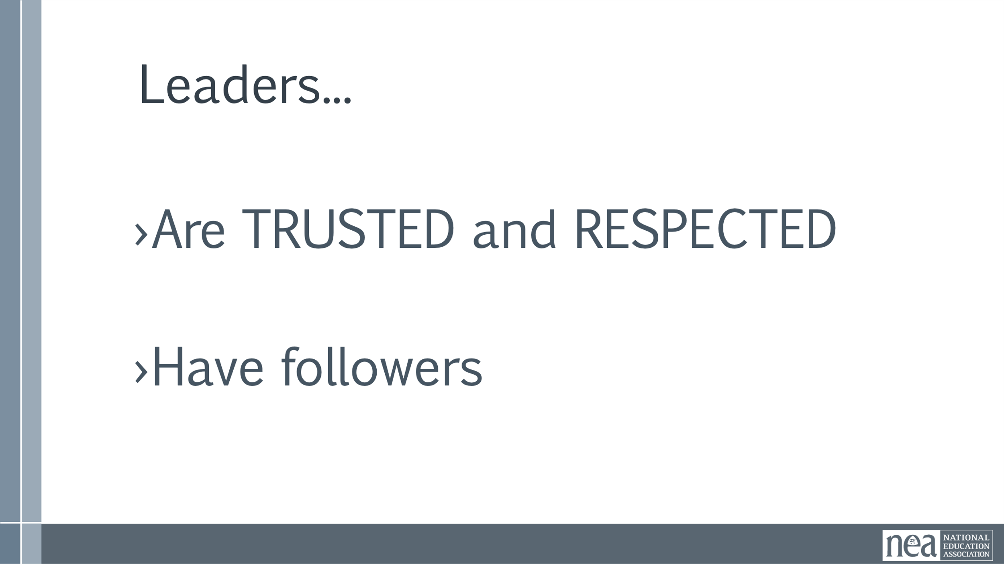  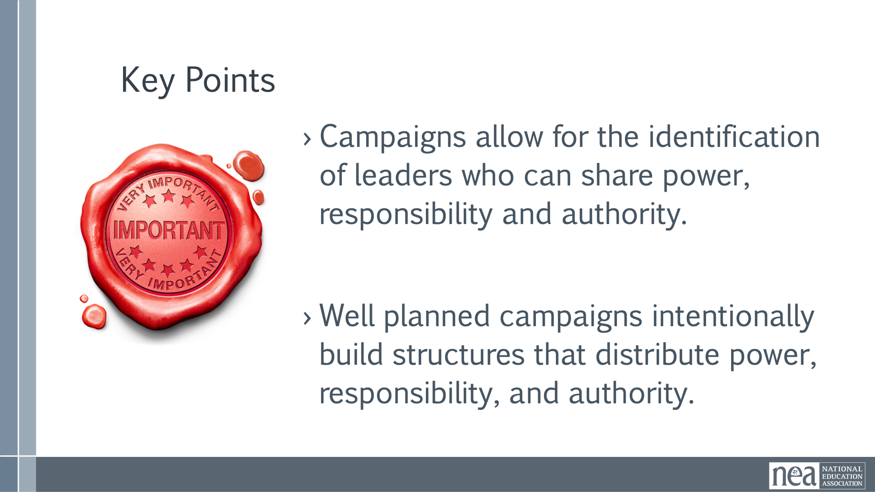 | Videos  60 Pin Bowling  (water molecule gif, no link necessary)  Cat whack-a-mole gif, weakness of the structure  Diamond structure video | 5 Min –  Begin by asking – who are leaders? (Take no more than three responses)  So, if we remember the first part of our Organizing definition: Organizers identify, recruit and develop leadership – I want to give you three structures to consider. As we move through these structures keep track of where the power is and what your job would look like in each of these structures.  In the next slide, you will see three illustrations of leadership structures.  The lines represent relationship, resources, communication, and connectivity. The circles represent people with accountability, responsibility, and knowledge. Pay attention to WHERE the connections flow and fail, and where it is critical.  5 Min  - Let’s take a look at the first model – the “I am the leader” model.  - In this slide- There are sixty pins in this structure. If there is one leader, one kingpin, where is the weight?  - Where is the power?  - Is this a powerful or sustainable model?  - Who benefits from the resources?  - What happens if the kingpin is knocked out?  3 Min  - Let’s take a look at another model – this is the “we are all leaders” model.  - In this model – where is the weight?  - Where is the power?  - Is this a powerful or sustainable model  - Who benefits from the resources?  - It wastes resources  3 Min  - Let’s take a look at our last model – this is the “Interdependent Leadership” model.  - In this model – where is the weight?  - Where is the power?  - Is this a powerful or sustainable model – Who benefits from the resources?  - Let’s look at a short video to help you remember this model – What do you notice about the bonds?  - How are they different from the dependent model?  - What are the qualities of a diamond that we get from this structure?  One of the strongest known materials  Cuts through almost anything  Diamonds form under pressure which is how most campaigns begin and grow as well  Table Talk - 3mins  - How close to or how far away are your organizations from interdependent Leadership?  - How does your work shift across these leadership models?  This model is messy and time consuming but is the best way to build and sustain power. If you find that you are struggling to get people to step up and engage, you may want to pause to look at your structure(s).  3 Min  - Who are Leaders- we could take lots of time to arrive at a common definition of what a leader is – I am asking you to consider the following:  - Leaders are those who take responsibility for enabling others to achieve purpose in the face of uncertainty.  Leadership is a practice and not a position, and facilitating leadership is a skill.  Key Points:  - Our primary job is to identify leaders who can share power, responsibility, and authority  - We support members and leaders by helping them identify structures that distribute power, responsibility and authority  - We are not the leaders – we are a resource/coach | What makes for effective leadership structures?  Participants will identify leadership structures in their locals.
11:50-12:00 | Dr. Taraja | 20 Minutes – Worksite Mapping: People in the Campaign (continues after lunch)
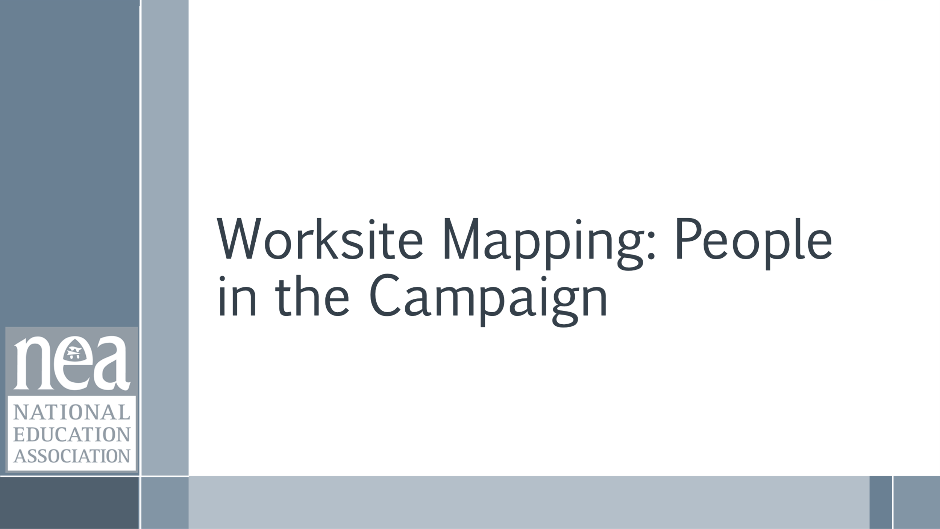 |  | 20 minutes of content and intro Definition of mapping for leaders,  Worksite mapping is a foundational tool in any organizing campaign. It allows us to visualize the workplace—who works where, when, and with whom. This helps us understand the natural structure and flow of communication. By mapping, we can identify key areas of influence, uncover organizing opportunities, and ensure we’re not missing any pockets of potential support. It’s about being strategic and intentional with our outreach.  We can answer these strategic questions that organizers ask  How do we know who our people are?  How do we know where our people are?  How do we know who they are connected to?  Mapping isn’t just about geography—it’s about leadership development. When leaders engage in mapping, they begin to see the workplace through an organizing lens. They learn who the influencers are, where relationships are strong, and where they need to build. This process helps leaders take ownership of their worksites and builds their confidence and capacity to lead organizing efforts.  Once we have a map, we can use it to guide our strategy. We can see where we have strong support and where we need to focus our efforts. It helps us plan actions, meetings, and visibility events with precision. We can also track progress—who’s been contacted, who’s signed a card, who’s attended a meeting—and adjust our tactics accordingly. It turns organizing into a measurable, strategic process.  Mapping is not a one-time task—it’s a living document. As staffing changes or shifts evolve, we need to update our maps. Leaders should use them to set goals, track progress, and coordinate with their teams. Sharing maps helps everyone stay aligned and ensures we’re moving together toward our organizing goals. The more actionable and dynamic the map, the more powerful it becomes.  These following questions are essential for evaluating the readiness and structure of your current worksites. They help identify the presence and strength of leaders, mobilizers, and activists—each playing a distinct role in the campaign. Understanding these dynamics allows for better planning, targeted outreach, and more effective organizing strategies. | Participants will understand that you need an intentional plan to map and track who your people are and where to find them.
12:00 –1:00 LUNCH
1:00 – 1:10 | Dr. Taraja | 20 Minutes – Worksite Mapping: People in the Campaign Cont.
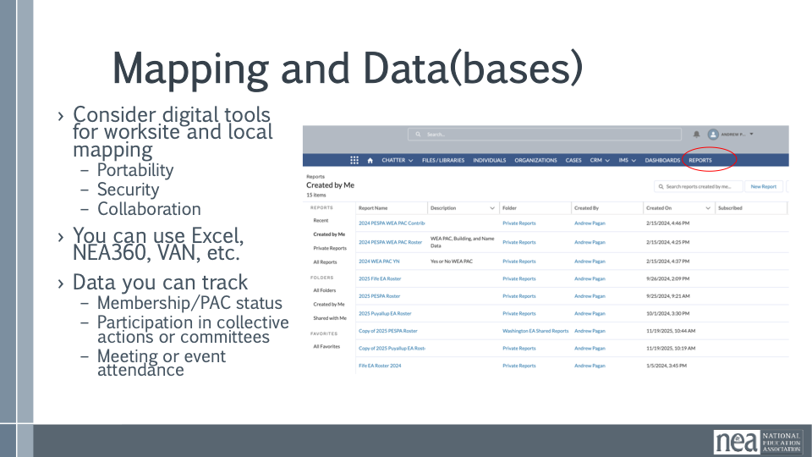  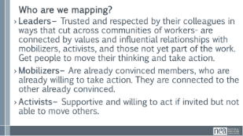  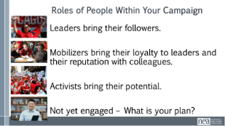  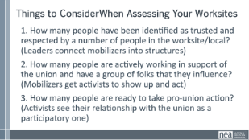  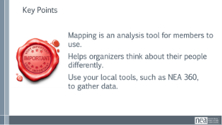 |  | 10 minutes of content and intro Definition of mapping for leaders, making a plan for identifying leaders.  How to use Data as we map: How do you currently use data to map at your worksites? What would the benefit be to track leaders electronically? What would that even look like?  Depending on what tools your state has available you may be able to look directly in NEA360 or VAN. You also might have your own database not listed. Some of us might even have to rely only on information in Excel documents.  If your local does not have a system, it’s a perfect time to develop that. Tracking members allows for an exponential growing database of member activities. It allows us to track member engagements and find leaders that we might have overlooked otherwise. It can be as simple as seeing who reads/responds to emails, who shows up to events, or what kind of events they show up to.  Who are we mapping?  Leaders – Trusted and respected by their colleagues in ways that cut across communities of workers- are connected by values and influential relationships with mobilizers, activists, and those not yet part of the work. Get people to move their thinking and take action.  Mobilizers – Are already convinced members, who are already willing to take action. They are connected to the other already convinced.  Activists – Supportive and willing to act if invited but not able to move others.  Specific roles of people in the campaign.  Leaders bring their followers.  Mobilizers bring their loyalty to leaders and their reputation with colleagues.  Activists bring their potential.  Not yet engaged – What is your plan? - This is the group that you need as much as any other because you have to build your base.  These following questions are essential for evaluating the readiness and structure of your current worksites. They help identify the presence and strength of leaders, mobilizers, and activists—each playing a distinct role in the campaign. Understanding these dynamics allows for better planning, targeted outreach, and more effective organizing strategies.  Things to Consider When Assessing Your Current Worksites:  How many people have been identified as trusted and respected by a number of people in the worksite/ local? (Leaders connect mobilizers into structures)  How many people are actively working in support of the union and have a group of folks that they influence? (Mobilizers get activists to show up and act)  How many people are ready to take pro-union action? (Activists see their relationship with the union as a participatory one)  Key points  Mapping is an analysis tool for members to use.  Helps organizers think about their people differently.  Use your local tools, such as NEA 360, to gather data. | Participants will understand that you need an intentional plan to map and track who your people are and where to find them.
1:10 – 1:40 | Dr. Taraja | 30 Minutes – Leaders: Where do you find them?- Team Work Time
 | Bring their Lists  Maybe we also use the Base Building Plan here  2.4 Base Building Plan.pdf | 30 Minutes Team Work time  Reiterate- How do you Map your organization to find your leaders?  What tools, resources, supports do you need? What do you have access to at this moment?  Name, Role, Location, Work Schedule, Etc  What roles do you need them to play in a particular campaign?  A list of what you don’t yet have  5 minutes Report out  Key Points  Title does not indicate a leader.  Leadership characteristics (think True Colors do not make natural leaders.  Our primary job is to identify leaders who can build shared power, responsibility, and authority.  We grow our campaign’s resources for action by intentionally and continually increasing the base of people.  Our people are our greatest resource | Participants will do a deeper dive into defining leaders and use their lists to identify leaders.
1:40–2:00 | Amanda | 20 Minutes - Building Power
 |  | 2 Minutes Intro and Review –  Remember we said that power is built through campaigns and not programs. Why? (ask for responses)  Main point if not mentioned:  Campaigns get people involved in changing their own conditions by challenging power through collective action.  The Campaign Lab is an intentionally created and networked leadership structure focused on building and using power within and across issue campaigns.  5 Minutes Content -  Organizing is about Building Power. We say the word, we know we need it, let’s get intentional then about what we mean in the Campaign Lab.  Definition of power  - Power is the ability to create, control, and prevent change.  - Power is made up of organized people and organized resources (which is why we need organized structures)  - Power is not static, it is either growing or waning.  Understanding Power  Power is neutral. Power is simply the ability to make change. Society has biased our beliefs and feelings about who should have and how they should use power – but ultimately power is neutral – we bring all our feels and biases to that.  Our values affect the way we use power. If we are in relationship with people with a certain set of values we would find it easier to risk our resources and personal agency to advance an agenda based on our shared values. Power of the people is always grounded in our values and relationships.  Truths About Building Power  - Power has to be consistently built or it is waning  - Not everyone wants us to have power and will actively work to take our power away  - Public actions through shared vision, shared purpose, shared resources, shared risk, and unity is how we build power  - The bigger the win – the more power you need  - Building power requires leadership  7 Minutes – Return to Your Charts (Dreams and Villains)  What kind of power will you need to Achieve the Dreams you want?  Think in terms of structures and leaders  3 Minutes –  What is something that you think the room needs to hear about your group’s discussion?  3 Minutes - Key Points  - Intentional campaigns, not programs, build power.  - The power to win is only built through people with a shared vision, making public commitments to act, to risk their collective resources, for the big meaningful changes they want.  - The kind of power we needs depends a distributed and interdependent leadership structure. | Participants will understand that the only way that we build power is actually through the theory of organizing.
2:00 – 3:15 | Beth / Hedy | 75 Minutes – Self Assessment (include break)
 | Self-Assessment of Local Strength and Growth Framework | 5 Minutes – We are going to do some assessment of how your local is operating currently. You want to win the dreams you identified at the top of today. You will be using page 6 of the Participant Handouts  That is going to require a certain amount of power – we call that strength, the ability to win. Using that strength and achieving wins in ways that are visible helps us with another factor in building power – and that is growth – the focus on membership, leaders, structure, and partners.  A local union should perform a self-assessment of its effectiveness to improve its performance, increase member engagement, and adapt to changing conditions in order to better protect and advance workers' rights. This proactive evaluation can identify strengths and weaknesses, highlight areas for growth, and ensure the union remains relevant and powerful.  There are four steps to the iterative self assessment cycle.  - Assess your current status  - Prioritize what you can take on and make some decisions about what can wait for later  - Plan what actions you can do that will grow your local and build strength. Thinking strategically about how to do both at the same time is the best practice – set outcomes and timelines  - Review regularly how you are progressing toward your outcomes and make new ones  Emphasize: One of the steps we tend to fail/skip/ignore in this cycle is the assessment. Especially when we win. We get very excited about victory and success, and we do not take the time to talk about why. What structures were in place that made this happen, and how do we sustain them into the future so we can build upon our success.  In the Campaign Lab, we are using the Self Assessment of Local Strength and Growth Framework. This is a compilation from a number of “effectiveness tools” and input from folks like you.  Here is how you use it. First it is simply a planning tool. There are five broad categories  - Organizing and Engaged Membership  - Bargaining and Worksite Advocacy  - Communications  - Member Education  - Infrastructure  Each Category is separated into key components and then into descriptors. You select the descriptor in each row that BEST describes you local – nothing is going to be a 100% match.  You will total your ratings for each category. Low score indicates a strength and a high score indicates an area for growth.  45 Minutes Group Work (include break time self monitored)  Within this time – take a 15min break  10 Minutes Report Out  - What did you notice?  - Are these “internal” issues?  - How could “external” campaigns help address your internal issues?  Rhetorical question to put in the room: If there was a crisis, how prepared is your local?  15 min – Think about that as you consider these 5 questions:  1. Has your local set goals for membership growth and participation? If yes, what are they?  2. What do you think are your organization’s main strengths that will allow you to build a strong union and effective campaign?  3. Overall, which of the areas above do you think are the largest challenges for your local?  4. In the areas that you’ve identified as your biggest challenges, what are the main barriers your local faces?  5. Which of the above areas do you think should be the top three priorities for your local to address?  Return to the cycle slide – remind people that even though they may feel as though they have a long way to go and are a bit deflated after completing the assessment, there is a way out. Be intentional in your work, use the process outlined in the cycle.  Key Points  - Weaker locals are fixed, are leader sparse, are not focused on winning fights, are limited in capacity beyond single issues, and do not have enough resources to achieve the wins they want. Focus is on Growth.  - Stronger locals are nimble, leader dense, have the ability to focus on a number of campaigns, are a series of interconnected structures, with the resources to achieve the wins they want. Focus is on Strength. | Participants will be able to assess where they are using the indicators in the framework and make plans for where they want to go.  Participants will use a couple of different frameworks to assess where they believe they currently are in terms of leadership and structure and their ability to build and use power.  They will then look at their campaigns in terms of internal needs and external actions.  They will develop plans that support both
BUILD IN YOUR OWN BREAK IN THE SECTION ABOVE
3:15-4:15 | Amanda | Internal vs External Campaigns
 | Internal and External Campaign Summary Guide.docx | 10 Minutes Introduction - We have identified big dreams, defined campaigns, leaders, structures, and power. Now we are going to look at how we start building power, by which we mean increasing our membership and winning stuff, through internal and external campaign cycles. But more specifically, we mean increasing our membership SO THAT we can win more. And winning more SO THAT we keep attracting new members. That is what is meant by “campaign cycles”.  Whole room discussion - What is the difference between and internal or external campaign?  Take a few responses then share the definitions:  External campaigns have a clearly defined goal that can be granted by an external target. For example, union members can build public pressure to force school board members to vote on a policy they want changed.  Internal campaigns have clearly defined goals that improve the capacity of union members to win their fights. When union members organize to increase their membership density and ensure reps are trained and active at every worksite, they are engaged in an internal campaign.  These kinds of campaigns are connected, and ideally one flows into the other. Union members increase and organize their membership so that they can win external campaigns. When workers are engaged in an external campaign, their visibility makes more workers get active and want to join their union. Internal and external campaigns are really just two halves of a campaign cycle.  A strategic campaign plan is one that is long enough to incorporate both halves in repeated cycles that grow and escalate in tandem towards achieving a common vision. This is what we mean by “multi-issue”.  So how do you put it all together? And what do you do when things go sideways?  Let’s practice. You will use your answers from the assessment you just completed for this activity.  40 minutes- Group activity. Each team gets a piece of chart paper to record their answers.  1. At the top of your chart paper, write one metric that would indicate you are achieving the goal for your campaign. Even if you are not sure on the goal yet, you can still name some outcomes you would expect from a successful campaign. For example a gain in membership, and an increase in members actively participating in actions or events. Whatever it is, you need a number and a date by which you want to achieve that number.  - Given your current rep structure, how many worksites or groups of members do you think would be able to get more than 50% of their coworkers to take a small action such as signing an online petition or wearing a sticker?  Do a quick around the room report out of numbers. Ask- show of hands- how many of you have the numbers you need to get majority worker participation already?  Those that are raising their hands now are truly ready for an external campaign.  - For the rest of us, how do we get there? Where do you even start?  - Make a list of worksites or groups (for example by job category or department) that starts with your most committed and ends with your “best worst”- groups or worksites at least have some sign of being active. At least they have a rep even if that rep isn’t always reliable.  - Organizers will often tell you that a ratio of 1:10 is realistic for reps. In other words, one rep can organize 10 people. So how many more people do you need to support your reps to organize the worksites or groups you just listed?  Do a quick around the room report out of numbers.  So now you have your internal campaign!  4. Take some time to brainstorm how you might build those teams.  Refer to the handout pg 15 - Internal and External Campaign Summary Guide.docx to help you with ideas. Put your ideas on your chart paper, and add questions you need to answer to put your plan in place. You have 10 minutes to write down your ideas.  Also- Bonus Hint! What if you replaced your email blasts with member-to-member communication chains?  Put your ideas on your chart paper, and add questions you need to answer to put your plan in place. You have 10 minutes to write down your ideas.  - Ask teams to share their ideas.  - Now, how often do things go according to plan? Rarely! What happens if you have a crisis? Now that you have worked through these questions, has your answer changed regarding prepared your local is currently to meet a crisis?  Key Points- 5 minutes  At the end of the day, union members win what they build the power to win. Building capacity through membership recruitment and engagement alongside building strong community support is far more likely to win on issues than being morally and factually right in your views. If all it took was being right to win, we would live in a very different world!  Your opposition will always have more money and lawyers, better PR, and stronger connections to elected officials than you have, so while helpful, those things will only get you so far. What you have is a majority of the people. That’s why your job is fundamentally to unite as many people as you can around a common cause. And that’s why you need internal campaigns to fuel your external campaigns.  - Internal campaigns build the power to win external campaigns.  - External campaigns engage your constituents and bring in potential members and community support.  - Internal and external organizing feed each other and are how locals build power.  - Strategic campaigns combine multiple cycles of internal and external organizing to win on multiple issues towards long term strategic goals, such as achieving your vision for public schools. | Participants will understand that issue campaigns build the power of the union and that it also requires capacity – one builds the other builds the other.  Participants will complete an assessment of their local to determine if they should focus on an internal, external, or strategic (both) campaign.  Key Points:  Internal campaigns build the power to win external campaigns. External campaigns engage your constituents and bring in potential members and community support.  Internal and external organizing feed each other and are how locals build power.  Strategic campaigns combine multiple cycles of internal and external organizing to win on multiple issues towards long term strategic goals, such as achieving your vision for public schools.
4:15-4:30 | Ellen? | 15 Minutes - Ending It Right
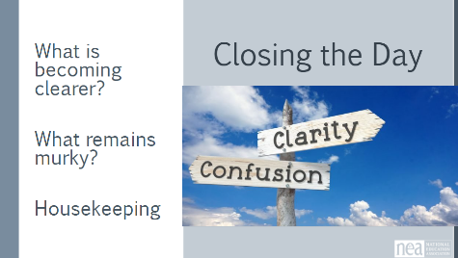 | Daily Feedback Form send out  Make handout for journal | Things to consider -  Take 10 minutes of your own time Write / journal intentional questions about today.  Move them into role-alike groups:  - What is one big idea that you know you are going to go home and do in the next 30 days.?  - Who do you wish you had invited to attend this meeting with you?  What did we do well? Where could we focus more?  Questions, Connections, Reflections  Housekeeping announcements  Plus/Delta at the Door  FOR TOMORROW – | Participants will be able to bring a little closure to their learning and provide feedback on the day.
4:30-5:00 |  | Adult Choice Networking
 |  | This is a time for participants to meet and discuss any issues they are thinking about with other members of the group. This is not led by facilitators and highly encourage to occur in any other space besides the conference room. | Participants will make useful connections with staff from other affiliates.
5:00 - ADJOURN

