Economic System
Thinking about money…
What is wealth? | What is income?
Are you in control over your income and your wealth? In other words, can you increase them?

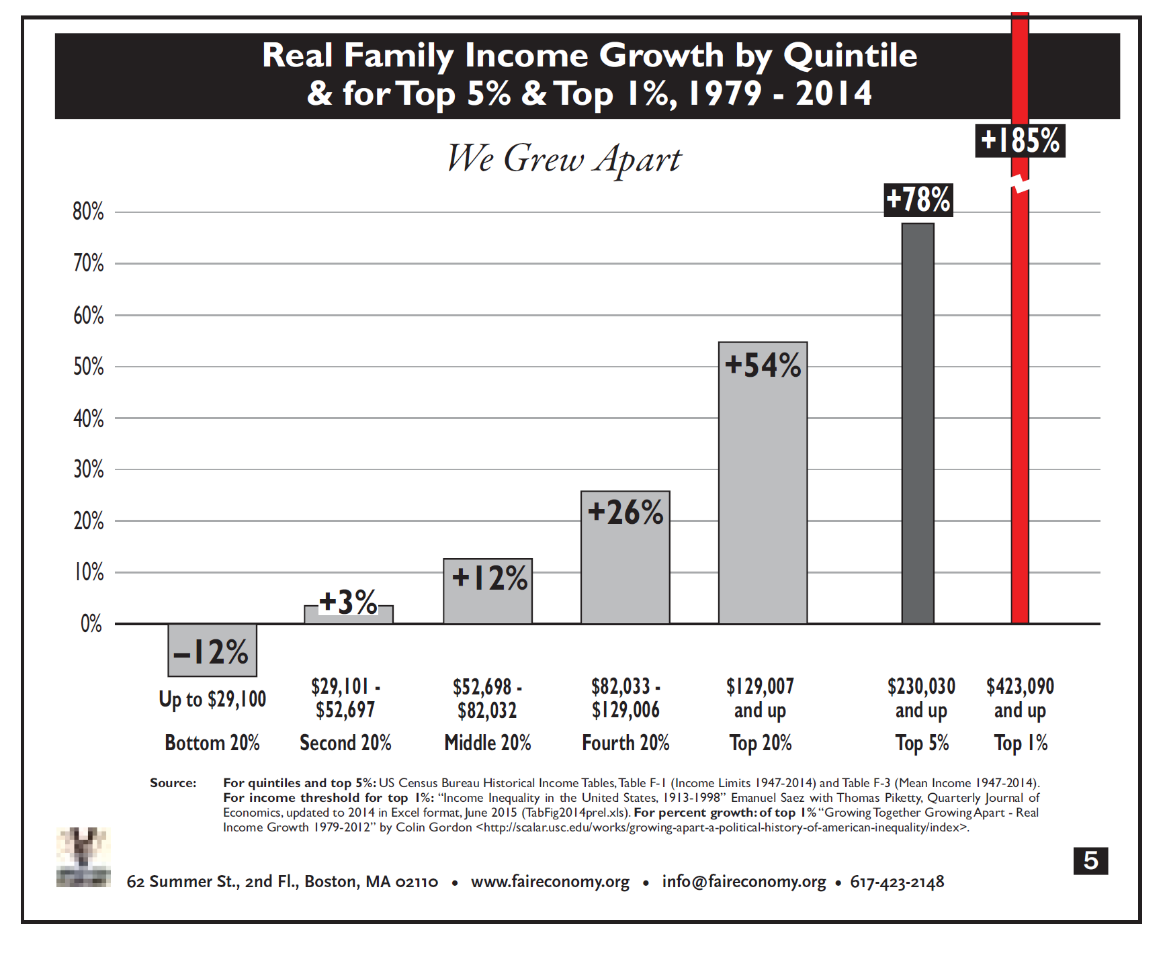
Questions for Reflection:
Which of the quintiles are my members in? What about my ESP members? Other thoughts….
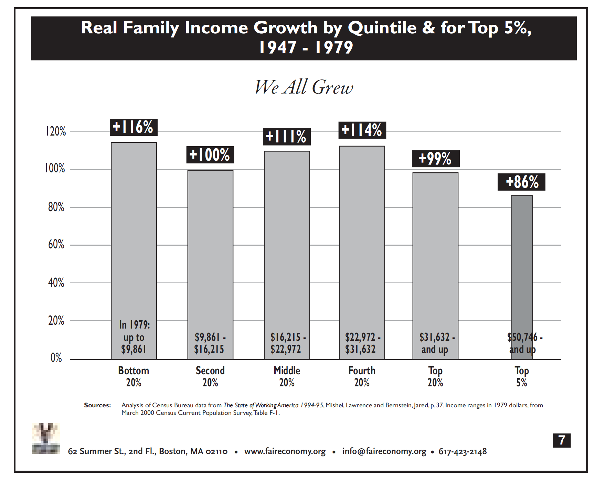

Questions for reflection:
What was the difference in politics and policies between the first time period and this one?

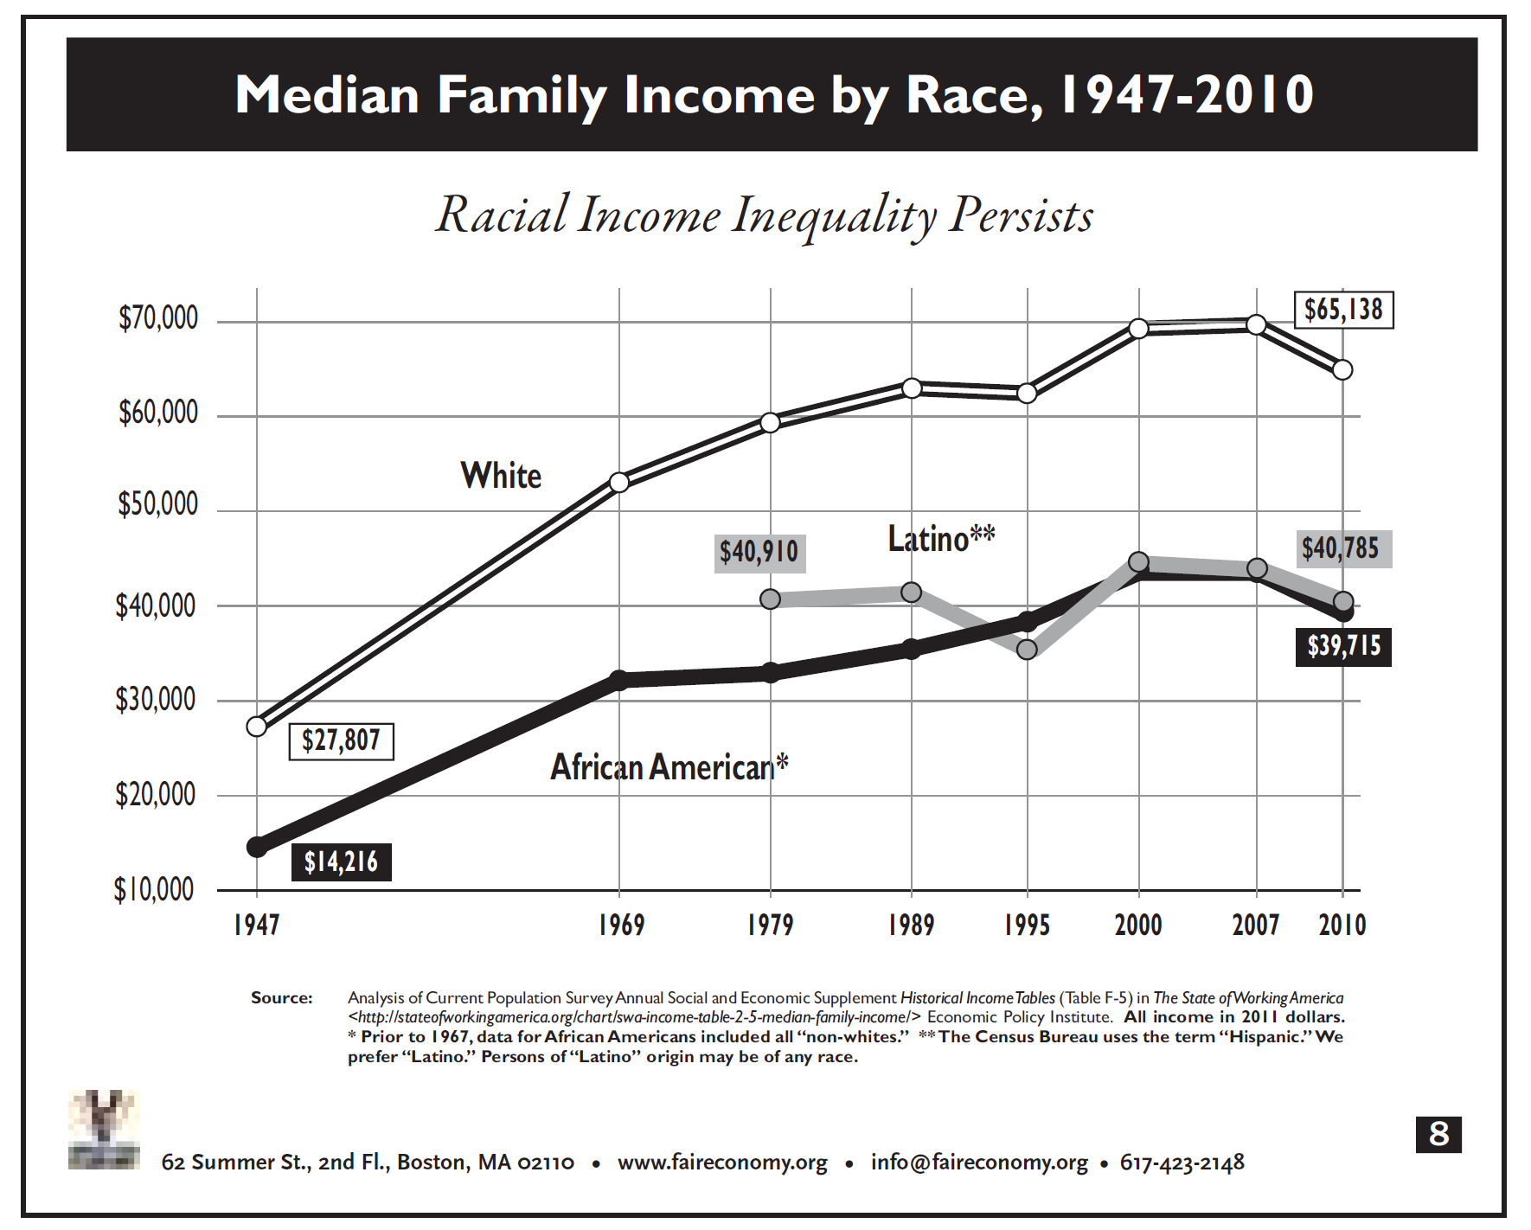

Reflections and Connections:
What are the expressions of racism apparent in the economic system?

