Facilitator Agenda: Day 2 Making a Plan to Win
General Materials Needed: |  |  |  | Room Set-up: 50 people max
1 Set of Handouts per Person  Name Tents with the Norms  Room signs, Stick on Name Tags  Chart Paper (4 to 5 full w Sticky Strip) |  | Materials Box for each table with:  Markers (Mr. Sketch variety)  Post its – 3x3” and 4X5” sizes  One ream of white photocopy paper |  | No podium, table with projector big enough for laptop  Long Rectangle table at back for facilitators  Round Tables for participants  Projector, Screen, mics, and Speakers  Carousel stations and reporting stations
Key Outcomes for the Event: Focus is on Structures for Day 2  Participants will begin to vision outcomes they want to achieve 5 years into the future  Participants will use a ladder of engagement to begin planning how to develop leaders and structures in their campaign  Participants will develop a Demand/Win for their Campaign and Identify the Target(s) that can grant it  Participants will explore the structural pillars of power their target uses to maintain control and will develop plans for pulling those pillars down  Participants will analyze their spectrum of allies and develop communication strategies for each of the spectrum portions  Participants will plan for the creation of a Dossier for their target  Participants will use a case study to identify power building structures that grow people engagement exponentially, then they will apply that to their own campaigns |  |  | End each day with a return to the community agreements. Begin each day with the community agreements, use these to ground the participants and facilitators. Consider the community agreements as a way for frame the time together consistently throughout the time together.

Overview of Content, Time, and Facilitator Assignment (Focus of Day 2 is how to build leaders –test and coach, and ID structures)
8:30-9:00 Entry and Welcome  9:00-9:30 Future Dreaming  9:30-10:10 Problems and Issues  10:10-10:25 Break  10:25-11:00 Demand and Target  11:00-12:00 Spectrum of Allies  12:00 –1:00 Lunch | Ellen |  | 1:00-1:30 Spectrum of Allies and Messages in your campaign  1:30-2:00 Dossier of Target  2:00 – 3:10 Organizer Math  2:15-2:30 Break  3:10- 4:10 Ladder of Engagement  4:10-4:30 Ending it Right  4:30 -5:00 Adult Choice Networking  5:00 Adjourn
Time Slides Facilitator | Resources | Instructions, Activity and Debrief (Facilitator Script) | Essential Questions and Outcomes
 | Charts, handouts, articles, materials, slide | What are you saying, what are they doing, what questions will you use to guide learning and make clear the important points  Include an estimate for how long each section of the learning will take | What question(s) will this learning answer? What will participants know or be able to do?
7:00 -8:30 – Team prep, practice, room set up, sound check, etc.
Entry Activity

8:30 –9:00 | Ellen | 30 Mins TOTAL Getting Started
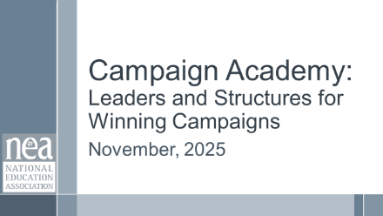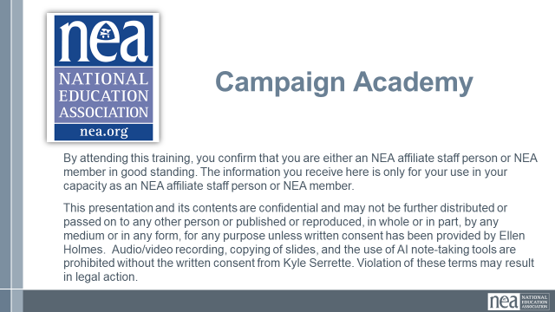  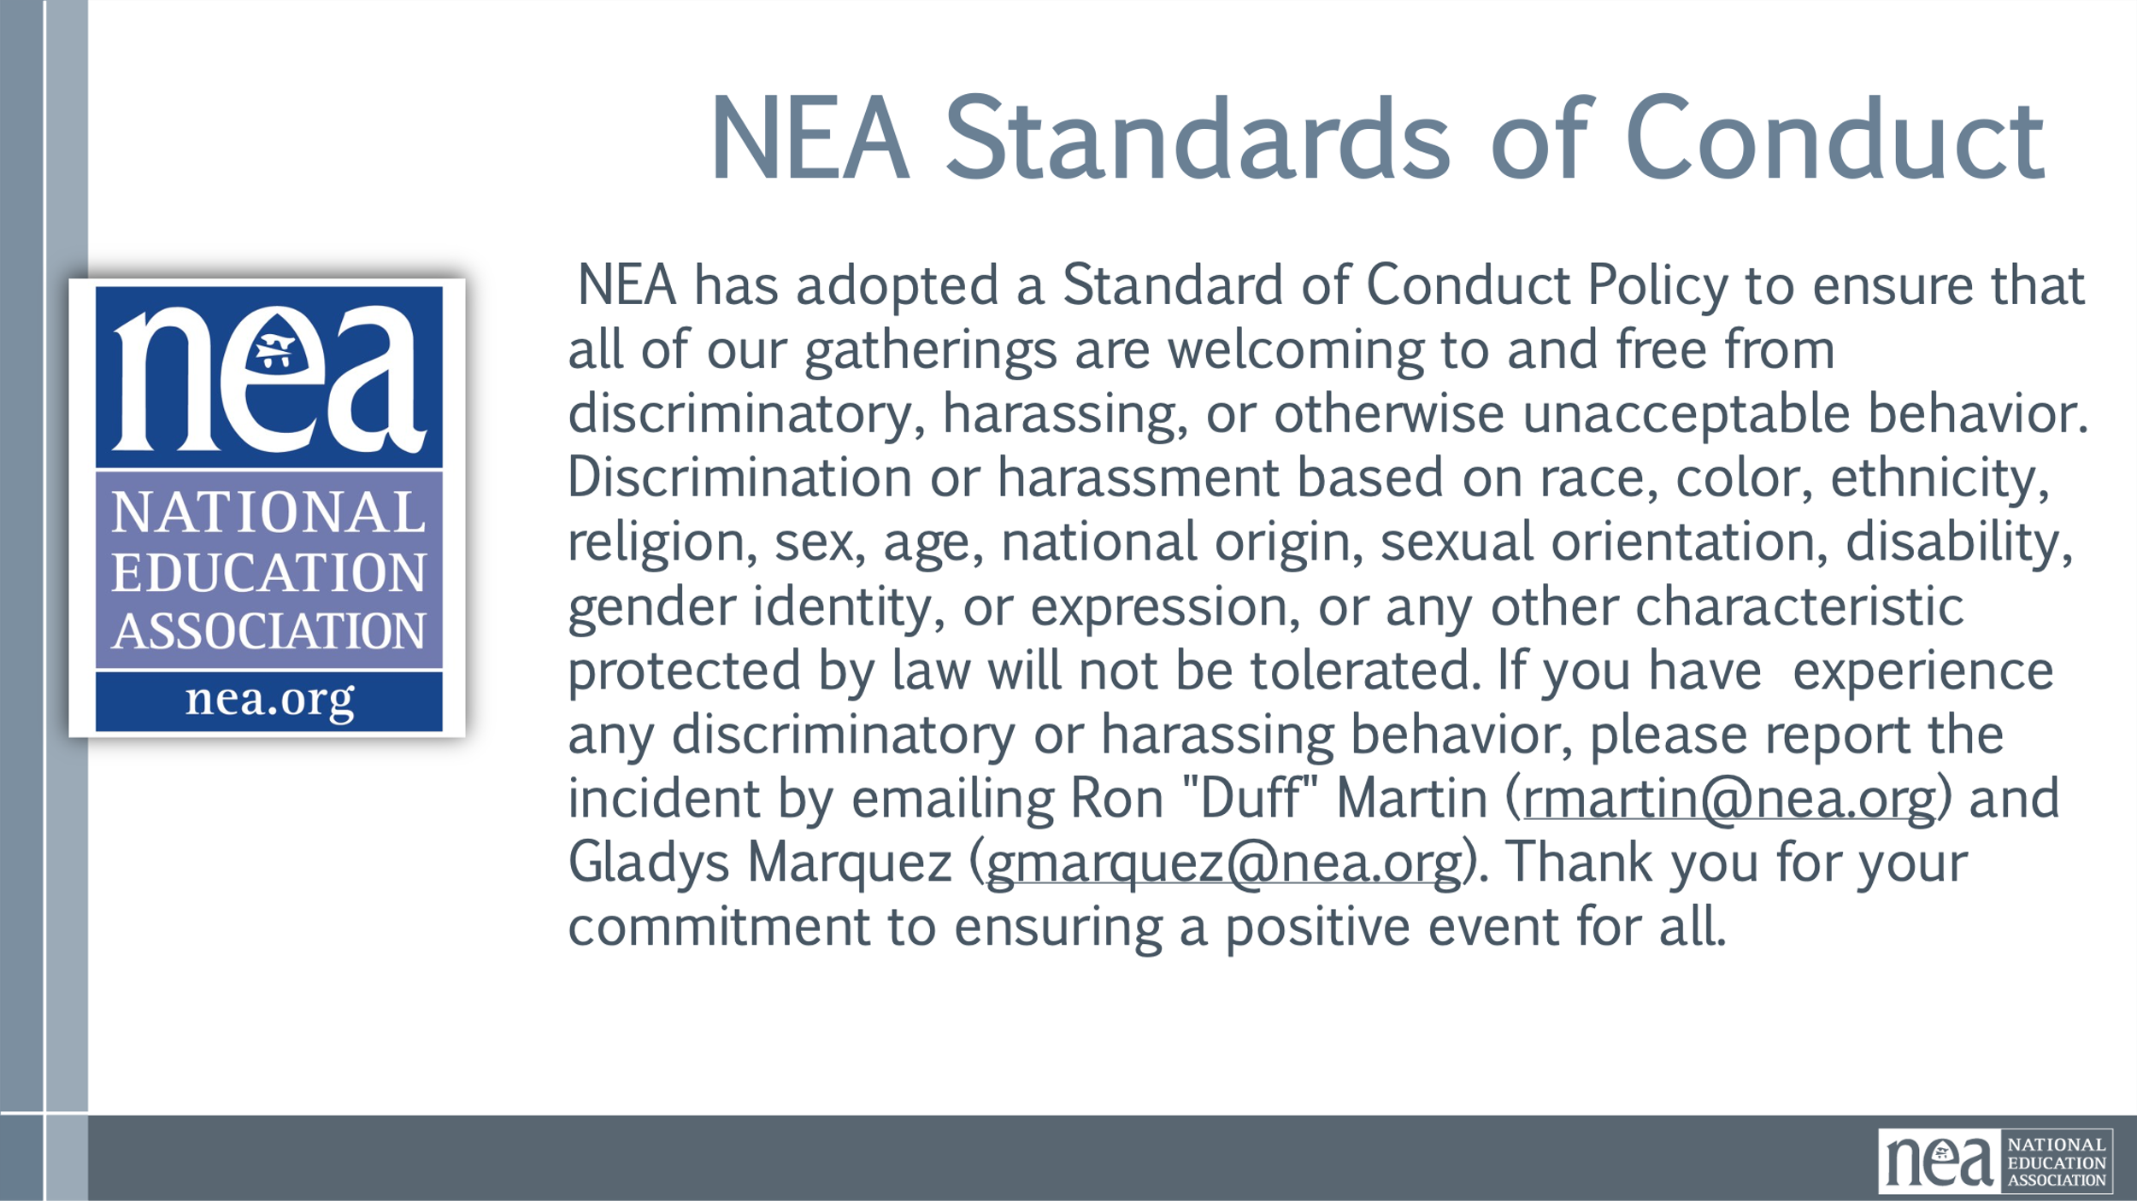  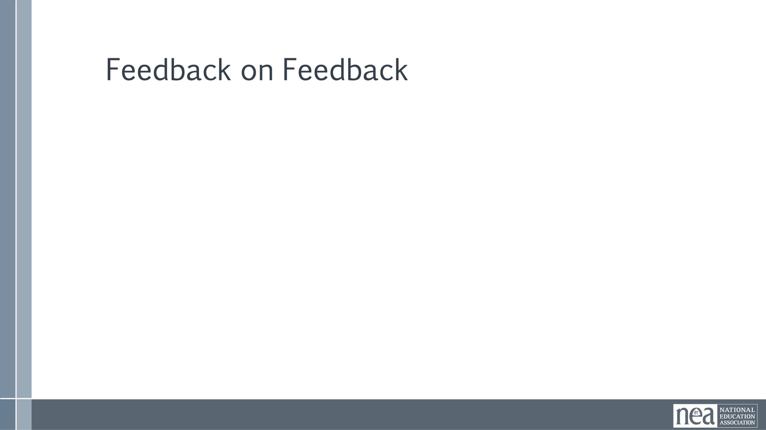  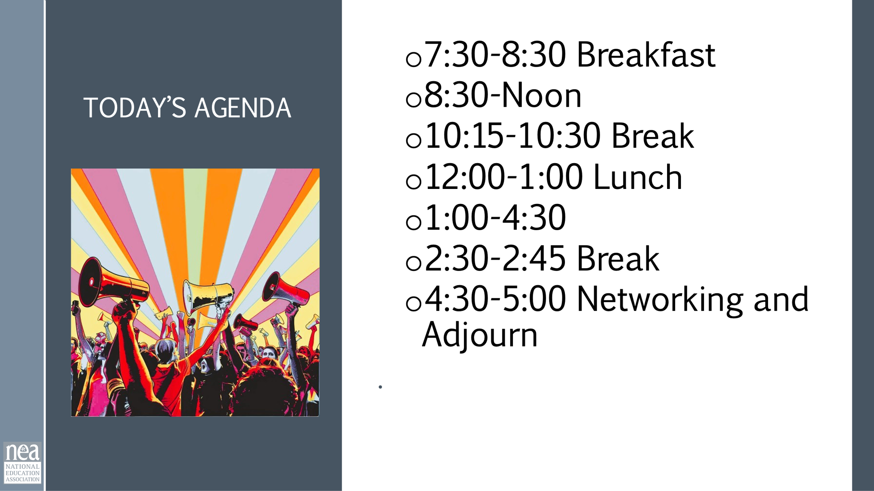  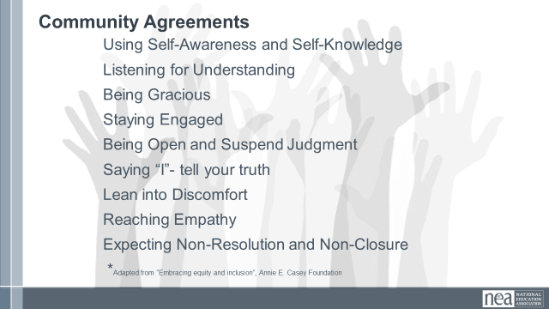  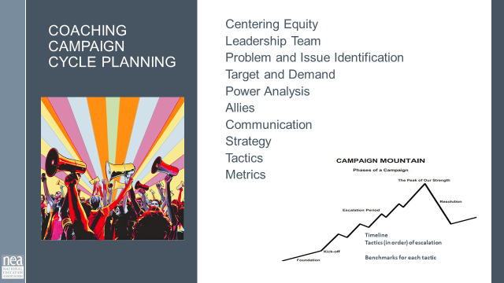  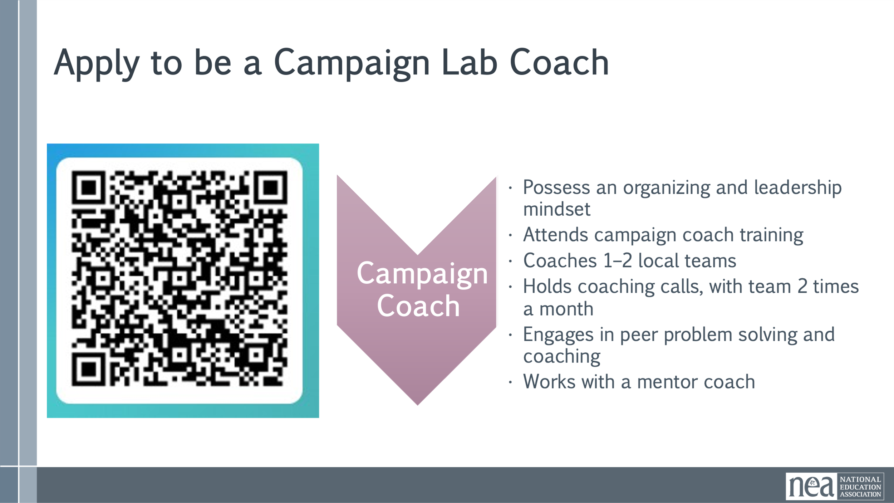  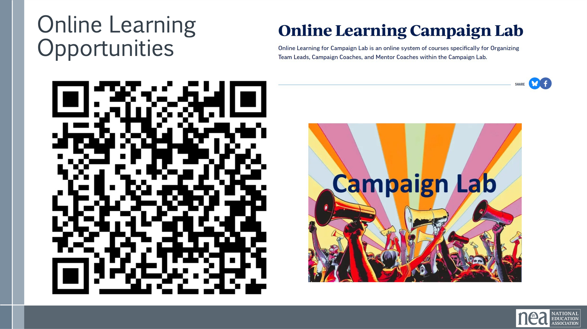  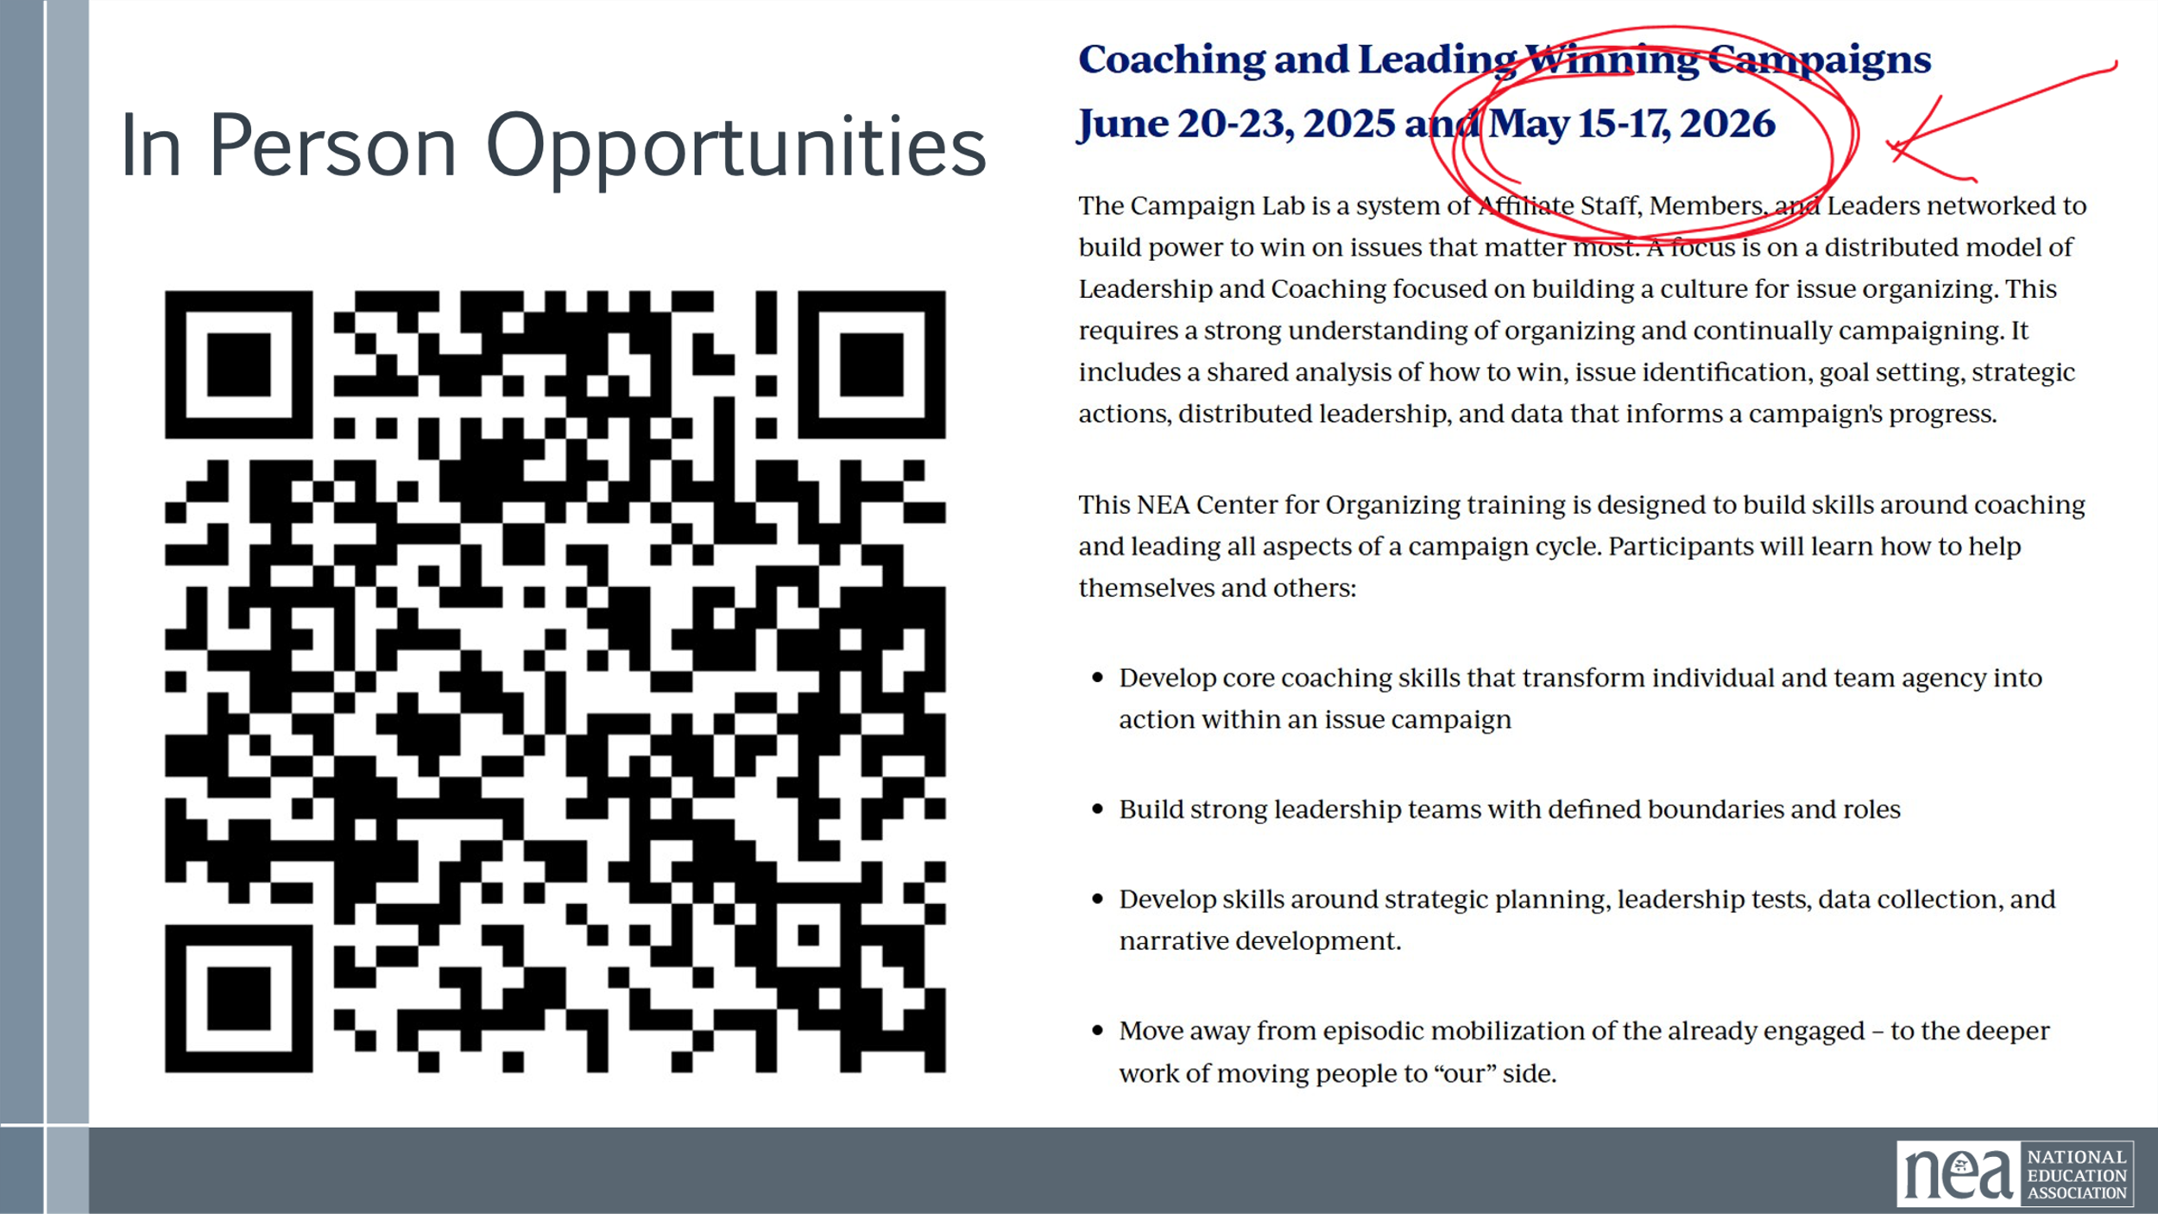  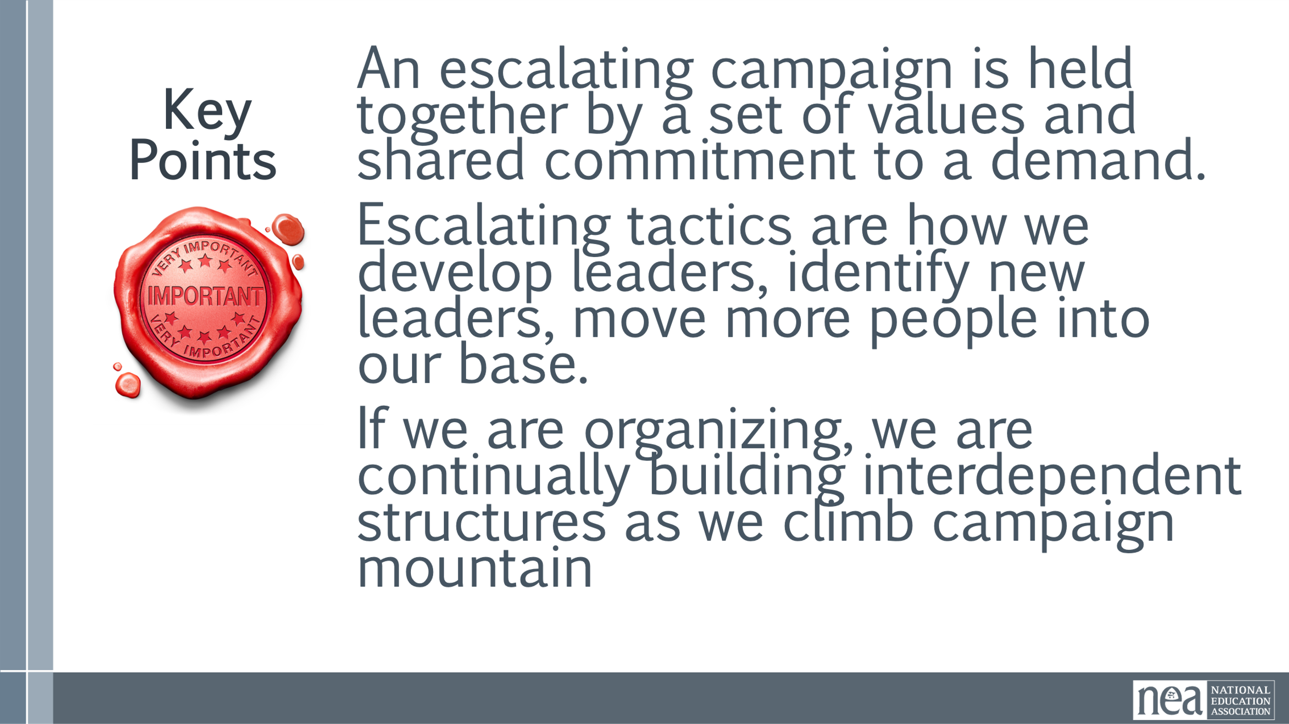 | Norms in Handouts  Agenda on Slides  Parking Lot Chart  Name Tents  Handout Package | Minutes  Review of Agenda, Agreements, housekeeping  Yesterday we said we would focus/consider more of ______ – is there something additional or different we should consider? Does where we left the conversation yesterday still land as a good focus of our time today?  Show the are you a member and the warning about materials  Share the agenda  Review the Community Agreements  How did we do? Any roses or thorns you want to lift up?  Quick overview of steps in a campaign cycle  Quick overview of campaign lab opportunities  Key Point –  An escalating campaign is held together by a set of values and shared commitment to a demand.  Escalating tactics are how we develop leaders, identify new leaders, move more people into our base.  If we are organizing, we are continually building interdependent structures as we climb campaign mountain | Participants will be re-grounded and reminded of our outcomes, agenda, and community agreements.  Participants will be introduced to a campaign cycle
9:00 – 9:30 | Melissa | 30 Minutes –– Dreaming of 2030
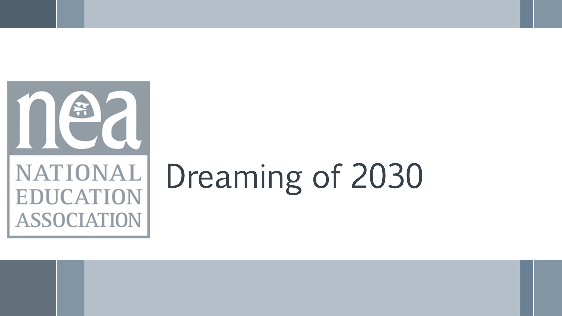  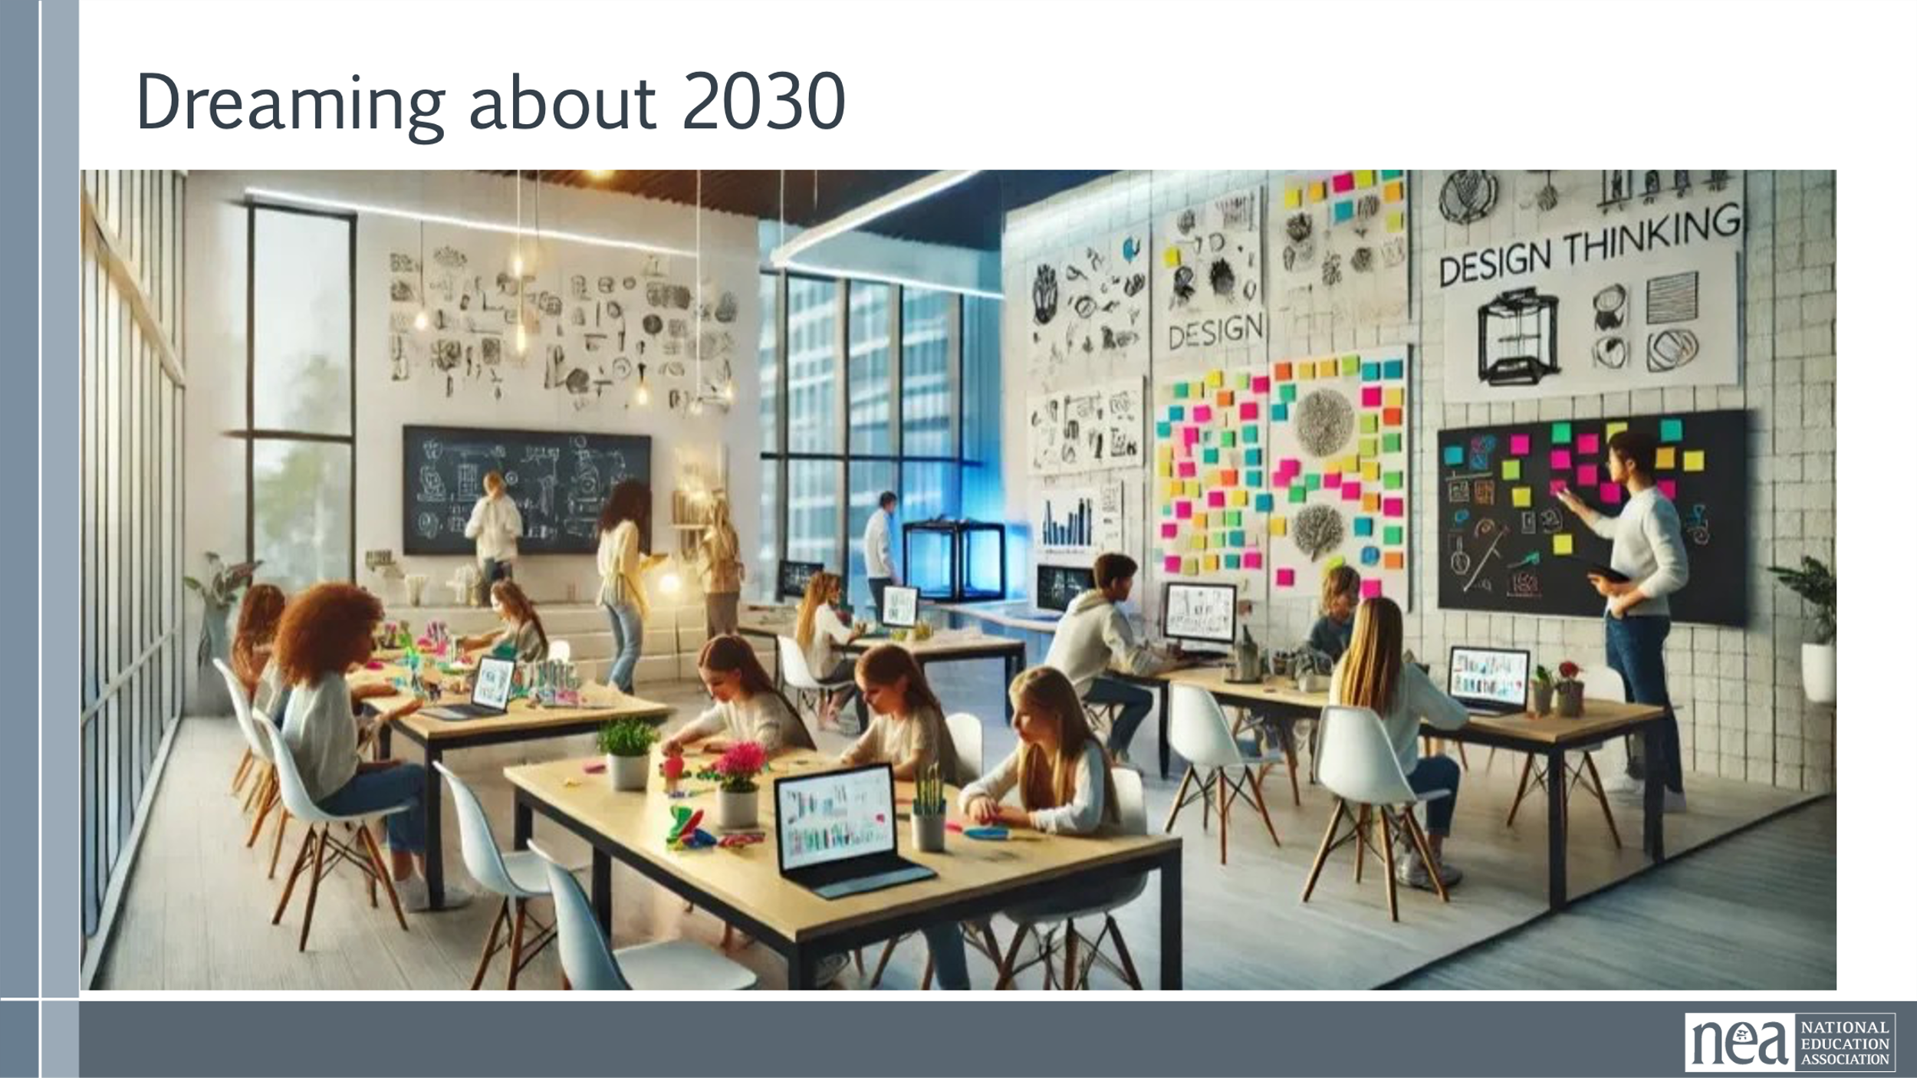  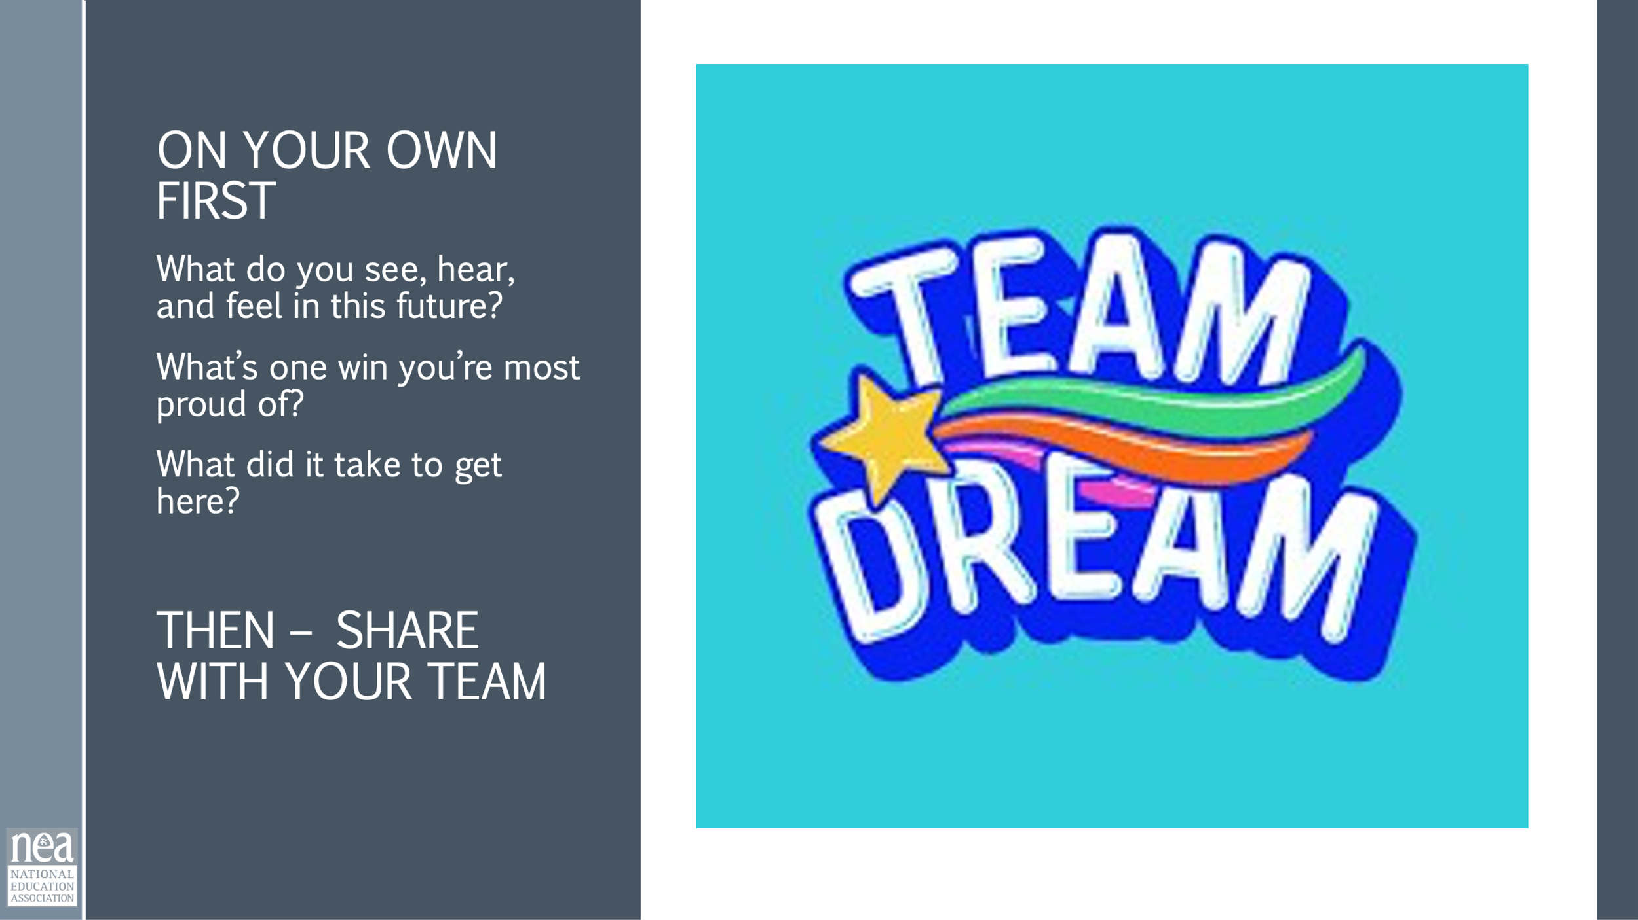  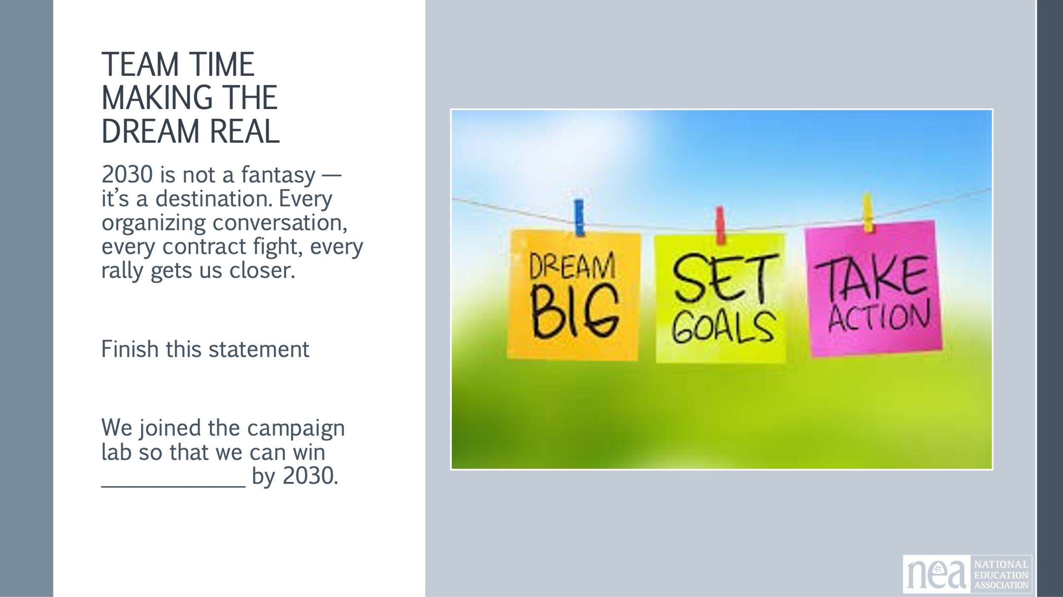  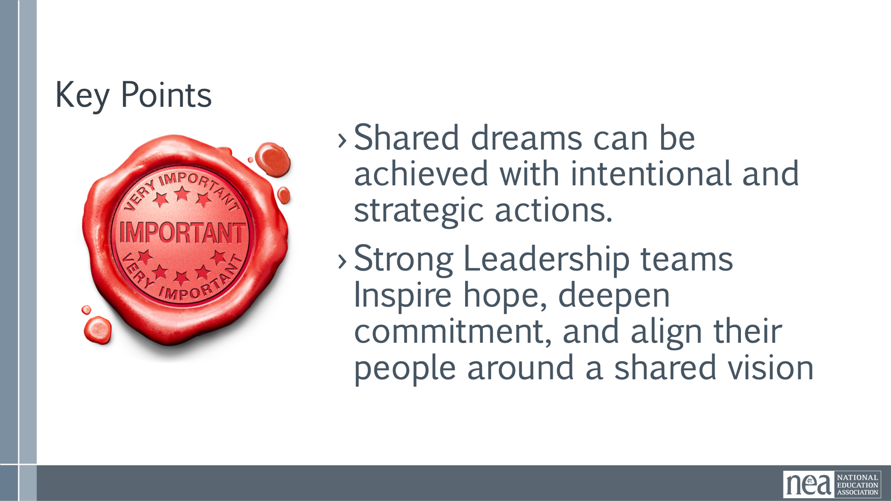 | Journal Page?  Chart Paper | 5 Minutes Introduction: Close your eyes. It’s the year 2030. Every fight you’ve waged — you’ve won. Public schools are thriving. Educators are respected. Unions are powerful. Take a deep breath and step into this future. You walk into a school building. It’s bright, clean, buzzing with energy. Teachers are smiling — not because they’re pretending, but because they’re rested, well-paid, and supported. Class sizes are small. Every student has what they need.  You pass a bulletin board: ‘Union Wins of the Decade.’ It lists victories — universal healthcare, debt-free college, climate-resilient schools, racial equity programs, and more. You enter the staff lounge. There’s laughter. A new educator shares how the union helped them navigate their first year. You feel proud. You helped build this.”  3 Minute Journal Time –  Individual consider the following and answer in your journal:  - What do you see, hear, and feel in this future?  - What’s one win you’re most proud of?  - What did it take to get here  5 Minutes of Team Talk  10 Minutes Team Time  2030 is not a fantasy — it’s a destination. Every organizing conversation, every contract fight, every rally gets us closer. Let’s carry this vision into our next steps.  Create a team chart words and visuals that answers the following– We joined the campaign lab so that we can win _____________ by 2030.  5minutes Share Out  2 Minute Key Points  - Shared dreams can be achieved with intentional and strategic actions.  - Strong Leadership teams Inspire hope, deepen commitment, and align their people around a shared vision | To help organizers imagine a future where every major labor win has been achieved — and use that vision to inspire present-day action.
9:30-10:10 | Hedy | 40 Minutes TOTAL – Problem and Issue
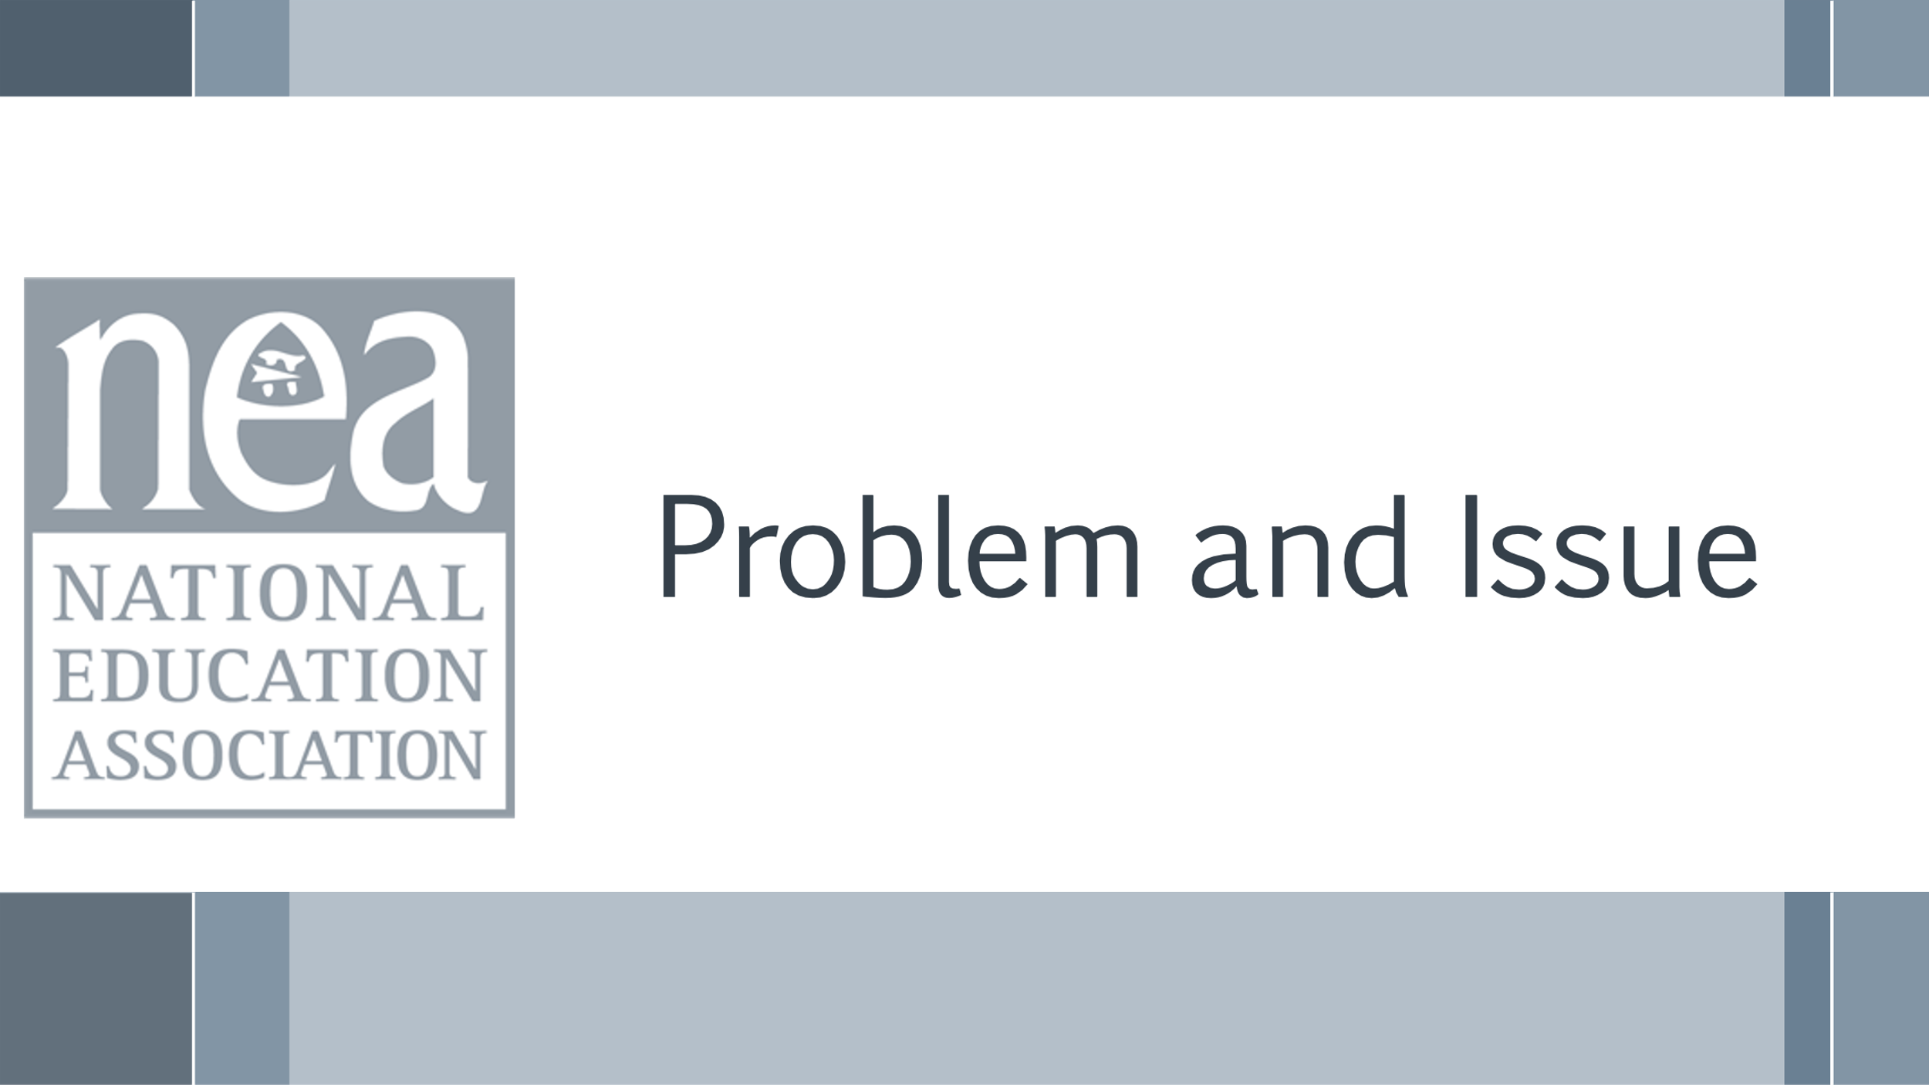  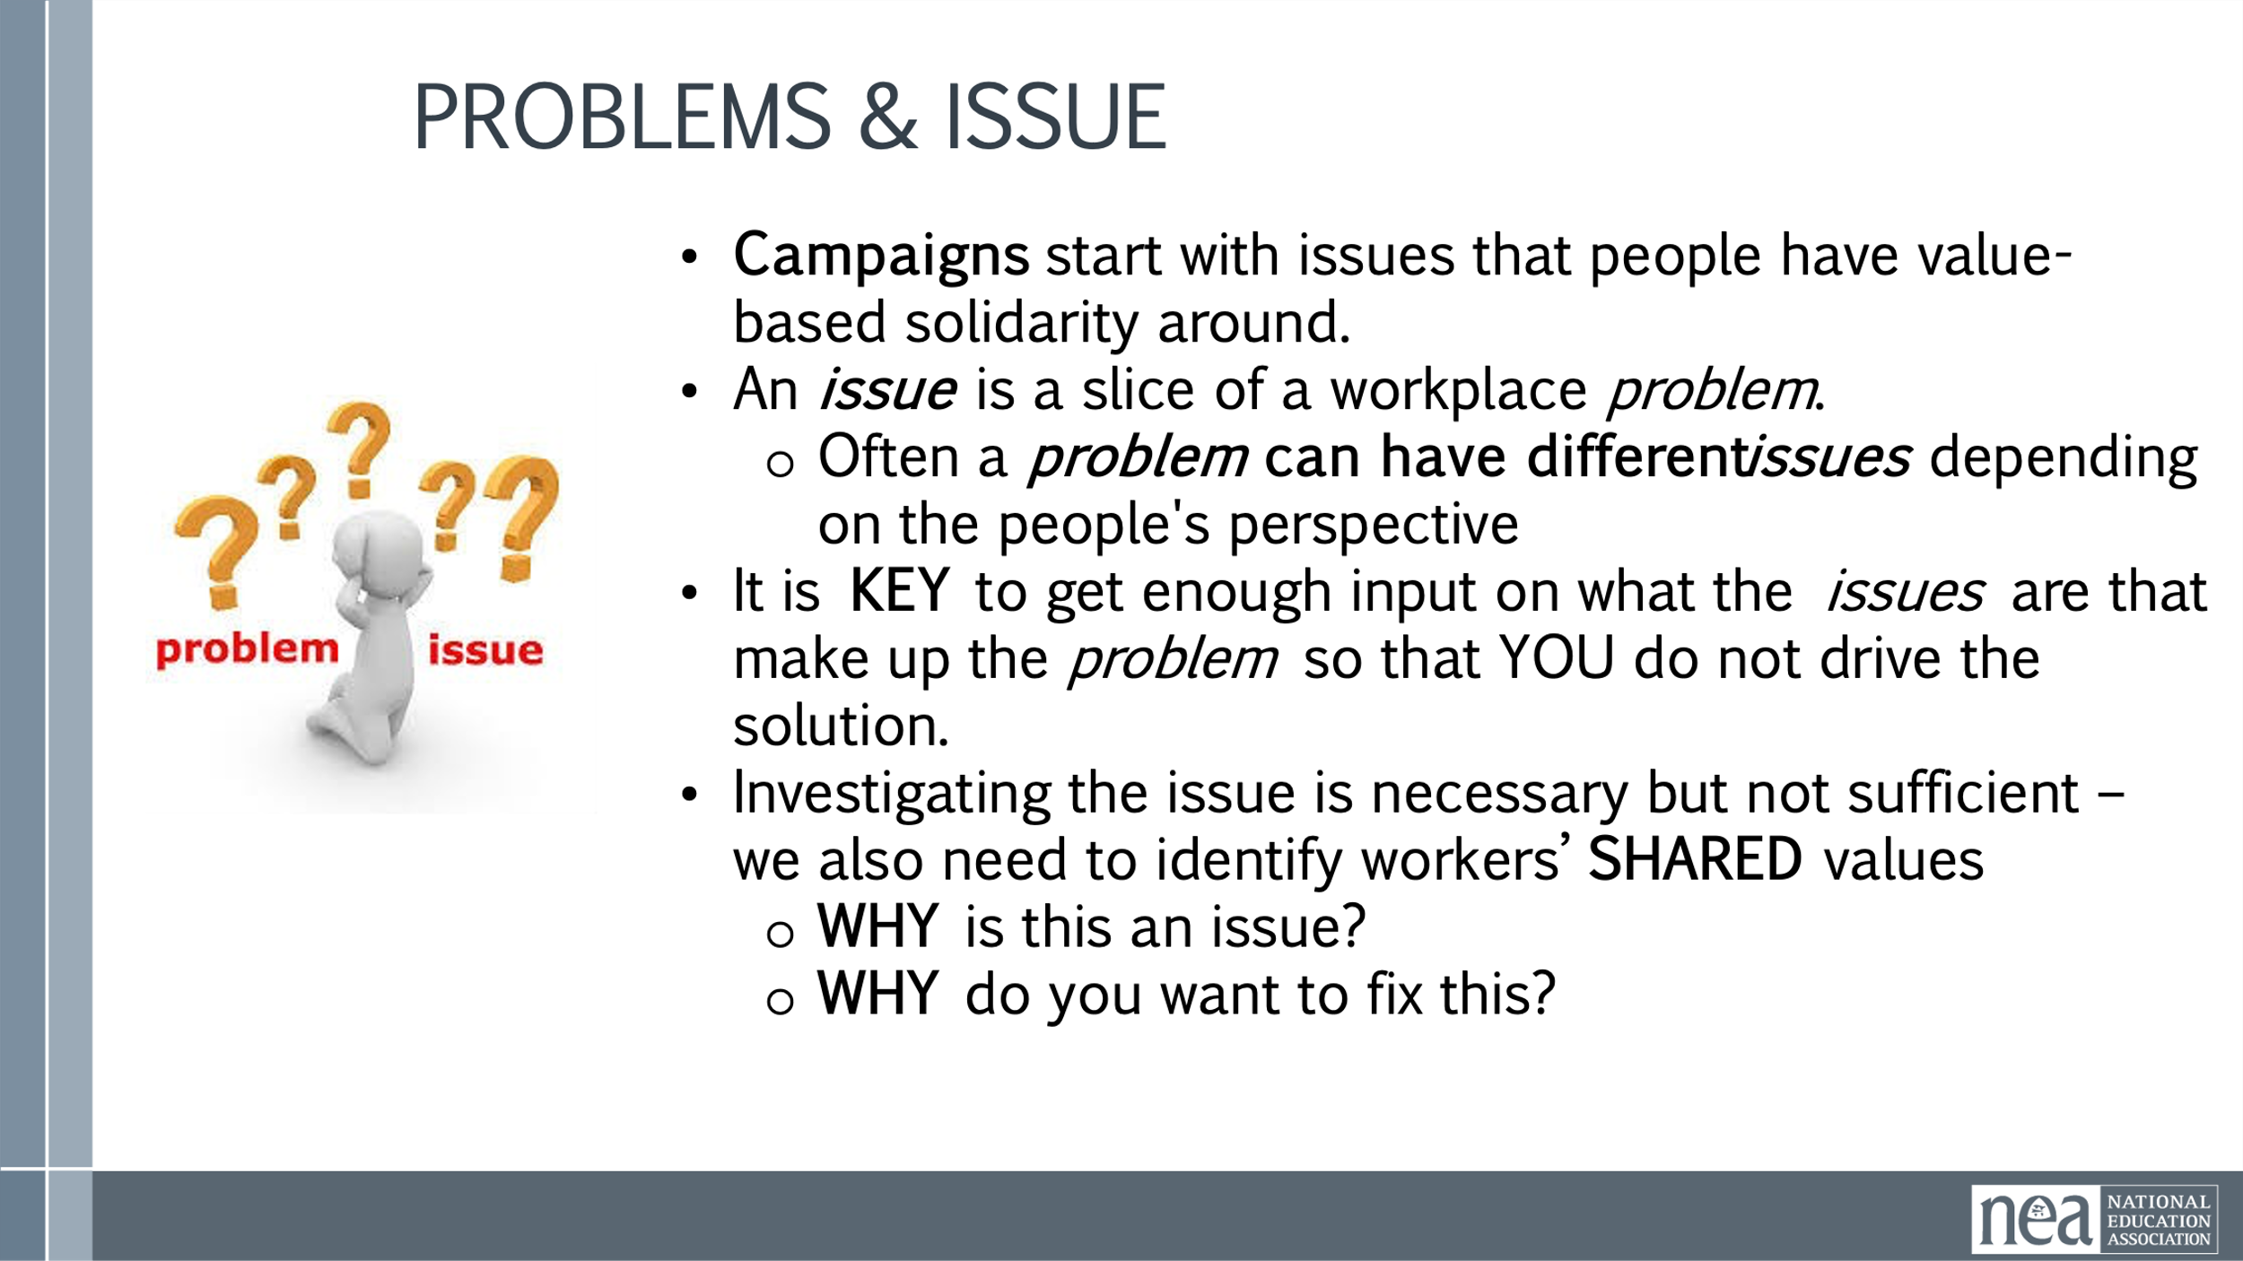  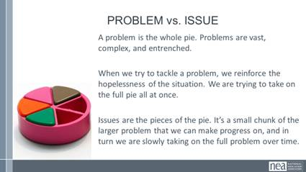  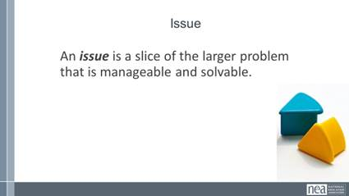  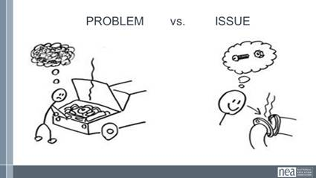  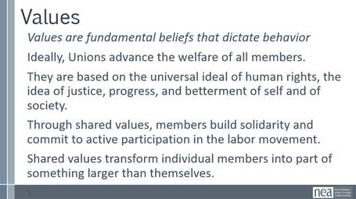  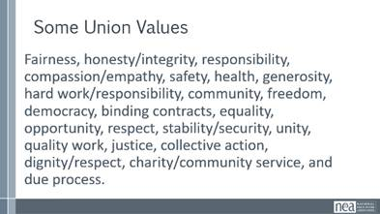  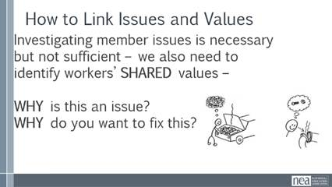  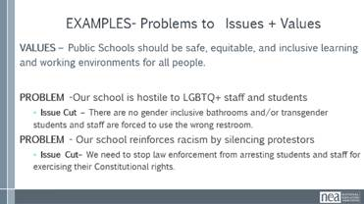  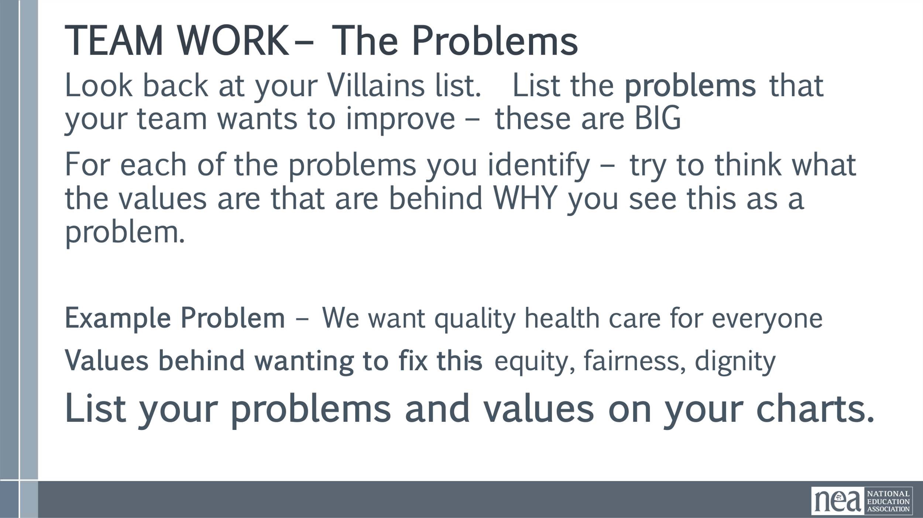  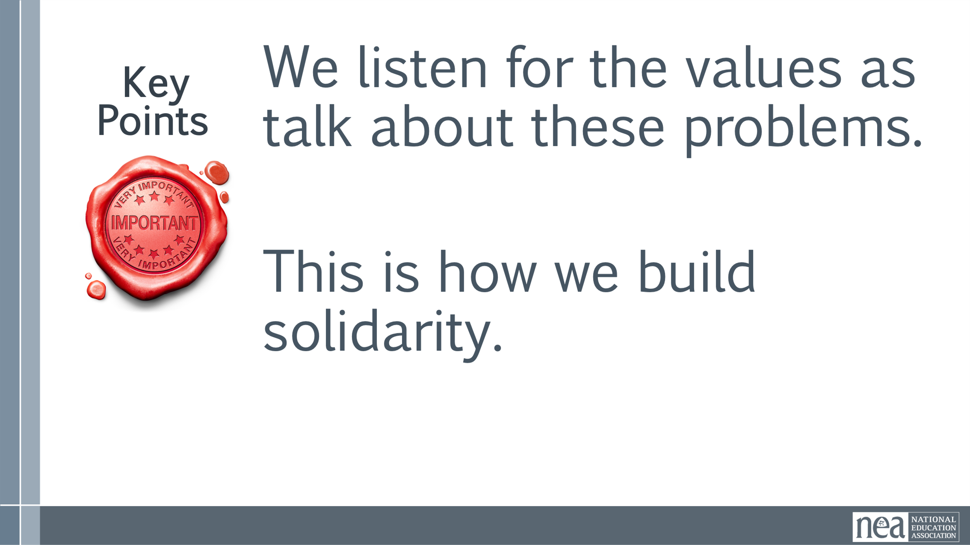  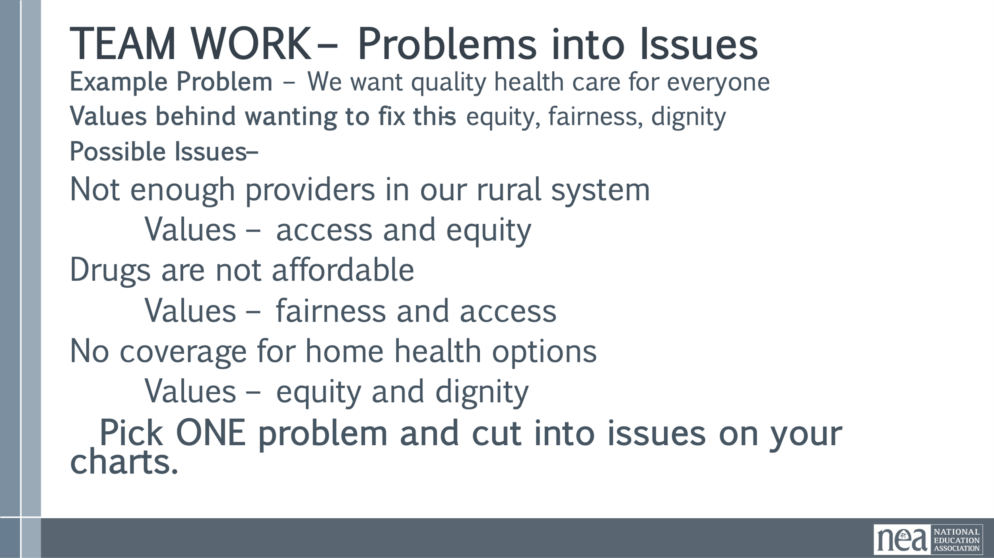  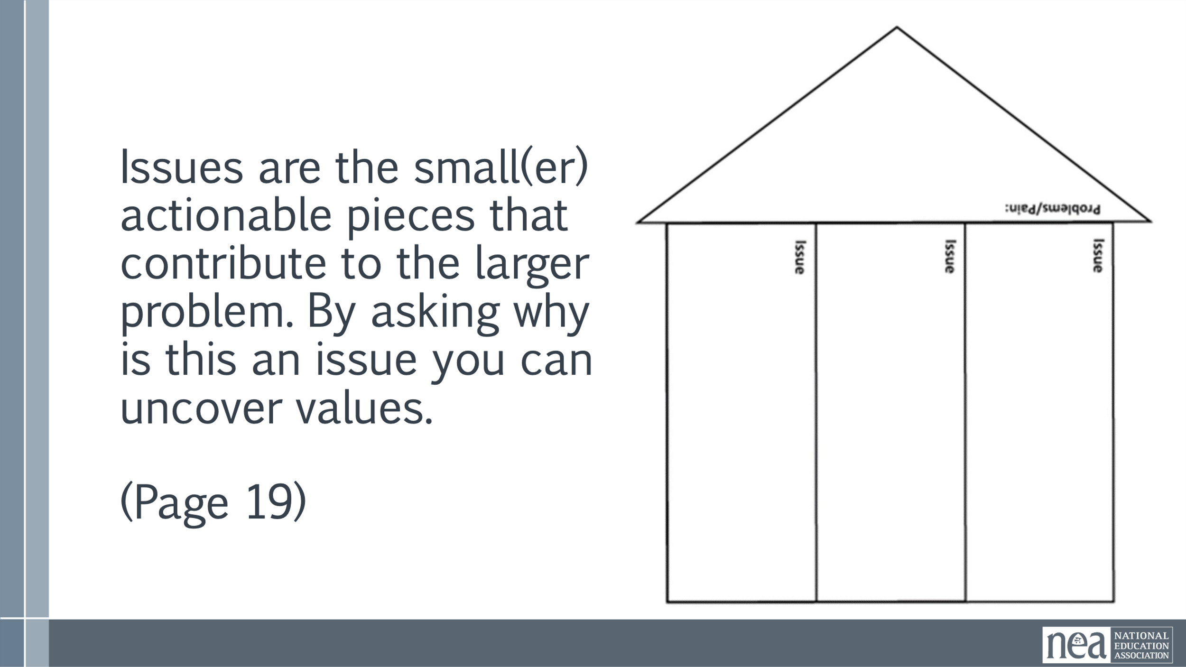  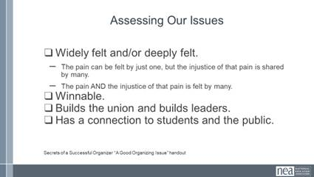  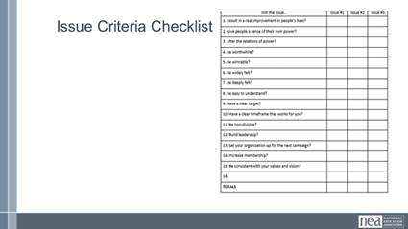  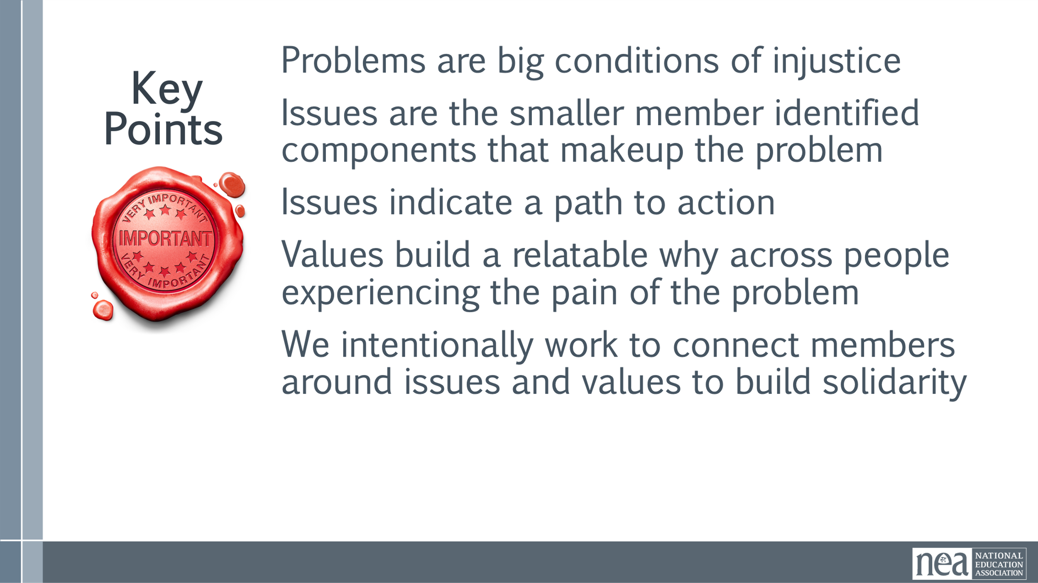 | Campaign Planning Guide  Problem to Issue analysis | 10 Minutes PROBLEM , ISSUES and Values  - Campaigns start with issues that people have value-based solidarity around.  - An issue is a slice of a workplace problem.  - Often a problem can have different issues depending on the perspective of the people we are working with.  - It is KEY to get enough input on what the issues are that make up the problem so that YOU do not drive the solution.  - Investigating the issue is necessary but not sufficient – we also need to identify workers’ SHARED values – WHY is this an issue? WHY do you want to fix this?  For example, A problem My Car is a piece of JUNK --- Issues – broken radiator hose, bad brakes, smelly interior, hole in the muffler.  Using Data to determine if an issue is widely felt or deeply felt initially can be a way to minimize implicit biases we all carry. It can give concrete data to issues that aren’t always concrete.  Microsoft forms allow you to collect information from members and pull the results in excel for analysis. Other platforms can also be used but make sure you understand what they can and can’t do before you decide.  Polling members around the issues that can be pulled out of problems can be a first step in engaging them in your campaign as well.  Something to remember:  Voluntary Response Bias: Because the participants are self-selected, the results often overemphasize extreme views and underrepresent the average opinion. One way to be mindful of this bias: When you notice only a small percentage of members are responding, even if their views are clear/powerful, it DOES NOT represent the membership as a whole. In this case, no response tells you something. If you think this is what is happening, consider actively working to solicit more responses. You can do this through one-on-ones, phone banks, and any other method for engaging membership you use. This will help determine if the problem/issues you are surveying about are the correct ones for your members.  We are also driven by our values.  Values are fundamental beliefs that dictate behavior  Ideally, Unions advance the welfare of all members.  They are based on the universal ideal of human rights, the idea of justice, progress, and betterment of self and of society.  Through shared values, members build solidarity and commit to active participation in the labor movement. Shared values transform individual members into part of something larger than themselves.  Here are some typically stated union values  How we link Issues and values  Investigating member issues is necessary but not sufficient – we also need to identify workers’ SHARED values –  WHY is this an issue?  WHY do you want to fix this?  Here are some examples of Problems to Issues plus the values.  VALUES – Public Schools should be safe, equitable, and inclusive learning and working environments for all people.  PROBLEM -Our school is hostile to LGBTQ+ staff and students  ◦ Issue Cut – There are no gender inclusive bathrooms and/or transgender students and staff are forced to use the wrong restroom.  PROBLEM - Our school reinforces racism by silencing protestors  ◦ Issue Cut– We need to stop law enforcement from arresting students and staff for exercising their Constitutional rights.  10 Minutes - Cutting our Problems into Issues Page 19  Using the charts you made as we started pick one of your big problems and think about the issues that might be built into that.  Example Problem – We want quality health care for everyone  Values behind wanting to fix this – equity, fairness, dignity  Possible Issues –  Not enough providers in our rural system  benefits don’t cover specialists  Drugs are not sourced in ways that make them affordable  No coverage for home health options  Cut your problems into issues on your charts  10 Minutes -Assessing Our Issues  2-3 minutes on content, 10 minutes on group work - 2-3 minutes on report out.  So how can we determine – assess what issues make the best organizing issues. We can work them through a couple of processes. Using these processes with them keeps us from taking over and allows for leadership development opportunities. They build their confidence and trust and solidarity through a shared process.  At the very least a good issue  - It is widely felt and/or deeply felt.  - The pain can be felt by just one, but the injustice of that pain is shared by many.  - The pain AND the injustice of that pain is felt by many.  - It is winnable.  - It builds their union and builds leaders.  - It has a values-based connection to our workers, students, and the public.  Using the issues you charted at the beginning of this section about issues – Spend just a few minutes using the simplified screener from Labor Notes – and see how it would allow you to screen out issues that might not be good for Organizing.  10 Minutes Report out - what did you find? (if it doesn’t come out, reemphasize the earlier Key Point – Not every issue is an organizing issue)  Key Ideas  Problems are big conditions that have several smaller solutions  - Issues are the components that make up the problem  - Issues indicate a path to action  - Values build a relatable why across people experiencing the pain of the problem  We intentionally work to connect people around issues and values to build Solidarity | Why are problem and issue something we need to know? 4  Participants will differentiate between problems and issues, and evaluate issues as being well connected to values and the community, deeply and widely felt, and winnable.
10:10-10:25 BREAK
10:25-11:00 | Melissa | 35 Minutes – Targets and Demands
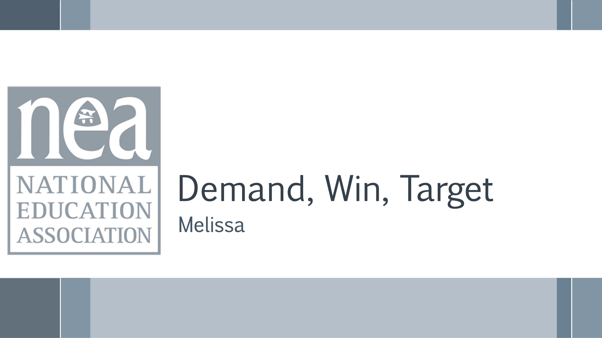  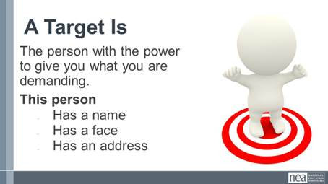  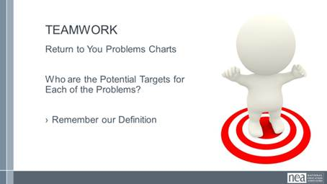  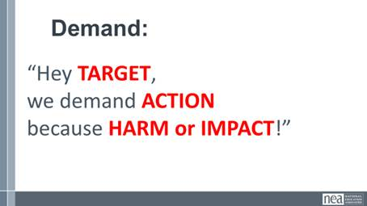  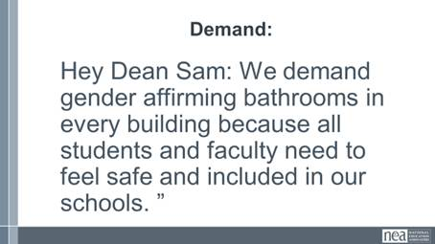  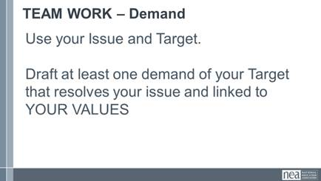  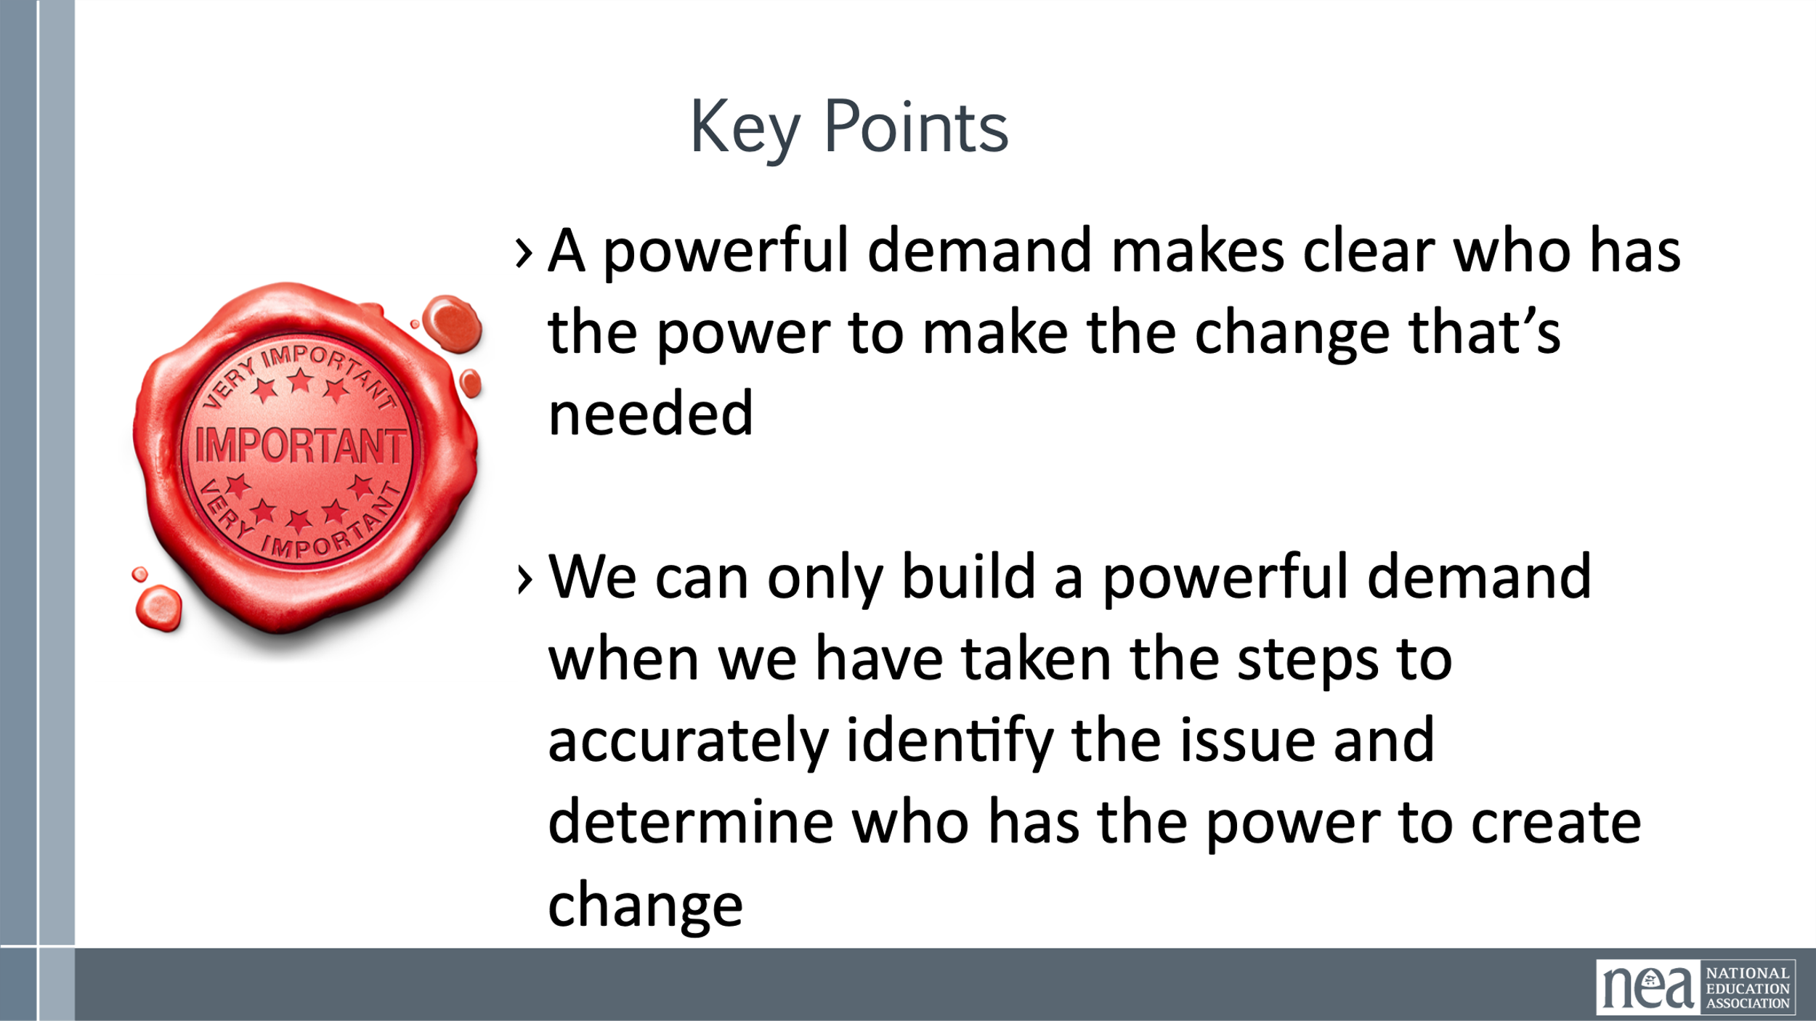 | Campaign Guide | Content 5 Minutes -Identify and Analyze the Target(s)  We are now going to do a little work identifying the Target and Demand for your campaign.  Definition of Target  Ask group: Who has an idea of what we mean by a target in the context of a campaign?  - A target is the person who can make the decision to give you what you want. The target is the person who can meet your demands. We need to be very specific in identifying the target. A target is not an organization or a committee. A target is a person with a face, name, and address.  10 Minutes – Teamwork Identify Potential Targets for your Issues  10 Minutes of Content  A demand is the outcome that addresses the issue that you are making of a target. In your campaign you can have a very simple demand, or you can include community needs and think bigger.  The demand should have 3 components: the target, the action, and the harm or impact.  “Hey Superintendent Sam: We demand gender affirming bathrooms in every school because all students need to feel safe and included in our schools. ”  This example clearly articulates the Target (Superintendent Sam), the action that we want the target to take (implement gender affirming bathrooms in every school), and the harm or impact (that this will allow students to feel safe and included).  The demand is usually the first thing that your supporters or potential supporters will hear about the campaign. This is why it is important to include the harm or impact, because it creates a moral crisis in the listener and moves them to act in support of the campaign.  - Measurable  - Achievable  The demand should be measurable in that we can clearly know whether the target takes the action in the demand or not  Team work – 5 Minutes  Return to your charts and draft a demand of your Target that resolves your issue and linked to YOUR VALUE  4 Minutes – Share some Targets and Demands  1 Minute Key Ideas  - A powerful demand makes clear who has the power to make the change that’s needed  We can only build a powerful demand when we have taken the steps to accurately identify the issue and determine who has the power to create change | How do you identify your TARGET? How do you determine the demand?  Participants will understand how to NAME A TARGET for their campaign and determine a measurable and winnable demand.
11:00 – 12:00 | Amanda | 60 Minutes Total – Spectrum of Allies and Messages
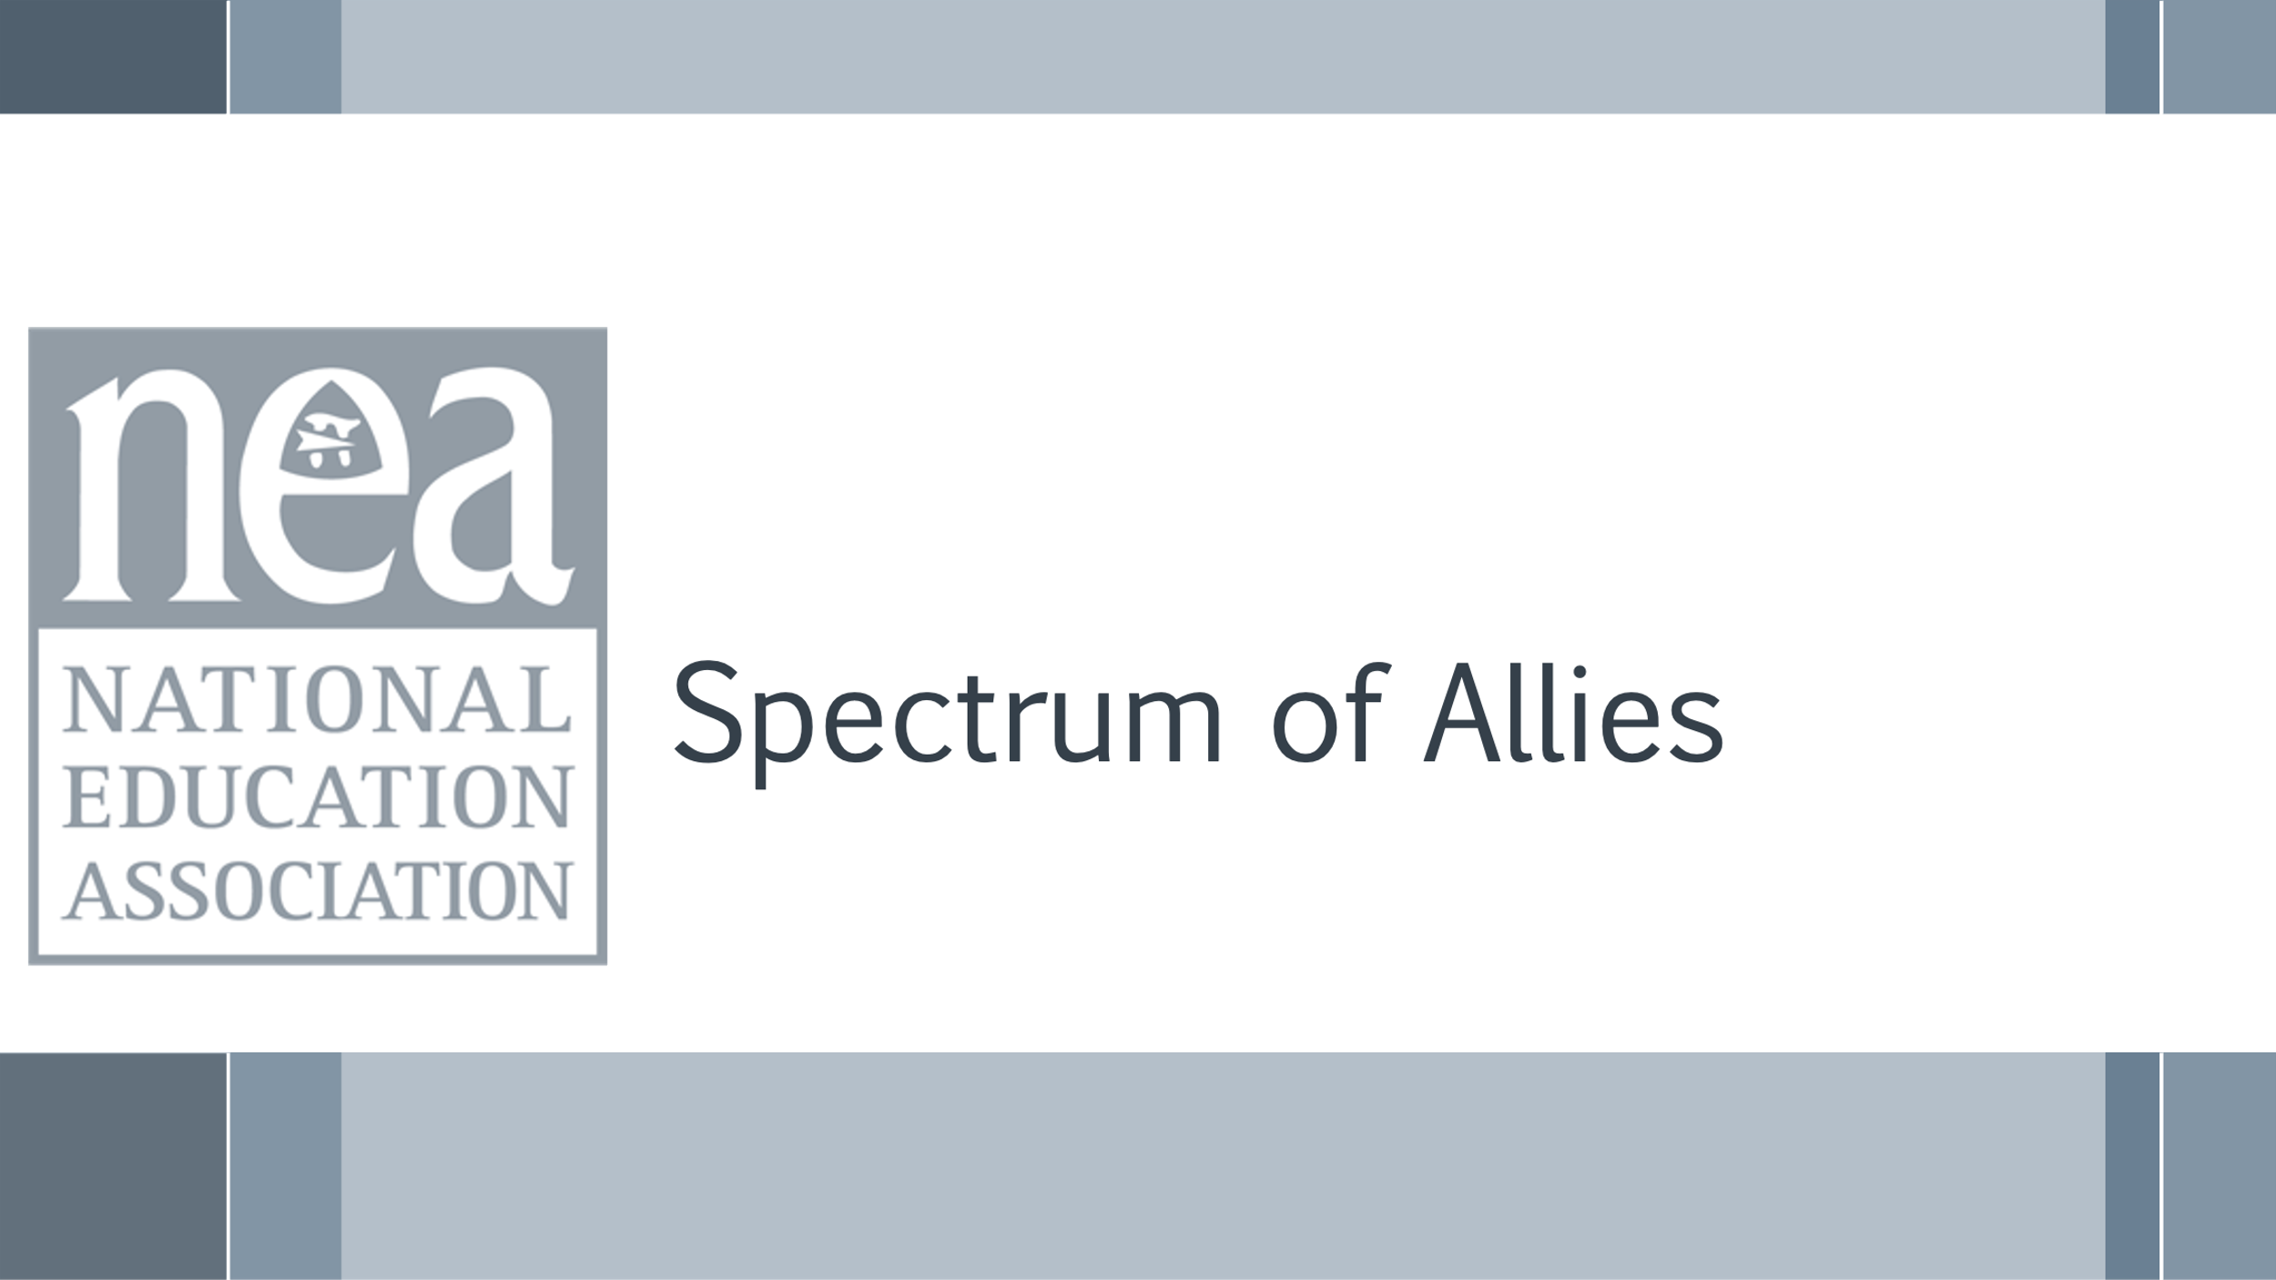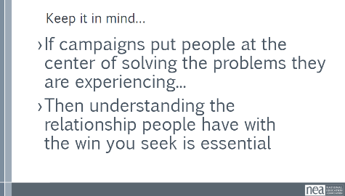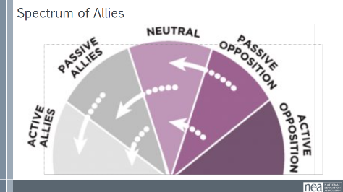  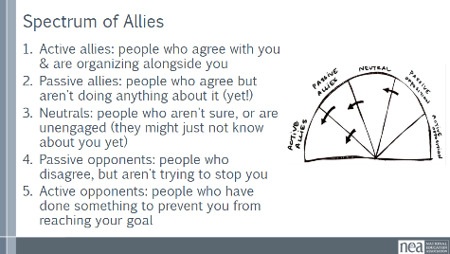  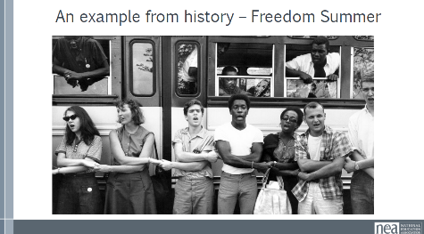  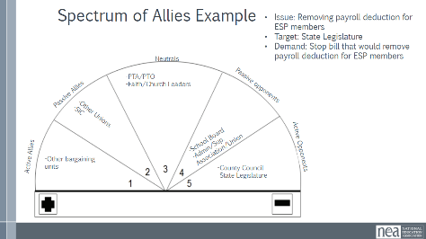  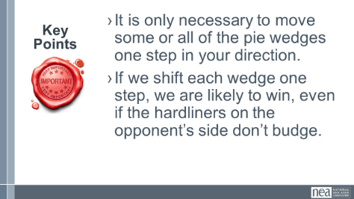  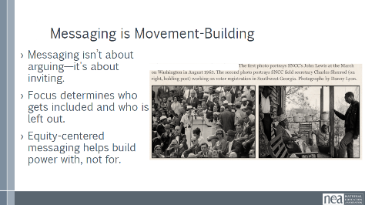  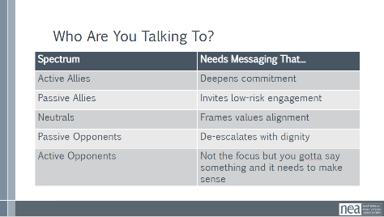 | 3 Map Spectrum of Allies.pdf  Campaign Guide | 20 Minutes - Spectrum of Allies Content  If campaigns put people at the center of solving the problems they are experiencing...then understanding the relationship people have with the win you seek is essential.  We are going to learn a method called Spectrum of Allies. All of our campaigns CAN include a wide range of groups, but particularly in the campaigns we are thinking about they must include that. These include a wide range of groups that can be put on a kind of spectrum, from those closest to the point of view of the advocates to those who actively oppose change.  When working within these groups, it is helpful to move people, constituents, groups, etc. as close to active allyship as possible and probable.  - Active allies: people who agree with you & are organizing alongside you.  - Passive allies: people who agree but aren't doing anything about it (yet!)  - Neutrals: people who aren't sure, or are unengaged (they might just not know about you yet)  - Passive opponents: people who disagree, but aren't trying to stop you  - Active opponents: people who have done something to prevent you from reaching your goal  An example from history -  In 1964, the Student Nonviolent Coordinating Committee (SNCC), a major driver of the civil rights movement in the U.S. South, conducted a spectrum of-allies"-style analysis. They had a lot of passive student allies in the North: they were sympathetic, but had no entry point into the movement. They didn’t need to be “educated” or convinced, they needed an invitation to enter. SNCC sent buses north to bring folks down to “Freedom Summer.” Students became active allies -- they came in droves, and many were deeply radicalized in the process, witnessing lynching & violent police simply because black folks were trying to vote.  Many wrote letters home to their parents, who suddenly had a personal connection to the struggle. This triggered another shift: their families became passive allies as they learned about the struggle from those letters. The students went back to school in the fall and proceeded to organize their campuses. More shifts. The result: a profound transformation of the political landscape of the U.S., resulting from a deliberate movement strategy.  15 Minutes  Ask questions – turn and talk at table  I am going to share a couple of questions  - Which group should a campaign spend the least amount of time trying to move?  - Which group is the most dangerous to a campaign if they don’t move?  5 Minutes – Key Points  - It is only necessary to move some or all of the pie wedges one step in your direction.  - If we shift each wedge one step, we are likely to win, even if the hardliners on the opponent’s side don’t budge.  20 minutes - Messaging Lecturette -  Messaging is one of our most powerful organizing tools. But too often we aim in the wrong direction. Focusing only on opponents—or even just active allies—can burn people out or create silos. Centering equity means we think about who is included in our messaging and who is left out. When we focus only on powerholders, we often ignore the people closest to the problem—people we should be building with.  Good messaging doesn't try to convince, it tries to connect  Use messaging to activate, not just inform  The goal is to message centering equity  This means seeing and reaching people in their full humanity  This table breaks down how messaging changes depending on where someone is on the spectrum of allies. For example, you wouldn’t message the same way to an active ally as you would to a passive opponent. Passive allies often need invitations. Neutrals need to hear how the issue connects to their values. You can coach your teams to think about who they’re messaging to and tailor their message accordingly. | Participants will apply the Spectrum of Allies connecting to messaging. This prepares coaches to coach team leads on this concept.  Coaches will assess what their possible interventions might be if these practices are not in place with the locals they are coaching.
12:00-1:00 LUNCH
1:00-1:30 | Ellen and Beth | 30 Minutes Total – Spectrum of Allies and Messages in your campaign
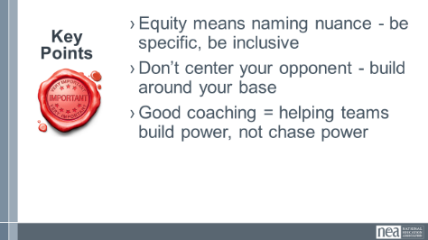 | 3 Map Spectrum of Allies.pdf  Campaign Guide | In campaign lab groups (need charts with spectrum predrawn)  10 mins - Identify the allies in each wedge for your campaign  13-minute activity  Using the allies you have identified in each groups will select a wedge within the spectrum to craft messaging around the issue. The goal is to invite folks in that wedge to move at least one wedge to the left. The messaging should be 1-3 minutes at most  (Remind them that the end wedges are the least effective wedges to target)  5 - minute share out  Have groups share out providing any pluses or deltas where appropriate  2 minutes – Key Points  Equity means naming nuance - be specific, be inclusive  Don’t center your opponent - build around your base  Good coaching = helping teams build power, not chase power | Participants will apply the Spectrum of Allies connecting to messaging. This prepares coaches to coach team leads on this concept.  Coaches will assess what their possible interventions might be if these practices are not in place with the locals they are coaching.
1:30-2:00 | Hedy | 30 Minutes Dossier of Target
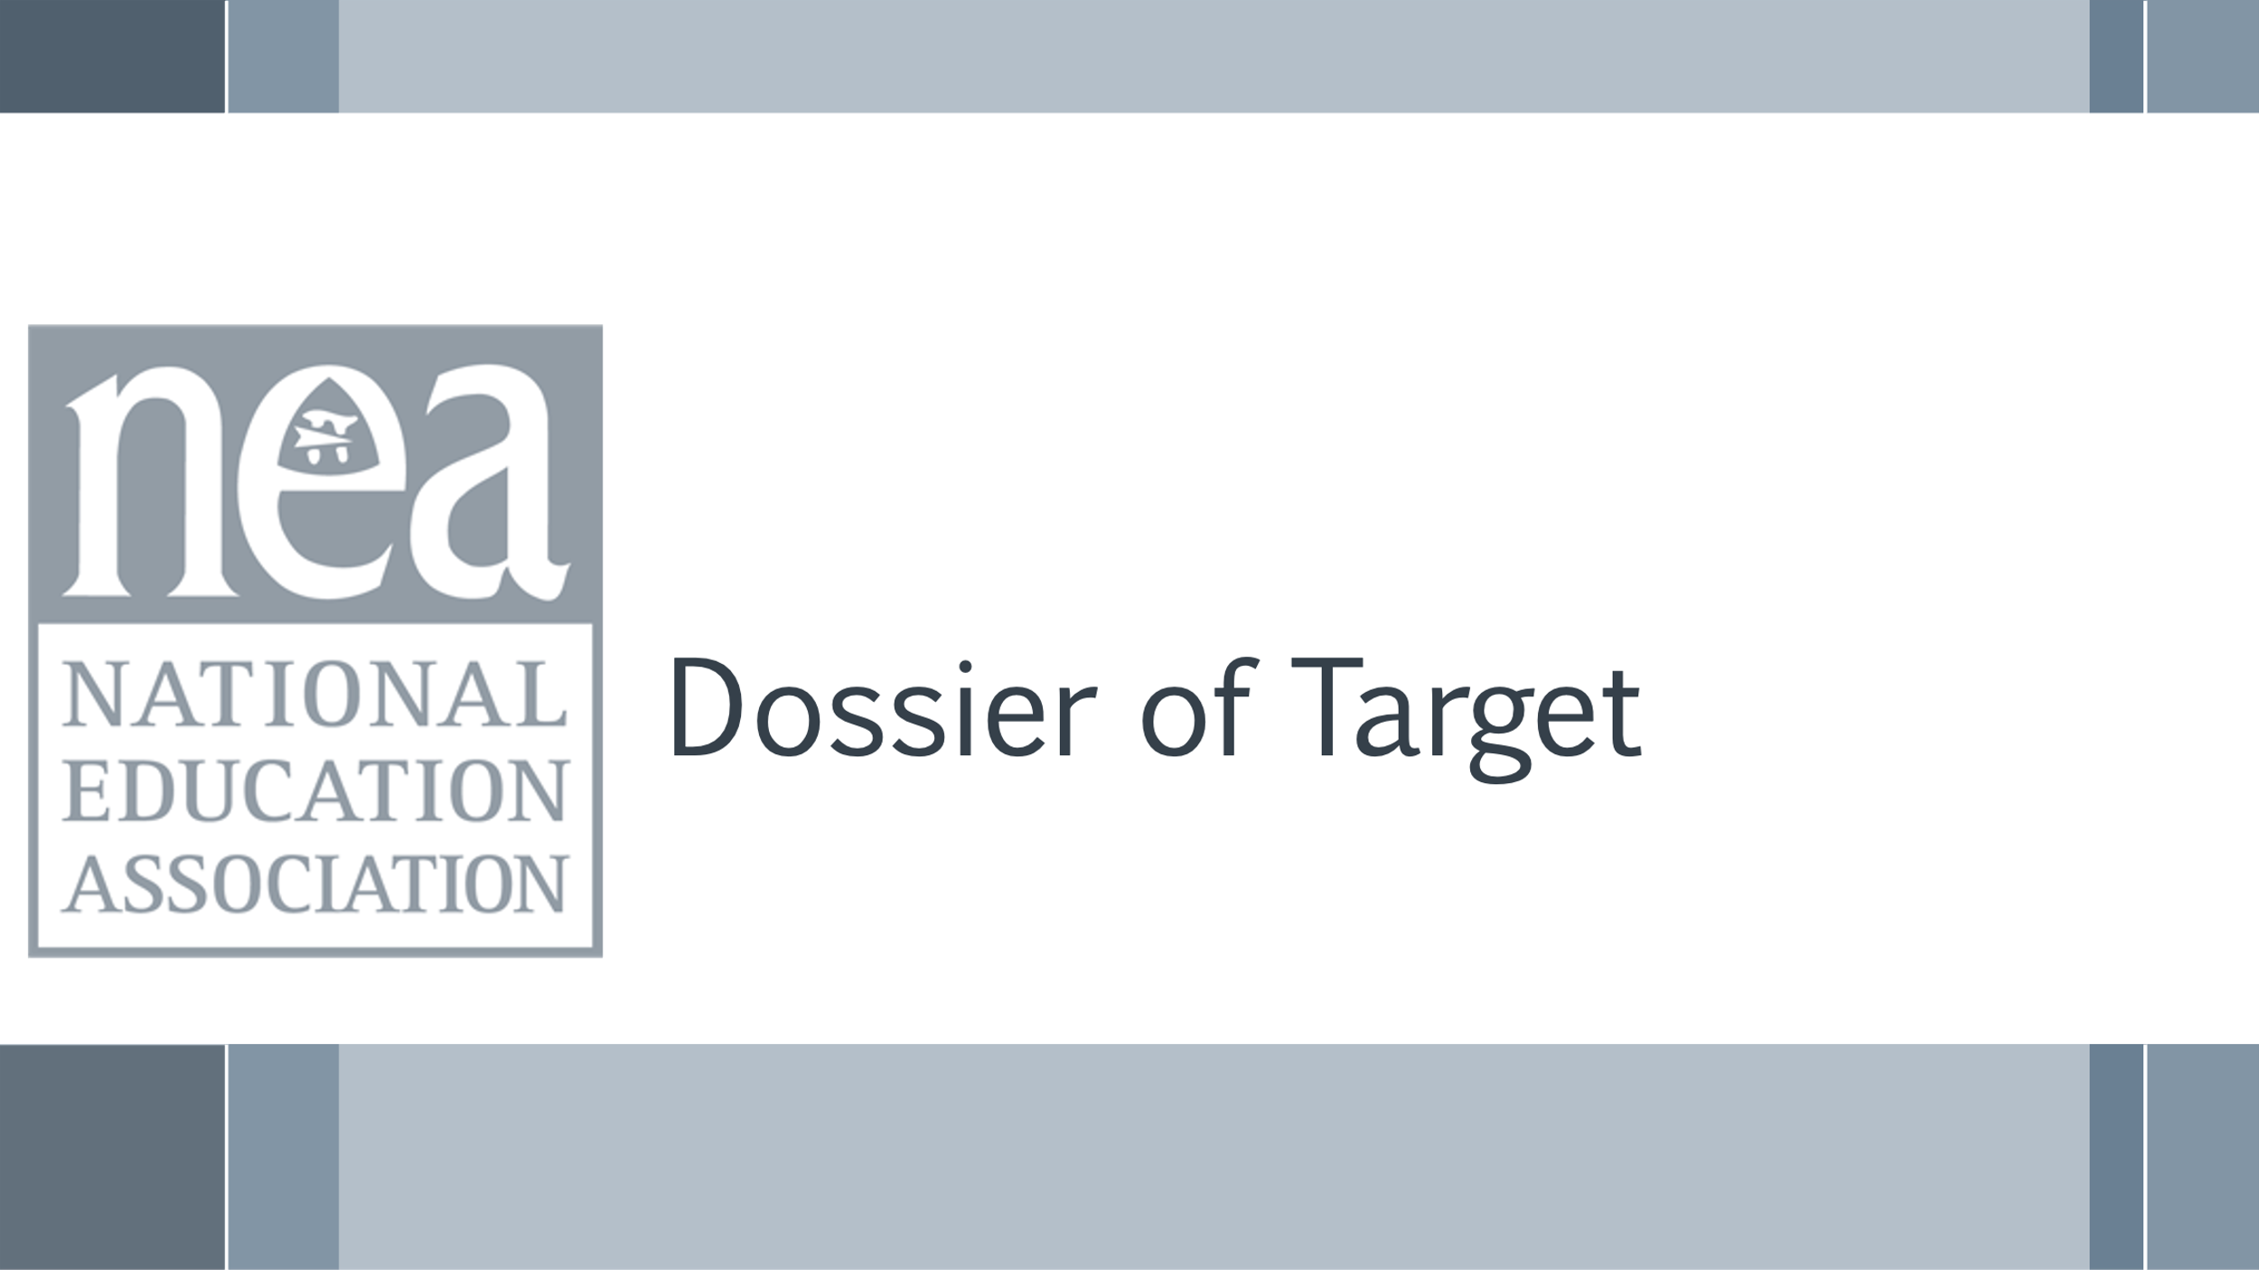  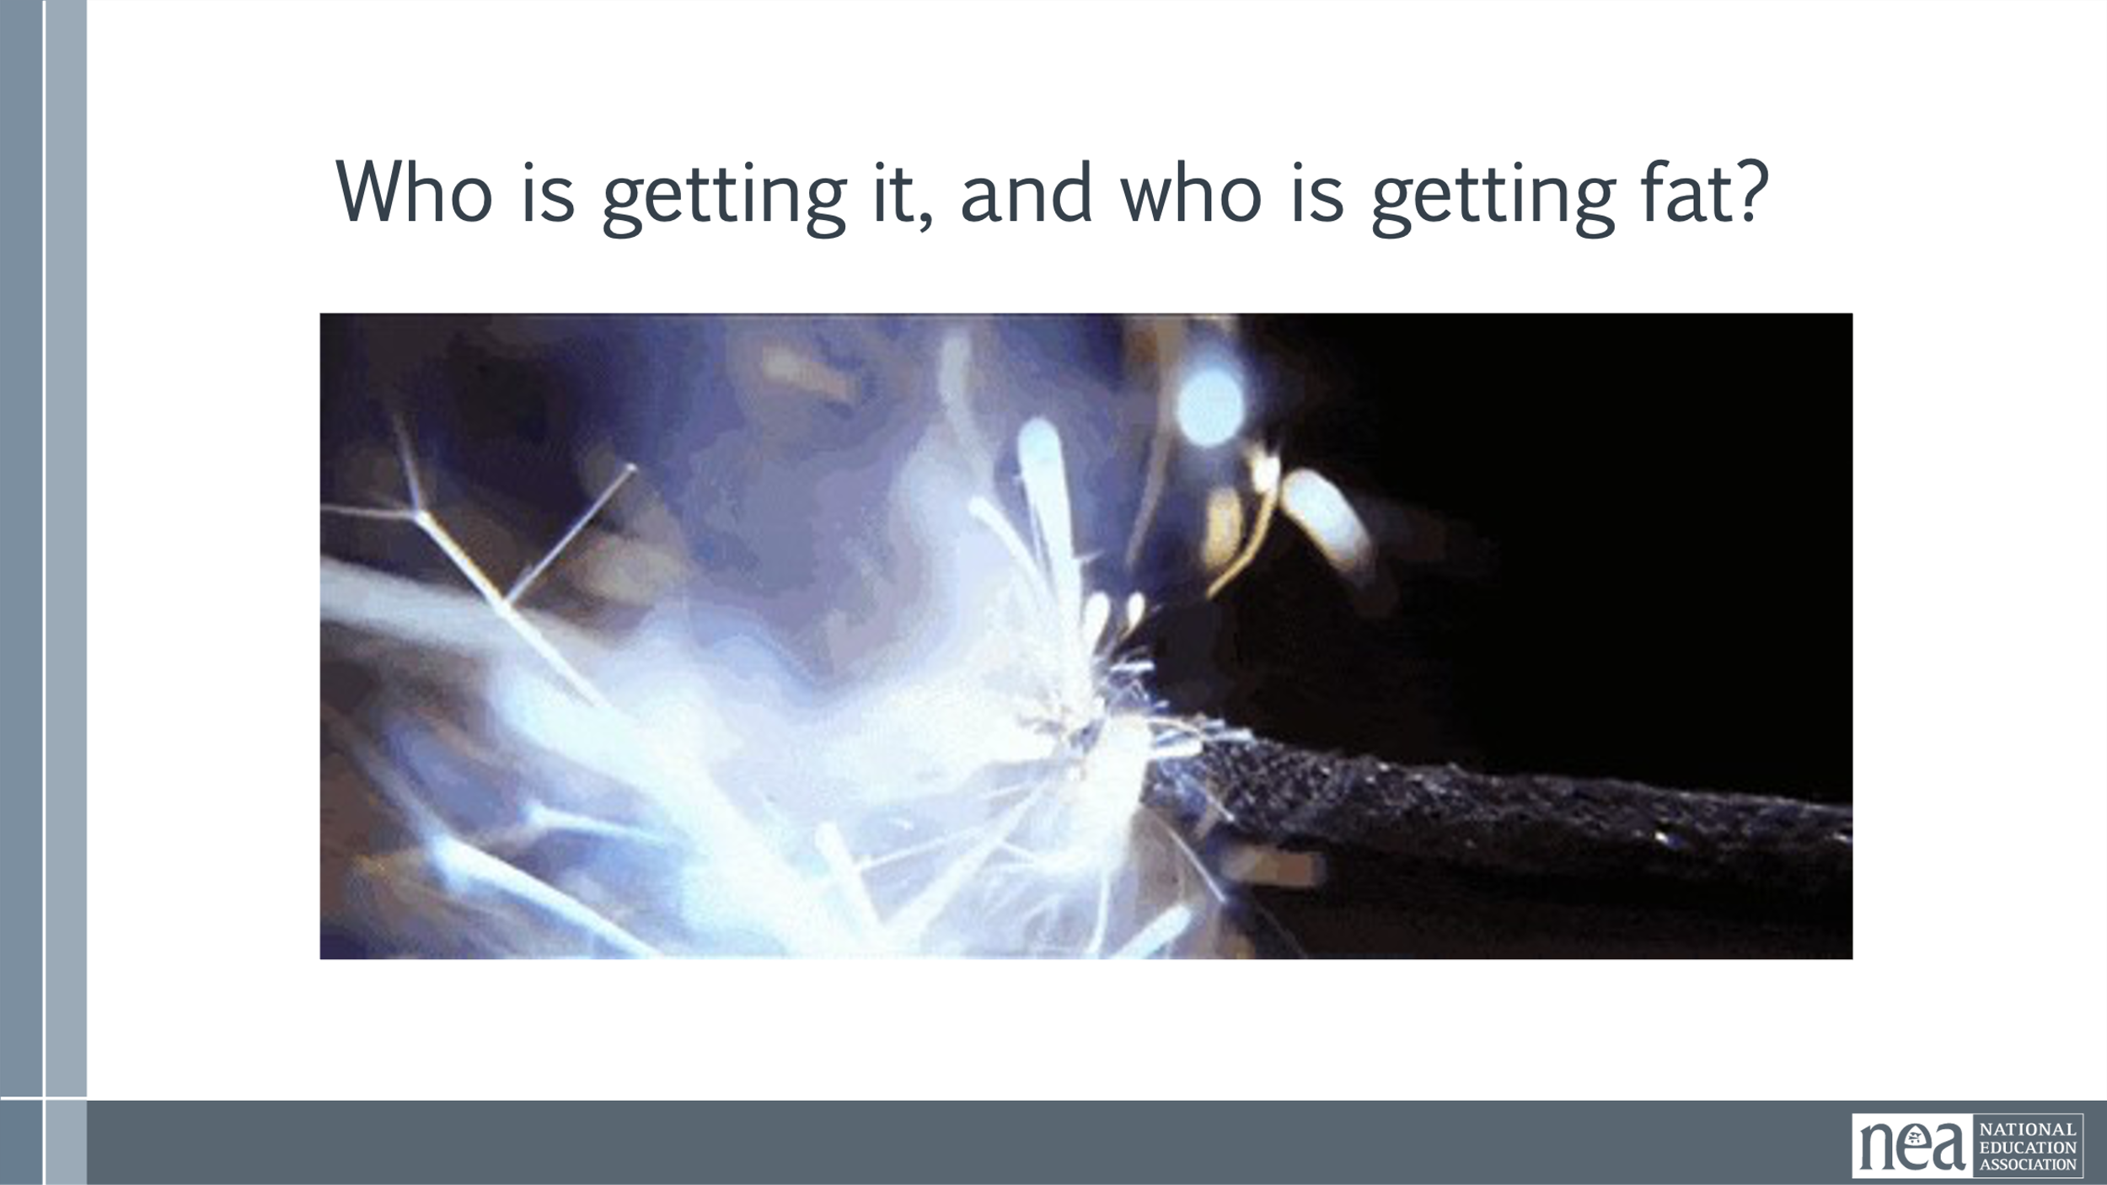  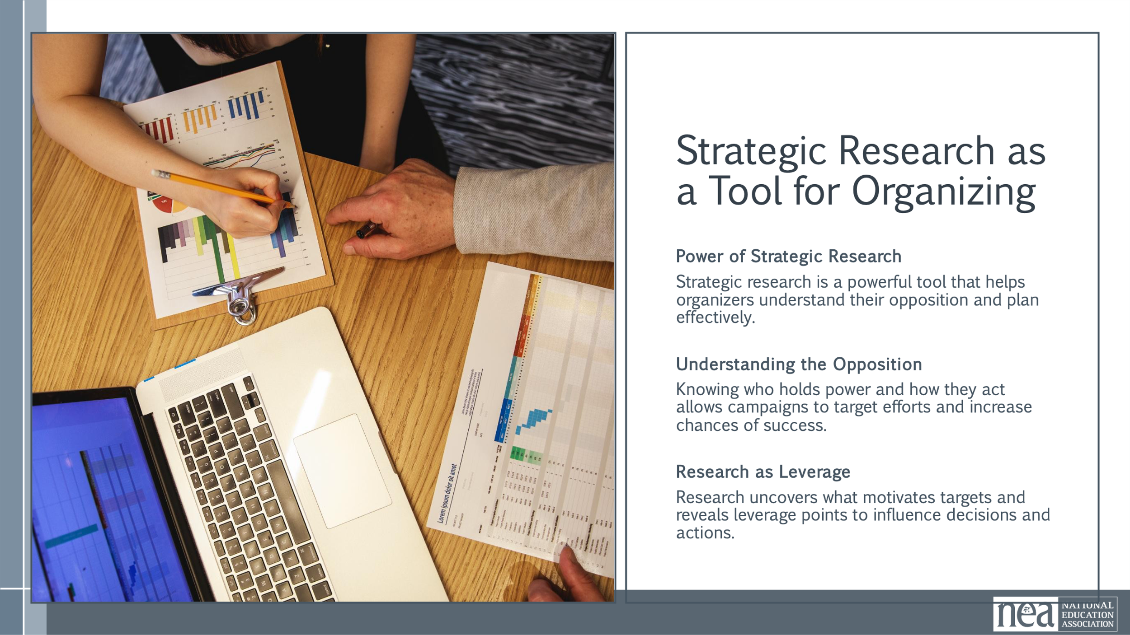  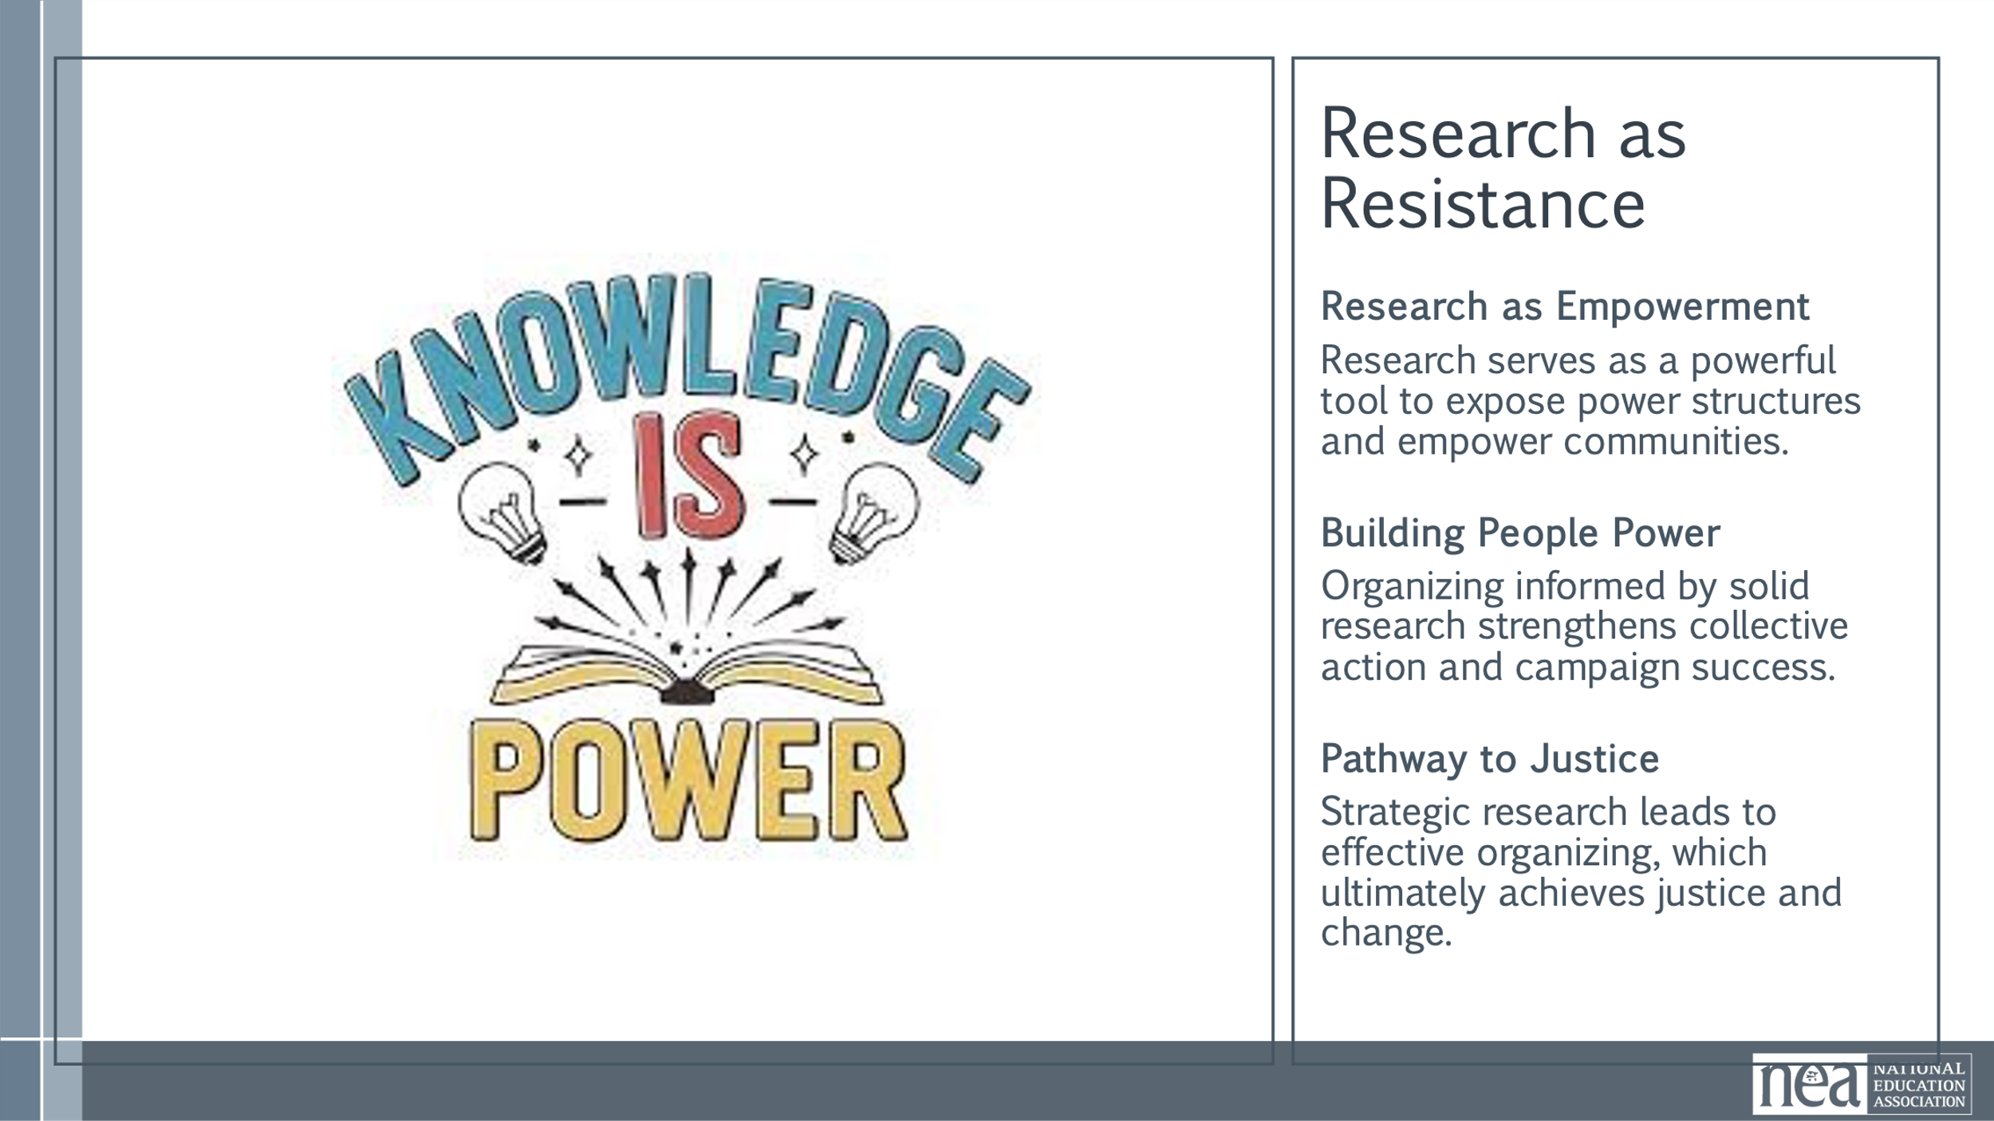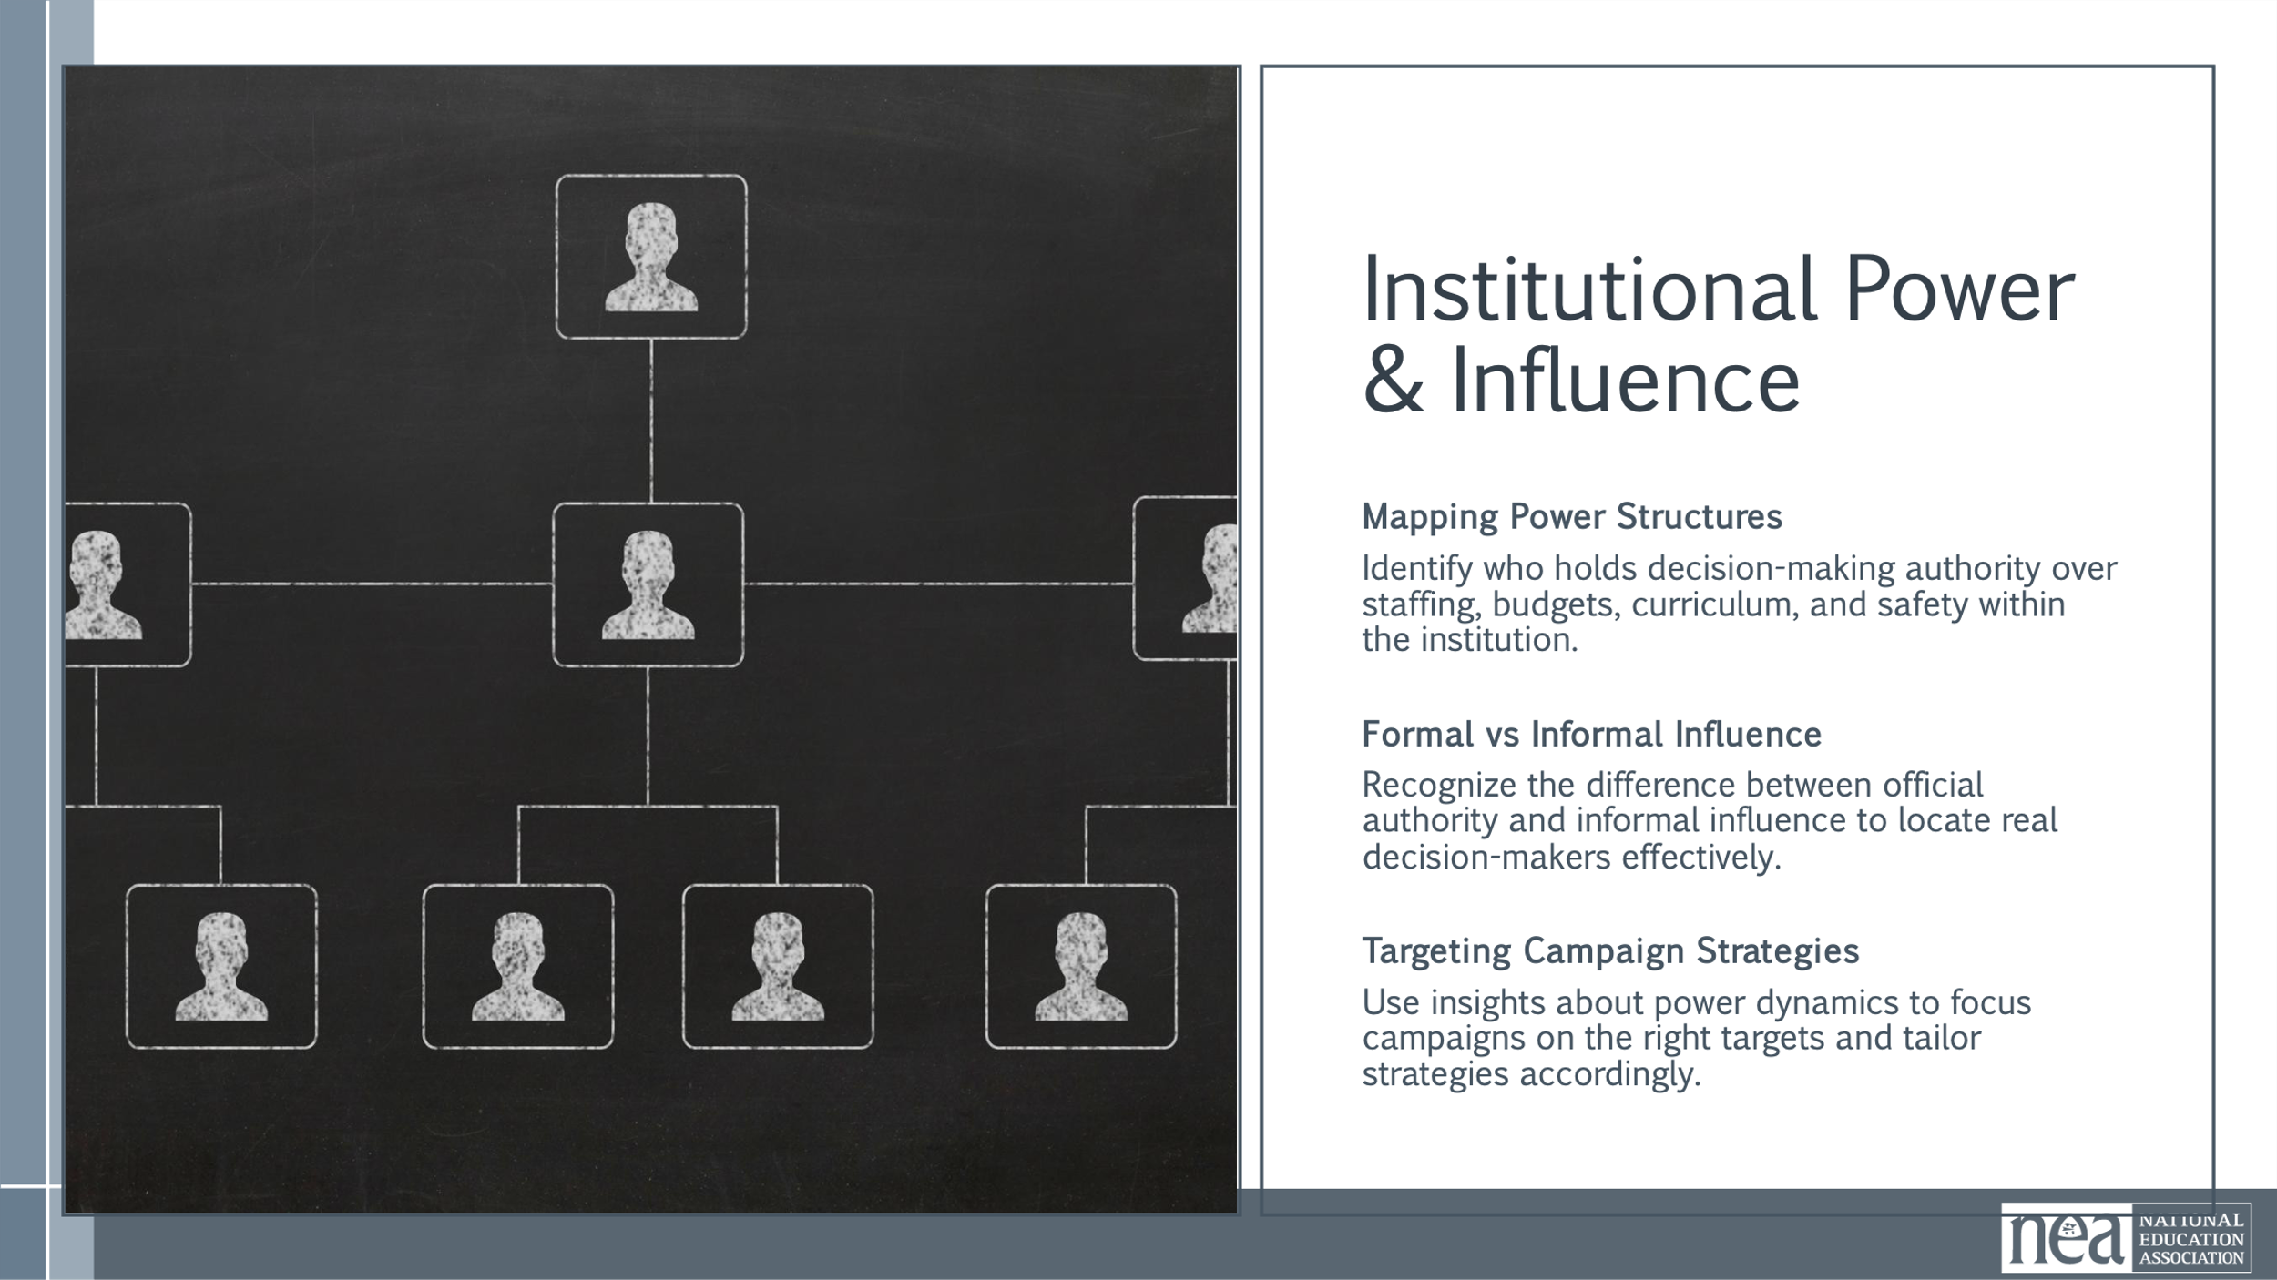  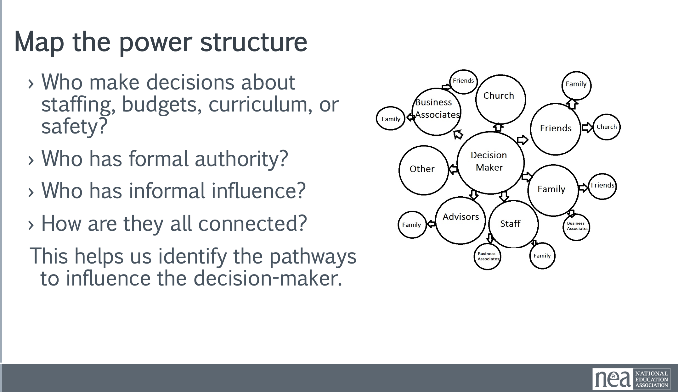  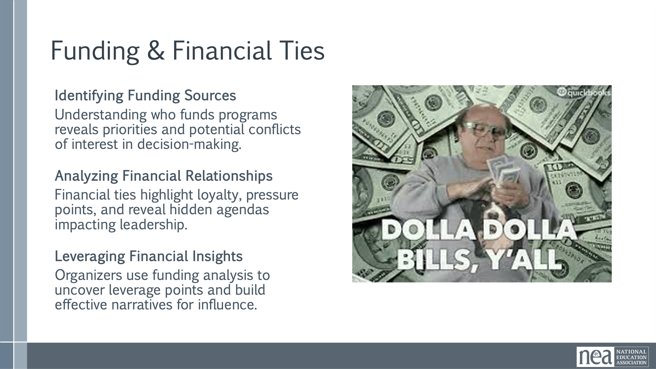  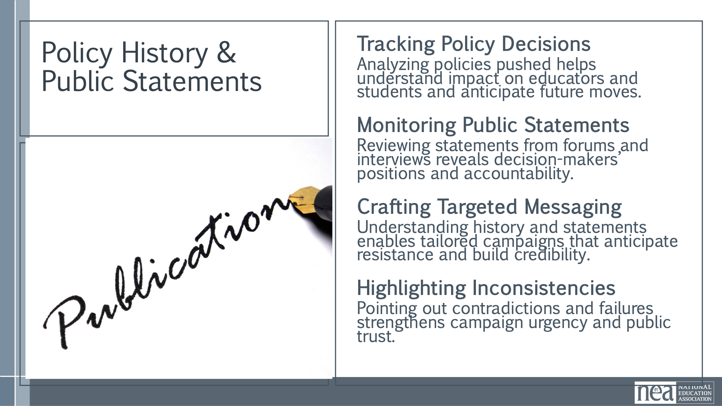  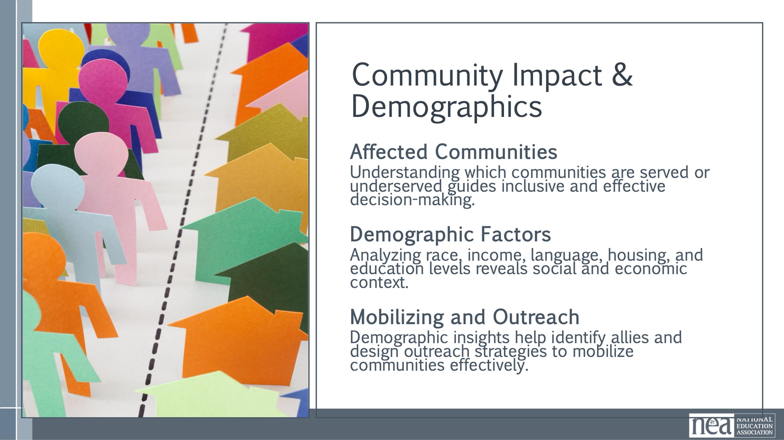  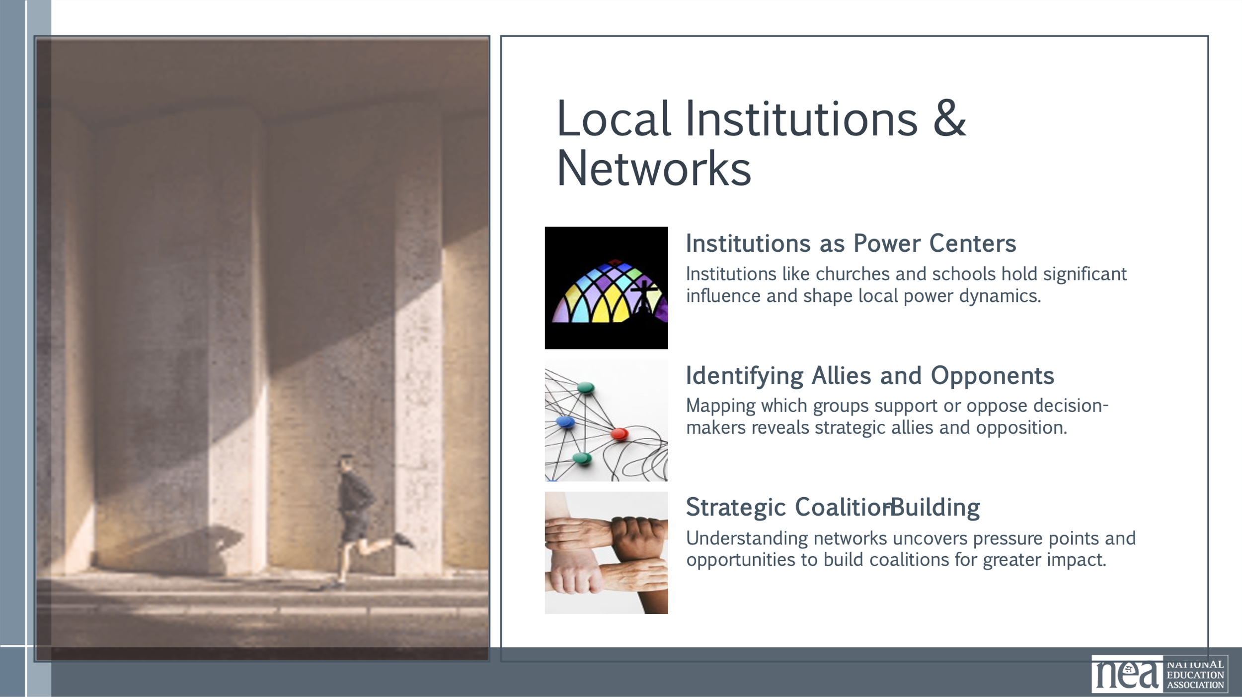  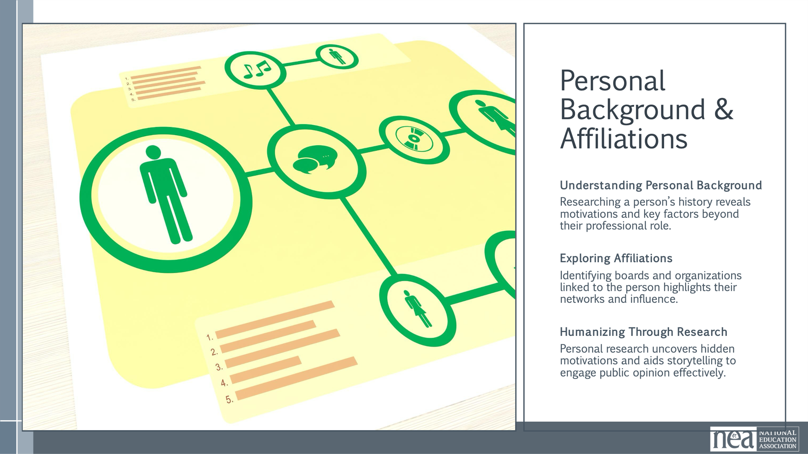  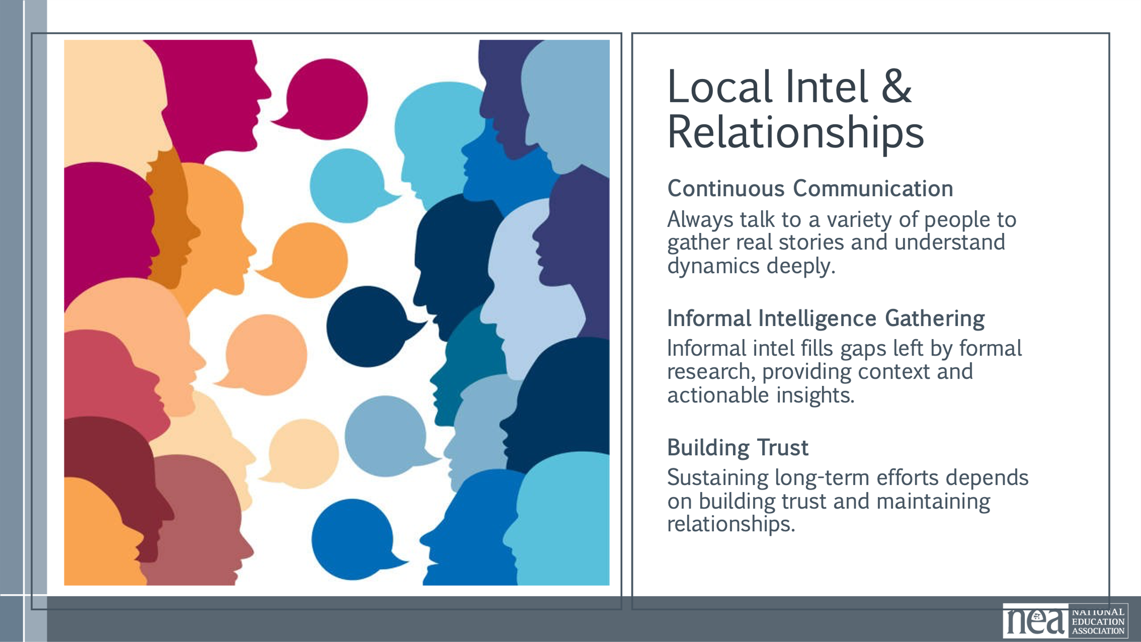  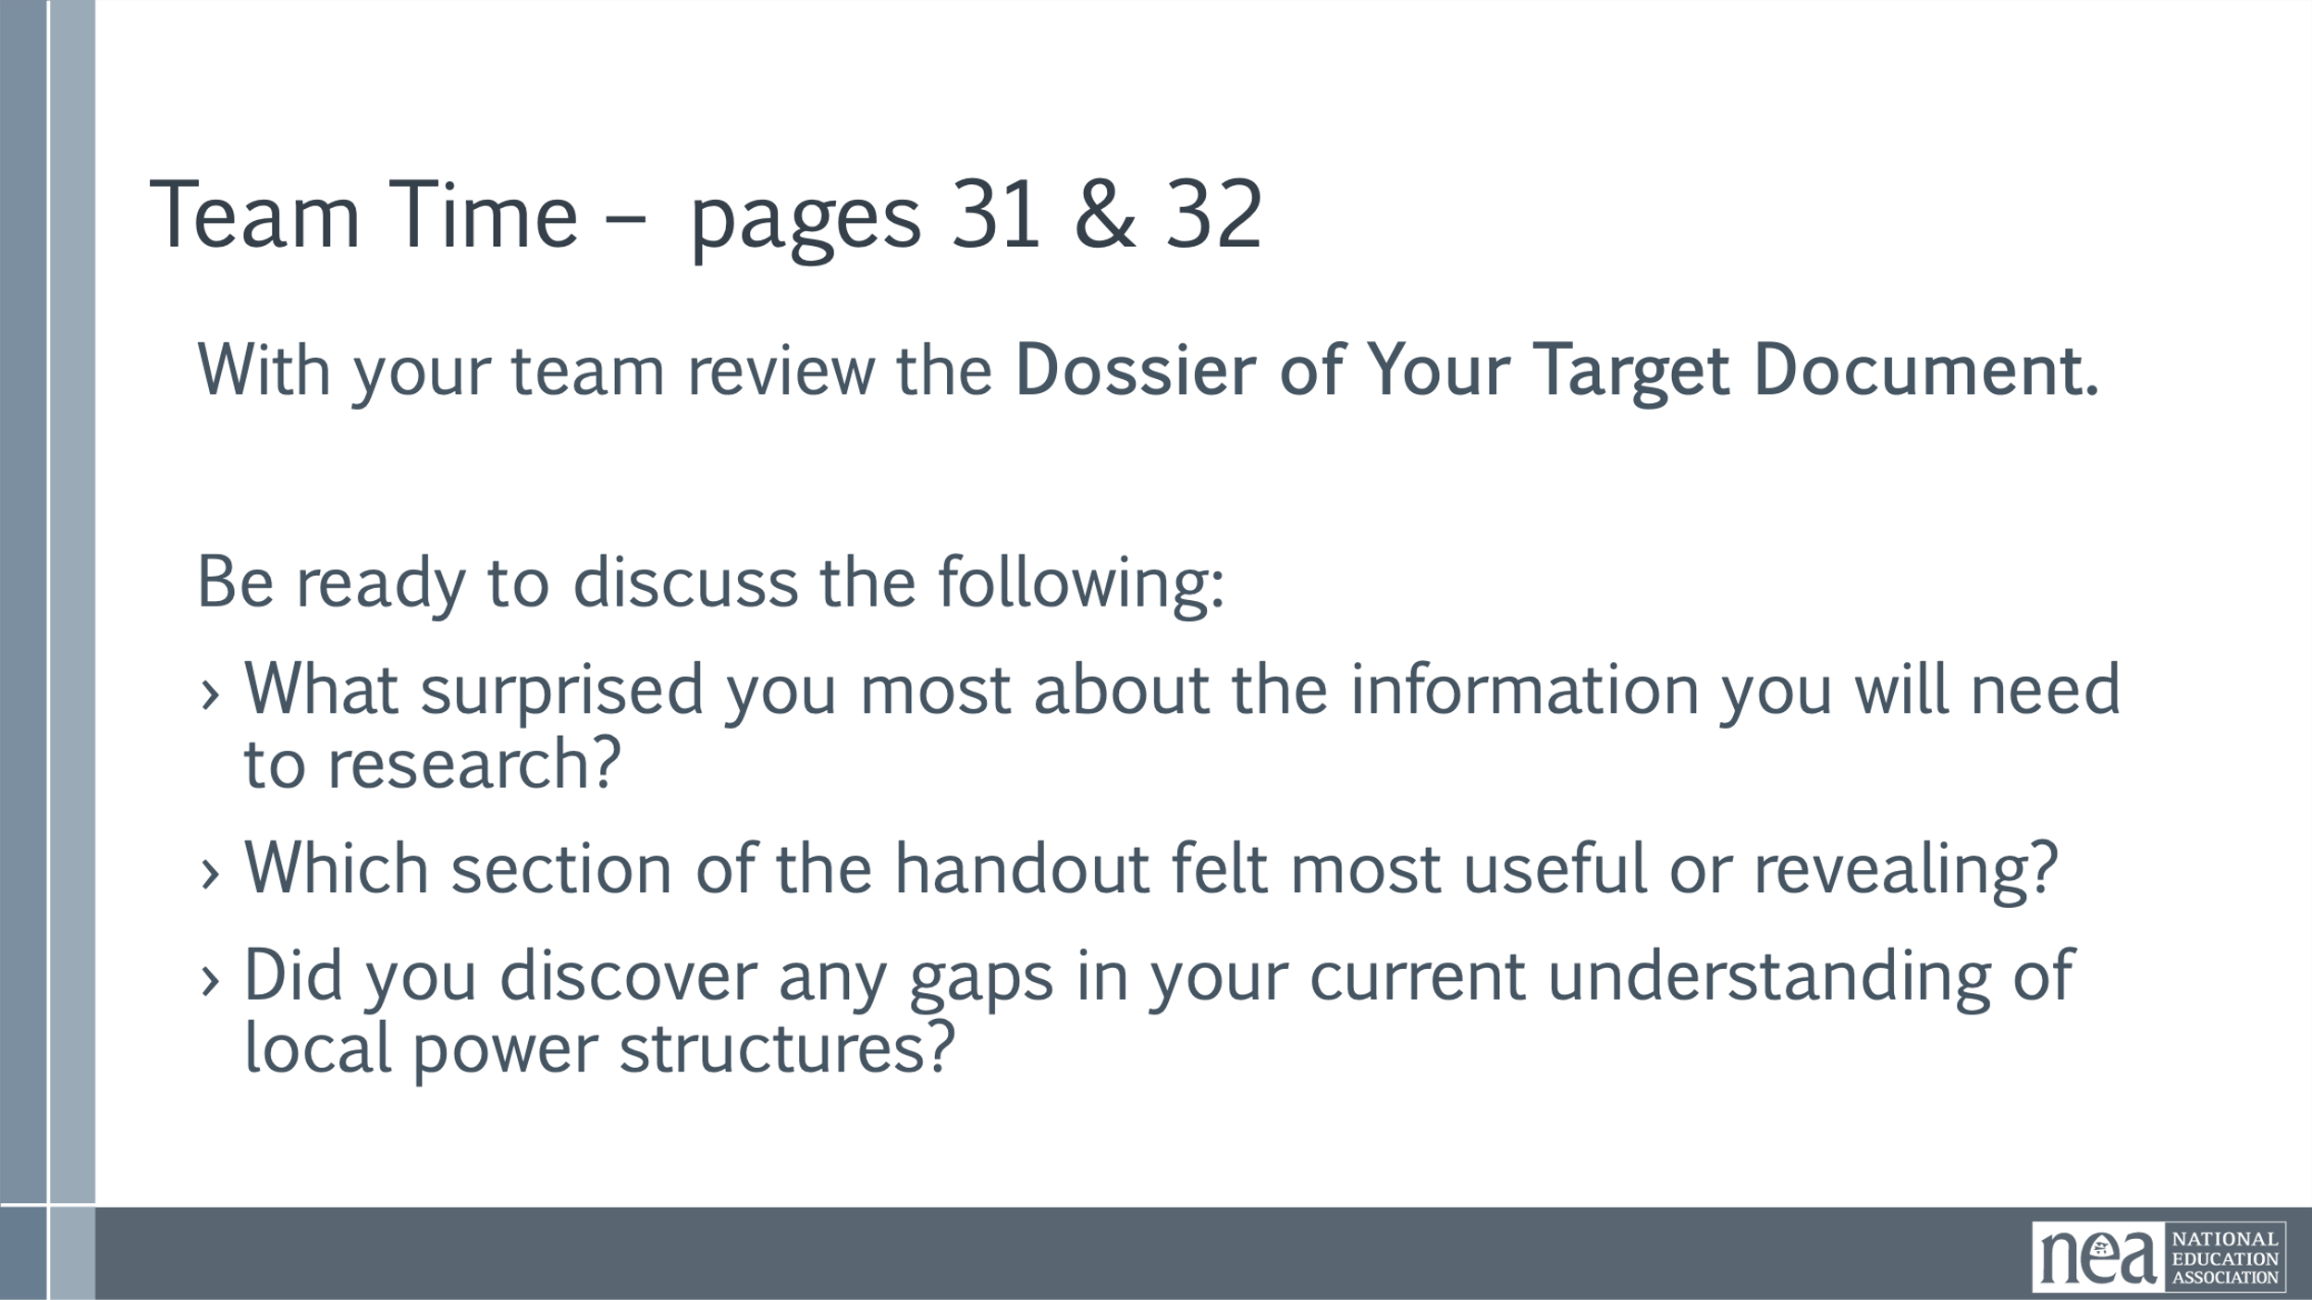  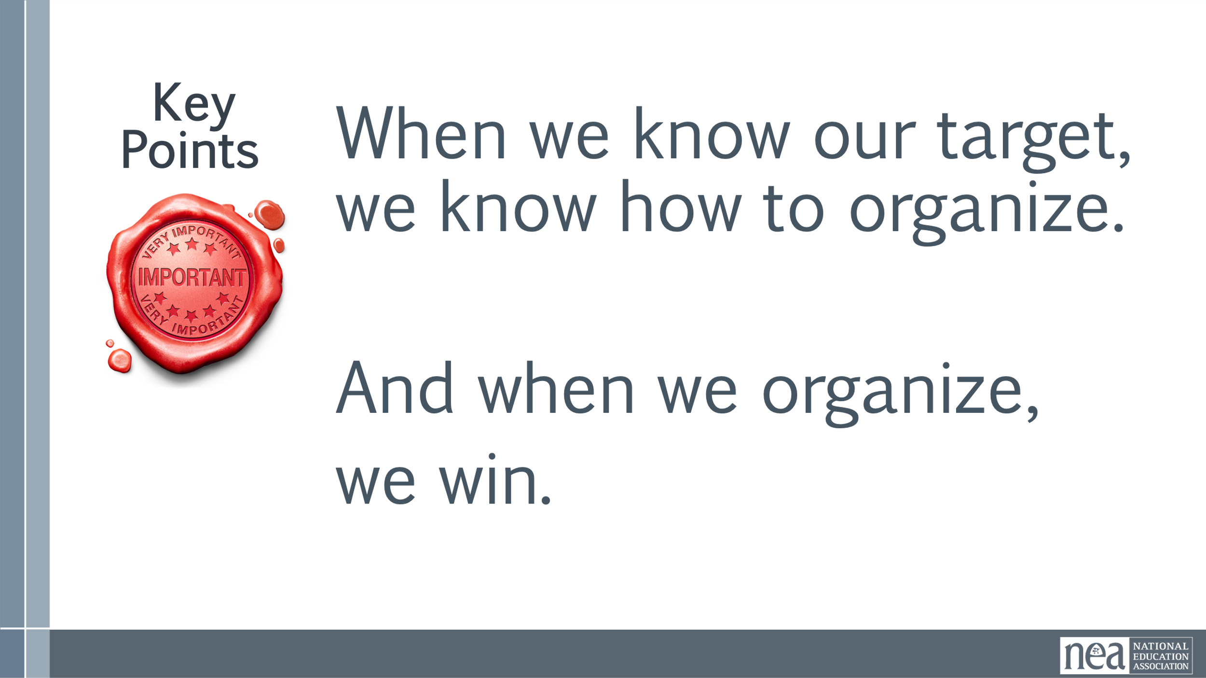 | USE DOSSIER Handout | Prepare 7 charts and place them around the room  - Institutional Power and Influence  - Funding and Financial Ties  - Policy History and Public Statements  - Community impact and demographics  - Local Institutions and Networks  - Personal Background and affiliations  - Local Intel and Relationships  7 Minutes of Content  We are going to talk about one of the most powerful tools in our organizing toolbox: research. Not just any research—strategic, targeted, and relentless.  Because when we know who we’re up against—whether it’s a superintendent, a school board chair, or a department head—we know how to win. We don’t organize in the dark. Every campaign we run—whether it’s for better pay, safer schools, or stronger contracts—depends on knowing who holds the power and how they use it.  Research isn’t just about facts. It’s about finding leverage. It’s about understanding what makes our targets tick, and how we can make them move.  There are sevens areas we suggest you spend time researching your target.  - Institutional Power and Influence  - Funding and Financial Ties  - Policy History and Public Statements  - Community impact and demographics  - Local Institutions and Networks  - Personal Background and affiliations  - Local Intel and Relationships  Let’s talk about each of them briefly.  Institutional Power and Influence  We need to know who has formal authority—and who has informal influence. Understanding both types of power helps us identify the real decision-makers and the pathways to influence them. This foundational step ensures our campaigns are directed at the right targets and that our strategies are grounded in the actual dynamics of local governance.  Funding and Financial Ties  Money talks - Follow the money to understand loyalty and pressure points. Financial relationships often reveal hidden agendas and can be used to expose vulnerabilities or influence decision-making. By analyzing these ties, organizers can uncover leverage points and build narratives that resonate with stakeholders and the public.  Policy History and Public Statements  We use this to hold them accountable and to anticipate their moves. Understanding a decision-maker’s policy history and public engagement helps us craft targeted messaging and anticipate resistance. It also allows us to highlight inconsistencies or failures, strengthening our campaign’s credibility and urgency.  Community impact and demographics  This helps us understand who we’re fighting for and how to mobilize them. Demographic analysis reveals the social and economic context in which decisions are made and helps identify potential allies and constituencies. It also informs outreach strategies and ensures that campaigns are inclusive and representative of the communities most impacted.  Local Institutions and Networks  Mapping institutional networks helps us understand the broader ecosystem of influence and identify strategic partners. It also reveals potential pressure points and opportunities for coalition-building, which are essential for scaling our campaigns and amplifying our impact.  Personal Background and affiliations  Personal research helps humanize the target and uncover motivations that may not be visible through institutional analysis. It also provides material for storytelling and public engagement, which can be powerful tools in shifting public opinion and applying pressure.  Informal intelligence gathering fills in the gaps left by public records and formal research. It provides context, nuance, and actionable insights that can make or break a campaign. Building trust and maintaining these relationships is key to sustaining long-term organizing efforts.  18 mins Activity:  Have the participants count off by seven. Send them to one of the seven charts based on their number - 1’s go to Institutional power, 2’s go to Funding etc.  With your group identify the research work that would need to be done in this category. What questions should you be asking and working to answer? What documents would you collect, who would you talk to.  Give the participants 2 mins at each chart and then have them rotate to the next chart – adding only what they think has been missed.  5 mins Debrief: Gallery Walk  Have all the participants walk around the room and take note of what you see on the charts.  After the gallery walk - Debrief:  - What surprised you most about the information you will need to research?  - How do you think this will be useful to you in your campaign?  Point out the Dossier handout in the materials.  - Which section of the handout felt most useful or revealing?  - Did you discover any gaps in your current understanding of local power structures?  As you think about your local structures – where does this fit? Find the people that like to research and put them to work.  During the debrief be sure these points are brought out.  Institutional Power and Influence  They should identify the need to map the power structure in the district. Who makes decisions about staffing, budgets, curriculum, or safety? Is it the superintendent? A board committee? A department director? We need to know who has formal authority—and who has informal influence.  Funding and Financial Ties  Who funds the programs your target oversees? Are they connected to private vendors, consultants, or foundations? Are there contracts or partnerships that reveal priorities—or conflicts of interest?  Policy History and Public Statements  What policies have they pushed? What decisions have they made that impacted educators or students? What have they said in public forums, interviews, or board meetings?  Community impact and demographics  Who is affected by their decisions? What communities are being served—or underserved? We look at race, income, language, housing, and education levels.  Local Institutions and Networks  Power lives in institutions. Churches, schools, community centers, advocacy groups. Who does the decision-maker collaborate with? Who do they listen to? Who endorsed them or supports their leadership? This is where we find allies—and opponents.  Personal Background and affiliations  We’re not just researching a role—we’re researching a person. What’s their background? What boards do they sit on? What organizations are they affiliated with? What motivates them? What are they trying to protect—or hide?  Local Intel and Relationships  Talk to people. Always. Staff, union members, community leaders, journalists, even former colleagues. This is where you get the real story—the relationships, the grudges, the pressure points. This is gold.  This isn’t just research—it’s resistance. It’s how we build campaigns that win. So let’s commit to doing the work. Let’s build dossiers that expose power and build people power. Because when we know our target, we know how to organize. And when we organize, we win. This final message reinforces the strategic importance of research in organizing and calls for collective action. It frames research as a tool of empowerment and a pathway to justice, aligning with the values and goals of labor activism.  Discuss how would you track the data.  Key Points  When we know our target, we know how to organize.  And when we organize, we win. | Participants will understand that research must be a critical part of their campaign. It is a key leadership role and it helps to define the structures needed to win.
2:00-3:10 | Vanessa | 55 Minutes Organizer Math (+ 15 min break)  The break will need to be taken during this content but depending on the adjustability of the break we have left that up to the presentation team.
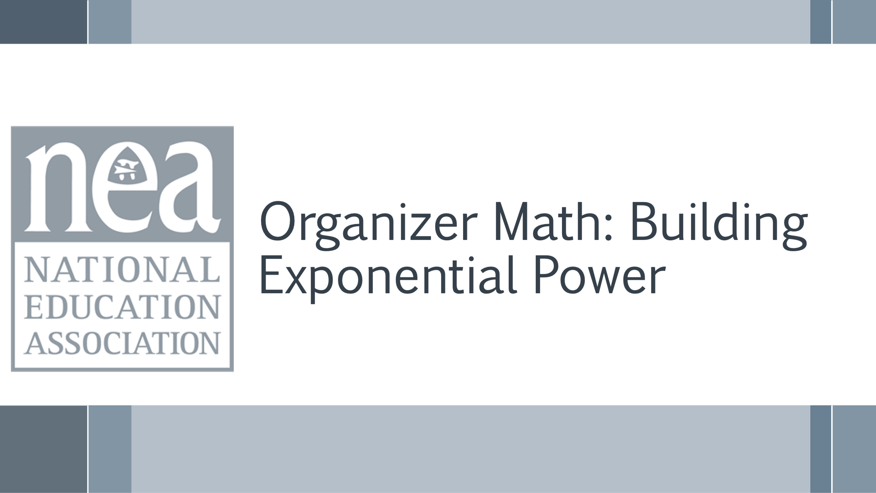  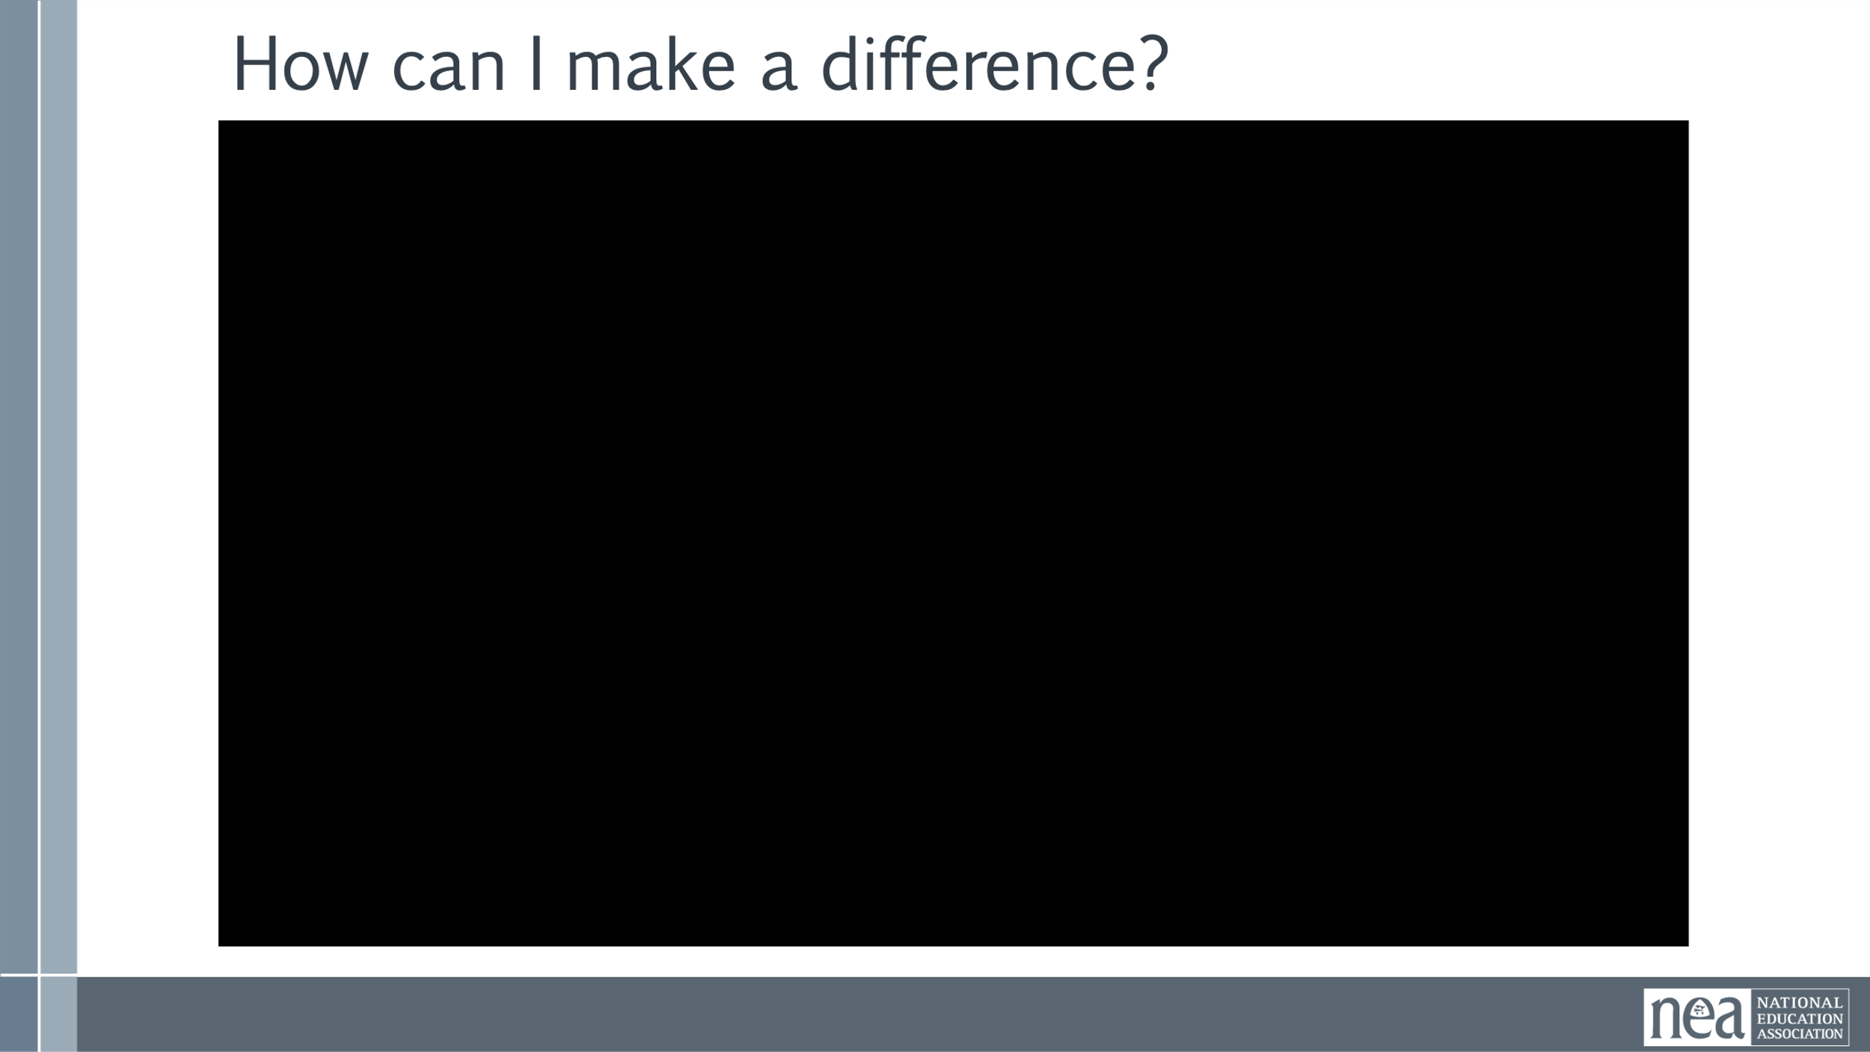  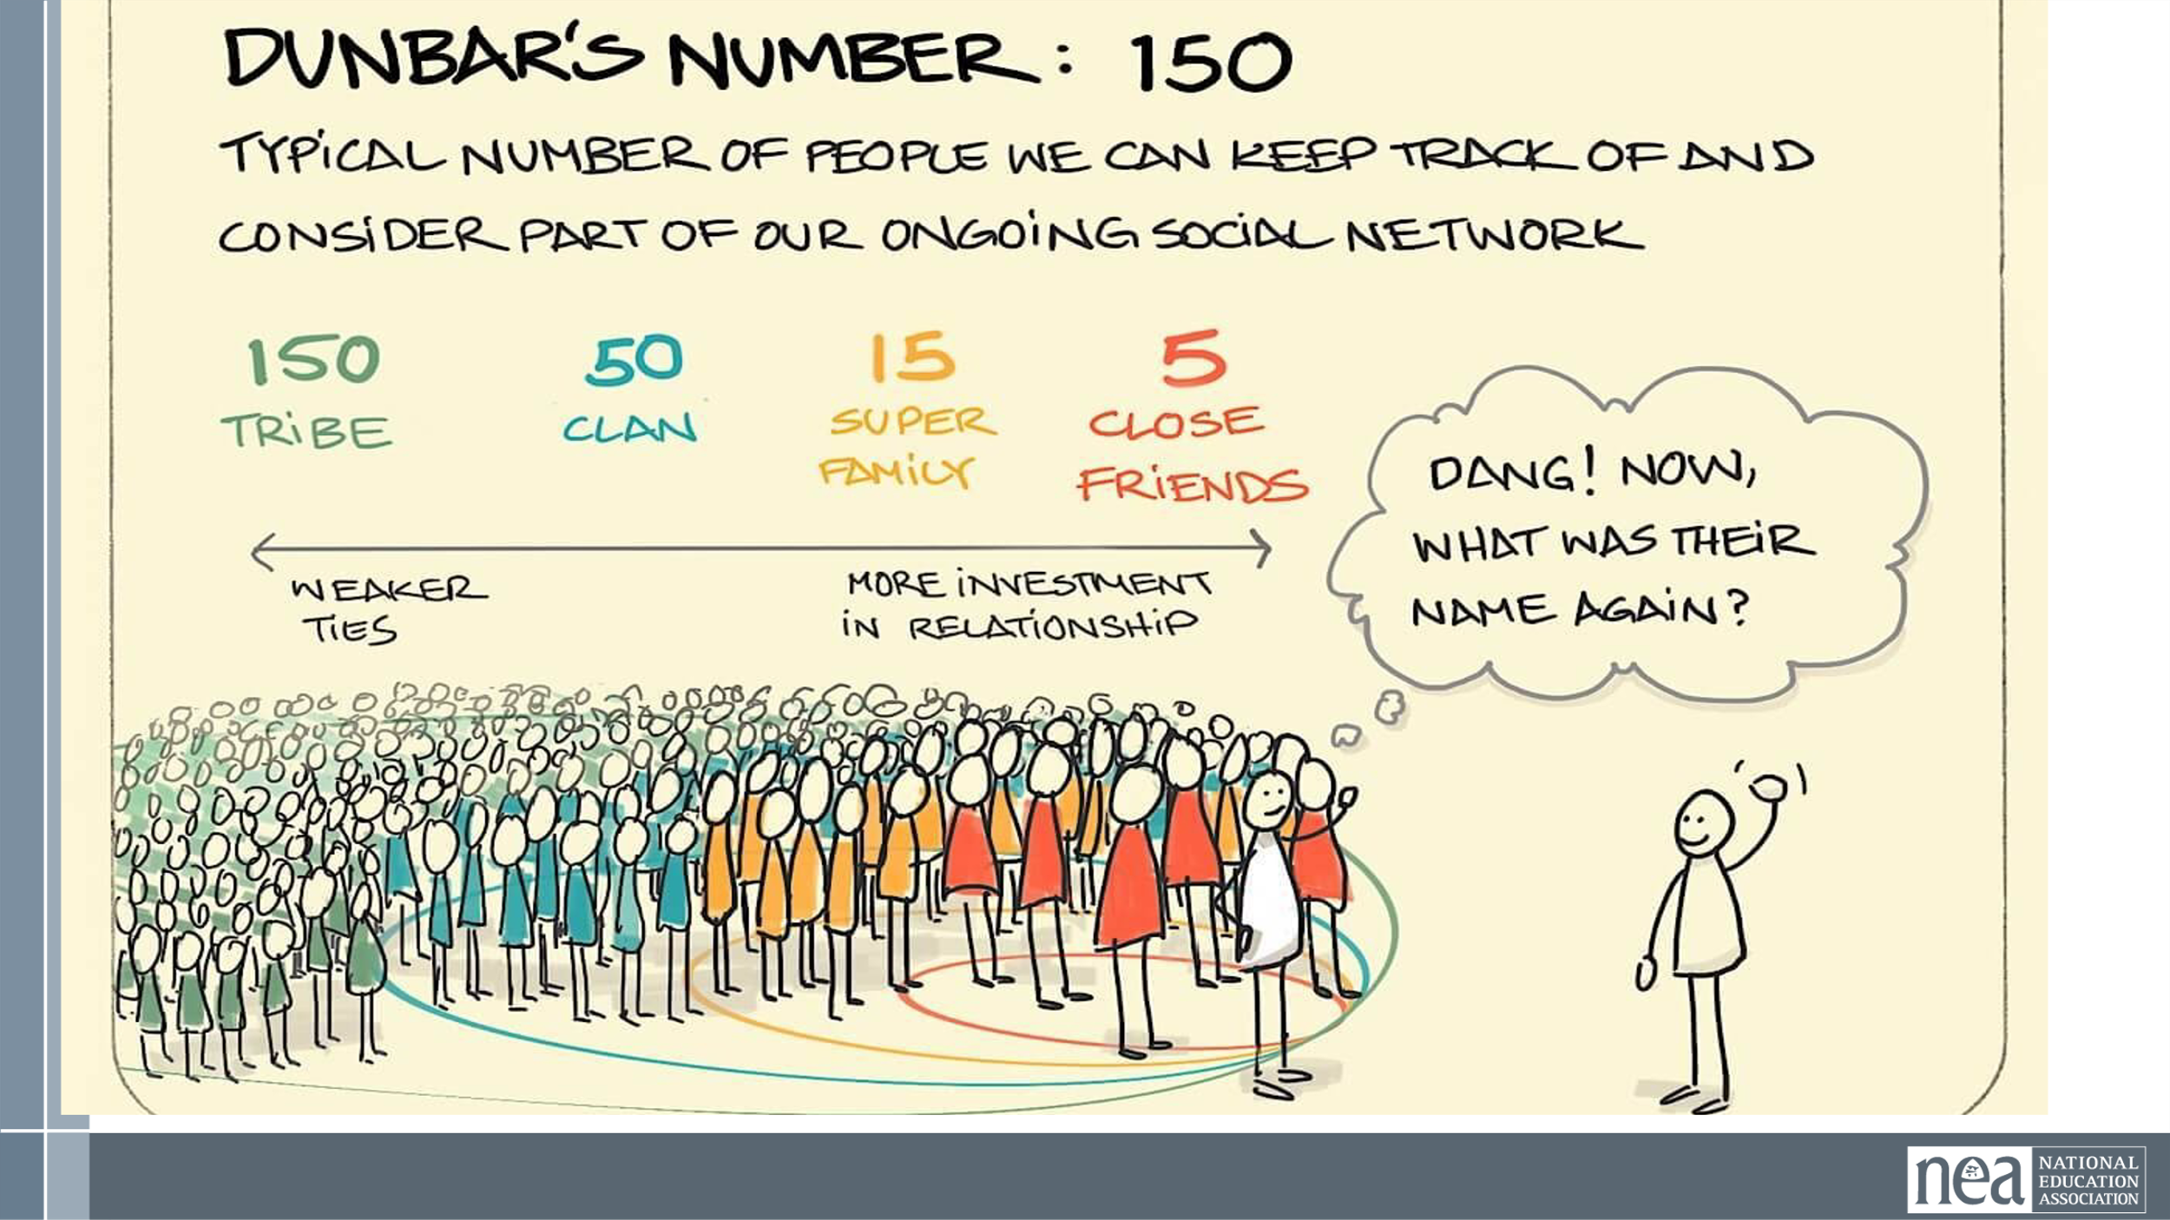  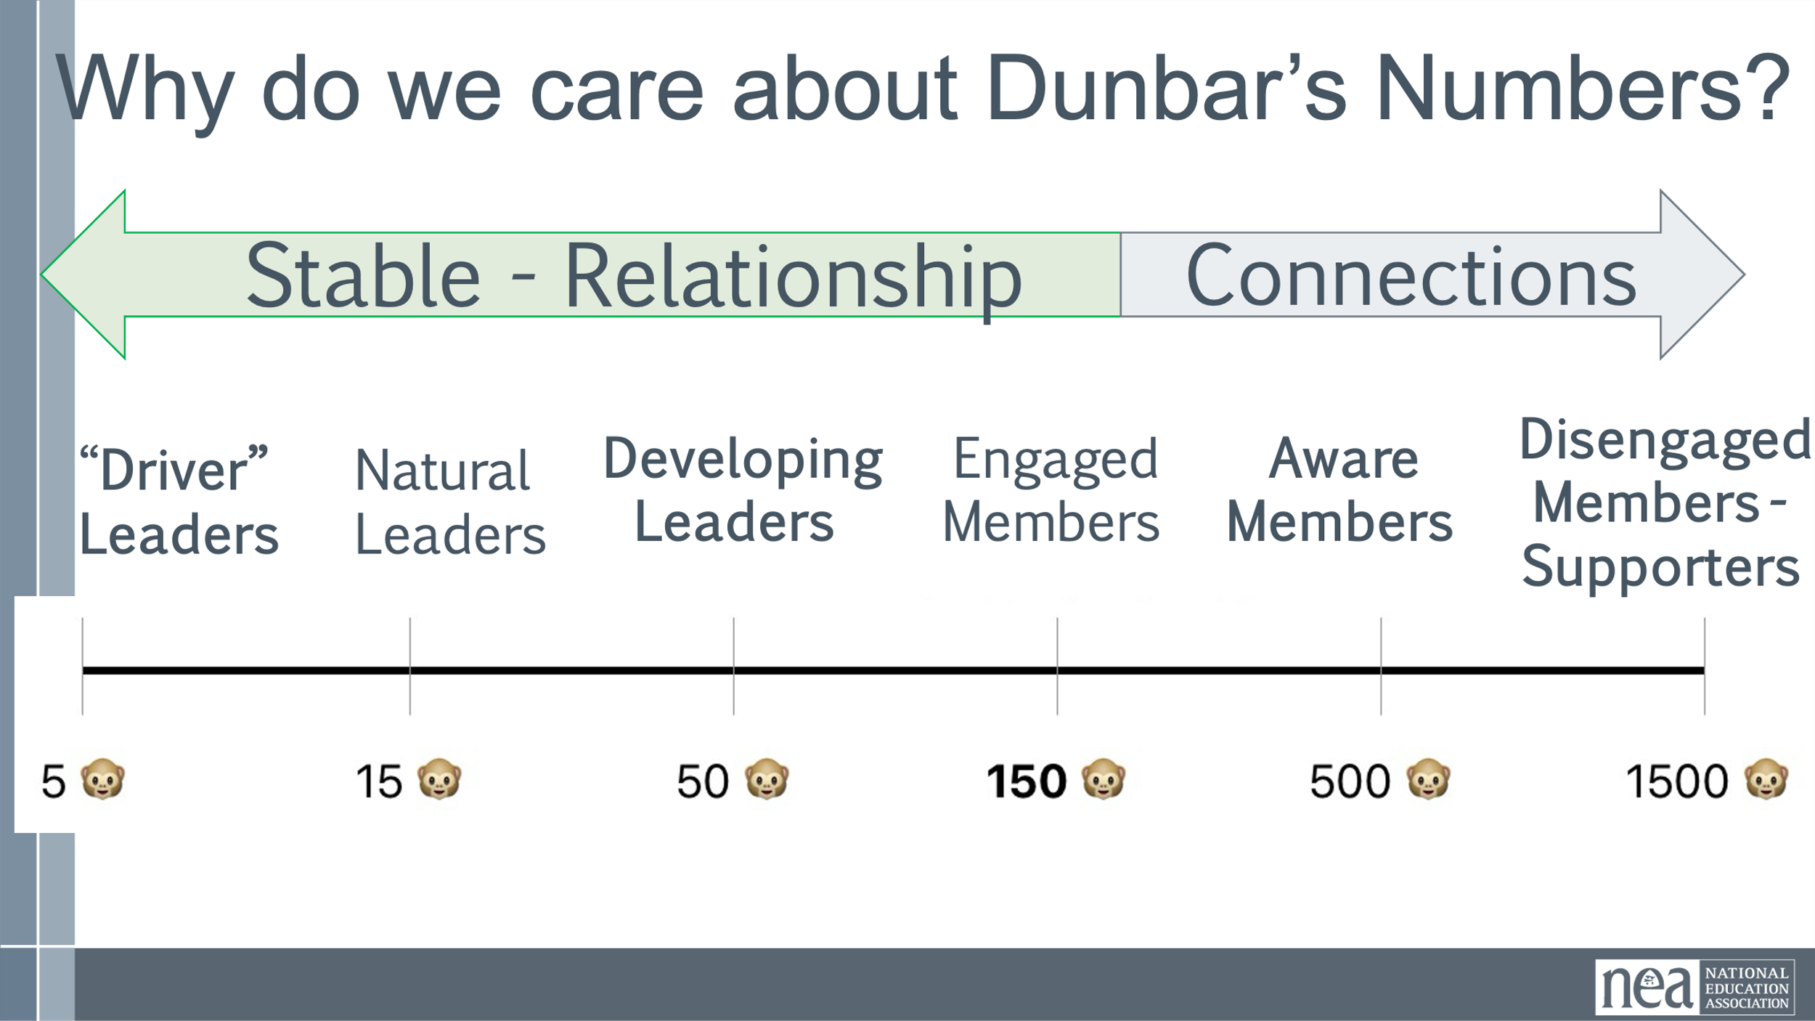  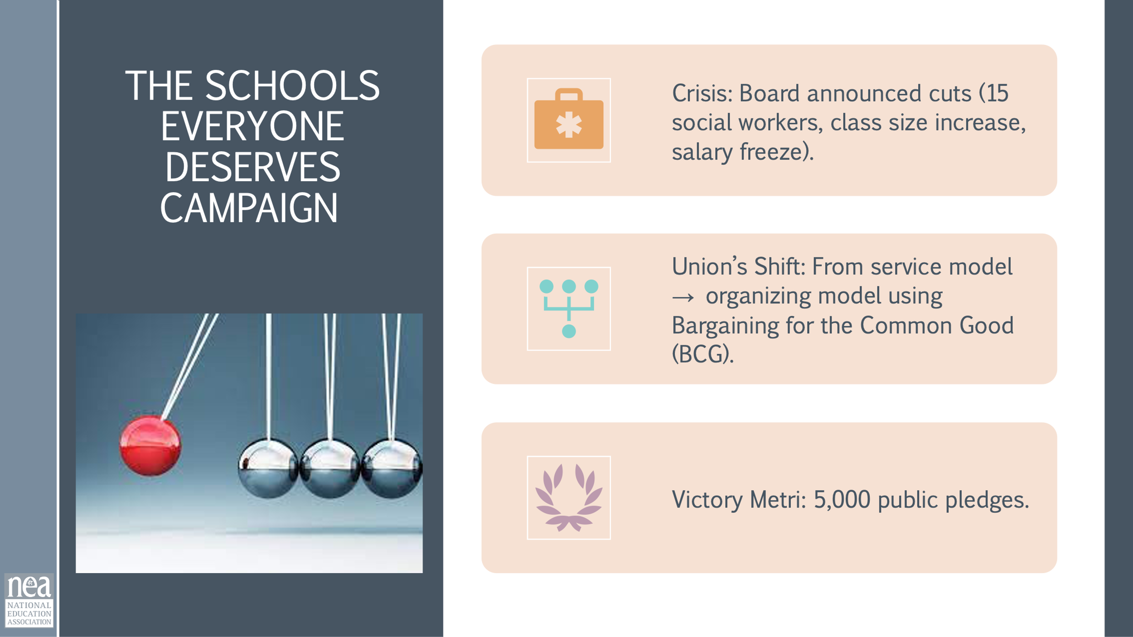  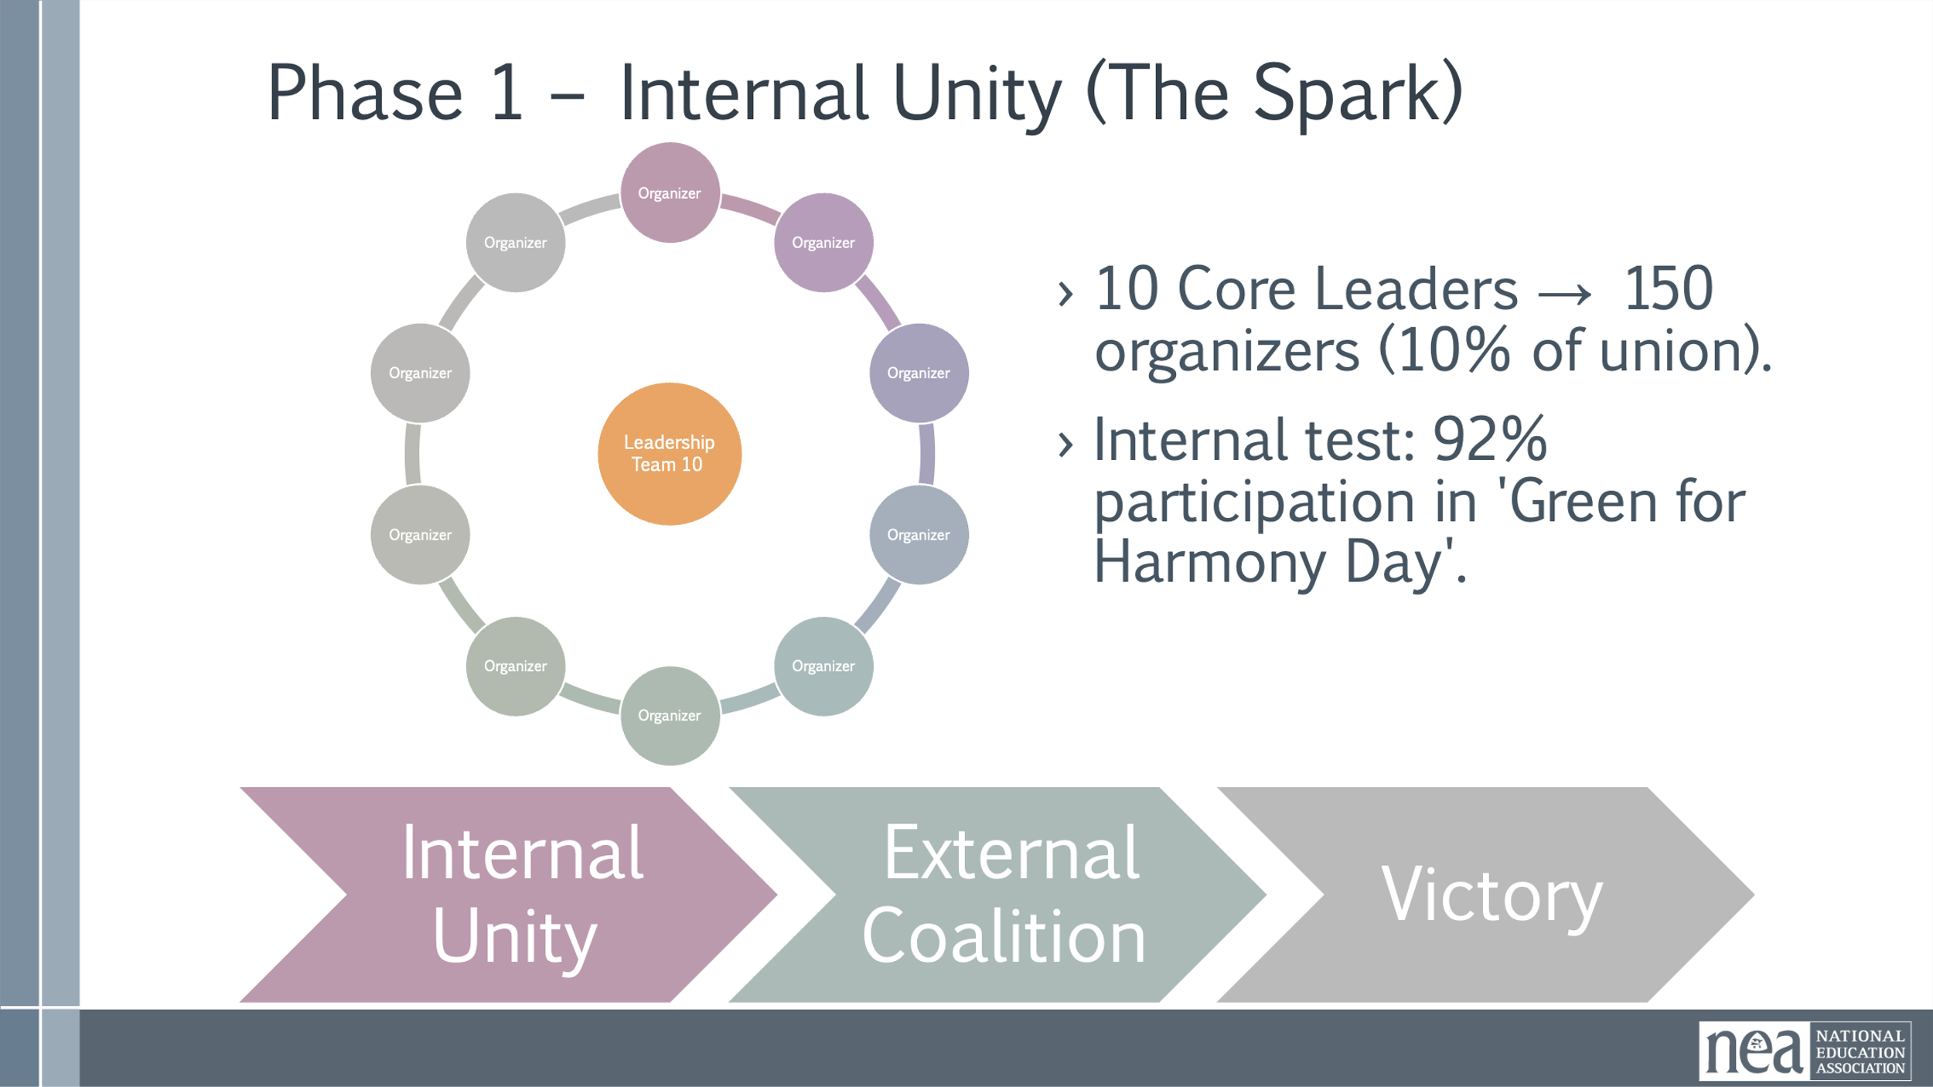  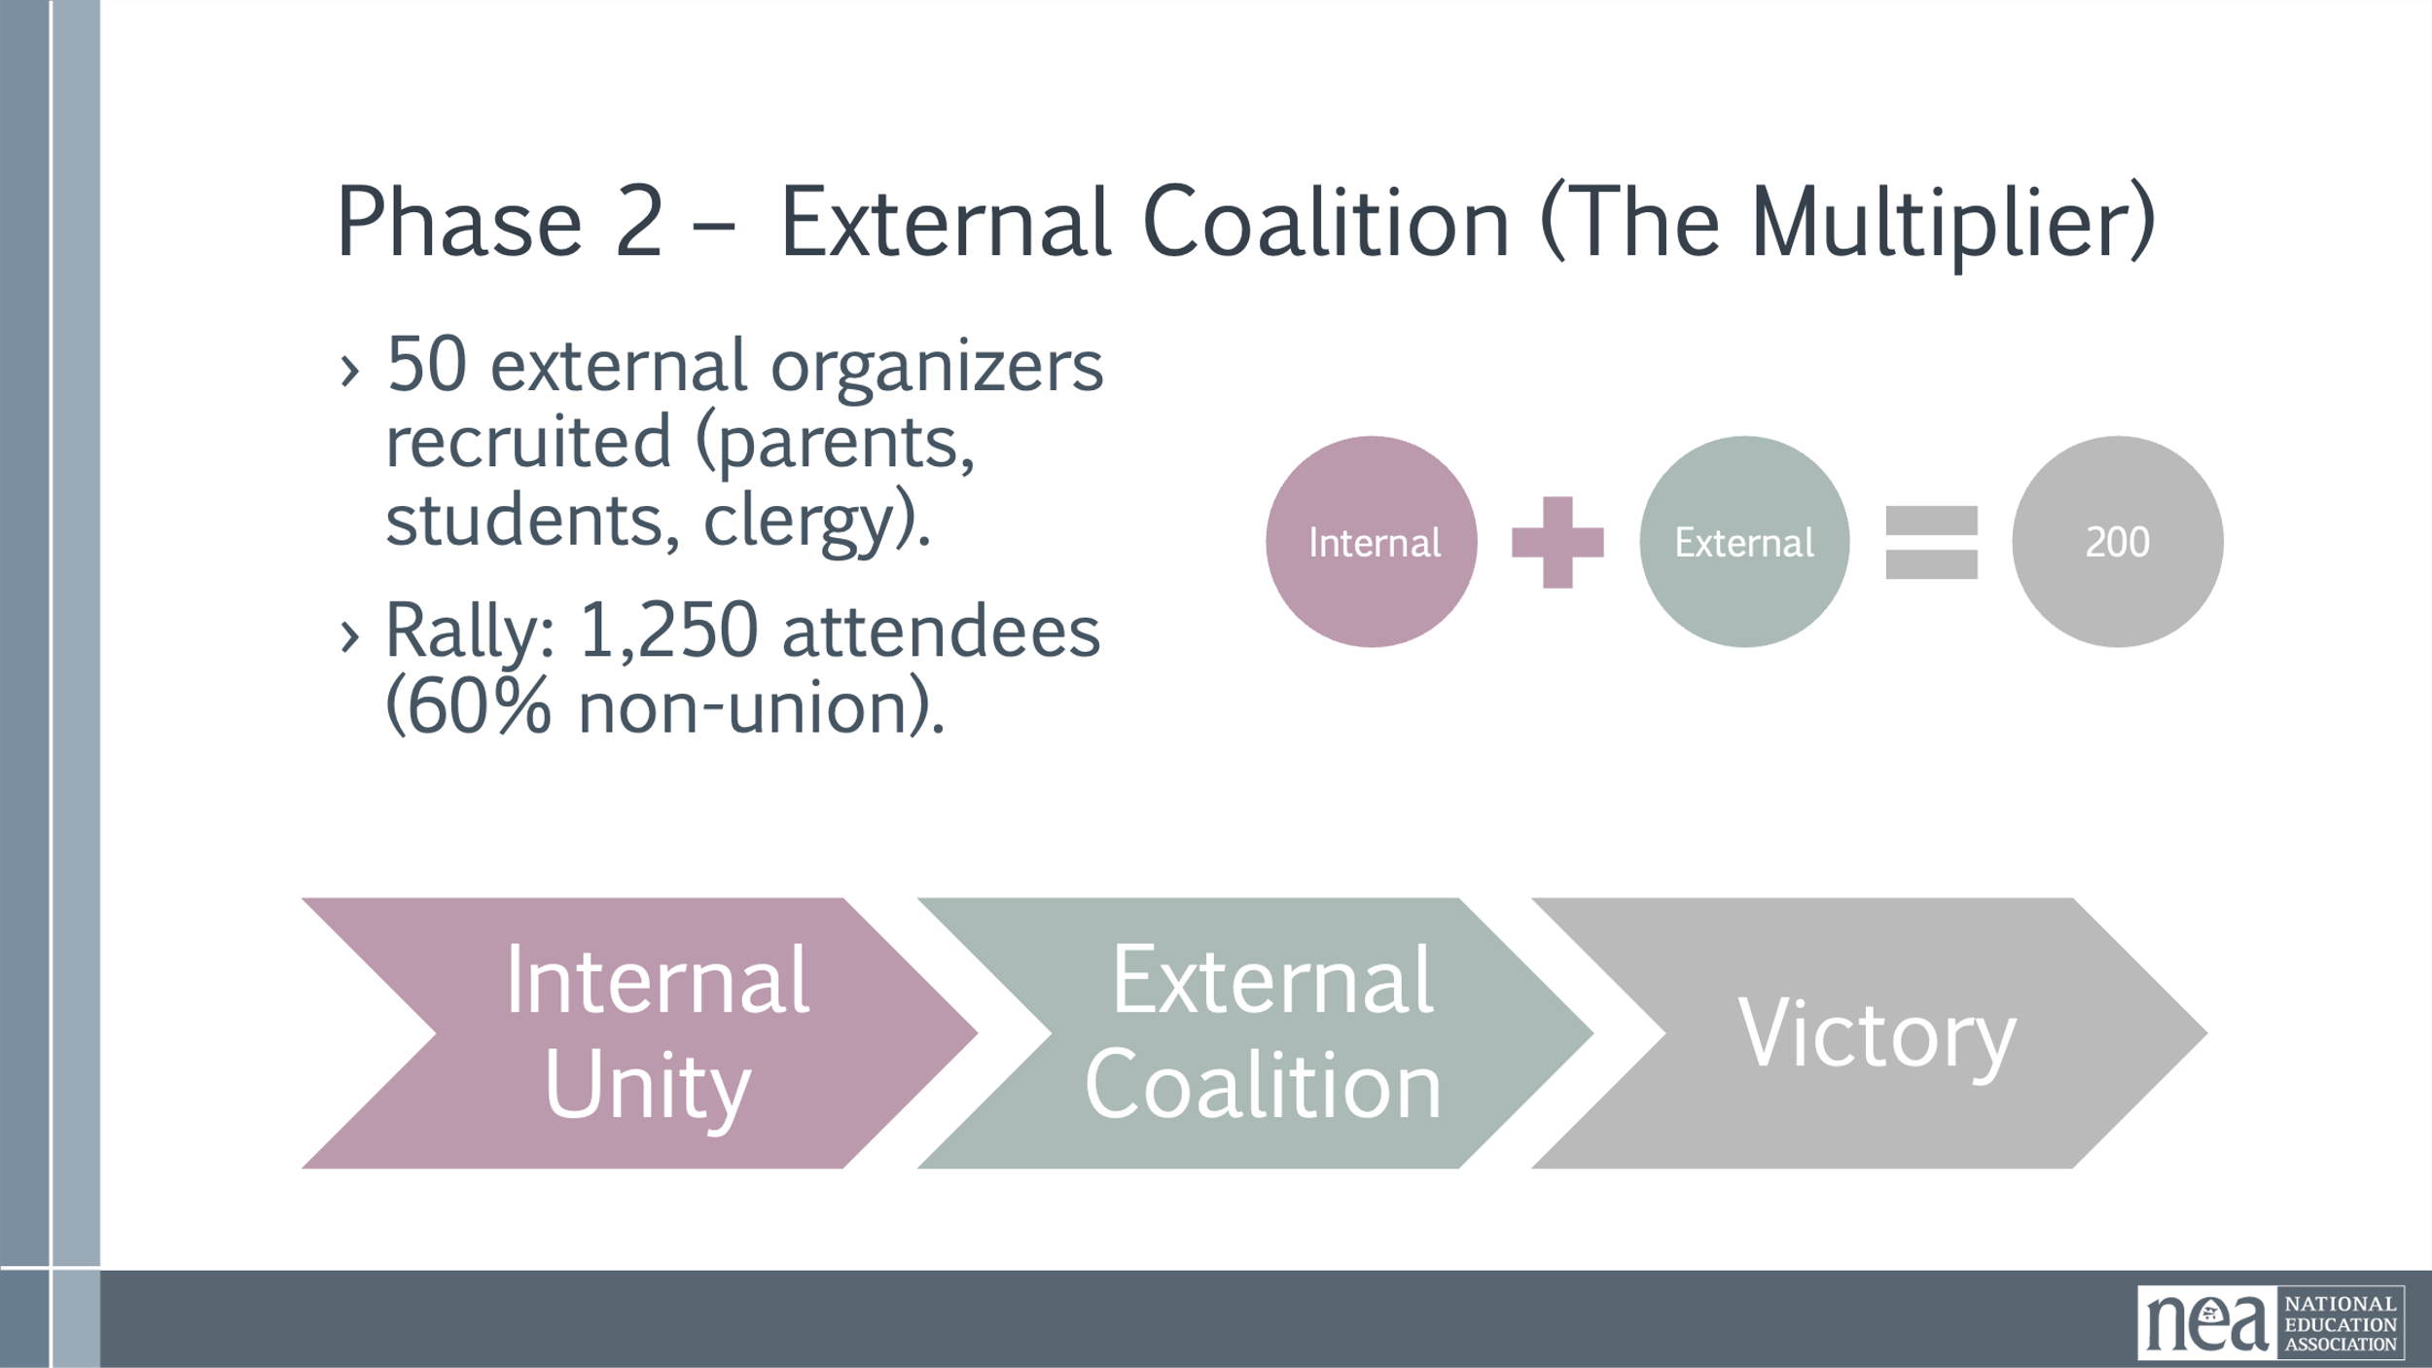  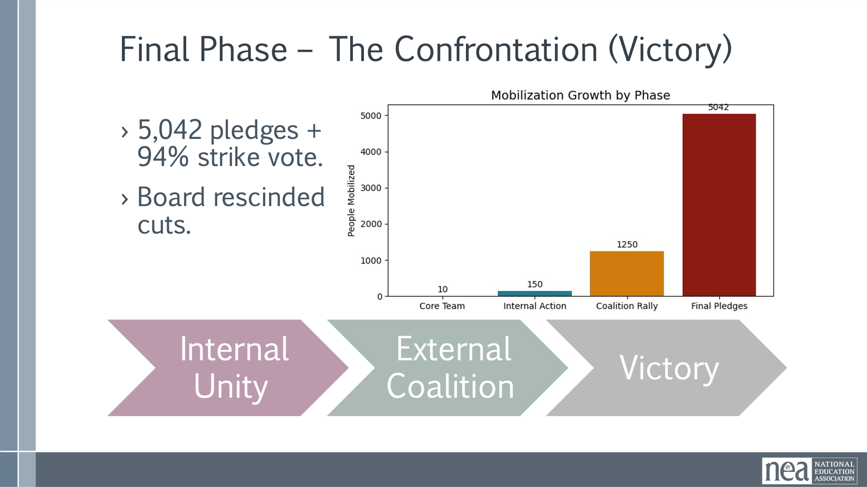  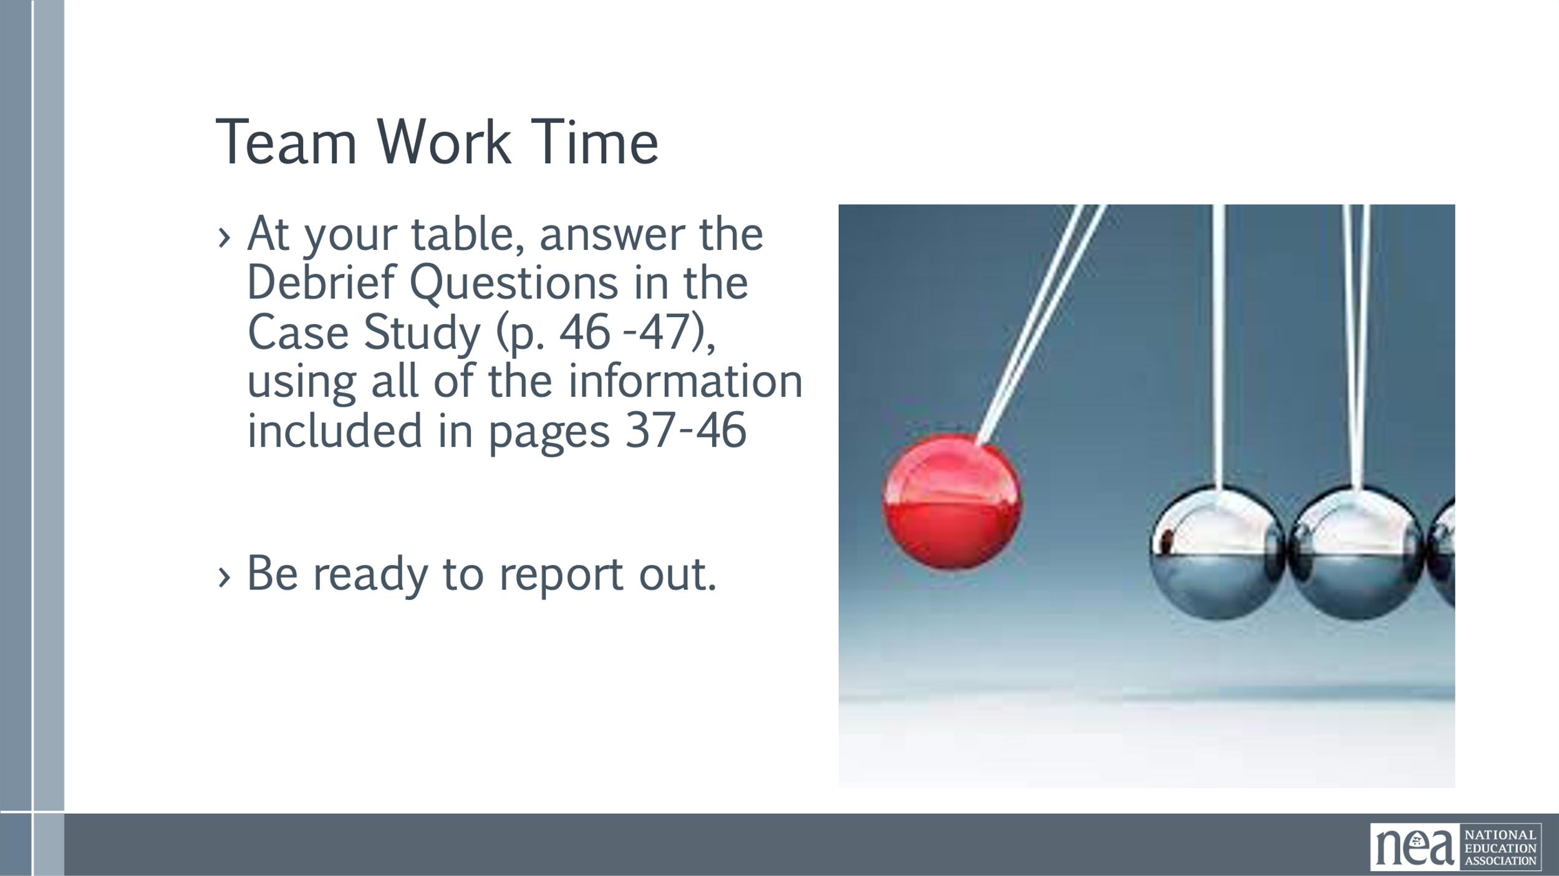  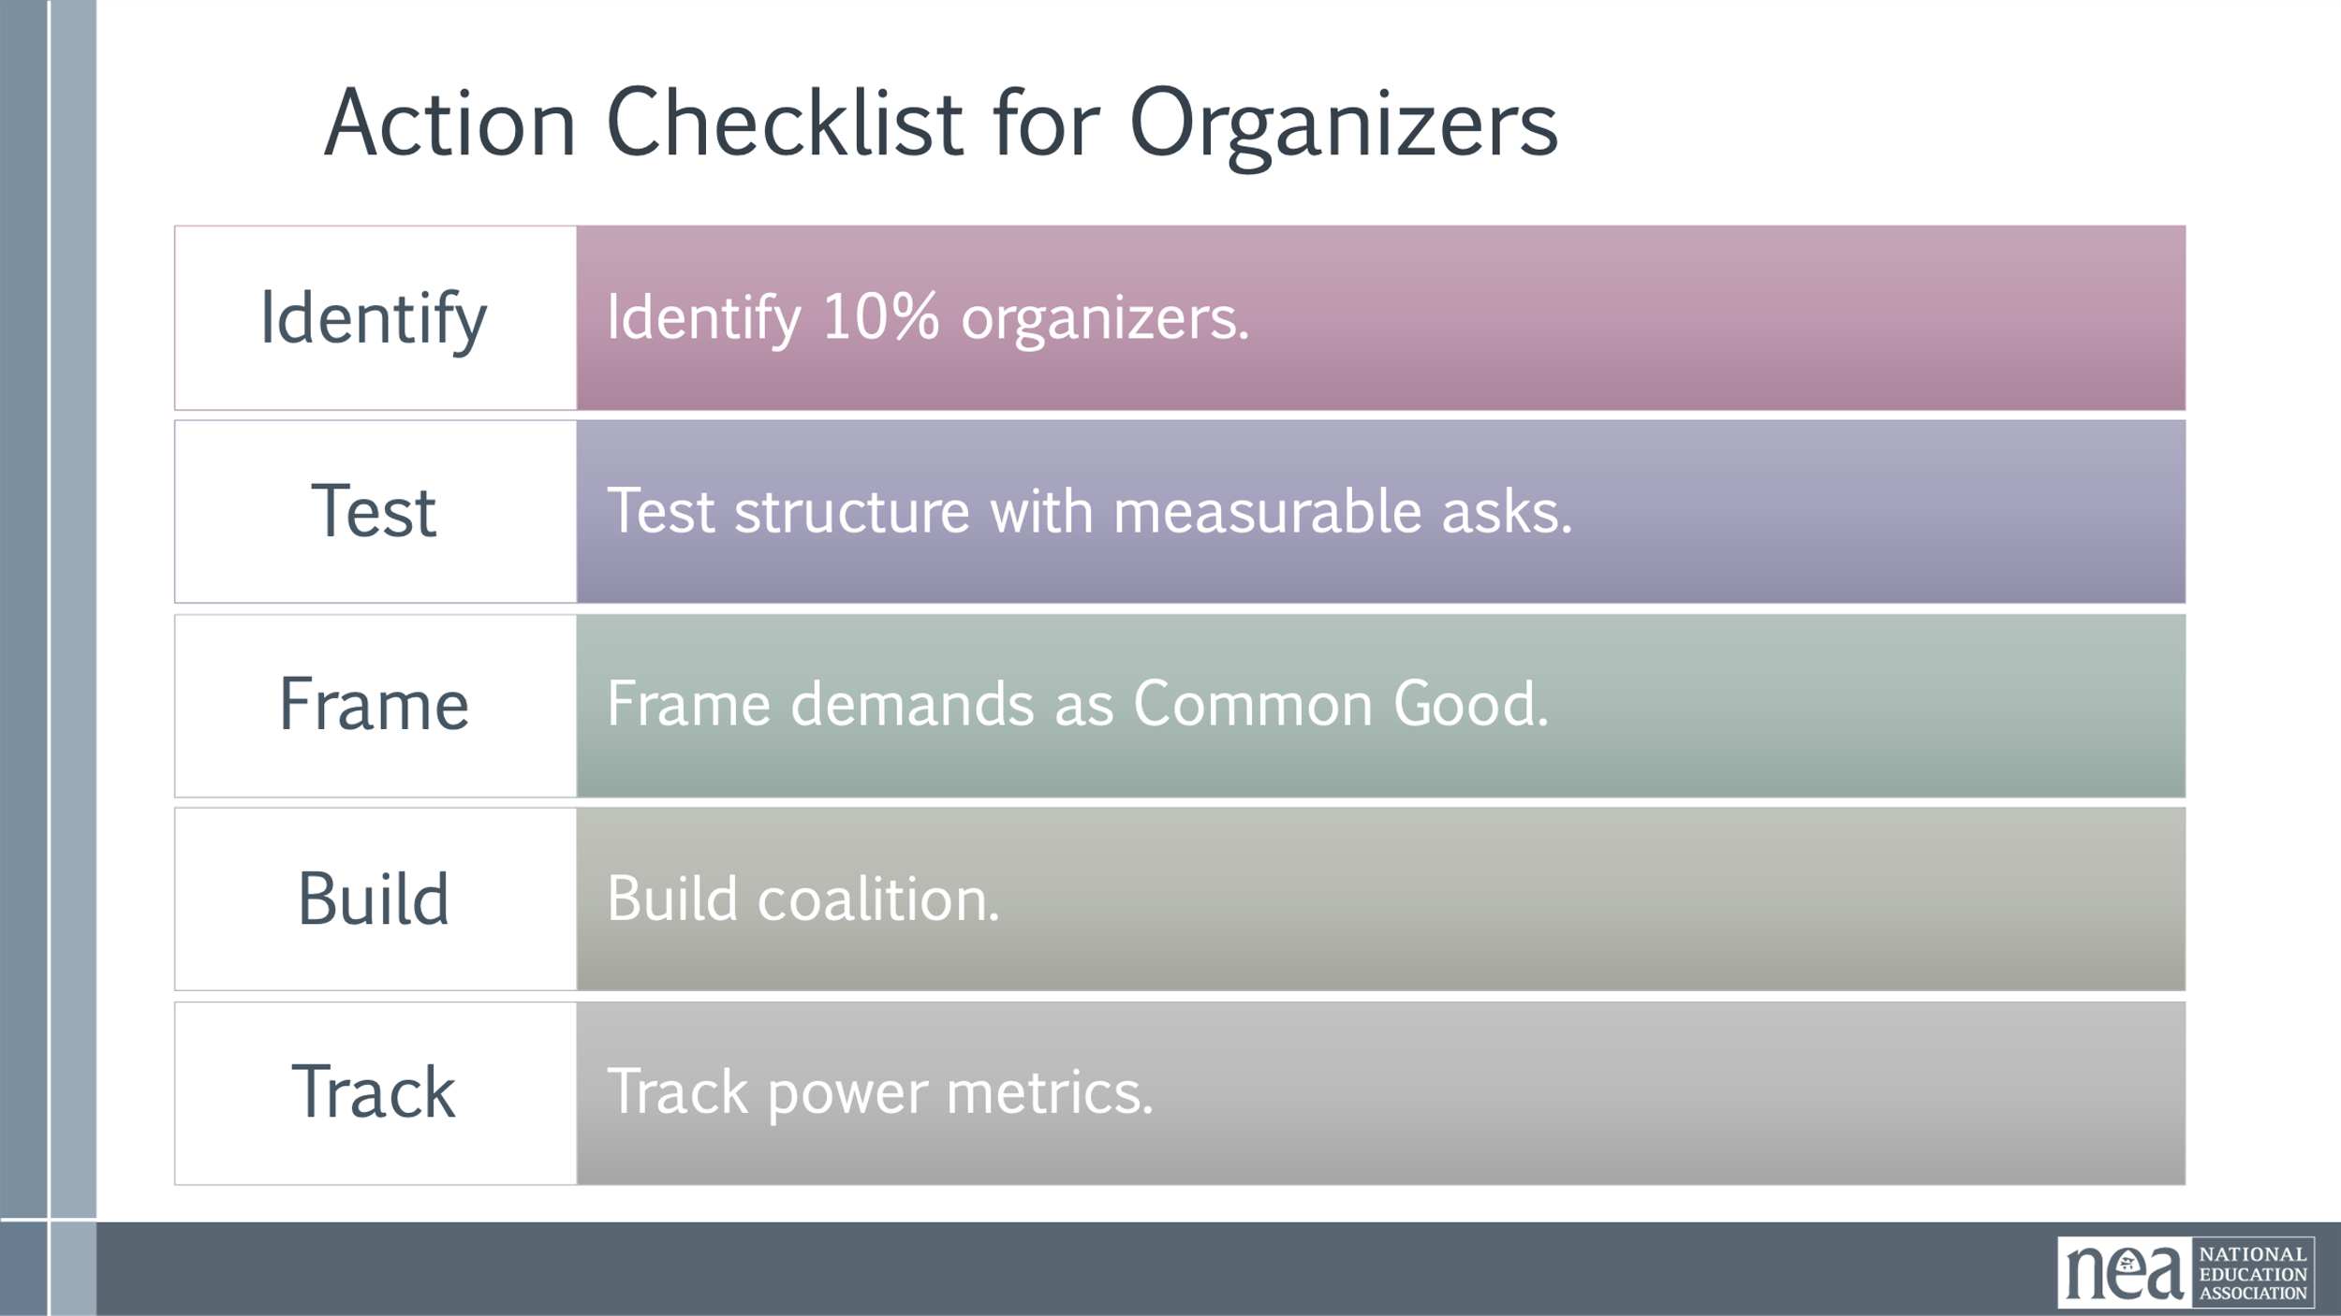 | Dunbar’s Numbers Content  Case Study of Organizer math | 15 Minutes Intro and Content –  How does one person topple the target?  Show video  What does this have to do with building structures and power in a campaign?  Dunbar's number is the cognitive limit to the number of people with whom an individual can maintain stable personal relationships, generally cited as approximately 150 people.  Challenges of Growth Beyond 150  Once a group surpasses 150 members, the reliance on informal bonds and peer pressure to maintain cohesion begins to fail, leading to:  - Loss of Solidarity: The sense of common purpose weakens as members can no longer know everyone personally, making it harder to build deep trust and kinship required for collective action.  - Weakened Communication: Communication shifts from fluid and informal to more structured and formalized, which reduces face-to-face interaction between general members and leadership.  - Need for Formal Structure: A more formal, hierarchical management structure becomes necessary to maintain organization.  Why do we care about Dunbar’s Numbers? Because it is all about the intersection of continual base building that leads to BOTH membership density and power. At a density of 50% +1, a local keeps lights on, but if you are not at 80% or greater of engagement then you are not building power  Anything beyond the 150 is why we need BOTH leaders and structures.  Scenario Summary  IN phase 1 we are building internal union. The goal is for 10% of the union to be engaged. 10 core Leaders each worked with 15 Organizers getting 150 people engaged in a leadership structure. The big test way to get 92% participation in Green for Harmony Day.  Stress importance of structure tests and supermajority commitment before going public. This phase builds internal strength.  IN phase 2 of the campaign, they moved to external work and that is the real power multiplier. They recruited 50 external organizers that shared their values through a framing that encompassed bigger shared interests. This framing helps bring more and more people in. The internal numbers, plus the external numbers resulted in a rally lf 1250 attendees where 60% are non union  The overall outcome – the measurable part of the win – was to get 5042 pledges – a 94% strike vote.  This internal and external pressure caused the board to rescind the cuts. Emphasize measurable commitment as ultimate power metric. Translate numbers into political cost for decision-makers.  15 mins- Teams will use the scenario worksheet and the answers that they developed as pre work to apply to their own campaign.  20 mins- Now, lets apply this to your campaigns. Here is a checklist for building leaders and structures that exponentially grow your campaign.  Provide practical steps for replication. Encourage organizers to apply these immediately in their campaigns  5 mins  Key points –  Power is not what you have, but what you can mobilize.  Organizing success depends on measurable commitment, not just membership size. | Participants will understand the actual number of people needed in order to pull off a final outcome.
2:30-2:45 BREAK (The break will fall in the middle of the previous content)
3:10-4:10 | Dr. Taraja | 60 Minutes Ladder of Engagement
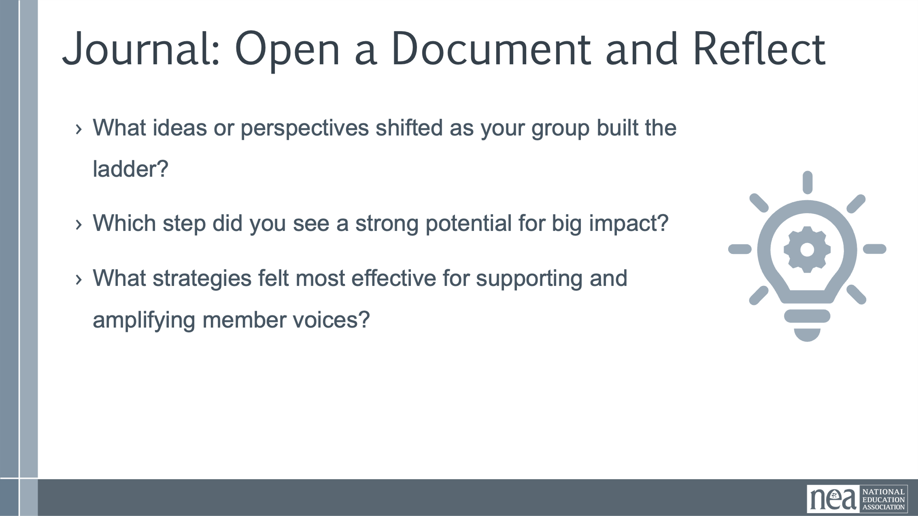 | Ladder of Engagement Handout | Introduction and Content: 30 minutes  Welcome to the “Stories That Lift Us” ladder activity. This guide is designed to support facilitators as they lead participants through a creative planning session for a book giveaway and storytelling event. The goal is to engage union members and community leaders in actions that uplift diverse voices and build collective power.  Participants will work in small groups to fill out a five-rung ladder, mapping out member activities, leadership support, and communication strategies for each stage of engagement. Use the prompts and examples below to guide discussion and inspire ideas.  After each step on the ladder, groups self-identify what that step has looked like (or could look like) in their local. Have them write down a couple examples on post-it's that fit the step for their local. DO NOT HAVE THEM SHARE THESE OUT (yet)!!  Spotting the Ladder  Description: Spark curiosity and introduce the campaign in a low-barrier way.  • Member Activity: Distribute flyers, post on social media, or start casual conversations about the book giveaway.  • Leadership Action: Create and share messaging materials; encourage leaders to model excitement and curiosity.  • Communication Method: Use posters, email blasts, and informal chats to raise awareness.  Gripping the First Rung  Description: Invite members to take a simple action to show interest.  • Member Activity: Sign up to donate books, RSVP for the event, or complete a short interest survey.  • Leadership Action: Provide sign-up sheets and digital forms; personally invite members to participate.  • Communication Method: Send targeted texts or emails and make announcements at meetings.  Climbing with Purpose  Description: Build momentum and visibility through collective action.  • Member Activity: Help sort books, prepare story-sharing materials, or invite others to attend the event.  • Leadership Action: Coordinate logistics, organize prep sessions, and support team collaboration.  • Communication Method: Share updates via group chats, social media, and printed schedules.  Standing Steady  Description: Deepen commitment by taking on leadership roles.  • Member Activity: Volunteer to lead a book table, facilitate story circles, or join the planning team.  • Leadership Action: Mentor new volunteers and delegate responsibilities to build ownership.  • Communication Method: Hold planning meetings and use collaborative tools like shared docs or group texts.  Reaching the Top  Description: Empower others and sustain the movement.  • Member Activity: Mentor new leaders, organize future giveaways, or speak publicly about the campaign.  • Leadership Action: Celebrate successes, document stories, and create pathways for continued engagement.  • Communication Method: Use newsletters, public speaking opportunities, and social media storytelling.  Gallery Walk  Notice there are signs around the room that say  Step 1 Spotting the Ladder  Step 2 Gripping the First Rung  Step 3 Climbing with Purpose  Step 4 Standing Steady  Step 5 Reaching the Top  Have a representative from your team place the examples you have been writing on post-its on the appropriate sign and then return to your table. (give time to do that before giving the next instruction)  Now as a team go to one of the posters, don’t worry everyone will see them all. We are going to do a gallery walk. Take a few moments to read over the examples everyone shared. As a team move to the next sign and repeat until you have seen them all. Once you have seen all 5 steps please return to your table.  Debrief Gallery Walk-  What did you see that struck you?  Did you have any questions after walking around?  Team Time Scenario: 20 minutes (USING HANDOUT) Page 22  Together, you will plan how to engage members and community leaders for an event within your campaign (if you are not at that step yet where you have events in mind for your campaign, use the scenario of engaging members in a book giveaway and storytelling event).  First, identify the event you want to focus on for this engagement activity.  Then, use this ladder to map out actions, leadership support, and communication strategies that build momentum and uplift diverse voices.  Share-Out: 5 minutes  10 Minutes Journal Questions  - What ideas or perspectives shifted as your group built the ladder?  - Which stage did you see a strong potential for impact?  - What strategies felt most effective for supporting and amplifying member voices?  - What’s one action you feel ready to take after this session?  - How can you help others climb the ladder with you? | Participants will understand how to engage the continuum of people inside their campaign to maximize leadership development.  They will develop plans for the people they are working with in their home campaigns.
4:10-4:30 | Ellen | 20 Minutes - Ending it Right
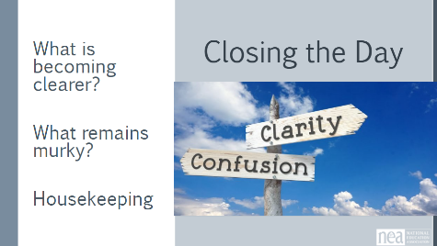 |  | Questions, Connections, Reflections  Housekeeping announcements  Plus/Delta at the Door  What did we do well? Where could we focus more?  FOR TOMORROW – | Participants will be able to bring a little closure to their learning and provide feedback on the day.
4:30 – 5:00 |  | 30 Minutes - Choice Networking Activities –
 |  | This is a time for participants to meet and discuss any issues they are thinking about with other members of the group. This is not led by facilitators and highly encourage to occur in any other space besides the conference room. | Participants will make useful connections with staff from other affiliates.
ADJOURN 5:00

