Facilitator Agenda: Day 3 Making a Plan to Win
General Materials Needed: |  |  |  | Room Set-up: 50 people max
1 Set of Handouts per Person  Name Tents with the Norms  Room signs, Stick on Name Tags  Chart Paper (4 to 5 full w Sticky Strip) |  | Materials Box for each table with:  Markers (Mr. Sketch variety)  Post its – 3x3” and 4X5” sizes  One ream of white photocopy paper |  | No podium, table with projector big enough for laptop  Long Rectangle table at back for facilitators  Round Tables for participants  Projector, Screen, mics, and Speakers  Carousel stations and reporting stations
Key Outcomes for Day 3  Participants will:  Develop a full theory of change and articulate a strategy for their campaign  Develop a strategic escalation of tactics and identify the possible structures needed for each step of the escalation  Develop a strategic timeline for their tactics and identity success metrics for each step |  |  | End each day with a return to the community agreements. Begin each day with the community agreements, use these to ground the participants and facilitators. Consider the community agreements as a way for frame the time together consistently throughout the time together.

Overview of Content, Time, and Facilitator Assignment
8:30-9:00 Entry and Welcome  9:00 –9:40 Theory of Change  9:40 –10:25 Strategy and Tactics  10:25 –10:55 Redline Pivoting  10:55 –11:10 Timeline and Escalation  11:10-12:10 Team Time on Campaign Planning all aspects learned across the whole academy | Ellen |  | 12:10-12:40 Team Sharing and Coaching  12:40-1:00 Ending it Right  1:00 Lunch on your own and  2:00 Adjourn |  | Full Team Effort to help with sharing and coaching that makes sense
Time Slides Facilitator | Resources | Instructions, Activity and Debrief (Facilitators) | Essential Questions and Outcomes
 | Charts, handouts, articles, materials, slide | What are you saying, what are they doing, what questions will you use to guide learning and make clear the important points  Include an estimate for how long each section of the learning will take | What question(s) will this learning answer? What will participants know or be able to do?
7:00 -8:30 – Team prep, practice, room set up, sound check, etc.
Entry Activity

8:30 -9:00 |  | 30 Mins TOTAL Getting Started
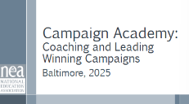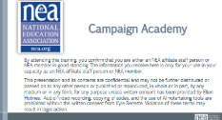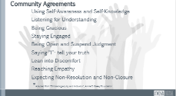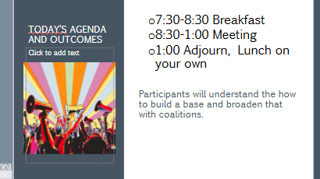 | Norms in Handouts  Agenda on Slides  Parking Lot Chart  Name Tents  Handout Package | 5 Minutes – Welcome Back  2 Minutes Agenda and Housekeeping  2 Minutes Agreement Revisit  Yesterday we said we would focus/consider more of ______ – is there something additional or different we should consider? Does where we left the conversation yesterday still land as a good focus of our time today? | Participants will know how we are going to work, the basic schedule, and the logistics relevant to the training.
9:00-9:40 | Vanessa | 40 Minutes Theory of Change
  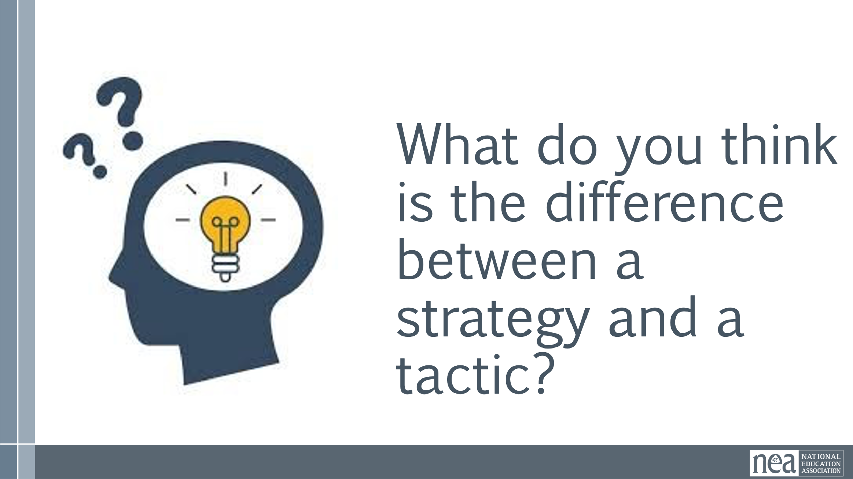  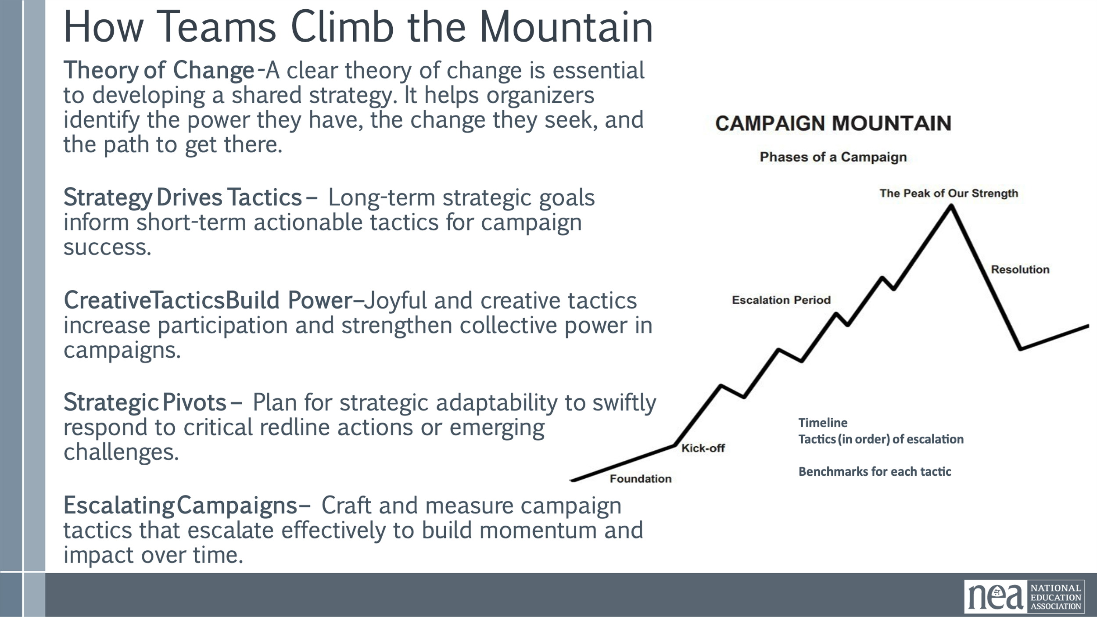  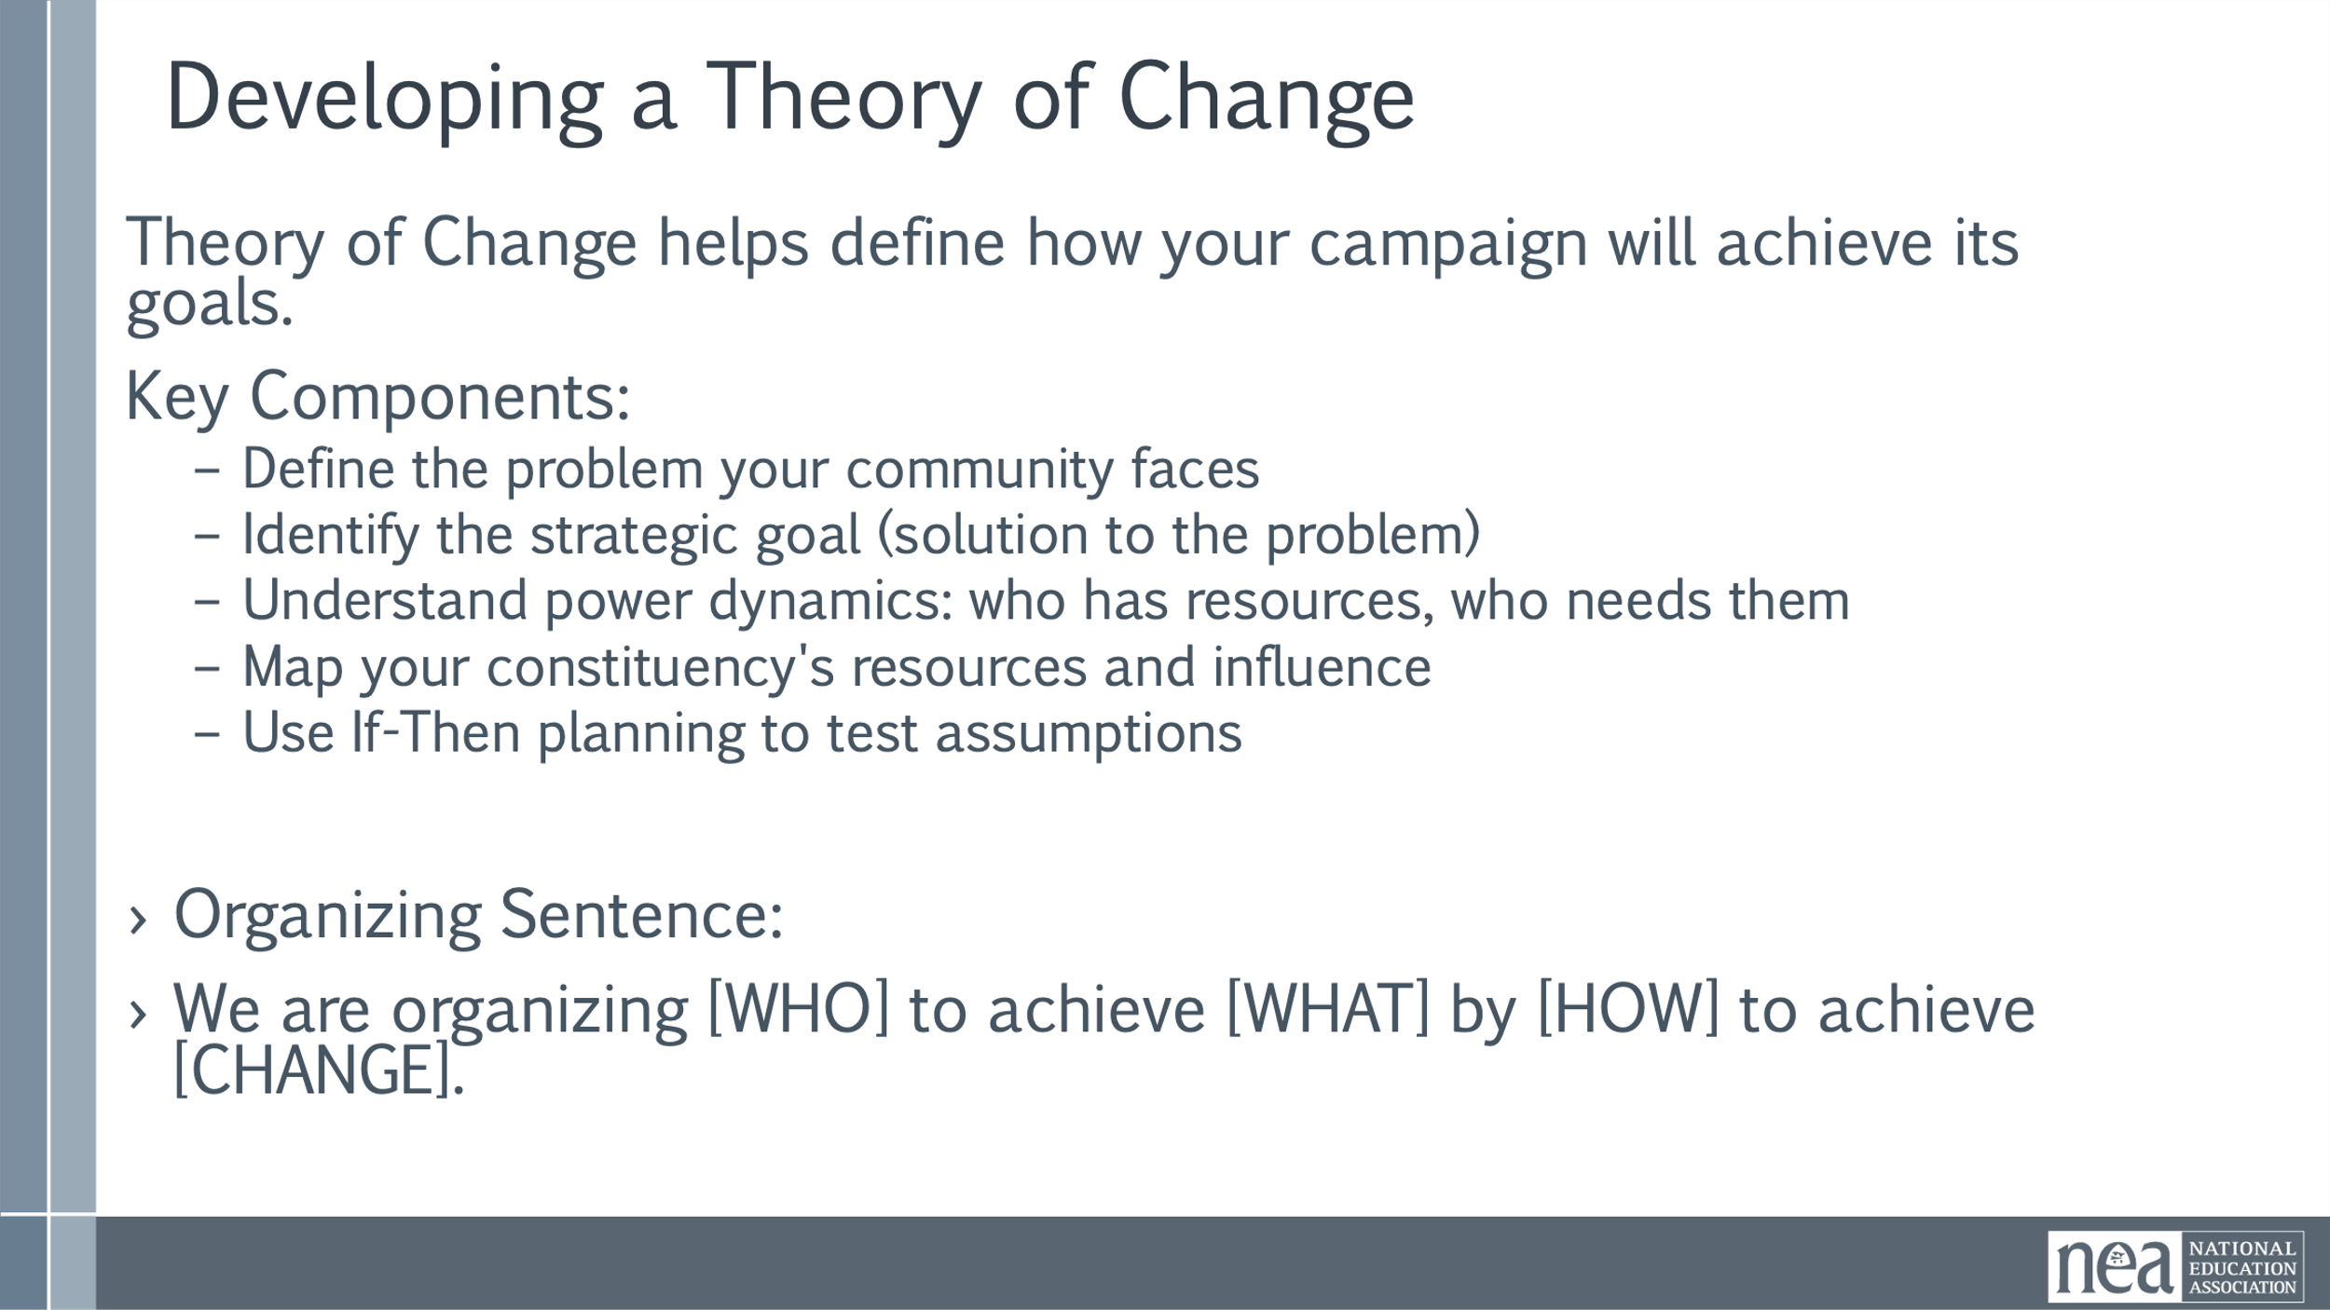  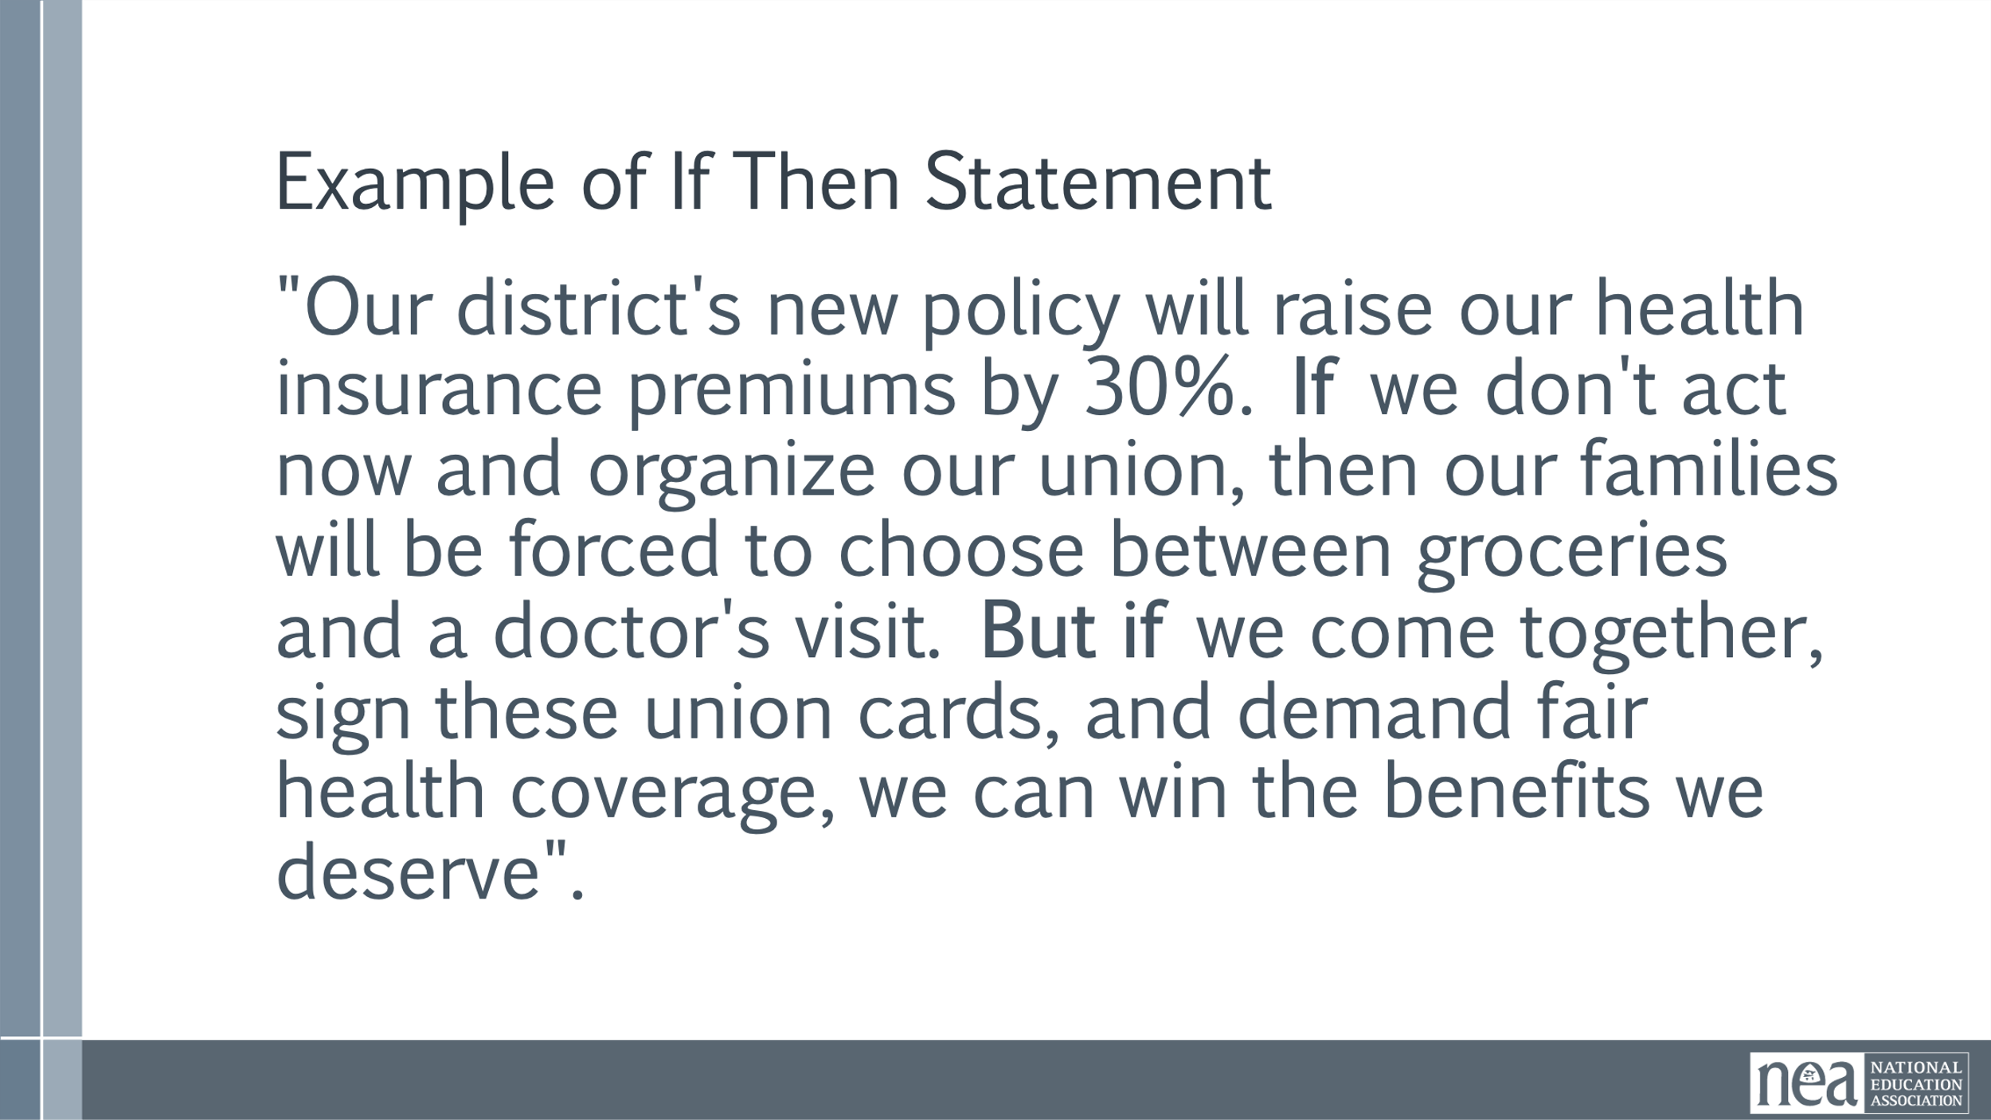  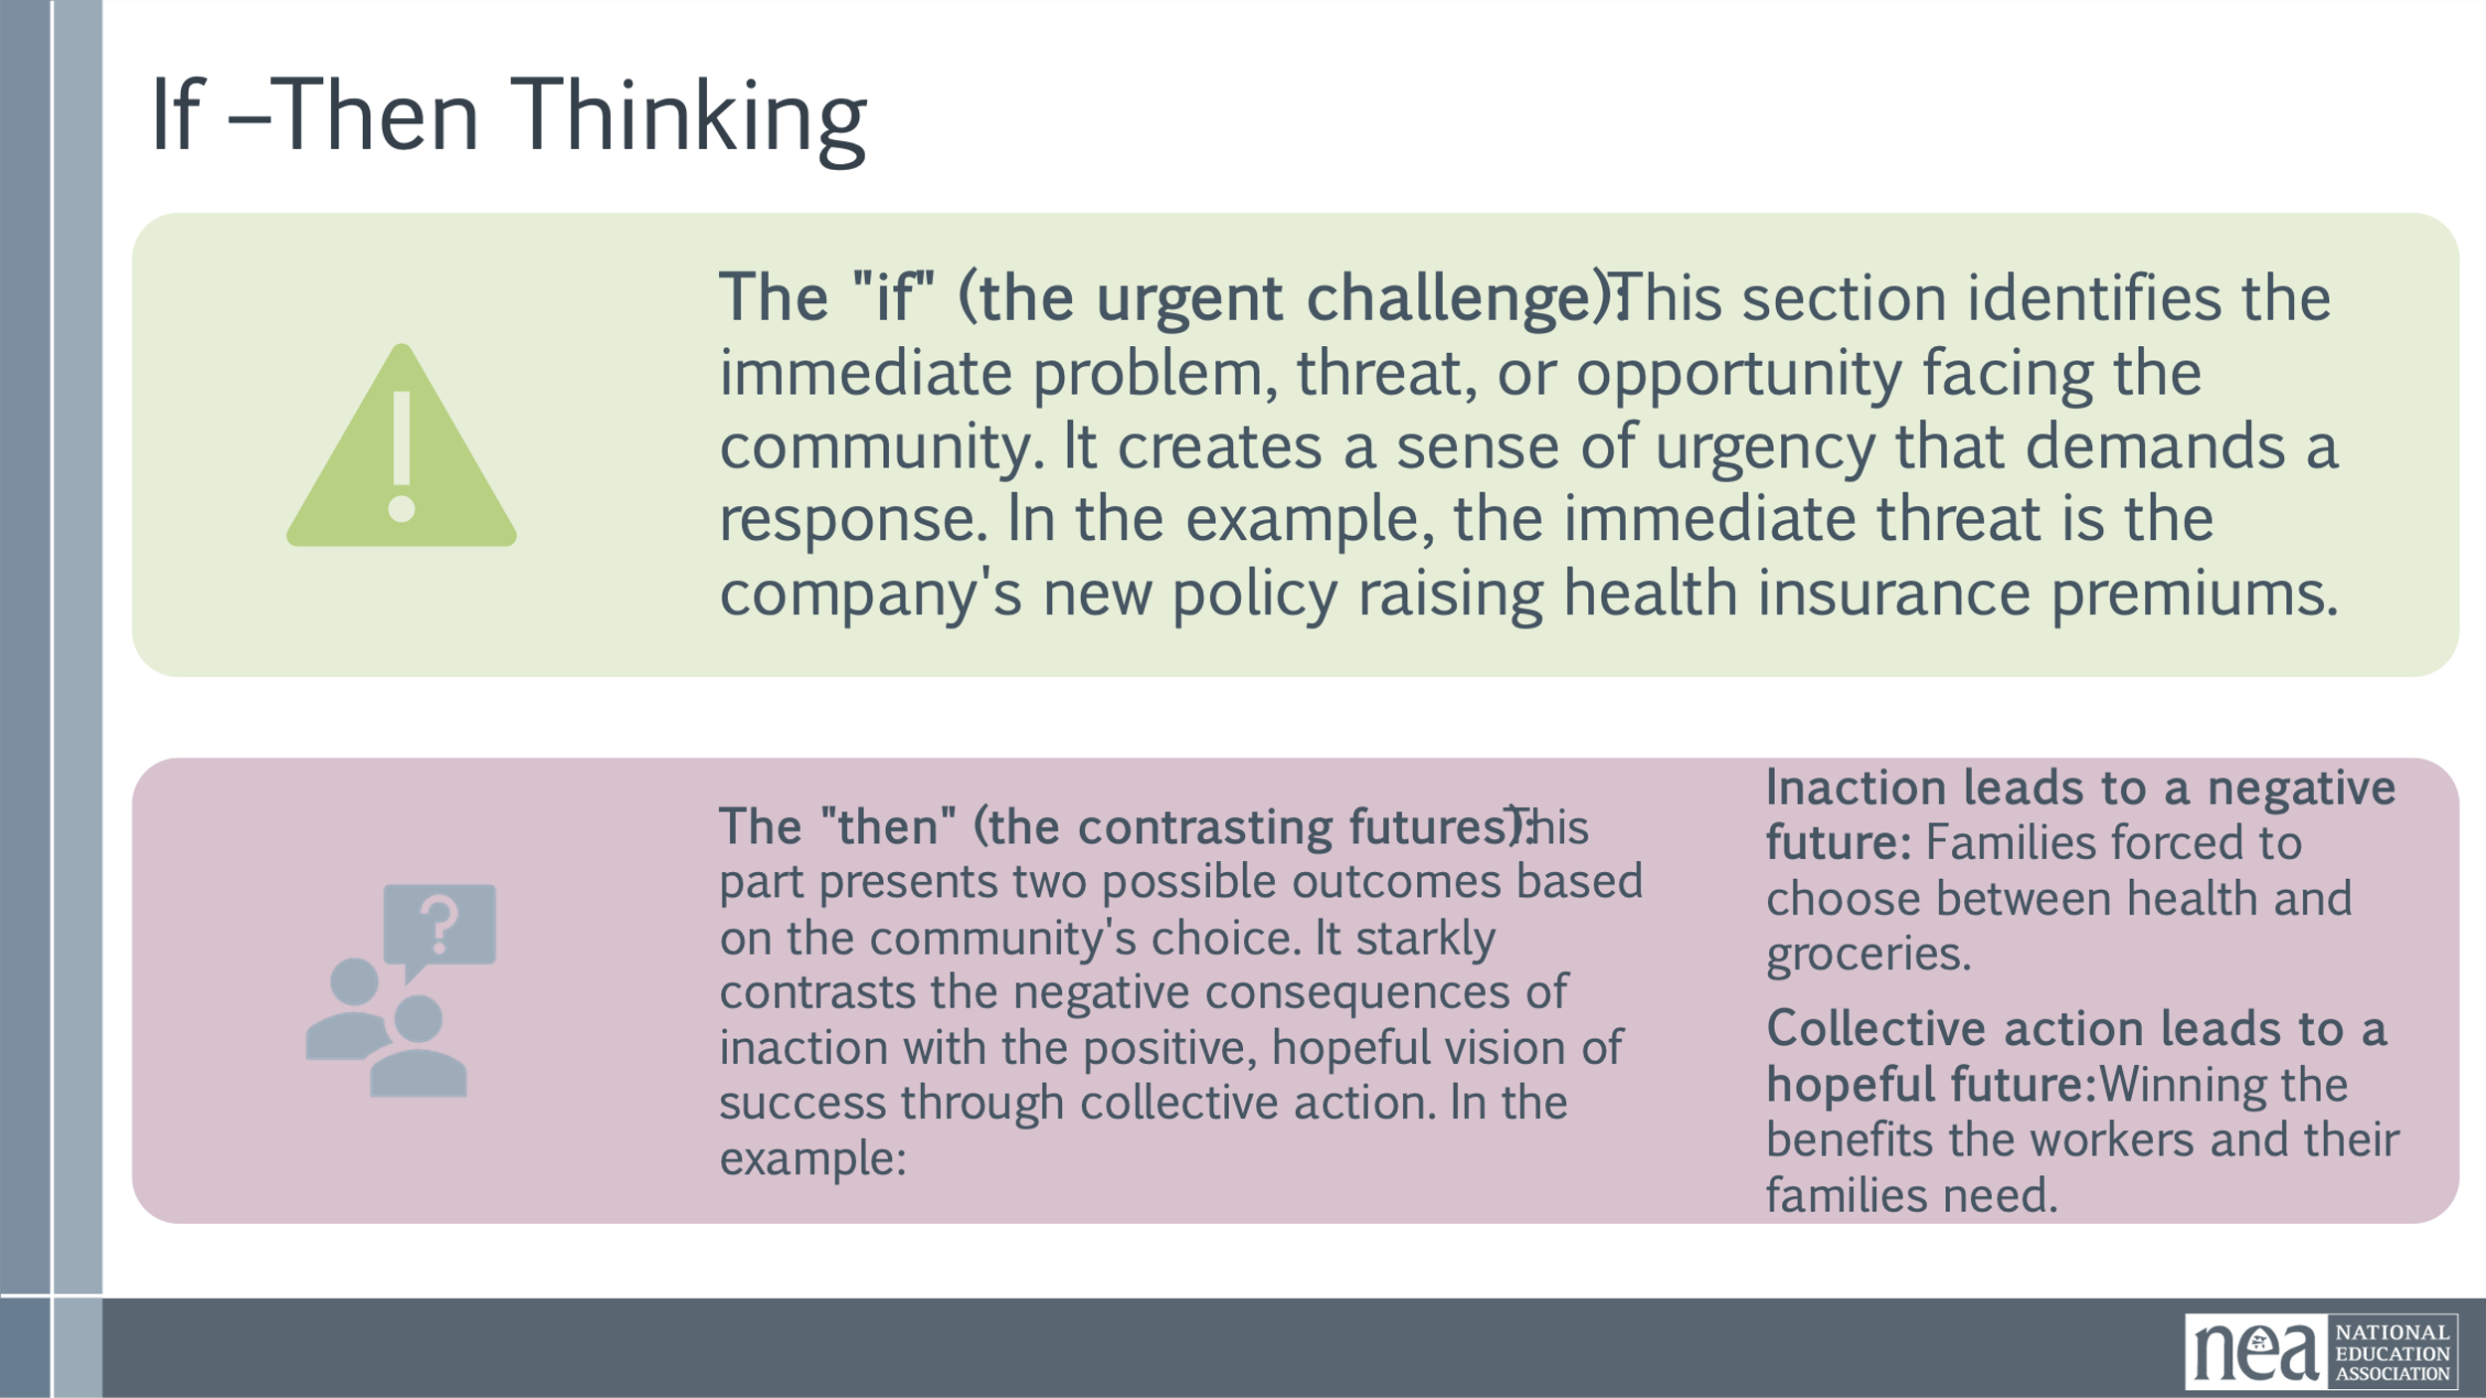  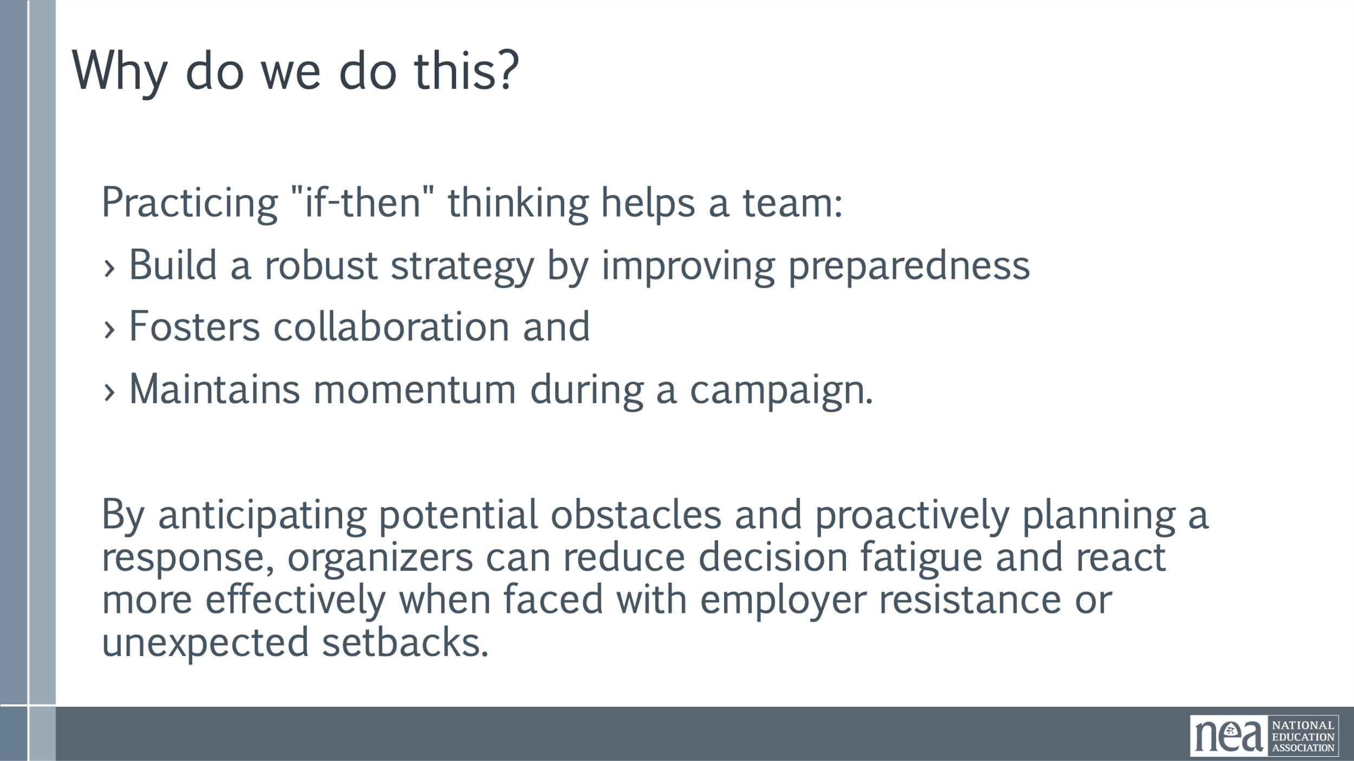  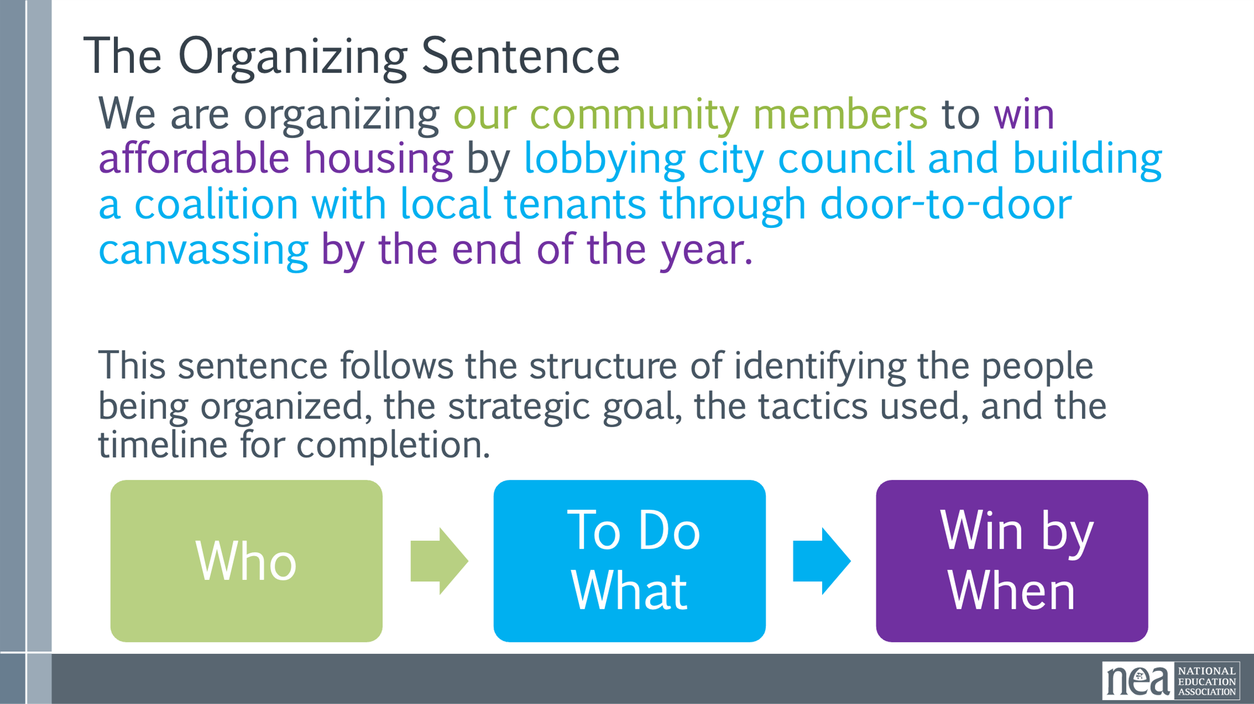  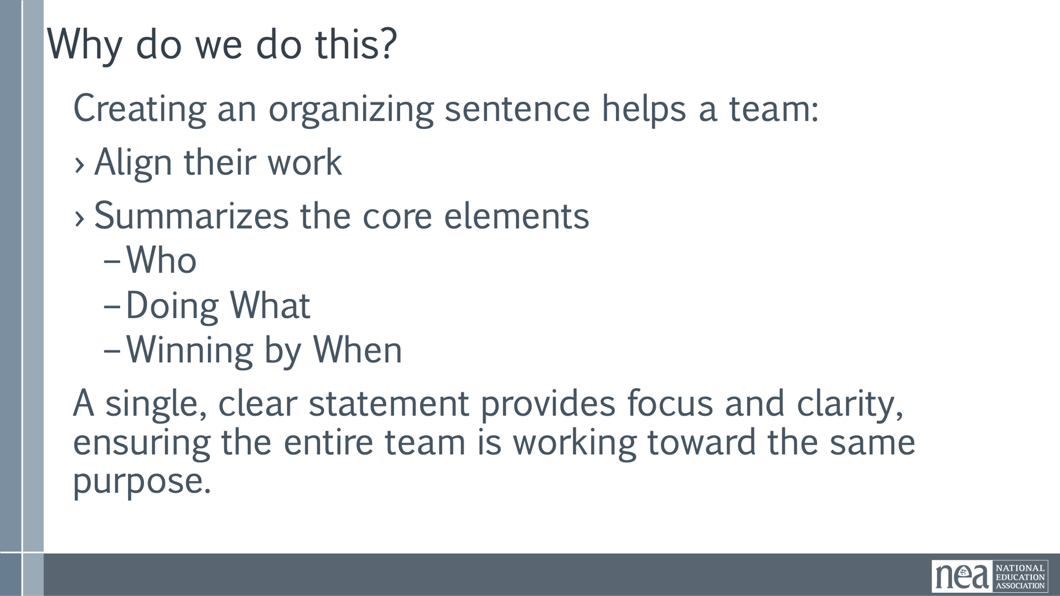  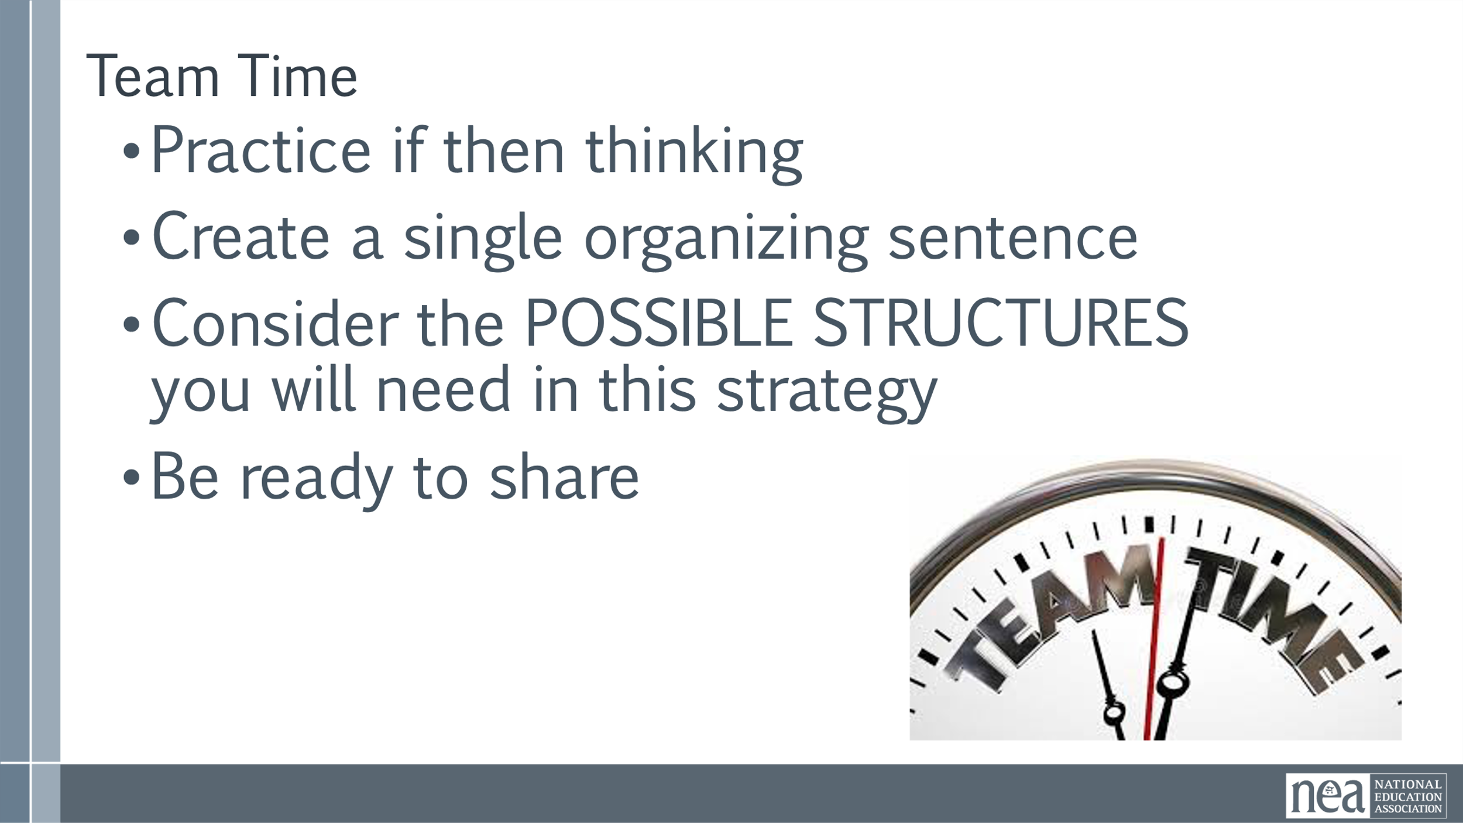  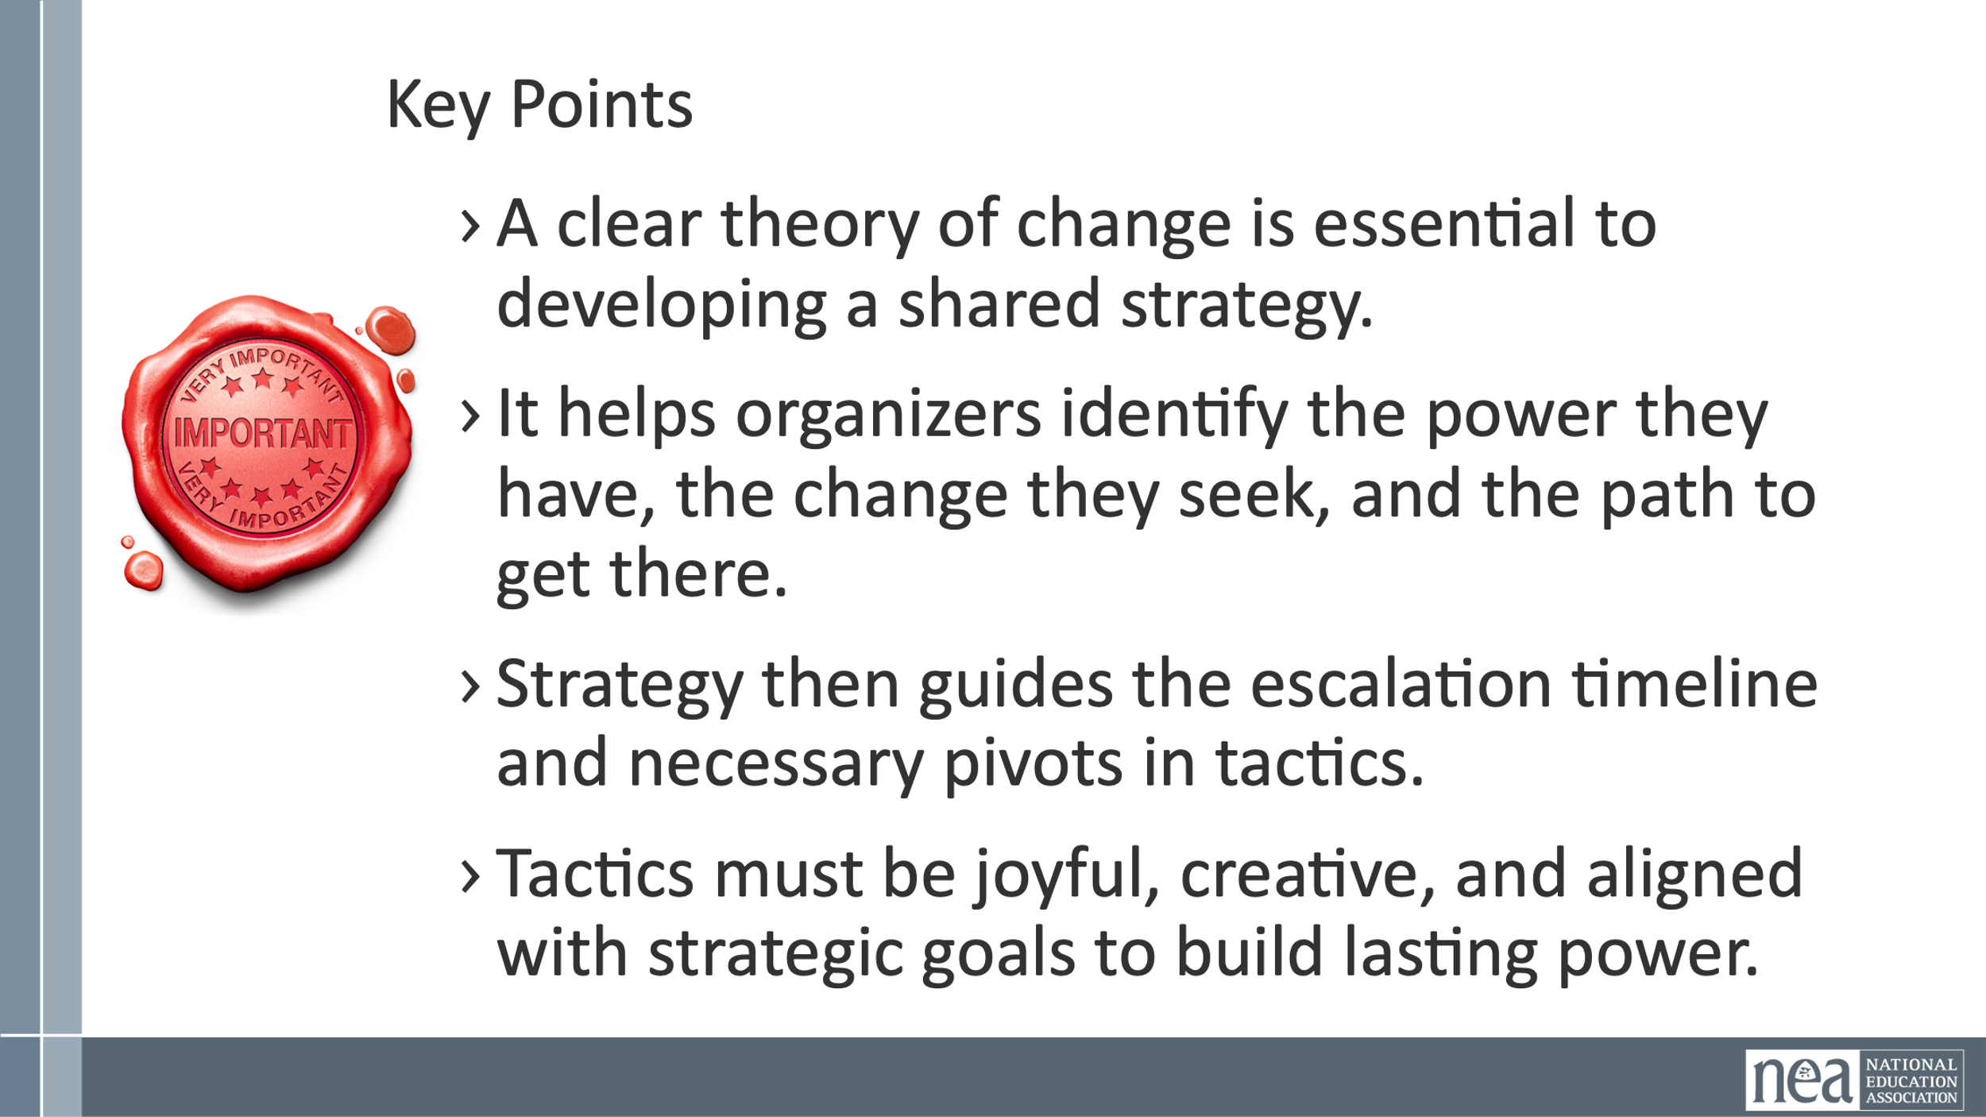 | Theory of Change Handout  charts | 10 Minutes of Intro  What do you think a theory for Change is?  It is the first step in the process that drives any campaign up campaign mountain.  Theory of Change -A clear theory of change is essential to developing a shared strategy. It helps organizers identify the power they have, the change they seek, and the path to get there.  Strategy Drives Tactics – Long-term strategic goals inform short-term actionable tactics for campaign success.  Creative Tactics Build Power –Joyful and creative tactics increase participation and strengthen collective power in campaigns.  Strategic Pivots – Plan for strategic adaptability to swiftly respond to critical redline actions or emerging challenges.  Escalating Campaigns – Craft and measure campaign tactics that escalate effectively to build momentum and impact over time.  Theory of Change helps define how your campaign will achieve its goals.  Key Components:  - Define the problem your community faces  - Identify the strategic goal (solution to the problem)  - Understand power dynamics: who has resources, who needs them  - Map your constituency's resources and influence  - Use If-Then planning to test assumptions  - Organizing Sentence:  - We are organizing [WHO] to achieve [WHAT] by [HOW] to achieve [CHANGE].  An example of an I then Statement:  "Our district's new policy will raise our health insurance premiums by 30%. If we don't act now and organize our union, then our families will be forced to choose between groceries and a doctor's visit. But if we come together, sign these union cards, and demand fair health coverage, we can win the benefits we deserve".  - The "if" (the urgent challenge): This section identifies the immediate problem, threat, or opportunity facing the community. It creates a sense of urgency that demands a response. In the example, the immediate threat is the company's new policy raising health insurance premiums.  - The "then" (the contrasting futures): This part presents two possible outcomes based on the community's choice. It starkly contrasts the negative consequences of inaction with the positive, hopeful vision of success through collective action. In the example:  - Inaction leads to a negative future: Families forced to choose between health and groceries.  - Collective action leads to a hopeful future: Winning the benefits the workers and their families need.  Why do we begin with this  Practicing "if-then" thinking helps a team:  - Build a robust strategy by improving preparedness  - Fosters collaboration and  - Maintains momentum during a campaign.  By anticipating potential obstacles and proactively planning a response, organizers can reduce decision fatigue and react more effectively when faced with employer resistance or unexpected setbacks.  We now work to turn this into an organizing sentence  We are organizing our community members to win affordable housing by lobbying city council and building a coalition with local tenants through door-to-door canvassing by the end of the year.  This sentence follows the structure of identifying the people being organized, the strategic  Why do we do this  Creating an organizing sentence helps a team:  - Align their work  - Summarizes the core elements  - Who  - Doing What  - Winning by When  A single, clear statement provides focus and clarity, ensuring the entire team is working toward the same purpose.  28 Minutes of Team Time and Include some Share Out  Using charts create some examples of if then thinking that your campaign is rooted in. Then from those come up with one clear organizing sentence.  - Practice if then thinking  - Create a single organizing sentence  - Consider the POSSIBLE STRUCTURES you will need in this strategy  - Be ready to share  2 Minutes Key Ideas  - A clear theory of change is essential to developing a shared strategy.  - It helps organizers identify the power they have, the change they seek, and the path to get there.  - Strategy then guides the escalation timeline and necessary pivots in tactics.  - Tactics must be joyful, creative, and aligned with strategic goals to build lasting power. | Participants will develop a Theory of Change that drives their strategic planning for their campaigns.
9:40-10:25 | Beth | 45 Minutes Strategy and Tactics
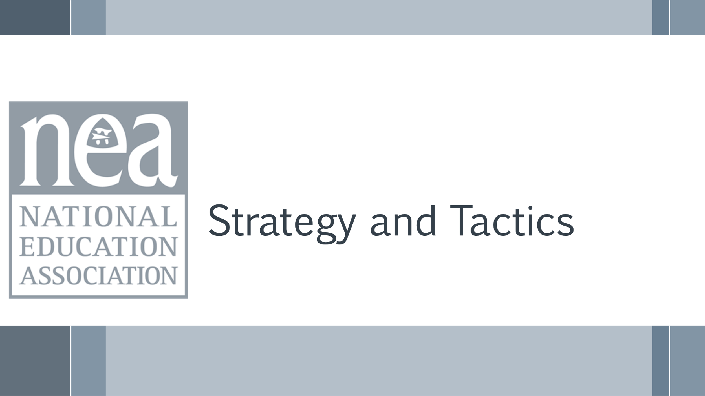  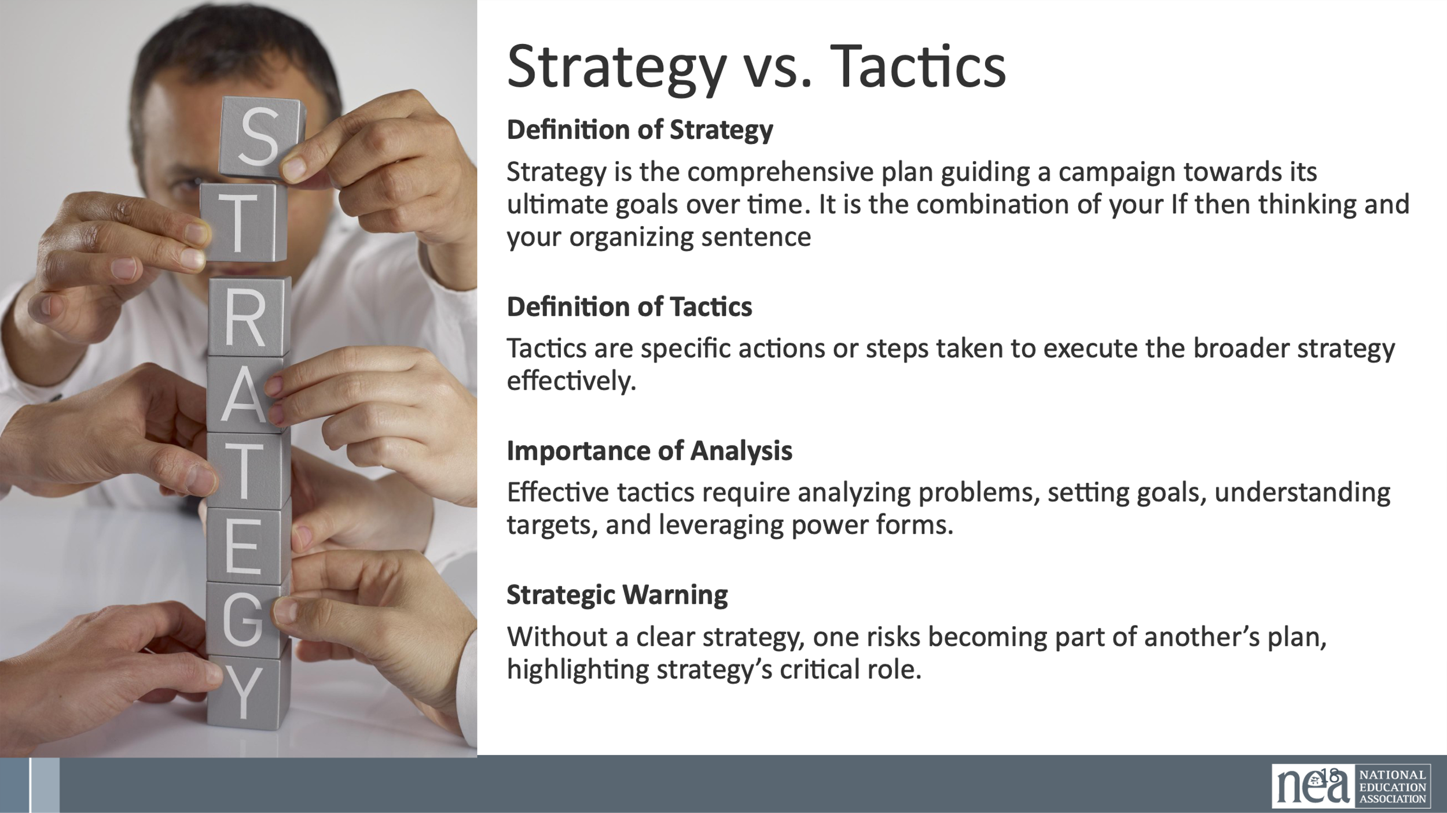  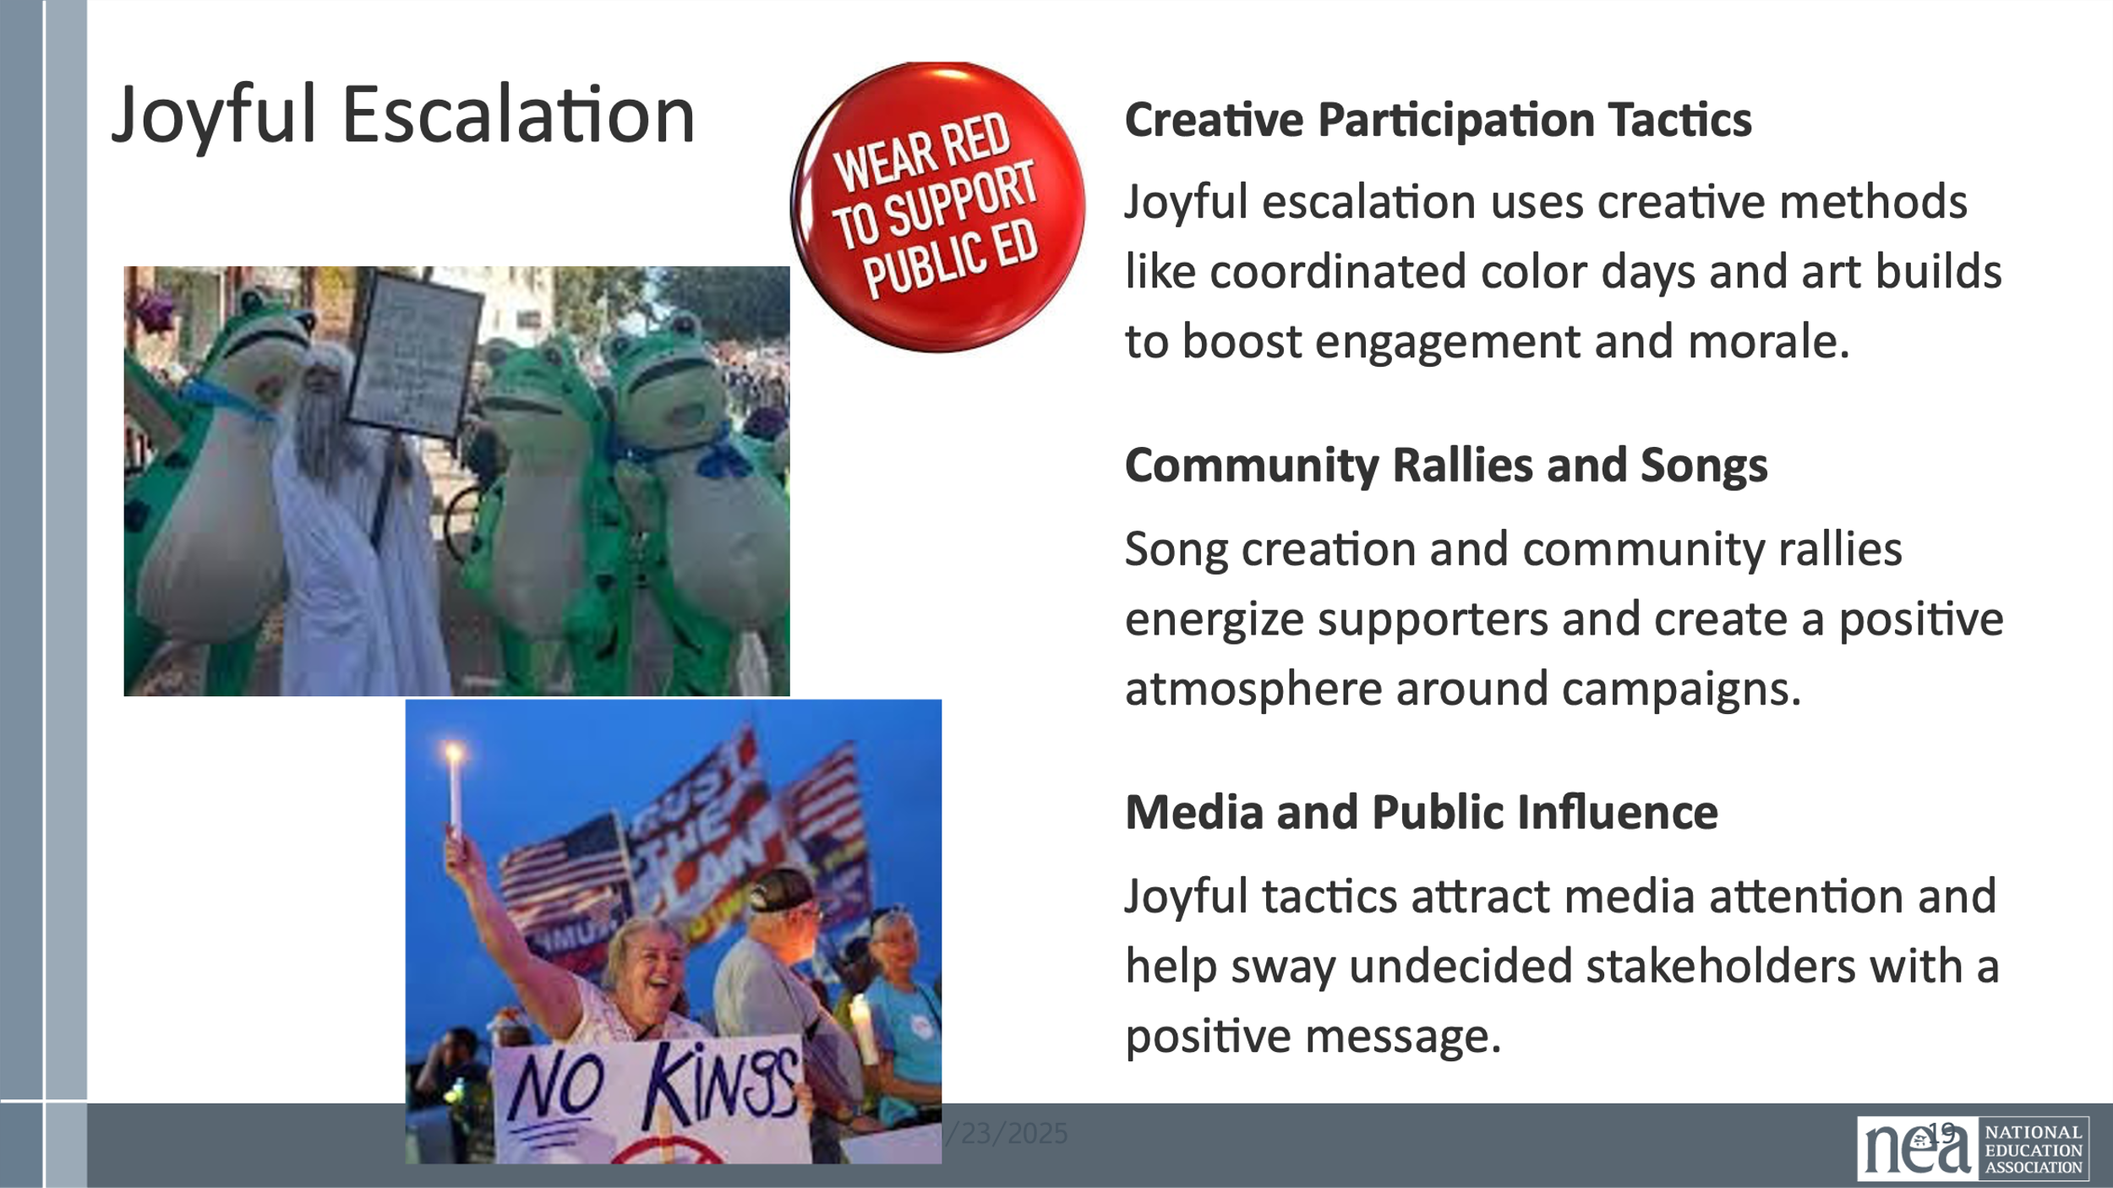  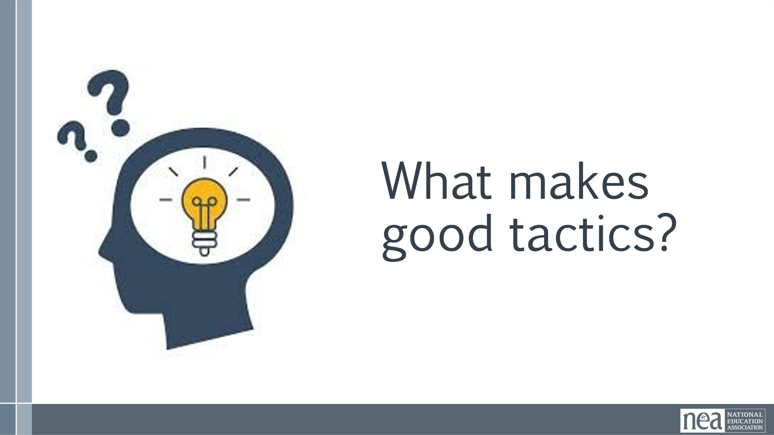  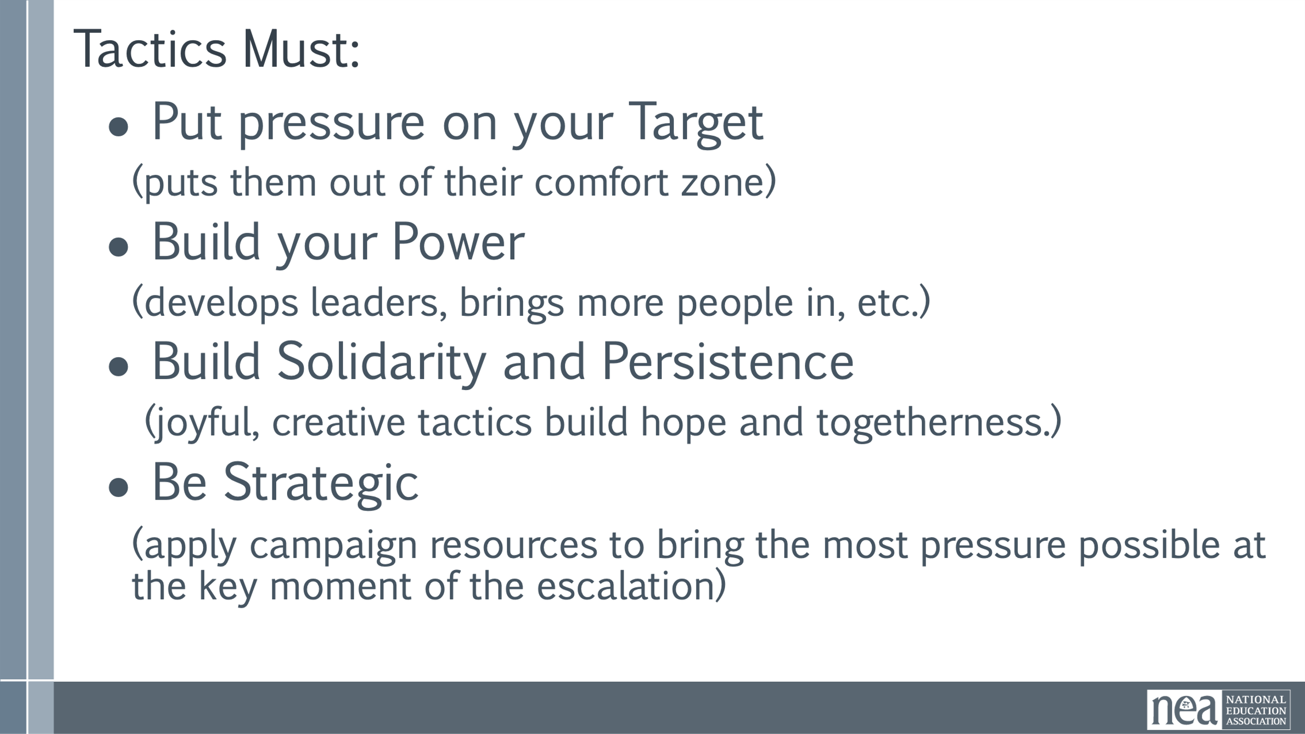  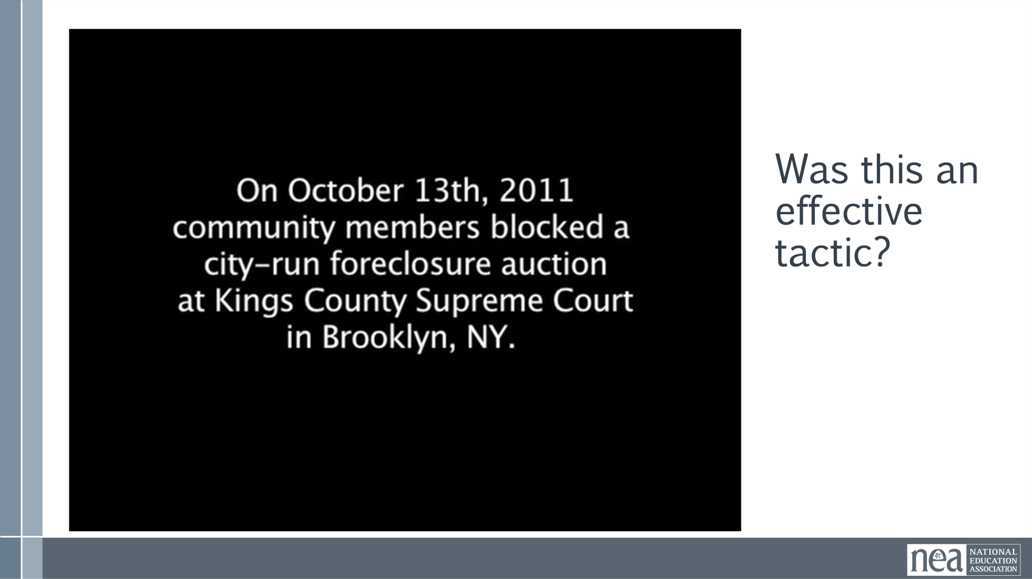  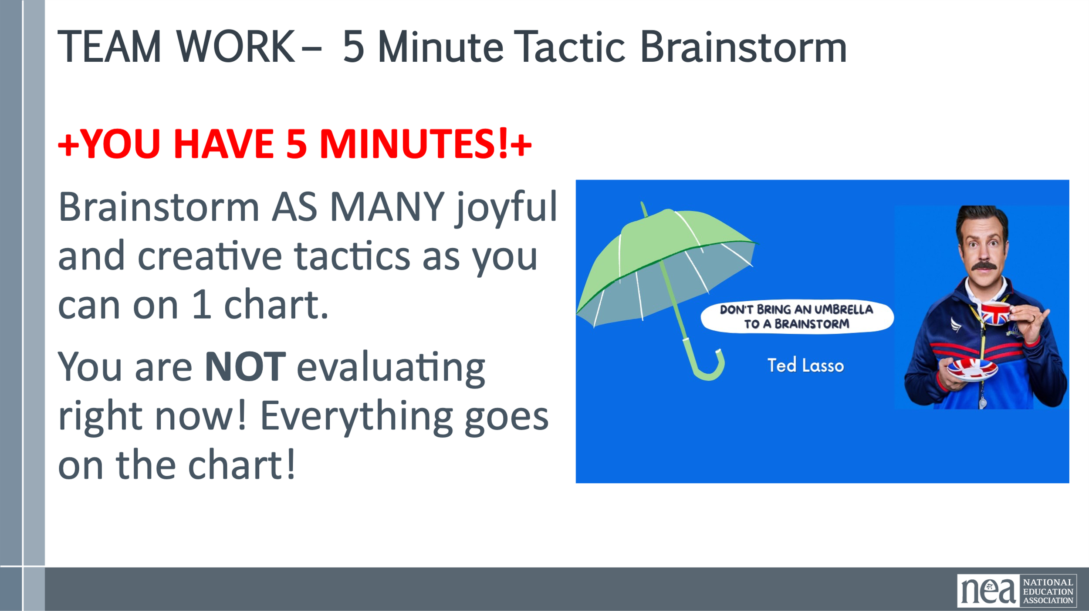  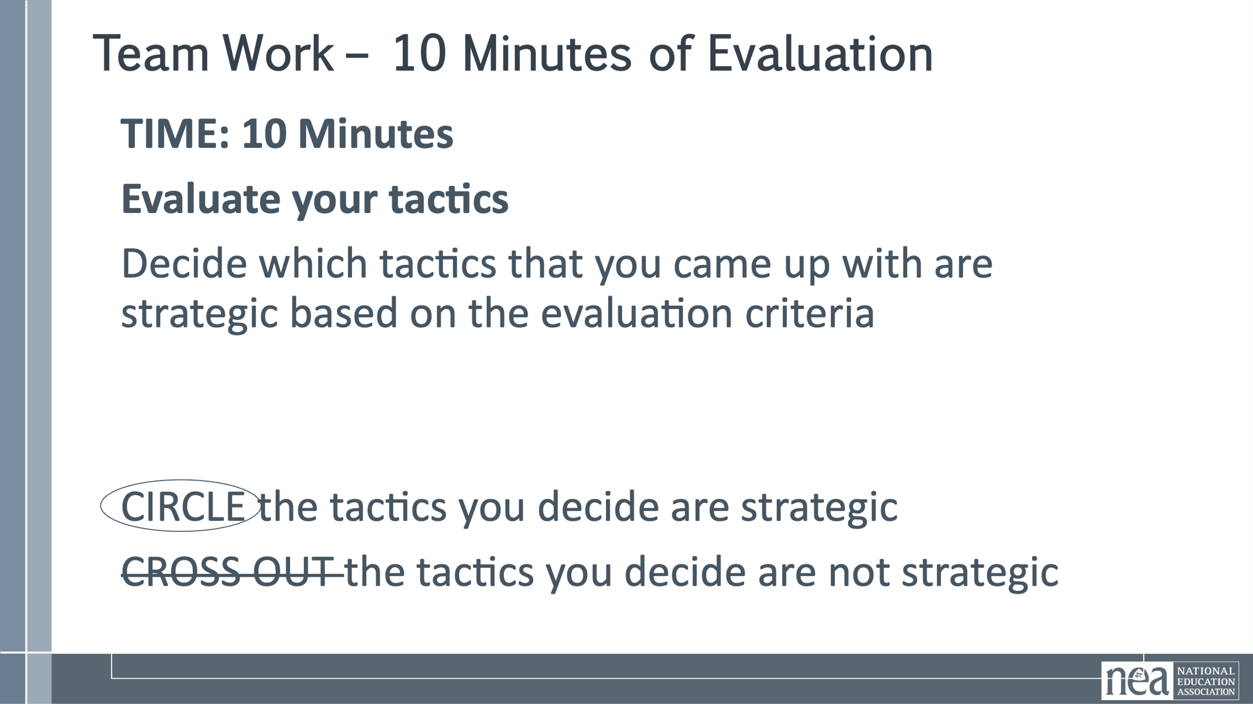  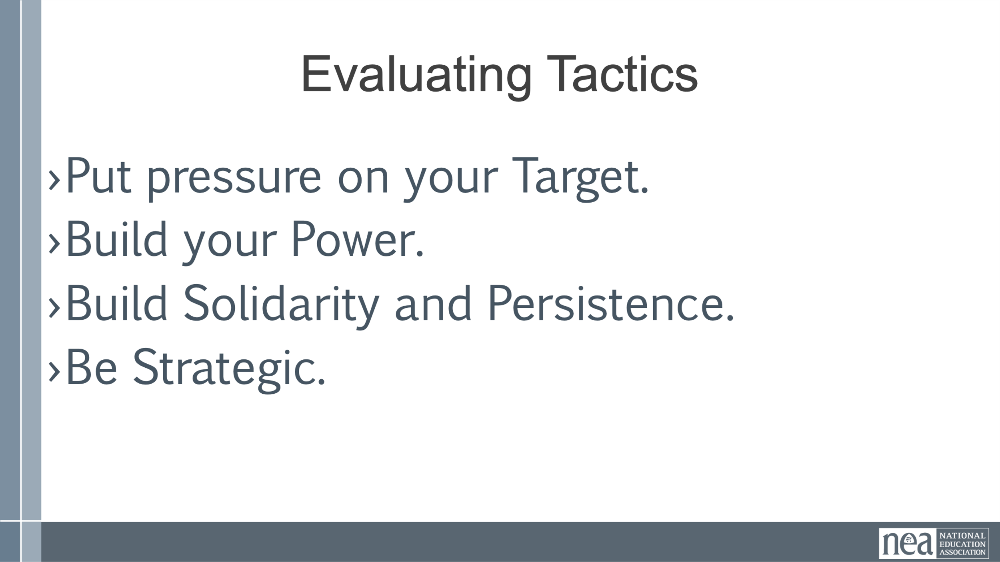  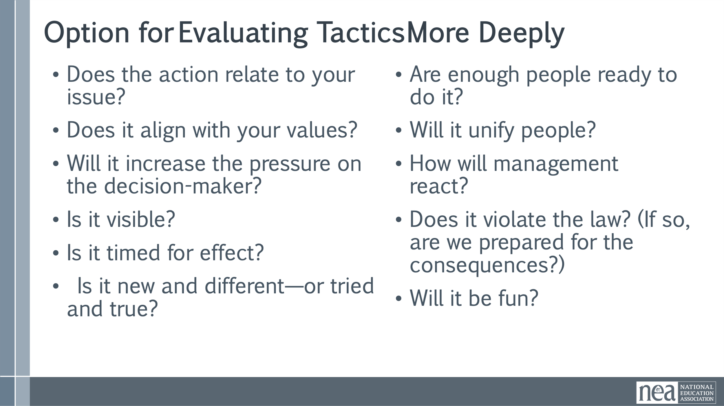  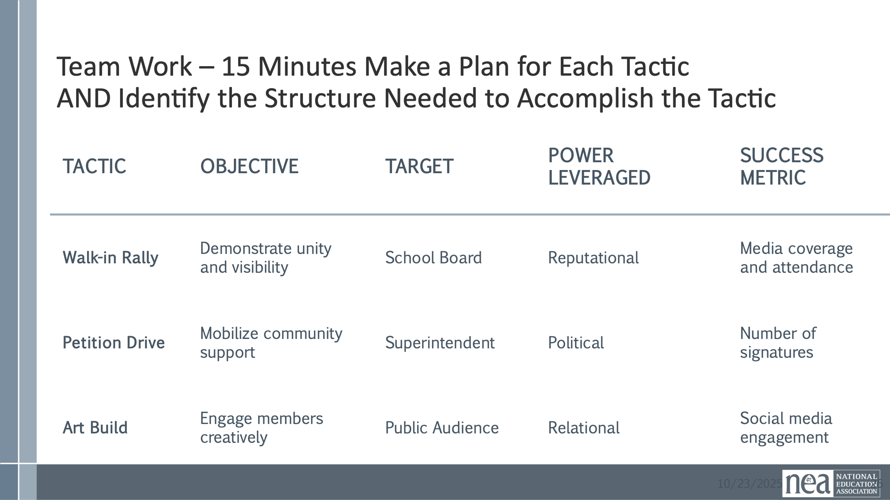  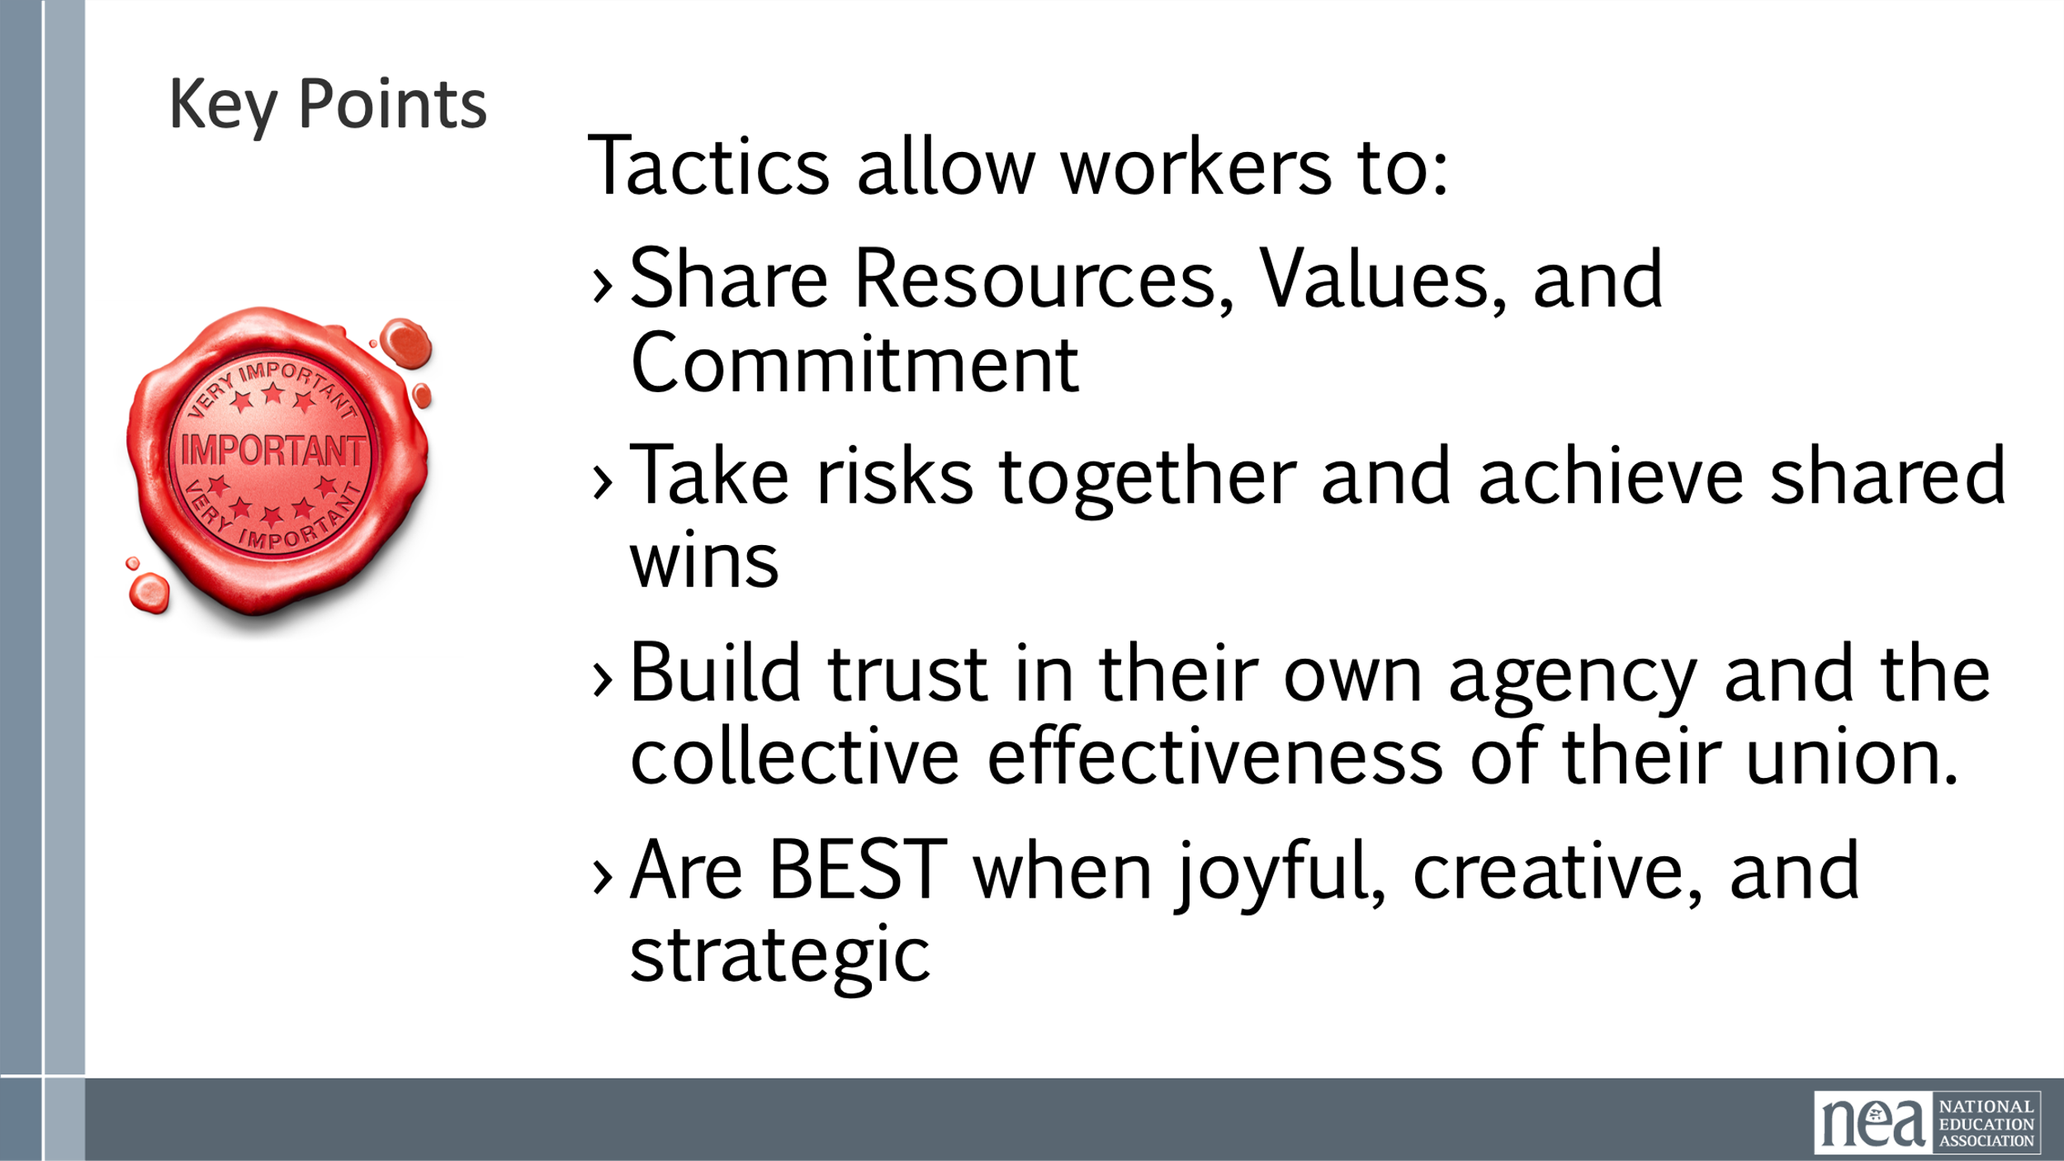 | Tactics Handouts P49  Examples of tactics  Campaign Planning Guide | 8 Minutes of Intro and Content  What do you think is the difference between strategy and tactics  Definition of Strategy  Strategy is the comprehensive plan guiding a campaign towards its ultimate goals over time. It is the combination of your If then thinking and your organizing sentence  Definition of Tactics  Tactics are specific actions or steps taken to execute the broader strategy effectively.  Importance of Analysis  Effective tactics require analyzing problems, setting goals, understanding targets, and leveraging power forms.  Strategic Warning  Without a clear strategy, one risks becoming part of another’s plan, highlighting strategy’s critical role.  We work to create tactics that are joyful so that hope is fostered and that people WANT to join in our actions. We try to create tactics that are creative to prevent the target from predicting what we will do. Tactics that are creative AND accessible also keep activists from losing interest. Joyful, creative tactics build solidarity and hope.  Creative Participation Tactics  Joyful escalation uses creative methods like coordinated color days and art builds to boost engagement and morale.  Community Rallies and Songs  Song creation and community rallies energize supporters and create a positive atmosphere around campaigns.  Media and Public Influence  Joyful tactics attract media attention and help sway undecided stakeholders with a positive message.  What makes good tactics?  Tactics must  - Put pressure on your Target  (puts them out of their comfort zone)  - Build your Power  (develops leaders, brings more people in, etc.)  - Build Solidarity and Persistence  (joyful, creative tactics build hope and togetherness.)  - Be Strategic  (apply campaign resources to bring the most pressure possible at the key moment of the escalation)  Share the video of the tactic from NY  35 Minutes Total for Team time  First teams spend 5 Minutes brainstorming as many creative tactics as possible that follow the “musts” on the previous slide. We are really brainstorming – not evaluating – write all ideas on the chart  NOW – lets look at those lists and take 10 minutes to evaluate them. We will use the 4 points of the “MUSTS” and that will fit within your strategy—circle the tactics that are strategic and cross out ones that are not.  The musts  - Put pressure on your Target.  - Build your Power.  - Build Solidarity and Persistence.  - Be Strategic.  IF you have time – you can use the longer optional evaluation that is in your handouts.  NOW for at least three of the tactics that you circled, take the next 15 minutes and make a plan for each.  The plan should include:  - the tactic,  - the objective (what are you hoping to achieve by using that tactic)  - the target (Has to be a person with a face)  - the power leveraged (examples include relational, political, legal, etc)  - measure of success aka what data will you use to measure engagement/effectiveness of the tactic. Think about the case study from yesterday and the metrics they used for each tactic.  2 Minutes Key Ideas  Tactics allow workers to:  - Share Resources, Values, and Commitment  - Take risks together and achieve shared wins  - Build trust in their own agency and the collective effectiveness of their union.  - Are BEST when joyful, creative, and strategic | Participants will identify a number of strategic tactics, the objectives for each, a success metric, and a possible structure required to carry out each tactic.
10:15-10:45 | Melissa | 30 Minutes - Redline Tactics
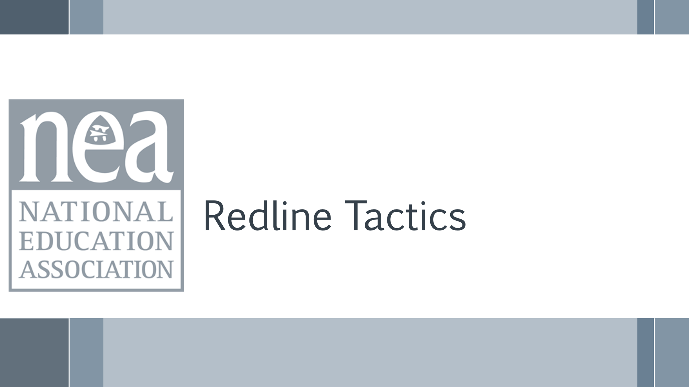  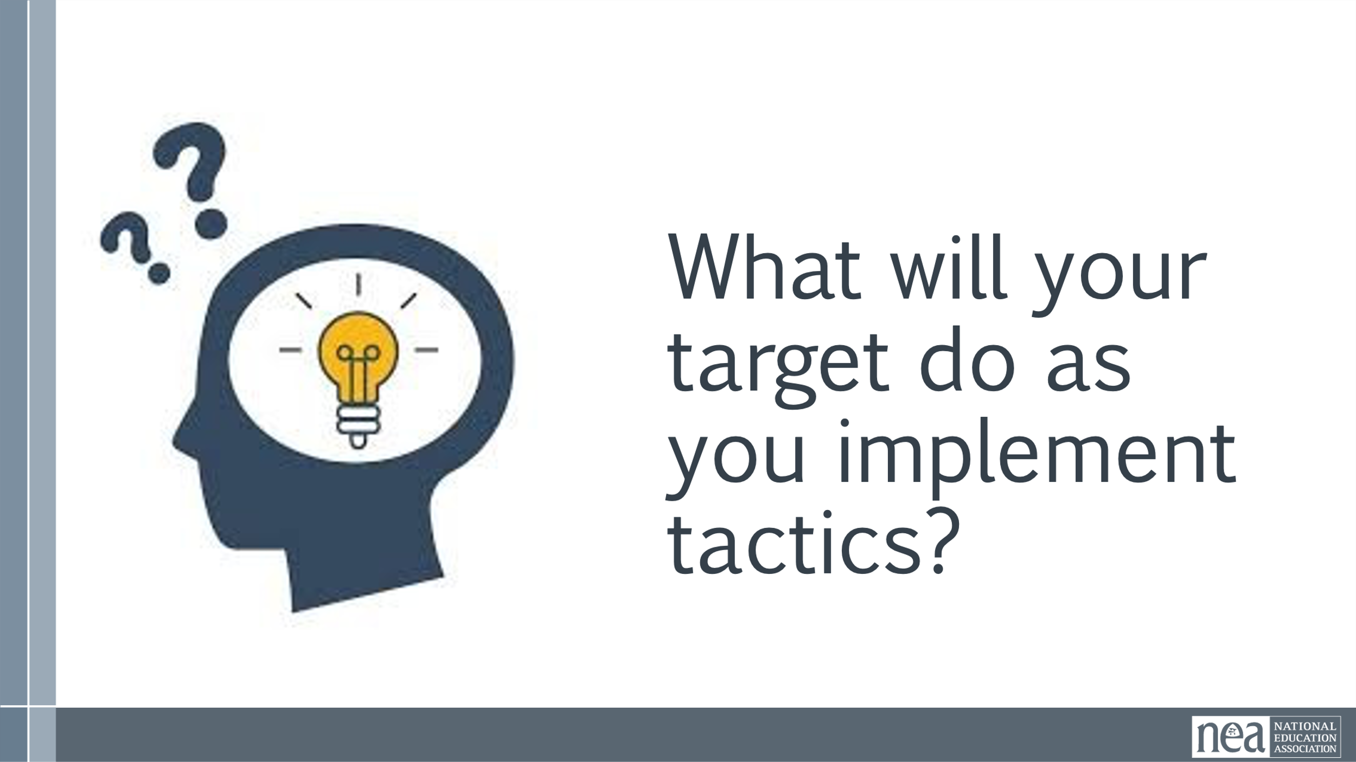  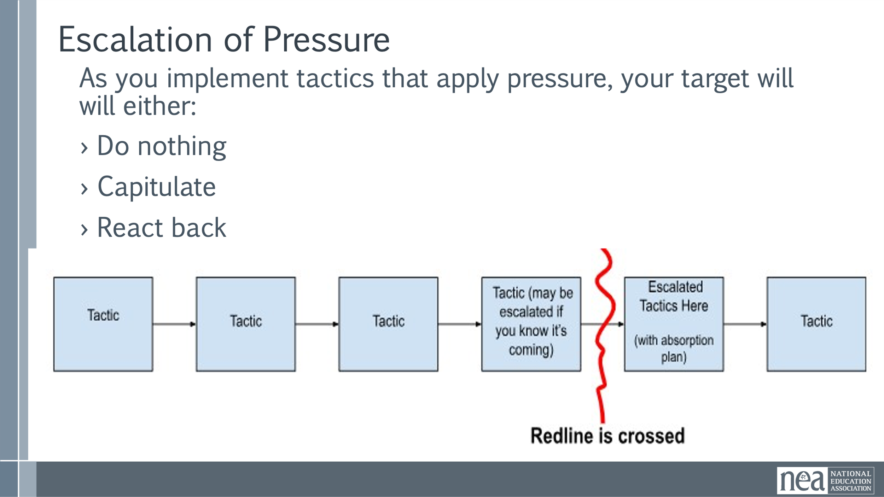  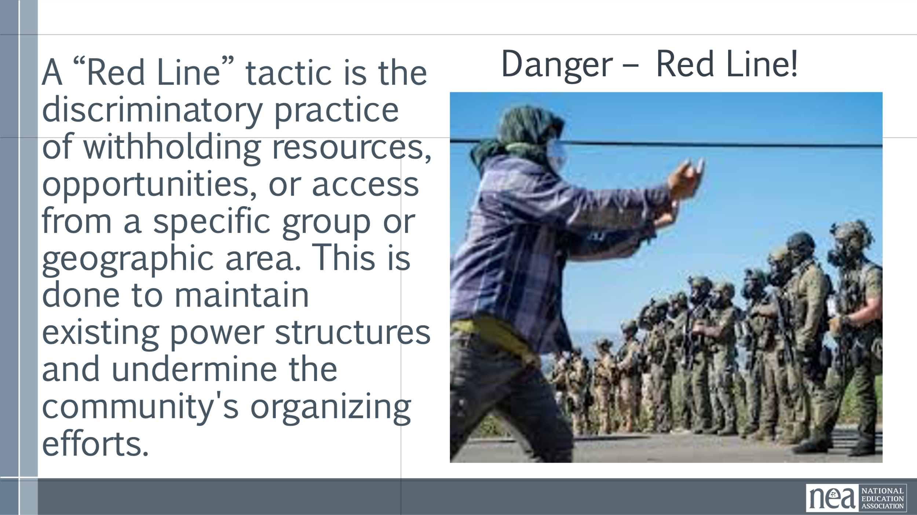  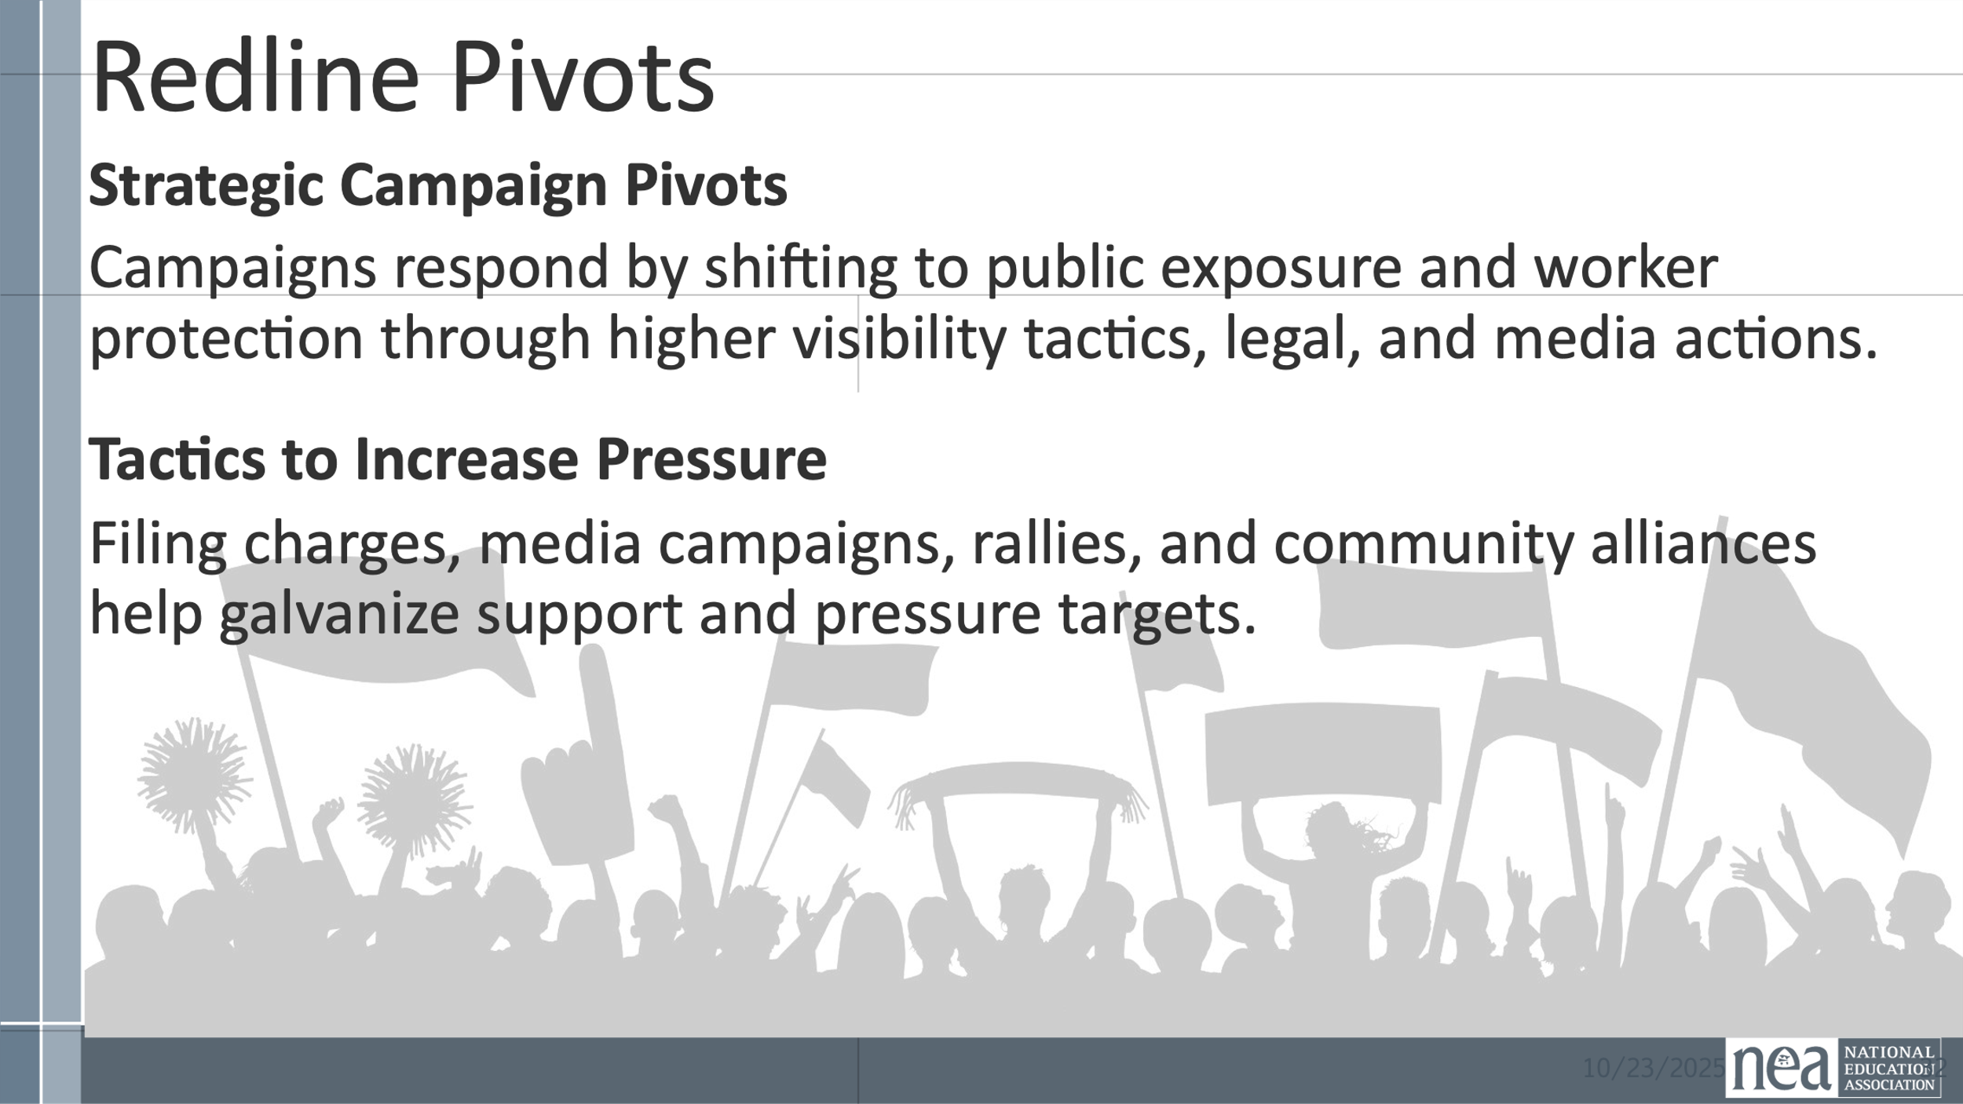  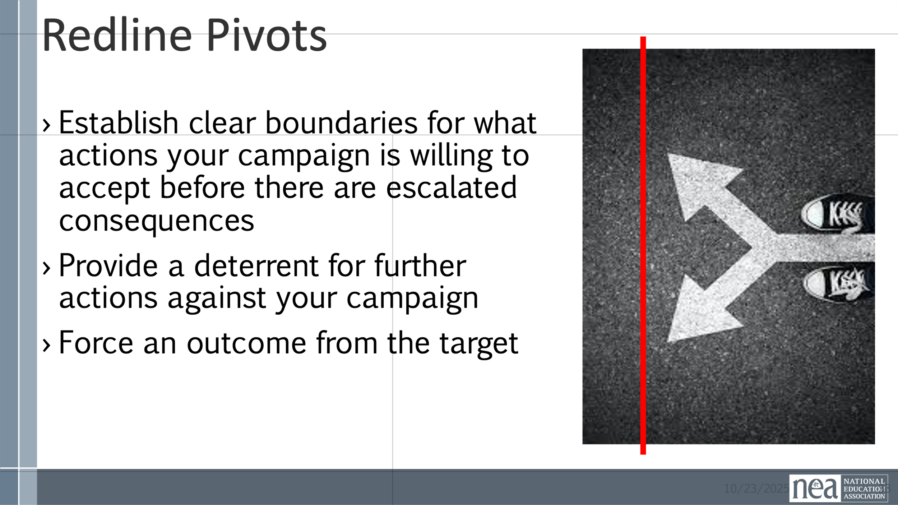  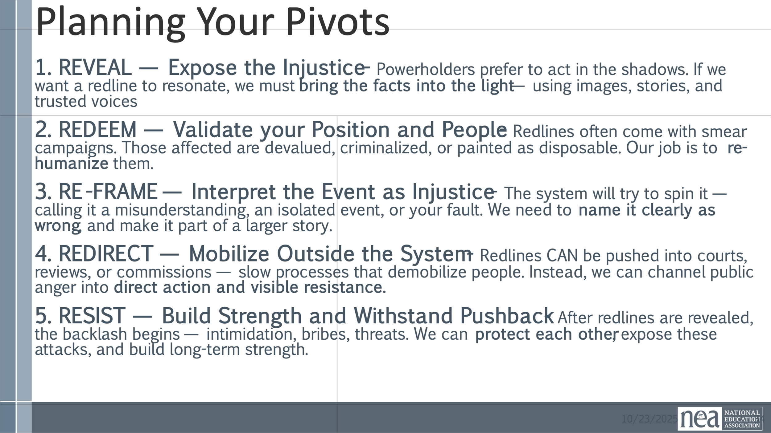  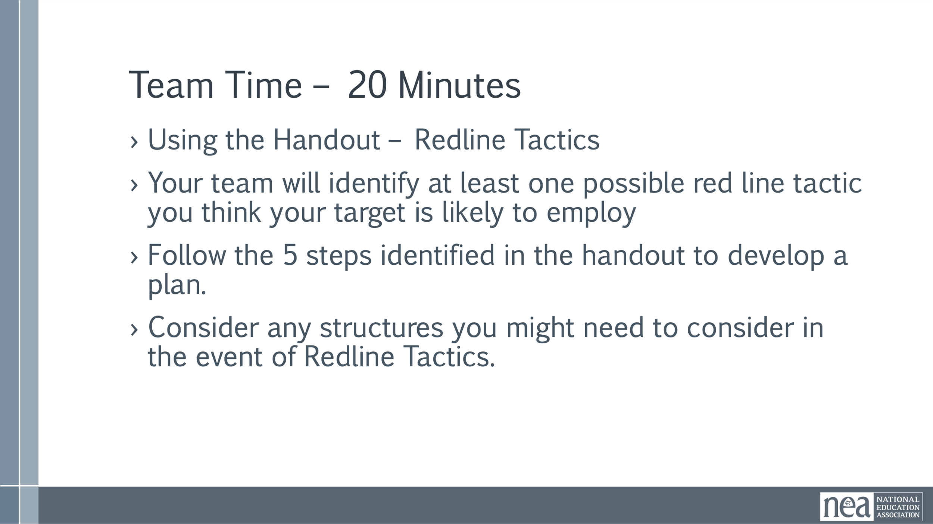  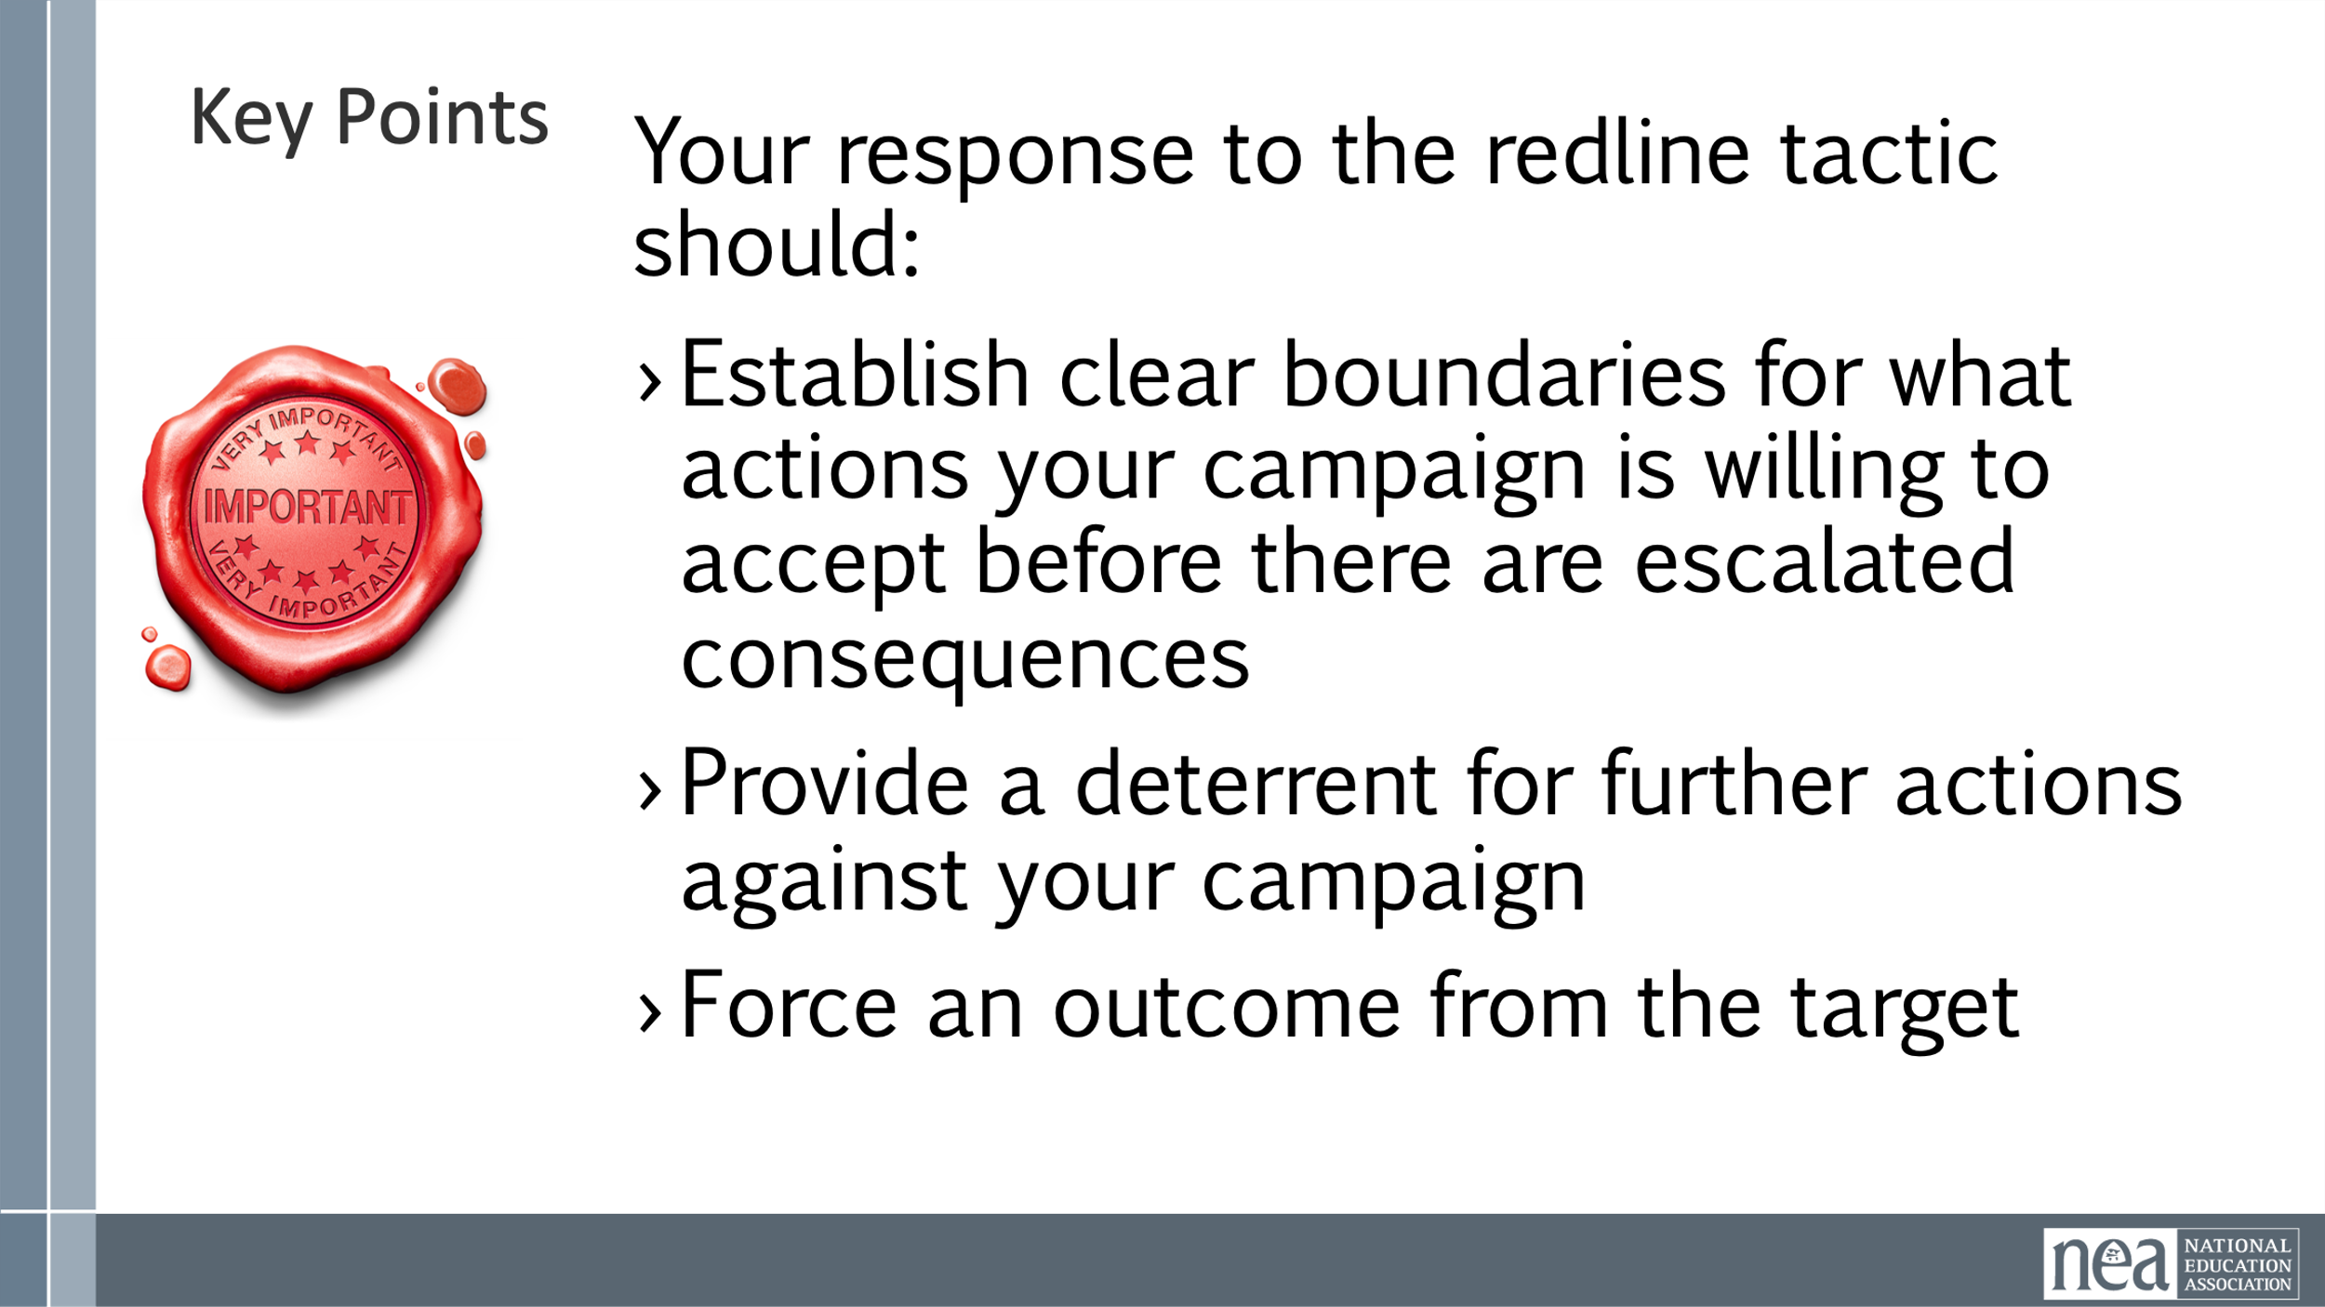 | Red Line Handout  p53 | 5 Minutes of Content –  What will your target do as you implement tactics?  As you implement tactics that apply pressure, your target will either:  - Do nothing  - Capitulate  - React back  There is a point in most campaigns where the target will cross a line with you. They will do a tactic in response to your pressure or possibly to intimidate others from joining your campaign and we call this a Red Line Tactic  A “Red Line” tactic is the discriminatory practice of withholding resources, opportunities, or access from a specific group or geographic area. This is done to maintain existing power structures and undermine the community's organizing efforts.  Strategic Campaign Pivots  Campaigns respond by shifting to public exposure and worker protection through higher visibility tactics, legal, and media actions.  Tactics to Increase Pressure  Filing charges, media campaigns, rallies, and community alliances help galvanize support and pressure targets.  Redline pivots  Establish clear boundaries for what actions your campaign is willing to accept before there are escalated consequences  Provide a deterrent for further actions against your campaign  Force an outcome from the target  There are five steps to consider when planning a pivot  1. REVEAL — Expose the Injustice - Powerholders prefer to act in the shadows. If we want a redline to resonate, we must bring the facts into the light — using images, stories, and trusted voices  2. REDEEM — Validate your Position and People - Redlines often come with smear campaigns. Those affected are devalued, criminalized, or painted as disposable. Our job is to re-humanize them.  3. RE-FRAME — Interpret the Event as Injustice - The system will try to spin it — calling it a misunderstanding, an isolated event, or your fault. We need to name it clearly as wrong, and make it part of a larger story.  4. REDIRECT — Mobilize Outside the System - Redlines CAN be pushed into courts, reviews, or commissions — slow processes that demobilize people. Instead, we can channel public anger into direct action and visible resistance.  5. RESIST — Build Strength and Withstand Pushback - After redlines are revealed, the backlash begins — intimidation, bribes, threats. We can protect each other, expose these attacks, and build long-term strength.  Team Time – 20 Minutes  - Using the Handout – Redline Tactics  - Your team will identify at least one possible red line tactic you think your target is likely to employ  - Follow the 5 steps identified in the handout to develop a plan.  - Consider any structures you might need to consider in the event of Redline Tactics.  2 Minutes Key Points  Your response to the redline tactic should:  - Establish clear boundaries for what actions your campaign is willing to accept before there are escalated consequences  - Provide a deterrent for further actions against your campaign  - Force an outcome from the target | Participants will understand that they will need to predict the types of pushback and redline tactics that their targets will use.
10:45-11:00 | Dr. Taraja | 15 minutes Timeline, Compression Points, and Escalation
  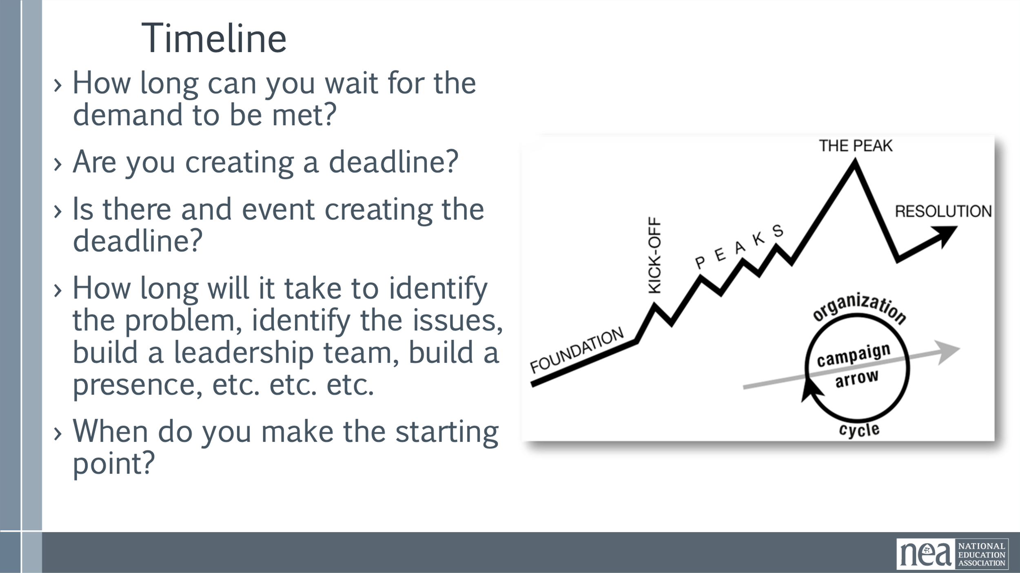  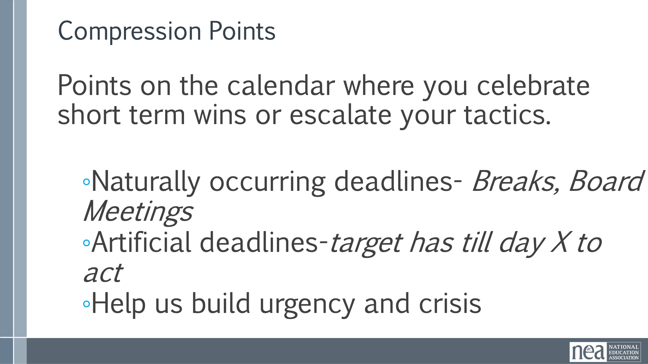  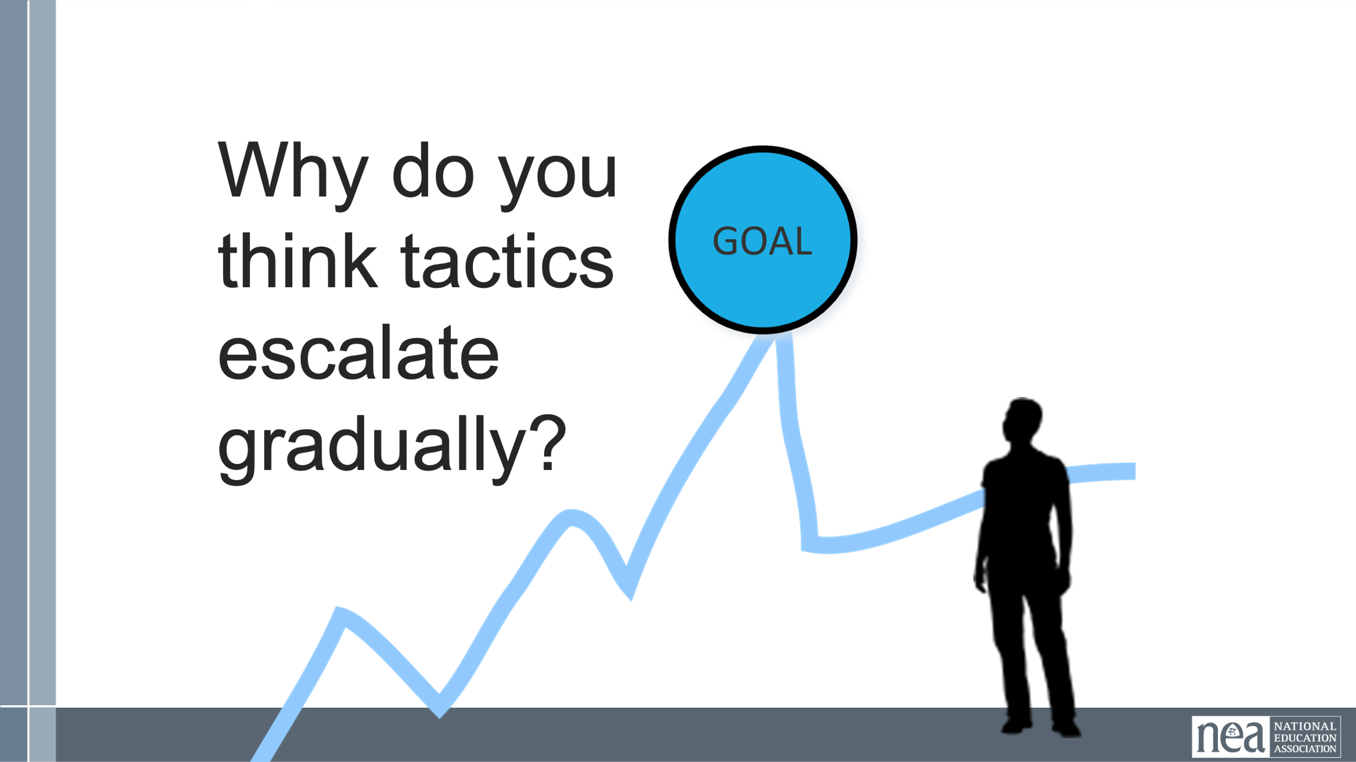  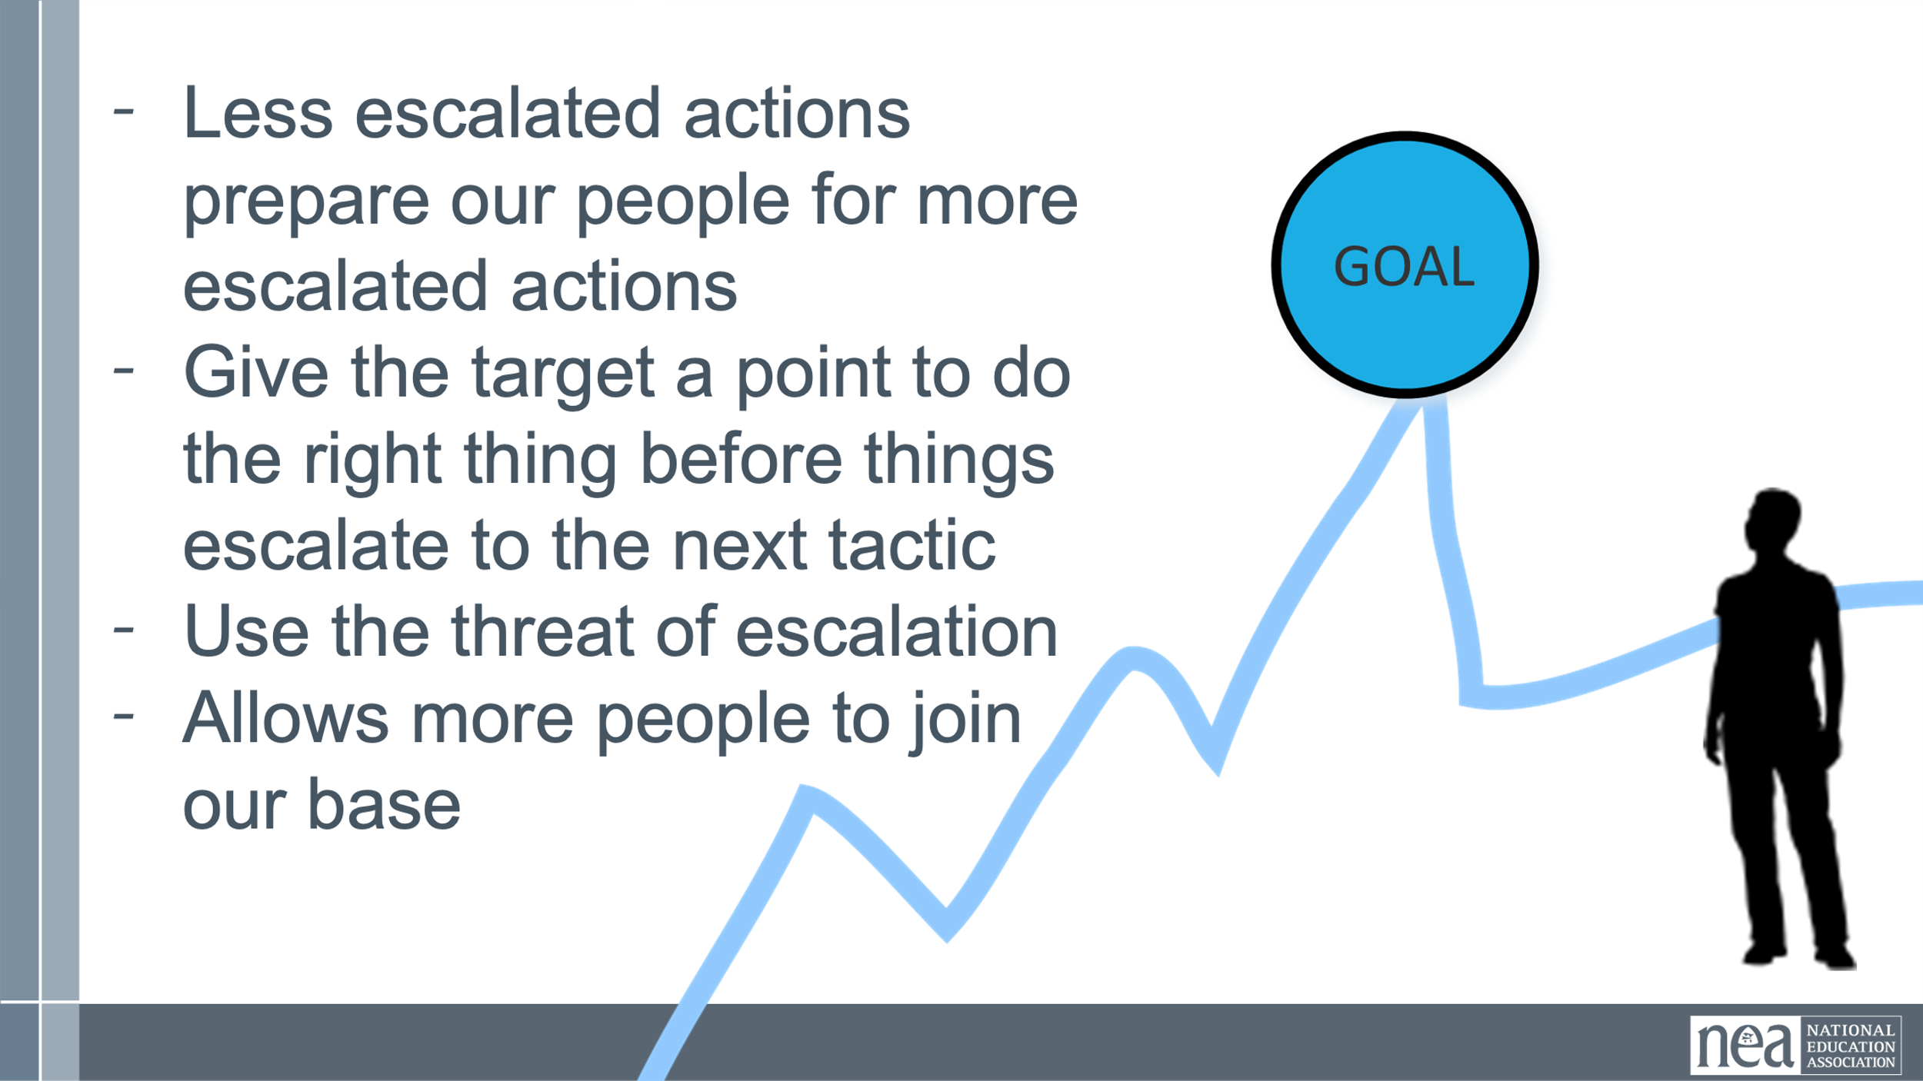  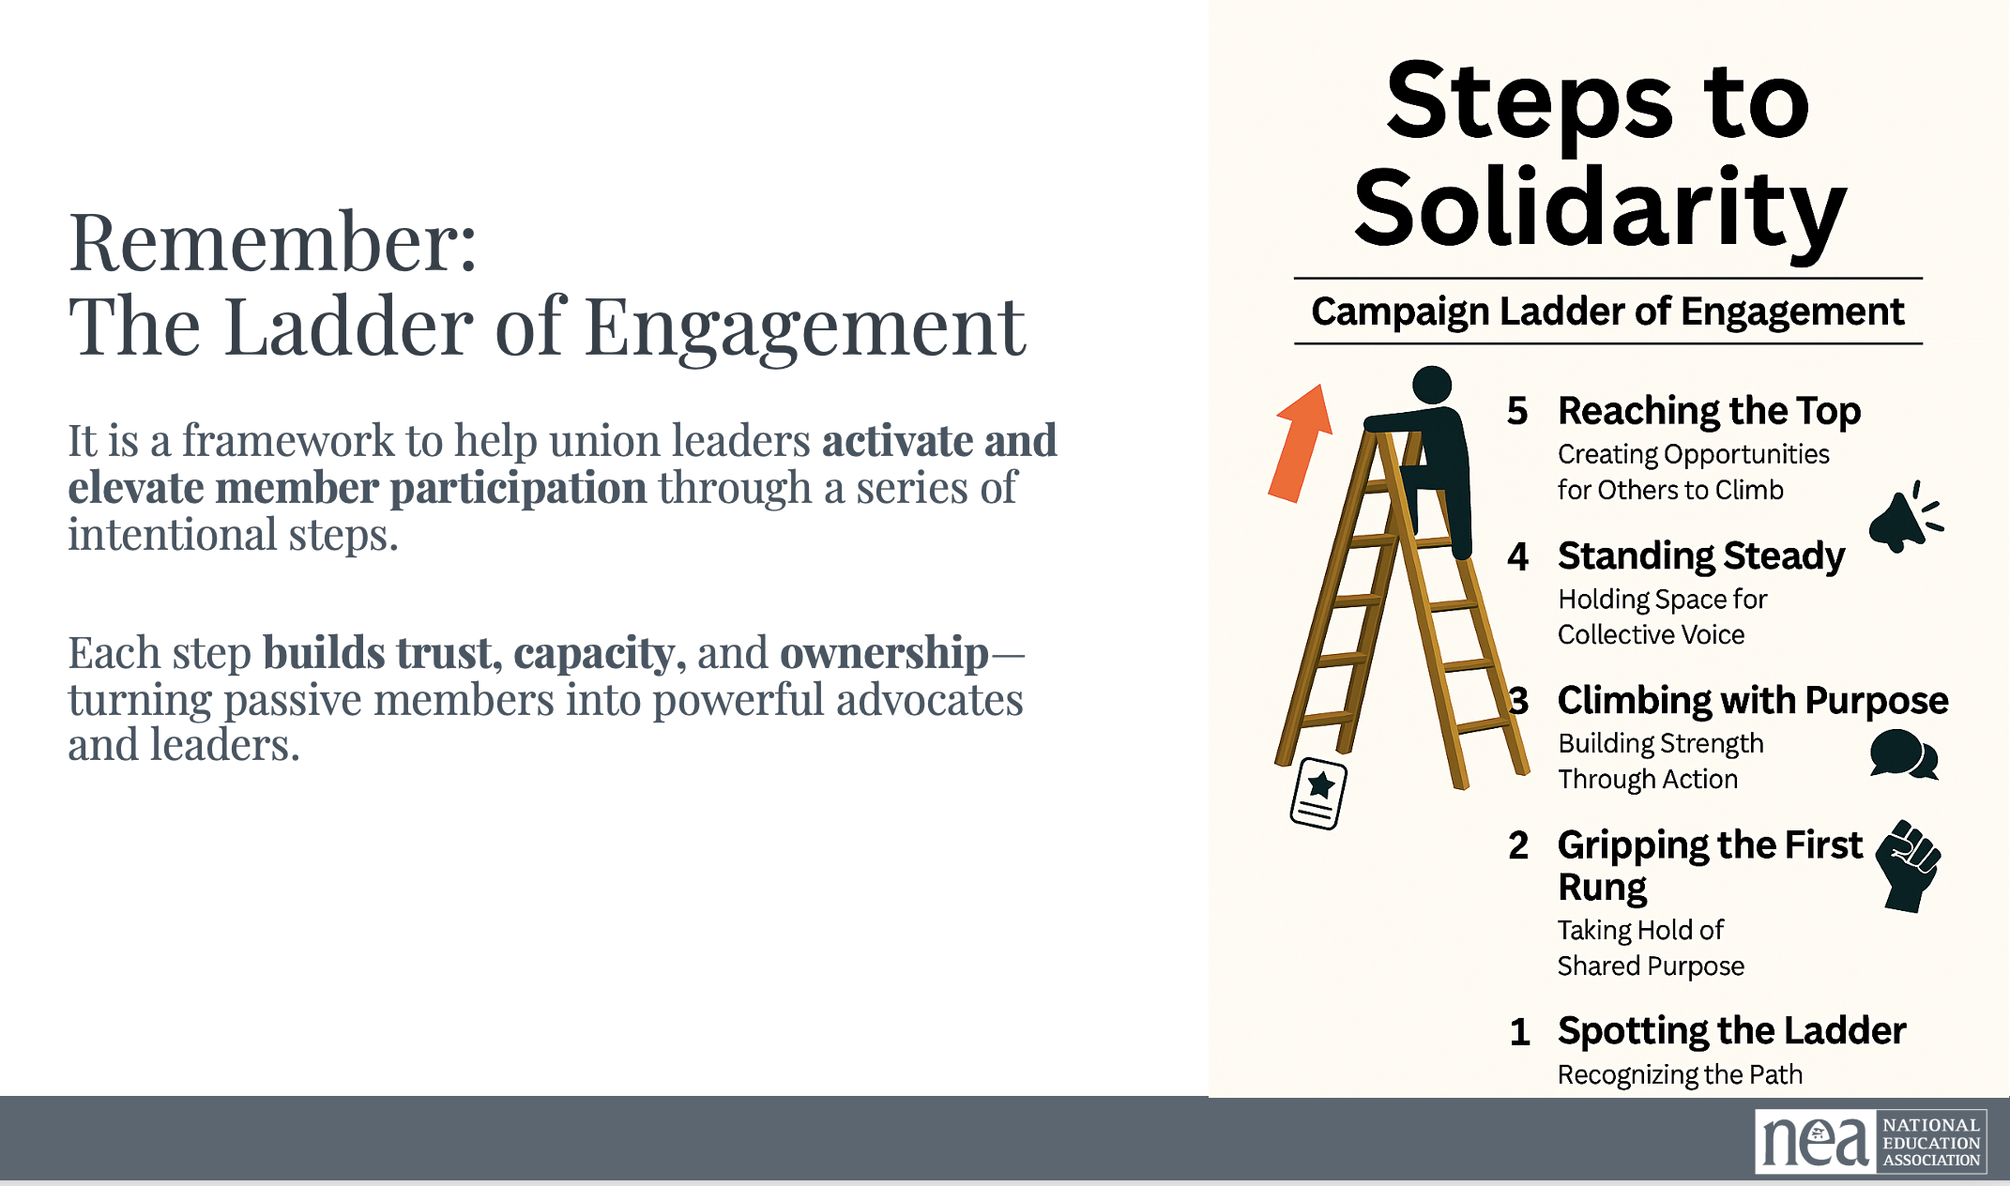  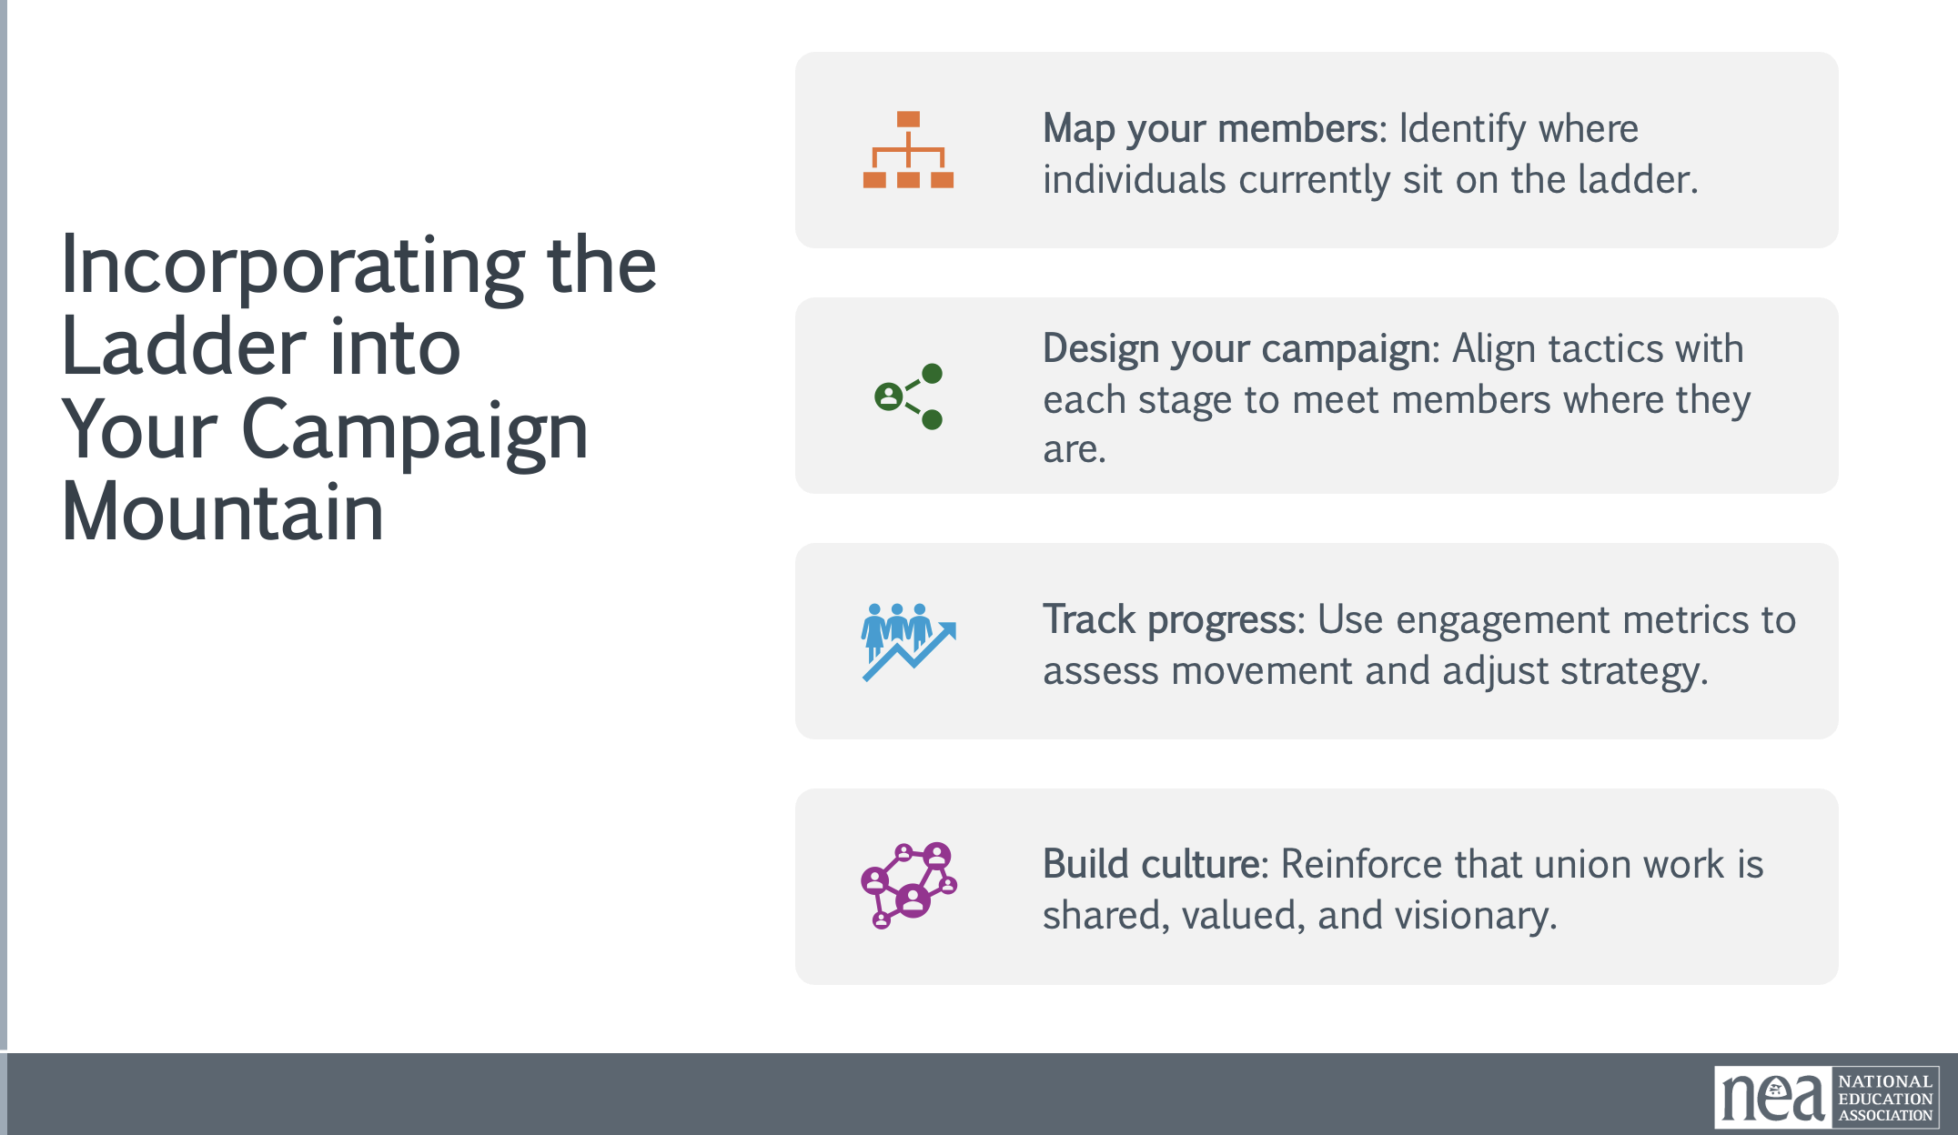  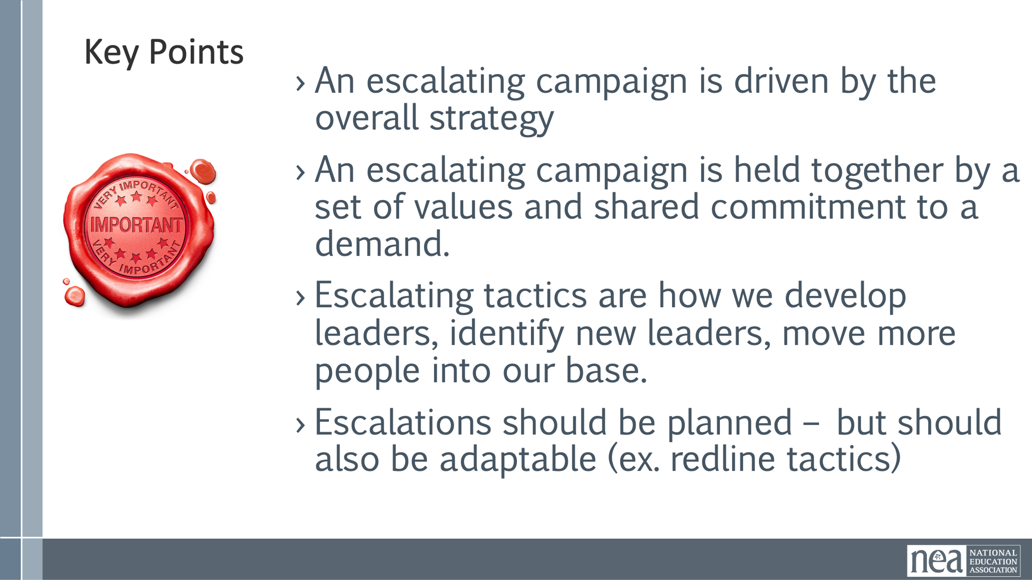 |  | 15 minutes of Content Only (this prepares them for their long work session that follows)  Every campaign has a strategic timeline. It is what keeps us climbing campaign mountain. The following are considerations your team needs to include when building their timeline.  - How long can you wait for the demand to be met?  - Are you creating a deadline?  - Is there and event creating the deadline?  - How long will it take to identify the problem, identify the issues, build a leadership team, build a presence, etc. etc. etc.  - When do you make the starting point?  You will want to think about compression points –  Points on the calendar where you celebrate short term wins or escalate your tactics.  ◦Naturally occurring deadlines- Breaks, Board Meetings  ◦Artificial deadlines-target has till day X to act  ◦Help us build urgency and crisis  We talk about an escalation of tactics – why do we say this? Why do you think tactics escalate gradually? Think about the case study from yesterday.  - Less escalated actions prepare our people for more escalated actions  - Give the target a point to do the right thing before things escalate to the next tactic  - Use the threat of escalation  - Allows more people to join our base  Key points  - An escalating campaign is driven by the overall strategy  - An escalating campaign is held together by a set of values and shared commitment to a demand.  - Escalating tactics are how we develop leaders, identify new leaders, move more people into our base.  - Escalations should be planned – but should also be adaptable (ex. redline tactics) | Participants will construct a strategic timeline for their campaign.
11:00-12:30 | Hedy | Team Work Time and Presentation  1 hr – planning  30 mins presentations
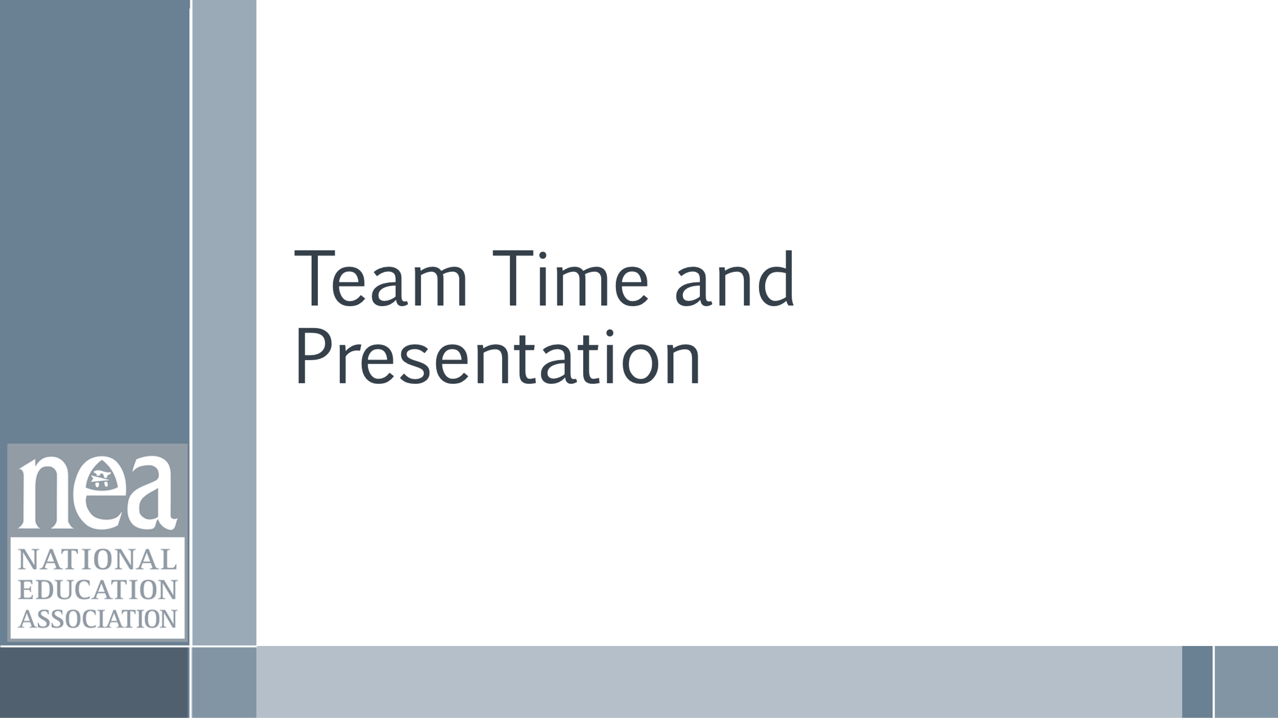  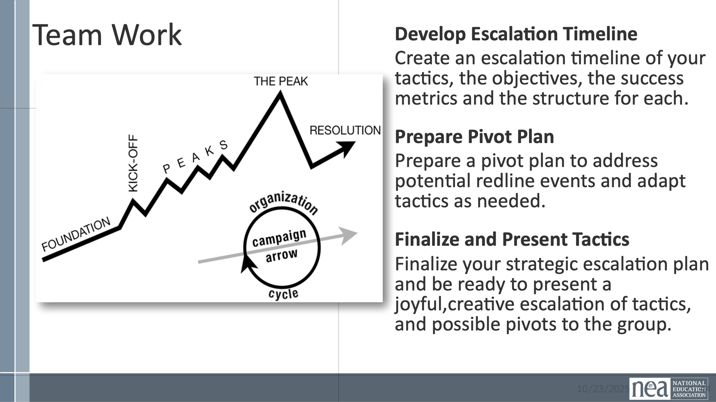  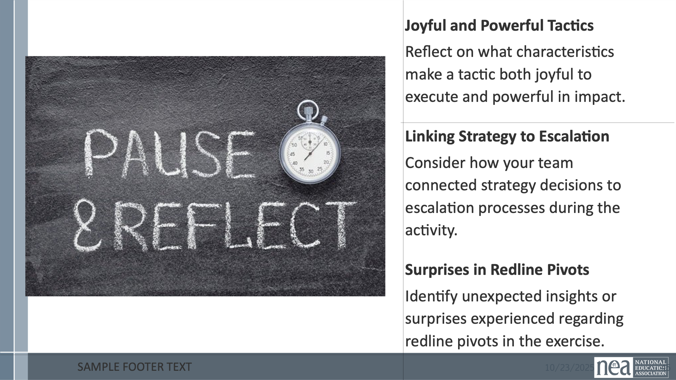  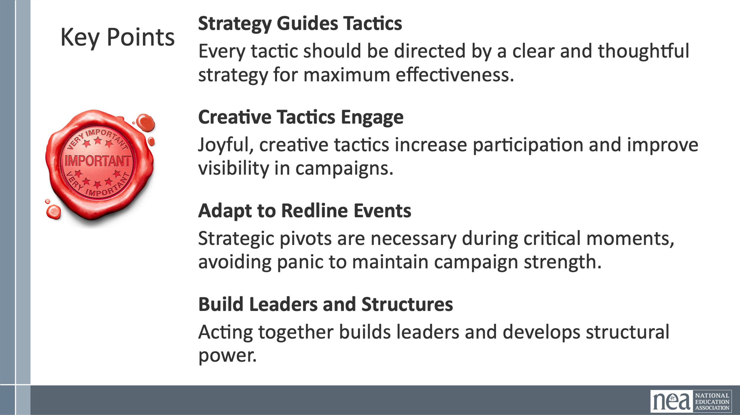   |  | Develop Escalation Timeline  Create an escalation timeline of your tactics, the objectives, the success metrics and the structure for each.  Prepare Pivot Plan  Prepare a pivot plan to address potential redline events and adapt tactics as needed.  Finalize and Present Tactics  Finalize your strategic escalation plan and be ready to present a joyful, creative escalation of tactics, and possible pivots to the group.  Before you start working, take time to reflect on the following  - Joyful and Powerful Tactics  - Reflect on what characteristics make a tactic both joyful to execute and powerful in impact.  - Linking Strategy to Escalation  - Consider how your team connected strategy decisions to escalation processes during the activity.  - Surprises in Redline Pivots  - Identify unexpected insights or surprises experienced regarding redline pivots in the exercise  AND REMEMBER THIESE KEY POINTS  - Strategy Guides Tactics  - Every tactic should be directed by a clear and thoughtful strategy for maximum effectiveness.  - Creative Tactics Engage  - Joyful, creative tactics increase participation and improve visibility in campaigns.  - Adapt to Redline Events  - Strategic pivots are necessary during critical moments, avoiding panic to maintain campaign strength.  - Build Leaders and Structures  - Acting together builds leaders and develops structural power.  Reserve about 30 minutes for Sharing of Plans  Three groups  Group 1 - Alan  GA- Retired  Lawrence  Des Moines  North Carolina  Group 2 - Tressie  Olathe  United Shelby County  Riverside  Group 3 - Jay  Celina  York  Classified Staff Union- MA  NEA-AK  Use the coaches in the room to run the presentations. Alan, Tressie, Jay. The facilitators time the presentations
12:30-1:00 | Ellen | 30 Minutes - Ending it Right
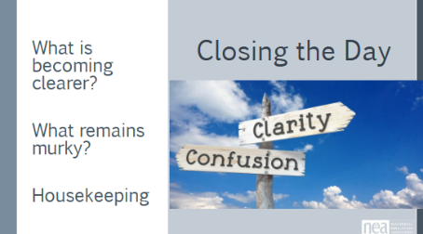 |  | Questions, Connections, Reflections  Housekeeping announcements  What did we do well? Where could we focus more? | Participants will be able to bring a little closure to their learning and provide feedback on the day.
1:00-2:00 |  | 60 Minutes - LUNCH on Your Own AND Adult Choice Networking Activities
 |  | This is a time for participants to meet and discuss any issues they are thinking about with other members of the group. This is not led by facilitators and highly encourage to occur in any other space besides the conference room. | Participants will make useful connections with staff from other affiliates.
2:00 Adjourn

