10:30 -11:30  Izaak and Ellen      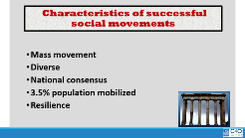  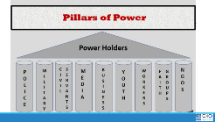        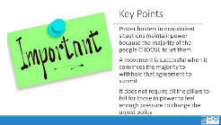   | How do the powerholders maintain the status quo and what can be done about that? | Pillars of Support Content  https://www.dropbox.com/s/fzyoi0pl7dvj4me/11.5%20Pillars%20of%20Support%20Content.docx?dl=0  Pillars of Support Worksheet  https://www.dropbox.com/s/tcxq1dbdow5jznf/11%20Pillars%20of%20Power.docx?dl=0  Article – Mapping the Movement to Dismantle Public Schools  https://www.dropbox.com/s/rruabfbbxhe6zwm/11.2%20Mapping%20the%20Movement%20to%20Dismantle%20Public%20Education.pdf?dl=0 | 60 Mins - Pillars Activity  10 mins – Powerholders are able to maintain their unjust policies because of the support they receive from supportive pillars “organizations and institutions” when we can win over these pillars or at the least, neutralize them, then we erode the power holders grip.  30 Mins - We are going to work in teams of 5ish to examine the pillars of support that exist to uphold the privatization of public schools. You will need the Pillars of Support Content Sheet, Worksheet and the article called “Mapping the Privatization of Public Schools” p.33-45  Using these resources, your team is going to create a House of Injustice Poster. In the top you will write the “Power Holders” for this issue AS YOUR TEAM SEES IT. You will identify the Pillars of Support that exist to keep this Injustice going. AND you will then identify the pillars that you YOUR TEAM believes they can win over or neutralize.  10 Mins – Report out from each team – (3 Mins or less each)  Who are the powerholders?  What are the pillars of support?  Which pillars can you neutralize or turn – by doing what?  10 mins-Debrief  What stands out to you?  Are there any questions you would like to ask a team?  Is there any idea you would like to hold up as a an awesome idea?  Key Points  Power holders in non-violent situations maintain power because the majority of the people CHOOSE to let them.  A movement is successful when it convinces the majority to withhold that agreement to submit.  It does not require all the pillars to fall for those in power to feel enough pressure to change the unjust policy  It only takes 3.5% of a population for a social change. | Participants will analyze the pillars of support for a particular social problem -privatization of schools – and identify the pillars they believe they can win or neutralize.

