Basic Coaching Content
Time Slides Facilitator | Resources | Instructions, Activity and Debrief (Facilitator Script) | Essential Questions and Outcomes
 | Charts, handouts, articles, materials, slide | What are you saying, what are they doing, what questions will you use to guide learning and make clear the important points  Include an estimate for how long each section of the learning will take | What question(s) will this learning answer? What will participants know or be able to do?
 |  | 30 Minutes - Centering Equity in your Campaigns
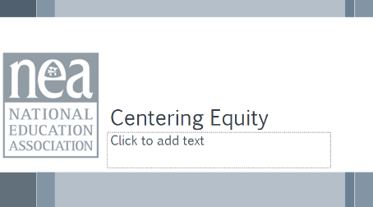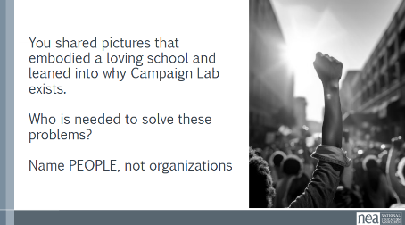  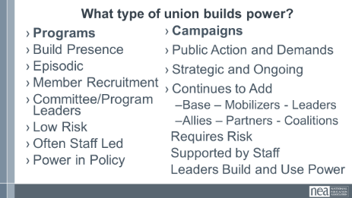  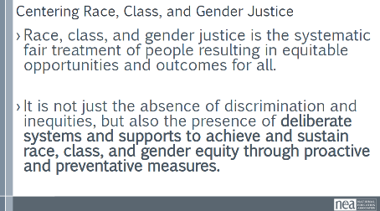  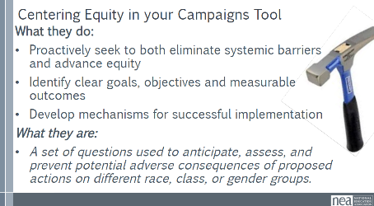  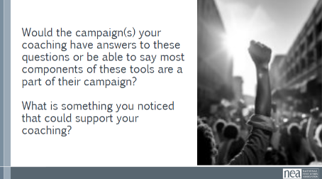  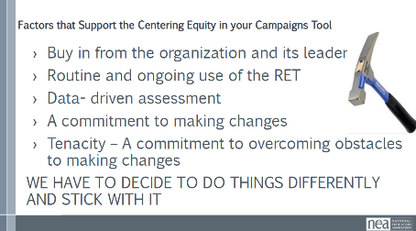  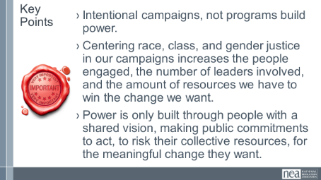 | Charts for problems  \ | 7 minutes – Problems chart and discussion  Whole group: Need someone to chart  Alt question: You shared pictures that embodied a loving school and leaned into why Campaign Lab exists. Who is needed to solve these problems? Name PEOPLE, not organizations  2 minutes – Union Work that Builds Power  For all those things, to make meaningful lasting STRUCTURAL change we need power. Power is defined as that ability to create, control, and prevent change. That typically means organized people and organized money or resources – your work is a resource.  What type of union builds power? Programs, such as professional learning, staff led advocacy, social focused events, even policy advocacy do little to build power. Why is that? Well all of these programs are self-selected with little risk to join or leave them. I want to improve my classroom management, so I come to the Union led training on that. I might even lead one – but I have done little to build power with others. Also in a program, I am choosing to solve a “me” Problem and it does not require any other collective commitment.  Campaigns put people at the center of solving the problems they are experiencing. They name the issue, they decide the solution, they decide who they follow, and they determine what the are willing to risk. When we center people in a campaign – staff move to a coaching role. When people are at the center they use their agency and decide how to act, who they will act with, and what they are willing to risk to win. This is when members and leaders feel powerful in their union.  To begin a campaign you have to ask what the people want to solve, ask what they are willing to risk to solve that, and form demands that they think will provided the solution to their problem.  2 mins - What does it mean to center racial, class and gender justice?  Race, class and gender dynamics, disparities, and divisions permeate our society, communities, schools, and classrooms.  Systemic oppression is so deeply rooted in our history, culture, and institutions that there is no escaping it. Visible or not, the impacts are ever-present. Race, class, and gender justice is the systematic fair treatment of people of all races, resulting in equitable opportunities and outcomes for all.  It is not just the absence of discrimination and inequities, but also the presence of deliberate systems and supports to achieve and sustain race, class, and gender equity through proactive and preventative measures.  To continually and systematically keep equity in your work you have to use a Race, Class, and Gender Equity tool, or lens. This is a person and institutional commitment to  - Proactively seek to both eliminate systemic barriers and advance equity  - Identify clear goals, objectives and measurable equity outcomes  - Develop mechanisms for successful implementation of equity focused programs  - A set of questions used to anticipate, assess, and prevent potential adverse consequences of proposed actions on different race, class, or gender groups.  TOOL IS ON PAGE 30  17 minutes – Review Centering Equity in your Campaigns  -5 minutes – Take a moment to review these tools  -11 minutes – Table discussion: Would the campaign(s) your coaching have answers to these questions or be able to say most components of these tools are a part of their campaign?  What is something you noticed that could support your coaching?  -2 minute – 3 brief things the room needs to hear  As a coach or mentor coach your role will be to continually probe to see if this process has been repeated at various steps and at key decision points throughout the campaign cycle  2 Minutes Key Points-  Intentional campaigns, not programs build power.  Centering race, class, and gender justice in our campaigns increases the people engaged, the number of leaders involved, and the amount of resources we have to win the change we want.  Power is only built through people with a shared vision, making public commitments to act, to risk their collective resources, for the meaningful change they want. | Participants will understand that centering equity in their campaigns at all stages of the planning ensures that they are focused on building power with those most likely to be experiencing the highest levels of oppression in the current systems of power.  Participants will apply a tool that helps them build the habit of practice for centering equity.  Coaches will assess what their possible interventions might be if these practices are not in place with the locals they are coaching.
 |  | 45 Minutes TOTAL –Why Coaching?
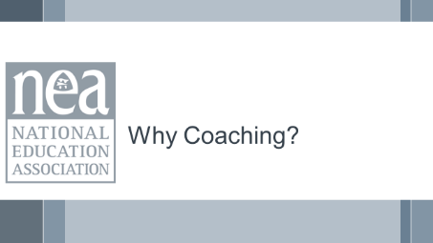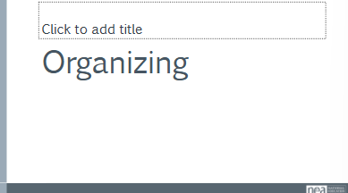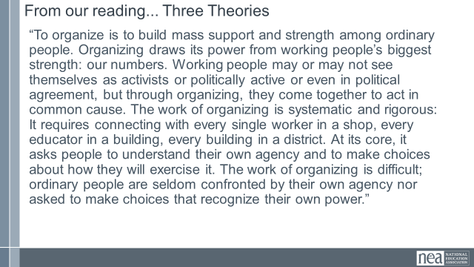  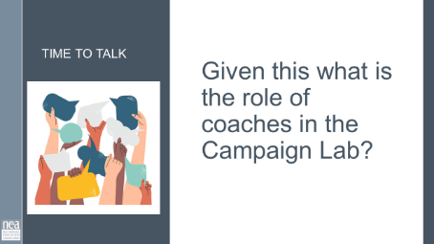  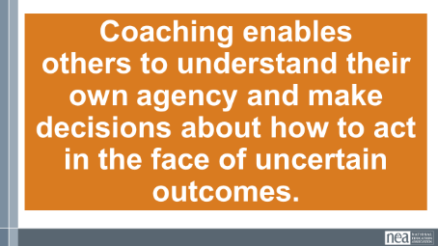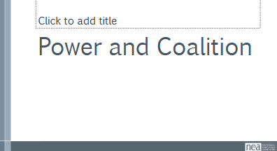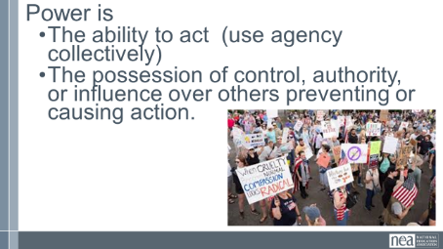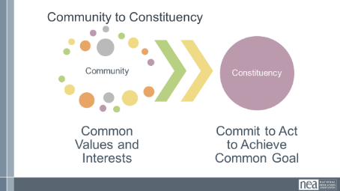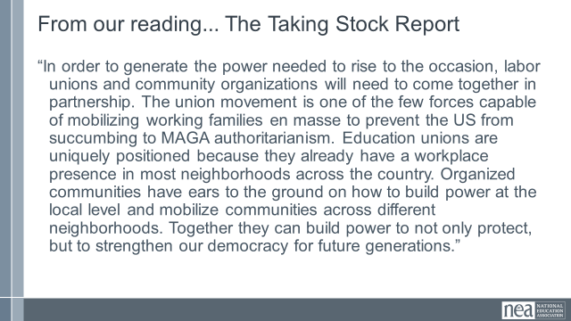  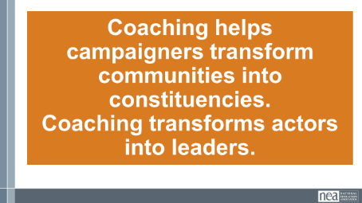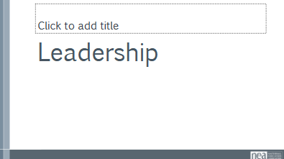  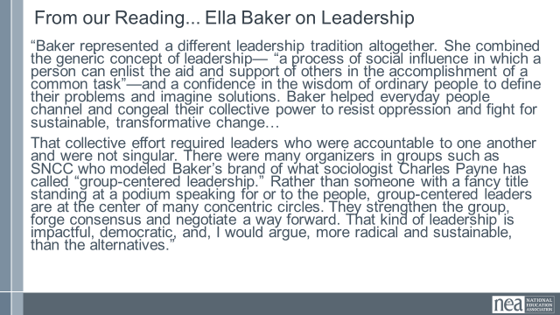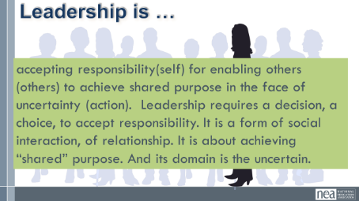  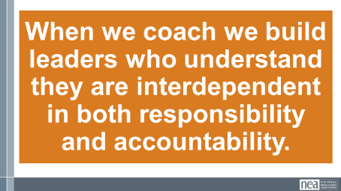  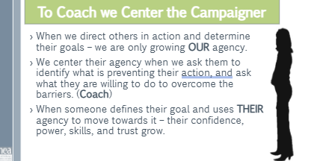  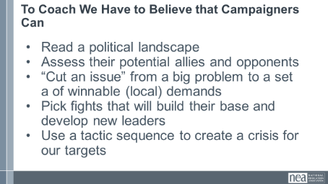  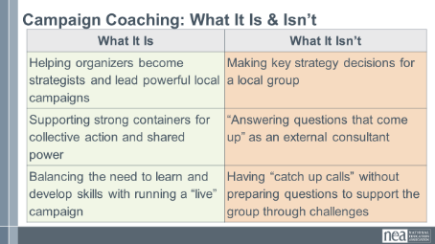  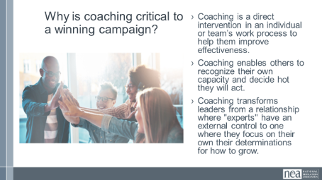  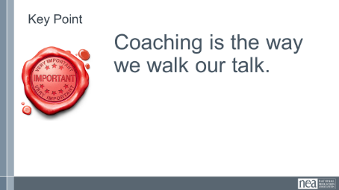 | Coaching 101  Campaign Cycle Plan  Basics of Coaching  5 Campaign Cycle Planning Workbook.pdf  0 Coaching Campaign Planning.pdf | 2 minutes Intro  10 Minutes - Organizing  10 Minutes – Power  10 Minutes – Leadership  8 Minutes – Putting it together  2 Minutes - You were asked to read some articles before you got here. We are going to discuss three of those in relationship to why coaching and why your roles are critical to the Campaign Lab. The Campaign Lab is a different way of doing work. Most programs and support from our state affiliates and from NEA come in the Form of Advocacy – an expert speaking on behalf of others. Another large batch of our work is spent Mobilizing – the episodic engagement and activation of those already committed to our goals. But these don’t get us the sustained power we need for the challenges we are facing and bold dreams you have.  10 Minutes – They Read slide, discuss, and report out  Share the following from three theories in the Pre academy package:  “To organize is to build mass support and strength among ordinary people. Organizing draws its power from working people’s biggest strength: our numbers. Working people may or may not see themselves as activists or politically active or even in political agreement, but through organizing, they come together to act in common cause. The work of organizing is systematic and rigorous: It requires connecting with every single worker in a shop, every educator in a building, every building in a district. At its core, it asks people to understand their own agency and to make choices about how they will exercise it. The work of organizing is difficult; ordinary people are seldom confronted by their own agency nor asked to make choices that recognize their own power.”  Given this – what are your primary roles as coaches in the Campaign Lab?  Discussion from across the room about roles.  Share - Coaching enables others to understand their own agency and make decisions about how to act in the face of their own power.  10 Minutes – Show two slides, then they Read slide, discuss, and report out  Power is the ability to act (use agency collectively)  The Posession of control, authority, or influence over others either preventing or causing action  Campaigners work to move loosely connected communities who shaer common values and interests into constituencies. Constituencies have developed shared commitments to act, to risk their resources to achieve a common goal. This is beyond internal base building – which is necessary, but not sufficient for the kind of power we need to achieve the wins we want.  Read the following slide from our Taking Stock Report  “In order to generate the power needed to rise to the occasion, labor unions and community organizations will need to come together in partnership. The union movement is one of the few forces capable of mobilizing working families en masse to prevent the US from succumbing to MAGA authoritarianism. Education unions are uniquely positioned because they already have a workplace presence in most neighborhoods across the country. Organized communities have ears to the ground on how to build power at the local level and mobilize communities across different neighborhoods. Together they can build power to not only protect, but to strengthen our democracy for future generations.”  Given this – what are your primary roles as coaches in the Campaign Lab?  Discussion from across the room about roles.  Coaching helps campaigners transform communities into constituencies. Coaching transforms actors into leaders.  10 Minutes – They Read two slides, discuss, and report out  “Baker represented a different leadership tradition altogether. She combined the generic concept of leadership— “a process of social influence in which a person can enlist the aid and support of others in the accomplishment of a common task”—and a confidence in the wisdom of ordinary people to define their problems and imagine solutions. Baker helped everyday people channel and congeal their collective power to resist oppression and fight for sustainable, transformative change…  That collective effort required leaders who were accountable to one another and were not singular. There were many organizers in groups such as SNCC who modeled Baker’s brand of what sociologist Charles Payne has called “group-centered leadership.” Rather than someone with a fancy title standing at a podium speaking for or to the people, group-centered leaders are at the center of many concentric circles. They strengthen the group, forge consensus and negotiate a way forward. That kind of leadership is impactful, democratic, and, I would argue, more radical and sustainable, than the alternatives.”  Organizing Leadership is accepting responsibility(self) for enabling others (others) to achieve shared purpose in the face of uncertainty (action). Leadership requires a decision, a choice, to accept responsibility. It is a form of social interaction, of relationship. It is about achieving “shared” purpose. And its domain is the uncertain.  Given this what is the role of coaching in the Campaign Lab?  Discussion across the room  When we coach we build leaders who understand they are interdependent in both responsibility and accountability.  8 Minutes – Let’s put it together  To Coach We Center Their Agency  - Remove barriers to the other’s use of their agency- ability to choose to act. We do this by asking what they think they can do to overcome the barriers (coach)  - When we direct others in action – this is OUR agency.  - When someone defines their goal and uses THEIR agency to move towards it – that builds confidence, power, skills, and trust. We can support the use of agency through good coaching.  Even if we KNOW how WE would do it – THEY have to decide how THEY and THEIR People will do it  To Coach We have to believe that Campaigners can… (Slide)  - Read a political landscape  - Assess their potential allies and opponents  - “Cut an issue” from a big problem to a set a of winnable (local) demands  - Pick fights that will build our base and develop new leaders  - Use a tactic sequence to create a crisis for our targets  Even if we have experts or expertise in this area – we need to rely on their capacity analyze their contexts.  Campaign Coaching: What It Is & Isn’t  - Given what we know about campaigners, here’s how to think of the role of campaign coach  Why is coaching critical to a winning campaign?  - Coaching is a direct intervention in an individual or team’s work process to help them improve effectiveness.  - Coaching enables others to build their own capacity to act.  - Coaching transforms leaders from a relationship where someone else has external control to one where they focus on how to grow.  - Framing for campaigner skills, why coach them.  Key Point – Coaching is the way we walk our talk.  Closing idea – we are going to explore the methods and skills required to coach in a movement focused, organizing context. | Participants will understand why coaching is the way to change culture and enable leaders to use their agency for change.
  What It Is | What It Isn’t
  Helping organizers become strategists and lead powerful local campaigns | Making key strategy decisions for a local group
  Supporting strong containers for collective action and shared power | “Answering questions that come up” as an external consultant
  Balancing the need to learn and develop skills with running a “live” campaign | Having “catch up calls” without preparing questions to support the group through challenges
 |  | 20 Minutes Coaching Lineage
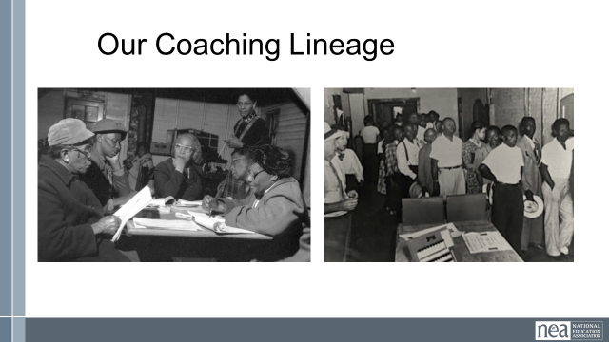  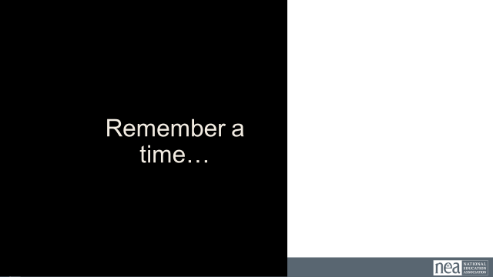  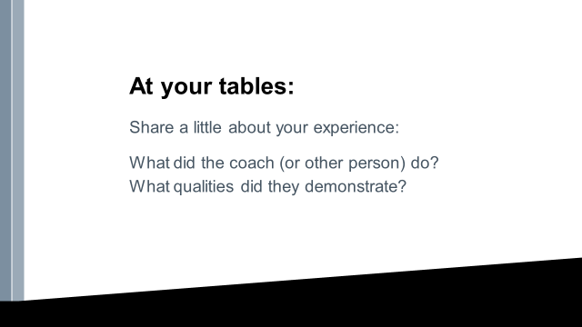  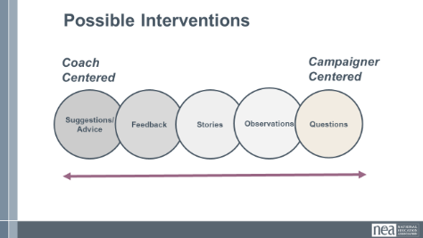  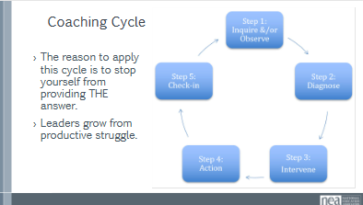  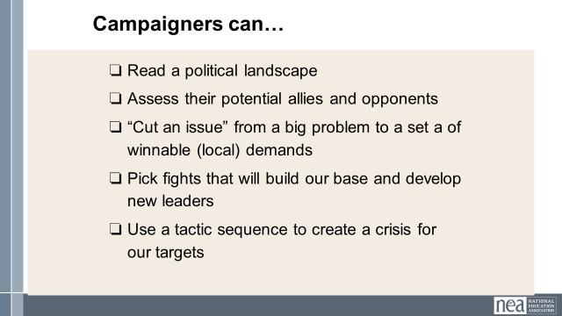  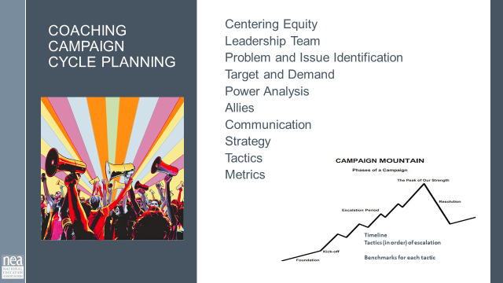  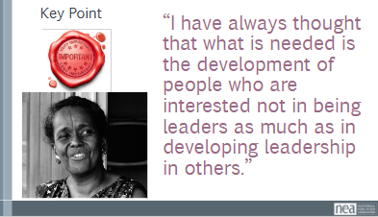 |  | 3 Minutes- Our Coaching Lineage -We know that the word ‘coaching’ gets used a lot these days. There’s life coaching, there’s athletic coaching, some of us might work with a personal trainer who coaches, and you can find a ton of coaching books written for corporate executives.  But just to be clear, when we say ‘campaign coaching’, we believe any time groups take collective action to change their material conditions, there are some people playing a coach role, intentionally trying to develop the insights and skills of their peers, mentees and even top leaders to help empower and grow people to become independent to lead their own campaigns. We’re especially inspired by US social movements that made widespread use of volunteer-based leadership development networks  3 minutes  Right now, I am going to ask you to close your eyes….Think of…  - “Think of an experience you’ve had of effective coaching, or being supported by someone – this could have been an athletic coach, a teacher mentor, or anyone else in your life who supported you to learn and grow in some way. What’s a moment you remember them providing a kind of support that exemplifies the role of a coach?...(continue closed eye in your own style)”  - What were you feeling as you came into coaching? How did you feel leaving the coaching session?  - What did they say? And if you can’t remember - what has stuck with you now that this is the moment you’re recalling?  You can open your eyes….  5 Minutes Share at your tables –  Share a little about your experience:  What did the coach (or other person) do? What qualities did they demonstrate?  5 Minutes – Share the Interventions slide  I want to hear from you, what did your coach do? We call this an intervention and they are intentional interruptions. They cause you to pause, reflect, assess, and then decide to act. That is your agency being activated.  How did they make you feel?  Look at this continuum of potential interventions – What do you notice?  We want our interventions to be like your most gorgeous experiences- we want our campaigners to feel that they are leading, they are deciding, they are succeeding. We want to center them as much as possible in their next steps.  To Do that we intentionally use 5 steps to that are designed to keep us at the most campaigner centered part of the intervention spectrum  - The reason to apply this cycle is to stop yourself from providing THE answer.  - Leaders grow from productive struggle.  Because, we do believe that the people closest to the work, our campaigners can ... QUICK REMINDER FROM LAST NIGHT(Slide)  - Read a political landscape  - Assess their potential allies and opponents  - “Cut an issue” from a big problem to a set a of winnable (local) demands  - Pick fights that will build our base and develop new leaders  - Use a tactic sequence to create a crisis for our targets  5 Minutes We are going to help them add to their repertoire for building power through campaign cycles. A lot of our typical local engagement is more about mobilizing – necessary but not sufficient – they are eposidic small cycles of Plan- DO- Act – but not nestled in a more strategic long view that includes significant power analysis and broad base building into coalition work.  This framework is a cycle intended to support this – not standardize it. They won’t all be identical, they wont all have every step of this proposed plan, but this outlines a replicable framework for developing and building winning campaign cycles.  Each part of the Campaign Plan or rest of day:  Presenters give a highlight of content, you’ll Discuss indicators that would allow you to know if that part was completed effectively, and determine how coaching practices that would move leads and teams  1 Minutes Key Point –  Effective campaign coaches are not the leaders, instead they help campaigners moving. In Ella’s words  “I have always thought that what is needed is the development of people who are interested not in being leaders as much as in developing leadership in others.” | Participants will understand the roots of our coaching theory.  Participants will be introduced to a planning framework and an accompanying coaching plan.
 |  | 60 Mins TOTAL – Coaching Practice
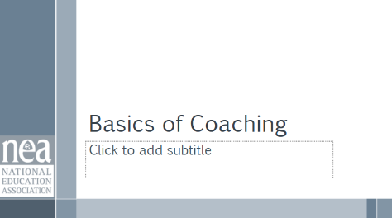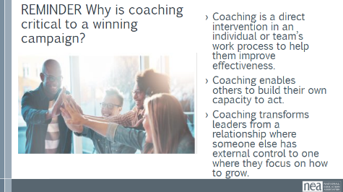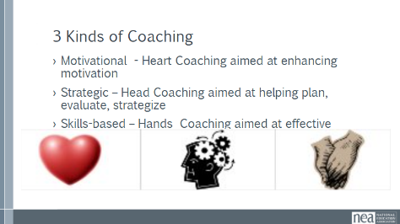  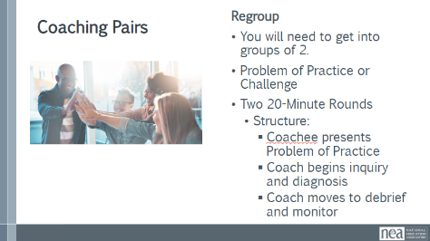  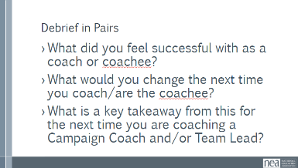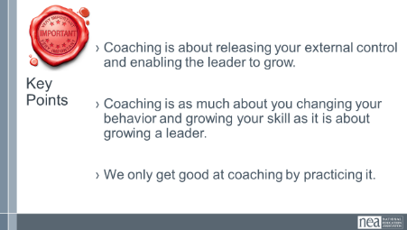 |  | There are two guides, One is an overview of coaching. That is for them to continue to review. The Campaign Cycle Planning Workbook is the primary one they will use.  3-minute Coaching Refresher  REMINDER: Why is coaching critical to a winning campaign?  - Coaching is a direct intervention in an individual or team’s work process to help them improve effectiveness.  - Coaching enables others to build their own capacity to act.  - Coaching transforms leaders from a relationship where someone else has external control to one where they focus on how to grow.  3 Categories of Coaching Interventions p. 5 of Basics of Coaching  - Motivational - Heart Coaching aimed at enhancing motivation  - Strategic – Head Coaching aimed at helping plan, evaluate, strategize  - Skills-based – Hands Coaching aimed at effective  55 Minutes TOTAL – Partner – Coaching Practice.  10 minutes - Whole group example of coaching practice  This should be very put together and well thought out. Save any debrief conversation for after they have a chance to practice  Get in groups to practice  You were asked to bring a problem of practice. A problem of practice is something that you care about that would make a difference for your locals if you improved it. The more specific the problem of practice is, the more helpful the recommendations for your next level of work will be. You were asked to identify what a goal would be for a short coaching session.  You are going to work in pairs and will do two rounds. For each round, one person agrees to be coached on an issue and one person agrees to do the coaching (if you have an odd number of participants have a facilitator participate; having only 2 per group is important) on their use of the 5 Step Cycle, and the application of craft and technique.  Structure of the 20 minute rounds  - Coachee begins to present the problem of practice and the goal. Coach is focused on figuring out the reality – so more clarifying questions here.  - Coach begins to move into Inquiry and diagnosis. IN their mind they develop a diagnosis and their questions around the intervention should match a Head, Heart, or Hand path of coaching – this will allow the Coachee to express and present options for improving their challenge  - Coach moves into Debrief and Monitor – Coach will use summarizing and reflecting techniques that allow the coachee to identify what they will do and identify how and who and by when – coach and coachee commit to what monitoring and support will look like.  5 Minutes to Debrief the Pairs  What Category of Intervention did you diagnose?  What did you feel successful with as a coach or coachee?  What would you change the next time you coach/are the coachee?  What is a key takeaway from this for the next time you are coaching a Campaign Coach and/or Team Lead?  2 minutes Key Points  - Coaching is about releasing your external control and enabling the leader to grow.  - Coaching is as much about you changing your behavior and growing your skill as it is about growing a leader.  We only get good at coaching by practicing it | Participants will understand how to diagnose and determine a coaching path.  They will develop and apply various coaching questions in scenarios.
 |  | 30 Mins TOTAL– Coaching Into Team Development
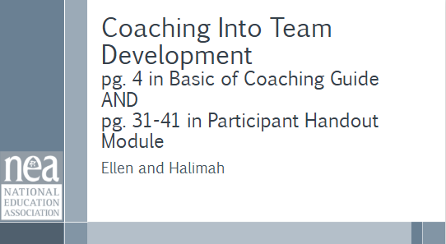  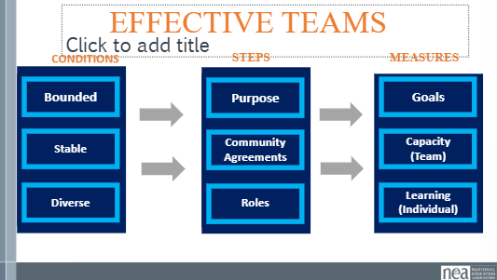  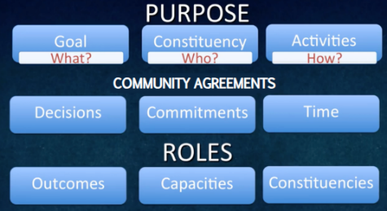  Review the Tools  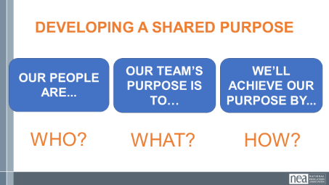  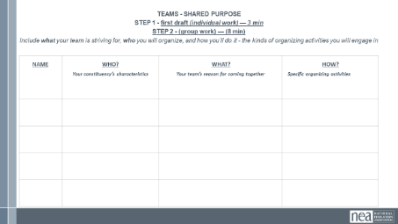  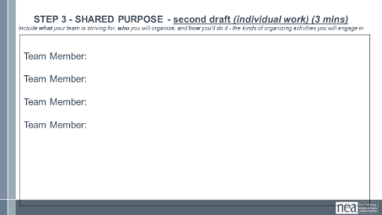  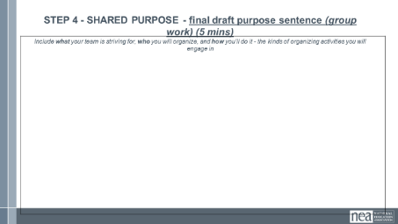  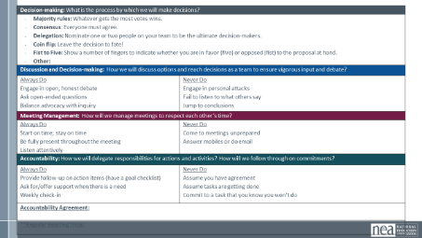  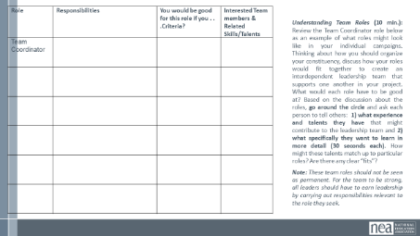  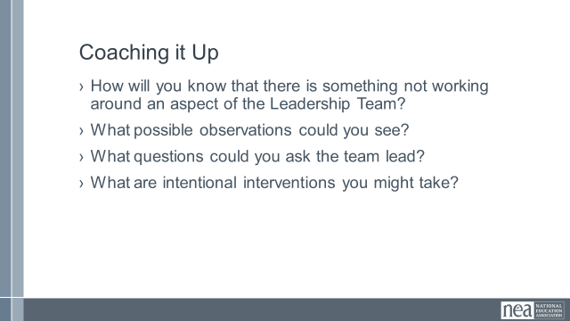  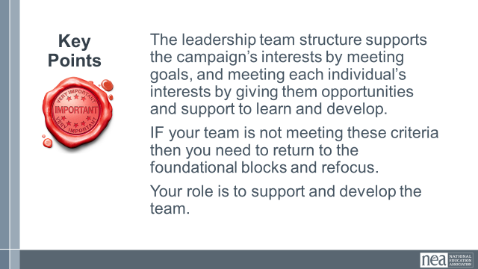 |  | REMINDER to participants – make sure that they have the Coaching Campaign Planning Document  3 min Review and content –  You will need page 31 and 41 in the Participants Handout and shoujld also use the Coaching Campaign Cycle Guide  We will never achieve our vision for Loving Schools and Communities and have the people you need to achieve that IF you don't intentionally build effective teams. If one of our shared values is that we are seeking a diverse, inclusive, and equitable society – then your team needs to reflect that.  When looking at effective teams, pay attention to the conditions that make a great team, the steps to get there, and the measures that help us know we got there.  Let’s start with the measures of an effective team.  MEASURES  - GOALS: A good team has goals AND takes action together to achieve the goal and effect the change they want to see.  - CAPACITY: An effective team also builds capacity. Learns how to work together and how to develop new leadership to replace them when they are gone.  - LEARNING: Lastly, an effective team also includes a learning component. You will know if your team is effective when you walk away with a new skill or perspective on how to do the work.  CONDITIONS  - Your team is bounded. You can name the people on it; they don’t come and go, whoever shows up doesn’t have the automatic right to participate in the team.  - Your team is stable. It meets regularly. It’s not a different, random group of people every time. Membership of the team remains constant long enough that the team learns to work together better and better; each member is fully committed to be on the team and commits consistent time and effort to it.  AND YOUR TEAM IS INTENTIONALLY DIVERSE – asking who is not yet here that has a shared value or interest in this  - Your team is interdependent. As on an athletic team, a string quartet, or an airplane cabin crew, the contribution that each person makes is critical to the success of the whole. Team members have a vital interest in each other’s success, looking for ways to offer support.  Finally, there are 3 Steps to reach these measures.  - Crafting a SHARED PURPOSE. Purpose assigned (low agency and commitment) vs. Purpose developed collectively (high agency, commitment  - Developing SHARED COMMUNITY AGREEMENTS.  - And establishing INTERDEPENDENT ROLES.  15 min – Discussion Activity – Pg 31-41 in the Participant Handouts – There is a separate guide in the Module named Teams that is for the Team Leads in Review the tools and processes for setting up a team at your tables, how have you done this in the past, what is your approach, how would you coach this.  10 Minutes Coaching It up Conversation:  › What are challenges you think you will see when you coach this  How will you know that there is something not working around an aspect of the Leadership Team?  ›What possible observations could you see?  ›What questions could you ask the team lead?  ›What are intentional interventions you might take?  1 Minute Key Points:  The leadership team structure supports the campaign’s interests by meeting goals, and meeting each individual’s interests by giving them opportunities and support to learn and develop.  IF your team is not meeting these criteria then you need to return to the foundational blocks and refocus.  Your role is to support and develop the team. | Team Leads and Coaches would understand the measures, conditions, and formation steps that make up an effective team.  Coaches and leads would be able to lead teams through the 3 steps.  Coaches will assess what their possible interventions might be if these practices are not in place with the locals they are coaching.
 |  | 30 Mins Total – Coaching into the Campaign Cycle – Problem Issue
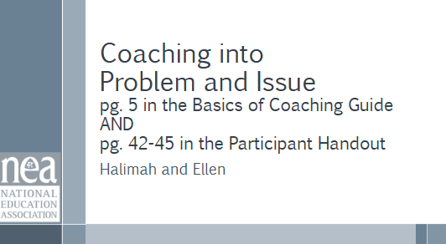  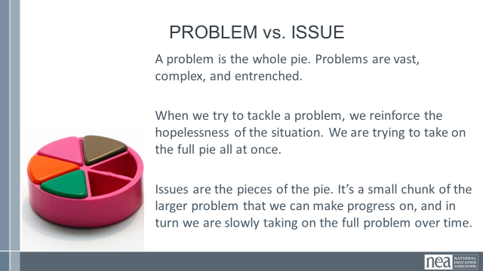  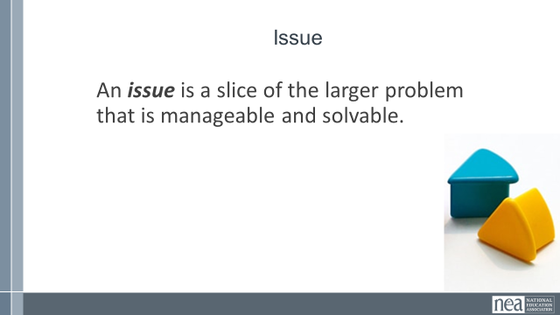  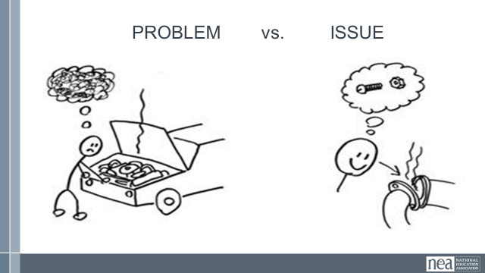  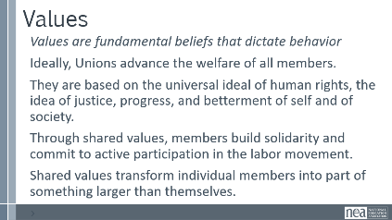  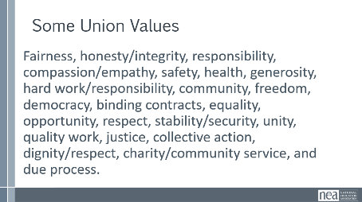  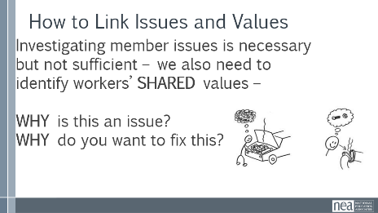  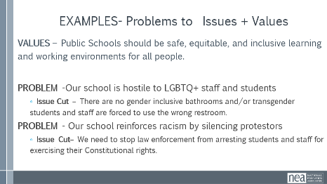  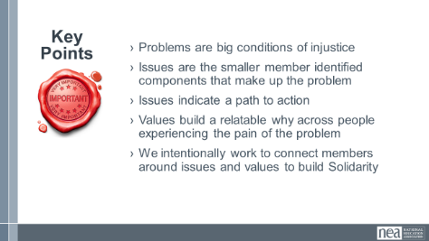  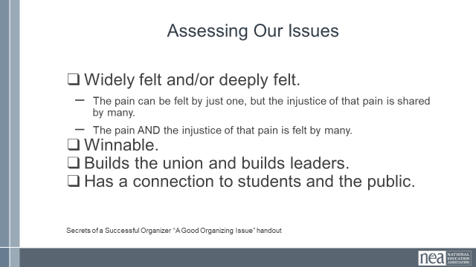  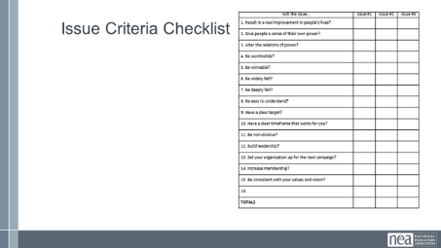  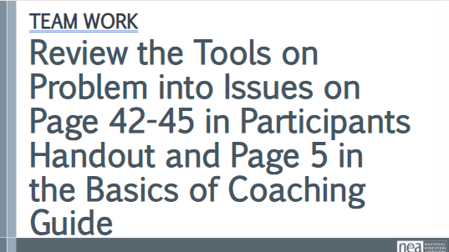  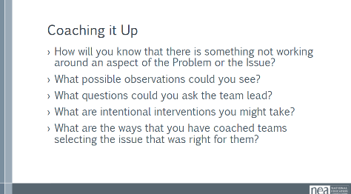  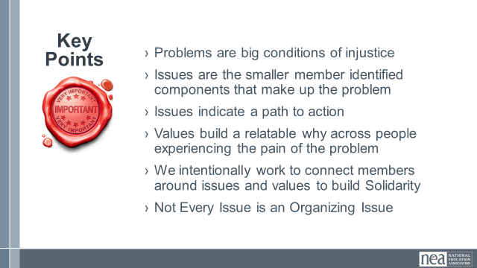 | 3 Problem to Issue Analysis.pdf  5 Campaign Cycle Planning Workbook.pdf  0 Coaching Campaign Planning.pdf | 5 Minutes PROBLEM , ISSUES and Values  Pg 5 in the Coaching the Plan Guide  Pg 42-45 in the Participant Handout  Campaigns start with issues that people have value-based solidarity around.  An issue is a slice of a workplace problem.  Often a problem can have different issues depending on the perspective of the people we are working with.  It is KEY to get enough input on what the issues are that make up the problem so that YOU do not drive the solution.  For example, A problem My Car is a piece of JUNK --- Issues – broken radiator hose, bad brakes, smelly interior, hole in the muffler.  Investigating the issue is necessary but not sufficient – we also need to identify workers’ SHARED values – WHY is this an issue? WHY do you want to fix this?  Values are fundamental beliefs that dictate behavior  Ideally, Unions advance the welfare of all members.  They are based on the universal ideal of human rights, the idea of justice, progress, and betterment of self and of society.  Through shared values, members build solidarity and commit to active participation in the labor movement.  Shared values transform individual members into part of something larger than themselves.  For my example, my car has bad brakes and that is a safety issue. Everyone on the road deserves to have safe transportation.  I want to be safe and I want others to be safe – they likely share that value and interest.  Key Ideas  Problems are big conditions that have several smaller solutions  - Issues are the components that make up the problem  - Issues indicate a path to action  - Values build a relatable why across people experiencing the pain of the problem  - We intentionally work to connect people around issues and values to build Solidarity  10 Minutes – Use page 5 of the Basics of Coaching Guide, and Pages 42-45 Review the Tools our Problems into Issues  Page 42 -- What are tools and processes and coaching that you have used that have led to a local campaign achieving the goals that they wanted to .  5 Minutes Coaching it Up Conversation  ›How will you know that there is something not working around an aspect of the Problem or the Issue?  ›What possible observations could you see?  ›What questions could you ask the team lead?  ›What are intentional interventions you might take?  What are the ways that you have coached teams selecting the issue that was right for them  2 Minutes Key Points  - Problems are big conditions of injustice  - Issues are the smaller member identified components that make up the problem  - Issues indicate a path to action  - Values build a relatable why across people experiencing the pain of the problem  - We intentionally work to connect members around issues and values to build Solidarity  - Not Every Issue is an Organizing Issue | Participants will understand the difference between a Problem and an Issue.  They will apply a tool for making an issue cut and evaluating issues.  Coaches will assess what their possible interventions might be if these practices are not in place with the locals they are coaching.
 |  | 30 Minutes – Coaching Campaign Cycle -Target and Power Analysis
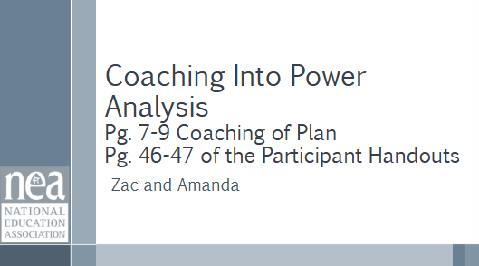  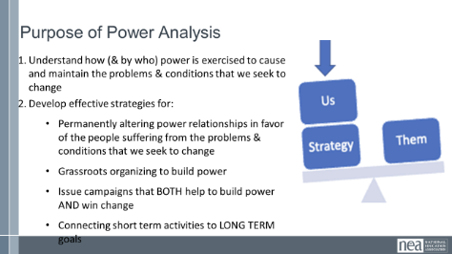  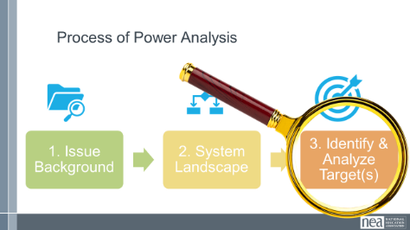  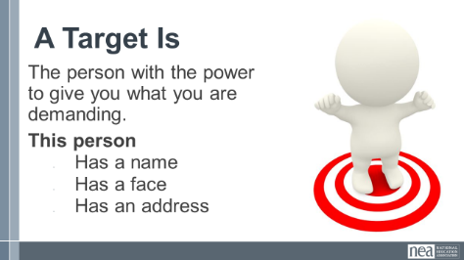  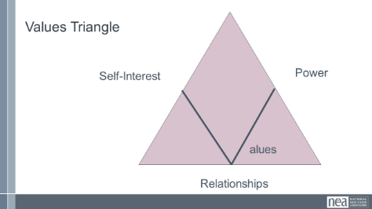  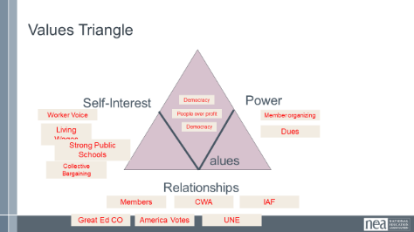  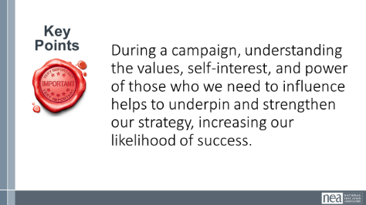 |  | 25 Minutes -Power Assessment / JWJ Values Triangle  5 Minutes – Coaching Implications, Question Development  5 min – Overview of power analysis and refresher on targets  Once we have a demand, we need to be clear about how we can leverage our power to get the outcome we want (or know what power we need to build).  We need to think about and get clear on both the sources of our target’s power and how we can interrupt and change the power dynamics at play. We do that through a process of understanding first the issue (we did that when we developed our demand), the system landscape (who can give us what we want), and finally how we can put pressure on the target.  Remember, the target we analyze should have a FACE, a NAME, and an ADDRESS.  Values Triangle Overview (15 mins) (shortened JWJ Values Triangle)  In order to understand how we can interrupt our opponent’s power, we need to understand our own power. There is a helpful tool for power analysis that we call the Values Triangle. FOUND ON PAGE in the handouts – 47 pages in the Campaign Cyle Coaching Guide too.  Say: The triangle works from the bottom up and the inside out. Draw the outline of a triangle  Point to the bottom line of the triangle. Label it RELATIONSHIPS  - At the bottom of the triangle, we have relationships.  - Everything starts with relationships because everything we do happens in, through, with and because of who we know and how we trust them.  Draw: a “V” inside the triangle. Label it VALUES  - Inside the triangle is where we have values.  - Do you remember how we defined values this morning? Values are deeply-held beliefs that shape who you are.  - We are our best possible selves when we have clarity on our values. The world we want to see and how we define ourselves are based on our values. A person who is clear on their values knows who they are and what they believe in.  Point to the left side of the triangle. Label it SELF-INTEREST  - On the left of the triangle, we have self-interest. Self-interest is what our values look like in the world, the tangible manifestation of our values. When you understand your values you can discover your self-interest. Your self-interest is what you’re willing to fight for.  - For example, if one of your values is people over profits, one of your self-interests could include stronger unions, living wage policies, hazard pay for essential workers, and more.  Point to the right side of the triangle. Label it POWER.  - On the right side of the triangle is Power. Who remembers our definition of Power?  - Power is the ability to create, control, and prevent change. Power is made up of organized people and organized resources.  - Bringing it all together, we build relationships, so that we can agitate people to live up to their values and get clear on their self-interest so that we can build the power we need to make the world reflect our values.  Say:  - This is the Values Triangle.  - Every person and organization has one of these.  - Understanding this triangle is key to your work and to making change.  - Remember that we build the Values Triangle from the bottom up and the inside out.  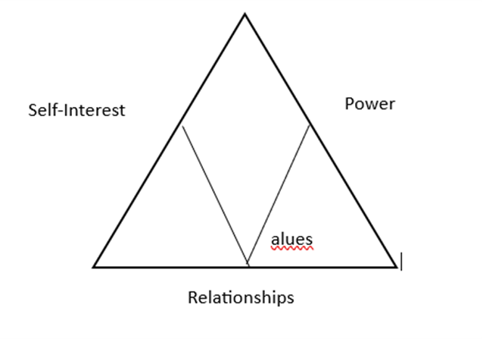  Lets start with NEA. What is NEA’s value triangle?  (10 min) values triangle practice  At our table groups, we’re going to take time to practice. Each group will have two volunteers to analyze a target (two rounds). The rest of the group will act as coaches.  Consider: What questions can you ask to help develop a more complete values triangle?  2 rounds: 1 min thinking from volunteers w/ target triangles. 3 min coaching from group.  (5 min) mini debrief  Share out – what were some helpful coaching questions?  What information or thinking did those questions pull out? | Participants will learn how to do a power analysis along with the inclusion of values.  Coaches will assess what their possible interventions might be if these practices are not in place with the locals they are coaching.
 |  | 60 Minutes Total – Spectrum of Allies and Messages
Albert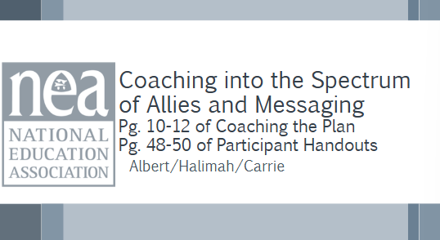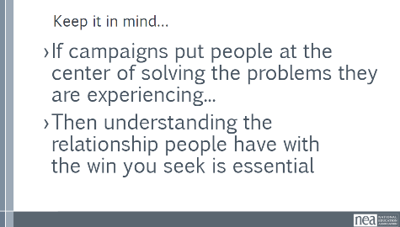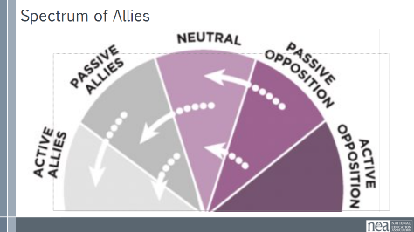  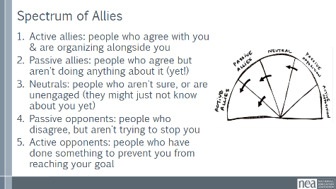  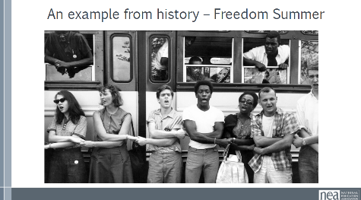  Carrie  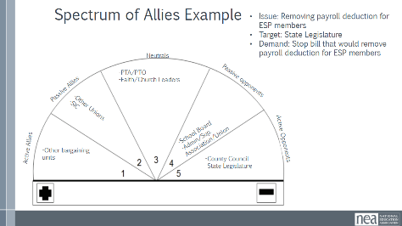  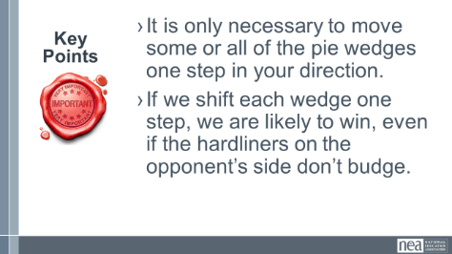  Halimah  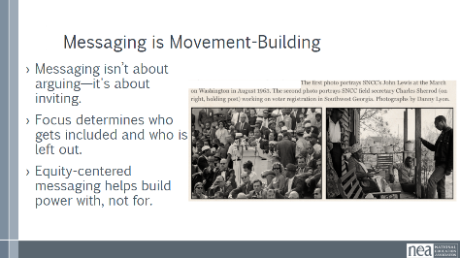  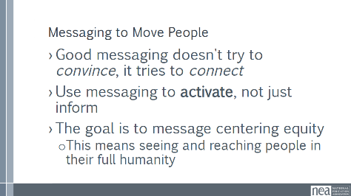  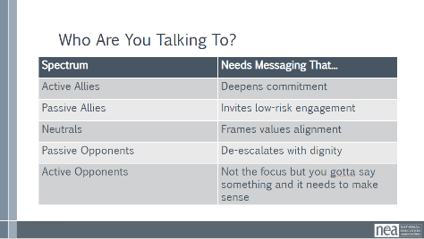  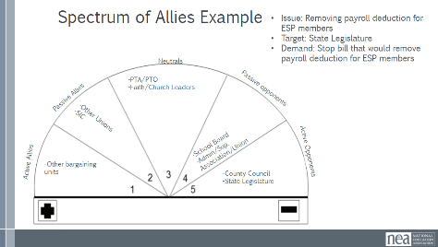  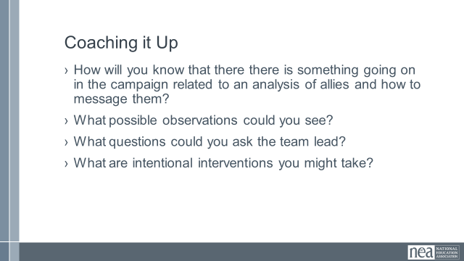  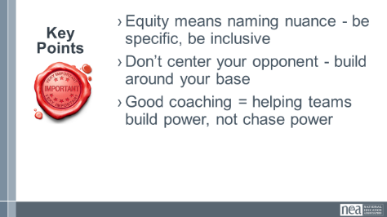 |  | 10 Minutes - Spectrum of Allies Content – Albert  Pg 10-12 of the Coaching the Plan, and pg 48- 50 of participant guide  If campaigns put people at the center of solving the problems they are experiencing...then understanding the relationship people have with the win you seek is essential.  We are going to learn a method called Spectrum of Allies. All of our campaigns CAN include a wide range of groups, but particularly in the campaigns we are thinking about they must include that. These include a wide range of groups that can be put on a kind of spectrum, from those closest to the point of view of the advocates to those who actively oppose change.  When working within these groups, it is helpful to move people, constituents, groups, etc. as close to active allyship as possible and probable.  - Active allies: people who agree with you & are organizing alongside you.  - Passive allies: people who agree but aren't doing anything about it (yet!)  - Neutrals: people who aren't sure, or are unengaged (they might just not know about you yet)  - Passive opponents: people who disagree, but aren't trying to stop you  - Active opponents: people who have done something to prevent you from reaching your goal  An example from history -  In 1964, the Student Nonviolent Coordinating Committee (SNCC), a major driver of the civil rights movement in the U.S. South, conducted a spectrum of-allies"-style analysis. They had a lot of passive student allies in the North: they were sympathetic, but had no entry point into the movement. They didn’t need to be “educated” or convinced, they needed an invitation to enter. SNCC sent buses north to bring folks down to “Freedom Summer.” Students became active allies -- they came in droves, and many were deeply radicalized in the process, witnessing lynching & violent police simply because black folks were trying to vote.  Many wrote letters home to their parents, who suddenly had a personal connection to the struggle. This triggered another shift: their families became passive allies as they learned about the struggle from those letters. The students went back to school in the fall and proceeded to organize their campuses. More shifts. The result: a profound transformation of the political landscape of the U.S., resulting from a deliberate movement strategy.  Charts/signs with each wedge of the Spectrum of allies around the room WE NEED TO PRE-MAKE THESE CHARTS  17 minutes - Movement Activity -- Carrie  I am going to share a couple of questions (don’t post them ahead of time) and you will move to the part of the spectrum that you think answers this question. (Facilitator note: as folks move take a moment to have them discuss why they moved to that space and a few whole group share outs as you go)  - Which group should a campaign spend the least amount of time trying to move?  - Which group is the most dangerous to a campaign if they don’t move?  - You’re coaching a campaign, and you notice there may be overgeneralizations about where people were placed in a group. What question would you ask to prompt the team leads to reassess this overgeneralization?  3 Minutes – Key Points  - It is only necessary to move some or all of the pie wedges one step in your direction.  - If we shift each wedge one step, we are likely to win, even if the hardliners on the opponent’s side don’t budge.  5 minutes - Messaging Lecturette - Halimah  Messaging is one of our most powerful organizing tools. But too often we aim in the wrong direction. Focusing only on opponents—or even just active allies—can burn people out or create silos. Centering equity means we think about who is included in our messaging and who is left out. When we focus only on powerholders, we often ignore the people closest to the problem—people we should be building with.  Good messaging doesn't try to convince, it tries to connect  Use messaging to activate, not just inform  The goal is to message centering equity  This means seeing and reaching people in their full humanity  This table breaks down how messaging changes depending on where someone is on the spectrum of allies. For example, you wouldn’t message the same way to an active ally as you would to a passive opponent. Passive allies often need invitations. Neutrals need to hear how the issue connects to their values. You can coach your teams to think about who they’re messaging to and tailor their message accordingly.  25 minutes TOTAL from Lecture to Key Points – Small Group Messaging Activity  Put participants in small groups  10-minute activity  Using the Spectrum of Allies Example, groups will select a wedge within the spectrum to craft messaging around the issue. The goal is to invite folks in that wedge to move at least one wedge to the left. The messaging should be 1-3 minutes at most  7-minute share out  Have groups share out providing any pluses or deltas where appropriate  5 Minutes Coaching It Up Conversation  ›How will you know that there is something going on in the campaign related to an analysis of allies and how to message them?  ›What possible observations could you see?  ›What questions could you ask the team lead?  ›What are intentional interventions you might take?  3 minutes – Key Points  Equity means naming nuance - be specific, be inclusive  Don’t center your opponent - build around your base  Good coaching = helping teams build power, not chase power | Participants will apply the Spectrum of Allies connecting to messaging. This prepares coaches to coach team leads on this concept.  Coaches will assess what their possible interventions might be if these practices are not in place with the locals they are coaching.
\ |  | 75 Minutes TOTAL – Coaching Campaign Cycle Strategy and Tactics Escalation
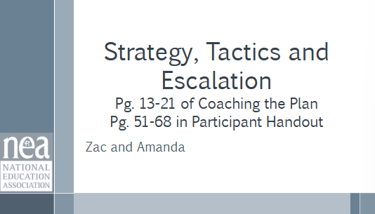]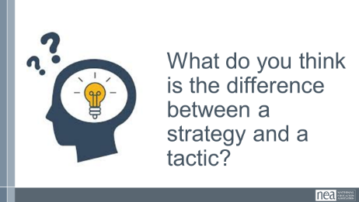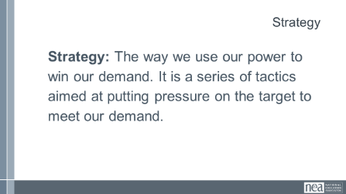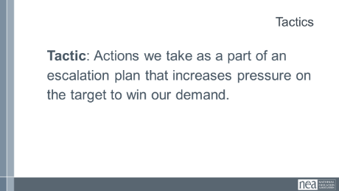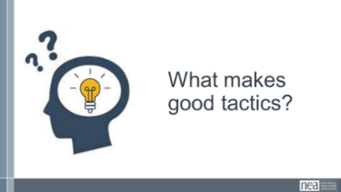  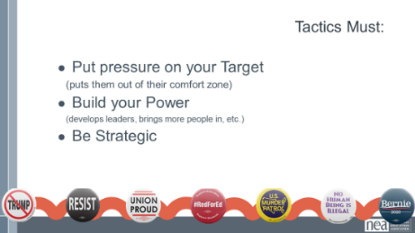  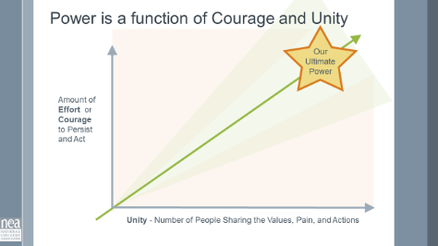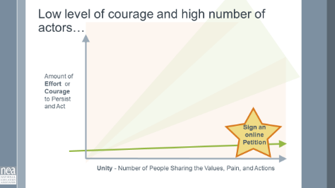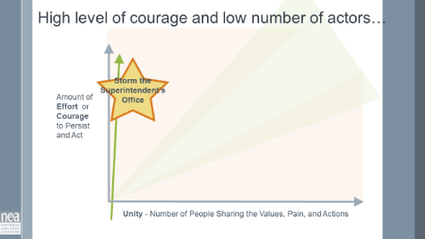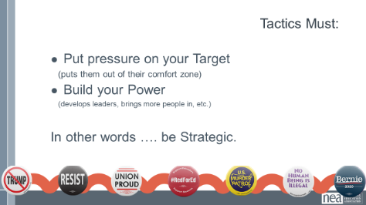  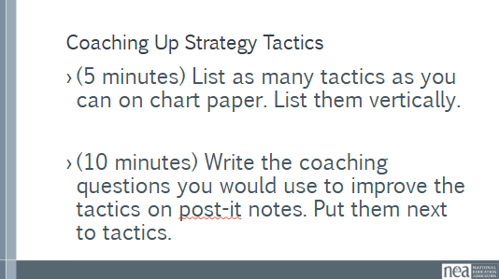  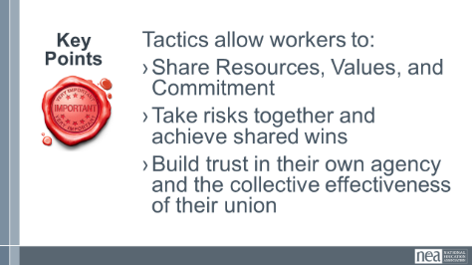  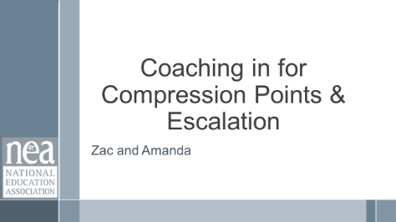  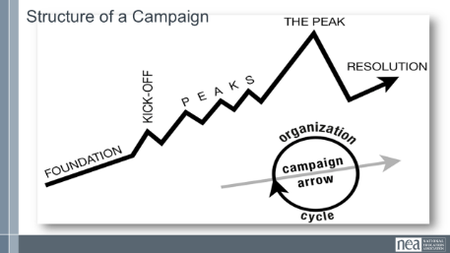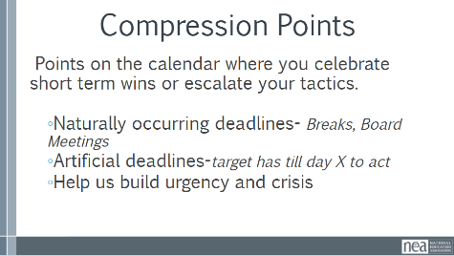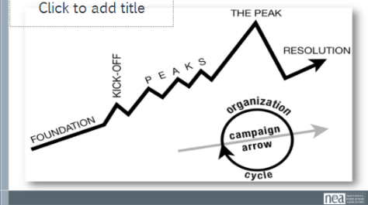  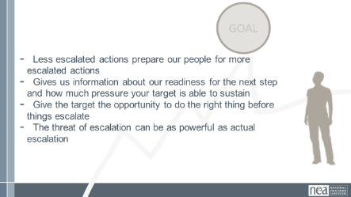  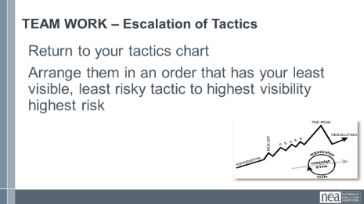  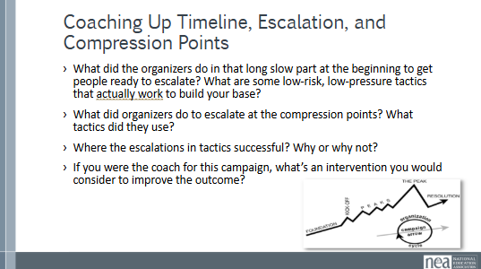  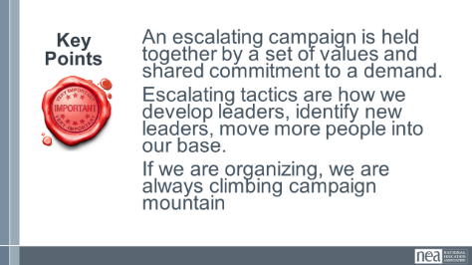  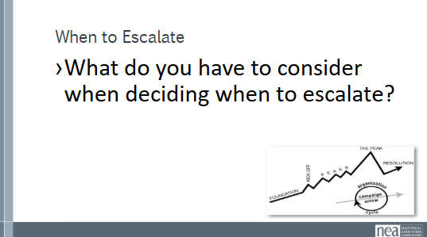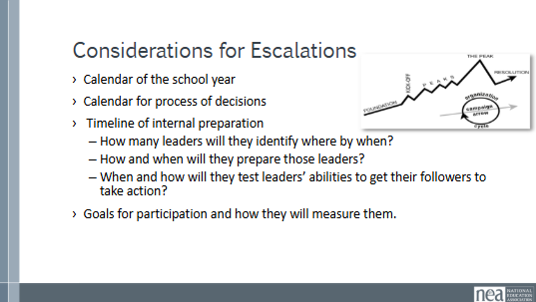  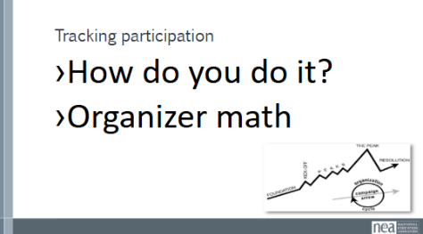  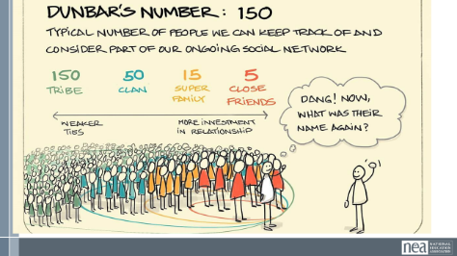  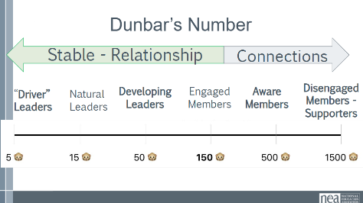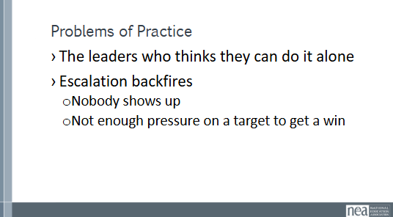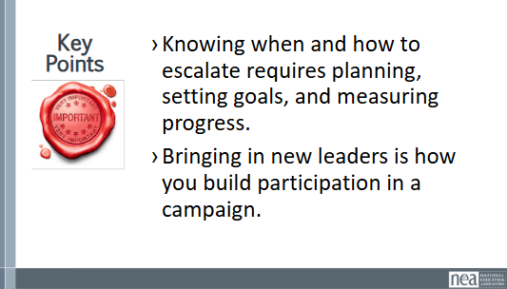 | There are handouts in the Campaign Cycle Planning  And a Strategy – Theory of Change Handout  3 Strategy TOC.pdf  5 Campaign Cycle Planning Workbook.pdf  0 Coaching Campaign Planning.pdf | 35 Minutes – Tactics and Strategy  10 min content review  15 min group work  10 min debrief/share out  20 Minutes – Timeline and Compression Points  20 Minutes – Preparing for Escalating Tactics and How to Measure them  Page 13-21 in Coaching the Plan and Page 51-68 in Participants Handouts  10 Minutes Strategy vs Tactic  Ask group: What do you think is the difference between a strategy and a tactic?  A strategy is the way we use our power to win our demand. It is a series of tactics aimed at putting pressure on the target to meet our demand. We need a strategy because we cannot just implement tactics in a random way, we need to plan and order our tactics strategically according to an escalation plan.  Tactics are actions we take as part of an escalation plan that increases pressure on the target to win our demand. We design tactics based on our power analysis on the target. Each tactic should put pressure on the target’s self-interest, relationships, or power that we identified in the power analysis. (remember the Values Triangle)  What makes good Tactics?  Let’s hear from a few people. Who wants to share about their favorite tactic and what made it a good tactic?  Tactics must:  - Put pressure on your Target. Tactics must put pressure on the Target’s Self-Interests, Relationships, or Power. Tactics should put the Target out of their comfort zone - we don’t want to use tactics that the Target is expecting or is used to seeing already, because that won’t put pressure on them.  - Build your Power. We should always be thinking about how each tactic can help us develop our leaders and brings more people into the campaign.  - Be Strategic. We don’t do tactics just for the sake of doing them. We need to make sure that our tactics make good use of our resources in order to put the most amount of pressure on the Target and as part of an escalation plan.  Power is a Function of Courage and Unity  The amount of Courage or Effort that is needed to commit to act  And the relationship to the Number of people feeling the pain, sharing the values, and participating in the change (unity and shared responsibility) is what gets us to our ultimate power to win the demand.  The more the courage and the more people who are acting – the more power we have.  Show the example online petition – high participation, low effort and courage – low power to cause the target to concede the demand  Show the example of storming the superintendent's office – a lot of courage and effort but low participation – low power to cause the target to concede the demand.  Group Activity (TOTAL For both charting activities 15 mins)  Makes sense to count off in random teams for this  5 Minute - List as many tactics as you can that you’ve heard from leaders (those you coach or others). Take 5 mins.  After 5 mins:  Now, take the next 10 mins in your groups to consider the tactics that meet the evaluation criteria outlined below -  Tactics must:  - Put pressure on your Target. Build your Power.  - Be Strategic.  Include on post-it notes What coaching questions you could ask to help leaders evaluate tactics?  Key Points  Tactics allow workers to:  - Share Resources, Values, and Commitment  - Take risks together and achieve shared wins  Build trust in their own agency and the collective effectiveness of their union  5 Minutes Now Let’s Escalate page 135- I don’t know what this is- AK  How many of you are familiar with the concept of campaign mountain?  (Show of hands to gauge the room)  What does a campaign mountain show you? (popcorn answers- An escalation of tactics, a timeline marked by compression points and structure tests).  What’s a structure test? (a test to see if the worksite structures you are building actually do what they are supposed to do)  What’s a compression point? I think of it like a blood pressure check on your target. Are you raising it or not? It’s a fixed point in time, like a school board meeting where a vote is supposed to happen, or a countdown like UAW’s “tick tock” strike threat to force management to agree to a contract. If you can get a concession from your target, even a small one, it’s a sign what you are doing is working. If not, you probably haven’t turned up the heat enough yet.  Let’s look at a picture of a campaign mountain.  What do you notice about this picture? (popcorn answers- there is a long time for low escalation tactics, then clustered higher escalation actions before going to the peak)  What is the reason for running a campaign this way- a long time for low risk escalation before you start to escalate?  (popcorn answers)  - Less escalated actions prepare our people for more escalated actions  - Give the target time to do the right thing before things escalate to the next tactic  - Use the threat of escalation  - Allows more people to join our base  10 Minutes Activity – What does Campaign Mountain Look Like in Action?  Time to talk real talk. Think about a campaign you have participated in. This campaign doesn’t have to have been successful. Indeed, if you have done this for a while, you know that you often lose more than you win (although learning to pivot a loss is something I will discuss a little later). Maybe you were a lead organizer, or maybe you participated in another way. Did the campaign follow this same general path? What tactics did the organizers use to build participation and pressure on the target? How successful were the tactics? Looking back now, what is something you wish the campaign had done differently? If you were a coach for that campaign, what intervention would you have used?  Find a partner with someone you don’t know and take turns sharing your story and discuss your analysis. Each of you will get 5 minutes and then you will switch. Key points:  - What did the organizers do in that long slow part at the beginning to get people ready to escalate? What are some low-risk, low-pressure tactics that actually work to build your base?  - What did organizers do to escalate at the compression points? What tactics did they use?  - Where the escalations in tactics successful? Why or why not?  - If you were the coach for this campaign, what’s an intervention you would consider to improve the outcome?  5 Minutes- Share outs  Ask one person to share something their partner talked about as an answer to each of the questions above.  3 Minutes Key Points – An escalating campaign is held together by a set of values and shared commitment to a demand.  Escalating tactics are how we develop leaders, identify new leaders, move more people into our base.  If we are organizing, we are always climbing campaign mountain  20 Minutes- Preparing for escalating tactics and how to measure them  Those of you who have done this before- what do you have to consider when deciding when to escalate? (popcorn answers- do you have enough participants for the tactic to be effective? Will it have the impact you want? Escalations are also tests of your leaders willingness and ability to turn their people out.)  10 minutes- Deciding when to escalate can be one of the most nerve-wracking decisions of a campaign for organizers. That’s why having a plan is so important. Let’s take a moment to talk about what the organizers need to prep for that plan. At your table, make a list of what organizers need to integrate into their timeline.  Share out-  If not mentioned, include:  - Calendar of the school year so you know when people are and aren’t around.  - Calendar of when decisions are made. This depends on your target- Board meetings, budget cyle dates, deadlines in the state legislature etc  - Timeline of internal preparation  - How many leaders will they identify where by when?  - How and when will they prepare those leaders?  - When and how will they test leaders’ abilities to get their followers to take action?  - Goals for participation and how they will measure them.  This last point is a topic until itself. How do you measure participation in tactics? Share some examples of how you have seen organizers do this. Facilitator will record answers.  Show Dunbar Slides -  It’s important for the campaign leads to understand they will never be able to personally get everyone they need to participate. This is why building leaders, and building INTENTIONALLY DIVERSE leaders is so important!  10 minutes  Show Dunbar Slides -  It’s important for the campaign leads to understand they will never be able to personally get everyone they need to participate. This is why building leaders, and building DIVERSE leaders is so important!  One way to look at this is through Dunbar’s numbers. This is a formula that shows how many people any of us are able to influence. The bigger the number, the further away from our own personal sphere, the less connection we have. It’s like the difference of when I get a text from a nationally known political figure asking me to take action. I will probably delete it without even reading it, even if I agree with everything the text says. But if Ellen texts me and asks me to do something, I do it. Because I know and trust her.  Two common problems of practice are the leader who thinks they can do everything on their own, or the campaign loses steam when their escalation backfires, either because not enough people participate or because it doesn't have the impact on the target the organizers wanted. How do you approach those problems? What are some questions to get at the heart of the problem. What are ways to get the lead to pivot and keep going when their plan backfires? (table talk and share out)  KEY POINTS  Knowing when and how to escalate requires planning, setting goals, and measuring progress.  Bringing in new leaders is how you build participation in a campaign. | Participants will learn about each part of the campaign cycle, how to teach it, and develop coaching points around each part.  Coaches will assess what their possible interventions might be if these practices are not in place with the locals they are coaching.

