============
Getting Started as a Coach
https://docs.google.com/document/d/156-zM5UqLGqa4UBztSxxLNyw5uduwS5fux-4pVcA05U/copy
============
Coaching for Power
https://show.pics.io/preview/66fea69ad15db5423dc44bef
============
Sample Questions for Campaign Coaching
https://show.pics.io/preview/66fea933d15db5423dc44c62
============
Campaign Coach Resources
https://docs.google.com/document/d/1loghe_AfoNyyGlBT9jsy-yq4ghPSZhfCCQMOXxdaOwU/edit
============

Agenda 10/17
- Debrief 10/10 and 10/5
- 10-10 agenda 10-10 - OSI : Campaign Coaching 101 with NEA
- Slides 2024 10 08 SLIDES: Campaign Coaching 101 with NEA
- Evals
- Discuss next trainings, system design pieces

Notes
- Adjustments from 5th to the 10th that second group still needs to get
- Didn’t revise goals after we revised the agenda, like coach self-awareness, practice prepping
- Qualities: Nicole would have started with questions from the left not the right
- How are we hoping the group uses qualities as a generalization? ie, we know how we want them to use Tools…
- Rethink what the priorities are for this training, then decide what gets full experiential cycle treatment
- Suggestion to harvest specific behaviors a coach did, towards retitling it “Interventions”
- To be able to go from “Eric is great” to “what did Eric do”
- First Scenario: Lucy appreciated getting to deep dive into questions, mixed quality from what was shared in the chat, needed more time to open up that tool
  - In TFC’s T4T, there’s an activity where participants get to come up with questions and get feedback (from pair, from facilitator, from group).
  - Document of questions brainstormed, pick one to workshop
- Coaching Campaigns: didn’t fill out the matrix live with the full group, there was confusion about what we’re diagnosing, questions weren’t about diagnosis they were about intervention
- Amanda’s story wasn’t written down, made it more challenging for participants to track
- Challenges weren’t captured succinctly and correctly, ie “school board”
- Again, redesigning around objectives, like diagnosis
- Didn’t introduce a schema for diagnosis, like head/heart/hands
- GROW model might be more appropriate for mentor coaches, what’s the differentiation for the others
- Kinds of Diagnosis
  - Motivation
  - Skill
  - Strategy
  - Interpersonal
  - Etc.

Notice…
    - The kind of topics that “light up the room” (they have a lot of energy for)
    - The topics they avoid
    - Where there’s “heat” between individual team members
- Common (Unstated) Beliefs That Undermine Campaign Teams
  - “We can’t win”
  - “We don’t know what we’re doing”
  - “We don’t know how to do it perfectly”
  - “It’s riskier to run this campaign than to not run it”
  - Etc.
- How to think about moving from observation to diagnosis
  - Linking Observation to Diagnosis
    - When you see…
      - Avoiding eye contact with each other → Interpersonal, etc.
      - Avoiding power mapping → Strategy
      - Reluctance to try new tactics → Skill
- Next steps
  - Originally, 2 skill ups on the calendar – Nov 14 and Dec 5
  - Pause on those sessions for now, Lucy & Ellen get clarity on those session topics, find new dates in Dec and January
  - Book time week of Nov 4 to think through coaching structuring, and building in accountability
  - Between now and then,

10/10

Hi,
I’m noticing that one reason the worksheets might feel repetitive, is that we have removed some of the generalizations we were heading towards without replacing them with something else to practice.

In the moment, the story I made up was, “this makes sense, the diagnosis of this group seems to be, they mostly just need ‘practice reps’ as coaches.” But another option is to either debrief the practice sessions towards specific skills or options, or set them up so that

Existing generalizations we unpack
- Qualities of a coach
- Five core interventions
- Getting started as a coach (which we no longer really offer, just inviting them to add for a few minutes)

Generalizations we “nod towards”
- How to go from your observations to identifying a curiosity
  - Make a list of what they’re noticing about their own process
- Characteristics of good questions

Generalizations that pair with what they’re practicing
- How to “do our detective work” as coaches
  - Ask about…
    - Their favorite moments or the ones they’re proudest of as a team
    - The kinds of local organizing victories they’ve seen (could be at a different local) they’re inspired by
    - Etc.
  - Notice…
    - The kind of topics that “light up the room” (they have a lot of energy for)
    - The topics they avoid
    - Where there’s “heat” between individual team members
- Common (Unstated) Beliefs That Undermine Campaign Teams
  - “We can’t win”
  - “We don’t know what we’re doing”
  - “We don’t know how to do it perfectly”
  - “It’s riskier to run this campaign than to not run it”
  - Etc.
- How to think about moving from observation to diagnosis
  - Linking Observation to Diagnosis
    - When you see…
      - Avoiding eye contact with each other → Interpersonal, etc.
      - Avoiding power mapping → Strategy
      - Reluctance to try new tactics → Skill
  - Kinds of Diagnosis
    - Motivation
    - Skill
    - Strategy
    - Interpersonal
    - Etc.
- How to think about moving from diagnosis to intervention
  - Matching diagnosis to interventions
    - Ex. Group isn’t prioritizing the campaign → Motivation → Repeat what you’ve heard about their stake, Ask the group to reflect on what’s at stake, …
    - Ex. Leaders hesitant to step into roles that would require them to engage in public conflict → Skill → Model what a speech or public testimony might look like, or invite them to roleplay a debate with an opponent

10/9

Agenda
- Overall
  - Practice groups / breakouts suggestions
  - Return to generalization, “as unionists, the reason we do elicitive… building agency, scaling movements, whereas with directive you’re teaching dependence…” “and, another value, people closest to the work…”
  - Refer to mentor coaches who will coach campaign coaches
- Qualities
  - Nicole will try to elicit the Interventions list from the pair debrief on Qualities
  - Retitle Skills as Interventions, and make it a spectrum
  - Nicole will look for or offer a generalization & story about coaching for performance vs. learning
  - Practice time: expand to 10-15’
  - Practice scenario: Your campaign coach just met with their organizing team that has a local that is split on whether or not to escalate tactics around their issue campaign. The local president doesn’t want to “ruffle feathers” with the district and wants to accept the most recent offer. About half the committee, mostly younger/newer members, want to hold a public action to put pressure on the district. It’s my assessment that escalation is the best option. How do I coach the team to build consensus around escalation?
  - Application for Qualities:
    - “To help us assist in crafting questions, here’s a chart we find helpful…”
    - You’re planning for your next meeting with the campaign coach. What are good questions you could use to help them through this challenge? Use the chart below to assist in developing your questions.
  - 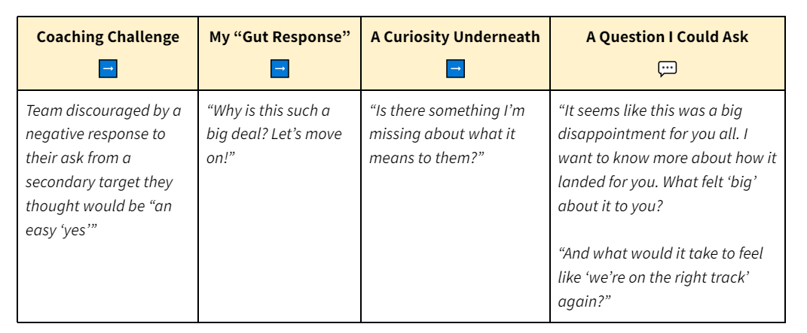
  - Offer coaching questions handout as a resource afterwards
- Coaching Campaigns (40’)
  - Introduce worksheet
  - Amanda tells a story as a coach (5’)
    - She includes four challenges: motivation, skill, strategy (add part to worksheet at the top to ID them)
    - Tell the story as a series of obstacles
    - Prep the group to look for four obstacles
    - Observation, Diagnosis, Interventions
      - Interventions = story, feedback, observation…
      - Not giving them a schema for diagnosis, “some of you might use head heart hands…” the what vs. the so what
    - 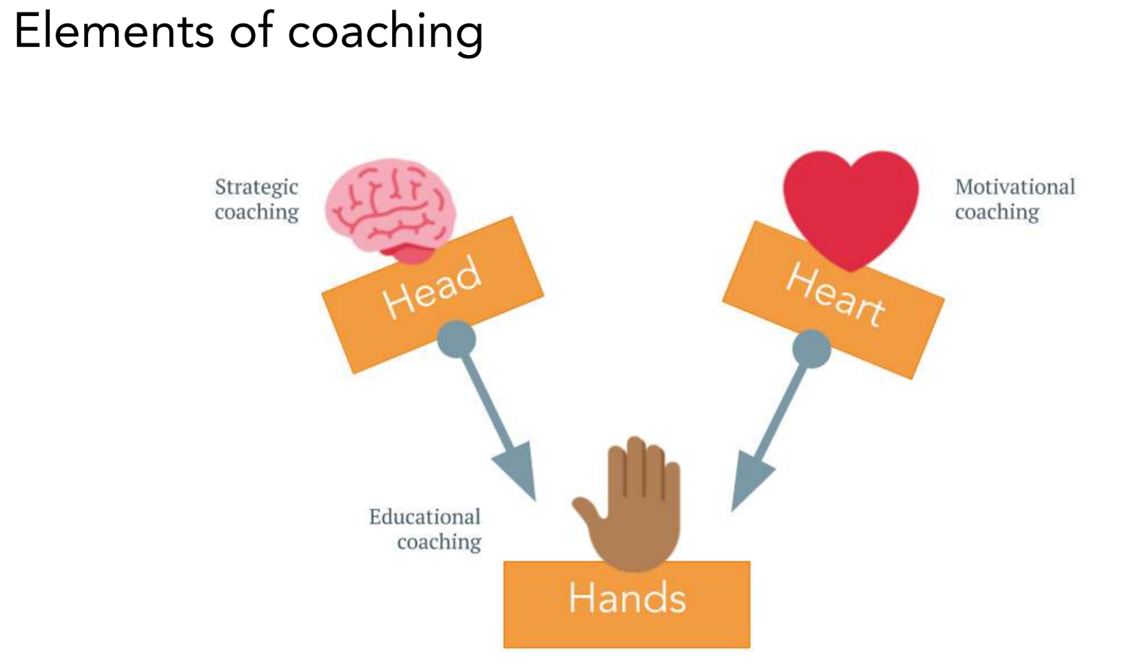
  - Debrief story before breakouts (5’)
    - First, drop obstacles in chat - what was the first one we heard?
  - Breakouts (15’)
    - Use worksheet
Debrief in large group (15’)
      - Which was the easiest to diagnose? Get options for intervention
      - Which of these was the hardest? Get options for intervention
- Coaching Practice (52’)
  - Participant tells a story, (5-7’)
    - Ben (not Megan) agreed to tell a story and receive live coaching. Here is the scenario to add to the handout they will use in this section:
    - Challenge: I am currently working with a local on a campaign to recertify their bargaining rights. I am confident that the local will win the recertification campaign, however I am concerned that they will default to a service-model bargaining strategy on the other side of the recert vote. In this local, the dominant thinking among leadership is “preserve the relationship with the district, don’t challenge them for power.” In this vein, there is talk of using an Interest Based Bargaining approach and no plans to provide members with paths to participate in the bargaining campaign. The IBB model of bargaining is also being promoted by state affiliate staff assigned to the local. Similarly, the leadership believes that the path to membership growth is winning a good contract “to use as a selling point,” rather than moving members into action. I am struggling with how to agitate the leadership team towards a winning bargaining strategy that will deliver the strength and growth the leadership team desires.

  - Then… options:
    - Solo time (5’)
    - Breakouts for interventions (10’)
    - Debriefing in large group (10’)
    - “Who’s confident and wants to try this out?”
    - Fishbowl roleplay (7')
    - Debrief roleplay (20’)
      - How did that feel? What worked? What were other possibilities?
    - Drop “Coaching Responses” generalization?
- Preparing to Coach (change to 5’)
  - Does this look correct for this group?
  - Share brainstorm slide. “How can you ‘set the tone’ for coaching? What might establish your role, style, and goals as a campaign coach? Add your responses to this slide”
    - Cofacilitator paste in chat:
=====
Think of a time you had to set the tone for a new relationship with someone in another organization. This could have been an NEA local, but it could have also been a partner in a coalition, or something else. What did you do in the first couple of meetings that helped “set the right tone” for the work you would do together? [INSERT SLIDE LINK]
=======
  - Verbalize and start to generalize the range of ways to set the tone, as the slide fills up.
    - List to reference, in your back pocket:
  - Next Steps - change to 1’ - nod to the evaluation question about what you still want to learn, follow-up to come
- Next Steps

Coaching Practice #1: A fantastic community organization I’m coaching is a small team managing a huge amount - their campaign work, mutual aid for their base, now hurricane relief. We had a great retreat where we made a plan for the coming year, and much of that has stalled because of capacity and responding to crises (even before the hurricane). I’m a little confused about how I can be most useful to them at this point. What is my role as a coach - helping them figure out how to get back on track with the plan they made, changing that plan to match what they can manage, helping them figure out systems and resources to increase capacity and manage workflow, or all of the above?

Qualities Practice #2: The Tucson local's method for choosing campaigns is currently "whenever someone feels strongly about something, they start a campaign and whoever's interested jumps on board." This has produced some good momentum and even some surprise victories (paid family leave was a massive win on a relatively low-participation campaign, so the sense of ownership by workers is very narrow but the win is fantastic nonetheless). It's also producing a sense of chaos and overwhelm, and doesn't give them the opportunity to bring the full strength of their organizing structure to bear on one escalation timeline, on one uniting platform. They want to move in that direction, but starting to try is surfacing a lot of challenging ambiguity about roles, responsibilities, structure and decision-making authority - all questions that will need to be clarified if they are going to transition to a more cohesive and centralized approach to campaigning.

Qualities Practice#3: I’m going to be coaching an Organizing Committee working on a first contract after card check. A challenge I face is stepping in years into the process and not having set up the campaign from the start. My challenge is that, through trial and error, I worked with teams over decades to do new organizing a certain way and decisions were already made that I feel tie one hand behind my back. I’m keeping an open mind and will work to maximize what we can do, but I see How do I be supportive and move the campaign forward but also look for openings to reconsider strategy? What decisions are set in stone and what can be reexamined? What is my role (place?) as NEA staff when affiliates and colleagues in NEA have been doing the groundwork.

10/7

Goals
- Prep for 10/10

Agenda
- Plus/deltas

Notes
- Thursday group will be coaching coaches
- Modifications
  - Challenges specific to coaching coaches
  - Scenarios specific to coaching coaches
- General plus/deltas
  - Plus
    - Good flow, right-size content for amount of time we had
    - Toolkit
    - Strong first hour – breakouts quickly, generalizing qualities, use of elicitive questions throughout,
  - Delta
    - Very Quick Intro whip in the chat stack or on mic
    - Tighten up to create more engagement
    - Call on people to bring in more voices / avoid dead air
    - This group participated less than usual in the large group
    - “Tools” - “Here’s what we propose are tools for coaching” and let them fill it in live or in a breakout, would have gotten 90% of it elicitive
    - Framing in the scenarios the need to have a plan, listening “is this challenge about being motivated, having skills, strategy?”, coach has to quickly discern + frame questions
    - Hour of what felt like direct instruction, from Google Slides pieces to directly before the break, rethink pieces there to create more engagement
    - In the room so much rich experience, everyon Thurs will be coaching multiple campaigns, can we mine them for scenarios
    - Thurs people might say “I know…” so might not be consistent with their practice, want to change the culture of we’re all independent, coaching styles might give them more permission to be solo
- Modification ideas
  - Mine them for scenarios
  - Do a fishbowl for the scenario so people can model their intervention
  - Remove coaching styles piece
  - Intro - say your name which coach why 30 secs or less, name pronoun which coach you’d be
  - Why we’re here - put goals on slide, say less on TFC’s approach, Lucy doesn’t need to say anything
  - Abridged story of self, for credentialing
  - Just a high level overview agenda, break halfway thru, expect to keep camera on along with other invitations
  - Remember a time was great, elicitive piece great
  - Slide 12 - elicitive to directive went over heads but so important, arrange on the spectrum, explain, and parallel concept coaching for perf – “sometimes that can be at the expense of learning, trying to do this rarely…” link it back to our values as unionists to develop others’ agency
  - These are the interventions not skills
  - Deepen the application here - practice, everyone come with a campaign challenge, to breakouts, prompt try to use one of the top 3
    - One specific issue you’re having right now
    - Or to a written scenario, come up in teams of 3 come up with the question you would use
    - No more than 2 paragraphs on the problem of practice in your campaign, put it in this google doc
    - Change to be issue organizing: You’re meeting with an organizing team that has… a local that is split on whether or not to escalate tactics around their issue campaign. The local president doesn’t want to “ruffle feathers” with the district and wants to accept the most recent offer. About half the committee, mostly younger/newer members, want to hold a public action to put pressure on the district. It’s my assessment that escalation is the best option. How do I coach the team to build consensus around escalation?
    - Drop force copy doc to come up with intervention options
    - Use the question prompt – change it to come up with an intervention, not a question
    - Change breakout time to 10-15’
    - Debrief for a new insight, something that surprised you
  - Coaching campaigns felt like a lot of instruction
    - Observations Diagnosis Intervention worksheet
    - Get someone to tell a story on Thurs emphasizing challenge points so they surface 3-5
    - Each participant write down each challenge point, see if we all got the same 5 challenges, then what observations, what diagnosis… what intervention options do you see
    - Generate slides 29-30 from worksheet debrief
    - Not yet walking away with a GROW or other coaching cycle, right now they’re just getting a meeting template
    - Begin with observing/listening, make meaning of what I can bring to them (and which tool would I use), and from that diagnosis - what decisions / interventions will you make
    - Could we elicit and get to something like a 4-step cycle ask, diagnose, intervene and develop their will to follow up

Overall shifts

10/1

Goals

Agenda
- Review latest agenda draft
- Key questions
  - NEA approach / “the why” to share?
  - Next Steps to share (placeholder below)
  - Current draft eval form

- Priority for formatted handouts? We’re assuming we might want to slim this down to 4-6 pages of handouts to make it more likely the coaches will review them. Here’s the current list, interested to know which you’d like to prioritize
  - Why coaching
  - Coaching lineages
  - Coaching “in a nutshell”
  - Coaching styles
  - Six essential qualities
  - Campaign coaching tools
  - Learning to campaign vs. campaigning
  - Coaching pitfalls to avoid
  - Crafting questions
  - List of questions (I assume this will be its own standalone doc)

For review –

Next Steps  (15 min)  Start: 02:40  Trainer | [Go over NEA resources]  - Schedule  - Setting Expectations  - How to Structure Your Time  - How to Prepare  - How to Get Support  - Q&A  - Next Steps
Evaluation + Closing  (5 min)  Start: 02:55  Trainer | - Evaluation form “Take a moment to fill out our feedback form - the link is in the chat box. Your input helps us improve this curriculum”  - Cofacilitator paste in chat:  ============  Take a moment to give us feedback on this training:  https://trainingforchange.ourpowerbase.net/OSI-Evaluation  ============  - Mention other OSI trainings & resources: “Training for Change offers other organizing skills and training for trainers workshops, for anyone interested.”  - Cofacilitator paste in chat:  ============  Learn more about TFC’s Organizing Skills Institute trainings:  https://www.trainingforchange.org/programs/osi/  ============  Listen to the Craft of Campaigns podcast: https://www.trainingforchange.org/craft-of-campaigns/  ============  Browse the Campaign Strategy Workbook for other coaching tools  http://tiny.cc/tfc-campaign-workbook  ============  www.trainingforchange.org  ============  - Share in Chat: [Closing prompt]  - Cofacilitator paste in chat:  ======  [Closing prompt]  ======

Links:
- NEA Coach Training Agenda & Tools - Google Docs
- Pop Ed Tradition: Highlander & Citizenship Schools - Google Docs
- Coach Getting Started Form - Google Docs

Andrew Meeting

- Check in
- Dates / calendaring
  - 9/24 - from 2-3pm
  - 10/1 - from noon-1pm - Lucy will invite 2-3 members of the coaching committee
  - MENTOR Thursday October 10th from 2-5 or second choice is 9-noon
    - If just Campaign Lab coaches (15 people) if broader from the center more like 30
  - MEMBER Campaign Coach - Saturday October 5th 12-3
    - NEA will create the zoom link - Training team and coaching committee will be on 15-20 mins early
- Content and objectives
  - Staff would say coaching is their growth edge, want something more from a movement tradition vs consulting/management
  - NEA doesn’t have a defined organizing framework so draw on Jane, Labor Notes, Ganz,
  - Alliance to Reclaim Our Schools leading Six Weeks of Power (AFT SEIU Journey for Justice etc), 260 on first call, 55 of 62 locals turned out, high energy, what defines organizing, labor-community, whole worker organizing, need for basebuilding, 1:1s, types 1:1s, much from Midwest framework & strategy chart
  - How do you coach around a campaign plan, issue ID after a survey (most participants hadn’t cut an issue just big problems), so to what extent are we coaching vs. organizing
  - Coaching cycle – in the lab until they win or disbands, refresh every 4 months like coaching commitment, this cycle wraps December, then more ppl will come in and fall group can stay
  - Meet w/coaches 2x/month (coaches 9 hr/month for 1 local team)
  - Some local teams only 2 ppl vs Austin or LA, might take a few months for their plans
  - With attrition maybe 50 locals get put in clusters
  - Group diagnosis / tea
    - Tried to ID member coaches who have run issue campaigns at worksite, strikes, one is an aspiring educator / preservice teacher oriented more to lobbying, might be a margin that organizing is recruitment or their weak power analysis – proximity to power is power vs social view of power
    - Mentors have opted-in and still margin with proximity to power/elite orientation, some variation in experience escalating campaigns of greater risks over time, maybe 75% have done that
- Content + goals
  - Why coaching over advising – an ethical why and an efficacy why, this works, elicit from the room
  - “Coaching 101” - what does a coaching convo look like, strategies you’re using as a coach, designing questions, how to listen, how directive vs elicitive schema, part of coaching is about knowing when to switch between modes
  - All will relate to org convo bridge
  - Some are ESPs but others had mentor teachers
  - Do a doc that’s questions for organizing convos – to dig into the challenge, questions to develop solutions, to hold them accountable, etc. from GROW model
  - Roleplay coaching during the call, other experiential work
  - Recommend coaching via phone or zoom ie get more body language
  - From organizing to coaching also is follow-up, relationship-building
  - Really used to organizing spaces that are report-outs, how to move them to vulnerability, to dig deep, and using interruptions etc, other convo moves
  - Pre work? Staff love reading/listening if there are resources. Have found “advice monster” helpful
  - In our profession ppl have found value in having answers, so if they don’t have answers… so if giving answers isn’t effective then what is
  - We “parachute in” like Fairfax and parachuted out and now no support few leaders were developed
  - And story about we’re more reactive as NEA than long-term campaign builders so desire for that shift
  - Trying to switch up for scale too
  - Coaching coaches content for mentors
  - Local cultures very hierarchical so might need to go deeper w members on nondirective / coaching basics vs can go faster with mentors, have more spaciousness
- Local Team Accountability
  - Weeks
    - Get to know you
    - Assessments
    - TBD
  - Need due dates for campaign plan
  - Need shorter menu - things that folks will be successful with
- Coaching conversation template
- Accountability - how to log convos
- Structure of monthly coaching calls for member and mentor coaches
- Next Steps
  - Send all the things - coaching job descriptions
  - Lucy - refine the why for coaching

