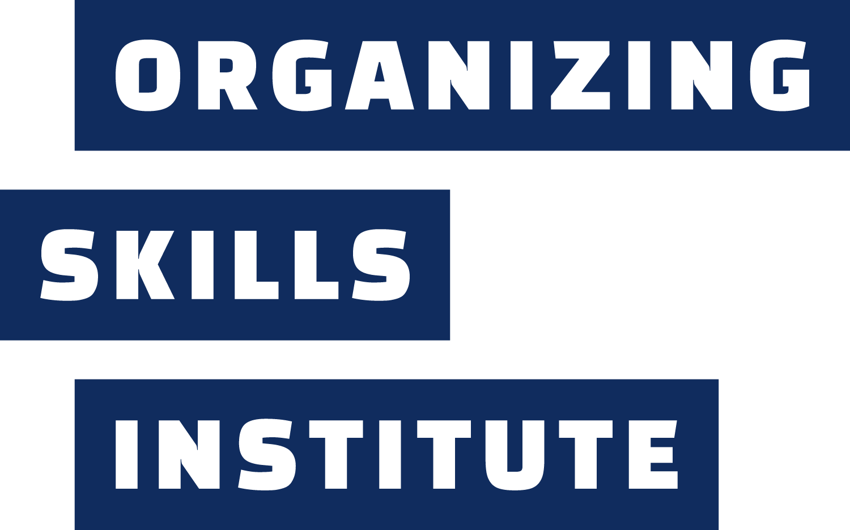
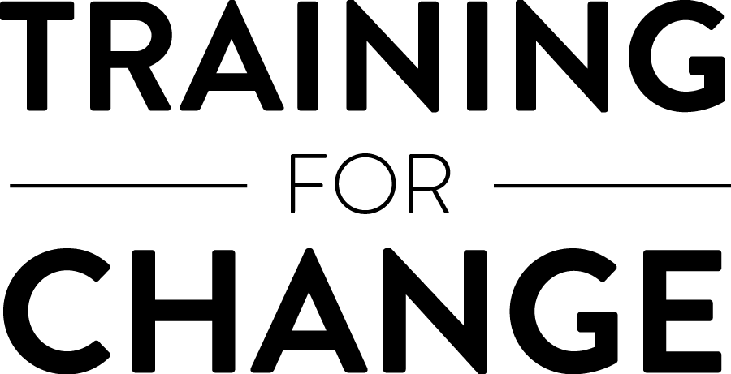
Campaign Coach Resources
Frameworks, tips, tools, and more

Campaign Coaching Tools

Coaches have plenty of tools for helping strategists-in-training develop insights, identify more options “under the bright lights” of an active campaign and develop strong organizing teams. And we think five tools are most useful for helping develop organizers as campaign strategists:

- Questions – What’s the insight you want to tell someone? You can almost always reverse engineer a question that might lead them to discover it for themselves.

- Observations – Sometimes drawing attention and inviting curiosity to a key dynamic you’re noticing is enough to generate learning.

- Stories – “We don’t know what we don’t know,” and your stories about having traveled similar paths will help your coachees sidestep common stumbles, identify options available to them, and your stories of unexpected victory will inspire their confidence and motivate them to keep moving forward

- Feedback – Sometimes your honest assessments, paired with an empathetic suggestion, are what will most help your coachees move forward: “I’m really worried this is going to come off wrong, but I see you getting in your own way, by constantly focusing on what’s not working here. I’ve been there! We’re often surrounded by negativity in our school buildings. But unless you find a way to focus on what’s going right, I don’t think a lot more coworkers are going to say ‘yes’ to taking action…”

- Suggestions/Advice – Advice is the least likely to develop our coachees into strategists, capable of making the many assessment-driven decisions needed in the “heat” of any campaign. But there are moments when our suggestions are what’s needed, particularly when “coaching for performance” rather than “coaching for learning.”

Tell stories & ask questions to…
- Help them imagine “getting to the playoffs”
- Help them remember their “stake”
- Cheerlead to “the finish line”
- Gain awareness of their strengths and how they’re overcoming challenges
- Reflect on what they’re learning

Offer observations to
- Help them notice “what’s going right here”
- Boost their confidence
- Notice what’s going on with other “teams”
- Acknowledge challenges, effort, persistence

Coaching Styles

Campaign coaching is similar to athletic team coaching in several ways – most obviously, the “players” (your coachees) are learning campaigning skills “during the regular season” (while planning and running a live campaign). But even more than a team head coach, we campaign coaches have to switch coaching styles to match what our teams need – some days, we might be more “cheerleader” than co-strategists, or might spend more time commiserating about how difficult it can be to be a full-time educator also trying to change local policy. Coaches often have more success when we’re thoughtful about the coaching styles available to us.

- Curious Co-Conspirator – Campaign coaches spend most of our time discovering “the right answers for right now” alongside the organizers we’re coaching

- Expert Campaigner – And campaigning is a complex skill to learn, and we draw on our experiences to craft questions, make observations and help them see more options for handling a challenge

- Cheerleader – We’re in charge of “noticing what’s going right here” and helping them access the motivation needed to keep going to the next mile marker past challenges that emerge

- Head Coach – We keep them moving from “scrimmages” (planning) to “the regular season” (launching a campaign) and towards “the playoffs” (campaign escalation)

- Supportive Peer – We’ve experienced how hard it can be, and can help organizers feel less alone during tough times (and help them feel proud of every small success)

Essential Qualities of an Effective Campaign Coach

We believe the most effective coaches don’t just switch between styles, we also strike a balance between several qualities that support our coachees to get the most out of this as a learning relationship.

 | Ineffective | Effective (“The Sweet Spot”) | Ineffective
Elicitive | Only offering advice | Leaning largely on asking questions, and sometimes providing suggestions | Only asking questions
Directive | “I set the agenda” | Staying flexible in providing guidance on how to focus your time together, collaborating to set and change agendas | “I only respond to what comes up naturally”
Transparency | Always leading with my observations & opinions | Providing enough detail about your assessments so coachees have a sense of “what I’m thinking” | Never sharing my observations & opinions
Experience | “I’m the expert” | Offering stories about your experiences when appropriate, and what you’ve learned from them | “I know nothing”
Vulnerability | Always staying surface level | Balancing handling challenges identified by coachees with curiosity about “what else might be going on” | Always inviting coachees to reflect on deeper patterns
Taskiness | Meetings are “all business” | Balancing authentically connecting with coachees with the need to “get to work” | Meetings are “all small talk”

We encourage coaches to use this list to do an inventory, asking questions like:

- How much am I using open-ended questions and modeling curiosity in our coach time?
- How much “scaffolding” am I providing to coachees for our sessions in the form of an agenda or other structure, based on my assessment of their campaign’s current status?
- How transparent am I being about “my take” on their work – do they think they have to ‘read my mind’?
- How am I balancing providing insight into my experiences of campaigning while discovering the answers to their current challenges alongside them?
- How often do I invite coachees to “drop below the surface”, and also reveal some of “what I’m wrestling with” as a person or a campaigner?
- How am I balancing building trust and inviting “small talk” or personal connection with “staying on task”?

Performance and learning zones

Michael Bungay Stanier describes this tension as “coaching for performance vs. coaching for development”:

Coaching for performance is about addressing and fixing a specific problem or challenge. It's putting out the fire or building up the fire or banking the fire. It's everyday stuff, and it's important and necessary. Coaching for development is about turning the focus from the issue to the person dealing with the issue, the person who's managing the fire. This conversation is more rare and significantly more powerful. If I ask you to think back to a time when someone coached you in a way that stuck and made a difference, I'll bet that it was a coaching-for-development conversation. The focus was on calling you forward to learn, improve and grow, rather than on just getting something sorted out.

When you’re coaching a “live” campaign, there may be times when it makes more sense to help a team or coachee quickly choose the best option, particularly in a high-stress moment. We think Bungay Stanier’s invitations and questions can help us navigate coaching in the “learning zone” or the “performance zone”.

Questions for Choosing “Performance Zone” or “Learning Zone”
- Is this a moment for immediate action or reflection?
- What are the consequences of failure in this situation?
- Is there time and space for experimentation?

Coaching in the Learning Zone
- Suggestion: Use more open-ended questions to promote exploration and growth.
- Example: "What possibilities do you see that we haven't considered yet?"

Coaching in the Performance Zone
- Suggestion: Provide more direct guidance and feedback when necessary.
- Example: "Based on our current constraints, I think the second approach would be most effective."

Transitioning Between Zones
- Suggestion: Develop cues or rituals to signal zone shifts.
- Example: Use specific language like "Let's enter learning mode for a moment" to indicate a zone change.

Coaching Pitfalls to Avoid

Some of the most common challenges of coaching aren’t unique to campaign coaching, we’ve adapted some of these from The Coaching Habit.

- Being Too “Hands-Off” with Campaign Planning – Campaign coaches, especially when coaching via Zoom, have a tricky challenge: We want to earn the trust of our coachees, and follow them into the organizing terrain that seems most urgent and relevant, but in many cases we have more knowledge about the essential ingredients needed to launch and sustain a strong campaign. We encourage coaches not to “hold back” if our assessment is that the “cake isn’t ready to bake yet”

- Answering the Wrong Question – Sometimes the campaign teams we coach want to focus on a surface-level challenge that may not be the most important to explore. Asking “And what else?” or “Which of these is the most important for our campaign right now?” can help identify additional layers or help a group prioritize

- The Small Talk Tango – We might spend too much time catching up or “circling the problem”. You can always draw attention to this dynamic: “I feel like all of us here have more energy for ‘small talk’ today than usual, and I’m worried about impolitely rushing us into ‘getting down to work’... What do you think might be going on today?”

- The Default Diagnosis – We might have a bias as coaches or coachees towards one way of approaching a challenge, like looking for the people who might be at fault, or being too focused on the problem itself as opposed to a behavioral pattern getting in our way.

- The Ossified Agenda – We sometimes get stuck using the same structure for coaching sessions over and over in a way that discourages learning. We recommend “mixing up” your approach to time with coachees if it seems like they aren’t developing as many insights or taking as many risks

- Using “Advice with a Question Mark Attached” - Questions like “Have you thought about…?”, “What about…?”, “Did you consider…?” aren’t effective for inviting reflection and learning – they are suggestions followed by a question mark.

Crafting Questions

Crafting great coaching questions can take practice. We suggest preparing in advance, especially when you want to have more options for yourself to support the group through more emotionally difficult challenges. No matter how much experience we have, it can be tough to avoid giving advice based on our “gut reaction”, and instead translate that into a question that might elicit learning.

Great questions…
- Are open-ended (not a ‘yes-no’ answer)
- Are answerable (not too complex or theoretical)
- Generate options, ideas, or insights
- Avoid being ‘advice with a question mark attached’ (“You should do this tactic next, don’t you think?)

Example:

Coaching Challenge  ➡️ | My “Gut Response”  ➡️ | A Curiosity Underneath  ➡️ | A Question I Could Ask  💬
Team discouraged by a negative response to their ask from a secondary target they thought would be “an easy ‘yes’” | “Why is this such a big deal? Let’s move on!” | “Is there something I’m missing about what it means to them?” | “It seems like this was a big disappointment for you all. I want to know more about how it landed for you. What felt ‘big’ about it to you?  “And what would it take to feel like ‘we’re on the right track’ again?”

Selecting Stories & Anecdotes

We encourage campaign coaches to periodically review stories we can bring to coaching sessions that might inspire new insights or sharpen our coachees’ strategic thinking. Here are some “cues” for searching through the stories you know:

- The political geography of this particular place
- The composition of this group (identity, roles, (un)willingness to take risks)
- The target selection challenge they’re currently facing
  - Go after the “villain”, our opponent
  - Focus on a target who is currently “neutral”
- Hesitation to engage in conflict with a target
- The unexpected alliances that formed in the “heat” of a campaign
- The relative strength or weakness of the targets themselves
- The need to recruit a new constituency in order to build the power to win
- The campaigning “posture” or tone (playful, confrontational, “cheering on” targets, determined, etc.)

We recommend reviewing case studies from the Craft of Campaigns podcast and Campaign Strategy Workbook.

Coaching the Campaigning “Windows”

Organizing teams have success timing around the “windows” when their base and potential recruits will have the most energy for campaigning. For example, campaign plans are often set in the summer and early winter, to get ready to invite active support for public actions in the early fall, late winter or the spring, and often to take advantage of openings to set local policies (e.g., when municipal budgets are set, or in advance of local primary elections). These are rules of thumb, not hard-and-fast rules – plenty of successful campaigns have operated on a different rhythm. Campaign coaches play an important role in “cheerleading” campaign teams towards launch, and in helping them plan ambitious action sequences that activate the number of supporters needed to win. For that reason we encourage coaches to set an expectation that they’ll help their teams stay on schedule.

Campaign coaching can be simplified to three unique windows, with a central challenge unique to each.
- Planning Phase – Organizing teams struggle the most with launching on-time, to avoid missing their ideal campaign window
- Launch Phase – Teams have the most difficulty planning a sequence of at least three public actions, rather than one-at-at-ime
- (If Needed) Pivot Phase – Balancing the need to keep momentum while flexibly responding to new conditions
- Debrief Phase – Timing the debrief to follow a period of rest but while the campaign is still “fresh”

Key Ingredients of Issue Campaigns

Like baking a cake, we believe there are a few key ingredients to make a campaign “rise” – ready to launch, and to absorb new active supporters into public actions.

- An engaged leadership team – Three to ten volunteer leaders who have drafted the campaign strategy and can convincingly recruit others to participate

- A campaign theory of change – Also sometimes called a plan to win, this is a few sentences that describe how the group’s actions will change the actions of a group of targets over a short period of time

- One to three specific demands for one to three targets – Nothing suppresses our campaigns as effectively as too many demands for too many targets

- A tactic sequence of at least three public actions – Planning three actions is the surest way to ensure we build pressure, “bake-in” opportunities to recruit new supporters and develop new leaders, change the public story about our demands and create structure tests to ensure we’re building the people power needed to win

Common Challenges for New Campaigning Groups

We’ve noticed four challenges that most teams new to campaigning have difficulty navigating, and that we encourage coaches to prioritize during coaching sessions.

- Conducting a rigorous power analysis – Looking at our target’s Pillars of Support and our own Spectrum of Support to come up with an accurate guess about what demands we have leverage to win (i.e., if we activate [these people] to [take this action] we’ll get [our target] to agree to [this demand])

- Selecting demands that hit the “sweet spot” – They feel urgent to our base and the people we want to recruit, and they can be achieved in the next 6-12 months.

- Designing a tactic sequence – The strongest campaign plans sequence multiple actions over a specific time period, rather than planning one-at-a-time.

- Picking a posture that matches our level of support – Are we “cheering on” our targets to agree to our demands, because it doesn’t make sense to challenge them via public pressure? Are we encouraging potential champions to come out in favor of our demands, and then challenge our targets’ reelection candidacies?

Sample Coaching Session Agenda

We usually don’t get much time with our groups. Here’s a sample 60’-90’ agenda.

5-10 min | Warming Up & Checking-In
5 min | Reviewing Our Agenda & Outcomes for Today
5-10 min | Reviewing Our “Dashboard” – Where we are in this phase of the campaign, and providing any needed updates
30-60 min | Key Questions or Challenges – Key questions to “land” by the end of the meeting
1-30 min | Secondary Topics or Challenges
5-10 min | Next Steps
2-5 min | Closing – We recommend closing with a ritual, evaluation or check-in about “how this is going / what was most helpful about today”

Sample Outcomes (we recommend having fewer than five)
- Get clarity on our theory of change
- Decide which secondary target to focus on
- Pick a second tactic in our three-act tactic sequence

Prepping for Coaching Sessions

To maximize your time together we suggest spending at least twenty minutes preparing for each session. Here are some guiding questions to guide your prep:

Session Prep

Overall Assessment
- One strength the group is demonstrating, that I’d like to make sure they also notice is…
- One thing I think they need is…
- One other wish I have for them is…
- Looking back at what they told me would make this relationship a success, I also want to remember, remind them of, or check-in about…

Campaign Timeline
- A way they are “on time” on the rough campaign timeline as I see it is…
- An opportunity I hope they’ll seize, that they would need to make a plan for now is…

Learning Campaigning
- An insight or skill of campaigning I think they’re demonstrating is…
- A key element of campaigning or campaign strategy we’re heading into, that I’d like them to get more practice unpacking, is…
- An insight I’d like them to come to is…

Session Plan

Coaching Tools – Questions, Observations, Stories, Feedback, Suggestions

Our Session Goals & Agenda
- I think we should focus most of our time on landing these one to three outcomes…
- If there’s time, we should also…

Questions, Observations & Stories
- A few questions I could ask to help them reach our goals are…
- A campaign story this moment or this group reminds me of is…
- Another observation that might be helpful to this group is …

Other Campaign Resources

Campaign Strategy Workbook
A resource for campaign organizers, with theory, case studies, and worksheets for campaign planning and strategy, including many of the campaign frameworks in this resource document.
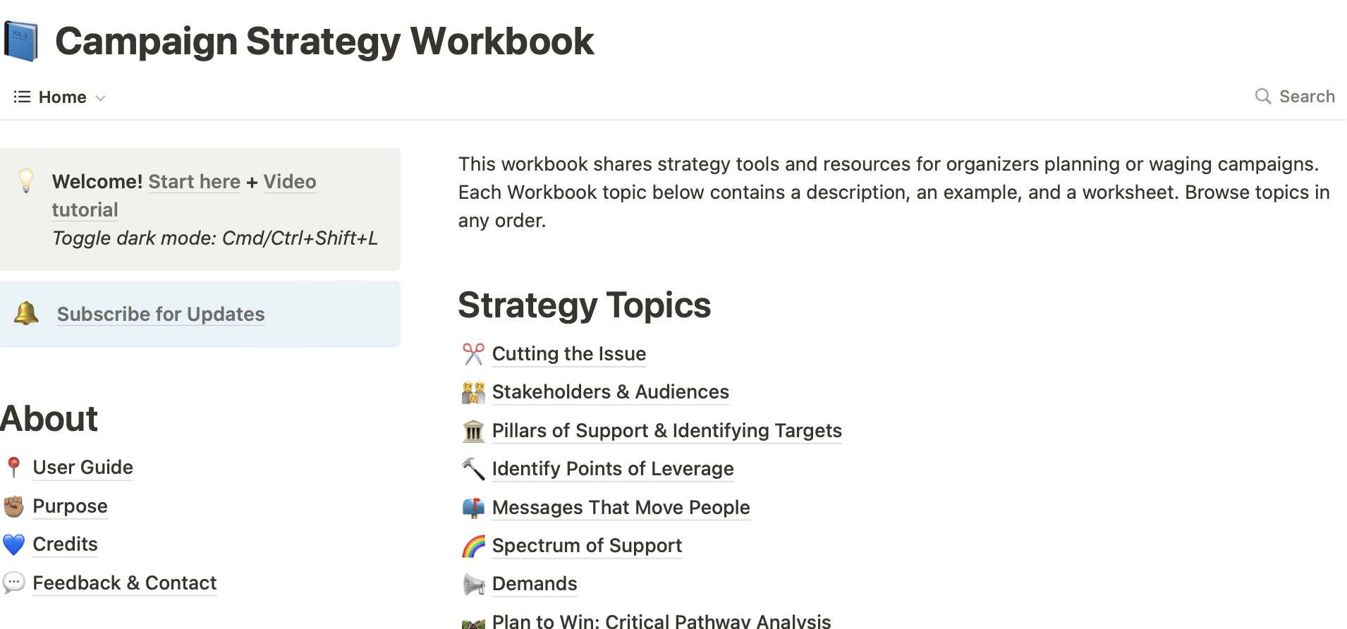
Craft of Campaigns Podcast
Stories and lessons from issue-based action campaigns, beyond one-off mobilizations and single election cycles. In each episode, we interview organizers about how a campaign unfolded, strategy decisions, and lessons for our current moment. Each episode includes a transcript and writeup of key take-aways.

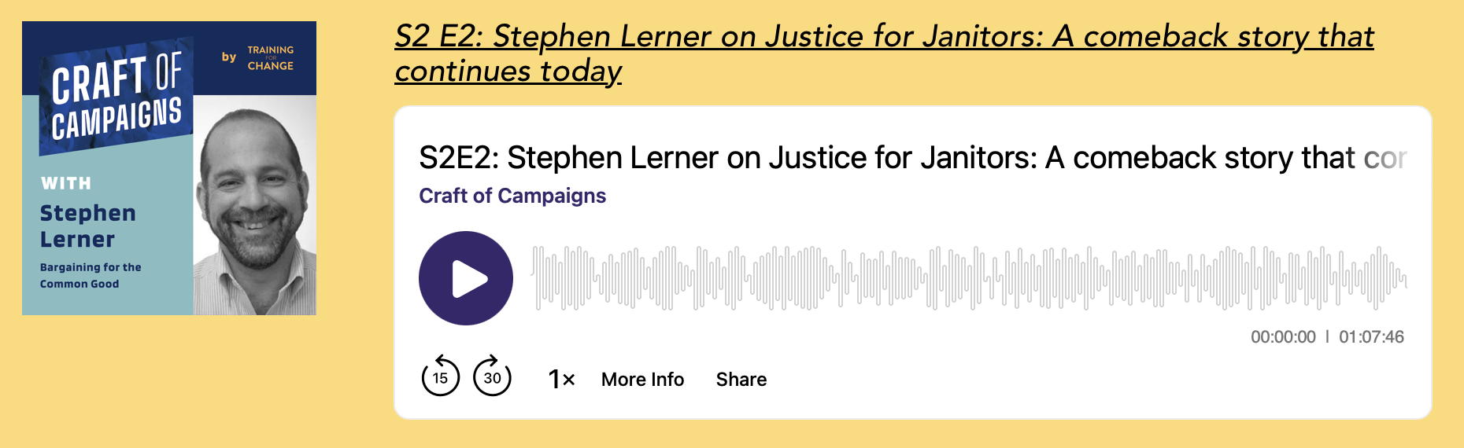
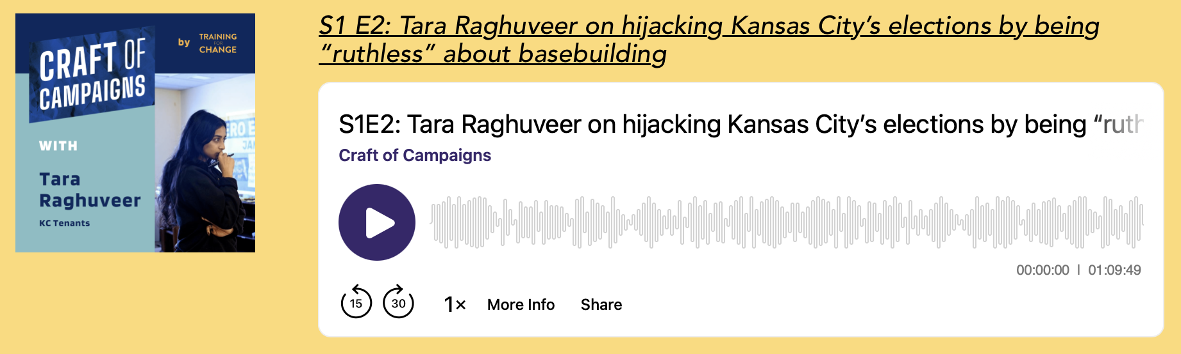

[Template] Setting Expectations & Getting Started
(make your own copy) Template and guiding questions for setting up a new campaign coaching relationship.

Credits & Acknowledgements

Principal Author: Andrew Willis Garcés

Developed in partnership with National Education Association in support of The Campaign Lab coaching program. If sharing outside this partnership, please be in touch with Training for Change.

Licensed under Creative Commons (CC BY-NC 4.0 license) by Training for Change

Contact

Training for Change
www.trainingforchange.org
info@trainingforchange.org

