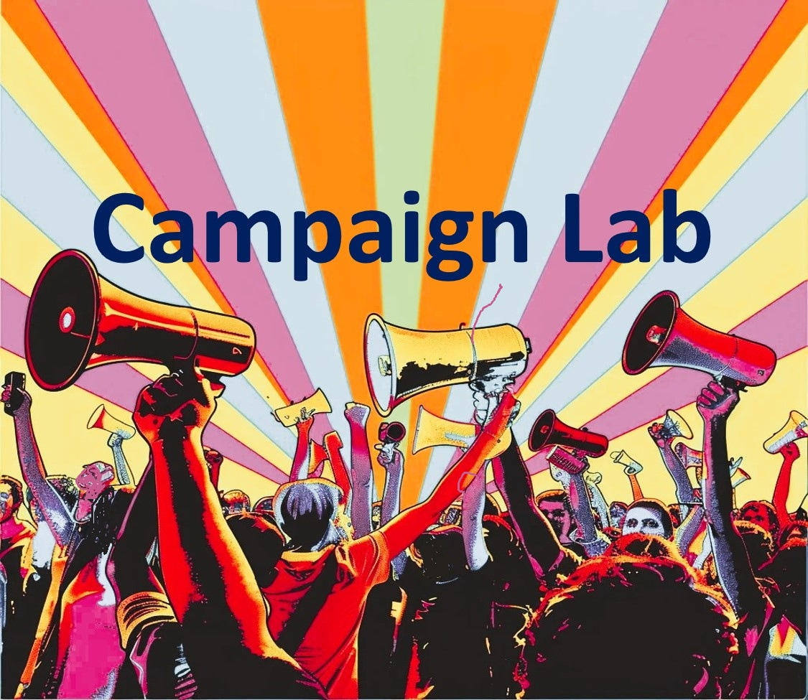

High Participation Local Guide  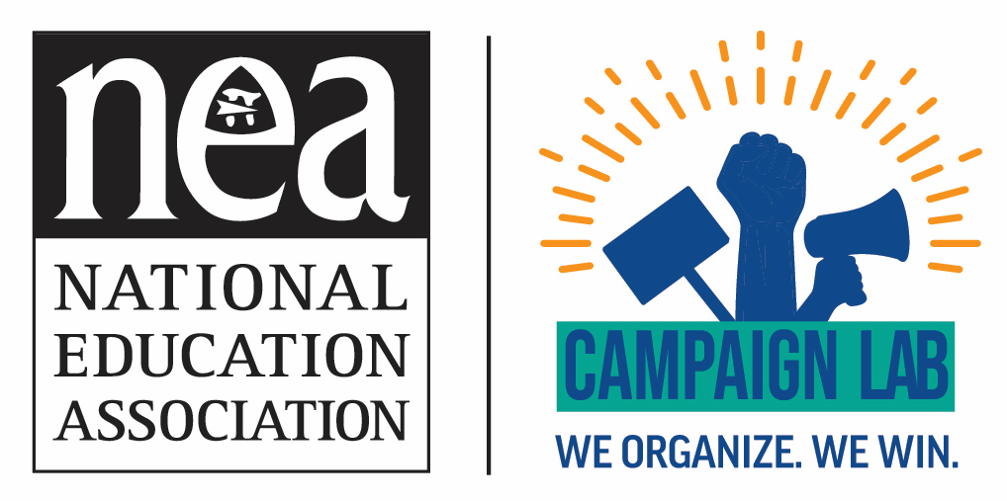 | Introduction  Assessment Tool  Scoring Process  Coaching Guide

High Participation Locals Overview
Definition and Core Foundation
High Participation Locals are unions where leadership, responsibility, organizing skills, and decision-making are broadly distributed throughout the membership rather than concentrated in a small group of officers, staff, or activists. Moving a local from a passive "servicing model" to a member-led "organizing model" is a technical craft that restructures governance, staff roles, data systems, and campaign execution.
Members are active participants in building, exercising, and sustaining collective power. Grounded in 11 core structural dimensions, a high-participation local intentionally centers equity as an everyday organizing practice—identifying and removing barriers to participation, developing diverse leadership, and ensuring all members shape the union's strategic roadmap.
The 11 Dimensions of a High-Participation Local
1. School Site Leaders & Contract Action Teams: Empowered campus representatives operate with local authority ("building swagger") in every worksite. They resolve Level 1 grievances directly with principals, map campuses, manage 10-to-1 Contract Action Teams (CATs) or Site Organizing Squads, and lead building-level governing councils.
2. The Union Staff Role: Union field staff transition from direct grievance handlers and transactional problem-solvers into strategic coaches, capacity builders, and organizers of synchronized campaigns.
3. Valley Work (Non-Bargaining Lulls): Locals utilize off-contract "valleys" as critical windows to enforce contract terms, run continuous skill-building workshops, cultivate social camaraderie, and build durable community alliances before crises strike.
4. Bargaining in High-Participation Locals: Collective bargaining is transformed into an active organizing campaign. Locals deploy massive, representative, and silent bargaining teams, reject media blackouts for radical transparency, and center demands on "common good" community issues.
5. Being a President of a High-Participation Local: Local presidents shift their focus from administrative crisis management to strategic coordination, geographic turf-walking, budget reallocation toward organizing capacity, and expanding multi-officer release teams.
6. How High-Participation Locals Use Data to Build Power: Data management shifts from passive record-keeping to active campaign tracking. Locals decentralize data entry to site leaders, utilize mobile database systems (e.g., Action Builder, OrgDB) for digital wall-charting, and measure real-time engagement.
7. How High-Participation Locals Train Their Members: Training relies on active organizing pedagogy, utilizing a "gradual release" model (moving from high-touch staff modeling to autonomous campaigns), the core "Skills to Win" curriculum, mobile site-based workshops, and intensive summer institutes.
8. Overcoming "Respectability Politics" and the Fear of Conflict: Leaders help members overcome the socialized aversion to conflict by rejecting quiet backroom handshakes and symbolic "moral victories" in favor of visible, majoritarian site actions that command real leverage.
9. Defensive Organizing & Anti-Authoritarian Protection: Permanent site-level communication trees and strike machinery are repurposed for rapid-response community defense, including ICE defense, protecting LGBTQ+ youth, and election protection.
10. The Strategic Plan—Guarding the Roadmap and Building Coherence: Unions eliminate reactive firefighting by co-creating a unified strategic plan. The president acts as gatekeeper to align all committees, budgets, and worksite visits around shared organizing goals.
11. Methodical Structure Tests: Unions deploy escalating, quantifiable workplace actions (e.g., hand petitions, button days, practice pickets, strike pledges) as mathematical "gates" to evaluate true member leverage and readiness before major campaign escalations.
Why High Participation Locals Matter Across the 11 Dimensions
- Sustainable Union Power: Distributing workload through a "choir model" of shared pacing prevents burnout, smooths leadership transitions, and ensures power never depends on a single officer or staff person.
- Increased Member Ownership: Members solve Level 1 workplace problems, chart campuses, and shape policy directly from assembly floors, transforming the union from an external service provider into an organization members run together.
- Stronger Worksite Power: Functional 1:10 site structures (CATs, UBCs) allow issues to be identified early and resolved directly with administrators using collective site actions.
- Methodical Organizing Outcomes: Combining active data tracking with structured 1:1 organizing conversations (80/20 listening rule) enables supermajority density, organic leader identification, mobile trainings, and self-directed, synchronized actions across sites.
- Democratized Bargaining and Advocacy: Open, representative bargaining teams and direct member updates backed by disciplined structure tests ensure locals command real leverage at the negotiating table.
- Expanded Influence Beyond the Workplace: Permanent community-labor alliances built around "common good" demands create mutual trust, allowing worksite networks to rapidly mobilize for community defense.
Core Beliefs of a High Participation Local
- Success Metric: Measured by how many members are organized, developed, connected, mapped, and prepared to exercise collective power together—not by staff problem-solving volume.
- Equity & Access: An everyday organizing methodology that systematically dismantles structural barriers to expand who participates, who leads, whose experiences are centered, and whose voices drive the strategic roadmap.
- Action & Leverage: Respectability politics and polite closed-door committee meetings are structural traps; real compliance occurs only when backed by majoritarian power and protected solidarity.
The Four Essential Outcomes of a High Participation Local
1. Supermajority Membership: Membership density reaches high thresholds (80%–90%+) reflecting every worksite, shift, department, and job classification across the bargaining unit.
2. Supermajority Participation: Members actively engage in 1:1 conversations, campaign actions, trainings, and escalating structure tests verified through active data tracking.
3. Leadership at Every Worksite: Campus representatives operate with authority ("building swagger") and confidence, managing 1:10 CAT trees and local governance bodies across all sites.
4. Equitable Access to Power & Participation: Structural barriers (meeting times, language, shift schedules) are systematically audited so all members have meaningful opportunities to contribute, lead, and shape the union's strategic roadmap.

Key Takeaway: A high-participation local builds power through supe-majority participation, leadership through gradual-release development, and solidarity through equity. It succeeds because the local union has systematically aligned its governance, staff roles, data systems, strategic planning, and training infrastructure across all 11 core dimensions to empower everyday members to lead and exercise collective power together.

High Participation Local Self-Assessment Tool
Rating Scale
1: Servicing Participation
2: Emerging Participation
3: Growing Participation
4: High Participation Local

1. School Site Leaders & Contract Action Teams
How empowered and organized are school site member leaders and teams?
1 (Servicing): Site leaders primarily relay information; equity and member access are not considered. | 2 (Emerging): Site leaders occasionally assist with workplace concerns and begin recognizing participation gaps across underrepresented groups. | 3 (Growing): Site leaders/CATs organize members, handle Level 1 grievances locally, build 10:1 communication networks, and intentionally recruit leaders from diverse job titles, classifications, and backgrounds. | 4 (High): Site leaders confidently handle Level 1 concerns locally, manage active 1:10 CATs/Organizing Squads, and run building councils. Equity is embedded in leadership identification, ensuring rank-and-file teams reflect the full diversity of campus staff.

2. The Union Staff Role - Who owns the work—the staff or the members?
1 (Servicing): Staff act as primary problem-solvers, handling individual grievances, organizing, and communications. Servicing and equity considerations are absent. | 2 (Emerging): Staff begin involving member leaders in union work; training occurs occasionally with growing awareness of representational equity gaps. | 3 (Growing): Staff regularly coach worksite leaders and support member-led campaigns, structurally separating individual representational servicing from field organizing. | 4 (High): Staff function primarily as strategic coaches, capacity builders, and organizers. Staff train members to resolve Level 1 issues, analyze data through an equity lens, and build sustainable, member-driven systems across all job classifications.

3. Valley Work (Non-Bargaining Lulls)
How does the local stay active and build power during non-bargaining periods?
1 (Servicing): Union activity completely pauses between contracts; no ongoing workplace organizing or community connection exists. | 2 (Emerging): Local occasionally offers workshops or events during lulls, with initial attempts to engage broader member groups. | 3 (Growing): Local organizes around local site fights, contract enforcement, and continuous skill-building workshops during lulls while building relationships with community partners. | 4 (High): Off-contract lulls are intentionally leveraged for site-level enforcement, needs assessments, continuous mobile training, and permanent, non-transactional community-labor alliances (e.g., racial, social, and economic justice partnerships).

4. Collective Bargaining in High-Participation Locals
How is collective bargaining structured and executed?
1 (Servicing): Bargaining is closed-door, secret, and handled by third parties or small isolated committees with strict ground rules. | 2 (Emerging): Local shares occasional bargaining updates and surveys members on contract priorities. | 3 (Growing): Local expands bargaining teams, uses plain-language proposals, and conducts site-level briefings to build member awareness. | 4 (High): Bargaining is treated as an active organizing campaign with open, massive, representative bargaining teams (reflecting all job classifications/backgrounds), radical transparency, and community-centered "common good" demands.

5. Being a President of a High-Participation Local
How does the local president lead and distribute organizational power?
1 (Servicing): President acts as an administrative crisis manager, top-down decision-maker, and primary grievance handler. | 2 (Emerging): President encourages participation but retains primary operational and political responsibilities. | 3 (Growing): President guards the strategic plan, coordinates leadership teams, and reallocates resources toward organizing and member capacity. | 4 (High): President focuses on strategic coordination, political diplomacy, geographic turf organizing, and budget reallocation. They actively delegate power, guard the strategic plan ("if it's not on the plan, it's not happening"), and foster a "choir model" of shared leadership pacing to prevent burnout.

6. How High-Participation Locals Use Data to Build Power
How are data systems utilized across the local?
1 (Servicing): Data management is purely administrative and passive (dues tracking, static lists). | 2 (Emerging): Data is occasionally reviewed after campaigns to evaluate turnout. | 3 (Growing): Data informs organizing decisions; site leaders begin tracking meeting attendance and petition signers. | 4 (High): Data management is decentralized and active. Leaders analyze digital wall-charts (Action Builder/OrgDB) and run quantitative structure tests (e.g., physical paper petitions) as "gates" to evaluate supermajority campaign readiness and address engagement gaps across diverse subgroups.

7. How High-Participation Locals Train Their Members
How does the local build rank-and-file organizing capacity?
1 (Servicing): Training is non-existent, top-down, or limited to reading static policy documents. | 2 (Emerging): Occasional ad-hoc trainings are offered for newly elected building reps. | 3 (Growing): Local offers structured skill workshops (e.g., 1:1 conversations, charting) and reduces barriers through accessible meeting times. | 4 (High): Local operates active, multi-tiered training pipelines (e.g., Summer Institutes, Member Organizer cohorts, "Skills to Win") using a "gradual release" model (from staff modeling to autonomous member execution) with mobile, on-site, and rotational workshops.

8. Overcoming "Respectability Politics" and the Fear of Conflict
How does the local navigate workplace conflict and authority?
1 (Servicing): Local relies on "respectability politics," assuming polite, closed-door labor-management meetings resolve disputes. | 2 (Emerging): Growing awareness that quiet meetings yield limited results, but leaders hesitate to organize visible collective pressure. | 3 (Growing): Worksite leaders occasionally organize collective site actions (e.g., petition deliveries, wear-red days) to enforce contract rights. | 4 (High): Local actively rejects respectability traps and "moral victories," focusing on concrete demands backed by collective leverage. 1:10 CAT networks transform isolated fear into collective confidence and protected solidarity.

9. Defensive Organizing & Anti-Authoritarian Protection
How does the local respond to political, civil rights, and community threats?
1 (Servicing): Union does not respond to community or political crises outside standard contractual scope. | 2 (Emerging): Local issues statements or attends community rallies during major political or civil rights crises. | 3 (Growing): Local coordinate with community organizations on specific defense efforts (e.g., voter education, student safety). | 4 (High): Local repurposes its site-level communication trees and strike infrastructure for rapid-response community defense (e.g., protecting immigrant families/ICE defense, supporting LGBTQ+ youth, and election protection).

10. The Strategic Plan—Guarding the Roadmap and Building Coherence
How does the local align its vision and prevent reactive firefighting?
1 (Servicing): Planning is non-existent; local operates in continuous reactive firefighting mode. | 2 (Emerging): Annual goals exist but are regularly set aside when daily operational crises occur. | 3 (Growing): A strategic plan guides major campaign cycles and budget allocations. | 4 (High): A co-created, democratized strategic plan (distilled into a clear roadmap) drives all operations. The local distinguishes structure-building from issue campaigns, aligns annual launches around the roadmap, and systematically executes program-driven worksite visits.

11. Methodical Structure Tests—Measuring Member Readiness
How does the local evaluate member leverage before escalating campaigns?
1 (Servicing): Local relies on guesswork or assumptions, jumping into escalations without testing member readiness. | 2 (Emerging): Local tracks basic participation metrics (e.g., online survey response counts). | 3 (Growing): Local uses simple structure tests (e.g., button days, wear-red days) to gauge member engagement before major events. | 4 (High): Local deploys an escalating sequence of quantifiable structure tests (e.g., 1:1 signed platform pledges, sticker days, strike vote pledges) with strict majoritarian thresholds (70–80%+ active participation) acting as mathematical "gates" to confirm supermajority readiness.
Total of All Dimensions

High Participation Local Self-Assessment Scoring Process
The 4-Step Self-Assessment Scoring Process
Step 1: Individual Scoring & Evidence Gathering
- Independent Evaluation: Each leadership team participant independently scores the local from 1 to 4 on all 11 core dimensions .
- Evidence Mandate: For every rating assigned, participants must cite specific concrete evidence (ex. 'We reached 80% on the staffing petition,' 'Staff still handle Level 1 grievances at 60% of schools .
Step 2: Peer Dialogue & Consensus Alignment
- Group Comparison: Compare individual scores across roles (ex. comparing how staff rate Dimension 2 vs. how rank-and-file building reps rate it.
- Evidence Debrief: Focus discussion on areas with a 2-point gap (e.g., one person scores a 2, another scores a 4). Resolve differences by examining data, wall-charts, and worksite realities.
- Consensus Rating: Agree upon a single baseline score (1–4) for each of the 11 dimensions for the local.
Step 3: Calculating Total Score & Organizational Readiness Level
Sum the agreed consensus scores across all 11 categories (Maximum Total Score: 44 Points). Match the total score to the corresponding Organizational Tier:

Score Range | Organizational Tier | Dominant Model | Strategic Priority
11 – 18 | Tier 1: Servicing Local | Reactive / Third-Party Servicing | Rebuild steward/Member networks; basic 1:1 training.
19 – 27 | Tier 2: Emerging Local | Transitioning / Hybrid Model | Implement wall-charts; launch basic structure tests.
28 – 36 | Tier 3: Growing Local | Organizing / Member-Driven | Decentralize training; build rapid community defense.
37 – 44 | Tier 4: High Participation Local | Supermajority Power Engine | Sustain choir pacing; guard strategic roadmap.
Step 4: Strategic Roadmap Integration
- Identify Critical Anchors: Pinpoint the 2–3 lowest-scoring dimensions that are bottlenecking the local's power (ex. strong bargaining team but zero data charting).
- Targeted Action Plan: Set 90-day and 1-year benchmarks to raise those specific categories by at least one level.
- Roadmap Alignment: Embed these growth goals directly into the local's Strategic Roadmap ('If it's not on the plan, it's not happening').

High Participation Local Self-Assessment Scoring Process
The 4-Step Self-Assessment Scoring Process
Step 1: Individual Scoring & Evidence Gathering
- Independent Evaluation: Each leadership team participant independently scores the local from 1 to 4 on all 11 core dimensions .
- Evidence Mandate: For every rating assigned, participants must cite specific concrete evidence (ex. 'We reached 80% on the staffing petition,' 'Staff still handle Level 1 grievances at 60% of schools .
Step 2: Peer Dialogue & Consensus Alignment
- Group Comparison: Compare individual scores across roles (ex. comparing how staff rate Dimension 2 vs. how rank-and-file building reps rate it.
- Evidence Debrief: Focus discussion on areas with a 2-point gap (e.g., one person scores a 2, another scores a 4). Resolve differences by examining data, wall-charts, and worksite realities.
- Consensus Rating: Agree upon a single baseline score (1–4) for each of the 11 dimensions for the local.

Step 3: Identify Organizational Strengths
Circle all categories scoring 3 (Growing) or 4 (High Participation). Discuss:
- What are we doing well? Which specific practices or structures created this success?
- Systemic Roots: What underlying systems (e.g., active wall-charts, 1:10 CAT networks, open bargaining) drove these scores?
- Asset Leverage: How can these high-performing assets accelerate growth in lower-scoring categories?
- Replication: Which specific organizing practices can be adapted across underperforming worksites or job classifications?
Step 4: Identify Priority Growth Areas
Highlight all categories scoring 1 (Servicing) or 2 (Emerging). Rather than attempting to fix everything at once, select no more than three strategic priorities:
- Priority 1 (The Bottleneck): The category currently placing the greatest structural limit on the local’s growth (e.g., lacking site-level CATs).
- Priority 2 (The Multiplier): The category that will create the greatest immediate surge in member power if upgraded (e.g., shifting staff into strategic coaches).
- Priority 3 (Campaign Catalyst): The category most directly tied to upcoming contract negotiations or community defense campaigns.
Step 5: Analyze Foundational Capacity Drivers
Certain dimensions act as structural engines for the entire local union. When these core capacity drivers score low, progress across other dimensions becomes nearly impossible.
Weak Foundational Capacity Area | Direct Organizational Impact
Dimension 1: Site Leaders & CATs | Weak campaign execution, isolated members, and slow communication.
Dimension 2: Union Staff Role | Staff bottlenecking growth by acting as third-party problem-solvers.
Dimension 5: President’s Leadership | Firefighting default; failure to guard the Strategic Roadmap.
Dimension 6: Data & Wall-Charting | Poor resource allocation, guesswork, and blind spots in member coverage.
Dimension 7: Member Training | Lack of rank-and-file confidence, leading to fear of conflict and authority.
Dimension 10: Strategic Roadmap | Constant reactive firefighting; loss of campaign coherence.
Step 6: Examine Equity Across All Dimensions
Equity is not a standalone item; it is a core organizing methodology embedded across every single assessment category. Review your scores using an intentional equity lens:
- Who participates and who is missing? Are night-shift custodians, ESPs, adjuncts, or rural staff participating at equal rates?
- Who leads? Does leadership reflect the full demographic, geographic, and occupational diversity of the membership?
- Who benefits? Do bargaining proposals and budget allocations address historically underrepresented groups?
- What structural barriers exist? Are meeting times, language access, childcare, or travel distances limiting involvement?
Step 7: Define Next-Level Incremental Actions
Organizing growth is built on deliberate step-by-step progress, not overnight perfection. Focus on moving up one level at a time:
Growth Arc: Level 1 (Servicing) ──► Level 2 (Emerging) ──► Level 3 (Growing) ──► Level 4 (High Participation)

- Moving from Level 1 to Level 2: Ask, 'What single, low-barrier action will move us away from passive servicing toward basic member involvement?'
- Moving from Level 2 to Level 3: Ask, 'What formal systems (e.g., 1:10 CAT structures, regular wall-charting) must we establish to build member-driven capacity?'
- Moving from Level 3 to Level 4: Ask, 'How do we make this structure self-directed, sustainable, and fully embedded across every worksite?'
Part II: Interpretation Framework
Tier | Total Score | Operating Mindset & Style | Strategic Focus & Goal
Level 1: Servicing Local | 11 – 18 Pts | 'The union is a service provider.' Staff/officers solve problems; members are passive consumers. | Key Question: 'How can we help members?'  Goal: Basic problem-solving.
Level 2: Emerging Local | 19 – 27 Pts | 'We need more volunteers.' Leadership wants involvement, but work stays in already activate core of people. | Key Question: 'How do we get people involved?'  Goal: Event turnout.
Level 3: Growing Local | 28 – 36 Pts | 'Growth happens through organizing.' 1:10 CATs handle site issues; staff coach. | Key Question: 'How do we build power?'  Goal: Developing leaders.
Level 4: High Participation | 37 – 44 Pts | 'Members ARE the union.' Supermajority participation; choir-model leadership. | Key Question: 'How do we win and transform?'  Goal: Supermajority power.
Part III: The 11-Dimension Coaching Matrix
Use these targeted coaching prompts to guide leadership debriefs across each assessment dimension:
1. School Site Leaders & CATs (Dimension 1)
- Level 1 → 2: Do all worksites have an identified point person?
- Level 2 → 3: How are site leaders trained to handle Level 1 issues locally rather than calling staff?
- Level 3 → 4: Does every campus operate an active 1:10 CAT or Site Organizing Squad that reflects the building's full diversity?
2. Union Staff Role (Dimension 2)
- Level 1 → 2: What routine casework are staff performing that member leaders could learn to handle?
- Level 2 → 3: How are staff structurally separating individual representational servicing from field organizing?
- Level 3 → 4: Are staff spending 80%+ of their time coaching, training, and building long-term campaign strategy?
3. Valley Work / Non-Bargaining Lulls (Dimension 3)
- Level 1 → 2: Does union activity completely stop when the contract is signed?
- Level 2 → 3: What site enforcement, contract literacy workshops, or needs assessments occur during off-contract lulls?
- Level 3 → 4: How are non-bargaining periods intentionally leveraged for permanent, non-transactional community-labor alliances?
4. Collective Bargaining (Dimension 4)
- Level 1 → 2: Is bargaining closed-door and secret, or are members provided basic updates?
- Level 2 → 3: Has the local expanded its bargaining team and translated dense proposals into plain language?
- Level 3 → 4: Is bargaining run as an open, mass-representative campaign featuring silent observers and 'common good' demands?
5. President's Leadership & Delegation (Dimension 5)
- Level 1 → 2: Is the president acting as a daily crisis manager and primary grievance handler?
- Level 2 → 3: How is the president actively guarding the Strategic Roadmap ('If it's not on the plan, it's not happening')?
- Level 3 → 4: How effectively is the president delegating geographic turfs and fostering a 'choir model' of shared pacing?
6. Data Systems & Wall-Charting (Dimension 6)
- Level 1 → 2: Is data management purely administrative (dues tracking)?
- Level 2 → 3: Are site leaders logging meeting attendance, petition signatures, and member assessments?
- Level 3 → 4: Are leaders analyzing decentralized digital wall-charts (Action Builder/OrgDB) to evaluate campaign readiness?
7. Member Training Pipelines (Dimension 7)
- Level 1 → 2: Is training non-existent or limited to reading static policy documents?
- Level 2 → 3: Does the local offer structured skill workshops (1:1 conversations, charting) at accessible times?
- Level 3 → 4: Does the local operate multi-tiered pipelines ('Skills to Win', Member Organizers) using a 'gradual release' model?
8. Overcoming Respectability Politics (Dimension 8)
- Level 1 → 2: Does the local rely on quiet, closed-door labor-management meetings to resolve disputes?
- Level 2 → 3: Are worksite leaders organizing visible site actions (wear-red days, petition deliveries) to enforce rights?
- Level 3 → 4: Has the local actively rejected respectability traps, using 1:10 CAT networks to turn isolated fear into protected collective leverage?
9. Defensive Organizing & Anti-Authoritarian Protection (Dimension 9)
- Level 1 → 2: Does the local ignore community or political crises outside standard contract terms?
- Level 2 → 3: Does the local coordinate defense efforts with community organizations around major crises?
- Level 3 → 4: Has the local repurposed its site communication trees and strike machinery for rapid-response community defense (ICE defense, LGBTQ+ youth, election protection)?
10. Strategic Planning & Coherence (Dimension 10)
- Level 1 → 2: Is the local operating in continuous reactive firefighting mode?
- Level 2 → 3: Does a strategic plan guide major campaign cycles and budget reallocations?
- Level 3 → 4: Does a democratized Strategic Roadmap drive all operations, distinguishing structure-building from issue campaigns?
11. Methodical Structure Tests (Dimension 11)
- Level 1 → 2: Does the local rely on guesswork before escalating campaigns?
- Level 2 → 3: Are simple structure tests (button days, wear-red days) used to gauge member readiness?
- Level 3 → 4: Does the local deploy an escalating sequence of quantifiable tests (signed pledges, practice pickets) with strict majoritarian threshold gates (70–80%+)?
Part IV: Reflection & Organizational Action Plan
1. The Grand Coaching Question
Core Reflection: What would need to be true for twice as many members to take meaningful responsibility for the success of this union?
2. Key Outcome Measures (Tracking Matrix)
Internal Power Measures
- Supermajority Density: 80%+ member density across all worksites and job classifications.
- Supermajority Engagement: 70%+ participation in structure tests and campaign actions.
- CAT Coverage: Active 1:10 member-to-leader communication trees in every building.
- Representative Leadership: Leaders matching member diversity across race, gender, classification, and shift.
External Power Measures
- Durable Coalitions: Permanent, non-transactional community-labor partnerships.
- Common Good Bargaining: Campaigns centered on community, racial, and economic justice demands.
- Rapid Response: Repurposed strike machinery capable of mobilizing rapid community defense within 48 hours.
3. Growth Snapshot (12-Month Action Plan)
Complete these four strategic statements at the conclusion of the self-assessment retreat:
1. Our greatest organizational strengths are:

2. Our most significant capacity bottlenecks are:

3. The emerging rank-and-file leaders we must intentionally develop are:

4. The three highest-impact priority actions we will execute in the next 12 months are:
• Priority Action 1:

• Priority Action 2:

• Priority Action 3:

Step 3: Calculating Total Score & Organizational Readiness Level
Sum the agreed consensus scores across all 11 categories (Maximum Total Score: 44 Points). Match the total score to the corresponding Organizational Tier:
Score Range | Organizational Tier | Dominant Model | Strategic Priority
11 – 18 | Tier 1: Servicing Local | Reactive / Third-Party Servicing | Rebuild steward/CAT network; basic 1:1 training [cite: 1, 4].
19 – 27 | Tier 2: Emerging Local | Transitioning / Hybrid Model | Implement wall-charts; launch basic structure tests [cite: 1, 4].
28 – 36 | Tier 3: Growing Local | Organizing / Member-Driven | Decentralize training; build rapid community defense [cite: 1, 4].
37 – 44 | Tier 4: High Participation Local | Supermajority Power Engine | Sustain choir pacing; guard strategic roadmap [cite: 1, 4].
Step 4: Strategic Roadmap Integration
- Identify Critical Anchors: Pinpoint the 2–3 lowest-scoring dimensions that are bottlenecking the local's power (ex. strong bargaining team but zero data charting).
- Targeted Action Plan: Set 90-day and 1-year benchmarks to raise those specific categories by at least one level.
- Roadmap Alignment: Embed these growth goals directly into the local's Strategic Roadmap ('If it's not on the plan, it's not happening').

Coaching Questions for Building a High Participation Local
The purpose of these coaching questions is not simply to improve assessment scores. The goal is to help local leaders identify how to build broader participation, stronger worksite structures, deeper leadership development, and greater collective power. A high participation local develops members, distributes responsibility, removes barriers to engagement, and creates conditions where members increasingly own the work of the union.

1. School Site Leaders & Contract Action Teams
- How are building representatives currently handling Level 1 grievances, and what training or mindset shifts are needed to help them resolve workplace issues directly with their principals rather than referring them to union staff?
- Does every school building have a functional Contract Action Team (CAT) or Site Organizing Squad operating on a 1-to-10 ratio, and how do you monitor communication coverage across grade levels and departments?
- Equity Focus: How intentionally are you identifying organic leaders across all job classifications, shift schedules, races, and linguistic backgrounds to ensure your building leadership reflects the full diversity of campus staff?

2. The Union Staff Role
- How much of your field staff’s time is spent solving individual member issues versus coaching rank-and-file members to lead their own site campaigns?
- Which staff habits or systems currently help develop independent member leadership, and which reinforce member dependency on staff?
- What structural boundaries can you put in place—such as dedicated servicing roles versus field organizers—to protect staff capacity for long-term building organizing?
- Equity Focus: How are staff trained to analyze grievance trends and data through an equity lens to identify systemic workplace inequities across job titles or underrepresented groups?

3. Valley Work (Non-Bargaining Lulls)
- When a contract campaign ends, how does the local maintain site structure and redirect CATs toward local contract enforcement and daily workplace issues?
- What continuous, mobile training opportunities (such as bringing workshops directly to school lunchrooms or libraries) are offered during lulls to build ongoing rank-and-file literacy?
- Equity Focus: How are you utilizing non-bargaining "valleys" to invest in non-transactional, permanent alliances with local civil rights, racial justice, and immigrant rights organizations before a crisis occurs?

4. Collective Bargaining in High-Participation Locals
- What steps are you taking to reject closed-door ground rules and build radical transparency (e.g., plain-language proposals, site observer programs, post-session video debriefs)?
- How are parent, student, and community priorities integrated directly into your contract platform to fight for "common good" demands alongside standard educator needs?
- Equity Focus: How does your bargaining structure ensure that historically marginalized job classifications (such as ESPs, classified staff, or temporary workers) have direct, proportional representation and decision-making power at the table?

5. Being a President of a High-Participation Local
- As president, what administrative or Level 1 representational tasks can you delegate so you can focus on strategic coordination, political diplomacy, and geographic turf visits?
- How strictly are you acting as the "gatekeeper" of the strategic plan to ensure that unaligned requests or passive expenditures do not derail core organizing priorities?
- Are officers and executive board members primarily measured by what they personally accomplish, or by the new leaders they develop?
- Equity Focus: How are you actively disrupting historical patterns of leadership succession to mentor, recruit, and share organizational power with members from underrepresented social and job groups?

6. How High-Participation Locals Use Data to Build Power
- How decentralized is your data collection—can building reps and CAT leads update site mapping and turnout metrics directly in real time?
- How are quantitative structure-test results evaluated as mathematical "gates" to confirm supermajority readiness before escalating to a higher-stakes action?
- Equity Focus: When reviewing digital wall-charts (such as Action Builder or OrgDB), how do you disaggregate participation data to spot engagement gaps across specific job titles, worksites, or demographic groups?

7. How High-Participation Locals Train Their Members
- How does your training program move leaders through a deliberate "gradual release" model—from staff co-leading early actions to rank-and-file members running fully autonomous campaigns?
- What structured, core skill-building frameworks (such as Structured Organizing Conversations and 1:1 listening rules) are standard across all leadership cohorts?
- Equity Focus: How do specific logistics—such as meeting times, childcare responsibilities, language accessibility, shift schedules, or transportation—affect who can access training, and what assumptions are we making about who is available to lead?

8. Overcoming "Respectability Politics" and the Fear of Conflict
- Where is the local defaulting to "respectability politics"—hoping closed-door administrative meetings will solve systemic issues—rather than building visible workplace leverage?
- How do site leaders frame collective actions to ensure the local isn't settling for symbolic "moral victories," but instead forcing concrete policy or resource changes?
- Equity Focus: How do your 1:10 CAT networks build collective protection for vulnerable workers (such as non-tenured staff or immigrant educators) who face disproportionate retaliation when challenging authority?

9. Defensive Organizing & Anti-Authoritarian Protection
- How ready is your site-level CAT communication network to mobilize rapidly in defense of community, student, or civil rights threats outside standard contract issues?
- How is the local utilizing scenario planning or tabletop exercises with community coalition partners to prepare for broader political or legal crises?
- Equity Focus: What concrete rapid-response protocols (such as ICE defense networks, safe-space protections for LGBTQ+ youth, or sanctuary school policies) exist to protect the most vulnerable members of your school community?

10. The Strategic Plan—Guarding the Roadmap and Building Coherence
- Does the local have a clear, co-created strategic plan distilled into an accessible roadmap that every leader and site rep understands?
- How clearly does your leadership team distinguish between internal structure-building campaigns (building capacity) and external issue campaigns (expending leverage)?
- What sustainable organizing systems need to be built within this strategic plan, rather than relying on the heroic effort of individual leaders?
- Equity Focus: How were members most impacted by structural inequities involved in co-creating the strategic plan, and how is equity used as a lens to evaluate resource allocation in that roadmap?

11. Methodical Structure Tests—Measuring Member Readiness
- What escalating sequence of structure tests (e.g., platform pledges, dress/button days, face-to-face vote commitments) do you require before moving to high-stakes escalations?
- Why does the local prioritize physical paper petitions and 1:1 face-to-face organizing conversations over passive online forms or surveys?
- Equity Focus: When evaluating whether a structure test meets your majoritarian threshold (e.g., 70%–80%+ active participation), how do you ensure that threshold is met across all job classifications and buildings, rather than driven primarily by privileged or high-density sites?

Coaching Strategic Thinking (12-Month Action Plan)
Coaches are supporting teams in the completion of these four strategic statements at the conclusion of the self-assessment retreat:
1. Our greatest organizational strengths are:

2. Our most significant capacity bottlenecks are:

3. The emerging rank-and-file leaders we must intentionally develop are:

4. The three highest-impact priority actions we will execute in the next 12 months are:
• Priority Action 1:

• Priority Action 2:

• Priority Action 3:

