Facilitator Agenda– Board of Directors 2 Days August 2025
General Materials Needed: |  | Room Set-up:
1 Set of Handouts per Person  One ream of white photocopy paper  Chart Paper (4 to 5 full w Sticky Strip)  Name Tags | Materials Box for each table with:  Markers (Mr. Sketch variety)  Post its – 3x3” and 4X5” sizes  Pens and Pencils Participant “toys” | Round Tables for participants  Projector, Screen, mics, and Speakers  Carousel stations and reporting stations  No podium, table with projector big enough for laptop
Key Outcomes:
Participants will be able to engage in dialogue around crucial issues with individuals, teams, and as an organization
Participants will assess their own communication styles, identify assets and challenges, and apply strategies based on these allowing them to engage in dialogue around crucial issues.
Participants will apply a decision making matrix to identified crucial issues to help assess what level of decision is needed and who should be involved in the dialogue.
Time Slides Facilitator | Resources | Instructions, Activity and Debrief (Facilitators) | Essential Questions and Outcomes
 | Charts, handouts, articles, materials, slide | What are you saying, what are they doing, what questions will you use to guide learning and make clear the important points  Include an estimate for how long each section of the learning will take | What question(s) will this learning answer? What will participants know or be able to do?
7:45-9:00 –prep, practice, room set up, sound check, etc.
 | Entry Activity – Review your answers to page 3 of the Community agreements
9:00-9:45 |  | 45 Minutes TOTAL Getting Started
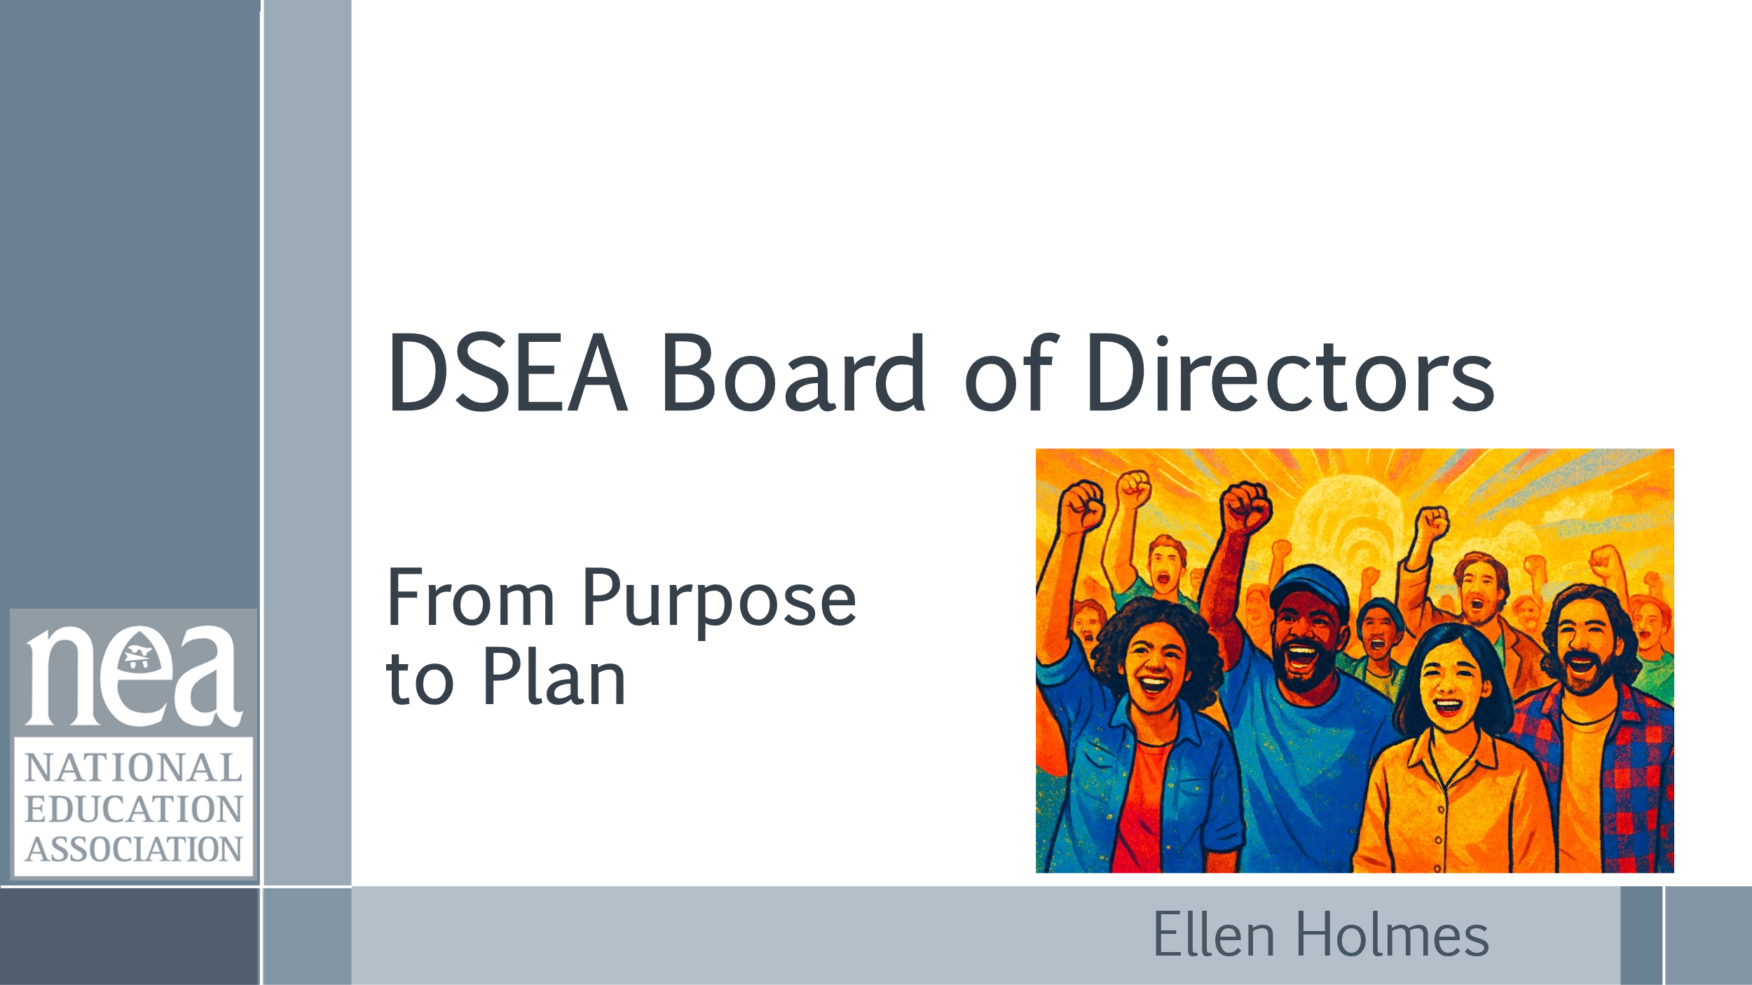  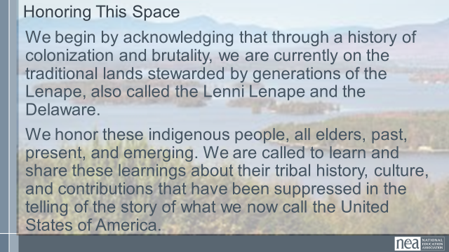  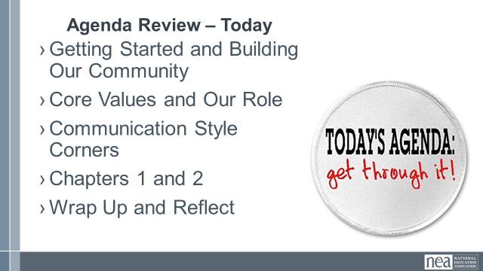  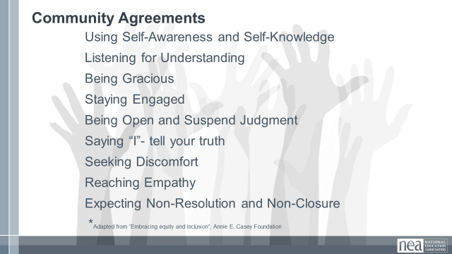  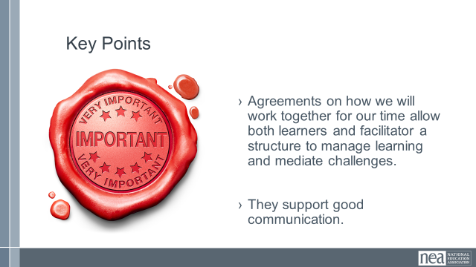  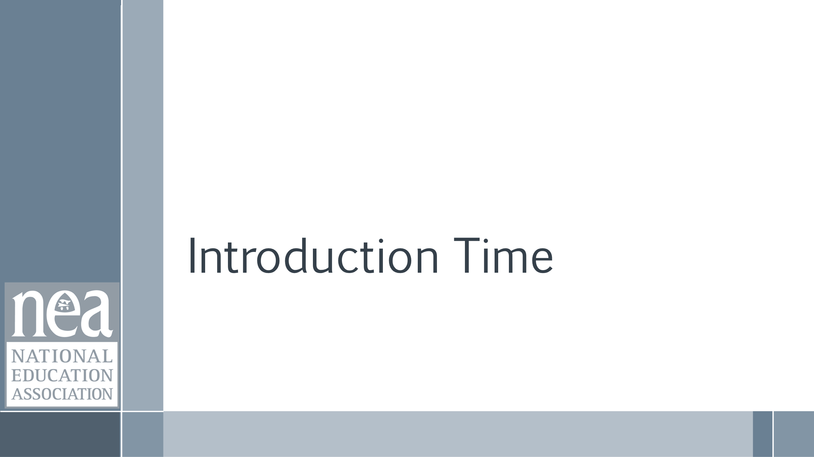  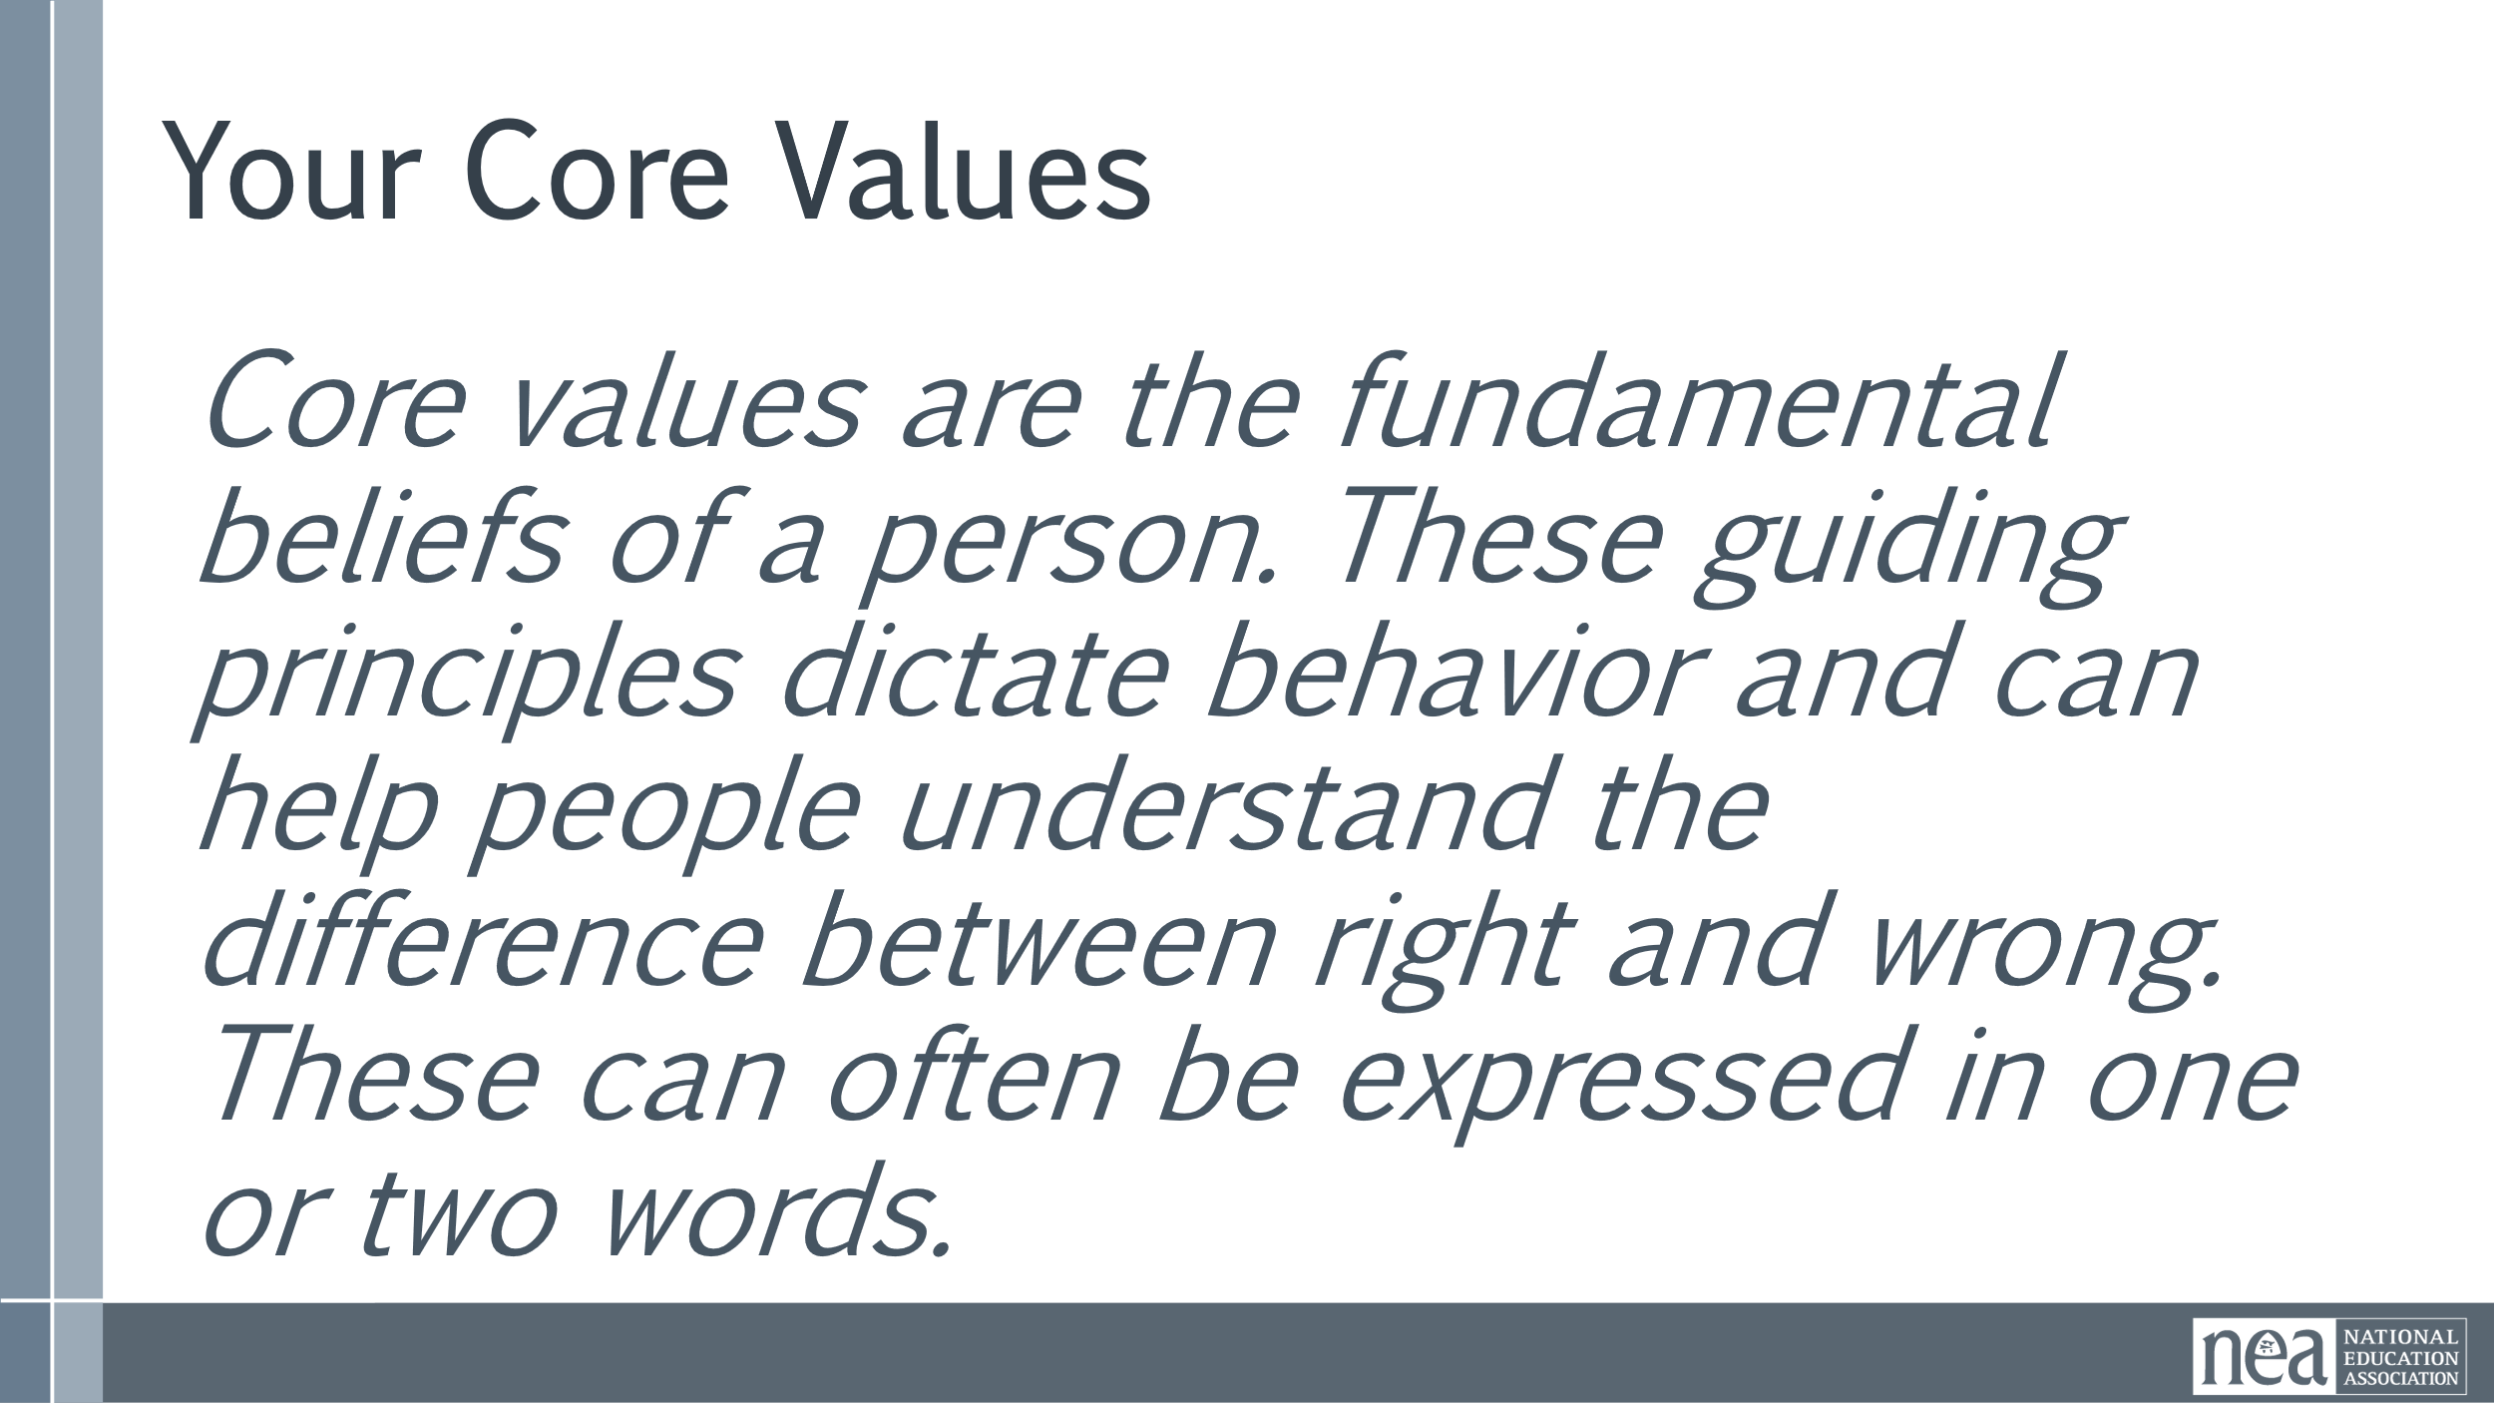    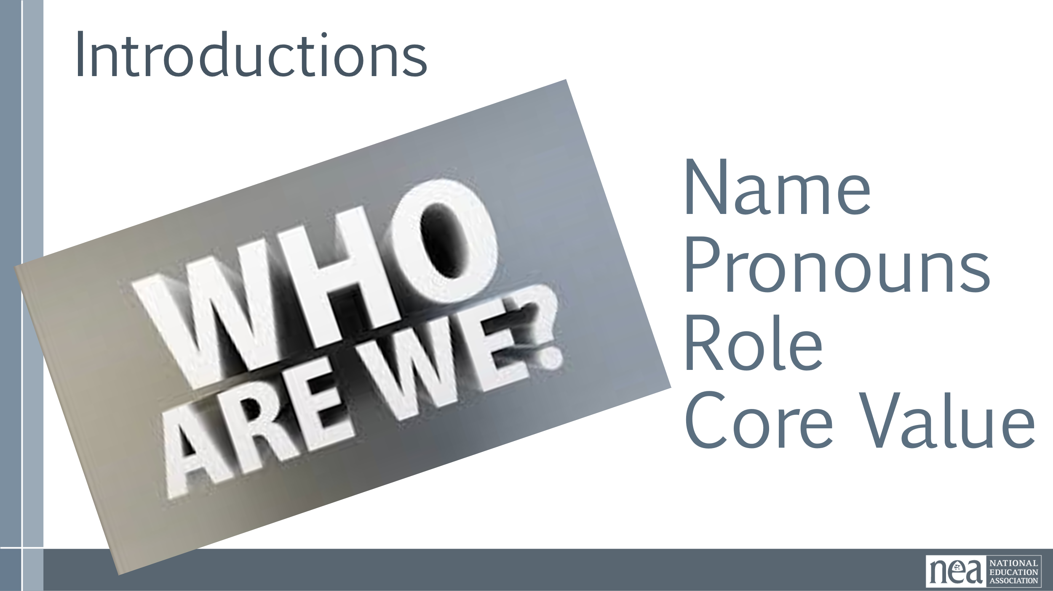    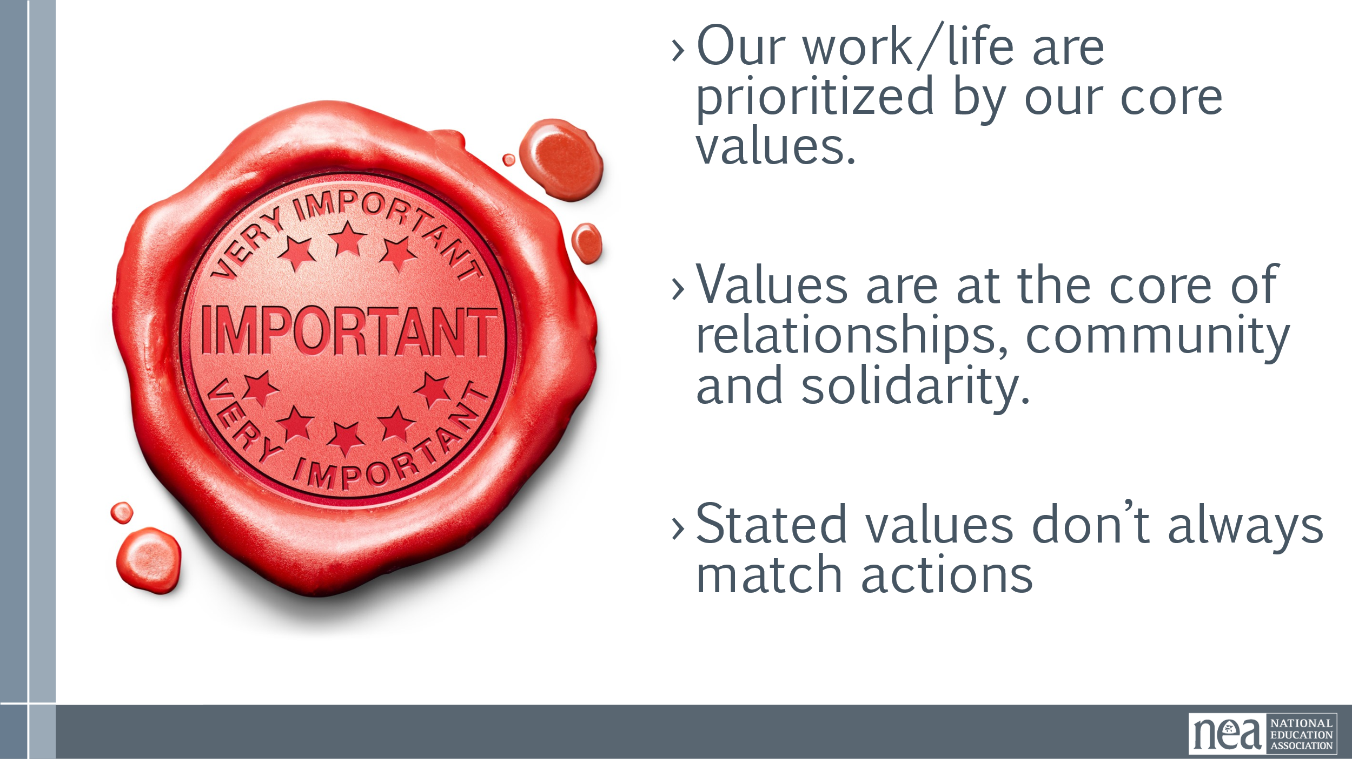 | Community Agreements  Core Values | 3 Minutes – Welcomes  Land Acknowledgement  begin by acknowledging that through a history of colonization and brutality, we are currently on the traditional lands stewarded by generations of the Indigenous people in the area (XXXXXXXXXXXX). We honor these indigenous people, all elders, past, present, and emerging. We are called to learn and share these learnings about this tribal history, culture, and contributions that have been suppressed in the telling of the story of what we now call the United States of America.  Agenda Review  - Getting Started and Building Our Community  - Core Values and Our Role  - Communication Style Corners  - Chapters 1 and 2  - Wrap Up and Reflect  5 Min - Group Review (p.2-3)  Begin with a proposed list of community agreements, each table needs to describe what they think each agreement means and propose any additional norms not covered by the proposed agreements:  - Using Self-Awareness and Self-Knowledge  - Listening for Understanding  - Being Gracious  - Staying Engaged  - Being Open and Suspend Judgment  - Saying “I”- tell your truth  - Seeking Discomfort  - Reaching Empathy  - Expecting Non-Resolution and Non-Closure  Refer them to the Community Agreements in their handouts and that they received as part of their Pre-Attendance documents.  5 Min  Prompt table groups to review the agreements.  - Give them 10 minutes to scan the agreements looking for items that they don’t understand.  - They should also be tracking what they think is missing.  5 Min - Debrief  Share what you mean by the agreements.  Check to see if tables are on track or need clarity for EACH of the agreements.  Before moving on - ask the group to show thumbs:  - Thumbs up is I totally agree  - Thumbs sideways is I can live with it and I am fine to move on  - Thumbs down – I simply cannot move on AND I have questions or something different to propose.  - A thumbs down comes with the responsibility of working until your thumb can at least be sideways.  2 Key Point  Agreement on how we will work together allows us the space to manage “airtime” and teaching - AND allows adult learners a safe space to learn.  15 Minutes Getting to Know Each Other  Let’s do a quick whip introduction – I will start, Name Pronouns and Role  Share a Core Value  2 minute Directions and Review  - A core value –  - Review what a core value is (Core values are the fundamental beliefs of a person. These guiding principles dictate behavior and can help people understand the difference between right and wrong – one or two words)  - You are going to One word or two that describes a fundamental belief held by you – start the chart with yours (ex. Solidarity) - you and your partners will chart the core values only as they are shared – Use two charts and two recorders so that it can move quickly.  Use the Handouts to record your core value – we will come back to this sheet.  Debrief did you notice any patterns? | How will we work together?  Participants will review, clarify and agree to a set of expectations and behaviors that support their learning as a community.
9:45-10:15 |  | 30 TOTAL Minutes – Purpose Share
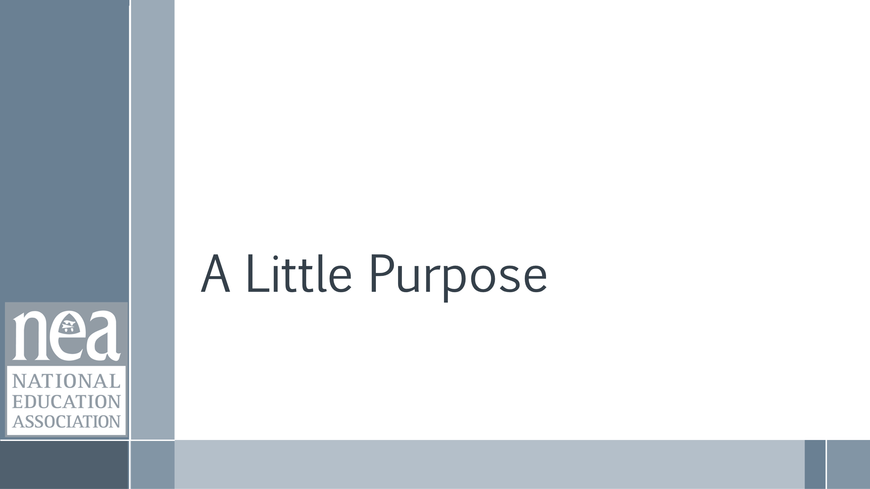  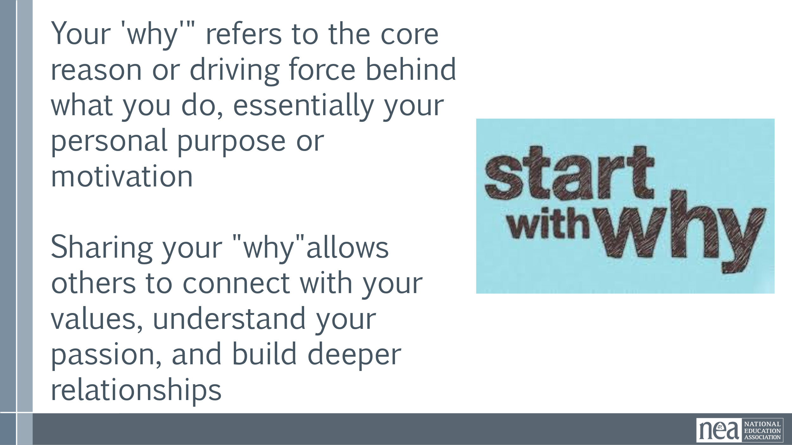  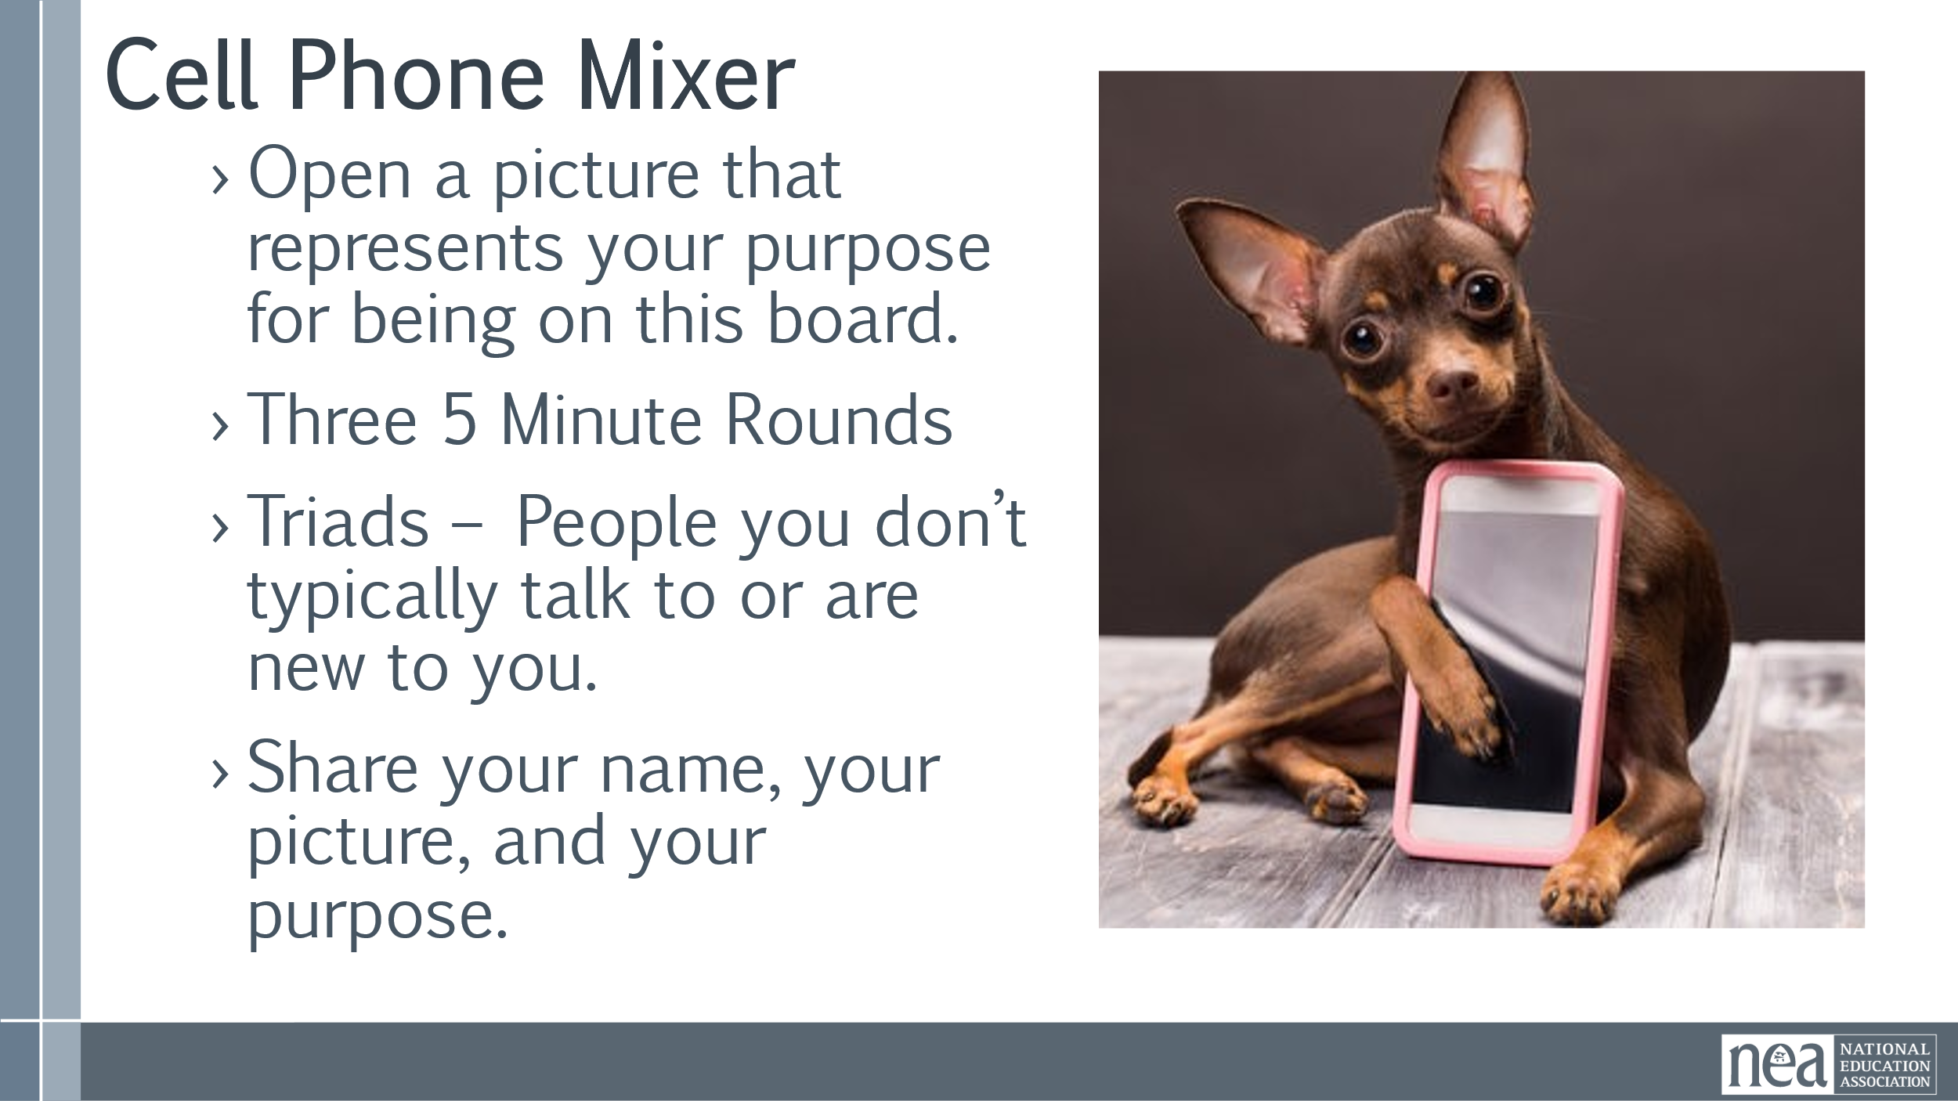  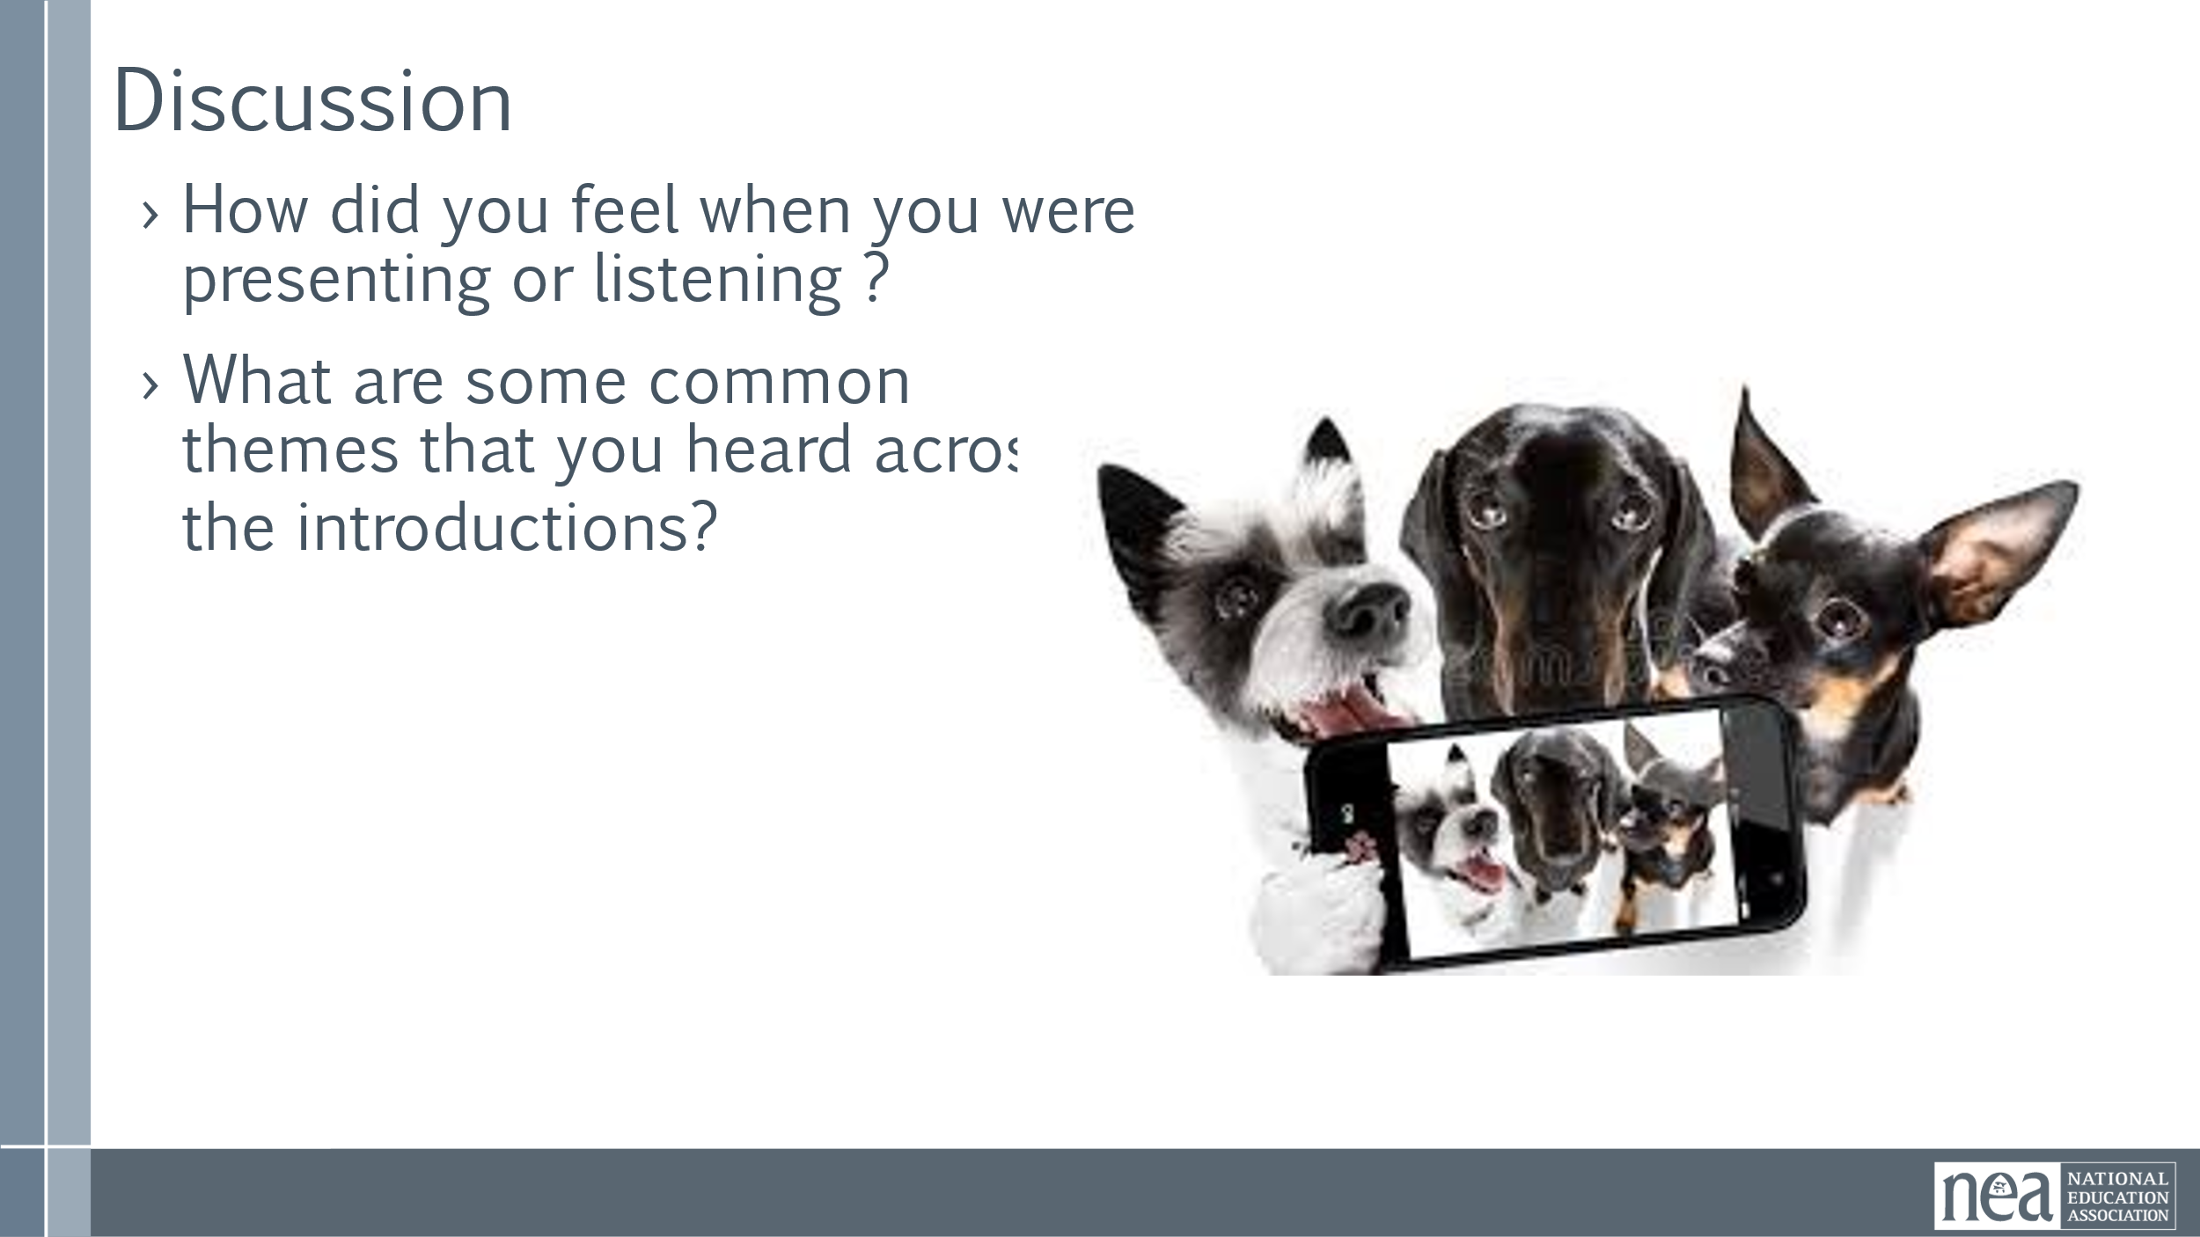  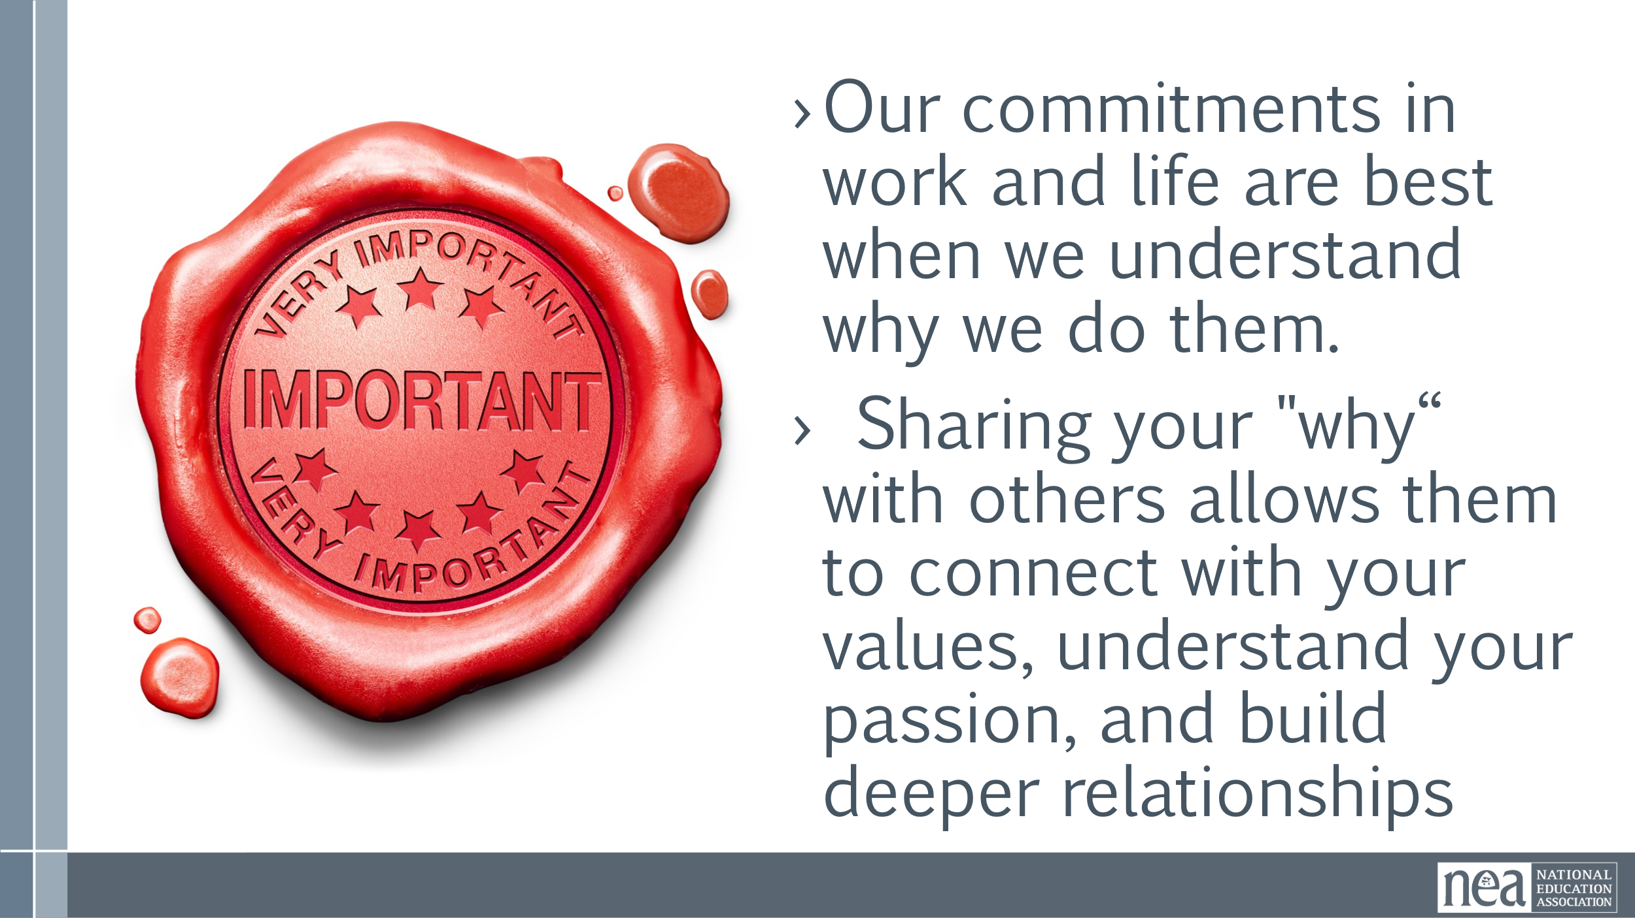 | Core Values That Drive Work / Life | 5 Minutes Introduction  Now I am going to model something you are going to do – share your WHY – our “Why” Your 'why'" refers to the core reason or driving force behind what you do, essentially your personal purpose or motivation  Sharing your "why" allows others to connect with your values, understand your passion, and build deeper relationships  15 Minutes Group Sharing  We will be repeating at least 3 rounds of the following:  - Open a picture that represents your purpose for being on this board.  - Three 5 Minute Rounds  - Triads – People you don’t typically talk to or are new to you.  - Share your name, your picture, and your purpose.  10 Min - Debrief  - How did you feel when you were presenting or listening ?  - What are some common themes that you heard across the introductions?  - Did you notice any partterns?  1 Min - Key Point  - Our commitments in work and life are best when we understand why we do them.  - Sharing your "why“ with others allows them to connect with your values, understand your passion, and build deeper relationships | Who are we as a group?  The group will share their own and develop a collective set of core values.  The group will begin to explore and share their identity.  The group will build a sense of community with each other.
10:30 BREAK
10:30-11:30 |  | 60 Minutes Dreams and Challenges
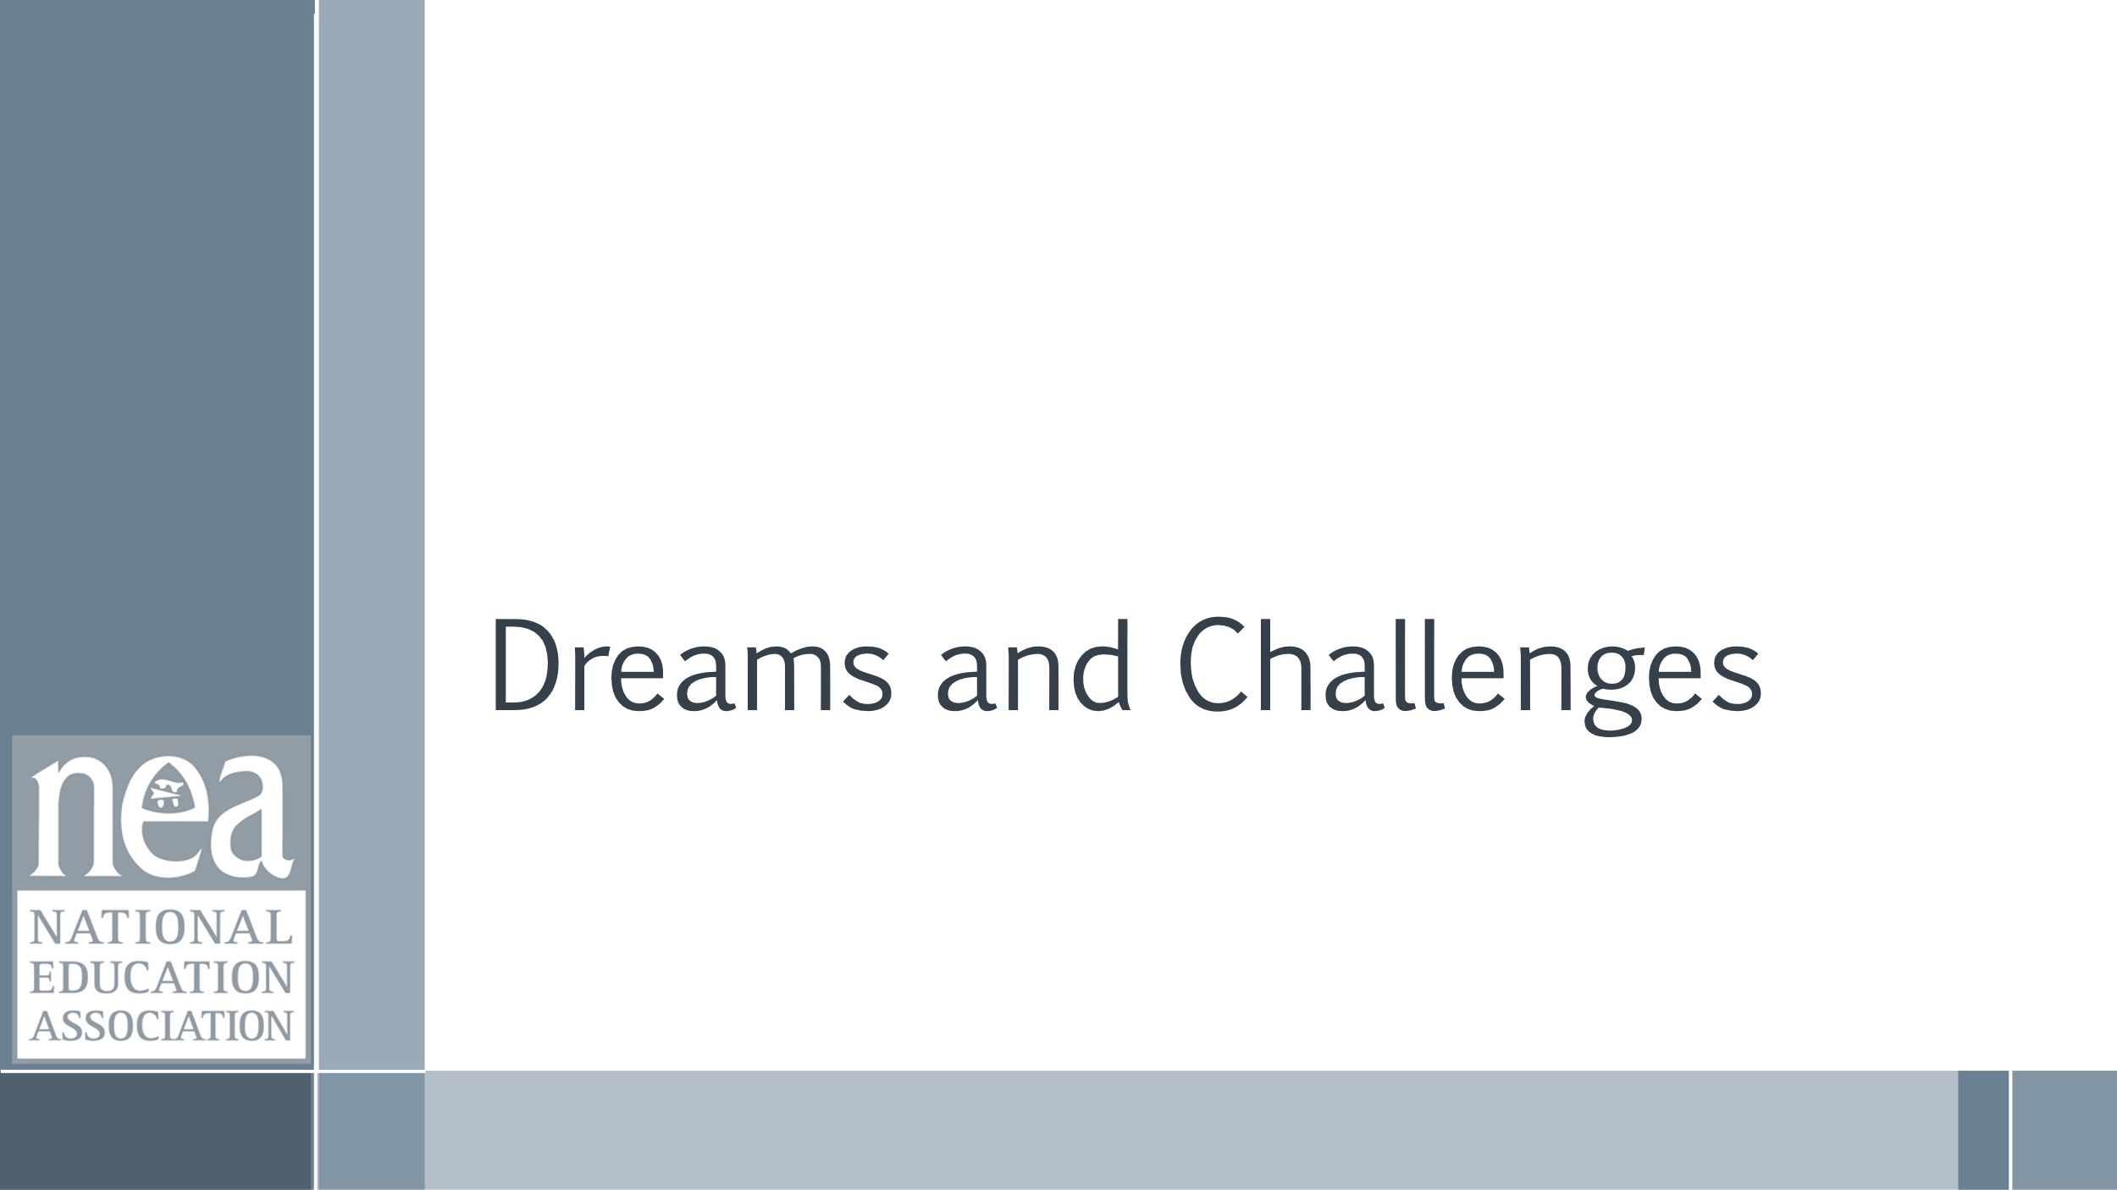  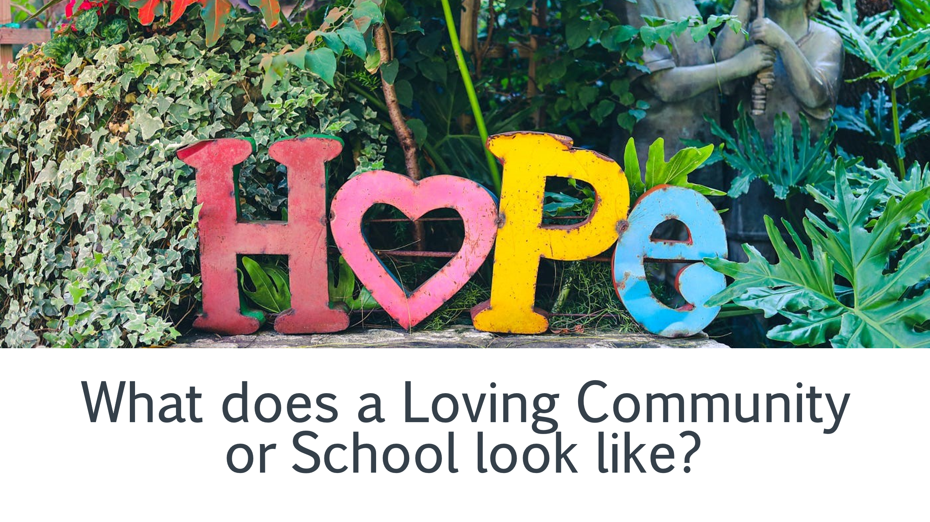    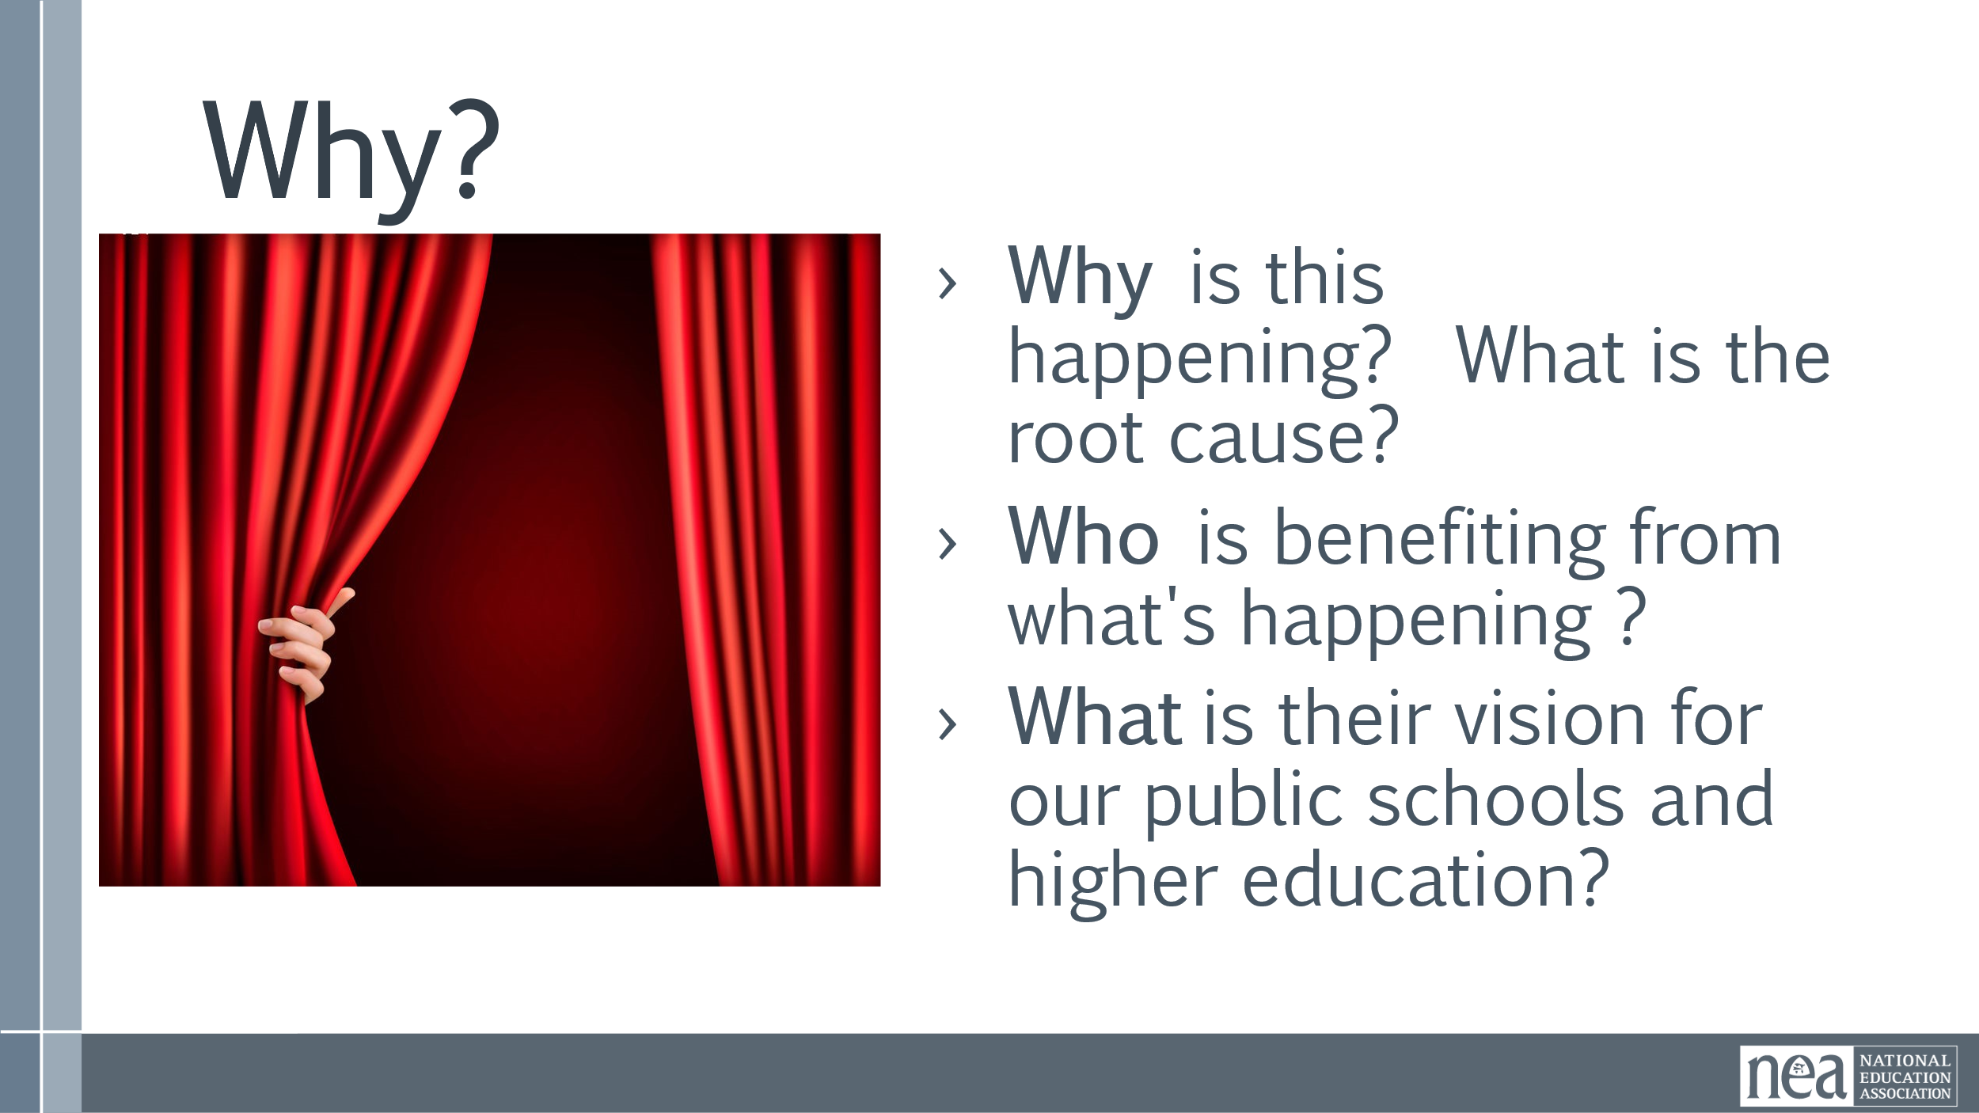  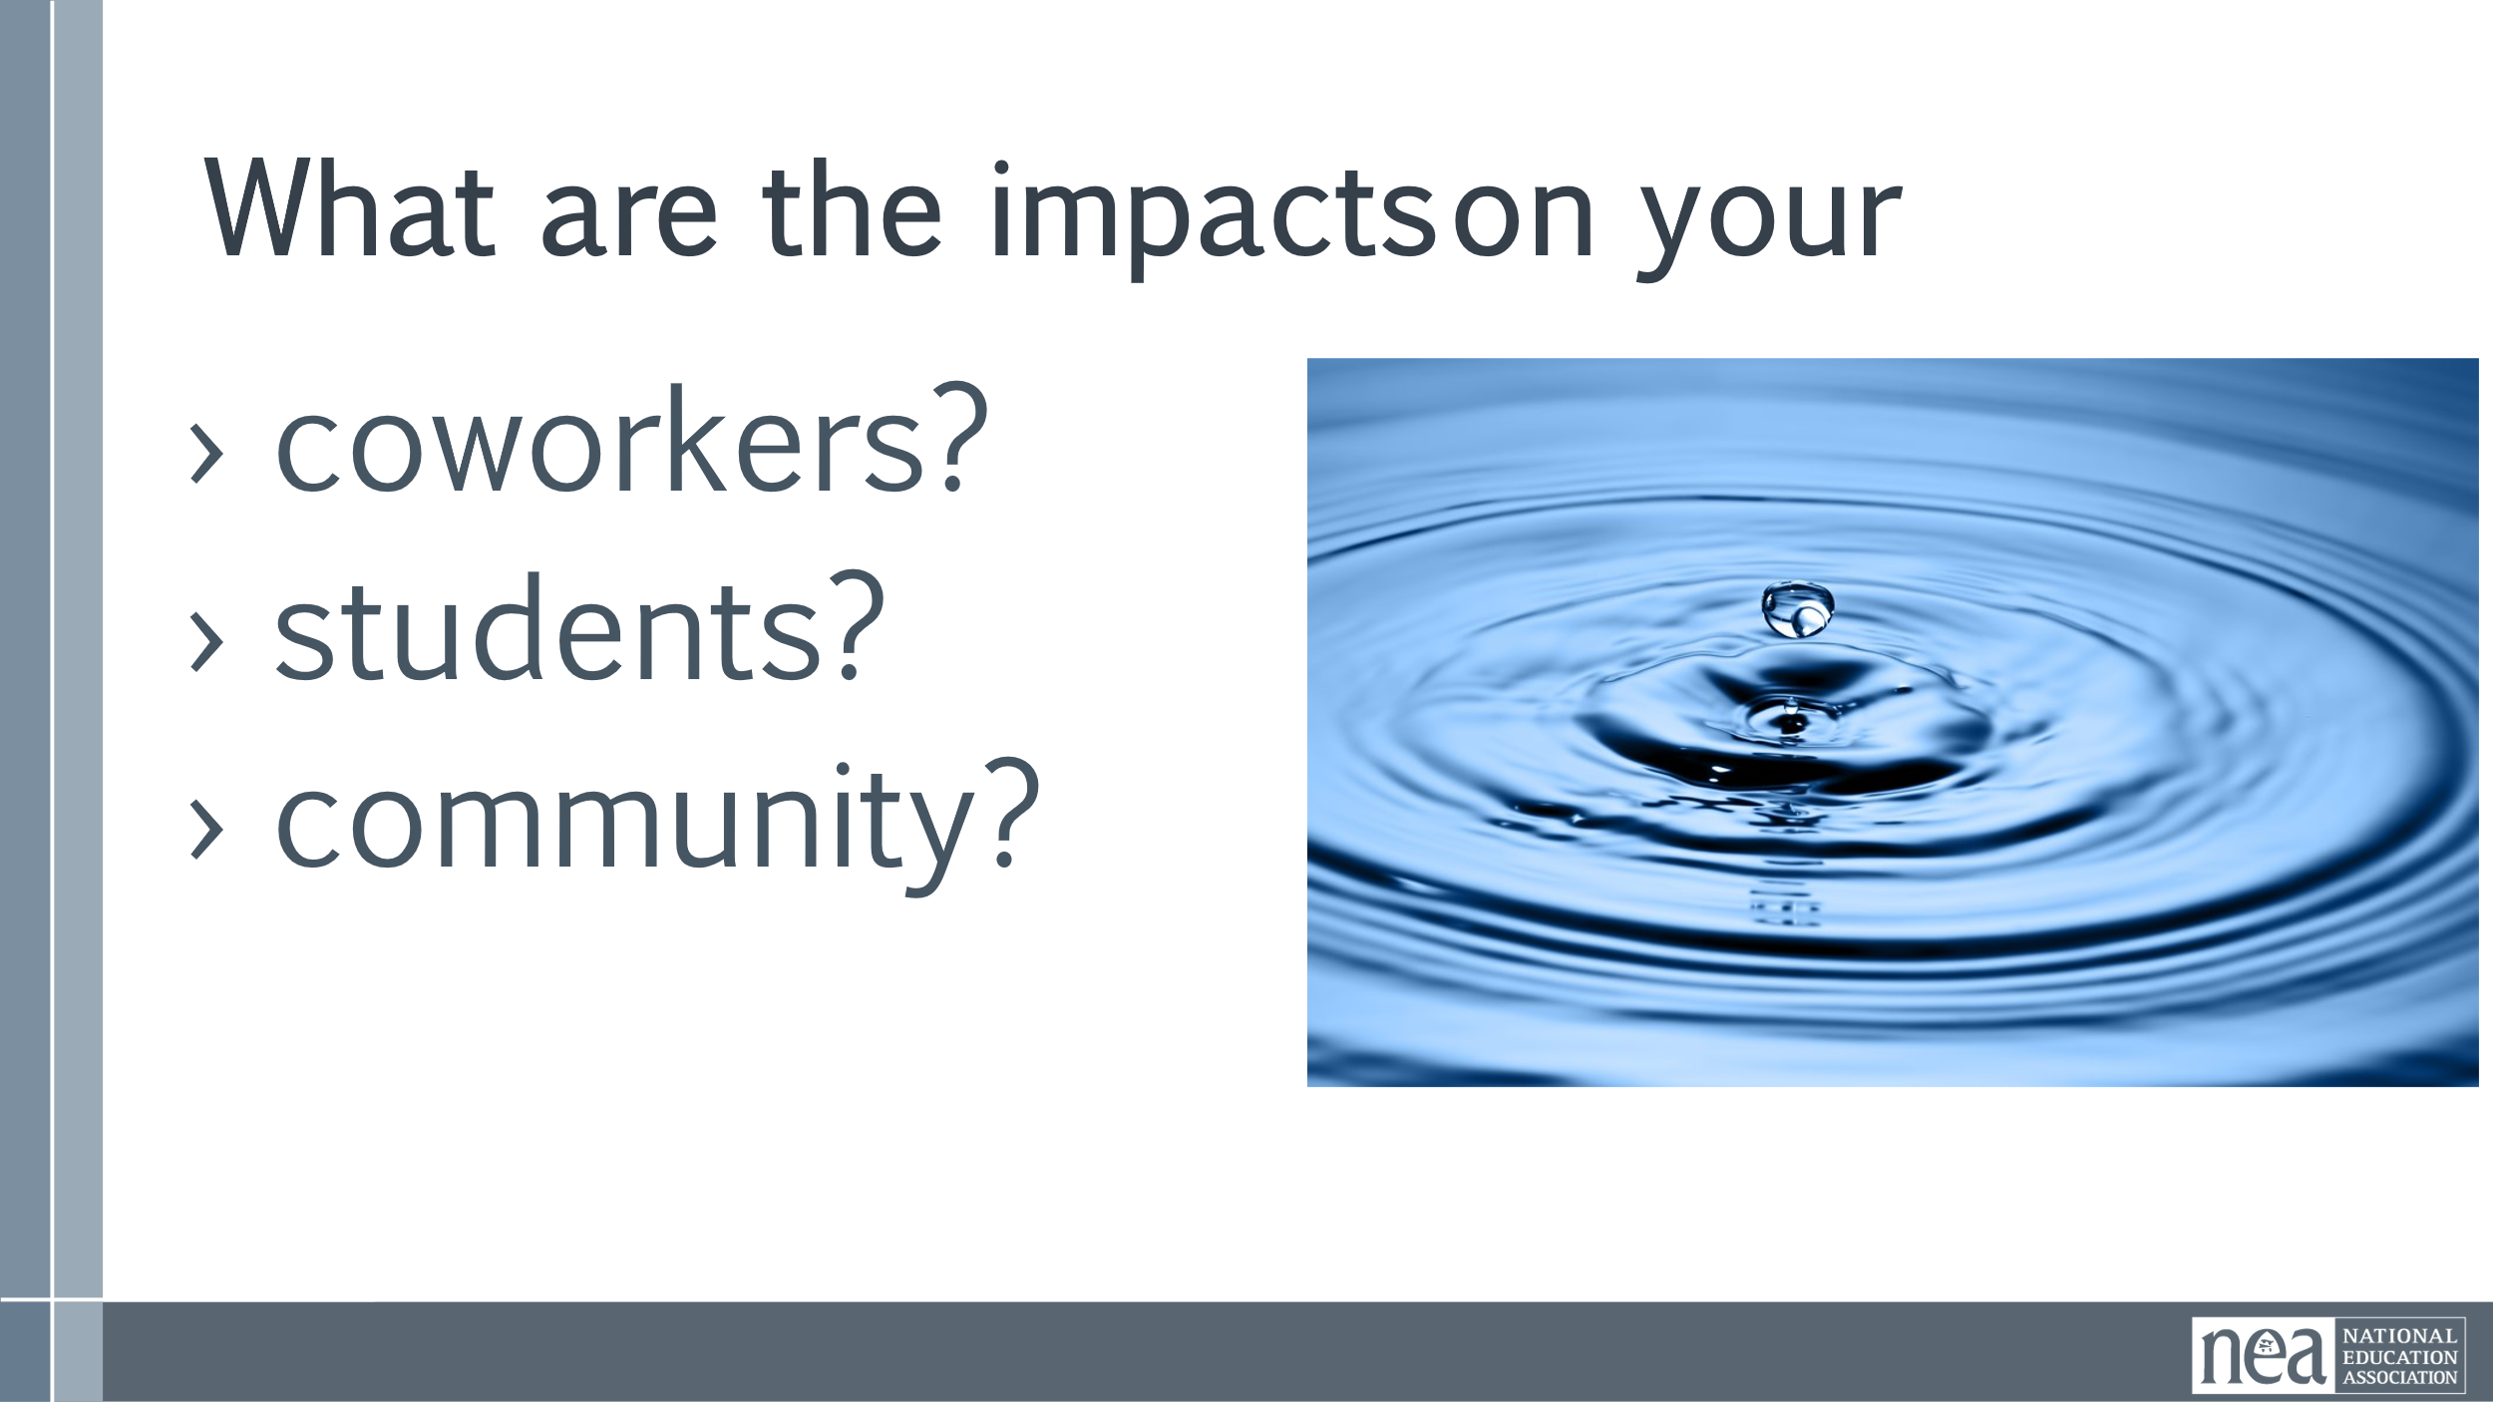  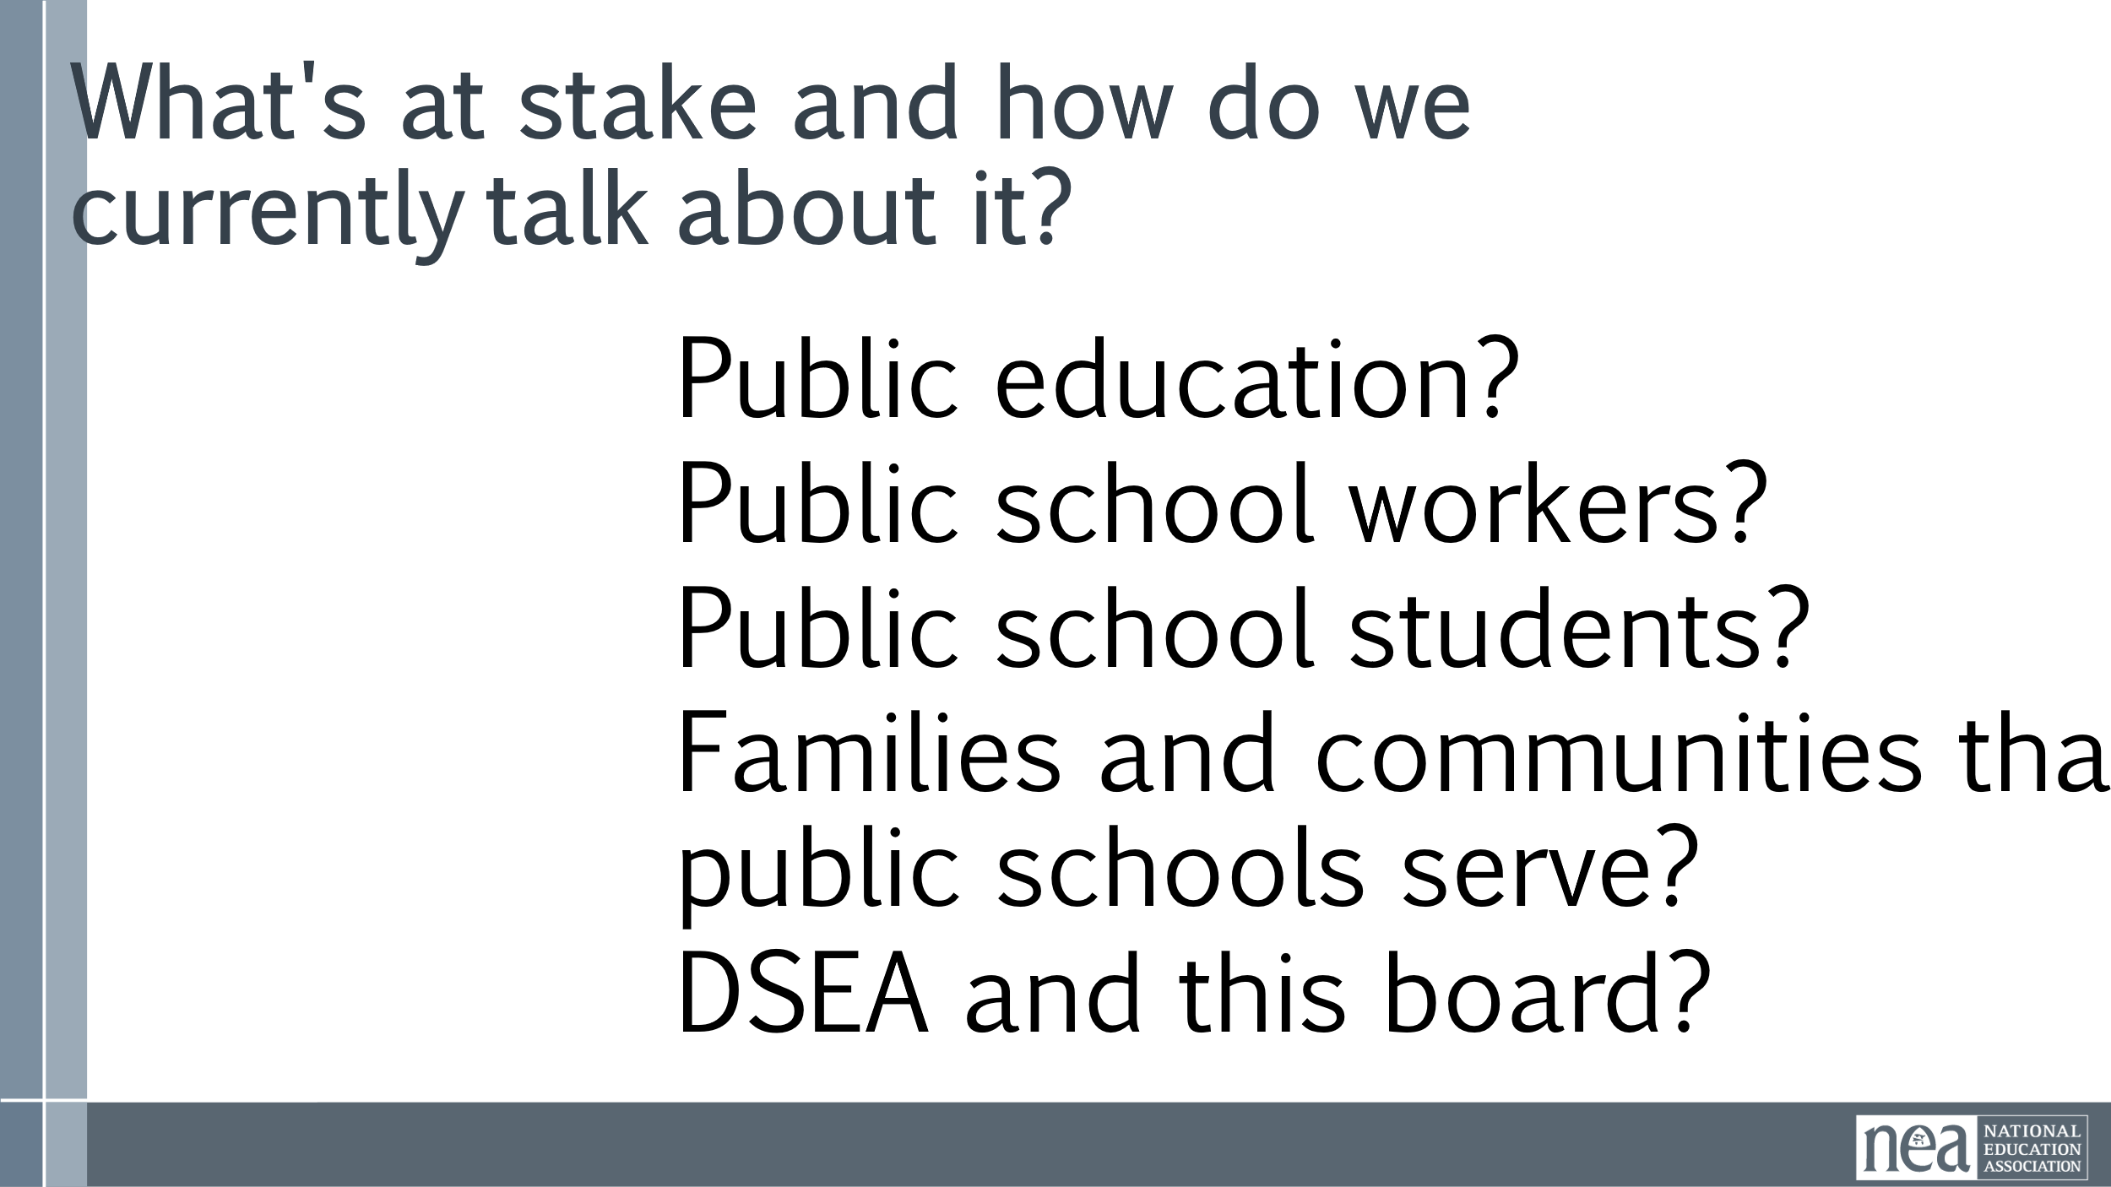  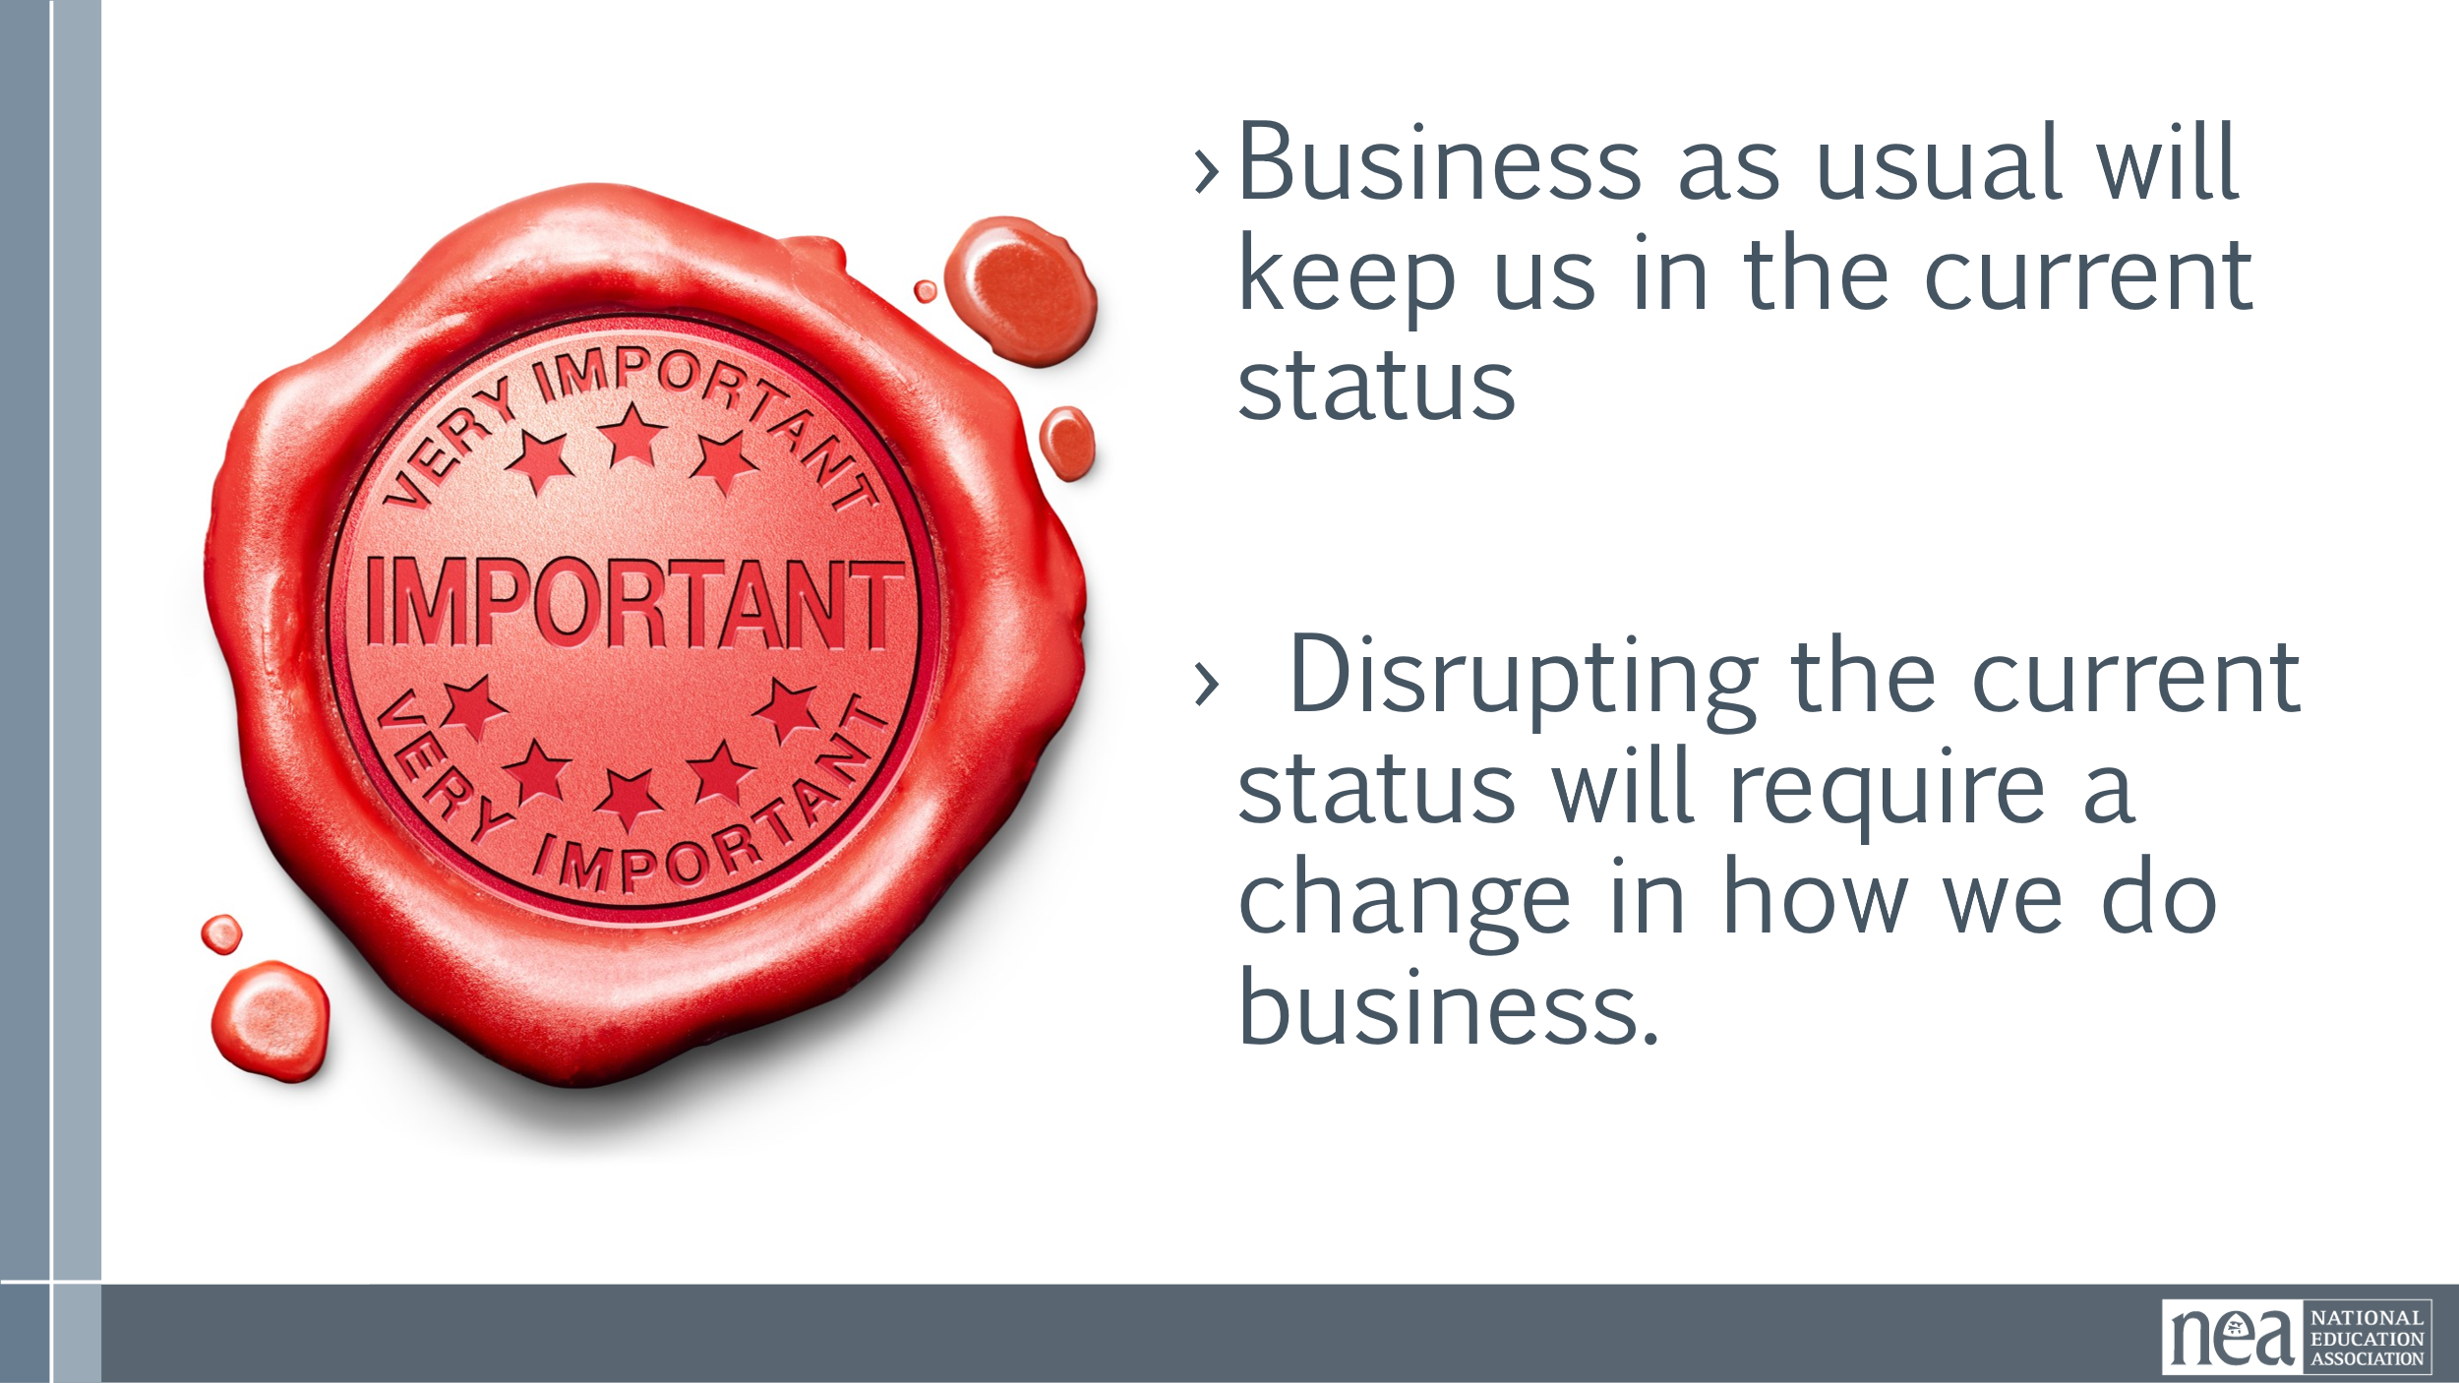 |  | Charting in Small Groups  What does a loving school community look like?  Who is preventing you from achieving this dream?  Why is this happening?  - Why is this happening? What is the root cause?  - Who is benefiting from what's happening ?  - What is their vision for our public schools and higher education?  What are the impacts on your  - coworkers?  - students?  - community?  What’s at stake and how do we currently talk about it?  Public education?  Public school workers?  Public school students?  Families and communities that public schools serve?  DSEA and this board?  What do we want to do about this?  Key Points  - Business as usual will keep us in the current status  - Disrupting the current status will require a change in how we do business. | Participants will explore a shared analysis of what their challenges are in achieving the public schools they want.
11:30-12:00 |  | 30 Minutes Review Current Strategic Plan
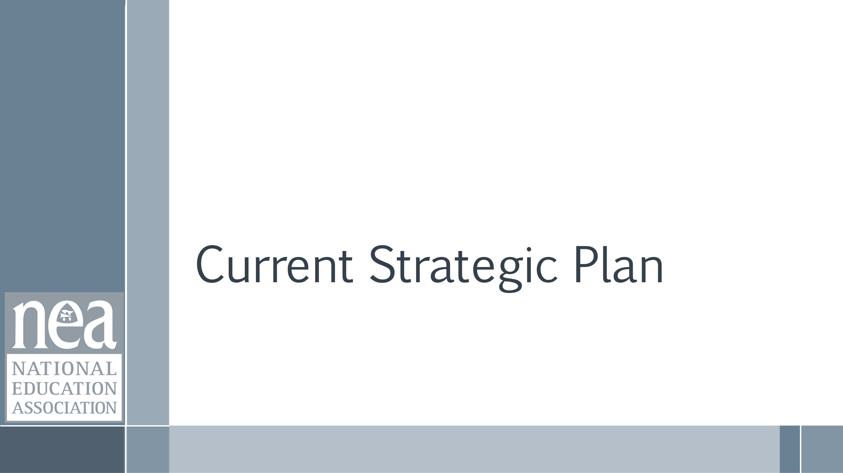    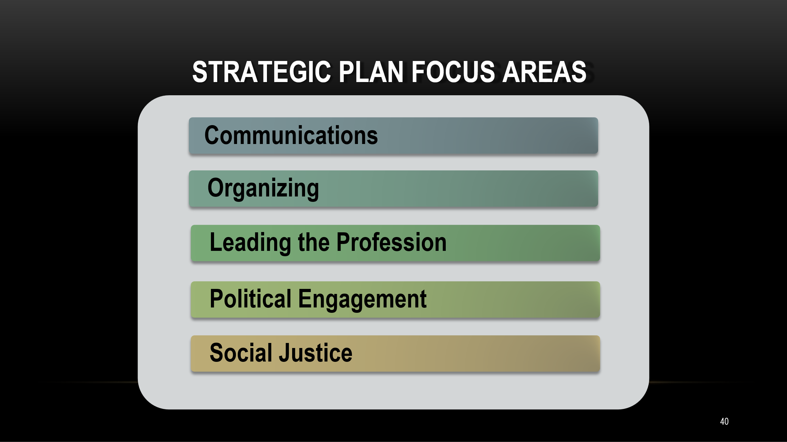  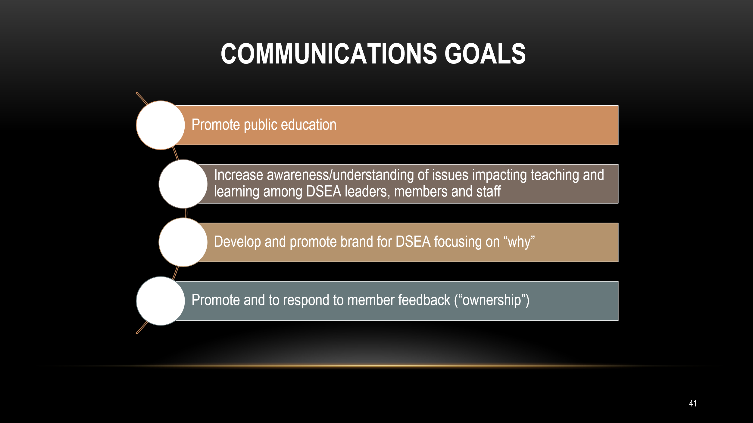  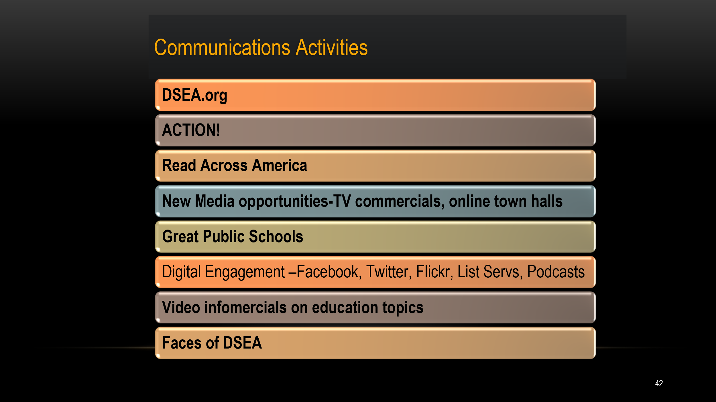  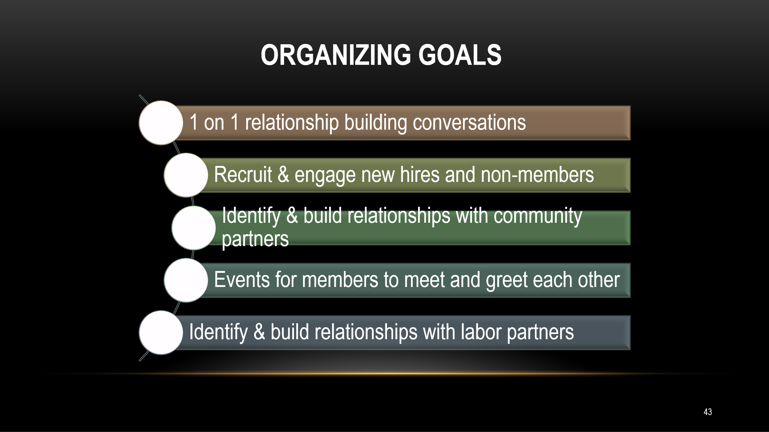  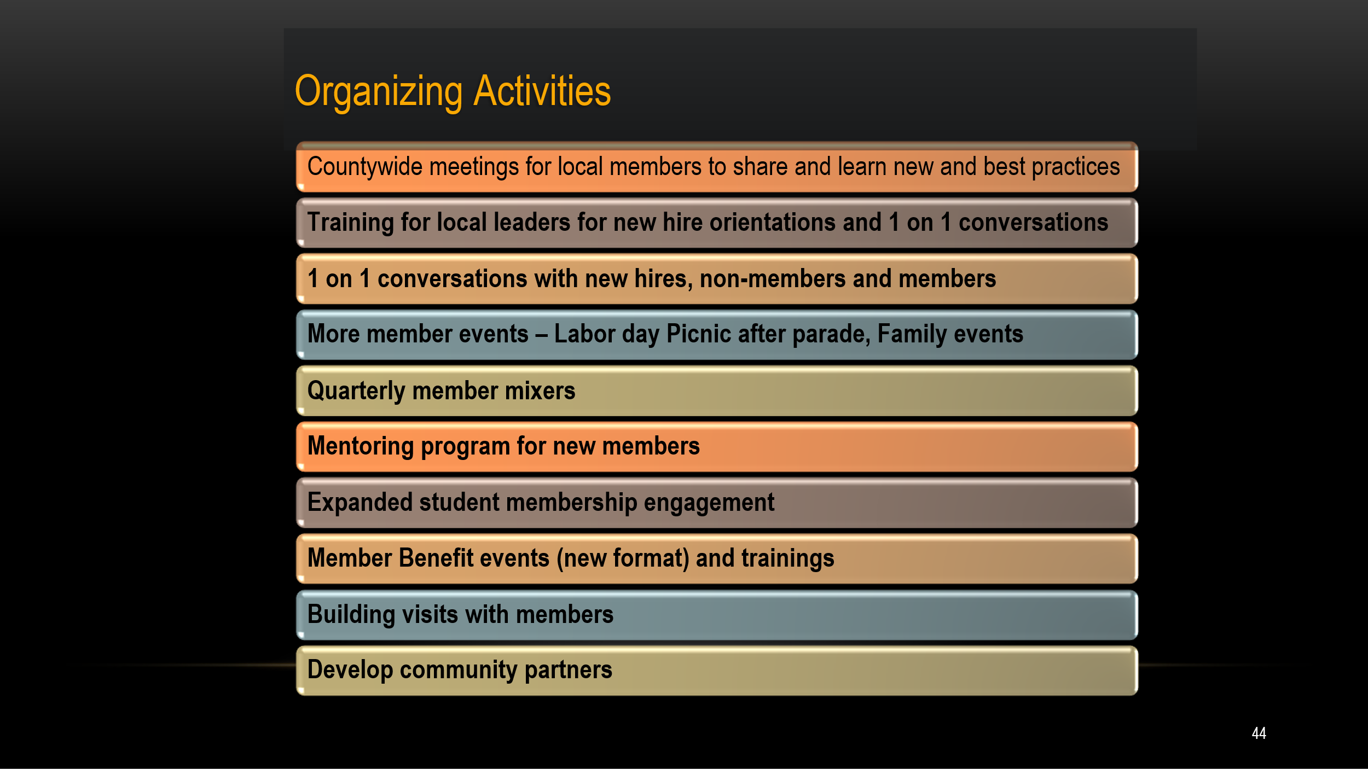  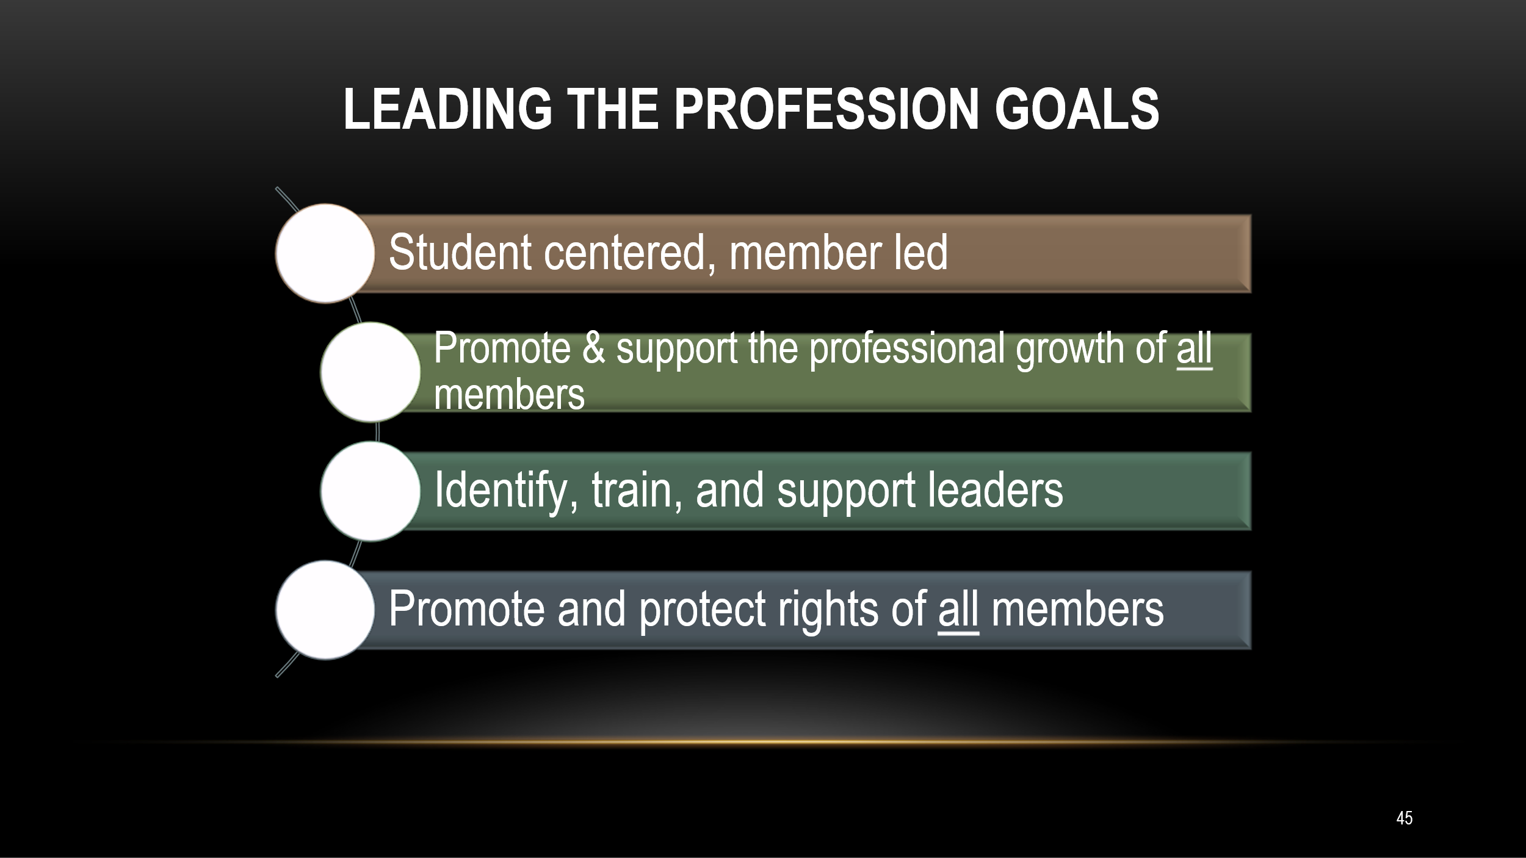  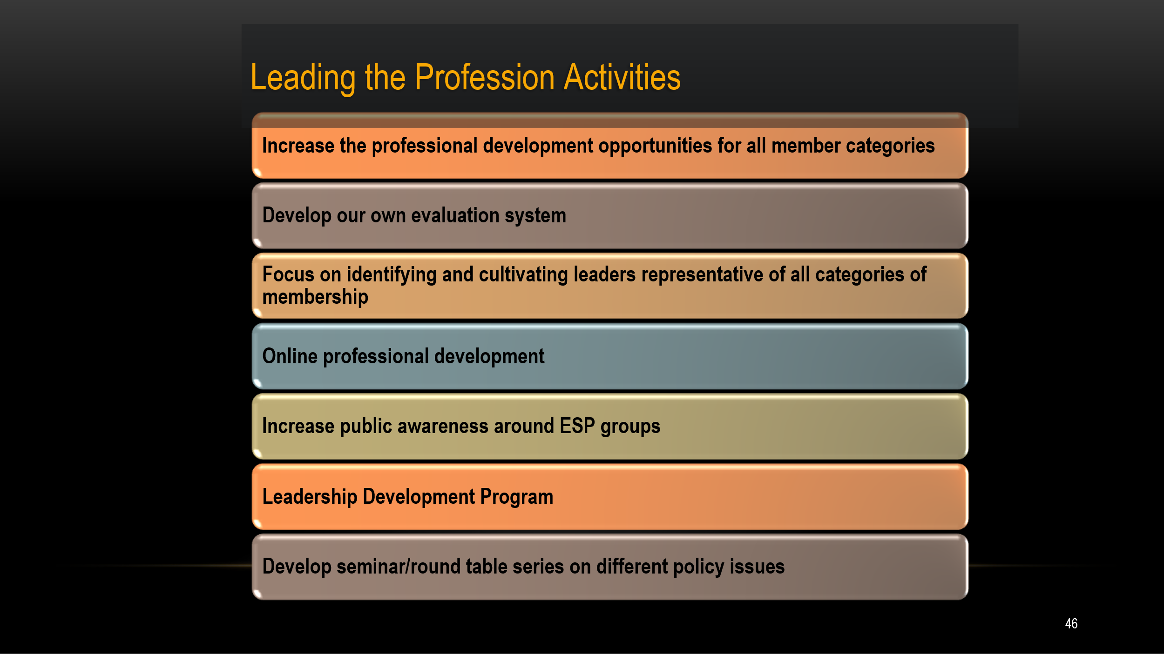  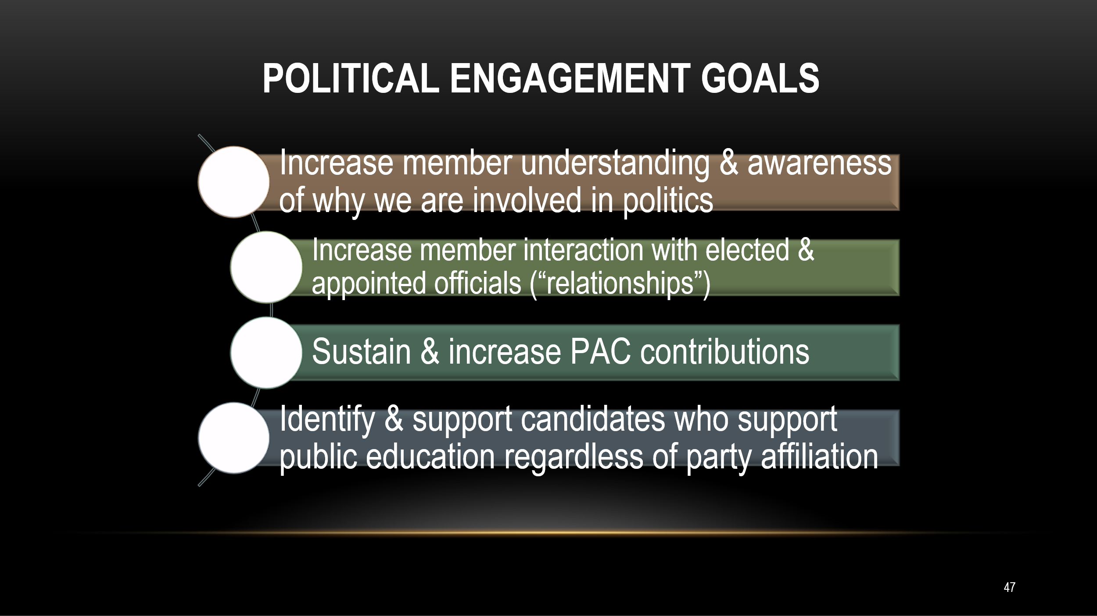  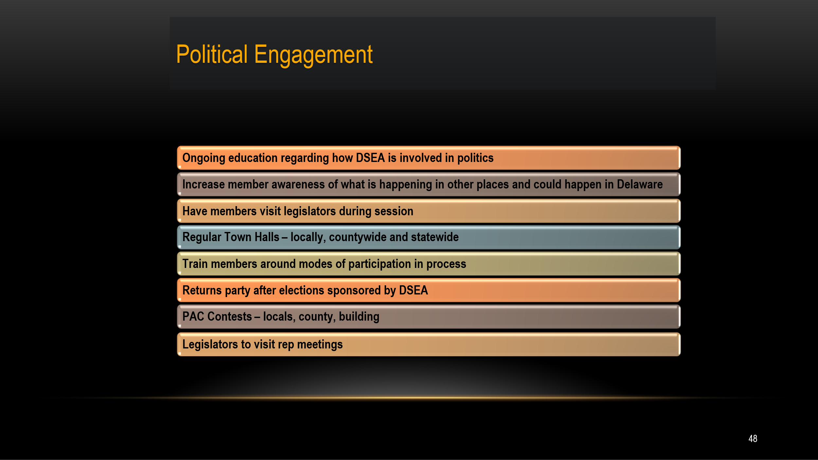  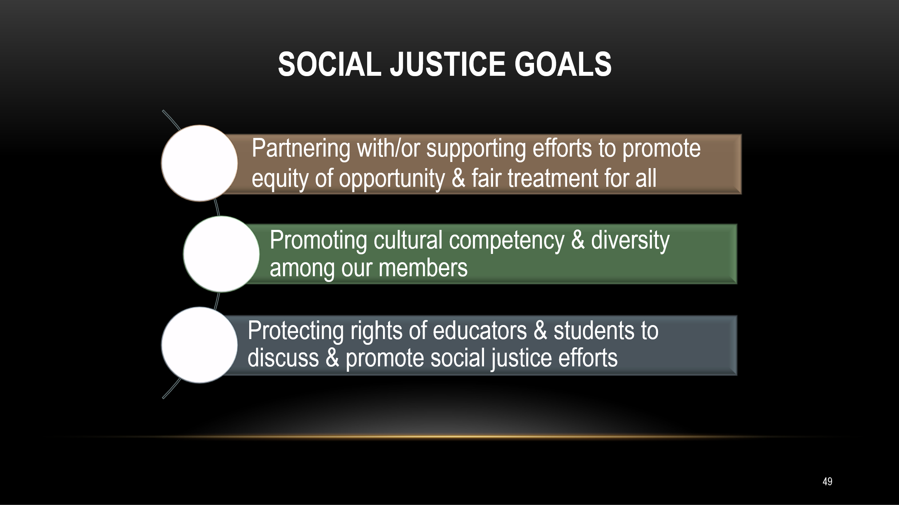  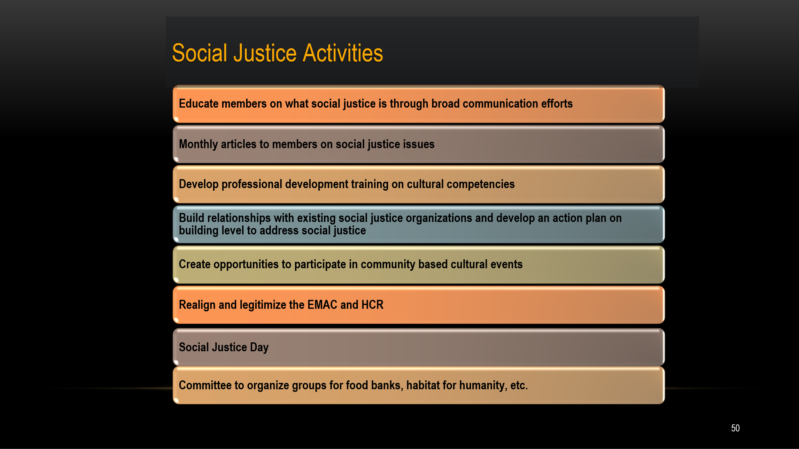 |  | Will this get us where we need to go?  What would you keep and what would you change?  What do you think your members would say about this plan and how it builds a loving school community? | Participants will identify gaps for discussion in the current and dated strategic plan
12:00-12:45 |  | LUNCH
12:45-1:45 |  | 60 Minutes – Building Power
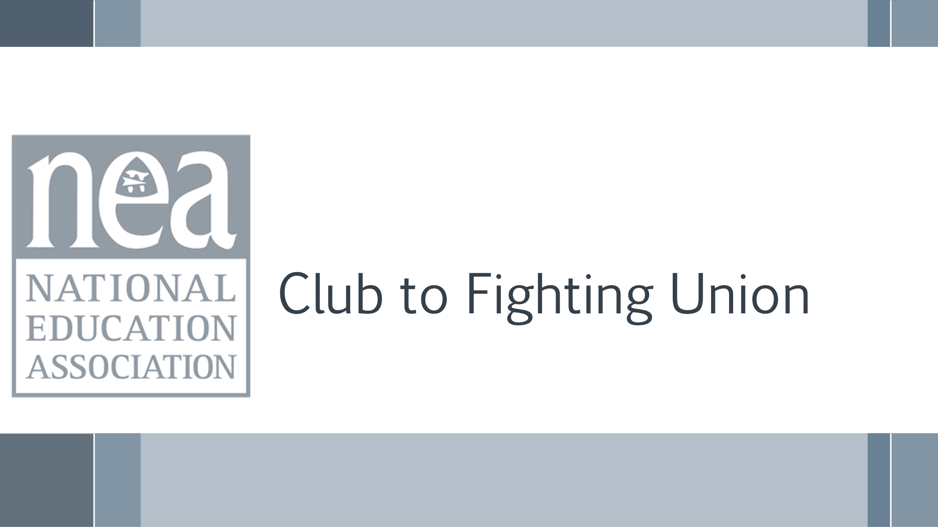  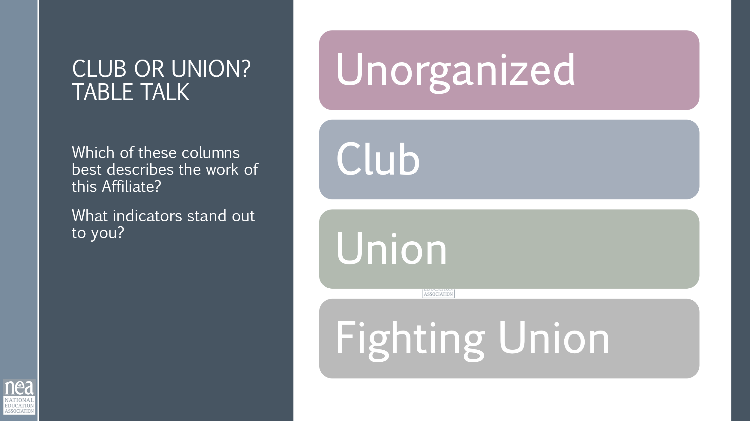  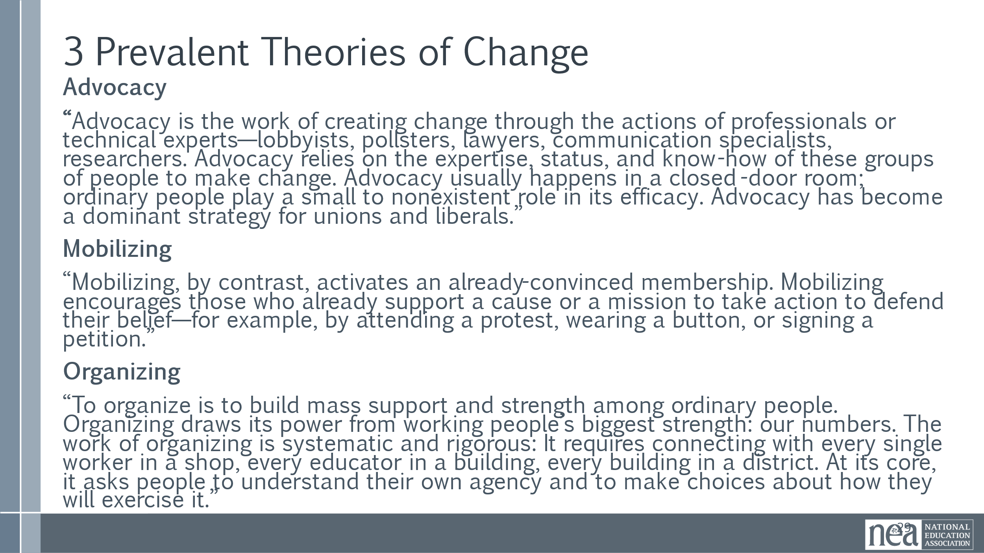  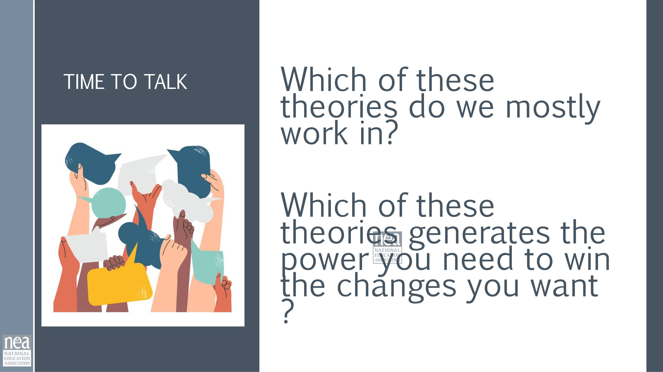  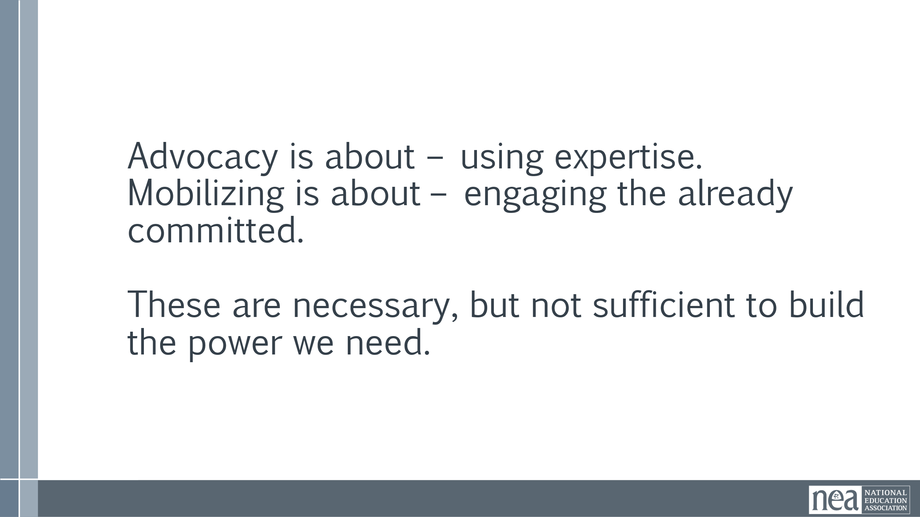  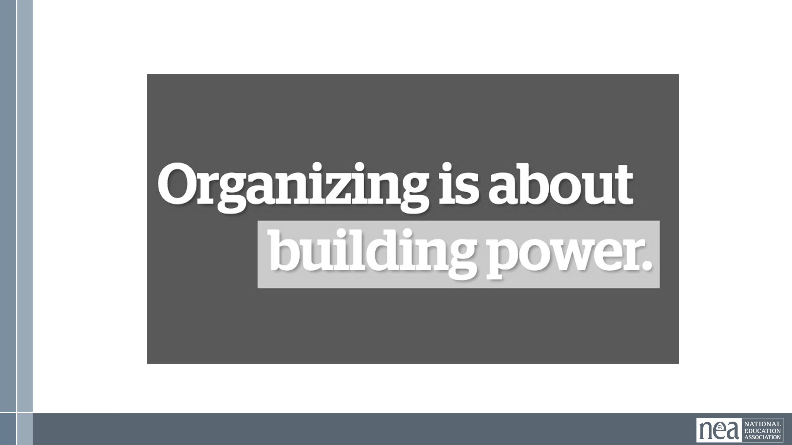  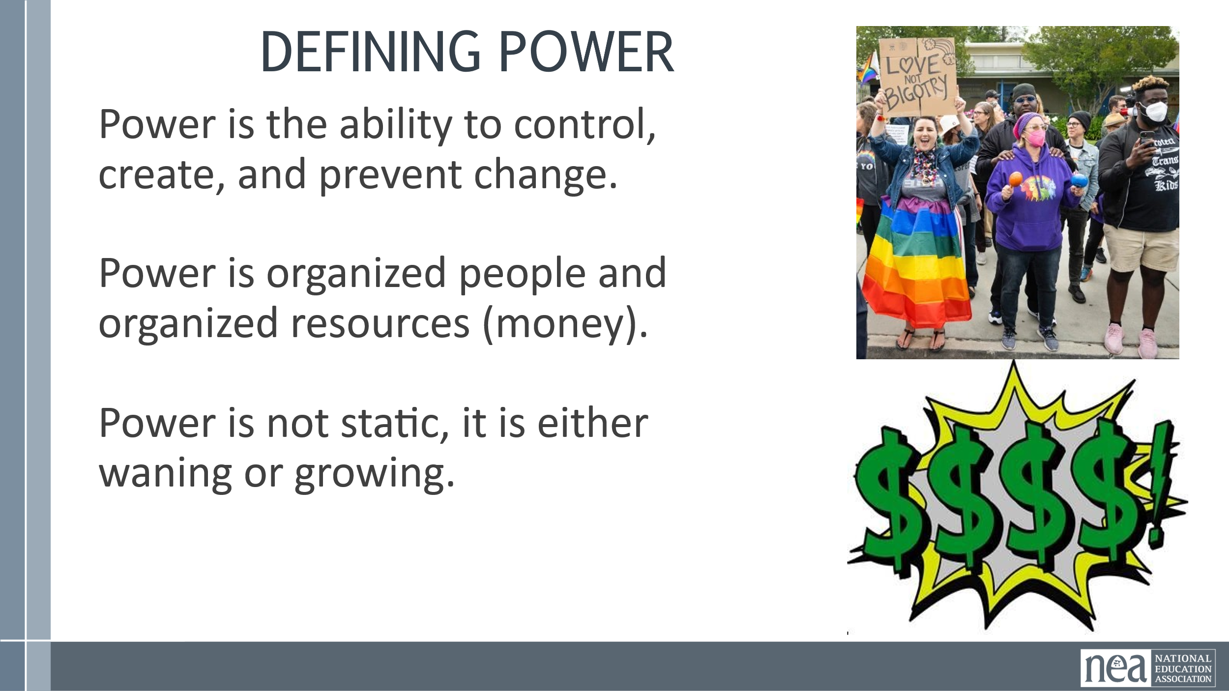  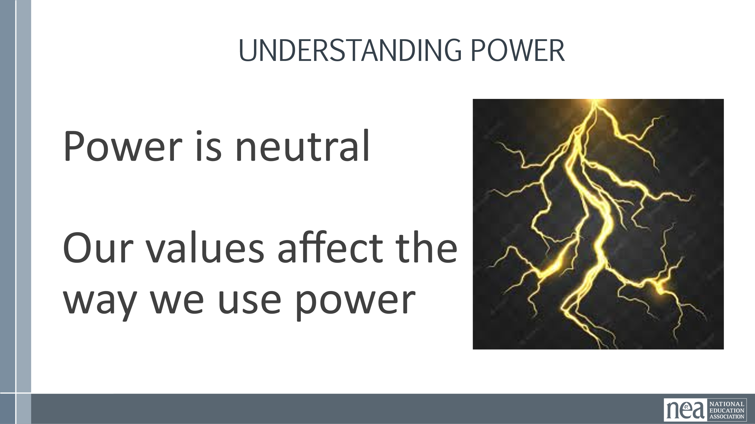  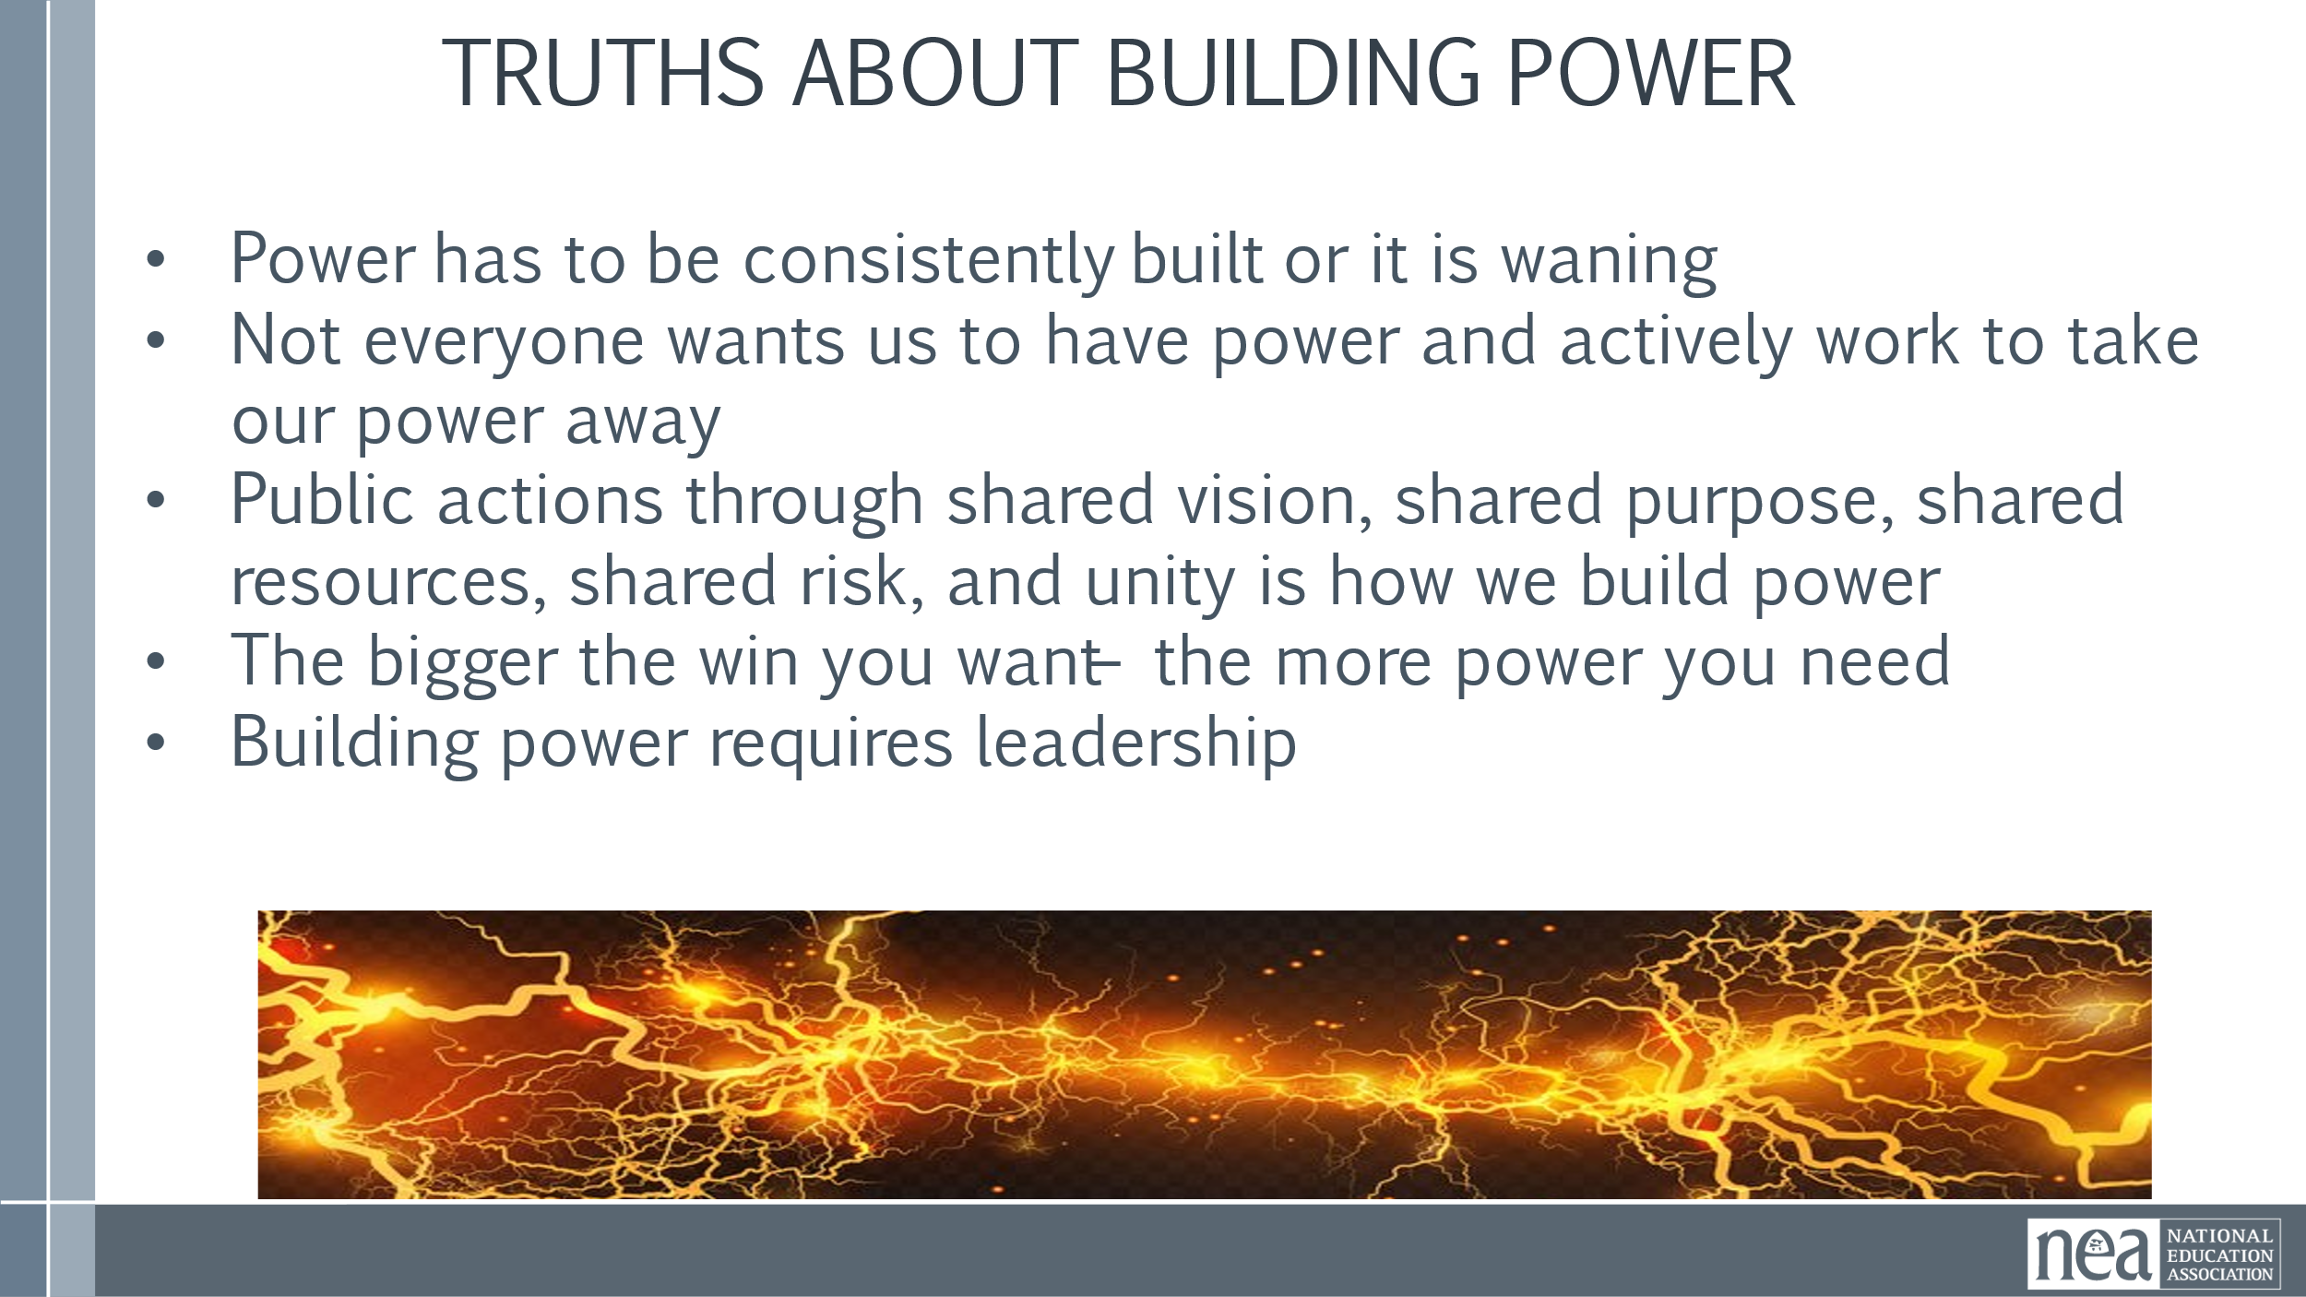  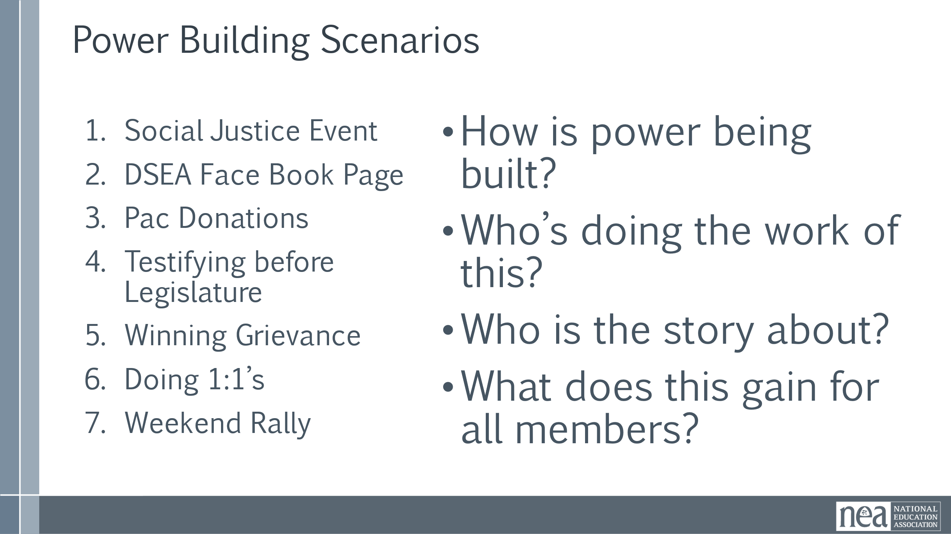  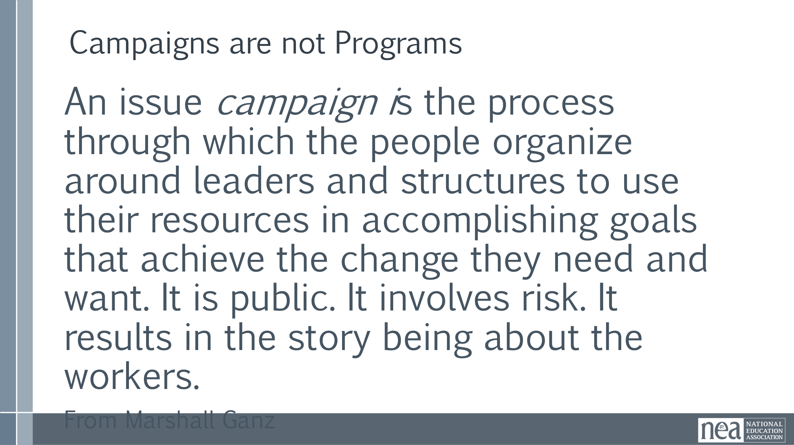  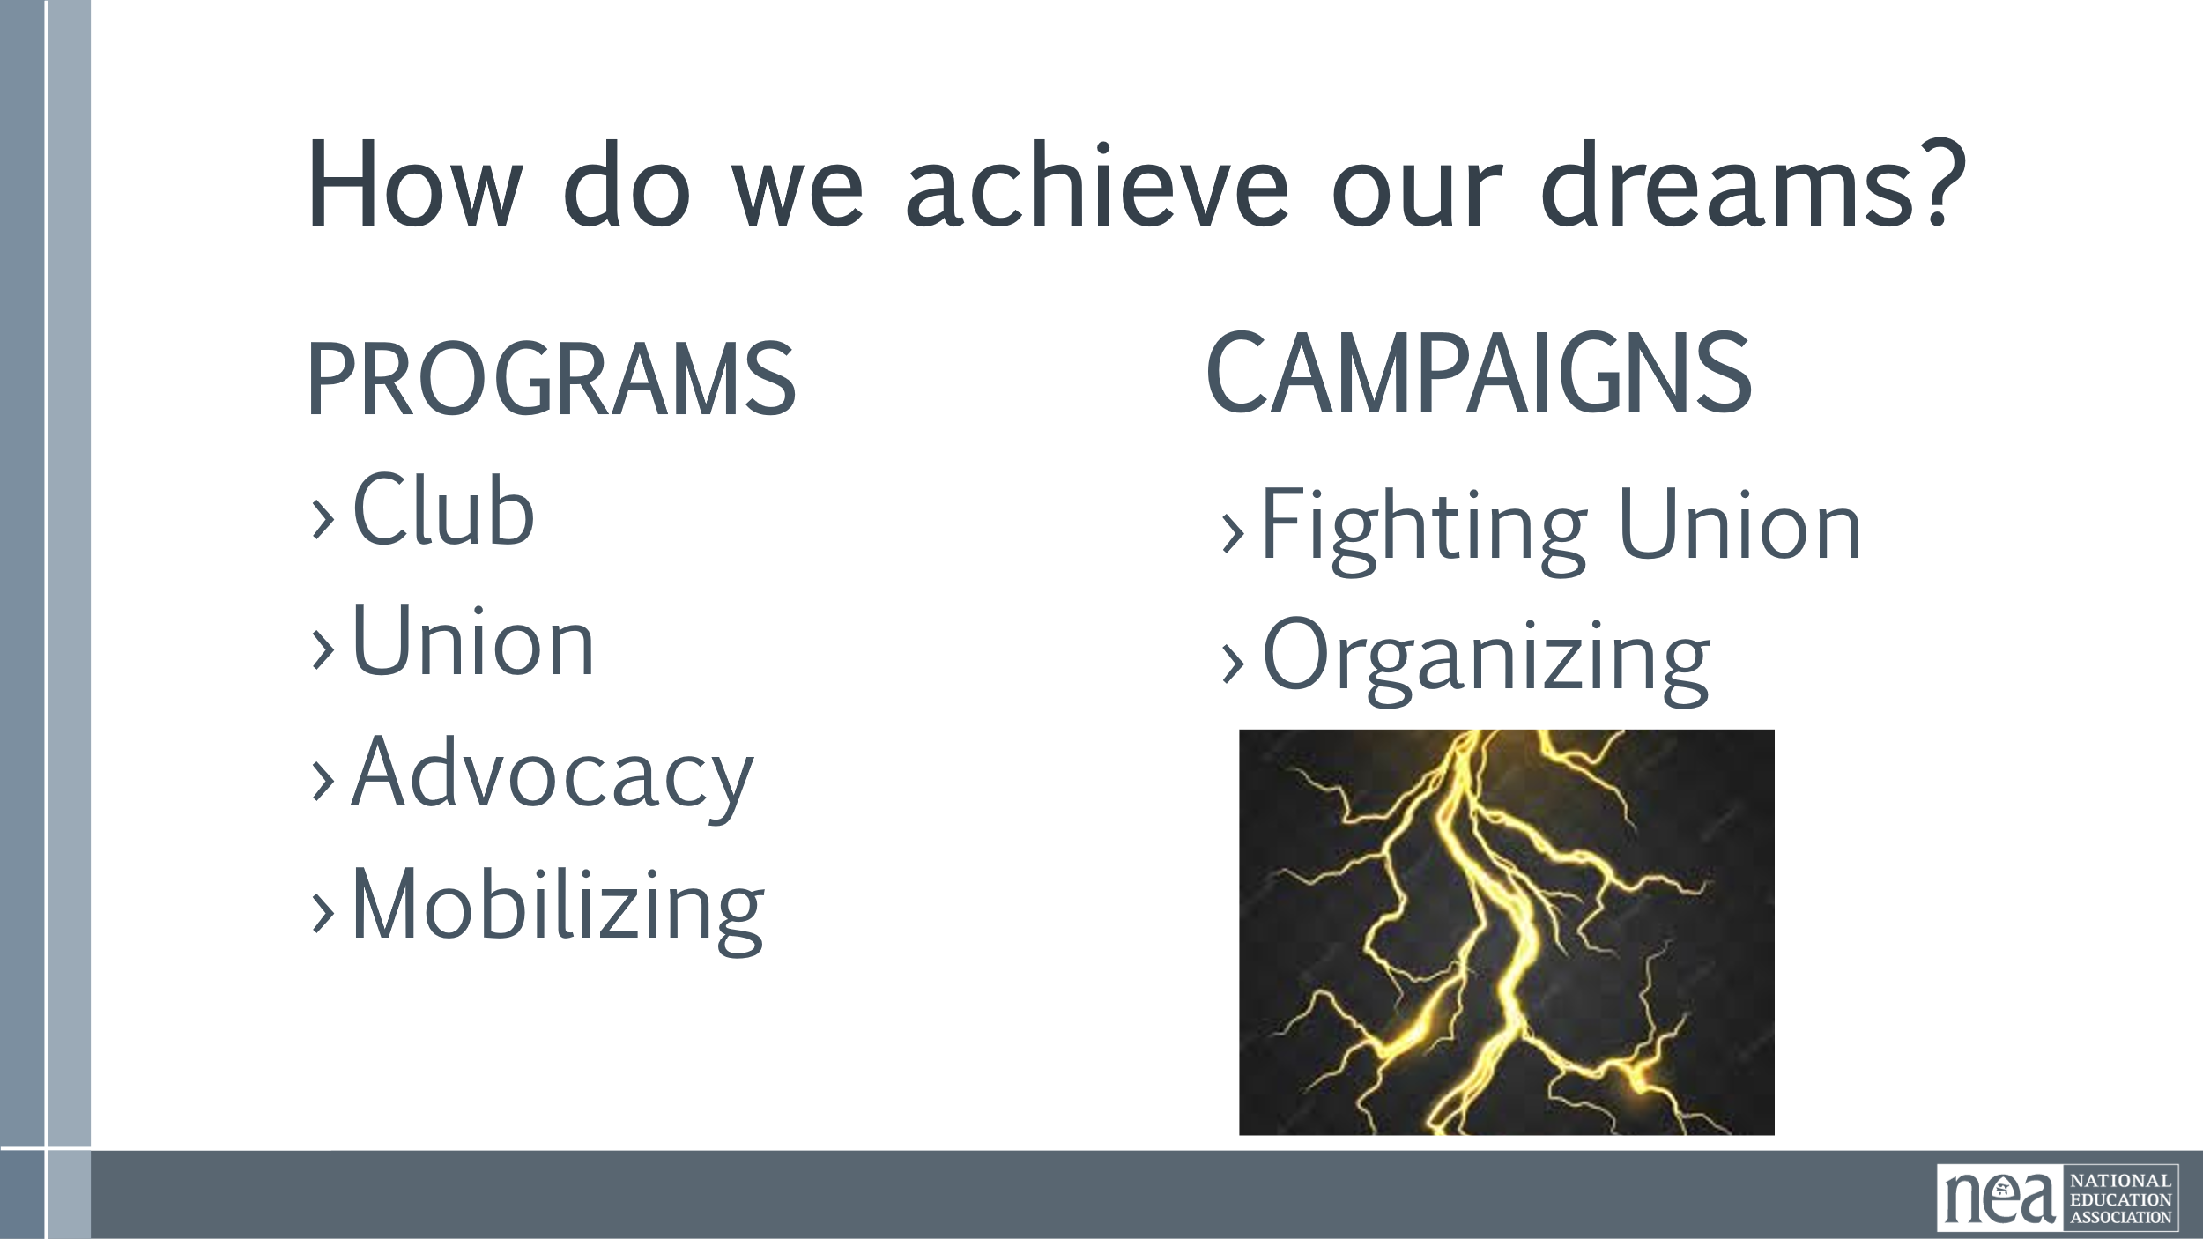  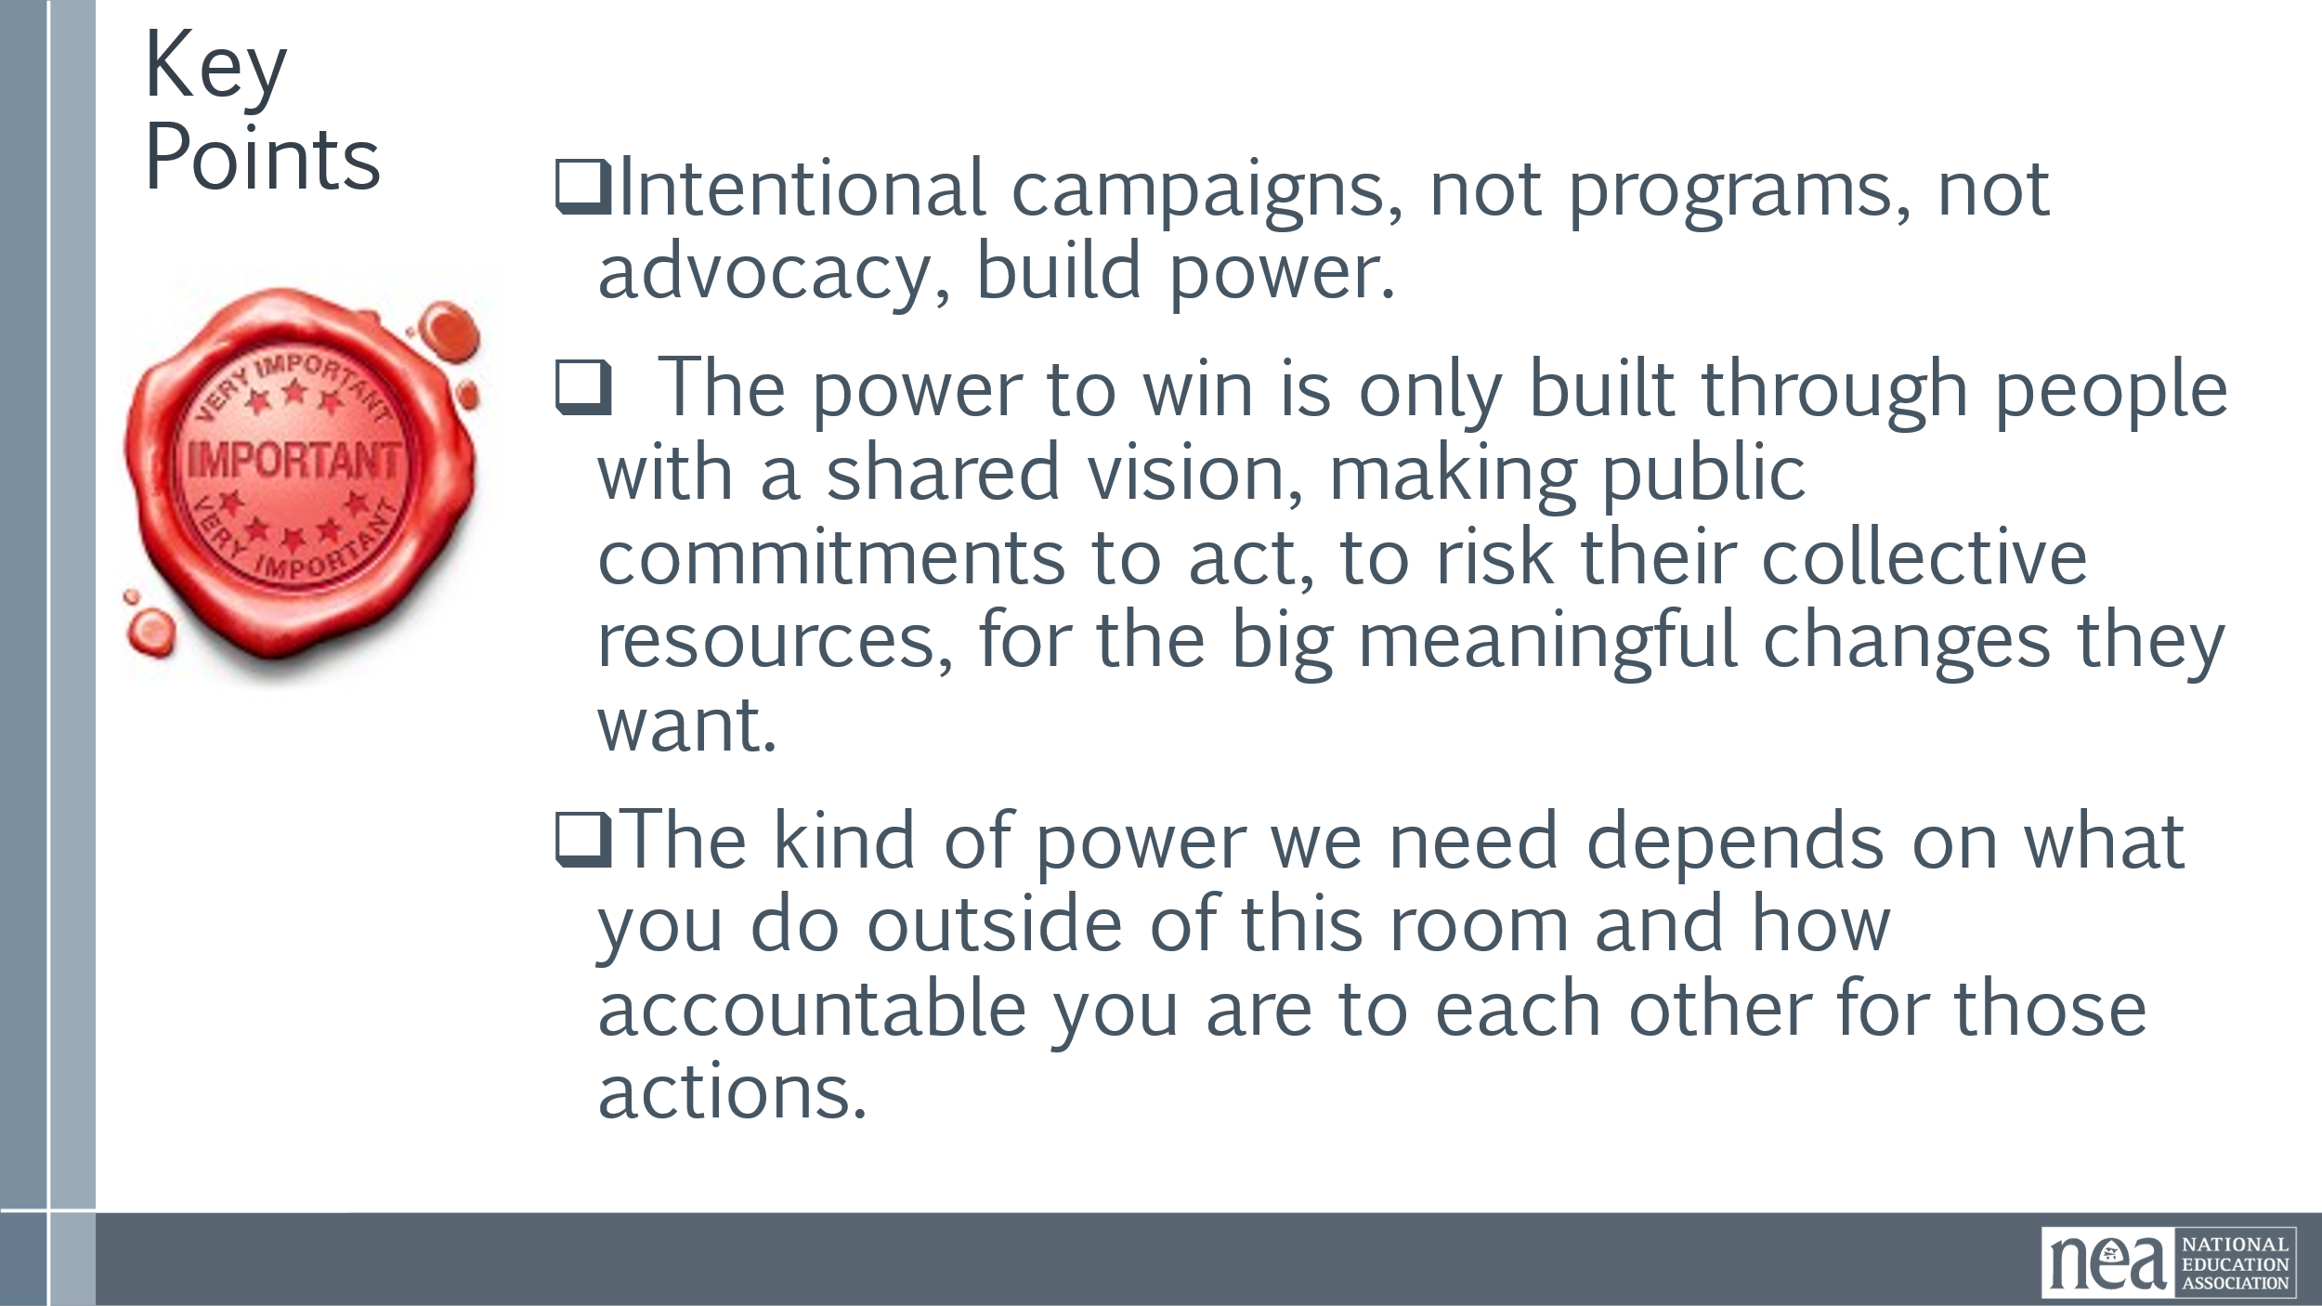 | Club to Fighting Union  Three Theories for Change | Use the two frameworks  Club to Fighting Union  Three Theories for Change  To accomplish a shared analysis of where DSEA is in regards to power building.
1:45-2:15 |  | 30 Minutes TOTAL Communication Styles With New Stuff
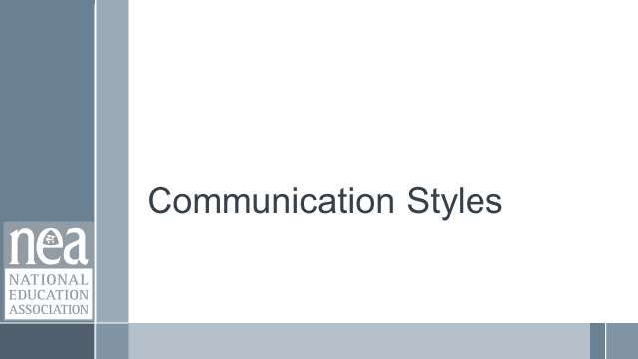  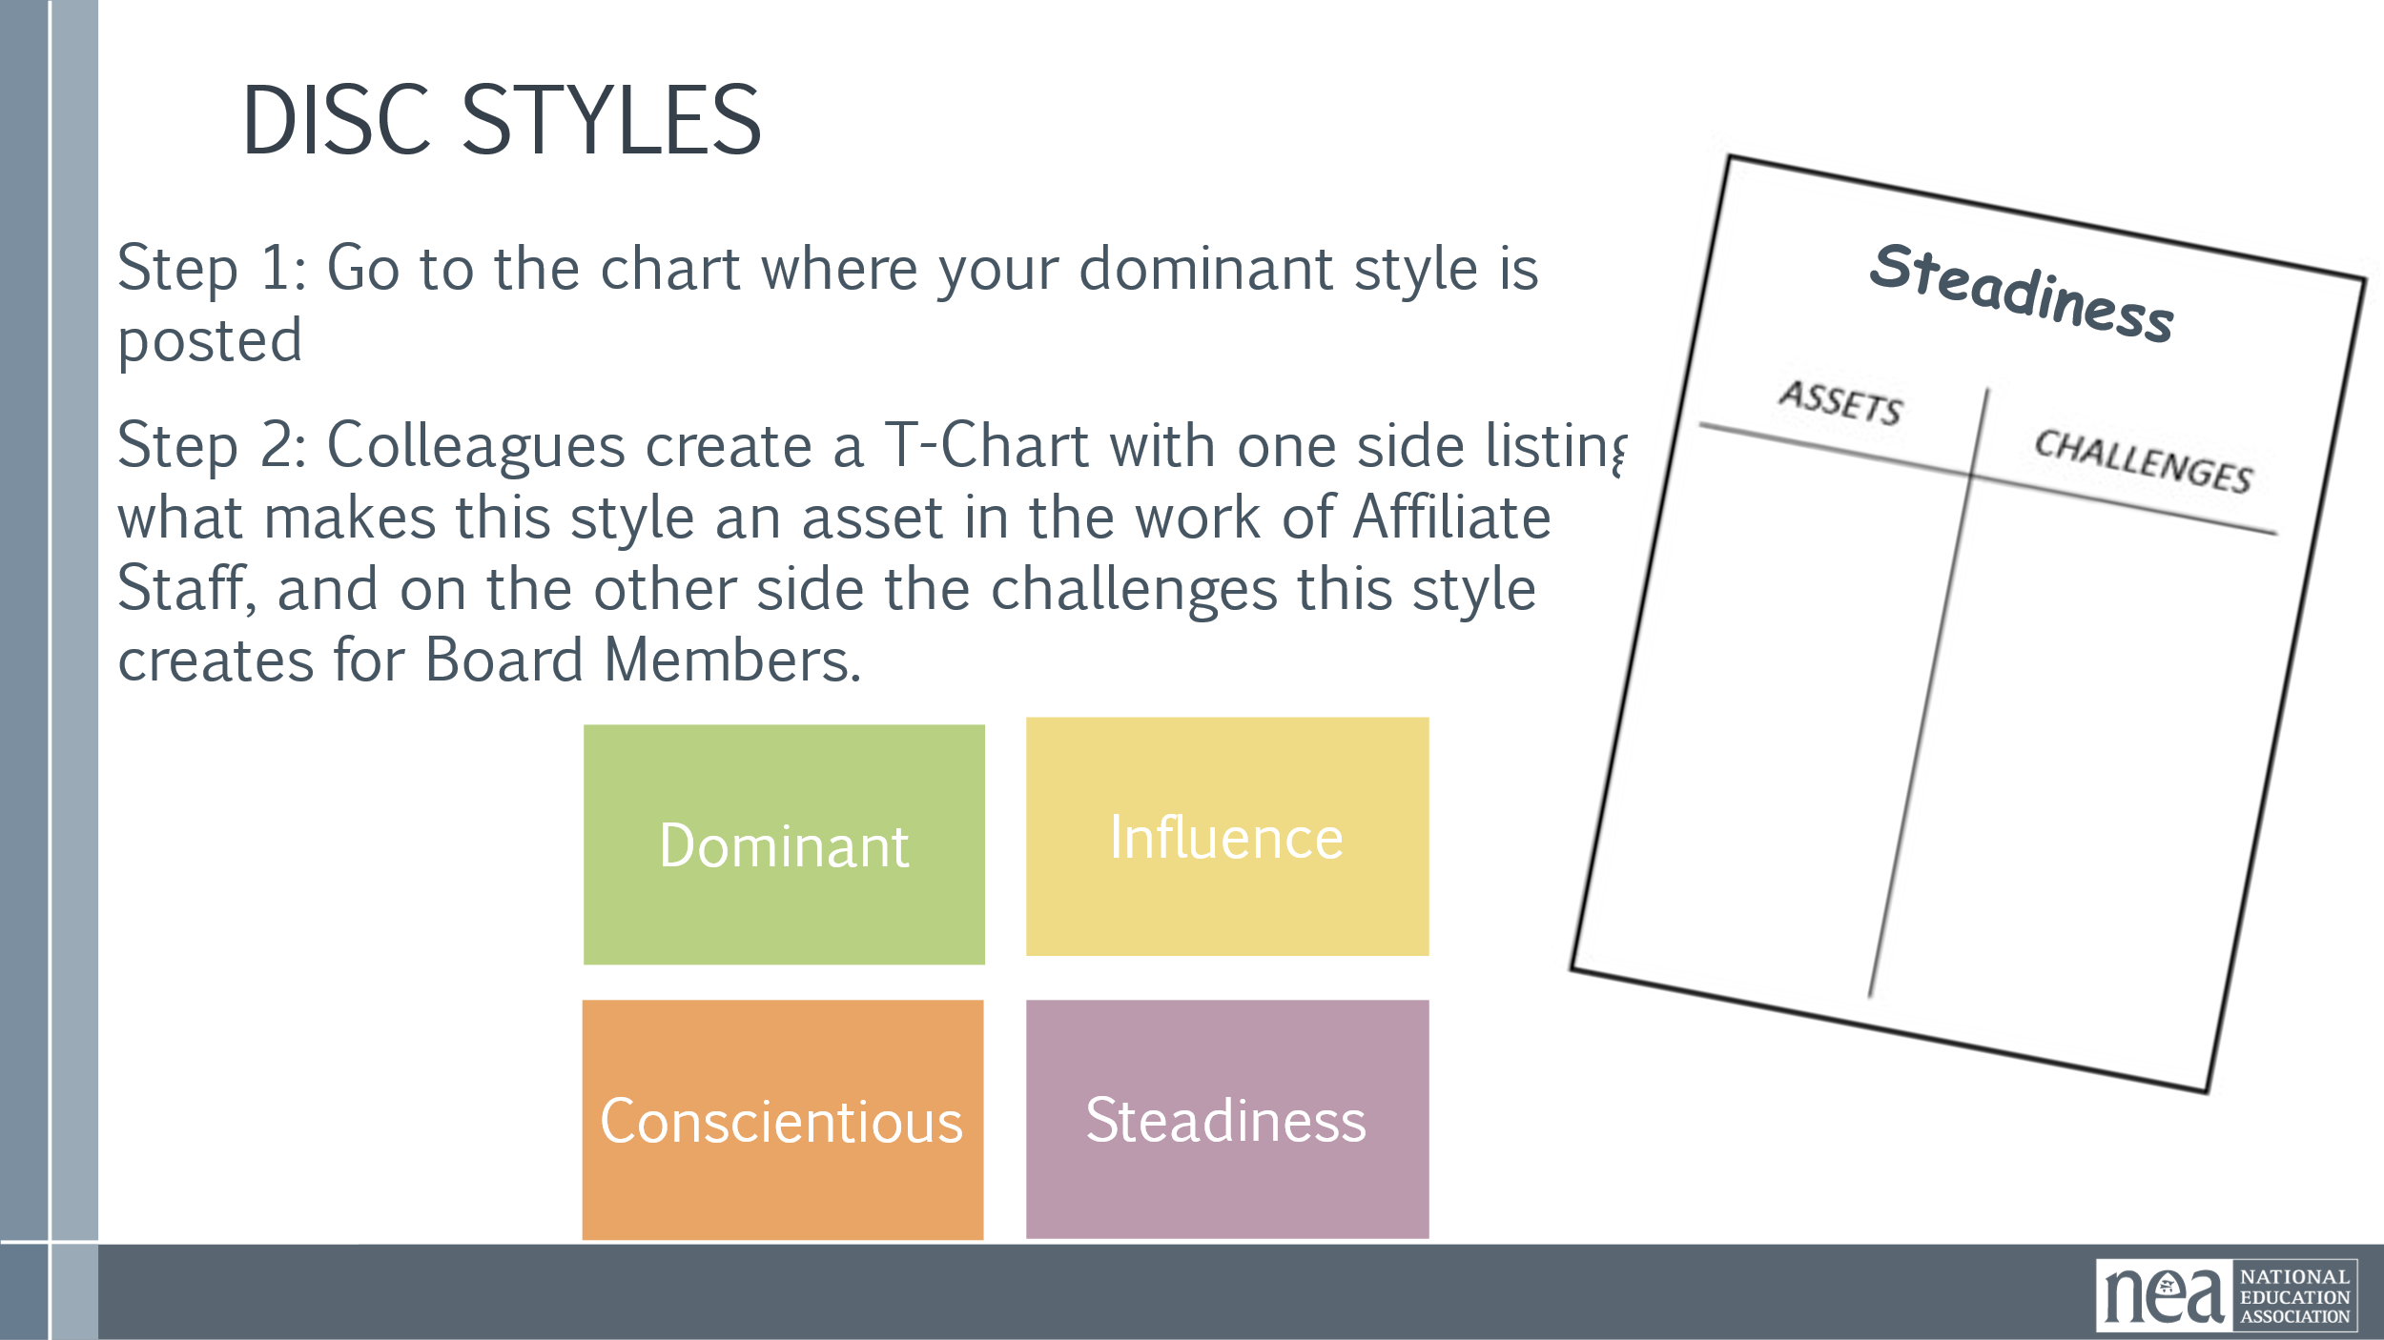  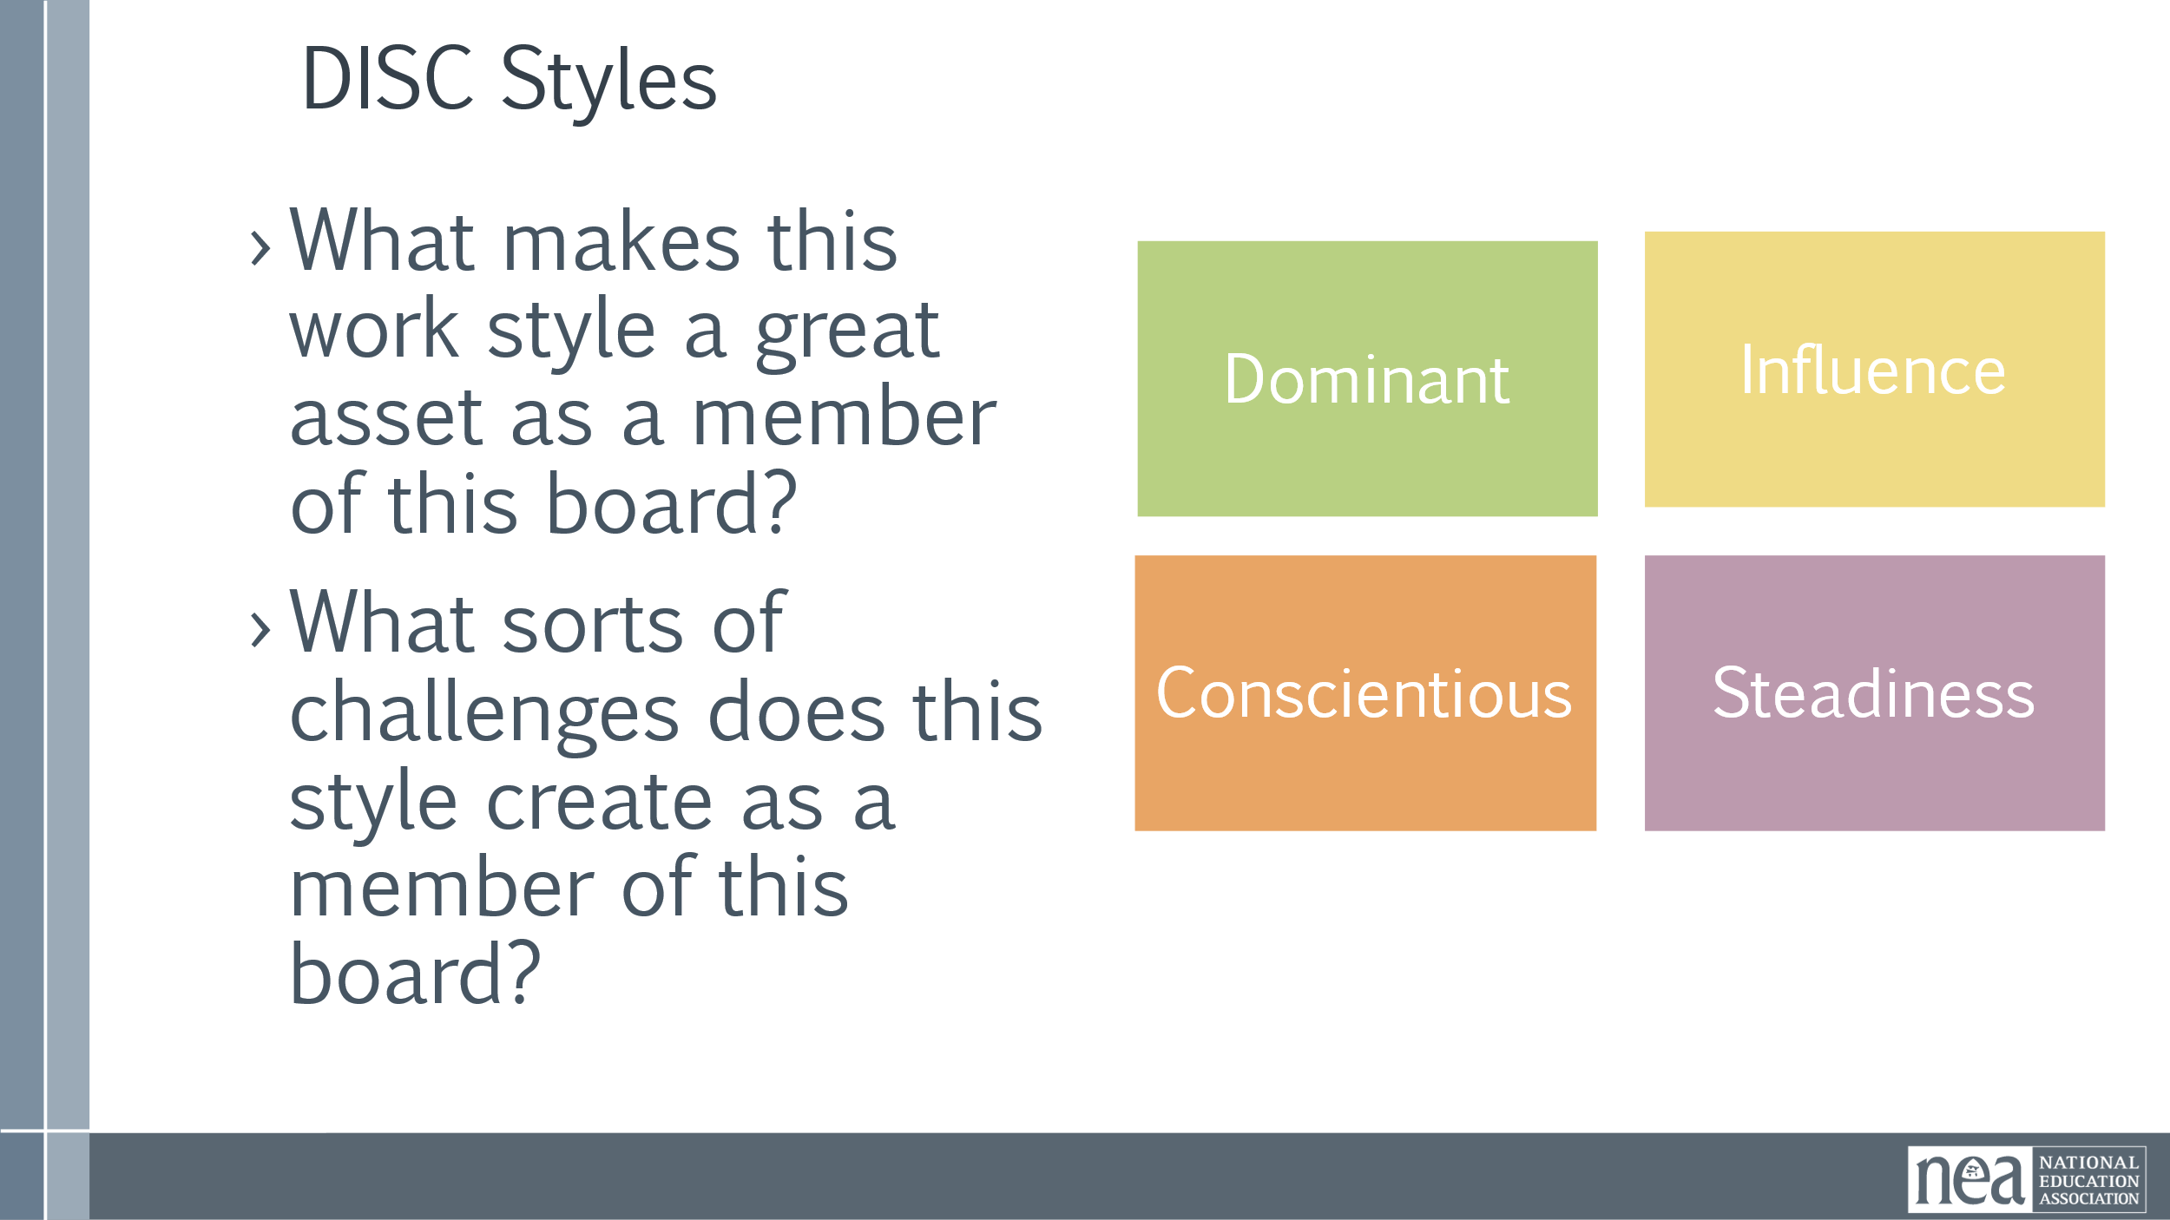  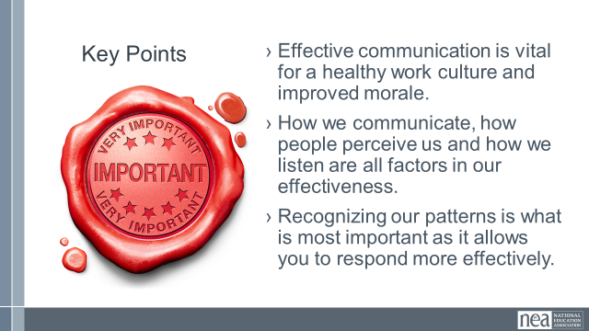 | Leadership Style  Survey Done in Advance  Style Under Stress done in advance  4 Charts:  Direct Systematic Spirited Considerate | Communciation Style Survey  Intro 2 Minutes Participants will have completed this PRIOR to attending and will have it ready for this experience.  - Share that everyone has recognizable, consistent communication styles.  - We are exploring these today because each style can have positive and negative aspects to it.  - We are going to work in style-alike groups to identify these.  10 Min  - Go to the chart with the heading of your style as defined by this profile.  - With your colleagues, create a T-Chart  - Side 1 – What makes this work style a great asset as an affiliate staff?  - Side 2 - What sorts of challenges does this style create as an affiliate staff?  12 Min - Report Out  - Each Corner will have 3 Minutes to Share an overview of their Assets and Challenges.  8 Min - Final Debrief  - Ask each group to point to the style that they find most challenging to work with.  - How do those differences impact our work?  Key concept to draw out – we are in a line of work that requires us to communicate effectively – 80% of that is in our ability to attend to others. Reflect especially on which of the other styles we find most challenging to work with.  Key Points  - Effective communication is vital for a healthy work culture and improved morale.  - How we communicate, how people perceive us and how we listen are all factors in our effectiveness.  - Recognizing our patterns is what is most important as it allows you to respond more effectively. | Participants will assess and reflect on their communication styles using two separate tools.  They will chart their assets and challenges and continue to reflect and connect this to effective communication.
2:15-2:30 BREAK
2:30-3:00 |  | 30 Mins TOTAL– Communication Styles Under Stress | .
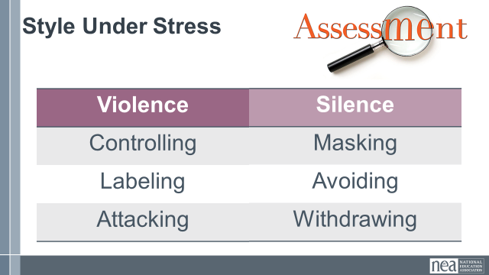 | WENT VERY QUICKLY OVER THIS 5 to 10 minutes are the most | Leadership and Communication Style Under Stress Continued  There is a connection between the two assessments I asked you to complete. Let’s see how you connect.  Silence Patterns – Silence patterns consist of any act to purposefully withhold information from the pool of meaning. It’s almost always done as a means of avoiding potential problems, and it always restricts the flow of meaning.  Methods range from playing verbal games to avoiding a person entirely.  The three most common forms of silence are masking, avoiding, and withdrawing.  Violence Patterns – Violence patterns consist of any verbal strategy that attempts to convince, control, or compel others to your point of view. It violates safety by trying to force meaning into the pool.  Methods range from name-calling and monologuing to making threats.  The three most common forms are controlling, labeling, and attacking.  Key Points  - Effective communication is vital for a healthy work culture and improved morale.  - How we communicate, how people perceive us and how we listen are all factors in our effectiveness.  - Recognizing our patterns is what is most important as it allows you to respond more effectively.
3:00-3:45 |  | 45 Mins Total – Crucial Conversations
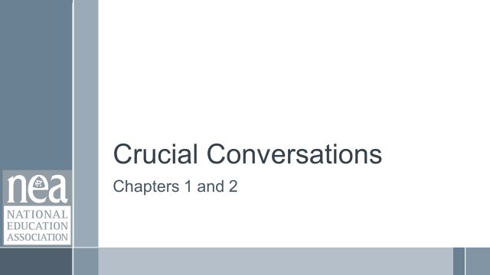  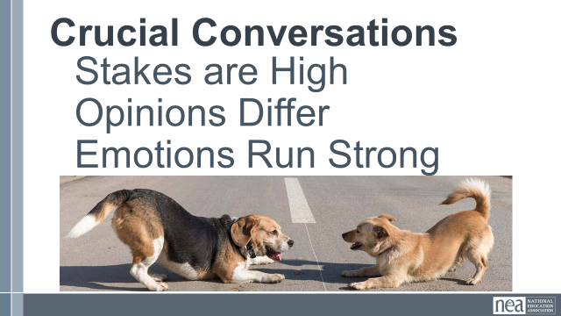  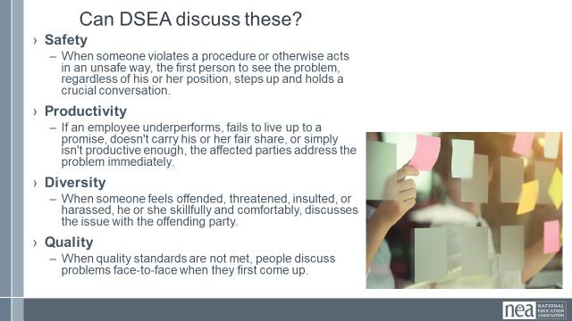  ENDED HERE FOR THE DAY  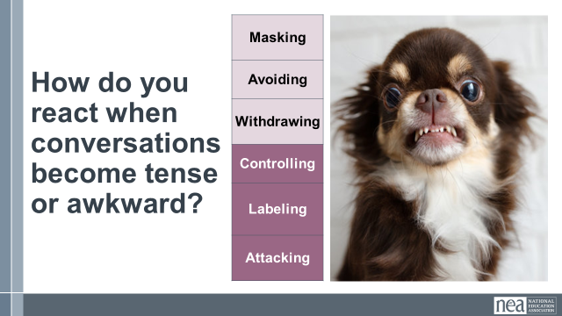 | Spent a long time discussing the 4 topics that they could talk safely about.  Had them count off by 11 and in small groups talked about which of these are the most difficult to talk about and why.  Closed by pointing out what boards could put in place as next steps for better communication:  Shared Purpose and Values  Community Agreements that are revisited  Identifying and talking about the difficult conversations in affinity groups first. | Introduction  We are going to do some work with Chapters 1 and 2 – these are the chapters that you all read commonly.  So how do we know that a conversation is crucial?  A crucial conversation is a discussion between two or more people where opinions vary, emotions are high, and stakes are high. These conversations can happen in the workplace or at home. When handled poorly, they can lead to strained relationships.  Turn and Talk Opportunity Can DSEA Discuss these?  Safety When someone violates a procedure or otherwise acts in an unsafe way, the first person to see the problem, regardless of his or her position, steps up and holds a crucial conversation.  Productivity If an employee underperforms, fails to live up to a promise, doesn't carry his or her fair share, or simply isn't productive enough, the affected parties address the problem immediately.  Diversity When someone feels offended, threatened, insulted, or harassed, he or she skillfully and comfortably, discusses the issue with the offending party.  Quality When quality standards are not met, people discuss problems face-to-face when they first come up.  ENDED HERE FOR THE DAY  Remember those communication styles? How do you react when one of the crucial conversations on that affinity wall come up?  Why is that?  Keyboard warriors, too busy to really pay attention, underlying personal issues, anxious and feeling unsafe.  People often react poorly to crucial conversations because of strong emotions that initiate our brain’s threat system. The typical source of strong destructive emotions is that people don’t feel respected and safe.  We go into fight , flight, freeze, or fear mode. Look at how they are linked to the styles under stress. The typical source of strong destructive emotions is that people don’t feel respected and safe.  What is needed is dialogue Dialogue  A two-way communication between persons who hold significantly differing views on a subject, with purpose of learning more truth about the subject from one another. Both are committed to speaking and listening.  Building a pool of shared meaning. The best way to make someone feel safe and respected and to listen and this begins to bring them out of the threat cycle.  Pool of Shared Meaning  - All the shared knowledge in a conversation.  - A measure of a group’s shared maturity.  - More information in the pool makes for better decisions.  - Remember  - The totality of information in the pool is what matters most  - One dominant person shouldn’t control it  - Other people’s contributions are just as valuable  - People are also more likely to follow through if they have contributed.  - Morale and trust grown when people feel they’re working towards a common goal.  How does our style affect the shared pool of meaning  IF we stay in threat mindset mode – then our styles are activated and they can get in the way of our participation in dialogue and creating a shared pool of meaning.  Violence patterns consist of any verbal strategy that attempts to convince, control, or compel others to your point of view. It violates safety by trying to force meaning into the pool.  Silence patterns consist of any act to purposefully withhold information from the pool of meaning. It’s almost always done as a means of avoiding potential problems, and it always restricts the flow of meaning.  Key Points  - Effective communication is vital for a healthy work culture and improved morale.  - Dialogue is necessary to build trust and become a better organization.  - Decisions that matter must include dialogue | Participants will be able to identify what a crucial conversation is.  Participants will connect the Threat mindset to their communication styles.  Participants will discuss and assess DSEA’s abililty to have crucial conversations around broad topics of safety, diversity, quality, and productivity.  Participants will connect decision making to dialogue.  Participants will assess DSEA’s ability to use dialogue and make decisions around crucial issues.
3:45-4:00 |  | 15 Minutes - Ending it Right
 |  | Plus  Delta  Key Learnings  Prep for Tomorrow | Participants will be able to bring a little closure to their learning and provide feedback on the day.
4:00 ADJOURN

9:00 Reentry
9:00 - 9:30
Welcome back

Review of the agreements

Magnetic Ideas

Discussion about what it tough

How do you get to trust?
9:30-9:45 |  | Three Steps to an Effective Board
- You have a shared – and engaging – purpose. You are clear on what the Board does (purpose), who you will be doing it with (constituency), and what kinds of activities your board will participate in. The work you have to do is readily understood, it’s challenging, it matters and you know why it matters. Team members need to be able to articulate for
themselves and others this “purpose”
- Your board has explicit agreements Your board sets clear expectations for how to govern itself in your work together. How will you manage meetings, regular communication, decisions, and commitments? And, most importantly, how will you correct violations of the agreements so they remain real, trusted agreements? Boards with explicit operating rules are more likely to achieve their goals. Some team norms are operational, such as how often will we meet? How will we share and store documents? Communicate with others outside the team? etc. Others address expectations for member interaction with each other. Initial norms guide your team in its early stages as members learn how to work together. Norms can be refined through regular group review of how well the team is doing.
- You have created clear interdependent roles. Each team member must have their own responsibility, their own “chunk” of the work, on which the success of the whole depends. No one is carrying out activity in a silo that’s secretive to others. A good team will have a diversity of identities, experiences and opinions, ensuring that everyone is bringing the most possible to the table.

9:45-10:15 |  | 30 Minutes Your Shared Purpose
 | Shared Purpose Worksheet | Sharing values and purpose with others is important because it fosters trust, builds strong relationships, facilitates collaboration, and provides a common foundation for decision-making, allowing individuals to work towards a shared goal with greater alignment and motivation, especially in teams or organizations.  You co constructed this shared value statement  Lets look at DSEA’s core purpose statement  How does it align with the 5 Strategic Areas?  What are gaps you see?  Lets look at DSEA’s core purpose statement  How does it align with the 5 Strategic Areas?  What are gaps you see?  Key Points:  Stronger bonds and connection:  When people share similar values, they tend to feel more connected and comfortable with each other, which strengthens relationships and fosters trust.  Improved communication and collaboration:  A shared understanding purpose can lead to more effective communication and collaboration, as everyone is on the same page about priorities and goals.  Increased motivation and engagement:  Knowing that you are working towards a shared purpose can be highly motivating and lead to greater commitment and engagement in the work.  Resilience in challenging situations:  During difficult times, a shared sense of purpose can help a group stay focused and united, overcoming obstacles more effectively. | Identify the connection between why we exist and the strategic goals we set.
10:15-10:30 BREAK
10:30-11:15 |  | 30 Minutes Shared Values
 | Shared Value Handouts | This morning we began with each of us recording our values. We identified some common themes.  Core values are the fundamental beliefs of a person or an organization. These guiding principles dictate behavior and can help people understand the difference between right and wrong. These can often be expressed in one or two words. We are taking a moment to consider our core values because they can provide a basis for solidarity in the midst of struggles  Identifying shared values allows groups to communicate more effectively about what matters most and collaborate more deeply. A shared understanding of values allows diverse groups to be more aligned about priorities and goals. When facing challenges and dilemmas, shared values can help focus a group on making tough decisions that allow their actions to align with an overall purpose. Shared values are key to a strong culture where individuals feel comfortable expressing their opinions, supporting each other, and holding each other accountable.  Let’s Look at DSEA’s values in light of the 5 strategic areas  What are the alignments you see?  What are gaps you notice?  I want to show you some universal Union Values  What do you think are the 5 most important values from this list that are exemplified by this Board?  What are specific examples of that?  KEY POINTS  Improved communication and collaboration:  A shared understanding of values can lead to more effective communication and collaboration, as everyone is on the same page about priorities and goals.  Better decision-making:  When faced with challenges or dilemmas, shared values can act as a guiding principle to make decisions that align with the group's overall purpose.  Positive team dynamics:  Shared values contribute to a more positive and supportive team environment, where individuals feel comfortable expressing their opinions and supporting each other  - Ideally – The purpose of Unions is to advance the welfare of all workers. They are based on the idea of justice, progress, and betterment of self and of society. They embody the universal ideal of human rights and the need to aspire to become more complete human beings. By becoming an active participant in the labor movement, members become part of something larger than themselves.  - However, without INTENTIONAL APPLICATION of our stated values to dismantling systems of oppression we make no forward movement movement. | Identify the connection between shared Values and the strategic goals we set.
11:15-12:00 |  | Shared Agreements
11:15-12:00 |  | 45 Minutes Walking Our Values
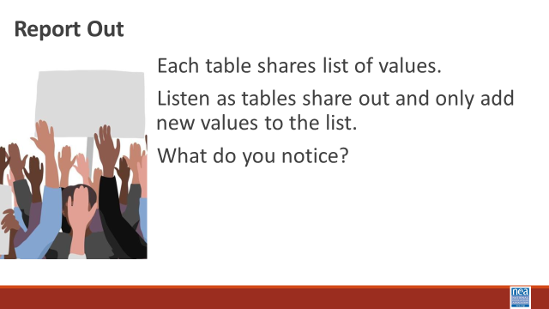  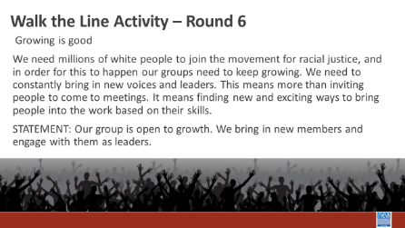  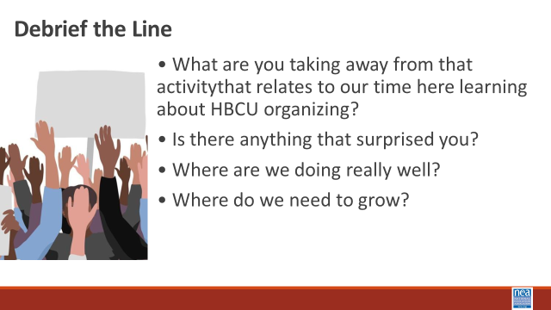  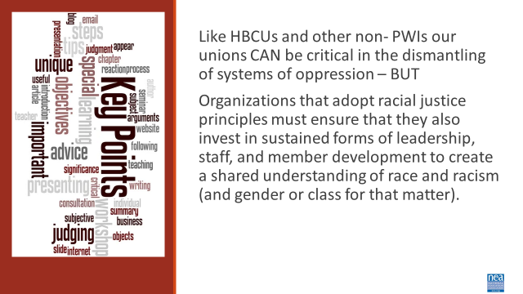 |  | 15 Minutes Introduction and Core value Brainstorm for Unionism -  Introduction – 4 Minutes We are going to begin thinking about how values shape our unions. Let’s look at how the values held by black workers shaped the history of unionism.  Show Video (2 Minutes)  We like to think that Unions have always been about equity and fairness. Truth is, Women and formerly enslaved black people were excluded from unions. Black teachers founded Colored Teachers Associations CTAs to enhance educational opportunities for Black children, to develop themselves as professionals, political actors, and intellectuals, as well as to organize around broader socio-political concerns in the Black Freedom Movement. Today – it is more important than ever for our work in our unions to be rooted in anti-racism. Unionism is a collection of core values. Core values are the fundamental beliefs of a person or an organization. These guiding principles dictate behavior and can help people understand the difference between right and wrong. These can often be expressed in one or two words. We are taking a moment to consider our core values because they can provide a basis for solidarity in the midst of struggles.  At your tables, brainstorm what you think are CORE union values (turn and talk at your table and list those – be ready to report out). Use p. in your participant handout to record them.  Report out by asking each table to report their list – record those (chart them) – as you go to each table ask them to only add not repeat. Some examples you would expect to see – keep them to one or two words.  Fairness, honesty/integrity, responsibility, compassion/empathy, safety, health, generosity, hard work/responsibility, community, freedom, democracy, binding contracts, equality, opportunity, respect, stability/security, unity, quality work, justice, collective action, dignity/respect, charity/community service, and due process.  5 Minutes -Whole room discussion – How did you see these values exemplified in your time with our HBCU?  Key idea for this introduction and brainstorm activity (2 Minutes)  (don’t read this out loud- ask them to read it for themselves) Ideally - Unions advance the welfare of all workers. They are based on the idea of justice, progress, and betterment of self and of society. They embody the universal ideal of human rights and the need to aspire to become more complete human beings. By becoming an active participant in the labor movement, members become part of something larger than themselves. We experienced some of these same values exemplified in the interactions we have had with the HBCU here. However, without INTENTIONAL APPLICATION of our stated values to dismantling systems of oppression we make no forward movement.  40 Minutes TOTAL- Union Values Walk the Line Activity  (Set Up) Take into consideration that this activity will require standing for an extended period, moving in a small space and some reading. Mark a line on the floor of the room with string or tape. Note that this line needs to be long enough for all of the participants to have space on it. On one side of the line, post a sign that reads “Strongly Agree,” and on the other, post a sign that reads “Strongly Disagree.”  Directions to Give- 2 Minutes  This activity gives us a chance to check and see how our Core Union Values we just discussed, and the Core Values we saw exemplified in our time with the HBCU relates to the values of unionism where we work, in our affiliate. When we intentionally add values that center anti-oppression in our work – Race Class and Gender are systemic forms of oppression that we are socialized to normalize in our work. I am going to read some common Union value statements out loud with a short description. After the description, I will read a simple statement. Once I read the statement, please move and stand on the spectrum of agree/disagree based on your opinion and what you have seen your affiliate do. Keep in mind, this is a reflection activity. People may feel very differently about the values and how they see our work. The variety of perspectives is important.  For each round, (there are 6) Read the description of a value and the statement that follows it. Repeat the statement twice. Then ask people to move. Intentionally call on people, just two or three for each statement, to share why they choose to stand where they did.  Walk the Line Activity 20 Minutes (About 3 minutes per round)  Round 1  Calling People In Not Out  Calling people in means trying to create a culture and community that people actually want to be a part of. Calling people in means we don’t shame or blame. It requires direct, specific and compassionate communication with one another. We all have space to grow, and calling people in is how we support one another through growth.  STATEMENT: Our affiliate calls one another in when we need to communicate within our affiliate and with other white people.  Round 2  Accountability through Collective Action  Collective actions means that we look to build a movement of millions of people. Individual transformation is not enough. This is done through building accountability relationships with people of color who are doing racial justice work in the movement and who are accountable to a group of people. We don’t wait to be asked to take action to organize white people.  STATEMENT: Our affiliate is taking accountable collective action on a regular basis.  Round 3  Taking risks, making mistakes, learn, and keep going.  Making mistakes is part of life, and we know we have to be outside of our comfort zones in order to make change. Even when we take on real risk, we know that the risk is always greater for people of color. When we make mistakes, we want to reflect and stay in motion. We cannot let making mistakes prevent us from continuing our work. When others make mistakes, we do not shame, blame or exile.  STATEMENT: Our affiliate stays in the process of taking action, receiving feedback and staying in motion. We support one another through our mistakes.  Round 4  Mutual Interest  Racial justice isn’t something we help people of color with. The system of white supremacy harms all of us—including white people, though in very different ways than people of color. We need to get clear with ourselves about what we have to gain through this fight.  STATEMENT: Our affiliate and members are clear on our mutual interest. We’ve spent time getting clear on what’s at stake for us as individuals and as a group.  Round 5  Enough for All  There are enough resources in the world for everyone's basic needs to be met— for folks to have decent housing, enough food, safety, etc. The problem isn’t that we don’t have enough stuff—it’s that it’s distributed unfairly. White supremacy tells us we need to compete with everyone, even other people doing this work.  STATEMENT: We organize from a place of abundance and cooperation.  Round 6  Growing is good  We need millions of white people to join the movement for racial justice, and in order for this to happen our groups need to keep growing. We need to constantly bring in new voices and leaders. This means more than inviting people to come to meetings. It means finding new and exciting ways to bring people into the work based on their skills.  STATEMENT: Our group is open to growth. We bring in new members and engage with them as leaders.  Debrief Questions - 15 Minutes  • What are you taking away from that activity that relates to our time here learning about HBCU organizing?  • Is there anything that surprised you?  • Where are we doing really well?  • Where do we need to grow?  2 Minutes Key Ideas  Like HBCUs and other non- PWIs our unions CAN be critical in the dismantling of systems of oppression – BUT  Organizations that adopt racial justice principles must ensure that they also invest in sustained forms of leadership, staff, and member development to create a shared understanding of race and racism (and gender or class for that matter). | Participants will use the core values of unionism and the exemplified core values from the HBCU encounter to reflect on the level of intentional anti-racist values found in their own affiliates.
12:00-1:00 LUNCH
1:00-2:30 |  | Plan to Act around 5 Priority Areas
2:30-3:30 |  | Ownership and Accountability
3:30-4:00 |  | 30 Minutes - Ending it Right
 |  | Questions, Connections, Reflections  I used to think now I know …  Plus and Deltas | Participants will be able to bring a little closure to their learning and provide feedback on the day.
4:00 ADJOURN

