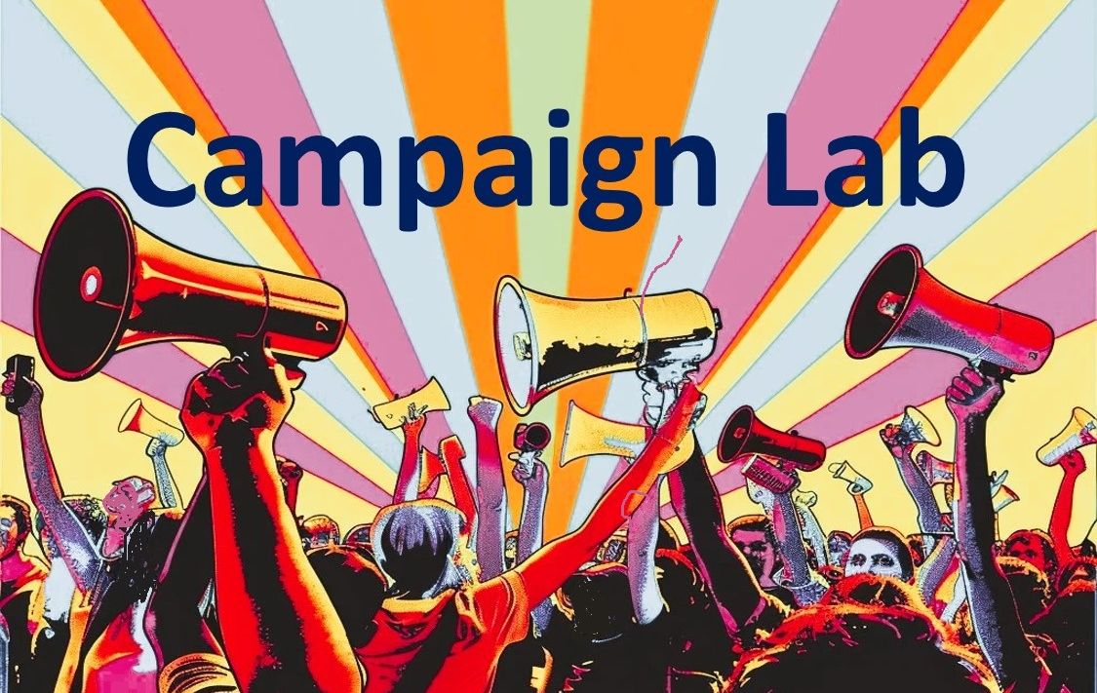

Facilitator Guidebook  for Organizational Strategic Planning  Integrated with High Participation Local &  Centering Equity Assessment Frameworks  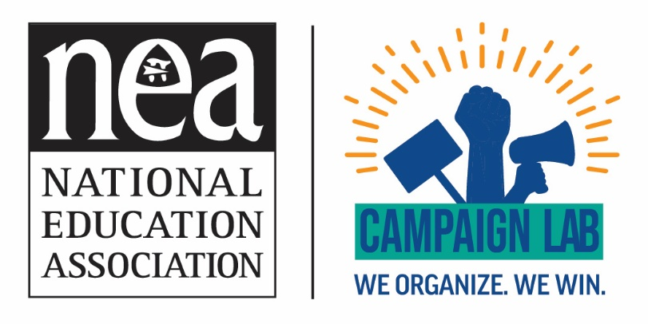 | Strategic planning looks beyond immediate campaigns to evaluate overall power, leadership pipelines, member engagement, financial sustainability, staff and volunteer capacity, partnerships, and systemic equity. Campaign plans must align with and advance the broader strategic direction established through organizational strategic planning.

What is the Difference Between Program or Campaign Planning and Organizational Strategic Planning?
All plans require that key decision-makers are part of the process. All planning processes begin with research about the current reality and a shared understanding of the desired future state. They identify goals, establish priorities, and lay out how people, time, money, and other resources will be deployed to achieve desired outcomes.
While these planning processes share common elements, they differ in scale, scope, and purpose:
- Program or Campaign Planning: Focuses on a specific initiative, project, campaign, or outcome. It answers questions such as: What are we trying to accomplish? Who do we need to engage? What activities, tactics, timelines, and resources are required to achieve success? Campaign and program plans are often shorter-term and designed to produce measurable results within a defined period.

- Organizational Strategic Planning: Larger in scope and longer in time horizon. Rather than focusing on a single campaign or program, it examines the organization as a whole and determines where the organization is headed, what it wants to become, and what capacities it must build to be successful. Strategic planning clarifies mission, vision, values, priorities, and long-term goals. It helps leaders make choices about where to invest resources, what work to prioritize, what opportunities to pursue, and what organizational changes are needed to achieve their desired future.

A Useful Distinction: Campaign and program plans help an organization decide how to win a particular fight, while strategic plans help an organization decide which fights to take on and how to build the power, capacity, and alignment needed to win over the long term.

For a local, strategic planning looks beyond immediate campaigns to evaluate overall power, leadership pipelines, member engagement, financial sustainability, staff and volunteer capacity, partnerships, and systemic equity. Campaign plans must align with and advance the broader strategic direction established through organizational strategic planning.

Facilitator’s Discovery Process
Strategic planning meetings often succeed or fail before participants ever enter the room. The facilitator's job is to understand the organization's history, culture, power dynamics, opportunities, and challenges well enough to design a process that produces meaningful decisions.

What "Pre-Meeting" Steps Do You Need to Take?
Before developing an agenda, conduct interviews, gather documents, distribute pre-planning surveys, and clarify expectations with key leaders, staff, members, and stakeholders. At a minimum, seek answers to the following questions:
- Organizational Purpose and Direction: What is the organization's mission, vision, and core values? Is there a shared understanding among leaders, staff, and members? What does success look like over the next 3 to 5 years?
- Current Strategic Position: Is there a current strategic plan? What goals were achieved or missed, and what lessons were learned? What organizational strengths and weaknesses exist?
- Participants and Decision-Making Authority: Who will participate? Do they hold decision-making authority? Are power dynamics, historical conflicts, or underrepresented constituencies present?
- Desired Outcomes: What specific decisions need to be made? What level of specificity is expected?
- Internal Organizational Health: How healthy is the culture and level of trust? Are systems of communication and decision-making effective?
- External Environment: What external opportunities, threats, political/budgetary shifts, or demographic changes exist?
- Member, Staff, and Stakeholder Voice: What are members and staff saying in recent surveys or listening sessions ? Whose voices are typically heard, and whose are missing?
- Equity and Inclusion Considerations: How well does the organization serve all constituencies? What patterns of participation suggest barriers to inclusion across race, class, gender, job classification, language group, or geography?
- Readiness for Strategic Planning: Why engage in planning now? Is there urgency for change, and are leaders prepared to prioritize resources based on outcomes?
Facilitator's Guiding Question: "What is this organization trying to become, what stands in its way, what strengths can it build upon, and who needs to be part of creating the path forward?"
Structuring the Strategic Planning Process

Stage 1: Building Community and Establishing Purpose
Objectives: Build trust and psychological safety, create working agreements, establish shared purpose, surface differing perspectives, and benchmark ground truth.
Facilitator's Role & Tools:
- Surfaces differences in experience, power, identity, and authority.
- Helps individuals connect personal motivations to organizational purpose.
- Tools: Wheel of Privilege, Leadership Styles Assessment, Centering Equity Tool, and the High Participation Local Assessment. Use the 13-category assessment to establish a baseline score (1.0–4.0 scale) across union operations.

Stage 2: Understanding the Current State & Capacity Gap Diagnosis
Objectives: Make meaning from data rather than just presenting information. Move beyond standard SWOT analysis by pairing data with capacity-gap mechanics.
Capacity-Gap Cascades (Integrated Framework):
When analyzing internal data (membership density, financial reports, organizing outcomes), help participants map low scores in core assessment categories directly to their root organizational consequences:
Foundational Capacity Area (Low Score) | Organizational Impact & Cascade Effect
Role of Union Leaders | Few new leaders available; leadership remains concentrated in a small core.
Communication Systems | Low member participation; information flow is bottlenecked.
Organizing Data | Poor targeting of resources; inability to identify engagement gaps.
Worksite Structures | Weak campaign execution; lack of immediate workplace response.
Centering Equity | Uneven participation and leadership across job types, shifts, and backgrounds.

Stage 3: Creating Future Vision & Establishing Benchmark Metrics
Objectives: Envision 3 to 5-year future states and establish concrete, non-vague targets for success.
Visioning and Benchmarks:
Use Affinity Wall processes for visioning. When translating vision into quantifiable strategic targets, incorporate the High Participation Local benchmarks where possible:
- Supermajority Membership Density: Reach >85% signed union membership across all job classifications (e.g., certified educators and classified support staff) and worksites.

- Supermajority Member Participation: Achieve >75% routine participation in member-to-member conversations, surveys, meetings, campaigns, and collective actions.

- Worksite Leadership Coverage: Establish a ratio of 1 trained building representative/steward per 15–20 members across 100% of worksites.

- Multi-Demographic Equity Audit: Evaluate all success metrics across demographic filters—job classification, shift time, race, gender, language group, and geography—to ensure outcomes do not reinforce existing disparities.

Beyond the core High Participation Local benchmarks, strategic goals across union and advocacy organizations frequently incorporate performance metrics across five primary operational areas:

1. Financial Sustainability & Resource Growth
- PAC & Political Action Growth: Target a specific percentage increase in voluntary member contributions to political action funds (e.g., a 15%–20% annual increase in PAC contributors).

- Resource Realignment: Percentage of annual budget reallocated directly to organizing, leadership development, and field infrastructure versus routine administrative overhead.

2. Organizing & New-Hire Onboarding

- New-Hire Conversion Rate: Percentage of newly hired employees signed as members within 30 days of district onboarding (e.g., 90%+ conversion rate).

- Classified & Underrepresented Constituency Density: Targeted growth percentage for historically underrepresented job classifications (e.g., increasing support personnel/classified staff participation by 25%).

- Site Coverage: Percentage of worksites with active, functioning Contract Action Teams (CAT) or building teams (e.g., placing CAT representatives in 90% of buildings).

3. Communications & Digital Reach
- Digital Engagement: Benchmark member open rates on core communication channels (e.g., 65%+ open rate on digital newsletters and a 30% increase in active portal engagement).

- Rapid Response Capability: Time required to deploy coordinated communications or calls-to-action to local leadership (e.g., 100% outreach to affiliate leaders within 2 hours during crisis situations).

- Public Perception & Media Reach: Quantifiable growth in earned media coverage highlighting organizational priorities (e.g., a 15% increase in positive local press coverage).

4. Leading the Profession & Member Advocacy

- Professional Development Turnout: Percentage increase in member participation in sponsored professional learning programs, workshops, or micro-credentials (e.g., 25% turnout growth).

- Policy Impact & Member Leadership: Frequency of member-led policy proposals formally presented to governing bodies (e.g., presenting educator-led recommendations to the Board of Education twice annually).

- Mentorship & Early-Career Retention: Target satisfaction or retention rates within organizational mentorship programs designed to reduce early-career turnover (e.g., 90%+ participant satisfaction rating).

5. Coalition & Social Justice Advocacy

- Active Community Partnerships: Number of formal, active coalitions maintained with local civil rights, parent, and community organizations (e.g., establishing active working partnerships with at least 4–5 community allies).

- Leadership Equity Training: Completion metrics for internal diversity, equity, and restorative practice training across elected leadership, executive boards, and staff (e.g., 100% completion across all executive board members and local presidents).

- Electoral & Mobilization Turnout: Targeted turnout percentages for key advocacy actions (e.g., mobilizing 30%–35% of active membership for public budget hearings, lobby days, or voter turnout campaigns).

Stage 4: Strategic Choices & Operational Shift Model
Objectives: Force choices and align organizational priorities with real capacity. Recognize that strategic planning requires saying "no" to non-essential work.
The Servicing-to-Organizing Operational Shift:
Facilitate a structured Start / Stop / Continue exercise using the assessment's operational model :
Here is the complete Servicing-to-Organizing Operational Shift table with the CONTINUE column included, reflecting high-capacity core operations that must be sustained:
Category | STOP (Servicing Model / Low-Capacity) | START (Organizing Model / High-Capacity) | CONTINUE (Core Operations to Sustain)
Role of Staff & Officers | Acting as primary problem-solvers who directly handle routine workplace grievances. | Functioning as coaches, strategists, and trainers who build leadership capacity. | Providing strategic advice, leading political/coalition work, and handling complex legal/Level 2 issues.
Worksite Reps | Relying on reps to merely pass down flyers or relay top-down announcements. | Training reps to confidently resolve Level 1 issues, recruit, and organize coworkers. | Annual steward academies, regular worksite team check-ins, and building-level representation.
Communication | Relying solely on one-way email blasts or top-down newsletter updates. | Building active member-to-member communication networks in every building. | Regular digital newsletters and official policy/bargaining updates.
Data Usage | Treating data strictly as administrative records or roster lists. | Routinely analyzing data to target resources and identify participation gaps. | Maintaining accurate membership records, dues tracking, and contact lists.

Stage 5: Resource Alignment and Implementation Roadmap
Objectives: Keep conversations strategic rather than purely operational, while anchoring resource allocation to structural benchmarks.
Capacity Alignment Prompts:
For each strategic priority, the facilitator must ask:
- Who owns this priority, and what budget/resources are allocated?
- Does this resource allocation build organizing infrastructure, worksite teams, and leadership pipelines, or does it merely maintain administrative routine?
- What specific leadership development frameworks are required to achieve a 1:15–20 rep-to-member ratio in under-resourced sites?

Stage 6: Integration, Commitment, and Adoption
Objectives: Ensure internal consistency across priorities, goals, timelines, accountability owners, and rollout plans.
Plan Deliverables:
- Strategic Priorities & Goals: 3–5 focus areas with explicit quantifiable targets.
- Implementation Roadmap: Action steps, designated leads, resource requirements, and quarterly target timelines.
- Member-Facing Rollout Plan: Communication strategies designed to cascade the plan to rank-and-file members in primary languages spoken across the organization.

Stage 7: Monitoring, Evaluation, and Continuous Learning
Objectives: Maintain the strategic plan as a living document with continuous adaptation mechanisms.
Review & Assessment Schedule:
- Quarterly Progress Audits: Executive leadership and committee leads review key performance indicator metrics, organizing data, and field progress.
- Annual Assembly Reporting: Present progress reports to rank-and-file delegates and reassess priorities based on workplace or legislative shifts.
- Re-Assessment Cycle: Re-administer the High Participation Local Assessment and Centering Equity Assessment annually to track institutional progress along the 1–4 participation continuum.

Facilitator’s Follow-On Process: Post-Planning Implementation & Adoption
A facilitator’s responsibility extends well beyond the planning session. Next, establish your ongoing support model: will you drive the follow-on process directly, or coach an internal implementation committee to lead execution? While direct facilitation ensures momentum, intentionally equipping affiliate leaders to write, rollout, monitor, and adjust their own plan builds the institutional muscles characteristic of a High Participation Local.

Phase 1: Document Synthesis & Plan Finalization (Within 10 Business Days)
- Consolidate & Structure Outcomes: Translate workshop flipcharts, affinity wall groupings, and priority matrices into a clear, structured Strategic Plan document.

- Verify Internal Consistency: Audit the finalized draft to ensure goals map directly to the 3–5 strategic priorities, timelines are realistic, and designated leads are assigned.

- Leadership Alignment Review: Facilitate a brief follow-up session with executive leadership and board members to confirm shared ownership, clarify final wording, and ratify the adoption roadmap.

Phase 2: Member-Facing Cascade & Rollout Strategy (Weeks 2–4)
- Develop Accessible Summaries: Help the leadership team distill the multi-page plan into a clear 1-page summary flyer and digital presentation for general membership.

- Multilingual & Multi-Constituency Access: Ensure member-facing collateral is translated into key non-English languages spoken across the membership and tailored for different job classifications (e.g., certified staff, support personnel).

- Worksite Representative Briefings: Design and co-facilitate briefing toolkits for building stewards/representatives so they can lead site-level discussions with rank-and-file members.

Phase 3: Capacity-Building & Operational Shift Onboarding (Months 1–3)
- Servicing-to-Organizing Transition Coaching: Host targeted coaching sessions for staff, officers, and committee chairs to reinforce the Start / Stop / Continue operational model (shifting staff from direct problem-solvers to capacity coaches).

- Steward Roster Audit & Launch: Help organizing leads conduct an initial school-by-school/worksite gap audit to begin recruiting and training toward the 1:15–20 rep-to-member ratio benchmark.

- Data Tracking Alignment: Assist operations/organizing leads in configuring internal database systems to regularly track supermajority participation metrics (>75% engagement target) and density metrics (>85% density target).

Phase 4: Quarterly Review Coaching & Progress Audits (Every 90 Days)
- Quarterly Audit Facilitation: Co-facilitate quarterly progress reviews with Executive Officers and Committee Leads to evaluate KPI metrics, field progress, and budget alignment.

- Strategic Friction Resolution: Use quarterly check-ins to force hard choices if non-priority projects begin creeping back into operations or if progress on key deliverables stalls.

- Course Correction: Help leadership adjust target timelines or reallocate resources in response to external environmental shifts (e.g., unexpected legislative, budget, or employer changes).

Phase 5: Annual Re-Assessment & Adaptation Cycle (Month 12)
- Annual Assembly Presentation: Assist leaders in framing progress reports and success metrics for presentation to delegates at the annual membership conference.

- Annual Self-Assessment Re-Test: Re-administer the High Participation Local Assessment and Centering Equity Assessment to measure growth along the 1.0–4.0 scale across all 13 operational categories.

- Multi-Demographic Equity Audit: Analyze year-one participation data across job classifications, shift times, race, gender, language groups, and locations to identify remaining participation barriers before launching Year 2 priorities.

