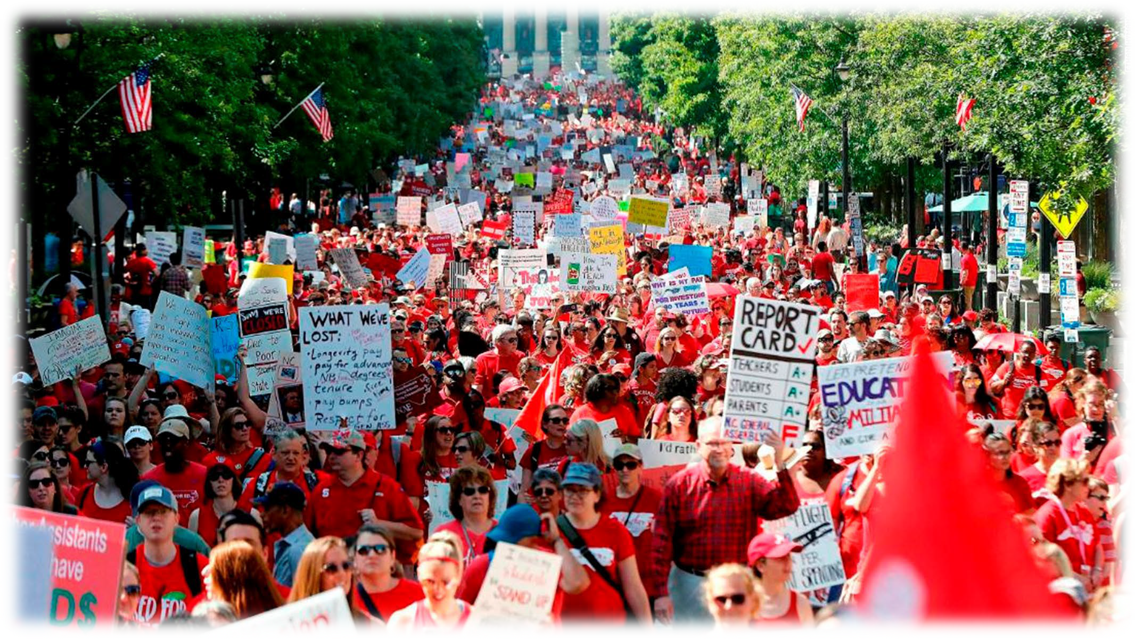
  Campaign Planning for Coaches | Campaign Mountain Issues  Power Analysis Targets Demands Tactics

Campaign Planning Document

Centering Equity (process to ensure this throughout your campaign?
Problem (big issue, no clear
solution)

Issue (personal, manageable, specific to the problem needing to be solved with a tangible solution)
Demand (what do we want in order to solve the issue)

Target (has the decision making or resources to solve your
problem)
Allies (supporters on this issue)

Opposition (do not support you on this issue)

Metrics (inform is you are winning along the way)
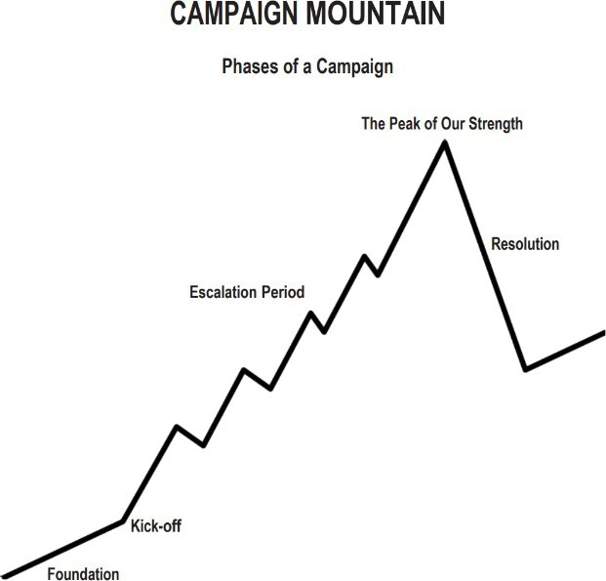

Timeline
Tactics (in order) of escalation Benchmarks for each tactic

Data (what will you collect and how) Campaign Team and Roles (consider distributing responsibilities) Res

CENTERING EQUITY (Iterative Analysis)
What does it mean to center equity in your campaign?
Race, class, and gender dynamics, disparities, and divisions permeate our society, communities, schools, and classrooms. Systemic oppression is so deeply rooted in our history, culture, and institutions that there is no escaping it. Visible or not, the impacts are ever-present. Race, class, and gender justice is the systematic fair treatment of all people resulting in equitable opportunities and outcomes for all. Justice, or equity goes beyond being against the systematic use of oppressions like misogyny, racism, and classism. It is not just the absence of discrimination and inequities, but also the presence of deliberate systems and supports to achieve and sustain equity through proactive and preventative measures.

To engage in a systems analysis of a racial issue and develop solutions or to test if the campaign demands center race, class, and gender justice, good discussion questions to have with partners and union members include:
Problems: What inequities are you noticing or experiencing? What are the impacts on different groups? Who benefits most and who is hurt most?
Causes: What institutions, policies, or practices are causing or contributing to the inequities? What social norms, popular myths, or cultural biases
may be contributing?
History: How did things get this way and are things worsening or improving?
Solutions: What solutions could address the root causes and eliminate the inequities? How would
different racial groups be impacted by the proposed solutions?
Strategies: What strategies and actions could be used to advance the solutions?
Leadership: Who are the stakeholders most affected by the inequities? Are they involved in naming the issues and solutions? What kinds of
active leadership roles could they take to advance the proposed solution?
Additional Equity Tool Questions:
Who is most directly impacted?
Who has been left out?
How can they be directly engaged?
How do our demands center race, class, and gender justice?

CAMPAIGN PLANNING WORKSHEET

PEOPLE - Who are your people in this organizing plan?
Leadership Team Members
Who are the key people that will lead the actions and shape the plan?
Name | Role | Responsibility

PROBLEM AND ISSUE
What is the problem(s) we are trying to address?

What is a concrete solution(s) to one part of this problem? This is where we find our issue.

Is the issue.. (See Issue Analysis Tools)
- Widely felt and/or deeply felt?
- Winnable?
- Aligned with our values?
Does the issue..
- Build the union and builds leaders?
DEMAND
What is the demand to the target(s)? The demand should name a clear target, call on the target to take a specific action, and demonstrate the harm or impact. There may be a primary target and a secondary target.

ORGANIZATIONAL ASSESSMENT - RESOURCES
Examine what resources we have to build and use power. Power is organized people and organized money (and resources).
People
Who are our organized people?
- How many current leaders and active members do we have?
- Who are potential new leaders and active members, and how can we recruit them?
- Who are our allies? How many leaders and active members do they have? What relationship do they have with the target(s)?

Expertise
Key, specialized knowledge that is used to support the change you want to see. Where is it, how do you get it, how do you communicate it, how do you use it?

Durable Resources
Does not go away (meeting space, research)

Exhaustible Resources
One time use, need to be replenished, need a sustainability plan (money, time)

PRIMARY POWER ANALYSIS OF THE ISSUE

Issue Background
What is the history and current status of the issue?

What are the competing agendas or positions on the issue?

What are the narratives surrounding the issue?

Who are allies on the issue? Who are opponents on the issue?

System Landscape
What are the decision making processes on this issue?
Who is involved in each step of the decision making process?

TARGET(S)
Primary Target Name:

- Based on the Primary Power Analysis who is the primary target? Who can give us what we want?
- Be specific. A target has a name, a face and an address.

Primary Target Power Analysis

Position  - What is the target’s position on the issue?  - Why is the target taking this position?  - What is the target’s history on the issue? | Self-Interest  - What does the target care about?  - What motivates the target to act?  - What are the target’s goals?
Relationships  - What relationship do we have with the target?  - Who influences the target? Do we (or our allies) have a relationship with any of them?  - Who are the target’s allies and opponents?  - To whom is the target accountable? Is the target elected or appointed?  - Who are the target’s base of support? | Power  - What power does the target have and where does their power derive from?  - How do they organize people?  - How do they organize money and resources?

Secondary Target Name (if there is one) :

- Be specific. A target has a name and a face. A secondary target can MOVE the primary target.

Secondary Target Power Analysis (if applicable)

Position  - What is the target’s position on the issue?  - Why is the target taking this position?  - What is the target’s history on the issue? | Self-Interest  - What does the target care about?  - What motivates the target to act?  - What are the target’s goals?
Relationships  - What relationship do we have with the target?  - Who influences the target? Do we (or our allies) have a relationship with any of them?  - Who are the target’s allies and opponents?  - To whom is the target accountable? Is the target elected or appointed?  - Who are the target’s base of support? | Power  - What power does the target have and where does their power derive from?  - How do they organize people?  - How do they organize money and resources?
SPECTRUM OF ALLIES POWER ANALYSIS (WHO CAN WE MOVE?)

Active Allies: Your Constituency
You believe you can already count on them to help you.
If your target falls in this area of the spectrum – you tactics will need to find ways to engage your allies even more actively in working with you toward your goal.

Passive Allies: Support
You think they have the same interest, investment or need to solve the problem as you do, and may be close to agreeing with you about your vision, but perhaps may not be able or willing to actively or overtly support you.
If your target falls in this area of the spectrum - your tactics will need to help move them to the “active ally” position; increasing their interest and willingness to be active.

Neutral: Not Yet – With you or Against you
These are people, organizations, institutions that may not know about the problem; may not know about you and your work; have no particular investment in the problem.
If your target falls in this area of the spectrum – your tactics will need to find ways to inform or educate them about the problem and your position in order to move them to a “passive ally” position. Examine your tactics to be sure you will not move them toward your opponent’s position.

Passive Opponents:
These are people, organizations, institutions that you think have some interests that would be opposed to your vision; they may have relationships with people who are actively opposed to you.
If your target falls in this area of the spectrum – your tactics will need to create doubt about their position, raise fears that their position may be “costly” to them in some way. You want your tactics to move them to a “neutral” position and NOT to an active opponent position.

Active Opponents:
These are people, organizations, institutions that have a big investment in opposing your position (related to power, position, finances, relationships, etc.).
If your target is located in this area of the spectrum – your tactic goal would need to put them into a great dilemma, that any action they would take against you would be very “costly” to them. Your tactic goal would be to move them into a “passive opponent” position.


New Tactics in Human Rights is a program of The Center for Victims of Torture
www.newtactics.org ● www.cvt.org
Creative Commons: Attribution-Noncommercial 4.0 International License ● http://creativecommons.org/licenses/by-nc/4.0/

Problem Statement:
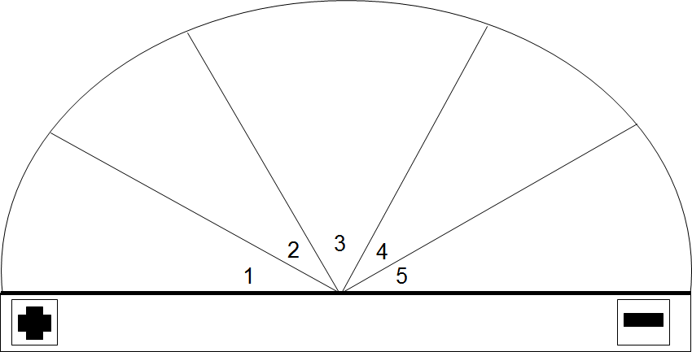

Source: Original Source – Training for Change (www.trainingforchange.org) and adapted into five segments by New Tactics in Human Rights.

New Tactics in Human Rights is a program of The Center for Victims of Torture
www.newtactics.org ● www.cvt.org
Creative Commons: Attribution-Noncommercial 4.0 International License ● http://creativecommons.org/licenses/by-nc/4.0/

PEOPLE COMMUNICATION PLAN – Based on the spectrum of allies analysis, how do you strategically communicate with the people in each of these groups?

Constituency- Your people who care about this issue and may take action to work towards the win
What is your plan for being in contact with as many of these folks as often as possible? How will you know they care about this issue?
Support- Individuals and organizations who support the win but may not be a part of the actions | Neutral - Individuals and organizations who are not yet working towards similar wins or against you. | Passive Opposition and Opposition - Individuals and organizations who are against the win you are seeking to achieve
What is your plan for being in contact with these folks? How will you know they support this issue? | What is your plan for being in contact with these folks? How will you know if and when they move towards you or away from you? | What is your plan for being in contact with these folks? How will you know that they oppose this issue?
Individuals and Organizations you identified that you may not know yet if they support, oppose, or compete with you.
What is your plan for being in contact with these folks?

MESSAGING
Focusing only on the opposition leads to becoming disheartened or cynical, which means you ignore potential allies and support. Focusing only on how to convince the important power-holder who is against you leads to ignoring all of the potential support you could build that could overpower her opposition.

Focusing only on active allies leads to being an isolated interest-group, which also means you ignore potential allies and support Always doing events with the same group of individuals or organizations isolates you from creative, powerful community-building that can arise from new alliances and partnerships

Generalizing about whole groups of people risks misunderstanding the nuances of communities If you think about "students" as an entire group, you ignore the huge number of different groups & organizations (potential allies!) that exist in a student community

DO focus on passive allies. These are folks who know or care
about what you’re up to, but aren’t doing anything about it! Give them a chance to participate and build power with you. Good news, In most social change campaigns, it is not necessary to win the opponent to your point of view, even if the powerholders are the opponent. It is only necessary to move some or all of the pie wedges one step in your direction. If we shift each wedge one step, we are likely to win, even if the hardliners on the opponent’s side don’t budge.
Who is the audience for the campaign messaging? What kind of message will reach them? What are their values? Think about 5 sectors you communicate with – Allies, Passive Allies, Neutral, Passive Opponents, Opponents.
Allies
Passive Allies
Neutral
Passive Opponents
Opponents

STRATEGY AND TACTICS
Brainstorm tactics that will put pressure on the target(s).
Name how each tactic would disrupt the target(s)’s self-interest, relationships, or power.

List the tactics above which meet the criteria below:
- Put pressure on the target (push them out of their comfort zone)
- Build our power (develop our leaders and bring more people into the campaign)
- Are strategic (make good use of our resources to put pressure on target)

Number the tactics above in order of escalation:
Think about how much participation, resources, and risk each tactic requires, as well as how much pressure it will put on the target(s).

Keep reviewing this list throughout the campaign. Remember that each implemented tactic gives us more information about the readiness of our members for the next step and how much pressure the target(s) can sustain. Use this information to inform the next tactic.

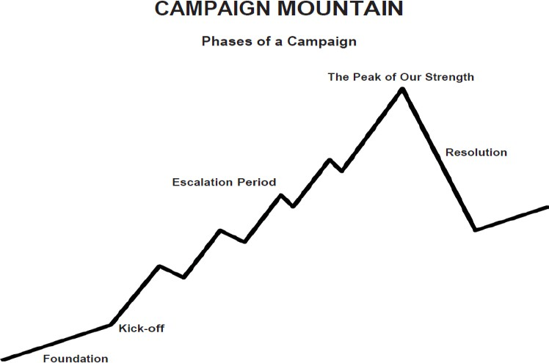

COMPRESSION POINTS
What are the key dates to plan the campaign around?
This can be either externally set dates (board meetings, breaks, etc) or internally set dates (deadlines we give to the target).
BUILDING POWER & DEVELOPING LEADERS
In what ways will we activate more members and build power throughout this campaign?

In what ways will we develop leaders throughout this campaign?

BUILDING POWER & DEVELOPING LEADERS – Do the Math

What is your goal? How many people on what date will it take to win that?

Example:
Goal is 5000 paper petitions signed 4 months from now.
Universe of Potential Actors: 60 Worksites each with 100 Workers

Team Planning: 10 Campaign Team Lead Members create plan (30 Days) (10 People)

Foundation: Each Campaign Team Lead Works with 5 Sites to recruit and train a Campaign Action Lead. (1 Team Lead to 5 Worksite Leads - 50 People)

Structure Building: Those 50 Campaign Action Leads recruit 5 People and train them. (50 Worksite Leads to 5 Building Team Members - 250 People)

Second Peak: Expansion Communication and Kick-off (30 Days)
Each Building team holds one10 Minute Meeting recruiting 25 people in attendance. (each Campaign Action Team Member is responsible for recruiting 5 people to the meeting) (250 Building Team Members to 5 Supporters -1250 People)

Third Peak: Resolution - Asking for Signatures (30 Days)
Each of the 25 who attended each of the 50 building meetings are responsible for collecting at least 5 petition signatures. (1250 Supporters to 5 Supporters - 6250 Signatures and People)

What is your math?

OUTLINE OF STRATEGIC PLAN
- What foundation do you need to build before implementing your campaign (leadership team, initial planning, recruit leaders, gather resources, etc.)? How many people? Date?
- What will you do to kick-off your campaign and gear up for the first tactic? How many people? Date?
- What tactics will you take to reach the win? How many people? Date?
- Are there any natural compression points (dates, events, deadlines) that tactics should align with?
Foundation
Kick-off
Tactic 1
Tactic 2
Tactic 3
Tactic 4
Tactic 5
Win/Demand

Kick-Off
Kick-Off Goal
# Leaders
# Participants
Date(s)
Location(s)
Recruitment and Communication Plan
Resources and Supplies
Measurable Data (Qualitative and Quantitative)

Debrief (Complete after action, Plus, Delta, Key Learning)

Tactic 1 (Complete for each tactic)
Tactical Goal
#Leaders
#Participants
Date(s)
Location(s)
Recruitment and Communication Plan
Resources and Supplies
Measurable Data (Qualitative and Quantitative)

Debrief (Complete after action, Plus, Delta, Key Learning for Next Action)

