Advancing LGBTQ+ Justice Agenda: Day # 1
General Materials Needed: |  |  |  | Room Set-up:
1 Set of Handouts per Person  Name Tents with the Norms  Room signs,  One ream of white photocopy paper  Chart Paper (4 to 5 full w Sticky Strip) |  | Materials Box for each table with:  Markers (Mr. Sketch variety)  Post its – 3x3” and 4X5” sizes  Index Cards  Highlighters – 4 colors  Pens and Pencils Participant “toys” |  | Long Rectangle table at back for facilitators  Round Tables for participants  Projector, Screen, mics, and Speakers  Carousel stations and reporting stations  No podium, table with projector big enough for laptop
Key Outcomes for the Day:

Understanding of identity and how it informs a person’s relationship to privilege and power
Explore unconscious biases around LGBTQ+ and how these can change
Explore the history of the construction of oppression for LGBTQ+ community and times justice has prevailed
Understand aspects of gender as a continuum
Develop a foundational understanding of key terminology

Overview of Content, Time, and Facilitator Assignment
8:30-9:30 Entry and Welcome  9:30- 10:00 Ice Breaker and Core Values  10:00-10:20 Shared Identity  10:20-10:35 Break  10:35-11:00 Intro to RCGN  11:00- 11:30 Quiz/Terminology Review  11:30-12:00 1st Impressions  Lunch – 12:00 -1:00 | Ellen/ Anthony  Natasha  Sara  Salina  Alex  Natasha |  | 1:00-1:20 Shared Identity #2  1:20-1:50 Timeline  1:50-2:05 Break  2:05-2:35 Terminology and shoes  2:35-3:35 Contract  3:35-4:00 Gender  4:00-4:30 Transition  4:30-4:40 Closing  4:40-5:00 Networking |  | Zac  Rachel  Sara  Zac and Sara  Alex  Salina  Ellen

Time Slides Facilitator | Resources | Instructions, Activity and Debrief (Facilitators) | Essential Questions and Outcomes
Name of facilitator, the slides to be used, the clock time to accomplish the learning section | Charts, handouts, articles, materials, slide | What are you saying, what are they doing, what questions will you use to guide learning and make clear the important points  Include an estimate for how long each section of the learning will take | What question(s) will this learning answer? What will participants know or be able to do?
ENTRY ACTIVITY:
Upon entering the room participants go to the front of the room and indicate what state they are from, and the facilitator drags the dot to the state.
If the laminated map arrives at the training site transfer information from the slide to the room map and keep the map up throughout all three days of the training.
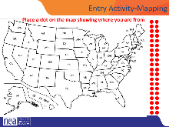 Zach will move dots
8:30-9:30 Ellen and Anthony |  | 30 Minutes Getting Started – Salina Timing
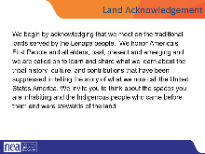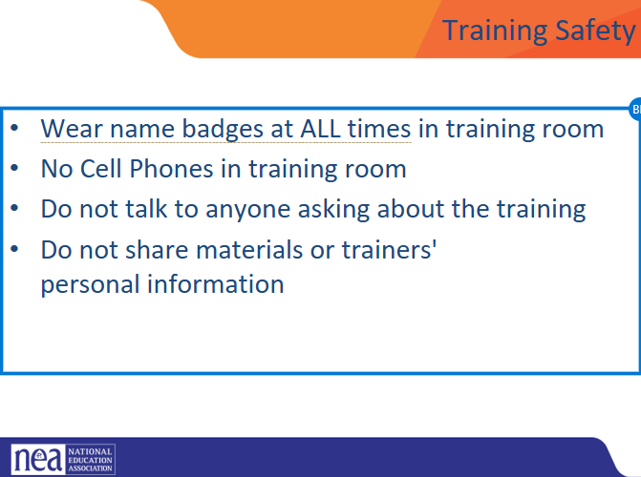  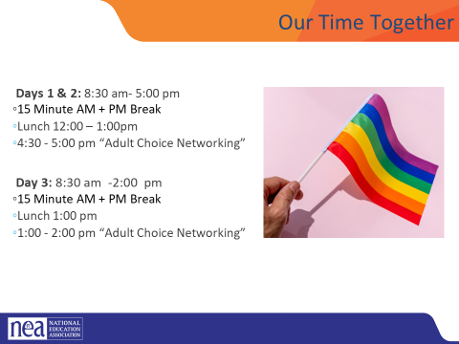  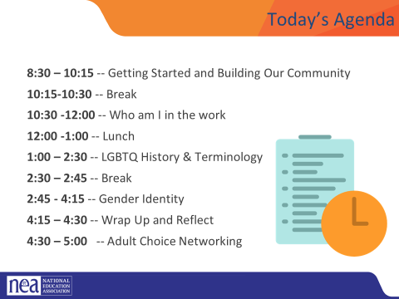  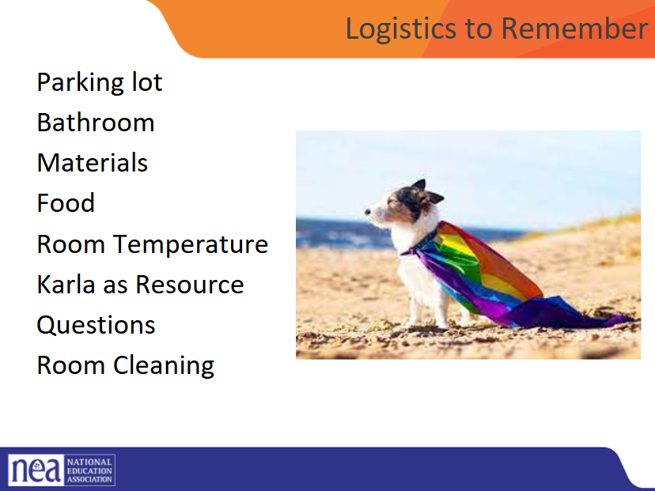  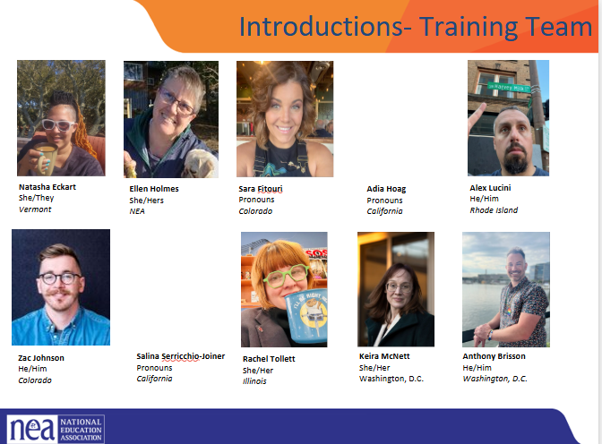  s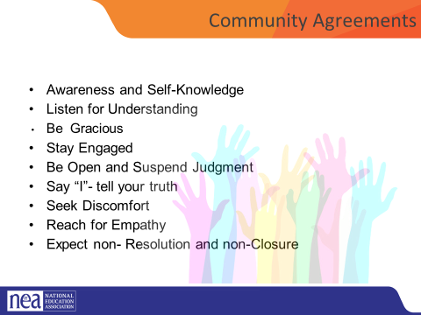  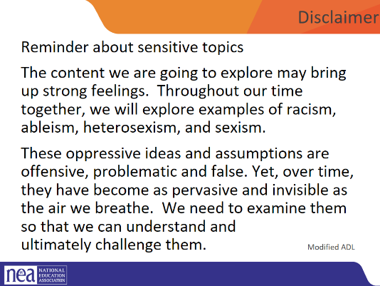  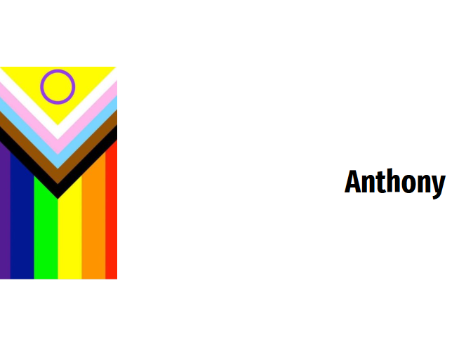  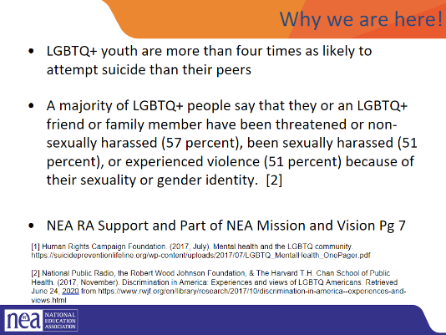  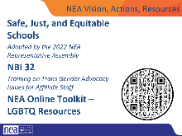  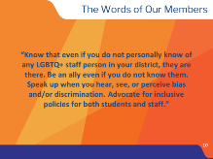   | Chart of “Lingering Questions/Continuing Conversations” that stays up that participants can write stuff on | 15 Minutes  General Welcome  Land Acknowledgment - We begin by acknowledging that we meet on the traditional lands served by the Lenape people. We honor America’s First People and all elders, past, present and emerging and we are called on to learn and share what we learn about the tribal history, culture, and contributions that have been suppressed in telling the story of what we now call the United States America. We invite you to think about the spaces you are inhabiting and the Indigenous people who came before them and were stewards of the land.  Our Time Together  Overview of Agenda – 3 Day view and Today View  Logistics  Intro of Facilitators  10 Minutes Community Agreement Review  Group Review  Begin with a proposed list of community agreements, each table needs to describe what they think each agreement means and propose any additional norms not covered by the proposed agreements:  - Using Self-Awareness and Self-Knowledge  - Listening for Understanding  - Being Gracious  - Staying Engaged  - Being Open and Suspend Judgment  - Saying “I”- tell your truth  - Seeking Discomfort  - Reaching Empathy  - Expecting Non-Resolution and Non-Closure  Refer them to the Community Agreements in their handouts and that they received as part of their Pre Attendance documents  - Prompt table groups to review the agreements  - They will have 10 minutes to scan the agreements looking for items that they don’t understand.  - They should also be tracking what they think is missing.  Debrief  - Share what you mean by the agreements  - Check to see if tables were on track or need clarity for EACH of the Agreements. Before moving to the next one- ask the group to show thumbs  - Thumbs up is I totally agree  - Thumbs sideways is I can live with it and I am fine to move on  - Thumbs down – I simply cannot move on AND I have questions or something different to propose.  - A thumbs down comes with the responsibility of working until your thumb can at least be sideways. (what follows are facilitator notes to help you debrief the ways of thinking that shaped each of the proposed agreements 1-4)  Disclaimer  Anthony - 15 Minutes  Why We are Here  Why are we here – the system of oppression’s outcomes on the LGBTQ+ community are something that justice seeking people can not tolerate.  Interim SPARK Report brings rate of suicide attempts up to 47% from 41% in 2023 – Worsening Condition for LGBTQIA+ youth in the United States  NEA Mission, Actions and Resources Slides  Campaign lab – teams can receive coaching  In the words of our members – show slide  TIK TOK VIDEO SLIDE  As staff supporting members we need to check ourselves before we wreck ourselves, we want to provide guidance and not be patronizing.  When a member says this is the thing I want to say, want to do, our job is not to cut them off – but advise them of what the consequences are. We are not here to protect them from all harm – our role is to advise them of the choices they make. We want them to know they are valuable and we support them in the choices they make. This is actually how leaders and power are realized. | How will this program be structured?  Participants will understand how the entire program flows. They will review the day 1 agenda. They will create a core values chart.
9:30-9:45 Natasha |  | 15 Minutes -ICE BREAKER –
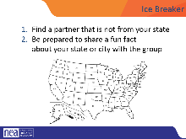 |  | Group introductions  Using the Map, people will introduce their partner with name, their state, and something interesting about their state. Example: state bird! | Who is here?  Participants will begin to develop a learning community.
9:45-10:00 Natasha |  | 15 Minutes – Core Values Introduction- Pg 11
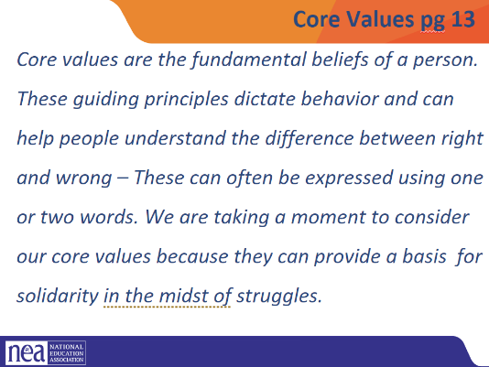  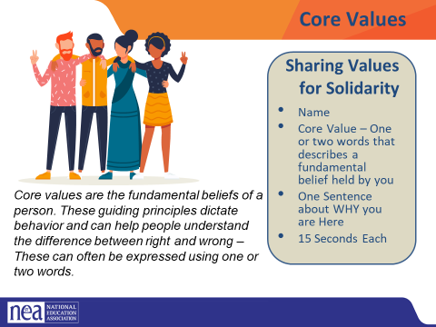  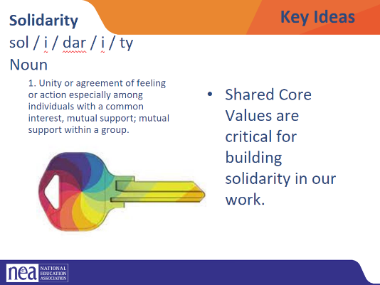 | CORE VALUES CHART  Core Values Handout pg 13  Charting Folks - | Core Value Quick whip intro  Review what a core value is (Core values are the fundamental beliefs of a person. These guiding principles dictate behavior and can help people understand the difference between right and wrong – one or two words) These can often be expressed as one or two words, WE are taking a moment to consider our core values because they can provide a basis for solidarity in the midst of struggles.  Have participants go to the handout, and take five minutes to list a number of their core values in the one or two word format.  Next ask participants to introduce themselves:  Begin by asking the facilitators to model  - By saying their name and a core value –  - One word or two that describes a fundamental belief held by you – start the chart with yours (ex. Solidarity) - you and your partners will chart the core values only as they are shared – Use two charts and two recorders so that it can move quickly. (15 seconds per person INCLUDE THE PRESENTERS)  A copy of this can be found on your handouts.  Key Ideas for Debrief  Shared Core Values are critical for building solidarity in our work.  IDEALLY -Unions advance the welfare of all workers. They are based on the idea of justice, progress, and betterment of self and of society. They embody the universal ideal of human rights and the need to aspire to become more complete human beings. By becoming an active participant in the labor movement, members become part of something larger than themselves. | Why do I do this work?  Participants will reflect on their own core values and how those are related to union and justice seeking values that build solidarity.
10:00-10:20 Sara  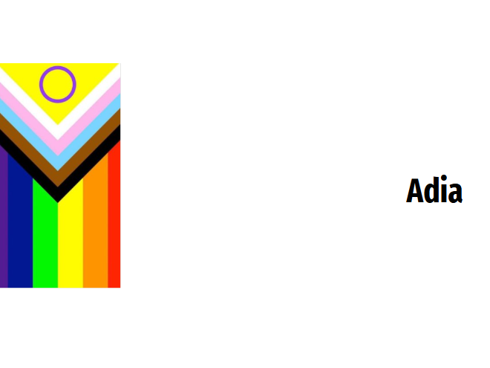 |  | Salina keeps Timing – Zach Mic Runs  Shared Identity
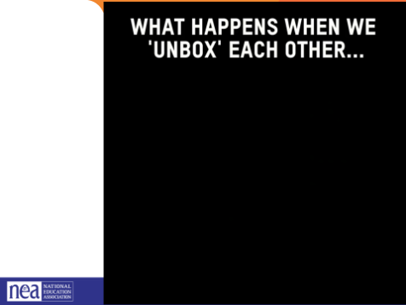  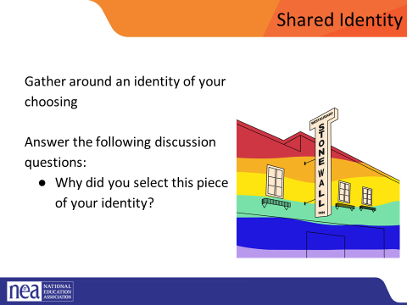  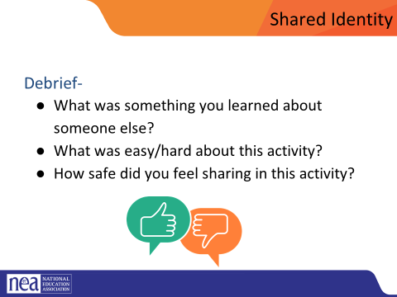  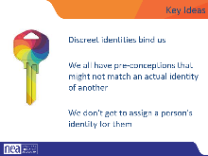 | Unboxing video  (3 min)  Signs that we need  Low Risk Labels  musician, traveler, foodie, planner, nature lover, indoor person, pet parent/Animal Lover | Post the following identities around the room: (we are only using day one labels today)  - Low risk (day 1) - musician, traveler, foodie, planner, nature lover, indoor person pet owner/Animal Lover  - Medium risk (day 2) – parent, only child, has siblings, struggles with technology, tech is easy, life-long learner  - High risk (day 3) – religious, spiritual, agnostic, immigrant, LGBTQ+, in recovery/survivor, nontraditional family  We are going to explore our identities. Identities are personal and only we know what they are. Let's watch this video that shows what happens when we unbox each other. (show video=3 min)  Show the video what happens when we unbox each other video as an introduction to what we are going to do  Participants will get up and gather around an identity of their choosing. Everyone needs to make a choice that makes sense for them (2 min instructions), then they will answer the following discussion questions (8 min):  - Why did you select this piece of your identity?  - What are some challenges you face with this identity?  Share out/debrief (5 min)  - What was something you learned about someone else  - What was easy/hard about this activity?  - Which of these identities are internal vs external?  - How did you find yourself reacting?  - What is similar about each of these identities  If additional time, consider having folks go to another poster, share if there were multiple possibilities, why they chose that one, or the one most unlike you and discuss.  Possible Key Ideas for these on each day  (Identity is different from beliefs)  - Identity is a socially and historically constructed concept. We learn about our own identity and the identity of others through interactions with family, peers, organizations, institutions, media, and other connections we make in our everyday life.  - Key facets of identity—like gender, social class, age, sexual orientation, race and ethnicity, religion, age and disability—play significant roles in determining how we understand and experience the world, as well as shaping the types of opportunities and challenges we face.  - Social and cultural identity is inextricably linked to issues of power, value systems, and ideology.  - Discrete identities bind us | How do I think about my identity?  Participants will deepen their understanding of identity and how this informs their relationship with privileges and oppression.
10:20-10:35 |  | Break
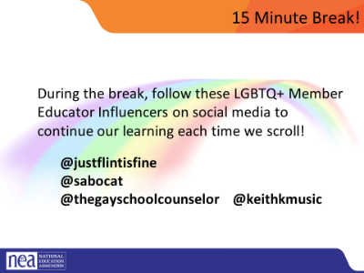 |  | Make sure participants are able to access the online quiz platform so they are ready for the terminology activity
10:35-11:00 Salina |  | Centering Race, Class and Gender
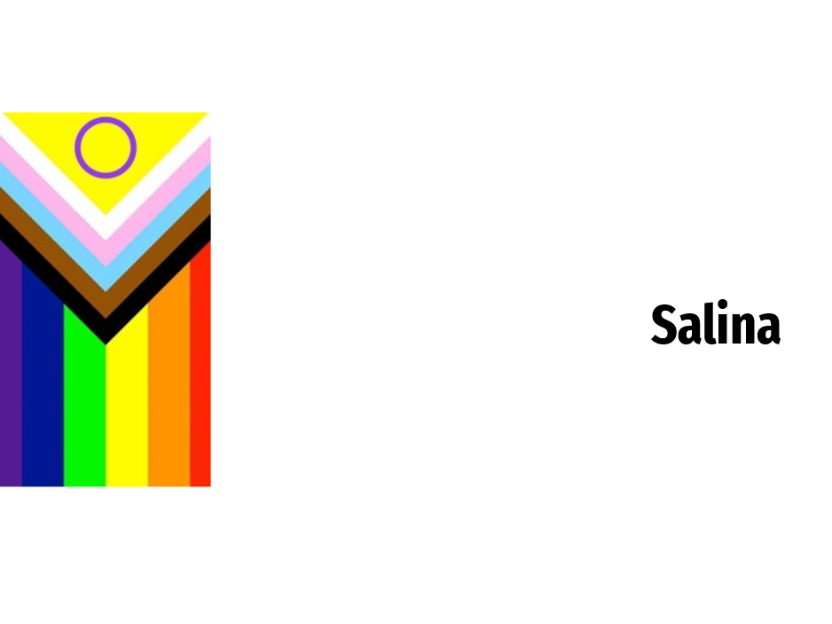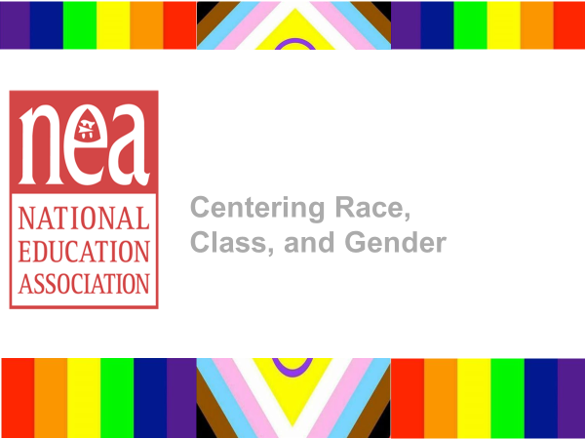  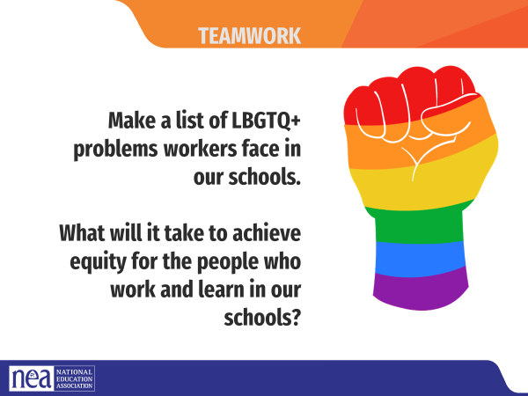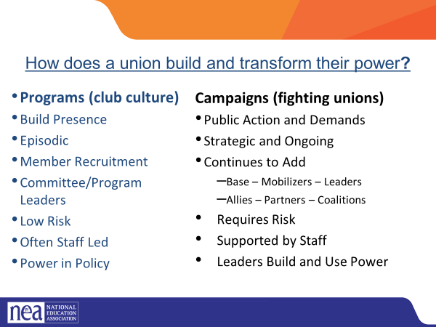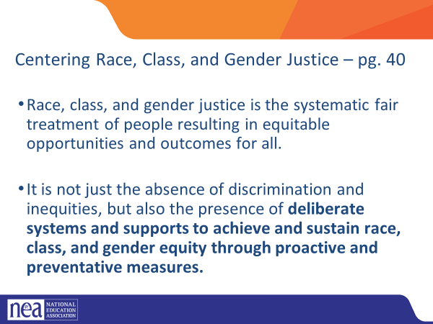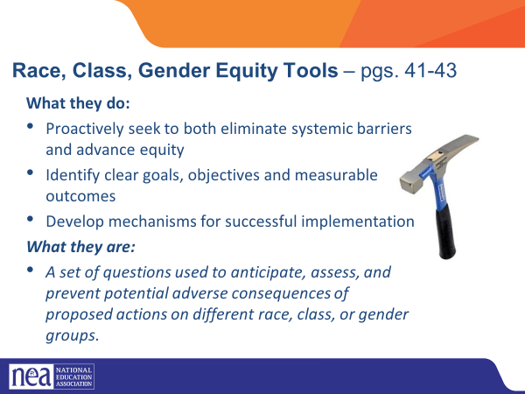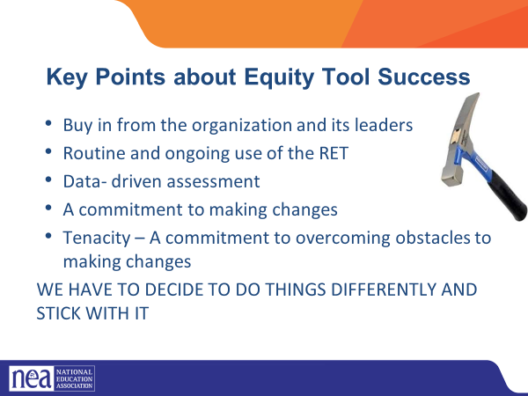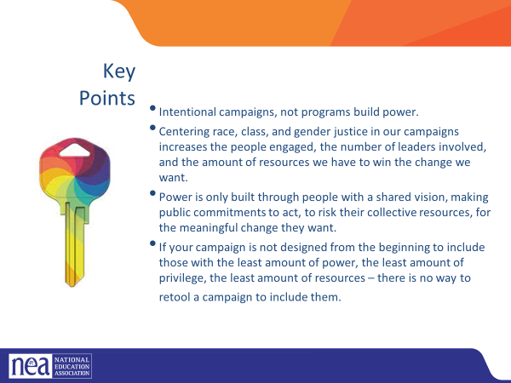 |  | How does a union build and transform their power?  Programs tend to be exclusive and exclusionary. They only allow a certain number and/or type of person. Campaigns seek to include as many people as possible.  Programs, such as professional learning, staff led advocacy, social focused events, even policy advocacy do little to build power. Why is that? Well all of these programs are self-selected with little risk to join or leave them. I want to improve my classroom management, so I come to the Union led training on that. I might even lead one – but I have done little to build power with others. Also in a program, I am choosing to solve a “me” Problem and it does not require any other collective commitment.  Campaigns put people at the center of solving the problems they are experiencing. They name the issue, they decide the solution, they decide who they follow, and they determine what they are willing to risk. When we center people in a campaign – staff move to a coaching role. When people are at the center they use their agency and decide how to act, who they will act with, and what they are willing to risk to win. This is when members and leaders feel powerful in their union.  To begin a campaign you have to ask what the people want to solve, ask what they are willing to risk to solve that, and form demands that they think will provided the solution to their problem.  What does it mean to center racial, class and gender justice? P. 40 in PH  Race, class and gender dynamics, disparities, and divisions permeate our society, communities, schools, and classrooms. Systemic oppression is so deeply rooted in our history, culture, and institutions that there is no escaping it. Visible or not, the impacts are ever-present. Race, class, and gender justice is the systematic fair treatment of people of all races, resulting in equitable opportunities and outcomes for all. It is not just the absence of discrimination and inequities, but also the presence of deliberate systems and supports to achieve and sustain race, class, and gender equity through proactive and preventative measures.  To continually and systematically keep equity in your work you have to use a Race, Class, and Gender Equity tool (p. 40 & p.41-43), or lens. This is a person and institutional commitment to  - Proactively seek to both eliminate systemic barriers and advanc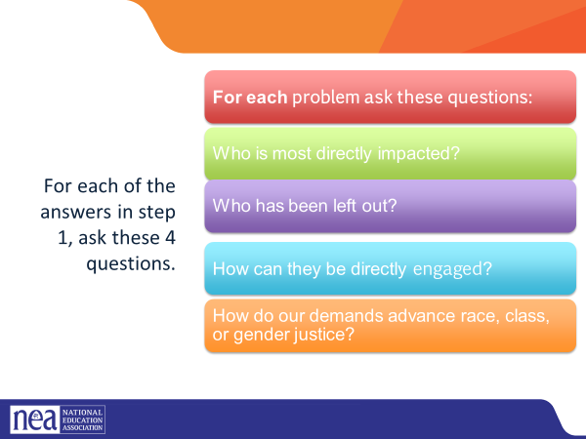e equity  - Identify clear goals, objectives and measurable equity outcomes  - Develop mechanisms for successful implementation of equity focused programs  A set of questions used to anticipate, assess, and prevent potential adverse consequences of proposed actions on different race, class, or gender groups.  Step 1  Looking at your PROBLEM CHARTS – consider the c4 Organizing Questions for at least one of your problems - Who are my people? What are their issues? What do they Demand? What are they willing to risk to achieve that demand?  Step 2- Apply the following Equity Tool:  Who is most directly impacted?  Who has been left out?  How can they be directly engaged?  - Intentional campaigns, not programs build power.  - Centering race, class, and gender justice in our campaigns increases the people engaged, the number of leaders involved, and the amount of resources we have to win the change we want.  - Power is only built through people with a shared vision, making public commitments to act, to risk their collective resources, for the meaningful change they want.  - If your campaign is not designed from the beginning to include those with the least amount of power, the least amount of privilege, the least amount of resources – there is no way to retool a campaign to include them.
11:00-11:30 Alex |  | Terminology Review
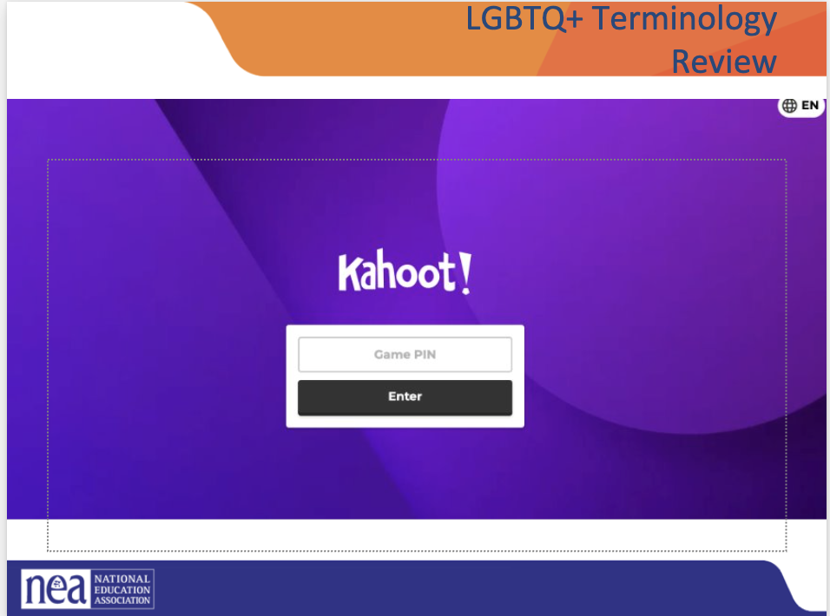 |  | 1. Opening (0:00–2:00)  “Welcome, everyone! We’re going to warm up with an interactive activity using Kahoot. This quiz focuses on key LGBTQ+ terminology—terms that help us communicate respectfully, understand diverse identities, and support inclusive workplaces.  The goal of this activity is learning, not perfection. This is a judgment-free space. If you get something wrong, that’s okay—that’s where learning happens.”  2. Establish/Remind Norms (2:00–3:00)  “Before we begin, let’s reset our few norms so everyone feels supported:  If everyone can agree to these, we’ll get started.”  3. Instructions for Joining Kahoot (3:00–4:00)  “Please take out a device—your phone or laptop.  Go to kahoot.it and enter the game PIN on the screen.  You’ll create a nickname. Please choose something appropriate and respectful.”  (Assist participants with joining as needed.)  Gameplay Transition (4:00–4:30)  Facilitator Script:  “The quiz has 10 questions and will take about 12 minutes. After each question, we’ll pause briefly for guided feedback or clarification. Let’s begin!”  Question-by-Question Guided Feedback (4:30–16:30)  Use the following flexible, repeatable cues after each question.  Incorrect Answer Support:  “If you selected something else, that’s completely fine. These terms evolve over time, and many people learned different language growing up. The key takeaway is: ____.”  Wrap-Up Discussion (16:30–19:00)  Facilitator Script:  “Great job, everyone! Before we close, I’d like to hear a couple of reflections:  - What’s one term you learned or clarified?  - How can understanding these terms support a more inclusive workplace?  - Any surprises or insights?  Closing Remarks (19:00–20:00)  “Thank you for participating with openness and curiosity today.  Learning inclusive language is an ongoing process, and activities like this help us build a workplace where everyone feels seen and respected.  If you’d like to explore these terms further, there are additional resources in the resources folder.”
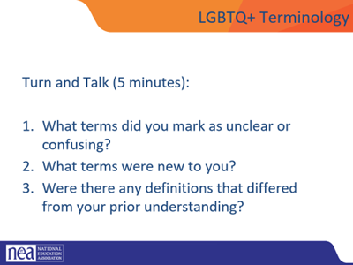  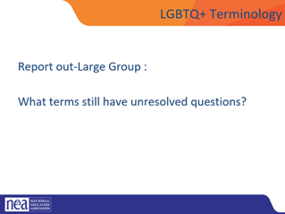  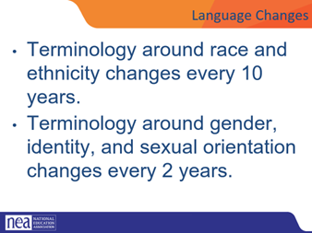  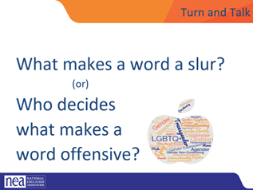  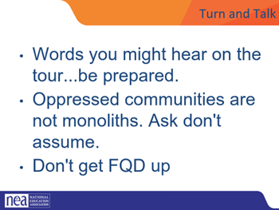  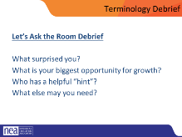  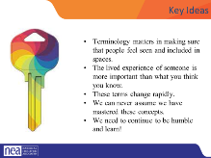 |  | 5 minutes—turn and talk:  Before you arrived, we asked you to review the terminology handout and mark down which terms you know well, which terms you have questions about, and which you don’t know at all. Using the collective knowledge at your table, become more comfortable with the terms you have questions about. You will have five minutes to have this conversation.  15 minutes—Large Group:  Which words do you still have questions about? Facilitators will help to large group answer questions. Remember: when there is dissent about the terminology—fall back on the idea that these are vetted NEA/HRC definitions that are meant to work professionally and may not reflect the personal life or experiences of unique individuals.  Language in the LGBTQ+ communities changes very quickly. Language in ethnic communities' changes about every ten years while language in the LGBTQ+ communities changes about every two years.  What makes a word a slur? (10 minutes)  Individuals get to ID what makes it a slur  If privileged folks use it to injure others. Targeted group gets to identify slurs not privileged folks (generally). Make sure to bring up “queer” specifically.  On the Gayborhood tour: there were folks who use terminology that makes you feel some type of way. We will offer the grace that people are using terminology that empowers them and they are not trying to bring you down or make you uncomfortable.  Faggot, Queer, Dyke -- These words have reclaimed by some in the community.  LGBTQ+ Terminology Debrief (5 minutes)  - Which of these surprised you?  Which of these terms do you find difficult or confusing to use correctly/implement? Where do you have the most opportunity for growth? What else do you need? (Do others share this same struggle? What hints/tricks do we have for working through that?)  For Example: GLSEN gay straight alliance is now gender sexuality alliances  Key Ideas:  Terminology matters in making sure that people feel seen and included in spaces. The lived experience of someone is more important than what you think you know. These terms change rapidly. We can never assume we have mastered these concepts. We need to continue to be humble and learn!  *** Add the evolution of language is always changing
11:30-12:00 Natasha  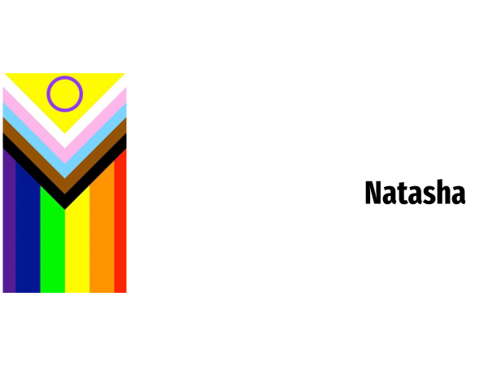 |  | First Impressions
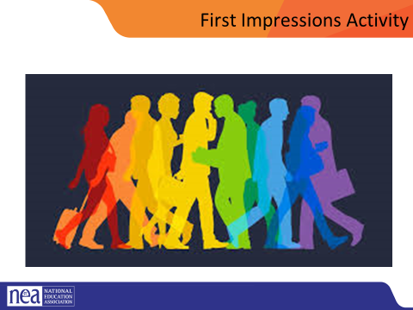  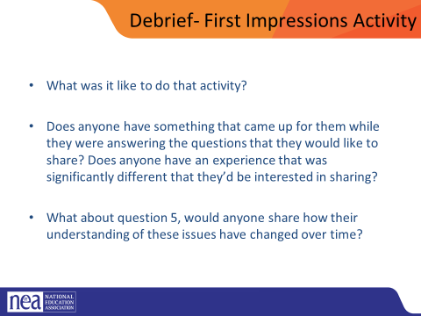  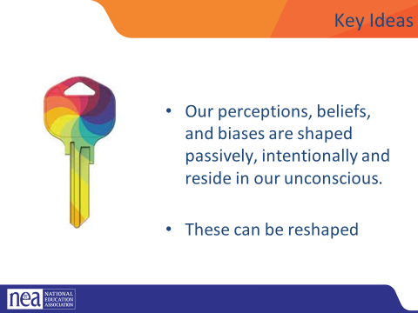 | First impressions handout  www.TheSafeZoneProject.com  Pg 17  P.15 | Provide directions (2 min)  for the activity and assure participants that this activity is primarily reflective and they won’t be asked to share anything they don’t want to. For example, “We are going to start with a reflective activity called First Impressions. We’re going to give you a few minutes to think about and write some answers to the list of questions on the following slide. These questions are for your reflection, so open up a word document to type your thinking. We aren’t going to collect your work or require you to share anything with the group that you don’t want to. If there is any question you’re struggling with skip it and come back at the end of the activity. We’ll give you a few minutes here to answer the questions and then bring it back to the big group.”  Reflection QUESTIONS P: (8 minutes)  Answer the following questions to the best of your ability on a document on your devices:  1. When’s the first time you can remember learning that some people are lesbian, gay, bisexual, or queer?  2. Where did most of the influence of your initial impressions/understanding of lesbian, gay, bisexual, and queer people come from? (e.g., family, friends, television, books, news, church)  3. When’s the first time you can remember learning that some people are transgender?  4. Where did most of the influence of your initial impressions/understanding of transgender people come from? (e.g., family, friends, television, books, news, church)  5. How have your impressions/understanding of LGBTQ+ (lesbian, gay, bisexual, transgender, and queer/questioning) people changed or evolved throughout your life?  Debrief (18 minutes)  As a table: (8 minutes)  Turn and talk, share what you are comfortable sharing  Whole Group (10 minutes)  What was it like to do that activity?  Does anyone have something that came up for them while they were answering the questions that they would like to share?  Does anyone have an experience that was significantly different that they’d be interested in sharing?  What about question 5, would anyone share how their understanding of these issues have changed over time?  Key Ideas (2mins)  - Our perceptions, beliefs, and biases are shaped passively, intentionally and reside in our unconscious.  - These can be reshaped | What are my perceptions of others? Have they changed over time?  Participants will reflect upon their first impressions with LGBTQ+ people and identity.  Participants will reflect on how their understanding of LGBTQ+ people and identity has changed  over their lifetime.  Participants will have an opportunity to hear how diverse the group’s experience with LGBTQ+  people and identity are.
12:00-1:00 |  | Lunch
 |  | The Arc of LGBTQ+ Oppression and Justice in Time (30 mins)
1:00-1:20 Zach |  | Shared Identity #2
Post the following identities around the room:
Medium risk – parent, only child, has siblings, struggles with technology, tech is easy, life-long learner

We are going to explore our identities. Identities are personal and only we know what they are. Let's watch this video that shows what happens when we unbox each other. (video=3 min)

Show the video what happens when we unbox each other video as an introduction to what we are going to do

Participants will get up and gather around an identity of their choosing. Everyone needs to make a choice that makes sense for them (2 min instructions), then they will answer the following discussion questions (8 min):
- Why did you select this piece of your identity?
- What are some challenges you face with this identity?
Share out/debrief (5 min)
- What was something you learned about someone else
- What was easy/hard about this activity?
- Which of these identities are internal vs external?
- How did you find yourself reacting?
- What is similar about each of these identities

If additional time, consider having folks go to another poster, share if there were multiple possibilities, why they chose that one, or the one most unlike you and discuss.

Possible Key Ideas for these on each day
(Identity is different from beliefs)
- Identity is a socially and historically constructed concept. We learn about our own identity and the identity of others through interactions with family, peers, organizations, institutions, media and other connections we make in our everyday life.
- Key facets of identity—like gender, social class, age, sexual orientation, race and ethnicity, religion, age and disability—play significant roles in determining how we understand and experience the world, as well as shaping the types of opportunities and challenges we face.
- Social and cultural identity is inextricably linked to issues of power, value systems, and ideology.
- Discrete identities bind us

1:20-1:50 Rachel |  | Timeline Activity
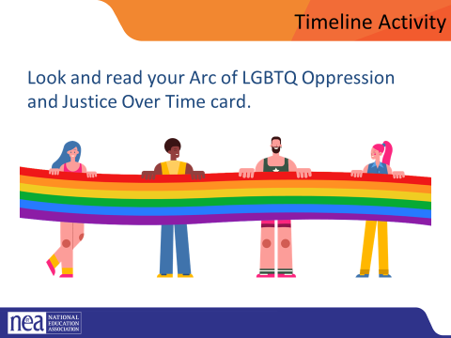  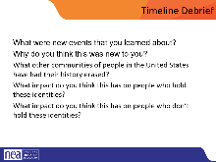  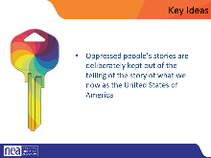 | LGBTQ-History-Cards.pdf (glsen.org)  LGBTQ-History-Timeline-References.pdf (glsen.org)  LGBTQ-History-Timeline-Lesson.pdf (glsen.org)  Resources for history and timelines: LGBTQ Rights Timeline in American History » Teaching LGBTQ History | 10 minutes of prep and participant movement - You are going to build a timeline circle. The earliest date and latest date will be standing side by side – and the rest of you will be place yourself in chronological order around the circle. (Facilitator note – it would be easiest for the facilitator to have the 1620 card and use that to model how to present, it also gives a point for participants to join the circle. On your tables, you will find an assortment of cards. Select one and work to get in chronological order on the circle. Once we do that, I will give you a new direction.  (15 minutes) of report out. Each person is going to share the event on their card along with their name and the state that they are from.  Timeline Debrief: What were new events that you learned about? Why do you think this was new to you? What other communities of people in the United States have had their history erased? What impact do you think this has on people who hold these identities? What impact do you think this has on people who don’t hold these identities?  KEY IDEAS:  Oppressed people’s stories are deliberately kept out of the telling of the story of what we now as the United States of America | What is the history of LGBTQ+?  What do I need to know about the history?  Participants will understand the systemic development of oppressions against the LGBTQ+ community and the points where those oppressions are challenged or dismantled.  What understanding do I need to know from learning history?  Participants will explore what it feels like to be awkward, uncomfortable and unsafe.
1:50-2:05 BREAK
2:05-2:35 Sara |  | Terminology and Shoes
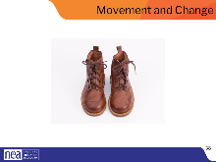  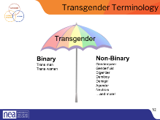  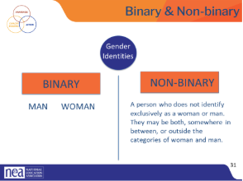  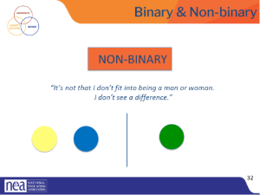  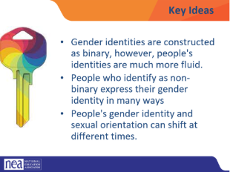  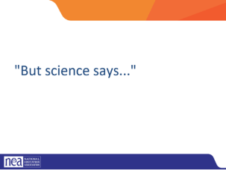  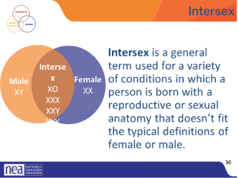  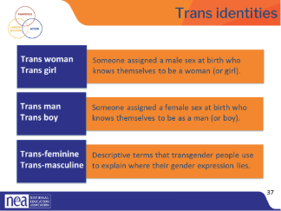  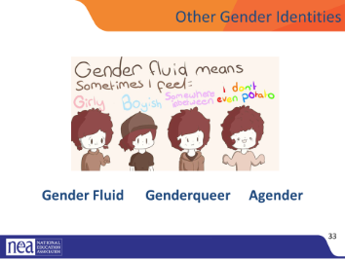  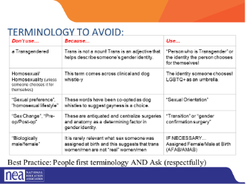  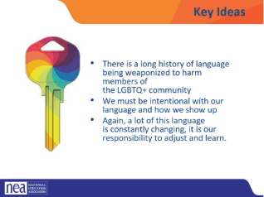  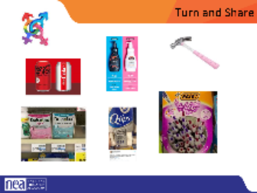  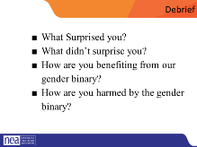  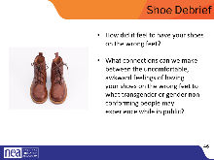  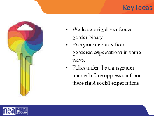 |  | 5 minutes - Opening Activity- Switch shoes!  Ask each participant to switch their left and right shoes (left shoe on the right foot, right shoe on the left foot). Say it’s part of the training, and then move on. DO NOT mention their shoes further. (The objective is that participants will experience a familiar but uncomfortable sensation that their shoes are on the opposite foot. This will help them experience, in a non-threatening way, the uncomfortable, awkward feelings or fear that transgender or gender non-conforming people may experience while they are in public.)  Trans men and trans women are men or women- don’t need the trans as a choice!- or reason to be asking for it- as if tracking it for demographic purposes  Transgender/Trans: This is an umbrella term for people whose gender identity and/or expression is different from cultural expectations based on the sex they were assigned at birth. Being transgender does not imply any specific sexual orientation. Both binary and non-binary genders and gender expressions fall under the umbrella.  Often, we hear transphobic comments when the appearance of Black and Brown bodies are compared to white/Eurocentric views of femininity. For example, internet conspiracy theories have long criticized the natural muscular frame of tennis superstar Serena Williams, and even former First Lady Michelle Obama. Obviously, these comparisons are harmful, and are just one example of how hate, prejudice and fear show up.  Activity: Turn and share gendered items (drinks, clothing, appearance) How embedded is binary in society?- ideas: Magazine, advertising, stores  Debrief  - What Surprised you? What didn’t surprise you? How are you benefiting from our gender binary? How are you harmed by the gender binary?  Key takeaway- We have a rigidly enforced gender binary. Everyone deviates from gendered expectations in some ways. Folks under the transgender umbrella face oppression from these rigid social expectations  Facilitator note: link between what is said about good/bad and help recognize that the binary actually serves no one  Key points:  We have a rigidly enforced gender binary. Everyone deviates from gendered expectations in some ways. Folks under the transgender umbrella face oppression from these rigid social expectations  Science shows us that Intersex conditions comprise more than 30 natural genetic variations. Historically, these variations have not been socially acceptable.  Proposed laws focused on the rights of transgender people regarding restroom usage, participation in sports, and even access to specific health care coverage, and have centered on genitals or proposed chromosome tests. These laws also affect the intersex community, who are often entirely ignored or left out of those conversations.  More people are intersex than we realize. In the past, this was often discovered in testing for the Olympic games, because some women were subjected to gender testing if they were thought to have a perceived physical advantage.  Scientists say there is no clear definition of male & female – that one’s sex includes more than just physical anatomy. It also includes hormone levels, chromosomes, and more.  Please note that “transgender” or “trans” are adjectives. They are terms that describe. A person is transgender, not “a transgender.”  A trans woman (or trans girl) is assigned a male sex at birth but knows themself to be a woman. Alternately, a trans man is assigned a female sex at birth but knows themself to be a man.  Someone who is transmasculine, identifies on the masculine side of the gender spectrum, but may not identify as a man. The same is true for transfeminine people. They may identify as more feminine, but not see themselves as a woman.  Gender fluid is exactly what it sounds like. Gender flows in a more masculine way at times and in a more feminine way at others, with no internal struggle between the two. That fluidity could happen over many years, or it may fluctuate during a week.  Genderqueer people are fluid in their gender and often their sexuality. People who consider themselves genderqueer will often say that no rules apply. They like what they like, who they like, and feel the best living outside of any boxes.  Added some from here- https://freedomforallamericans.org/messaging-terms-avoid/  Agender is the last term on this slide, and it describes someone who does not have a gender. Agender people can feel no connection to the concept of gender at all. They may feel genderless or gender neutral.  Terminology to Avoid - Thinking back to the conversations we had around intersectionality and the work we do, let’s explore some of the clear do NOTs that come up when these topics are discussed. *Note- relate this back to contract work*  Key ideas:  There is a long history of language being weaponized to harm members of the LGBTQ+ community.  We must be intentional with our language and how to show up.  Again, a lot of this language is constantly changing, it is our responsibility to adjust and learn.  A Note About Phobias:  A phobia is a persistent, irrational and exaggerated fear of an object, person, activity, animal or situation. Homophobia is a fear of people who are gay and lesbian. Transphobia is a fear of people who are transgender. When someone’s identity challenges a person’s expectations or preconceived notions of man and woman, they may go into a panic. The incongruence of what someone sees, and what they think creates fear and misunderstanding.  We say “i-dentity” because it’s about the individual and how they personally identify, not “you-dentity” because of how you want to determine someone else’s existence.  With what we have now discussed about gender and how it may not be as black/white a conversation for everyone I want you to look at the list of assumptions and corrections your group created earlier.  Switch your shoes back.  Shoe debrief (15 minutes)  Ask participants to focus on their feet. How has it felt to have their shoes on the wrong feet during today’s session? What connections can they make between the uncomfortable, awkward feelings of having their shoes on the wrong feet to what transgender or gender non-conforming people may experience while in public?  it’s important to note that trans visibility does not equal the advancement of transgender rights, or progress for transgender people. The goal is liberation. Our hope is that with what we’ve learned today, that you too will be an advocate for trans educators across all our schools and districts.  What did it feel like to switch your shoes? What was your experience with switching them? Why do you think we asked you to do this activity? (The objective is that participants will experience a familiar but uncomfortable sensation that their shoes are on the opposite foot. This will help them experience, in a non-threatening way, the uncomfortable, awkward feelings or fear that transgender or gender non-conforming people may experience while they are in public.) | What does it mean to be transgender?  Participants will explore and be able to recognize how the binary presentation of gender is prevalent and normalized.
2:35- 3:35 Zac and Sara  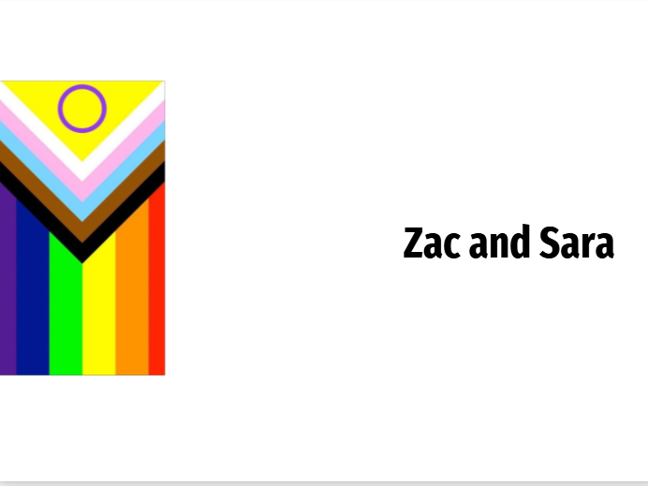 |  | Contract Activity (50 Mins)
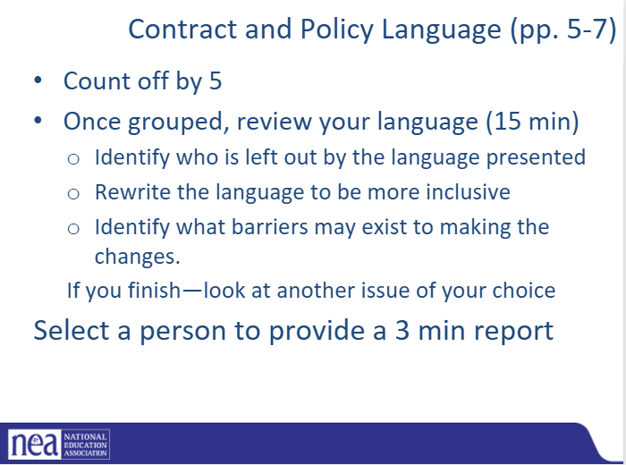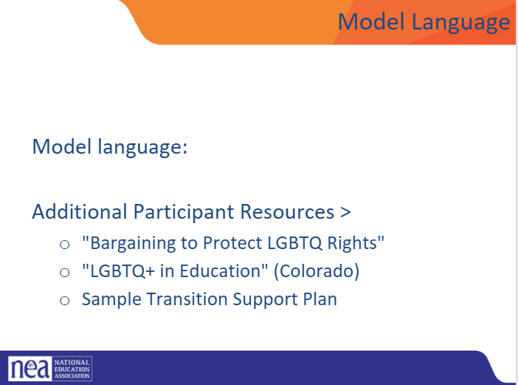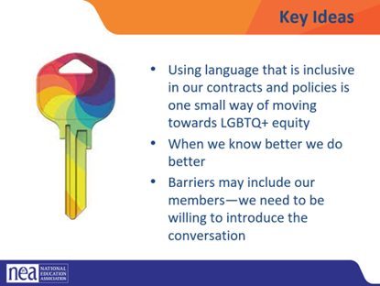 | Contract and Policy Language Activity Handout  Pg. 11-13 | Directions: (5 minutes)  Count off by FIVE (can be more if the group is large—then double up some of the larger examples).  Number of group corresponds with the contract example. Go into POPs, into the participant handouts and look at pages 11-13. You will see Examples 1-5. Take 15 minutes with your group to look at the language and work to identify the problem with it and figure out how to revise it to be more inclusive. You should also think about what barriers may exist to making the changes. Pick a person who will be your reporter.  Group Work (20 minutes)  Feel free to move around inside or outside the room, look over your  Report Out (20 minutes)  Pick a person to do a three-minute share out of work done. Share a brief summary of your original language, why it is problematic, and what changes you made, barriers to change  Key Points: (5 minutes)  Using language that is inclusive in our contracts and policies is one small way of moving towards LGBTQ+ equity.  When we know better, we need to do better.  Barriers may include our members—we need to be willing to introduce the conversation.
3:35-4:00 Alex |  | Gender
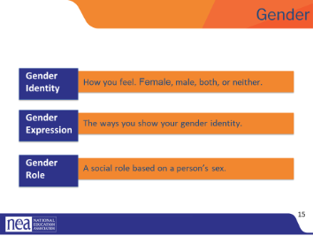  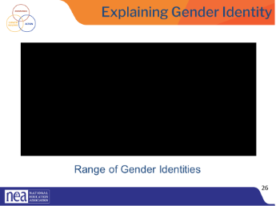  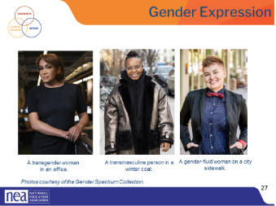  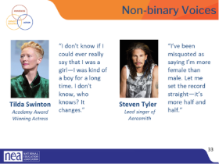 |  | ender, or gender identity, is that internal sense of self we just mentioned—the feeling of being male, female, both, neither, or somewhere in between.  Gender expression includes all the ways you show your gender to the world. For example, your hair and clothes, how you cross your legs, how you walk, and even your voice inflections. Some of these are innate, and some are learned from our cultural norms.  Gender roles are social constructs based on one’s sex or biological attributes. They can be very different from one culture to another. These roles can become so internalized that they create stereotypes or an implicit bias within us (e.g., assuming nurses are women, or mechanics are men).  Gender non-conforming simply means the person is breaking cultural or social rules about gender roles and/or expression.  Video: (3 minute)  - This video offers a simple way of looking at various gender identities (~3 mins).  - Debrief the video with these three questions: At your tables discuss  - How many of you grew up thinking the only gender options were man or woman?  Transgender, non-binary, and gender non-conforming individuals show their gender to the world in many ways. Just as cisgender people have different hairstyles, clothing choices, mannerisms, and more, the same is true for trans, non-binary, and gender-non-conforming people. There is no “one way” to look to be any gender.  These images are from the Gender Spectrum Collection – a group that works with trans and non-binary models. In the first image we see a transgender woman in an office. The second is a transmasculine person in a winter coat. Transmasculine is a term generally used for people who were born female at birth, but who identify with masculinity. As we can see in both of these two photos, they present within the gender binary of man and woman.  In the last image, we see a gender-fluid woman. Gender fluid refers to a person who does not feel they have a fixed gender.  Genderfluid individuals may identify as non-binary or transgender, or also identify with their assigned gender.  Gender non-conforming refers to people who do not follow dominant social norms or stereotypes about how they should look or act based on their biological sex at birth.  For a lot of cisgender people, those whose sex and gender align really well, the concept of non-binary identities is really hard to understand. But we have some famous people who have described it really well.  Tilda Swinton and Steven Tyler have never indicated that they identify as transgender, but they describe a blending or fluidity of gender. For a lot of non-binary folks, that’s the only label they apply to themselves. Others can refine things a bit more.  - (Read the slide.)
4:00-4:30 Salina |  | Transition
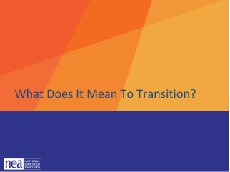  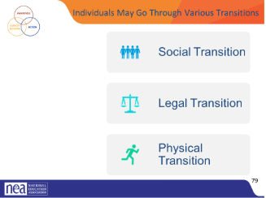  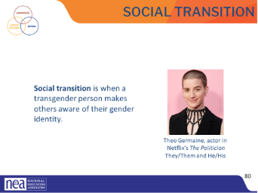  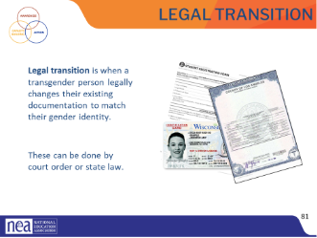  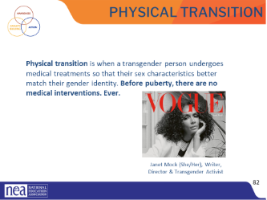  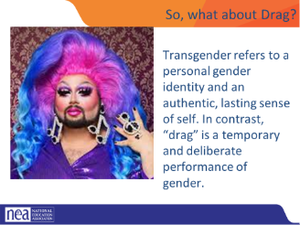  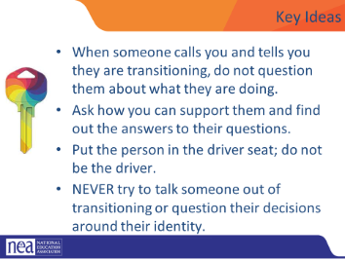 | Refer to Supporting an Employee During Transition handout | Given all that a transgender person may be experiencing, one option is to transition. This means they align their inner identity with their external one. We’re going to talk about this process and how it affects trans adults.  Transitioning is not a simple, one-time event, and there is no “one-size-fits-all” process, checklist, or approach. Transitioning is a complex issue, and it involves a wide variety of options for an individual.  Many factors influence a person’s decision to transition, and because of these factors, their transition may not be linear.  Transitioning is a personal decision specific to the individual, so how a person goes about transitioning can change over time and vary from person to person.  There are 3 main types of transitions someone could go through: social, legal, and physical  Social transition is just what it sounds like—changing how you present yourself and how others see you socially. A social transition can happen at any age. A person may start their transition, pause it, move back, and move forward again. It often includes changing clothing or hairstyles. Usually, it entails changing a name and switching pronouns—sometimes more than once.  A person may try on names for a while and switch from one gendered pronoun to another, only to decide that a non-binary pronoun fits better. Again, no rules.  A legal transition means updating documents through the legal process.  Some parts of the legal transition can include changing gender markers on birth certificates, changing names on social security cards, driver’s licenses, or passports. Legal transitions can also have other identification components, such as school documents. Passports are the easiest documents to change.  People cannot always experience a legal transition because of several barriers. Those barriers do not make their gender identity or their distress at being misgendered any less real.  Transgender health is a specialized area of medicine. There is no one way to have a physical transition.  Given the specialized nature of transgender health care, we can see how problematic it is for a trans person to be told they can only access gender-segregated spaces once they have “had a surgery.” It puts a burden on them that is impossible to overcome, denies their full identity, and creates equal-access issues. Additionally, not all trans people want to have surgery. It’s wrong to demand that another person undergo serious, invasive medical procedures to make other people comfortable.  Keep in mind that just like you would not want to be asked about your medical procedures, we don’t ask others about theirs.  What about drag?  Transgender refers to a personal gender identity and an authentic, lasting sense of self. In contrast, “drag” is a temporary and deliberate performance of gender.  Drag is most commonly associated with gay men dressing up and embodying a “larger-than-life” woman persona. Drag queens are flamboyant and this form of drag often involves sequins and feathers but it can also be sleek and edgy.  For drag queens, their drag persona can be an important part of their own identity as a gay man (this does not mean they are transgender). Similarly, women also perform drag as drag kings. Drag kings dress as men and take on male personas, often wearing facial hair, adopting masculine mannerisms and a deep voice.  Key Ideas  - When someone calls you and tells you they are transitioning, do not question them about what they are doing.  - Ask how you can support them and find out the answers to their questions.  - Put the person in the driver seat; do not be the driver.  - NEVER try to talk someone out of transitioning or question their decisions around their identity. | Participants will analyze what they need in their understanding to properly advocate for employees who are transitioning.
4:30-4:40 Ellen |  | Closing
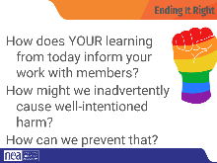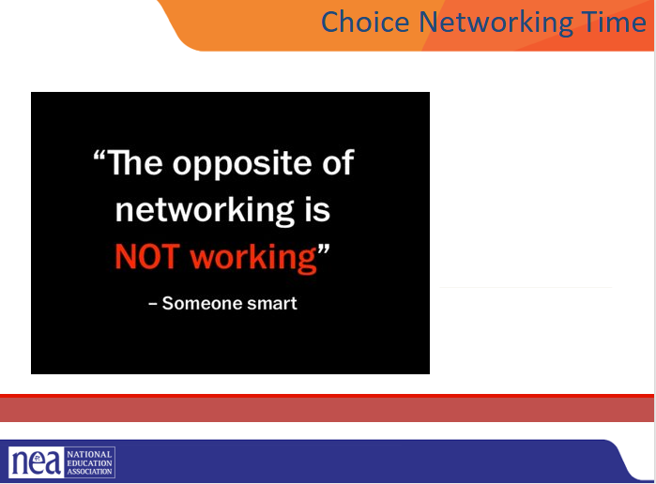 |  | How does YOUR learning from today inform your work with members? How might we inadvertently cause well-intentioned harm?  How can we prevent that?  Open Questions  Added Information  Evening Email  Feedback Forms  Any Logistics for Next Day  Vouchers and Travel | What do I think about today?  What am I doing tomorrow?  Participants will engage in some reflection and closing activities.
4:30 – 5:00 |  | Choice Networking Time
5:00 ADJOURN

