Advancing LGBTQ+ Justice Facilitator Agenda: Day # 2
General Materials Needed: |  |  |  | Room Set-up:
1 Set of Handouts per Person  Name Tents with the Norms  Room signs,  One ream of white photocopy paper  Chart Paper (4 to 5 full w Sticky Strip) |  | Materials Box for each table with:  Markers (Mr. Sketch variety)  Post its – 3x3” and 4X5” sizes  Index Cards  Highlighters – 4 colors  Pens and Pencils Participant “toys” |  | Long Rectangle table at back for facilitators  Round Tables for participants  Projector, Screen, mics, and Speakers  Carousel stations and reporting stations  No podium, table with projector big enough for laptop
Key Outcomes for the Day:

Overview of Content, Time, and Facilitator Assignment
8:30-8:50 Entry and Welcome  8:50-9:10 Shared Identity  9:10-10:10 Transition Plan  10:10-10:25 Break  10:25-11:15 Systems of Oppression  11:15-12:00 Legal Overview  Lunch – 12:00 -1:00 | Ellen  Alex  Salina and Natasha  Rachel  Kiera and Anthony |  | 1:00-2:00 Legal Q&A  2:00-2:15 Break  2:15-2:30 What is our collective strength  2:30-3:00 RCGN Breakdown  3:00-3:20 Overview of Organizing, Create RCGN Statement  3:20-3:40 Problem vs Issue  3:40-3:50 Demand, Targets  Tactics and Escalation  3:50-4:00 Closing  4:30 |  | Anthony and Kiera  Zac  Zac  Alex  Alex  Sara  Sara  Ellen  Behind the Bell Tour

General Materials Needed: |  |  |  | Room Set-up:
1 Set of Handouts per Person  Name Tags or Name Tents  Sign-in Sheet  Highlighters – 3 colors  Chart Markers – non-permanent  Pens and Pencils |  | Chart Paper  Markers  Post its  Index Cards |  | Round Tables  Projector, Screen and Speakers  Carousel stations and reporting stations around the perimeter  50 people
Key Outcomes for the Day
Participants will expand their ability to use correct terminology
Participants will become familiar with a framework of oppression for the purpose of understanding the size and target of solutions that seek justice
Participants will practice applying advocacy strategies to a scenario and understand strategies to implement in a workplace for improving inclusivity
Participants will understand key laws and policies for the purpose of understanding the limits of legal advocacy
Time Slides Facilitator | Resources |  | Instructions, Activity and Debrief |  | Outcomes and Essential Questions
 | Charts, handouts, articles, materials, slide |  | What are you saying, what are they doing, what questions will you use to guide learning and make clear the important points  Include an estimate for how long each section of the learning will take |  | As a result of this section of learning, what will participants know or be able to do?
Entry Activity  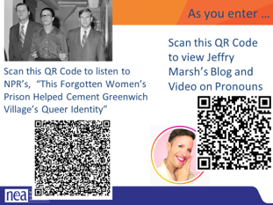 |  |  | View Videos Jeffrey Marsh | Nonbinary LGBTQ Activist, Speaker & Author  View Webpage This forgotten women's prison helped cement Greenwich Village's queer identity | NPR & Houston Public Media This is a Fresh Air episode
8:30-8:50 Ellen |  |  | Getting Started (20 Minutes)
Feedback on Feedback slides  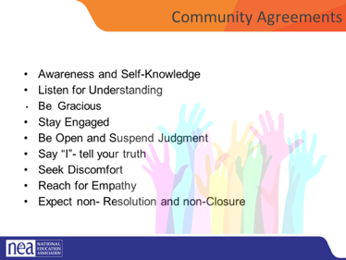  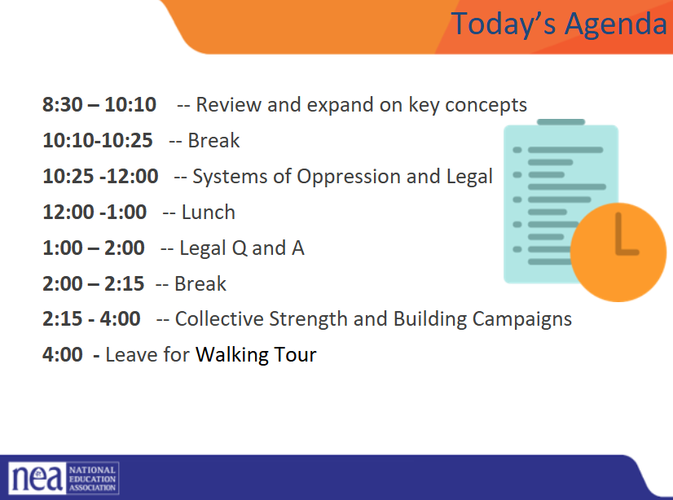 |  |  | Intro to the day  revisit group agreements,  Review Feedback,  Review Agenda  Questions/Needs/Etc.  Possible discussion of visits to Giovanni’s Book Store  Discuss logistics for the walking tour |  | What do we need to know today?  Participants will understand how day 2 will work.
8:50-9:10 : Alex |  |  | Shared Identity Activity - Higher risk, content groups (20 minutes)
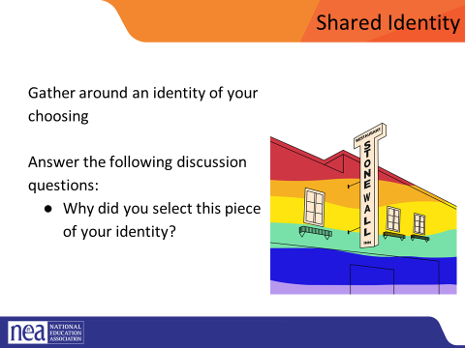  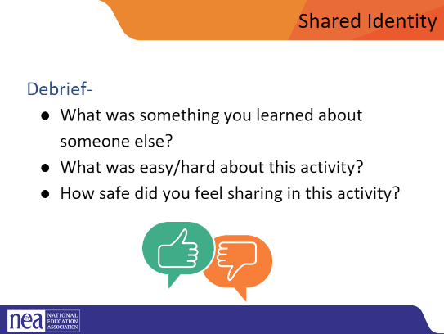  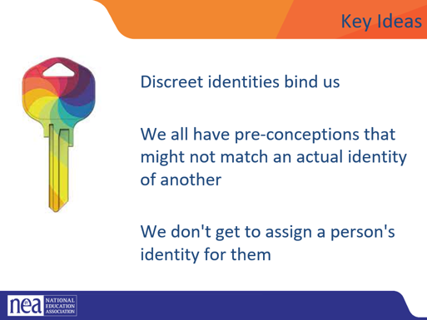 |  |  | Post the following identities around the room:  High risk – religious, spiritual, agnostic, immigrant, LGBTQ+, in recovery/survivor, nontraditional family  Participants will get up and gather around an identity of their choosing (2 min instructions), then they will answer the following discussion questions (8 min):  - Why did you select this piece of your identity?  - What are some challenges you face with this identity?  - How do your reactions to today’s prompts compare to yesterday?  Share out/debrief (10 min)  - What was something you learned about someone else?  - What was easy/hard about this activity?  - How safe did you feel sharing in this activity?  - What challenged your thinking?  - How did you reactions to today’s prompts compare to Day 1?  Remember Possible Key Ideas from Day 1 facilitator guide  Key Ideas  Discreet identities bind us  We all have pre-conceptions that might not match an actual identity of another  We don't get to assign a person's identity for them |  | Who am I and Who are we?  Participants will continue to expand their connections to each other and build a learning community.
9:10-10:10 Salina and Nastasha |  |  | Transition Plan ( Salina)
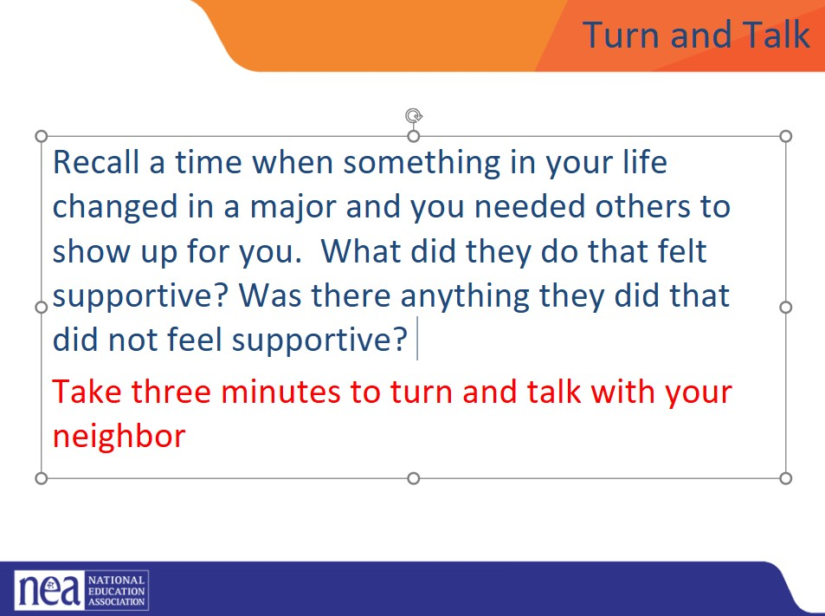  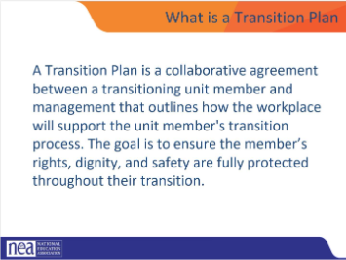  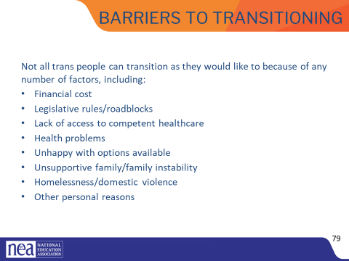  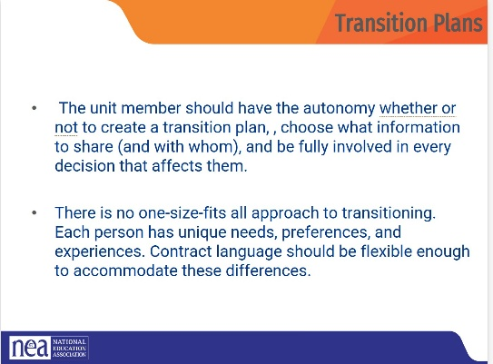  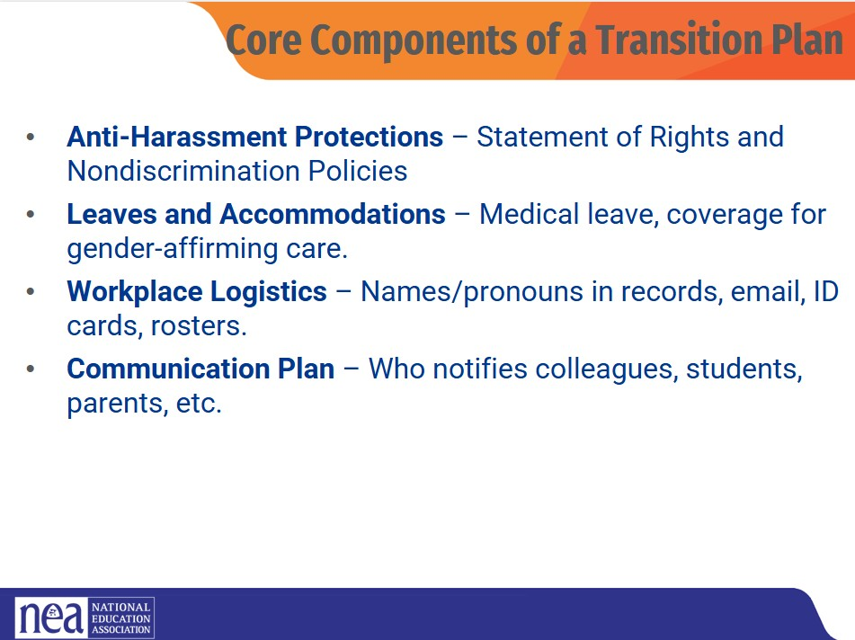  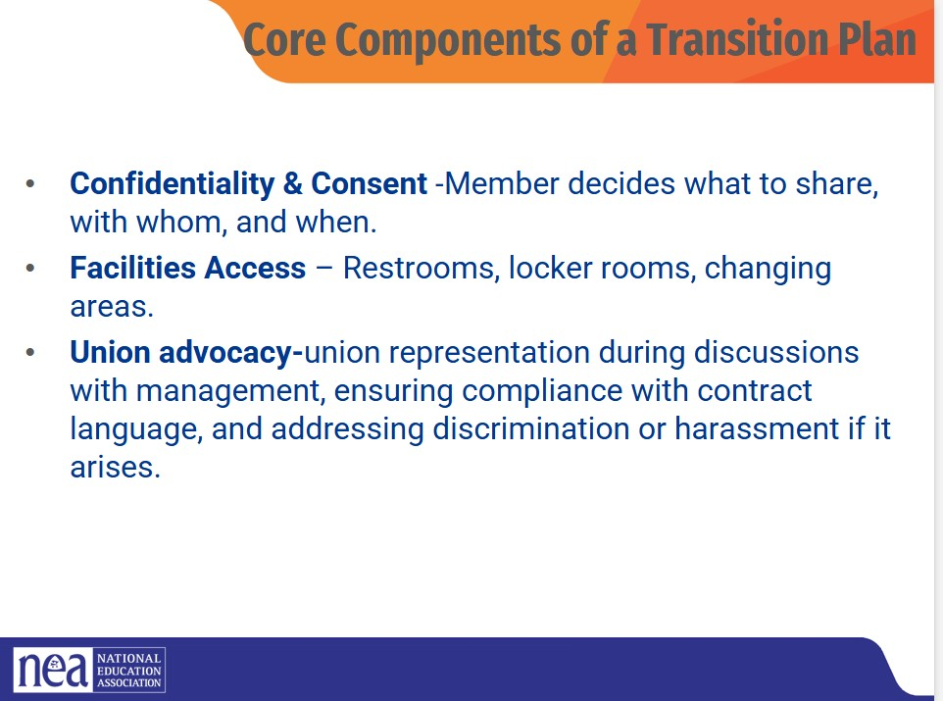  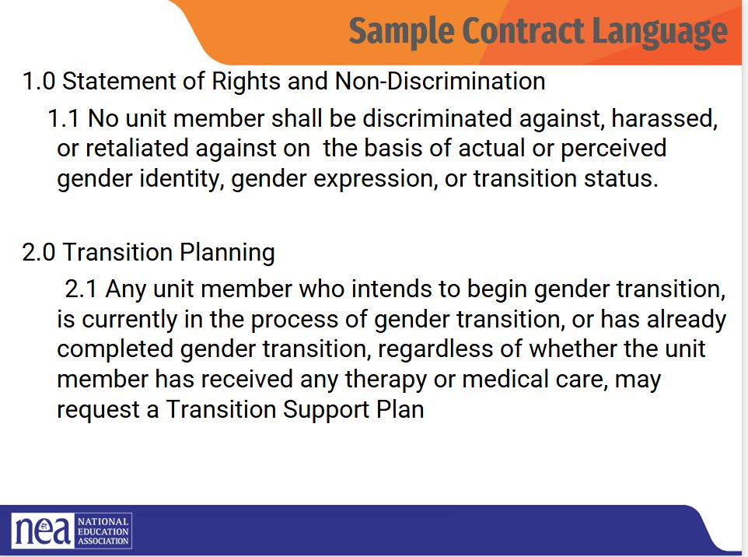  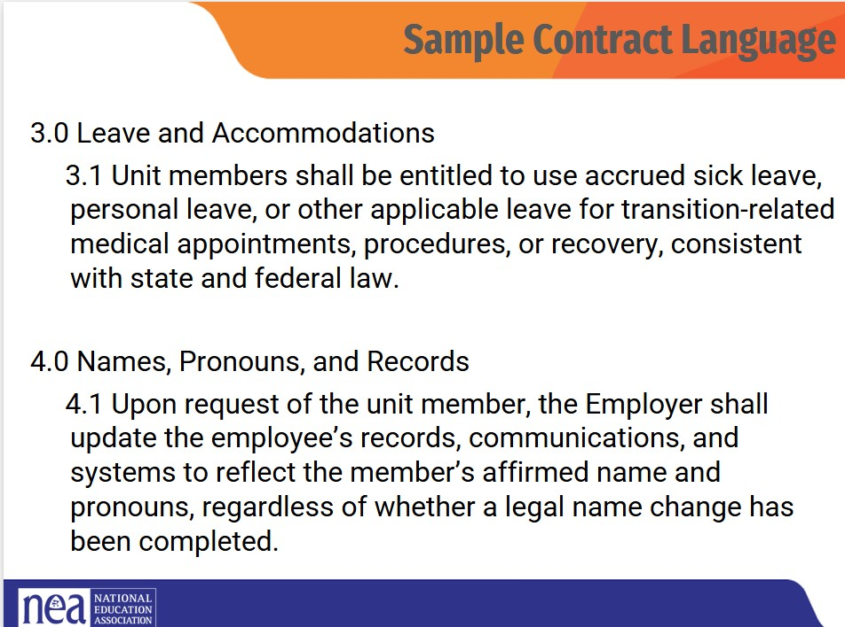  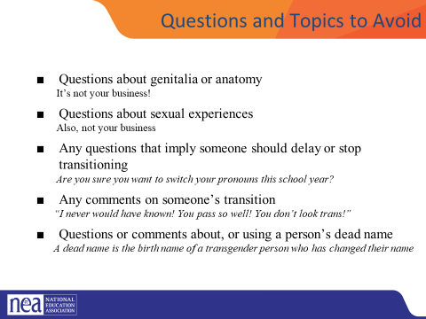  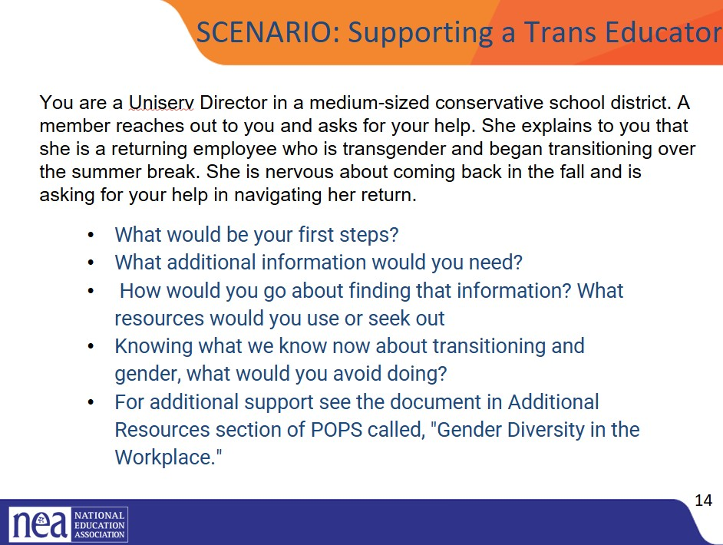  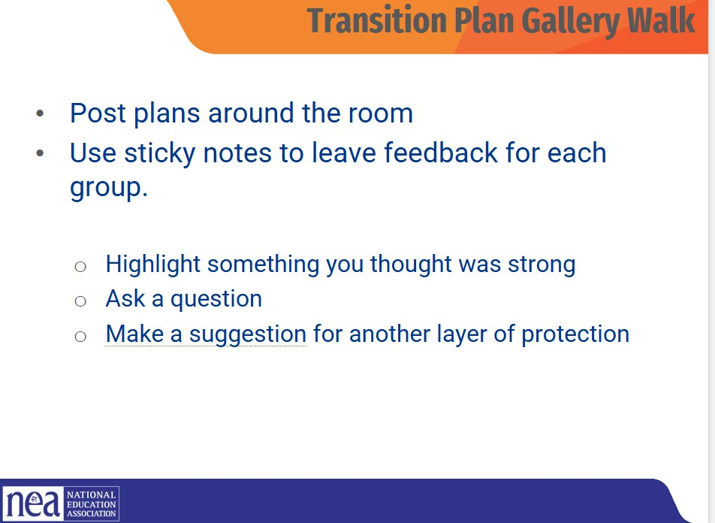  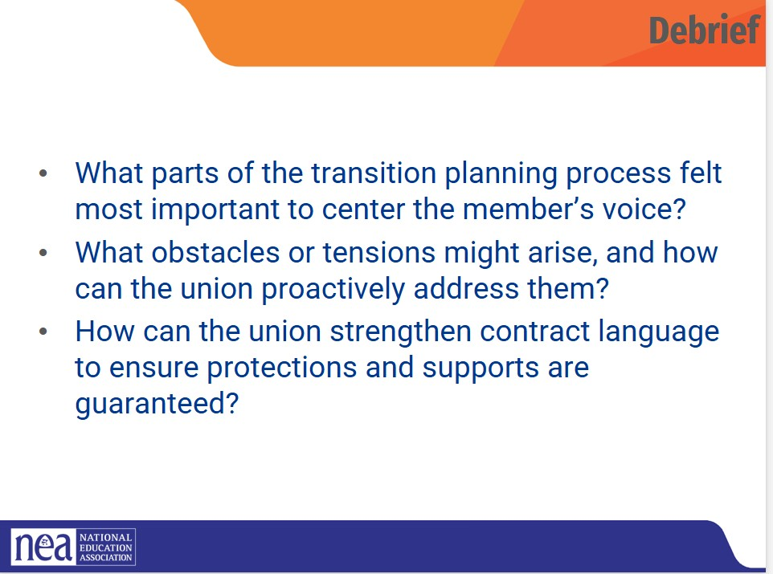  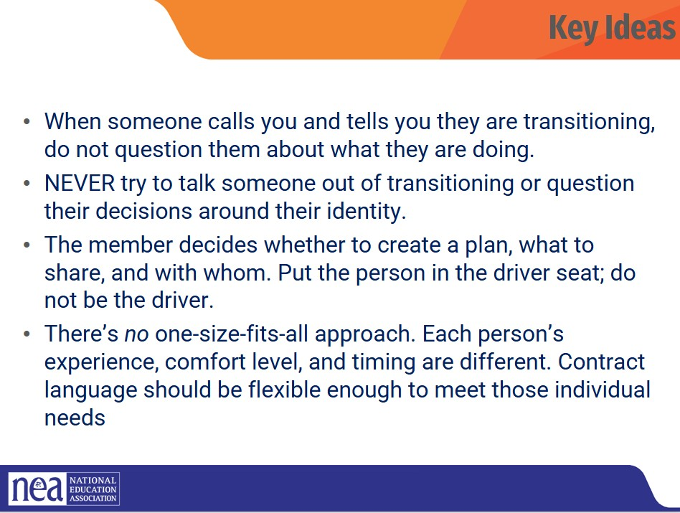 |  |  | Turn to someone near you. You will have three minutes to reflect on a time you experienced a major change in life and what support helped you through it.  After 3 minutes ask, “Based on our experiences, what are some universal needs people have during big changes in life? How might these needs apply to a colleague navigating a gender transition? (5mins)  What is a transition Plan? (2mins) ( Salina)  How do we support our members in their workplace that are transitioning? One way we can support them is through developing a transition plan.  A Transition Plan is a collaborative agreement between a transitioning unit member and management. It outlines the support systems, communication plans, and workplace accommodations that will help ensure the member’s transition is respected and protected.  The purpose is simple but powerful to make sure the members’ rights, dignity, and safety are upheld at every stage.  As a union, our responsibility is to make sure this isn’t just a promise, but a protected right through policy and contract language.  A reminder- EVERY EDUCATOR HAS THE LEGAL RIGHT TO TRANSITION AT WORK UNDER BOSTOCK. Your job is to make a plan to help this educator exercise their legal right!  Barriers to Transitioning: ( 2mins) ( Salina)  - Not all trans people can transition as they would like to because of any number of factors, including:  - Financial cost  - Legislative rules/roadblocks  - Lack of access to competent healthcare  - Health problems  - Unhappy with options available  - Unsupportive family/family instability  - Homelessness/domestic violence  - Other personal reasons  Transition Plans ( 2mins) Natasha  One of the most important principles is autonomy.  The unit member should have complete choice about whether or not to create a plan, what details to share, and who to share them with.  There’s no one-size-fits-all path, every person’s transition journey is different. Some members may want broad communication and visibility; others may want to keep it very private. Both are valid.  As unions and leaders, we need to ensure our contract language and workplace practices are flexible enough to support this range of experiences and always centering the member’s comfort, timing, and consent.  So, what does all this look like when we put it into practice? Let’s look at the key components of a strong Transition Plan  Core Components of Transition Plan: (2mins) Natasha  Here are the core components of an effective Transition Plan. Each one plays a role in creating a safe, affirming environment.  - Anti-Harassment Protections – Statement of Rights and Nondiscrimination Policies.  - Leaves and Accommodations – Medical leave, coverage for gender-affirming care.  - Workplace Logistics – Names/pronouns in records, email, IDcards, rosters.  - Communication Plan – Who notifies colleagues, students,parents, etc  - Confidentiality & Consent -Member decides what to share, with whom, and when.  - Facilities Access – Restrooms, locker rooms, changing areas.  - Union advocacy-union representation during discussions with management, ensuring compliance with contract language, and addressing discrimination or harassment if it arises.  Sample Contract Language Slides 1 and 2. (3mins) Natasha  Here a few examples of contract language that may be used when supporting a member in their transition plan .  Questions and Topics to Avoid (2mins) Natasha  Questions about genitalia or anatomy  It’s not your business!  Questions about sexual experiences  Also, not your business  Any questions that imply someone should delay or stop transitioning  Are you sure you want to switch your pronouns this school year  Any comments on someone’s transition  “I never would have known! You pass so well! You don’t look trans!”  Questions or comments about, or using a person’s dead name  A dead name is the birth name of a transgender person who has changed their name  Anything that assumes they are the expert on everything LGBTQ+  It's not their job to teach you or to speak for an entire, diverse community  Scenario: Supporting a Trans Educator (25mins) Salina  Now that we’ve reviewed what goes into a strong Transition Plan, we’re going to put that learning into practice.  At your tables, you’ll find a scenario  Your task is to work together to create a Transition Plan for that person.  As you do, think about how your, contract could protect and support this member. You’ll use the Core Components we just reviewed as a guide:  - Anti-harassment and nondiscrimination protections  - Leaves and accommodations  - Workplace logistics (like names, pronouns, and records)  - Communication plans  - Confidentiality and consent  - Facilities access  - And union advocacy  Once your group has created its transition plan, we’ll do a gallery walk to share ideas and give each other feedback.  Gallery Walk: ( 10mins) Salina  Now it’s time to share your work.  Each group, please post your Transition Plan somewhere around the room. Once everything’s up, take a walk and explore what other groups created.  As you walk, use the sticky notes on your tables to leave feedback  - You might highlight something you thought was strong,  - Ask a question, or  - Suggest another layer of protection  Debrief (5mins) Natasha  - What parts of the transition planning process felt most important to center the member’s voice?  - What obstacles or tensions might arise, and how can the union proactively address them?  - How can the union strengthen contract language to ensure protection and support are guaranteed?  Key Ideas: ( 2mins) Natasha  - When someone calls you and tells you they are transitioning, do not question them about what they are doing.  - NEVER try to talk someone out of transitioning or question their decisions around their identity.  - The member decides whether to create a plan, what to share, and with whom. Put the person in the driver seat; do not be the driver  - There is no one size fits all approach, Each person’s experience, comfort level, and timing are different. Contract language should be flexible enough to meet those individual needs.
10:10-10:25 BREAK
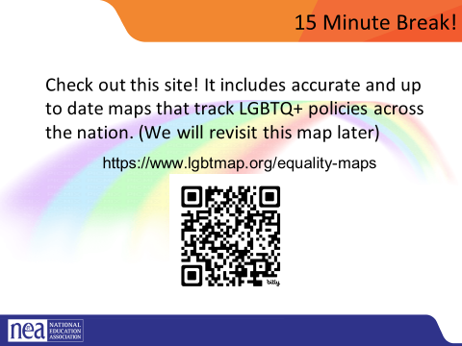

BER 1-8 FOR GROUPS
10:25-11:15 Rachel |  |  | 4 expressions of Oppression and Intersectionality – (50 minutes)
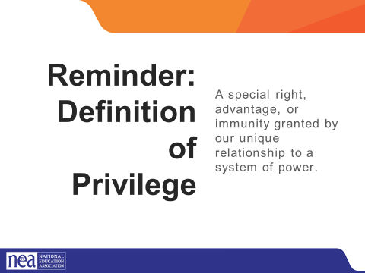  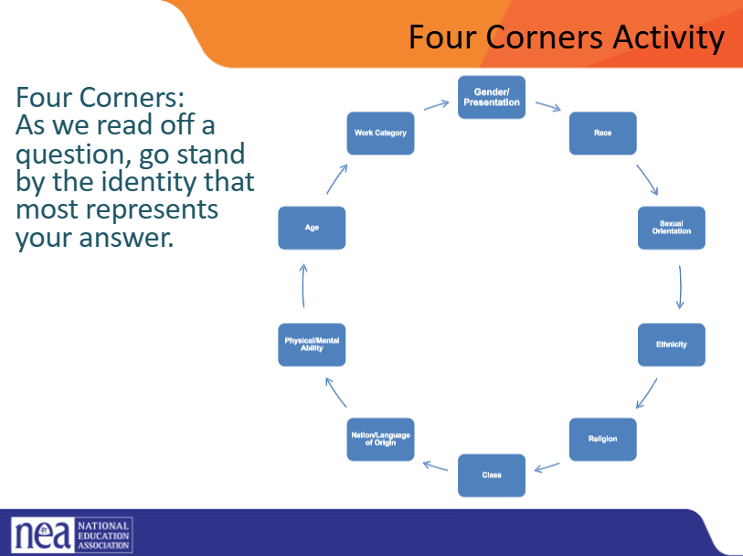  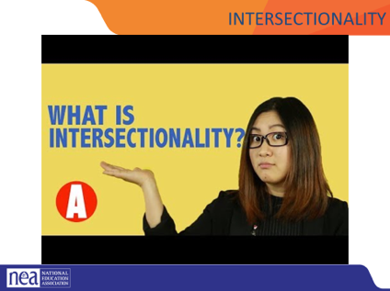  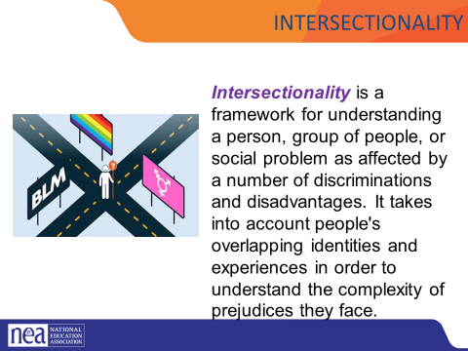  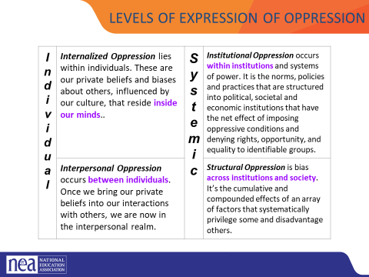  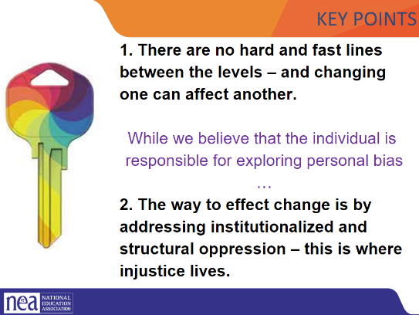  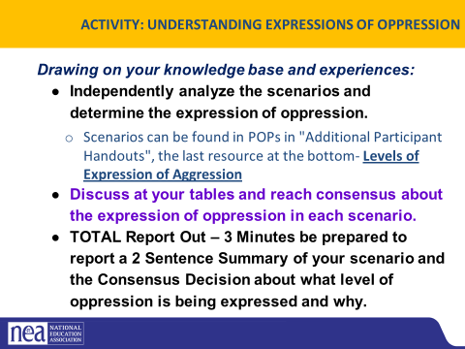  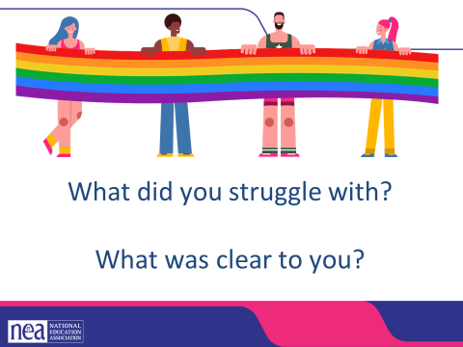 | Page 4  Video on Intersectionality we could use  https://neahq-my.sharepoint.com/:v:/g/personal/eholmes_nea_org/EYAirmGnDFpPvXDQZRhUzJEB1jZxORMr-bcuK4L7mu_z_A?e=lWWeeU  Levels of Expression Of Oppression Handout |  | (2 minutes to introduce activity) We are going to take a minute to look intentionally at our identities.  [Facilitator] REMEMBER OUR Definition of the term: Privilege: A special right, advantage, or immunity granted by our unique relationship to a system of power.  Introduce activity by saying  We are going to take some time to intentionally explore our identities and how they relate to power.  - Each identity is posted around the room. Take a moment to look around and see what is on the walls:  - Gender/Presentation  - Race  - Sexual Orientation  - Ethnicity  - Religion  - Class  - Nation/Language of Origin  - Physical/Mental Ability  - Age  - Work Category  Does anyone need clarity on any of the identities?  Gender is referring to gender for this activity. ie Man, woman, non-binary with Man/Masculinity being the place of privilege, and femininity and woman being the place of oppression.  Sexual Orientation: Who people have romantic and sexual attraction to. (Gender is who you are, sexual orientation is who you love)  Ethnicity- : Some people identify with a part of their cultural heritage, or they may not know it, they lean into one part more than another. They celebrate traditions of a culture they embrace.  I am going to ask you some questions, after each question, move to the identity that best answers the question. Remember, challenge by choice, this is not meant to out anyone  10 min. Movement Questions:  - Which identity do you think about the most?  - Which identity do you think about the least?  - Which identity are people most surprised to learn about?  - Which identity brings you the most discomfort or confusion?  - Which identity brings you the most joy?  8 Min - small group reflection  - Which identity of yours did you think about the least? Discuss why you didn’t have to think about it as much, and what that could mean in terms of your identity? How can you leverage that privilege/power for marginalized people in your scope of influence?  4 expressions of Oppression and Intersectionality – (30 minutes)  10 Mins We are going to define two key terms in this next section, the first is Intersectionality –  Let’s watch the following video  3-5 minutes Video  - Video of intersectionality –  To review Intersectionality is a framework for understanding a person, group of people, or social problem as affected by a number of discriminations and disadvantages. It takes into account people's overlapping identities and experiences in order to understand the complexity of prejudices they face. This is important to keep in mind as we approach our work in supporting individuals experiencing oppression.  Now, let’s define The Levels of Expressions of Oppression. We use this framework because it allows us to think about the scope of the solution to a particular problem. (This is a tool that people in power use) Facilitator Note: Connect identities from earlier activity and the identities of others to this piece.  Internalized oppression lies within individuals. These are our private beliefs and biases about others, influenced by our culture.  Interpersonal Oppression occurs between individuals. Once we bring our private beliefs about differences into our interactions with others, we are now in the interpersonal realm.  Institutional Oppression occurs within institutions and systems of power. It is the norms, policies and practices that are structured into political, societal and economic institutions that have the net effect of imposing oppressive conditions and denying rights, opportunity, and equality to identifiable groups based upon differences.  Structural Racism is bias across institutions and society. It’s the cumulative and compounded effects of an array of factors that systematically privilege white people and disadvantage people of color.  Key point – there are not hard and fast lines between the levels – and changing one can affect another. While we believe that the individual is responsible for exploring personal bias – the way to effect change is by addressing institutionalized and structural racism – this is where injustice lives.  15 Min Defining Expressions of Racism Activity - Use the Handout Levels of Expression Oppression Scenarios found in your POPS in additional participant resources.  3 minutes form 8 groups. Each group is given a scenario to look at. They are to determine which level of oppression this scenario is about  5 minutes for teams to review scenarios and come up with what level of oppression their scenario is and why. Prepare a summary of your scenario to share with the whole group. Each group will have a total of 3 minutes to share a short summary, provide which level of oppression the scenario exemplifies, and tell why.  5 Mins: Debrief – Choose 1-2 good share outs of scenario work (either from listening as they work or by asking the room) to share with the whole group. Each group will have a total of 3 minutes to share a short summary, provide which level of oppression the scenario exemplifies, and tell why. what level did your group determine your scenario was at and why?  Overall debrief questions if there is time:  - What did you struggle with? What was Clear to You?  Let’s revisit our key point - there are not hard and fast lines between the levels – and changing one can affect another. While we believe that the individual is responsible for exploring personal bias – the way to effect change is by addressing institutionalized and structural racism – this is where injustice lives.  Also, let’s revisit how using an intersectional lens alongside the understanding of levels of oppression can really help us decide the scope of the solution we need and the power it will take to implement that solution.  Key Points there are not hard and fast lines between the levels – and changing one can affect another. While we believe that the individual is responsible for exploring personal bias – the way to effect change is by addressing institutionalized and structural racism – this is where injustice lives. |  | What are the right size solutions for the level of oppression?  Participants will learn about a framework of understanding oppression so that they can better identify actions to take in seeking justice.
11:15-12:00 : Keira and Anthony |  |  | Legal Overview (60 Minutes total)
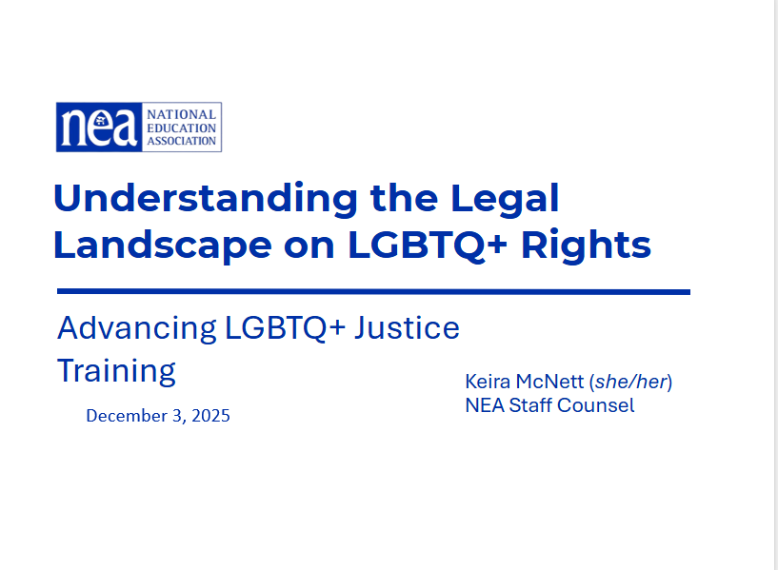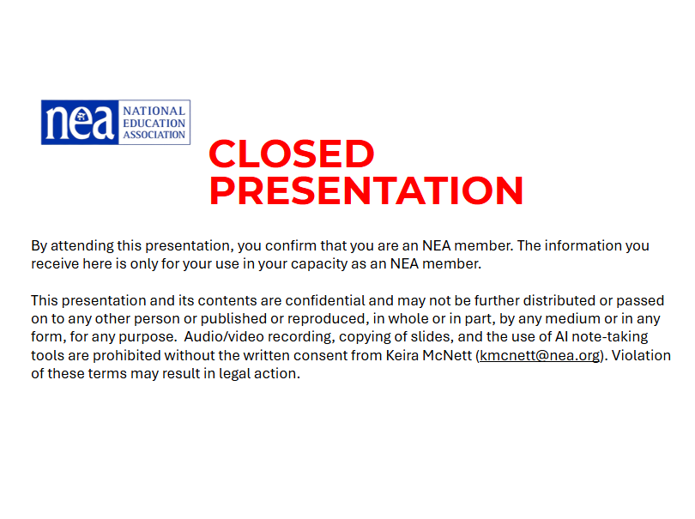  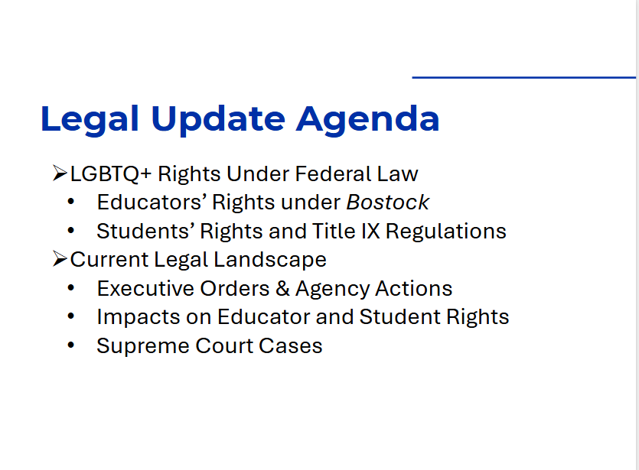  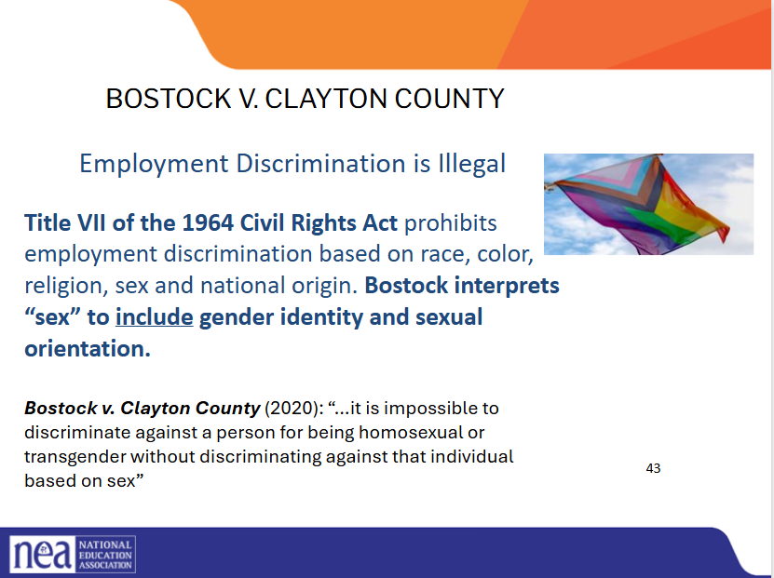  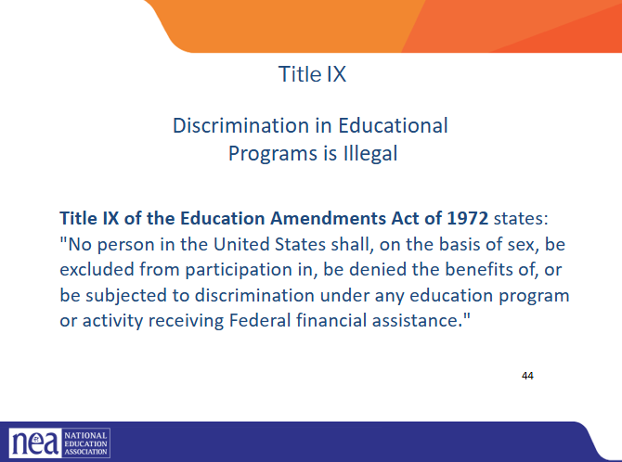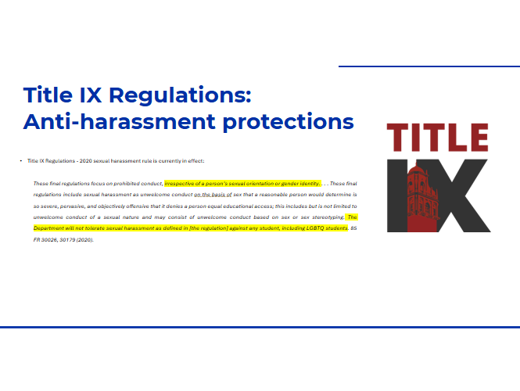  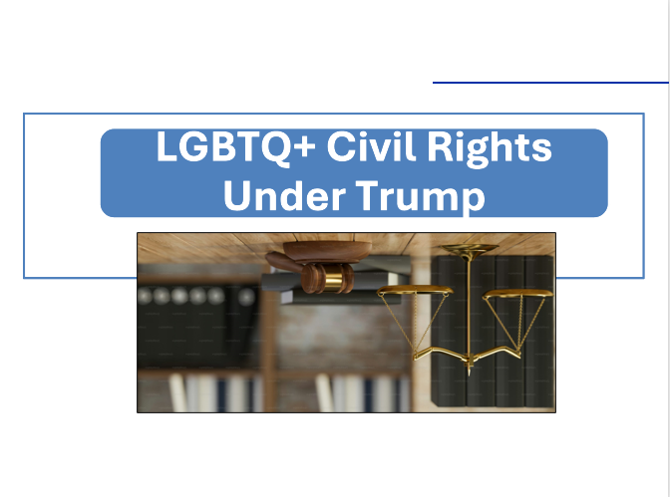  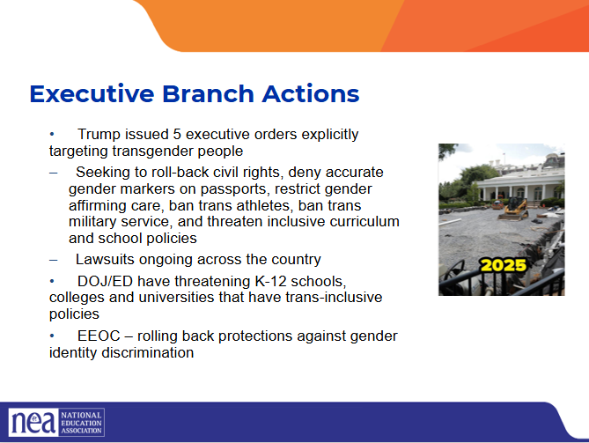  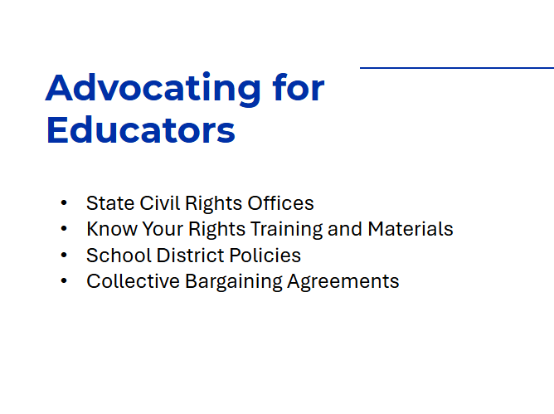  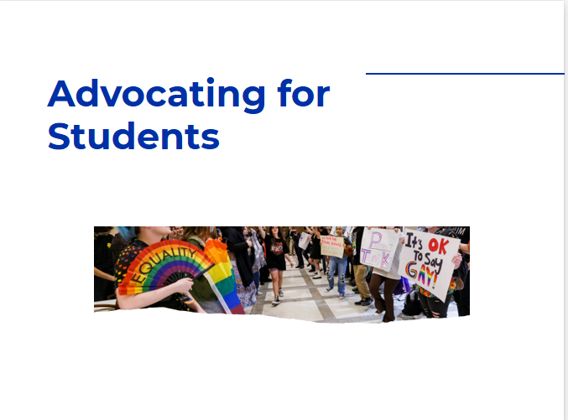  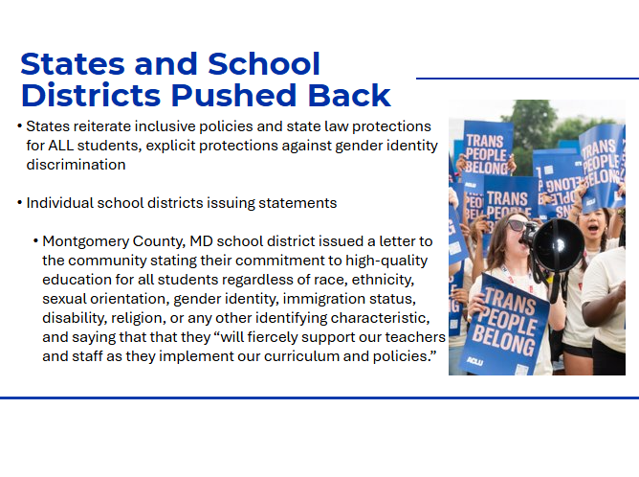  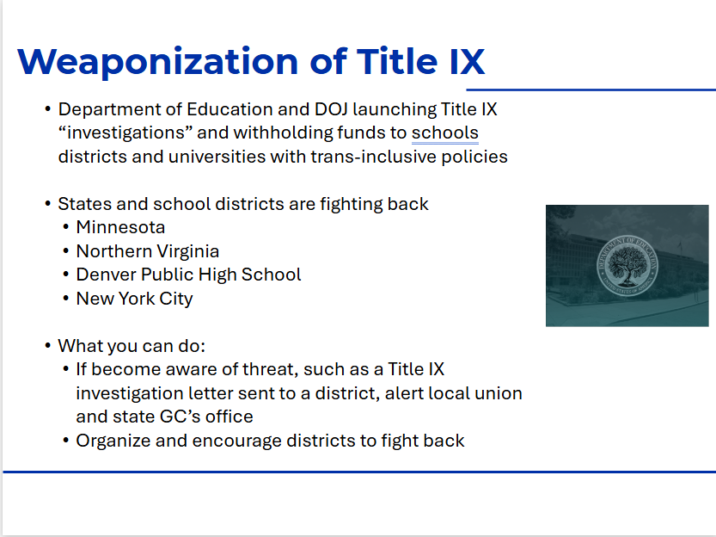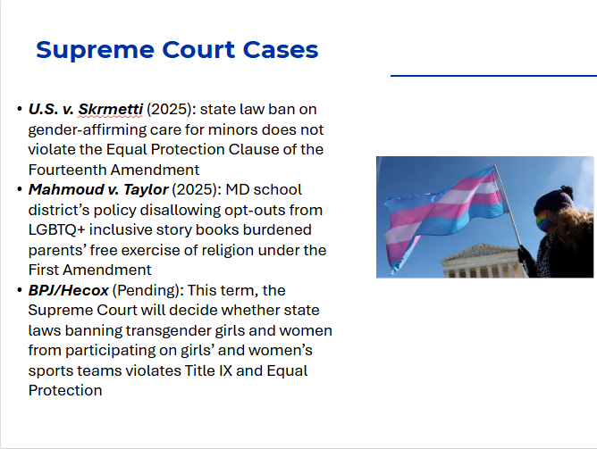  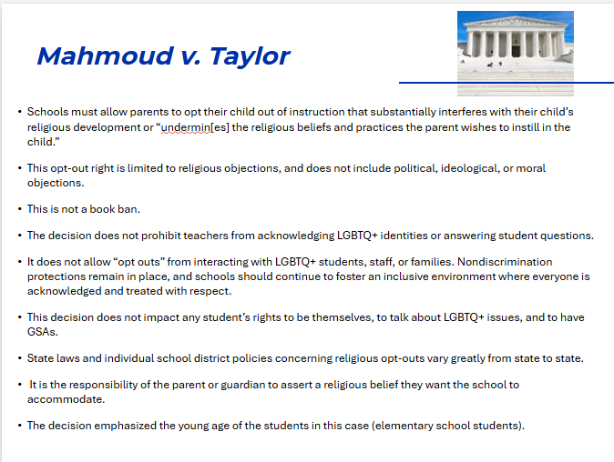  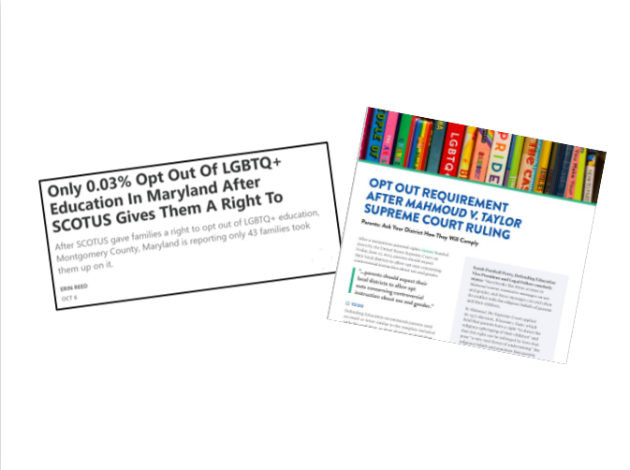 | SEND NEA RESOURCE PAGES TO PARTICIPANT EMAIL |  | In 2019, there were 157 million employees in the US. What do you think this number represents?  According to Catalyst.org, there are an estimated 8.1 million LGBTQ+ employees in the United States who are age 16 or older. 50% of these employees are not out at work because of fears of discrimination or ostracization. Nearly one quarter (23.7%) LGBTQ+ employees have experienced discrimination.  Reference: https://www.catalyst.org/research/lesbian-gay-bisexual-and-transgender-workplace-issu - broken/outdated link  New link: https://www.catalyst.org/research/lgbtq-workplace-issues/  - Legal information, not legal advice. For advice on specific situations, consult local or state legal counsel  - Still, some confidentiality in this space – closed, not to be shared without express permission  - The Bostock ruling specifically states that employment discrimination on the basis of gender identity and sexual orientation is illegal.  - Title VII of the Civil Rights Act covers the full spectrum of employment decisions, including recruitment, selections, terminations, and other actions concerning terms and conditions of employment. This is significant for the LGBTQ+ community because, as we saw, in many states it was legal to be denied an interview or a promotion, and even to be fired because of one’s gender identity or sexual orientation.  * Summarize back and forth of T9 regs  - Reference: Department of Justice, “Application of Bostock v. Clayton County to Title IX of the Education Amendments of 1972,” March 26, 2021, https://www.justice.gov/crt/page/file/1383026/download  Currently the Trump 2020 regulations are in effect  Dept of Education OCR no help, but at school district and institution level, this is what schools are held to – schools have liability under Title IX if parent/student brings private lawsuit  K-12 schooling EO Attacking “gender ideology”; threatening prosecution for affirming trans, intersex and nonbinary students  The President cannot change existing federal civil rights laws.  The President cannot direct states and school districts how they will enforce their laws.  State non-discrimination, anti-harassment and bullying prevention laws, school district policies, and educator ethics codes often require that educators respect, affirm and include students of all genders.  In addition, state laws, school policies or professional ethics may require that staff respect the confidentiality of students who seek support.  KYR – employment law rights (federal and state and under district policies/CBAs) and rights as advocates (limitations of 1st amendment rights, esp K-12, but advocating on matters of public concern in private capacity)  Policies and CBA – can speak to incidents (like microaggressions) that can be addressed before something rises to the level of harassment  CBAs – NEA has guidance on bargaining for protections  CA AG Bonta; CA State Superintendent: “In California, all still means all.”  NJ, MA, others reiterating state law protections  Schools do not have to remove any books from classrooms or school libraries; nor do they have to censor the curriculum in any way. LGBTQ+ inclusive books and curriculum are not presumptively objectionable.  - Most districts already have opt-out policies in place that should be evaluated to determine if they are sufficient to provide parents with the required notice and opportunity to have their child excused from instruction that substantially interferes with their religion.  - Educators and school administrators do not have an obligation to make guesses about what religious beliefs anyone holds or what may be objectionable based on those beliefs.  - While the Court didn’t create a bright-line rule, it strongly implied that religious objections to exposure to LGBTQ+ topics (and presumably other topics about which a parent may have a religious objection) are particularly forceful when focused on younger students.  Parents Defending Education  Erin in the Morning – substack  Very specific to state law/opt-out policies, district policies |  | Participants will gain an understanding of the legal landscape.
12:00 – 1:00  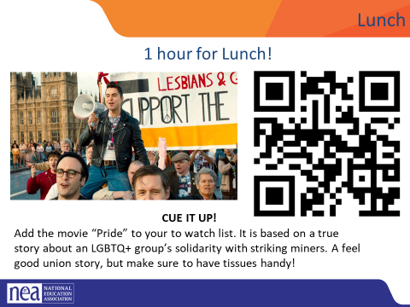 | LUNCH
1:00-2:00 | Legal Q&A with Kiera and Anthony
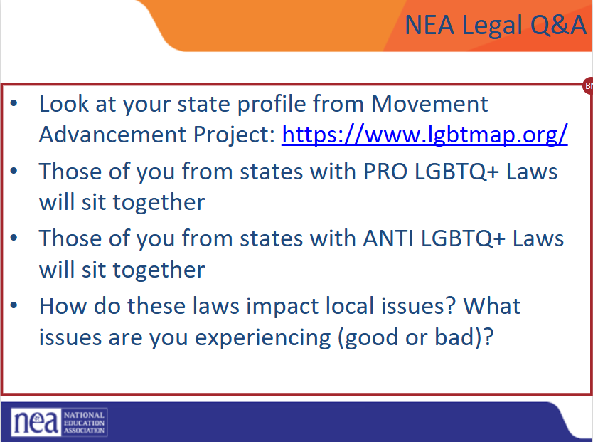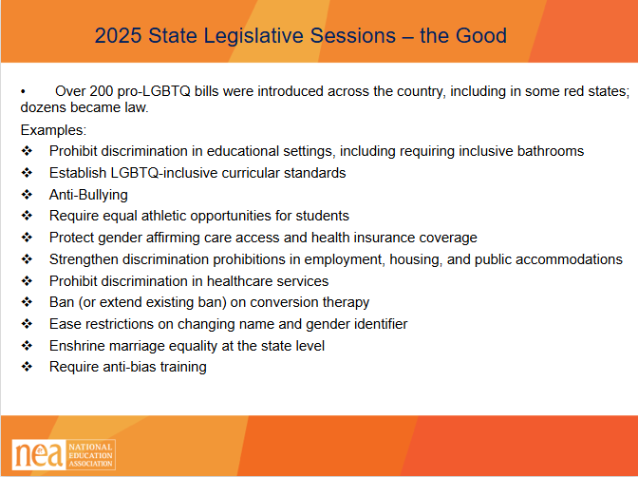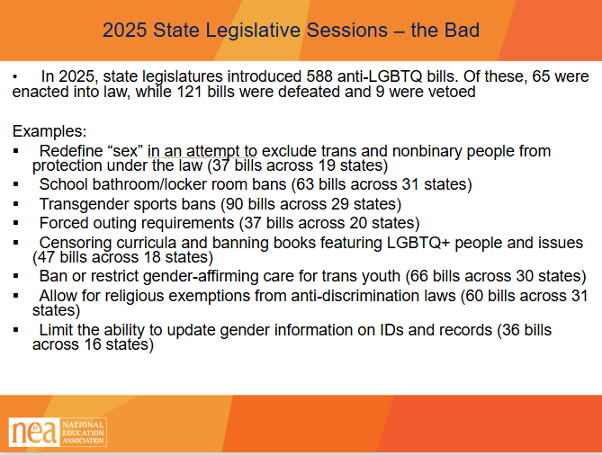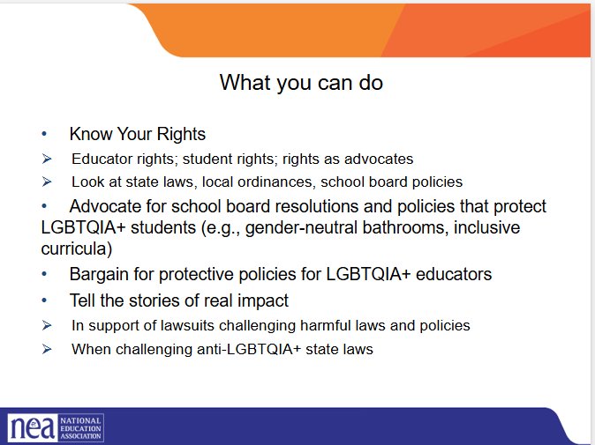 | Insert Script  These 3 slides are possibilities for starting the discussion after lunch, prior to having folks look at MAP for their state. What do you think?
2:00-2:15 | Break
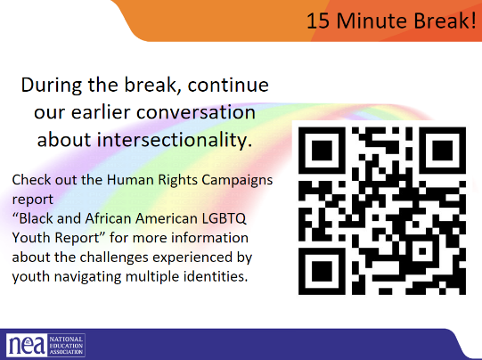
2:15-2:30 Sara and Zac | Collective Strength
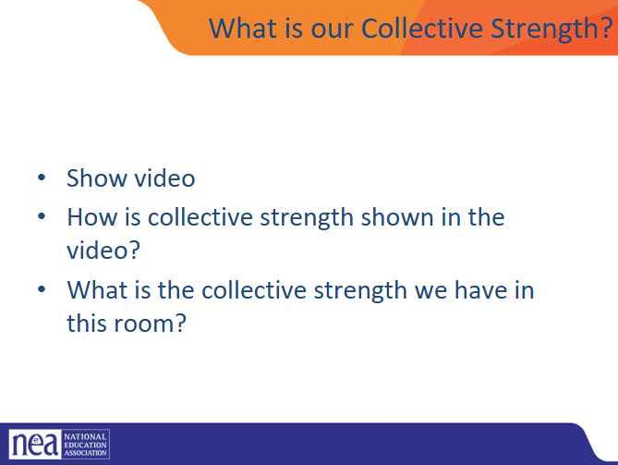  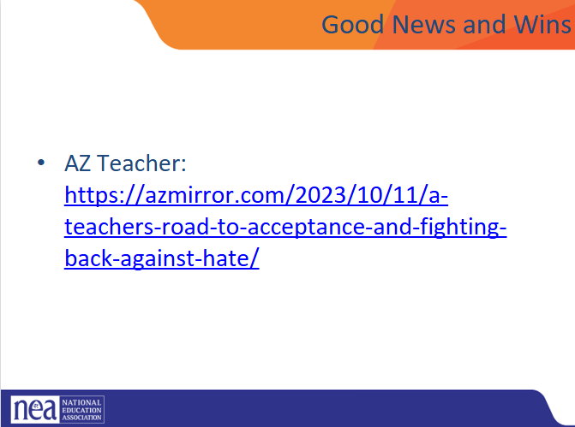 |  |  | Overall Support:  A 2024 PRRI survey found 75% of Americans support policies protecting LGBTQ Americans from discrimination in housing, employment, and public accommodations, down from 80% in 2022.  GLAAD Study:  A 2024 GLAAD report also showed support for LGBTQ equal rights at 80%, a decline from 84% a year prior.
2:30-3:00 Sara and Zac |  |  | Create RCGN
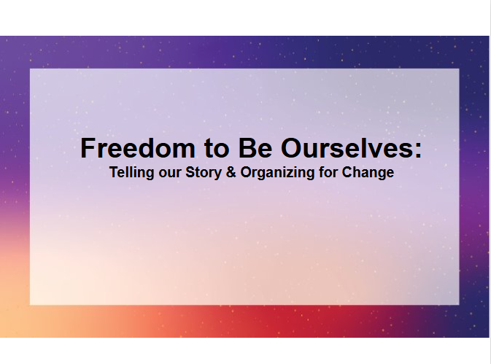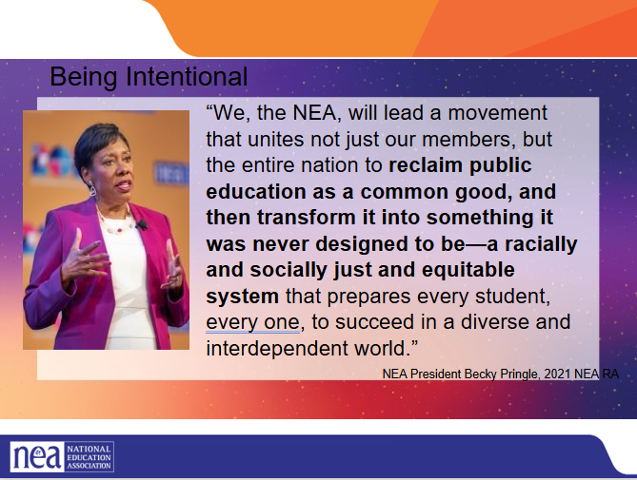  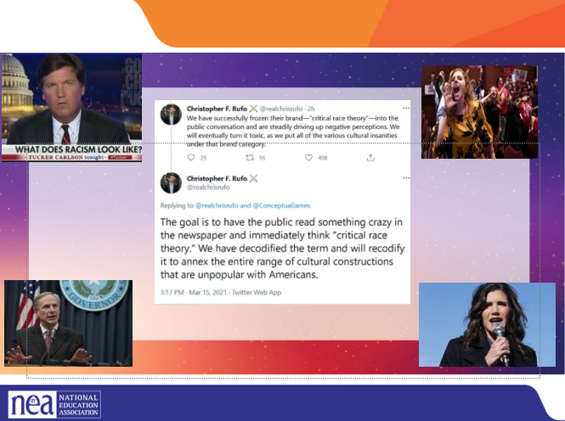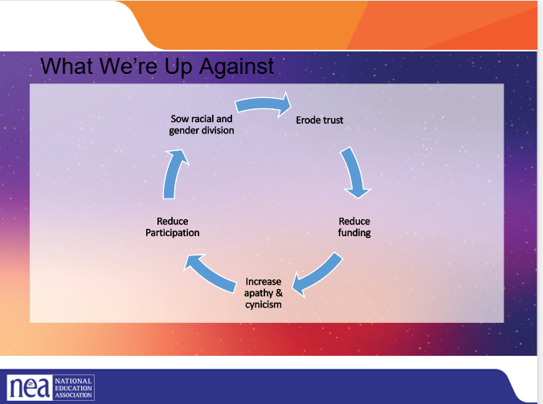  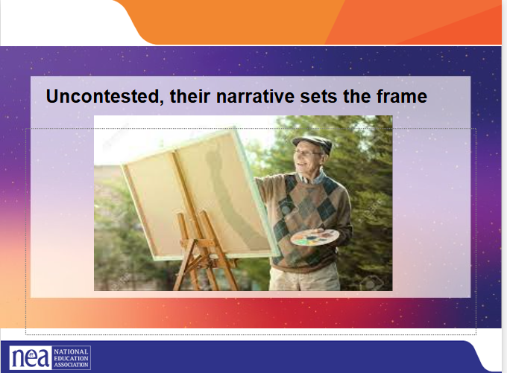  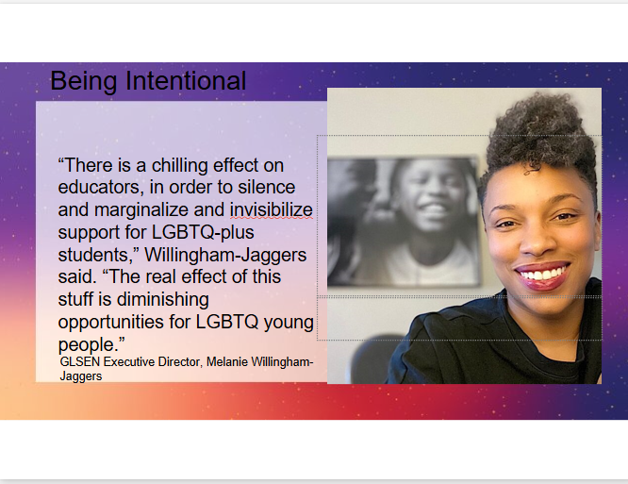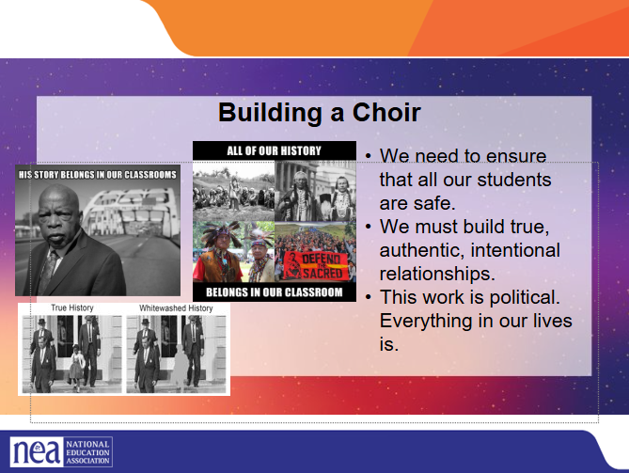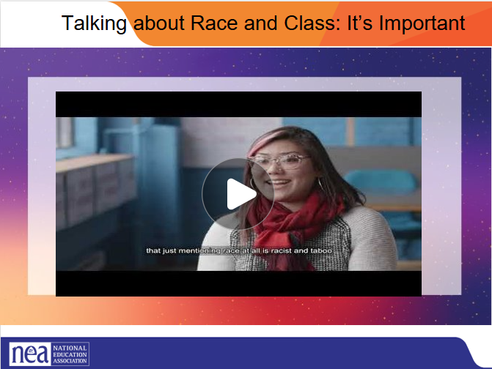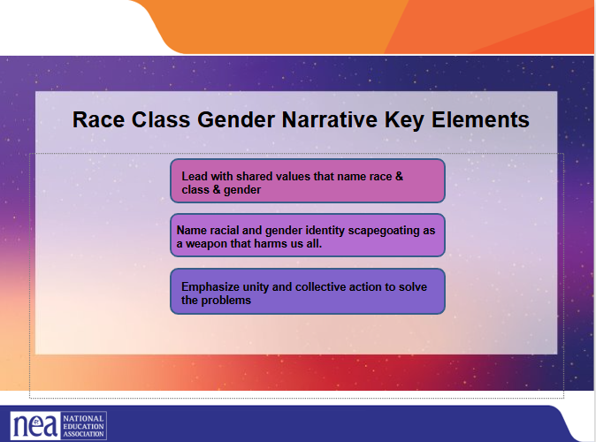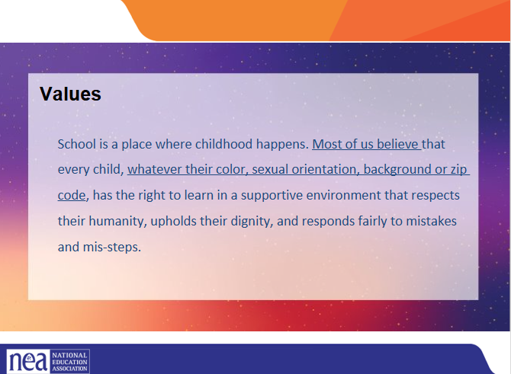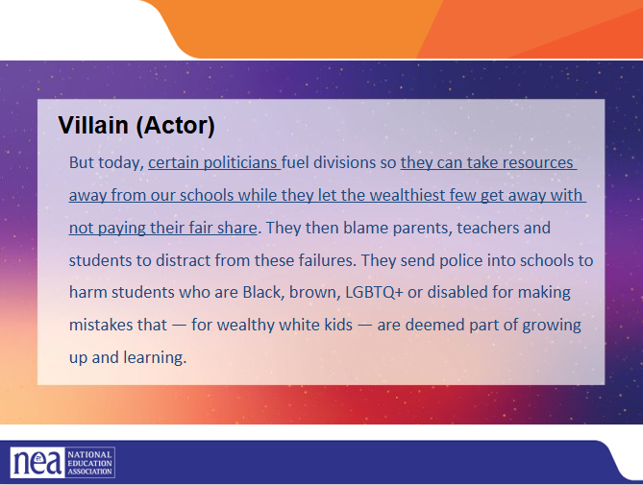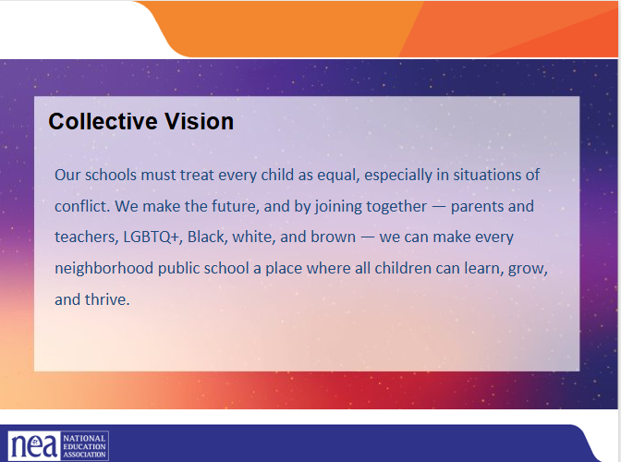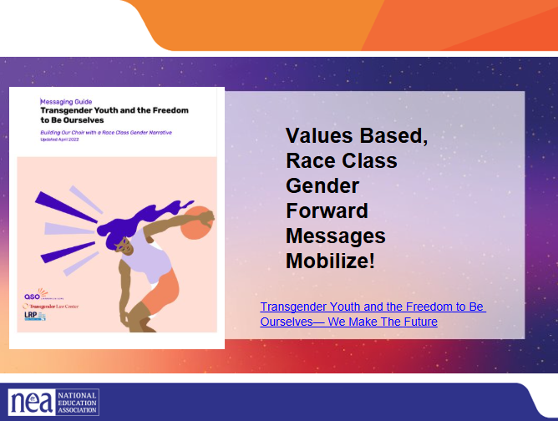  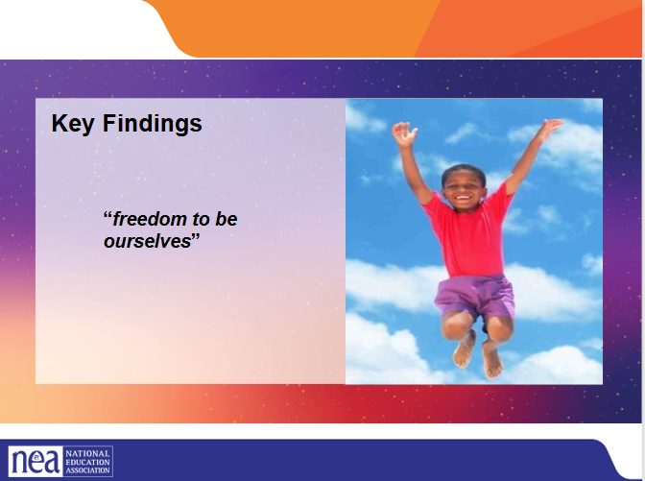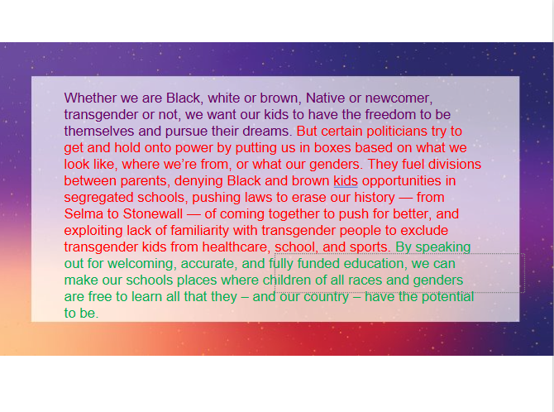 |  |  | - Today we are going to talk about Navigating and Narrating the Road to Education Justice and will share resources and tools to move our vision of education justice.  - We are grateful to our partners who worked around the clock to get results ready for the research briefings we held in October. We have a recording of that presentation and the key findings documents for you in our Resources and Tools document that you will receive after this session.  - In the next few weeks you will be receiving the message guidance that came from that research. This is not a research briefing.  - Today, I want us to think about….  •Who’s talking about race?  •And how do we interrupt dog-whistle tactics to win the great public schools our students deserve?  But the NEA is clear on our collective vision and our responsibility to our students and educators… to win all that we need for all kids to thrive –whether Black, brown or white –  PICTURES:  Tucker Carlson  Greg Abbott  Kristi Noem  Mike Pence  Parent at Virginia School Board meeting  ==================  So, let’s look who’s talking about race  - Christopher Rufo’s tweet is the most recent version of the age-old playbook – that has been used by so many –especially in public education.  - And it caught on in the months that followed, we’ve seen governors, presidential hopefuls, TV personalities using this tactic to move a radical agenda.  - Same coordinated & well funded actors: anti-vax, masks, LGBTQ and voting rights.  - For months our opponents have channeled racial grievances into a race-baiting -debate challenging the progress we have made in teaching more honest and accurate history.  - Based on lies and disinformation campaigns, they created a culture war issue meant to mobilize their base by spreading fear.  - We’ve all seen the heightened attacks on educators, parents and students who speak out against these tactics.  - But these tactics have also worked to move the conversation away from the learning and working conditions for students and educators and the very curriculum and care kids need to thrive.  - Uncontested, we know that race baiting attacks and attempts at whitewashing history have direct impacts on achieving our vision for public education --fully funded and equitable for every student.  - These tactics are directly linked to the rights agenda to:  --defund public schools  -privatize public schools and other public services and  --decrease professional respect for educators, union rights and collective bargaining power  These attacks impact every one of us who work in service of safe, affirming and just schools for our students.  The hateful rhetoric and policy language being spread seems designed to appeal to fringe partisans, it is part of a conservative effort to foster a moral panic that will help limit how and what educators teach — by restricting history lessons, banning books, and curbing discussions of systemic racism and LGBTQ issues. Inflicting pain on our students in service of creating division aimed at eroding trust in public education and public institutions writ large.  Now that we have define dog whistles can you identify a few dog whistles used in education:  CRT  Private Schools  Government Schools  Indoctrination  Socialism  Title I Schools  The key elements of RCN messages include:  1. Lead with a shared value that names race and class.  2. Naming the motive behind why our opponents are using racial scapegoating as a way to divide us...  3. Connect joining together to achieve desired outcomes. Give a call to action urging people to be an active participant in creating change.  The public is with us in supporting public schools. It is time to boldly, loudly, and repeatedly share our vision for public education. When we do, we win.  New research by ASO Communications, Transgender Law Center, and Lake Research Partners finds that we can cultivate resistance to these attacks, build cross-racial solidarity, and advance a shared vision for the future by weaving together our shared values, experiences, and demands across races and genders. This new approach builds on the Race Class Narrative to tell a convincing story of how our opposition uses strategic racism and transphobia to harm us all; and how, by coming together, we can ensure we all have the freedom to be ourselves and support one another. Using a Race Class Gender Narrative, we can mobilize our base (particularly Black, AAPI, and Gen Z audiences), marginalize our opposition, and move persuadables across race.  TAKING THE WORD FREEDOM BACK. Across racial lines, evoking freedom as an aspirational value increases agreement with expressions of equity against opposition claims about parental freedom and choice. Talking about the “freedom for children to pursue their dreams” wins by big margins. Indeed, making children the protagonists in freedom-based framing is more effective than casting teachers in this role by discussing their freedom to determine what they teach.  This is one example of how the race class gender narrative can be used to connect our issues… our fights.  PURPLE text is the VALUE  RED text describes the actors and their motivations  Green text is our COLLECTIVE Call to Action  **MAYBE CALL ON 3 AUDIENCE MEMBERS TO READ EACH COLOR?  That red part is important –We have to name the actors and their motivations. People are cynical that anything can change right now. If we don’t tell them who is making the decisions that impact their lives and what the motivations are, the people we want to mobilize to come to a school board meetings, or tur out to vote won’t –BECAUSE the problem will feel too overwhelming and the actions we are asking them to take won’t connect.  Thirdly, positioning bans as shortchanging children of the skills they need for the future proves effective. Our base and persuadables respond to the idea that “these bans shortchange [children] from developing critical thinking skills.”
3:00-3:20 Alex |  |  | Campaign Scenarios and Overview of Campaign Plan
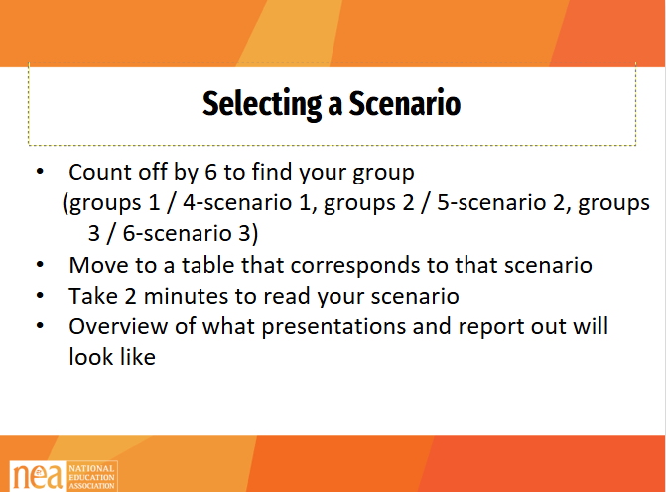  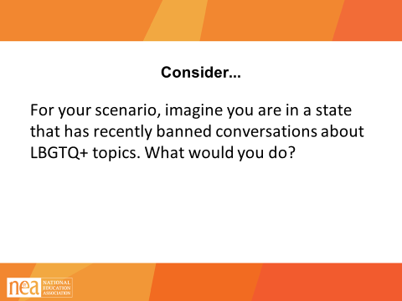  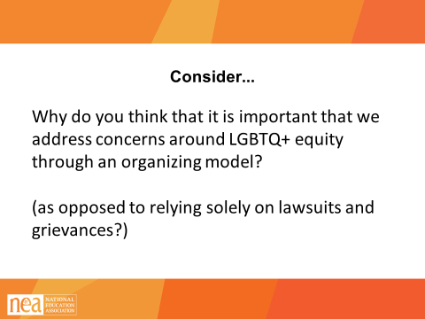  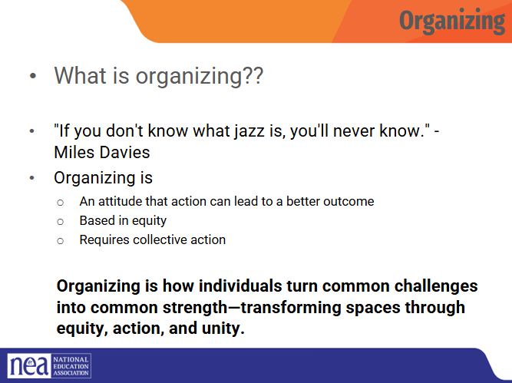  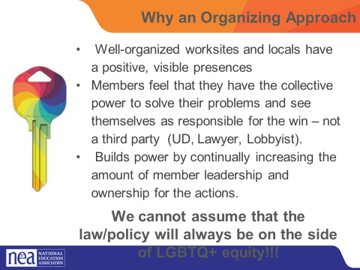  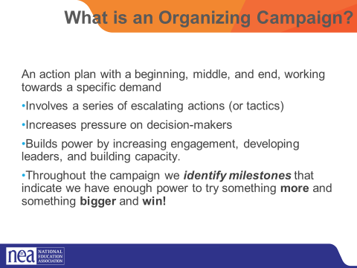  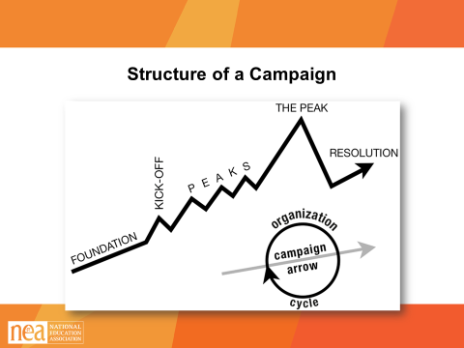  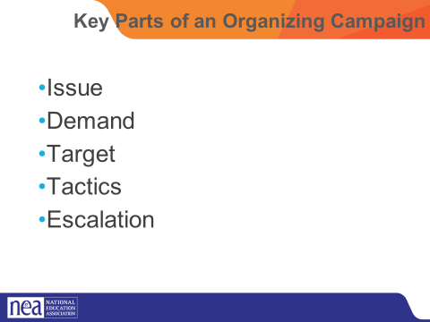  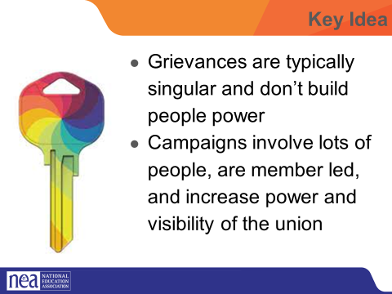 | POPS Participant Handouts  Scenario Package Handouts Pg 7-10  Campaign Plan Handouts  UPLOAD THE CAMPAIGN PLAN HANDOUTS  ASSESSING OUR ISSUE CHARTS |  | Today we are going to spend a lot of our time practicing what we have learned over the past two days. You will break into groups and work on building an organizing campaign that addresses one of the scenarios found on pages 7-10 of your participant handouts in POPs.  Getting into Scenario Groups (2 minutes)  The facilitator will count participants off by 6.  - numbers 1 and 4 will work on scenario 1  - Numbers 2 and 5 will work on scenario 2  - Numbers 3 and 6 will work on scenario 3  Once participants have counted off, they will move to the table with the corresponding number (have a piece of chart paper on the wall showing groups, have table numbers)  Take 2 minutes to read your scenario, found on Page 7-10 in POPs. For much of our remaining time, we are going to work on building an organizing plan to address these issues. Go to the table that corresponds with the scenario you would like to work on.  At your table, consider the following prompt: For your scenario, imagine you’re in a state that has recently banned conversation about LGBTQ+ topics. What would you do?  Ask for one participant to answer the following question: Why do you think that it is important that we address concerns around LGBTQ+ equity through an organizing model? (as opposed to relying solely on lawsuits and grievances?)  Well-organized worksites and locals have a positive, visible presences  Members feel that they have the collective power to solve their problems and see themselves as responsible for the win – not a third party (UD, Lawyer, Lobbyist).  Builds power by continually increasing the amount of member leadership and ownership for the actions.  We cannot assume that the law/policy will always be on the side of LGBTQ+ equity!!!  2 mins – INTRODUCTION TO CAMPAIGN PLANS Mountain  - So why do we need campaigns? A campaign is an action plan with a beginning, middle, and end, working towards a specific demand that we want to win.  - A campaign has a target, someone who can give us what we want. It usually involves a series of escalating actions (or tactics), which means that we progressively turn up the heat.  - A good campaign creates increasing pressure on decision-makers over time by escalating the intensity and visibility of the tactics and increasing the numbers of people involved.  - Campaigns are a way to identify in advance the ingredients we need to win and put them together in a way that maximizes our chances of success.  - One isolated action may not be enough to solve the problem.  - Campaigns help us to shift the balance of power in our workplaces and build members’ confidence.  - Many issues that members care about can’t be solved with grievances.  - Besides, grievances are invisible to most members, because they don’t usually involve collective action.  - We need our actions to be participatory and public.  There are five main parts to a campaign. We are going to go through each-  - Issue  - Demand  - Target  - Tactic  - Escalation  We are going to go through each of the key components of an organizing campaign and apply each to our scenario. Then, at the end, we will compile and present our final campaign plans for our scenarios.  1 MIN- WRAP UP/KEY POINTS  - Grievances are typically singular and don’t build people power  - Campaigns involve lots of people are member led and increase power and visibility of the union |  | Participants will apply their new learnings to complex teams-based scenarios.  Participants will apply a campaign framework to their plan to seek justice for the individual(s) in the scenario.
3:20-3:40 Alex |  |  | Problem vs Issue
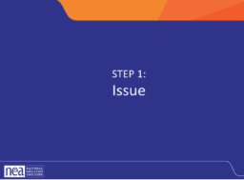  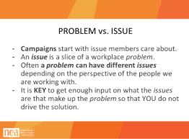  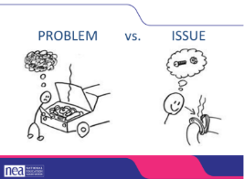  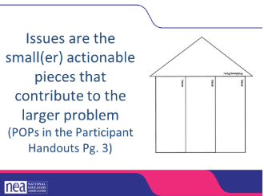  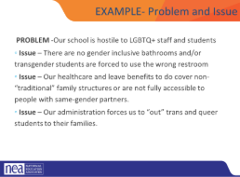  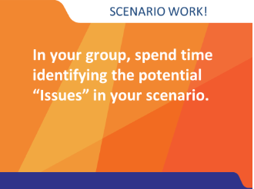  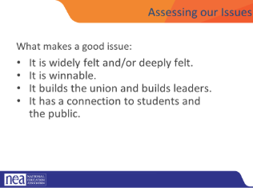  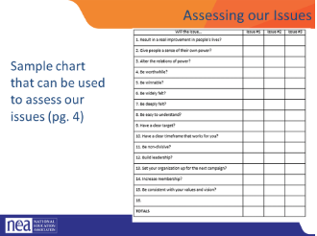  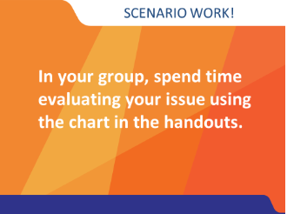 |  |  | There are a lot of problems in our work. They weigh us down, they drain our energy, they feel unsolvable. The first step in a campaign is taking the time to turn your problems into an issue.  5 Minutes Intro - PROBLEM vs. ISSUE  - Campaigns start with issues members care about.  - An issue is a slice of a workplace problem.  - Often, a problem can have different issues depending on the perspective of the people we are working with.  - It is key to get enough input on what the issues are that make up the problem so that YOU don’t drive the solution.  - A staff-driven solution may not meet the needs and commitment of the people you are working with.  Note: for your scenarios, there may be a “service” model solution and an organizing issue. Think of direct service as a way of solving the immediate crisis and organizing as a way of addressing a bigger systemic issue so it doesn’t happen again  So, for example, the problem here is that the car doesn’t work. In order to address that, we need to figure out the specific thing that we can change to make the car work—in this case, it is a missing screw in a pipe joint.  Issues are the smaller, actionable pieces that contribute to the larger problem. I think this is supposed to be a house, but I actually think of it as a rocket. We are trying to build the energy and power to remove the problem. The problem is at the cone of the rocket, and each issue is a rocket booster. With each issue that we identify and organize around to resolve, we build more power until we can blast the problem out of our world.  Here is an example that we put together—yours will be better because you have more heads thinking about it.  Go over the text on the slide:  Now go back to your small groups  5 Mins – GROUP WORK including Intro  In your groups, return to your scenario and decide the:  The potential issues in your scenario  BRAINSTORM- ON CHART PAPER- ANYTHING GOES- ALL IDEAS ON CHART PAPER  5 minutes CONVERSATION ABOUT WHAT MAKES A GOOD ISSUE (then switch slide)  Assessing an issue (5 min)  How to select an issue  - Since there may be many issues confronting workers on the job, we have to also think about what makes a good issue to organize around.  - CRITERIA:  - It is deeply felt.  - It is winnable.  - It builds the union and builds leaders.  - It has a connection to students and the public.  A NOTE HERE: Often, issues of equity are deeply felt by a marginalized few, and NOT by the privileged majority. If an issue is very deeply felt, it does not have to be widely felt.  This is only a tool – it helps in the facilitation of teams who are selecting their issues – there is no hard and fast way to determine a good issue.  5 Mins – GROUP WORK  In your groups, return to your selected issues. Use the chart in the handout PAGE 112 to determine whether the issue you identified is a good issue.
3:40-4:20 Natasha |  |  | Demand, Targets, Tactics and escalation
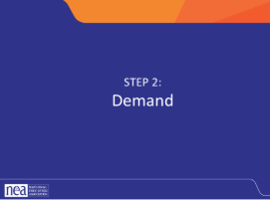  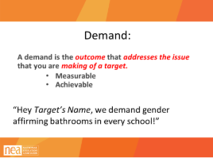    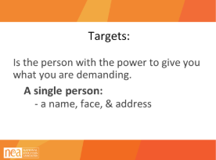  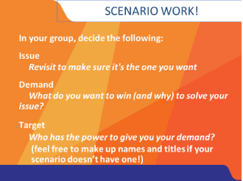  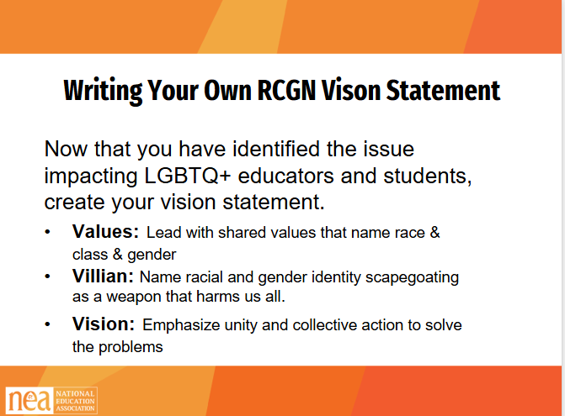  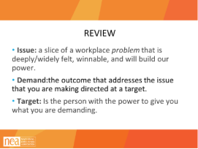  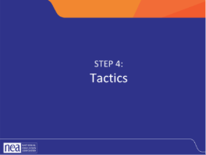  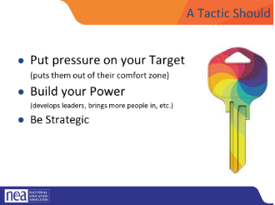  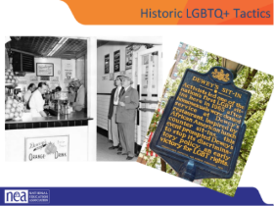  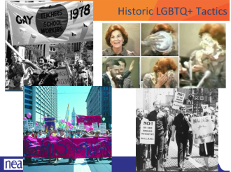  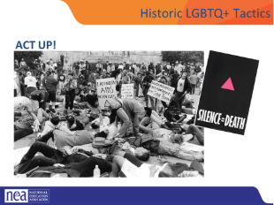  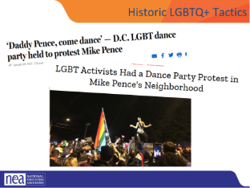  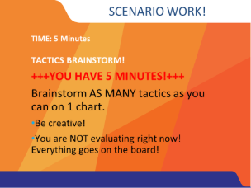  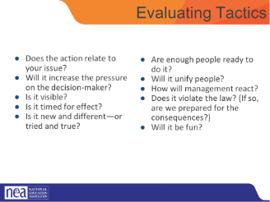  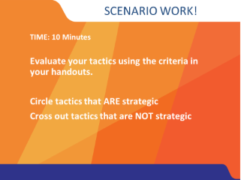  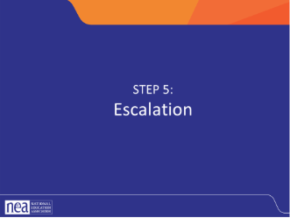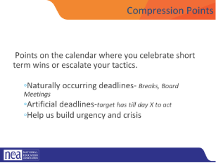  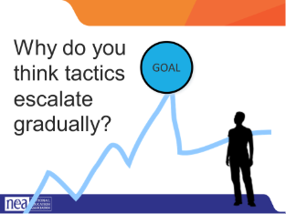  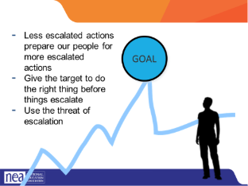 |  |  | Page 5 in POPS
4:20-4:30 Ellen – |  |  | Ending and Wrap Up 10 Minutes
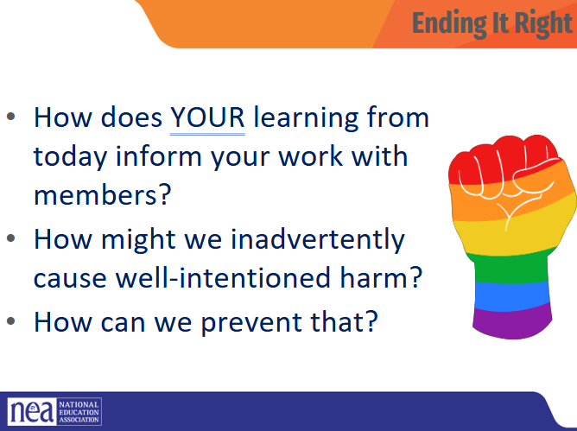 |  |  | Any logistics or questions and then out the door  .  Facilitator – Affiliate staff and those who lead others need to be able to vision a hopeful change and help others move from the world as it is into a place where they can describe the hopeful world that they want to build
LEAVE BY 4 PM for Walking Tour – Adjust before accordingly |  |  | Choice Networking

