Facilitator Agenda: Advancing LGBTQ+ Justice Day # 3
General Materials Needed: |  |  | Room Set-up:
1 Set of Handouts per Person  Name Tents with the Norms  Room signs,  One ream of white photocopy paper  Chart Paper (4 to 5 full w Sticky Strip) |  | Materials Box for each table with:  Markers (Mr. Sketch variety)  Post its – 3x3” and 4X5” sizes  Index Cards  Highlighters – 4 colors  Pens and Pencils Participant “toys” | Long Rectangle table at back for facilitators  Round Tables for participants  Projector, Screen, mics, and Speakers  Carousel stations and reporting stations  No podium, table with projector big enough for laptop
Key Outcomes for the Day:

Overview of Content, Time, and Facilitator Assignment
8:30-8:40 Entry and Welcome  8:40-9:45 Finish Day 2 Topics  9:45-10:30 Power  10:30-11:15 Coalition Building  11:15-12:00 Team Time  12:00-12:40 Presentation  12:40-1:00 Final Closing Conversations  Lunch – 1:00-2:00 BOXED Lunch | Ellen  Zac and Sara  Zac  Sara and Salina  Rachel and Natasha  Natasha and Rachel  Ellen

General Materials Needed: |  |  |  | Room Set-up:
1 Set of Handouts per Person  Name Tags or Name Tents  Sign-in Sheet  UBL Form Folder  Agendas on the table (1 per)  Room signs, sign in signs |  | Chart Paper  Markers  Post its  Index Cards  Highlighters – 3 colors  Chart Markers – non-permanent  Pens and Pencils |  | Round Tables  Projector, Screen and Speakers  Carousel stations and reporting stations around the perimeter  50 people
Key Outcomes for the Day
Participants will be able to build a campaign of escalating of tactics designed to target an LGBTQ+ issue within a scenario
Participants will understand that collective action is the way to address systemic issues of injustice
Time Slides Facilitator | Resources |  | Instructions, Activity and Debrief |  | Outcomes and Essential Questions
 | Charts, handouts, articles, materials, slide |  | What are you saying, what are they doing, what questions will you use to guide learning and make clear the important points  Include an estimate for how long each section of the learning will take |  | As a result of this section of learning, what will participants know or be able to do?
8:30-8:40 Ellen |  |  | Getting Started 10 Minutes
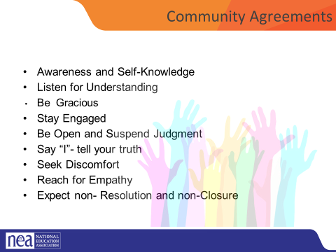    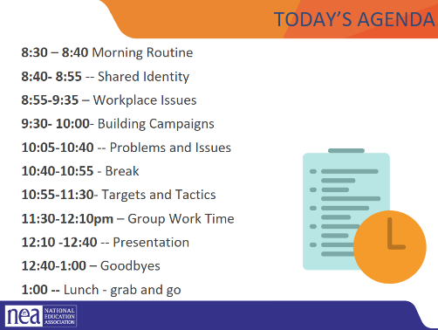 |  |  | - Intro, revisit group agreements, feedback/ Questions/Needs/Etc. Last minute logistics (10 minutes) |  | Participants will understand how their learning for the day will be structured.
8:40-9:00 Alex |  |  | Shared Identity Activity - Highest risk, content groups (15 minutes)
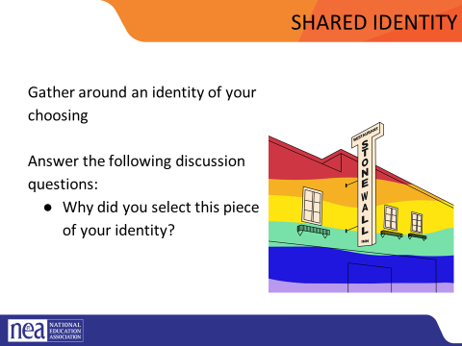 | Video  https://docs.google.com/presentation/d/1iw4K2ibF4PRp79A-CN9qeqv6b-VoNe6T/edit#slide=id.p86  (25 seconds) |  | Participants will reflect on how the intersectional aspects of each person’s identity continue to inform their relationship to privilege and oppression.  Post the following identities around the room: (we are only using day one labels today)  - High risk (day 3) – caregiver, speaker language other than English, environmental/political/social activist, neurodivergent, organizer, experienced heartbreak  Participants will get up and gather around an identity of their choosing. Everyone needs to make a choice that makes sense for them (2 min instructions), then they will answer the following discussion questions (8 min):  - Why did you select this piece of your identity?  - What are some challenges you face with this identity?  Share out/debrief (5 min)  - What was something you learned about someone else  - What was easy/hard / risky about this activity?  - Which of these identities are internal vs external?  - How did you find yourself reacting?  - Describe your feelings / thoughts about the progression from Day 1-Day 3.  ***Review the possible key ideas from Day 1 facilitator agenda***
9:00-9:45 Sara and Natasha |  |  | Power
Introduce work for third day:
Power analysis
Coalition building

Definition of power
Application or power to each element of an organizing campaign

Count off by 8
Three Minute Report Outs
Summary
What Level
Why
Then for all groups…
What did you struggle with?
What was Clear to You?

Who are people that we find powerful in our society?
(Chart out their answers)

Now looking at this list of people... What makes them powerful?
(Try to reframe or pull out answers that come back to organized people and organized money. Ex... Taylor swift’s swifties= she has a lot of people who do what she says. Donald trump= people voted for him. People work for him. He has money)

When we talk about power, the definition we use is “The ability to create, control, and prevent change. It is organized people and organized money”.

Pick one or two of the “powerful people” they have identified and ask the group, to think through, using this definition, what is that persons power.

Zac J
One helpful tool for completing a power analysis of our own context is called the Values Triangle. The triangle works from the bottom up and the inside out. At the bottom of the triangle, we have relationships. Everything starts with relationships because everything we do happens in, through, with and because of who we know and how we trust them. Inside the triangle is where we have values. Do you remember how we defined values this morning? Values are deeply-held beliefs that shape who you are. We are our best possible selves when we have clarity on our values. The world we want to see and how we define ourselves are based on our values. A person who is clear on their values knows who they are and what they believe in.
On the left of the triangle, we have self-interest. Self-interest is what our values look like in the world, the tangible manifestation of our values. When you understand your values you can discover your self-interest. Your self-interest is what you’re willing to fight for. For example, if one of your values is people over profits, one of your self-interests could include stronger unions, living wage policies, hazard pay for essential workers, and more. On the right side of the triangle is Power. Who remembers our definition of Power? Power is the ability to create, control, and prevent change. Power is made up of organized people and organized resources. Bringing it all together, we build relationships, so that we can agitate people to live up to their values and get clear on their self-interest so that we can build the power we need to make the world reflect our values. Understanding this triangle is key to your work and to making change. Every person and organization has one of these.
Values Triangle Overview (15 mins) (shortened JWJ Values Triangle)
In order to understand how we can interrupt our opponent’s power, we need to understand our own power. There is a helpful tool for power analysis that we call the Values Triangle. FOUND ON PAGE in the handouts – 47 pages in the Campaign Cyle Coaching Guide too.
Say: The triangle works from the bottom up and the inside out. Draw the outline of a triangle
Point to the bottom line of the triangle. Label it RELATIONSHIPS
- At the bottom of the triangle, we have relationships.
- Everything starts with relationships because everything we do happens in, through, with and because of who we know and how we trust them.

Draw: a “V” inside the triangle. Label it VALUES
- Inside the triangle is where we have values.
- Do you remember how we defined values this morning? Values are deeply-held beliefs that shape who you are.
- We are our best possible selves when we have clarity on our values. The world we want to see and how we define ourselves are based on our values. A person who is clear on their values knows who they are and what they believe in.

Point to the left side of the triangle. Label it SELF-INTEREST
- On the left of the triangle, we have self-interest. Self-interest is what our values look like in the world, the tangible manifestation of our values. When you understand your values you can discover your self-interest. Your self-interest is what you’re willing to fight for.
- For example, if one of your values is people over profits, one of your self-interests could include stronger unions, living wage policies, hazard pay for essential workers, and more.

Point to the right side of the triangle. Label it POWER.
- On the right side of the triangle is Power. Who remembers our definition of Power?
- Power is the ability to create, control, and prevent change. Power is made up of organized people and organized resources.
- Bringing it all together, we build relationships, so that we can agitate people to live up to their values and get clear on their self-interest so that we can build the power we need to make the world reflect our values.

The point where the ”V” intersects the relationship line is the agitation point. This is where we consider how the pieces on the top (self-interest, power, values) are brought to bear on the relationships.

Example: if we want to impact a Superintendent’s relationship with parents, it needs to factor in a self-interest that actually matters to them (e.g., public appeal/support).

Example: Mean Girls – leveraging self interest in taking down Regina George.

Say:
- This is the Values Triangle.
- Every person and organization has one of these.
- Understanding this triangle is key to your work and to making change.
- Remember that we build the Values Triangle from the bottom up and the inside out.
Lets start with NEA. What is NEA’s value triangle?

(10 min) values triangle practice

At our table groups, we’re going to take time to practice. Each group will have two volunteers to analyze a target (two rounds).

Chart with your group one of the actors/villains we’ve identified in drafting RCGN statements.

(5 min) mini debrief
What were the agitation points you identified?

9:45-10:30 Zac and Salina |  |  | Coalition Building
 |  |  | Yesterday, we talked about the importance of coalition building in order to win. We know that if we are going to win
10:30-11:40 Natasha and Rachel |  |  | Group Work
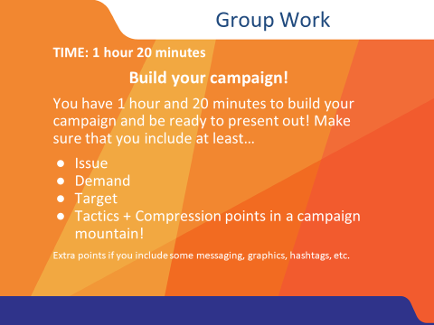 |  |  | - During this time, you will work on your scenario- in teams  - Scenario description in day two- can be placed here for reference or here if enough time is not available in day two  - Goal is to produce charts that show all five steps  Issues  Goals  Target  Tactics  Escalation  Winning!!!! |  | Participants will create a campaign composed of escalating tactics.
11:40-12:40 Rachel and Adia |  |  | Presentations (60 Minutes)
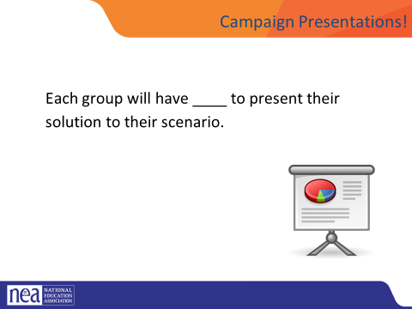 |  |  | First 30 Minutes is the team presenting to at least one other and receiving some coaching, questions, feedback  Additional 30 Minutes - What would a legal approach look like?  Have the same campaign groups look at their scenario and try to apply a legal approach. What would that look like? What are the limits of doing that? What are the benefits of doing that? How many? And who is engaged in this approach?  HOLD: If anything comes up, etc. If not....  Lingering questions/Bringing this work back home- Some sort of gallery walk/Affinity wall, etc.
12:40-1:00 Ellen |  |  | Closing activity- circle (20 Minutes)
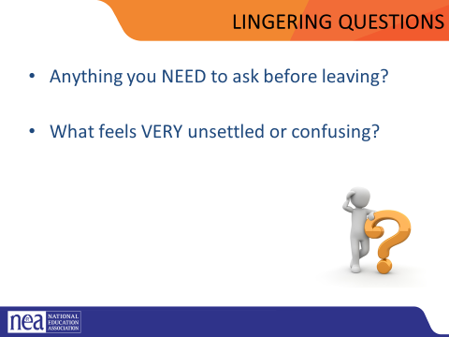
1:00 – 2:00 |  |  | Boxed Lunches and Adult Networking

