Advancing LGBTQ+ Justice Facilitator Agenda: Day # 2
General Materials Needed: |  |  |  | Room Set-up:
1 Set of Handouts per Person  Name Tents with the Norms  Room signs,  One ream of white photocopy paper  Chart Paper (4 to 5 full w Sticky Strip) |  | Materials Box for each table with:  Markers (Mr. Sketch variety)  Post its – 3x3” and 4X5” sizes  Index Cards  Highlighters – 4 colors  Pens and Pencils Participant “toys” |  | Long Rectangle table at back for facilitators  Round Tables for participants  Projector, Screen, mics, and Speakers  Carousel stations and reporting stations  No podium, table with projector big enough for laptop
Key Outcomes for the Day:

Overview of Content, Time, and Facilitator Assignment
8:30-8:50 Entry and Welcome  8:50-9:10 Shared Identity  9:10-10:15 Key Terminology  10:15-10:30 Break  10:30-11:20 Systems of Oppression  11:20-12:00 Legal Overview  Lunch – 12:00 -1:00 | Ellen  Beth  Pete - Anthony  Natasha  Grat - Bekah |  | 1:00-1:15 Continue Legal Overview  1:15-1:45 Types of Transitions  1:45-2:00 Break  2:00-3:30 Panel Discussion  3:30-3:55 Supporting Transitioning Members  3:55-4:30 Discussion Group Conversations  4:30 -5:00 Adult Choice Networking  5:00 Adjourn |  | Grat - Bekah  Anthony  Grat – Beth  Pete – Dawn  Ellen

General Materials Needed: |  |  |  | Room Set-up:
1 Set of Handouts per Person  Name Tags or Name Tents  Sign-in Sheet  Highlighters – 3 colors  Chart Markers – non-permanent  Pens and Pencils |  | Chart Paper  Markers  Post its  Index Cards |  | Round Tables  Projector, Screen and Speakers  Carousel stations and reporting stations around the perimeter  50 people
Key Outcomes for the Day
Participants will expand their ability to use correct terminology
Participants will become familiar with a framework of oppression for the purpose of understanding the size and target of solutions that seek justice
Participants will practice applying advocacy strategies to a scenario and understand strategies to implement in a workplace for improving inclusivity
Participants will understand key laws and policies for the purpose of understanding the limits of legal advocacy
Time Slides Facilitator | Resources |  | Instructions, Activity and Debrief |  | Outcomes and Essential Questions
 | Charts, handouts, articles, materials, slide |  | What are you saying, what are they doing, what questions will you use to guide learning and make clear the important points  Include an estimate for how long each section of the learning will take |  | As a result of this section of learning, what will participants know or be able to do?
Entry Activity  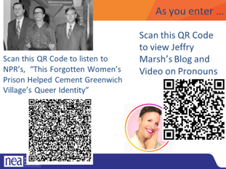 |  |  | View Videos Jeffrey Marsh | Nonbinary LGBTQ Activist, Speaker & Author  View Webpage This forgotten women's prison helped cement Greenwich Village's queer identity | NPR & Houston Public Media This is a Fresh Air episode
8:30-8:50 Ellen |  |  | Getting Started (20 Minutes)
Feedback on Feedback slides  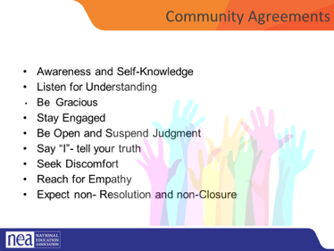  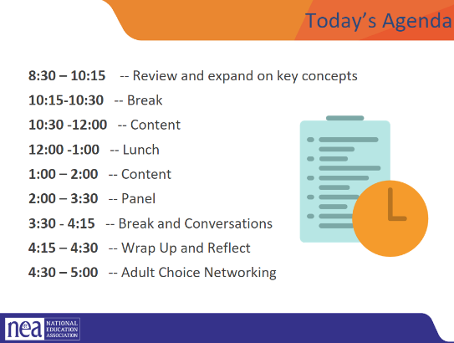 |  |  | Intro to the day  revisit group agreements,  Review Feedback,  Review Agenda  Questions/Needs/Etc.  Possible discussion of visits to Giovannis Book Store |  | What do we need to know today?  Participants will understand how day 2 will work.
8:50-9:10 Beth |  |  | Shared Identity Activity - Higher risk, content groups (20 minutes)
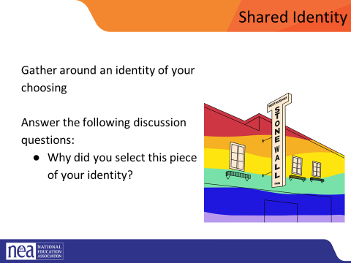  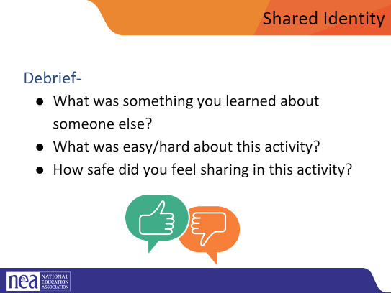  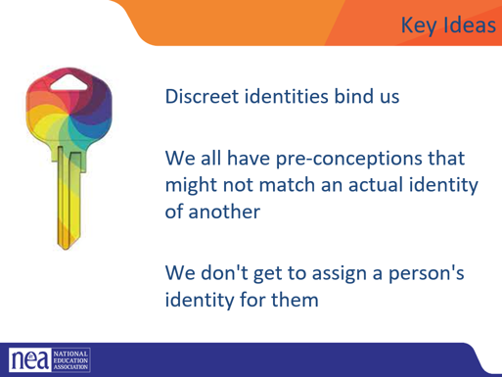 |  |  | Post the following identities around the room:  Medium risk (day 2) – parent, only child, has siblings, struggles with technology, tech is easy, life-long learner  Participants will get up and gather around an identity of their choosing (2 min instructions), then they will answer the following discussion questions (8 min):  - Why did you select this piece of your identity?  - What are some challenges you face with this identity?  - How do your reactions to today’s prompts compare to yesterday?  Share out/debrief (10 min)  - What was something you learned about someone else?  - What was easy/hard about this activity?  - How safe did you feel sharing in this activity?  - What challenged your thinking?  - How did you reactions to today’s prompts compare to Day 1?  Remember Possible Key Ideas from Day 1 facilitator guide  Key Ideas  Discreet identities bind us  We all have pre-conceptions that might not match an actual identity of another  We don't get to assign a person's identity for them |  | Who am I and Who are we?  Participants will continue to expand their connections to each other and build a learning community.
9:10-10:15 Pete and Anthony |  |  | Digging into key terminology 102 (65 Minutes)
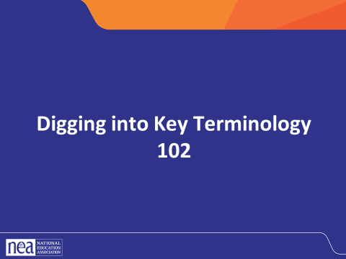  Sexual and Gender Identity  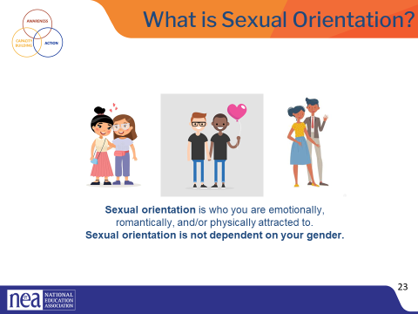  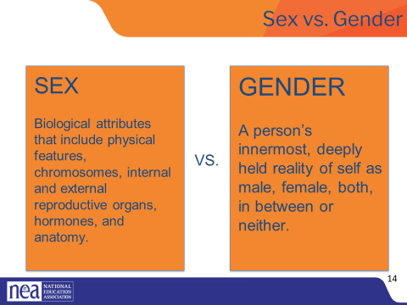  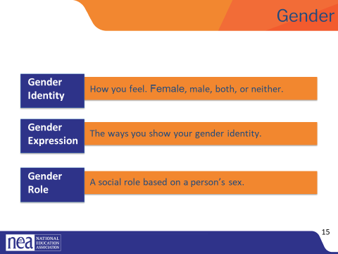  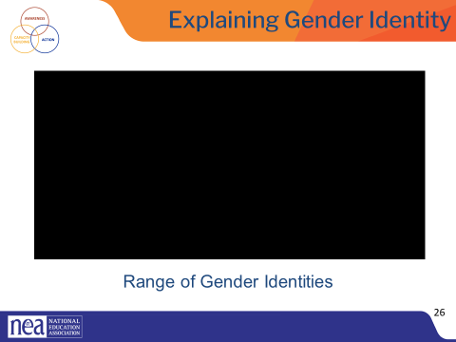  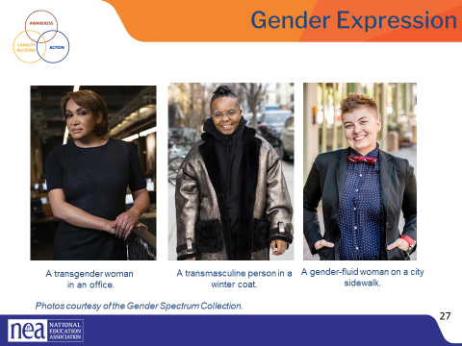  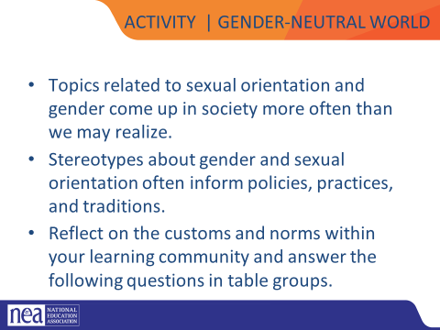  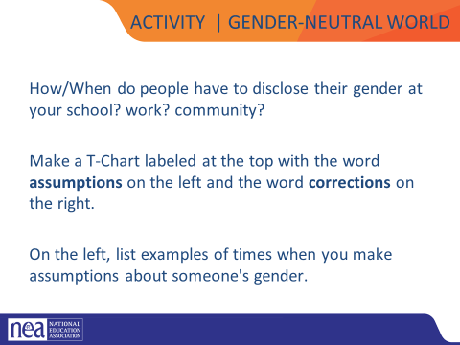  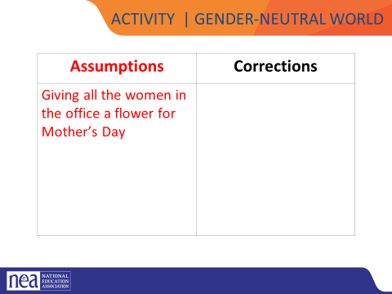  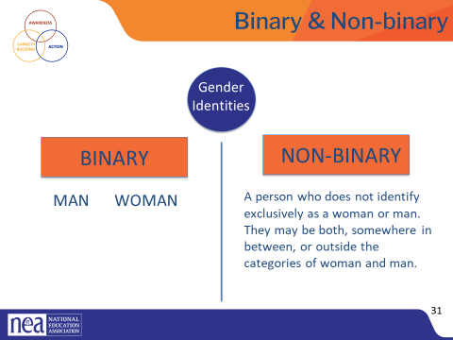  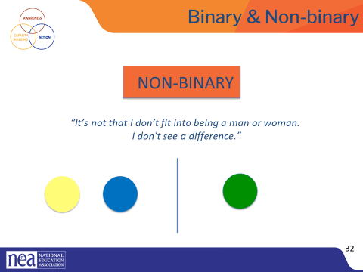  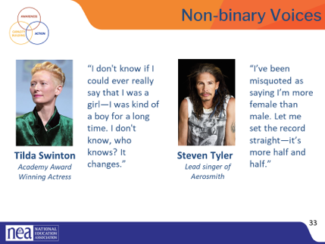  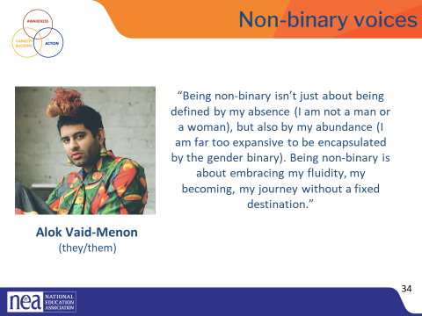  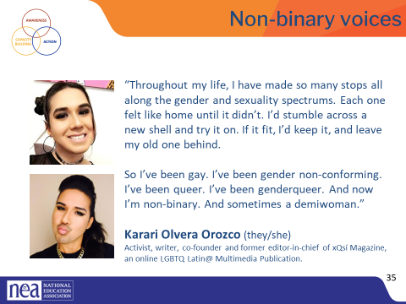  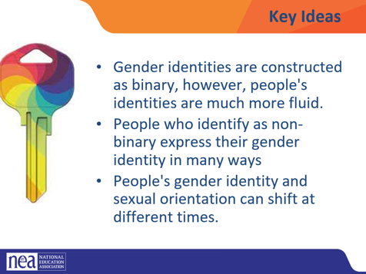  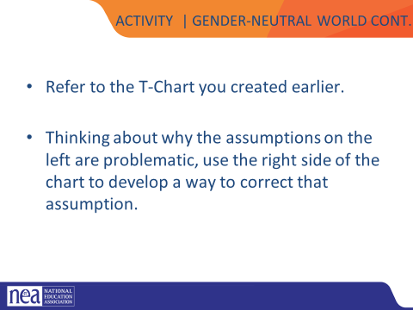  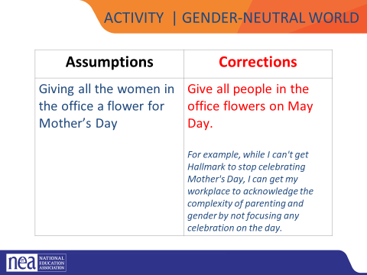  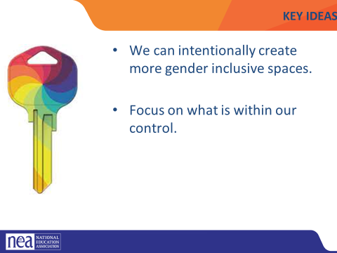  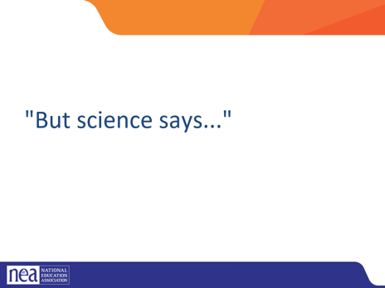  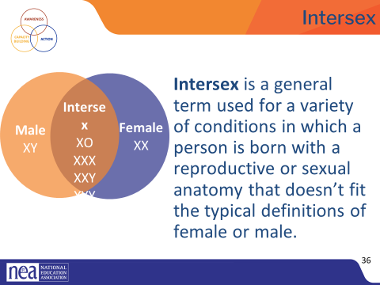  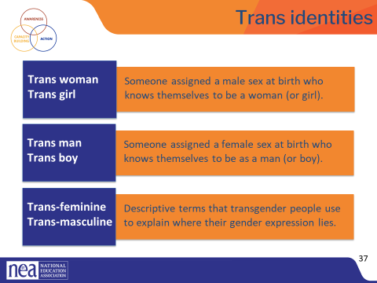  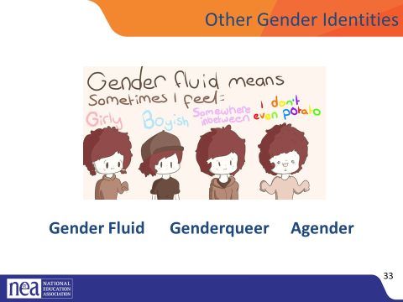  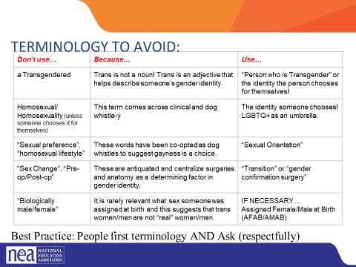  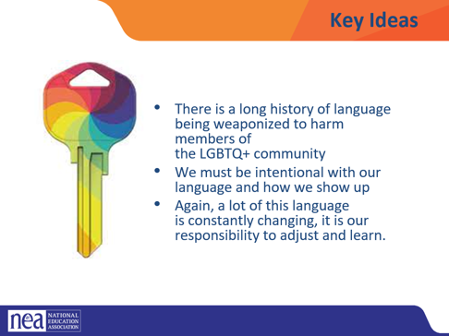 | Video: https://youtu.be/i83VQIaDlQw |  | We are now going to dig into some terminology that you reviewed in the pre-attendance vocabulary quiz.  Sexual Orientation and Gender identity  Sexual orientation is an important part of a person’s identity. It is not a decision that one makes, rather it is an awakening.  There are a variety of sexual orientations:  - Heterosexual  - Bisexual  - Homosexual  - Pansexual  - Asexual  Even though sexual orientation is a private identity, it can be a source of public scorn and a basis for exclusionary practices and discrimination.  Sex and Gender do NOT mean the same thing.  Our sex is determined by biological attributes such as chromosomes, hormones, reproductive organs, and other parts of our anatomy.  Gender is a person’s innermost, deeply held reality of self. It’s almost like being right-handed or left-handed. We don’t know why each person favors one hand over the other, but we all know that one just feels more correct for us. And, some people feel comfortable using either hand.  A person can have an inner reality of being male, female, both, neither, or somewhere in between.  Gender, or gender identity, is that internal sense of self we just mentioned—the feeling of being male, female, both, neither, or somewhere in between.  Gender expression includes all the ways you show your gender to the world. For example, your hair and clothes, how you cross your legs, how you walk, and even your voice inflections. Some of these are innate, and some are learned from our cultural norms.  Gender roles are social constructs based on one’s sex or biological attributes. They can be very different from one culture to another. These roles can become so internalized that they create stereotypes or an implicit bias within us (e.g., assuming nurses are women, or mechanics are men).  Gender non-conforming simply means the person is breaking cultural or social rules about gender roles and/or expression.  Yesterday we used the gender unicorn to expand our understanding of gender and gender identity. This video will help us review the different components of gender and sexual orientation.  Video: (3 minute)  - This video offers a simple way of looking at various gender identities (~3 mins).  - Debrief the video with these three questions: At your tables discuss  - How many of you grew up thinking the only gender options were man or woman?  Transgender, non-binary, and gender non-conforming individuals show their gender to the world in many ways. Just as cisgender people have different hairstyles, clothing choices, mannerisms, and more, the same is true for trans, non-binary, and gender-non-conforming people. There is no “one way” to look to be any gender.  These images are from the Gender Spectrum Collection – a group that works with trans and non-binary models. In the first image we see a transgender woman in an office. The second is a transmasculine person in a winter coat. Transmasculine is a term generally used for people who were born female at birth, but who identify with masculinity. As we can see in both of these two photos, they present within the gender binary of man and woman.  In the last image, we see a gender-fluid woman. Gender fluid refers to a person who does not feel they have a fixed gender.  Genderfluid individuals may identify as non-binary or transgender, or also identify with their assigned gender.  Gender non-conforming refers to people who do not follow dominant social norms or stereotypes about how they should look or act based on their biological sex at birth.  Check in - Where are you on the spectrum? Note that some people will feel this does not apply to them.  Left Side is the Assumption and Corrections (10 minute Activity)  Make a t chart with a heading that has assumptions on the left and corrections on the right. On the left list examples of times when you make assumptions about someones gender.  Possible Examples of assumptions:  Giving all the women in the office a flower for Mother’s Day  In small groups create at T chart on your piece of paper and list assumptions that your group comes up with COUNT PEOPLE OFF INTO GROUPS AND HAVE THEM MOVE TO A CORNER WITH A PIECE OF CHART PAPER. WHEN FINISHED THE LEFT COLUMN, HAVE THEM SIT BACK DOWN.  Binary and non-binary are two types of gender identities.  Gender is a social construct. What it means to be a man and what it means to be a woman are concepts created by humans, and over time, those definitions and views became generally accepted by society at large. Most of us align with these long-standing definitions of a man and a woman and feel comfortable saying so.  A non-binary person is someone who does not adhere to these gender expectations or stereotypes. The binary—being man or woman—will feel very incongruous to their true self.  For a non-binary person, their gender identity does not fit within the binary of man and woman.  While we might see two separate colors, yellow and blue, a non-binary person may only see green, or tie dye, or a beautiful rainbow of colors the include yellow and blue. Someone who is agender (or who has no gender identity) might only see gray.  This is why non-binary is a gender identity and not a gender expression. Non-binary people are not attached to gender.  For a lot of cisgender people, those whose sex and gender align really well, the concept of non-binary identities is really hard to understand. But we have some famous people who have described it really well.  Tilda Swinton and Steven Tyler have never indicated that they identify as transgender, but they describe a blending or fluidity of gender. For a lot of non-binary folks, that’s the only label they apply to themselves. Others can refine things a bit more.  - (Read the slide.)  Here we see the words of Alok Vaid-Menon who uses the gender pronouns they/them. They are an internationally acclaimed gender non-conforming writer, performer, and public speaker. As a mixed-media artist, Alok’s work explores themes of trauma, belonging, and the human condition.  - (Read the slide.)  As we’ve said, gender can be fluid. Here, writer and activist Karari Olvera Orozco shares a bit of their story. (Read the slide.)  A demiwoman is someone who was assigned female at birth but does not fully identify with being a woman, socially or mentally.  If someone has two types of pronouns, like we see here with Karari, they may feel more comfortable with one over the other. So be sure to ask which one they are most comfortable with.  Key Ideas:  Gender identities are constructed as binary, however, people’s identities are much more fluid.  People who identify as non-binary express their gender identity in many ways.  People’s gender identity and sexual orientation can shift at different times  Complete the T Chart activity (10 Minutes) RECOUNT PEOPLE INTO GROUPS. SOME MAY END UP IN THE SAME GROUP AND THAT IS OKAY.  Thinking about the assumptions and why they are problematic, as a group, on the right side of the t chart – come up with a way to correct that assumption.  Return to your t chart on right side your group is now going to  For example – Giving all women a flower for Mother’s Day - Correction is give everyone flowers on May Day instead of on Mother’s Day  Key Ideas  We can intentionally create more gender inclusive spaces  Focus on what is with our control  More and more we are hearing arguments against inclusive identity based on scientific reasoning. ..  Science shows us that Intersex conditions comprise more than 30 natural genetic variations. Historically, these variations have not been socially acceptable.  Proposed laws focused on the rights of transgender people regarding restroom usage, participation in sports, and even access to specific health care coverage, and have centered on genitals or proposed chromosome tests. These laws also affect the intersex community, who are often entirely ignored or left out of those conversations.  More people are intersex than we realize. In the past, this was often discovered in testing for the Olympic games, because some women were subjected to gender testing if they were thought to have a perceived physical advantage.  Scientists say there is no clear definition of male & female – that one’s sex includes more than just physical anatomy. It also includes hormone levels, chromosomes, and more.  Please note that “transgender” or “trans” are adjectives. They are terms that describe. A person is transgender, not “a transgender.”  A trans woman (or trans girl) is assigned a male sex at birth but knows themself to be a woman. Alternately, a trans man is assigned a female sex at birth but knows themself to be a man.  Someone who is transmasculine, identifies on the masculine side of the gender spectrum, but may not identify as a man. The same is true for transfeminine people. They may identify as more feminine, but not see themselves as a woman.  Gender fluid is exactly what it sounds like. Gender flows in a more masculine way at times and in a more feminine way at others, with no internal struggle between the two. That fluidity could happen over many years, or it may fluctuate during a week.  Genderqueer people are fluid in their gender and often their sexuality. People who consider themselves genderqueer will often say that no rules apply. They like what they like, who they like, and feel the best living outside of any boxes.  Added some from here- https://freedomforallamericans.org/messaging-terms-avoid/  Agender is the last term on this slide, and it describes someone who does not have a gender. Agender people can feel no connection to the concept of gender at all. They may feel genderless or gender neutral.  Terminology to Avoid - Thinking back to the conversations we had around intersectionality and the work we do, let’s explore some of the clear do NOTs that come up when these topics are discussed. *Note- relate this back to contract work*  Key ideas:  There is a long history of language being weaponized to harm members of the LGBTQ+ community.  We must be intentional with our language and how to show up.  Again, a lot of this language is constantly changing, it is our responsibility to adjust and learn.  A Note About Phobias:  A phobia is a persistent, irrational and exaggerated fear of an object, person, activity, animal or situation. Homophobia is a fear of people who are gay and lesbian. Transphobia is a fear of people who are transgender. When someone’s identity challenges a person’s expectations or preconceived notions of man and woman, they may go into a panic. The incongruence of what someone sees, and what they think creates fear and misunderstanding.  We say “i-dentity” because it’s about the individual and how they personally identify, not “you-dentity” because of how you want to determine someone else’s existence.  With what we have now discussed about gender and how it may not be as black/white a conversation for everyone I want you to look at the list of assumptions and corrections your group created earlier. |  | Why do my words matter?  Participants will apply their understanding of the key terminology around gender and sexual orientation.
10:15-10:30 BREAK
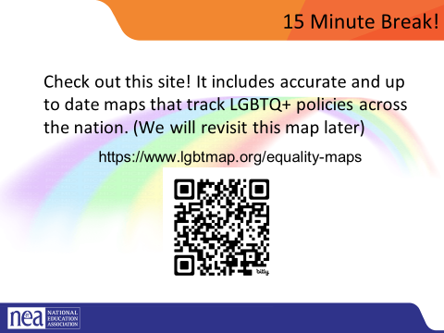
BREAK AS THEY RETURN FROM BREAK ASSIGN NUMBER 1-8 FOR GROUPS
10:30-11:20 Natasha |  |  | 4 expressions of Oppression and Intersectionality – (50 minutes)
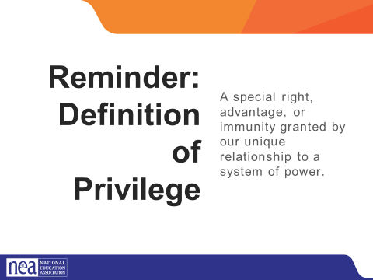  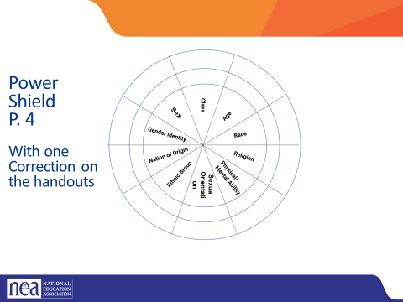  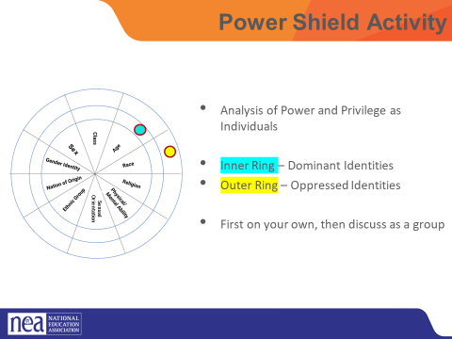  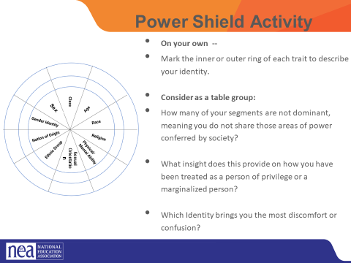  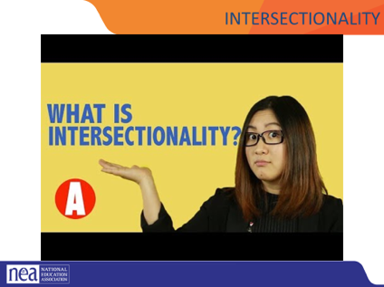  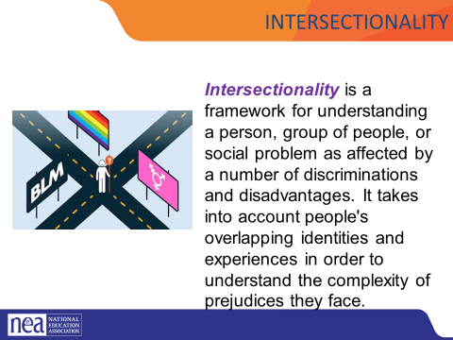  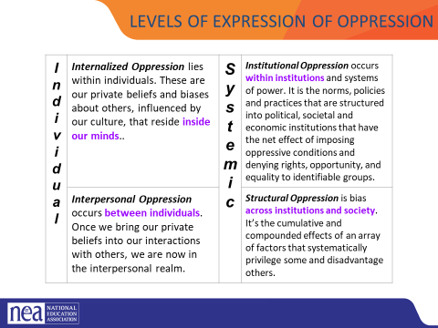  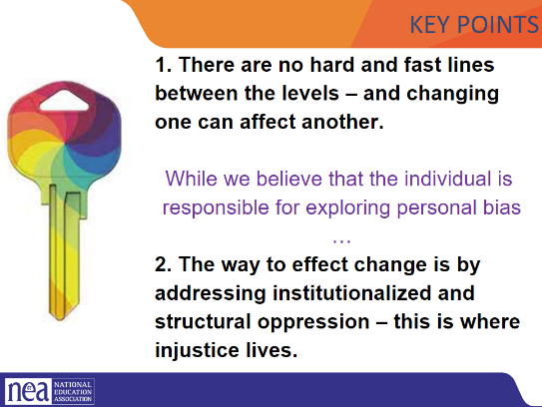  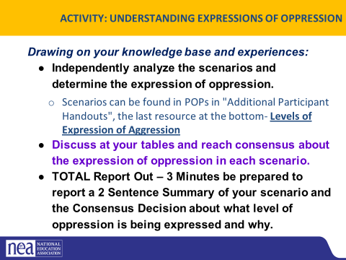  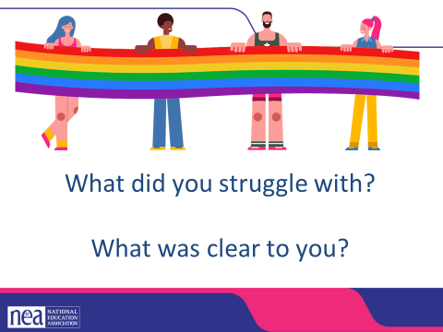 | Page 4  Video on Intersectionality we could use  https://neahq-my.sharepoint.com/:v:/g/personal/eholmes_nea_org/EYAirmGnDFpPvXDQZRhUzJEB1jZxORMr-bcuK4L7mu_z_A?e=lWWeeU  Levels of Expression Of Oppression Handout |  | (7 min intro power shield) We are going to take a minute to look intentionally at our identities.  [Facilitator] REMEMBER OUR Definition of the term: Privilege: A special right, advantage, or immunity granted by our unique relationship to a system of power.  Introduce activity by saying (p. 4)  - This activity is based on “Power Flower,” a tool developed by social change educators when working with groups to “identify who we are (and who we aren’t) as individuals and as a group in relation to those who wield power in our society.” The object of the exercise is to discover how close, or how distant, each person is to the dominant identity of their current society.  The center of a shield is divided into 10 segments, each representing one facet or category of our social identity.  Facilitator note: Explain any confusing identities-  Gender is referring to gender for this activity. ie Man, woman, non-binary with Man/Masculinity being the place of privilege, and femininity and woman being the place of oppression.  Gender Identity: For this one, we are referring to whether you are cisgender (identify with the gender you were assigned at birth) and transgender (does not identify with the gender they were assigned at birth)  Sexual Orientation: Who people have romantic and sexual attraction to. (Gender is who you are, sexual orientation is who you love)  Ethnicity- : Some people identify with a part of their cultural heritage, or they may not know it, they lean into one part more than another. They celebrate traditions of a culture they embrace.  Each identity is surrounded by an inner and outer ring segment. The inner ring segments represent the dominant or powerful identities within that category in society. The outer ring segments represent oppressed or marginalized identities within that category. You will select inner or outer segments to describe your social identity.  Facilitator note: Participants decide for themselves which ring segment to choose in ambiguous situations such as: non-dominant religious beliefs with no external visual cues, passing or presenting features, or disabilities that may not be obvious to others.  Some coaching questions may include,  - Can you choose whether to express this part of your identity?  - If so, how does that choice affect your access to privilege?  - How does that choice feel?  - The more inner segments an individual marks, the more social power that person possesses.  - 5 Min - Participants complete shield activity and individual reflection questions at their seat THEN each person comes to the large poster and places dots corresponding to their own shield. This makes up the composite, communal social identity of your group.  Questions for individual reflection at your seats:  - How many of your petals are different from the dominant petals, which means you do not share those areas of power conferred by society?  - What light does this throw on the way you have been treated as a person of privilege or as a marginalized person?  - Which identity of yours brings you the most discomfort or confusion?  8 Min - small group reflection and movement  - Notice the stations around the room correlated to the identities in the shield. Which identity of yours do you think about the most? Move to that station, discuss your reasons why, and report out on common themes. (Everyone chooses. It is a sign of privilege to sit out.)  - Which identity of yours do you think about the least? Move to that station, and discuss why you don’t have to think about it as much, and what that could mean in terms of your identity? How can you leverage that privilege/power for marginalized people in your scope of influence?  4 expressions of Oppression and Intersectionality – (30 minutes)  10 Mins We are going to define two key terms in this next section, the first is Intersectionality –  Let’s watch the following video  3-5 minutes Video  - Video of intersectionality –  To review Intersectionality is a framework for understanding a person, group of people, or social problem as affected by a number of discriminations and disadvantages. It takes into account people's overlapping identities and experiences in order to understand the complexity of prejudices they face. This is important to keep in mind as we approach our work in supporting individuals experiencing oppression.  Now, let’s define The Levels of Expressions of Oppression. We use this framework because it allows us to think about the scope of the solution to a particular problem. (This is a tool that people in power use) Facilitator Note: Connect identities from earlier activity and the identities of others to this piece.  Internalized oppression lies within individuals. These are our private beliefs and biases about others, influenced by our culture.  Interpersonal Oppression occurs between individuals. Once we bring our private beliefs about differences into our interactions with others, we are now in the interpersonal realm.  Institutional Oppression occurs within institutions and systems of power. It is the norms, policies and practices that are structured into political, societal and economic institutions that have the net effect of imposing oppressive conditions and denying rights, opportunity, and equality to identifiable groups based upon differences.  Structural Racism is bias across institutions and society. It’s the cumulative and compounded effects of an array of factors that systematically privilege white people and disadvantage people of color.  Key point – there are not hard and fast lines between the levels – and changing one can affect another. While we believe that the individual is responsible for exploring personal bias – the way to effect change is by addressing institutionalized and structural racism – this is where injustice lives.  15 Min Defining Expressions of Racism Activity - Use the Handout Levels of Expression Oppression Scenarios found in your POPS in additional participant resources.  3 minutes form 8 groups. Each group is given a scenario to look at. They are to determine which level of oppression this scenario is about  5 minutes for teams to review scenarios and come up with what level of oppression their scenario is and why. Prepare a summary of your scenario to share with the whole group. Each group will have a total of 3 minutes to share a short summary, provide which level of oppression the scenario exemplifies, and tell why.  5 Mins: Debrief – Choose 1-2 good share outs of scenario work (either from listening as they work or by asking the room) to share with the whole group. Each group will have a total of 3 minutes to share a short summary, provide which level of oppression the scenario exemplifies, and tell why. what level did your group determine your scenario was at and why?  Overall debrief questions if there is time:  - What did you struggle with? What was Clear to You?  Let’s revisit our key point - there are not hard and fast lines between the levels – and changing one can affect another. While we believe that the individual is responsible for exploring personal bias – the way to effect change is by addressing institutionalized and structural racism – this is where injustice lives.  Also, let’s revisit how using an intersectional lens alongside the understanding of levels of oppression can really help us decide the scope of the solution we need and the power it will take to implement that solution.  Key Points there are not hard and fast lines between the levels – and changing one can affect another. While we believe that the individual is responsible for exploring personal bias – the way to effect change is by addressing institutionalized and structural racism – this is where injustice lives. |  | What are the right size solutions for the level of oppression?  Participants will learn about a framework of understanding oppression so that they can better identify actions to take in seeking justice.
11:20-12:00 Grat and Bekah |  |  | Legal Overview (60 Minutes total)
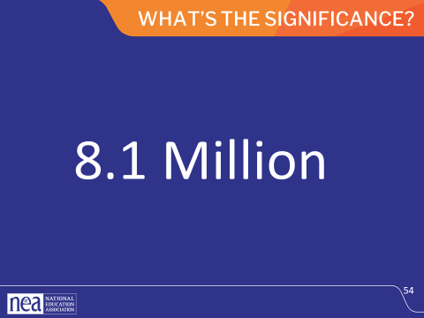  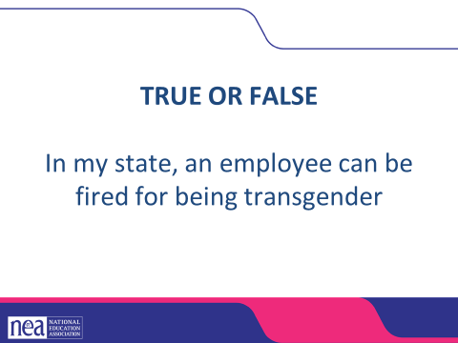  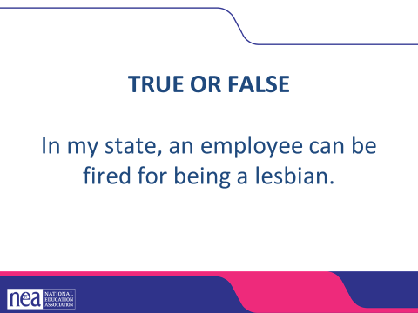  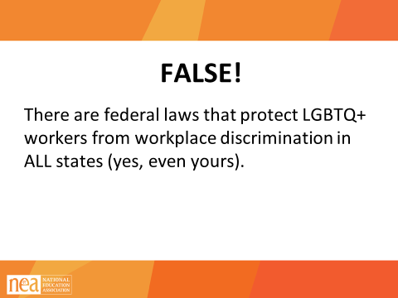  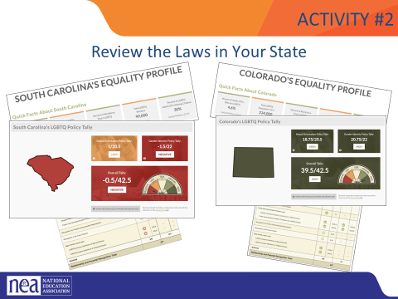  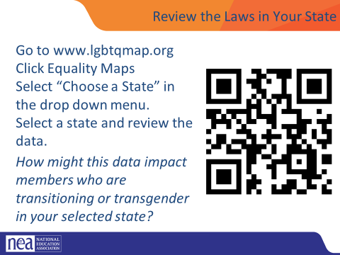  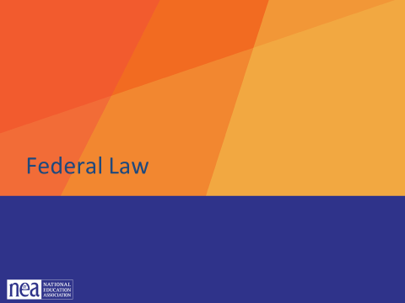  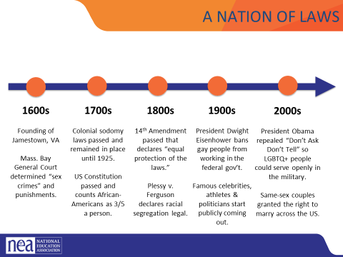  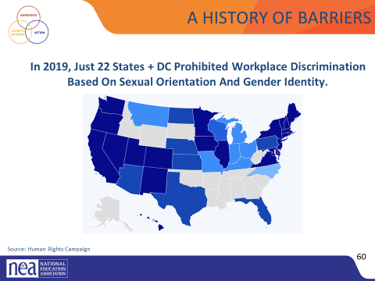  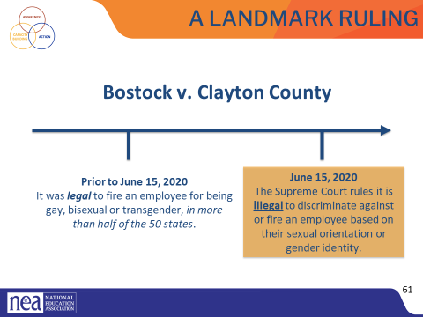  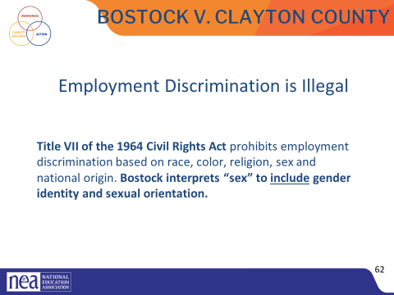  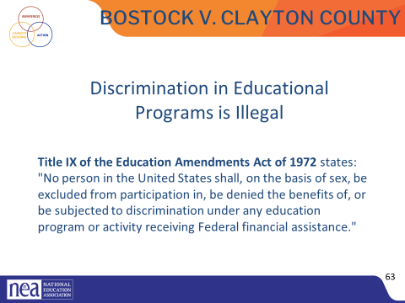  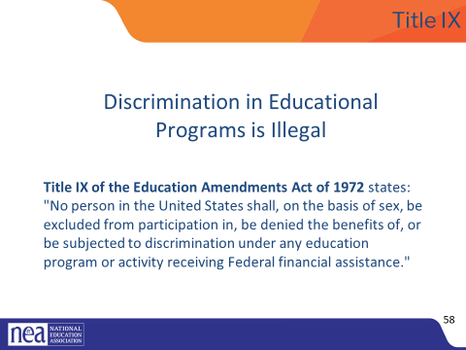  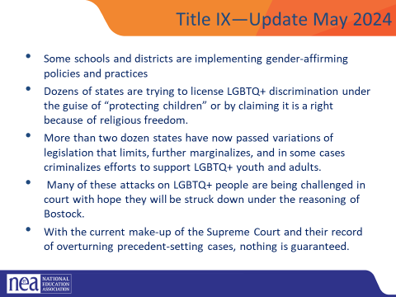  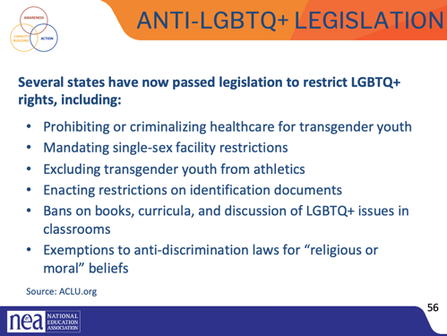  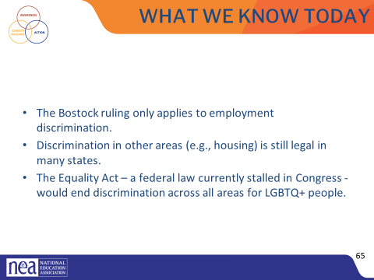  Predicting that Lunch is going to go here  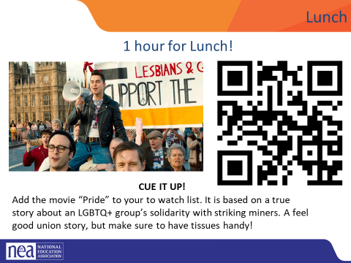  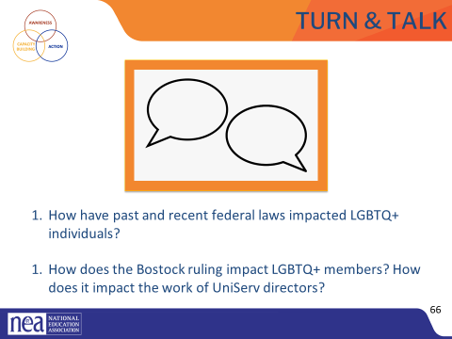  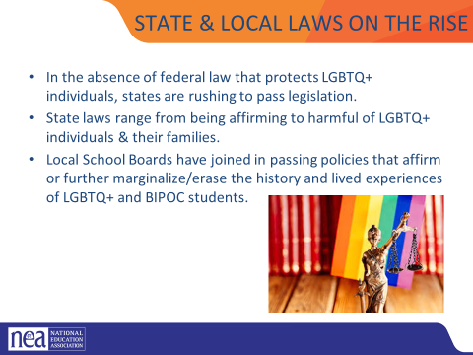  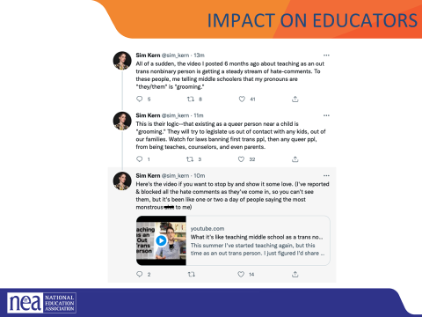  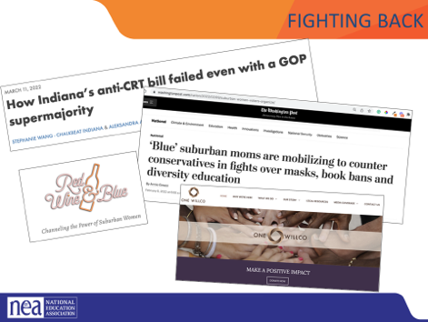  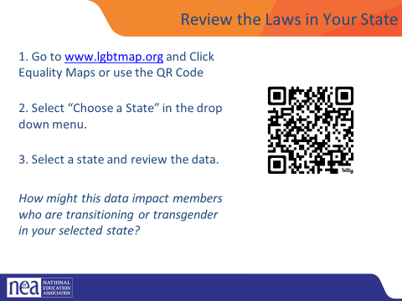  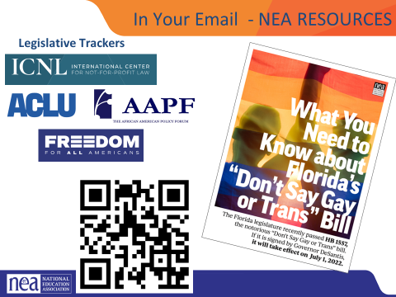  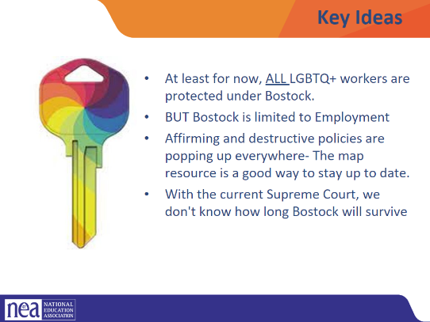 | SEND NEA RESOURCE PAGES TO PARTICIPANT EMAIL |  | In 2019, there were 157 million employees in the US. What do you think this number represents?  According to Catalyst.org, there are an estimated 8.1 million LGBTQ+ employees in the United States who are age 16 or older. 50% of these employees are not out at work because of fears of discrimination or ostracization. Nearly one quarter (23.7%) LGBTQ+ employees have experienced discrimination.  Reference: https://www.catalyst.org/research/lesbian-gay-bisexual-and-transgender-workplace-issu - broken/outdated link  New link: https://www.catalyst.org/research/lgbtq-workplace-issues/  ACTIVITY: Look at Your State’s Equality Profile.  How might this impact members who are transitioning or transgender?  Instructions:  Go to www.lgbtqmap.org  Click Equality Maps  Select “Choose a State” in the drop down menu.  Select a state and review the data. How might this data impact members who are transitioning or transgender in your selected state?  The NEA has several resources and recommendations for legislative trackers. (See handout for full list and website links.)  https://www.icnl.org/usprotestlawtracker/  https://www.aclu.org/legislation-affecting-lgbtq-rights-across-country  THIS Section can be done in 8 minutes tops. Flash these slides in a manner that allows your participants enough time to use the EQUALITY MAPS with fidelity. Get to Bostock and Title IX sooner.  The US has called itself a “Nation of Laws,” but what are the laws for? And, who do they help or harm? This timeline shows only a glimpse of how discrimination, exclusion, and beliefs in white supremacy have been a part of US laws since the earliest of colonial times. For a more comprehensive list of laws that impact LGBTQ+ people throughout US history, please see your handout.  Highlights for further discussion:  1607 – Founding of Jamestown, VA, the first permanent English settlement in the “New World.”  1607 – Massachusetts Bay Colony was established believing they made a “covenant with God to build an ideal Christian community.”  1619 – The first enslaved Africans arrive to Jamestown, VA  1631 – The Massachusetts Bay General Court, in accordance with Puritan religious and moral beliefs, declared that the following were considered sex crimes and punishable by whipping, banishment or execution: fornication, adultery, rape and sodomy.  1705 – The Colony of Virginia adopted the first Blood Quantum Law. A person’s blood quantum is defined as the fraction of their ancestors, out of their total ancestors, who are documented as full-blood Native Americans. These laws were applied across the thirteen colonies and later the entire United States. They limited the civil rights of Native Americans and regulated who could be classified as Native American.  1714 – Sodomy laws were passed in the early colonies and in the colonial militia. They stayed in place until challenged in 1925.  1775 – Population of enslaved people in the colonies is nearly 500,000.  1776 – Declaration of Independence signed.  1778 – Lieutenant Gotthold Frederick Enslin of the Continental Army becomes the first documented service member to be dismissed from the U.S. military for homosexuality. Read more at U.S. History Naval Institute Blog / Timeline of Military Gay History.  1779 – Thomas Jefferson proposes Virginia law to make sodomy punishable by mutilation rather than death. It was rejected by the Virginia legislature.  1788 – U.S. Constitution adopted. Includes a three-fifths clause that counted each enslaved person as three-fifths of a person for the purposes of congressional representation and tax apportionment.  1852 – Scottish writer J.D. Bothwick reports his attendance at a “miner’s ball” – a men’s only dance held in Angels’ Camp in California.  1857-1861 – James Buchanan elected president. A lifelong bachelor, Buchanan had a long-term relationship with William Rufus King, who served as vice president under Franklin Pierce. The two men lived together from 1840-1853 until King’s death. Some historians suggest Buchanan, by today’s terms, was gay.  1868 – Fourteenth Amendment Ratified. This is the most cited amendment in Supreme Court civil rights cases and has been the basis for landmark civil rights cases such as Brown v. Board of Education, Roe v. Wade and Obergefell v. Hodges. Gay rights advocates cite this amendment in support of equality for future court cases.  “All persons born or naturalized in the United States and subject to the jurisdiction thereof, are citizens of the United States and of the State wherein they reside. No State shall make or enforce any law, which shall abridge the privileges or immunities of citizens of the United States; nor shall any State deprive any person of life, liberty, or property, without due process of law; nor deny to any person within its jurisdiction the equal protection of the laws.”  1868 – Two-Spirit, We’wha, a Zuni Native American, meets with President Grover Cleveland.  Source: https://www.lgbtqhistory.org/lgbt-rights-timeline-in-american-history/  Source: https://en.wikipedia.org/wiki/Blood_quantum_laws  Systemic oppression - This is why it is so hard to change the systems.  US history is full of barriers for BIPOC and LGBTQ+ people. Discrimination because of one’s race and LGBTQ+ identity means lost wages, jobs, promotions, unfair treatment and even harassment at work. This discrimination compels many to hide their LGBTQ+ status for fear of retribution, losing one’s livelihood, support system, and more.  Before 2019, only a handful of states (in dark blue above) provided LGBTQ+ people some protection against employment discrimination, as well as in housing and public accommodations. This meant that in all the other states (those in tan and lighter shades of blue), LGBTQ+ people could be denied jobs, health care, housing, hotels, and more. This discrimination – across the majority of the US, and nearly all of the South— was perfectly legal.  The Civil Rights Act of 1964 prohibits discrimination based on race, color, religion, sex, or national origin. The courts and the federal government have long refused to recognize LGBTQ+ discrimination as a form of sex discrimination. Over the past 20 years, however, federal courts and the government have at times recognized LGBTQ+ discrimination as sex discrimination.  It was not until June 15, 2020 that the Supreme Court finally recognized that LGBTQ+ employment discrimination is prohibited sex discrimination under Title VII of the Civil Rights Act of 1964.  This ruling recognized that it is illegal to discriminate against or fire an employee based on their sexual orientation or gender identity. Now lower federal courts and the Biden Administration are applying that ruling to education, health care, housing, credit discrimination, and more.  The Bostock ruling specifically states that employment discrimination on the basis of gender identity and sexual orientation is illegal.  Title VII of the Civil Rights Act covers the full spectrum of employment decisions, including recruitment, selections, terminations, and other actions concerning terms and conditions of employment. This is significant for the LGBTQ+ community because, as we saw, in many states it was legal to be denied an interview or a promotion, and even to be fired because of one’s gender identity or sexual orientation.  On March 26, 2021, the Department of Justice concluded that, as a result of the Bostock ruling, Title IX of the Education Amendments Act of 1972 also prohibits sexual-orientation and gender-identity discrimination in educational institutions that receive federal funding. This means all public schools. This means that students cannot be discriminated against in schools based on their LGBTQ+ identity.  There have been some significant wins recently for LGBTQ+ rights in the US But while progress is being made, attacks on LGBTQ+ rights in certain states have accelerated.  Reference: Department of Justice, “Application of Bostock v. Clayton County to Title IX of the Education Amendments of 1972,” March 26, 2021, https://www.justice.gov/crt/page/file/1383026/download  Updates Title IX Language  While some schools and districts are implementing gender-affirming policies and practices, like recognizing proper names and pronouns for children, in the background, dozens of states are trying to license LGBTQ+ discrimination under the guise of “protecting children” or by claiming it is a right because of religious freedom. More than two dozen states have now passed variations of legislation that limits, further marginalizes, and in some cases criminalizes efforts to support LGBTQ+ youth and adults.  Many of these attacks on LGBTQ+ people, especially young people, are being challenged in court and we can hope they will be struck down under the reasoning of Bostock. But those lawsuits are just getting started and with the current make-up of the Supreme Court and their record of overturning precedent-setting cases, nothing is guaranteed.  Key Notes  Bostock only applies to employers with more than 15 employees. Employers with fewer than 15 total employees are not covered by Title VII.  Bostock applies nationwide and protects employees from sexual orientation or gender identity discrimination regardless of state or local laws.  An employer covered by Title VII is not allowed to fire, refuse to hire, or take assignments away from someone (or discriminate in any other way) because customers or clients would prefer to work with people who have a different sexual orientation or gender identity. (For example, keeping LGBTQ+ employees out of public-facing positions.)  Although accidental misuse of a transgender employee’s preferred name and pronouns does not violate Title VII, intentionally and repeatedly using the wrong name and pronouns to refer to a transgender employee could contribute to an unlawful hostile work environment.  PREDICTING THAT LUNCH WILL HAPPEN HERE  Get in groups of 4- with folks you haven’t worked or spoken to before.  Turn & Talk: Suggested Discussion Questions  - How have past and recent federal laws impacted LGBTQ+ individuals?  - How does the Bostock ruling support LGBTQ+ members? How does it impact the work of UniServ directors?  Well funded political groups have launched a coordinated and strategic approach to overwhelm and see what legislation sticks regarding harmful legislation.  Local School boards & the public education system have become a focus for advancing anti-LGBTQ+ policies  While children of color make up the majority of U.S. public school students, policies that affirm their histories and lived experiences are not centered in local and state legislation.  The coordinated attacks on LGBTQ+ individuals include providing people scripts that denounce teaching topics such as transgender rights, banning books from well known authors, and labeling inclusive and culturally responsive instruction as “critical race theory.” Unfortunately, these efforts have been effective.  As we see in this Twitter thread, a trans person shared their experience of teaching in middle school and months later had their post shared along with accusations of “grooming” students because they simply shared their pronouns.  FIGHTING BACK- PATCHES OF HOPE: While many states and lawmakers are working to advance anti-LGBTQ+ and other laws that discourage teaching an honest history of the US, not every effort is successful. While many of these efforts are specific to students, it worth noting that not all attempts have been successful.  - In March 2022, a “CRT” bill in Indiana failed despite having a GOP supermajority.  - Parents are mobilizing to counter the loud voices that dominate local school board meetings:  - Red Wine & Blue is a national network of more than 300,000 like-minded, mostly Democratic suburban women who believe the only way to fight back is to present a calm face to counter the angry groups that have dominated and disrupted board meetings and in some cases threatened officials. The group recently broadened its focus to fight the rising number of book bans across the country, and is running training sessions to help women testify and manage highly charged government meetings.  - One WillCo is a community organization in Williamson County Tennessee that was organized by two mothers to address racial disparities in the community in 2021.  - Invite discussion: Ask participants if they have heard of anti-LGBTQ+ or anti “CRT” laws that have failed to pass. Why do they think this is?  Sources:  https://www.wfyi.org/news/articles/indiana-anti-crt-bill-failed-republican-supermajority  https://onewillco.org/  KEY IDEAS –  At least for now, ALL LGBTQ+ workers are protected under Bostock.  BUT Bostock is limited to Employment  Affirming and destructive policies are popping up everywhere- The map resource is a good way to stay up to date.  With the current Supreme Court, we don't know how long Bostock will survive |  | Participants will gain an understanding of the legal landscape.
12:00 – 1:00  See above for when we broke last time | LUNCH
1:00-1:20 Grat and Bekah  See above for the slides that were part of this time slot | Continuation of Legal from Before Lunch
1:20 – 1:45 Anthony | Types of transitions and barriers to transitioning (25 Minutes)
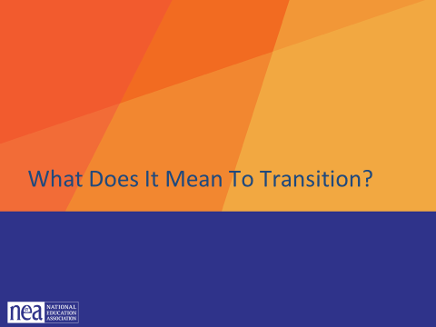  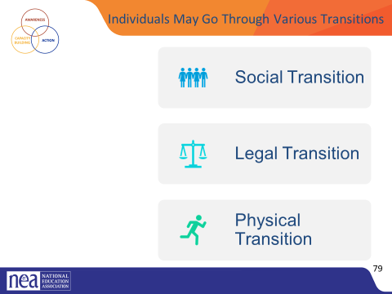  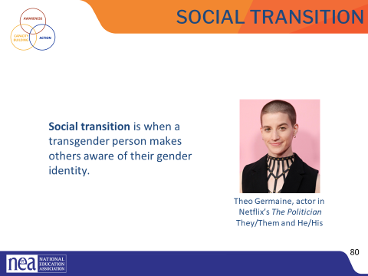  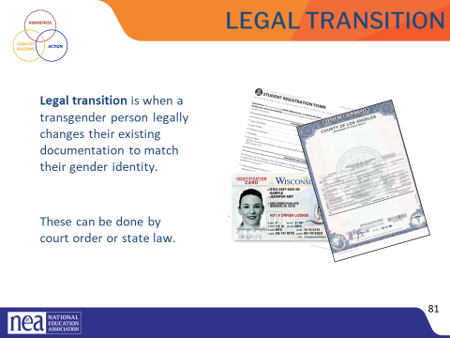  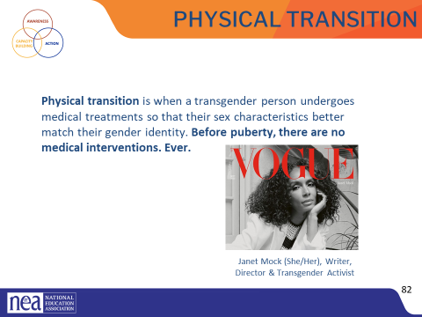  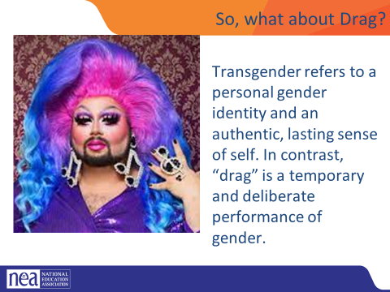  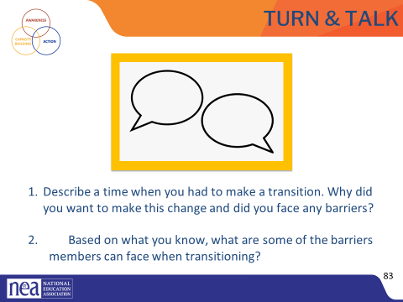  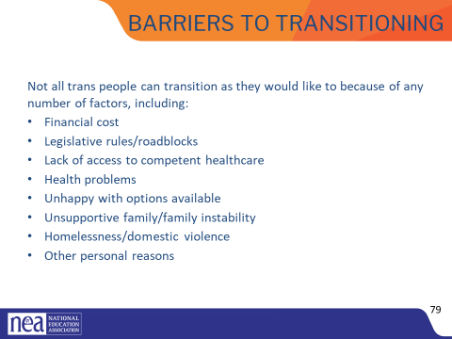  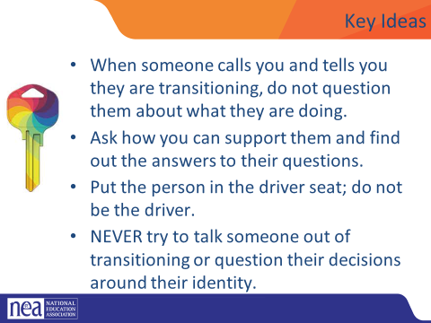 | Refer to Supporting an Employee During Transition handout |  | Given all that a transgender person may be experiencing, one option is to transition. This means they align their inner identity with their external one. We’re going to talk about this process and how it affects trans adults.  Transitioning is not a simple, one-time event, and there is no “one-size-fits-all” process, checklist, or approach. Transitioning is a complex issue, and it involves a wide variety of options for an individual.  Many factors influence a person’s decision to transition, and because of these factors, their transition may not be linear. Transitioning is a personal decision specific to the individual, so how a person goes about transitioning can change over time and vary from person to person.  There are 3 main types of transitions someone could go through: social, legal, and physical  Social transition is just what it sounds like—changing how you present yourself and how others see you socially. A social transition can happen at any age. A person may start their transition, pause it, move back, and move forward again. It often includes changing clothing or hairstyles. Usually, it entails changing a name and switching pronouns—sometimes more than once.  A person may try on names for a while and switch from one gendered pronoun to another, only to decide that a non-binary pronoun fits better. Again, no rules.  A legal transition means updating documents through the legal process.  Some parts of the legal transition can include changing gender markers on birth certificates, changing names on social security cards, driver’s licenses, or passports. Legal transitions can also have other identification components, such as school documents. Passports are the easiest documents to change.  People cannot always experience a legal transition because of several barriers. Those barriers do not make their gender identity or their distress at being misgendered any less real.  Transgender health is a specialized area of medicine. There is no one way to have a physical transition.  Given the specialized nature of transgender health care, we can see how problematic it is for a trans person to be told they can only access gender-segregated spaces once they have “had a surgery.” It puts a burden on them that is impossible to overcome, denies their full identity, and creates equal-access issues. Additionally, not all trans people want to have surgery. It’s wrong to demand that another person undergo serious, invasive medical procedures to make other people comfortable.  Keep in mind that just like you would not want to be asked about your medical procedures, we don’t ask others about theirs.  What about drag?  Transgender refers to a personal gender identity and an authentic, lasting sense of self. In contrast, “drag” is a temporary and deliberate performance of gender.  Drag is most commonly associated with gay men dressing up and embodying a “larger-than-life” woman persona. Drag queens are flamboyant and this form of drag often involves sequins and feathers but it can also be sleek and edgy.  For drag queens, their drag persona can be an important part of their own identity as a gay man (this does not mean they are transgender). Similarly, women also perform drag as drag kings. Drag kings dress as men and take on male personas, often wearing facial hair, adopting masculine mannerisms and a deep voice.  Groups of 4 based on your shoes (let them define this matching styles, colors, sizes, etc)- 5 mins  Turn & Talk: Suggested Discussion Questions:  - Describe a time when you had to transition (e.g. moving to a new city, starting a new job, getting married, having or adopting a child, becoming a pet parent, etc.). Why did you want to make this change and did you have support?  - Based on what you know, what are some of the barriers members can face when transitioning?  Table talk Debrief - have participants share out- show slide- is there anything we missed?  - Not all trans people can transition as they would like to because of any number of factors, including:  - Financial cost  - Legislative rules/roadblocks  - Lack of access to competent healthcare  - Health problems  - Unhappy with options available  - Unsupportive family/family instability  - Homelessness/domestic violence  - Other personal reasons  Here are a few examples of barriers a transgender educator might face:  Legislative rules/roadblocks — In most states, a person’s gender marker can only be changed on their birth certificate after permanent medical procedures have occurred. This is often stipulated as surgery.  Lack of access to competent healthcare — Trans health is still not taught in most medical schools. Often there is one class (class period…not entire course) devoted to it, if at all. Many providers are afraid to treat trans patients, and some patients travel to other states just to get competent care.  Health problems — Underlying health conditions can complicate a physical transition just as they would complicate any number of other medical treatments or procedures.  Unhappy with options available — This could be surgical options, but could also affect a non-binary person who does not want to proceed with hormones that would make them look too feminine or too masculine.  And, other personal reasons.  Key Ideas  - When someone calls you and tells you they are transitioning, do not question them about what they are doing.  - Ask how you can support them and find out the answers to their questions.  - Put the person in the driver seat; do not be the driver.  - NEVER try to talk someone out of transitioning or question their decisions around their identity. |  | Participants will analyze what they need in their understanding to properly advocate for employees who are transitioning.
1:45-2:00 Break
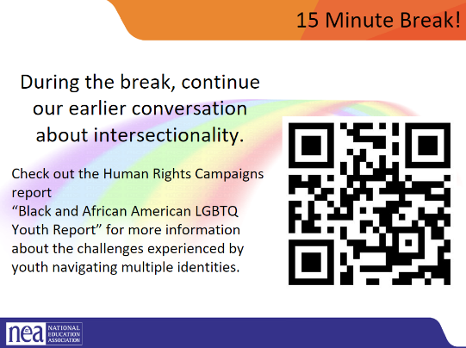

2:00 –3:30 |  |  | Panel
Questions for all panelists:
- Tell us about yourself. What brought you to this work?
- Share your experiences in school. What people and experiences were affirming?
- Tell about a couple of the programs that you lead or support that are working and advocating with LGBTQIA+ students or youth. Can you share a success in this work that you are particularly proud of?
- The staff in the room come from all across the country - some from districts and states with LGBTQ+ affirming policies and laws and others with increasingly harmful anti-LGBTQ+ policies and laws. Many of you have been advocates across a variety of spaces and contexts and I wonder if you can share about a time that you had to advocate in a challenging environment and share any lessons you have for LGBTQ+ advocacy and organizing in particularly challenging contexts.
- The past couple of days we have been learning about the importance of using affirming language and advocacy practices. We also discussed that messing up or unintentionally causing harm is inevitable for many given the depth of our socialization into dominant ways of thinking and acting. Will you share about a time that you had to call someone in after they caused harm? Or a time that you had to repair after causing harm? How can we handle calling in and repair conversations with care?
- This work can be hard - especially as the oppressive social structures we are working to shift also show up in our workplaces, our movement spaces, and our professional and personal relationships. How do you rest, revitalize, and reset?
- One concept that comes out of queer theory and queer movements is the idea of “queering” - which is a lens to analyze and intervene in the world with a focus on centering queerness, undoing hierarchies, and looking at the world through a lens of queer liberation. How do we feel about “queering” this panel?
  - IF YES: Each panelist will lead a team of participants in an activity. The teams will 1) come up with a team name and 2) have ten minutes to come up with a skit, chant, song, dance or other creative form of expression that celebrates queer liberation 3) share with the group

Possible specific questions for the panel:

I read that your mission is to “to change people's perception of artistic expression one subculture at a time.” Our work in pursuit of LGBTQIA+ justice in education not only involves changing contracts, policies, and laws, but changing culture. We work to shift the culture of schools and school districts, but also in organizing spaces like our union halls. What are your insights to changing culture, especially the culture of groups and organizations? What are everydays ways that you invite in and shift culture?
- Black feminist Toni Cade Bambara famously said “As a culture worker who belongs to an oppressed people my job is to make revolution irresistible.” So much of your work - be it producing festivals, performing, or youth development - seem to overflow with joy, authenticity, and creativity. What can folks do to make the work we do irresistible?
- In looking at some of the programs that you lead through S.P.L.A.T, it feels very clear that queer youth of color are at the center of your program design. From music production classes and after school drop-ins to comprehensive sex ed topics like Gender 101 and Healthy Relationship Building and Boundary setting - the content and design feel radically relevant. What advice or insights do you have on building programs or spaces that are radically relevant to our LBGTQIA+ members and those committed to LGBTQIA+ justice?
- What does it mean to your community to provided books, safe places, gathering opportunities particularly for marginalized groups of people? Do you think it would be different if it were not located in the Gayborhood? How important is proximity to your space?
- What role do you see centers like yours at the University? Have you seen attitudes change over the years regarding LGBTQ+ acceptance and tolerance?
- What are you most concerned about when it comes to LGBTQ+ issues, and marginalized populations?

Lightning Round Questions (answer in 10 seconds or less)
- A book that changed my life…
- A song I play to feel my power…
- Favorite chant at a protest or march…
- A favorite bite of food in Philly…
- A secret talent I have…
- An activist or movement worker that inspires me…
- Something I just want to share….
3:30-3:55 Pete and Dawn |  |  | Supporting a transitioning employee scenario (25 Minutes)
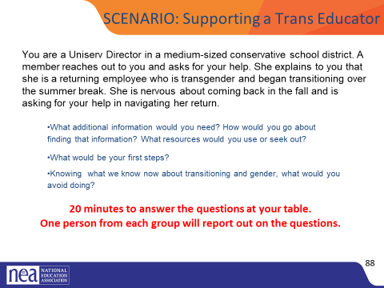  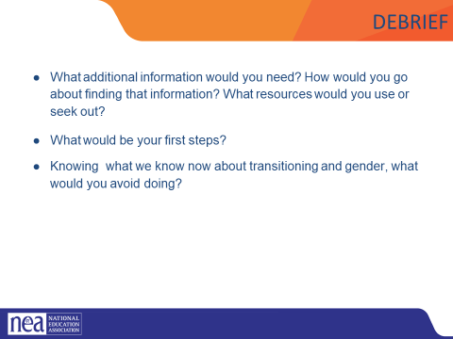  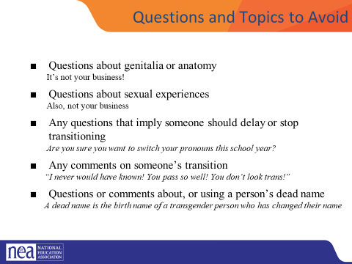 | Additional Resources in POPS Gender Diversity in the Workplace: a Transgender and Non Binary Toolkit for employers |  | Scenario is on the Slide not in handouts  Intro-  We are now going to apply the information we have learned over the last day and a half to a scenario about supporting a transitioning educator in our roles as Uniserv directors. You have 15 minutes to discuss the scenario with the people at your table and answer the questions. Please make sure one person is prepared to report out.  Transition in different ways in different places.  A reminder- EVERY EDUCATOR HAS THE LEGAL RIGHT TO TRANSITION AT WORK UNDER BOSTOCK. Your job is to make a plan to help this educator exercise their legal right!  Group Work- 10 minutes  Scenario is on the slides with questions  Debrief- 5 minutes- page 37- some questions you could use.  - Have each group report on the three questions.  - Things to push back on  - Incorrect or inappropriate language  - Inappropriate lines of questions to the member  - Any suggestion that the UD would challenge or discourage the member from transitioning  Questions and Topics to Avoid  Questions about genitalia or anatomy  It’s not your business!  Questions about sexual experiences  Also, not your business  Any questions that imply someone should delay or stop transitioning  Are you sure you want to switch your pronouns this school year  Any comments on someone’s transition  “I never would have known! You pass so well! You don’t look trans!”  Questions or comments about, or using a person’s dead name  A dead name is the birth name of a transgender person who has changed their name  Anything that assumes they are the expert on everything LGBTQ+  It's not their job to teach you or to speak for an entire, diverse community  Key Ideas  - When someone calls you and tells you they are transitioning, do not question them about what they are doing.  - Ask how you can support them and find out the answers to their questions.  - Put the person in the driver seat; do not be the driver.  - NEVER try to talk someone out of transitioning or question their decisions around their identity. |  | Participants will analyze what they need in their understanding to properly advocate for employees who are transitioning.  Participants will apply their new understanding to a scenario.t
3:55-4:15 Natasha |  |  | Campaign Scenarios
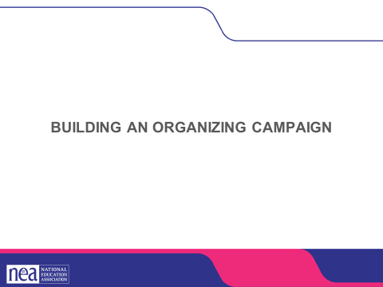  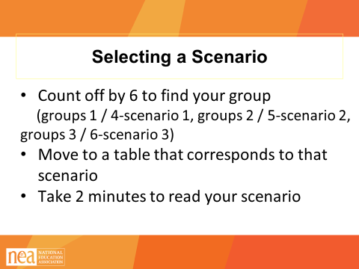  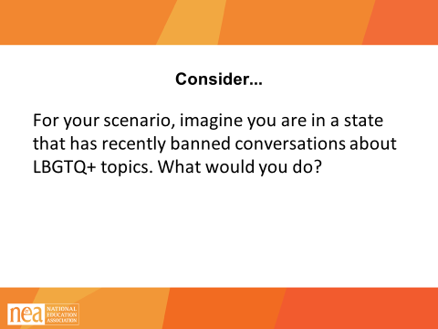  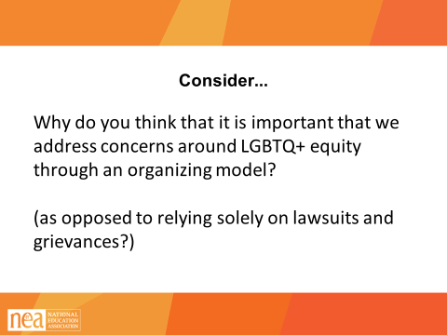  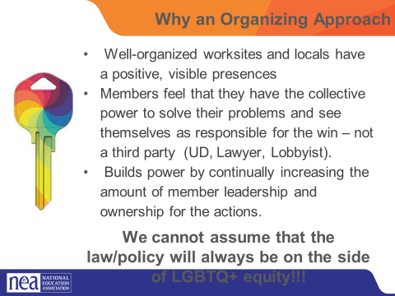  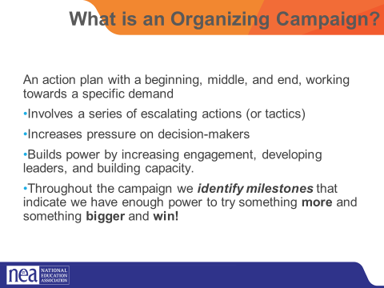  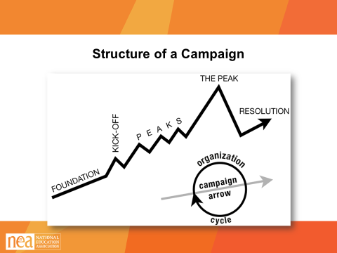  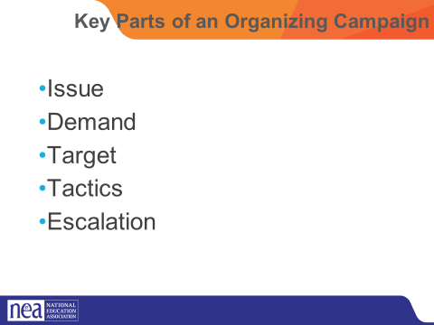  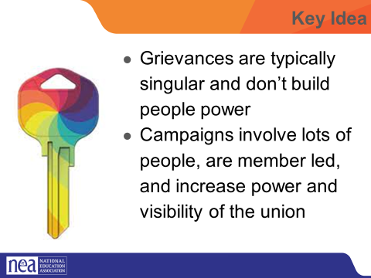 | POPS Participant Handouts  Scenario Package Handouts Pg 7-10  Campaign Plan Handouts  UPLOAD THE CAMPAIGN PLAN HANDOUTS  ASSESSING OUR ISSUE CHARTS |  | Today we are going to spend a lot of our time practicing what we have learned over the past two days. You will break into groups and work on building an organizing campaign that addresses one of the scenarios found on pages 7-10 of your participant handouts in POPs.  Getting into Scenario Groups (2 minutes)  The facilitator will count participants off by 6.  - numbers 1 and 4 will work on scenario 1  - Numbers 2 and 5 will work on scenario 2  - Numbers 3 and 6 will work on scenario 3  Once participants have counted off, they will move to the table with the corresponding number (have a piece of chart paper on the wall showing groups, have table numbers)  Take 2 minutes to read your scenario, found on Page 7-10 in POPs. For much of our remaining time, we are going to work on building an organizing plan to address these issues. Go to the table that corresponds with the scenario you would like to work on.  At your table, consider the following prompt: For your scenario, imagine you’re in a state that has recently banned conversation about LGBTQ+ topics. What would you do?  Ask for one participant to answer the following question: Why do you think that it is important that we address concerns around LGBTQ+ equity through an organizing model? (as opposed to relying solely on lawsuits and grievances?)  Well-organized worksites and locals have a positive, visible presences  Members feel that they have the collective power to solve their problems and see themselves as responsible for the win – not a third party (UD, Lawyer, Lobbyist).  Builds power by continually increasing the amount of member leadership and ownership for the actions.  We cannot assume that the law/policy will always be on the side of LGBTQ+ equity!!!  2 mins – INTRODUCTION TO CAMPAIGN PLANS Mountain  - So why do we need campaigns? A campaign is an action plan with a beginning, middle, and end, working towards a specific demand that we want to win.  - A campaign has a target, someone who can give us what we want. It usually involves a series of escalating actions (or tactics), which means that we progressively turn up the heat.  - A good campaign creates increasing pressure on decision-makers over time by escalating the intensity and visibility of the tactics and increasing the numbers of people involved.  - Campaigns are a way to identify in advance the ingredients we need to win and put them together in a way that maximizes our chances of success.  - One isolated action may not be enough to solve the problem.  - Campaigns help us to shift the balance of power in our workplaces and build members’ confidence.  - Many issues that members care about can’t be solved with grievances.  - Besides, grievances are invisible to most members, because they don’t usually involve collective action.  - We need our actions to be participatory and public.  There are five main parts to a campaign. We are going to go through each-  - Issue  - Demand  - Target  - Tactic  - Escalation  We are going to go through each of the key components of an organizing campaign and apply each to our scenario. Then, at the end, we will compile and present our final campaign plans for our scenarios.  1 MIN- WRAP UP/KEY POINTS  - Grievances are typically singular and don’t build people power  - Campaigns involve lots of people are member led and increase power and visibility of the union |  | Participants will apply their new learnings to complex teams-based scenarios.  Participants will apply a campaign framework to their plan to seek justice for the individual(s) in the scenario.
4:20-4:30 Ellen |  |  | Ending and Wrap Up 10 Minutes
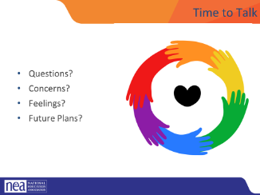 |  |  | Any logistics or questions and then out the door  Ended with a visual – pictures only – small groups of 3 or 4 created a chart – top half the world as it is and the bottom half the world as it should be.  Facilitator – Affiliate staff and those who lead others need to be able to vision a hopeful change and help others move from the world as it is into a place where they can describe the hopeful world that they wan to build
4:30-5:00 |  |  | Choice Networking

