Facilitator Agenda: Advancing LGBTQ+ Justice Day # 3
General Materials Needed: |  |  | Room Set-up:
1 Set of Handouts per Person  Name Tents with the Norms  Room signs,  One ream of white photocopy paper  Chart Paper (4 to 5 full w Sticky Strip) |  | Materials Box for each table with:  Markers (Mr. Sketch variety)  Post its – 3x3” and 4X5” sizes  Index Cards  Highlighters – 4 colors  Pens and Pencils Participant “toys” | Long Rectangle table at back for facilitators  Round Tables for participants  Projector, Screen, mics, and Speakers  Carousel stations and reporting stations  No podium, table with projector big enough for laptop
Key Outcomes for the Day:

Overview of Content, Time, and Facilitator Assignment
8:30-8:40 Entry and Welcome  8:40-8:55 Shared Identity  8:55-9:05 Building a Campaign  9:05-9:40 Problem vs. Issue  9:40-10:25 Demand, Targets, Tactics and escalation  10:25-12:10 Team Time  12:10-12:40 Presentation  12:40-1:00 Final Closing Conversations  Lunch – 1:00-2:00 BOXED Lunch | Ellen  Beth  Natasha  Bekah  Pete – Dawn (Ellen and Grat on Standby)  Anthony  Anthony  Ellen

General Materials Needed: |  |  |  | Room Set-up:
1 Set of Handouts per Person  Name Tags or Name Tents  Sign-in Sheet  UBL Form Folder  Agendas on the table (1 per)  Room signs, sign in signs |  | Chart Paper  Markers  Post its  Index Cards  Highlighters – 3 colors  Chart Markers – non-permanent  Pens and Pencils |  | Round Tables  Projector, Screen and Speakers  Carousel stations and reporting stations around the perimeter  50 people
Key Outcomes for the Day
Participants will be able to build a campaign of escalating of tactics designed to target an LGBTQ+ issue within a scenario
Participants will understand that collective action is the way to address systemic issues of injustice
Time Slides Facilitator | Resources |  | Instructions, Activity and Debrief |  | Outcomes and Essential Questions
 | Charts, handouts, articles, materials, slide |  | What are you saying, what are they doing, what questions will you use to guide learning and make clear the important points  Include an estimate for how long each section of the learning will take |  | As a result of this section of learning, what will participants know or be able to do?
8:30-8:40 Ellen |  |  | Getting Started 10 Minutes
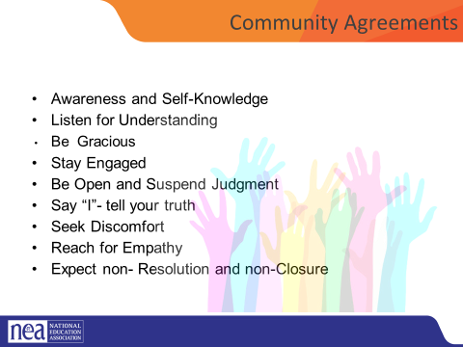    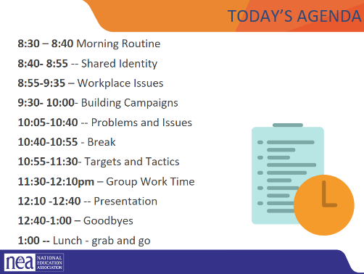 |  |  | - Intro, revisit group agreements, feedback/ Questions/Needs/Etc. Last minute logistics (10 minutes) |  | Participants will understand how their learning for the day will be structured.
8:40-8:55 Beth |  |  | Shared Identity Activity - Highest risk, content groups (15 minutes)
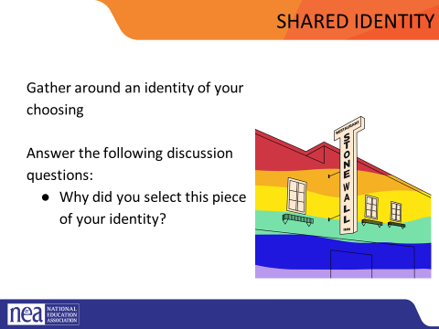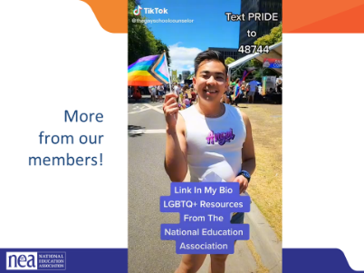  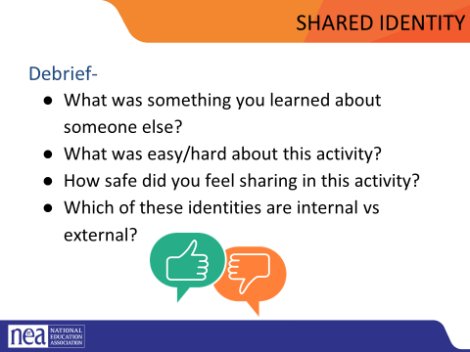 | Video  https://docs.google.com/presentation/d/1iw4K2ibF4PRp79A-CN9qeqv6b-VoNe6T/edit#slide=id.p86  (25 seconds) |  | Participants will reflect on how the intersectional aspects of each person’s identity continue to inform their relationship to privilege and oppression.  Post the following identities around the room: (we are only using day one labels today)  - High risk (day 3) – religious, spiritual, agnostic, immigrant, LGBTQ+, in recovery/survivor, nontraditional family  Participants will get up and gather around an identity of their choosing. Everyone needs to make a choice that makes sense for them (2 min instructions), then they will answer the following discussion questions (8 min):  - Why did you select this piece of your identity?  - What are some challenges you face with this identity?  Share out/debrief (5 min)  - What was something you learned about someone else  - What was easy/hard / risky about this activity?  - Which of these identities are internal vs external?  - How did you find yourself reacting?  - Describe your feelings / thoughts about the progression from Day 1-Day 3.  ***Review the possible key ideas from Day 1 facilitator agenda***
8:55-9:05 Natasha |  |  | Building a Campaign around the Scenarios (Review and Revisit)
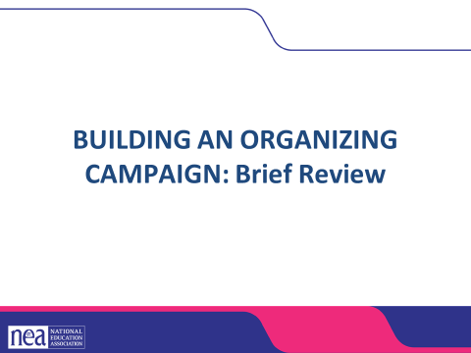  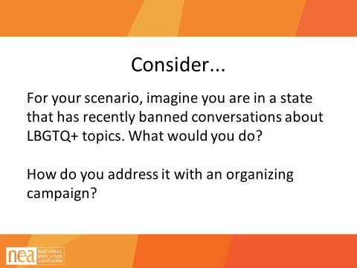  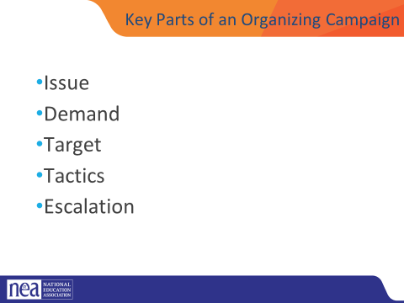 | Scenario Package Handouts Pg 7-10  Campaign Plan Handouts  UPLOAD THE CAMPAIGN PLAN HANDOUTS  ASSESSING OUR ISSUE CHARTS |  | (Review and Revisit from yesterday at the end of the day  Today we are going to spend a lot of our time practicing what we have learned over the past two days. You will break into groups and work on building an organizing campaign that addresses one of the scenarios found on pages 7-10 of your participant handouts in POPs.  Getting into Scenario Groups (2 minutes)  The facilitator will count participants off by 6.  - numbers 1 and 4 will work on scenario 1  - Numbers 2 and 5 will work on scenario 2  - Numbers 3 and 6 will work on scenario 3  Once participants have counted off, they will move to the table with the corresponding number (have a piece of chart paper on the wall showing groups, have table numbers  Take 2 minutes to read your scenario, found on Page 7-10 in POPs. For much of our remaining time, we are going to work on building an organizing plan to address these issues. Go to the table that corresponds with the scenario you would like to work on.  At your table, consider the following prompt:  For your scenario, imagine you’re in a state that has recently banned conversation about LGBTQ+ topics. What would you do?  Ask for one participant to answer the following question: Why do you think that it is important that we address concerns around LGBTQ+ equity through an organizing model? (as opposed to relying solely on lawsuits and grievances?)  Well-organized worksites and locals have a positive, visible presences  Members feel that they have the collective power to solve their problems and see themselves as responsible for the win – not a third party (UD, Lawyer, Lobbyist).  Builds power by continually increasing the amount of member leadership and ownership for the actions.  We cannot assume that the law/policy will always be on the side of LGBTQ+ equity!!!  2 mins – INTRODUCTION TO CAMPAIGN PLANS Mountain  - So why do we need campaigns? A campaign is an action plan with a beginning, middle, and end, working towards a specific demand that we want to win.  - A campaign has a target, someone who can give us what we want. It usually involves a series of escalating actions (or tactics), which means that we progressively turn up the heat.  - A good campaign creates increasing pressure on decision-makers over time by escalating the intensity and visibility of the tactics and increasing the numbers of people involved.  - Campaigns are a way to identify in advance the ingredients we need to win and put them together in a way that maximizes our chances of success.  - One isolated action may not be enough to solve the problem.  - Campaigns help us to shift the balance of power in our workplaces and build members’ confidence.  - Many issues that members care about can’t be solved with grievances.  - Besides, grievances are invisible to most members, because they don’t usually involve collective action.  - We need our actions to be participatory and public.  There are five main parts to a campaign. We are going to go through each-  - Issue  - Demand  - Target  - Tactic  - Escalation  We are going to go through each of the key components of an organizing campaign and apply each to our scenario. Then, at the end, we will compile and present our final campaign plans for our scenarios.  1 MIN- WRAP UP/KEY POINTS  - Grievances are typically singular and don’t build people power  - Campaigns involve lots of people are member led and increase power and visibility of the union |  | Participants will apply their new learnings to complex teams-based scenarios.  Participants will apply a campaign framework to their plan to seek justice for the individual(s) in the scenario.
9:05-9:40 Bekah |  |  | Problem vs. Issue
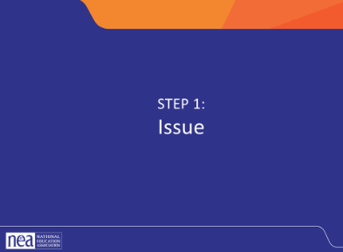  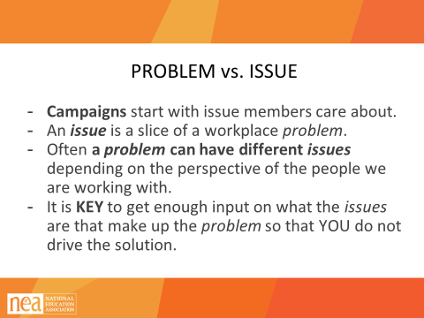  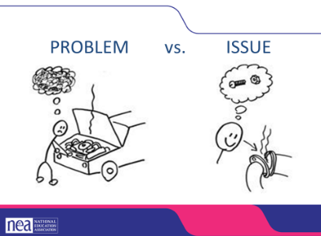  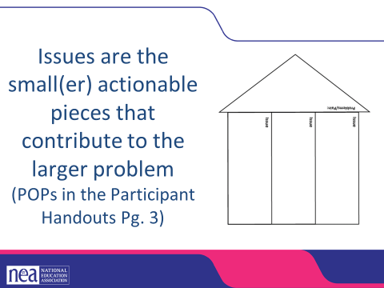  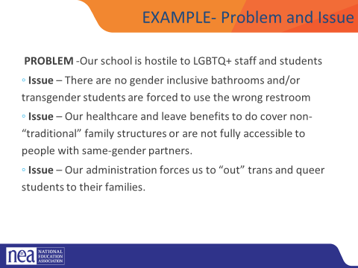  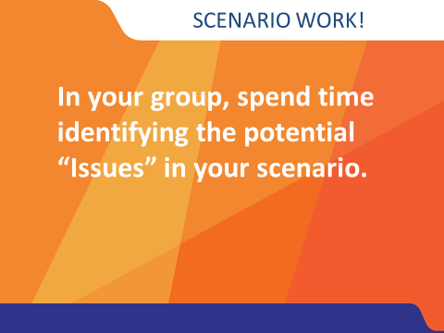  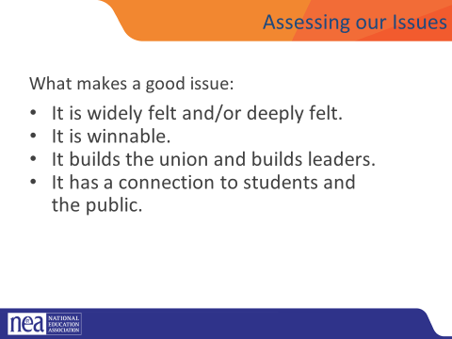  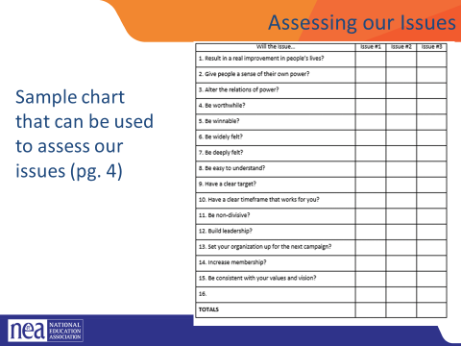  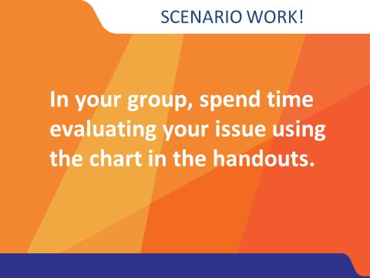 |  |  | There are a lot of problems in our work. They weigh us down, they drain our energy, they feel unsolvable. The first step in a campaign is taking the time to turn your problems into an issue.  5 Minutes Intro - PROBLEM vs. ISSUE  - Campaigns start with issues members care about.  - An issue is a slice of a workplace problem.  - Often, a problem can have different issues depending on the perspective of the people we are working with.  - It is key to get enough input on what the issues are that make up the problem so that YOU don’t drive the solution.  - A staff-driven solution may not meet the needs and commitment of the people you are working with.  Note: for your scenarios, there may be a “service” model solution and an organizing issue. Think of direct service as a way of solving the immediate crisis and organizing as a way of addressing a bigger systemic issue so it doesn’t happen again  So, for example, the problem here is that the car doesn’t work. In order to address that, we need to figure out the specific thing that we can change to make the car work—in this case, it is a missing screw in a pipe joint.  Issues are the smaller, actionable pieces that contribute to the larger problem. I think this is supposed to be a house, but I actually think of it as a rocket. We are trying to build the energy and power to remove the problem. The problem is at the cone of the rocket, and each issue is a rocket booster. With each issue that we identify and organize around to resolve, we build more power until we can blast the problem out of our world.  Here is an example that we put together—yours will be better because you have more heads thinking about it.  Go over the text on the slide:  Now go back to your small groups  5 Mins – GROUP WORK including Intro  In your groups, return to your scenario and decide the:  The potential issues in your scenario  BRAINSTORM- ON CHART PAPER- ANYTHING GOES- ALL IDEAS ON CHART PAPER  5 minutes CONVERSATION ABOUT WHAT MAKES A GOOD ISSUE (then switch slide)  Assessing an issue (5 min)  How to select an issue  - Since there may be many issues confronting workers on the job, we have to also think about what makes a good issue to organize around.  - CRITERIA:  - It is widely felt.  - It is deeply felt.  - It is winnable.  - It builds the union and builds leaders.  - It has a connection to students and the public.  A NOTE HERE: Often, issues of equity are deeply felt by a marginalized few, and NOT by the privileged majority. If an issue is very deeply felt, it does not have to be widely felt.  This is only a tool – it helps in the facilitation of teams who are selecting their issues – there is no hard and fast way to determine a good issue.  5 Mins – GROUP WORK  In your groups, return to your selected issues. Use the chart in the handout PAGE 112 to determine whether the issue you identified is a good issue. |  | Participants will apply their new learnings to complex team-based scenarios.  Participants will apply a campaign framework to their plan to seek justice for the individual(s) in the scenario.
9:40-10:25 Pete and Dawn  Grat and Ellen on standby |  |  | Demands, Targets, Tactics and Escalation (55 Mins)
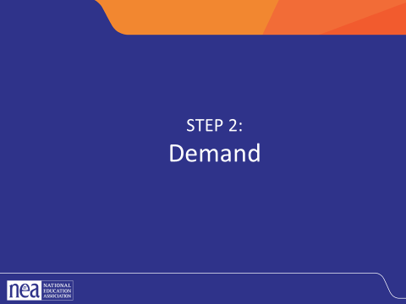  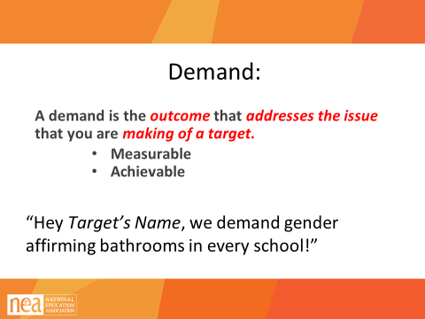  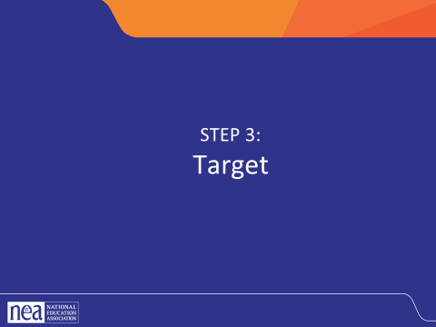  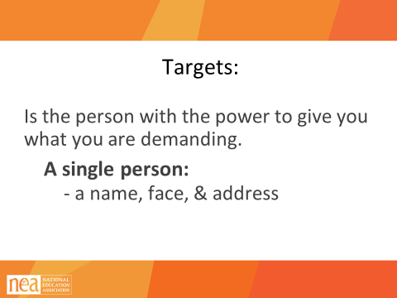  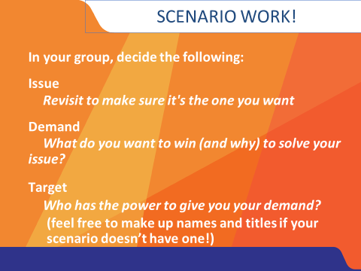  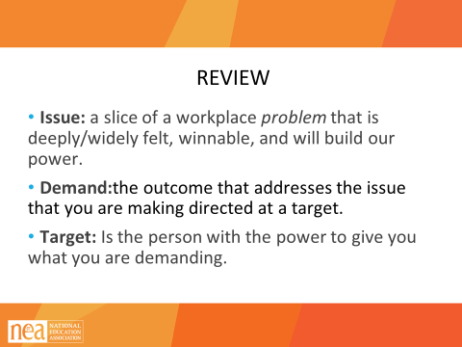  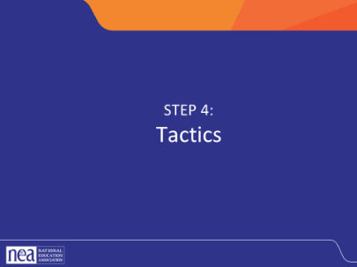  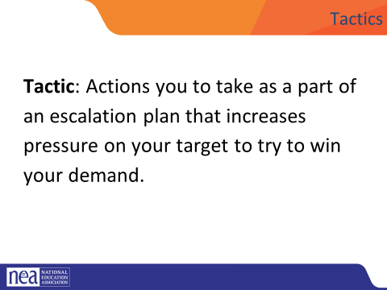  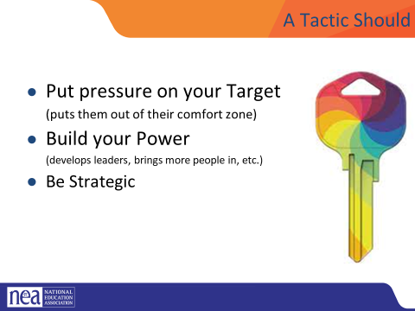  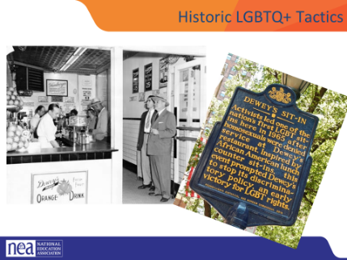  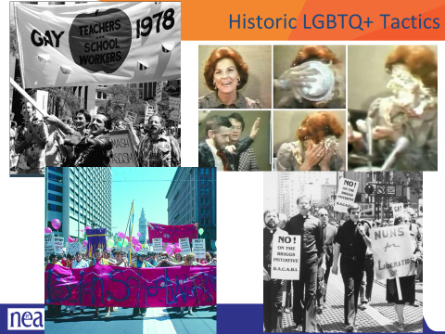  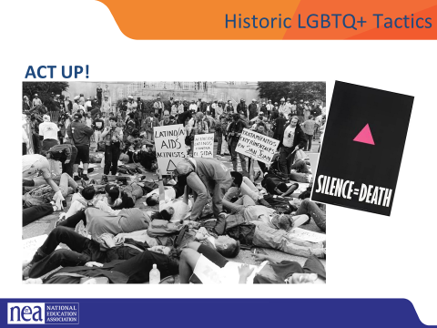  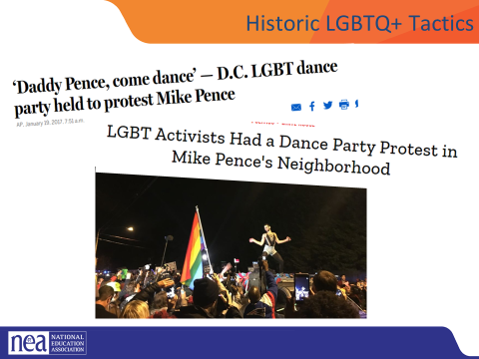  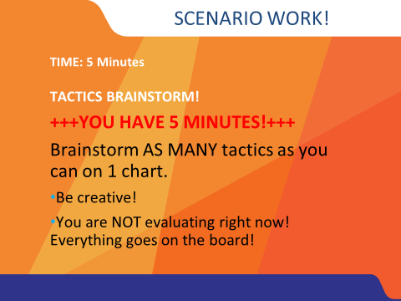  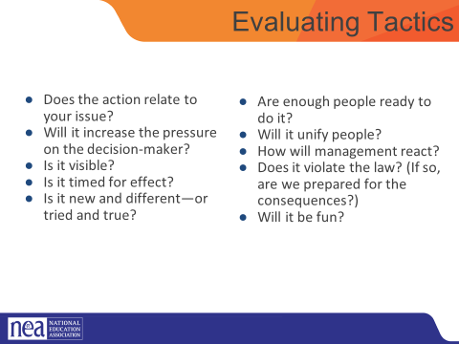  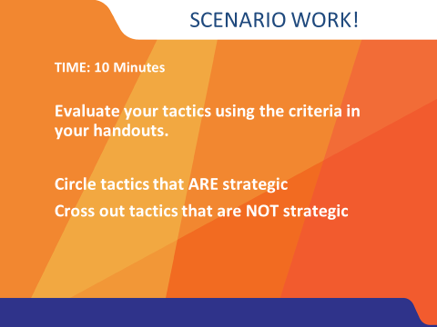  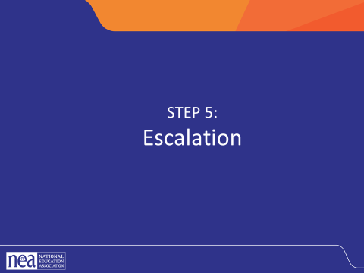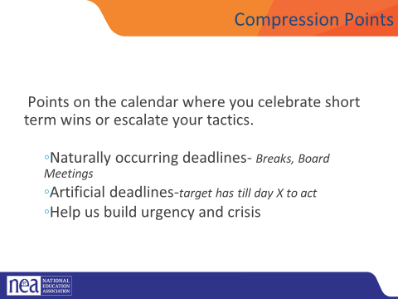  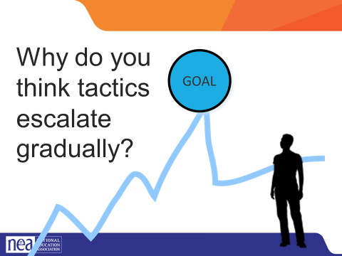  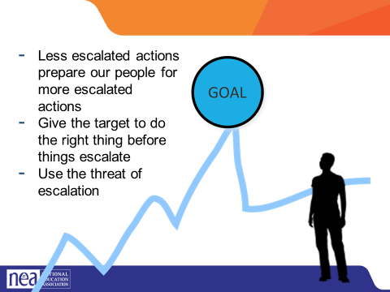 |  |  | DEMANDS & TARGETS—15 min (Dawn)  3 Min – Definitions (Dawn)  Define DEMAND:  - A demand is what the group wants – the win  - A demand is the outcome that addresses the issue you are making of the target  - If the issue is what is wrong, the demand is what we want that will fix the issue.  Define TARGET:  TARGET: A target is a single person with a name and an address. The target is the person with the power to give the workers the change they are asking for. A target has a name, a face and an address.  Remind participants that there may be more than one target at different levels of an escalating campaign  8 Min - Scenario Work (Dawn)  - Go to POPs Page 5 and complete the fillable form  - You now have 8 minutes to return to your scenario. In that time make sure you 1) review your issue and make sure it is good to go then 2) decide your demand then 3) decide on your target  3 Min - Report Out (Dawn)  Briefly go around the room and groups report their target and demand following the structure on the power point.  - Note- Even though we are explicit, someone will inevitably pick a group of people as the target.  - When they say these things, we need to redirect participants to think of an individual person (a person with a name and an address, not a group). Examples:  - School Board (Make them pick a member. Possibly the president or the swing vote. They can make up information if they need to)  - Members or the public (Often this is because they have an incorrect issue and have concluded that educating their members is the solution. Members are our base, they are never the target. And an education campaign will not make meaningful change in workers lives)  1 min REVIEW all (Dawn)  Remaining slides/content for TACTICS and ESCALATION = 30 min  1 min- INTRODUCE Tactics (Pete)  Now that we know what our demands and targets are, we can start planning how we achieve our demands.  Tactics are Actions you to take as a part of an escalation plan that increases pressure on your target to try to win your demand.  Brainstorming tactics is often considered the “fun part of organizing,” and our members often want to jump right into this process. It is important to get folks to identify demands and targets first because those demands and targets will help decide what tactics could be successful.  A tactic should  Puts pressure on your Target  (puts them out of their comfort zone)  Builds your Power  (develops leaders, brings more people in, etc.)  Is Strategic  5 min-HISTORICAL TACTICS: (Pete)  Let’s look at some tactics LGBTQ+ groups have used throughout history to advance justice for their community:  Dewey’s was a popular restaurant in Philadelpha that had a policy denying service to “avowed homosexuals.” The Janus Society, an early LGBTQ support organization, took a page from the civil rights movement playbook and staged sit-ins at both of Dewey’s locations. The pressure and negative attention from the sit-ins prompted the restaurant to end their policy.  In 1978 anti-LGBTQ legislators tried to ban LGBTQ folks from being educators, called the Briggs’ initiative. This was part of the larger, national, “Save Our Children” campaign with spokesperson Anita Bryant. Queer activist Thom Higgins, who coined the term “gay pride.” famously threw a fruit pie in Bryant’s face in protest. In California, LGBTQ educators took things into their own hands by forming groups like the Lesbian School Worker’s Assocition and the Gay Teacher and School Worker Association. By using an organizing framework as well as building a multi-ethnic and inter-faith coalition, they successfully defeated the Briggs’ initiative.  Born out of the first HIV awareness organization, Gay Men’s Health Crisis (GMHC), ACT UP (AIDS Coalition to Unleash Power) was formed to move HIV related activism from direct care to organized advocacy. ACT UP was an essential organization in bringing the US government’s attention, including Dr. Larry Fauci’s, to the AIDS crisis.  LGBTQ activists threw protest dance parties around Vice-President Elect Mike Pence’s pre-inaugural residence in DC. These protests related to Pence’s time as Governor of Indiana where he signed a “Religious Freedom (to discriminate)” bill and oversaw one of the fastest increases in new HIV cases in several decades in Indiana.  We are going to model a tactic of brainstorming that you can use when working with members.  5 Minutes Scenario Work (Pete)  Brainstorm AS MANY tactics as you can on 1 chart.  - Be creative!  - You are NOT evaluating right now! Everything goes on the board!  We are going to have 5 minutes to list as many tactics as you can. Extra points for super creative ideas. WE ARE NOT. NOT. NOT. Evaluating tactics at this time. If someone says something (example- We are going to wear the same clothes without washing them until we get what we want) you right, it down and move on. All ideas get on the board. Again, this is a brainstorm. NO EVALUATING.  YOU HAVE EXACTLY 5 MINUTES. After 5 minutes put your pens down.  Open your phone and actively start a timer. “ON YOUR MARKS. GET SET. GO”  Excellent! We now have a whole list of tactics. Next. We are going to assess our tactics. For this, I encourage you to use a list of questions like this-  (3 minutes- How to evaluate a tactic (Pete)  (pg. 5 POPS)  - Does the action relate to your issue?  - Will it increase the pressure on the decision-maker?  NOTE! This means that we have to engage in actions that make our target uncomfortable. SOOOOO the same old tactics WON’T WORK! They are used to them!  - ^{Is it visible?}  - ^{Is it timed for effect?}  - Is it new and different—or tried and true?  Note! SEE above. If a tactic is the same as always, your target has likely become comfortable with it AND it won’t develop new skills in your members and therefore build your power.  - Are enough people ready to do it?  - ^{Will it unify people?}  - ^{How will management react?}  - Does it violate the law? (If so, are we prepared for the consequences?)  NOTE! This doesn’t mean that it is off limits. Historically, breaking laws has been a big part of social justice movements. ESPECIALLY THE LABOR MOVEMENT! However, we have to consider if an unlawful tactic is the right tactic and whether you have the power to mitigate/absorb the consequences.  - ^{Will it be fun?}  Folks want to engage in things that fill them up! Who had a tactic that they would be excited to participate in?  10 minutes- Evaluating your tactics (Pete)  You have 10 minutes. Look at your list of tactics.  - Circle the ones that you think are strategic, when looking at these questions.  - Cross out the ones that are NOT strategic.  Escalation (Pete)  2 Minutes – Compression Point Definition  - Points on the calendar where you celebrate short term wins or escalate your tactics based on how you have assessed your readiness to escalate.  - Naturally occurring deadlines  - Artificial deadlines  - Help us build urgency and crisis  2 Minutes – Turn and Talk (Pete)  We keep saying that tactics should escalate gradually. Why do you think that is?  2 Minutes – Debrief (Pete)  Each escalation is more public, more visible, and has more risk. WE transform members to activists, activists to leaders by asking them to take bigger risks  Some points to make if they are not said by the group  - Less escalated actions prepare our people for more escalated actions  - Give the target to do the right thing before things escalate the threat of escalation |  | Participants will apply their new learnings to complex teams-based scenarios.  Participants will apply a campaign framework to their plan to seek justice for the individual(s) in the scenario.  Participants will create a campaign composed of escalating tactics.
10:25–12:10 Anthony |  |  | Team Time (1 hour and 45 Minutes) this includes your break
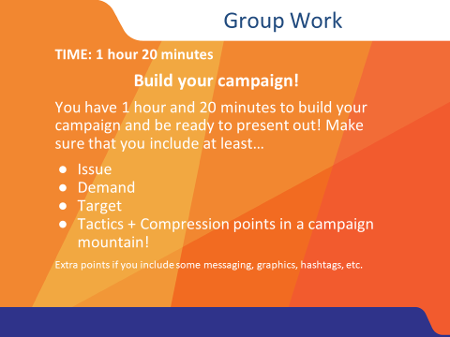 |  |  | - During this time, you will work on your scenario- in teams  - Scenario description in day two- can be placed here for reference or here in enough time is not available in day two  - Goal is to produce charts that show all five steps  Issues  Goals  Target  Tactics  Escalation  Winning!!!! |  | Participants will create a campaign composed of escalating tactics.
12:10-12:40 Anthony |  |  | Presentations (30 Minutes)
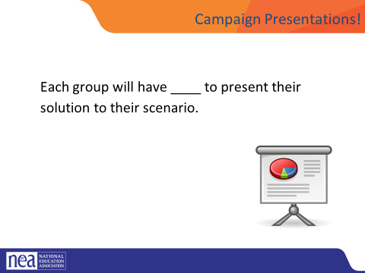 |  |  | First 30 Minutes is the team presenting to at least one other and receiving some coaching, questions, feedback  Additional 30 Minutes - What would a legal approach look like?  Have the same campaign groups look at their scenario and try to apply a legal approach. What would that look like? What are the limits of doing that? What are the benefits of doing that? How many and who are engaged in this approach?  HOLD: If anything comes up, etc. If not....  Lingering questions/Bringing this work back home- Some sort of gallery walk/Affinity wall, etc.
12:40-1:00 Ellen |  |  | Closing activity- circle (20 Minutes)
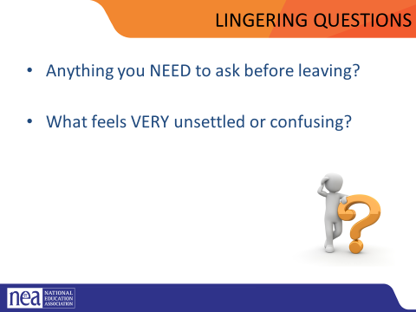
1:00 – 2:00 |  |  | Boxed Lunches and Adult Networking

